

VET Workforce Study

Background and context
Many of the skills shortages across the country rely on the vocational education and training (VET) system and its dual professional workforce to teach and train Australia’s future workers. If a sustainable VET workforce cannot be secured for the future, skills shortages will be difficult to fix in the wider Australian economy. Jobs and Skills Australia’s (JSA) VET Workforce Study (2024) highlights the extent of this challenge and provides evidence to inform the Department of Employment and Workplace Relations’ VET Workforce Blueprint.

Summary of key findings
Australia's VET workforce is critical to meeting the nation's skills needs but faces growing workforce challenges. The findings highlight the need for targeted workforce strategies, stronger workforce planning and improved data collection to support a sustainable and effective VET sector.
- The diversity of the VET workforce means different policy levers and workforce strategies are needed:
  - Existing VET workforce data is limited and obscures future risk and opportunities for an effective VET system to develop the workforce of the Australian economy.
- High demand, low supply and training pipeline issues:
  - VET teacher numbers have declined by 11–18% over the past decade, with demand expected to grow by a further 3,800 teachers over the next five years.
  - The pipeline of new teachers is shrinking, with Certificate IV in Training and Assessment completions down almost 25% since 2016.
- An older and ageing workforce that is lacking diversity, highly casualised and lower paid than their teaching counterparts in other sectors:
  - Almost half of the VET workforce is aged over 50, making it significantly older than the broader Australian workforce.
  - The sector has lower workforce diversity, high levels of casual employment and a 16% gender pay gap.
- The TAFE workforce has better employment conditions, more diversity and is higher paid:
  - It sits at around 40,000 workers, is slightly more feminised, higher paid, more likely to work full-time and older than the broader VET workforce.
- The biggest data gaps
  - Key data gaps remain around workforce size, qualifications, demographics, and diversity, limiting evidence-based workforce planning and policy development.

Figures
Figure 1 Change in the VET workforce size from FY2011/12 – FY2020/21
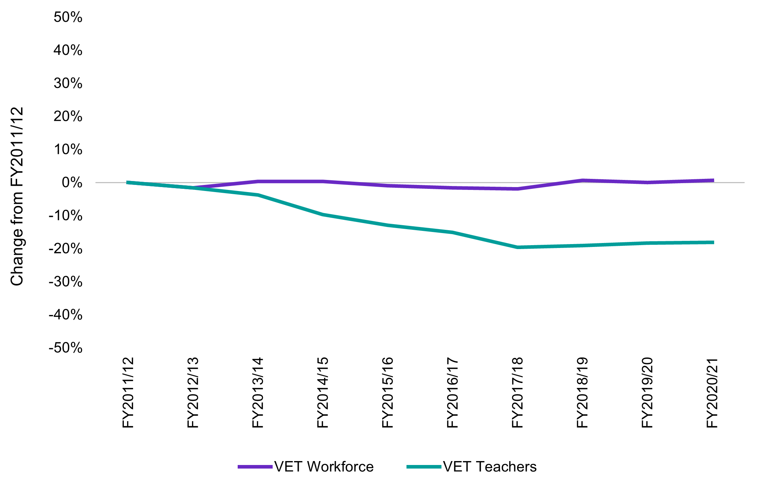

Source: Australian Bureau of Statistics (2023) Microdata: ATO Personal Income Tax (PIT)
(2010-11 – 2020-21) [Datalab]
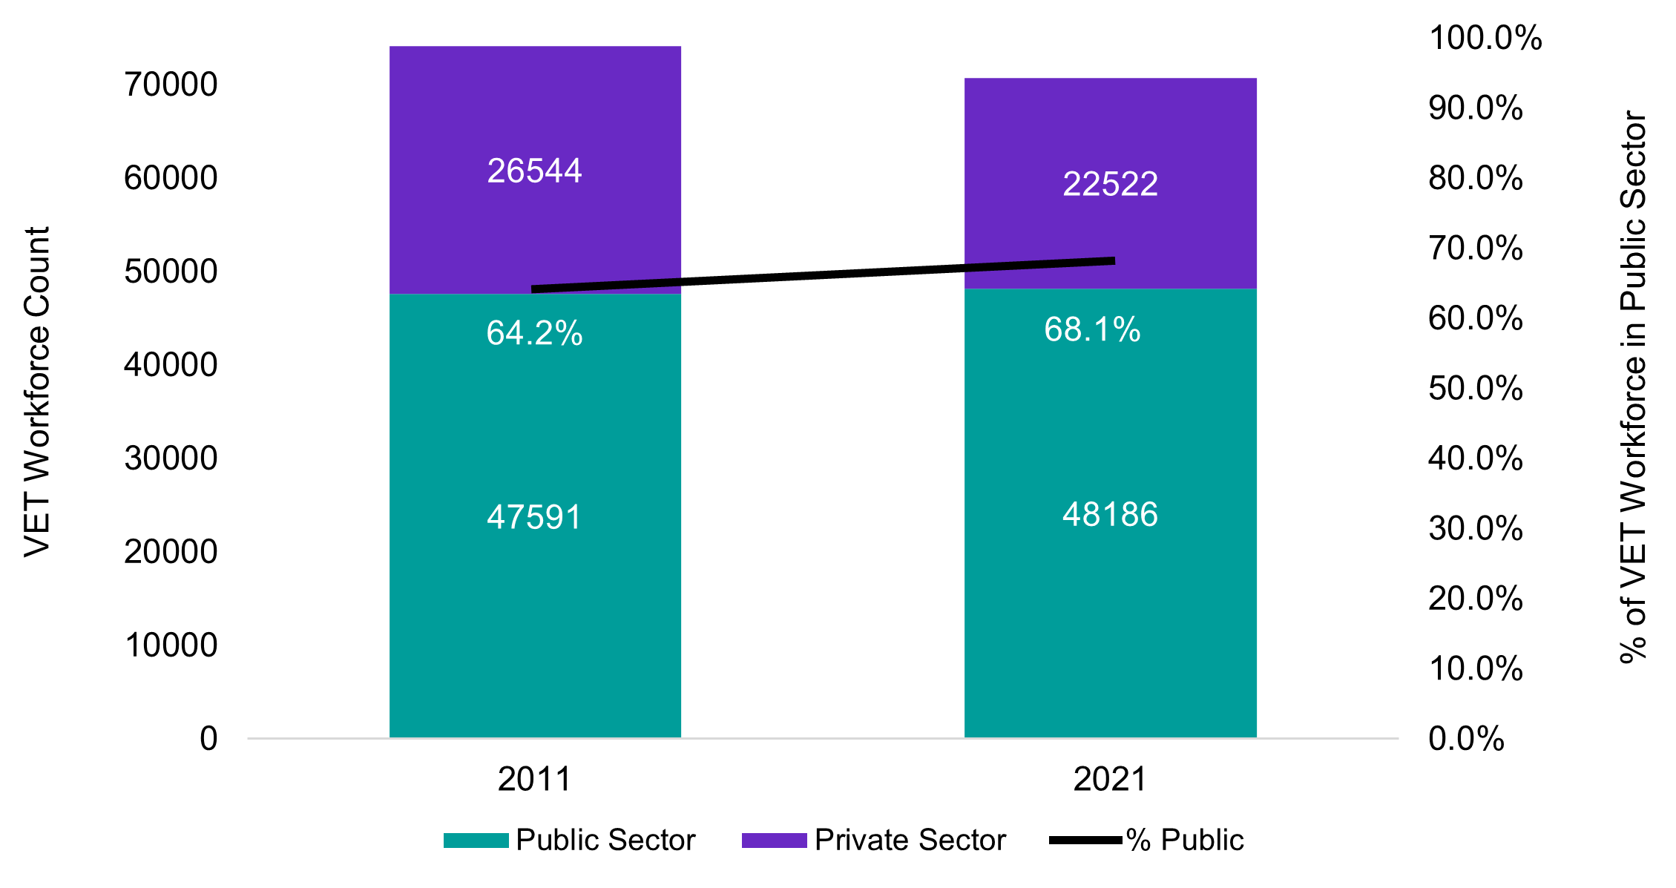
Figure 2 Count of VET Workforce in public and private sector employment in 2011 and 2021

Source: ABS (2021) Occupation (OCCP) and Industry of Employment (INDP) by Sector of Employment (GNGP), [Census TableBuilder] 2021, accessed 25 March 2024.

Further information



Connect with us Roadshow 2026

