

Training Occupation Pathways (TOP)

Connecting VET qualifications and occupations
TOP shows the relationships between vocational education and training (VET) qualifications and occupations, helping users understand how training pathways connect to occupations and the labour market.
By highlighting multiple pathways rather than simple one-to-one links, TOP shows the different routes that can lead to occupations, improves visibility of connections between qualifications and occupations, and helps users understand how training contributes to workforce capability. Together, these insights provide a richer understanding of how skills are developed and applied across the labour market.
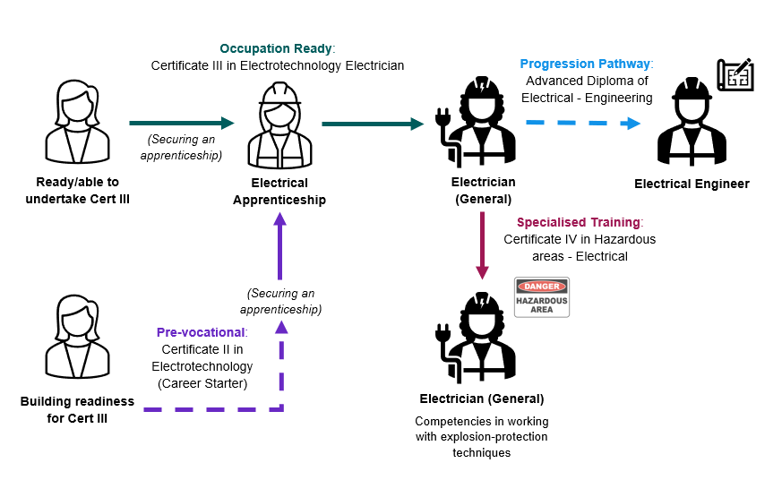
TOP maps more than 5,000 pathways between VET qualifications and occupations at the Occupation Standard Classification of Australia (OSCA) 6-digit level. TOP combines data-driven analysis with expert input from Jobs and Skills Councils and other stakeholders.
TOP identifies several pathway flags:
- Occupation ready: qualifications that provide the skills and knowledge typically required for entry into an occupation (noting additional licensing, registration or other requirements may apply).
- Specialised training: qualifications that build additional or advanced skills beyond those typically required for entry, supporting specialisation, leadership, or advanced practice.
- Progression pathway: qualifications that support progression towards an occupation by unlocking further study, training, or occupational experience.
- Pre-vocational: qualifications that build foundation skills for workforce participation or further training that leads to an occupation.
- Related: qualifications that provide transferable skills or industry context relevant to an occupation but do not represent a recognised pathway.
TOP supports informed decision-making
TOP provides a national evidence base that improves understanding of the relationship between training and work. By highlighting multiple pathways rather than simple one-to-one links, TOP shows the different routes that can lead to occupations, improves visibility of connections between qualifications and occupations, and helps users understand how training contributes to workforce capability. Together, these insights provide a richer understanding of how skills are developed and applied across the labour market.
These insights can support workforce planning, career exploration, skills and training analysis, and policy development. They help students, jobseekers, educators, employers, researchers and policy makers better understand qualification pathways and make more informed decisions about training, workforce development and skills needs.

Understanding TOP’s scope and limitations
This version of TOP includes training package qualifications only and does not include accredited courses or skill sets. While care has been taken to ensure the quality and accuracy of the data, some limitations remain:
- TOP shows indicative pathways, not guaranteed outcomes
- Complex and non-linear career pathways can be difficult to capture.
- Licensing, registration and regulatory requirements may vary across occupations and jurisdictions.
- Industry skill needs and workforce demands can change over time.
- Complex qualification-to-occupation relationships must be simplified for a wide range of users, which can reduce nuance.
- The analysis is undertaken at a national level and may not reflect all local, regional or industry-specific circumstances.

Help improve TOP
TOP will continue to be regularly updated and refined to reflect new data and stakeholder input. TOP 2026 is currently being updated.
We welcome feedback and suggestions to help improve the product:
SkillsDataAnalytics@jobsandskills.gov.au

Further information



Connect with us Roadshow 2026

