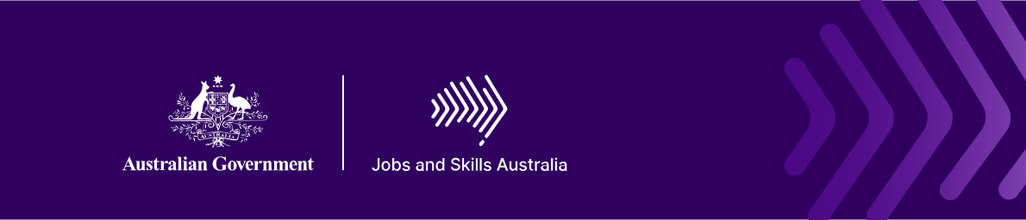

What is a skill?
Skills belong to people
We use skills every day. We use them to solve problems, communicate, care for others, operate equipment, create things, make decisions and adapt when circumstances change.
Jobs and Skills Australia define skill as:
"a valued and purpose-driven human ability that is acquired or refined through learning and practice. It is a dynamic function of an individual's knowledge, experience, and personal attributes that is continuously influenced by context, interaction with others, and the demands of the environment in which it is exercised."
Why are we talking about skills now?
The way we work is changing. Technology is reshaping tasks, people are working for longer and careers are becoming less linear. We increasingly need to update our skills, apply them in new situations and continue learning throughout our working lives.
To build a skills-first system, we first need a shared understanding of what a skill is. Without that foundation, it is difficult to recognise and describe skills consistently across education, training and work.
What does this definition tell us?
- Skills are human - Technology can automate tasks, process information and identify patterns. But people exercise judgement, build trust, reason ethically, apply cultural knowledge and respond to unexpected situations.
- Skills are developed - We acquire and refine skills through learning and practice. We develop them through education, training, work, community participation and life experience.
- Skills are dynamic - Skills are not fixed. They deepen through experience and change as we encounter new technologies, environments and demands.
- Skills depend on context - We can apply the same skill differently in different situations. Communication in an emergency is different from communication during a routine conversation, even though both draw on the same broad skill.
- Skills connect to the whole person - Knowledge, experience and personal attributes shape how we apply a skill. Skills rarely operate alone. We combine multiple skills when we manage a project, provide care, lead a team or solve a complex problem.

Making more skills visible
Not all valuable skills are technical
Communication, collaboration, adaptability, creativity, judgement, leadership and problem-solving are learned and practised human abilities. They contribute to productive workplaces and communities, but they can be difficult to see through qualifications, job titles or task lists alone.
This matters because what our systems recognise can influence what they value. A human-centred definition helps make visible the full range of skills used in areas such as care, education, community services, culture and other human-centred work.
From definition to action
The skills definition provides the foundation for Australia’s National Skills Taxonomy.
The definition gives us a shared understanding of what a skill is. The National Skills Taxonomy will give us a shared language for describing and connecting skills across education, training and work.
Together, they can help:
- people understand and communicate what they can do
- employers better identify and develop workforce skills
- educators connect learning with changing workforce needs
- governments develop stronger evidence for workforce planning
- make skills gained through different forms of learning and experience easier to recognise.
Skills belong to people. Making them visible starts with understanding what they are.
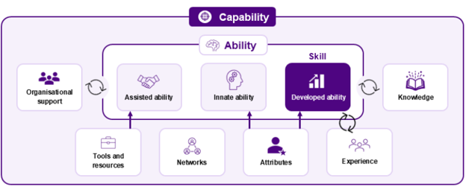

Further information
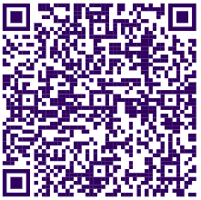
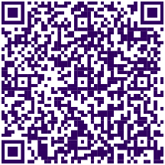

Connect with us Roadshow 2026

