

Regional Labour Market Indicator
What is the RLMI?
The Regional Labour Market Indicator (RLMI) brings together a range of labour market measures to provide an easy-to-interpret assessment of regional labour market performance, relative to the national average.
The RLMI brings together 11 measures, including employment, unemployment, income support, job vacancies, matching efficiency, underemployment, skills use, income growth and productivity. Together, these provide a more complete picture of regional labour market performance than any single measure, such as the unemployment rate.
Regions are grouped into 5 categories of relative labour market performance: strong, above average, average, below average and poor. Ratings are relative to the national average and allow users to compare labour market conditions across Australia and monitor how they change over time.

What do the results show?
Labour market conditions vary considerably across Australia:  - Labour market conditions are stronger on average in major cities, with 55% of major city regions rated strong or above average in June 2026.  - Regional Australia shows a more mixed picture, with both strong-performing labour markets and areas facing more persistent challenges.  - Remote Australia faces the greatest challenges, with all 6 remote regions rated poor. | Chart: RLMI ratings of relative labour market performance, June 2026  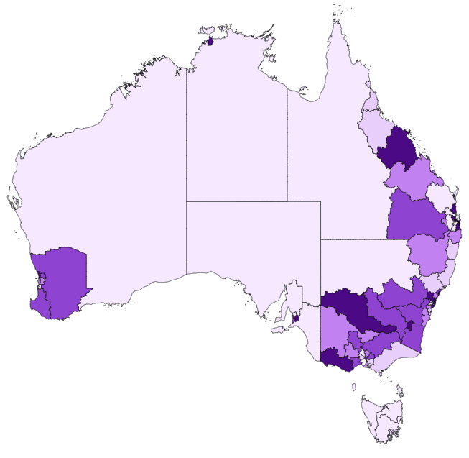

How have labour market conditions changed?
The gap between major city and regional labour market performance has narrowed over the past 3 years:
- Labour market conditions improved in several regional labour markets, including parts of north-eastern New South Wales.
- Over the same period, labour market conditions softened in some major cities, including in Melbourne.
- Remote labour market challenges have persisted, with all remote regions continuing to be rated poor.
Chart: 3-year change in RLMI ratings of relative labour market performance, June 2026
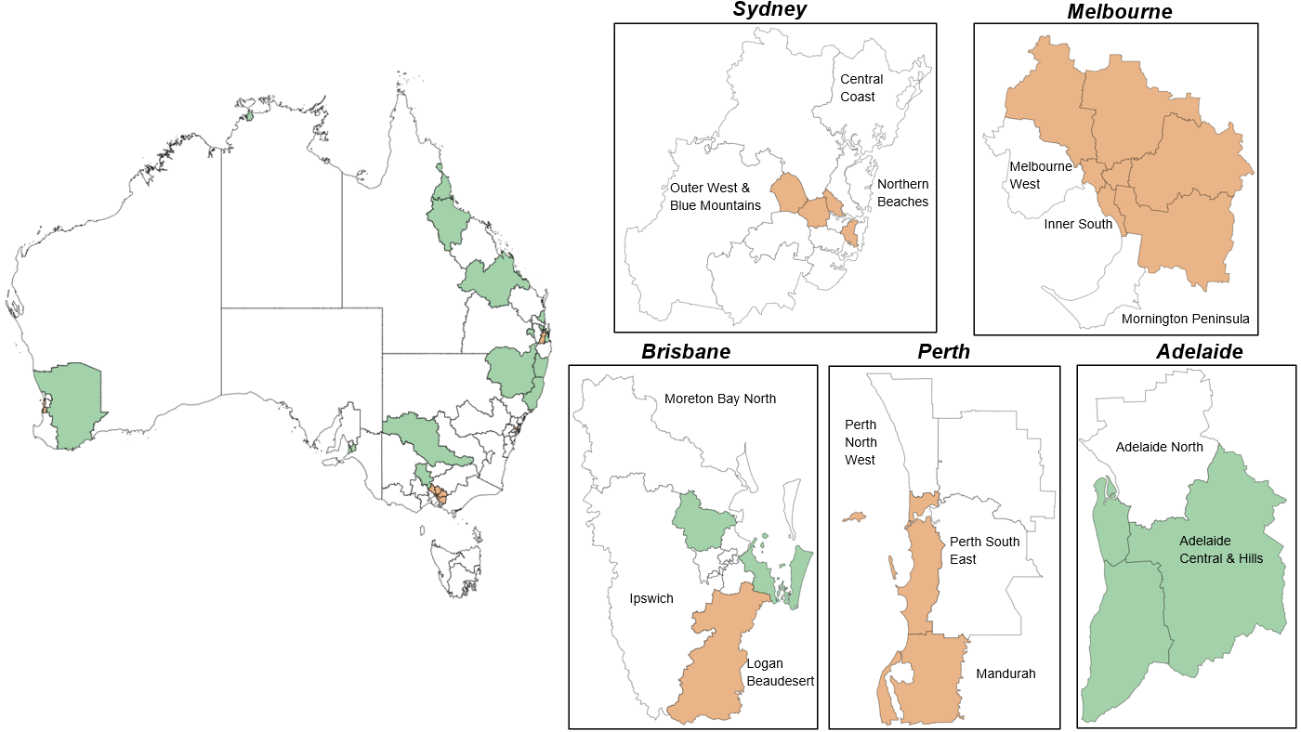

Further information



Connect with us Roadshow 2026

