Recruitment Experiences and Outlook Survey: September quarter 2026
Jobs and Skills Australia conducts the Recruitment Experiences and Outlook Survey (REOS) to monitor recruitment activity and conditions across Australia. Key national indicators from the survey are released monthly. Detailed data disaggregated by state, area, industry, and occupation are released in this quarterly report. For definitions or further information on this data and the REOS, see the notes on the last page.

Recruitment rate - National level
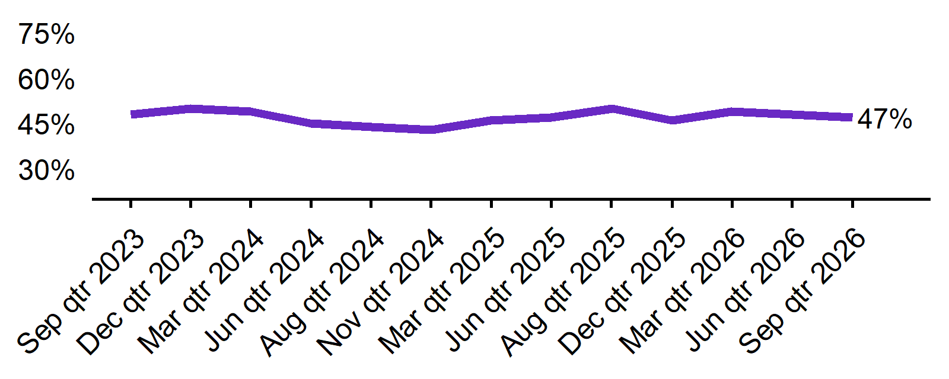 |  |  |  |  |  |  |  |  |  |  |  |  |  | - The recruitment rate in the September quarter 2026 was 47%.  - This was 3 percentage points lower than this time last year (50%).
Sep qtr 2023 | Dec qtr 2023 | Mar qtr 2024 | Jun qtr 2024 | Sep qtr 2024 | Dec qtr 2024 | Mar qtr 2025 | Jun qtr 2025 | Sep qtr 2025 | Dec qtr 2025 | Mar qtr 2026 | Jun qtr 2026 | Sep qtr 2026
48% | 50% | 49% | 45% | 44% | 43% | 46% | 47% | 50% | 46% | 49% | 48% | 47%

Recruitment difficulty rate - National level
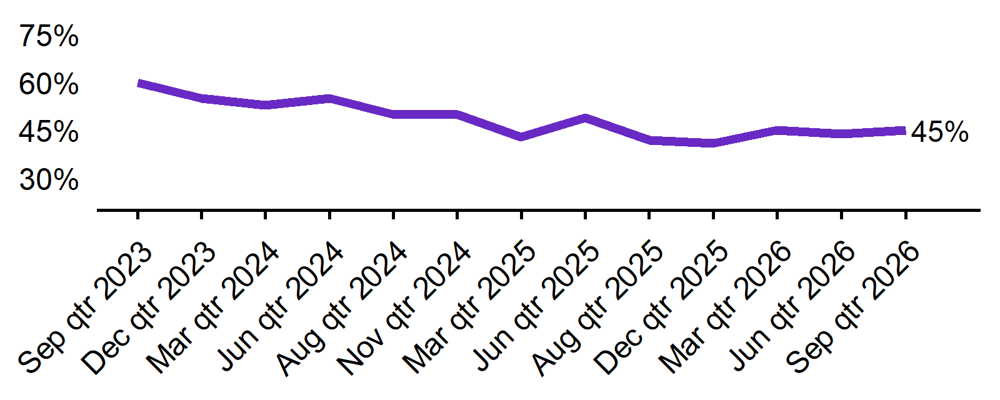 |  |  |  |  |  |  |  |  |  |  |  |  |  | - The recruitment difficulty rate in the September quarter 2026 was 45%.  - This was 3 percentage points higher than this time last year (42%).
Sep qtr 2023 | Dec qtr 2023 | Mar qtr 2024 | Jun qtr 2024 | Sep qtr 2024 | Dec qtr 2024 | Mar qtr 2025 | Jun qtr 2025 | Sep qtr 2025 | Dec qtr 2025 | Mar qtr 2026 | Jun qtr 2026 | Sep qtr 2026
60% | 55% | 53% | 55% | 50% | 50% | 43% | 49% | 42% | 41% | 45% | 44% | 45%

Expecting to increase staff - National level
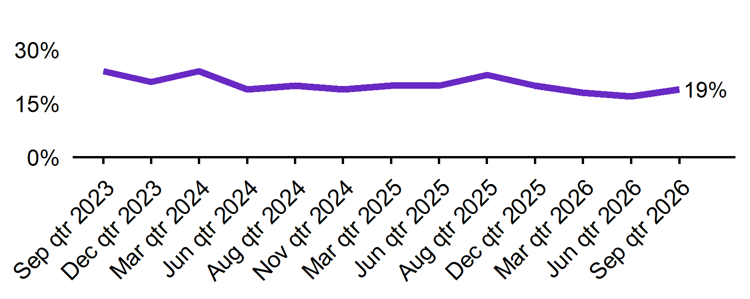 |  |  |  |  |  |  |  |  |  |  |  |  |  | - In the September quarter 2026, 19% of employers expected to increase staff. This was 4 percentage points lower than this time last year (23%).  - The proportion of employers who expected to decrease staff was 3% in the September quarter 2026.
Sep qtr 2023 | Dec qtr 2023 | Mar qtr 2024 | Jun qtr 2024 | Sep qtr 2024 | Dec qtr 2024 | Mar qtr 2025 | Jun qtr 2025 | Sep qtr 2025 | Dec qtr 2025 | Mar qtr 2026 | Jun qtr 2026 | Sep qtr 2026
24% | 21% | 24% | 19% | 20% | 19% | 20% | 20% | 23% | 20% | 18% | 17% | 19%

Key indicators by state/territory
In the September quarter 2026, Queensland recorded the highest recruitment rate among the states (54%), while also recording the highest state-level recruitment difficulty (49%). Across all jurisdictions, the Northern Territory reported the highest recruitment rate (55%) and recruitment difficulty (63%*) in the September quarter 2026.

Table 1. Key indicators by state/territory, September quarter 2026
 | Recruitment rate |  | Recruitment difficulty rate |  | Expect to increase staff
 | % of employers | Annual change  (% points) | % of recruiting employers | Annual change  (% points) | % of employers | Annual change  (% points)
NSW | 46% | -3 pts | 47% | 5 pts | 19% | -5 pts
VIC | 40% | -6 pts | 36% | 3 pts | 15% | -5 pts
QLD | 54% | -3 pts | 49% | 3 pts | 21% | -5 pts
SA | 46% | 1 pts | 47% | 4 pts | 23% | 3 pts
WA | 51% | -5 pts | 46% | -3 pts | 21% | -1 pts
TAS | 38% | -4 pts | 38%* | 3 pts* | 18% | 1 pts
NT# | 55% | -14 pts | 63%* | 6 pts* | 16% | -7 pts
ACT# | 46% | 6 pts | 28%* | -12 pts* | 19% | 0 pts

# Due to smaller sample sizes, data for the NT and ACT are based on six-month average data (Jun qtr. to Sep qtr.).
* Interpret with caution due to low sample size.

Figure 1. Recruitment rate by state, September quarter 2025 - September quarter 2026
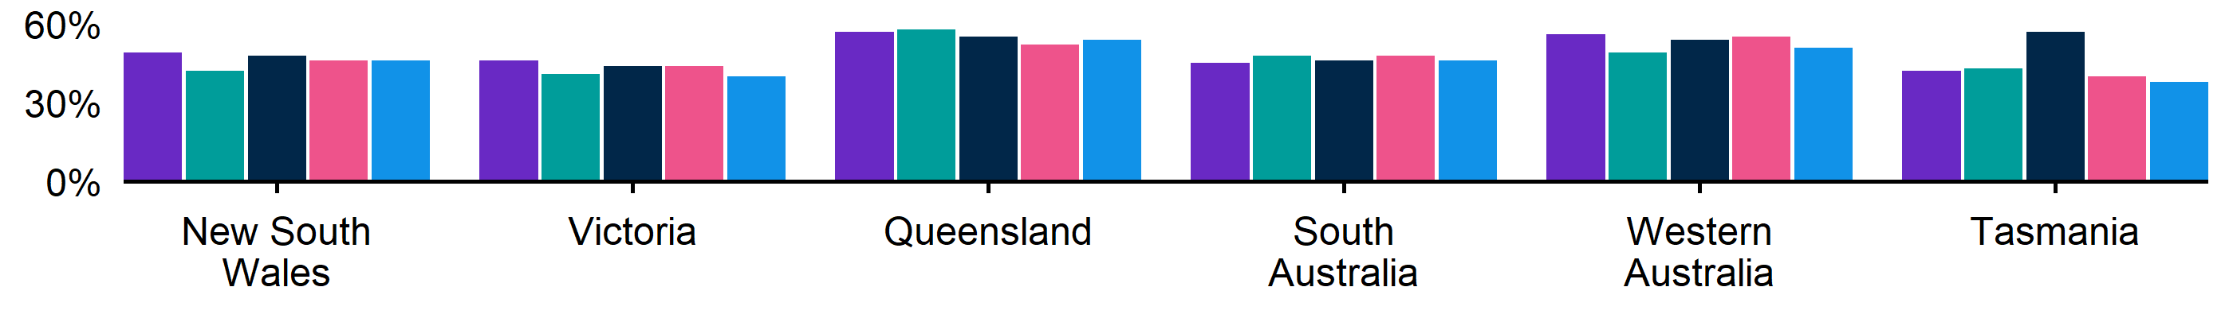
 | Sep qtr 2025 | Dec qtr 2025 | Mar qtr 2026 | Jun qtr 2026 | Sep qtr 2026
NSW | 49% | 42% | 48% | 46% | 46%
QLD | 57% | 58% | 55% | 52% | 54%
SA | 45% | 48% | 46% | 48% | 46%
TAS | 42% | 43%* | 57% | 40% | 38%
VIC | 46% | 41% | 44% | 44% | 40%
WA | 56% | 49% | 54% | 55% | 51%

Figure 2. Recruitment difficulty rate by state, September quarter 2025 - September quarter 2026
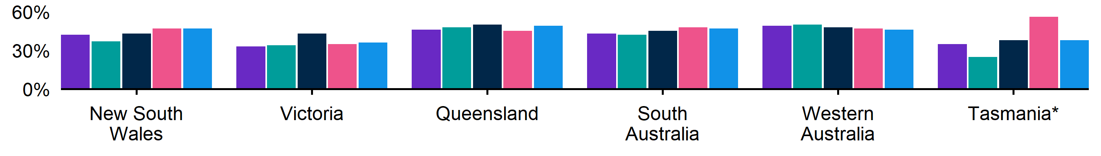
 | Sep qtr 2025 | Dec qtr 2025 | Mar qtr 2026 | Jun qtr 2026 | Sep qtr 2026
NSW | 42% | 37% | 43% | 47% | 47%
QLD | 46% | 48% | 50% | 45% | 49%
SA | 43%* | 42%* | 45%* | 48% | 47%
TAS | 35%* | n.p. | 38%* | 56%* | 38%*
VIC | 33% | 34% | 43% | 35% | 36%
WA | 49% | 50%* | 48% | 47% | 46%

Figure 3. Expecting to increase staff numbers over the next 3 months by state, September quarter 2025 - September quarter 2026
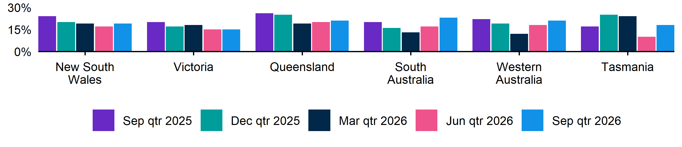
 | Sep qtr 2025 | Dec qtr 2025 | Mar qtr 2026 | Jun qtr 2026 | Sep qtr 2026
NSW | 24% | 20% | 19% | 17% | 19%
QLD | 26% | 25% | 19% | 20% | 21%
SA | 20% | 16% | 13% | 17% | 23%
TAS | 17% | 25%* | 24% | 10% | 18%
VIC | 20% | 17% | 18% | 15% | 15%
WA | 22% | 19% | 12% | 18% | 21%

Key indicators by remoteness classification (ARIA location)
Labour market conditions remained comparatively stronger outside major cities. In the September quarter 2026, Outer Regional, Remote and Very Remote Australia recorded both the highest recruitment rate (53%) and recruitment difficulty rate (53%) among the ARIA regions. Employers in these areas were also the most likely to expect staff growth over the next three months (21%).
Table 2. Key indicators by ARIA location, September quarter 2026
 | Recruitment rate |  | Recruitment difficulty rate |  | Expect to increase staff
 | % of employers | Annual change  (% points) | % of recruiting employers | Annual change  (% points) | % of employers | Annual change  (% points)
Major Cities of Australia | 45% | -5 pts | 42% | 2 pts | 19% | -4 pts
Inner Regional Australia | 52% | 5 pts | 49% | 4 pts | 20% | -2 pts
Outer Regional, Remote and Very Remote Australia | 53% | -5 pts | 53% | 4 pts | 21% | -1 pts

* Interpret with caution due to low sample size. Accessibility and Remoteness Index of Australia (ARIA) classifications of Outer Regional Australia, Remote Australia, and Very Remote Australia have been combined into one category to increase sample size.

Figure 4. Recruitment rate by ARIA location, September quarter 2025 - September quarter 2026
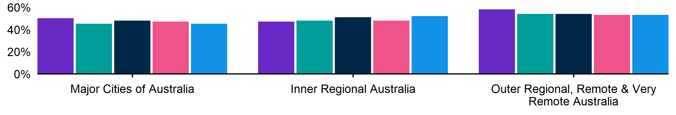
 | Sep qtr 2025 | Dec qtr 2025 | Mar qtr 2026 | Jun qtr 2026 | Sep qtr 2026
Inner Regional Australia | 47% | 48% | 51% | 48% | 52%
Major Cities of Australia | 50% | 45% | 48% | 47% | 45%
Outer Regional, Remote and Very Remote Australia | 58% | 54% | 54% | 53% | 53%

Figure 5. Recruitment difficulty rate by ARIA location, September quarter 2025 - September quarter 2026
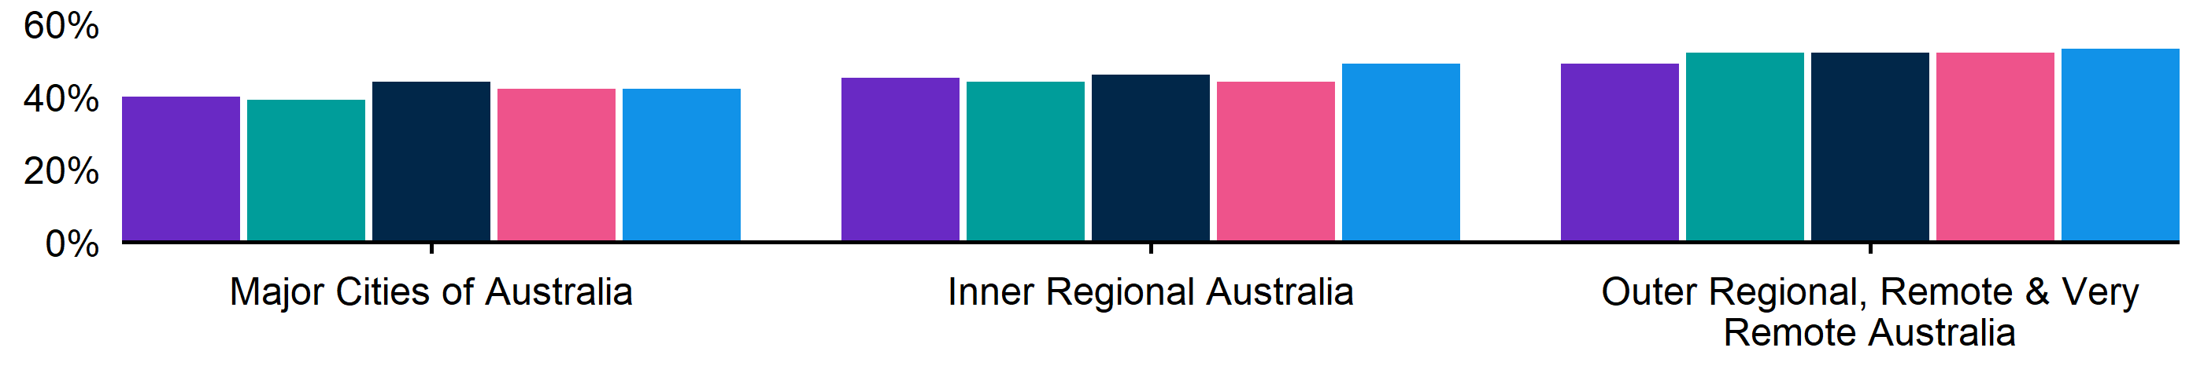
 | Sep qtr 2025 | Dec qtr 2025 | Mar qtr 2026 | Jun qtr 2026 | Sep qtr 2026
Inner Regional Australia | 45% | 44% | 46% | 44% | 49%
Major Cities of Australia | 40% | 39% | 44% | 42% | 42%
Outer Regional, Remote and Very Remote Australia | 49% | 52% | 52% | 52% | 53%

Figure 6. Expecting to increase staff numbers over the next 3 months by ARIA location, September quarter 2025 - September quarter 2026
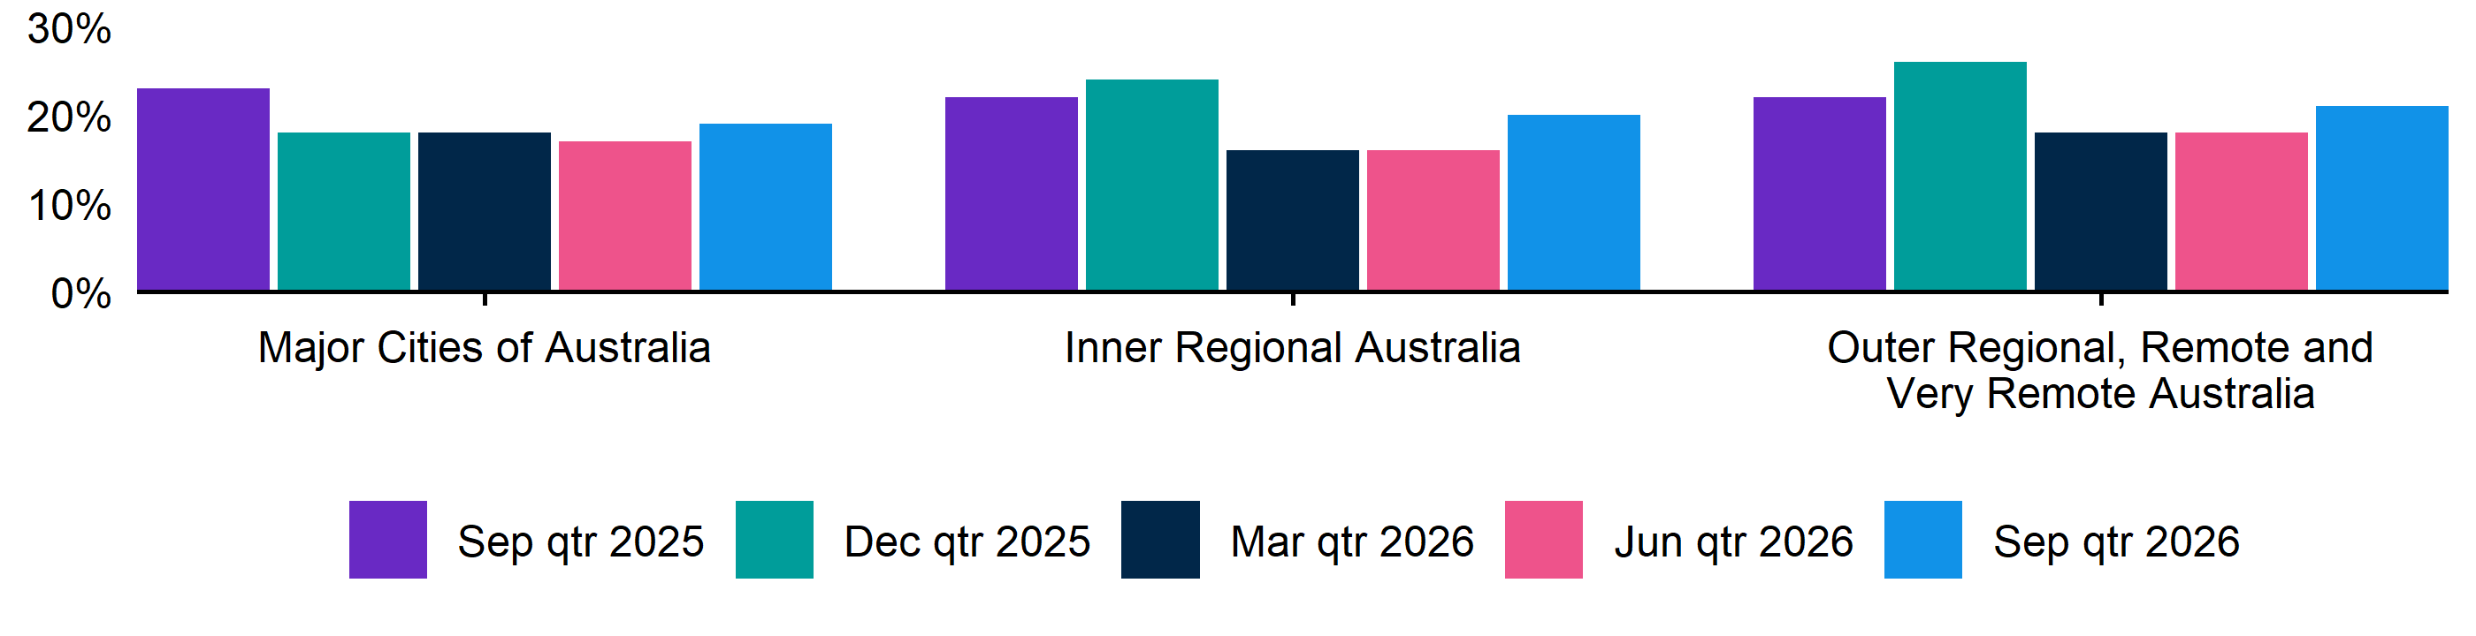
 | Sep qtr 2025 | Dec qtr 2025 | Mar qtr 2026 | Jun qtr 2026 | Sep qtr 2026
Inner Regional Australia | 22% | 24% | 16% | 16% | 20%
Major Cities of Australia | 23% | 18% | 18% | 17% | 19%
Outer Regional, Remote and Very Remote Australia | 22% | 26% | 18% | 18% | 21%

Key indicators by selected industries
Recruitment activity remained strongest in Accommodation and Food Services, where two-thirds of employers (66%) were recruiting. Recruitment difficulties were most pronounced in Manufacturing (58%) and Construction (56%), suggesting ongoing hiring challenges in parts of the goods-producing sector. Despite maintaining the highest staffing intentions (32%), employers in Accommodation and Food Services were less likely to expect staff growth than a year ago (down 10 percentage points).

Table 3. Key indicators by industry, September quarter 2026
 | Recruitment rate |  | Recruitment difficulty rate |  | Expect to increase staff
 | % of employers | Annual change  (% points) | % of recruiting employers | Annual change  (% points) | % of employers | Annual change  (% points)
Manufacturing | 45% | -1 pts | 58% | 6 pts | 20% | -3 pts
Construction | 46% | -3 pts | 56% | 0 pts | 19% | -2 pts
Wholesale Trade | 43% | -1 pts | 43%* | -5 pts* | 21% | -2 pts
Retail Trade | 44% | 1 pts | 37% | 3 pts | 16% | 1 pts
Accommodation and Food Services | 66% | -9 pts | 26% | 4 pts | 32% | -10 pts
Professional, Scientific and Technical Services | 39% | -6 pts | 49% | 1 pts | 13% | -7 pts
Health Care and Social Assistance | 55% | -1 pts | 44% | -1 pts | 19% | -4 pts

*Interpret with caution due to low sample size.

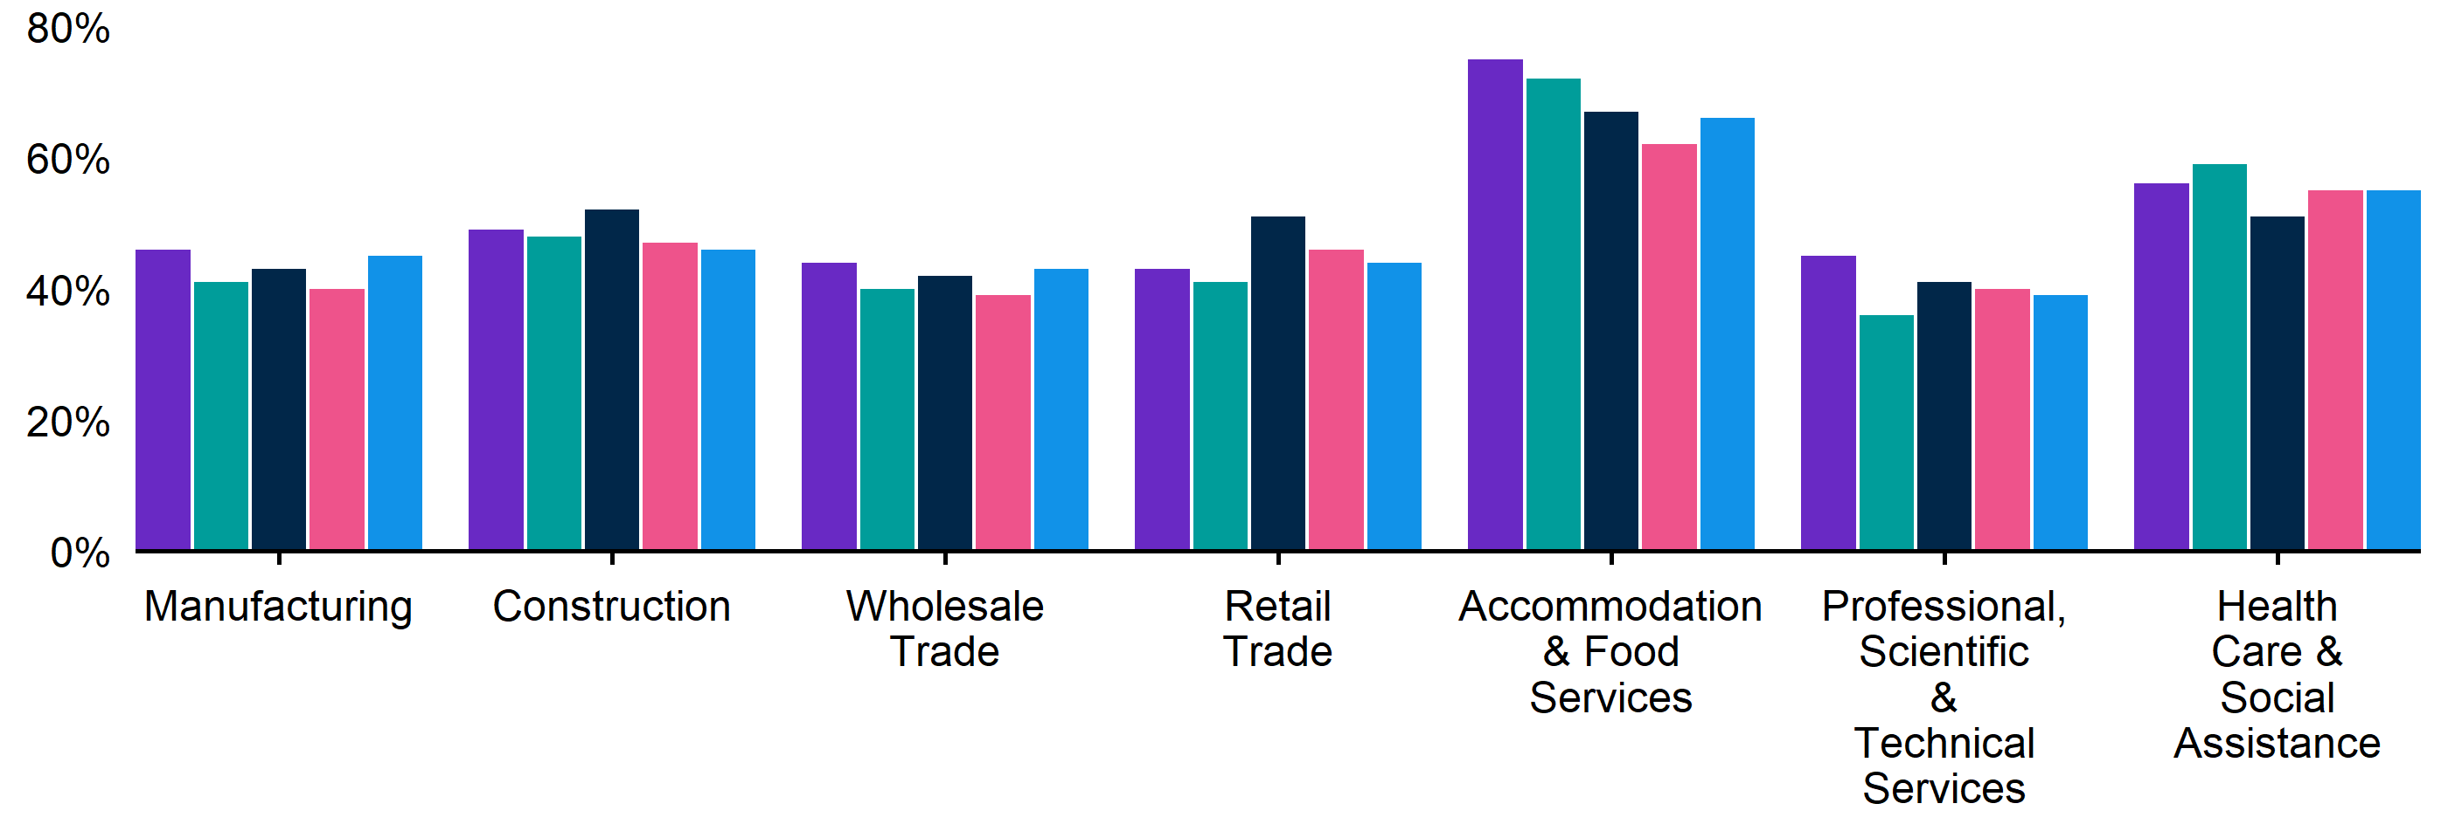
Figure 7. Recruitment rate by industry, September quarter 2025 - September quarter 2026

 | Sep qtr 2025 | Dec qtr 2025 | Mar qtr 2026 | Jun qtr 2026 | Sep qtr 2026
Accommodation and Food Services | 75% | 72% | 67% | 62% | 66%
Construction | 49% | 48% | 52% | 47% | 46%
Health Care and Social Assistance | 56% | 59% | 51% | 55% | 55%
Manufacturing | 46% | 41% | 43% | 40% | 45%
Professional, Scientific and Technical Services | 45% | 36% | 41% | 40% | 39%
Retail Trade | 43% | 41% | 51% | 46% | 44%
Wholesale Trade | 44% | 40%* | 42% | 39% | 43%

Figure 8. Recruitment difficulty rate by industry, September quarter 2025 - September quarter 2026
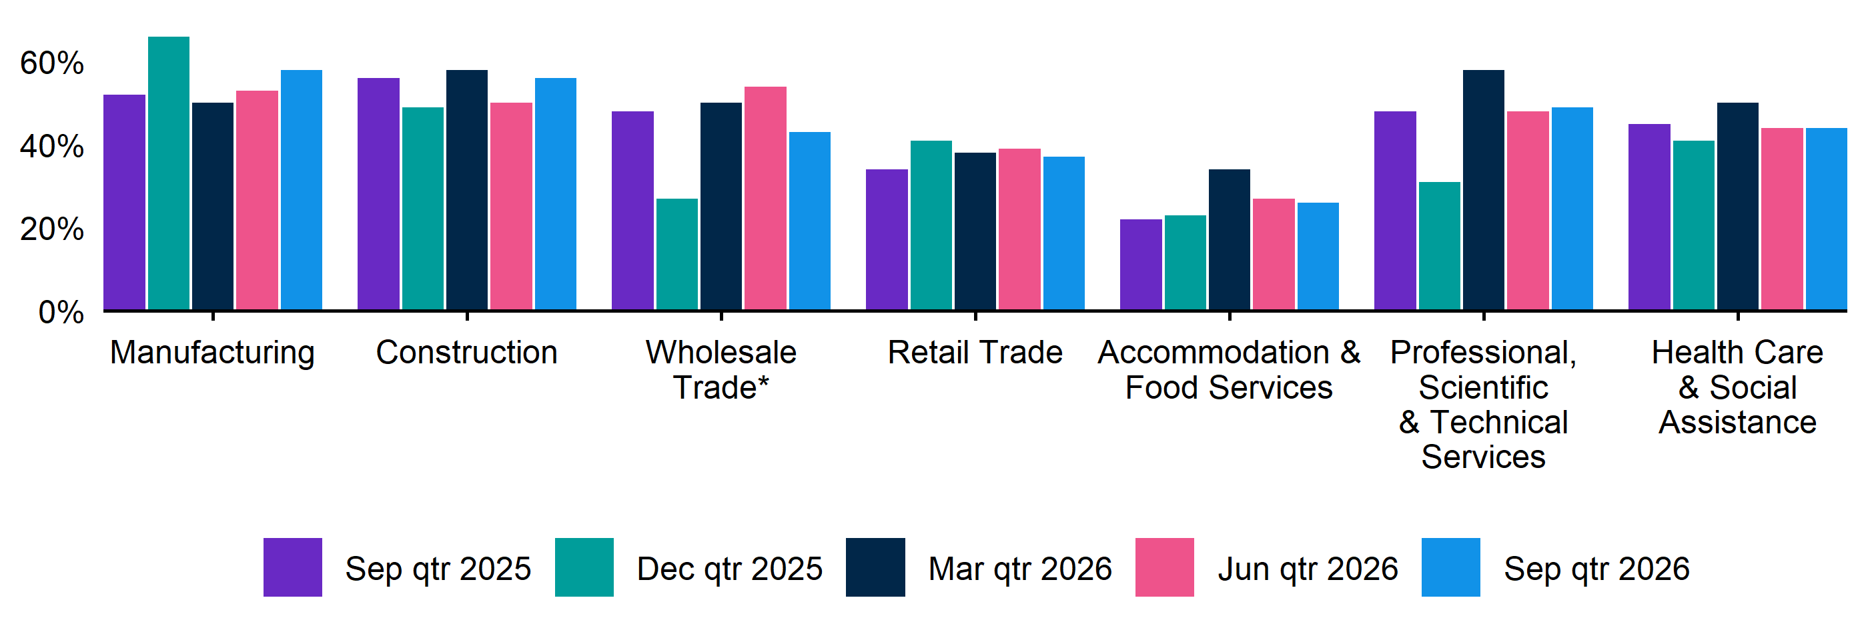
 | Sep qtr 2025 | Dec qtr 2025 | Mar qtr 2026 | Jun qtr 2026 | Sep qtr 2026
Accommodation and Food Services | 22% | 23%* | 34%* | 27% | 26%
Construction | 56%* | 49%* | 58%* | 50% | 56%
Health Care and Social Assistance | 45% | 41% | 50%* | 44% | 44%
Manufacturing | 52% | 66%* | 50%* | 53% | 58%
Professional, Scientific and Technical Services | 48%* | 31%* | 58%* | 48%* | 49%
Retail Trade | 34% | 41%* | 38% | 39% | 37%
Wholesale Trade | 48%* | n.p. | 50%* | 54%* | 43%*

Key indicators by selected occupation groups

Recruitment challenges remained most acute for Technicians and Trades Workers. Nearly two-thirds (65%) of employers recruiting for these occupations reported difficulty filling positions, while 60% reported vacancies remaining unfilled for more than one month. This was the highest result across all major occupation groups on both measures.

Table 4. Key indicators by occupation, September quarter 2026
 | Recruitment difficulty rate |  | Vacancies taking longer  than 1 month to fill
 | % of recruiting employers | Annual change  (% points) | % of recruiting employers | Annual change  (% points)
Professionals | 50% | 5 pts | 51% | -5 pts
Technicians and Trades Workers | 65% | 3 pts | 60% | 5 pts
Community and Personal Service Workers | 41% | 1 pts | 27% | -9 pts
Clerical and Administrative Workers | 29% | -6 pts | 26% | -12 pts
Sales Workers | 34% | 10 pts | 27% | 2 pts
Machinery Operators and Drivers | 44% | -1 pts | 36%* | 3 pts*
Labourers | 37% | -3 pts | 22% | -6 pts

*Interpret with caution due to low sample size.

Figure 9. Recruitment difficulty rate by occupation, September quarter 2025 - September quarter 2026
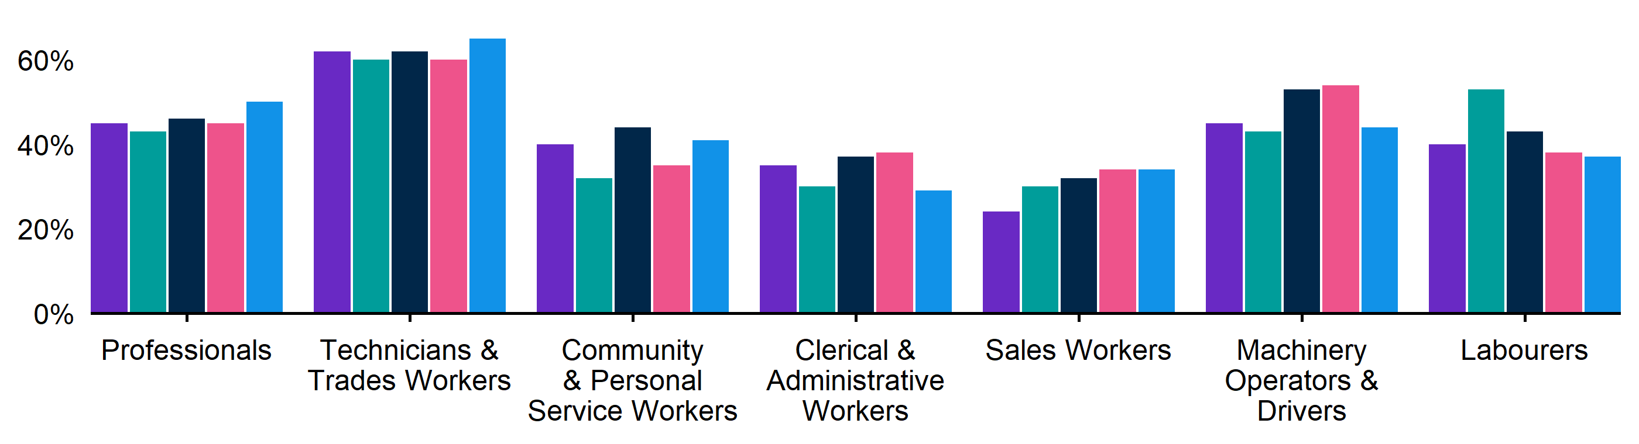
 | Sep qtr 2025 | Dec qtr 2025 | Mar qtr 2026 | Jun qtr 2026 | Sep qtr 2026
Clerical and Administrative Workers | 35%* | 30%* | 37%* | 38% | 29%
Community and Personal Service Workers | 40% | 32% | 44% | 35% | 41%
Labourers | 40% | 53%* | 43%* | 38% | 37%
Machinery Operators and Drivers | 45%* | 43%* | 53%* | 54%* | 44%
Professionals | 45% | 43%* | 46%* | 45% | 50%
Sales Workers | 24% | 30% | 32% | 34% | 34%
Technicians and Trades Workers | 62% | 60% | 62% | 60% | 65%

Figure 10. Vacancies taking longer than 1 month to fill, by occupation group, September quarter 2025 - September quarter 2026
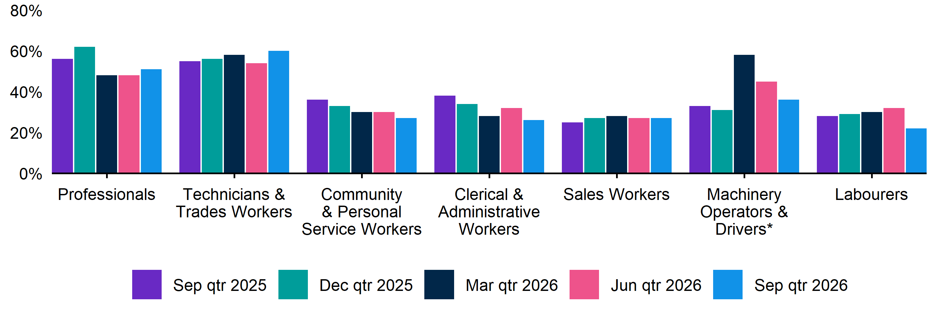
 | Sep qtr 2025 | Dec qtr 2025 | Mar qtr 2026 | Jun qtr 2026 | Sep qtr 2026
Clerical and Administrative Workers | 38%* | 34%* | 28%* | 32%* | 26%
Community and Personal Service Workers | 36% | 33% | 30% | 30% | 27%
Labourers | 28%* | 29%* | 30%* | 32% | 22%
Machinery Operators and Drivers | 33%* | 31%* | 58%* | 45%* | 36%*
Professionals | 56% | 62%* | 48%* | 48% | 51%
Sales Workers | 25% | 27%* | 28% | 27% | 27%
Technicians and Trades Workers | 55% | 56% | 58% | 54% | 60%

REOS Background and Notes
Jobs and Skills Australia conducts the Recruitment Experiences and Outlook Survey (REOS), a telephone administered survey of at least 1,000 employers each month (except for December and January, during which fewer employers are surveyed). While the results are indicative of recruitment activity, they may be subject to seasonal factors and other volatility and should therefore be used with a degree of caution. In addition, the survey is targeted towards employers with 5 or more employees, and excludes many government organisations. More detail is available at https://www.jobsandskills.gov.au/work/reos-survey-methodology. REOS data are published on the Jobs and Skills Australia website.
Data in this release should be referenced as: Jobs and Skills Australia, Recruitment Experiences and Outlook Survey: September quarter 2026.

Data notations
* Interpret with caution due to low sample size.

Recruitment rate
The proportion of employers either currently recruiting or who had recruited in the previous month. It is calculated by dividing the number of employers who recruited or were attempting to recruit by the number of employers that responded to the survey (excluding ‘unsure’ responses).

Recruitment difficulty rate
The proportion of recruiting employers who experienced difficulty hiring staff. This indicator focusses on the most recent recruitment round in the month prior to being surveyed. The indicator is calculated as: employers who recruited and reported difficulty, divided by all employers who recruited (excluding ‘unsure’ responses).

Expectations to increase staffing levels over the next 3 months
This is calculated as the percentage of employers who expect to increase staff over the next 3 months, divided by all employers. Expectations to decrease staff is also collected.

Vacancies taking longer than 1 month to fill
The proportion of recruiting employers unable to fill all their vacancies within a month. It excludes employers with unfilled vacancies who have been recruiting for less than a month.

Recent REOS releases
The Jobs and Skills Australia website includes:
- The September 2026 monthly REOS report, including a more detailed excel datafile. The datafile includes both the monthly results as well as the quarterly series. The quarterly estimates are aggregated results for the 3 months within each quarter.
- REOS Spotlight series featuring analysis on topics of interest not covered in the regular monthly. Recent spotlight releases cover recruitment trends in the IT industry and recruitment pressures in the higher-skilled labour market.
For queries, contact: REOS@jobsandskills.gov.au

Australian Bureau of Statistics, Remoteness Areas, Australian Statistical Geography Standard (ASGS) Edition 3, https://www.abs.gov.au/statistics/standards/australian-statistical-geography-standard-asgs-edition-3/jul2021-jun2026/remoteness-structure/remoteness-areas

