REOS Recruitment Insights Report - September 2026
Jobs and Skills Australia surveys around 1000 employers in the Recruitment Experiences and Outlook Survey (REOS) each month to find out their experiences recruiting staff, and whether they are expecting to increase staffing levels.

Key Findings
Recruitment activity eased in September 2026, with 48% of employers either recruiting or having recently recruited. This was slightly lower than in August and below the level recorded a year earlier. Recruitment activity was similar across regions, although rates remained marginally higher in Rest of State areas than in Capital Cities.
Employers' recruitment experiences became more challenging over the month. The recruitment difficulty rate increased to 48% of recruiting employers, driven by a rise in Rest of State areas. Despite the increase, recruitment difficulty remained well below the record levels experienced during 2022.
Recruitment continued to be driven primarily by staff replacement rather than workforce expansion. Around six in ten recruiting employers were hiring solely to replace workers who had left, while just over one-quarter were recruiting only for new positions.
Employer confidence improved slightly in September 2026, with 22% of employers expecting to increase staffing levels over the next three months. While higher than in August, staffing expectations remained below year-earlier levels.
Overall, the results suggest employer demand for labour remained moderate in September 2026. While recruitment activity softened over the month, hiring intentions strengthened slightly and remained above the lows recorded earlier in 2026.

Recruitment activity
In September 2026, 48% of employers were recruiting or had recently recruited. This was 2 percentage points lower than in August and 3 percentage points lower than a year earlier. Recruitment activity was broadly in line with the smoothed trend estimate.
Recruitment rates were similar across regions, with 49% of employers in Rest of State areas recruiting compared with 48% in Capital Cities. While recruitment activity was unchanged over the month in Capital Cities, it declined in Rest of State areas. Compared with a year earlier, recruitment activity was lower in both regions, particularly outside the capital cities.

Recruitment difficulty
The recruitment difficulty rate increased to 48% of recruiting employers in September 2026, up 3 percentage points over the month. While recruitment difficulty was higher than a year earlier, it remained substantially below the record high of 75% recorded in July 2022.
Recruitment difficulty varied considerably across regions. A lower proportion of recruiting employers in Capital Cities (42%) reported recruitment difficulty compared with those in Rest of State areas (60%). Recruitment difficulty declined slightly in Capital Cities but increased sharply outside the capital cities over the month.

Staffing outlook: employers expecting to increase staff
The proportion of employers expecting to increase staffing levels over the next three months rose to 22% in September 2026, an increase of 2 percentage points from August. Despite the monthly improvement, staffing expectations were 2 percentage points lower than a year earlier.
Staffing expectations remained slightly stronger in Capital Cities, where 23% of employers expected to increase staff numbers, compared with 20% in Rest of State areas. Expectations improved over the month in Capital Cities but eased slightly outside the capital cities.

Reason for recruiting
Recruitment activity continued to be driven mainly by staff turnover. In September 2026, 62% of recruiting employers were hiring solely to replace employees who had left, while 28% were recruiting only for new positions and 10% were recruiting for both replacement and new roles.
The findings indicate that recruitment remained more strongly associated with replacing existing staff than creating new positions, consistent with recent survey results.

Staffing changes over the last month
Around 11% of employers reported increasing staff numbers during September 2026, while 11% reported a reduction in staffing. Both figures were broadly unchanged compared with a year earlier.

Employers unable to fill vacancies in a month
The proportion of recruiting employers with vacancies that remained unfilled for longer than one month increased to 40% in September 2026. Despite the monthly increase, the result was 3 percentage points lower than a year earlier and remained well below the peak levels recorded in 2022.

REOS national indicators

Recruitment rate

Proportion of employers currently recruiting or who recruited in the previous month.
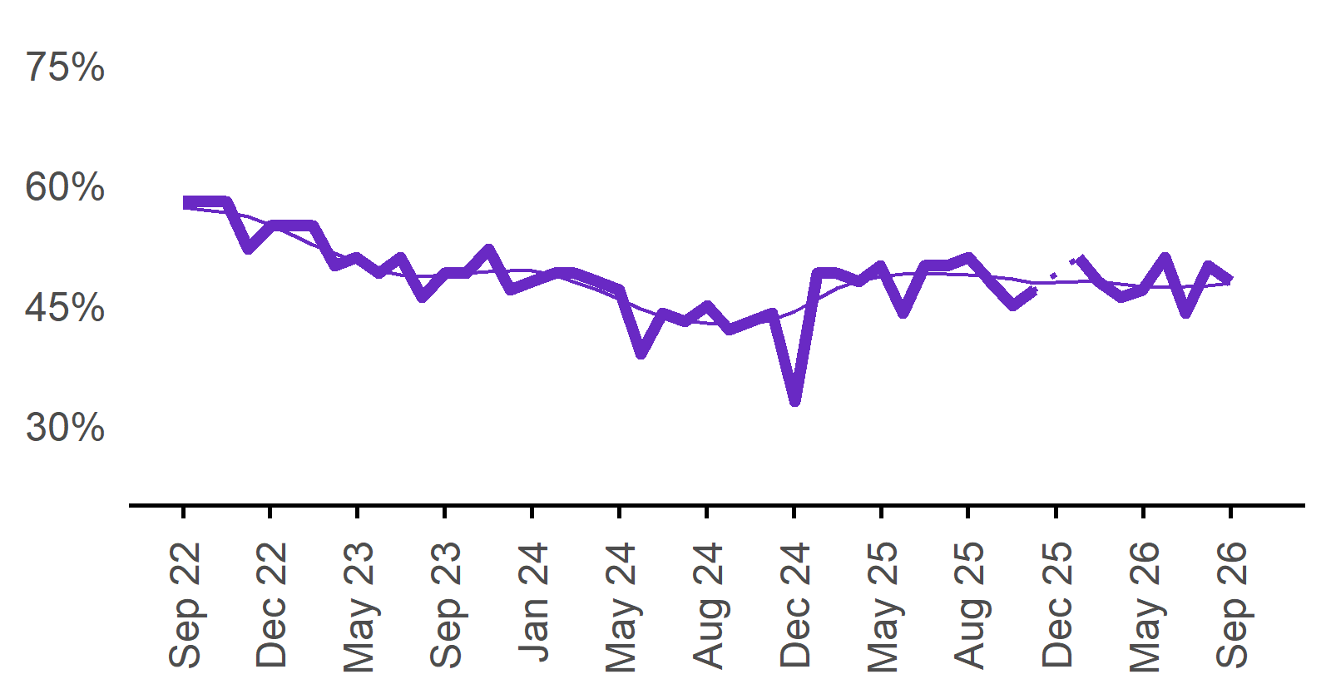 | 48%  Monthly change:  ▼ 2%pts  Annual change:  ▼ 3%pts
  Date | Recruitment rate | Smoothed recruitment rate
  Sep 2022 | 58% | 57%
  Oct 2022 | 58% | 57%
  Nov 2022 | 58% | 57%
  Dec 2022 | 52% | 56%
  Jan 2023 | 55% | 55%
  Feb 2023 | 55% | 54%
  Mar 2023 | 55% | 53%
  Apr 2023 | 50% | 52%
  May 2023 | 51% | 50%
  Jun 2023 | 49% | 49%
  Jul 2023 | 51% | 49%
  Aug 2023 | 46% | 49%
  Sep 2023 | 49% | 49%
  Oct 2023 | 49% | 49%
  Nov 2023 | 52% | 49%
  Dec 2023 | 47% | 49%
  Jan 2024 | 48% | 49%
  Feb 2024 | 49% | 49%
  Mar 2024 | 49% | 48%
  Apr 2024 | 48% | 47%
  May 2024 | 47% | 46%
  Jun 2024 | 39% | 45%
  Jul 2024 | 44% | 44%
  Aug 2024 | 43% | 43%
  Sep 2024 | 45% | 43%
  Oct 2024 | 42% | 43%
  Nov 2024 | 43% | 43%
  Dec 2024 | 44% | 43%
  Jan 2025 | 33% | 44%
  Feb 2025 | 49% | 46%
  Mar 2025 | 49% | 47%
  Apr 2025 | 48% | 48%
  May 2025 | 50% | 49%
  Jun 2025 | 44% | 49%
  Jul 2025 | 50% | 49%
  Aug 2025 | 50% | 49%
  Sep 2025 | 51% | 49%
  Oct 2025 | 48% | 49%
  Nov 2025 | 45% | 48%
  Dec 2025 | 47% | 48%
  Jan 2026 |  | 48%
  Feb 2026 | 51% | 48%
  Mar 2026 | 48% | 48%
  Apr 2026 | 46% | 48%
  May 2026 | 47% | 47%
  Jun 2026 | 51% | 47%
  Jul 2026 | 44% | 47%
  Aug 2026 | 50% | 47%
  Sep 2026 | 48% | 48%

Recruitment difficulty rate

Proportion of recruiting employers who stated they had difficulty hiring staff.
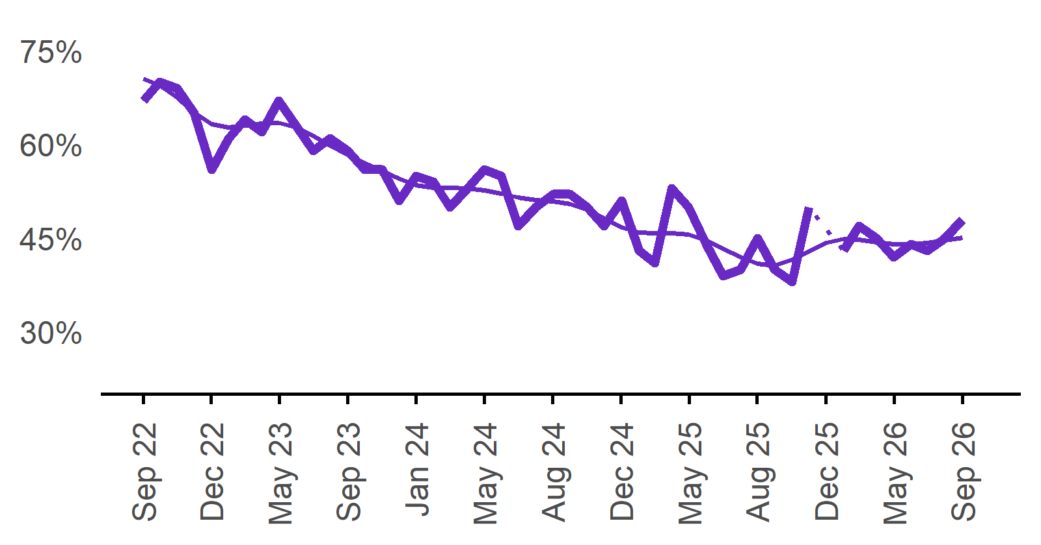 | 48%  Monthly change:  ▲ 3%pts  Annual change:  ▲ 3%pts
  Date | Recruitment rate | Smoothed recruitment rate
  Sep 2022 | 58% | 57%
  Oct 2022 | 58% | 57%
  Nov 2022 | 58% | 57%
  Dec 2022 | 52% | 56%
  Jan 2023 | 55% | 55%
  Feb 2023 | 55% | 54%
  Mar 2023 | 55% | 53%
  Apr 2023 | 50% | 52%
  May 2023 | 51% | 50%
  Jun 2023 | 49% | 49%
  Jul 2023 | 51% | 49%
  Aug 2023 | 46% | 49%
  Sep 2023 | 49% | 49%
  Oct 2023 | 49% | 49%
  Nov 2023 | 52% | 49%
  Dec 2023 | 47% | 49%
  Jan 2024 | 48% | 49%
  Feb 2024 | 49% | 49%
  Mar 2024 | 49% | 48%
  Apr 2024 | 48% | 47%
  May 2024 | 47% | 46%
  Jun 2024 | 39% | 45%
  Jul 2024 | 44% | 44%
  Aug 2024 | 43% | 43%
  Sep 2024 | 45% | 43%
  Oct 2024 | 42% | 43%
  Nov 2024 | 43% | 43%
  Dec 2024 | 44% | 43%
  Jan 2025 | 33% | 44%
  Feb 2025 | 49% | 46%
  Mar 2025 | 49% | 47%
  Apr 2025 | 48% | 48%
  May 2025 | 50% | 49%
  Jun 2025 | 44% | 49%
  Jul 2025 | 50% | 49%
  Aug 2025 | 50% | 49%
  Sep 2025 | 51% | 49%
  Oct 2025 | 48% | 49%
  Nov 2025 | 45% | 48%
  Dec 2025 | 47% | 48%
  Jan 2026 |  | 48%
  Feb 2026 | 51% | 48%
  Mar 2026 | 48% | 48%
  Apr 2026 | 46% | 48%
  May 2026 | 47% | 47%
  Jun 2026 | 51% | 47%
  Jul 2026 | 44% | 47%
  Aug 2026 | 50% | 47%
  Sep 2026 | 48% | 48%

Expecting to increase staff

Proportion of employers who expected to increase staffing numbers over the next three months.
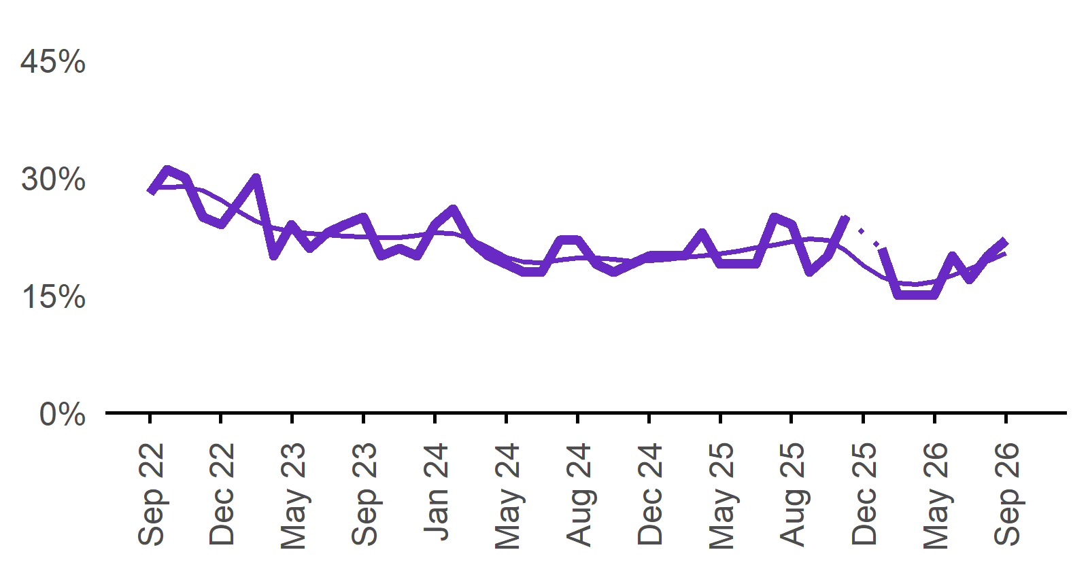 | 22%  Monthly change:  ▲ 2%pts  Annual change:  ▼ 2%pts
  Date | Expect to increase | Smoothed expect to increase
  Sep 2022 | 28% | 29%
  Oct 2022 | 31% | 29%
  Nov 2022 | 30% | 29%
  Dec 2022 | 25% | 28%
  Jan 2023 | 24% | 27%
  Feb 2023 | 27% | 26%
  Mar 2023 | 30% | 24%
  Apr 2023 | 20% | 24%
  May 2023 | 24% | 23%
  Jun 2023 | 21% | 23%
  Jul 2023 | 23% | 23%
  Aug 2023 | 24% | 23%
  Sep 2023 | 25% | 22%
  Oct 2023 | 20% | 22%
  Nov 2023 | 21% | 22%
  Dec 2023 | 20% | 23%
  Jan 2024 | 24% | 23%
  Feb 2024 | 26% | 23%
  Mar 2024 | 22% | 22%
  Apr 2024 | 20% | 21%
  May 2024 | 19% | 20%
  Jun 2024 | 18% | 19%
  Jul 2024 | 18% | 19%
  Aug 2024 | 22% | 19%
  Sep 2024 | 22% | 20%
  Oct 2024 | 19% | 20%
  Nov 2024 | 18% | 20%
  Dec 2024 | 19% | 19%
  Jan 2025 | 20% | 19%
  Feb 2025 | 20% | 20%
  Mar 2025 | 20% | 20%
  Apr 2025 | 23% | 20%
  May 2025 | 19% | 20%
  Jun 2025 | 19% | 21%
  Jul 2025 | 19% | 21%
  Aug 2025 | 25% | 21%
  Sep 2025 | 24% | 22%
  Oct 2025 | 18% | 22%
  Nov 2025 | 20% | 22%
  Dec 2025 | 25% | 21%
  Jan 2026 |  | 19%
  Feb 2026 | 21% | 17%
  Mar 2026 | 15% | 17%
  Apr 2026 | 15% | 16%
  May 2026 | 15% | 17%
  Jun 2026 | 20% | 18%
  Jul 2026 | 17% | 18%
  Aug 2026 | 20% | 19%
  Sep 2026 | 22% | 20%

Capital City/Rest of State areas

Recruitment rate

Proportion of employers currently recruiting or who recruited in the previous month.
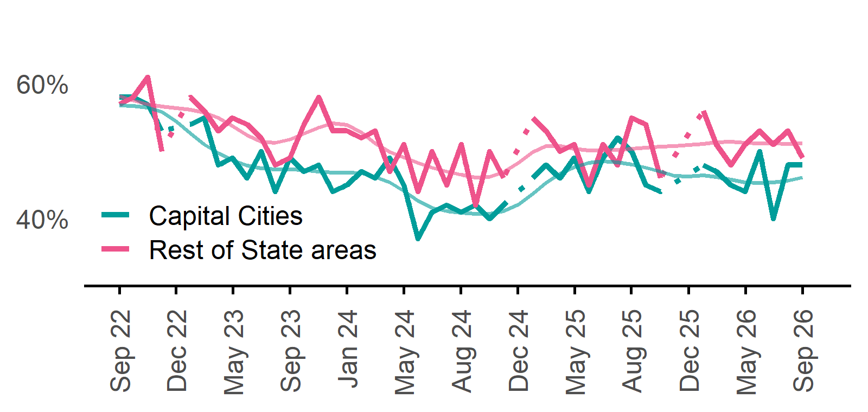 | Capital Cities: 48%  Monthly change:  ◄► 0%pts  Annual change:  ▼ 2%pts  Rest of State: 49%  Monthly change:  ▼ 4%pts  Annual change:  ▼ 6%pts
  Date | Capital Cities - Recruitment rate | Rest of State areas - Recruitment rate | Capital Cities - Smoothed recruitment rate | Rest of State areas - Smoothed recruitment rate
  Sep 2022 | 58% | 57% | 57% | 58%
  Oct 2022 | 58% | 58% | 57% | 58%
  Nov 2022 | 57% | 61% | 56% | 57%
  Dec 2022 | 53% | 50% | 56% | 57%
  Jan 2023 | n.p. | n.p. | 54% | 56%
  Feb 2023 | 54% | 58% | 53% | 56%
  Mar 2023 | 55% | 56% | 51% | 56%
  Apr 2023 | 48% | 53% | 50% | 55%
  May 2023 | 49% | 55% | 49% | 54%
  Jun 2023 | 46% | 54% | 48% | 52%
  Jul 2023 | 50% | 52% | 47% | 51%
  Aug 2023 | 44% | 48% | 47% | 51%
  Sep 2023 | 49% | 49% | 47% | 52%
  Oct 2023 | 47% | 54% | 47% | 53%
  Nov 2023 | 48% | 58% | 47% | 54%
  Dec 2023 | 44% | 53% | 47% | 54%
  Jan 2024 | 45% | 53% | 47% | 54%
  Feb 2024 | 47% | 52% | 47% | 53%
  Mar 2024 | 46% | 53% | 46% | 51%
  Apr 2024 | 49% | 47% | 45% | 50%
  May 2024 | 45% | 51% | 44% | 49%
  Jun 2024 | 37% | 44% | 43% | 48%
  Jul 2024 | 41% | 50% | 42% | 48%
  Aug 2024 | 42% | 45% | 41% | 47%
  Sep 2024 | 41% | 51% | 41% | 46%
  Oct 2024 | 42% | 42% | 41% | 46%
  Nov 2024 | 40% | 50% | 41% | 46%
  Dec 2024 | 42% | 46% | 41% | 47%
  Jan 2025 | n.p. | n.p. | 42% | 48%
  Feb 2025 | 46% | 55% | 44% | 50%
  Mar 2025 | 48% | 53% | 45% | 51%
  Apr 2025 | 46% | 50% | 47% | 51%
  May 2025 | 49% | 51% | 48% | 50%
  Jun 2025 | 44% | 45% | 48% | 50%
  Jul 2025 | 49% | 51% | 48% | 50%
  Aug 2025 | 52% | 48% | 48% | 50%
  Sep 2025 | 50% | 55% | 48% | 50%
  Oct 2025 | 45% | 54% | 48% | 51%
  Nov 2025 | 44% | 46% | 47% | 51%
  Dec 2025 | n.p. | n.p. | 46% | 51%
  Jan 2026 |  |  | 46% | 51%
  Feb 2026 | 48% | 56% | 46% | 51%
  Mar 2026 | 47% | 51% | 46% | 51%
  Apr 2026 | 45% | 48% | 46% | 51%
  May 2026 | 44% | 51% | 45% | 51%
  Jun 2026 | 50% | 53% | 45% | 51%
  Jul 2026 | 40% | 51% | 45% | 51%
  Aug 2026 | 48% | 53% | 46% | 51%
  Sep 2026 | 48% | 49% | 46% | 51%

Recruitment difficulty rate

Proportion of recruiting employers who stated they had difficulty hiring staff.
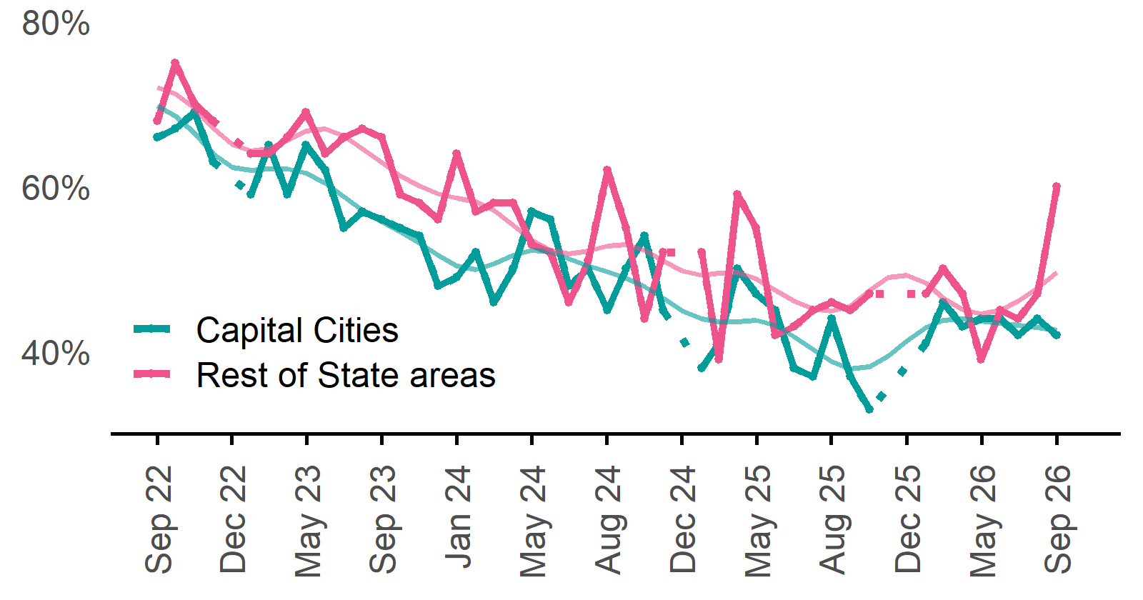 | Capital Cities: 42%  Monthly change:  ▼ 2%pts  Annual change:  ▼ 2%pts  Rest of State: 60%  Monthly change:  ▲ 13%pts  Annual change:  ▲ 14%pts
  Date | Capital Cities - Recruitment difficulty rate | Rest of State areas - Recruitment difficulty rate | Capital Cities - Smoothed recruitment difficulty rate | Rest of State areas - Smoothed recruitment difficulty rate
  Sep 2022 | 66% | 68% | 70% | 72%
  Oct 2022 | 67% | 75% | 69% | 71%
  Nov 2022 | 69% | 70% | 66% | 69%
  Dec 2022 | 63% | 68% | 64% | 67%
  Jan 2023 | n.p. | n.p. | 62% | 65%
  Feb 2023 | 59% | 64% | 62% | 64%
  Mar 2023 | 65% | 64% | 62% | 65%
  Apr 2023 | 59% | 66% | 62% | 66%
  May 2023 | 65% | 69% | 62% | 67%
  Jun 2023 | 62% | 64% | 60% | 67%
  Jul 2023 | 55% | 66% | 59% | 66%
  Aug 2023 | 57% | 67% | 57% | 65%
  Sep 2023 | 56% | 66% | 56% | 63%
  Oct 2023 | 55% | 59% | 55% | 61%
  Nov 2023 | 54% | 58% | 53% | 60%
  Dec 2023 | 48% | 56% | 52% | 59%
  Jan 2024 | 49% | 64% | 50% | 59%
  Feb 2024 | 52% | 57% | 50% | 58%
  Mar 2024 | 46% | 58% | 51% | 57%
  Apr 2024 | 50% | 58% | 52% | 55%
  May 2024 | 57% | 53% | 52% | 53%
  Jun 2024 | 56% | 52% | 52% | 52%
  Jul 2024 | 48% | 46% | 51% | 52%
  Aug 2024 | 50% | 51% | 50% | 52%
  Sep 2024 | 45% | 62% | 50% | 53%
  Oct 2024 | 50% | 55% | 49% | 53%
  Nov 2024 | 54% | 44% | 48% | 52%
  Dec 2024 | 45% | 52% | 47% | 51%
  Jan 2025 | n.p. | n.p. | 45% | 50%
  Feb 2025 | 38% | 52% | 44% | 49%
  Mar 2025 | 41% | 39% | 44% | 49%
  Apr 2025 | 50% | 59% | 44% | 50%
  May 2025 | 47% | 55% | 44% | 49%
  Jun 2025 | 45% | 42% | 43% | 47%
  Jul 2025 | 38% | 43% | 42% | 46%
  Aug 2025 | 37% | 45% | 40% | 45%
  Sep 2025 | 44% | 46% | 39% | 45%
  Oct 2025 | 37% | 45% | 38% | 46%
  Nov 2025 | 33% | 47% | 38% | 47%
  Dec 2025 | n.p. | n.p. | 39% | 49%
  Jan 2026 |  |  | 41% | 49%
  Feb 2026 | 41% | 47% | 43% | 48%
  Mar 2026 | 46% | 50% | 44% | 47%
  Apr 2026 | 43% | 47% | 44% | 45%
  May 2026 | 44% | 39% | 44% | 45%
  Jun 2026 | 44% | 45% | 43% | 45%
  Jul 2026 | 42% | 44% | 43% | 46%
  Aug 2026 | 44% | 47% | 43% | 48%
  Sep 2026 | 42% | 60% | 43% | 50%

Staffing outlook – Expecting to increase staff

Proportion of employers who expected to increase staffing numbers over the next three months.
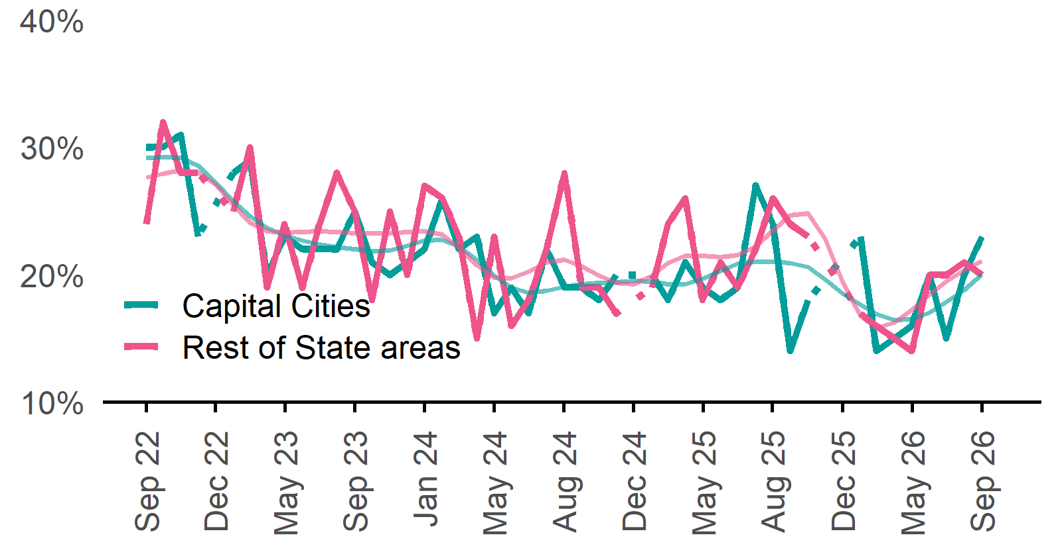 | Capital Cities: 23%  Monthly change:  ▲ 3%pts  Annual change:  ▼ 1%pt  Rest of State: 20%  Monthly change:  ▼ 1%pt  Annual change:  ▼ 6%pts
  Date | Capital Cities - % expecting to increase | Rest of State areas - % expecting to increase | Capital Cities - Smoothed % expecting to increase | Rest of State areas - Smoothed % expecting to increase
  Sep 2022 | 30% | 24% | 29% | 28%
  Oct 2022 | 30% | 32% | 29% | 28%
  Nov 2022 | 31% | 28% | 29% | 28%
  Dec 2022 | 23% | 28% | 29% | 28%
  Jan 2023 | n.p. | n.p. | 27% | 27%
  Feb 2023 | 28% | 25% | 26% | 26%
  Mar 2023 | 29% | 30% | 25% | 24%
  Apr 2023 | 20% | 19% | 24% | 23%
  May 2023 | 23% | 24% | 23% | 23%
  Jun 2023 | 22% | 19% | 23% | 23%
  Jul 2023 | 22% | 24% | 22% | 23%
  Aug 2023 | 22% | 28% | 22% | 23%
  Sep 2023 | 25% | 25% | 22% | 23%
  Oct 2023 | 21% | 18% | 22% | 23%
  Nov 2023 | 20% | 25% | 22% | 23%
  Dec 2023 | 21% | 20% | 22% | 23%
  Jan 2024 | 22% | 27% | 23% | 23%
  Feb 2024 | 26% | 26% | 23% | 23%
  Mar 2024 | 22% | 23% | 22% | 22%
  Apr 2024 | 23% | 15% | 21% | 21%
  May 2024 | 17% | 23% | 20% | 20%
  Jun 2024 | 19% | 16% | 19% | 20%
  Jul 2024 | 17% | 18% | 19% | 20%
  Aug 2024 | 22% | 22% | 19% | 21%
  Sep 2024 | 19% | 28% | 19% | 21%
  Oct 2024 | 19% | 19% | 19% | 21%
  Nov 2024 | 18% | 19% | 19% | 20%
  Dec 2024 | 20% | 17% | 19% | 19%
  Jan 2025 | n.p. | n.p. | 20% | 19%
  Feb 2025 | 20% | 19% | 19% | 20%
  Mar 2025 | 18% | 24% | 19% | 21%
  Apr 2025 | 21% | 26% | 19% | 22%
  May 2025 | 19% | 18% | 20% | 21%
  Jun 2025 | 18% | 21% | 20% | 21%
  Jul 2025 | 19% | 19% | 21% | 22%
  Aug 2025 | 27% | 22% | 21% | 22%
  Sep 2025 | 24% | 26% | 21% | 23%
  Oct 2025 | 14% | 24% | 21% | 25%
  Nov 2025 | 18% | 23% | 21% | 25%
  Dec 2025 | n.p. | n.p. | 20% | 23%
  Jan 2026 |  |  | 19% | 19%
  Feb 2026 | 23% | 17% | 18% | 17%
  Mar 2026 | 14% | 16% | 17% | 16%
  Apr 2026 | 15% | 15% | 16% | 16%
  May 2026 | 16% | 14% | 16% | 17%
  Jun 2026 | 20% | 20% | 17% | 18%
  Jul 2026 | 15% | 20% | 18% | 19%
  Aug 2026 | 20% | 21% | 19% | 20%
  Sep 2026 | 23% | 20% | 20% | 21%

Other recruitment indicators

Reason for recruiting

Proportion of employers currently recruiting or who recruited in the previous month.
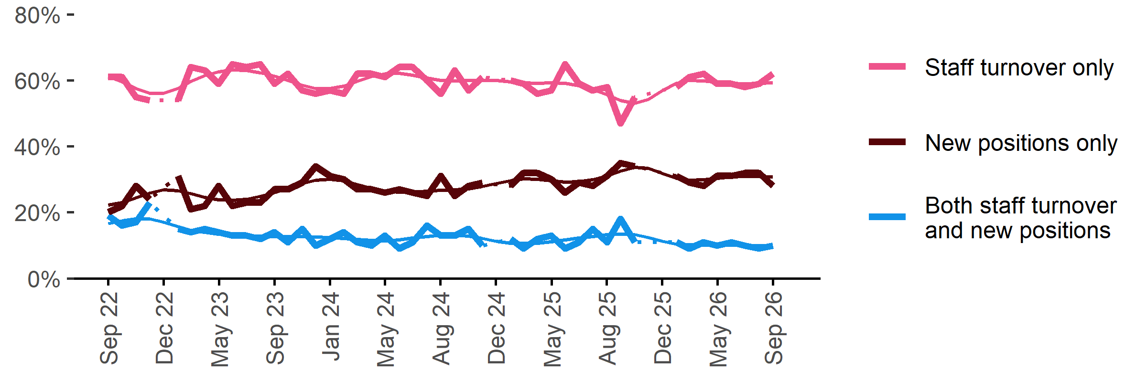
Date | Staff turnover only | Staff turnover and new positions | New positions only | Smoothed - staff turnover only | Smoothed - staff turnover and new positions | Smoothed - new positions only
Sep 2022 | 61% | 19% | 20% | 61% | 17% | 22%
Oct 2022 | 61% | 16% | 22% | 60% | 17% | 23%
Nov 2022 | 55% | 17% | 28% | 58% | 18% | 24%
Dec 2022 | 54% | 23% | 24% | 56% | 18% | 26%
Jan 2023 | n.p. | n.p. | n.p. | 56% | 17% | 27%
Feb 2023 | 54% | 15% | 31% | 58% | 16% | 27%
Mar 2023 | 64% | 14% | 21% | 60% | 15% | 26%
Apr 2023 | 63% | 15% | 22% | 61% | 14% | 25%
May 2023 | 59% | 14% | 28% | 63% | 13% | 24%
Jun 2023 | 65% | 13% | 22% | 63% | 13% | 24%
Jul 2023 | 64% | 13% | 23% | 63% | 13% | 24%
Aug 2023 | 65% | 12% | 23% | 62% | 13% | 25%
Sep 2023 | 59% | 14% | 27% | 61% | 13% | 26%
Oct 2023 | 62% | 11% | 27% | 60% | 13% | 27%
Nov 2023 | 57% | 15% | 29% | 59% | 13% | 29%
Dec 2023 | 56% | 10% | 34% | 58% | 13% | 30%
Jan 2024 | 57% | 12% | 31% | 57% | 12% | 30%
Feb 2024 | 56% | 14% | 30% | 58% | 12% | 30%
Mar 2024 | 62% | 11% | 27% | 60% | 12% | 28%
Apr 2024 | 62% | 10% | 27% | 61% | 12% | 27%
May 2024 | 61% | 13% | 26% | 62% | 11% | 27%
Jun 2024 | 64% | 9% | 27% | 62% | 12% | 26%
Jul 2024 | 64% | 11% | 26% | 62% | 12% | 26%
Aug 2024 | 60% | 16% | 25% | 61% | 13% | 27%
Sep 2024 | 56% | 13% | 31% | 60% | 13% | 27%
Oct 2024 | 63% | 13% | 25% | 60% | 13% | 27%
Nov 2024 | 57% | 15% | 28% | 60% | 13% | 27%
Dec 2024 | 61% | 10% | 29% | 60% | 12% | 28%
Jan 2025 | n.p. | n.p. | n.p. | 60% | 11% | 29%
Feb 2025 | 60% | 12% | 28% | 60% | 11% | 30%
Mar 2025 | 59% | 9% | 32% | 59% | 11% | 30%
Apr 2025 | 56% | 12% | 32% | 59% | 11% | 30%
May 2025 | 57% | 13% | 30% | 59% | 11% | 30%
Jun 2025 | 65% | 9% | 26% | 59% | 12% | 29%
Jul 2025 | 59% | 11% | 29% | 58% | 12% | 29%
Aug 2025 | 57% | 15% | 28% | 57% | 13% | 30%
Sep 2025 | 58% | 11% | 31% | 56% | 13% | 31%
Oct 2025 | 47% | 18% | 35% | 54% | 13% | 33%
Nov 2025 | 55% | 11% | 34% | 53% | 13% | 34%
Dec 2025 | n.p. | n.p. | n.p. | 54% | 12% | 33%
Jan 2026 |  |  |  | 57% | 11% | 32%
Feb 2026 | 58% | 11% | 31% | 59% | 10% | 30%
Mar 2026 | 61% | 9% | 29% | 60% | 10% | 30%
Apr 2026 | 62% | 11% | 28% | 60% | 10% | 30%
May 2026 | 59% | 10% | 31% | 60% | 10% | 30%
Jun 2026 | 59% | 11% | 31% | 59% | 10% | 31%
Jul 2026 | 58% | 10% | 32% | 59% | 10% | 31%
Aug 2026 | 59% | 9% | 32% | 59% | 10% | 31%
Sep 2026 | 62% | 10% | 28% | 59% | 10% | 31%

Staffing changes over the last month

Proportion of employers who said they increased or decreased staffing compared to the previous month.
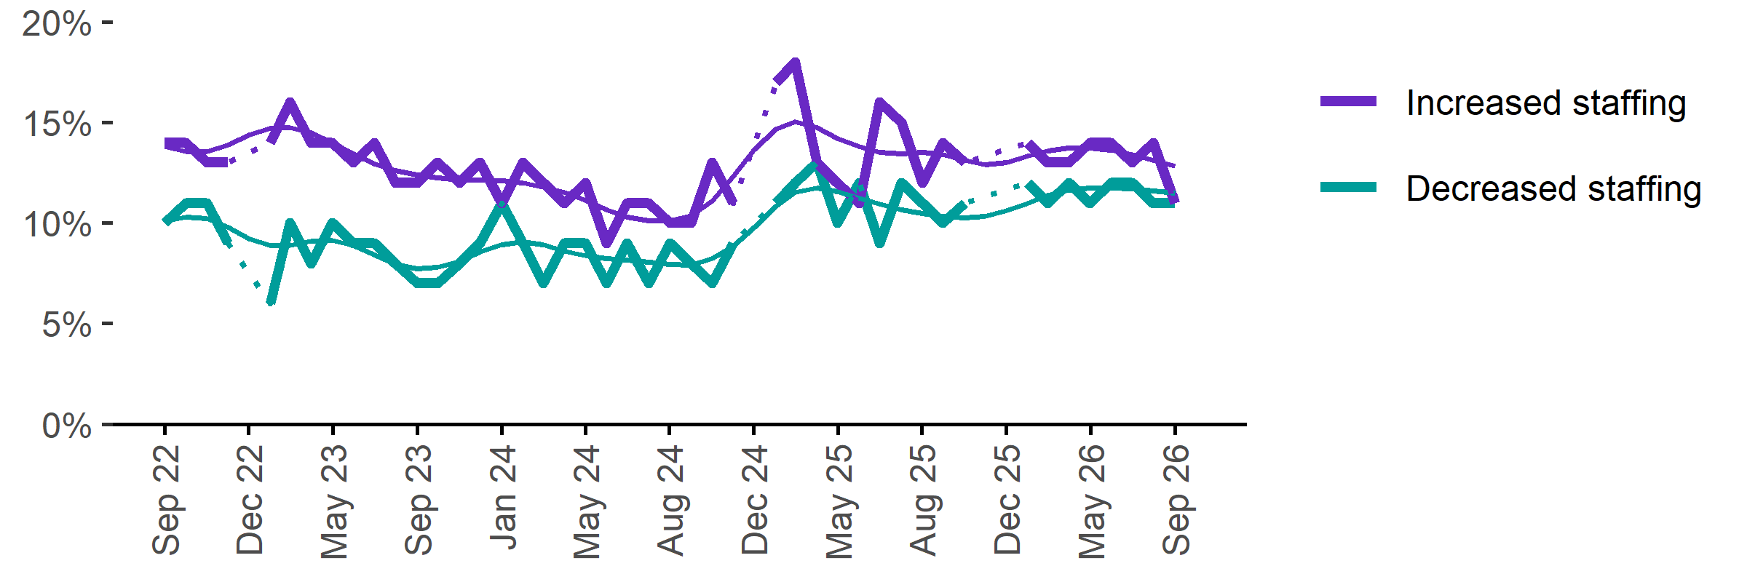
Date | Increased staff | Decreased staff | Smoothed - increased staff | Smoothed - decreased staff
Sep 2022 | 14% | 10% | 14% | 10%
Oct 2022 | 14% | 11% | 14% | 10%
Nov 2022 | 13% | 11% | 14% | 10%
Dec 2022 | 13% | 9% | 14% | 10%
Jan 2023 | n.p. | n.p. | 14% | 9%
Feb 2023 | 14% | 6% | 15% | 9%
Mar 2023 | 16% | 10% | 15% | 9%
Apr 2023 | 14% | 8% | 14% | 9%
May 2023 | 14% | 10% | 14% | 9%
Jun 2023 | 13% | 9% | 13% | 9%
Jul 2023 | 14% | 9% | 13% | 8%
Aug 2023 | 12% | 8% | 13% | 8%
Sep 2023 | 12% | 7% | 12% | 8%
Oct 2023 | 13% | 7% | 12% | 8%
Nov 2023 | 12% | 8% | 12% | 8%
Dec 2023 | 13% | 9% | 12% | 9%
Jan 2024 | 11% | 11% | 12% | 9%
Feb 2024 | 13% | 9% | 12% | 9%
Mar 2024 | 12% | 7% | 12% | 9%
Apr 2024 | 11% | 9% | 12% | 9%
May 2024 | 12% | 9% | 11% | 8%
Jun 2024 | 9% | 7% | 11% | 8%
Jul 2024 | 11% | 9% | 10% | 8%
Aug 2024 | 11% | 7% | 10% | 8%
Sep 2024 | 10% | 9% | 10% | 8%
Oct 2024 | 10% | 8% | 10% | 8%
Nov 2024 | 13% | 7% | 11% | 8%
Dec 2024 | 11% | 9% | 12% | 9%
Jan 2025 | n.p. | n.p. | 14% | 10%
Feb 2025 | 17% | 11% | 15% | 11%
Mar 2025 | 18% | 12% | 15% | 12%
Apr 2025 | 13% | 13% | 15% | 12%
May 2025 | 12% | 10% | 14% | 12%
Jun 2025 | 11% | 12% | 14% | 11%
Jul 2025 | 16% | 9% | 14% | 11%
Aug 2025 | 15% | 12% | 13% | 11%
Sep 2025 | 12% | 11% | 14% | 10%
Oct 2025 | 14% | 10% | 13% | 10%
Nov 2025 | 13% | 11% | 13% | 10%
Dec 2025 | n.p. | n.p. | 13% | 10%
Jan 2026 |  |  | 13% | 11%
Feb 2026 | 14% | 12% | 13% | 11%
Mar 2026 | 13% | 11% | 14% | 11%
Apr 2026 | 13% | 12% | 14% | 12%
May 2026 | 14% | 11% | 14% | 12%
Jun 2026 | 14% | 12% | 14% | 12%
Jul 2026 | 13% | 12% | 13% | 12%
Aug 2026 | 14% | 11% | 13% | 12%
Sep 2026 | 11% | 11% | 13% | 11%

Employers unable to fill vacancies within a month

Proportion of recruiting employers who were unable to fill their vacancies within a month.*
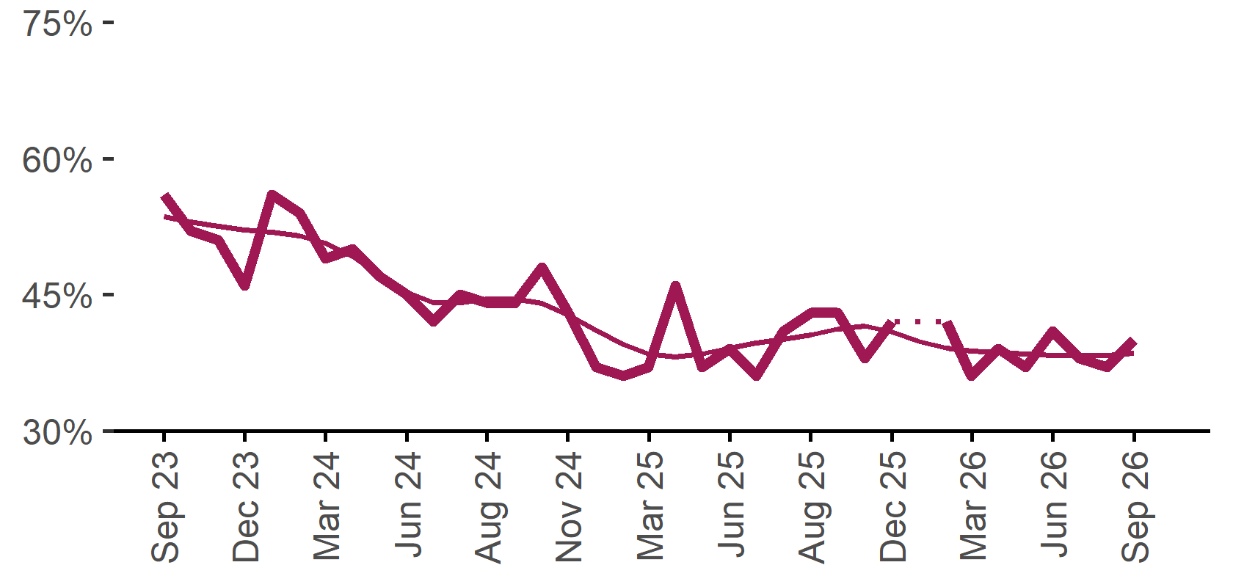 | 40%  Monthly change:  ▲ 3%pts  Annual change:  ▼ 3%pts
  Date | % unable to fill vacancies in a month | Smoothed - % unable to fill vacancies in a month
  Sep 2023 | 56% | 54%
  Oct 2023 | 52% | 53%
  Nov 2023 | 51% | 53%
  Dec 2023 | 46% | 52%
  Jan 2024 | 56% | 52%
  Feb 2024 | 54% | 52%
  Mar 2024 | 49% | 51%
  Apr 2024 | 50% | 49%
  May 2024 | 47% | 47%
  Jun 2024 | 45% | 45%
  Jul 2024 | 42% | 44%
  Aug 2024 | 45% | 44%
  Sep 2024 | 44% | 45%
  Oct 2024 | 44% | 45%
  Nov 2024 | 48% | 44%
  Dec 2024 | 43% | 43%
  Jan 2025 | 37% | 41%
  Feb 2025 | 36% | 40%
  Mar 2025 | 37% | 38%
  Apr 2025 | 46% | 38%
  May 2025 | 37% | 38%
  Jun 2025 | 39% | 39%
  Jul 2025 | 36% | 40%
  Aug 2025 | 41% | 40%
  Sep 2025 | 43% | 41%
  Oct 2025 | 43% | 41%
  Nov 2025 | 38% | 42%
  Dec 2025 | 42% | 41%
  Jan 2026 |  | 40%
  Feb 2026 | 42% | 39%
  Mar 2026 | 36% | 39%
  Apr 2026 | 39% | 39%
  May 2026 | 37% | 38%
  Jun 2026 | 41% | 38%
  Jul 2026 | 38% | 38%
  Aug 2026 | 37% | 38%
  Sep 2026 | 40% | 39%

* Excludes employers who have been recruiting for less than a month.

Background
Jobs and Skills Australia (JSA) conducts the Recruitment Experiences and Outlook Survey (REOS), a telephone administered survey with the business owner or other person in the business responsible for recruitment. Around 1000 employers are surveyed each month, with data published on the JSA website. While the data are indicative of recruitment activity, they may be subject to seasonal factors and other volatility and should therefore be used with a degree of caution. In addition, the survey is targeted towards employers with 5 or more employees and excludes many government organisations. Details of the survey methodology can be accessed from the JSA website.

Smoothed series in charts
Charts include Henderson-smoothed lines in addition to original data for most of our recruitment indicators. As the timeseries is not yet long enough for seasonal adjustment, a Henderson smoothed moving average with a 13-term filter (equating to 13 months) has been directly applied to the original series. This provides an indication of the general movement in each recruitment indicator relative to previous months. Due to using 13 months in the moving average, results for the most recent six months will be revised each month.

How to reference data from this report
Jobs and Skills Australia, Recruitment Insights Report, September 2026.

Contact us
For additional information, email REOS@jobsandskills.gov.au

Also available from the REOS

Data file with monthly and quarterly recruitment indicators
A REOS data file is available on the JSA website. Breakdowns by Capital City/Rest of State area, Business size, and OSCA & ANZSCO Skill Level are included in the monthly results. Quarterly recruitment indicators provide detail by state, ARIA (ABS’ Accessibility and Remoteness Index of Australia) as well as selected industry and occupation groups.
Next Recruitment Insights Report release:
- October 2026 Recruitment Insights Report – 17 November 2026

Stay up to date
JSA also releases semi-regular reports including spotlight articles, detailing aspects of the REOS that cannot be included in our monthly Recruitment Insights Report. Sign up and get the Recruitment Insights Report notifications sent straight to your inbox.
Upcoming spotlight:
- September quarter 2026 results – 29 October 2026
Recent spotlights:
- Recruitment trends in the IT industry – 24 September 2026
- Recruitment pressures in Australia’s higher-skilled labour market – 27 August 2026

A Henderson smoothed line has been included in the charts to reduce month to month volatility and illustrate long term patterns. See the explanatory note for more information.
Data are not available for January in some years. Data points have been joined by a dotted line between December and February to reflect this. ‘Rest of State’ refers to areas outside the capital cities.

