Occupation shortage analysis

  - 2026 Occupation Shortage List (OSL)
The OSL is an annual product that shows the occupations in national and metro and regional level shortage in Australia. Over 1000 skill level 1 to 4 occupations, defined by the Occupation Standard Classification for Australia (OSCA) framework, are covered. The OSL methodology involves 3 stages:
- Generating preliminary occupation ratings using a modelling framework.
- Manually checking ratings using additional evidence collected from a range of sources, including feedback received from stakeholders through the OSL Stakeholder Survey.
- Incorporating feedback on the draft results from government partners and Jobs and Skills Councils.

Figure 1: The OSL assessment stages and assessment inputs
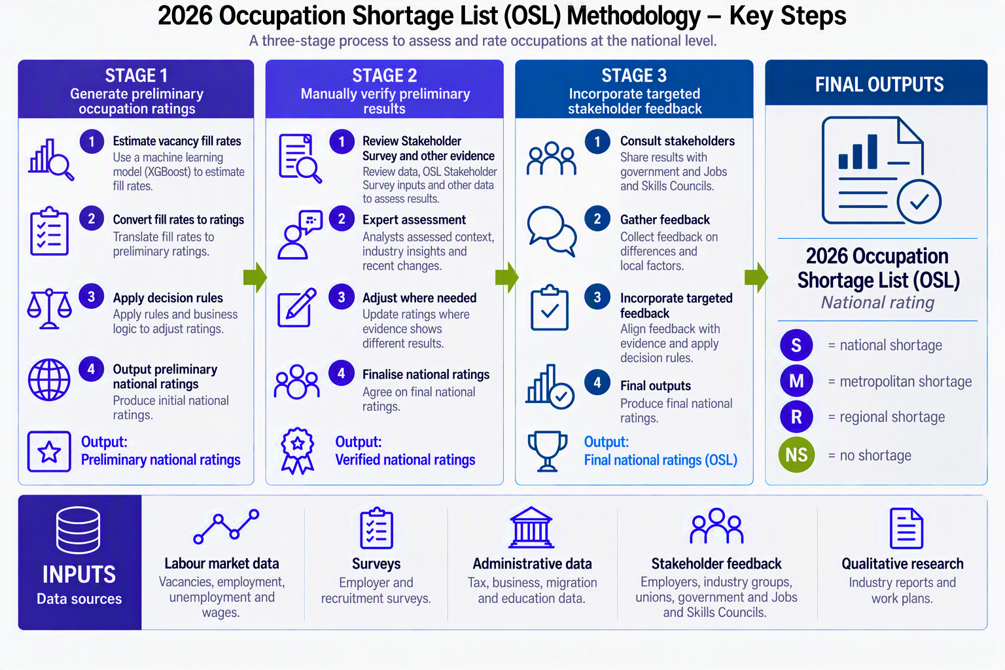
Source: Jobs and Skills Australia.
Refer to the 2026 OSL Methodology Report for more details on how evidence is used.

Select, key results
Occupation shortages continued to ease in 2026, with 279 occupations, 27% of those assessed, in national shortage, down from 29% in 2025 and a peak of 36% in 2023.
- About half of the occupations that were no longer in shortage were in health, engineering, science and ICT roles, with the rest spread across the other major groups.
But persistent shortages remain, with 127 occupations in shortage from 2021 to 2026.
- Technicians and Trades Workers and Professionals accounted for 90% of these occupations concentrated in construction, engineering, electrotechnology and telecommunications trades, health, early childhood education, and various engineering and science roles.
Refer to the 2026 OSL Key Findings Report for more details and factors behind the results.

  - 2026 Occupation Shortage Drivers (OSD)
OSD analysis provides further insight into why shortages occur. It shows three key drivers: supply pipeline constraints, a lack of suitable applicants and retention challenges. Understanding the reasons behind shortages is crucial for developing targeted solutions.

The OSD framework and methodology
Table 1: occupation shortage drivers and descriptions
Driver | Definition
Education and training gap (ETG) | An education and training gap shortage occurs when there are insufficient commencement, completion and qualified applicants. That is, when education and training is not delivering the pipeline supply of workers needed in the labour market.
Retention gap (RG) | A retention gap shortage occurs when employers are unable to retain workers. Workers may not remain in the role due to low pay, poor working conditions or moving to higher skilled roles. As such, employers may be required to increase the frequency of recruitment activities to fill the vacant roles.
Suitability gap (SG) | The suitability gap shortage focuses on labour supply capability. While there may be enough qualified applicants, applicants may not be deemed suitable by employers. Reasons include a lack of employability skills and work experience.
Source: Jobs and Skills Australia (2026).

OSD results are produced at the 2022 Australian and New Zealand Standard Classification of Occupations (ANZSCO) unit group level to overcome data limitations. Also, other data are readily available for unit groups and on the ANZSCO basis, allowing greater ability to test and refine the methodology over time.
Unlike previous years, for 2026 approach used allows Jobs and Skills Australia to show unit groups, with a single, main shortage driver or with links to multiple shortage drivers.

Select, key results
In 2026, the two most common, main shortage driver was suitability and education and training gaps, followed by retention issues. The suggests shortage pressures could stem primarily from labour supply capability and capacity limitations.
But results differ by major groups, and for individual unit groups. For example:
- Aged and Disabled Carers – high demand may be outpacing supply, contribute to a training-gap shortage.
- Motor Mechanics – both training and suitability gaps contribute to shortage, with the training gap as the main driver.
- Registered Nurses – the suitability gap is the main driver, with the training gap is a close secondary driver.
- Cooks and Chefs – although employed in the same sector, the occupations experience different drivers. Shortages among Cooks are more evenly split between retention and training gaps, while shortages among Chefs are driven mainly by training gaps.
Retention challenges remain concentrated in Technicians and Trades Workers spanning food and hospitality, automotive, and construction sectors.
Refer to the 2026 OSD Report for additional results and insights, including details on the methodology and data sources.

Further information



Connect with us Roadshow 2026

