

National Skills Taxonomy
The National Skills Taxonomy (NST) is a common skills language for Australia. It will provide a consistent way to describe skills across education, training and work.

Why do we need the NST?
Australia is moving towards a skills-first system. A skills-first approach focuses on what people can do from their combined formal and non-formal education, work history and life experience.
Today, skills are often hidden inside job titles, qualifications and employment histories. Different systems also describe skills in different ways. This can make it difficult for people, employers and educators to understand how skills connect across jobs, industries and learning pathways.
The NST will help make skills more visible, portable and transferable. It provides a shared language to help people understand their skills, career options and learning opportunities.

How will the NST help?
A common skills language can help:
- make existing skills more visible including through credit transfer and recognition of prior learning
- connect learning with changing workforce needs
- identify skills that can transfer between jobs, industries and sectors
- support clearer education, training and career pathways
- support better workforce planning and labour market insights.
The NST does not replace qualifications, occupations or industry expertise. Instead, it makes skills easier to see, understand and compare. It acts as enabling infrastructure that helps education, training and employment systems work together more effectively.

Built on a shared definition of skill
A shared language starts with a shared understanding of what a skill is. The NST is underpinned by Jobs and Skills Australia’s definition of skill:
A valued and purpose-driven human ability that is acquired or refined through learning and practice. It is a dynamic function of an individual’s knowledge, experience and personal attributes that is continuously influenced by context, interaction with others and the demands of the environment in which it is exercised.
This definition helps ensure skills are recognised consistently across education, training and employment, while acknowledging that skills are human, dynamic and shaped by context.

Building Australia’s skills-first future
The NST is foundational infrastructure for a skills-first system. By providing a common skills language, it can connect workers, employers, educators and governments around a shared understanding of capability.
Over time, this can support better recognition of skills, stronger learning pathways, improved workforce mobility and more efficient matching of skills to opportunities.
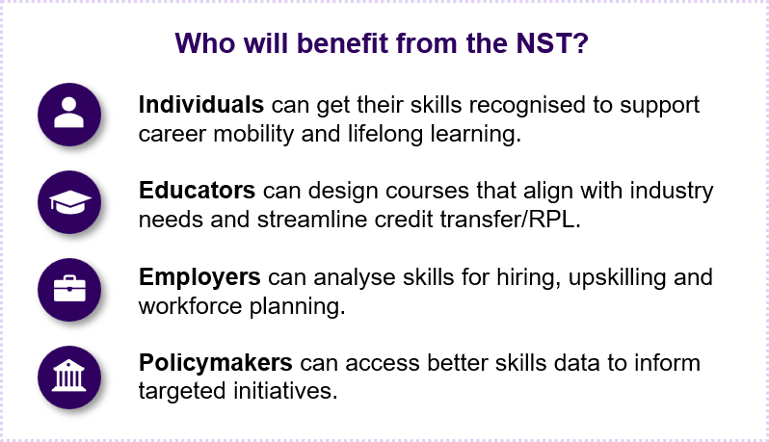

The NST journey
The NST has entered a two-year build phase from July 2026 to June 2028. The early design and proof-of-value work is complete. Development is continuing through consultation, testing and collaboration across education, training, industry and government.
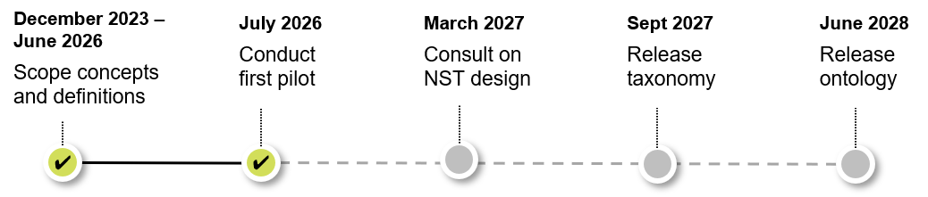

Further information
Visit the JSA website for opinion pieces, webinar recordings and consultation reports about the NST.
Email NationalSkillsTaxonomy@jobsandskills.gov.au to subscribe to the NST newsletter.



Connect with us Roadshow 2026

