

Recent trends for displaced workers in Australia

Changing profiles and outcomes from 2015 to 2025
Jobs and Skills Australia’s report examines how worker displacement has changed over the past decade, who is affected and what happens after job loss. A displaced worker is someone who loses their job involuntarily generally due to negative economic events, stress or adjustment. The report provides new occupational, geographic and demographic insights to help policymakers and industry target support and monitor future change.

585,800  people aged 15–64 displaced  in the year to February 2025 | 6% → 4%  of the labour force aged 15–64  displaced, 2015 → 2025 | 39% → 30%  displaced workers’ share of  all job separations, 2015 → 2025
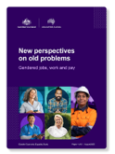

Displacement has declined and earnings recovery has improved over the past decade. But the jobs, industries and regions affected are changing, and recovery remains uneven.

What is happening with displacement?
- Of almost 2 million people aged 15–64 who left or lost a job in the year to February 2025, 30% were displaced.
- The industry profile of displacement is changing. Rates fell in mining, manufacturing and construction, but rose in accommodation and food services, administrative and support services, and other services.

Who is being displaced
- The occupational profile of displacement has shifted. Displacement is less concentrated in mining-related technical and trade occupations and has shifted towards professional and managerial occupations, including ICT, media, finance and human resources.
- The geographic profile of displacement has also shifted. The highest redundancy-related displacement rates moved from mining and manufacturing regions in 2015–16 towards greater Sydney and Melbourne in 2023–24. Larger labour markets offer broader opportunities for re-employment.
- Displacement is more evenly shared by sex. Males accounted for 59% of displaced workers in 2015 and 52% in 2025.

Displacement rates for workers aged 15-64 years, by broad industry in 2015 and 2025
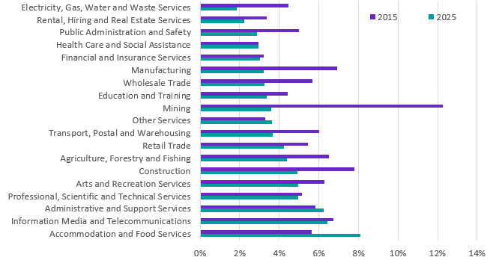

What happens after displacement
Returning to work is only one measure of recovery. The report also examines earnings and introduces a Post-displacement Outcomes Index that combines re-employment and earnings outcomes.
- Most workers made redundant return to employment. In linked administrative data, 74% of workers displaced by redundancy in 2022–23 were employed one year later, compared with 72% for the 2015–16 cohort. Three-year re-employment rates ranged from 85% to 89% across the available cohorts.
- Short-term earnings losses have become smaller. Among workers returning to employment, the median real earnings loss one year after redundancy fell from 26% for the 2015–16 cohort to 6% for the 2022–23 cohort.
- Longer-term earnings recovery has improved. Three years after redundancy, median real earnings were 11% below pre-displacement levels for the 2015–16 cohort, compared with 3% above for the 2020–21 cohort.
- Recovery remains uneven. The index shows strong improvements in practical, operational and frontline service occupations. Several professional, managerial and administrative occupations experienced declining outcomes over the period.

Further information



Connect with us Roadshow 2026

