

Australia's AI Transition: Jobs, Skills and the Future of Work
The Generative AI Capacity Study, released 14 August 2025, provides the first national whole-of-labour-market view of Gen AI and its potential impact, current impact, and medium-term implications for both the labour market and skills. As a result, it demonstrates what is needed to support Australia’s digital and AI transition.

The study in brief
The Study highlights Gen AI’s capacity to be used across a wide range of tasks and across the majority of occupations, with a greater capacity to augment rather than automate work.
The Study also identifies the early and uneven adoption of Gen AI across Australian industries, highlighting worker-led experimentation, emerging productivity gains, and the critical need for coordinated policy and workforce readiness to support a successful national transition.
Gen AI is reshaping skills demand in the Australian labour market. The Study emphasises the growing importance of both digital and human-centric capabilities and the emergence of new workforce personas. Importantly, there is a need to mobilise the entire skills system – including both VET and higher education – to prioritise whole-of-population digital and AI capability uplift.
Australia’s AI transition will create both challenges and opportunities across the workforce. There will be particular implications for entry-level roles, labour mobility, and equity across diverse worker cohorts. This reinforces the need for inclusive and adaptive policy responses.
There are emerging approaches for effectively implementing Gen AI in workplaces. These include emphasising the importance of organisational adaptability, leveraging the expertise of workers, and investment in skills development to ensure safe, effective, and inclusive adoption.
The Study includes 10 recommendations that focus on the labour market and skills system, which would enable Australia to best realise the potential opportunities and manage the challenges of the digital and AI transition (see figure over page). Corresponding advice for policy makers is also included in the Study.
The Australian Government’s National AI Plan, released on 2 December 2025, states that government, Jobs and Skills Council, employer and union action to build an inclusive AI-ready workforce will be guided by the Study. It also identifies JSA reports as part of the evidence base for monitoring and refining of the Plan’s implementation.
JSA will continue to strengthen the evidence base on artificial intelligence and its implications for the labour market and skills system, building on the work of the Gen AI Study.
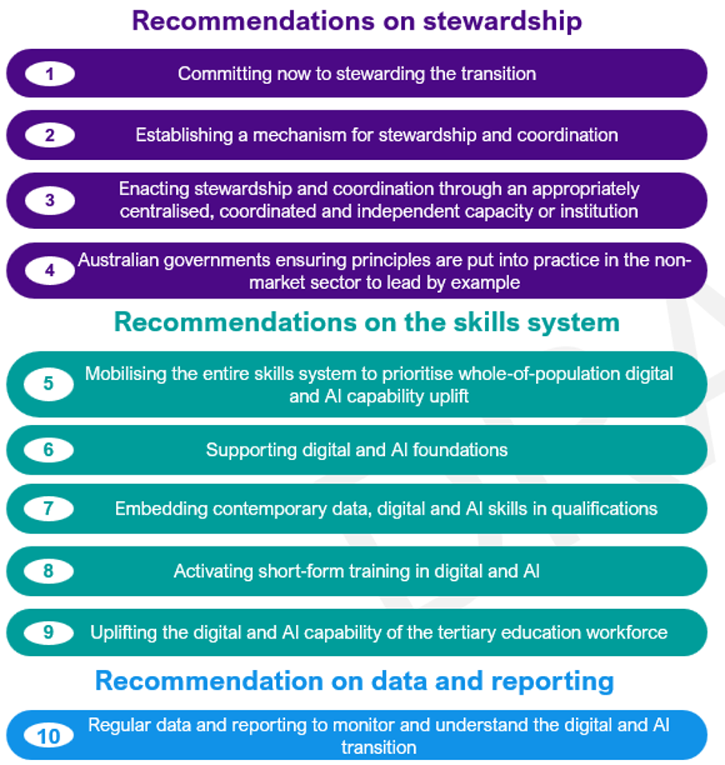

Where can I find the Study and what is available?
The full Study, including a suite of supporting data and analysis, is available from the Study’s page on the Jobs and Skills Australia website (QR code below).
The overarching report, analysis papers and case studies provide detailed evidence and recommendations on Australia's experiences, opportunities and challenges with Gen AI and the implications for policy. The Study’s final release includes non-market, cohort & intersectional analysis, as well as technical matters. A range of interactive tables and visualisations and data downloads are also available.

Further information



Connect with us Roadshow 2026

