


2026 Occupation Shortage List Methodology

October 2026

Contents
Introduction 4
The essentials: a quick summary 4
Preliminary ratings 5
Manual checks 5
Seeking feedback from stakeholders 5
Assessing occupations defined by the Australian Bureau of Statistics 6
Important features and context 6
Scope and granularity 6
Caveats 6
OSL categorisations 7
Occupation shortage definition 8
The vacancy fill rate metric 9
Assessing whether fill rates are high or low 10
OSL assessment framework 11
Stage 1: Generating preliminary occupation ratings 11
The GBM and modelling framework 11
Converting fill rates into ratings 12
Stage 2: Manual checks of preliminary ratings 14
Stage 3: Incorporating stakeholder feedback 16
Consultation with select external stakeholders 16
Incorporating the feedback 16
Appendices 18
Appendix A: Occupations out of OSL scope 18
Appendix B: Mapping to 2022 ANZSCO and to 2024 OSCA 20
Appendix C: Creating a unit group shortage list 22
Appendix D: GBM and input variables 23
Appendix E: SERA 26
Appendix F: OSL Stakeholder Survey 27

Tables
Table 1: The OSL ratings and their interpretation 8
Table 2: Key steps of the preliminary occupation rating modelling framework 11
Table 3: Additional decision rules applied to determine Stage 1 occupation ratings 13
Table 4: Sources and metrics used to review and verify the preliminary ratings 15
Table 5: Steps used when reviewing and incorporating feedback from Commonwealth stakeholders 16
Table 6: Further rules used for state ratings 17
Table A1: List of occupations excluded from the OSL, 2022 ANZSCO 18
Table A2: List of occupations excluded from the OSL, 2024 OSCA 19
Table A3: GBM input variables 23

Figures
Figure 1: The OSL assessment stages and assessment inputs 4
Figure 2: The OSL ratings 7
Figure 3: The vacancy fill rate and its underlying intuition 9
Figure 4: Key decision rules for shortage ratings 12
Figure A1: Mapping ratings from 2013 ANZSCO to 2022 ANZSCO 20
Figure A2: Mapping from ANZSCO to 2024 OSCA 21
Figure A3: Converting occupation ratings to a unit group rating 22
Figure A4: An example of a decision tree fit to data 24

Boxes
Box 1: Example of Stage 1 ratings using criteria (in Table 3) 13
Box 2: An example of Rule 2 17

Introduction
Jobs and Skills Australia publish the Occupation Shortage List (OSL) annually. It is a point-in-time assessment of occupations in the Australian labour market.
This report explains how occupations were assessed to produce the 2026 OSL ratings, the information used, and the role of stakeholder engagement in shaping the OSL.
The report was written for the general audience, using plain language, tables and infographics to outline the key elements of the OSL methodology.

The essentials: a quick summary
The OSL methodology involves 3 stages. The stages are as follows:
- Generating preliminary occupation ratings using a Gradient Boosting Machine learning model (GBM) and a modelling framework.
- Verifying ratings through manual assessment of evidence collected from a range of sources.
- Incorporating feedback on the draft results from stakeholder partners.
The stages are summarised in Figure 1.
Figure 1: The OSL assessment stages and assessment inputs
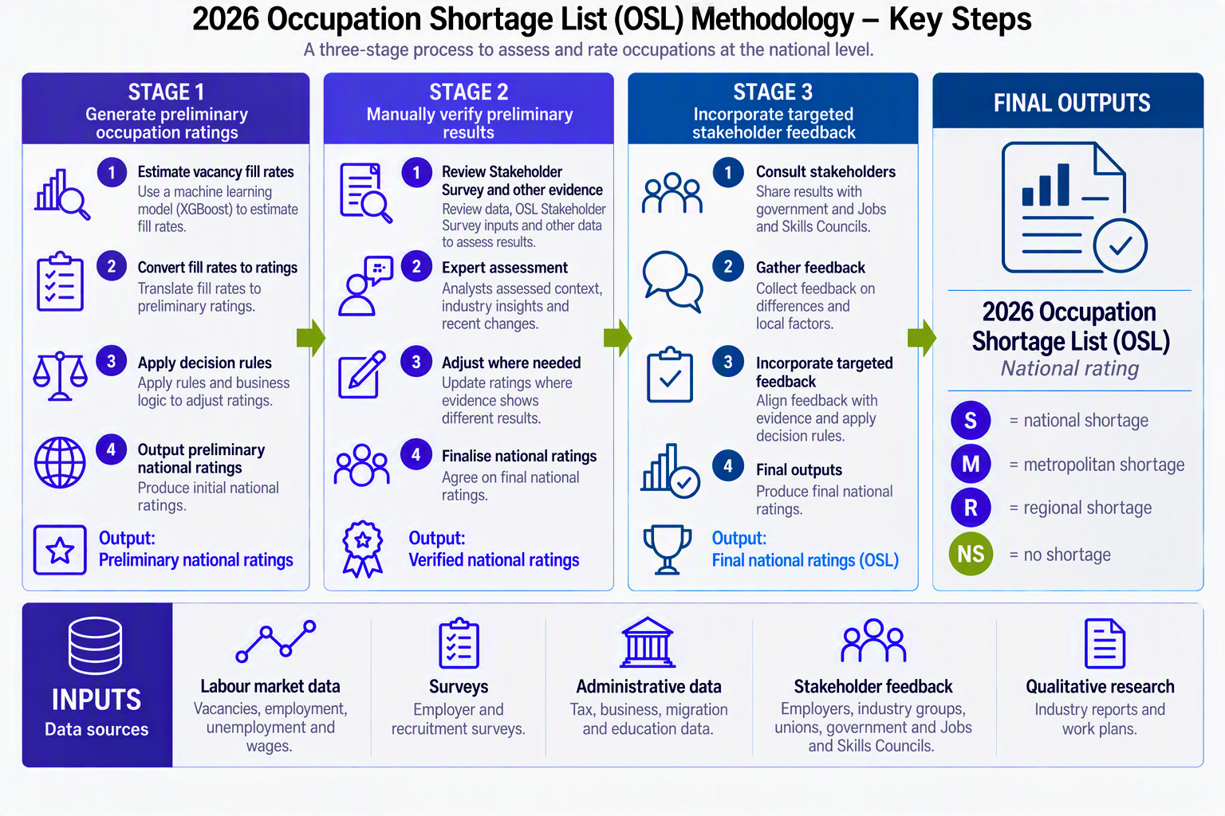
Source: Jobs and Skills Australia.

Preliminary ratings
Preliminary occupation ratings are based on the GBM and a modelling framework. Model inputs include administrative and survey data, covering measures of labour demand, supply, geography, demography and education characteristics.
The GBM is used to generate estimates of the proportion of vacancies that are filled for each occupation (the fill rate). The fill rate is a key measure in the analysis of occupations as:
- it captures a wide range of important labour market factors and developments
- a high fill rate suggests there is a lower chance of a shortage and low fill rate suggests there is a higher chance of shortage
- Jobs and Skills Australia use a definition of shortage that relates to challenges faced by employers when recruiting, with higher difficulty leading to fewer filled vacancies.
The fill rate is converted to the familiar shortage or no shortage ratings using rules that are applied to various data sources such as employment size of the occupation and measures of the accuracy of the model estimates.

Manual checks
The preliminary results are manually checked using data analysis of labour market indicators, employer survey and the OSL Stakeholder Survey, and other qualitative information gathered through research.
The analysis focuses on recruitment outcomes, measures of labour demand and supply, and replacement rates of workers within occupations.
During this stage, Jobs and Skills Australia also adds a confidence label to the preliminary occupation. The labels show whether the rating is Clear: supported by strong and consistent evidence; or On-balance: where the evidence points in one direction, but it is close to the threshold between shortage and no shortage, or the evidence is mixed or limited.
The confidence label was introduced to better indicate which occupation ratings might change from one year to the next and which are less likely to.

Seeking feedback from stakeholders
Jobs and Skills Australia seeks feedback from stakeholders through 2 channels:
- The OSL Stakeholder Survey, which collects information from bodies representing employers, workers, and regions. The survey opens in January and closes in March each year. As mentioned above, results from the survey are used during the manual checking process. More information on the survey indicators used is in Stage 2: Manual checks of preliminary ratings. More background on the survey is provided in Appendix F.
- Targeted consultation with Commonwealth Government departments, and state and territory (state) government departments and Job and Skills Councils (JSCs) on the draft results. More information on the targeted consultation is provided in Stage 3: Incorporating stakeholder feedback.
The feedback from stakeholders ensures that the evidence base used to inform the final OSL ratings is broad and comprehensive.

Assessing occupations defined by the Australian Bureau of Statistics
Occupations assessments are based on data that are defined by a classification system produced and maintained by the Australian Bureau of Statistics (ABS). The classification system defines the occupation titles; the skills and tasks associated with the occupation.
The benefit of basing outputs on ABS frameworks is that insights can be produced in a standardised, transparent and verifiable manner.

Important features and context

Scope and granularity
The 2026 OSL is available based on 2 occupation classifications from the ABS:
- 2024 Occupation Standard Classification for Australia (OSCA)
- 2022 Australian and New Zealand Standard Classification of Occupations (ANZSCO).
Only Skill Levels 1 to 4 (as defined by OSCA and ANZSCO) are in scope of the OSL. Occupations at these skill levels usually need a university qualification, vocational qualification, apprenticeship or traineeship.
Several occupations are excluded from the OSL scope:
- Skill Level 5 occupations
- New Zealand-based occupations (relevant for ANZSCO only)
- Occupations where employers do not recruit openly from the labour market such as detectives, judges, military roles and professional athletes.
The full list of excluded occupations is in Appendix A.

Caveats
Occupation assessments in the OSL depend on the quality and availability of evidence. Specifically, the caveats include the following:
- The OSL uses ANZSCO and OSCA occupation classifications, which do not capture every job title that employers use.
- Data inputs can range from one-month lag to one or more years of lag.
- The OSL does not forecast future shortages. It also does not assess how important an occupation is.
- The OSL is an employer-focused view of shortages and is primarily driven by data on employers’ recruitment activity.
- The OSL ratings do not show how severe a shortage is.
- The OSL is based on assessments of occupations across the whole labour market, not sector by sector.

OSL categorisations
Each occupation on the OSL has:
- a rating which shows whether an occupation is in shortage or not; and if in shortage, whether it is national, regional or in metropolitan areas.
- a confidence label.
The confidence label shows whether the rating is:
- Clear — supported by strong and consistent evidence
- On-balance — where the evidence points in one direction but is either close to the threshold between shortage and no shortage, or the evidence is mixed or limited.
The ratings and the confidence labels are shown in Figure 2.
Figure 2: The OSL ratings
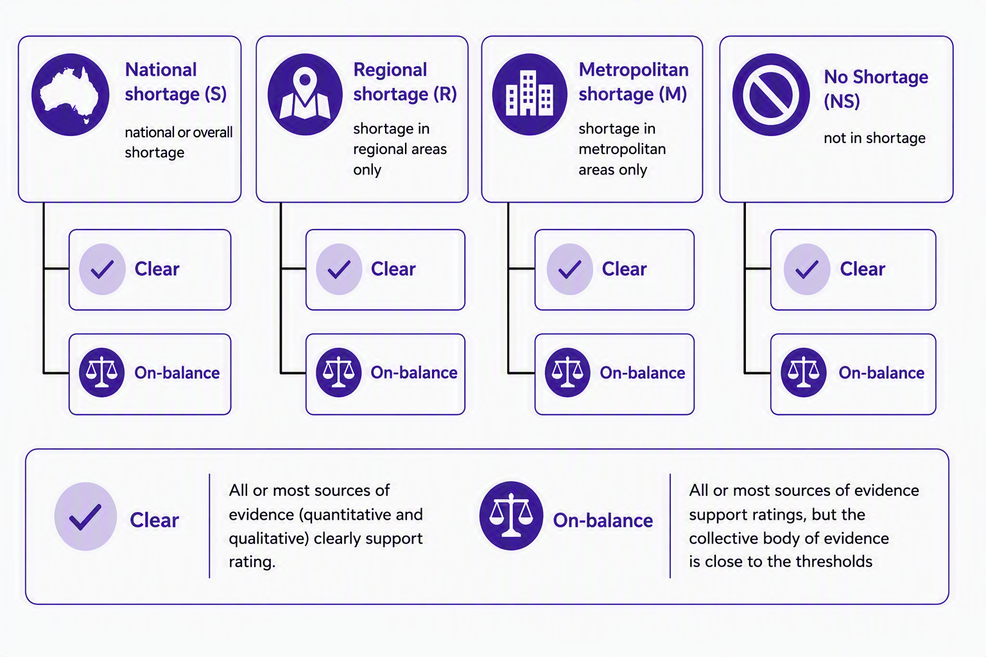
Source: Jobs and Skills Australia.
Table 1 explains what each rating and confidence label mean.
Table 1: The OSL ratings and their interpretation
Occupation rating | Confidence label | Interpretation
Shortage ratings  National shortage (S)  Regional shortage (R)  Metropolitan shortage (M) | Clear | - All or most sources of evidence (quantitative and qualitative) clearly support a shortage rating.
Shortage ratings  National shortage (S)  Regional shortage (R)  Metropolitan shortage (M) | On-balance | - All or most sources of evidence point towards a shortage rating, but the collective body of evidence is close to the thresholds that separate shortage and no shortage ratings.  - The sources of evidence provide conflicting signals: some point to a shortage, while others indicate no shortage. However, the combined evidence leans towards a shortage.
No shortage (NS) | Clear | - All or most sources of evidence (quantitative and qualitative) clearly support a no shortage rating.
No shortage (NS) | On-balance | - All or most sources of evidence support a no shortage rating, but the collective body of evidence is close to the thresholds that separate shortage and no shortage ratings.  - The sources of evidence provide conflicting signals: some indicate shortage, while others suggest no shortage. Overall, the collective body of evidence leans towards a no shortage rating.  - There is very limited evidence to conclusively assess occupations as Shortage.
Source: Jobs and Skills Australia.

Occupation shortage definition
The OSL makes 2 assumptions when analysing occupation shortages:
- When employers need more workers, they will try to recruit those extra workers.
- When employers find suitable applicants, they will hire them.
Based on these assumptions, an occupation is in shortage when employers cannot fill a significant share of their advertised vacancies at current pay and working conditions.

The vacancy fill rate metric
The main measure of an occupational shortage, based on the definition, is the fill rate – the proportion of vacancies that employers can fill.
The metric has a simple intuition:
- Lower fill rates imply greater difficulty for employers in filling vacancies, indicating a higher likelihood of occupations in shortage.
- Higher fill rates imply lower difficulty for employers in filling vacancies, indicating a lower likelihood of occupations in shortage.
This relationship is illustrated in Figure 3.
Figure 3: The vacancy fill rate and its underlying intuition
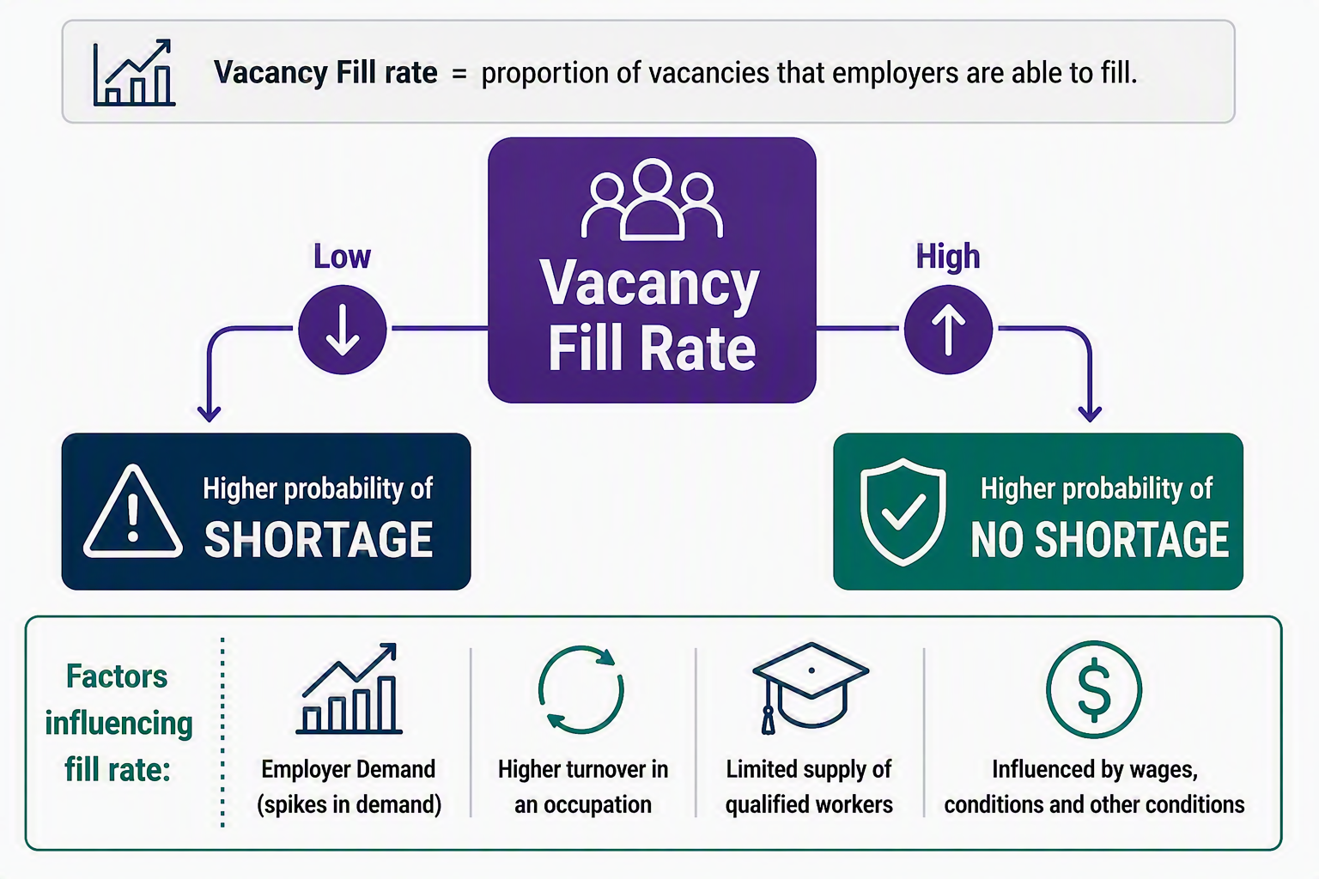Source: Jobs and Skills Australia.
The fill rate reflects a wide range of labour market factors. For example, increased demand from employers, higher turnover and low numbers of graduates can result in the number of available workers being smaller. This results in lower fill rates, which increases the likelihood of occupation shortages.
Additionally, these factors are likely to be influenced by current wages, wage growth, working conditions and other considerations that impact employers' decisions to recruit and workers’ decisions to apply.

Assessing whether fill rates are high or low
The OSL uses 67% fill rate as a threshold to assess if an occupation is likely to be in shortage. If employers fill less than 67% of advertised vacancies for an occupation, that occupation is more likely to be in shortage.
No single measure can reliably capture fill rates. Survey-based fill rates can be volatile for small occupations or where vacancy numbers are low and can be affected by short-term or local factors that do not reflect broader labour market conditions. As a result, the OSL methodology uses both observed and estimated fill rates.
- Observed fill rates are taken primarily from employer-based surveys such as the Survey of Employers who have Recently Advertised (SERA) and Recruiting Employer Outlook Survey (REOS).
- Estimated fill rates are derived from a Gradient Boosted Machine Learning Model (GBM), which predicts fill rates. GBM-estimated fill rates also ensure consistent coverage across all occupations, especially where survey data is limited.
The OSL methodology does not rely solely on fill rate analysis. It uses a broad range of quantitative and qualitative evidence, along with stakeholder feedback. This means that not all occupations with a fill rate below 67% are considered as being in shortage. Likewise, occupations with fill rates above 67% are not automatically assessed as not in shortage.
In the following sections, the different stages of occupation assessments are explained, and how fill rates, other broad range of evidence and stakeholder feedback are used.

OSL assessment framework
The occupation assessment is made up of 3 stages and uses a wide range of information.

Stage 1: Generating preliminary occupation ratings
In Stage 1, preliminary ratings are produced on 2013 ANZSCO as most data from the ABS and Jobs and Skills Australia are currently based on this ANZSCO version.
The Stage 1 occupation ratings are then mapped to the 2022 ANZSCO and 2024 OSCA occupations. The mapping approach is described in Appendix B.
Preliminary occupation ratings are based on a modelling framework, which includes results from the GBM. The key elements of the modelling framework are summarised in Table 2.
Table 2: Key steps of the preliminary occupation rating modelling framework
Key elements of the modelling framework
- Estimating occupation fill rates using a GBM
- Combining the GBM-based estimated fill rates with observed fill rates from the SERA
- Producing 80% confidence intervals for the combined occupation fill rates
- Using decision rules to turn fill rates, confidence intervals and employment size data into occupation ratings
Source: Jobs and Skills Australia.

The GBM and modelling framework
The GBM is a statistical model used in the OSL to estimate how hard it is for employers to fill vacancies in different occupations. The model looks at a wide range of labour market indicators and uses them together to estimate an occupation’s fill rate.
The GBM does not determine whether an occupation is in shortage. Instead, it provides a consistent, evidence-based starting point for assessment.
The GBM combines many decision rules rather than relying on a single indicator. Each rule asks questions of the data, for example:
- is unemployment higher or lower than the previous year
- are vacancies per worker rising or falling
- has employment in the occupation grown or declined?
Each rule gives a signal. The model combines these signals and improves its estimate of the fill rate with each step. This approach recognises shortages are rarely driven by one factor. The GBM can recognise patterns across multiple indicators at the same time, rather than treating each indicator separately.
The final GBM model uses 23 inputs from 13 sources. A detailed list of data inputs and how the model works are in Appendix D.

Blending the GBM-based fill rates with SERA and producing confidence intervals
The modelling framework combines the estimated fill rates from the GBM and SERA for each occupation. The blending is based on the level of uncertainty of each type of fill rate (GBM or SERA). When the GBM estimated fill rate has a lower uncertainty, more weight is given to it; and when it has a higher uncertainty, more weight is given to the SERA-based fill rate. The blending ensures the final fill rate estimate for each occupation is robust and is based on a comprehensive body of labour market information.
The modelling framework uses an 80% confidence interval for the estimated fill rate of each occupation. This interval shows a range of possible values for the fill rate with an 80% chance of containing the true value of the fill rate. These intervals help with assessing occupations:
- Narrow confidence intervals suggest the estimate is relatively reliable.
- Wide confidence intervals suggest the estimate is less reliable, leading to greater uncertainty.

Converting fill rates into ratings
Jobs and Skills Australia apply a set of decision rules on the blended fill rates and confidence intervals to convert them into Stage 1 ratings (Figure 4 and Table 3).
Figure 4: Key decision rules for shortage ratings
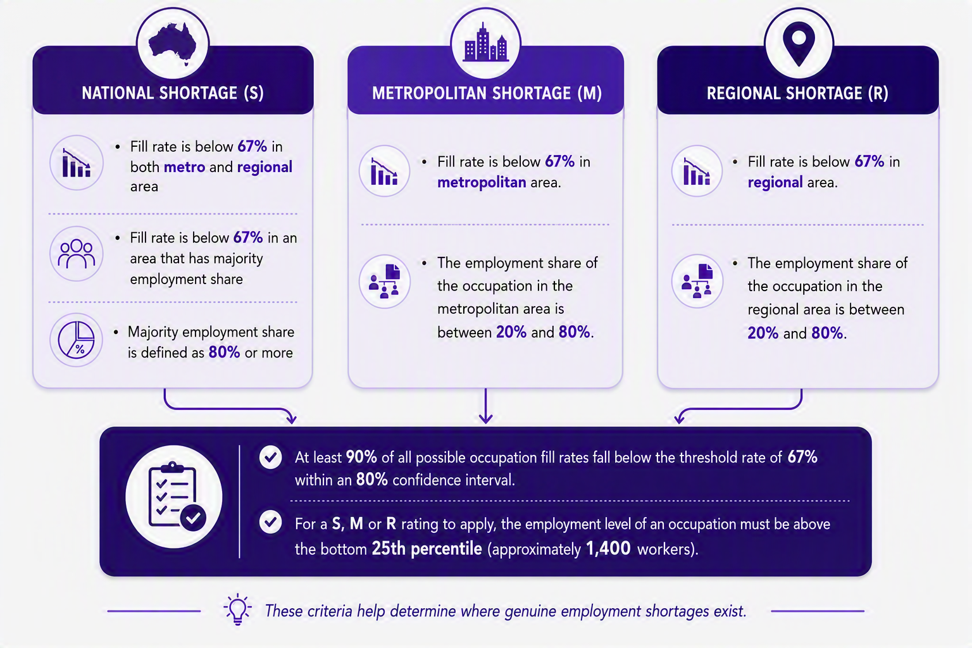
Source: Jobs and Skills Australia.

Additional rules used to convert the occupation fill rates into ratings
Table 3: Additional decision rules applied to determine Stage 1 occupation ratings
Criteria
- An occupation's fill rate is considered to have a low fill rate when at least 90% of all its possible fill rates are below 67%, based on an 80% confidence interval.
- If the number of workers employed in the occupation is below the 10th percentile, an NS rating is applied as there is too much uncertainty to rate the occupation as S, M or R.
- For an S, M or R rating to apply, the employment size for an occupation must be greater than the bottom 25th percentile (approximately 1,400 workers).
- If the employment size is between the 10th and 25th percentiles, an uncertainty flag is applied for close review during manual, human checks.
- If the above rules are not satisfied, an NS rating is applied.
- To change an occupation's Stage 1 rating from last year, the model must show more certainty, indicated by a narrower 80% confidence interval, and the predicted fill rate must change in the direction consistent with the change in rating.
Source: Jobs and Skills Australia.
The above rules were based on sensitivity tests to produce the most stable and consistent results over time.
These rules and thresholds ensure that:
- preliminary ratings are based on strong data evidence
- rating changes reflect, as best as possible, changes in labour market conditions rather than being influenced by data volatility.
As a result, an occupation with a preliminary NS rating could mean either:
- the occupation is not in shortage in the labour market
- there is uncertainty due to mixed or limited data evidence.
Box 1: Example of Stage 1 ratings using criteria (in Table 3)
Tyre Fitter has an employment size of about 7000 (well above the 25th percentile) with even split between regional and metropolitan areas. In 2025, Tyre Fitter was rated as NS. In 2026, the GBM predicted fill rates below 50% with the 80% confidence intervals all below 67%. The confidence intervals were narrower than in 2025 and the predicted fill rate decreased. This indicated more certainty in 2026 and provided strong enough evidence to change the rating in Stage 1 from NS to S.
Source: Jobs and Skills Australia.
The preliminary occupation ratings are further verified in Stage 2 of the OSL assessment process, which is explained in the next section.

Stage 2: Manual checks of preliminary ratings
In Stage 2, the Stage 1 occupation ratings are individually and manually reviewed using:
- additional labour market indicators,
- stakeholder evidence gathered through the annual OSL Stakeholder Survey,
- qualitative information gathered from industry reports submitted by stakeholders when participating in the OSL Stakeholder Survey and through desktop research.
The manual checks are based on the 2022 ANZSCO because most of labour market data used for assessment is currently available on an ANZSCO basis. Doing so supports consistency of assessment over time. After that, the results are mapped to the 2024 OSCA framework. Where additional reliable information is available for 2024 OSCA occupations, such as from the Occupation Shortage Stakeholder Survey, it is considered separately as part of the assessment.
A second review is conducted for occupations where the mapping from 2022 ANZSCO to 2024 OSCA frameworks are complex, including:
- One 2022 ANZSCO occupation which map to multiple 2024 OSCA occupations,
- multiple 2022 ANZSCO occupations which map to one 2024 OSCA occupation,
- newly created occupations in the 2024 OSCA framework.
The sources and metrics analysed and compared with the preliminary results during the review are listed in Table 4.

Table 4: Sources and metrics used to review and verify the preliminary ratings
Metrics | Source
- Supply levels relative to previous year  - Demand levels relative to previous year  - Occupation vacancy fill rate | OSL Stakeholder Survey
- Occupation vacancy fill rate  - Qualified applicants per vacancy  - Suitable applicants per vacancy  - Duration of vacancies | SERA
- 2021 employment level  - Current employment level  - Trend employment growth | ABS 2021 Census of Population and Housing; Industry and Occupation Employment Trending; GBM
Recruitment difficulty rates | REOS
Labour Supply Index (LSI) | SERA; REOS
Occupation replacement rates | Data on Occupation Mobility
Desktop research of occupations and industries | Industry reports; Jobs and Skills Council Workforce Plan reports
Demand to unemployment ratio | Internet Vacancy Index; Custom request from ABS
Source: Jobs and Skills Australia.
Testing of past OSL outcomes show that, on average, 90% of Stage 1 ratings match the final ratings after manual review.
The review is an exercise of professional judgement on what the collective body of evidence suggests about an occupation’s rating. Below are 3 simplified examples:
- Example 1: The Stage 1 rating for an occupation is NS, but the occupation just narrowly misses the criteria for S. Additional sources summarised in Table 4 provide mixed signals: some support a NS while others support a S. The occupation is rated as NS On-balance.
- Example 2: The Stage 1 rating for an occupation is NS (or S) and is close to the threshold for changing. However, most or all sources from Table 4 provide more compelling signals to the opposite rating of S (or NS). The occupation is rated as S Clear or (NS Clear).
- Example 3: The Stage 1 rating is S (or NS) and strongly meets the criteria or S (or NS). All or most other sources from Table 4 all strongly support S (or NS). The occupation is rated as S Clear (or NS Clear).

Stage 3: Incorporating stakeholder feedback

Consultation with select external stakeholders
Jobs and Skills Australia seek feedback on the Stage 2 ratings from:
- Commonwealth Government departments, requesting review of the national level ratings
- State government departments, requesting review of whether the national level ratings apply to the state
- JSCs, requesting review on the national level ratings and the ratings that should apply to each state.
Feedback is collected using a structured template which allows stakeholders to provide:
- their suggested rating for each occupation at the national and/or state or territory levels
- information on the evidence used to inform their suggested rating.
Because of limited data currently available on the 2024 OSCA framework, feedback for the 2026 OSL was primarily requested on the 2022 ANZSCO version of the OSL. As data based on the 2024 OSCA framework becomes more readily available in future years, this will become the primary framework for seeking feedback.
The aim of Stage 3 is to gather additional evidence. Seeking feedback from governments and JSCs ensures that the evidence base that informs the final OSL ratings is broad and comprehensive.

Incorporating the feedback
Table 5 outlines the process Jobs and Skills Australia used to incorporate feedback from the 3 groups of stakeholders into national level ratings.
Table 5: Steps used when reviewing and incorporating feedback from Commonwealth stakeholders
Key steps
- Score the feedback in the templates for each occupation using a scoring matrix.
- Reject feedback for occupations that do not meet the minimum benchmark score.
- For feedback that meets the benchmark, compare it against the evidence used during the manually verified ratings from Stage 2.
- Accept feedback if it provides stronger evidence than what was used in Stage 2.
- Adjust the national level ratings based on accepted feedback in step 4.
- For occupations where no feedback was received, retain Stage 2 ratings as the final national level ratings.
Source: Jobs and Skills Australia.
Additional rules are applied to state feedback and JSC feedback for state ratings (Table 6).
Table 6: Further rules used for state ratings
Rule | Reason or assumption
- An occupation is rated as NS in a state with zero employment recorded. | A shortage cannot exist where there is no active labour market for that occupation.
- National level rating of occupations is adjusted to reflect the accepted state ratings where employment share for those states collectively exceeds two-thirds of the national employment for that occupation. | Ensures that the national level ratings for occupations are aligned with the majority of accepted state ratings, reflecting broader labour market conditions across states.
Source: Jobs and Skills Australia.
Suggested ratings for States are used as an input to validate the national level results. Given they are inputs only, accepted State ratings are not published.
Box 2 shows an example of how Rule 2 (in Table 6) is applied.
Box 2: An example of Rule 2
- Occupation A was rated as NS in the Stage 2 verification.
- The national total employment for Occupation A is 1,000.
- Occupation A is rated as S in NSW, VIC and QLD with state employment figures of 400, 200 and 100, respectively.
- Occupation A is rated as NS in the remaining states which have a combined employment size of 300.
- The combined employment share of S rated states (NSW, VIC, and QLD) is 70%, while the NS rated states make up 30%.
- Therefore, the national level rating for occupation A is changed from NS to S as 70% exceeds the two-thirds criteria.
Source: Jobs and Skills Australia.
Once feedback has been accepted and reflected into the national level ratings, the 2022 ANZSCO results are then mapped to 2024 OSCA. Refer to Appendix B for more details.

Appendices

Appendix A: Occupations out of OSL scope
Several occupations are excluded from the OSL. These are:
- Skill Level 5 occupations
- Occupations specific to New Zealand (such as Māori specific occupations)
- Occupations where the labour market is not considered open and contestable.
Skill Level 5 occupations are excluded from both the 2024 OSCA and the 2022 ANZSCO versions of the OSL.
For more information on OSCA and ANZSCO, refer to their Australian Bureau of Statistics (ABS) webpages.

Occupations where the labour market is not open and contestable
Jobs and Skills Australia excludes occupations where the labour market is not open and contestable. For example, Defence Force roles, Judges and Detectives are excluded from scope as recruitment is mainly conducted internally. Table A1 lists the 2022 ANZSCO occupations that were excluded from the 2026 OSL.
Table A1: List of occupations excluded from the OSL, 2022 ANZSCO
ANZSCO | Description
111212 | Defence Force Senior Officer
111311 | Local Government Legislator
111312 | Member of Parliament
111399 | Legislators nec
139111 | Commissioned Defence Force Officer
139112 | Commissioned Fire Officer
139113 | Commissioned Police Officer
139211 | Senior Non-commissioned Defence Force Member
271211 | Judge
271212 | Magistrate
271213 | Tribunal Member
441111 | Defence Force Member – Other Ranks
441311 | Detective
452411 | Footballer
452412 | Golfer
452413 | Jockey
452499 | Sportspersons nec
Source: Jobs and Skills Australia.
Table A2 lists the occupations that were excluded from the 2024 OSCA version of the 2026 OSL.
Table A2: List of occupations excluded from the OSL, 2024 OSCA
OSCA | Description
121232 | Defence Force Senior Officer
121331 | Local Government Legislator
121332 | Member of Parliament
121399 | Legislators nec
149231 | Commissioned Defence Force Officer
149232 | Commissioned Fire Officer
149233 | Commissioned Police Officer
149431 | Senior Non-commissioned Defence Force Member
281233 | Judge
281235 | Magistrate
281238 | Tribunal Member
451131 | Defence Force Member - Other Ranks
299231 | Specialist Police Officer
462631 | Footballer
462632 | Golfer
462633 | Jockey
462699 | Sportspersons nec
Source: Jobs and Skills Australia.

Appendix B: Mapping to 2022 ANZSCO and to 2024 OSCA
Preliminary occupation ratings, determined in Stage 1, start on a 2013 ANZSCO basis, where most data sources are readily available. The ratings are then mapped to 2022 ANZSCO (Figure A1) and to 2024 OSCA (Figure A2).
Figure A1: Mapping ratings from 2013 ANZSCO to 2022 ANZSCO
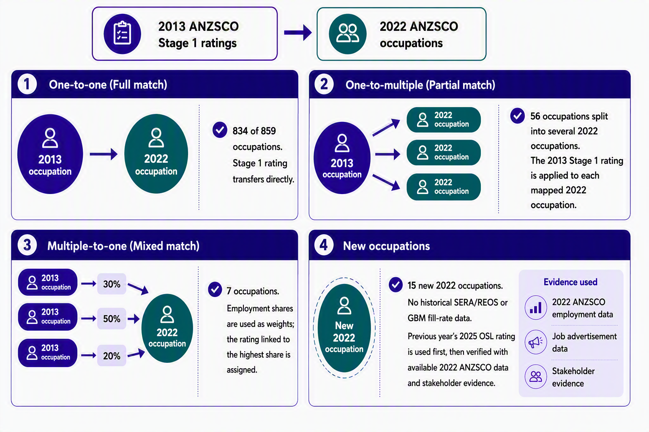
Source: Jobs and Skills Australia.
OSCA ratings are created by mapping existing ANZSCO-based OSL ratings to 2024 OSCA, then manually verifying and checking the mapping (Figure A2).

Figure A2: Mapping from ANZSCO to 2024 OSCA
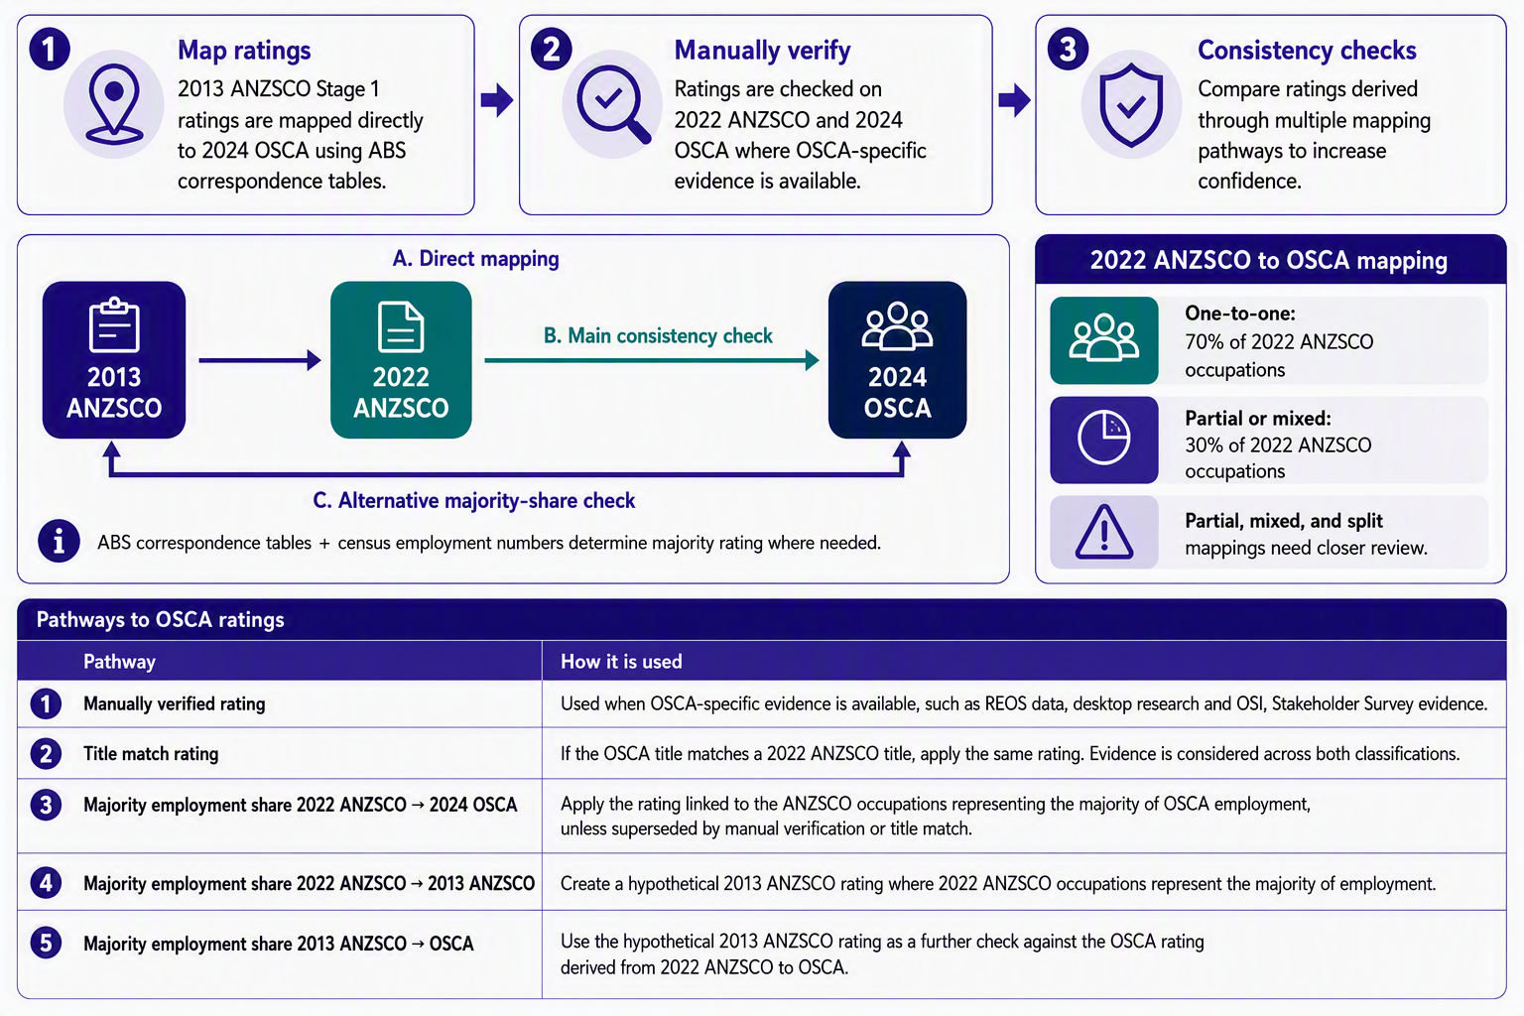Source: Jobs and Skills Australia.

Appendix C: Creating a unit group shortage list
The final occupation ratings (OSL) are converted to unit group ratings to support the Occupation Shortage Driver (OSD) analysis. Unit groups are a broader classification than occupations. For example, under ANZSCO 2022, the 915 occupations in scope of the OSL are classified into 311 unit groups. These unit groups have fewer and more general titles than individual occupations. Figure A3 is an example of converting occupation shortage ratings to a unit group rating.
Figure A3: Converting occupation ratings to a unit group rating
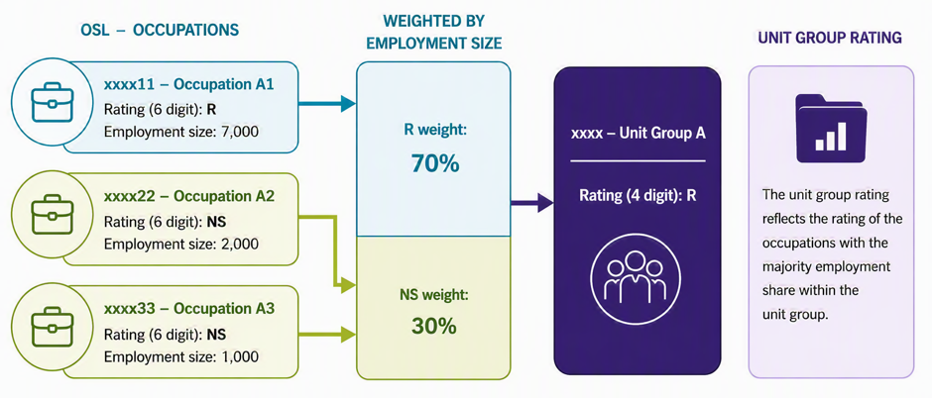
Source: Jobs and Skills Australia.
The process uses:
- the OSL results
- employment size from the ABS 2012 Census of Population and Housing
- ABS ANZSCO occupation-to-unit group mappings.
Each unit group may contain multiple occupations with different shortage ratings. Where all occupations within a unit group share the same shortage rating, that rating is assigned directly to the unit group.
Where occupations within a unit group have different shortage ratings, occupations are weighted according to their employment size. The unit group is then assigned the rating associated with the largest employment share. Only occupations within the scope of the OSL are included in this process.
Unit group ratings have the same classifications as occupation-level ratings: Shortage, No Shortage, Regional Shortage and Metropolitan Shortage.

Appendix D: GBM and input variables
The GBM model uses decision trees to predict fill rates for each occupation. The GBM operates by consecutively fitting new decision trees to enhance the estimate of the response variable (the fill rate). The above process of fitting new models continues until a stopping rule is reached. For example, when the performance of the model on the data set on which it is trained ceases to improve. The final predicted fill rates are therefore the weighted sum of the predicted values made by the previous tree’s models. Thus, the GBM produces the estimated fill rates in a gradual, additive and sequential manner.
The final GBM model uses 24 indicators from 13 sources. Most indicators (16) are at the national level, 7 are at state-level and there is a metro/non-metro indicator for each statistical area level 4 (SA4) – a spatial unit defined under the Australian Statistical Geography Standard (ASGS).
Table A3 lists the GBM inputs and their source.
Table A3: GBM input variables
Variable | Geography | Period | Source
Internet Vacancy Index (IVI) vacancies per employed  Change in IVI vacancies per employed (3 years) | State | 2006 to 2025 | Jobs and Skills Australia
Change in number employed  (3 years) | National  State | 1987 to 2024 | ABS Labour Force Survey
Unemployment rate  Change in unemployment rate  (1 year) | State  National | 2008 to 2025 | ABS Labour Force Survey
Change in ‘Seek weeks’  (3 years) | National | 1991 to 2025 | ABS Labour Force Survey
Temporary Resident (skilled) visas granted per employed | National | 2006 to 2025 | Department of Home Affairs
Proportion of hours worked by people aged under 25  Proportion of hours worked by people aged 55 and over  Proportion of hours worked by females | State  State  National | 2021 | ABS, 2021 Census of Population and Housing
Proportion employed in metro areas  Whether the Statistical Area Level 4 (SA4) is in a metro or non-metro area | State  SA4 | 2021 | ABS, 2021 Census of Population and Housing  ABS, ASGS
Mean similarity across top 3 most similar occupations, weighted by employment size | National | Dec 2023 | Jobs and Skills Australia
Skill level of occupation |  | 2013 | ABS, ANZSCO
Scaled fill rate at ANZSCO unit group | National | May 2021 to  Apr 2025 | Jobs and Skills Australia
Total size of inflow to the occupation  Inflow yearly change  Percentage net flow; net flow relative to occupation size  Outflow diversity | National | 2011–12 to  2022–23 | Jobs and Skills Australia
Proportion requiring bachelor and above | National | Jan 2012 to  Jun 2025 | Lightcast vacancies
Study diversity | National | 2021 | ABS, 2021 Census of Population and Housing
Proportion of unemployment flows into occupation | National | 2011–12 to  2021–22 | Jobs and Skills Australia
Source: Jobs and Skills Australia.
Figure A4 below provides an illustration of a decision tree, which is made up of a series of decision rules that split the inputs into groups.
Figure A4: An example of a decision tree fit to data
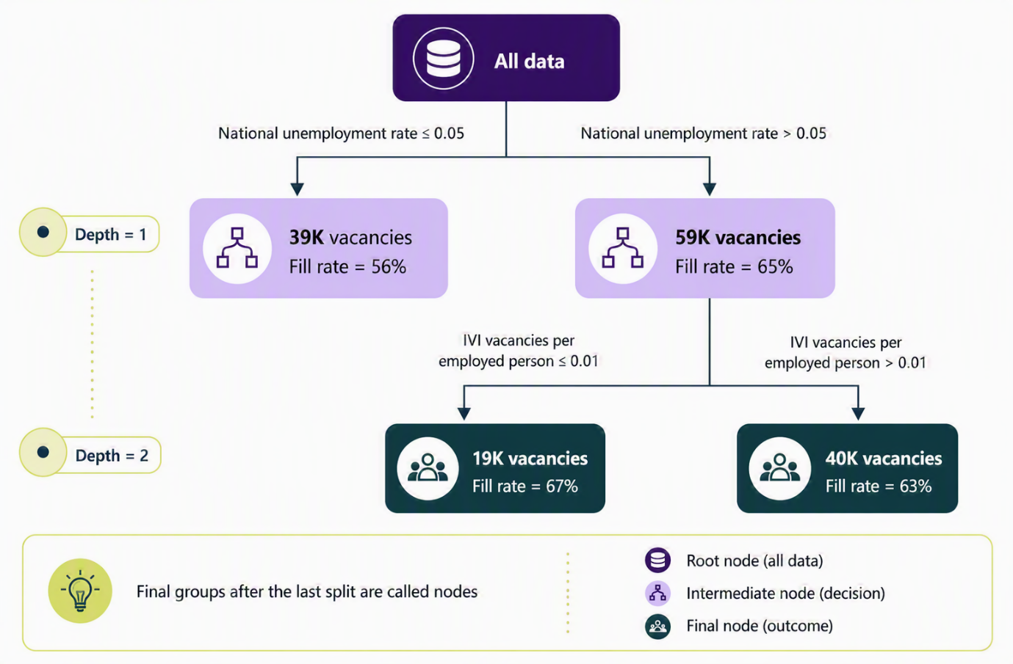
Source: Jobs and Skills Australia.
In Figure A4:
- All data are first split on the national unemployment rate being above or below 5%.
- Where the national unemployment rate is above 5%, there is a second split based on the number of vacancies per employed person being above or below 0.01.
After these 2 splits, the dataset has now been divided into 3 groups based on the unemployment rate and the number of IVI vacancies per employed person. The depth of this decision tree is 2 as there are (at most) 2 decision rules allocating the data into the groups. The algorithm selects the best decision rule for the data in each group. This is the split, which maximises the homogeneity of the modelling target within each split.
As mentioned above, GBM fits many decision trees, with each subsequent tree fit to the residual (target minus estimate) to improve the current estimate.
The GBM estimates fill rates over a 12-month period, starting from April for all occupations defined by 2013 ANZSCO.

Appendix E: SERA
The Survey of Employers who have Recently Advertised (SERA) is a survey of employers conducted by a third-party contractor on behalf of Jobs and Skills Australia. The purpose of the survey is to collect information on the recruitment experiences of employers. More than 11,000 employers are surveyed each year, covering more than 20,000 vacancies for around 580 occupations. The survey provides both quantitative and qualitative data.
The target population for the survey is all employers and recruiters with advertised job vacancies in Australia in occupations:
- within 2022 ANZSCO Skill Levels 1 to 4
- with at least 1,500 people across Australia who were employed in the occupation, according to the ABS 2021 Population and Housing Census.
The survey is stratified by Major Group and state/territory. Within each stratum, all vacancies have an equal chance of being selected. This helps to ensure that the sample provides unbiased and representative data.
For more information on SERA contact Jobs and Skills Australia at: OccupationShortageList@jobsandskills.gov.au.

Appendix F: OSL Stakeholder Survey
The OSL Stakeholder Survey (the stakeholder survey) collects responses from peak bodies, professional associations, unions, regional representative bodies, and education and training advisory bodies. Responses are also received from government agencies, recruitment agencies/labour hire firms, employers, workers and JSCs.
The stakeholder survey can be completed between January and March of each year.
The stakeholder survey collects high level information on 3 key areas related to recruitment experience:
- Proportion of vacancies filled, by states/territories, and by location
(metropolitan, regional or both)
- Supply of workers
- Demand for workers compared to the previous year.
Information is collected at the occupation level on a 2024 OSCA basis. It is used, along with other information, during Stage 2 of occupation assessments.
The stakeholder survey is limited because generally responses received for each occupation are small, while skill levels 3 and 4 are overrepresented and there may be self-selection bias, as employers who are not experiencing workforce challenges may be less inclined to participate in this survey.

OSCA and ANZSCO are skill-based frameworks used to classify occupations in the Australian labour market. OSCA, an update to ANZSCO, was released in December 2024 and only contains Australian occupations. Both classifications are organised into a 5 level hierarchy: major groups, sub-major groups, minor groups, unit groups and occupations. Occupation is the most detailed and is represented by 6 digit OSCA and ANZSCO codes This is the level that the report refers to.
Skill Level 5 occupations typically require an Australian Qualifications Framework Certificate I or compulsory secondary education. For some occupations, a short period of on-the-job training may be required in addition to or instead of formal qualifications. Skill Level 5 occupations are excluded as they generally have fewer barriers to entry and unlike other in-scope occupations, generally do not require significant post-school education and training.
Māori-specific occupations are examples of New Zealand-based occupations only.
Confidence labels are introduced for the first time in the 2026 OSL. They are based on professional judgement. This is explained further in the report.
There are some very small occupations (employment level below the 25th percentile) where there is very limited information. This creates a high level of uncertainty. For these occupations, Jobs and Skills Australia undertake a cautious approach of rating these occupations as No shortage.
The 67% threshold was based on the national average fill rate estimated from the Jobs and Skills Australia Gradient Boosted Machine Learning Model. Analysis showed that over time the national average fill rate tends to be around 67%. Further testing showed that a threshold rate of 67% produced the most stable OSL results.
Refer to Appendix D for more information on SERA. For more information on REOS, refer to Recruitment Experiences and Outlook Survey | Jobs and Skills Australia.
The observed SERA fill rates are a 5-year weighted moving average. A moving average means the 5-year window shifts each year. For example: the 2026 rate uses data from 2022 to 2026. the 2025 rate uses data from 2021 to 2025. A weighted average means not all years contribute equally. More recent years receive higher weights. For example, the 2026 data has the highest weight, the 2025 data has a lower weight, and earlier years have progressively smaller weights.
Some highly complex rules have been excluded from this report as they have marginal impact on the final ratings.
Refer to footnote 5.
While some OSCA-based data is available, it does not yet cover enough occupations or provide enough historical information to support consistent assessments across the full occupation set.
Refer to Appendix B for the approach used.
Ibid.
Refer to Appendix E.
For more information refer to Labour Force Trending | Jobs and Skills Australia
One feature used by the GBM model is an estimate of the current year's employment size based on Census 2021 employment sizes and updated information from the ABS Labour Force Survey and Jobs and Skills Australia Nowcast of Employment by Region and Occupation (NERO). For more information on NERO, refer to Nowcast of Employment by Region and Occupation (NERO) | Jobs and Skills Australia.
The LSI measures how far the applicants per vacancy for a specific unit group deviates from the overall average as a measure of how oversupplied or undersupplied the unit group is. A large negative LSI indicates an undersupply of applicants, while a large positive LSI indicates an oversupply. For more information on the LSI, refer to the Occupation Shortage Report – March 2025.
Replacement rate was constructed from Data on Occupation Mobility (DOM) which was created using Person Level Integrated Data Asset, 2010-11 to 2023-24, Income Tax Return data, ABS DataLab.
In some instances, feedback that scores below the acceptance benchmark may still be considered if it presents strong qualitative evidence, based on judgement.
The occupation employment level is based on the 2021 ABS Census.
In some cases, the collective employment share of states where the rating has been accepted is marginally short of 2 thirds share of national level employment. For those cases, judgement is applied to determine whether the national level rating should be adjusted.
In previous years, Jobs and Skills Australia published accepted state ratings alongside the OSL. From 2026, these ratings will no longer be published. This change is intended to avoid any misunderstanding that they represent Jobs and Skills Australia’s own assessment of labour market conditions in each state and territory, which they do not.
For the OSCA classification, see the Australian Bureau of Statistics webpage: OSCA - Occupation Standard Classification for Australia, 2024, Version 1.0 | Australian Bureau of Statistics. For the ANZSCO classification, consult the webpage: ANZSCO - Australian and New Zealand Standard Classification of Occupations, 2022 | Australian Bureau of Statistics.
nec stands for ‘not elsewhere classified’.
A unit groups can also be referred to by a 4 digit code. For more detail on the hierarchies within the classifications see footnote 1.
More information on GBMs is available online, including high level introductions. An example is: Introduction to Boosted Trees — xgboost 2.0.3 documentation.
Number of weeks searching for job divided by the number of unemployed.
As per Jobs and Skills Australia’s Internet Vacancy Index (IVI).

