Recruitment trends in the IT industry: Analysis of the REOS dataset
The IT industry is a significant contributor to Australia's digital economy and has recorded strong employment growth in recent years. While long-term employment projections remain positive, other labour market indicators point to changing conditions, including lower levels of online job advertisements, softer recruitment activity and more subdued employer staffing expectations. Understanding these developments is important because the sector plays a key role in technological adoption and innovation across the broader economy.
The IT industry may also provide an early indication of how emerging technologies are influencing workforce and recruitment patterns. Recent evidence suggests that many ICT occupations are experiencing rapid skill change and relatively high exposure to AI-related augmentation. However, current evidence does not indicate widespread AI-related disruption to employment growth. This report considers whether broader labour market indicators point to changing recruitment conditions in the sector and how these compare with wider industry trends.
Using data from Jobs and Skills Australia’s Recruitment Experiences and Outlook Survey (REOS), this report examines recruitment trends in the IT industry, including recruitment activity, hiring difficulty, applicant per vacancy numbers and employer expectations. It also draws on other labour market evidence, including employment, vacancy and occupational data, to provide a broader picture of recruitment trends in the industry. The findings suggest that recruitment conditions in the IT industry, on average, tend to be softer than in many other industries, with relatively large applicant pools and lower recruitment difficulty pointing to strong competition for vacancies, although employers continue to report challenges in finding candidates with specific technical skills.
For this report, the IT industry is defined as the ABS ANZSIC Subdivision 70 Computer System Design and Related Services. This industry sits within the Professional, Scientific and Technical Services industry division. The remaining industries within this division fall into the ANZSIC Subdivision 69 Professional, Scientific and Technical Services (Except Computer System Design and Related Services) and are referred to as ‘Other Professional, Scientific and Technical Services’ industries in this paper.
While the IT industry employs the largest share of ICT Professionals, these workers are employed across all industry divisions. Similarly, the IT industry itself has a broad occupational profile, employing workers across all major occupation groups, from managers and professionals through to labourers.
Given the relatively small REOS sample size for the IT industry, findings should be interpreted in their broader labour market context and not in isolation. Where possible, annual results are presented on a financial year basis, while more disaggregated analysis draws on the broader REOS dataset covering financial years 2020-21 to 2025-26 to increase sample size and support more robust results.

Key findings

For the IT industry
- REOS results indicate a significant recent shift in the areas of major concern cited by employers in the IT industry - away from concerns about recruitment or retention difficulties and towards concerns about a lack of demand for products or services.
- In 2025-26, only 3% nominated recruitment or retention difficulties as their greatest concern over the next three months, compared with 20% of employers in Other Professional, Scientific and Technical Services industries. This represents a significant reduction compared to previous years. Annualised data from 2021-22 from 2024-25 highlights that between 18% and 30% of employers in the IT industry nominated recruitment or retention difficulties as their greatest concern each year.
- Instead, lack of demand for products or services was the most cited concern for employers in the IT industry in 2025-26 (43%, compared with 23% for Other Professional, Scientific and Technical Services industries). This represents a significant increase when compared to only 8% of employers in the IT industry citing lack of demand for products and services in 2023-24.
- This shift in IT industry employer concerns is likely to have influenced both their recent recruitment activity and their recent views on future employment expectations to some degree, though this effect cannot be quantified.
- In 2025-26, the IT industry recruitment rate (32%) was considerably lower than the average for Other Professional, Scientific and Technical Services (41%) and the average for all industries (49%). This is consistent with a theme of softened recruitment levels highlighted in Future Skills Organisation's Workforce Plan 2026.
- Employment expectations were also subdued in the IT industry in 2025-26, with just 16% of employers in the industry expecting to increase staffing in the three months after being surveyed, the lowest level in recent years and below the all-industry average (19%).
- In line with this weaker hiring demand, recruitment difficulty in the IT industry was relatively low, recording the second-lowest recruitment difficulty rate among the industry subdivisions analysed.
- REOS data also suggest strong competition for vacancies in the industry, with 34% of recruiting employers receiving 20 or more applicants per vacancy, the second-highest proportion among the industry subdivisions analysed. However, data on applicant numbers should be interpreted with caution, as around one-third of recruiting employers were unable to provide this information.
- Taken together, REOS data suggest that recruitment activity in the IT industry is currently subdued, and recruitment difficulty is relatively low compared to other industries, while competition among job seekers remains strong. The findings also suggest that recruitment difficulties are more likely to reflect specific technical skill mismatches and/or an oversupply of candidates than a general shortage of applicants.

For ICT Professionals
- Looking specifically at ICT Professionals over 2020-21 to 2025-26, REOS data indicate that employers attracted large applicant fields for their advertised positions with 42% of recruiting employers receiving 20 or more applicants per vacancy, the second highest of any of the analysed 2-digit occupation groups.
- Recruitment difficulty for employers hiring ICT Professionals was also well below average, at 44%. A very low proportion of employers cited a lack of applicants as a reason for difficulty, while a relatively high proportion cited a lack of technical skills.

Broad labour market trends in the IT industry
In February 2026, the IT industry employed 376,100 workers, accounting for around 2.5% of total employment in Australia. Over the last year, employment in the IT industry grew by 5.2%, well above the average for all industries (1.5%).
Looking over the last five years, IT industry employment increased by 29.5% (or 85,600 persons), compared with 14.8% for all industries. By contrast, the Other Professional, Scientific and Technical Services industry grew at a slower rate, up by 17.5% (or 154,100 persons) over this period. ICT Professionals have also recorded similarly strong employment growth over this period (up by 29.3% or 99,500).
Despite optimism around future staffing levels being low in 2025-26, looking over the longer term, strong employment growth is expected to continue. JSA projects that employment in the IT industry will increase by 54,200 (or 15.3%) in the five years to May 2030. This is above the 8.3% for Other Professional, Scientific and Technical Services industries and the 6.5% for all industries. Employment for ICT Professionals is forecast to increase by 62,200 (or 14.8%) over the same period.
Around 48% of employment in the IT industry is accounted for by ICT Professionals. Several ICT Professional occupations have high AI automation exposure scores which indicate that AI is more likely to provide opportunities to support, enhance, or improve the way they carry out their existing tasks. The recent AI and Employment in Australia report suggests that while AI may be changing the way that ICT Professionals undertake tasks, there is no evidence of widespread slowing in employment growth due to AI.
Employment growth for ICT Professionals has been strong over the last five years and is expected to continue to grow strongly over the five years to May 2030. JSA’s Internet Vacancy Index is not available for the IT industry. However, the number of online job advertisements for ICT Professionals was at the lowest level recorded in the time series (at 5,960 in July 2026). Internet vacancy numbers for ICT Professionals have been trending down since the recent high recorded in April 2022 (of 14,780).

Future concerns in the IT industry
As part of the REOS survey, employers are asked about their single greatest concern over the next three months (i.e. for the three months following the survey). Over the past five financial years, REOS data indicate a notable shift in employers’ reported concerns. In 2025–26, lack of demand for products or services was the most commonly reported concern, rising to 43%, up from 35% in 2024–25 and 8% in 2023–24 (Table 1). In contrast, the proportion citing recruitment or retention difficulties and skill shortages as their greatest concern fell sharply, from 22% to 3% over the latest year. Together, these results suggest that employers’ concerns in the industry have shifted away from workforce availability towards demand-related issues.
Table 1: Single greatest future concern responses, IT industry, 2021-22 to 2025-26
Greatest future concern over the next three months | 2021-22 | 2022-23 | 2023-24 | 2024-25 | 2025-26
Lack of demand for products/services | 21% | 16% | 8% | 35% | 43%
Other reasons | 15% | 1% | 5% | 13% | 20%
No concerns | 25% | 22% | 30% | 15% | 19%
Costs | 3% | 14% | 11% | 9% | 5%
Keeping up with demand for products or services | 1% | 8% | 4% | 0% | 5%
Recruitment/ retention difficulty/skill shortages | 18% | 30% | 24% | 22% | 3%
Cash flow | 6% | 4% | 14% | 4% | 3%
Government regulation/red tape | 0% | 0% | 0% | 0% | 2%
Health related concerns (inc. mental health) | 0% | 6% | 0% | 3% | 0%
Supply chain issues | 11% | 0% | 3% | 0% | 0%
Source: JSA, Recruitment Experiences and Outlook Survey (REOS), 30 June 2026
Comparing with other industries, in 2025-26, weak demand for their products or services was the dominant concern in the IT industry, reported by 43% of businesses in the industry. This was considerably higher than in Other Professional, Scientific and Technical Services industries (23%) and across all industries (24%). 20% of employers in the industry nominated other reasons (more than double the proportion across all industries (9%)) and 19% reported no concerns. Just 3% of businesses in the IT industry nominated recruitment or retention difficulties (ranked sixth) compared with 20% in Other Professional, Scientific and Technical Services businesses.
Table 2: Single greatest future concern, by industry, 2025-26
Greatest future concern over the next three months | 2025-26
 | IT industry | Other Professional, Scientific and Technical Services industries | All industries
Lack of demand for products/services | 43% | 23% | 24%
Other reasons | 20% | 10% | 9%
No concerns | 19% | 24% | 21%
Costs | 5% | 7% | 13%
Keeping up with demand for products or services | 5% | 8% | 4%
Recruitment/ retention difficulty/skill shortages | 3% | 20% | 21%
Cash flow | 3% | 6% | 4%
Government regulation/red tape | 2% | 2% | 1%
Health related concerns (inc. mental health) | 0% | 0% | 1%
Supply chain issues | 0% | 0% | 1%
Source: JSA, Recruitment Experiences and Outlook Survey (REOS), 30 June 2026

Recruitment activity in the IT industry
Employers are also asked whether they are currently recruiting or had recruited in the previous month.
In 2025-26, the recruitment rate for the IT industry was 32%, which was considerably lower than the average for Other Professional, Scientific and Technical Services industries (41%). The recruitment rate for all industries was 49% in 2025-26. It is worth noting that, although the recruitment rate for the IT industry appeared higher in 2024–25, the rate fell back to 32% in 2025–26, a level similar to that recorded in 2023–24 (31%). The 2025-26 recruitment rate was well below the rates recorded in all years during 2020-2023 period.
Using two-year rolling averages to smooth the year-to-year volatility (see Chart 5 in the Appendix), the data show that the IT industry’s recruitment rate declined from around 46% in the period 2021-22 to 2022-23, to around 37% in the period 2023-24 to 2025-26. This suggests that the lower recruitment rates observed in recent years may reflect a broader moderation in recruitment activity rather than a one-off result, although the limited time series means this pattern should be interpreted with caution.
Chart 1: Recruitment rate in the IT industry compared with all Other Professional, Scientific and Technical Services industries, 2020-21 to 2025-26
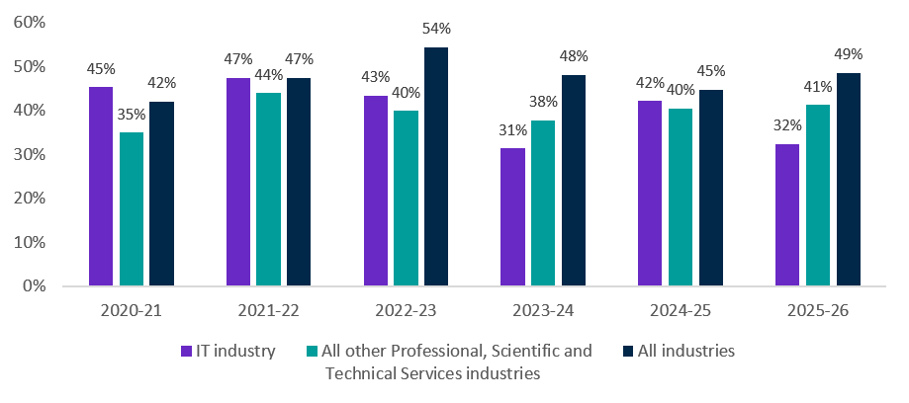
Source: JSA, Recruitment Experiences and Outlook Survey (REOS), 30 June 2026

Expectations for future staffing level increases
As part of the REOS survey, employers are asked about their expectations for staffing numbers over the next three months (i.e. in the three months following the survey).
In 2025-26, 16% of employers in the IT industry expected to increase their staffing in the next three months, below the 21% recorded for Other Professional, Scientific and Technical Services industries and the 19% recorded for all industries. The relativity between these results differs noticeably from the preceding four financial years, where the percentage of employers expecting to increase their staffing was greater in the IT industry than it was for either Other Professional, Scientific and Technical Services industries or for all industries.
Chart 2: Expectations for staffing numbers to increase in the IT industry compared with Other Professional, Scientific and Technical Services industries, 2020-21 to
2025-26
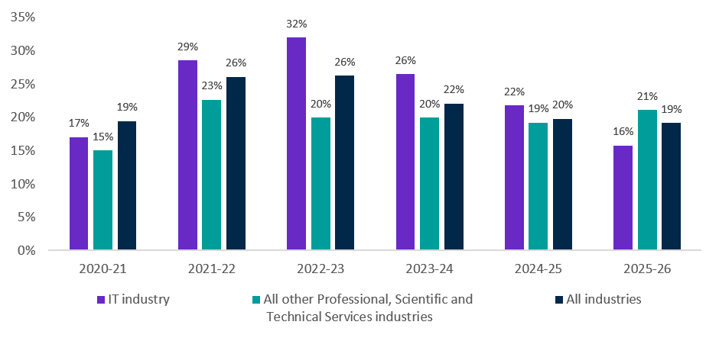
Source: JSA, Recruitment Experiences and Outlook Survey (REOS), 30 June 2026

Recruitment difficulty in the IT industry
Unless otherwise specified, this section uses combined data for 2020-21 to 2025-26 due to the smaller sample sizes available at this level of disaggregation.
As part of the REOS survey, employers are asked a series of questions about the occupation for which they most recently recruited in the previous month.
For this period, two key trends are evident:
- Employers in the IT industry, on average, had considerably less difficulty recruiting than those in Other Professional, Scientific and Technical Services industries.
- Small businesses in this industry had considerably more difficulty recruiting than medium and larger businesses.
Over this period, 39% of recruiting employers in the IT industry stated that they had difficulty hiring staff. This was the second lowest recruitment difficulty rate of the 39 industry subdivisions (2-digit) analysed. This compares with 54% of recruiting employers in Other Professional, Scientific and Technical Services industries and 54% across all industries.
Data also suggest that recruitment difficulty rates vary considerably by business size, with 46% of small IT businesses (less than 20 employees) experiencing recruitment difficulty, compared with 27% of larger businesses (20 or more employees).
- Larger businesses in the IT industry tend to have significantly lower recruitment difficulty rates compared with larger businesses in Other Professional, Scientific and Technical Services industries (48%) and the all-industries average for larger businesses (48%).

Applicant numbers in the IT industry
The REOS survey asks employers how many applicants they received for their most recent recruitment exercise. Employers who were unsure about their applicant numbers were excluded from the analysis. It should be noted that a large proportion of employers surveyed were unsure about applicant numbers – with around one in three employers unable to provide an estimate. Industries were excluded from the analysis if they did not have a sufficient sample size for analysis.
Data suggest that employers in the IT industry tend to attract large applicant fields when they recruit and that applicants tend to face strong competition to secure positions in this industry.
Looking at businesses in the IT industry, 34% of recruiting employers stated that they had 20 or more applicants per vacancy. This was the second highest of the 2-digit industries analysed and is well above the average of 26% for Other Professional, Scientific and Technical Services industries and of 19% for the all-industries average.
Table 3, below, shows the recruitment difficulty rate and the proportion of employers with 20 or more applicants per vacancy by 2-digit industry. Employers surveyed in the IT industry tended to report relatively lower recruitment difficulty and higher applicant per vacancy numbers than many other selected 2-digit industries. Specifically, 39% of employers in the IT industry reported recruitment difficulty, the second lowest among the 39 industries analysed, behind Food Retailing (37%). At the same time, 34% of IT employers received 20 or more applicants, the second-highest proportion, behind Other Goods Wholesaling (37%). Table 3 is sorted in ascending order by the recruitment difficulty rate.
Table 3: Recruitment difficulty rate and proportion of employers receiving 20 or more applicants per vacancy, by selected 2-digit industry, combined data from 2020-21 to 2025-26
Industry code (2-digit) | Industry title (2-digit) | Recruitment difficulty rate | % with 20 or more applicants
41 | Food Retailing | 37% | 11%
70 | IT industry (Computer System Design and Related Services) | 39% | 34%
91 | Sports and Recreation Activities | 40% | 20%
67 | Property Operators and Real Estate Services | 43% | 27%
72 | Administrative Services | 45% | 28%
45 | Food and Beverage Services | 46% | 13%
64 | Auxiliary Finance and Insurance Services | 47% | 29%
36 | Grocery, Liquor and Tobacco Product Wholesaling | 47% | 24%
40 | Fuel Retailing | 47% | 17%
80 | Preschool and School Education | 47% | 12%
12 | Beverage and Tobacco Product Manufacturing | 48% | 14%
30 | Building Construction | 48% | 22%
37 | Other Goods Wholesaling | 49% | 37%
42 | Other Store-Based Retailing | 49% | 22%
95 | Personal and Other Services | 50% | 22%
11 | Food Product Manufacturing | 50% | 19%
85 | Medical and Other Health Care Services | 50% | 25%
44 | Accommodation | 51% | 18%
86 | Residential Care Services | 52% | 14%
33 | Basic Material Wholesaling | 52% | 22%
19 | Polymer Product and Rubber Product Manufacturing | 53% | 20%
69 | Professional, Scientific and Technical Services (Except Computer System Design and Related Services) | 54% | 26%
01 | Agriculture | 55% | 15%
66 | Rental and Hiring Services (except Real Estate) | 55% | 24%
16 | Printing (including the Reproduction of Recorded Media) | 56% | 29%
73 | Building Cleaning, Pest Control and Other Support Services | 58% | 22%
31 | Heavy and Civil Engineering Construction | 59% | 21%
32 | Construction Services | 59% | 18%
25 | Furniture and Other Manufacturing | 60% | 22%
34 | Machinery and Equipment Wholesaling | 61% | 24%
87 | Social Assistance Services | 62% | 11%
24 | Machinery and Equipment Manufacturing | 63% | 29%
20 | Non-Metallic Mineral Product Manufacturing | 64% | 13%
39 | Motor Vehicle and Motor Vehicle Parts Retailing | 64% | 18%
22 | Fabricated Metal Product Manufacturing | 65% | 17%
46 | Road Transport | 69% | 15%
94 | Repair and Maintenance | 72% | 12%
14 | Wood Product Manufacturing | 75% | 7%
23 | Transport Equipment Manufacturing | 77% | 19%
Source: JSA, Recruitment Experiences and Outlook Survey (REOS), 30 June 2026

Putting the two indicators in Table 3 into a quadrant analysis, Chart 3 below shows how 2-digit industries are distributed according to their recruitment difficulty rate and the proportion of employers receiving 20 or more applicants per vacancy. The IT industry is located in the upper left-hand quadrant, combining a below-median recruitment difficulty rate and an above-median proportion of employers receiving 20 or more applicants per vacancy.
It is also worth noting that the IT industry is also positioned relatively far from both median lines, indicating that its recruitment difficulty rate was notably lower, and its proportion of employers receiving 20 or more applicants was notably higher, than the medians across the industries analysed. Together, these results suggest that recruitment conditions in the IT industry were characterised by larger applicant fields and lower recruitment difficulty than in many other industries. This may indicate a relatively strong supply of applicants for employers and greater competition for vacancies among job seekers.
Chart 3: Scaled recruitment difficulty rate and scaled proportion of employers receiving 20 or more applicants per vacancy, combined data from 2020-21 to 2025-26, selected 2-digit industries
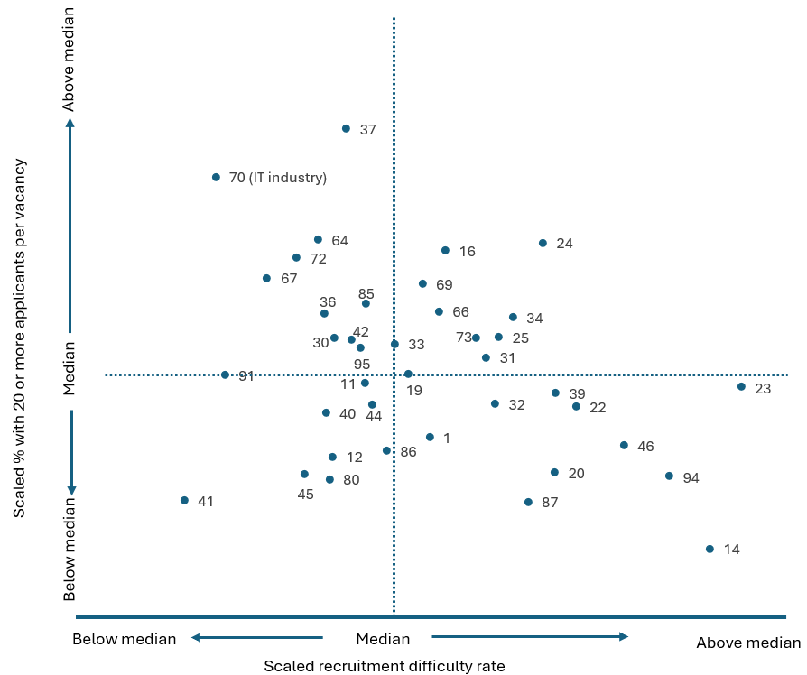
Source: JSA, Recruitment Experiences and Outlook Survey (REOS), 30 June 2026. The numbers next to each point indicate the relevant 2-digit Australian and New Zealand Standard Industrial Classification (ANZSIC) subdivision code.

ICT Professionals
The following section shifts from an industry lens to an occupation lens, examining ICT Professionals regardless of the industry in which they are employed.
The IT industry employs a diverse range of roles. Based on Australian Bureau of Statistics data, around 48% of employment in this industry is accounted for by ICT Professionals, followed by Specialist Managers (13%), Business, Human Resource and Marketing Professionals (10%) and Engineering, ICT and Science Technicians (9%). Together these groups comprise 81% of total employment in this industry.
While most ICT Professionals are employed within the IT industry (defined for the purposes of this report to be 70 Computer System Design and Related Services), ICT Professionals are also employed across other industry sectors.
Looking at ICT Professionals, the average recruitment difficulty rate for employers hiring ICT Professionals was 44% over the period 2020-21 to 2025-26, compared with 58% for all other Professionals and 54% across all occupations.
Employers hiring ICT Professionals were far more likely to cite a lack of technical skills and considerably less likely to cite a lack of applicants as a reason for having recruitment difficulty. They were also slightly less likely to cite a lack of suitable applicants and undesirable working conditions (which includes working conditions, hours and wages) as a reason for difficulty. By contrast, lack of experience is more likely to be cited as a reason for difficulty.
Several ICT Professionals were included on the JSA’s Occupational Shortage List (OSL) in 2023 and 2024. These were Multimedia Specialists and Web Developers, Software and Applications Programmers, and Computer Network Professionals. These occupations were not in shortage in 2025 due to labour market indicators suggesting weak demand, sufficient supply of workers, and low recruitment difficulty rates.
For these occupations (that were previously in shortage), suitability gap was main the driver, suggesting the issue stems from a mismatch between employers’ expectations and workers’ skills and experience. Data from JSA’s Survey of Employers who have Recently Advertised (SERA) showed the main reasons for job applicants’ unsuitability for the roles were a lack of experience and qualification and a lack of working rights.

Chart 4: Selected reasons for recruitment difficulty, aggregated data 2020-21 to 2025-26, ICT Professionals and selected comparisons
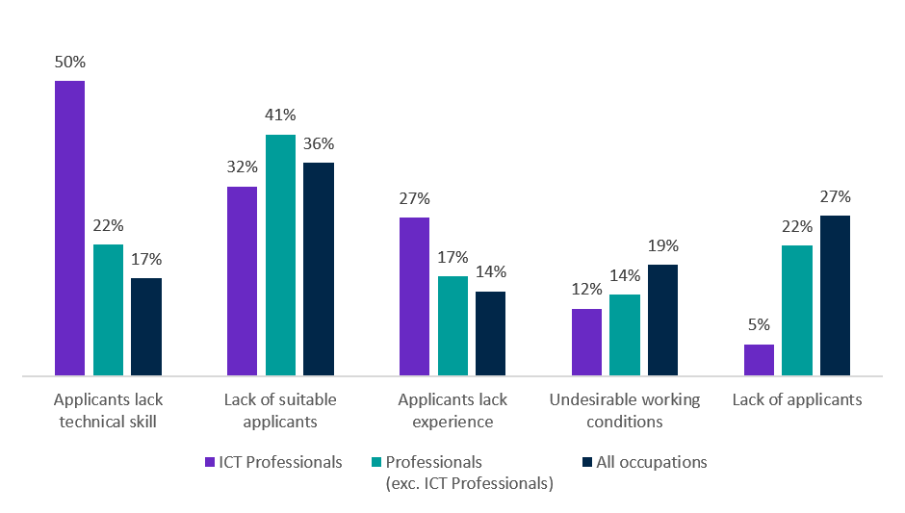
Source: JSA, Recruitment Experiences and Outlook Survey (REOS), 30 June 2026

Applicant fields for ICT Professional roles
Similar to the situation for the IT industry, employers tend to have larger applicant fields for ICT Professional roles relative to many other occupations.
On average, around 42% of employers recruiting for ICT Professionals receive 20 or more applicants per vacancy for their advertised position. This was the second highest of the 39 occupations analysed. This compares with 22% of employers recruiting for Professional occupations (excluding ICT Professionals) and 19% for those recruiting across all occupations.

What can we conclude about these findings?
Taken together, these findings suggest that the IT industry continues to demonstrate strong long-term employment growth, while current recruitment activity and employer staffing expectations are relatively subdued. Combined REOS data from 2020-21 to 2025-26 show that IT employers generally received large applicant fields and reported lower recruitment difficulty than employers in other industries over this period. This suggests that applicants may have faced relatively strong competition for vacancies when applying for jobs in the industry. Where employers did experience recruitment difficulty, the findings point more towards specific technical skill mismatches than a general shortage of applicants.
Applicant numbers and recruitment difficulty in 2025-26 are more difficult to assess due to the small sample size. However, results based on limited available data suggest relatively high applicant numbers and recruitment difficulty being slightly below the average for all higher-skilled occupations.

Background
The Recruitment Experiences and Outlook Survey (REOS) is an ongoing survey of employers across Australia. Approximately 1,000 employers are surveyed each month, with data published on the Jobs and Skills Australia website. While the data are indicative of recruitment activity, they may be subject to seasonal factors and other volatility and should therefore be used with caution. The survey is targeted towards employers with five or more employees and excludes many government organisations. Further information is available in the REOS methodology paper.
REOS data are published monthly in the Recruitment Insights Report which is generally published on the third Tuesday of the month. Spotlights are also produced in most months.

Note on REOS applicants per vacancy data
A REOS spotlight is expected to be released in late 2026 which analyses REOS data on applicants per vacancy at the state, industry (1-digit) and occupation level (1-digit). This spotlight will use a new measure that focuses on employers who had recruited through the internet (other methods could also have been used in conjunction) and excludes employers who had unfilled vacancies for less than a month. The methodology used for the results in this paper however, includes all employers (regardless of recruitment method used or the time since vacancies were advertised) to maximise the number of 2-digit industries included in the analysis of applicants per vacancy.

Technical notes
The REOS is a telephone-administered survey with the business owner or other person in the business who is responsible for recruitment. All figures presented in this report have been weighted by location and workplace size, according to the Australian Bureau of Statistics Counts of Australian Businesses, including Entries and Exits (June 2018 to June 2022) publication. The weighted figures are intended to create nationally representative results by correcting for the oversampling of smaller regions compared with larger regions.
REOS survey data are coded and reported according to the following ABS classifications:
- Industry is defined by the Australian and New Zealand Standard Industrial Classification (ANZSIC), 2006, Version 2.0.
- Occupation is defined by both:
  - the Australian and New Zealand Standard Classification of Occupations (ANZSCO), 2022, and;
  - the Occupation Standard Classification for Australia (OSCA), 2024.
- Capital City and Rest of State areas are defined by the Australian Statistical Geography Standard (ASGS): Volume 1 - Main Structure and Greater Capital City Statistical Areas, July 2021.
Data in this release should be referenced as: Jobs and Skills Australia, Recruitment trends in the IT industry: Analysis of the REOS dataset, September 2026.
For more information, email: reos@jobsandskills.gov.au

Appendix
Chart 5: Recruitment rate in the IT industry compared with all Other Professional, Scientific and Technical Services industries, rolling two-year average, 2021-22 to 2025-26
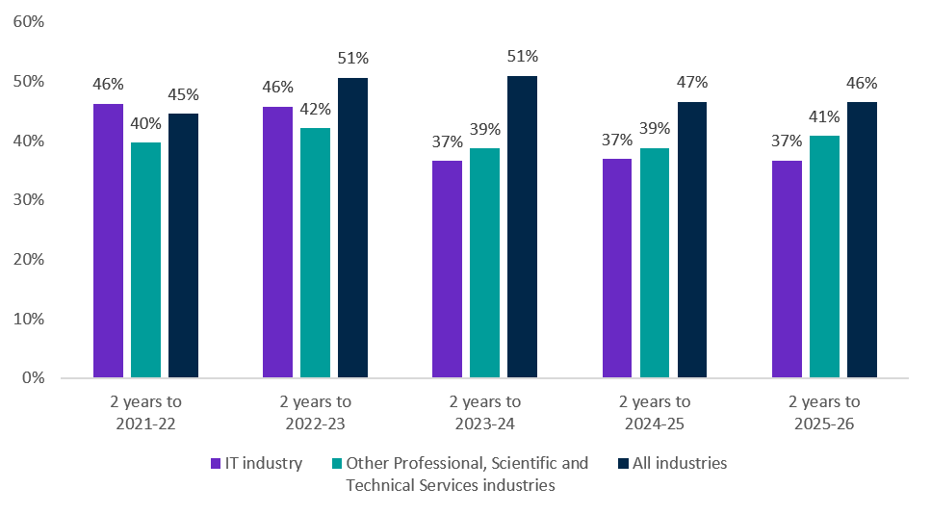

JSA, Generative AI Capacity Study - Interactive Tables Data, Table 1, Occupation Augmentation exposure score, 2025. These occupations are Software and Applications Programmers; ICT Business and Systems Analysts;
DEWR, AI and Employment in Australia: Monitoring framework and evidence to date, July 2026
ABS, Labour Force, customised data, 2026 (2025 reference period). At this time, 40% of ICT Professionals were employed in the IT industry. ICT Professionals account for 48% of total employment in the IT industry.
ABS, Labour Force, Australia, Detailed, February 2026, ABS and JSA trend estimates (latest available data). Occupation estimates from the ABS Labour Force Survey are currently paused. The ABS intends to resume producing Labour Force Survey occupation data, starting from the September 2026 reference period Labour Force Survey release.
JSA, Generative AI Capacity Study - Interactive Tables Data, 2025. IT Professional occupations with high AI augmentation exposure scores include: Software and Applications Programmers; ICT Business and Systems Analysts; and Multimedia Specialists and Web Developers.
DEWR, AI and Employment in Australia: Monitoring framework and evidence to date, July 2026
JSA, Employment Projections, May 2025
JSA, Internet Vacancy Index, July 2026, trend estimates
The available data do not indicate what these other concerns involved.
Professional, Scientific and Technical Services (Except Computer System Design and Related Services) is referred to as ‘Other Professional, Scientific and Technical Services’ industries in this paper.
The recruitment rate is the proportion of employers who were either currently recruiting at the time of the survey or had recruited in the month prior to being surveyed.
ABS, Labour Force, customised data, 2026 (2025 reference period)

