REOS Recruitment Insights Report - August 2026
Jobs and Skills Australia surveys around 1000 employers in the Recruitment Experiences and Outlook Survey (REOS) each month to find out their experiences recruiting staff, and whether they are expecting to increase staffing levels.

Key Findings
Recruitment activity strengthened in August 2026, with half of all employers either recruiting or having recently recruited. This represented a notable increase from July and returned recruitment activity to the level recorded a year earlier. Recruitment activity was higher in Rest of State areas than in Capital Cities.
Employers' recruitment experiences changed little over the month. Recruitment difficulty increased slightly to 45% of recruiting employers, although it remained well below the peak levels experienced during 2022. The proportion of employers unable to fill vacancies within a month also remained below year-earlier levels, indicating labour shortages have eased compared with recent years.
Recruitment continued to be driven primarily by staff replacement rather than workforce expansion. Almost six in ten recruiting employers were hiring solely to replace workers who had left, while around one-third were recruiting only for new positions.
Employer confidence improved modestly in August, with 20% of employers expecting to increase staffing levels over the next three months. While this was higher than in July, staffing expectations remained below year-earlier levels, indicating employers remain cautious about workforce growth.
Overall, the results indicate that employer demand for labour strengthened in August. However, hiring intentions remained relatively subdued compared with a year earlier, suggesting workforce growth is likely to remain modest in the near term.

Recruitment activity
In August 2026, 50% of employers were recruiting or had recently recruited. This represented a notable increase from July and returned recruitment activity to the level recorded a year earlier. The result was also above the smoothed trend estimate, indicating recruitment activity reported by employers was stronger than the longer-term trend.
Recruitment activity remained stronger outside the capital cities, with 53% of employers in Rest of State areas recruiting compared with 48% in Capital Cities. The increase over the month was largely reflected in Capital Cities, where recruitment rates were higher than in July.

Recruitment difficulty
Recruitment difficulty increased slightly to 45% of recruiting employers in August 2026. While this was the highest result recorded since March 2026, it remained considerably lower than the peak of 75% recorded during July 2022.
Compared with a year earlier, a higher proportion of recruiting employers reported experiencing recruitment difficulty, particularly when recruiting for higher-skilled occupations.
More than half of employers recruiting for higher-skilled occupations reported recruitment difficulty, compared with around one-third of those recruiting for lower-skilled occupations.
Recruitment difficulty remained somewhat higher in Rest of State areas (47%) than in Capital Cities (44%), continuing a pattern evident throughout much of the survey series. Despite this difference, reported recruitment difficulty remained below the levels recorded during 2022 and early 2023.

Staffing outlook: employers expecting to increase staff
The proportion of employers expecting to increase staffing levels over the next three months rose to 20% in August 2026. This followed several months of lower reported staffing expectations and represents an increase from July.
Despite the monthly increase, staffing expectations remained below the levels recorded throughout much of 2025 and were 5 percentage points lower than a year earlier.
Expectations were broadly similar across regions, with 20% of employers in Capital Cities and 21% in Rest of State areas expecting staffing increases over the next three months.

Reason for recruiting
Recruitment activity continued to be driven mainly by staff turnover. In August 2026, 59% of recruiting employers were hiring solely to replace employees who had left, while 32% were recruiting only for new positions and 9% were recruiting for both replacement and new roles.
The findings indicate that recruitment was more commonly associated with replacing existing staff than creating new positions. While a sizeable share of employers are still creating new positions, replacement hiring continued to be the most reported reason for recruitment.

Staffing changes over the last month
Approximately 14% of employers reported increasing staff numbers during August 2026, while 11% reported a reduction in staffing. Both measures were broadly unchanged from a year earlier.
The relatively small difference between the proportion of employers increasing and decreasing staff suggests that overall staffing levels remained broadly stable in August.

Employers unable to fill vacancies in a month
The proportion of recruiting employers with vacancies that remained unfilled for longer than one month declined to 37% in August 2026. This was lower than a year earlier and remained below the levels recorded during 2022 and 2023.
Although more than one-third of recruiting employers still reported difficulty filling vacancies within a month, the current result indicates a smaller proportion of recruiting employers reported vacancies remaining unfilled for more than one month compared with the peak period in 2022.
Recent results have been broadly stable, with the proportion of employers reporting vacancies unfilled for more than one month remaining below peak levels.

REOS national indicators

Recruitment rate

Proportion of employers currently recruiting or who recruited in the previous month.
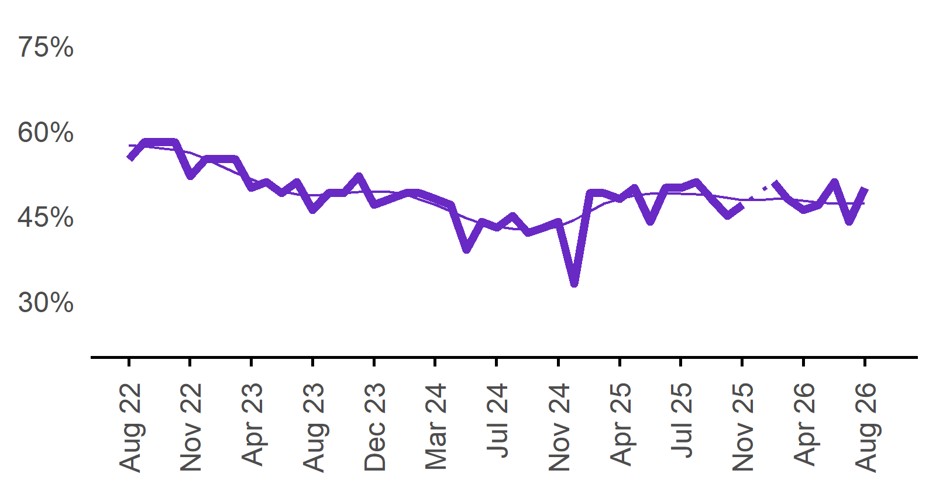 | 50%  Monthly change:  ▲ 6%pts  Annual change:  ◄► 0%pts
  Date | Recruitment rate | Smoothed recruitment rate
  Aug 2022 | 55% | 58%
  Sep 2022 | 58% | 57%
  Oct 2022 | 58% | 57%
  Nov 2022 | 58% | 57%
  Dec 2022 | 52% | 56%
  Jan 2023 | 55% | 55%
  Feb 2023 | 55% | 54%
  Mar 2023 | 55% | 53%
  Apr 2023 | 50% | 52%
  May 2023 | 51% | 50%
  Jun 2023 | 49% | 49%
  Jul 2023 | 51% | 49%
  Aug 2023 | 46% | 49%
  Sep 2023 | 49% | 49%
  Oct 2023 | 49% | 49%
  Nov 2023 | 52% | 49%
  Dec 2023 | 47% | 49%
  Jan 2024 | 48% | 49%
  Feb 2024 | 49% | 49%
  Mar 2024 | 49% | 48%
  Apr 2024 | 48% | 47%
  May 2024 | 47% | 46%
  Jun 2024 | 39% | 45%
  Jul 2024 | 44% | 44%
  Aug 2024 | 43% | 43%
  Sep 2024 | 45% | 43%
  Oct 2024 | 42% | 43%
  Nov 2024 | 43% | 43%
  Dec 2024 | 44% | 43%
  Jan 2025 | 33% | 44%
  Feb 2025 | 49% | 46%
  Mar 2025 | 49% | 47%
  Apr 2025 | 48% | 48%
  May 2025 | 50% | 49%
  Jun 2025 | 44% | 49%
  Jul 2025 | 50% | 49%
  Aug 2025 | 50% | 49%
  Sep 2025 | 51% | 49%
  Oct 2025 | 48% | 49%
  Nov 2025 | 45% | 48%
  Dec 2025 | 47% | 48%
  Jan 2026 |  | 48%
  Feb 2026 | 51% | 48%
  Mar 2026 | 48% | 48%
  Apr 2026 | 46% | 48%
  May 2026 | 47% | 47%
  Jun 2026 | 51% | 47%
  Jul 2026 | 44% | 47%
  Aug 2026 | 50% | 47%

Recruitment difficulty rate

Proportion of recruiting employers who stated they had difficulty hiring staff.
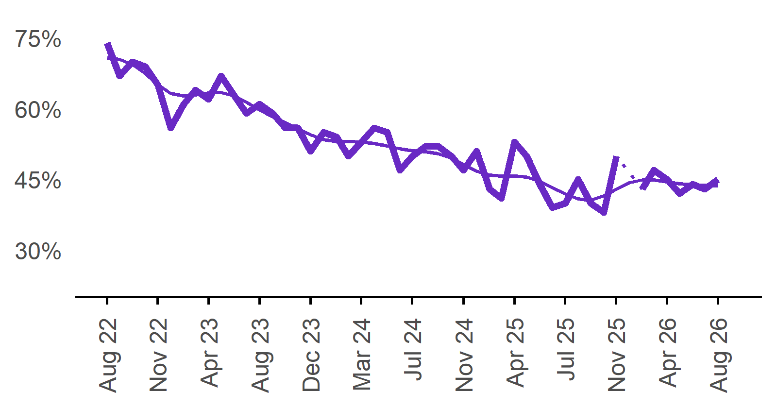 | 45%  Monthly change:  ▲ 2%pts  Annual change:  ▲ 5%pts
  Date | Recruitment difficulty rate | Smoothed recruitment difficulty rate
  Aug 2022 | 74% | 71%
  Sep 2022 | 67% | 71%
  Oct 2022 | 70% | 69%
  Nov 2022 | 69% | 68%
  Dec 2022 | 65% | 65%
  Jan 2023 | 56% | 63%
  Feb 2023 | 61% | 63%
  Mar 2023 | 64% | 63%
  Apr 2023 | 62% | 63%
  May 2023 | 67% | 63%
  Jun 2023 | 63% | 63%
  Jul 2023 | 59% | 61%
  Aug 2023 | 61% | 60%
  Sep 2023 | 59% | 58%
  Oct 2023 | 56% | 57%
  Nov 2023 | 56% | 56%
  Dec 2023 | 51% | 55%
  Jan 2024 | 55% | 54%
  Feb 2024 | 54% | 53%
  Mar 2024 | 50% | 53%
  Apr 2024 | 53% | 53%
  May 2024 | 56% | 53%
  Jun 2024 | 55% | 52%
  Jul 2024 | 47% | 51%
  Aug 2024 | 50% | 51%
  Sep 2024 | 52% | 51%
  Oct 2024 | 52% | 50%
  Nov 2024 | 50% | 50%
  Dec 2024 | 47% | 48%
  Jan 2025 | 51% | 47%
  Feb 2025 | 43% | 46%
  Mar 2025 | 41% | 46%
  Apr 2025 | 53% | 46%
  May 2025 | 50% | 46%
  Jun 2025 | 44% | 45%
  Jul 2025 | 39% | 43%
  Aug 2025 | 40% | 42%
  Sep 2025 | 45% | 41%
  Oct 2025 | 40% | 41%
  Nov 2025 | 38% | 42%
  Dec 2025 | 50% | 43%
  Jan 2026 |  | 44%
  Feb 2026 | 43% | 45%
  Mar 2026 | 47% | 45%
  Apr 2026 | 45% | 45%
  May 2026 | 42% | 44%
  Jun 2026 | 44% | 44%
  Jul 2026 | 43% | 44%
  Aug 2026 | 45% | 44%

Expecting to increase staff

Proportion of employers who expected to increase staffing numbers over the next three months.
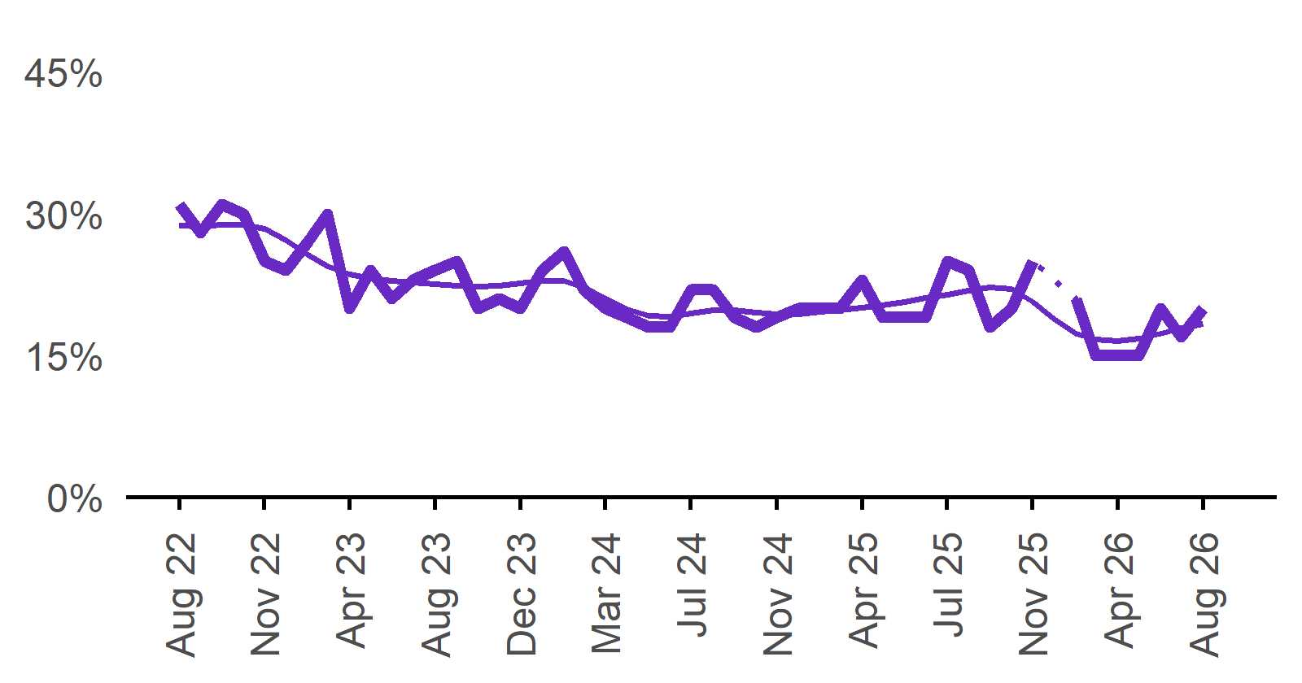 | 20%  Monthly change:  ▲ 3%pts  Annual change:  ▼ 5%pts
  Date | Expect to increase | Smoothed expect to increase
  Aug 2022 | 31% | 29%
  Sep 2022 | 28% | 29%
  Oct 2022 | 31% | 29%
  Nov 2022 | 30% | 29%
  Dec 2022 | 25% | 28%
  Jan 2023 | 24% | 27%
  Feb 2023 | 27% | 26%
  Mar 2023 | 30% | 24%
  Apr 2023 | 20% | 24%
  May 2023 | 24% | 23%
  Jun 2023 | 21% | 23%
  Jul 2023 | 23% | 23%
  Aug 2023 | 24% | 23%
  Sep 2023 | 25% | 22%
  Oct 2023 | 20% | 22%
  Nov 2023 | 21% | 22%
  Dec 2023 | 20% | 23%
  Jan 2024 | 24% | 23%
  Feb 2024 | 26% | 23%
  Mar 2024 | 22% | 22%
  Apr 2024 | 20% | 21%
  May 2024 | 19% | 20%
  Jun 2024 | 18% | 19%
  Jul 2024 | 18% | 19%
  Aug 2024 | 22% | 19%
  Sep 2024 | 22% | 20%
  Oct 2024 | 19% | 20%
  Nov 2024 | 18% | 20%
  Dec 2024 | 19% | 19%
  Jan 2025 | 20% | 19%
  Feb 2025 | 20% | 20%
  Mar 2025 | 20% | 20%
  Apr 2025 | 23% | 20%
  May 2025 | 19% | 20%
  Jun 2025 | 19% | 21%
  Jul 2025 | 19% | 21%
  Aug 2025 | 25% | 21%
  Sep 2025 | 24% | 22%
  Oct 2025 | 18% | 22%
  Nov 2025 | 20% | 22%
  Dec 2025 | 25% | 21%
  Jan 2026 |  | 19%
  Feb 2026 | 21% | 17%
  Mar 2026 | 15% | 17%
  Apr 2026 | 15% | 17%
  May 2026 | 15% | 17%
  Jun 2026 | 20% | 17%
  Jul 2026 | 17% | 18%
  Aug 2026 | 20% | 18%

Capital City/Rest of State areas

Recruitment rate

Proportion of employers currently recruiting or who recruited in the previous month.
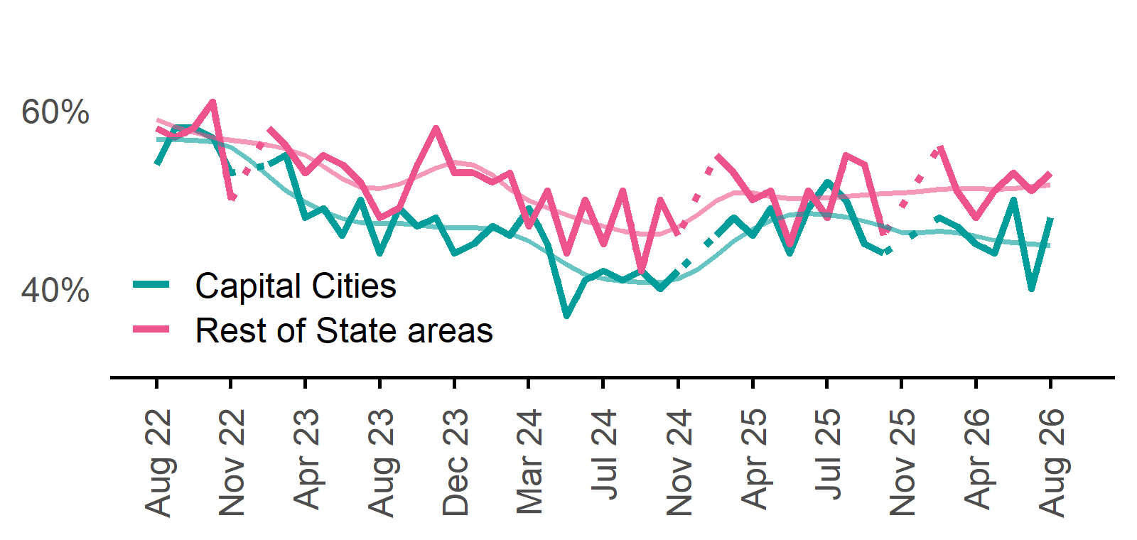 | Capital Cities: 48%  Monthly change:  ▲ 8%pts  Annual change:  ▼ 4%pts  Rest of State: 53%  Monthly change:  ▲ 2%pts  Annual change:  ▲ 5%pts
  Date | Capital Cities - Recruitment rate | Rest of State areas - Recruitment rate | Capital Cities - Smoothed recruitment rate | Rest of State areas - Smoothed recruitment rate
  Aug 2022 | 54% | 58% | 57% | 59%
  Sep 2022 | 58% | 57% | 57% | 58%
  Oct 2022 | 58% | 58% | 57% | 58%
  Nov 2022 | 57% | 61% | 56% | 57%
  Dec 2022 | 53% | 50% | 56% | 57%
  Jan 2023 | n.p. | n.p. | 54% | 56%
  Feb 2023 | 54% | 58% | 53% | 56%
  Mar 2023 | 55% | 56% | 51% | 56%
  Apr 2023 | 48% | 53% | 50% | 55%
  May 2023 | 49% | 55% | 49% | 54%
  Jun 2023 | 46% | 54% | 48% | 52%
  Jul 2023 | 50% | 52% | 47% | 51%
  Aug 2023 | 44% | 48% | 47% | 51%
  Sep 2023 | 49% | 49% | 47% | 52%
  Oct 2023 | 47% | 54% | 47% | 53%
  Nov 2023 | 48% | 58% | 47% | 54%
  Dec 2023 | 44% | 53% | 47% | 54%
  Jan 2024 | 45% | 53% | 47% | 54%
  Feb 2024 | 47% | 52% | 47% | 53%
  Mar 2024 | 46% | 53% | 46% | 51%
  Apr 2024 | 49% | 47% | 45% | 50%
  May 2024 | 45% | 51% | 44% | 49%
  Jun 2024 | 37% | 44% | 43% | 48%
  Jul 2024 | 41% | 50% | 42% | 48%
  Aug 2024 | 42% | 45% | 41% | 47%
  Sep 2024 | 41% | 51% | 41% | 46%
  Oct 2024 | 42% | 42% | 41% | 46%
  Nov 2024 | 40% | 50% | 41% | 46%
  Dec 2024 | 42% | 46% | 41% | 47%
  Jan 2025 | n.p. | n.p. | 42% | 48%
  Feb 2025 | 46% | 55% | 44% | 50%
  Mar 2025 | 48% | 53% | 45% | 51%
  Apr 2025 | 46% | 50% | 47% | 51%
  May 2025 | 49% | 51% | 48% | 50%
  Jun 2025 | 44% | 45% | 48% | 50%
  Jul 2025 | 49% | 51% | 48% | 50%
  Aug 2025 | 52% | 48% | 48% | 50%
  Sep 2025 | 50% | 55% | 48% | 50%
  Oct 2025 | 45% | 54% | 48% | 51%
  Nov 2025 | 44% | 46% | 47% | 51%
  Dec 2025 | n.p. | n.p. | 46% | 51%
  Jan 2026 |  |  | 46% | 51%
  Feb 2026 | 48% | 56% | 46% | 51%
  Mar 2026 | 47% | 51% | 46% | 51%
  Apr 2026 | 45% | 48% | 46% | 51%
  May 2026 | 44% | 51% | 45% | 51%
  Jun 2026 | 50% | 53% | 45% | 51%
  Jul 2026 | 40% | 51% | 45% | 51%
  Aug 2026 | 48% | 53% | 45% | 52%

Recruitment difficulty rate

Proportion of recruiting employers who stated they had difficulty hiring staff.
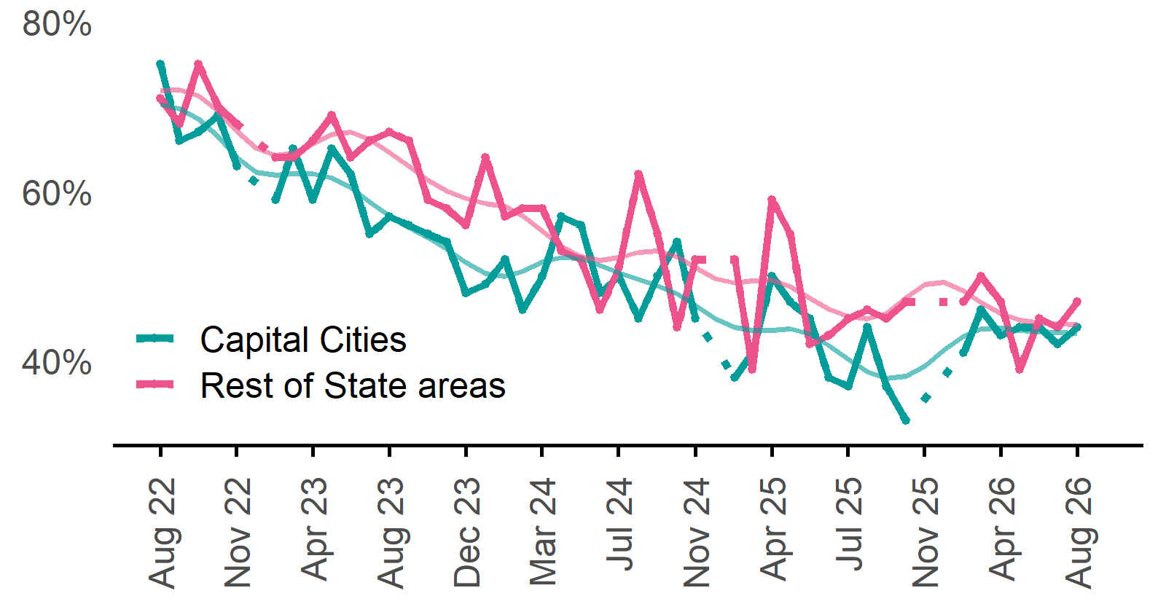 | Capital Cities: 44%  Monthly change:  ▲ 2%pts  Annual change:  ▲ 7%pts  Rest of State: 47%  Monthly change:  ▲ 3%pts  Annual change:  ▲ 2%pts
  Date | Capital Cities - Recruitment difficulty rate | Rest of State areas - Recruitment difficulty rate | Capital Cities - Smoothed recruitment difficulty rate | Rest of State areas - Smoothed recruitment difficulty rate
  Aug 2022 | 75% | 71% | 70% | 72%
  Sep 2022 | 66% | 68% | 70% | 72%
  Oct 2022 | 67% | 75% | 69% | 71%
  Nov 2022 | 69% | 70% | 66% | 69%
  Dec 2022 | 63% | 68% | 64% | 67%
  Jan 2023 | n.p. | n.p. | 62% | 65%
  Feb 2023 | 59% | 64% | 62% | 64%
  Mar 2023 | 65% | 64% | 62% | 65%
  Apr 2023 | 59% | 66% | 62% | 66%
  May 2023 | 65% | 69% | 62% | 67%
  Jun 2023 | 62% | 64% | 60% | 67%
  Jul 2023 | 55% | 66% | 59% | 66%
  Aug 2023 | 57% | 67% | 57% | 65%
  Sep 2023 | 56% | 66% | 56% | 63%
  Oct 2023 | 55% | 59% | 55% | 61%
  Nov 2023 | 54% | 58% | 53% | 60%
  Dec 2023 | 48% | 56% | 52% | 59%
  Jan 2024 | 49% | 64% | 50% | 59%
  Feb 2024 | 52% | 57% | 50% | 58%
  Mar 2024 | 46% | 58% | 51% | 57%
  Apr 2024 | 50% | 58% | 52% | 55%
  May 2024 | 57% | 53% | 52% | 53%
  Jun 2024 | 56% | 52% | 52% | 52%
  Jul 2024 | 48% | 46% | 51% | 52%
  Aug 2024 | 50% | 51% | 50% | 52%
  Sep 2024 | 45% | 62% | 50% | 53%
  Oct 2024 | 50% | 55% | 49% | 53%
  Nov 2024 | 54% | 44% | 48% | 52%
  Dec 2024 | 45% | 52% | 47% | 51%
  Jan 2025 | n.p. | n.p. | 45% | 50%
  Feb 2025 | 38% | 52% | 44% | 49%
  Mar 2025 | 41% | 39% | 44% | 49%
  Apr 2025 | 50% | 59% | 44% | 50%
  May 2025 | 47% | 55% | 44% | 49%
  Jun 2025 | 45% | 42% | 43% | 47%
  Jul 2025 | 38% | 43% | 42% | 46%
  Aug 2025 | 37% | 45% | 40% | 45%
  Sep 2025 | 44% | 46% | 39% | 45%
  Oct 2025 | 37% | 45% | 38% | 46%
  Nov 2025 | 33% | 47% | 38% | 47%
  Dec 2025 | n.p. | n.p. | 39% | 49%
  Jan 2026 |  |  | 41% | 49%
  Feb 2026 | 41% | 47% | 43% | 48%
  Mar 2026 | 46% | 50% | 44% | 47%
  Apr 2026 | 43% | 47% | 44% | 46%
  May 2026 | 44% | 39% | 44% | 45%
  Jun 2026 | 44% | 45% | 43% | 44%
  Jul 2026 | 42% | 44% | 43% | 44%
  Aug 2026 | 44% | 47% | 43% | 44%

Staffing outlook – Expecting to increase staff

Proportion of employers who expected to increase staffing numbers over the next three months.
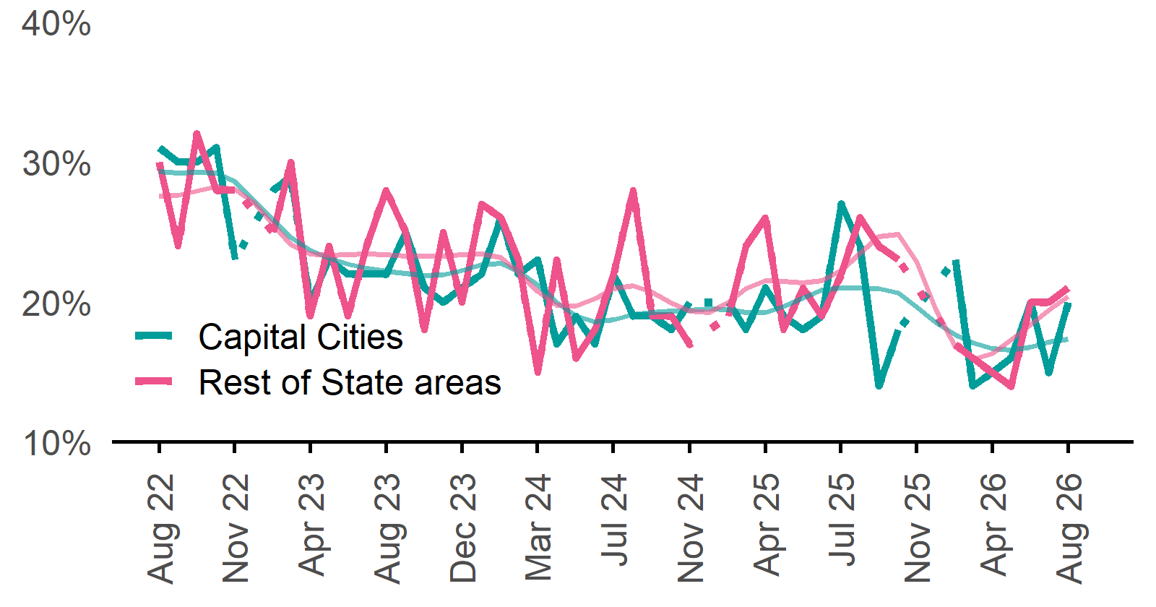 | Capital Cities: 20%  Monthly change:  ▲ 5%pts  Annual change:  ▼ 7%pts  Rest of State: 21%  Monthly change:  ▲ 1%pt  Annual change:  ▼ 1%pt
  Date | Capital Cities - % expecting to increase | Rest of State areas - % expecting to increase | Capital Cities - Smoothed % expecting to increase | Rest of State areas - Smoothed % expecting to increase
  Aug 2022 | 31% | 30% | 29% | 28%
  Sep 2022 | 30% | 24% | 29% | 28%
  Oct 2022 | 30% | 32% | 29% | 28%
  Nov 2022 | 31% | 28% | 29% | 28%
  Dec 2022 | 23% | 28% | 29% | 28%
  Jan 2023 | n.p. | n.p. | 27% | 27%
  Feb 2023 | 28% | 25% | 26% | 26%
  Mar 2023 | 29% | 30% | 25% | 24%
  Apr 2023 | 20% | 19% | 24% | 23%
  May 2023 | 23% | 24% | 23% | 23%
  Jun 2023 | 22% | 19% | 23% | 23%
  Jul 2023 | 22% | 24% | 22% | 23%
  Aug 2023 | 22% | 28% | 22% | 23%
  Sep 2023 | 25% | 25% | 22% | 23%
  Oct 2023 | 21% | 18% | 22% | 23%
  Nov 2023 | 20% | 25% | 22% | 23%
  Dec 2023 | 21% | 20% | 22% | 23%
  Jan 2024 | 22% | 27% | 23% | 23%
  Feb 2024 | 26% | 26% | 23% | 23%
  Mar 2024 | 22% | 23% | 22% | 22%
  Apr 2024 | 23% | 15% | 21% | 21%
  May 2024 | 17% | 23% | 20% | 20%
  Jun 2024 | 19% | 16% | 19% | 20%
  Jul 2024 | 17% | 18% | 19% | 20%
  Aug 2024 | 22% | 22% | 19% | 21%
  Sep 2024 | 19% | 28% | 19% | 21%
  Oct 2024 | 19% | 19% | 19% | 21%
  Nov 2024 | 18% | 19% | 19% | 20%
  Dec 2024 | 20% | 17% | 19% | 19%
  Jan 2025 | n.p. | n.p. | 20% | 19%
  Feb 2025 | 20% | 19% | 19% | 20%
  Mar 2025 | 18% | 24% | 19% | 21%
  Apr 2025 | 21% | 26% | 19% | 22%
  May 2025 | 19% | 18% | 20% | 21%
  Jun 2025 | 18% | 21% | 20% | 21%
  Jul 2025 | 19% | 19% | 21% | 22%
  Aug 2025 | 27% | 22% | 21% | 22%
  Sep 2025 | 24% | 26% | 21% | 23%
  Oct 2025 | 14% | 24% | 21% | 25%
  Nov 2025 | 18% | 23% | 21% | 25%
  Dec 2025 | n.p. | n.p. | 20% | 23%
  Jan 2026 |  |  | 19% | 19%
  Feb 2026 | 23% | 17% | 18% | 17%
  Mar 2026 | 14% | 16% | 17% | 16%
  Apr 2026 | 15% | 15% | 17% | 16%
  May 2026 | 16% | 14% | 17% | 17%
  Jun 2026 | 20% | 20% | 17% | 18%
  Jul 2026 | 15% | 20% | 17% | 19%
  Aug 2026 | 20% | 21% | 17% | 20%

Other recruitment indicators

Reason for recruiting

Proportion of employers currently recruiting or who recruited in the previous month.
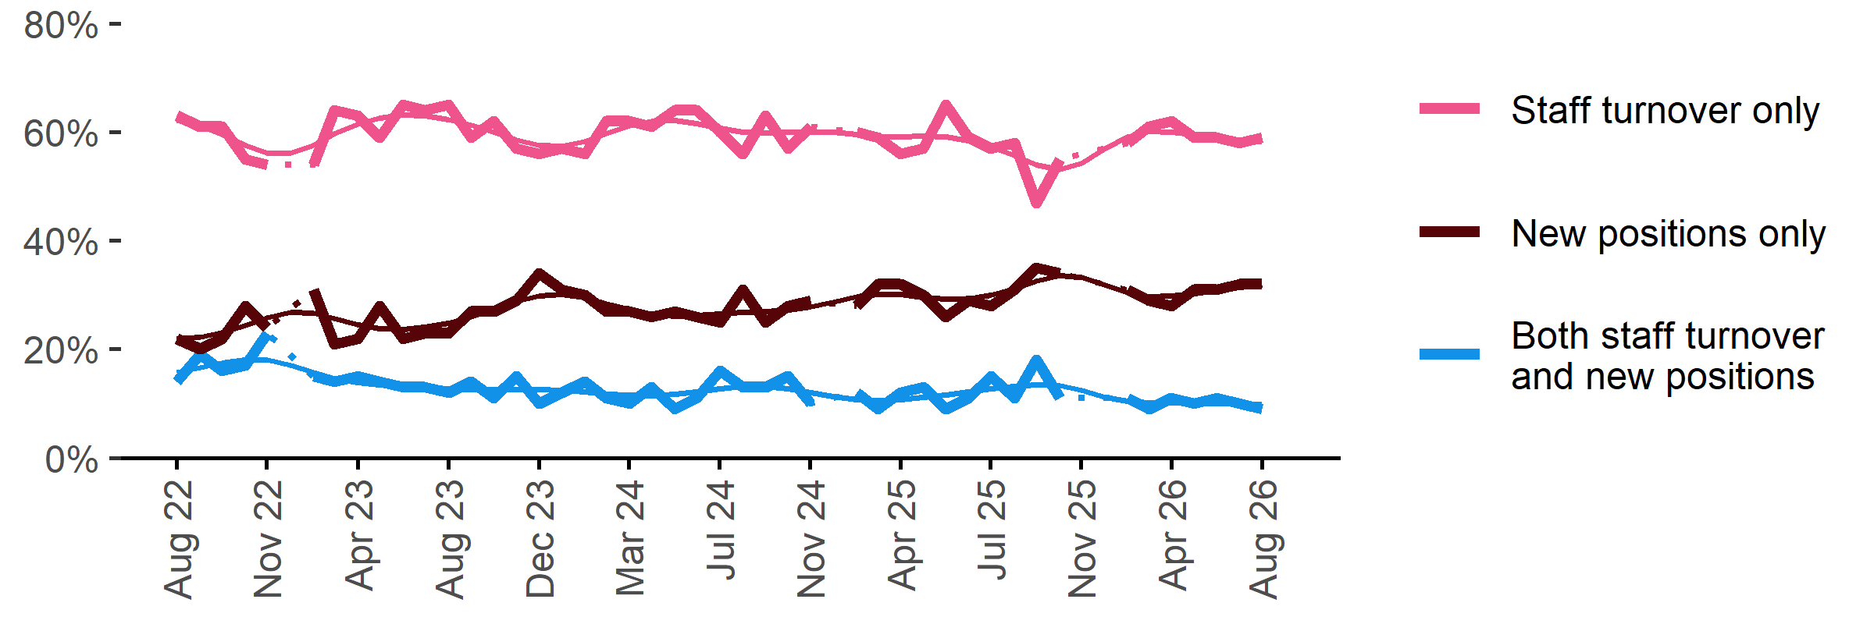
Date | Staff turnover only | Staff turnover and new positions | New positions only | Smoothed - staff turnover only | Smoothed - staff turnover and new positions | Smoothed - new positions only
Aug 2022 | 63% | 14% | 22% | 62% | 16% | 22%
Sep 2022 | 61% | 19% | 20% | 61% | 17% | 22%
Oct 2022 | 61% | 16% | 22% | 60% | 17% | 23%
Nov 2022 | 55% | 17% | 28% | 58% | 18% | 24%
Dec 2022 | 54% | 23% | 24% | 56% | 18% | 26%
Jan 2023 | n.p. | n.p. | n.p. | 56% | 17% | 27%
Feb 2023 | 54% | 15% | 31% | 58% | 16% | 27%
Mar 2023 | 64% | 14% | 21% | 60% | 15% | 26%
Apr 2023 | 63% | 15% | 22% | 61% | 14% | 25%
May 2023 | 59% | 14% | 28% | 63% | 13% | 24%
Jun 2023 | 65% | 13% | 22% | 63% | 13% | 24%
Jul 2023 | 64% | 13% | 23% | 63% | 13% | 24%
Aug 2023 | 65% | 12% | 23% | 62% | 13% | 25%
Sep 2023 | 59% | 14% | 27% | 61% | 13% | 26%
Oct 2023 | 62% | 11% | 27% | 60% | 13% | 27%
Nov 2023 | 57% | 15% | 29% | 59% | 13% | 29%
Dec 2023 | 56% | 10% | 34% | 58% | 13% | 30%
Jan 2024 | 57% | 12% | 31% | 57% | 12% | 30%
Feb 2024 | 56% | 14% | 30% | 58% | 12% | 30%
Mar 2024 | 62% | 11% | 27% | 60% | 12% | 28%
Apr 2024 | 62% | 10% | 27% | 61% | 12% | 27%
May 2024 | 61% | 13% | 26% | 62% | 11% | 27%
Jun 2024 | 64% | 9% | 27% | 62% | 12% | 26%
Jul 2024 | 64% | 11% | 26% | 62% | 12% | 26%
Aug 2024 | 60% | 16% | 25% | 61% | 13% | 27%
Sep 2024 | 56% | 13% | 31% | 60% | 13% | 27%
Oct 2024 | 63% | 13% | 25% | 60% | 13% | 27%
Nov 2024 | 57% | 15% | 28% | 60% | 13% | 27%
Dec 2024 | 61% | 10% | 29% | 60% | 12% | 28%
Jan 2025 | n.p. | n.p. | n.p. | 60% | 11% | 29%
Feb 2025 | 60% | 12% | 28% | 60% | 11% | 30%
Mar 2025 | 59% | 9% | 32% | 59% | 11% | 30%
Apr 2025 | 56% | 12% | 32% | 59% | 11% | 30%
May 2025 | 57% | 13% | 30% | 59% | 11% | 30%
Jun 2025 | 65% | 9% | 26% | 59% | 12% | 29%
Jul 2025 | 59% | 11% | 29% | 58% | 12% | 29%
Aug 2025 | 57% | 15% | 28% | 57% | 13% | 30%
Sep 2025 | 58% | 11% | 31% | 56% | 13% | 31%
Oct 2025 | 47% | 18% | 35% | 54% | 13% | 33%
Nov 2025 | 55% | 11% | 34% | 53% | 13% | 34%
Dec 2025 | n.p. | n.p. | n.p. | 54% | 12% | 33%
Jan 2026 |  |  |  | 57% | 11% | 32%
Feb 2026 | 58% | 11% | 31% | 59% | 10% | 30%
Mar 2026 | 61% | 9% | 29% | 60% | 10% | 30%
Apr 2026 | 62% | 11% | 28% | 60% | 10% | 30%
May 2026 | 59% | 10% | 31% | 60% | 10% | 30%
Jun 2026 | 59% | 11% | 31% | 59% | 10% | 31%
Jul 2026 | 58% | 10% | 32% | 59% | 10% | 31%
Aug 2026 | 59% | 9% | 32% | 58% | 10% | 32%

Staffing changes over the last month

Proportion of employers who said they increased or decreased staffing compared to the previous month.
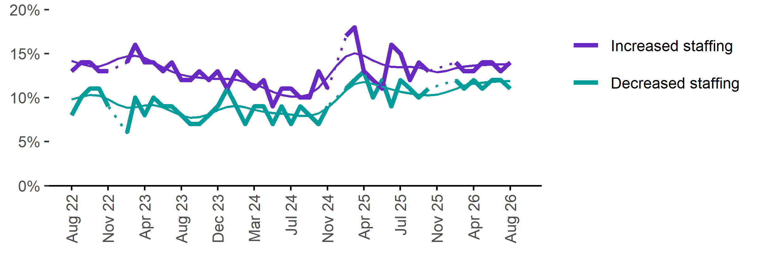
Date | Increased staff | Decreased staff | Smoothed - increased staff | Smoothed - decreased staff
Aug 2022 | 13% | 8% | 14% | 10%
Sep 2022 | 14% | 10% | 14% | 10%
Oct 2022 | 14% | 11% | 14% | 10%
Nov 2022 | 13% | 11% | 14% | 10%
Dec 2022 | 13% | 9% | 14% | 10%
Jan 2023 | n.p. | n.p. | 14% | 9%
Feb 2023 | 14% | 6% | 15% | 9%
Mar 2023 | 16% | 10% | 15% | 9%
Apr 2023 | 14% | 8% | 14% | 9%
May 2023 | 14% | 10% | 14% | 9%
Jun 2023 | 13% | 9% | 13% | 9%
Jul 2023 | 14% | 9% | 13% | 8%
Aug 2023 | 12% | 8% | 13% | 8%
Sep 2023 | 12% | 7% | 12% | 8%
Oct 2023 | 13% | 7% | 12% | 8%
Nov 2023 | 12% | 8% | 12% | 8%
Dec 2023 | 13% | 9% | 12% | 9%
Jan 2024 | 11% | 11% | 12% | 9%
Feb 2024 | 13% | 9% | 12% | 9%
Mar 2024 | 12% | 7% | 12% | 9%
Apr 2024 | 11% | 9% | 12% | 9%
May 2024 | 12% | 9% | 11% | 8%
Jun 2024 | 9% | 7% | 11% | 8%
Jul 2024 | 11% | 9% | 10% | 8%
Aug 2024 | 11% | 7% | 10% | 8%
Sep 2024 | 10% | 9% | 10% | 8%
Oct 2024 | 10% | 8% | 10% | 8%
Nov 2024 | 13% | 7% | 11% | 8%
Dec 2024 | 11% | 9% | 12% | 9%
Jan 2025 | n.p. | n.p. | 14% | 10%
Feb 2025 | 17% | 11% | 15% | 11%
Mar 2025 | 18% | 12% | 15% | 12%
Apr 2025 | 13% | 13% | 15% | 12%
May 2025 | 12% | 10% | 14% | 12%
Jun 2025 | 11% | 12% | 14% | 11%
Jul 2025 | 16% | 9% | 14% | 11%
Aug 2025 | 15% | 12% | 13% | 11%
Sep 2025 | 12% | 11% | 14% | 10%
Oct 2025 | 14% | 10% | 13% | 10%
Nov 2025 | 13% | 11% | 13% | 10%
Dec 2025 | n.p. | n.p. | 13% | 10%
Jan 2026 |  |  | 13% | 11%
Feb 2026 | 14% | 12% | 13% | 11%
Mar 2026 | 13% | 11% | 14% | 11%
Apr 2026 | 13% | 12% | 14% | 12%
May 2026 | 14% | 11% | 14% | 12%
Jun 2026 | 14% | 12% | 14% | 12%
Jul 2026 | 13% | 12% | 14% | 12%
Aug 2026 | 14% | 11% | 14% | 12%

Employers unable to fill vacancies within a month

Proportion of recruiting employers who were unable to fill their vacancies within a month.*
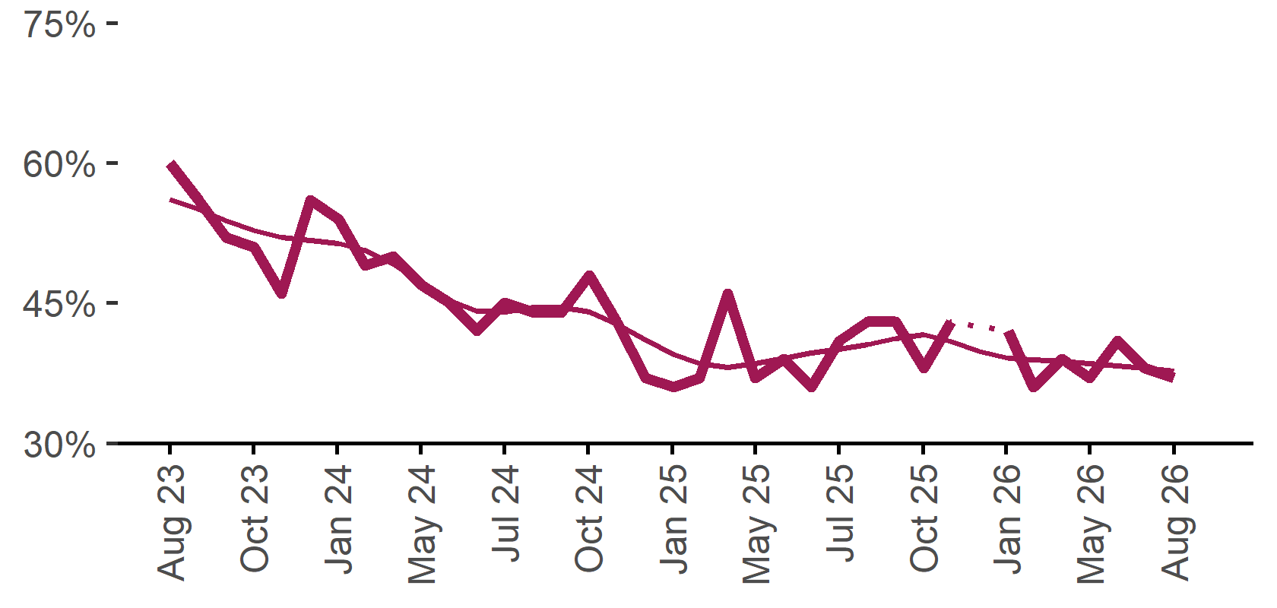 | 37%  Monthly change:  ▼ 1%pt  Annual change:  ▼ 4%pts
  Date | % unable to fill vacancies in a month | Smoothed - % unable to fill vacancies in a month
  Aug 2023 | 60% | 56%
  Sep 2023 | 56% | 55%
  Oct 2023 | 52% | 54%
  Nov 2023 | 51% | 53%
  Dec 2023 | 46% | 52%
  Jan 2024 | 56% | 52%
  Feb 2024 | 54% | 51%
  Mar 2024 | 49% | 51%
  Apr 2024 | 50% | 49%
  May 2024 | 47% | 47%
  Jun 2024 | 45% | 45%
  Jul 2024 | 42% | 44%
  Aug 2024 | 45% | 44%
  Sep 2024 | 44% | 45%
  Oct 2024 | 44% | 45%
  Nov 2024 | 48% | 44%
  Dec 2024 | 43% | 43%
  Jan 2025 | 37% | 41%
  Feb 2025 | 36% | 40%
  Mar 2025 | 37% | 38%
  Apr 2025 | 46% | 38%
  May 2025 | 37% | 38%
  Jun 2025 | 39% | 39%
  Jul 2025 | 36% | 40%
  Aug 2025 | 41% | 40%
  Sep 2025 | 43% | 41%
  Oct 2025 | 43% | 41%
  Nov 2025 | 38% | 42%
  Dec 2025 | 43% | 41%
  Jan 2026 |  | 40%
  Feb 2026 | 42% | 39%
  Mar 2026 | 36% | 39%
  Apr 2026 | 39% | 39%
  May 2026 | 37% | 38%
  Jun 2026 | 41% | 38%
  Jul 2026 | 38% | 38%
  Aug 2026 | 37% | 38%
* Excludes employers who have been recruiting for less than a month.

Background
Jobs and Skills Australia (JSA) conducts the Recruitment Experiences and Outlook Survey (REOS), a telephone administered survey with the business owner or other person in the business responsible for recruitment. Around 1000 employers are surveyed each month, with data published on the JSA website. While the data are indicative of recruitment activity, they may be subject to seasonal factors and other volatility and should therefore be used with a degree of caution. In addition, the survey is targeted towards employers with 5 or more employees and excludes many government organisations. Details of the survey methodology can be accessed from the JSA website.

Smoothed series in charts
Charts include Henderson-smoothed lines in addition to original data for most of our recruitment indicators. As the timeseries is not yet long enough for seasonal adjustment, a Henderson smoothed moving average with a 13-term filter (equating to 13 months) has been directly applied to the original series. This provides an indication of the general movement in each recruitment indicator relative to previous months. Due to using 13 months in the moving average, results for the most recent six months will be revised each month.

How to reference data from this report
Jobs and Skills Australia, Recruitment Insights Report, August 2026.

Contact us
For additional information, email REOS@jobsandskills.gov.au

Also available from the REOS

Data file with monthly and quarterly recruitment indicators
A REOS data file is available on the JSA website. Breakdowns by Capital City/Rest of State area, Business size, and ANZSCO Skill Level are included in the monthly results. Quarterly recruitment indicators provide detail by state, ARIA (ABS’ Accessibility and Remoteness Index of Australia) as well as selected industry and occupation groups.
Next Recruitment Insights Report release:
- September 2026 Recruitment Insights Report – 20 October 2026

Stay up to date
JSA also releases semi-regular reports including spotlight articles, detailing aspects of the REOS that cannot be included in our monthly Recruitment Insights Report. Sign up and get the Recruitment Insights Report notifications sent straight to your inbox.
Upcoming spotlight:
- Recruitment trends in the IT industry – 24 September 2026
Recent spotlights:
- Recruitment pressures in Australia higher-skilled labour market– 27 August 2026
- REOS spotlight June quarter results – 30 July 2026

A Henderson smoothed line has been included in the charts to reduce month to month volatility and illustrate long term patterns. See the explanatory note for more information.
Data are not available for January in some years. Data points have been joined by a dotted line between December and February to reflect this. ‘Rest of State’ refers to areas outside the capital cities.

