

Total New Vacancies Report

May 2026

Released 26 August 2026

Uncovering hidden labour demand: JSA’s Total New Vacancies series
1,353,000
New Vacancies
▲ | 8.0% | Annual change
Over the year to May 2026, vacancies increased by 8.0% (or around 99,000 job advertisements) to stand at 1,353,000.
In some occupations and regions, over half of job vacancies are advertised online. The TNV offers a broader measure, estimating total new vacancies across all recruitment methods.
Total New Vacancies (TNV) is a new quarterly data series from Jobs and Skills Australia that provides a more comprehensive view of job vacancy trends across Australia. While online recruitment methods are popular, their use varies across regions and industries, and change with labour market conditions. This variability can make it difficult to accurately identify emerging trends in the economy and labour market.
JSA’s TNV series helps address this challenge. It estimates the total number of new vacancies created each quarter, offering insights into hiring activity beyond online job ads or point-in-time measures. The series combines data from JSA’s Internet Vacancy Index (IVI) with employer feedback on recruitment methods collected through JSA’s Recruitment Experiences and Outlook Survey (REOS). Using these inputs, TNV estimates the total number of jobs available each quarter, including those filled through informal channels such as word of mouth, signs in shop windows, and social media groups.
Improving the evidence base on regional and occupational labour demand is a core principle of Jobs and Skills Australia’s legislation. The TNV series contributes to this objective by providing a more complete picture of job opportunities across occupations and regions. This richer evidence base supports the development of place-based initiatives and regional planning, helping to ensure that industry policy responses are better tailored to emerging trends.
Figure 1: Total New Vacancies, Feb 2016 to May 2026
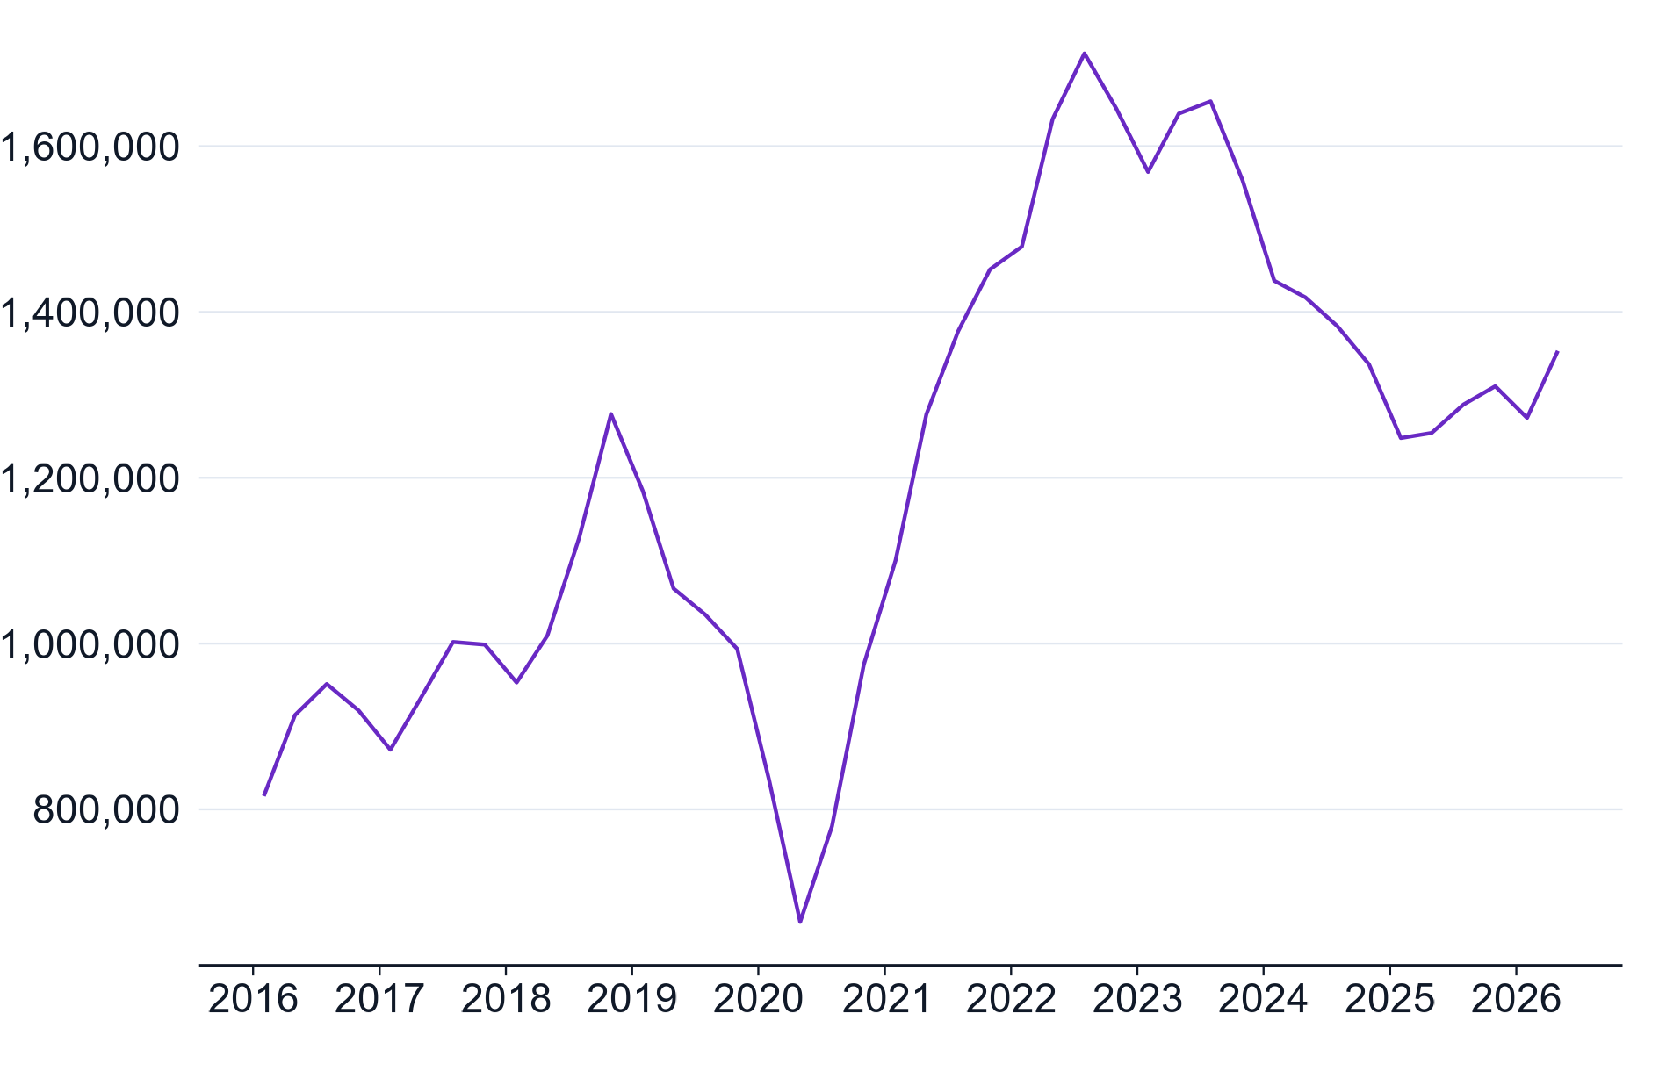
Source: Jobs and Skills Australia, Total New Vacancies, May 2026.



The next TNV release is scheduled for 25 November 2026. The TNV is published on the JSA website at jobsandskills.gov.au.
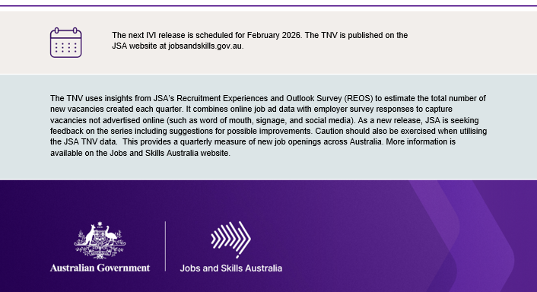
The TNV uses insights from JSA’s Recruitment Experiences and Outlook Survey (REOS) to estimate the total number of new vacancies created each quarter. It combines online job advertisement data with employer survey responses to capture vacancies not advertised online (such as word of mouth, signage, and social media). As a new release, JSA is seeking feedback on the series including suggestions for possible improvements. Caution should also be exercised when utilising the JSA TNV data. This provides a quarterly measure of new job openings across Australia. More detail on the TNV is available at jobsandskills.gov.au/data/total-new-vacancies.

