


Regional Labour Market Indicator (RLMI)
  - Quarterly Report
June 2026

Contents
Introduction 2
Labour market conditions are stronger on average in major cities 3
The major city-regional gap has narrowed 4
Softening labour market conditions in Greater Melbourne 6
Improving labour market conditions in North-eastern New South Wales 7
Challenging labour market conditions persist in Remote Australia 8
Appendices 11
Appendix 1: Labour Market Rating by SA4, June 2026 11
Appendix 2: RLMI Explanatory Notes 14

Introduction
The RLMI combines key measures of labour supply and demand, including factors that capture how these interact, into a single, easy‑to‑interpret summary measure.
Regions are grouped into distinct categories of relative overall labour market performance, ranging from ‘poor’ to ‘strong’, which provides an accurate and reliable view of labour market performance, relative to the national average.
This Report:
- Labour market conditions continue to be stronger on average in major cities compared to outcomes across regional Australia, which are more mixed.
- The gap between major city and regional labour market performance has narrowed over the 3 years to June 2026. This reflects improving conditions in several regional labour markets, including parts of north-eastern New South Wales, alongside softer labour market conditions in some major city areas, including in Melbourne.
- Remote Australia continues to face persistently challenging labour market conditions. While employment opportunities remain available, persistent recruitment difficulties, lower job matching efficiency, and elevated levels of long-term JobSeeker Income Support continue to constrain labour market performance.

Labour market conditions are stronger on average in major cities
Chart 1: RLMI ratings of relative labour market performance, June 2026
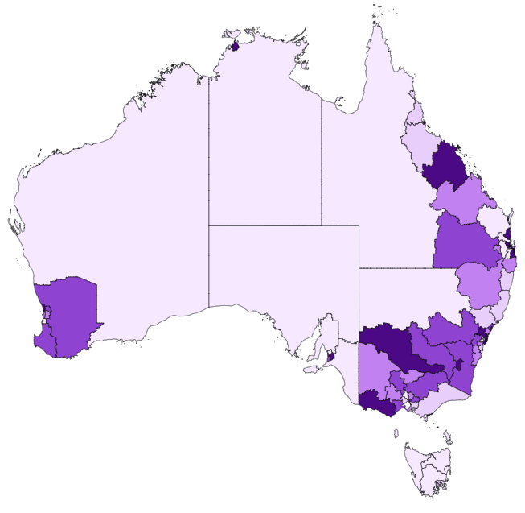

Source: JSA, Regional Labour Market Indicator (RLMI), June 2026

The June 2026 RLMI results show that regional and remote areas are more likely than major cities to experience relatively weaker labour market conditions, while also reflecting a diverse range of outcomes across regional Australia (see Chart 1, above).
- More than half (55%) of SA4s located in major city areas were rated either ‘strong’ or ‘above average’ in June 2026. Strong labour market conditions are evident across most major city labour markets, particularly in Sydney, Brisbane and Adelaide.
- Strong labour market conditions are also evident in a number of regional areas. This includes regional areas surrounding Greater Brisbane, such as the Gold Coast and Sunshine Coast, as well as parts of south west Western Australia, the Surf Coast region of Victoria, and across parts of the Southern Murray–Darling Basin.
- With that said, outcomes vary across regional labour markets, with 35% rated ‘below average’ or ‘poor’, including in parts of Northern Australia, regional and coastal New South Wales (such as the Mid North Coast and Coffs Harbour–Grafton), the Spencer Gulf region and surrounds of South Australia, and across Tasmania, including Hobart.
- All 6 remote SA4s (100%) were rated ‘poor’ in June 2026, highlighting the particularly challenging labour market conditions in the remote areas of Australia.
Chart 2: RLMI ratings of relative labour market performance, June 2026
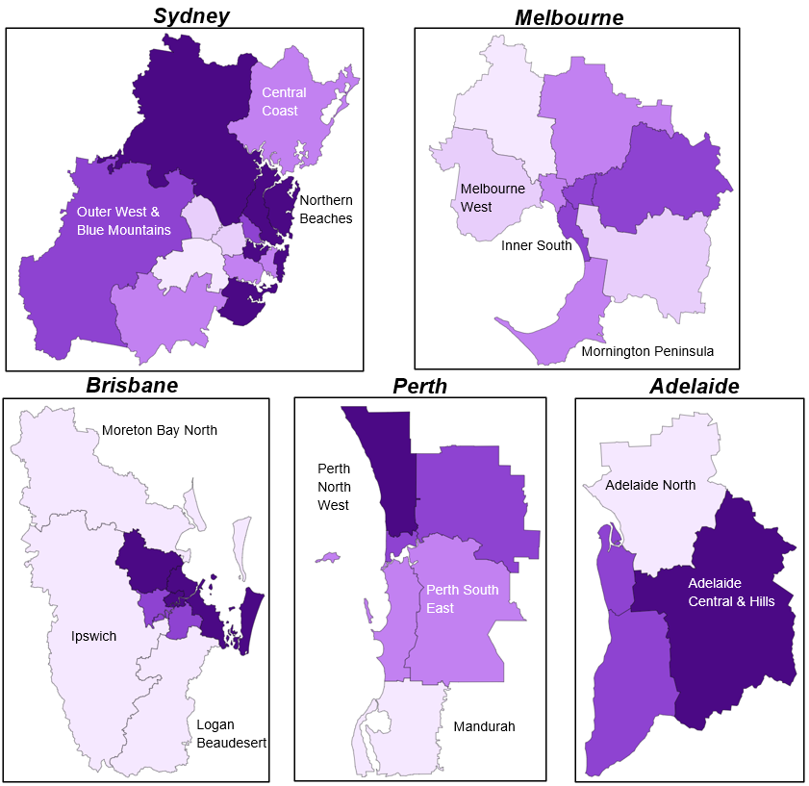
Source: JSA, Regional Labour Market Indicator (RLMI), June 2026

The major city-regional gap has narrowed
While major city labour markets continue to perform somewhat better on average than regional labour markets, the gap has narrowed in recent years. This reflects a relative improvement in a number of regional labour markets, alongside some softening in labour market conditions across parts of the major cities.
Chart 3 presents the change in RLMI ratings over the past 3 years. While most regions recorded no change in their relative labour market rating, the results indicate a narrowing in the difference between major city and regional labour market performance.
Chart 3: 3-year change in RLMI ratings of relative labour market performance, June 2026
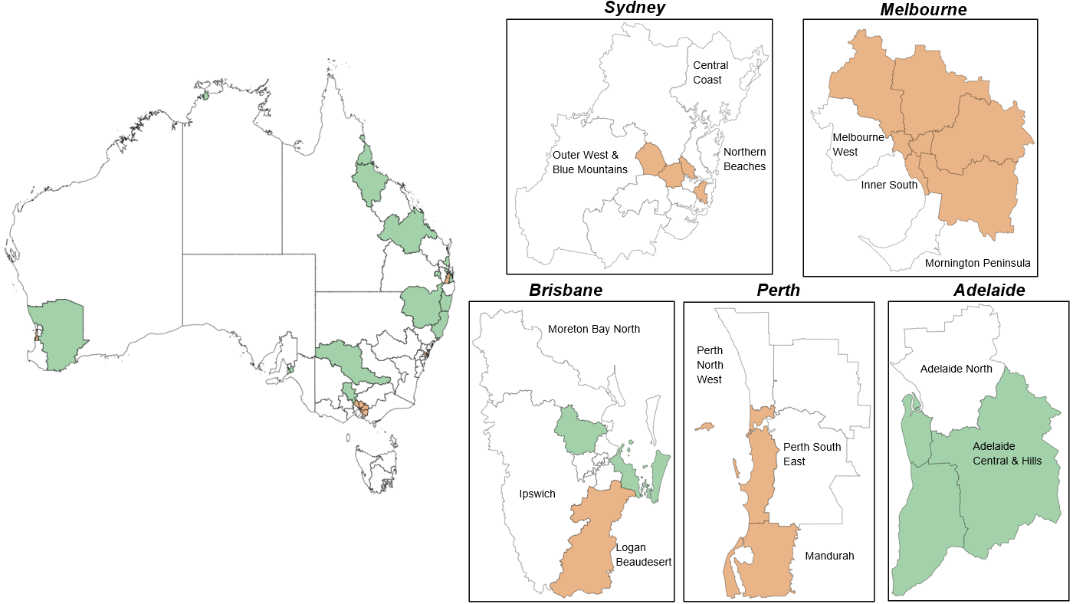
Source: JSA, Regional Labour Market Indicator (RLMI), June 2026
Table 1 below shows the change in the share of regions rated either ‘strong’ or ‘above average’ and ‘below average’ or ‘Poor’ between June 2023 and June 2026 by remoteness category.
- The results indicate that the share of regional labour markets rated ‘strong’ or ‘above average’ increased by 5 percentage points over the last 3 years, while the share rated ‘below average’ or ‘poor’ fell by 8 percentage points.
- Over the same period, the share of major city labour markets rated ‘strong’ or ‘above average’ declined by 5 percentage points, while the share rated ‘Below average’ or ‘poor’ increased by 7 percentage points.
- Labour market ratings in Remote Australia remain unchanged, with all remote regions continuing to be rated ‘poor’.
Table 1: Change in the share (%) of regions by rating category over the 3-years to June 2026
 | Major City | Regional | Remote
'Strong' or 'Above average' | -5% pts | +5% pts | 0% pts
'Below average' or 'Poor' | +7% pts | -8% pts | 0% pts
Source: JSA, Regional Labour Market Indicator (RLMI), June 2026
The narrowing in the gap between major city and regional labour markets largely reflects changes in a relatively small number of labour markets rather than a broad-based shift in labour market conditions. As illustrated by the working-age employment and unemployment rates shown in Charts 4 and 5, the overall relationship between major city and regional labour markets remains broadly unchanged.
Rather, several metropolitan regions, including across Melbourne, recorded weaker RLMI ratings in recent years, while a number of regional labour markets strengthened, including parts of north-eastern New South Wales. Together, these movements contributed to a narrowing in the gap between major city and regional labour market performance.
Chart 4: Employment rate (15-64 years), June 2016 to 2026  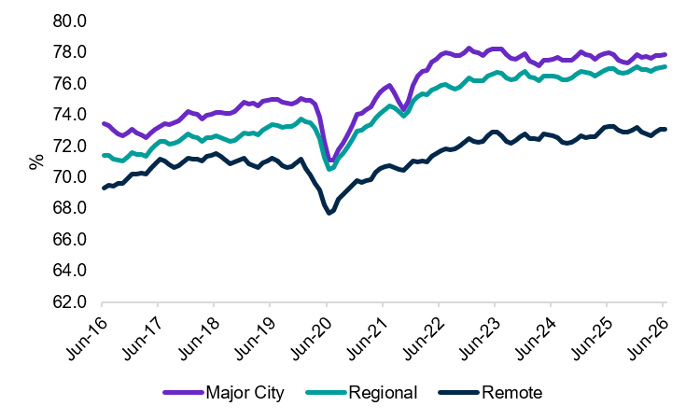 | Chart 5: Unemployment rate, June 2016 to 2026  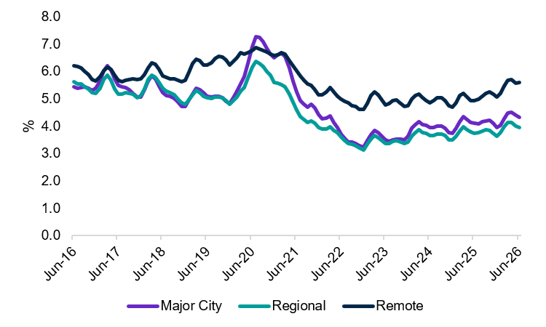
Source: ABS, Labour Force, June 2026, 3-month averages of original estimates

Softening labour market conditions in Greater Melbourne
Several regions across Greater Melbourne recorded weaker RLMI ratings between June 2023 and June 2026. As shown in Chart 6, relative labour market performance weakened across much of Greater Melbourne over the 3-year period.  Contributing to softening labour market conditions in Greater Melbourne is a decline in the working-age employment rate, an increase in unemployment, and a rise in the proportion of the working-age population receiving JobSeeker Income Support. Over the same period, job vacancy rates declined, indicating fewer employment opportunities were available. Together, these trends contributed to lower job matching efficiency, indicating greater difficulty matching jobseekers to available employment opportunities, and weaker productivity growth. | Chart 6: 3-year change in RLMI ratings of relative labour market performance, June 2026  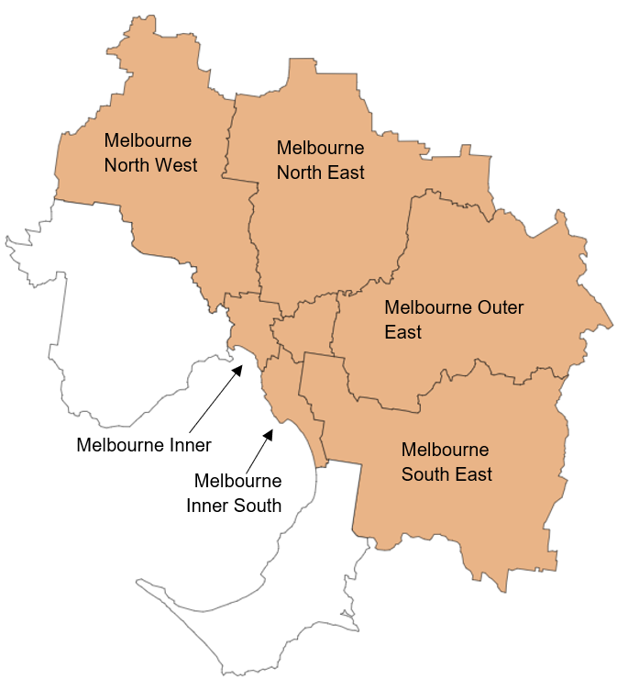
Table 2: Change in key factors used to assess labour market performance (RLMI) over the last year
 | Working Age (15-64 years) Employment Rate (%) | Unemployment Rate (%) | JobSeeker Income Support (%) | Job Vacancy Rate (%) | Job Matching Efficiency Rate (%) | Productivity growth rate (%)
Greater Melbourne | -0.9% pts | +1.2% pts | +1.0% pts | -1.3% pts | -4.3% pts | -1.1% pts
National average | 0.0% | +0.7% pts | +0.7% pts | +1.1% pts | +0.4% pts | +0.1% pts
Note: JobSeeker Income Support refers to the proportion of the working age population (15-64 years) on the JobSeeker payment and Youth Allowance (other) payment. Productivity growth rate refers to the 5-year annual average growth rate of labour productivity.

Improving labour market conditions in North-eastern New South Wales
Several regions across North-eastern New South Wales recorded stronger RLMI ratings between June 2023 and June 2026. As shown in Chart 7, relative labour market performance improved across the region over the 3-year period.  Contributing to improving labour market conditions in North-eastern New South Wales was an increase in the working-age employment rate. Over the same period, vacancy fill rates increased and job matching efficiency improved, indicating labour markets were becoming more effective at connecting jobseekers with available employment opportunities. These improvements were accompanied by a decline in the proportion of the working-age population receiving long-term JobSeeker Income Support.  It is important to note that while labour market conditions have improved, Coffs Harbour Grafton and Mid North Coast were still rated ‘below average’ in June 2026, indicating ongoing labour market challenges for both jobseekers and employers. | Chart 7: 3-year change in RLMI ratings of relative labour market performance, June 2026  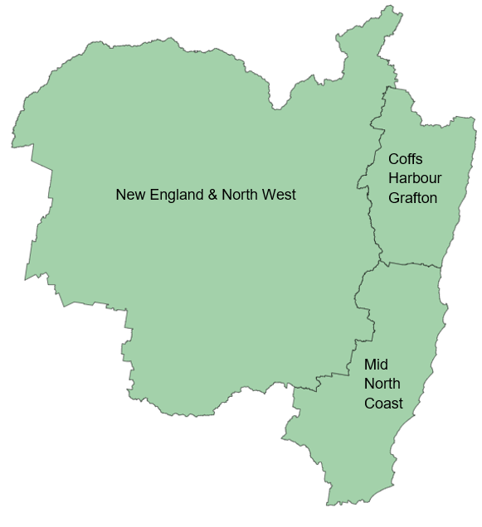
Table 3: Change in key factors used to assess labour market performance (RLMI) over the last 3-years
 | Working Age (15-64 years) Employment Rate (%) | Job Matching Efficiency Rate (%) | Fill Rate (%) | Long-term JobSeeker Income Support (%)
New England & North West | 0.0% pts | +9.3% pts | +16.5% pts | -0.2% pts
Coffs Harbour Grafton | 1.0% pts | +2.6% pts | +16.5% pts | -0.9% pts
Mid North Coast | 1.2% pts | +7.3% pts | +16.5% pts | -0.8% pts
National average | 0.0% | -0.3% pts | -0.2% pts | +0.2% pts
Note: Long-term JobSeeker Income Support refers to the proportion of the working age population (15-64 years) on the JobSeeker payment and Youth Allowance (other) payment for 2 or more years.

Challenging labour market conditions persist in Remote Australia
Remote Australia continues to experience the most challenging labour market conditions in the country. All six remote SA4 regions were rated 'poor' in June 2026, reflecting a longstanding pattern of relatively weaker labour market conditions.
Table 4 shows a selection of key indicators contributing to the RLMI assessment for Remote Australia. Compared with the national average, Remote Australia recorded a lower working-age employment rate, a higher unemployment rate and, most notably, a substantially higher proportion of the working-age population receiving JobSeeker Income Support for 2 or more years. The elevated prevalence of long-term income support receipt points to entrenched labour market disadvantage and reflects the persistence of barriers to employment experienced in many remote labour markets.
Table 4: Key factors used to assess labour market performance (RLMI)
 | Working Age (15-64 years) Employment Rate (%) | Unemployment Rate (%) | Long-term JobSeeker Income Support (%) | Job Vacancy Rate (%) | Job Matching Efficiency Rate (%)
 | Jun-26 | Jun-26 | Jun-26 | Feb-26 | Nov-25
Remote Australia | 73.5% | 5.4% | 5.5% | 6.0% | 60.9%
National average | 77.2% | 4.2% | 2.5% | 3.6% | 82.2%
Note: Long-term JobSeeker Income Support refers to the proportion of the working age population (15-64 years) on the JobSeeker payment and Youth Allowance (other) payment for 2 or more years.
At the same time, the data indicate that labour demand in Remote Australia remains relatively strong. As shown in Chart 8, the job vacancy rate (measured using JSA’s Total New Vacancies) has consistently remained well above that observed in major city and regional labour markets. The job vacancy rate measures the number of new job vacancies as a proportion of the labour force and provides an indication of the availability of employment opportunities. The persistently elevated vacancy rate suggests that, despite generally weaker labour market conditions, there continues to be a significant number of job opportunities available across Remote Australia.
Chart 8: Job vacancy rate, February 2026
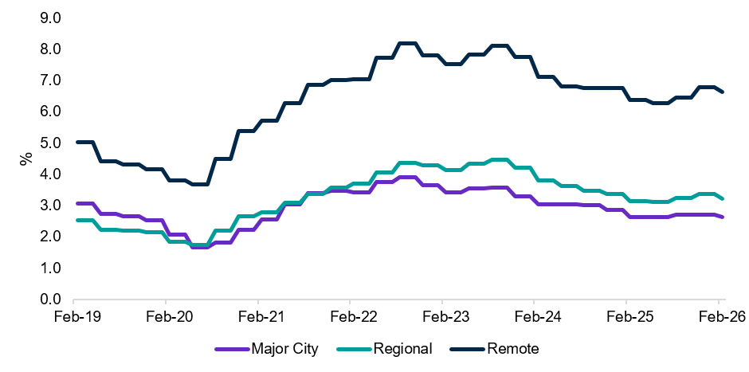
Source: JSA, Total New Vacancies, February 2026 (latest available data)
While the relatively high vacancy rate is encouraging, its persistence may also indicate difficulty filling available positions. Further evidence of recruitment challenges is provided by JSA's Survey of Employers who have Recently Advertised (SERA). As shown in Chart 9, employers in Remote Australia receive substantially fewer applicants per vacancy than employers in major city and regional labour markets.
- On average, skilled vacancies in Remote Australia attracted 7.6 applicants, of whom 2.3 were qualified and 1.8 were considered suitable.
- This compares with 24.5 applicants, 8.5 qualified applicants and 5.3 suitable applicants per vacancy in major cities.
- Remote Australia also recorded the lowest vacancy fill rate (42.5%), compared with 68.7% in major cities and 66.8% in regional areas.
These results highlight the significant recruitment challenges faced by employers across remote labour markets.
Chart 9: Fill rate (%) and total, qualified, and suitable applicants per vacancy (no.), March 2026
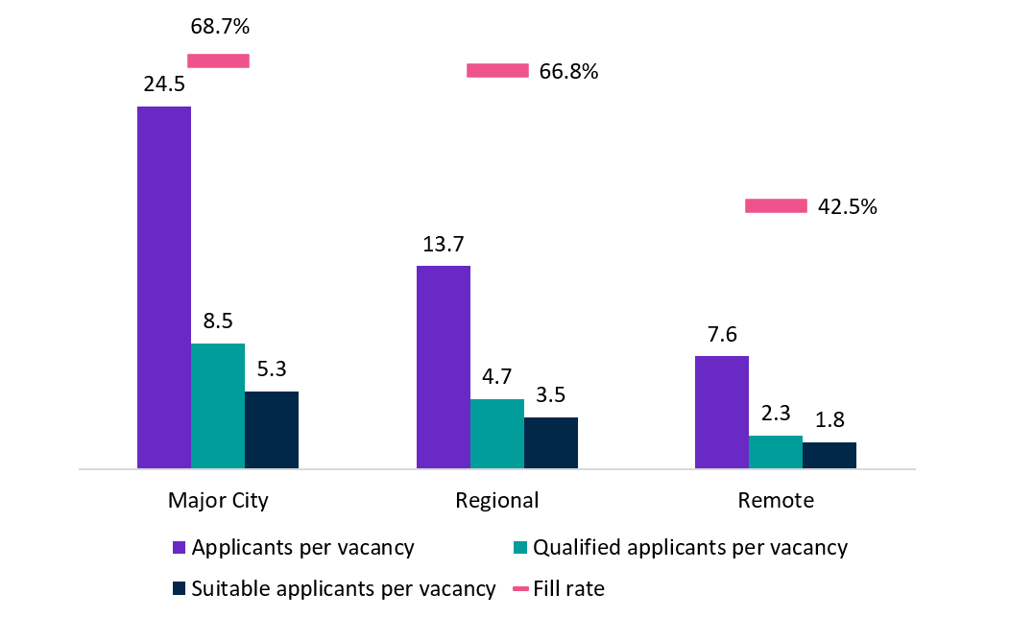
Source: JSA, SERA, 12-months to March 2026 (latest available data)
The coexistence of plentiful job opportunities and ongoing recruitment difficulty suggests that the challenge in many remote labour markets is not solely the availability of jobs. Rather, it reflects difficulties matching available workers with available employment opportunities.
- Consistent with this, Remote Australia recorded a job matching efficiency rate of 60.9%, substantially below the national average of 82.2% (Table 4).
Taken together, these indicators suggest that labour market challenges in Remote Australia reflect both weaker labour market conditions and difficulty connecting available workers with available jobs. While employment opportunities remain available, a combination of structural barriers, recruitment difficulties and lower matching efficiency continues to constrain labour market performance across Remote Australia.

Appendices

Appendix 1: Labour Market Rating by SA4, June 2026
Statistical Area Level 4 (SA4) | Remoteness | Jun-25 | Jun-26 | 1-year change
Central Coast | Major City | Average | Average | Stable
Sydney - Baulkham Hills and Hawkesbury | Major City | Strong | Strong | Stable
Sydney - Blacktown | Major City | Below average | Below average | Stable
Sydney - City and Inner South | Major City | Average | Average | Stable
Sydney - Eastern Suburbs | Major City | Strong | Strong | Stable
Sydney - Inner South West | Major City | Average | Average | Stable
Sydney - Inner West | Major City | Above average | Strong | Improved
Sydney - North Sydney and Hornsby | Major City | Strong | Strong | Stable
Sydney - Northern Beaches | Major City | Strong | Strong | Stable
Sydney - Outer South West | Major City | Average | Average | Stable
Sydney - Outer West and Blue Mountains | Major City | Above average | Above average | Stable
Sydney - Parramatta | Major City | Below average | Below average | Stable
Sydney - Ryde | Major City | Above average | Above average | Stable
Sydney - South West | Major City | Poor | Poor | Stable
Sydney - Sutherland | Major City | Strong | Strong | Stable
Capital Region | Regional | Above average | Above average | Stable
New South Wales - Central West | Regional | Above average | Above average | Stable
Coffs Harbour - Grafton | Regional | Poor | Below average | Improved
Far West and Orana | Remote | Poor | Poor | Stable
Hunter Valley exc Newcastle | Regional | Poor | Below average | Improved
Illawarra | Cities of Regional Australia | Poor | Below average | Improved
Mid North Coast | Regional | Poor | Below average | Improved
Murray | Regional | Above average | Strong | Improved
New England and North West | Regional | Below average | Average | Improved
Newcastle and Lake Macquarie | Cities of Regional Australia | Average | Above average | Improved
Richmond - Tweed | Regional | Average | Average | Stable
Riverina | Regional | Above average | Above average | Stable
Southern Highlands and Shoalhaven | Regional | Below average | Average | Improved
Melbourne - Inner | Major City | Above average | Average | Declined
Melbourne - Inner East | Major City | Above average | Above average | Stable
Melbourne - Inner South | Major City | Above average | Above average | Stable
Melbourne - North East | Major City | Average | Average | Stable
Melbourne - North West | Major City | Poor | Poor | Stable
Melbourne - Outer East | Major City | Above average | Above average | Stable
Melbourne - South East | Major City | Below average | Below average | Stable
Melbourne - West | Major City | Below average | Below average | Stable
Mornington Peninsula | Major City | Average | Average | Stable
Ballarat | Regional | Average | Average | Stable
Bendigo | Regional | Above average | Above average | Stable
Geelong | Cities of Regional Australia | Above average | Above average | Stable
Hume | Regional | Above average | Above average | Stable
Latrobe - Gippsland | Regional | Below average | Below average | Stable
Victoria - North West | Regional | Average | Average | Stable
Shepparton | Regional | Average | Average | Stable
Warrnambool and South West | Regional | Strong | Strong | Stable
Source: JSA, Regional Labour Market Indicator (RLMI), June 2026

Note: The remoteness classification is a bespoke, Statistical Area 4 (SA4) level typology that draws on elements of the ASGS main and remoteness structures and is supported by factors such as population size and density, and proximity to major centres. The classification is not directly concordant with standard ABS classifications.

Statistical Area Level 4 (SA4) | Remoteness | Jun-25 | Jun-26 | 1-year change
Brisbane - East | Major City | Strong | Strong | Stable
Brisbane - North | Major City | Strong | Strong | Stable
Brisbane - South | Major City | Above average | Above average | Stable
Brisbane - West | Major City | Strong | Above average | Declined
Brisbane Inner City | Major City | Strong | Strong | Stable
Ipswich | Major City | Below average | Poor | Declined
Logan - Beaudesert | Major City | Poor | Poor | Stable
Moreton Bay - North | Major City | Poor | Poor | Stable
Moreton Bay - South | Major City | Strong | Strong | Stable
Cairns | Cities of Regional Australia | Below average | Below average | Stable
Darling Downs - Maranoa | Regional | Above average | Above average | Stable
Central Queensland | Regional | Average | Average | Stable
Gold Coast | Cities of Regional Australia | Strong | Strong | Stable
Mackay - Isaac - Whitsunday | Regional | Strong | Strong | Stable
Queensland - Outback | Remote | Poor | Poor | Stable
Sunshine Coast | Cities of Regional Australia | Above average | Strong | Improved
Toowoomba | Cities of Regional Australia | Average | Average | Stable
Townsville | Cities of Regional Australia | Below average | Below average | Stable
Wide Bay | Regional | Poor | Poor | Stable
Adelaide - Central and Hills | Major City | Above average | Strong | Improved
Adelaide - North | Major City | Poor | Poor | Stable
Adelaide - South | Major City | Above average | Above average | Stable
Adelaide - West | Major City | Average | Above average | Improved
Barossa - Yorke - Mid North | Regional | Poor | Poor | Stable
South Australia - Outback | Remote | Poor | Poor | Stable
South Australia - South East | Regional | Poor | Poor | Stable
Mandurah | Major City | Poor | Poor | Stable
Perth - Inner | Major City | Above average | Above average | Stable
Perth - North East | Major City | Above average | Above average | Stable
Perth - North West | Major City | Strong | Strong | Stable
Perth - South East | Major City | Average | Average | Stable
Perth - South West | Major City | Above average | Average | Declined
Bunbury | Regional | Above average | Above average | Stable
Western Australia - Outback (North and South) | Remote | Below average | Poor | Declined
Western Australia - Wheat Belt | Regional | Above average | Above average | Stable
Hobart | Cities of Regional Australia | Below average | Below average | Stable
Launceston and North East | Regional | Poor | Poor | Stable
Tasmania - South East | Regional | Poor | Poor | Stable
Tasmania - West and North West | Remote | Poor | Poor | Stable
Darwin | Cities of Regional Australia | Strong | Strong | Stable
Northern Territory - Outback | Remote | Poor | Poor | Stable
Australian Capital Territory | Major City | Strong | Strong | Stable
Northern Australia |  | Below average | Below average | Stable
Remote Australia | Remote | Poor | Poor | Stable
Source: JSA, Regional Labour Market Indicator (RLMI), June 2026

Note: The remoteness classification is a bespoke, Statistical Area 4 (SA4) level typology that draws on elements of the ASGS main and remoteness structures and is supported by factors such as population size and density, and proximity to major centres. The classification is not directly concordant with standard ABS classifications.

Appendix 2: RLMI Explanatory Notes

Overview
The RLMI combines key measures of labour supply and demand, including factors that capture how these interact, into a single, easy‑to‑interpret summary measure.
Regions are grouped into distinct categories of relative overall labour market performance, ranging from ‘poor’ to ‘strong’, which provides an accurate and reliable view of labour market performance, relative to the national average.
A strong labour market, that is characterised by a high rate of employment, where employers can attract, develop and retain sufficient suitable labour to meet current skills needs, and where employment opportunities are broadly accessible and secure, help drive a more productive economy that is central to building a prosperous and inclusive society.

Factors used to assess labour market performance
The 11 input factors currently included in the RLMI are listed below. The factors can be grouped into broader measures of labour supply, demand, with several indicators capturing dynamics at the intersection of these dimensions.
Factor | Description | Factor Type |  | Availability | Geography | Weight
Employment rate (15-64 years) | The number of employed persons as a proportion of the working age (15-64 years) population (%) | Supply |  | Monthly | SA4 | 20%
Unemployment rate | The number of unemployed persons as a proportion of the total labour force (%) | Supply |  | Monthly | SA4 | 15%
JobSeeker income support rate | Proportion of the working age (15-64 years) population on JobSeeker Income Support* | Supply |  | Monthly | SA4 | 5%
JobSeeker income support for 2 or more years rate | Proportion of the working age (15-64 years) population on JobSeeker Income Support for 2 or more years | Supply (structural) |  | Monthly | SA4 | 15%
Underemployment rate | The number of underemployed persons as a proportion of the labour force (%) | Supply |  | Monthly | GCCSA | 5%
Job vacancy rate | The number of new job vacancies as a proportion of the labour force (%) | Demand |  | Quarterly | SA4/GCCSA² | 15%
Job matching efficiency rate | The efficiency with which available jobseekers and vacancies result in successful hires (%) | Intersection |  | Quarterly | SA4 | 15%
Vacancy fill rate | The percentage of vacancies that have been filled (%) | Intersection |  | Monthly | GCCSA | 5%
Labour productivity (5-year annual average growth rate) | 5-year annual average labour productivity growth rate (%) where productivity is defined as Local Industry GRP (GRP at factor cost) per employed person on an industry adjusted basis. | Intersection (structural) |  | Quarterly³ | GCCSA | ~2%⁴
Annual median income growth rate | The percentage change in median total income over the past year (%) | Intersection |  | Yearly³ | SA4 | ~2%⁴
Skill underutilisation rate | Proportion of employed persons working at a lower skill level than the skill level associated with their highest level of qualification (%) | Intersection |  | 5-yearly³ | SA4 | ~2%⁴
¹JobSeeker income support’ is a combination of the JobSeeker payment and Youth Allowance (other) payment
² Measured at the Greater Capital City Statistical Area (GCCSA) for Major Cities (Sydney, Melbourne, Brisbane, Adelaide, Perth). Measured at the Statistical Area 4 (SA4) level for all other regions.
³ Note, the data is released with a substantial delay (typically 1–2 years after collection), which limits its usefulness for assessing current labour market conditions.
⁴ The 5-year annual average growth rate of productivity, the annual median income growth rate, and the skill underutilisation rate have a combined weight of 5%.

Methodology
Please refer to the RLMI Methodology Paper for more information on the RLMI, including its purpose and factor selection.

Referencing this report
Data in this release should be referenced as: Jobs and Skills Australia, RLMI, June 2026

Contact us
For additional information, email RegionalWorkforceAssessment@jobsandskills.gov.au

Fill Rate measure for Rest of NSW (Greater Capital City Statistical Area).
Remote Australia comprises the following SA4 regions: Far West and Orana (NSW), Queensland – Outback, South Australia – Outback, Western Australia – Outback (North and South), Tasmania – West and North West, and the Northern Territory – Outback.
The number of new job vacancies as a proportion of the labour force (%)
Job matching efficiency measures how effectively jobseekers and vacancies are translated into new hires, providing a key signal of the intersection of labour supply and demand.

