REOS Recruitment Insights Report - July 2026
Jobs and Skills Australia surveys around 1000 employers each month in the Recruitment Experiences and Outlook Survey (REOS) to understand their recruitment experiences and staffing expectations.

Key Findings
Employers in Capital Cities are showing signs of holding back on recruitment, with recruitment rates and future staffing outlook decreasing sharply over the month and year. Employers in Rest of State areas appear to be resilient, with recruitment rates remaining higher than in Capital Cities over the same periods. The recruitment difficulty rate eased over the month in line with the falling recruitment rate. Likewise, the proportion of employers with long-term unfilled vacancies across Australia decreased over the month.
In smoothed terms, which provides a more general indication of movement among the indicators relative to previous months, both the recruitment rate and difficulty rate experienced only minor declines compared with results observed in the prior month.

Recruitment activity
The recruitment rate decreased by 7 percentage points to 44% of employers in July 2026 and is currently 6 percentage points lower than it was a year ago ― despite the large monthly movement in the recruitment rate, in smoothed terms, there was only a marginal decrease recorded over the month.
The largest decrease in recruitment rates occurred in Capital Cities, which fell by 10 percentage points over the month to 40% of employers (down by 9 percentage points compared to last year). The decrease was smaller in Rest of State areas, with a recruitment rate of 51%, 2 percentage points lower than last month. In July, the recruitment rate in Rest of State areas was the same as it was a year earlier.

Recruitment difficulty
There were small decreases in the recruitment difficulty rate over the month, coinciding with the backdrop of decreased recruitment activity. Overall, recruitment difficulty eased by 1 percentage point to 43% of recruiting employers in July 2026. Despite this decline, the rate remained 4 percentage points higher than last year. For context, the July difficulty rate was 32 percentage points lower than the peak rate recorded in July 2022.
While noting the month-to-month variability in this series, the recruitment difficulty rate eased by 2 percentage points in Capital Cities to 42% of recruiting employers, 4 percentage points higher than last year. In Rest of State areas, the rate declined by 1 percentage point to 44% of recruiting employers and is 1 percentage point higher than it was a year earlier.
In smoothed terms, the recruitment difficulty rate in both Capital Cities and Rest of State areas was unchanged over the month.

Staffing outlook: employers expecting to increase staff
The proportion of employers expecting to increase staff numbers also eased in July 2026, falling by 3 percentage points to 17% of employers (2 percentage points lower than last year). The fall was concentrated in Capital Cities, at 15% of employers (5 percentage points lower than last month and 4 percentage points lower than last year). The staffing outlook in Rest of State areas was more resilient, remaining at 20% of employers in July 2026, and 1 percentage point higher than last year.
In smoothed terms, this series has remained stable throughout much of 2026, with a gradual decline observed in Capital Cities. In Rest of State areas, the rate decreased from October 2025 through to March 2026, increasing slightly between March and July 2026.

Reason for recruiting
Recruitment due to staff turnover only was the main reason why employers recruited in July 2026 (accounting for 58% of recruiting employers). Some 32% of recruiting employers aimed to fill new staff positions only, and the remaining 10% were recruiting to fill both new staff and staff turnover positions.

Staffing changes over the last month
Some 13% of employers increased their staff in July 2026, compared with 16% at the same time last year. Meanwhile, around 12% of employers reported a decrease in their staff numbers over the month, compared with 9% of employers a year ago.

Employers unable to fill vacancies in a month
The proportion of recruiting employers who were unable to fill their vacancies within a month fell by 3 percentage points to 38% of recruiting employers in July 2026. This figure was 2 percentage points higher than the 36% recorded in July 2025.
The proportion of employers with unfilled vacancies in Capital Cities stood at 39% of recruiting employers in Capital Cities but decreased by 8 percentage points to 36% in Rest of State areas. By skill level, the proportion of employers with unfilled lower-skilled vacancies (ANZSCO skill levels 4–5) decreased by 7 percentage points to 27% of recruiting employers, while the proportion with unfilled higher-skilled vacancies (ANZSCO skill levels 1–3) eased by just 1 percentage point to 48% in July 2026.

REOS national indicators

Recruitment rate

Proportion of employers currently recruiting or who recruited in the previous month.
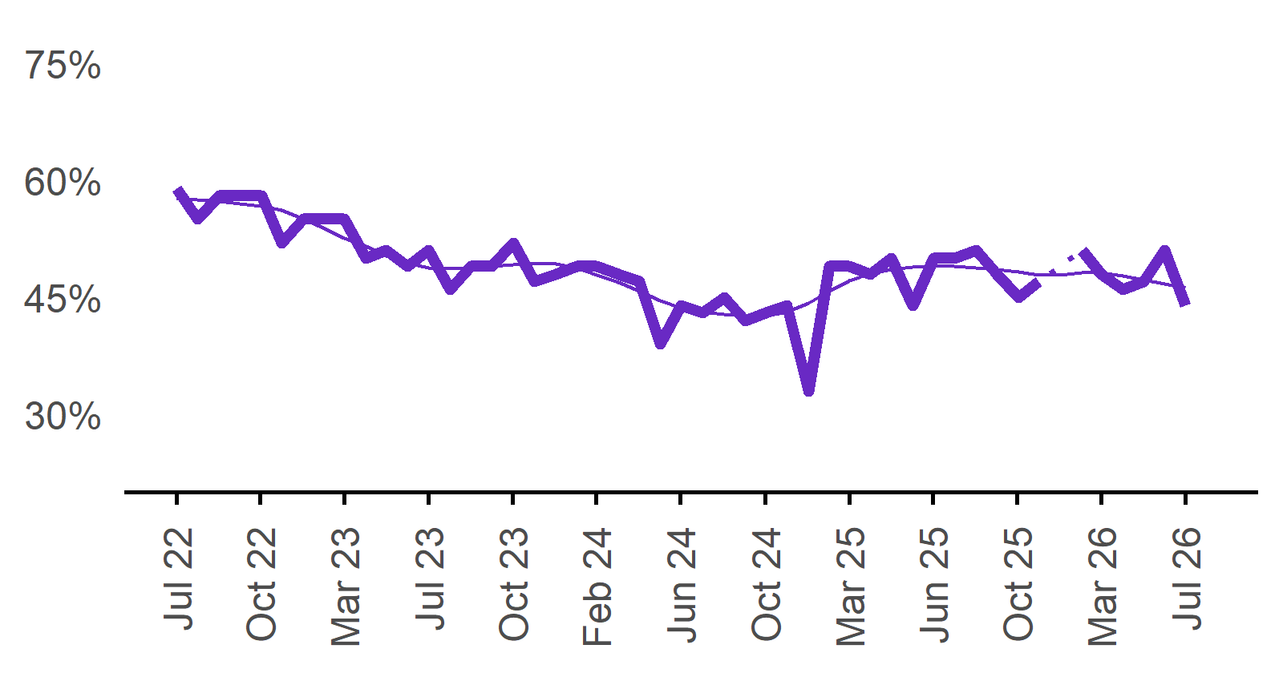 | 44%  Monthly change:  ▼ 7% pts  Annual change:  ▼ 6% pts
  Date | Recruitment rate | Smoothed recruitment rate
  Jul 2022 | 59% | 58%
  Aug 2022 | 55% | 58%
  Sep 2022 | 58% | 57%
  Oct 2022 | 58% | 57%
  Nov 2022 | 58% | 57%
  Dec 2022 | 52% | 56%
  Jan 2023 | 55% | 55%
  Feb 2023 | 55% | 54%
  Mar 2023 | 55% | 53%
  Apr 2023 | 50% | 52%
  May 2023 | 51% | 50%
  Jun 2023 | 49% | 49%
  Jul 2023 | 51% | 49%
  Aug 2023 | 46% | 49%
  Sep 2023 | 49% | 49%
  Oct 2023 | 49% | 49%
  Nov 2023 | 52% | 49%
  Dec 2023 | 47% | 49%
  Jan 2024 | 48% | 49%
  Feb 2024 | 49% | 49%
  Mar 2024 | 49% | 48%
  Apr 2024 | 48% | 47%
  May 2024 | 47% | 46%
  Jun 2024 | 39% | 45%
  Jul 2024 | 44% | 44%
  Aug 2024 | 43% | 43%
  Sep 2024 | 45% | 43%
  Oct 2024 | 42% | 43%
  Nov 2024 | 43% | 43%
  Dec 2024 | 44% | 43%
  Jan 2025 | 33% | 44%
  Feb 2025 | 49% | 46%
  Mar 2025 | 49% | 47%
  Apr 2025 | 48% | 48%
  May 2025 | 50% | 49%
  Jun 2025 | 44% | 49%
  Jul 2025 | 50% | 49%
  Aug 2025 | 50% | 49%
  Sep 2025 | 51% | 49%
  Oct 2025 | 48% | 49%
  Nov 2025 | 45% | 48%
  Dec 2025 | 47% | 48%
  Jan 2026 |  | 48%
  Feb 2026 | 51% | 48%
  Mar 2026 | 48% | 48%
  Apr 2026 | 46% | 48%
  May 2026 | 47% | 47%
  Jun 2026 | 51% | 47%
  Jul 2026 | 44% | 46%

Recruitment difficulty rate

Proportion of recruiting employers who stated they had difficulty hiring staff.
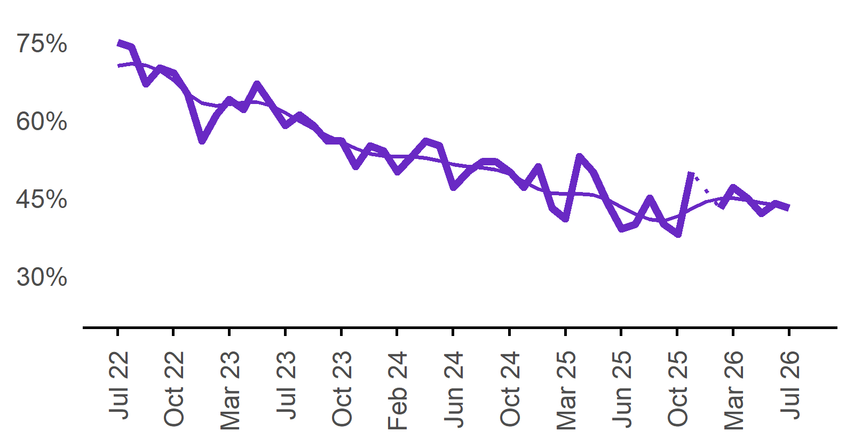 | 43%  Monthly change:  ▼ 1% pt  Annual change:  ▲ 4% pts
  Date | Recruitment difficulty rate | Smoothed recruitment difficulty rate
  Jul 2022 | 75% | 70%
  Aug 2022 | 74% | 71%
  Sep 2022 | 67% | 71%
  Oct 2022 | 70% | 69%
  Nov 2022 | 69% | 68%
  Dec 2022 | 65% | 65%
  Jan 2023 | 56% | 63%
  Feb 2023 | 61% | 63%
  Mar 2023 | 64% | 63%
  Apr 2023 | 62% | 63%
  May 2023 | 67% | 63%
  Jun 2023 | 63% | 63%
  Jul 2023 | 59% | 61%
  Aug 2023 | 61% | 60%
  Sep 2023 | 59% | 58%
  Oct 2023 | 56% | 57%
  Nov 2023 | 56% | 56%
  Dec 2023 | 51% | 55%
  Jan 2024 | 55% | 54%
  Feb 2024 | 54% | 53%
  Mar 2024 | 50% | 53%
  Apr 2024 | 53% | 53%
  May 2024 | 56% | 53%
  Jun 2024 | 55% | 52%
  Jul 2024 | 47% | 51%
  Aug 2024 | 50% | 51%
  Sep 2024 | 52% | 51%
  Oct 2024 | 52% | 50%
  Nov 2024 | 50% | 50%
  Dec 2024 | 47% | 48%
  Jan 2025 | 51% | 47%
  Feb 2025 | 43% | 46%
  Mar 2025 | 41% | 46%
  Apr 2025 | 53% | 46%
  May 2025 | 50% | 46%
  Jun 2025 | 44% | 45%
  Jul 2025 | 39% | 43%
  Aug 2025 | 40% | 42%
  Sep 2025 | 45% | 41%
  Oct 2025 | 40% | 41%
  Nov 2025 | 38% | 42%
  Dec 2025 | 50% | 43%
  Jan 2026 |  | 44%
  Feb 2026 | 43% | 45%
  Mar 2026 | 47% | 45%
  Apr 2026 | 45% | 45%
  May 2026 | 42% | 44%
  Jun 2026 | 44% | 44%
  Jul 2026 | 43% | 43%

Expecting to increase staff

Proportion of employers who expected to increase staffing numbers over the next three months.
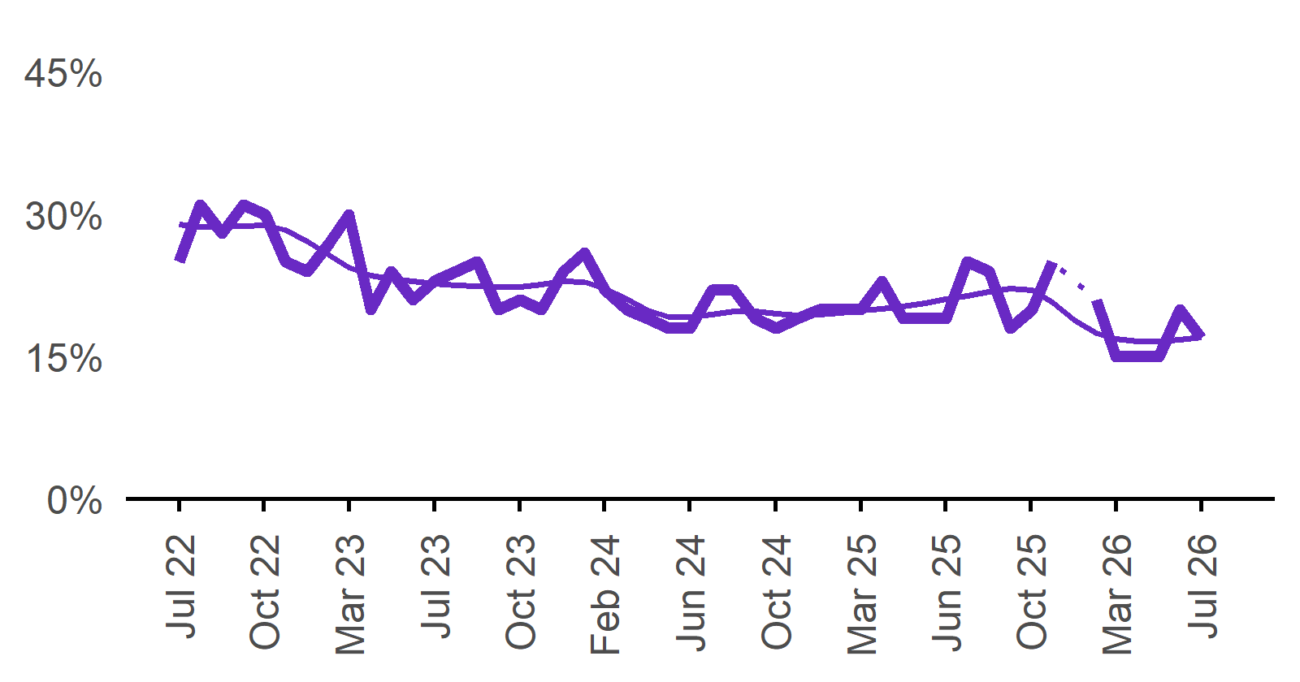 | 17%  Monthly change:  ▼ 3% pts  Annual change:  ▼ 2% pts
  Date | Expect to increase | Smoothed expect to increase
  Jul 2022 | 25% | 29%
  Aug 2022 | 31% | 29%
  Sep 2022 | 28% | 29%
  Oct 2022 | 31% | 29%
  Nov 2022 | 30% | 29%
  Dec 2022 | 25% | 28%
  Jan 2023 | 24% | 27%
  Feb 2023 | 27% | 26%
  Mar 2023 | 30% | 24%
  Apr 2023 | 20% | 24%
  May 2023 | 24% | 23%
  Jun 2023 | 21% | 23%
  Jul 2023 | 23% | 23%
  Aug 2023 | 24% | 23%
  Sep 2023 | 25% | 22%
  Oct 2023 | 20% | 22%
  Nov 2023 | 21% | 22%
  Dec 2023 | 20% | 23%
  Jan 2024 | 24% | 23%
  Feb 2024 | 26% | 23%
  Mar 2024 | 22% | 22%
  Apr 2024 | 20% | 21%
  May 2024 | 19% | 20%
  Jun 2024 | 18% | 19%
  Jul 2024 | 18% | 19%
  Aug 2024 | 22% | 19%
  Sep 2024 | 22% | 20%
  Oct 2024 | 19% | 20%
  Nov 2024 | 18% | 20%
  Dec 2024 | 19% | 19%
  Jan 2025 | 20% | 19%
  Feb 2025 | 20% | 20%
  Mar 2025 | 20% | 20%
  Apr 2025 | 23% | 20%
  May 2025 | 19% | 20%
  Jun 2025 | 19% | 21%
  Jul 2025 | 19% | 21%
  Aug 2025 | 25% | 21%
  Sep 2025 | 24% | 22%
  Oct 2025 | 18% | 22%
  Nov 2025 | 20% | 22%
  Dec 2025 | 25% | 21%
  Jan 2026 |  | 19%
  Feb 2026 | 21% | 18%
  Mar 2026 | 15% | 17%
  Apr 2026 | 15% | 17%
  May 2026 | 15% | 17%
  Jun 2026 | 20% | 17%
  Jul 2026 | 17% | 17%

Capital City/Rest of State areas

Recruitment rate

Proportion of employers currently recruiting or who recruited in the previous month.
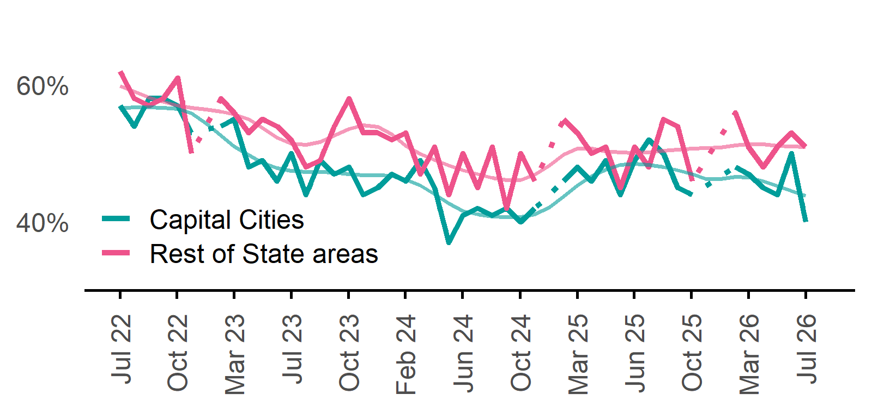 | Capital Cities: 40%  Monthly change:  ▼ 10%pts  Annual change:  ▼ 9%pts  Rest of State: 51%  Monthly change:  ▼ 2%pts  Annual change:  0%pts
  Date | Capital Cities - Recruitment rate | Rest of State areas - Recruitment rate | Capital Cities - Smoothed recruitment rate | Rest of State areas - Smoothed recruitment rate
  Jul 2022 | 57% | 62% | 57% | 60%
  Aug 2022 | 54% | 58% | 57% | 59%
  Sep 2022 | 58% | 57% | 57% | 58%
  Oct 2022 | 58% | 58% | 57% | 58%
  Nov 2022 | 57% | 61% | 56% | 57%
  Dec 2022 | 53% | 50% | 56% | 57%
  Jan 2023 | n.p. | n.p. | 54% | 56%
  Feb 2023 | 54% | 58% | 53% | 56%
  Mar 2023 | 55% | 56% | 51% | 56%
  Apr 2023 | 48% | 53% | 50% | 55%
  May 2023 | 49% | 55% | 49% | 54%
  Jun 2023 | 46% | 54% | 48% | 52%
  Jul 2023 | 50% | 52% | 47% | 51%
  Aug 2023 | 44% | 48% | 47% | 51%
  Sep 2023 | 49% | 49% | 47% | 52%
  Oct 2023 | 47% | 54% | 47% | 53%
  Nov 2023 | 48% | 58% | 47% | 54%
  Dec 2023 | 44% | 53% | 47% | 54%
  Jan 2024 | 45% | 53% | 47% | 54%
  Feb 2024 | 47% | 52% | 47% | 53%
  Mar 2024 | 46% | 53% | 46% | 51%
  Apr 2024 | 49% | 47% | 45% | 50%
  May 2024 | 45% | 51% | 44% | 49%
  Jun 2024 | 37% | 44% | 43% | 48%
  Jul 2024 | 41% | 50% | 42% | 48%
  Aug 2024 | 42% | 45% | 41% | 47%
  Sep 2024 | 41% | 51% | 41% | 46%
  Oct 2024 | 42% | 42% | 41% | 46%
  Nov 2024 | 40% | 50% | 41% | 46%
  Dec 2024 | 42% | 46% | 41% | 47%
  Jan 2025 | n.p. | n.p. | 42% | 48%
  Feb 2025 | 46% | 55% | 44% | 50%
  Mar 2025 | 48% | 53% | 45% | 51%
  Apr 2025 | 46% | 50% | 47% | 51%
  May 2025 | 49% | 51% | 48% | 50%
  Jun 2025 | 44% | 45% | 48% | 50%
  Jul 2025 | 49% | 51% | 48% | 50%
  Aug 2025 | 52% | 48% | 48% | 50%
  Sep 2025 | 50% | 55% | 48% | 50%
  Oct 2025 | 45% | 54% | 48% | 51%
  Nov 2025 | 44% | 46% | 47% | 51%
  Dec 2025 | n.p. | n.p. | 46% | 51%
  Jan 2026 |  |  | 46% | 51%
  Feb 2026 | 48% | 56% | 47% | 51%
  Mar 2026 | 47% | 51% | 47% | 51%
  Apr 2026 | 45% | 48% | 46% | 51%
  May 2026 | 44% | 51% | 45% | 51%
  Jun 2026 | 50% | 53% | 45% | 51%
  Jul 2026 | 40% | 51% | 44% | 51%

Recruitment difficulty rate

Proportion of recruiting employers who stated they had difficulty hiring staff.
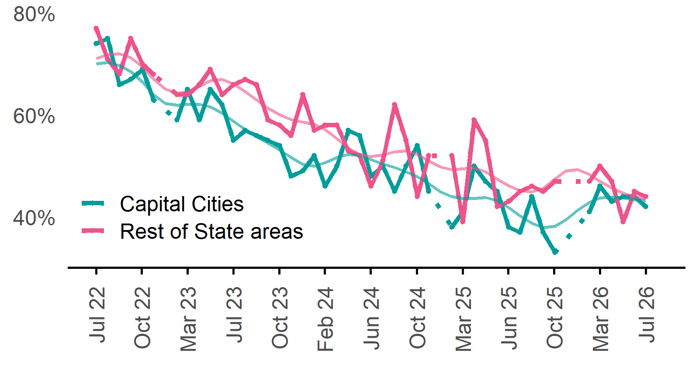 | Capital Cities: 42%  Monthly change:  ▼ 2%pts  Annual change:  ▲ 4%pts  Rest of State: 44%  Monthly change:  ▼ 1%pt  Annual change:  ▲ 1%pt
  Date | Capital Cities - Recruitment difficulty rate | Rest of State areas - Recruitment difficulty rate | Capital Cities - Smoothed recruitment difficulty rate | Rest of State areas - Smoothed recruitment difficulty rate
  Jul 2022 | 74% | 77% | 70% | 71%
  Aug 2022 | 75% | 71% | 70% | 72%
  Sep 2022 | 66% | 68% | 70% | 72%
  Oct 2022 | 67% | 75% | 69% | 71%
  Nov 2022 | 69% | 70% | 66% | 69%
  Dec 2022 | 63% | 68% | 64% | 67%
  Jan 2023 | n.p. | n.p. | 62% | 65%
  Feb 2023 | 59% | 64% | 62% | 64%
  Mar 2023 | 65% | 64% | 62% | 65%
  Apr 2023 | 59% | 66% | 62% | 66%
  May 2023 | 65% | 69% | 62% | 67%
  Jun 2023 | 62% | 64% | 60% | 67%
  Jul 2023 | 55% | 66% | 59% | 66%
  Aug 2023 | 57% | 67% | 57% | 65%
  Sep 2023 | 56% | 66% | 56% | 63%
  Oct 2023 | 55% | 59% | 55% | 61%
  Nov 2023 | 54% | 58% | 53% | 60%
  Dec 2023 | 48% | 56% | 52% | 59%
  Jan 2024 | 49% | 64% | 50% | 59%
  Feb 2024 | 52% | 57% | 50% | 58%
  Mar 2024 | 46% | 58% | 51% | 57%
  Apr 2024 | 50% | 58% | 52% | 55%
  May 2024 | 57% | 53% | 52% | 53%
  Jun 2024 | 56% | 52% | 52% | 52%
  Jul 2024 | 48% | 46% | 51% | 52%
  Aug 2024 | 50% | 51% | 50% | 52%
  Sep 2024 | 45% | 62% | 50% | 53%
  Oct 2024 | 50% | 55% | 49% | 53%
  Nov 2024 | 54% | 44% | 48% | 52%
  Dec 2024 | 45% | 52% | 47% | 51%
  Jan 2025 | n.p. | n.p. | 45% | 50%
  Feb 2025 | 38% | 52% | 44% | 49%
  Mar 2025 | 41% | 39% | 44% | 49%
  Apr 2025 | 50% | 59% | 44% | 50%
  May 2025 | 47% | 55% | 44% | 49%
  Jun 2025 | 45% | 42% | 43% | 47%
  Jul 2025 | 38% | 43% | 42% | 46%
  Aug 2025 | 37% | 45% | 40% | 45%
  Sep 2025 | 44% | 46% | 39% | 45%
  Oct 2025 | 37% | 45% | 38% | 46%
  Nov 2025 | 33% | 47% | 38% | 47%
  Dec 2025 | n.p. | n.p. | 39% | 49%
  Jan 2026 |  |  | 41% | 49%
  Feb 2026 | 41% | 47% | 43% | 48%
  Mar 2026 | 46% | 50% | 44% | 47%
  Apr 2026 | 43% | 47% | 44% | 46%
  May 2026 | 44% | 39% | 44% | 45%
  Jun 2026 | 44% | 45% | 43% | 44%
  Jul 2026 | 42% | 44% | 43% | 44%

Staffing outlook – Expecting to increase staff

Proportion of employers who expected to increase staffing numbers over the next three months.
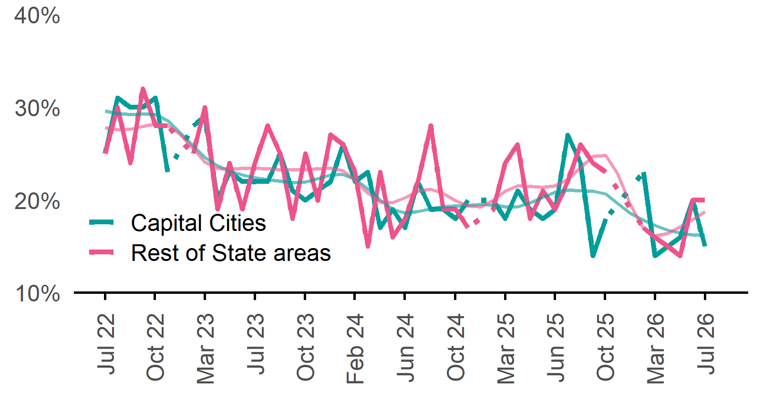 | Capital Cities: 15%  Monthly change:  ▼ 5%pts  Annual change:  ▼ 4%pts  Rest of State: 20%  Monthly change:  0%pts  Annual change:  ▲ 1%pt
  Date | Capital Cities - % expecting to increase | Rest of State areas - % expecting to increase | Capital Cities - Smoothed % expecting to increase | Rest of State areas - Smoothed % expecting to increase
  Jul 2022 | 25% | 25% | 30% | 28%
  Aug 2022 | 31% | 30% | 29% | 28%
  Sep 2022 | 30% | 24% | 29% | 28%
  Oct 2022 | 30% | 32% | 29% | 28%
  Nov 2022 | 31% | 28% | 29% | 28%
  Dec 2022 | 23% | 28% | 29% | 28%
  Jan 2023 | n.p. | n.p. | 27% | 27%
  Feb 2023 | 28% | 25% | 26% | 26%
  Mar 2023 | 29% | 30% | 25% | 24%
  Apr 2023 | 20% | 19% | 24% | 23%
  May 2023 | 23% | 24% | 23% | 23%
  Jun 2023 | 22% | 19% | 23% | 23%
  Jul 2023 | 22% | 24% | 22% | 23%
  Aug 2023 | 22% | 28% | 22% | 23%
  Sep 2023 | 25% | 25% | 22% | 23%
  Oct 2023 | 21% | 18% | 22% | 23%
  Nov 2023 | 20% | 25% | 22% | 23%
  Dec 2023 | 21% | 20% | 22% | 23%
  Jan 2024 | 22% | 27% | 23% | 23%
  Feb 2024 | 26% | 26% | 23% | 23%
  Mar 2024 | 22% | 23% | 22% | 22%
  Apr 2024 | 23% | 15% | 21% | 21%
  May 2024 | 17% | 23% | 20% | 20%
  Jun 2024 | 19% | 16% | 19% | 20%
  Jul 2024 | 17% | 18% | 19% | 20%
  Aug 2024 | 22% | 22% | 19% | 21%
  Sep 2024 | 19% | 28% | 19% | 21%
  Oct 2024 | 19% | 19% | 19% | 21%
  Nov 2024 | 18% | 19% | 19% | 20%
  Dec 2024 | 20% | 17% | 19% | 19%
  Jan 2025 | n.p. | n.p. | 20% | 19%
  Feb 2025 | 20% | 19% | 19% | 20%
  Mar 2025 | 18% | 24% | 19% | 21%
  Apr 2025 | 21% | 26% | 19% | 22%
  May 2025 | 19% | 18% | 20% | 21%
  Jun 2025 | 18% | 21% | 20% | 21%
  Jul 2025 | 19% | 19% | 21% | 22%
  Aug 2025 | 27% | 22% | 21% | 22%
  Sep 2025 | 24% | 26% | 21% | 23%
  Oct 2025 | 14% | 24% | 21% | 25%
  Nov 2025 | 18% | 23% | 21% | 25%
  Dec 2025 | n.p. | n.p. | 20% | 23%
  Jan 2026 |  |  | 19% | 19%
  Feb 2026 | 23% | 17% | 18% | 17%
  Mar 2026 | 14% | 16% | 17% | 16%
  Apr 2026 | 15% | 15% | 17% | 16%
  May 2026 | 16% | 14% | 16% | 17%
  Jun 2026 | 20% | 20% | 16% | 18%
  Jul 2026 | 15% | 20% | 16% | 19%

Other recruitment indicators

Reason for recruiting

Proportion of employers currently recruiting or who recruited in the previous month.
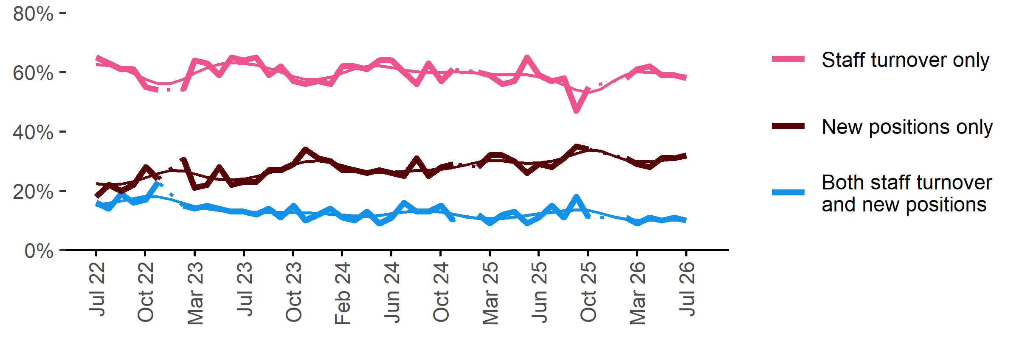
Date | Staff turnover only | Staff turnover and new positions | New positions only | Smoothed - staff turnover only | Smoothed - staff turnover and new positions | Smoothed - new positions only
Jul 2022 | 65% | 16% | 18% | 63% | 15% | 22%
Aug 2022 | 63% | 14% | 22% | 62% | 16% | 22%
Sep 2022 | 61% | 19% | 20% | 61% | 17% | 22%
Oct 2022 | 61% | 16% | 22% | 60% | 17% | 23%
Nov 2022 | 55% | 17% | 28% | 58% | 18% | 24%
Dec 2022 | 54% | 23% | 24% | 56% | 18% | 26%
Jan 2023 | n.p. | n.p. | n.p. | 56% | 17% | 27%
Feb 2023 | 54% | 15% | 31% | 58% | 16% | 27%
Mar 2023 | 64% | 14% | 21% | 60% | 15% | 26%
Apr 2023 | 63% | 15% | 22% | 61% | 14% | 25%
May 2023 | 59% | 14% | 28% | 63% | 13% | 24%
Jun 2023 | 65% | 13% | 22% | 63% | 13% | 24%
Jul 2023 | 64% | 13% | 23% | 63% | 13% | 24%
Aug 2023 | 65% | 12% | 23% | 62% | 13% | 25%
Sep 2023 | 59% | 14% | 27% | 61% | 13% | 26%
Oct 2023 | 62% | 11% | 27% | 60% | 13% | 27%
Nov 2023 | 57% | 15% | 29% | 59% | 13% | 29%
Dec 2023 | 56% | 10% | 34% | 58% | 13% | 30%
Jan 2024 | 57% | 12% | 31% | 57% | 12% | 30%
Feb 2024 | 56% | 14% | 30% | 58% | 12% | 30%
Mar 2024 | 62% | 11% | 27% | 60% | 12% | 28%
Apr 2024 | 62% | 10% | 27% | 61% | 12% | 27%
May 2024 | 61% | 13% | 26% | 62% | 11% | 27%
Jun 2024 | 64% | 9% | 27% | 62% | 12% | 26%
Jul 2024 | 64% | 11% | 26% | 62% | 12% | 26%
Aug 2024 | 60% | 16% | 25% | 61% | 13% | 27%
Sep 2024 | 56% | 13% | 31% | 60% | 13% | 27%
Oct 2024 | 63% | 13% | 25% | 60% | 13% | 27%
Nov 2024 | 57% | 15% | 28% | 60% | 13% | 27%
Dec 2024 | 61% | 10% | 29% | 60% | 12% | 28%
Jan 2025 | n.p. | n.p. | n.p. | 60% | 11% | 29%
Feb 2025 | 60% | 12% | 28% | 60% | 11% | 30%
Mar 2025 | 59% | 9% | 32% | 59% | 11% | 30%
Apr 2025 | 56% | 12% | 32% | 59% | 11% | 30%
May 2025 | 57% | 13% | 30% | 59% | 11% | 30%
Jun 2025 | 65% | 9% | 26% | 59% | 12% | 29%
Jul 2025 | 59% | 11% | 29% | 58% | 12% | 29%
Aug 2025 | 57% | 15% | 28% | 57% | 13% | 30%
Sep 2025 | 58% | 11% | 31% | 56% | 13% | 31%
Oct 2025 | 47% | 18% | 35% | 54% | 13% | 33%
Nov 2025 | 55% | 11% | 34% | 53% | 13% | 34%
Dec 2025 | n.p. | n.p. | n.p. | 54% | 12% | 33%
Jan 2026 |  |  |  | 57% | 11% | 32%
Feb 2026 | 58% | 11% | 31% | 59% | 10% | 30%
Mar 2026 | 61% | 9% | 29% | 60% | 10% | 30%
Apr 2026 | 62% | 11% | 28% | 60% | 10% | 30%
May 2026 | 59% | 10% | 31% | 60% | 10% | 30%
Jun 2026 | 59% | 11% | 31% | 59% | 10% | 31%
Jul 2026 | 58% | 10% | 32% | 59% | 10% | 31%

Staffing changes over the last month

Proportion of employers who said they increased or decreased staffing compared to the previous month.

Date | Increased staff | Decreased staff | Smoothed - increased staff | Smoothed - decreased staff
Jul 2022 | 15% | 11% | 15% | 9%
Aug 2022 | 13% | 8% | 14% | 10%
Sep 2022 | 14% | 10% | 14% | 10%
Oct 2022 | 14% | 11% | 14% | 10%
Nov 2022 | 13% | 11% | 14% | 10%
Dec 2022 | 13% | 9% | 14% | 10%
Jan 2023 | n.p. | n.p. | 14% | 9%
Feb 2023 | 14% | 6% | 15% | 9%
Mar 2023 | 16% | 10% | 15% | 9%
Apr 2023 | 14% | 8% | 14% | 9%
May 2023 | 14% | 10% | 14% | 9%
Jun 2023 | 13% | 9% | 13% | 9%
Jul 2023 | 14% | 9% | 13% | 8%
Aug 2023 | 12% | 8% | 13% | 8%
Sep 2023 | 12% | 7% | 12% | 8%
Oct 2023 | 13% | 7% | 12% | 8%
Nov 2023 | 12% | 8% | 12% | 8%
Dec 2023 | 13% | 9% | 12% | 9%
Jan 2024 | 11% | 11% | 12% | 9%
Feb 2024 | 13% | 9% | 12% | 9%
Mar 2024 | 12% | 7% | 12% | 9%
Apr 2024 | 11% | 9% | 12% | 9%
May 2024 | 12% | 9% | 11% | 8%
Jun 2024 | 9% | 7% | 11% | 8%
Jul 2024 | 11% | 9% | 10% | 8%
Aug 2024 | 11% | 7% | 10% | 8%
Sep 2024 | 10% | 9% | 10% | 8%
Oct 2024 | 10% | 8% | 10% | 8%
Nov 2024 | 13% | 7% | 11% | 8%
Dec 2024 | 11% | 9% | 12% | 9%
Jan 2025 | n.p. | n.p. | 14% | 10%
Feb 2025 | 17% | 11% | 15% | 11%
Mar 2025 | 18% | 12% | 15% | 12%
Apr 2025 | 13% | 13% | 15% | 12%
May 2025 | 12% | 10% | 14% | 12%
Jun 2025 | 11% | 12% | 14% | 11%
Jul 2025 | 16% | 9% | 14% | 11%
Aug 2025 | 15% | 12% | 13% | 11%
Sep 2025 | 12% | 11% | 14% | 10%
Oct 2025 | 14% | 10% | 13% | 10%
Nov 2025 | 13% | 11% | 13% | 10%
Dec 2025 | n.p. | n.p. | 13% | 10%
Jan 2026 |  |  | 13% | 11%
Feb 2026 | 14% | 12% | 13% | 11%
Mar 2026 | 13% | 11% | 14% | 11%
Apr 2026 | 13% | 12% | 14% | 12%
May 2026 | 14% | 11% | 14% | 12%
Jun 2026 | 14% | 12% | 14% | 12%
Jul 2026 | 13% | 12% | 14% | 12%
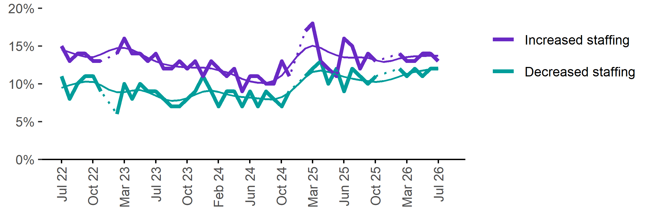

Employers unable to fill vacancies within a month

Proportion of recruiting employers who were unable to fill their vacancies within a month.*
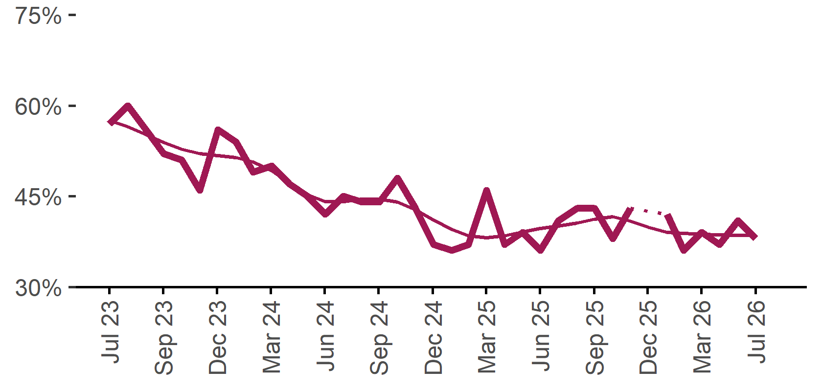 | 38%  Monthly change:  ▼ 3%pts  Annual change:  ▲ 2%pts
  Date | % unable to fill vacancies in a month | Smoothed - % unable to fill vacancies in a month
  Jul 2023 | 57% | 58%
  Aug 2023 | 60% | 56%
  Sep 2023 | 56% | 55%
  Oct 2023 | 52% | 54%
  Nov 2023 | 51% | 53%
  Dec 2023 | 46% | 52%
  Jan 2024 | 56% | 52%
  Feb 2024 | 54% | 51%
  Mar 2024 | 49% | 51%
  Apr 2024 | 50% | 49%
  May 2024 | 47% | 47%
  Jun 2024 | 45% | 45%
  Jul 2024 | 42% | 44%
  Aug 2024 | 45% | 44%
  Sep 2024 | 44% | 45%
  Oct 2024 | 44% | 45%
  Nov 2024 | 48% | 44%
  Dec 2024 | 43% | 43%
  Jan 2025 | 37% | 41%
  Feb 2025 | 36% | 40%
  Mar 2025 | 37% | 38%
  Apr 2025 | 46% | 38%
  May 2025 | 37% | 38%
  Jun 2025 | 39% | 39%
  Jul 2025 | 36% | 40%
  Aug 2025 | 41% | 40%
  Sep 2025 | 43% | 41%
  Oct 2025 | 43% | 41%
  Nov 2025 | 38% | 42%
  Dec 2025 | 43% | 41%
  Jan 2026 |  | 40%
  Feb 2026 | 42% | 39%
  Mar 2026 | 36% | 39%
  Apr 2026 | 39% | 39%
  May 2026 | 37% | 39%
  Jun 2026 | 41% | 39%
  Jul 2026 | 38% | 39%
* Excludes employers who have been recruiting for less than a month.

Background
Jobs and Skills Australia (JSA) conducts the Recruitment Experiences and Outlook Survey (REOS), a telephone administered survey with the business owner or other person in the business responsible for recruitment. Around 1000 employers are surveyed each month, with data published on the JSA website. While the data are indicative of recruitment activity, they may be subject to seasonal factors and other volatility and should therefore be used with a degree of caution. In addition, the survey is targeted towards employers with 5 or more employees and excludes many government organisations. Details of the survey methodology can be accessed from the JSA website.

Smoothed series in charts
Charts include Henderson-smoothed lines in addition to original data for most of our recruitment indicators. As the time series is not yet long enough for seasonal adjustment, a Henderson smoothed moving average with a 13-term filter (equating to 13 months) has been directly applied to the original series. This provides an indication of the general movement in each recruitment indicator relative to previous months. Due to using 13 months in the moving average, results for the most recent six months will be revised each month.

How to reference data from this report
Jobs and Skills Australia, Recruitment Insights Report, July 2026.

Contact us
For additional information, email REOS@jobsandskills.gov.au

Also available from the REOS

Data file with monthly and quarterly recruitment indicators
A REOS data file is available on the JSA website. Breakdowns by Capital City/Rest of State area, Business size, and ANZSCO Skill Level are included in the monthly results. Quarterly recruitment indicators provide detail by state, ARIA (ABS’ Accessibility and Remoteness Index of Australia) as well as selected industry and occupation groups.

Stay up to date
JSA also releases semi-regular reports including spotlight articles detailing aspects of the REOS that cannot be included in our monthly Recruitment Insights Report. Sign up and get the Recruitment Insights Report notifications sent straight to your inbox.
Upcoming spotlight:
- Recruitment pressures in Australia’s high skilled labour market– August 2026
Reasons for recruitment difficulty and future concerns by higher skilled occupations and location.
Recent spotlights:
- Recruitment Experiences and Outlook Survey, June quarter 2026 – July 2026
- Shifting employer sentiment (employers’ future concerns) – May 2026

A Henderson smoothed line has been included in the charts to reduce month to month volatility and illustrate long term patterns. See the explanatory note for more information.
Data are not available for January in some years. Data points have been joined by a dotted line between December and February to reflect this. ‘Rest of State’ refers to areas outside the capital cities.

