

Regional Labour Market Indicator (RLMI) Results – March 2026
This Report:
- Labour market conditions are stronger on average in major cities, compared to outcomes across regional Australia which are more mixed.
- The Regional Labour Market Indicator (RLMI) has been further enhanced through the addition of a labour productivity measure in March 2026. The inclusion of productivity reflects its central role in understanding labour market performance as it captures the efficiency with which labour is used in the economy – how effectively workers, jobs, and capital combine to generate output. Encouragingly, the data show productivity growth has strengthened in regional and remote Australia in recent years.
- This release also introduces a combined rating for Remote Australia, reflecting that some labour markets are geographically isolated, with shared structural challenges across regions. These may include limited job opportunities, lower levels of educational attainment, difficulties attracting and retaining workers, and more limited access to services and infrastructure.

Labour market conditions are stronger on average in major cities, compared to outcomes across regional Australia which are more mixed
The March 2026 RLMI results show that regional and remote areas are more likely than major cities to experience relatively weaker labour market conditions, while also reflecting a diverse range of outcomes across regional Australia (see Chart 1, below).
- Around two thirds (64%) of SA4s located in major city areas were rated either ‘strong’ or ‘above average’ in March 2026. Strong labour market conditions are evident across most major city labour markets, particularly in Sydney, Melbourne, Brisbane and Perth.
- Strong labour market conditions are also evident in a number of regional areas. This includes regions surrounding Greater Brisbane, such as the Gold Coast and Sunshine Coast, as well as parts of south west Western Australia, the Surf Coast region of Victoria, and across parts of the Southern Murray–Darling Basin.
- With that said, outcomes vary across regional labour markets, with 38% rated ‘below average’ or ‘poor’, including in parts of Northern Australia, regional and coastal New South Wales (such as the Mid North Coast and Coffs Harbour–Grafton), the Spencer Gulf region and surrounds of South Australia, and across Tasmania, including Hobart.
- All 6 remote SA4s (100%) were rated ‘poor’ in March 2026, highlighting the particularly challenging labour market conditions in the remote areas of Australia. The combined Remote Australia region was also rated ‘poor’.
Chart 1: RLMI ratings of relative labour market performance, March 2026
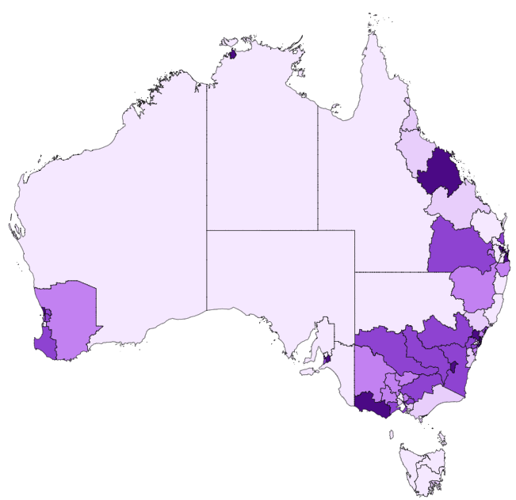

Source: JSA, Regional Labour Market Indicator (RLMI), March 2026

Chart 2: RLMI ratings of relative labour market performance, by selected Capital Cities, March 2026
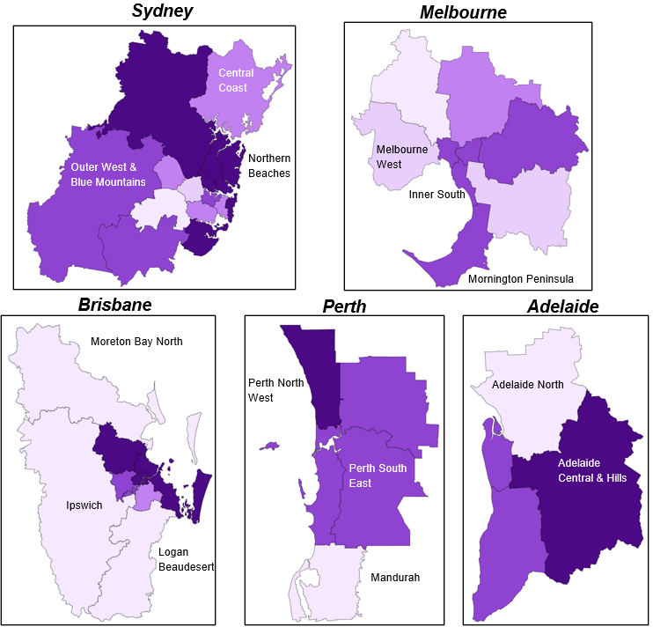
Source: JSA, Regional Labour Market Indicator (RLMI), March 2026

Chart 3: 1-year change in RLMI ratings of relative labour market performance, March 2026
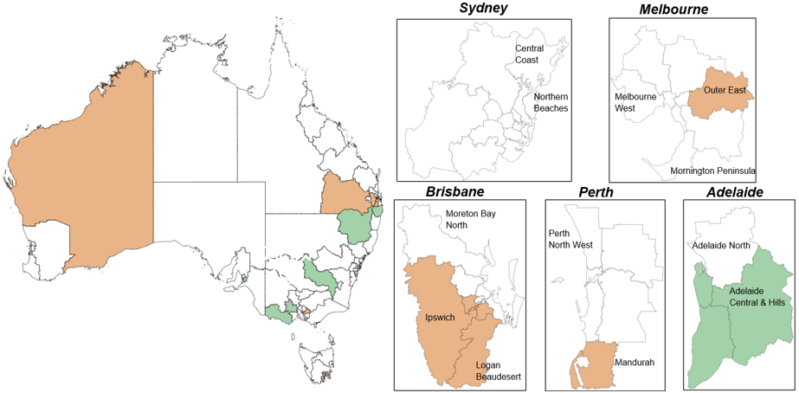

Source: JSA, Regional Labour Market Indicator (RLMI), March 2026

Chart 3 above presents the change in RLMI ratings over the past year. While most regions recorded no change, there are signs that labour market conditions have softened across parts of Greater Brisbane and surrounding areas, as well as in pockets of Western Australia (including Mandurah and the Outback), Outer East Melbourne, and Hobart. By contrast, labour market conditions have improved modestly across several regional areas of New South Wales, parts of regional Victoria, and across metropolitan Adelaide.

Incorporating productivity into labour market performance
The RLMI has been further enhanced through the addition of a productivity indicator in March 2026. The inclusion of productivity reflects its central role in understanding labour market performance as it captures the efficiency with which labour is used in the economy – how effectively workers, jobs, and capital combine to generate output.
Table 1: New RLMI Indicator – March 2026
Factor | Description | Factor Type
5-year annual average growth rate of productivity | 5-year annual average productivity growth rate (%) where productivity is defined as Local Industry Gross Regional Product (GRP at factor cost) per employed person on an industry adjusted basis.  Local GRP measures the value of economic activity accruing to the local area after taxes and dividends paid outside the region are removed. | Intersection (structural)

The productivity measure incorporated into the RLMI is based on 5-year average growth in industry-adjusted Gross Regional Product (GRP) per employed person. This industry adjustment ensures that differences across regions reflect variation in within-industry performance rather than variation in industry structure. The use of a 5-year average reduces short‑term volatility and cyclical effects, making this a more stable indicator of structural labour market performance, but less responsive to current labour market conditions.
Chart 4: 5-year annual average productivity growth, by remoteness
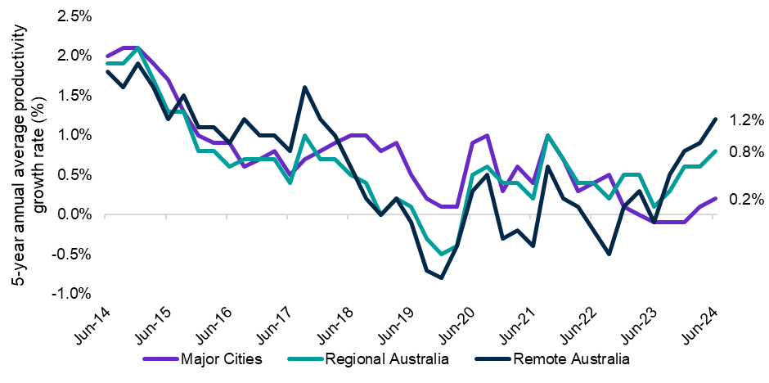
Source: National Institute of Economic and Industry Research (NIEIR), Regional Productivity dataset, adjusted for industry differences, 2024
Note: See Table 1 for the full list of regions and the classification of ‘Major Cities’, ‘Regional Australia’ and ‘Remote Australia’ used in this report.
Chart 4 above shows that the 5-year annual average productivity growth rate (adjusted for industry differences) has generally moderated over the past decade. While the series shows some variation over time, growth rates across all region types are lower than in the mid-2010s, consistent with broader evidence of a national productivity slowdown. The series also reflects the disruption associated with the COVID period, where measured productivity temporarily declined before rebounding as labour market conditions and output adjusted.
In recent years, however, productivity growth has strengthened in Remote and Regional Australia. Over the past 5 years, productivity has grown by an annual average rate 1.2% in Remote Australia and 0.8% in Regional Australia.
These patterns highlight the importance of interpreting productivity alongside other RLMI indicators. While productivity growth has been stronger in Regional and Remote Australia in recent years, this does not necessarily correspond to uniformly stronger labour market conditions as the March 2026 RLMI results show that regional and remote areas continue to be more likely to experience relatively weaker labour market conditions. Instead, productivity provides a complementary, longer-term lens on how effectively labour is utilised across regions.
The inclusion of productivity reflects continued development of the RLMI, and innovation in JSA data and methods, as JSA continues to review and refine the input factors included in the composite indicator. This ensures the RLMI is a highly robust and reliable measure of labour‑market strength.
Remote Australia
New in the March 2026 RLMI release is the inclusion of a combined rating for Remote Australia, produced in addition to the standard Statistical Area 4 (SA4) level ratings.
- Remote Australia comprises the following SA4 regions: Far West and Orana (NSW), Queensland – Outback, South Australia – Outback, Western Australia – Outback (North and South), Tasmania – West and North West, and the Northern Territory – Outback.
This addition recognises that some labour markets are geographically isolated, with shared structural challenges across regions. These may include limited job opportunities, lower levels of educational attainment, difficulties attracting and retaining workers, and more limited access to services and infrastructure. Viewing Remote Australia as a single integrated labour market may help to improve the consistency and interpretability of the evidence, supporting a clearer understanding of labour market conditions across these areas.

Table 1: Labour Market Rating by SA4, March 2026
Statistical Area Level 4 (SA4) | Remoteness¹ | Mar-25 | Mar-26 | Direction
Central Coast | Major City | Average | Average | Stable
Sydney – Baulkham Hills and Hawkesbury | Major City | Strong | Strong | Stable
Sydney – Blacktown | Major City | Average | Average | Stable
Sydney – City and Inner South | Major City | Average | Average | Stable
Sydney – Eastern Suburbs | Major City | Strong | Strong | Stable
Sydney – Inner South West | Major City | Average | Average | Stable
Sydney – Inner West | Major City | Above average | Above average | Stable
Sydney – North Sydney and Hornsby | Major City | Strong | Strong | Stable
Sydney – Northern Beaches | Major City | Strong | Strong | Stable
Sydney – Outer South West | Major City | Above average | Above average | Stable
Sydney – Outer West and Blue Mountains | Major City | Above average | Above average | Stable
Sydney – Parramatta | Major City | Below average | Below average | Stable
Sydney – Ryde | Major City | Strong | Strong | Stable
Sydney – South West | Major City | Poor | Poor | Stable
Sydney – Sutherland | Major City | Strong | Strong | Stable
Capital Region | Regional | Above average | Above average | Stable
New South Wales – Central West | Regional | Above average | Above average | Stable
Coffs Harbour – Grafton | Regional | Poor | Poor | Stable
Far West and Orana | Remote | Poor | Poor | Stable
Hunter Valley exc Newcastle | Regional | Below average | Below average | Stable
Illawarra | Cities of Regional Australia | Below average | Average | Improved
Mid North Coast | Regional | Poor | Poor | Stable
Murray | Regional | Above average | Above average | Stable
New England and North West | Regional | Below average | Average | Improved
Newcastle and Lake Macquarie | Cities of Regional Australia | Average | Above average | Improved
Richmond – Tweed | Regional | Below average | Average | Improved
Riverina | Regional | Average | Above average | Improved
Southern Highlands and Shoalhaven | Regional | Below average | Below average | Stable
Melbourne – Inner | Major City | Above average | Above average | Stable
Melbourne – Inner East | Major City | Above average | Above average | Stable
Melbourne – Inner South | Major City | Above average | Above average | Stable
Melbourne – North East | Major City | Average | Average | Stable
Melbourne – North West | Major City | Poor | Poor | Stable
Melbourne – Outer East | Major City | Strong | Above average | Declined
Melbourne – South East | Major City | Below average | Below average | Stable
Melbourne – West | Major City | Below average | Below average | Stable
Mornington Peninsula | Major City | Above average | Above average | Stable
Ballarat | Regional | Below average | Average | Improved
Bendigo | Regional | Average | Average | Stable
Geelong | Cities of Regional Australia | Above average | Above average | Stable
Hume | Regional | Above average | Above average | Stable
Latrobe – Gippsland | Regional | Below average | Below average | Stable
Victoria – North West | Regional | Average | Average | Stable
Shepparton | Regional | Average | Average | Stable
Warrnambool and South West | Regional | Above average | Strong | Improved

Statistical Area Level 4 (SA4) | Remoteness¹ | Mar-25 | Mar-26 | Direction
Brisbane - East | Major City | Strong | Strong | Stable
Brisbane - North | Major City | Strong | Strong | Stable
Brisbane - South | Major City | Above average | Average | Declined
Brisbane - West | Major City | Strong | Above average | Declined
Brisbane Inner City | Major City | Strong | Strong | Stable
Ipswich | Major City | Below average | Poor | Declined
Logan - Beaudesert | Major City | Below average | Poor | Declined
Moreton Bay - North | Major City | Poor | Poor | Stable
Moreton Bay - South | Major City | Strong | Strong | Stable
Cairns | Cities of Regional Australia | Below average | Below average | Stable
Darling Downs - Maranoa | Regional | Strong | Above average | Declined
Central Queensland | Regional | Below average | Below average | Stable
Gold Coast | Cities of Regional Australia | Strong | Strong | Stable
Mackay - Isaac - Whitsunday | Regional | Strong | Strong | Stable
Queensland - Outback | Remote | Poor | Poor | Stable
Sunshine Coast | Cities of Regional Australia | Above average | Above average | Stable
Toowoomba | Cities of Regional Australia | Average | Average | Stable
Townsville | Cities of Regional Australia | Below average | Below average | Stable
Wide Bay | Regional | Poor | Poor | Stable
Adelaide - Central and Hills | Major City | Above average | Strong | Improved
Adelaide - North | Major City | Poor | Poor | Stable
Adelaide - South | Major City | Average | Above average | Improved
Adelaide - West | Major City | Average | Above average | Improved
Barossa - Yorke - Mid North | Regional | Poor | Poor | Stable
South Australia - Outback | Remote | Poor | Poor | Stable
South Australia - South East | Regional | Poor | Poor | Stable
Mandurah | Major City | Below average | Poor | Declined
Perth - Inner | Major City | Above average | Above average | Stable
Perth - North East | Major City | Above average | Above average | Stable
Perth - North West | Major City | Strong | Strong | Stable
Perth - South East | Major City | Above average | Above average | Stable
Perth - South West | Major City | Above average | Above average | Stable
Bunbury | Regional | Above average | Above average | Stable
Western Australia - Outback (North and South) | Remote | Below average | Poor | Declined
Western Australia - Wheat Belt | Regional | Average | Average | Stable
Hobart | Cities of Regional Australia | Average | Below average | Declined
Launceston and North East | Regional | Poor | Poor | Stable
Tasmania - South East | Regional | Poor | Poor | Stable
Tasmania - West and North West | Remote | Poor | Poor | Stable
Darwin | Cities of Regional Australia | Strong | Strong | Stable
Northern Territory - Outback | Remote | Poor | Poor | Stable
Australian Capital Territory | Major City | Strong | Strong | Stable
Northern Australia |  | Below average | Below average | Stable
Remote Australia | Remote | Poor | Poor | Stable
Source: JSA, Regional Labour Market Indicator (RLMI), March 2026
Note: The remoteness classification is a bespoke, Statistical Area 4 (SA4) level typology that draws on elements of the ASGS main and remoteness structures and is supported by factors such as population size and density, and proximity to major centres. The classification is not directly concordant with standard ABS classifications.

RLMI Explanatory Notes

Overview
The RLMI combines key measures of labour supply and demand, including factors that capture how these interact, into a single, easy‑to‑interpret summary measure.
Regions are grouped into distinct categories of relative overall labour market performance, ranging from ‘poor’ to ‘strong’, which provides an accurate and reliable view of labour market performance, relative to the national average.
A strong labour market, that is characterised by a high rate of employment, where employers can attract, develop and retain sufficient suitable labour to meet current skills needs, and where employment opportunities are broadly accessible and secure, help drive a more productive economy that is central to building a prosperous and inclusive society.

Factors used to assess labour market performance
The 11 input factors currently included in the RLMI are listed below. The factors can be grouped into broader measures of labour supply, demand, with several indicators capturing dynamics at the intersection of these dimensions.
Factor | Description | Factor Type |  | Availability | Geography | Weight
Employment rate (15-64 years) | The number of employed persons as a proportion of the working age (15-64 years) population (%) | Supply |  | Monthly | SA4 | 20%
Unemployment rate | The number of unemployed persons as a proportion of the total labour force (%) | Supply |  | Monthly | SA4 | 15%
JobSeeker income support rate | Proportion of the working age (15-64 years) population on JobSeeker Income Support* | Supply |  | Monthly | SA4 | 5%
JobSeeker income support for 2 or more years rate | Proportion of the working age (15-64 years) population on JobSeeker Income Support for 2 or more years | Supply (structural) |  | Monthly | SA4 | 15%
Underemployment rate | The number of underemployed persons as a proportion of the labour force (%) | Supply |  | Monthly | GCCSA | 5%
Job vacancy rate | The number of new job vacancies as a proportion of the labour force (%) | Demand |  | Quarterly | SA4/GCCSA² | 15%
Job matching efficiency rate | The efficiency with which available jobseekers and vacancies result in successful hires (%) | Intersection |  | Quarterly | SA4 | 15%
Vacancy fill rate | The percentage of vacancies that have been filled (%) | Intersection |  | Monthly | GCCSA | 5%
5-year annual average growth rate of productivity | 5-year annual average productivity growth rate (%) where productivity is defined as Local Industry GRP (GRP at factor cost) per employed person on an industry adjusted basis. | Intersection (structural) |  | Quarterly³ | GCCSA | ~2%⁴
Annual median income growth rate | The percentage change in median total income over the past year (%) | Intersection |  | Yearly³ | SA4 | ~2%⁴
Skill underutilisation rate | Proportion of employed persons working at a lower skill level than the skill level associated with their highest level of qualification (%) | Intersection |  | 5-yearly³ | SA4 | ~2%⁴
¹JobSeeker income support’ is a combination of the JobSeeker payment and Youth Allowance (other) payment
² Measured at the Greater Capital City Statistical Area (GCCSA) for Major Cities (Sydney, Melbourne, Brisbane, Adelaide, Perth). Measured at the Statistical Area 4 (SA4) level for all other regions.
³ Note, the data is released with a substantial delay (typically 1–2 years after collection), which limits its usefulness for assessing current labour market conditions.
⁴ The 5-year annual average growth rate of productivity, the annual median income growth rate, and the skill underutilisation rate have a combined weight of 5%.

Methodology
Please refer to the RLMI Methodology Paper for more information on the RLMI, including its purpose and factor selection.

Referencing this report
Data in this release should be referenced as: Jobs and Skills Australia, RLMI, March 2026

Contact us
For additional information, email RegionalWorkforceAssessment@jobsandskills.gov.au

