REOS Recruitment Insights Report - May 2026
Jobs and Skills Australia surveys around 1,000 employers each month in the Recruitment Experiences and Outlook Survey (REOS) to understand their recruitment experiences and staffing expectations.

Key Findings
Over the month to May 2026, recruitment activity rose by 1 percentage point to stand at 47%, slightly lower than the average of 49% over the last five years. The recruitment difficulty rate fell by 3 percentage points to stand at 42% in May 2026. The proportion of employers expecting to increase staffing levels was unchanged over the month at 15%, its equal lowest level since August 2020.
In smoothed terms, recruitment activity declined gradually over the year to May 2026, while recruitment difficulty remained at low levels. Expectations around increasing staffing over the next three months were very low in both the capital cities and regional Australia. In addition, the proportion of vacancies remaining unfilled for more than a month was also near its lowest levels since the series began in May 2021.

Recruitment activity
In May 2026, the recruitment rate was 47%. This was 1 percentage point higher than last month, and 3 percentage points lower than a year ago. The rate of 47% was slightly below the last five-year average of 49%. In smoothed terms, there was a very slow, gradual decline in recruitment activity over the year to May 2026.
In the Capital Cities, 44% of employers recruited in May 2026, compared with 51% in Rest of State areas. Over the month, the recruitment rate decreased by 1 percentage point in the Capital Cities, compared with an increase of 3 percentage points in Rest of State areas. Compared with a year ago (May 2025), the recruitment rate in Capital Cities decreased by 5 percentage points, while in Rest of State areas it remained unchanged.
In smoothed terms, the recruitment rate in Rest of State areas increased slightly over the last year, offsetting a gentle easing in the Capital Cities areas.

Recruitment difficulty
The recruitment difficulty rate decreased by 3 percentage points to 42% of recruiting employers in May 2026. It was 8 percentage points lower than a year ago, but stood 5 percentage points above the series low of 37% recorded in February 2021.
A higher proportion of recruiting employers experienced recruitment difficulty in the Capital Cities (44%), compared with Rest of State areas (39%) in May 2026.
While noting the month-to-month variability in this series, recruitment difficulty increased by 1 percentage point over the month in the Capital Cities and was 3 percentage points lower relative to a year ago (May 2025). In Rest of State areas, recruitment difficulty decreased by 8 percentage points over the month to stand 16 percentage points lower than in May 2025.
In smoothed terms, the recruitment difficulty rate in Capital Cities has increased since September 2025.

Staffing outlook: employers expecting to increase staff
Compared with a month ago, the proportion of employers expecting to increase their staffing numbers in the next three months remained steady at 15% in May 2026, but down by 4 percentage points over the year, and was its equal lowest level since July 2020. In smoothed terms, this series has decreased since October 2025.
A higher proportion of employers in Capital Cities (16%) expected to increase their staffing levels in the next three months compared with Rest of State areas (14%). Over the month, this figure increased by 1 percentage point in Capital Cities, compared with a decline of 1 percentage point in Rest of State areas.
Looking through month-to-month volatility, in smoothed terms, this indicator has decreased since late 2025 in both Capital Cities and Rest of State areas.

Reason for recruiting
Recruitment due to staff turnover only was the main reason employers recruited in May 2026, accounting for 59% of recruiting employers. Some 31% of recruiting employers aimed to fill new staff positions only, and the remaining 10% recruited to fill both new staff and staff turnover positions.

Staffing changes over the last month
Some 14% of employers increased their staff in May 2026, compared with 12% at the same time last year. Meanwhile, around 11% of employers reported a decrease in their staff numbers over the month, compared with 10% of employers a year ago.

Employers unable to fill vacancies in a month
The proportion of recruiting employers who were unable to fill their vacancies within a month fell by 2 percentage points to 37% in May 2026. This figure was unchanged from the 37% recorded a year ago and was 1 percentage point above the series low of 36% recorded in March 2026.

REOS national indicators

Recruitment rate

Proportion of employers currently recruiting or who recruited in the previous month.
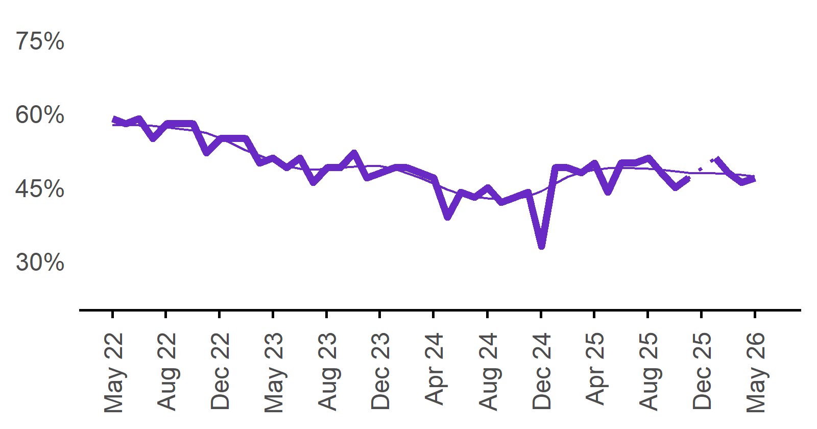 | 47%  Monthly change:  ▲ 1%pt  Annual change:  ▼ 3%pts
  Date | Recruitment rate | Smoothed recruitment rate
  May 2022 | 59% | 58%
  Jun 2022 | 58% | 58%
  Jul 2022 | 59% | 58%
  Aug 2022 | 55% | 58%
  Sep 2022 | 58% | 57%
  Oct 2022 | 58% | 57%
  Nov 2022 | 58% | 57%
  Dec 2022 | 52% | 56%
  Jan 2023 | 55% | 55%
  Feb 2023 | 55% | 54%
  Mar 2023 | 55% | 53%
  Apr 2023 | 50% | 52%
  May 2023 | 51% | 50%
  Jun 2023 | 49% | 49%
  Jul 2023 | 51% | 49%
  Aug 2023 | 46% | 49%
  Sep 2023 | 49% | 49%
  Oct 2023 | 49% | 49%
  Nov 2023 | 52% | 49%
  Dec 2023 | 47% | 49%
  Jan 2024 | 48% | 49%
  Feb 2024 | 49% | 49%
  Mar 2024 | 49% | 48%
  Apr 2024 | 48% | 47%
  May 2024 | 47% | 46%
  Jun 2024 | 39% | 45%
  Jul 2024 | 44% | 44%
  Aug 2024 | 43% | 43%
  Sep 2024 | 45% | 43%
  Oct 2024 | 42% | 43%
  Nov 2024 | 43% | 43%
  Dec 2024 | 44% | 43%
  Jan 2025 | 33% | 44%
  Feb 2025 | 49% | 46%
  Mar 2025 | 49% | 47%
  Apr 2025 | 48% | 48%
  May 2025 | 50% | 49%
  Jun 2025 | 44% | 49%
  Jul 2025 | 50% | 49%
  Aug 2025 | 50% | 49%
  Sep 2025 | 51% | 49%
  Oct 2025 | 48% | 49%
  Nov 2025 | 45% | 48%
  Dec 2025 | 47% | 48%
  Jan 2026 |  | 48%
  Feb 2026 | 51% | 48%
  Mar 2026 | 48% | 48%
  Apr 2026 | 46% | 48%
  May 2026 | 47% | 47%

Recruitment difficulty rate

Proportion of recruiting employers who stated they had difficulty hiring staff.
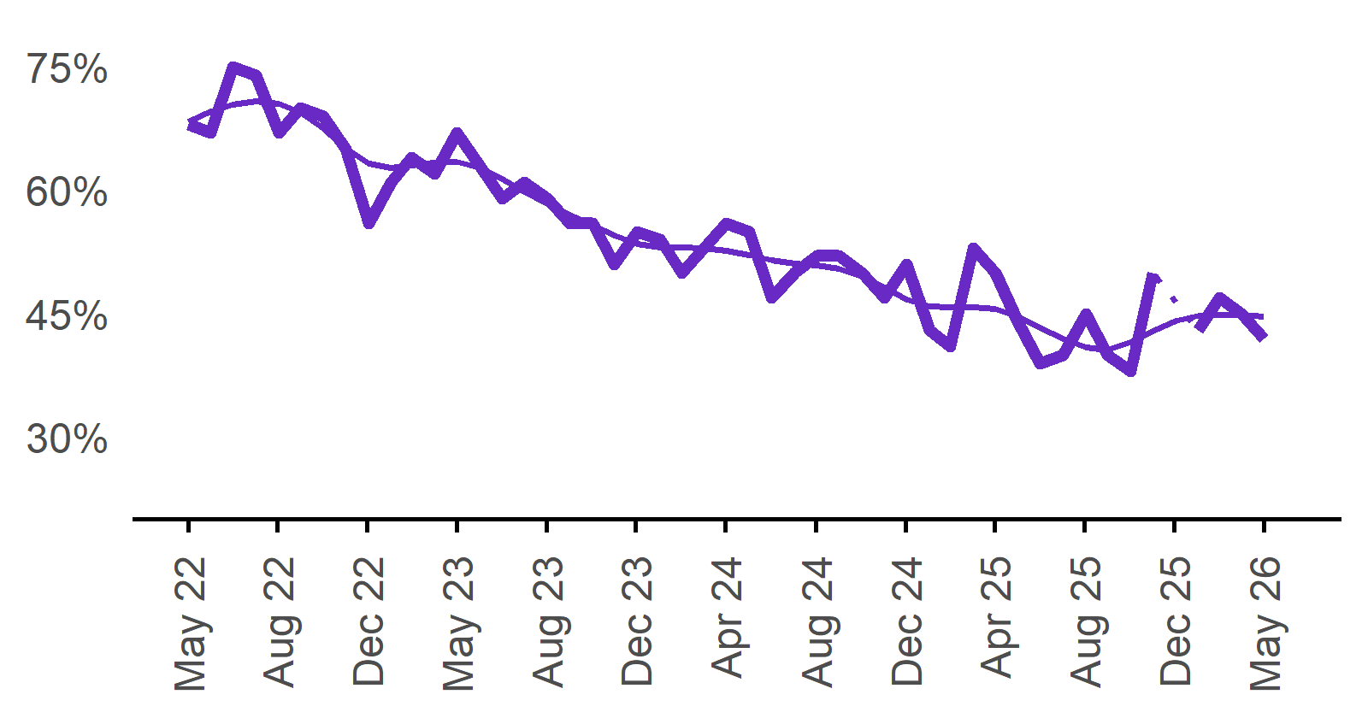 | 42%  Monthly change:  ▼ 3%pts  Annual change:  ▼ 8%pts
  Date | Recruitment difficulty rate | Smoothed recruitment difficulty rate
  May 2022 | 68% | 68%
  Jun 2022 | 67% | 70%
  Jul 2022 | 75% | 70%
  Aug 2022 | 74% | 71%
  Sep 2022 | 67% | 71%
  Oct 2022 | 70% | 69%
  Nov 2022 | 69% | 68%
  Dec 2022 | 65% | 65%
  Jan 2023 | 56% | 63%
  Feb 2023 | 61% | 63%
  Mar 2023 | 64% | 63%
  Apr 2023 | 62% | 63%
  May 2023 | 67% | 63%
  Jun 2023 | 63% | 63%
  Jul 2023 | 59% | 61%
  Aug 2023 | 61% | 60%
  Sep 2023 | 59% | 58%
  Oct 2023 | 56% | 57%
  Nov 2023 | 56% | 56%
  Dec 2023 | 51% | 55%
  Jan 2024 | 55% | 54%
  Feb 2024 | 54% | 53%
  Mar 2024 | 50% | 53%
  Apr 2024 | 53% | 53%
  May 2024 | 56% | 53%
  Jun 2024 | 55% | 52%
  Jul 2024 | 47% | 51%
  Aug 2024 | 50% | 51%
  Sep 2024 | 52% | 51%
  Oct 2024 | 52% | 50%
  Nov 2024 | 50% | 50%
  Dec 2024 | 47% | 48%
  Jan 2025 | 51% | 47%
  Feb 2025 | 43% | 46%
  Mar 2025 | 41% | 46%
  Apr 2025 | 53% | 46%
  May 2025 | 50% | 46%
  Jun 2025 | 44% | 45%
  Jul 2025 | 39% | 43%
  Aug 2025 | 40% | 42%
  Sep 2025 | 45% | 41%
  Oct 2025 | 40% | 41%
  Nov 2025 | 38% | 42%
  Dec 2025 | 50% | 43%
  Jan 2026 |  | 44%
  Feb 2026 | 43% | 45%
  Mar 2026 | 47% | 45%
  Apr 2026 | 45% | 45%
  May 2026 | 42% | 45%

Expecting to increase staff

Proportion of employers who expected to increase staffing numbers over the next three months.
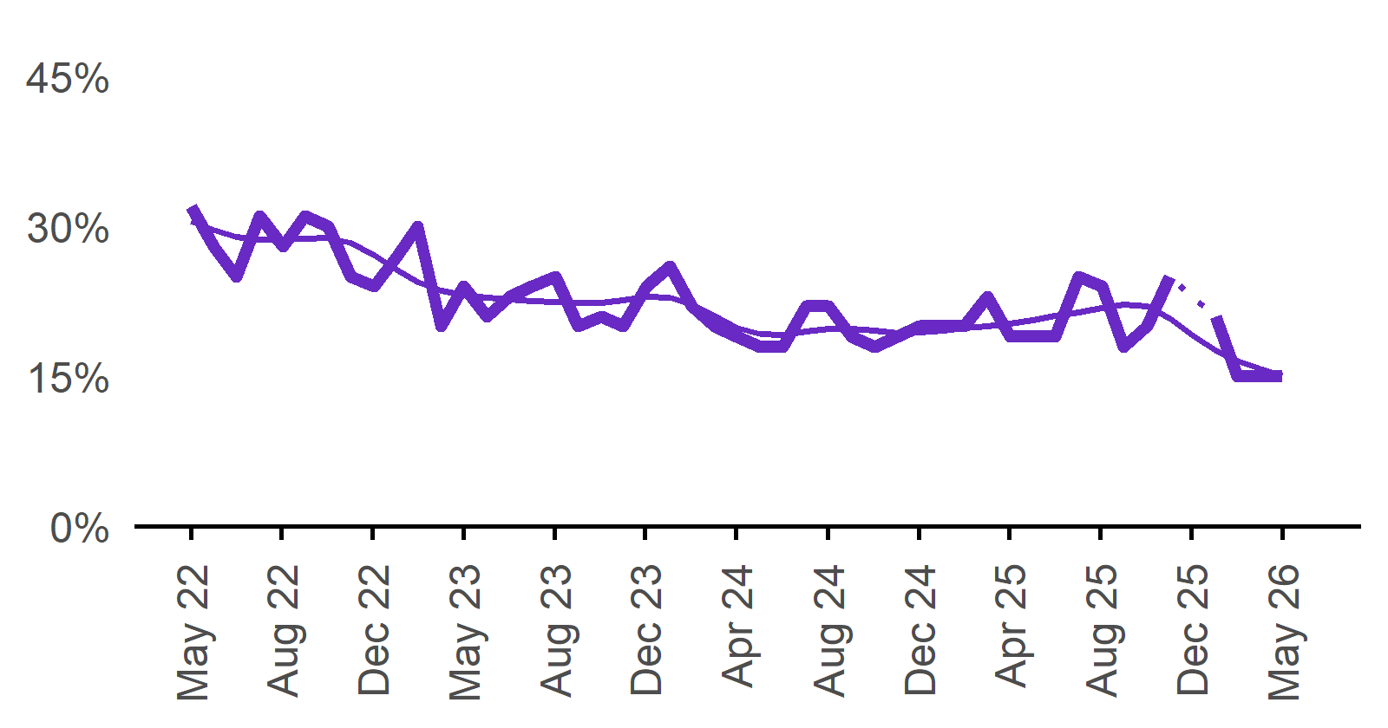 | 15%  Monthly change:  0%pts  Annual change:  ▼ 4%pts
  Date | Expect to increase | Smoothed expect to increase
  May 2022 | 32% | 31%
  Jun 2022 | 28% | 30%
  Jul 2022 | 25% | 29%
  Aug 2022 | 31% | 29%
  Sep 2022 | 28% | 29%
  Oct 2022 | 31% | 29%
  Nov 2022 | 30% | 29%
  Dec 2022 | 25% | 28%
  Jan 2023 | 24% | 27%
  Feb 2023 | 27% | 26%
  Mar 2023 | 30% | 24%
  Apr 2023 | 20% | 24%
  May 2023 | 24% | 23%
  Jun 2023 | 21% | 23%
  Jul 2023 | 23% | 23%
  Aug 2023 | 24% | 23%
  Sep 2023 | 25% | 22%
  Oct 2023 | 20% | 22%
  Nov 2023 | 21% | 22%
  Dec 2023 | 20% | 23%
  Jan 2024 | 24% | 23%
  Feb 2024 | 26% | 23%
  Mar 2024 | 22% | 22%
  Apr 2024 | 20% | 21%
  May 2024 | 19% | 20%
  Jun 2024 | 18% | 19%
  Jul 2024 | 18% | 19%
  Aug 2024 | 22% | 19%
  Sep 2024 | 22% | 20%
  Oct 2024 | 19% | 20%
  Nov 2024 | 18% | 20%
  Dec 2024 | 19% | 19%
  Jan 2025 | 20% | 19%
  Feb 2025 | 20% | 20%
  Mar 2025 | 20% | 20%
  Apr 2025 | 23% | 20%
  May 2025 | 19% | 20%
  Jun 2025 | 19% | 21%
  Jul 2025 | 19% | 21%
  Aug 2025 | 25% | 21%
  Sep 2025 | 24% | 22%
  Oct 2025 | 18% | 22%
  Nov 2025 | 20% | 22%
  Dec 2025 | 25% | 21%
  Jan 2026 |  | 19%
  Feb 2026 | 21% | 18%
  Mar 2026 | 15% | 17%
  Apr 2026 | 15% | 16%
  May 2026 | 15% | 15%

Capital City/Rest of State areas

Recruitment rate

Proportion of employers currently recruiting or who recruited in the previous month.
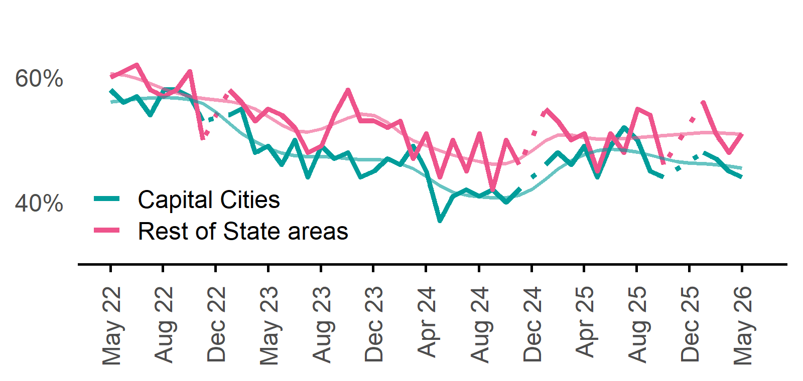 | Capital Cities: 44%  Monthly change:  ▼ 1%pt  Annual change:  ▼ 5%pts  Rest of State: 51%  Monthly change:  ▲ 3%pts  Annual change:  0%pts
  Date | Capital Cities - Recruitment rate | Rest of State areas - Recruitment rate | Capital Cities - Smoothed recruitment rate | Rest of State areas - Smoothed recruitment rate
  May 2022 | 58% | 60% | 56% | 61%
  Jun 2022 | 56% | 61% | 56% | 60%
  Jul 2022 | 57% | 62% | 57% | 60%
  Aug 2022 | 54% | 58% | 57% | 59%
  Sep 2022 | 58% | 57% | 57% | 58%
  Oct 2022 | 58% | 58% | 57% | 58%
  Nov 2022 | 57% | 61% | 56% | 57%
  Dec 2022 | 53% | 50% | 56% | 57%
  Jan 2023 | n.p. | n.p. | 54% | 56%
  Feb 2023 | 54% | 58% | 53% | 56%
  Mar 2023 | 55% | 56% | 51% | 56%
  Apr 2023 | 48% | 53% | 50% | 55%
  May 2023 | 49% | 55% | 49% | 54%
  Jun 2023 | 46% | 54% | 48% | 52%
  Jul 2023 | 50% | 52% | 47% | 51%
  Aug 2023 | 44% | 48% | 47% | 51%
  Sep 2023 | 49% | 49% | 47% | 52%
  Oct 2023 | 47% | 54% | 47% | 53%
  Nov 2023 | 48% | 58% | 47% | 54%
  Dec 2023 | 44% | 53% | 47% | 54%
  Jan 2024 | 45% | 53% | 47% | 54%
  Feb 2024 | 47% | 52% | 47% | 53%
  Mar 2024 | 46% | 53% | 46% | 51%
  Apr 2024 | 49% | 47% | 45% | 50%
  May 2024 | 45% | 51% | 44% | 49%
  Jun 2024 | 37% | 44% | 43% | 48%
  Jul 2024 | 41% | 50% | 42% | 48%
  Aug 2024 | 42% | 45% | 41% | 47%
  Sep 2024 | 41% | 51% | 41% | 46%
  Oct 2024 | 42% | 42% | 41% | 46%
  Nov 2024 | 40% | 50% | 41% | 46%
  Dec 2024 | 42% | 46% | 41% | 47%
  Jan 2025 | n.p. | n.p. | 42% | 48%
  Feb 2025 | 46% | 55% | 44% | 50%
  Mar 2025 | 48% | 53% | 45% | 51%
  Apr 2025 | 46% | 50% | 47% | 51%
  May 2025 | 49% | 51% | 48% | 50%
  Jun 2025 | 44% | 45% | 48% | 50%
  Jul 2025 | 49% | 51% | 48% | 50%
  Aug 2025 | 52% | 48% | 48% | 50%
  Sep 2025 | 50% | 55% | 48% | 50%
  Oct 2025 | 45% | 54% | 48% | 51%
  Nov 2025 | 44% | 46% | 47% | 51%
  Dec 2025 | n.p. | n.p. | 47% | 51%
  Jan 2026 |  |  | 46% | 51%
  Feb 2026 | 48% | 56% | 46% | 51%
  Mar 2026 | 47% | 51% | 46% | 51%
  Apr 2026 | 45% | 48% | 46% | 51%
  May 2026 | 44% | 51% | 45% | 51%

Recruitment difficulty rate

Proportion of recruiting employers who stated they had difficulty hiring staff.
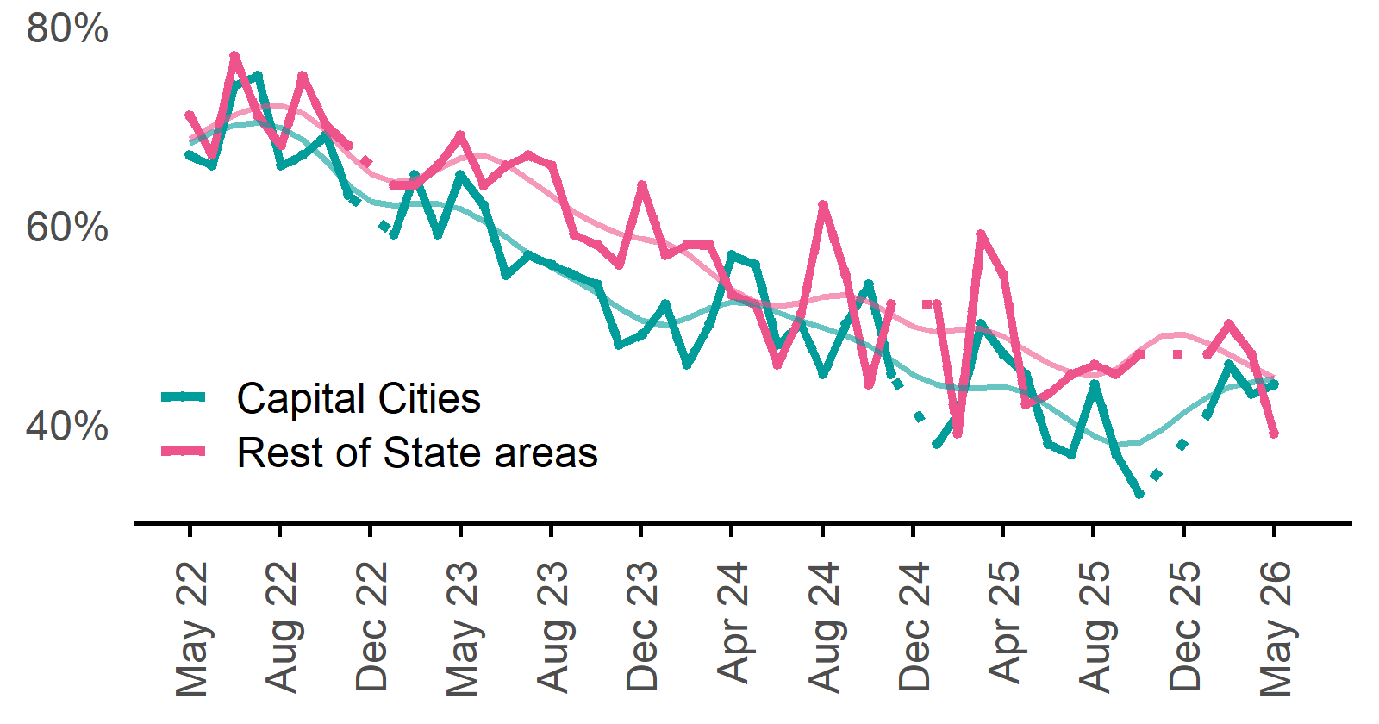 | Capital Cities: 44%  Monthly change:  ▲ 1%pt  Annual change:  ▼ 3%pts  Rest of State: 39%  Monthly change:  ▼ 8%pts  Annual change:  ▼ 16%pts
  Date | Capital Cities - Recruitment difficulty rate | Rest of State areas - Recruitment difficulty rate | Capital Cities - Smoothed recruitment difficulty rate | Rest of State areas - Smoothed recruitment difficulty rate
  May 2022 | 67% | 71% | 68% | 69%
  Jun 2022 | 66% | 67% | 69% | 70%
  Jul 2022 | 74% | 77% | 70% | 71%
  Aug 2022 | 75% | 71% | 70% | 72%
  Sep 2022 | 66% | 68% | 70% | 72%
  Oct 2022 | 67% | 75% | 69% | 71%
  Nov 2022 | 69% | 70% | 66% | 69%
  Dec 2022 | 63% | 68% | 64% | 67%
  Jan 2023 | n.p. | n.p. | 62% | 65%
  Feb 2023 | 59% | 64% | 62% | 64%
  Mar 2023 | 65% | 64% | 62% | 65%
  Apr 2023 | 59% | 66% | 62% | 66%
  May 2023 | 65% | 69% | 62% | 67%
  Jun 2023 | 62% | 64% | 60% | 67%
  Jul 2023 | 55% | 66% | 59% | 66%
  Aug 2023 | 57% | 67% | 57% | 65%
  Sep 2023 | 56% | 66% | 56% | 63%
  Oct 2023 | 55% | 59% | 55% | 61%
  Nov 2023 | 54% | 58% | 53% | 60%
  Dec 2023 | 48% | 56% | 52% | 59%
  Jan 2024 | 49% | 64% | 50% | 59%
  Feb 2024 | 52% | 57% | 50% | 58%
  Mar 2024 | 46% | 58% | 51% | 57%
  Apr 2024 | 50% | 58% | 52% | 55%
  May 2024 | 57% | 53% | 52% | 53%
  Jun 2024 | 56% | 52% | 52% | 52%
  Jul 2024 | 48% | 46% | 51% | 52%
  Aug 2024 | 50% | 51% | 50% | 52%
  Sep 2024 | 45% | 62% | 50% | 53%
  Oct 2024 | 50% | 55% | 49% | 53%
  Nov 2024 | 54% | 44% | 48% | 52%
  Dec 2024 | 45% | 52% | 47% | 51%
  Jan 2025 | n.p. | n.p. | 45% | 50%
  Feb 2025 | 38% | 52% | 44% | 49%
  Mar 2025 | 41% | 39% | 44% | 49%
  Apr 2025 | 50% | 59% | 44% | 50%
  May 2025 | 47% | 55% | 44% | 49%
  Jun 2025 | 45% | 42% | 43% | 47%
  Jul 2025 | 38% | 43% | 42% | 46%
  Aug 2025 | 37% | 45% | 40% | 45%
  Sep 2025 | 44% | 46% | 39% | 45%
  Oct 2025 | 37% | 45% | 38% | 46%
  Nov 2025 | 33% | 47% | 38% | 47%
  Dec 2025 | n.p. | n.p. | 39% | 49%
  Jan 2026 |  |  | 41% | 49%
  Feb 2026 | 41% | 47% | 43% | 48%
  Mar 2026 | 46% | 50% | 44% | 47%
  Apr 2026 | 43% | 47% | 44% | 46%
  May 2026 | 44% | 39% | 45% | 45%

Staffing outlook – Expecting to increase staff

Proportion of employers who expected to increase staffing numbers over the next three months.
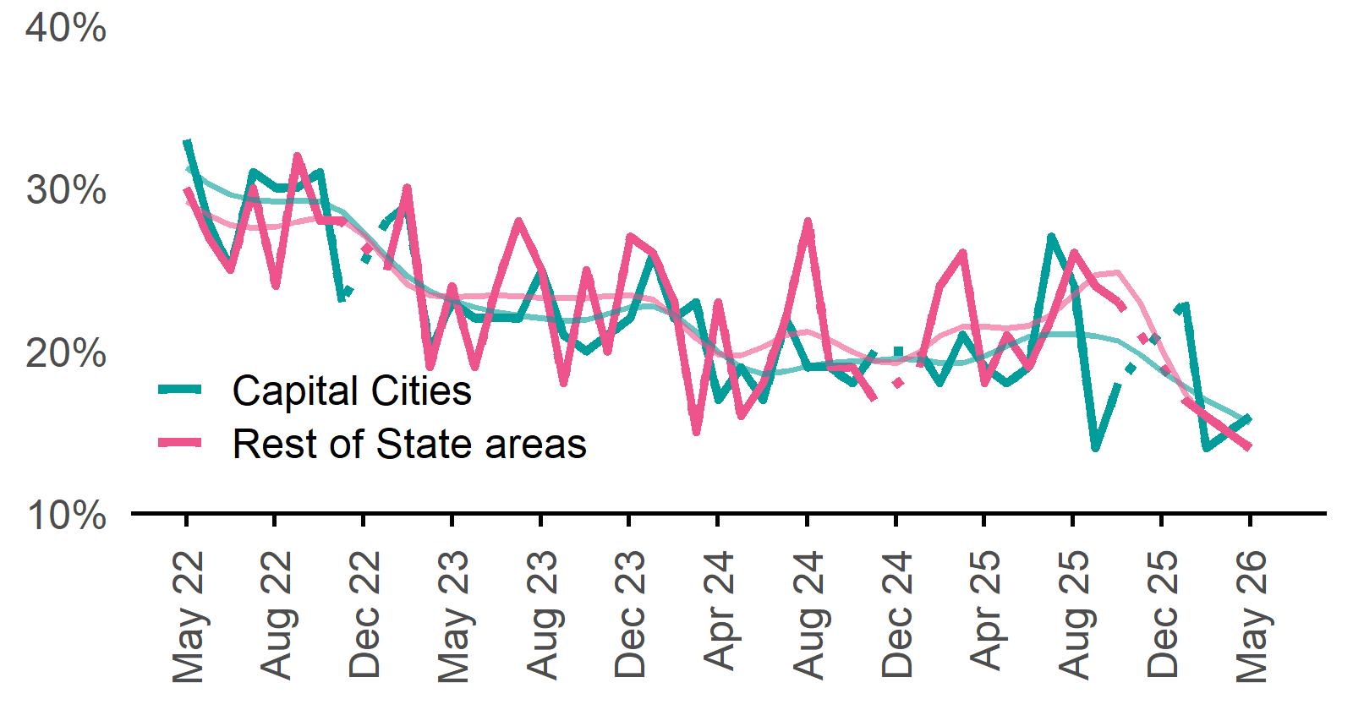 | Capital Cities: 16%  Monthly change:  ▲ 1%pt  Annual change:  ▼ 3%pts  Rest of State: 14%  Monthly change:  ▼ 1%pt  Annual change:  ▼ 4%pts

Other recruitment indicators

Reason for recruiting

Proportion of employers currently recruiting or who recruited in the previous month.
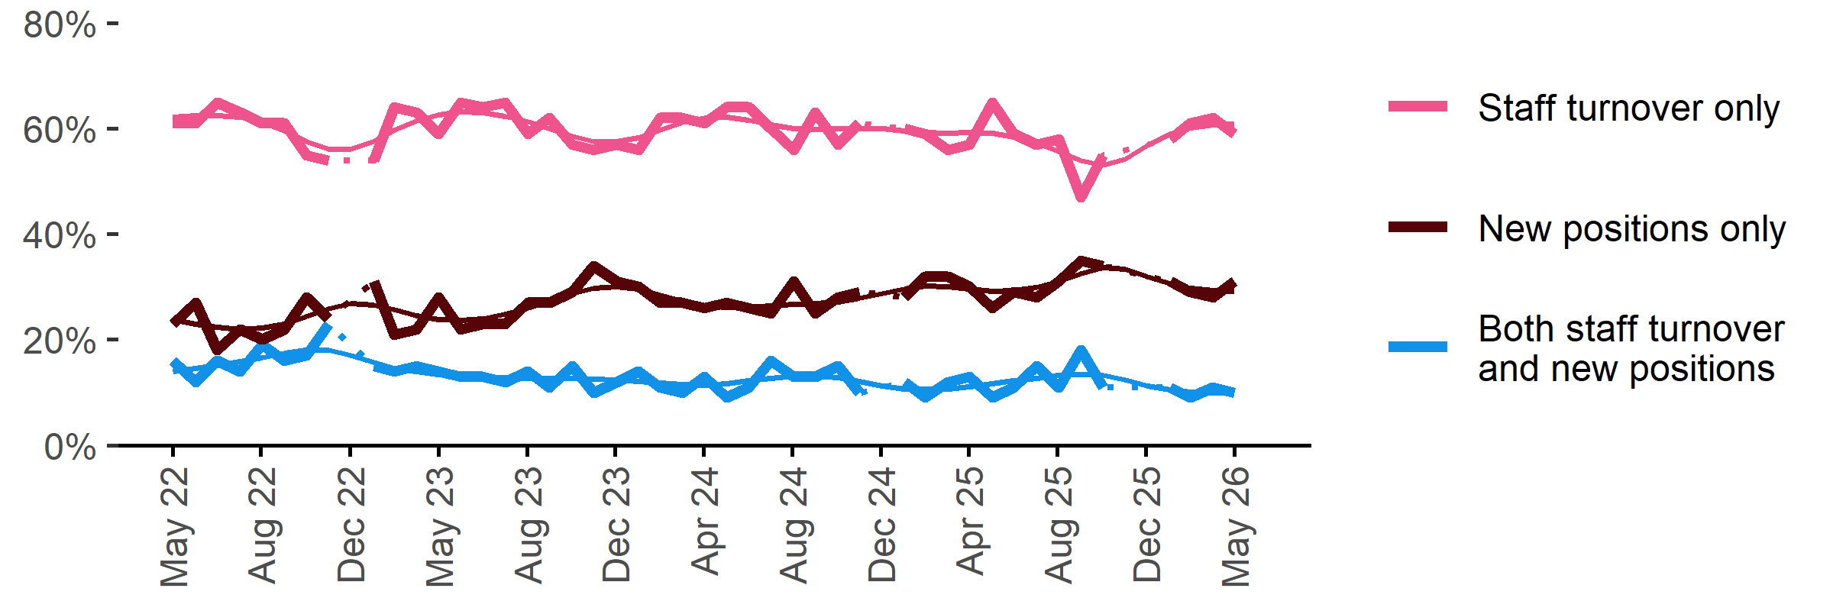
Date | Staff turnover only | Staff turnover and new positions | New positions only | Smoothed - staff turnover only | Smoothed - staff turnover and new positions | Smoothed - new positions only
May 2022 | 61% | 16% | 23% | 62% | 14% | 24%
Jun 2022 | 61% | 12% | 27% | 62% | 15% | 23%
Jul 2022 | 65% | 16% | 18% | 63% | 15% | 22%
Aug 2022 | 63% | 14% | 22% | 62% | 16% | 22%
Sep 2022 | 61% | 19% | 20% | 61% | 17% | 22%
Oct 2022 | 61% | 16% | 22% | 60% | 17% | 23%
Nov 2022 | 55% | 17% | 28% | 58% | 18% | 24%
Dec 2022 | 54% | 23% | 24% | 56% | 18% | 26%
Jan 2023 | n.p. | n.p. | n.p. | 56% | 17% | 27%
Feb 2023 | 54% | 15% | 31% | 58% | 16% | 27%
Mar 2023 | 64% | 14% | 21% | 60% | 15% | 26%
Apr 2023 | 63% | 15% | 22% | 61% | 14% | 25%
May 2023 | 59% | 14% | 28% | 63% | 13% | 24%
Jun 2023 | 65% | 13% | 22% | 63% | 13% | 24%
Jul 2023 | 64% | 13% | 23% | 63% | 13% | 24%
Aug 2023 | 65% | 12% | 23% | 62% | 13% | 25%
Sep 2023 | 59% | 14% | 27% | 61% | 13% | 26%
Oct 2023 | 62% | 11% | 27% | 60% | 13% | 27%
Nov 2023 | 57% | 15% | 29% | 59% | 13% | 29%
Dec 2023 | 56% | 10% | 34% | 58% | 13% | 30%
Jan 2024 | 57% | 12% | 31% | 57% | 12% | 30%
Feb 2024 | 56% | 14% | 30% | 58% | 12% | 30%
Mar 2024 | 62% | 11% | 27% | 60% | 12% | 28%
Apr 2024 | 62% | 10% | 27% | 61% | 12% | 27%
May 2024 | 61% | 13% | 26% | 62% | 11% | 27%
Jun 2024 | 64% | 9% | 27% | 62% | 12% | 26%
Jul 2024 | 64% | 11% | 26% | 62% | 12% | 26%
Aug 2024 | 60% | 16% | 25% | 61% | 13% | 27%
Sep 2024 | 56% | 13% | 31% | 60% | 13% | 27%
Oct 2024 | 63% | 13% | 25% | 60% | 13% | 27%
Nov 2024 | 57% | 15% | 28% | 60% | 13% | 27%
Dec 2024 | 61% | 10% | 29% | 60% | 12% | 28%
Jan 2025 | n.p. | n.p. | n.p. | 60% | 11% | 29%
Feb 2025 | 60% | 12% | 28% | 60% | 11% | 30%
Mar 2025 | 59% | 9% | 32% | 59% | 11% | 30%
Apr 2025 | 56% | 12% | 32% | 59% | 11% | 30%
May 2025 | 57% | 13% | 30% | 59% | 11% | 30%
Jun 2025 | 65% | 9% | 26% | 59% | 12% | 29%
Jul 2025 | 59% | 11% | 29% | 58% | 12% | 29%
Aug 2025 | 57% | 15% | 28% | 57% | 13% | 30%
Sep 2025 | 58% | 11% | 31% | 56% | 13% | 31%
Oct 2025 | 47% | 18% | 35% | 54% | 13% | 33%
Nov 2025 | 55% | 11% | 34% | 53% | 13% | 34%
Dec 2025 | n.p. | n.p. | n.p. | 54% | 12% | 33%
Jan 2026 |  |  |  | 57% | 11% | 32%
Feb 2026 | 58% | 11% | 31% | 59% | 10% | 31%
Mar 2026 | 61% | 9% | 29% | 60% | 10% | 30%
Apr 2026 | 62% | 11% | 28% | 61% | 10% | 29%
May 2026 | 59% | 10% | 31% | 61% | 10% | 29%

Staffing changes over the last month

Proportion of employers who said they increased or decreased staffing compared to the previous month.
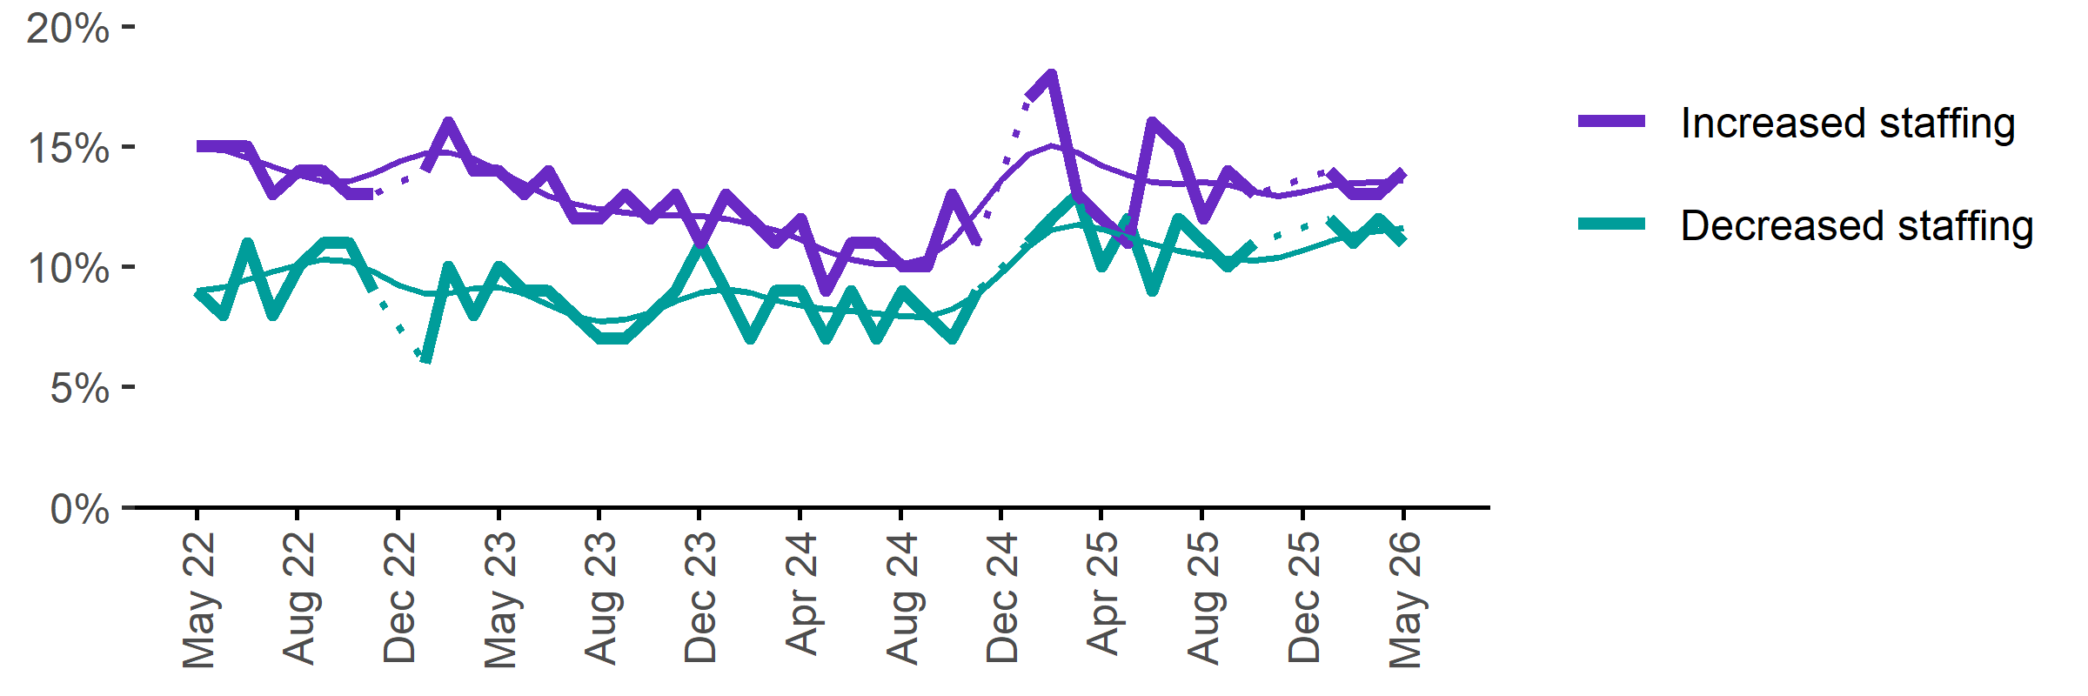
Date | Increased staff | Decreased staff | Smoothed - increased staff | Smoothed - decreased staff
May 2022 | 15% | 9% | 15% | 9%
Jun 2022 | 15% | 8% | 15% | 9%
Jul 2022 | 15% | 11% | 15% | 9%
Aug 2022 | 13% | 8% | 14% | 10%
Sep 2022 | 14% | 10% | 14% | 10%
Oct 2022 | 14% | 11% | 14% | 10%
Nov 2022 | 13% | 11% | 14% | 10%
Dec 2022 | 13% | 9% | 14% | 10%
Jan 2023 | n.p. | n.p. | 14% | 9%
Feb 2023 | 14% | 6% | 15% | 9%
Mar 2023 | 16% | 10% | 15% | 9%
Apr 2023 | 14% | 8% | 14% | 9%
May 2023 | 14% | 10% | 14% | 9%
Jun 2023 | 13% | 9% | 13% | 9%
Jul 2023 | 14% | 9% | 13% | 8%
Aug 2023 | 12% | 8% | 13% | 8%
Sep 2023 | 12% | 7% | 12% | 8%
Oct 2023 | 13% | 7% | 12% | 8%
Nov 2023 | 12% | 8% | 12% | 8%
Dec 2023 | 13% | 9% | 12% | 9%
Jan 2024 | 11% | 11% | 12% | 9%
Feb 2024 | 13% | 9% | 12% | 9%
Mar 2024 | 12% | 7% | 12% | 9%
Apr 2024 | 11% | 9% | 12% | 9%
May 2024 | 12% | 9% | 11% | 8%
Jun 2024 | 9% | 7% | 11% | 8%
Jul 2024 | 11% | 9% | 10% | 8%
Aug 2024 | 11% | 7% | 10% | 8%
Sep 2024 | 10% | 9% | 10% | 8%
Oct 2024 | 10% | 8% | 10% | 8%
Nov 2024 | 13% | 7% | 11% | 8%
Dec 2024 | 11% | 9% | 12% | 9%
Jan 2025 | n.p. | n.p. | 14% | 10%
Feb 2025 | 17% | 11% | 15% | 11%
Mar 2025 | 18% | 12% | 15% | 12%
Apr 2025 | 13% | 13% | 15% | 12%
May 2025 | 12% | 10% | 14% | 12%
Jun 2025 | 11% | 12% | 14% | 11%
Jul 2025 | 16% | 9% | 14% | 11%
Aug 2025 | 15% | 12% | 13% | 11%
Sep 2025 | 12% | 11% | 14% | 10%
Oct 2025 | 14% | 10% | 13% | 10%
Nov 2025 | 13% | 11% | 13% | 10%
Dec 2025 | n.p. | n.p. | 13% | 10%
Jan 2026 |  |  | 13% | 11%
Feb 2026 | 14% | 12% | 13% | 11%
Mar 2026 | 13% | 11% | 13% | 11%
Apr 2026 | 13% | 12% | 14% | 12%
May 2026 | 14% | 11% | 14% | 12%

Employers unable to fill vacancies within a month

Proportion of recruiting employers who were unable to fill their vacancies within a month.*
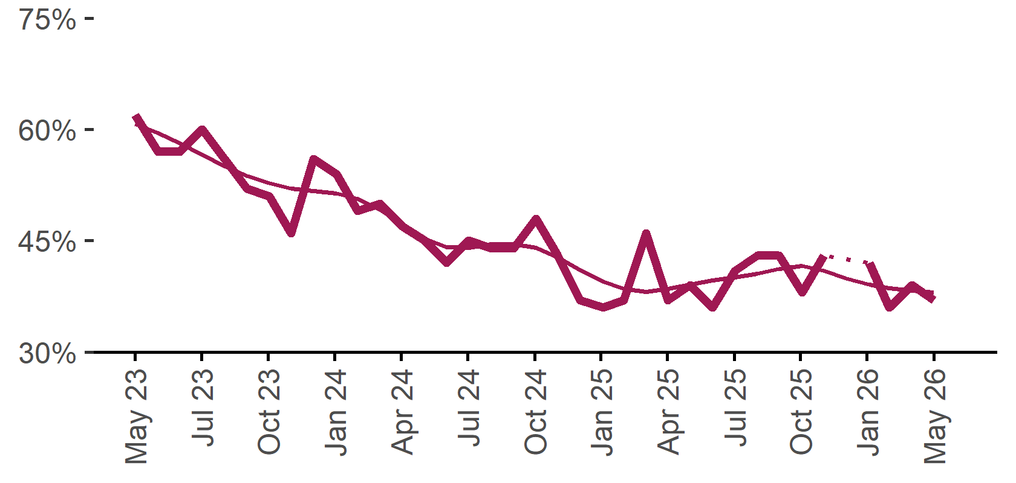 | 37%  Monthly change:  ▼ 2%pts  Annual change:  0%pts
  Date | % unable to fill vacancies in a month | Smoothed - % unable to fill vacancies in a month
  May 2023 | 62% | 61%
  Jun 2023 | 57% | 60%
  Jul 2023 | 57% | 58%
  Aug 2023 | 60% | 57%
  Sep 2023 | 56% | 55%
  Oct 2023 | 52% | 54%
  Nov 2023 | 51% | 53%
  Dec 2023 | 46% | 52%
  Jan 2024 | 56% | 52%
  Feb 2024 | 54% | 51%
  Mar 2024 | 49% | 51%
  Apr 2024 | 50% | 49%
  May 2024 | 47% | 47%
  Jun 2024 | 45% | 45%
  Jul 2024 | 42% | 44%
  Aug 2024 | 45% | 44%
  Sep 2024 | 44% | 45%
  Oct 2024 | 44% | 45%
  Nov 2024 | 48% | 44%
  Dec 2024 | 43% | 43%
  Jan 2025 | 37% | 41%
  Feb 2025 | 36% | 40%
  Mar 2025 | 37% | 38%
  Apr 2025 | 46% | 38%
  May 2025 | 37% | 38%
  Jun 2025 | 39% | 39%
  Jul 2025 | 36% | 40%
  Aug 2025 | 41% | 40%
  Sep 2025 | 43% | 41%
  Oct 2025 | 43% | 41%
  Nov 2025 | 38% | 42%
  Dec 2025 | 43% | 41%
  Jan 2026 |  | 40%
  Feb 2026 | 42% | 39%
  Mar 2026 | 36% | 39%
  Apr 2026 | 39% | 38%
  May 2026 | 37% | 38%

* Excludes employers who have been recruiting for less than a month.

Background
Jobs and Skills Australia (JSA) conducts the Recruitment Experiences and Outlook Survey (REOS), a telephone administered survey with the business owner or other person in the business responsible for recruitment. Around 1000 employers are surveyed each month, with data published on the JSA website. While the data are indicative of recruitment activity, they may be subject to seasonal factors and other volatility and should therefore be used with a degree of caution. In addition, the survey is targeted towards employers with 5 or more employees and excludes many government organisations. Details of the survey methodology can be accessed from the JSA website.

Smoothed series in charts
Charts include Henderson-smoothed lines in addition to original data for most of our recruitment indicators. As the timeseries is not yet long enough for seasonal adjustment, a Henderson smoothed moving average with a 13-term filter (equating to 13 months) has been directly applied to the original series. This provides an indication of the general movement in each recruitment indicator relative to previous months. Due to using 13 months in the moving average, results for the most recent six months will be revised each month.

How to reference data from this report
Jobs and Skills Australia, Recruitment Insights Report, May 2026.

Contact us
For additional information, email REOS@jobsandskills.gov.au

Also available from the REOS

Data file with monthly and quarterly recruitment indicators
A REOS data file is available on the JSA website. Breakdowns by Capital City/Rest of State area, Business size, and ANZSCO Skill Level are included in the monthly results. Quarterly recruitment indicators provide detail by state, ARIA (ABS’ Accessibility and Remoteness Index of Australia) as well as selected industry and occupation groups.
Next Recruitment Insights Report release:
- June 2026 Recruitment Insights Report – 21 July 2026.

Stay up to date
JSA also releases semi-regular reports including spotlight articles, detailing aspects of the REOS that cannot be included in our monthly Recruitment Insights Report. Sign up and get the Recruitment Insights Report notifications sent straight to your inbox.
Upcoming spotlight:
- Generative AI and Employers behaviour – 25 June 2026
Recent spotlights:
- Shifting Employer Sentiment – May 2026

A Henderson smoothed line has been included in the charts to reduce month to month volatility and illustrate long term patterns. See the explanatory note for more information.
Data are not available for January in some years. Data points have been joined by a dotted line between December and February to reflect this. ‘Rest of State’ refers to areas outside the capital cities.

