


Partial VET completion: Insights on outcomes and pathways
  - From the VET National Data Asset
June 2026

Contents
Executive Summary 3
Median Income 9
Employment outcomes 12
Further VET study outcomes 15
Income support exit 17
Outcome spotlights 20
Conclusion 25
Disclaimer 27
Appendix A 28
Appendix B 30
Appendix C 32
Appendix D 34


Acknowledgement of Country
Acknowledgement of Country
Jobs and Skills Australia acknowledges the Traditional Owners of Country throughout Australia and recognises the continuing connection to lands, waters and communities. We pay our respects to Aboriginal and Torres Strait Islander cultures, and to Elders past and present.
Jobs and Skills Australia acknowledges the Traditional Owners of Country throughout Australia and recognises the continuing connection to lands, waters and communities. We pay our respects to Aboriginal and Torres Strait Islander cultures, and to Elders past and present.

Executive Summary
Using the VET National Data Asset (VNDA), Jobs and Skills Australia has examined the average outcomes for partial completers – students who complete a VET unit or units but do not go on to complete a full qualification.
This is a large cohort that has historically been difficult to track in a consistent, outcomes-based way. By linking administrative records for over 900,000 domestic students, we move beyond completion to provide a picture of how people who complete part of a qualification subsequently move into the labour market. The findings show that on average, partial completion is associated with improved employment and income outcomes and engagement in further learning.
VET is designed to be a modular system through which people can build skills in a targeted way across their life. While qualification completion remains the primary and strongest pathway to improved outcomes across the VET system, these findings add nuance to how non-completion is understood, showing a wider range of outcomes than has been typically captured.
This analysis builds on the existing longstanding survey data and research on non-completion outcomes from the National Centre for Vocational Education Research (NCVER) and other research entities.
How to read this report
This report examines outcomes associated with partial completion of VET qualifications using linked administrative data.
Definitions and measures
Partial completers refer to students with their first VET enrolment recorded between 2015-16 to 2018-19 that have: no VET enrolments for at least two consecutive years after their last training date, no recorded qualification completion, and successfully completed at least one training unit that is not a compliance unit*.
Employment is measured as having any employee income, and income reflects employee income only (excluding self-employment).
Interpreting the results
Outcomes are observed one financial year after the learner’s last training date and describe associations rather than causal impacts. Differences may partly reflect pre-existing characteristics such as prior experience, motivation, or labour-market attachment.
This analysis provides a clear and transparent view of average outcomes for partial completers. As it is descriptive in nature, it focuses on observed data rather than inferred causal relationships.
* Units undertaken solely for regulatory or compliance purposes (such as mandatory inductions or safety training) are excluded so the analysis focuses on learners who engaged with VET for skill development rather than compliance. Further detail is provided in Appendix A.

Key national results at a glance
The table below summarises the national outcomes for partial completers and graduates one year after training, alongside selected cohort results.
Group | Outcome | National | First Nations | CALD | Female | People with disability | Lowest SES
Partial completer | Median Income (after last training date) | $44,500 | $30,600 | $39,300 | $36,300 | $20,600 | $36,600
Partial completer | Median Income Uplift | $7,000 | $6,700 | $6,900 | $6,900 | $3,800 | $6,300
Partial completer | Employment Rate (after last training date) | 75% | 63% | 61% | 72% | 54% | 67%
Partial completer | Employment rate Uplift | +10 pts | +10 pts | +15 pts | +11 pts | +8 pts | +11 pts
Partial completer | Further VET Study | 29% | 36% | 33% | 29% | 34% | 32%
Partial completer | Income Support Exit Rate | 28% | 22% | 28% | 23% | 14% | 23%
Graduate | Median Income (post-training) | $51,100 | $46,800 | $48,500 | $43,600 | $28,400 | $46,600
Graduate | Median Income Uplift | $14,100 | $15,700 | $13,900 | $12,800 | $10,300 | $13,700
Graduate | Employment Rate (post-training) | 88% | 84% | 82% | 88% | 73% | 83%
Graduate | Employment rate Uplift | +16 pts | +18 pts | +22 pts | +18 pts | +20 pts | +18 pts
Graduate | Further VET Study | 29% | 34% | 33% | 29% | 35% | 31%
Graduate | Income Support Exit Rate | 48% | 36% | 51% | 43% | 23% | 39%

Student characteristics
The table below shows national student characteristics for partial completers and graduates.
Outcome | First Nations | CALD | Female | People with disability | Apprentice or trainee | No prior year 12, No cert III | Government funded enrolments | Lowest SES
Partial completers | 6% | 19% | 46% | 9% | 11% | 36% | 56% | 26%
Graduates | 4% | 22% | 51% | 8% | 16% | 27% | 62% | 22%

Interpreting partial completion
Partial completion does not have a single meaning. In some cases, it reflects a positive and intentional outcome; in others, it may signal stalled progress or persistent disadvantage. Distinguishing between these is critical to how the results in this report should be interpreted.
In this report, partial completion is more likely to represent a positive outcome where it is associated with observable next steps, such as:
- movement into employment or higher earnings
- re-enrolment in further education or training
- exit from income support.
By contrast, partial completion may signal a problem where it is followed by:
- no subsequent employment or study engagement
- no improvement in income
- continued or persistent reliance on income support.
Importantly, qualification completion consistently delivers stronger outcomes and remains the central objective of the VET system. It is critical where training is intended to support entry to licensed, regulated, or credential-dependent occupations. For these roles a learner has either completed and can do the job or hasn’t. Partial completion is therefore best understood as sitting on a spectrum of outcomes, rather than being inherently positive or negative.

What the results show
The results point to a consistent story: while full VET qualification completion provides better outcomes, skills acquisition through VET can translate into improved labour-market outcomes even where a full qualification is not recorded as completed.

1. Skills-first outcomes
The findings indicate that skills gained through partial VET participation are associated with measurable improvements in employment and income observed after training, though outcomes remain lower than for those who complete qualifications
- Shorter duration with measurable short-term outcomes: Partial completers on average study for around half as long as full qualification completers (146 days compared to 296 days) yet still record positive post-training outcomes. In the year following training, partial completers recorded a median employee income uplift of $7,000, compared with $14,100 for those that completed their qualification.
- Improved employment outcomes: Post-training employment increased by 10 percentage points, to 75%. Notably, 48% of those who were not employed prior to enrolment gained employment within a year.
- Youth transitions: Younger cohorts recorded the largest income and employment rate uplifts post-training. Median income increased by $16,800 for those aged under 20 and $14,300 for those aged 20-24. For partial completers under 20, the employment rate increased from 44% prior to training to 75% after training, indicating that partial completion can act as a bridging step into entry-level or casual employment.

2. Reducing Reliance on Income Support
VET participation is associated with reduced reliance on income support for many partial completers. This highlights VET’s role in strengthening workforce participation and supporting greater financial independence.
- Exiting income support: One year after training, 28% of partial completers who had previously relied on income support were no longer receiving it.
- Transition to full-time employment: Among partial completers who were employed prior to training, 12% transitioned from part-time to full-time employment.

3. Apprenticeship and traineeships
Outcomes for apprentices and trainees who partially complete their training are stronger than the national partial-completer average, consistent with work-based learning pathways.
- Strong employment and income gains: Partial completer apprentices and trainees achieved a 90% employment rate, above the national average for partial completers of 88%, and a median income uplift of $13,800 - almost double the national median uplift of $7,000.
- Exiting income support: Among apprentices and trainees who were on income support prior to training, 47% exited income support after training, compared with 28% nationally. These outcomes may reflect the job-embedded nature of apprenticeships and traineeships and strong labour demand in many trade-related occupations.

4. Skills demand in shortage sectors
In sectors facing acute skills shortages, the outcomes are consistent with employers placing a high value on job-relevant skills and capability alongside formal credentialing.
- High-earning technical roles: Several qualifications in Engineering and Related Technologies recorded after training median incomes between $142,900 and $173,400, comparable to outcomes observed for full graduates.
- Strong outcomes in trades: Partial completers of Certificate II and III in Electrotechnology qualifications recorded strong income gains and employment uplifts. In these fields, partial completion is likely to reflect experienced workers undertaking targeted units or skill sets for upskilling and continuous professional development, rather than disengagement from a qualification pathway.

5. Equity and Regional Outcomes
The analysis indicates that partial completers across priority cohorts and regions recorded positive changes while also highlighting that gaps remain and targeted support continues to matter.
- Observed employment and income changes for First Nations learners: First Nations learners - who account for around 6% of partial completers, above their representation among full graduates - recorded a 10 percentage point increase in employment and a $6,700 income uplift. While gaps remain, the direction of change is positive.
- CALD outcomes: Partial completers from culturally and linguistically diverse (CALD) backgrounds recorded the strongest employment momentum, with a 15 percentage point uplift post-training.
- Regional strength: Partial completers in regional and remote areas recorded higher post-training employment (78%) than those in major cities (74%).
- Positive results for low SES learners: Partial completers from the lowest socio-economic status (SES) areas recorded meaningful gains in employment and income from lower baseline levels, and had higher-than-average rate of progression to further VET study (32%).

6. A Foundation for Lifelong Learning
For many learners, rather than signalling permanent exit from education, partial completion often forms part of a broader, ‘stackable skills’ learning journey.
- Recurrent upskilling: Nearly one in three (29%) partial completers enrolled in further VET study the year of or within a year, indicating many learners return to build capability as their work and life circumstances evolve.
- Advanced progression: Partial completion can be an intermediate step in a longer skill formation pathway, with 12% of partial completers enrolling in higher level VET in the year of, or the year following, partial completion.
- Continued Professional Development: Partial completion can support ongoing skill development, refresh essential competencies, and can support entry level employment and further training pathways.

A Holistic View of VET Value
This report complements the recent VNDA analysis on VET graduates Pathways to economic mobility and improved equity, providing a fuller picture of the sector’s performance across different patterns of engagement.
Full qualification completion is important, and students that complete their qualification see, on average, better outcomes for both income and employment. Full completion also remains critical in many contexts, particularly where credentials are required for entry, regulation of progression within an occupation.
Together, however, these reports show that the value of VET is not binary. Partial completion can also provide economic and social dividends - supporting labour market transitions, strengthening participation, and reducing reliance on income support.
Ultimately, this shows that success for the VET system is not only a function of qualification completion. The VNDA evidence reinforces that a flexible, diverse VET system can deliver value through capability gained and outcomes achieved - whether learning is completed in a single continuous pathway or built over time in stages.
These findings should not be interpreted as suggesting that non-completion is an equivalent substitute for qualification completion. Further work in understanding the patterns behind the outcomes of partial completers needs to be done, there are likely to be opportunities in formalising established partial completion pathways as qualifications, and focusing targeted intervention where progression stalls without qualification completion. Analysis on variation across outcomes for individuals and context will be the topic of subsequent JSA analysis, including through linking VNDA insights with results from NCVER’s student outcomes survey.
The analysis in this report strengthen the case for a skills system that recognises and supports job-relevant learning, re-entry, and progression. At a national level, this is the contribution of VET: a more capable workforce, stronger participation, and more resilient communities delivered not only through qualifications awarded, but through the skills that help Australians move into work, stay connected to work, and keep building capability over time.

Median Income
Data definitions and limitations:
Annual median income is defined using employee income earned the financial year after the last training date, declared to the ATO or Centrelink. Median income uplift is defined as the median of the individual differences in income earned between the financial year preceding enrolment and the financial year following the final training date associated with the partial completion. To enable comparison, all income figures have been inflation adjusted.
The median income in this chapter only includes employee income and does not include self-employment (business) income. Partial completers without an income do not contribute to the median income or median income uplift calculation.
It is important to note that this definition captures income earned as an employee in any occupation, full-time or part-time.

Improved income after training
Median income uplift is calculated for learners who were employed both prior to enrolment and in the financial year following their last training date. Nationally, partial completers recorded a median employee income uplift of $7,000, with a median annual employee income of $44,500 after training. This indicates positive income outcomes following partial completion for those engaged in employment before and after training.

Median income for priority cohorts
Figure 1.1 shows the median income and income uplift for priority cohorts (i.e. females, First Nations learners, CALD learners and people with disability). All priority cohorts recorded positive income growth following their last training date.
Males recorded a higher median income uplift than females ($7,200 compared with $6,900), as well as a higher median income after training ($53,400 compared with $36,300). This difference likely reflects variation in hours worked and occupational patterns, consistent with broader labour-market trends.
First Nations learners recorded a median income uplift of $6,700, slightly lower than that of non-Indigenous learners ($7,000). Median income after training for First Nations learners was $30,600—around 32% lower than for non-Indigenous learners ($45,300).
People with disability also experienced a positive income uplift ($3,800), though this was substantially lower than that recorded by people without disability ($7,300). This difference is reflected in post-training median incomes, which were approximately 55% lower for learners with disability ($20,600) than for learners without disability ($46,200).
CALD learners recorded a median income uplift of $6,900 and a median income of $39,300 after training, lower than that of non-CALD learners ($7,100 uplift and $45,600 median income respectively).
Figure 1.1: Median income for VET partial completers, by priority cohort
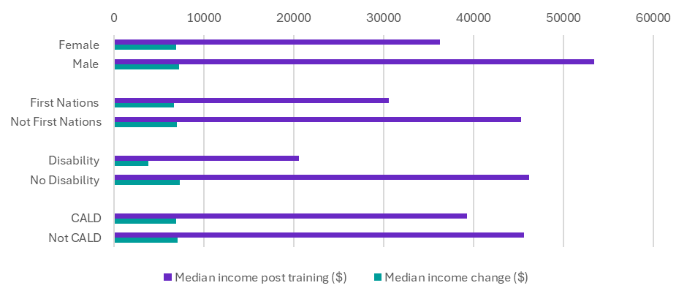
Source: Person Level Integrated Data Asset (PLIDA), 2002 – 2023, VET National Data Asset, ABS DataLab. Findings based on use of PLIDA data.

Median income by age group
Figure 1.2 shows that younger partial completers recorded the largest median income gains following training. Learners aged under 20 recorded the highest median income uplift ($16,800), followed by those aged 20–24 ($14,300). These increases likely reflect entry into first jobs, increases in hours worked, or transitions from part-time to full-time employment.
Older age groups recorded higher median incomes after training overall, with median incomes of $52,700 for learners aged 25–34, $58,000 for those aged 35–44, and $60,200 for those aged 45 and over. Income uplifts for these cohorts were smaller in magnitude, consistent with more established labour-market positions prior to training.
1.2: Median income for VET partial completers, by age group
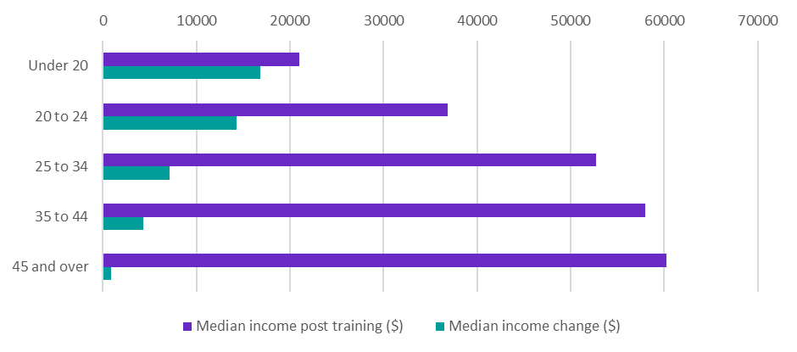
Source: Person Level Integrated Data Asset (PLIDA), 2002 – 2023, VET National Data Asset, ABS DataLab. Findings based on use of PLIDA data.

Interpreting income variation
Median income provides a clear and useful summary of post-training outcomes; however, income levels among partial completers vary widely. To support interpretation of the headline median results, distributional analysis was undertaken to examine the spread and shape of income outcomes, and to assess whether median estimates are influenced by extreme values or distinct sub-groups.
The analysis shows substantial dispersion and positive skewness in post-training incomes. Most learners cluster around modest income levels, while a smaller share achieve considerably higher earnings. Importantly, the analysis does not indicate strongly bimodal or polarised income patterns, confirming that the median income provides a robust summary of typical outcomes rather than being distorted by extreme values or underlying sub-groups.
Detailed income distribution charts and supporting analysis by cohort and age group are provided in Appendix B.

Interpreting income change after training
Income changes following training also display considerable variation across individuals. While the national median income change is positive, income-change outcomes are widely dispersed, with both positive and negative movements observed. This reflects differences in labour-market circumstances, including changes in hours worked, job transitions, and the timing and purpose of training.
Across cohorts and age groups, income-change distributions do not suggest that median uplifts are driven by extreme shifts among small groups. Rather, outcomes are concentrated across a broad middle range, reinforcing that median income change should be interpreted as a central tendency rather than a uniform effect across all learners.
Detailed income-change distribution charts and cohort-level analysis are provided in Appendix C.

Employment outcomes
Data definitions and limitations:
Employment rate after training is defined as the percentage of domestic VET partial completers who earned any employee income the financial year after the last training date.
It is important to note that this definition captures employment in any occupation, full-time or part-time and does not include self-employment or unpaid work. The employment is not necessarily in an occupation associated with the skills acquired from the partially completed VET qualification.
This analysis also presents the employment rates in the financial year prior to enrolment. This enables observation of changes in employment rates between pre- and post-training.
For the purpose of this report, the terms ‘employed’ and ‘not employed’ refer specifically to whether a student did or did not earn any employee income in the financial year in question.

Improved employment rates after training
Nationally, partial completers achieved a 10 percentage point increase in employment, rising to 75% between the pre and post training periods.
Taken together, the employment results indicate that partial completion is associated with improved labour market attachment, particularly for learners with lower employment prior to training. Employment gains are strongest for younger learners (up by 31 pts) and those previously not employed (up by 48 pts), while persistent gaps across some priority cohorts highlight the continued importance of complementary supports alongside training.

Employment rate for priority cohorts
Figure 2.1 shows that employment outcomes improved across all priority cohorts following training, though differences in employment rates relative to non-priority cohorts remain.
Prior to enrolment, women had a lower employment rate than men (62% compared with 69%). Following training, employment increased for both groups and the gap narrowed slightly, with 72% of women and 78% of men employed after training.
First Nations learners also recorded improved employment outcomes, with employment increasing by 10 percentage points, from 53% prior to enrolment to 63% after training. However, the employment gap relative to non-Indigenous learners persisted, with post-training employment rates of 63% for First Nations learners compared with 76% for non-Indigenous learners.
People with disability experienced an 8 percentage point increase in employment following training, rising from 46% to 54%. Despite this improvement, employment rates for people with disability remained more than 20 percentage points lower than for people without disability (77%), reflecting enduring barriers to full labour-market participation.
CALD learners recorded the largest employment gains among priority cohorts, with employment increasing by 15 percentage points, from 47% prior to enrolment to 61% after training. While the employment gap with non-CALD learners narrowed, it remained evident post-training (61% compared with 79%).
Figure 2.1: Employment rate for VET partial completers, by priority cohort
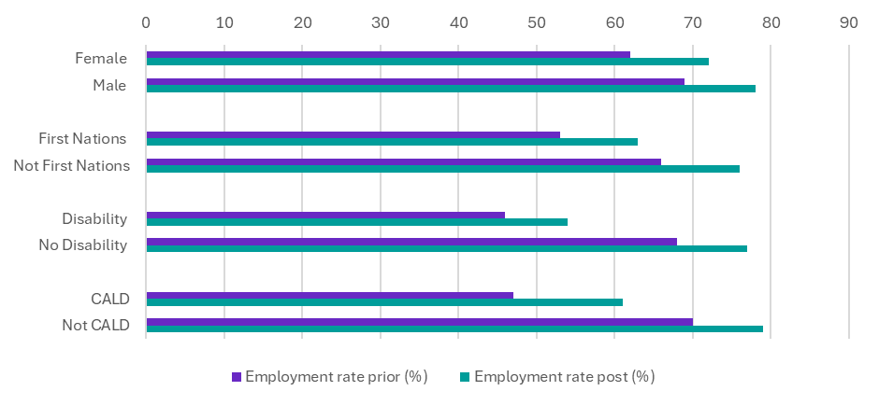
Source: Person Level Integrated Data Asset (PLIDA), 2002 – 2023, VET National Data Asset, ABS DataLab. Findings based on use of PLIDA data.

Employment rate by age group
Figure 2.2 shows that employment outcomes following training vary by age group, reflecting different stages of labour-market entry and progression.
The largest employment gains were recorded among partial completers aged under 20, with employment increasing by 31 percentage points to 75% in the year after training. This substantial uplift likely reflects transitions from study into first jobs or increased engagement with the labour market following training.
Employment rates peaked among those aged 20–24, with 79% employed in the year after training, representing an 11 percentage point increase compared with the year prior to enrolment. The relatively high employment rate for this cohort may be influenced by the greater prevalence of apprentices and trainees in this age group (20%, compared with 11% overall).
Figure 2.2: Employment rate for partial completers, by age group
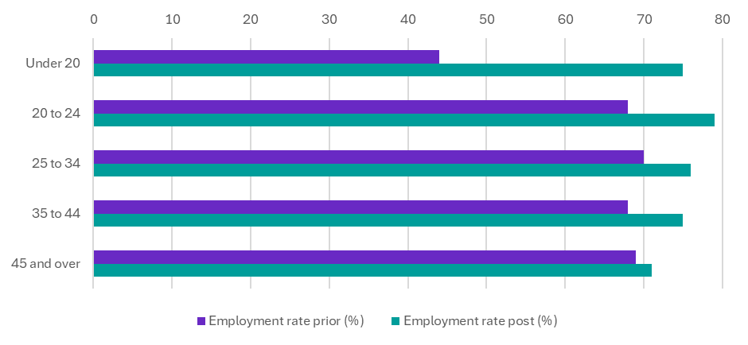
Source: Person Level Integrated Data Asset (PLIDA), 2002 – 2023, VET National Data Asset, ABS DataLab. Findings based on use of PLIDA data.

Transition to full-time employment after training
Partial completion is associated with some movement into stronger employment attachment. Nationally, 8% of learners who were employed part-time prior to enrolment transitioned to full-time employment in the year following training.
Higher transition rates were observed among apprentices and trainees (15%), learners aged 20–24 (14%), and those already employed prior to training (12%). Women recorded higher transition rates than men (11% compared with 6%), while learners with disability recorded lower transition rates (5%), potentially reflecting ongoing structural barriers to full-time employment.
Further information on part-time and full-time transitions can be found in Appendix D.

Further VET study outcomes
Data definitions and limitations:
Further study in 'another' or 'any' VET course is defined as the percentage of students who enrolled in another AQF VET qualification. Further higher-level VET study is defined as the percentage of students who enrolled in a higher-level AQF VET than the partial completion and is included in the 'another VET qualification' statistics. Both measures refer to enrolments in the same or following financial year after the last training date.
Further study captures enrolment only, not completion of the additional qualification. These metrics include enrolments in nationally recognised, AQF level qualifications only.
Due to unavailability of higher education data in PLIDA, progression to higher education statistics are not included in this report. The rate of VET students pursuing higher-level VET and another VET qualification are provided.

Further VET study
For many learners, partial completion of a VET qualification represents an intermediate step rather than an exit from education. Nationally, 29% of partial completers enrolled in a further VET qualification within a year of training, including 12% who progressed to a higher-level VET qualification. This indicates that partial completion often forms part of a broader learning pathway, consistent with a more flexible and modular skills system.

Further VET study for priority cohorts
Figure 3.1 shows that progression to further VET study varies across priority cohorts, with higher-than-average progression observed for several groups facing labour-market disadvantage.
Progression rates to another VET qualification were similar for females (29%) and males (30%), and rates of progression to higher-level VET were also comparable (13% for females and 12% for males).
First Nations learners recorded higher rates of further VET engagement than non-Indigenous learners, with 36% enrolling in another VET qualification, including 14% progressing to a higher-level qualification. This compared with 29% and 12% respectively for non-Indigenous learners.
Students with disability showed a similar pattern, with 34% progressing to another VET course, including 14% to higher-level VET, compared with 29% and 12% respectively for students without disability.
CALD learners also recorded relatively high rates of further study, with 33% enrolling in another VET qualification, including 16% undertaking higher-level VET, compared with 28% and 11% respectively for non-CALD learners.
Taken together, these results suggest that partial completion regularly supports further engagement in learning, particularly for cohorts that may face structural barriers to immediate labour-market progression.
Figure 3.1: Further VET Study for VET partial completers, by priority cohort
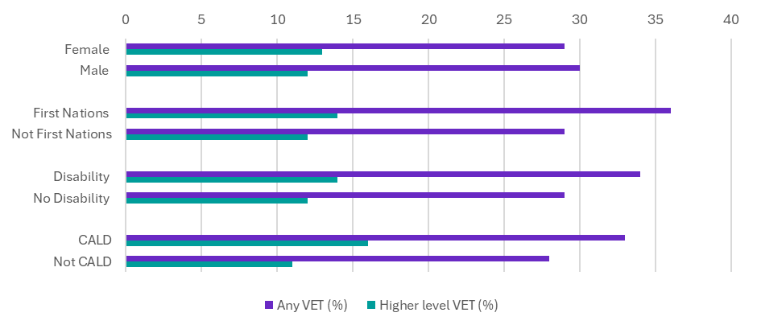
Source: Person Level Integrated Data Asset (PLIDA), 2002 – 2023, VET National Data Asset, ABS DataLab. Findings based on use of PLIDA data.

Further VET study by age group
Figure 3.2 shows a clear age gradient in progression to further VET study. Younger partial completers are the most likely to continue training, with 43% of learners aged under 20 enrolling in further VET, including 21% progressing to a higher-level qualification.
Rates of further study decline steadily with age. Among learners aged 45 and over, 22% enrolled in another VET qualification, including 8% progressing to a higher-level qualification. This pattern likely reflects differences in learning intent and life stage, with younger learners more likely to use partial completion as part of longer-term education pathways, while older learners may undertake training more selectively for targeted skill needs.
Figure 3.2: Further VET Study for VET partial completers
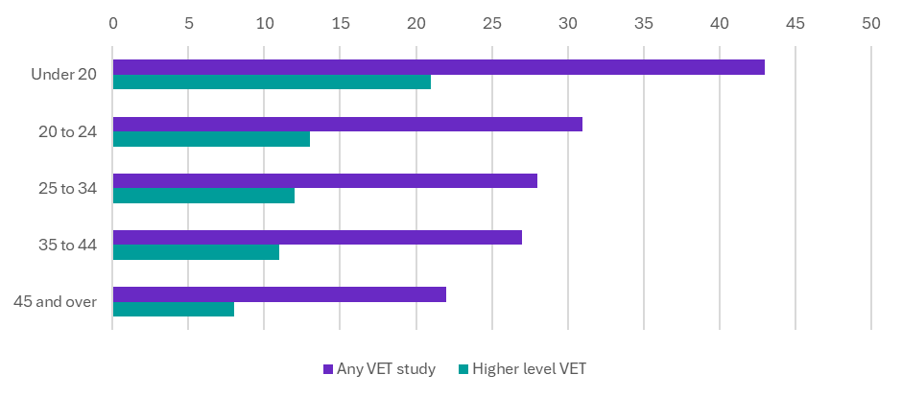
Source: Person Level Integrated Data Asset (PLIDA), 2002 – 2023, VET National Data Asset, ABS DataLab. Findings based on use of PLIDA data.

Income support exit
Data definitions and limitations:
The ‘income support exit rate’ is defined as the percentage of partial completers not on income support one financial year after the last training date, given they were on income support before course enrolment.
The income support payments used in this analysis are generally income tested and would be expected to reduce with the skills gained in a qualification. For instance, payments such as the JobSeeker Payment and Youth Allowance have been included, while others such as the Age Pension have been excluded. Study-related payments such as Austudy and ABSTUDY have also been excluded as the completion of study would lead to the ending of such payments, irrespective of any positive student outcomes. For more information on the calculation of income support exit rates, see the Technical report - VNDA 2020-21 graduate outcomes.
The income support exit rate measures the percentage of students transitioning out of income support services, reflecting progress towards financial independence. The income support exit rate is also distinct from the change in employment (Section 2 of this report), as many people are both employed and on income support.

Reduced reliance on income support
Reduced reliance on income support is an important indicator of improved economic participation and financial independence. Among VET partial completers who were receiving income support prior to enrolment, 28% were no longer receiving income support one year after their last training date.
Higher income-support exit rates were observed among groups with stronger labour-market attachment, including:
- learners who partially completed a Graduate Certificate or Diploma (49%),
- apprentices and trainees (47%), and
- learners who were employed prior to enrolment (36%).
These patterns suggest that partial completion is most strongly associated with income-support exit where it builds on existing employment or job-embedded training pathways.
Income-support exit rates are generally lower for disadvantaged cohorts. This may reflect a combination of factors, including ongoing employment barriers and differences in income-support eligibility and assessment rules, rather than training outcomes alone.

Income support exit rate for priority cohorts
Figure 4.1 shows that income-support exit rates for priority cohorts were generally below the national average, despite positive employment and income outcomes observed elsewhere in the analysis.
Female partial completers recorded an income-support exit rate of 23%, compared with 33% for males. First Nations learners recorded an exit rate of 22%, lower than the 28% recorded for non-Indigenous learners. People with disability recorded the lowest exit rate, at 14%, compared with 31% for people without disability.
CALD learners recorded an income-support exit rate of 28%, comparable to the national average and marginally higher than that of non-CALD learners (27%).
Taken together, these results highlight that while partial completion supports improved labour-market outcomes, income-support exit is more constrained by structural and eligibility settings for some cohorts, particularly people with disability.
Figure 4.1: VET partial completers, income support exit rate (%), by priority cohort
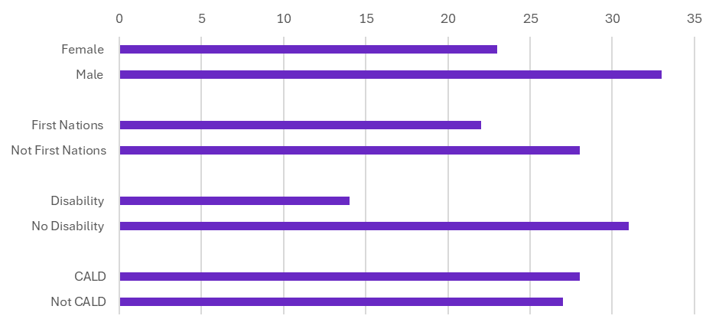
Source: Person Level Integrated Data Asset (PLIDA), 2002 – 2023, VET National Data Asset, ABS DataLab. Findings based on use of PLIDA data.

Income support exit rate by age group
Figure 4.2 shows that income-support exit rates vary by age, reflecting differing life-stage circumstances and patterns of income-support use.
The highest exit rate was recorded among learners aged 25–34 (31%), consistent with stronger post-training employment outcomes for this cohort. In contrast, learners aged under 20 recorded the lowest exit rate (9%), likely reflecting continued eligibility for income-support payments while studying or transitioning into early-career employment.

Figure 4.2: Income support exit rate for VET partial completers
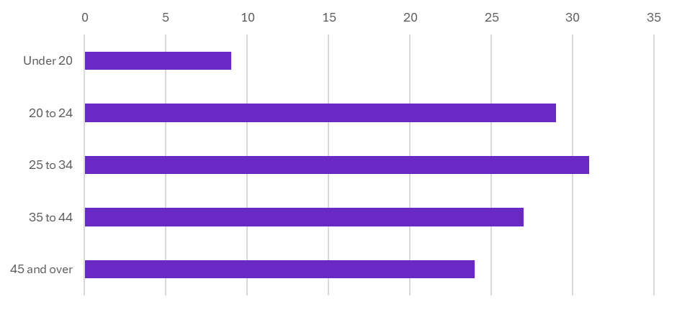
Source: Person Level Integrated Data Asset (PLIDA), 2002 – 2023, VET National Data Asset, ABS DataLab. Findings based on use of PLIDA data.

Outcome spotlights
This section highlights selected pathways, learner characteristics and contexts where outcomes for partial completers diverge most clearly from national patterns. The spotlights are illustrative rather than exhaustive and are intended to deepen understanding of how and why outcomes vary.

Apprentices and Trainees
Apprentices and trainees who partially complete their qualifications demonstrate consistently strong outcomes, reflecting the value of job-embedded vocational pathways even without full qualification completion.
Partial completer apprentices and trainees recorded the highest post-training employment rate (90%), above the national average for 2020-21 graduates (88%), indicating strong labour market demand for these skills. They also recorded a median income uplift of $13,800, almost double the national average, highlighting the earning potential associated with partial completion in employment aligned pathways.
These patterns are reinforced by income-support outcomes. Almost half (47%) of apprentices and trainees who were on income support prior to training had exited income support one year after training. Apprentices and trainees also recorded the highest transition from part-time to full-time employment (15%), double the rate observed for non-apprentices and trainees (7%). This corresponded with an increase in full-time employment from 55% prior to training to 69% after training, underscoring the role of VET in supporting progression to more secure employment.

Student characteristics
The table below shows that apprenticeship and trainee student characteristics for partial completes are similar to graduates for women, First Nations learners, people with disability and median age. There are some differences with the percentage of students with no prior year 12 or Certificate III and government funding. The most significant difference is study duration, with partial completers studying for less than half the duration of graduates.
Table 5.1: Student characteristics for apprentice and trainee partial completers
Outcome | First Nations | Female | People with disability | No prior year 12, No cert III | Government funded enrolments | Median age | Duration (median time in days)
Partial completers | 6% | 31% | 5% | 39% | 88% | 22 years | 318 days
Graduates | 6% | 32% | 6% | 32% | 95% | 23 years | 790 days
Several qualifications with the highest concentrations of apprentices and trainees align with strong employability outcomes, particularly in Engineering and Related Technologies and Architecture and Building. For example, employment increased from 76% to 91% for partial completers of Certificate III in Marine Craft Construction, and from 78% to 100% for Certificate III in Agricultural Mechanical Technology.
Figure 5.1: VET partial completers apprentices and trainees
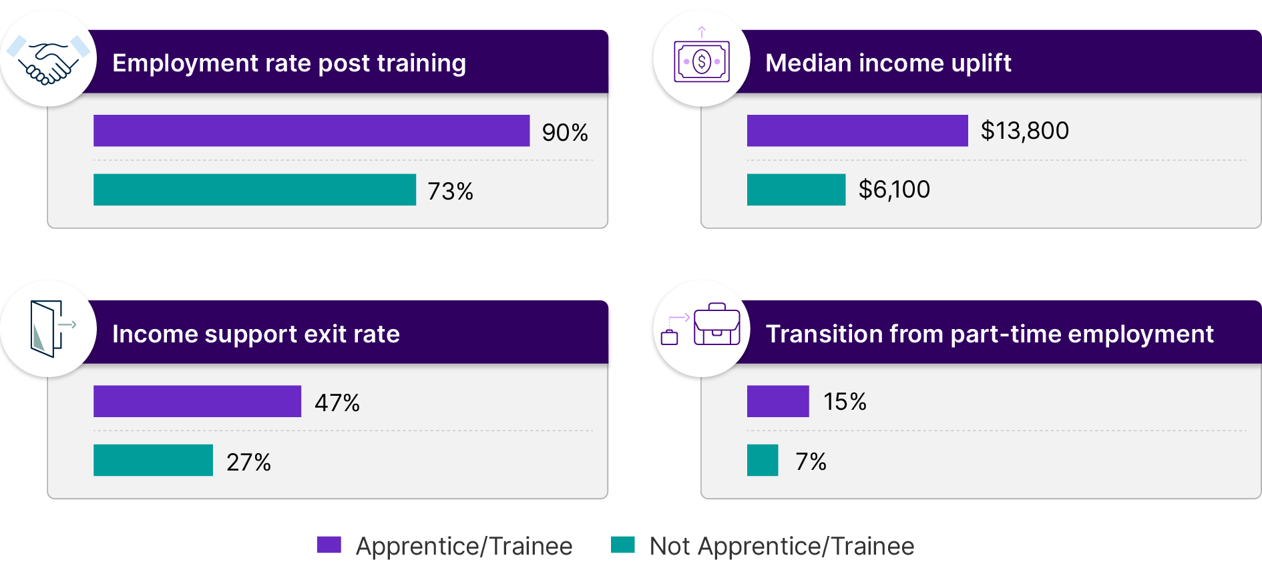
Source: Person Level Integrated Data Asset (PLIDA), 2002 – 2023, VET National Data Asset, ABS DataLab. Findings based on use of PLIDA data.
Note: Apprentice or trainee status is allocated to students who were enrolled as an apprentice or trainee for any subject as part of a program. Otherwise, the student is categorised as a ‘Not apprentice/trainee’.

Socio-economic status
Outcomes for partial completers vary systematically by socio-economic context, as measured by the ABS Index of Relative Socio-Economic Disadvantage (IRSD), highlighting both the benefits of training and persistent structural gaps.
Learners from the lowest socio-economic areas (IRSD quintile 1) recorded the lowest post-training employment rate (67%), while those from the least disadvantaged areas recorded the highest employment rate (80%). This pattern indicates that socio-economic disadvantage continues to shape labour-market outcomes, even where training delivers positive gains.
Income outcomes follow a similar gradient. Median income after training for learners from the most disadvantaged areas was $36,600, compared with $49,400 for those from the least disadvantaged areas. Median income uplift ranged from $6,300 for the most disadvantaged to $8,400 for the least disadvantaged learners. Income-support exit rates also varied, with 23% of learners from the most disadvantaged areas exiting income support, compared with 34% among the least disadvantaged.
Despite these economic gaps, partial completion appears to play an important role in supporting continued engagement in learning for learners from low socio-economic areas. Progression to further VET study was relatively similar across socio-economic groups, with learners from the lowest SES areas recording the highest rates of progression to further VET at 32%. These findings highlight partial completion as an important mechanism through which learners from disadvantaged backgrounds can build skills over time and progress to further, often higher level, training, even where employment outcomes are more constrained.
Differences in outcomes by socio economic status could also reflect underlying differences in learner characteristics, with lower SES cohorts more likely to include First Nations learners, people with disability, and those entering VET without Year 12 or prior Certificate III attainment.

Figure 5.2: VET partial completers socio-economic status
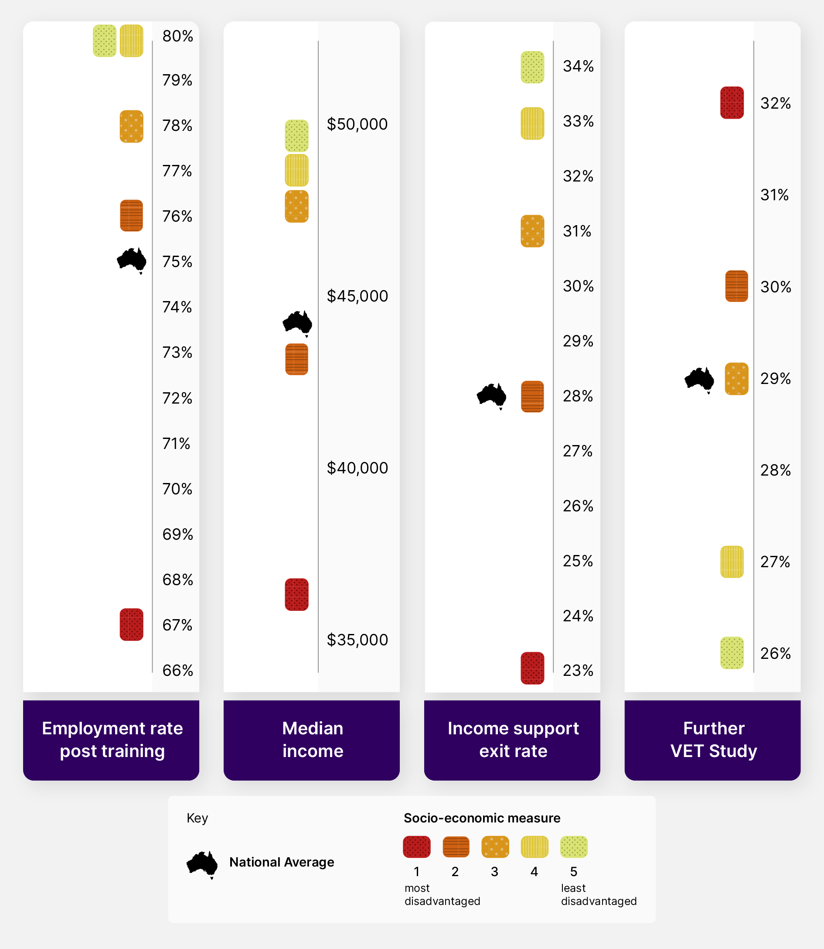
Source: Person Level Integrated Data Asset (PLIDA), 2002 – 2023, VET National Data Asset, ABS DataLab. Findings based on use of PLIDA data.
Note: Socio-economic status has been measured by the Index of Relative Socio-Economic Disadvantage (IRSD) at the quintile level, where 1 has the most disadvantage and 5 has the least disadvantage.

Remoteness
Geographic location also shapes outcomes for partial completers, reflecting differences in local labour-market conditions and industry demand.
Learners in regional and remote areas recorded higher post-training employment rates (78%) than those in major cities (74%), and above the national average. This suggests stronger local labour-market absorption in non-metropolitan areas, particularly where training aligns with regional workforce needs.
Median incomes were highest in remote areas ($53,400), well above the national median ($44,500). However, income uplift was largest in major cities ($7,500), compared with $6,400 in regional areas and $4,300 in remote areas. This indicates that while baseline earnings may be higher outside cities, incremental gains from training are stronger in metropolitan labour markets.
Income-support exit rates were broadly similar across geography, ranging from 25–28%, suggesting that location alone does not substantially mitigate reliance on income support without concurrent improvements in socio-economic conditions.
Figure 5.3: VET partial completers remoteness
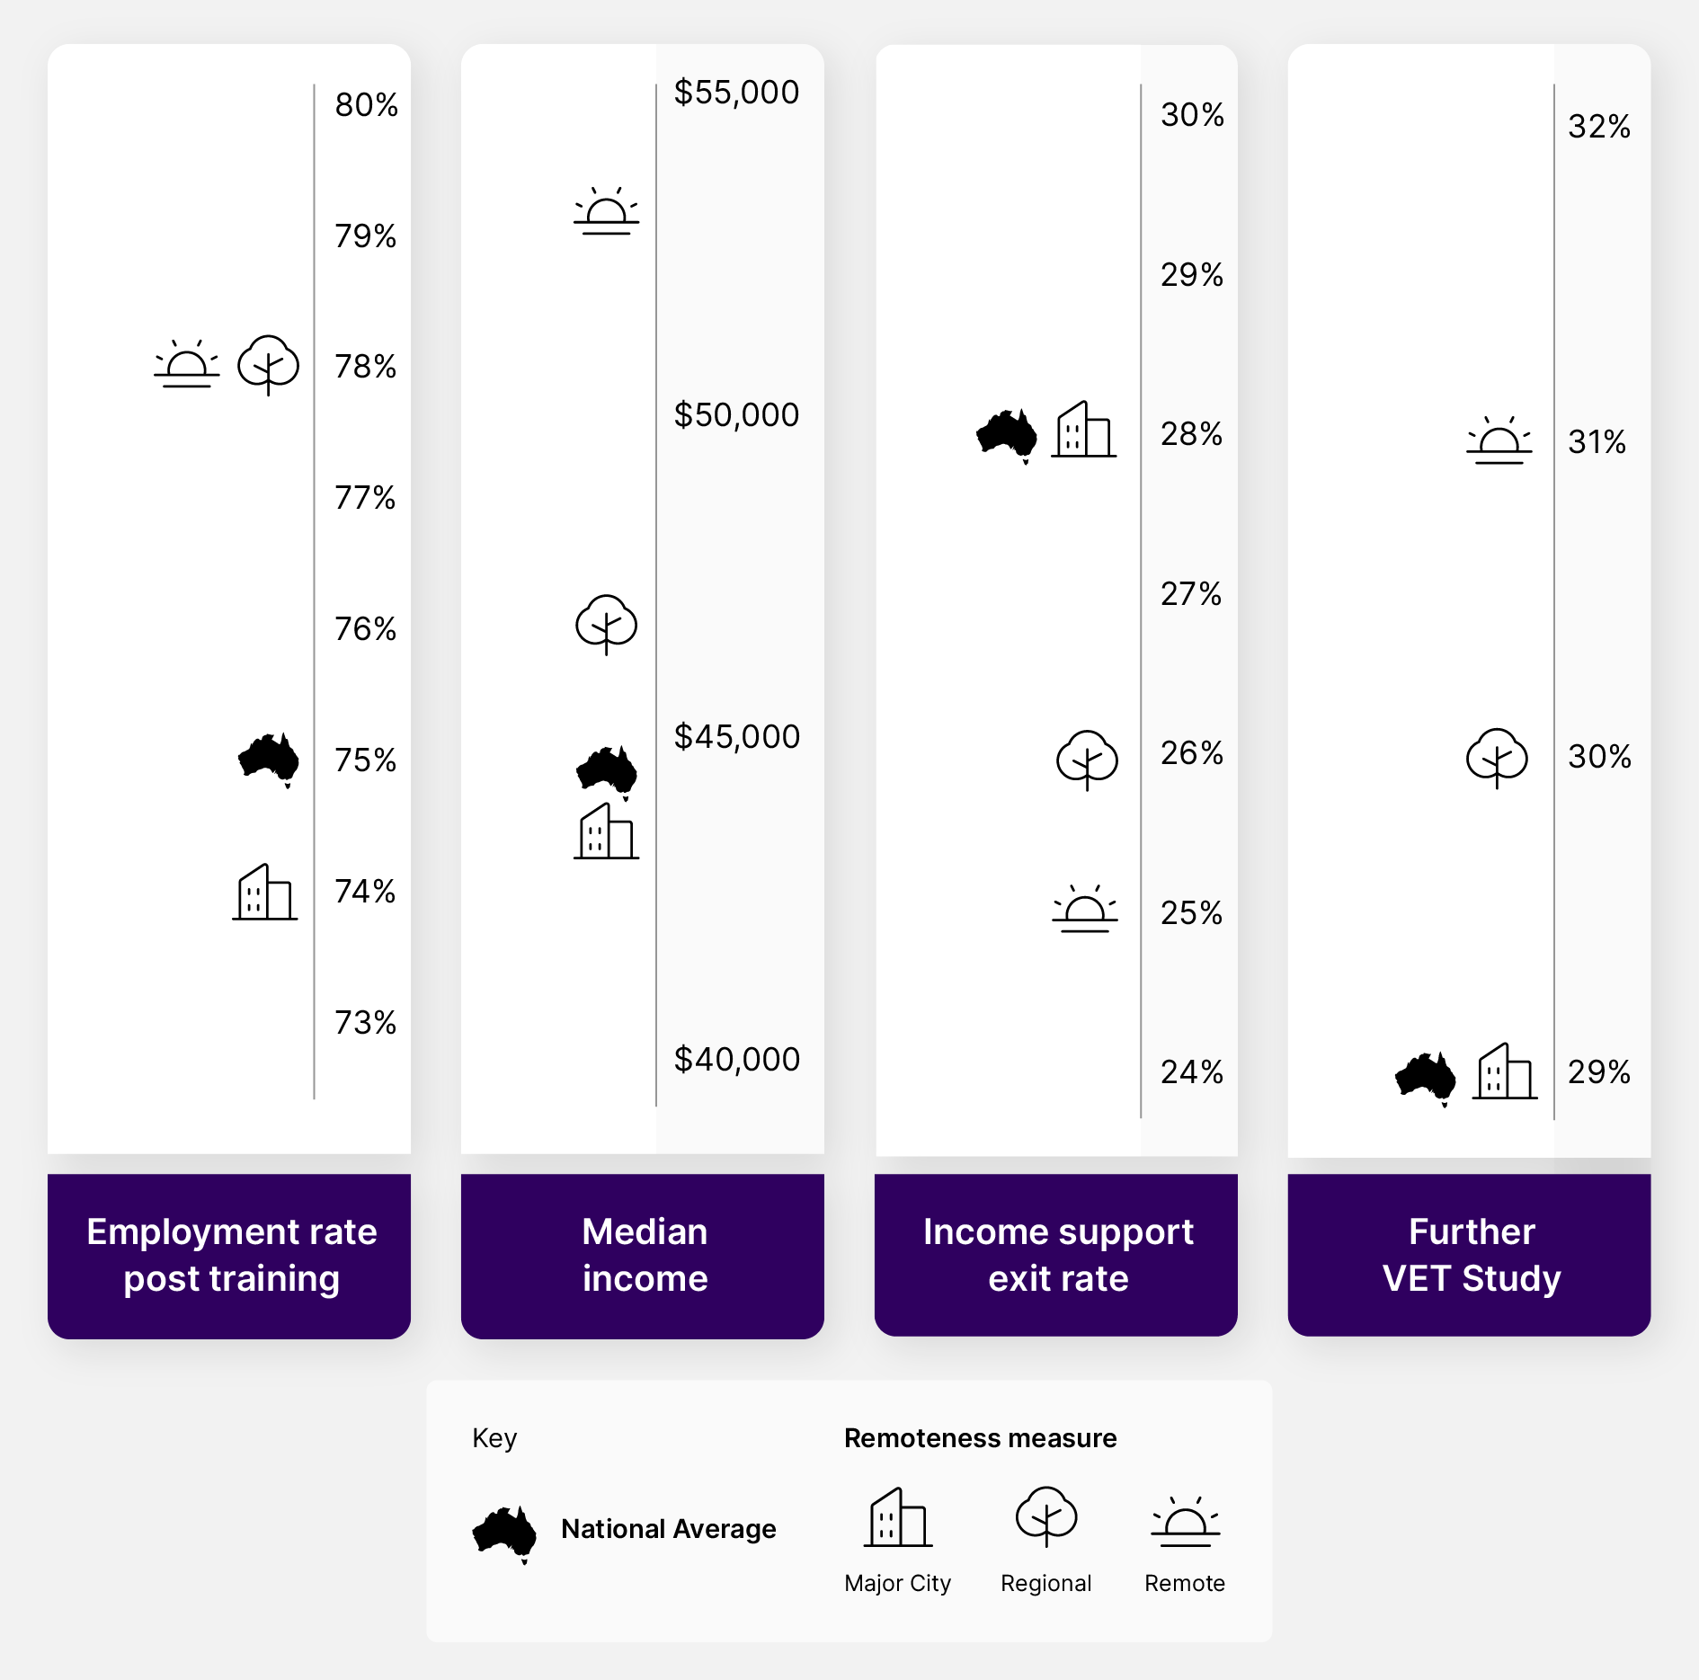
Source: Person Level Integrated Data Asset (PLIDA), 2002 – 2023, VET National Data Asset, ABS DataLab. Findings based on use of PLIDA data.

Top qualifications
Outcomes vary substantially by qualification. The qualifications highlighted below represent those with the strongest observed outcomes for partial completers and should not be interpreted as indicative of typical results across all fields of study.
Partial completers in Engineering and Related Technologies stand out across multiple measures, reinforcing the value of technical skills as a foundation for career progression and lifelong learning.
- The highest median income uplifts were recorded in Certificate II in Drilling Operations ($30,800), Certificate IV in Aeroskills (Mechanical) ($29,300) and Certificate III in International Freight Forwarding (Operator) ($25,900).
- The highest median incomes were observed in Certificate IV in Underground Coal Operations, Certificate IV in Process Plant Technology and Certificate III in ESI Generation, with median incomes exceeding $160,000, comparable to graduate outcomes.
- The largest employment rate increases (measured in percentage points) were observed for Certificate IV in EAL (English as an Additional Language) (Employment / Professional) (59 pts) and Certificate IV in Spoken and Written English – Employment (52 pts).
- Income-support exit rates exceeded 75% for Certificate III in Track Protection, Certificate III in Telecommunications Network Build and Operation, and Certificate III in Correctional Practice.
- Progression to further VET study was highest for Certificate II in Process Plant Operations (68%) and Certificate I in Core Skills for Employment and Training – Communication (56%).
These results illustrate that, in selected technical and pathway-oriented fields, partial completion can deliver substantial economic and learning benefits.

Conclusion
The latest VNDA release demonstrates that students who partially complete a nationally recognised VET qualification can achieve meaningful economic and learning outcomes. While lower than those seen for learners who complete their qualification, partial completers, on average, recorded improvements in employment and income, alongside reduced reliance on income support, with many entering work after training and some transitioning to full-time employment.
The findings also highlight the role of partial completion in supporting lifelong learning. Nearly one-third of partial completers enrol in further VET study within a year, indicating that partial completion often forms part of a broader, staged skills-development pathway rather than a permanent exit from education.
Outcomes vary across learner groups and contexts. Priority cohorts—including First Nations learners, CALD communities, women, and people with disability—experience positive post-training outcomes, though gaps persist. Apprentices and trainees recorded stronger employment, income, and income-support exit outcomes, reflecting the value of job-embedded training pathways. Outcomes also differ by age and field of education, with younger learners recording the largest income uplifts and selected technical fields, including Engineering and Related Technologies, delivering strong earnings and progression.
This report adds to the existing research around non-completion in VET, including the National Centre for Vocational Education Research (NCVER) report on The student journey: the many faces of completion and non-completion in VET, which provides a deeper understanding of how individuals journey through VET and NCVER’s current analysis which explores whether qualification completion rates can be supported by alternative measures of training success to capture ‘successful’ non-completed qualification enrolments.
Together, these analyses reinforces that the value of VET is not limited to full qualification completion. Partial completion can support labour-market participation, continued learning, and economic independence, underscoring the importance of a flexible VET system that recognises skills acquisition and progression over time.

Policy considerations
The findings in this report point to a number of policy-relevant considerations for the skills system, particularly in how partial completion is understood, supported and responded to.
- Recognise where partial completion works: Where partial completion is consistently associated with positive employment or progression outcomes, this suggests the system is supporting skills acquisition that is valued in the labour market.
- Formalise where pathways are well established: In cases where partial completion functions as a common and effective pathway, governments may wish to consider whether these outcomes would be better supported through formalised credentials, skill sets or stackable qualifications.
- Focus intervention where outcomes stall: Where partial completion is not followed by further learning, employment or income improvement, the results point to a need for targeted policy attention to reduce the risk of disengagement or persistent disadvantage.

Future work
This analysis represents an initial step in understanding the outcomes associated with partial completion. Further work could strengthen the evidence base and address key limitations highlighted in this report.
Future analytical priorities may include:
- Longer-term outcomes: Extending the follow-up period beyond 12 months to better understand the durability of employment, income and progression outcomes over time.
- Stronger causal inference: Developing counterfactual approaches and addressing selection effects to better isolate the contribution of partial completion from prior learner characteristics and labour-market attachment.
- Job quality measures: Incorporating additional indicators of job quality (such as stability, hours, and earnings progression) to complement the current employment and income measures.
- Targeted stratification: Exploring outcomes by volume of engagement (such as duration of study or units completed) to empirically distinguish different forms of partial completion.
These extensions would help move from identifying patterns in outcomes to a deeper understanding of when, how, and for whom partial completion delivers sustained benefits.

Further information
Technical details, including the methodology, data sources, data definitions and limitations, are the same for this report as those used in the VNDA 2020-21 report, Pathways to economic mobility and improved equity, with the addition of the definition for partial completion provided in Appendix A. Technical details for the VNDA 2020-21 graduate outcome report are available here Technical report - VNDA 2020-21 graduate outcomes, available on the JSA website.
JSA welcomes both feedback on this report and direct engagement to help shape both the modelling work that underpins the VNDA data asset and the focus of future analysis. Please get in touch at VNDA@jobsandskills.gov.au.

Disclaimer
The results of these studies are based, in part, on data supplied to the ABS under the Taxation Administration Act 1953, A New Tax System (Australian Business Number) Act 1999, Australian Border Force Act 2015, Social Security (Administration) Act 1999, A New Tax System (Family Assistance) (Administration) Act 1999, Paid Parental Leave Act 2010 and/or the Student Assistance Act 1973. Such data may only be used for the purpose of administering the Census and Statistics Act 1905 or performance of functions of the ABS as set out in section 6 of the Australian Bureau of Statistics Act 1975. No individual information collected under the Census and Statistics Act 1905 is provided back to custodians for administrative or regulatory purposes. Any discussion of data limitations or weaknesses is in the context of using the data for statistical purposes and is not related to the ability of the data to support the Australian Taxation Office, Australian Business Register, Department of Social Services and/or Department of Home Affairs’ core operational requirements.
Legislative requirements to ensure privacy and secrecy of these data have been followed. For access to PLIDA and/or BLADE data under Section 16A of the ABS Act 1975 or enabled by section 15 of the Census and Statistics (Information Release and Access) Determination 2018, source data are de-identified and so data about specific individuals has not been viewed in conducting this analysis. In accordance with the Census and Statistics Act 1905, results have been treated where necessary to ensure that they are not likely to enable identification of a particular person or organisation.

Appendix A
A Partial Completion represents a specific instance where a student has engaged in a training package qualification or accredited qualification but did not finish the full program of study. In this study, the student was identified as a partial completer if they meet all the following criteria:
- The student enrolled in their first unit of study for the qualification between the 2015–16 and 2018–19 financial years, and their final subject enrolment occurred before the 2021–22 financial year. This analysis window reflects the limits of available data.
- There is no official record indicating that the student completed the specific qualification in question.
- There are at least two consecutive years with no enrolments for that qualification, suggesting that the student has discontinued their training rather than taken a temporary break.
- The student has successfully completed (passed or received credit for) at least one unit of competency within the qualification that is not classed as a compliance subject.
- Units of competency related to compliance were removed from the analysis. Compliance training usually requires learners to complete one or more units of competency rather than an entire qualification. As a result, it’s common for students to enrol in compliance units as part of a full qualification without any intention of completing the qualification itself. For our analysis of partial completion, JSA considers it more meaningful to focus on partial completers who intend to complete a qualification or develop new skills, rather than those participating solely to maintain compliance.
- Examples of compliance subjects include general inductions and mandatory safety briefings. The list of compliance subjects used in this analysis is based on a list maintained by the National Centre for Vocational Education Research (NCVER). This list was originally developed by NCVER for their research into VET course completion and non-completion, ‘The student journey: the many dimensions of completion and non-completion in VET’.
- The student has not completed any other qualification during the period of their partially completed training (from the start of training to the training end date of the partial completion).
- The partially completed qualification is the student’s highest level AQF engagement during that period. If a student has multiple overlapping partial completions, they are identified as a partial completer only for the qualification at the highest AQF level. If they have multiple partial completions at the same highest level within the same year, they are excluded to avoid ambiguity.
- Pre training statistics are measured in the financial year before the training start date, and post training statistics are measured in the financial year following the training end date.
Results in this report may differ from the preliminary VET partial completer data in Connecting for impact - The Jobs and Skills Report 2025, published in November 2025. This reflects a minor update in the methodology, with data now restricted to students with an activity end date before FY 2021-22 due to missing post-study income data for some students whose final year of activity was 2022. Although the impact on overall results was minimal, the data has been updated to improve accuracy.

Appendix B

Income distribution
Median income provides a clear and useful summary of post-training outcomes; however, income levels among partial completers vary widely. To support interpretation of the median results, distributional analysis is used to illustrate the spread and shape of income outcomes.
The distributions show substantial dispersion and positive skewness: most learners cluster around modest income levels, while a smaller share achieve much higher earnings. Importantly, the distributions do not indicate strongly bimodal or polarised patterns, confirming that the median income is a robust summary measure rather than being distorted by extreme values or distinct sub groups.

Income distribution - national cohorts
Figure B.1 shows that while median income differs across cohorts, variation within cohorts differs more substantially. Male partial completers display a wider spread of incomes than females, with higher upper-end earnings, consistent with greater variation in hours worked and occupational outcomes.
First Nations partial completers also exhibit a wide income distribution, indicating diverse post-training outcomes rather than a single dominant trajectory. In contrast, people with disability show a narrower distribution centred on a lower median, reflecting more constrained earnings outcomes overall.
Figure B.1: Income distribution for VET partial completers, by priority cohort
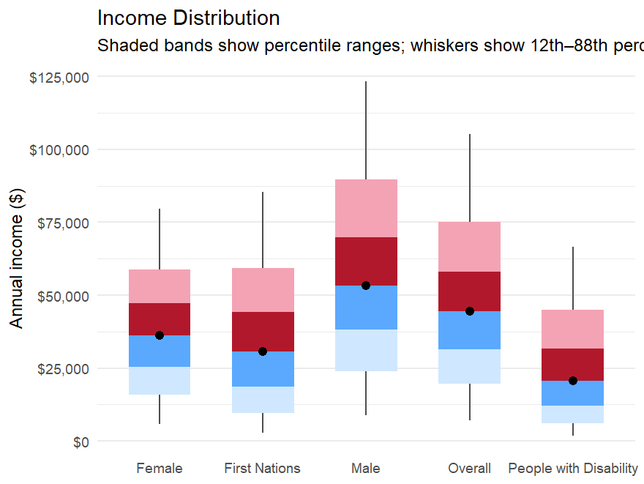
Source: Person Level Integrated Data Asset (PLIDA), 2002 – 2023, VET National Data Asset, ABS DataLab. Findings based on use of PLIDA data.

Income distribution - age groups
Figure B.2 shows that younger partial completers have lower incomes and a narrower distribution, consistent with entry-level or casual employment early in working lives. As age increases, income distributions shift upward and widen, with older cohorts showing greater dispersion and higher upper-end earnings.
Across age groups, distributions remain positively skewed, with no evidence that median outcomes are driven by polarised or bimodal earnings patterns. This supports the median as a stable indicator of typical post-training outcomes.
Figure B.2: Income distribution for VET partial completers, by age group
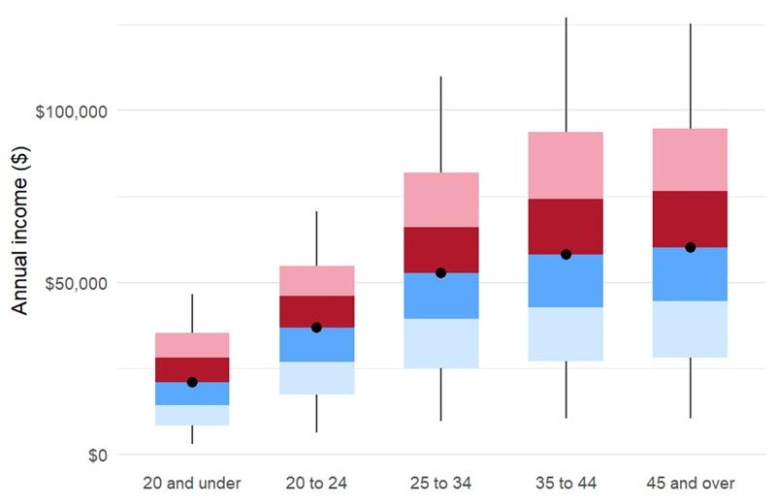
Source: Person Level Integrated Data Asset (PLIDA), 2002 – 2023, VET National Data Asset, ABS DataLab. Findings based on use of PLIDA data.

Appendix C

Income change distribution
Overall, income changes are widely dispersed, with both positive and negative movements observed. While the national median income change is positive, individual outcomes vary considerably, reinforcing that median uplifts should be interpreted as central tendencies rather than uniform effects.

Income change distribution - national cohorts
Figure C.1 shows that median income changes are broadly similar across cohorts, but the spread of income change varies. Males exhibit a wider distribution, reflecting both larger gains and declines. People with disability show a narrower distribution centred on smaller positive changes, while First Nations learners display more diverse post-training income movements.
Across cohorts, income changes are dispersed across a broad middle range, with no evidence that outcomes are driven by extreme shifts among small sub-groups.
Figure C.1: Income change distribution for VET partial completers, by priority cohort
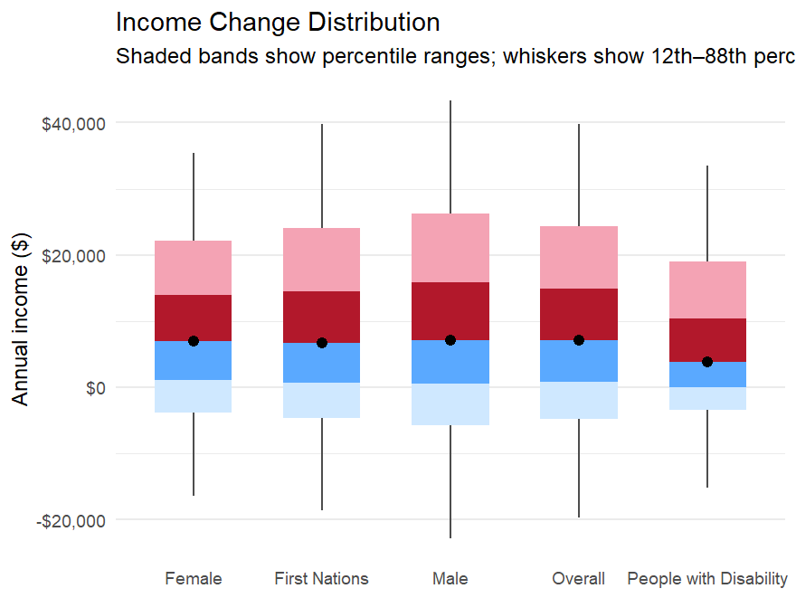
Source: Person Level Integrated Data Asset (PLIDA), 2002 – 2023, VET National Data Asset, ABS DataLab. Findings based on use of PLIDA data.

Income change distribution – age groups
Figure C.2 shows that younger partial completers record the largest typical income gains, consistent with entry into employment or increased hours after training.
For older cohorts, median income changes are smaller, but variability widens, reflecting more heterogeneous labour-market circumstances such as job transitions, changes in hours, or training undertaken for skill maintenance rather than immediate income growth. Negative income changes occur more frequently in these cohorts, consistent with transitional rather than disengagement-related dynamics.
Figure C.2: Income change distribution for VET partial completers, by age group
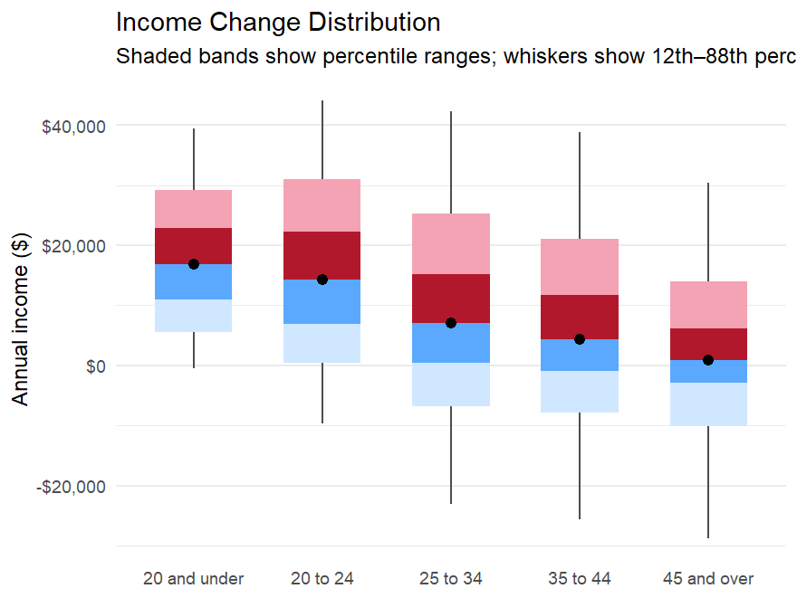
Source: Person Level Integrated Data Asset (PLIDA), 2002 – 2023, VET National Data Asset, ABS DataLab. Findings based on use of PLIDA data.

Appendix D

Part-time to full-time transitions

Transition from part-time employment to full-time employment after training
At a national level, the transition rate from student employed part-time prior to enrolment to full-time employment after training is 8%. Higher rates of transition from part-time to full-time employment were observed among apprentices (15%), students aged 20-24 (14%) and those employed prior to enrolment (12%). Female students had a significantly higher rate than male students (11% compared to 6%). First Nations students had a similar rate of transition to non-First Nations students (7% compared to 8%). Students with disability had a lower transition rate than students without disability (5% compared to 9%). CALD students had a slightly lower transition rate to non-CALD students (7% compared to 9%).
Figure D.1: Employment rate for partial completers, by transition rate from part-time employment prior to enrolment to full-time employment after training
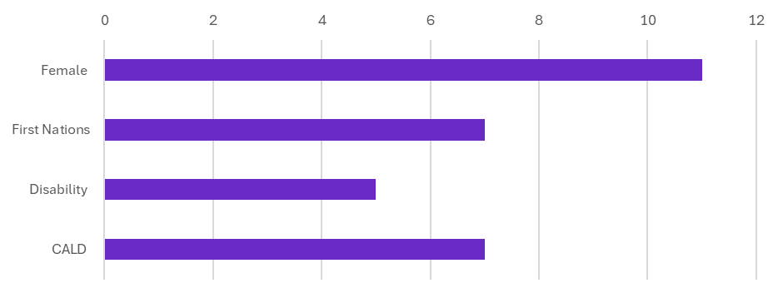
Source: Person Level Integrated Data Asset (PLIDA), 2002 – 2023, VET National Data Asset, ABS DataLab. Findings based on use of PLIDA data.

Part-time and full-time employment by priority groups
After training, 40% of women are employed part-time, an increase of 4 percentage points from before training. This compares with 11% of men, up 1 percentage point. Women also continue to have lower full-time employment rates than men both before and after training. Prior to training, 62% of men were employed full-time, increasing to 70% after training, compared with 28% of women prior and 34% after training.
For both First Nations and non-First Nations learners, 24% are employed part-time after training. This represents a 4-percentage point increase for First Nations learners and a 2-percentage point increase for non-First Nations learners. Full-time employment remains higher than part-time for both groups, both before and after training. Among First Nations learners, 34% were employed full-time prior to training, rising to 40% after training. For non-First Nations learners, full-time employment increased from 47% prior to training to 55% after training.
After training, 26% of people with disability are employed part-time, up 4 percentage points from before training. This compares with 24% of people without disability, an increase of 2 percentage points. Full-time employment is higher for both groups before and after training: for people with disability, 26% prior and 30% after training; for people without disability, 48% prior and 56% after training.
Among CALD students, 25% are employed part-time after training, an increase of 5 percentage points. This compares with 24% of non-CALD students, up 2 percentage points. Full-time employment increases for both groups following training. CALD students have an increase from 31% prior to 42% after training, while non-CALD students increase from 50% to 57%, after training.
Figure D.2: Employment rate for partial completers, by part-time employment
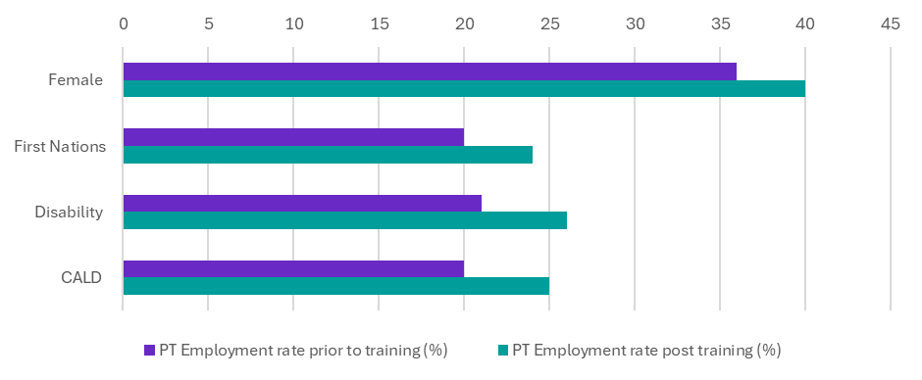
Source: Person Level Integrated Data Asset (PLIDA), 2002 – 2023, VET National Data Asset, ABS DataLab. Findings based on use of PLIDA data.
Figure D.3: Employment rate for partial completers, by full-time employment
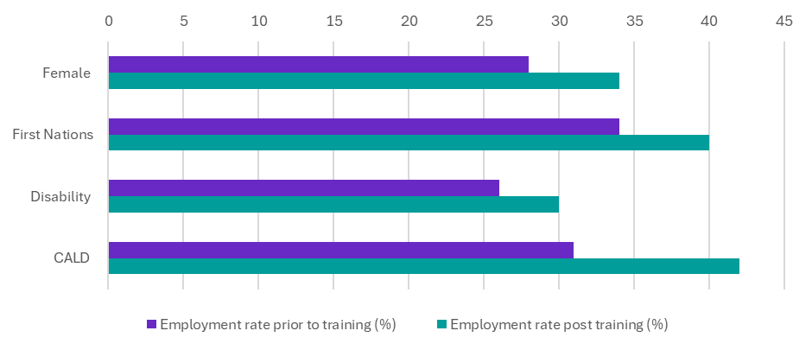
Source: Person Level Integrated Data Asset (PLIDA), 2002 – 2023, VET National Data Asset, ABS DataLab. Findings based on use of PLIDA data

Data for graduates comes from the recent VNDA analysis on VET graduates, Pathways to economic mobility and improved equity.
Lowest SES refers to the socio-economic status (SES) quintile 1 from the ABS Index of Relative Socio-Economic Disadvantage (IRSD).
Data for graduates comes from the recent VNDA analysis on VET graduates, Pathways to economic mobility and improved equity.
For some post-training financial years, higher education enrolment data is not yet available. To avoid issues with under coverage, outcomes related to higher education enrolments are not provided in this release.
Courses with small counts of fewer than 100 partial completers have been excluded.
Certificate III in Dance had a pre-training employment rate of 24%. Certificate IV in EAL (Employment / Professional) had a pre-training employment rate of 26%. Certificate IV in Spoken and Written English – Employment had a pre-training employment rate of 23%.
Income distributions are presented using modified boxplots. These show the interquartile range (from the 25th to the 75th percentile), alongside additional inner percentiles, while focusing on the 12th to 88th percentile range rather than minimum and maximum values. This approach reduces the influence of outliers - common in income data - while still capturing the substantial dispersion in outcomes across learners.
The part-time and full-time employment rates referenced are based on total employment, including both employee and business employment.

