REOS Recruitment Insights Report - April 2026
Jobs and Skills Australia surveys around 1000 employers each month in the Recruitment Experiences and Outlook Survey (REOS) to understand their recruitment experiences and staffing expectations.

Key Findings
Demand for workers eased further in April 2026. Fewer employers were recruiting, with 46% recently hiring or had recruited in the previous month, continuing a gradual decline since late 2025.
Hiring conditions also appeared to ease, with 45% reporting difficulty filling jobs. However, some challenges remained, as 39% of employers still had vacancies unfilled for more than a month.
Recruitment activity was largely driven by replacement rather than workforce expansion, with 62% of employers recruiting solely to replace staff who had left.
Looking ahead, hiring plans remained subdued. Only 15% of employers expected to increase staff over the next three months, suggesting demand for workers was likely to remain soft in the near term.
Overall, the results point to a labour market that continued to ease, with fewer employers hiring and less emphasis on growing workforces.

Recruitment activity
In April 2026, 46% of employers were recruiting or had recently recruited, down from 48% in March and 51% in February, and well below the series peak recorded in 2022. Recruitment activity had trended down since late 2025 but remained broadly in line with pre-pandemic norms.
Recruitment activity was slightly lower in Capital Cities (45%) than in the Rest of State areas (48%), with declines observed in both regions.
Larger employers were more likely to be recruiting (71%) than smaller employers (40%).

Recruitment difficulty
Recruitment difficulty decreased to 45% of recruiting employers in April 2026, down 2 percentage points over the month. This was 8 percentage points lower than in April 2025, and well below the series peak of 75% recorded in July 2022, indicating an easing in hiring pressures.
Despite this decline, recruitment difficulty remained above the series low of 37% recorded in February 2021, suggesting that some hiring challenges in filling vacancies remained.
Recruitment difficulty was lower in Capital Cities (43%) than in Rest of State areas (47%), with similar declines observed in both regions over the month. Over the year, the decline was more pronounced in Rest of State areas (down 12 percentage points) than in Capital Cities (down 7 percentage points), indicating that hiring conditions have eased more outside Capital Cities.

Staffing outlook: employers expecting to increase staff
The proportion of employers expecting to increase staffing levels over the next three months remained steady at 15% in April 2026. This was 8 percentage points lower than a year earlier and well below the series peak of 36% recorded in April 2022, indicating a continued softening in hiring intentions.
While expectations had declined, they remained above the series low of 4% recorded in April 2020, suggesting conditions were not as subdued as during the initial stages of the pandemic.
There was no difference in future staffing outlook between Capital Cities and Rest of State areas in April 2026, with 15% of employers in both regions expecting to increase staff over the next three months. However, trends over time differed slightly. In Capital Cities, expectation in April 2026 was 6 percentage points lower than a year ago, while in Rest of State areas it was 11 percentage points lower over the year. This suggests the softening in hiring intentions was somewhat more pronounced outside Capital Cities.

Reason for recruiting
Recruitment continued to be mainly driven by staff turnover in April 2026, with 62% of recruiting employers hiring solely to replace staff. A further 28% were hiring for new positions, while 11% were hiring for a mix of both.
The balance between replacement and expansion hiring remained broadly stable over time, with most recruitment activity reflecting the need to maintain existing staff levels rather than expand workforces.
The relatively smaller share of employers recruiting for new positions suggests that growth in workforce size is limited, with labour demand largely focused on replacement rather than the creation of additional roles.

Staffing changes over the last month
The proportion of employers increasing staff remained steady at 13% in April 2026, unchanged from a year earlier, while 12% reduced staff numbers, slightly lower than 13% recorded a year ago. Overall, this points to broadly balanced flows into and out of employment, consistent with a moderation in labour demand.

Employers unable to fill vacancies in a month
The proportion of recruiting employers with vacancies unfilled for more than one month increased to 39%, rising slightly over the month. Despite this increase, it remained lower than a year earlier, consistent with an overall easing in recruitment difficulties.
While the recent uptick suggests some ongoing challenges in filling roles, the current result is broadly in line with recent months, showing that conditions have stabilised following earlier periods of higher recruitment difficulty.

REOS national indicators

Recruitment rate

Proportion of employers currently recruiting or who recruited in the previous month.
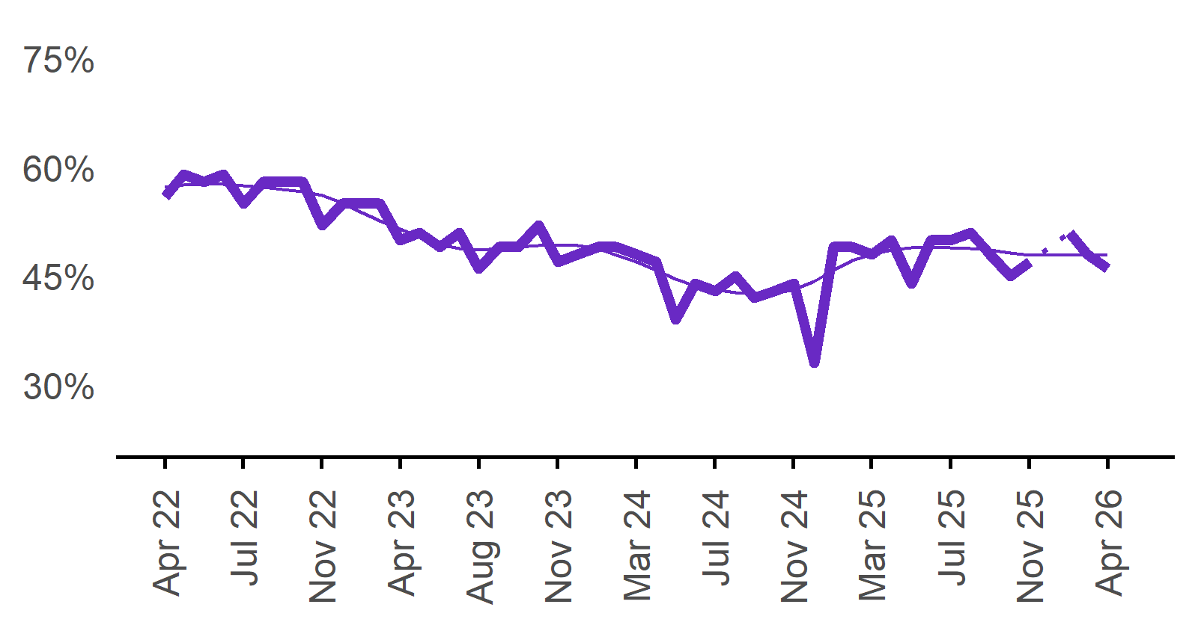 | 46%  Monthly change:  ▼ 2%pts  Annual change:  ▼ 2%pts
  Date | Recruitment rate | Smoothed recruitment rate
  Apr 2022 | 56% | 57%
  May 2022 | 59% | 58%
  Jun 2022 | 58% | 58%
  Jul 2022 | 59% | 58%
  Aug 2022 | 55% | 58%
  Sep 2022 | 58% | 57%
  Oct 2022 | 58% | 57%
  Nov 2022 | 58% | 57%
  Dec 2022 | 52% | 56%
  Jan 2023 | 55% | 55%
  Feb 2023 | 55% | 54%
  Mar 2023 | 55% | 53%
  Apr 2023 | 50% | 52%
  May 2023 | 51% | 50%
  Jun 2023 | 49% | 49%
  Jul 2023 | 51% | 49%
  Aug 2023 | 46% | 49%
  Sep 2023 | 49% | 49%
  Oct 2023 | 49% | 49%
  Nov 2023 | 52% | 49%
  Dec 2023 | 47% | 49%
  Jan 2024 | 48% | 49%
  Feb 2024 | 49% | 49%
  Mar 2024 | 49% | 48%
  Apr 2024 | 48% | 47%
  May 2024 | 47% | 46%
  Jun 2024 | 39% | 45%
  Jul 2024 | 44% | 44%
  Aug 2024 | 43% | 43%
  Sep 2024 | 45% | 43%
  Oct 2024 | 42% | 43%
  Nov 2024 | 43% | 43%
  Dec 2024 | 44% | 43%
  Jan 2025 | 33% | 44%
  Feb 2025 | 49% | 46%
  Mar 2025 | 49% | 47%
  Apr 2025 | 48% | 48%
  May 2025 | 50% | 49%
  Jun 2025 | 44% | 49%
  Jul 2025 | 50% | 49%
  Aug 2025 | 50% | 49%
  Sep 2025 | 51% | 49%
  Oct 2025 | 48% | 49%
  Nov 2025 | 45% | 48%
  Dec 2025 | 47% | 48%
  Jan 2026 |  | 48%
  Feb 2026 | 51% | 48%
  Mar 2026 | 48% | 48%
  Apr 2026 | 46% | 48%

Recruitment difficulty rate

Proportion of recruiting employers who stated they had difficulty hiring staff.
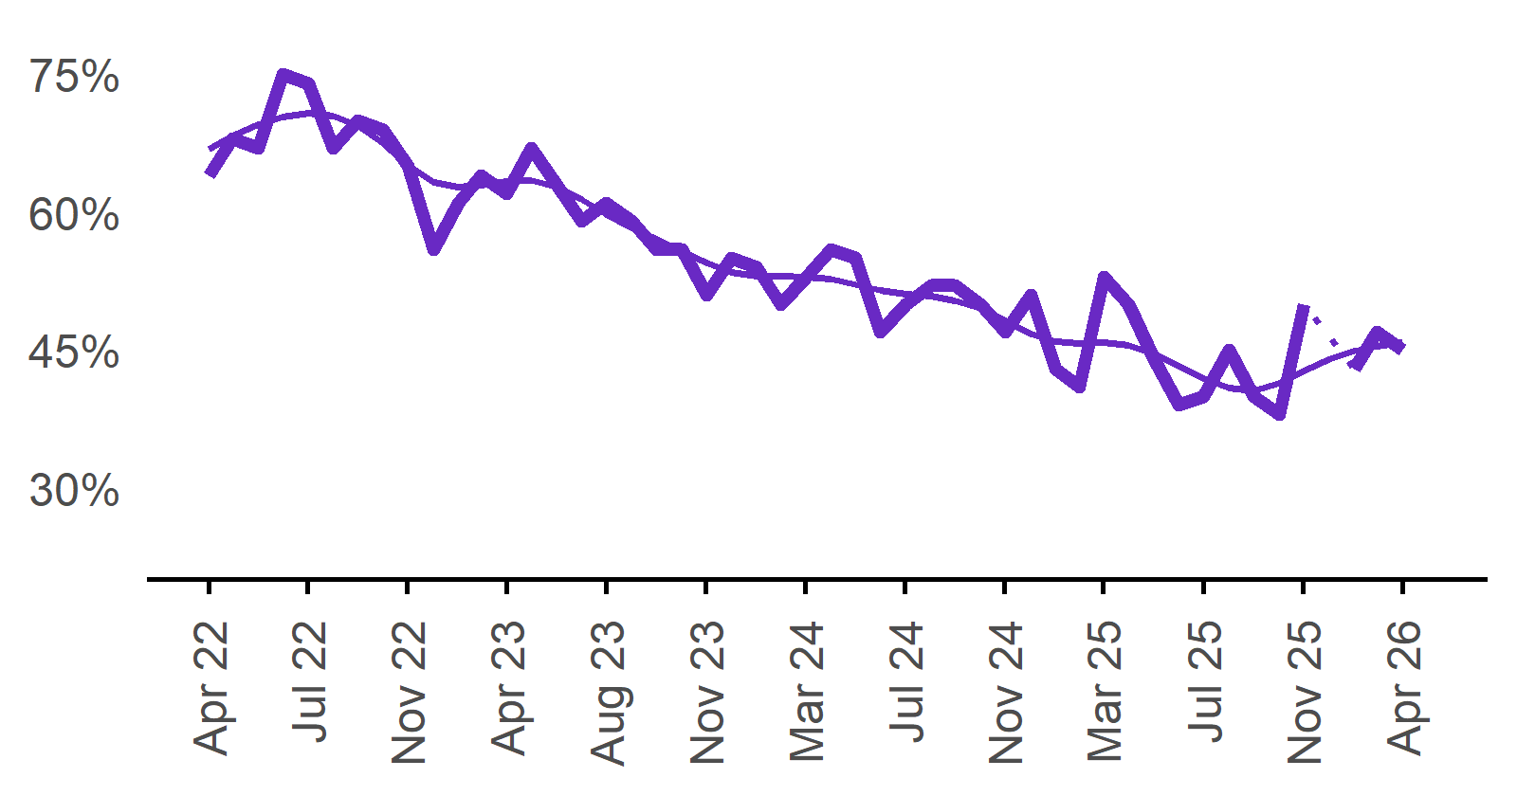 | 45%  Monthly change:  ▼ 2%pts  Annual change:  ▼ 8%pts
  Date | Recruitment difficulty rate | Smoothed recruitment difficulty rate
  Apr 2022 | 64% | 67%
  May 2022 | 68% | 68%
  Jun 2022 | 67% | 70%
  Jul 2022 | 75% | 70%
  Aug 2022 | 74% | 71%
  Sep 2022 | 67% | 71%
  Oct 2022 | 70% | 69%
  Nov 2022 | 69% | 68%
  Dec 2022 | 65% | 65%
  Jan 2023 | 56% | 63%
  Feb 2023 | 61% | 63%
  Mar 2023 | 64% | 63%
  Apr 2023 | 62% | 63%
  May 2023 | 67% | 63%
  Jun 2023 | 63% | 63%
  Jul 2023 | 59% | 61%
  Aug 2023 | 61% | 60%
  Sep 2023 | 59% | 58%
  Oct 2023 | 56% | 57%
  Nov 2023 | 56% | 56%
  Dec 2023 | 51% | 55%
  Jan 2024 | 55% | 54%
  Feb 2024 | 54% | 53%
  Mar 2024 | 50% | 53%
  Apr 2024 | 53% | 53%
  May 2024 | 56% | 53%
  Jun 2024 | 55% | 52%
  Jul 2024 | 47% | 51%
  Aug 2024 | 50% | 51%
  Sep 2024 | 52% | 51%
  Oct 2024 | 52% | 50%
  Nov 2024 | 50% | 50%
  Dec 2024 | 47% | 48%
  Jan 2025 | 51% | 47%
  Feb 2025 | 43% | 46%
  Mar 2025 | 41% | 46%
  Apr 2025 | 53% | 46%
  May 2025 | 50% | 46%
  Jun 2025 | 44% | 45%
  Jul 2025 | 39% | 43%
  Aug 2025 | 40% | 42%
  Sep 2025 | 45% | 41%
  Oct 2025 | 40% | 41%
  Nov 2025 | 38% | 41%
  Dec 2025 | 50% | 43%
  Jan 2026 |  | 44%
  Feb 2026 | 43% | 45%
  Mar 2026 | 47% | 45%
  Apr 2026 | 45% | 46%

Expecting to increase staff

Proportion of employers who expected to increase staffing numbers over the next three months.
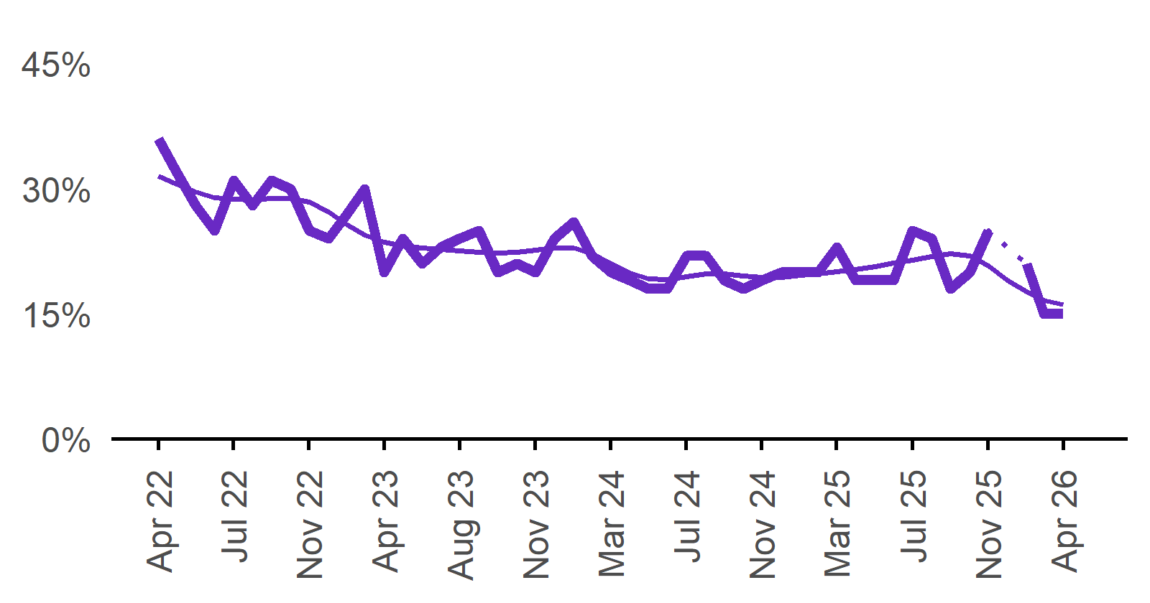 | 15%  Monthly change:  0%pts  Annual change:  ▼ 8%pts
  Date | Expect to increase | Smoothed expect to increase
  Apr 2022 | 36% | 31%
  May 2022 | 32% | 31%
  Jun 2022 | 28% | 30%
  Jul 2022 | 25% | 29%
  Aug 2022 | 31% | 29%
  Sep 2022 | 28% | 29%
  Oct 2022 | 31% | 29%
  Nov 2022 | 30% | 29%
  Dec 2022 | 25% | 28%
  Jan 2023 | 24% | 27%
  Feb 2023 | 27% | 26%
  Mar 2023 | 30% | 24%
  Apr 2023 | 20% | 24%
  May 2023 | 24% | 23%
  Jun 2023 | 21% | 23%
  Jul 2023 | 23% | 23%
  Aug 2023 | 24% | 23%
  Sep 2023 | 25% | 22%
  Oct 2023 | 20% | 22%
  Nov 2023 | 21% | 22%
  Dec 2023 | 20% | 23%
  Jan 2024 | 24% | 23%
  Feb 2024 | 26% | 23%
  Mar 2024 | 22% | 22%
  Apr 2024 | 20% | 21%
  May 2024 | 19% | 20%
  Jun 2024 | 18% | 19%
  Jul 2024 | 18% | 19%
  Aug 2024 | 22% | 19%
  Sep 2024 | 22% | 20%
  Oct 2024 | 19% | 20%
  Nov 2024 | 18% | 20%
  Dec 2024 | 19% | 19%
  Jan 2025 | 20% | 19%
  Feb 2025 | 20% | 20%
  Mar 2025 | 20% | 20%
  Apr 2025 | 23% | 20%
  May 2025 | 19% | 20%
  Jun 2025 | 19% | 21%
  Jul 2025 | 19% | 21%
  Aug 2025 | 25% | 21%
  Sep 2025 | 24% | 22%
  Oct 2025 | 18% | 22%
  Nov 2025 | 20% | 22%
  Dec 2025 | 25% | 21%
  Jan 2026 |  | 19%
  Feb 2026 | 21% | 18%
  Mar 2026 | 15% | 17%
  Apr 2026 | 15% | 16%

Capital City/Rest of State areas

Recruitment rate

Proportion of employers currently recruiting or who recruited in the previous month.
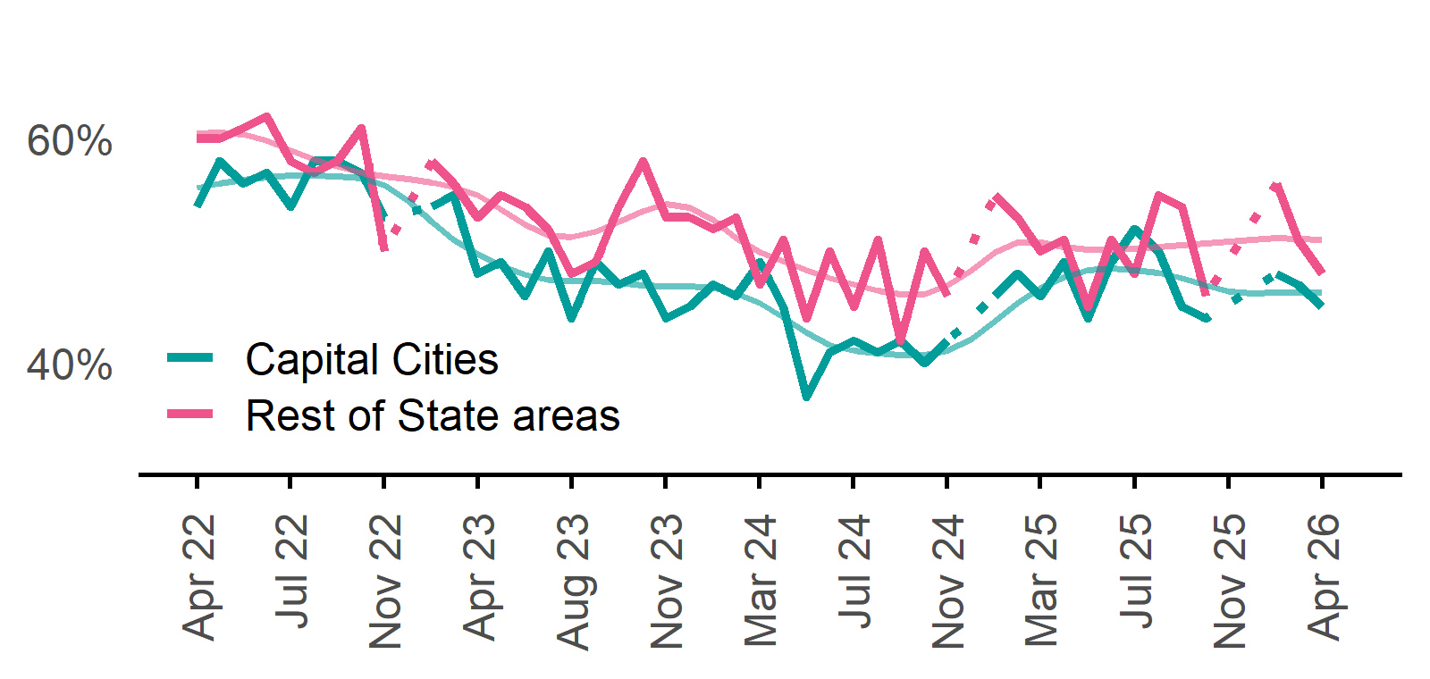 | Capital Cities: 45%  Monthly change:  ▼ 2%pts  Annual change:  ▼ 1%pt  Rest of State: 48%  Monthly change:  ▼ 3%pts  Annual change:  ▼ 2%pts
  Date | Capital Cities - Recruitment rate | Rest of State areas - Recruitment rate | Capital Cities - Smoothed recruitment rate | Rest of State areas - Smoothed recruitment rate
  Apr 2022 | 54% | 60% | 56% | 61%
  May 2022 | 58% | 60% | 56% | 61%
  Jun 2022 | 56% | 61% | 56% | 60%
  Jul 2022 | 57% | 62% | 57% | 60%
  Aug 2022 | 54% | 58% | 57% | 59%
  Sep 2022 | 58% | 57% | 57% | 58%
  Oct 2022 | 58% | 58% | 57% | 58%
  Nov 2022 | 57% | 61% | 56% | 57%
  Dec 2022 | 53% | 50% | 56% | 57%
  Jan 2023 | n.p. | n.p. | 54% | 56%
  Feb 2023 | 54% | 58% | 53% | 56%
  Mar 2023 | 55% | 56% | 51% | 56%
  Apr 2023 | 48% | 53% | 50% | 55%
  May 2023 | 49% | 55% | 49% | 54%
  Jun 2023 | 46% | 54% | 48% | 52%
  Jul 2023 | 50% | 52% | 47% | 51%
  Aug 2023 | 44% | 48% | 47% | 51%
  Sep 2023 | 49% | 49% | 47% | 52%
  Oct 2023 | 47% | 54% | 47% | 53%
  Nov 2023 | 48% | 58% | 47% | 54%
  Dec 2023 | 44% | 53% | 47% | 54%
  Jan 2024 | 45% | 53% | 47% | 54%
  Feb 2024 | 47% | 52% | 47% | 53%
  Mar 2024 | 46% | 53% | 46% | 51%
  Apr 2024 | 49% | 47% | 45% | 50%
  May 2024 | 45% | 51% | 44% | 49%
  Jun 2024 | 37% | 44% | 43% | 48%
  Jul 2024 | 41% | 50% | 42% | 48%
  Aug 2024 | 42% | 45% | 41% | 47%
  Sep 2024 | 41% | 51% | 41% | 46%
  Oct 2024 | 42% | 42% | 41% | 46%
  Nov 2024 | 40% | 50% | 41% | 46%
  Dec 2024 | 42% | 46% | 41% | 47%
  Jan 2025 | n.p. | n.p. | 42% | 48%
  Feb 2025 | 46% | 55% | 44% | 50%
  Mar 2025 | 48% | 53% | 45% | 51%
  Apr 2025 | 46% | 50% | 47% | 51%
  May 2025 | 49% | 51% | 48% | 50%
  Jun 2025 | 44% | 45% | 48% | 50%
  Jul 2025 | 49% | 51% | 48% | 50%
  Aug 2025 | 52% | 48% | 48% | 50%
  Sep 2025 | 50% | 55% | 48% | 50%
  Oct 2025 | 45% | 54% | 48% | 51%
  Nov 2025 | 44% | 46% | 47% | 51%
  Dec 2025 | n.p. | n.p. | 46% | 51%
  Jan 2026 |  |  | 46% | 51%
  Feb 2026 | 48% | 56% | 46% | 51%
  Mar 2026 | 47% | 51% | 46% | 51%
  Apr 2026 | 45% | 48% | 46% | 51%

Recruitment difficulty rate

Proportion of recruiting employers who stated they had difficulty hiring staff.
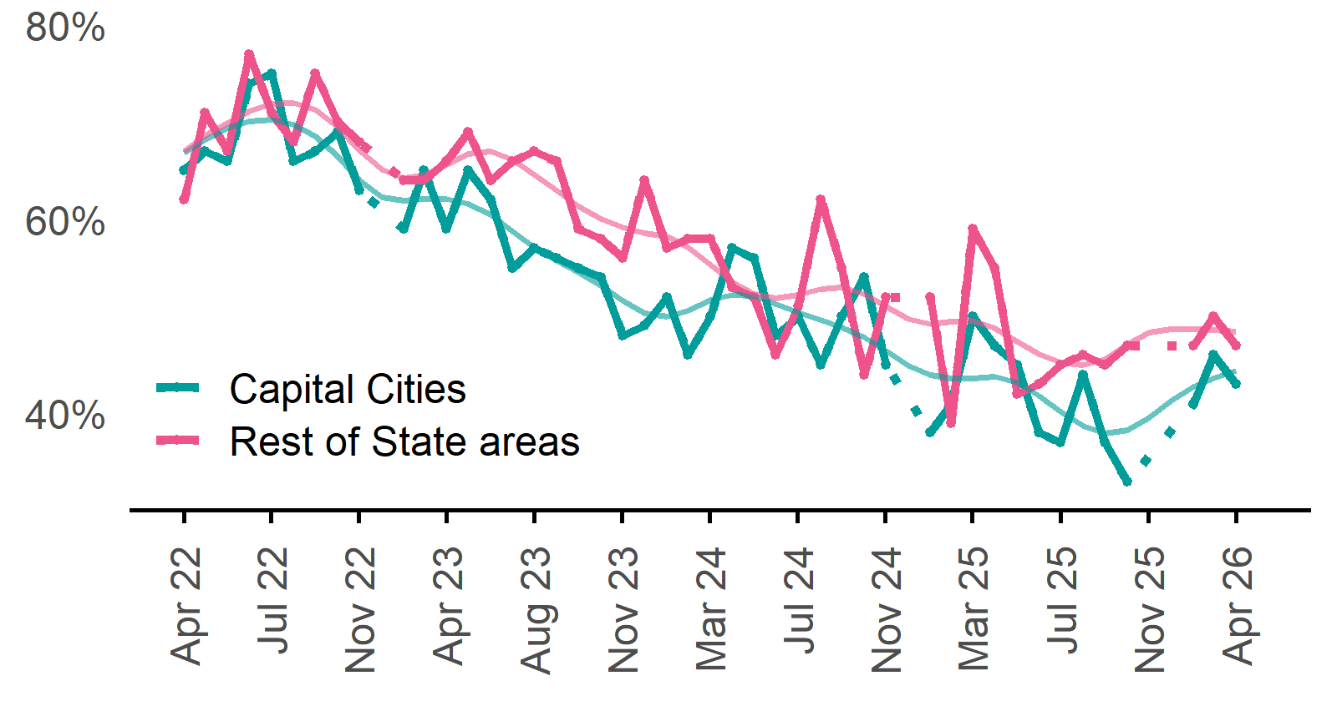 | Capital Cities: 43%  Monthly change:  ▼ 3%pts  Annual change:  ▼ 7%pts  Rest of State: 47%  Monthly change:  ▼ 3%pts  Annual change:  ▼ 12%pts
  Date | Capital Cities - Recruitment difficulty rate | Rest of State areas - Recruitment difficulty rate | Capital Cities - Smoothed recruitment difficulty rate | Rest of State areas - Smoothed recruitment difficulty rate
  Apr 2022 | 65% | 62% | 67% | 67%
  May 2022 | 67% | 71% | 68% | 69%
  Jun 2022 | 66% | 67% | 69% | 70%
  Jul 2022 | 74% | 77% | 70% | 71%
  Aug 2022 | 75% | 71% | 70% | 72%
  Sep 2022 | 66% | 68% | 70% | 72%
  Oct 2022 | 67% | 75% | 69% | 71%
  Nov 2022 | 69% | 70% | 66% | 69%
  Dec 2022 | 63% | 68% | 64% | 67%
  Jan 2023 | n.p. | n.p. | 62% | 65%
  Feb 2023 | 59% | 64% | 62% | 64%
  Mar 2023 | 65% | 64% | 62% | 65%
  Apr 2023 | 59% | 66% | 62% | 66%
  May 2023 | 65% | 69% | 62% | 67%
  Jun 2023 | 62% | 64% | 60% | 67%
  Jul 2023 | 55% | 66% | 59% | 66%
  Aug 2023 | 57% | 67% | 57% | 65%
  Sep 2023 | 56% | 66% | 56% | 63%
  Oct 2023 | 55% | 59% | 55% | 61%
  Nov 2023 | 54% | 58% | 53% | 60%
  Dec 2023 | 48% | 56% | 52% | 59%
  Jan 2024 | 49% | 64% | 50% | 59%
  Feb 2024 | 52% | 57% | 50% | 58%
  Mar 2024 | 46% | 58% | 51% | 57%
  Apr 2024 | 50% | 58% | 52% | 55%
  May 2024 | 57% | 53% | 52% | 53%
  Jun 2024 | 56% | 52% | 52% | 52%
  Jul 2024 | 48% | 46% | 51% | 52%
  Aug 2024 | 50% | 51% | 50% | 52%
  Sep 2024 | 45% | 62% | 50% | 53%
  Oct 2024 | 50% | 55% | 49% | 53%
  Nov 2024 | 54% | 44% | 48% | 52%
  Dec 2024 | 45% | 52% | 46% | 51%
  Jan 2025 | n.p. | n.p. | 45% | 50%
  Feb 2025 | 38% | 52% | 44% | 49%
  Mar 2025 | 41% | 39% | 44% | 49%
  Apr 2025 | 50% | 59% | 44% | 50%
  May 2025 | 47% | 55% | 44% | 49%
  Jun 2025 | 45% | 42% | 43% | 47%
  Jul 2025 | 38% | 43% | 42% | 46%
  Aug 2025 | 37% | 45% | 40% | 45%
  Sep 2025 | 44% | 46% | 39% | 45%
  Oct 2025 | 37% | 45% | 38% | 46%
  Nov 2025 | 33% | 47% | 38% | 47%
  Dec 2025 | n.p. | n.p. | 40% | 48%
  Jan 2026 |  |  | 41% | 49%
  Feb 2026 | 41% | 47% | 43% | 49%
  Mar 2026 | 46% | 50% | 44% | 49%
  Apr 2026 | 43% | 47% | 44% | 48%

Staffing outlook – Expecting to increase staff

Proportion of employers who expected to increase staffing numbers over the next three months.
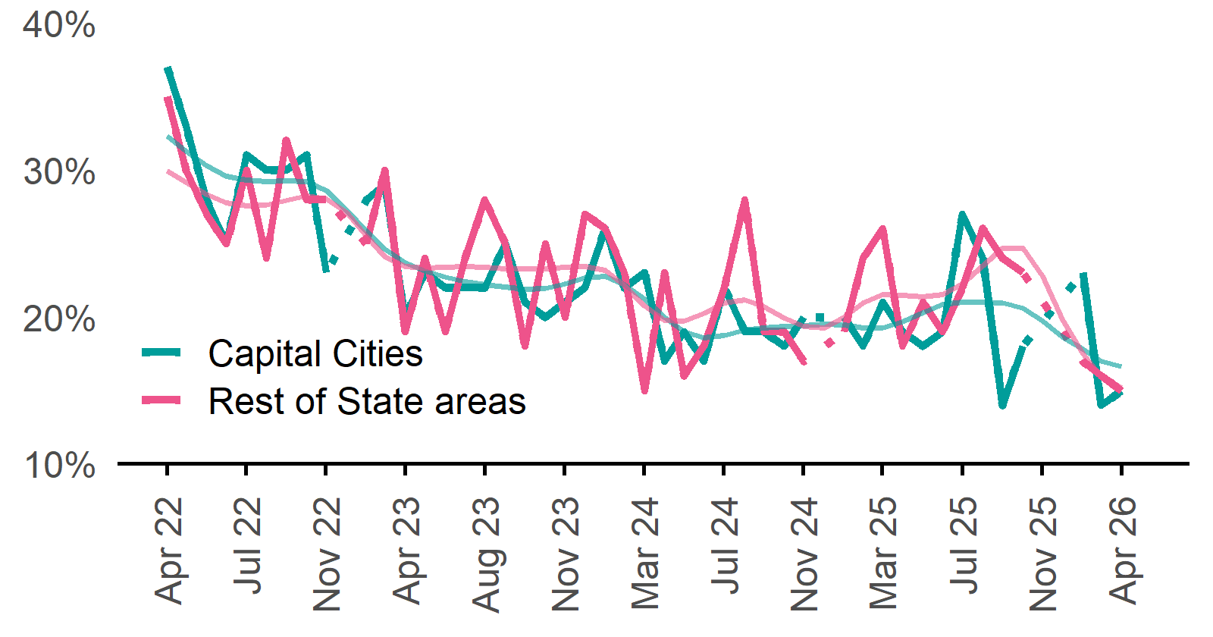 | Capital Cities: 15%  Monthly change:  ▲ 1%pt  Annual change:  ▼ 6%pts  Rest of State: 15%  Monthly change:  ▼ 1%pt  Annual change:  ▼ 11%pts
  Date | Capital Cities - % expecting to increase | Rest of State areas - % expecting to increase | Capital Cities - Smoothed % expecting to increase | Rest of State areas - Smoothed % expecting to increase
  Apr 2022 | 37% | 35% | 32% | 30%
  May 2022 | 33% | 30% | 31% | 29%
  Jun 2022 | 28% | 27% | 30% | 28%
  Jul 2022 | 25% | 25% | 30% | 28%
  Aug 2022 | 31% | 30% | 29% | 28%
  Sep 2022 | 30% | 24% | 29% | 28%
  Oct 2022 | 30% | 32% | 29% | 28%
  Nov 2022 | 31% | 28% | 29% | 28%
  Dec 2022 | 23% | 28% | 29% | 28%
  Jan 2023 | n.p. | n.p. | 27% | 27%
  Feb 2023 | 28% | 25% | 26% | 26%
  Mar 2023 | 29% | 30% | 25% | 24%
  Apr 2023 | 20% | 19% | 24% | 23%
  May 2023 | 23% | 24% | 23% | 23%
  Jun 2023 | 22% | 19% | 23% | 23%
  Jul 2023 | 22% | 24% | 22% | 23%
  Aug 2023 | 22% | 28% | 22% | 23%
  Sep 2023 | 25% | 25% | 22% | 23%
  Oct 2023 | 21% | 18% | 22% | 23%
  Nov 2023 | 20% | 25% | 22% | 23%
  Dec 2023 | 21% | 20% | 22% | 23%
  Jan 2024 | 22% | 27% | 23% | 23%
  Feb 2024 | 26% | 26% | 23% | 23%
  Mar 2024 | 22% | 23% | 22% | 22%
  Apr 2024 | 23% | 15% | 21% | 21%
  May 2024 | 17% | 23% | 20% | 20%
  Jun 2024 | 19% | 16% | 19% | 20%
  Jul 2024 | 17% | 18% | 19% | 20%
  Aug 2024 | 22% | 22% | 19% | 21%
  Sep 2024 | 19% | 28% | 19% | 21%
  Oct 2024 | 19% | 19% | 19% | 21%
  Nov 2024 | 18% | 19% | 19% | 20%
  Dec 2024 | 20% | 17% | 19% | 19%
  Jan 2025 | n.p. | n.p. | 20% | 19%
  Feb 2025 | 20% | 19% | 19% | 20%
  Mar 2025 | 18% | 24% | 19% | 21%
  Apr 2025 | 21% | 26% | 19% | 22%
  May 2025 | 19% | 18% | 20% | 21%
  Jun 2025 | 18% | 21% | 20% | 21%
  Jul 2025 | 19% | 19% | 21% | 22%
  Aug 2025 | 27% | 22% | 21% | 22%
  Sep 2025 | 24% | 26% | 21% | 23%
  Oct 2025 | 14% | 24% | 21% | 25%
  Nov 2025 | 18% | 23% | 21% | 25%
  Dec 2025 | n.p. | n.p. | 20% | 23%
  Jan 2026 |  |  | 19% | 20%
  Feb 2026 | 23% | 17% | 18% | 17%
  Mar 2026 | 14% | 16% | 17% | 16%
  Apr 2026 | 15% | 15% | 17% | 15%

Other recruitment indicators

Reason for recruiting

Proportion of employers currently recruiting or who recruited in the previous month.
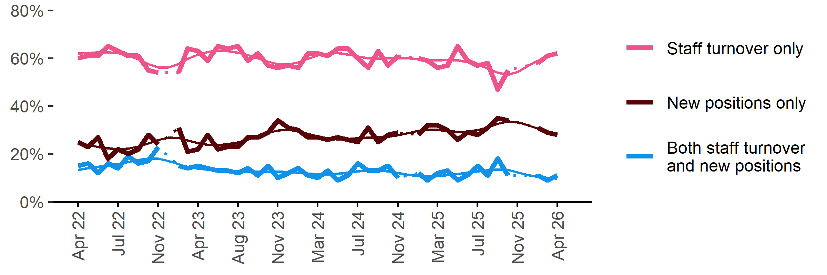
Date | Staff turnover only | Staff turnover and new positions | New positions only | Smoothed - staff turnover only | Smoothed - staff turnover and new positions | Smoothed - new positions only
Apr 2022 | 60% | 15% | 25% | 62% | 13% | 25%
May 2022 | 61% | 16% | 23% | 62% | 14% | 24%
Jun 2022 | 61% | 12% | 27% | 62% | 15% | 23%
Jul 2022 | 65% | 16% | 18% | 63% | 15% | 22%
Aug 2022 | 63% | 14% | 22% | 62% | 16% | 22%
Sep 2022 | 61% | 19% | 20% | 61% | 17% | 22%
Oct 2022 | 61% | 16% | 22% | 60% | 17% | 23%
Nov 2022 | 55% | 17% | 28% | 58% | 18% | 24%
Dec 2022 | 54% | 23% | 24% | 56% | 18% | 26%
Jan 2023 | n.p. | n.p. | n.p. | 56% | 17% | 27%
Feb 2023 | 54% | 15% | 31% | 58% | 16% | 27%
Mar 2023 | 64% | 14% | 21% | 60% | 15% | 26%
Apr 2023 | 63% | 15% | 22% | 61% | 14% | 25%
May 2023 | 59% | 14% | 28% | 63% | 13% | 24%
Jun 2023 | 65% | 13% | 22% | 63% | 13% | 24%
Jul 2023 | 64% | 13% | 23% | 63% | 13% | 24%
Aug 2023 | 65% | 12% | 23% | 62% | 13% | 25%
Sep 2023 | 59% | 14% | 27% | 61% | 13% | 26%
Oct 2023 | 62% | 11% | 27% | 60% | 13% | 27%
Nov 2023 | 57% | 15% | 29% | 59% | 13% | 29%
Dec 2023 | 56% | 10% | 34% | 58% | 13% | 30%
Jan 2024 | 57% | 12% | 31% | 57% | 12% | 30%
Feb 2024 | 56% | 14% | 30% | 58% | 12% | 30%
Mar 2024 | 62% | 11% | 27% | 60% | 12% | 28%
Apr 2024 | 62% | 10% | 27% | 61% | 12% | 27%
May 2024 | 61% | 13% | 26% | 62% | 11% | 27%
Jun 2024 | 64% | 9% | 27% | 62% | 12% | 26%
Jul 2024 | 64% | 11% | 26% | 62% | 12% | 26%
Aug 2024 | 60% | 16% | 25% | 61% | 13% | 27%
Sep 2024 | 56% | 13% | 31% | 60% | 13% | 27%
Oct 2024 | 63% | 13% | 25% | 60% | 13% | 27%
Nov 2024 | 57% | 15% | 28% | 60% | 13% | 27%
Dec 2024 | 61% | 10% | 29% | 60% | 12% | 28%
Jan 2025 | n.p. | n.p. | n.p. | 60% | 11% | 29%
Feb 2025 | 60% | 12% | 28% | 60% | 11% | 30%
Mar 2025 | 59% | 9% | 32% | 59% | 11% | 30%
Apr 2025 | 56% | 12% | 32% | 59% | 11% | 30%
May 2025 | 57% | 13% | 30% | 59% | 11% | 30%
Jun 2025 | 65% | 9% | 26% | 59% | 12% | 29%
Jul 2025 | 59% | 11% | 29% | 58% | 12% | 29%
Aug 2025 | 57% | 15% | 28% | 57% | 13% | 30%
Sep 2025 | 58% | 11% | 31% | 56% | 13% | 31%
Oct 2025 | 47% | 18% | 35% | 54% | 13% | 33%
Nov 2025 | 55% | 11% | 34% | 53% | 13% | 34%
Dec 2025 | n.p. | n.p. | n.p. | 54% | 12% | 33%
Jan 2026 |  |  |  | 57% | 11% | 32%
Feb 2026 | 58% | 11% | 31% | 59% | 10% | 31%
Mar 2026 | 61% | 9% | 29% | 61% | 10% | 29%
Apr 2026 | 62% | 11% | 28% | 62% | 10% | 29%

Staffing changes over the last month

Proportion of employers who said they increased or decreased staffing compared to the previous month.
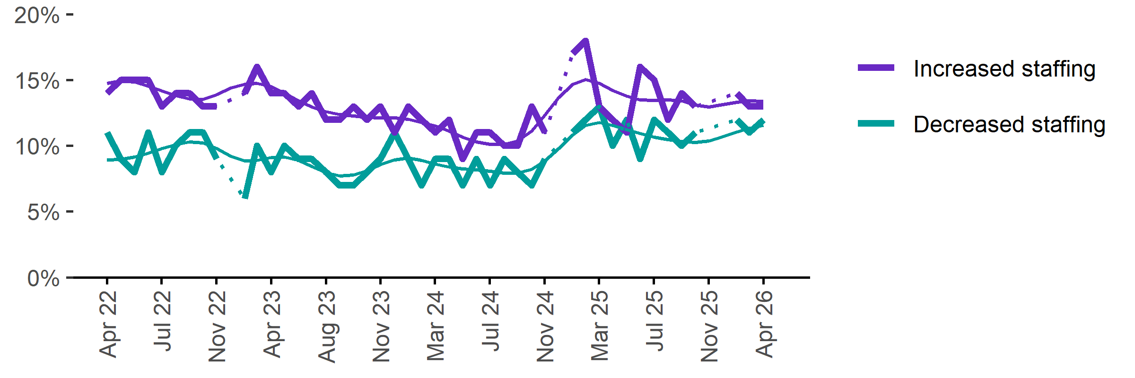
Date | Increased staff | Decreased staff | Smoothed - increased staff | Smoothed - decreased staff
Apr 2022 | 14% | 11% | 15% | 9%
May 2022 | 15% | 9% | 15% | 9%
Jun 2022 | 15% | 8% | 15% | 9%
Jul 2022 | 15% | 11% | 15% | 9%
Aug 2022 | 13% | 8% | 14% | 10%
Sep 2022 | 14% | 10% | 14% | 10%
Oct 2022 | 14% | 11% | 14% | 10%
Nov 2022 | 13% | 11% | 14% | 10%
Dec 2022 | 13% | 9% | 14% | 10%
Jan 2023 | n.p. | n.p. | 14% | 9%
Feb 2023 | 14% | 6% | 15% | 9%
Mar 2023 | 16% | 10% | 15% | 9%
Apr 2023 | 14% | 8% | 14% | 9%
May 2023 | 14% | 10% | 14% | 9%
Jun 2023 | 13% | 9% | 13% | 9%
Jul 2023 | 14% | 9% | 13% | 8%
Aug 2023 | 12% | 8% | 13% | 8%
Sep 2023 | 12% | 7% | 12% | 8%
Oct 2023 | 13% | 7% | 12% | 8%
Nov 2023 | 12% | 8% | 12% | 8%
Dec 2023 | 13% | 9% | 12% | 9%
Jan 2024 | 11% | 11% | 12% | 9%
Feb 2024 | 13% | 9% | 12% | 9%
Mar 2024 | 12% | 7% | 12% | 9%
Apr 2024 | 11% | 9% | 12% | 9%
May 2024 | 12% | 9% | 11% | 8%
Jun 2024 | 9% | 7% | 11% | 8%
Jul 2024 | 11% | 9% | 10% | 8%
Aug 2024 | 11% | 7% | 10% | 8%
Sep 2024 | 10% | 9% | 10% | 8%
Oct 2024 | 10% | 8% | 10% | 8%
Nov 2024 | 13% | 7% | 11% | 8%
Dec 2024 | 11% | 9% | 12% | 9%
Jan 2025 | n.p. | n.p. | 14% | 10%
Feb 2025 | 17% | 11% | 15% | 11%
Mar 2025 | 18% | 12% | 15% | 12%
Apr 2025 | 13% | 13% | 15% | 12%
May 2025 | 12% | 10% | 14% | 12%
Jun 2025 | 11% | 12% | 14% | 11%
Jul 2025 | 16% | 9% | 14% | 11%
Aug 2025 | 15% | 12% | 13% | 11%
Sep 2025 | 12% | 11% | 14% | 10%
Oct 2025 | 14% | 10% | 13% | 10%
Nov 2025 | 13% | 11% | 13% | 10%
Dec 2025 | n.p. | n.p. | 13% | 10%
Jan 2026 |  |  | 13% | 11%
Feb 2026 | 14% | 12% | 13% | 11%
Mar 2026 | 13% | 11% | 13% | 11%
Apr 2026 | 13% | 12% | 13% | 12%

Employers unable to fill vacancies within a month

Proportion of recruiting employers who were unable to fill their vacancies within a month.*
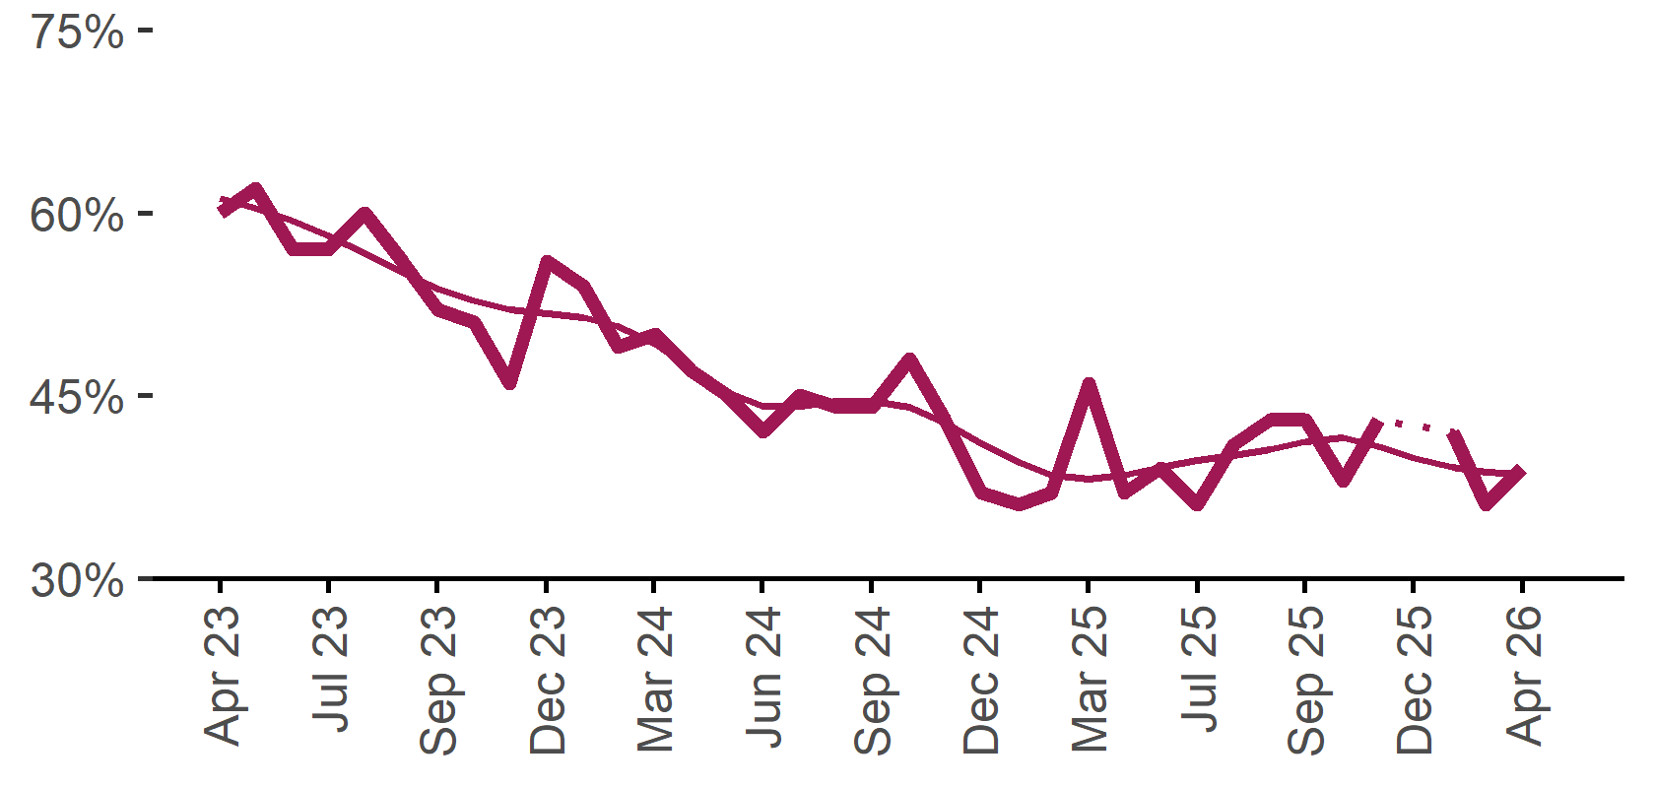 | 39%  Monthly change:  ▲ 3%pts  Annual change:  ▼ 7%pts
  Date | % unable to fill vacancies in a month | Smoothed - % unable to fill vacancies in a month
  Apr 2023 | 60% | 61%
  May 2023 | 62% | 60%
  Jun 2023 | 57% | 59%
  Jul 2023 | 57% | 58%
  Aug 2023 | 60% | 57%
  Sep 2023 | 56% | 55%
  Oct 2023 | 52% | 54%
  Nov 2023 | 51% | 53%
  Dec 2023 | 46% | 52%
  Jan 2024 | 56% | 52%
  Feb 2024 | 54% | 51%
  Mar 2024 | 49% | 51%
  Apr 2024 | 50% | 49%
  May 2024 | 47% | 47%
  Jun 2024 | 45% | 45%
  Jul 2024 | 42% | 44%
  Aug 2024 | 45% | 44%
  Sep 2024 | 44% | 45%
  Oct 2024 | 44% | 45%
  Nov 2024 | 48% | 44%
  Dec 2024 | 43% | 43%
  Jan 2025 | 37% | 41%
  Feb 2025 | 36% | 40%
  Mar 2025 | 37% | 38%
  Apr 2025 | 46% | 38%
  May 2025 | 37% | 38%
  Jun 2025 | 39% | 39%
  Jul 2025 | 36% | 40%
  Aug 2025 | 41% | 40%
  Sep 2025 | 43% | 41%
  Oct 2025 | 43% | 41%
  Nov 2025 | 38% | 41%
  Dec 2025 | 43% | 41%
  Jan 2026 |  | 40%
  Feb 2026 | 42% | 39%
  Mar 2026 | 36% | 39%
  Apr 2026 | 39% | 39%
* Excludes employers who have been recruiting for less than a month.

Background
Jobs and Skills Australia (JSA) conducts the Recruitment Experiences and Outlook Survey (REOS), a telephone administered survey with the business owner or other person in the business responsible for recruitment. Around 1000 employers are surveyed each month, with data published on the JSA website. While the data are indicative of recruitment activity, they may be subject to seasonal factors and other volatility and should therefore be used with a degree of caution. In addition, the survey is targeted towards employers with 5 or more employees and excludes many government organisations. Details of the survey methodology can be accessed from the JSA website.

Smoothed series in charts
Charts include Henderson-smoothed lines in addition to original data for most of our recruitment indicators. As the timeseries is not yet long enough for seasonal adjustment, a Henderson smoothed moving average with a 13-term filter (equating to 13 months) has been directly applied to the original series. This provides an indication of the general movement in each recruitment indicator relative to previous months. Due to using 13 months in the moving average, results for the most recent six months will be revised each month.

How to reference data from this report
Jobs and Skills Australia, Recruitment Insights Report, April 2026.

Contact us
For additional information, email REOS@jobsandskills.gov.au

Also available from the REOS

Data file with monthly and quarterly recruitment indicators
A REOS data file is available on the JSA website. Breakdowns by Capital City/Rest of State area, Business size, and ANZSCO Skill Level are included in the monthly results. Quarterly recruitment indicators provide detail by state, ARIA (ABS’ Accessibility and Remoteness Index of Australia) as well as selected industry and occupation groups.
Next Recruitment Insights Report release:
- May 2026 Recruitment Insights Report – 16 June 2026

Stay up to date
JSA also releases semi-regular reports including spotlight articles, detailing aspects of the REOS that cannot be included in our monthly Recruitment Insights Report. Sign up and get the Recruitment Insights Report notifications sent straight to your inbox.
Upcoming spotlight:
- Employers' greatest concern – 28 May 2026
Recent spotlights:
- Recruitment experiences and outlook survey – March quarter 2026 results - April 2026
- Employer attitudes toward disability inclusion in the Australian workforce – March 2026

A Henderson smoothed line has been included in the charts to reduce month to month volatility and illustrate long term patterns. See the explanatory note for more information.
Data are not available for January in some years. Data points have been joined by a dotted line between December and February to reflect this. ‘Rest of State’ refers to areas outside the capital cities.

