Recruitment Experiences and Outlook Survey: March quarter 2026
Jobs and Skills Australia conducts the Recruitment Experiences and Outlook Survey (REOS) to monitor recruitment activity and conditions across Australia. Key national indicators from the survey are released monthly. Detailed data disaggregated by state, area, industry, and occupation are released in this quarterly report. For definitions or further information on this data and the REOS, see the notes on the last page.

Recruitment rate - National level
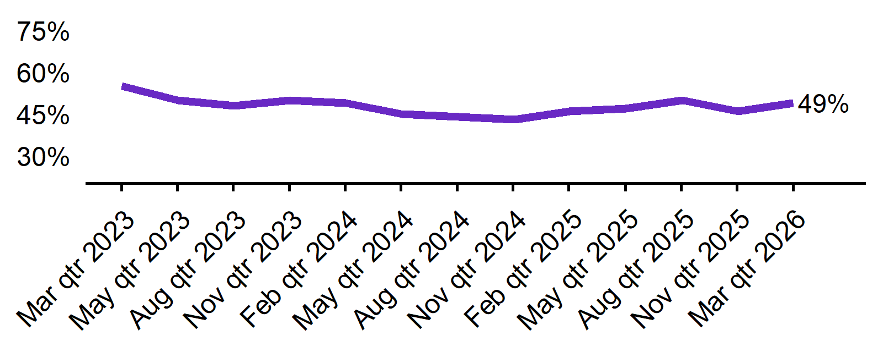 | - The recruitment rate in the March quarter 2026 was 49%.  - This was 3 percentage points higher than this time last year (46%).
  Mar qtr 2023 | Jun qtr 2023 | Sep qtr 2023 | Dec qtr 2023 | Mar qtr 2024 | Jun qtr 2024 | Sep qtr 2024 | Dec qtr 2024 | Mar qtr 2025 | Jun qtr 2025 | Sep qtr 2025 | Dec qtr 2025 | Mar qtr 2026
  55% | 50% | 48% | 50% | 49% | 45% | 44% | 43% | 46% | 47% | 50% | 46% | 49%

Recruitment difficulty rate - National level
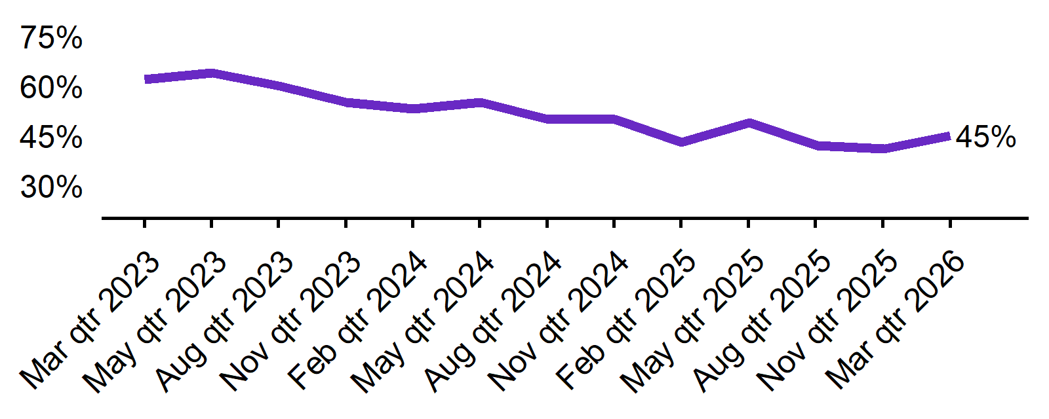 | - The recruitment difficulty rate in the March quarter 2026 was 45%.  - This was 2 percentage points higher than a year earlier (43%).
  Mar qtr 2023 | Jun qtr 2023 | Sep qtr 2023 | Dec qtr 2023 | Mar qtr 2024 | Jun qtr 2024 | Sep qtr 2024 | Dec qtr 2024 | Mar qtr 2025 | Jun qtr 2025 | Sep qtr 2025 | Dec qtr 2025 | Mar qtr 2026
  62% | 64% | 60% | 55% | 53% | 55% | 50% | 50% | 43% | 49% | 42% | 41% | 45%

Expecting to increase staff - National level
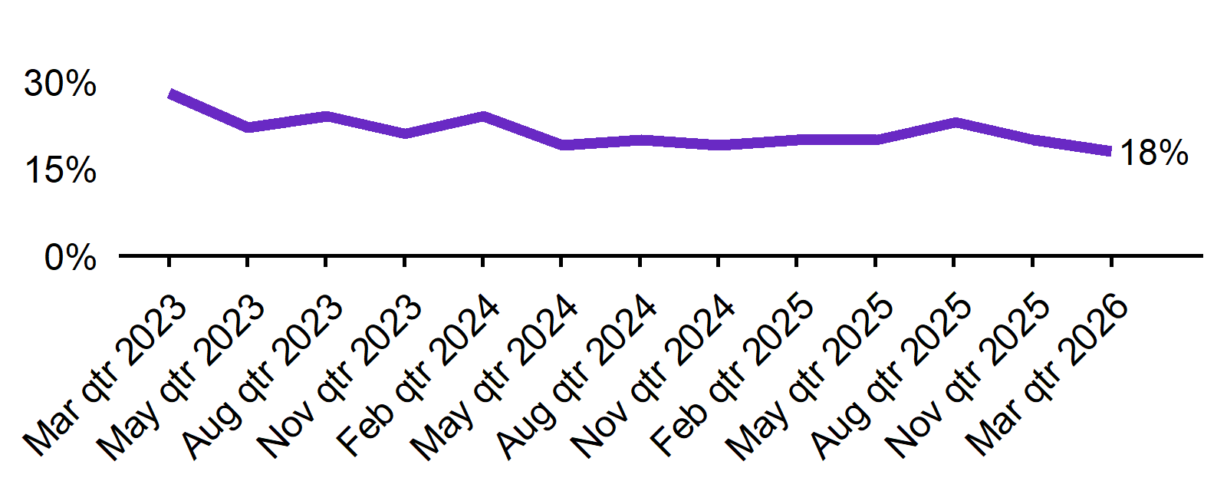 | - In the March quarter 2026, 18% of employers expected to increase staff. This was 2 percentage points lower than this time last year (20%).  - The proportion of employers who expected to decrease staff was 4% in the March quarter 2026.
  Mar qtr 2023 | Jun qtr 2023 | Sep qtr 2023 | Dec qtr 2023 | Mar qtr 2024 | Jun qtr 2024 | Sep qtr 2024 | Dec qtr 2024 | Mar qtr 2025 | Jun qtr 2025 | Sep qtr 2025 | Dec qtr 2025 | Mar qtr 2026
  28% | 22% | 24% | 21% | 24% | 19% | 20% | 19% | 20% | 20% | 23% | 20% | 18%

Key indicators by state/territory
In the March quarter 2026, Tasmania recorded the highest recruitment rate of the six states (57%). At 50%, Queensland recorded the highest recruitment difficulty rate. Out of all states and territories, Northern Territory reported the highest recruitment rate (65%), the highest recruitment difficulty rate (61%) and the highest optimism around future staffing (34%) in the March quarter 2026, noting the smaller sample size for this quarter.

Table 1. Key indicators by state/territory, March quarter 2026
 | Recruitment rate |  | Recruitment difficulty rate |  | Expect to increase staff
 | % of employers | Annual change  (% points) | % of recruiting employers | Annual change  (% points) | % of employers | Annual change  (% points)
NSW | 48% | 4 pts | 43% | 0 pts | 19% | 1 pts
VIC | 44% | 5 pts | 43% | 0 pts | 18% | -1 pts
QLD | 55% | 2 pts | 50% | 5 pts | 19% | -3 pts
SA | 46% | -6 pts | 45%* | 3 pts* | 13% | -4 pts
WA | 54% | 4 pts | 48% | 5 pts | 12% | -10 pts
TAS | 57% | 10 pts | 38%* | 2 pts* | 24% | 9 pts
NT# | 65%* | 4 pts* | 61%* | 4 pts* | 34%* | 2 pts*
ACT# | 47% | 2 pts | 50%* | 19 pts* | 15% | -3 pts

# Due to smaller sample sizes, data for the NT and ACT are based on six-month average data (Dec qtr. to Mar qtr.).
* Interpret with caution due to low sample size.

Figure 1. Recruitment rate by state, March quarter 2025 - March quarter 2026
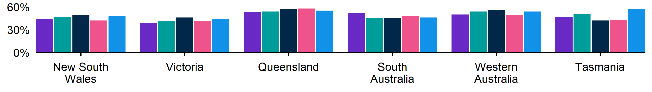

Figure 2. Recruitment difficulty rate by state, March quarter 2025 - March quarter 2026

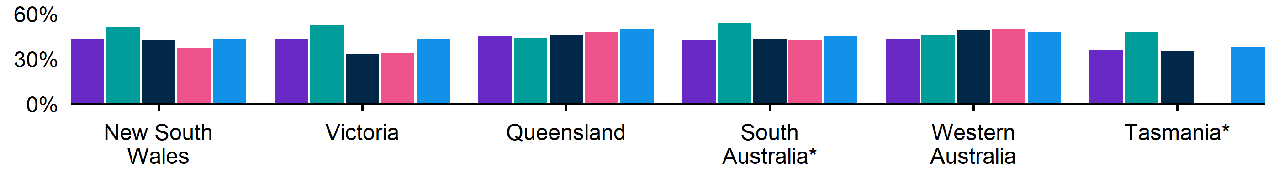 Note: No data are shown for Tasmania in the December quarter 2025 due to a small sample size

Figure 3. Expecting to increase staff numbers over the next 3 months by state, March quarter 2025 - March quarter 2026
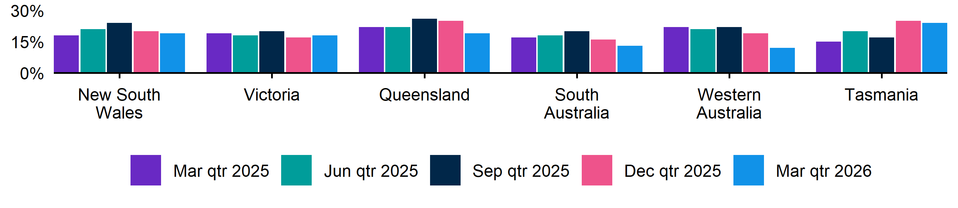

Key indicators by remoteness classification (ARIA location)
In the March quarter 2026, Outer Regional, Remote and Very Remote Australia recorded the highest recruitment rate of the ARIA regions (54%) and the highest rate of recruitment difficulty (52%). Future staffing expectations fell in all three regions compared with a year ago.

Table 2. Key indicators by ARIA location, March quarter 2026
 | Recruitment rate |  | Recruitment difficulty rate |  | Expect to increase staff
 | % of employers | Annual change  (% points) | % of recruiting employers | Annual change  (% points) | % of employers | Annual change  (% points)
Major Cities of Australia | 48% | 4 pts | 44% | 3 pts | 18% | -1 pts
Inner Regional Australia | 51% | 4 pts | 46% | -6 pts | 16% | -4 pts
Outer Regional, Remote and Very Remote Australia | 54% | 0 pts | 52% | 11 pts | 18% | -5 pts

* Interpret with caution due to low sample size. Accessibility and Remoteness Index of Australia (ARIA) classifications of Outer Regional Australia, Remote Australia, and Very Remote Australia have been combined into one category to increase sample size.

Figure 4. Recruitment rate by ARIA location, March quarter 2025 - March quarter 2026
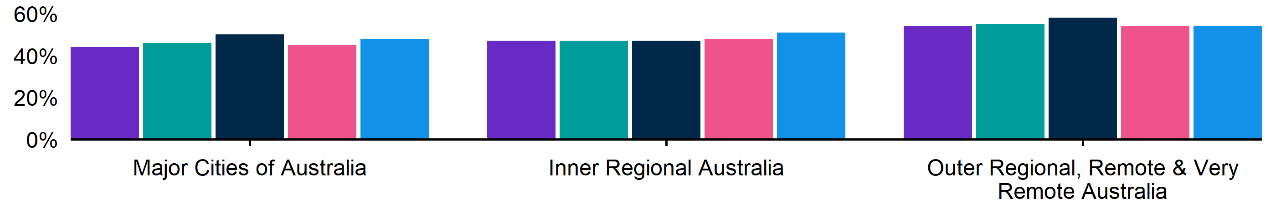

Figure 5. Recruitment difficulty rate by ARIA location, March quarter 2025 - March quarter 2026
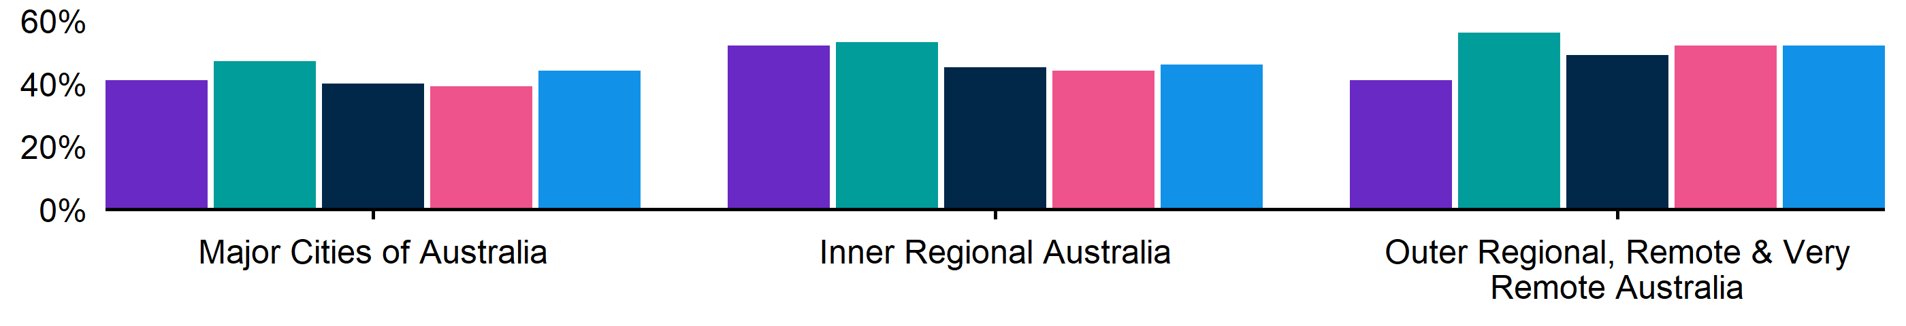

Figure 6. Expecting to increase staff numbers over the next 3 months by ARIA location, March quarter 2025 - March quarter 2026
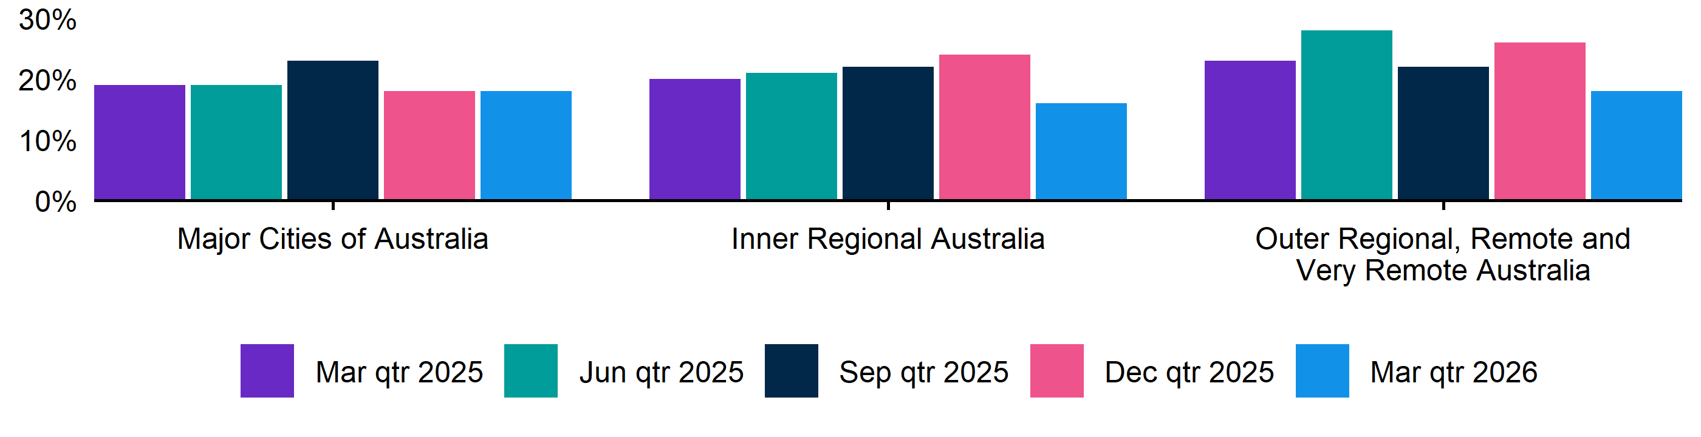

Key indicators by selected industries
In the March quarter 2026, Accommodation and Food Services recorded the highest recruitment rate of the selected industries (67%). Construction and Professional, Scientific and Technical services shared the highest recruitment difficulty rate across industries, both at 58% this quarter. Compared to a year ago, Health Care and Social Assistance experienced the highest increase in future staffing optimism (at 25%, 6 percentage points higher than this time last year).

Table 3. Key indicators by industry, March quarter 2026
 | Recruitment rate |  | Recruitment difficulty rate |  | Expect to increase staff
 | % of employers | Annual change  (% points) | % of recruiting employers | Annual change  (% points) | % of employers | Annual change  (% points)
Manufacturing | 43% | -5 pts | 50%* | -1 pts* | 14% | -8 pts
Construction | 52% | 10 pts | 58%* | 16 pts* | 21% | -2 pts
Wholesale Trade | 42% | 6 pts | 50%* | 11 pts* | 16% | 0 pts
Retail Trade | 51% | 13 pts | 38% | -12 pts | 12% | -6 pts
Accommodation and Food Services | 67% | 5 pts | 34%* | 7 pts* | 24% | 1 pts
Professional, Scientific and Technical Services | 41% | 0 pts | 58%* | 8 pts* | 22% | 5 pts
Health Care and Social Assistance | 51% | -1 pts | 50%* | 15 pts* | 23% | 6 pts

* Interpret with caution due to low sample size.

Figure 7. Recruitment rate by industry, March quarter 2025 - March quarter 2026
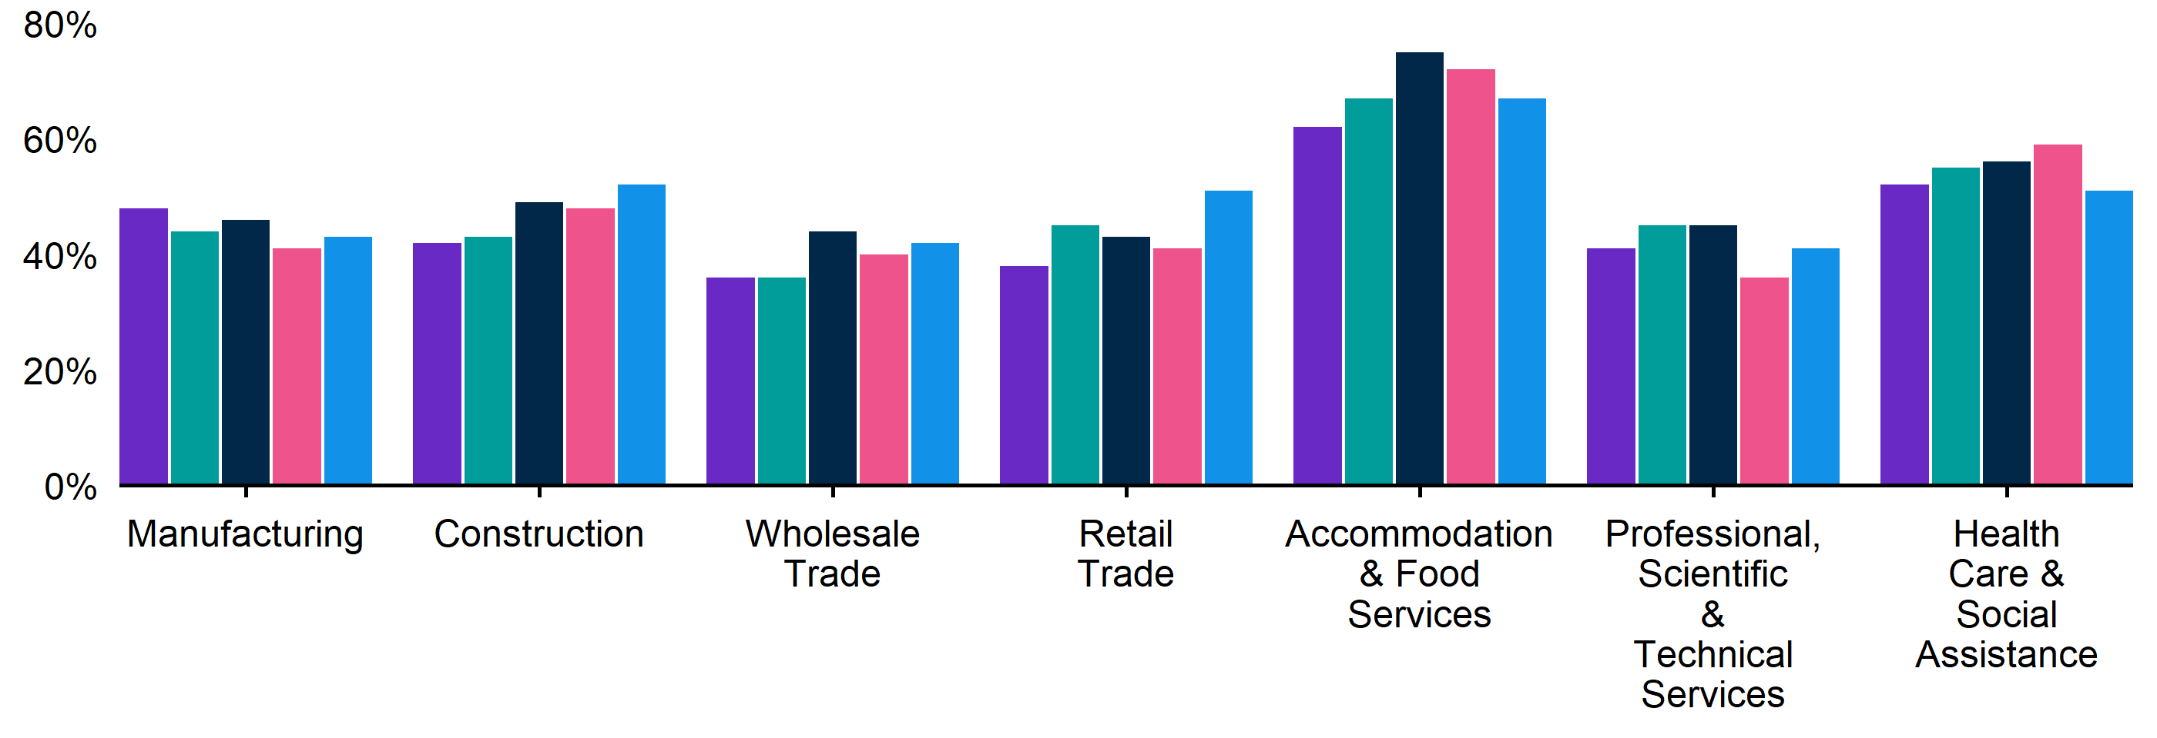

Figure 8. Recruitment difficulty rate by industry, March quarter 2025 - March quarter 2026

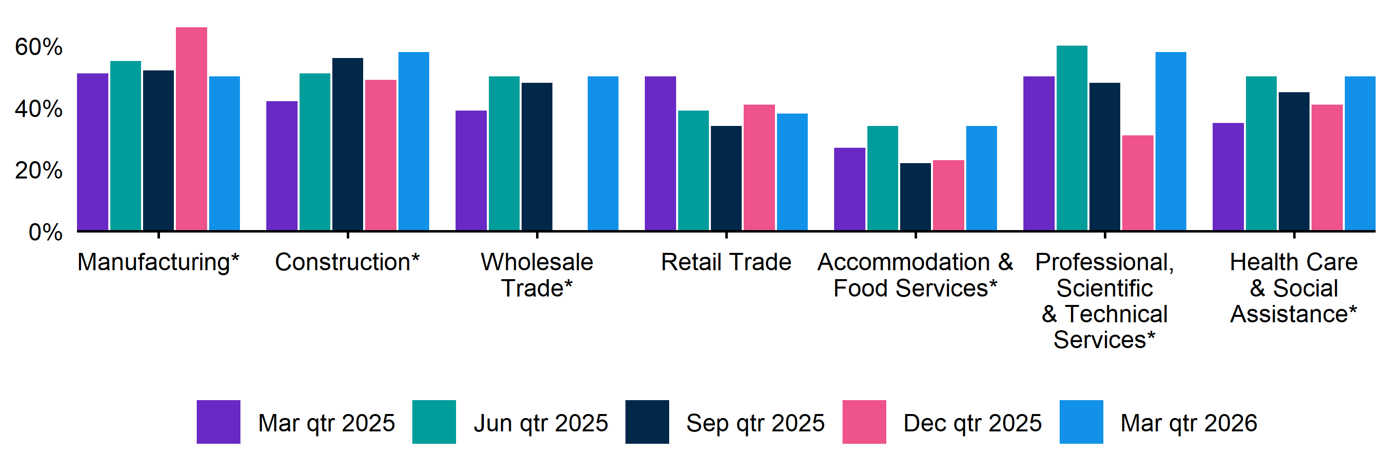Note: No data are shown for Wholesale Trade in the December quarter 2025 due to a small sample size.
Key indicators by selected occupation groups
In the March quarter 2026, Technicians and Trades Workers recorded the highest rate of recruitment difficulty (63%). At 59%, employers recruiting for Technicians and Trades Workers and Machinery Operators and Drivers both had the highest proportion of vacancies unfilled for longer than a month. These two occupation groups also experienced the highest difficulty levels, at 63% and 54%, respectively.

Table 4. Key indicators by occupation, March quarter 2026
 | Recruitment difficulty rate |  | Vacancies taking longer  than 1 month to fill
 | % of recruiting employers | Annual change  (% points) | % of recruiting employers | Annual change  (% points)
Professionals | 45%* | -6 pts* | 46%* | -6 pts*
Technicians and Trades Workers | 63% | 2 pts | 59% | 7 pts
Community and Personal Service Workers | 44% | 16 pts | 30%* | 14 pts*
Clerical and Administrative Workers | 38%* | 9 pts* | 30%* | 4 pts*
Sales Workers | 33% | 0 pts | 28% | 0 pts
Machinery Operators and Drivers | 54%* | 8 pts* | 59%* | 25 pts*
Labourers | 42%* | -3 pts* | 30%* | -7 pts*

* Interpret with caution due to low sample size.

Figure 9. Recruitment difficulty rate by occupation, March quarter 2025 - March quarter 2026
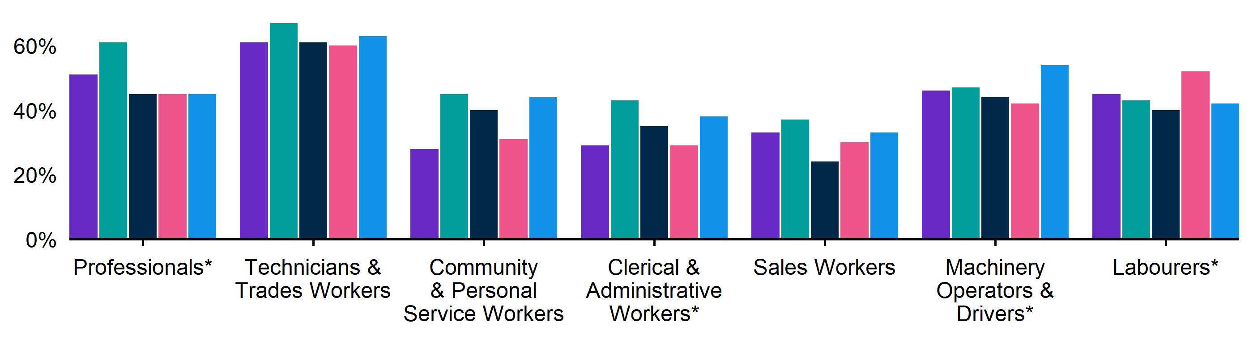

Figure 10. Vacancies taking longer than 1 month to fill, by occupation group, March quarter 2025 - March quarter 2026
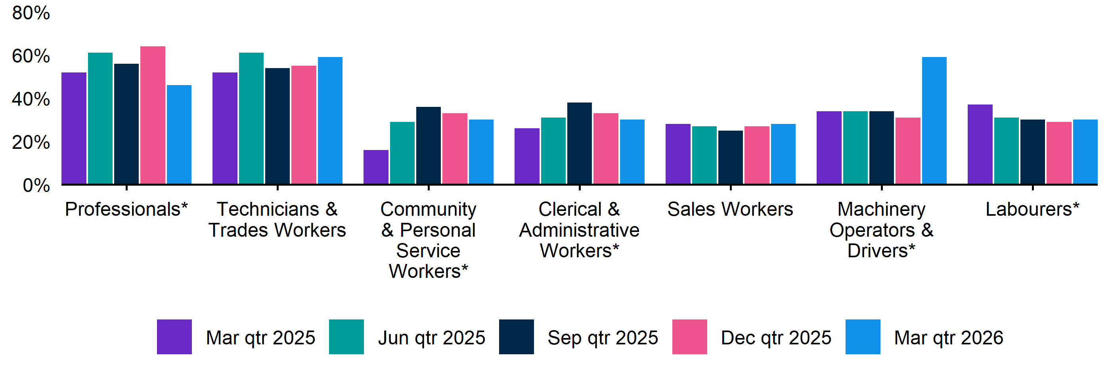

REOS Background and Notes
Jobs and Skills Australia conducts the Recruitment Experiences and Outlook Survey (REOS), a telephone administered survey of around 1,000 employers each month (except for December and January, during which fewer employers are surveyed). While the results are indicative of recruitment activity, they may be subject to seasonal factors and other volatility and should therefore be used with a degree of caution. In addition, the survey is targeted towards employers with 5 or more employees, and excludes many government organisations. More detail is available at https://www.jobsandskills.gov.au/work/reos-survey-methodology. REOS data are published on the Jobs and Skills Australia website.
Data in this release should be referenced as: Jobs and Skills Australia, Recruitment Experiences and Outlook Survey: March quarter 2026.

Data notations
* Interpret with caution due to low sample size.

Recruitment rate
The proportion of employers either currently recruiting or who had recruited in the previous month. It is calculated by dividing the number of employers who recruited or were attempting to recruit by the number of employers that responded to the survey (excluding ‘unsure’ responses).

Recruitment difficulty rate
The proportion of recruiting employers who experienced difficulty hiring staff. This indicator focusses on the most recent recruitment round in the month prior to being surveyed. The indicator is calculated as: employers who recruited and reported difficulty, divided by all employers who recruited (excluding ‘unsure’ responses).

Expectations to increase staffing levels over the next 3 months
This is calculated as the percentage of employers who expect to increase staff over the next 3 months, divided by all employers. Expectations to decrease staff is also collected.

Vacancies taking longer than 1 month to fill

The proportion of recruiting employers unable to fill all their vacancies within a month. It excludes employers with unfilled vacancies who have been recruiting for less than a month.

Recent REOS releases
The Jobs and Skills Australia website includes:
- The March 2026 monthly REOS report, including a more detailed excel datafile. The datafile includes both the monthly results as well as the quarterly series. The quarterly estimates are aggregated results for the 3 months within each quarter.
- REOS Spotlight series featuring analysis on topics of interest not covered in the regular monthly. Recent spotlight releases cover successful methods of recruitment, and entry level jobs across city, coastal, inland and remote regions.
For queries, contact: REOS@jobsandskills.gov.au

Australian Bureau of Statistics, Remoteness Areas, Australian Statistical Geography Standard (ASGS) Edition 3, https://www.abs.gov.au/statistics/standards/australian-statistical-geography-standard-asgs-edition-3/jul2021-jun2026/remoteness-structure/remoteness-areas

