REOS Recruitment Insights Report - March 2026
Jobs and Skills Australia surveys around 1000 employers each month through the Recruitment Experiences and Outlook Survey (REOS) to understand their recruitment experiences and staffing expectations.

Key Findings
Over the month to March 2026, a lower proportion of employers were recruiting. At the same time, a higher share reported having recruitment difficulty compared to both the previous month and the same time last year. This indicates that while fewer employers are actively recruiting, those that are actively recruiting are finding it harder to fill roles.
There was a fall in the proportion of employers expecting to increase their staff in the next three months, suggesting a more cautious approach to staffing expansion under the current conditions. Recruitment to fill ‘staff turnover positions only’ increased over the month and remained the primary reason for recruiting among surveyed employers.
In March 2026, the proportion of employers citing ‘costs’ as their single greatest business concern for the next three months increased by 9 percentage points, to 21% of all employers.

Recruitment activity
In March 2026, the recruitment rate was 48%. This was 3 percentage points lower than last month. Compared with a year earlier (March 2025), the recruitment rate decreased by 1 percentage point.
In Capital Cities, 47% of employers recruited in March 2026, compared with 51% in Rest of State areas. Over the month, the recruitment rate decreased by 1 percentage point in Capital Cities, and by 5 percentage points in Rest of State areas.
Compared to a year ago (March 2025), the recruitment rate declined by 1 percentage point in Capital Cities and by 2 percentage points in Rest of State areas.

Recruitment difficulty
The recruitment difficulty rate increased by 4 percentage points to 47% of recruiting employers in March 2026. Recruitment difficulty was 6 percentage points higher than a year ago and remained 28 percentage points below the record high of 75% in July 2022.
A lower proportion of recruiting employers experienced recruitment difficulty in Capital Cities (46%), compared with Rest of State areas (50%) in March 2026.
Over the month, recruitment difficulty increased by 5 percentage points in Capital Cities and was 5 percentage points higher than a year earlier (March 2025).
In Rest of State areas, recruitment difficulty increased by 3 percentage points over the month, 11 percentage points higher than in March 2025.

Staffing outlook: employers expecting to increase staff
Compared with a month ago, the proportion of employers expecting to increase their staffing numbers in the next three months decreased by 6 percentage points to 15% in March 2026. This was also 5 percentage points lower than a year earlier.
A lower proportion of employers in Capital Cities (14%) were expecting to increase their staffing levels in the next three months compared with Rest of State areas (16%).
Over the month, this proportion declined by 9 percentage points in Capital Cities and was 4 percentage points lower than a year ago. In Rest of State areas this figure fell by 1 percentage point over the month and was 8 percentage points lower than a year ago.

Reason for recruiting
Recruitment due to staff turnover only was the main reason employers recruited in March 2026, accounting for 61% of recruiting employers. Some 29% of recruiting employers aimed to fill new staff positions only, and the remaining 9% were recruiting to fill both new staff and staff turnover positions.

Staffing changes over the last month
Some 13% of employers increased their staff numbers in March 2026, compared with 18% at the same time last year. Meanwhile, around 11% of employers reported a decrease in their staff numbers over the month, compared with 12% of employers a year ago.

Employers unable to fill vacancies in a month
The proportion of recruiting employers who were unable to fill their vacancies within a month fell by 6 percentage points to 36% in March 2026, equal to its lowest level since the series started in May 2021. The March result was 1 percentage point lower than the 37% recorded in March 2025.

Single greatest concern
As part of the REOS, employers are asked about their current single greatest concern. Last month, 9% of employers cited costs as their single greatest concern and it ranked as the fifth highest concern. In March 2026, this proportion rose to 21%, making costs the highest-ranked concern, above the 19% recorded for recruitment and retention and the 17% recorded for lack of demand for their products or services.

REOS national indicators

Recruitment rate

Proportion of employers currently recruiting or who recruited in the previous month.
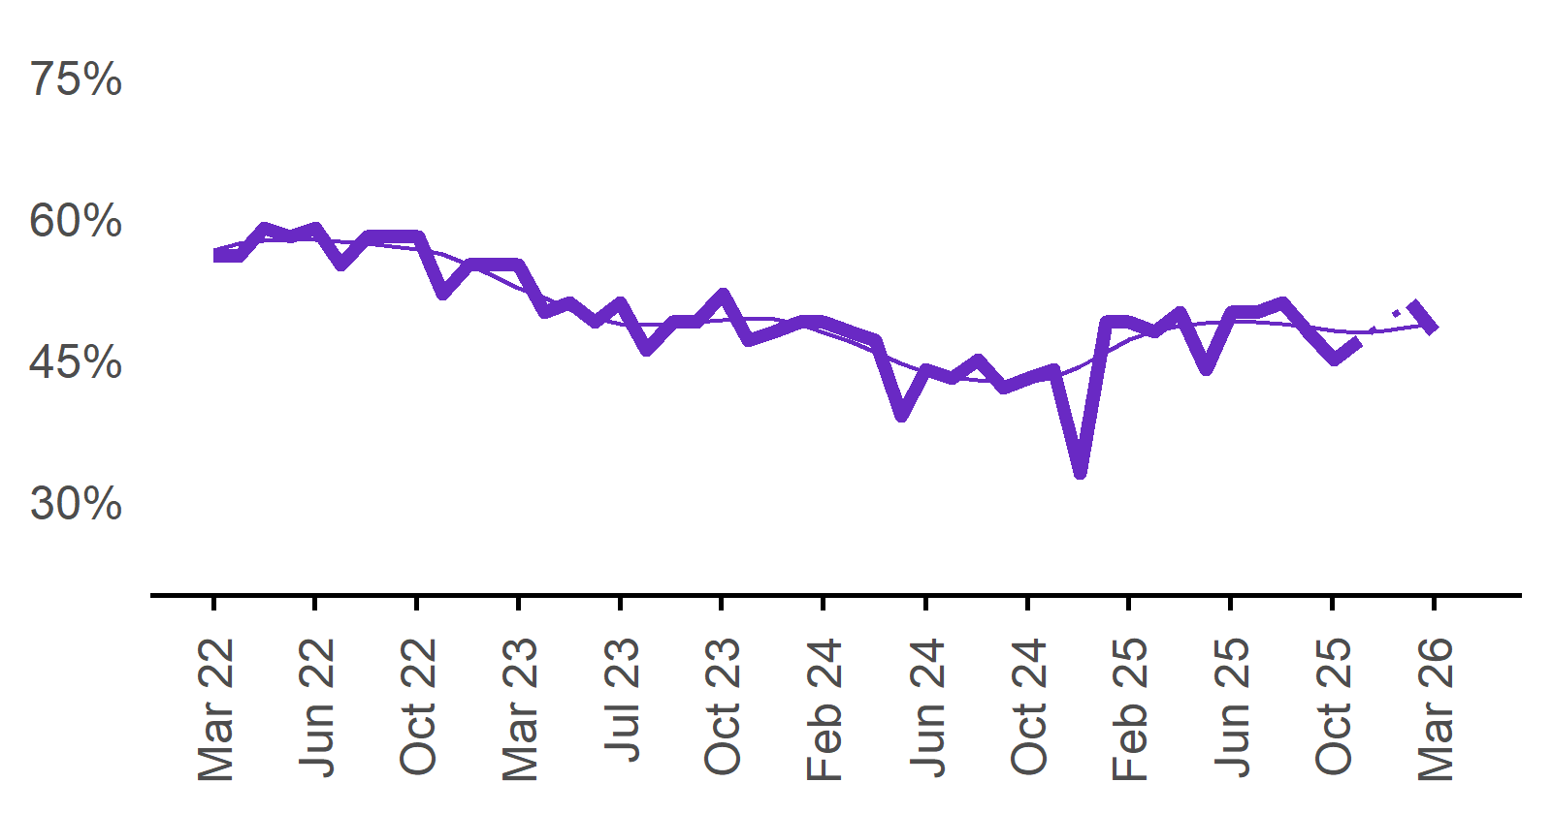 | 48%  Monthly change:  ▼ 3%pts  Annual change:  ▼ 1%pt
  Date | Recruitment rate | Smoothed recruitment rate
  Mar 2022 | 56% | 57%
  Apr 2022 | 56% | 57%
  May 2022 | 59% | 58%
  Jun 2022 | 58% | 58%
  Jul 2022 | 59% | 58%
  Aug 2022 | 55% | 58%
  Sep 2022 | 58% | 57%
  Oct 2022 | 58% | 57%
  Nov 2022 | 58% | 57%
  Dec 2022 | 52% | 56%
  Jan 2023 | 55% | 55%
  Feb 2023 | 55% | 54%
  Mar 2023 | 55% | 53%
  Apr 2023 | 50% | 52%
  May 2023 | 51% | 50%
  Jun 2023 | 49% | 49%
  Jul 2023 | 51% | 49%
  Aug 2023 | 46% | 49%
  Sep 2023 | 49% | 49%
  Oct 2023 | 49% | 49%
  Nov 2023 | 52% | 49%
  Dec 2023 | 47% | 49%
  Jan 2024 | 48% | 49%
  Feb 2024 | 49% | 49%
  Mar 2024 | 49% | 48%
  Apr 2024 | 48% | 47%
  May 2024 | 47% | 46%
  Jun 2024 | 39% | 45%
  Jul 2024 | 44% | 44%
  Aug 2024 | 43% | 43%
  Sep 2024 | 45% | 43%
  Oct 2024 | 42% | 43%
  Nov 2024 | 43% | 43%
  Dec 2024 | 44% | 43%
  Jan 2025 | 33% | 44%
  Feb 2025 | 49% | 46%
  Mar 2025 | 49% | 47%
  Apr 2025 | 48% | 48%
  May 2025 | 50% | 49%
  Jun 2025 | 44% | 49%
  Jul 2025 | 50% | 49%
  Aug 2025 | 50% | 49%
  Sep 2025 | 51% | 49%
  Oct 2025 | 48% | 48%
  Nov 2025 | 45% | 48%
  Dec 2025 | 47% | 48%
  Jan 2026 |  | 48%
  Feb 2026 | 51% | 48%
  Mar 2026 | 48% | 49%

Recruitment difficulty rate

Proportion of recruiting employers who stated they had difficulty hiring staff.
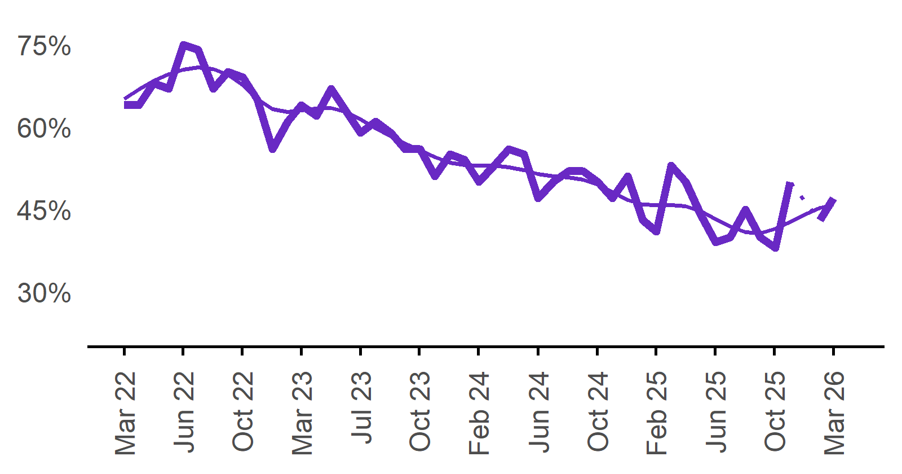 | 47%  Monthly change:  ▲ 4%pts  Annual change:  ▲ 6%pts
  Date | Recruitment difficulty rate | Smoothed recruitment difficulty rate
  Mar 2022 | 64% | 65%
  Apr 2022 | 64% | 67%
  May 2022 | 68% | 68%
  Jun 2022 | 67% | 70%
  Jul 2022 | 75% | 70%
  Aug 2022 | 74% | 71%
  Sep 2022 | 67% | 71%
  Oct 2022 | 70% | 69%
  Nov 2022 | 69% | 68%
  Dec 2022 | 65% | 65%
  Jan 2023 | 56% | 63%
  Feb 2023 | 61% | 63%
  Mar 2023 | 64% | 63%
  Apr 2023 | 62% | 63%
  May 2023 | 67% | 63%
  Jun 2023 | 63% | 63%
  Jul 2023 | 59% | 61%
  Aug 2023 | 61% | 60%
  Sep 2023 | 59% | 58%
  Oct 2023 | 56% | 57%
  Nov 2023 | 56% | 56%
  Dec 2023 | 51% | 55%
  Jan 2024 | 55% | 54%
  Feb 2024 | 54% | 53%
  Mar 2024 | 50% | 53%
  Apr 2024 | 53% | 53%
  May 2024 | 56% | 53%
  Jun 2024 | 55% | 52%
  Jul 2024 | 47% | 51%
  Aug 2024 | 50% | 51%
  Sep 2024 | 52% | 51%
  Oct 2024 | 52% | 50%
  Nov 2024 | 50% | 50%
  Dec 2024 | 47% | 48%
  Jan 2025 | 51% | 47%
  Feb 2025 | 43% | 46%
  Mar 2025 | 41% | 46%
  Apr 2025 | 53% | 46%
  May 2025 | 50% | 46%
  Jun 2025 | 44% | 45%
  Jul 2025 | 39% | 43%
  Aug 2025 | 40% | 42%
  Sep 2025 | 45% | 41%
  Oct 2025 | 40% | 41%
  Nov 2025 | 38% | 41%
  Dec 2025 | 50% | 43%
  Jan 2026 |  | 44%
  Feb 2026 | 43% | 45%
  Mar 2026 | 47% | 46%

Expecting to increase staff

Proportion of employers who expected to increase staffing numbers over the next three months.
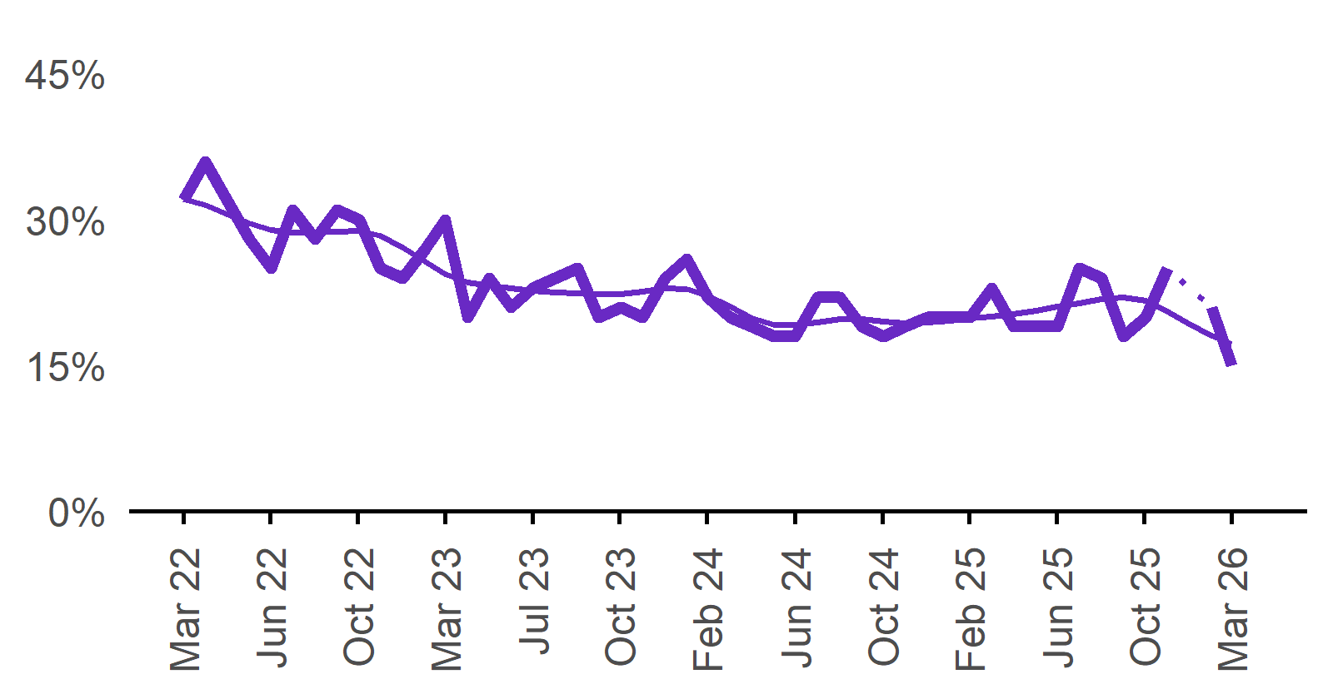 | 15%  Monthly change:  ▼ 6%pts  Annual change:  ▼ 5%pts
  Date | Expect to increase | Smoothed expect to increase
  Mar 2022 | 32% | 32%
  Apr 2022 | 36% | 31%
  May 2022 | 32% | 31%
  Jun 2022 | 28% | 30%
  Jul 2022 | 25% | 29%
  Aug 2022 | 31% | 29%
  Sep 2022 | 28% | 29%
  Oct 2022 | 31% | 29%
  Nov 2022 | 30% | 29%
  Dec 2022 | 25% | 28%
  Jan 2023 | 24% | 27%
  Feb 2023 | 27% | 26%
  Mar 2023 | 30% | 24%
  Apr 2023 | 20% | 24%
  May 2023 | 24% | 23%
  Jun 2023 | 21% | 23%
  Jul 2023 | 23% | 23%
  Aug 2023 | 24% | 23%
  Sep 2023 | 25% | 22%
  Oct 2023 | 20% | 22%
  Nov 2023 | 21% | 22%
  Dec 2023 | 20% | 23%
  Jan 2024 | 24% | 23%
  Feb 2024 | 26% | 23%
  Mar 2024 | 22% | 22%
  Apr 2024 | 20% | 21%
  May 2024 | 19% | 20%
  Jun 2024 | 18% | 19%
  Jul 2024 | 18% | 19%
  Aug 2024 | 22% | 19%
  Sep 2024 | 22% | 20%
  Oct 2024 | 19% | 20%
  Nov 2024 | 18% | 20%
  Dec 2024 | 19% | 19%
  Jan 2025 | 20% | 19%
  Feb 2025 | 20% | 20%
  Mar 2025 | 20% | 20%
  Apr 2025 | 23% | 20%
  May 2025 | 19% | 20%
  Jun 2025 | 19% | 21%
  Jul 2025 | 19% | 21%
  Aug 2025 | 25% | 21%
  Sep 2025 | 24% | 22%
  Oct 2025 | 18% | 22%
  Nov 2025 | 20% | 22%
  Dec 2025 | 25% | 21%
  Jan 2026 |  | 19%
  Feb 2026 | 21% | 18%
  Mar 2026 | 15% | 17%

Capital City/Rest of State areas

Recruitment rate

Proportion of employers currently recruiting or who recruited in the previous month.
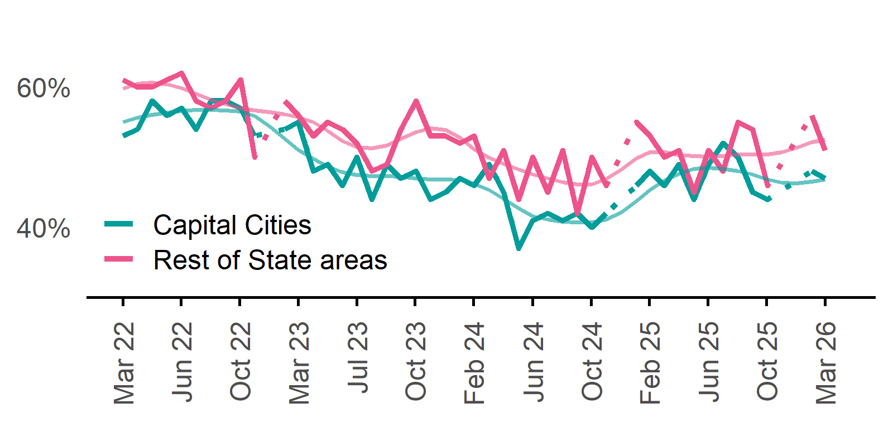 | Capital Cities: 47%  Monthly change:  ▼ 1%pt  Annual change:  ▼ 1%pt  Rest of State: 51%  Monthly change:  ▼ 5%pts  Annual change:  ▼ 2%pts
  Date | Capital Cities - Recruitment rate | Rest of State areas - Recruitment rate | Capital Cities - Smoothed recruitment rate | Rest of State areas - Smoothed recruitment rate
  Mar 2022 | 53% | 61% | 55% | 60%
  Apr 2022 | 54% | 60% | 56% | 61%
  May 2022 | 58% | 60% | 56% | 61%
  Jun 2022 | 56% | 61% | 56% | 60%
  Jul 2022 | 57% | 62% | 57% | 60%
  Aug 2022 | 54% | 58% | 57% | 59%
  Sep 2022 | 58% | 57% | 57% | 58%
  Oct 2022 | 58% | 58% | 57% | 58%
  Nov 2022 | 57% | 61% | 56% | 57%
  Dec 2022 | 53% | 50% | 56% | 57%
  Jan 2023 | n.p. | n.p. | 54% | 56%
  Feb 2023 | 54% | 58% | 53% | 56%
  Mar 2023 | 55% | 56% | 51% | 56%
  Apr 2023 | 48% | 53% | 50% | 55%
  May 2023 | 49% | 55% | 49% | 54%
  Jun 2023 | 46% | 54% | 48% | 52%
  Jul 2023 | 50% | 52% | 47% | 51%
  Aug 2023 | 44% | 48% | 47% | 51%
  Sep 2023 | 49% | 49% | 47% | 52%
  Oct 2023 | 47% | 54% | 47% | 53%
  Nov 2023 | 48% | 58% | 47% | 54%
  Dec 2023 | 44% | 53% | 47% | 54%
  Jan 2024 | 45% | 53% | 47% | 54%
  Feb 2024 | 47% | 52% | 47% | 53%
  Mar 2024 | 46% | 53% | 46% | 51%
  Apr 2024 | 49% | 47% | 45% | 50%
  May 2024 | 45% | 51% | 44% | 49%
  Jun 2024 | 37% | 44% | 43% | 48%
  Jul 2024 | 41% | 50% | 42% | 48%
  Aug 2024 | 42% | 45% | 41% | 47%
  Sep 2024 | 41% | 51% | 41% | 46%
  Oct 2024 | 42% | 42% | 41% | 46%
  Nov 2024 | 40% | 50% | 41% | 46%
  Dec 2024 | 42% | 46% | 41% | 47%
  Jan 2025 | n.p. | n.p. | 42% | 48%
  Feb 2025 | 46% | 55% | 44% | 50%
  Mar 2025 | 48% | 53% | 45% | 51%
  Apr 2025 | 46% | 50% | 47% | 51%
  May 2025 | 49% | 51% | 48% | 50%
  Jun 2025 | 44% | 45% | 48% | 50%
  Jul 2025 | 49% | 51% | 48% | 50%
  Aug 2025 | 52% | 48% | 48% | 50%
  Sep 2025 | 50% | 55% | 48% | 50%
  Oct 2025 | 45% | 54% | 48% | 50%
  Nov 2025 | 44% | 46% | 47% | 50%
  Dec 2025 | n.p. | n.p. | 46% | 51%
  Jan 2026 |  |  | 46% | 51%
  Feb 2026 | 48% | 56% | 47% | 52%
  Mar 2026 | 47% | 51% | 47% | 52%

Recruitment difficulty rate

Proportion of recruiting employers who stated they had difficulty hiring staff.
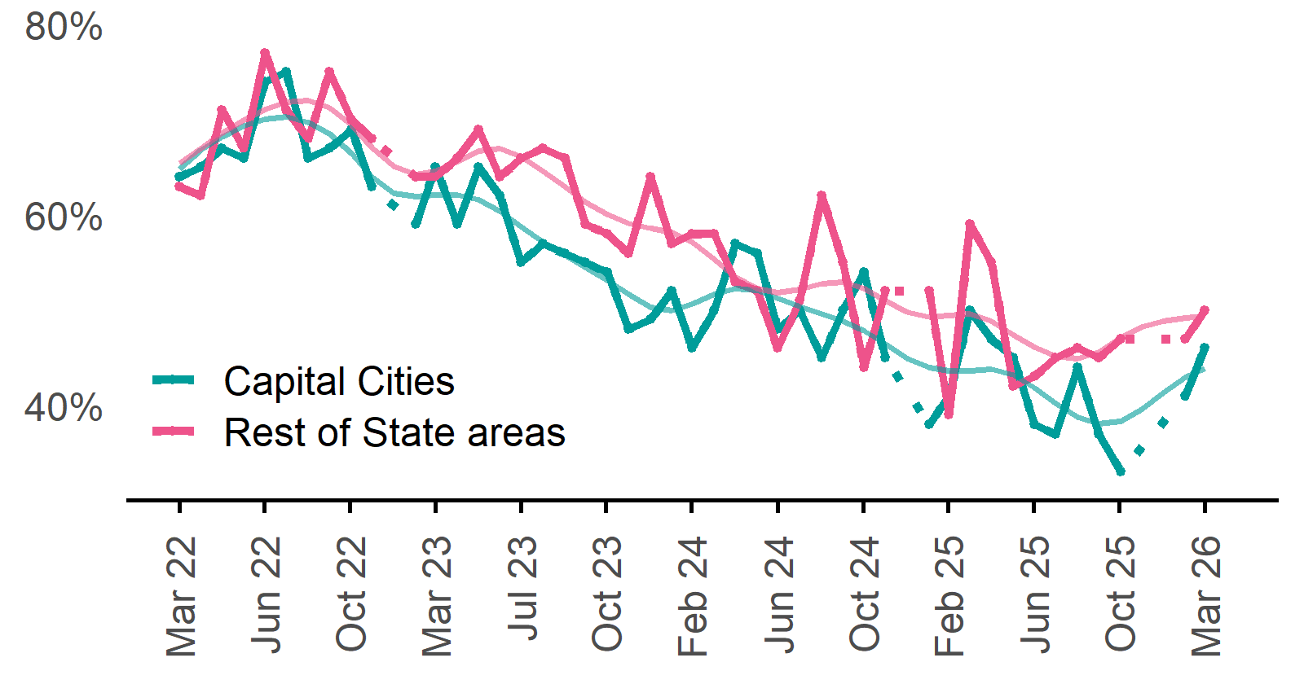 | Capital Cities: 46%  Monthly change:  ▲ 5%pts  Annual change:  ▲ 5%pts  Rest of State: 50%  Monthly change:  ▲ 3%pts  Annual change:  ▲ 11%pts
  Date | Capital Cities - Recruitment difficulty rate | Rest of State areas - Recruitment difficulty rate | Capital Cities - Smoothed recruitment difficulty rate | Rest of State areas - Smoothed recruitment difficulty rate
  Mar 2022 | 64% | 63% | 65% | 65%
  Apr 2022 | 65% | 62% | 67% | 67%
  May 2022 | 67% | 71% | 68% | 69%
  Jun 2022 | 66% | 67% | 69% | 70%
  Jul 2022 | 74% | 77% | 70% | 71%
  Aug 2022 | 75% | 71% | 70% | 72%
  Sep 2022 | 66% | 68% | 70% | 72%
  Oct 2022 | 67% | 75% | 69% | 71%
  Nov 2022 | 69% | 70% | 66% | 69%
  Dec 2022 | 63% | 68% | 64% | 67%
  Jan 2023 | n.p. | n.p. | 62% | 65%
  Feb 2023 | 59% | 64% | 62% | 64%
  Mar 2023 | 65% | 64% | 62% | 65%
  Apr 2023 | 59% | 66% | 62% | 66%
  May 2023 | 65% | 69% | 62% | 67%
  Jun 2023 | 62% | 64% | 60% | 67%
  Jul 2023 | 55% | 66% | 59% | 66%
  Aug 2023 | 57% | 67% | 57% | 65%
  Sep 2023 | 56% | 66% | 56% | 63%
  Oct 2023 | 55% | 59% | 55% | 61%
  Nov 2023 | 54% | 58% | 53% | 60%
  Dec 2023 | 48% | 56% | 52% | 59%
  Jan 2024 | 49% | 64% | 50% | 59%
  Feb 2024 | 52% | 57% | 50% | 58%
  Mar 2024 | 46% | 58% | 51% | 57%
  Apr 2024 | 50% | 58% | 52% | 55%
  May 2024 | 57% | 53% | 52% | 53%
  Jun 2024 | 56% | 52% | 52% | 52%
  Jul 2024 | 48% | 46% | 51% | 52%
  Aug 2024 | 50% | 51% | 50% | 52%
  Sep 2024 | 45% | 62% | 50% | 53%
  Oct 2024 | 50% | 55% | 49% | 53%
  Nov 2024 | 54% | 44% | 48% | 52%
  Dec 2024 | 45% | 52% | 46% | 51%
  Jan 2025 | n.p. | n.p. | 45% | 50%
  Feb 2025 | 38% | 52% | 44% | 49%
  Mar 2025 | 41% | 39% | 44% | 49%
  Apr 2025 | 50% | 59% | 44% | 50%
  May 2025 | 47% | 55% | 44% | 49%
  Jun 2025 | 45% | 42% | 43% | 47%
  Jul 2025 | 38% | 43% | 42% | 46%
  Aug 2025 | 37% | 45% | 40% | 45%
  Sep 2025 | 44% | 46% | 39% | 45%
  Oct 2025 | 37% | 45% | 38% | 46%
  Nov 2025 | 33% | 47% | 38% | 47%
  Dec 2025 | n.p. | n.p. | 40% | 48%
  Jan 2026 |  |  | 41% | 49%
  Feb 2026 | 41% | 47% | 43% | 49%
  Mar 2026 | 46% | 50% | 44% | 49%

Staffing outlook – Expecting to increase staff

Proportion of employers who expected to increase staffing numbers over the next three months.
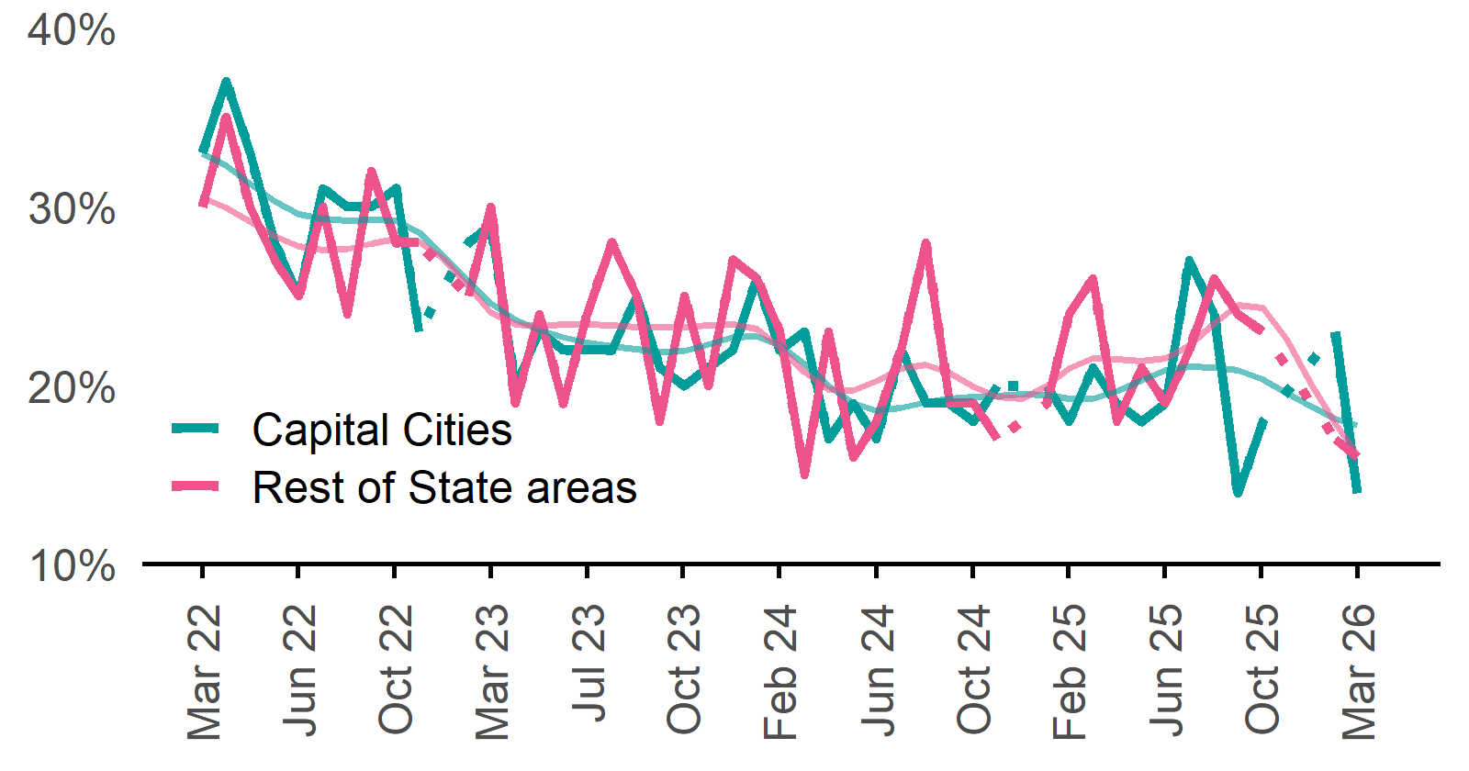 | Capital Cities: 14%  Monthly change:  ▼ 9%pts  Annual change:  ▼ 4%pts  Rest of State: 16%  Monthly change:  ▼ 1%pt  Annual change:  ▼ 8%pts
  Date | Capital Cities - % expecting to increase | Rest of State areas - % expecting to increase | Capital Cities - Smoothed % expecting to increase | Rest of State areas - Smoothed % expecting to increase
  Mar 2022 | 33% | 30% | 33% | 30%
  Apr 2022 | 37% | 35% | 32% | 30%
  May 2022 | 33% | 30% | 31% | 29%
  Jun 2022 | 28% | 27% | 30% | 28%
  Jul 2022 | 25% | 25% | 30% | 28%
  Aug 2022 | 31% | 30% | 29% | 28%
  Sep 2022 | 30% | 24% | 29% | 28%
  Oct 2022 | 30% | 32% | 29% | 28%
  Nov 2022 | 31% | 28% | 29% | 28%
  Dec 2022 | 23% | 28% | 29% | 28%
  Jan 2023 | n.p. | n.p. | 27% | 27%
  Feb 2023 | 28% | 25% | 26% | 26%
  Mar 2023 | 29% | 30% | 25% | 24%
  Apr 2023 | 20% | 19% | 24% | 23%
  May 2023 | 23% | 24% | 23% | 23%
  Jun 2023 | 22% | 19% | 23% | 23%
  Jul 2023 | 22% | 24% | 22% | 23%
  Aug 2023 | 22% | 28% | 22% | 23%
  Sep 2023 | 25% | 25% | 22% | 23%
  Oct 2023 | 21% | 18% | 22% | 23%
  Nov 2023 | 20% | 25% | 22% | 23%
  Dec 2023 | 21% | 20% | 22% | 23%
  Jan 2024 | 22% | 27% | 23% | 23%
  Feb 2024 | 26% | 26% | 23% | 23%
  Mar 2024 | 22% | 23% | 22% | 22%
  Apr 2024 | 23% | 15% | 21% | 21%
  May 2024 | 17% | 23% | 20% | 20%
  Jun 2024 | 19% | 16% | 19% | 20%
  Jul 2024 | 17% | 18% | 19% | 20%
  Aug 2024 | 22% | 22% | 19% | 21%
  Sep 2024 | 19% | 28% | 19% | 21%
  Oct 2024 | 19% | 19% | 19% | 21%
  Nov 2024 | 18% | 19% | 19% | 20%
  Dec 2024 | 20% | 17% | 19% | 19%
  Jan 2025 | n.p. | n.p. | 20% | 19%
  Feb 2025 | 20% | 19% | 19% | 20%
  Mar 2025 | 18% | 24% | 19% | 21%
  Apr 2025 | 21% | 26% | 19% | 22%
  May 2025 | 19% | 18% | 20% | 21%
  Jun 2025 | 18% | 21% | 20% | 21%
  Jul 2025 | 19% | 19% | 21% | 22%
  Aug 2025 | 27% | 22% | 21% | 22%
  Sep 2025 | 24% | 26% | 21% | 23%
  Oct 2025 | 14% | 24% | 21% | 25%
  Nov 2025 | 18% | 23% | 20% | 24%
  Dec 2025 | n.p. | n.p. | 20% | 23%
  Jan 2026 |  |  | 19% | 20%
  Feb 2026 | 23% | 17% | 18% | 18%
  Mar 2026 | 14% | 16% | 18% | 16%

Other recruitment indicators

Reason for recruiting

Proportion of employers currently recruiting or who recruited in the previous month.
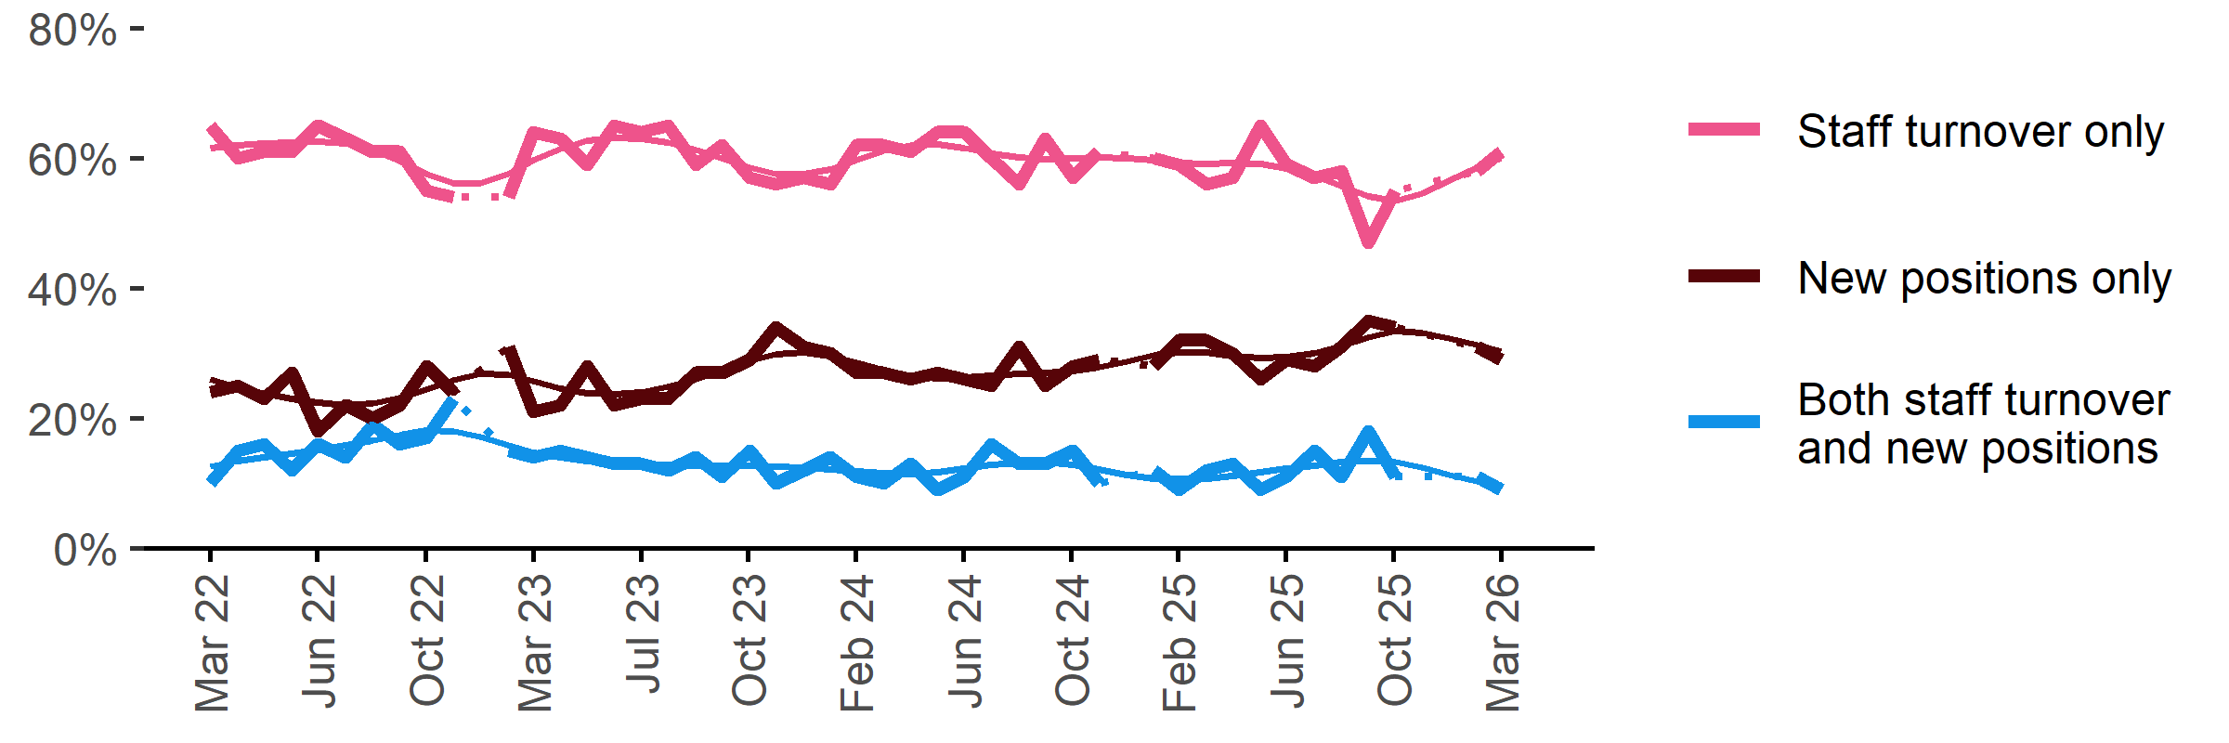
Date | Staff turnover only | Staff turnover and new positions | New positions only | Smoothed - staff turnover only | Smoothed - staff turnover and new positions | Smoothed - new positions only
Mar 2022 | 65% | 10% | 24% | 62% | 13% | 26%
Apr 2022 | 60% | 15% | 25% | 62% | 13% | 25%
May 2022 | 61% | 16% | 23% | 62% | 14% | 24%
Jun 2022 | 61% | 12% | 27% | 62% | 15% | 23%
Jul 2022 | 65% | 16% | 18% | 63% | 15% | 22%
Aug 2022 | 63% | 14% | 22% | 62% | 16% | 22%
Sep 2022 | 61% | 19% | 20% | 61% | 17% | 22%
Oct 2022 | 61% | 16% | 22% | 60% | 17% | 23%
Nov 2022 | 55% | 17% | 28% | 58% | 18% | 24%
Dec 2022 | 54% | 23% | 24% | 56% | 18% | 26%
Jan 2023 | n.p. | n.p. | n.p. | 56% | 17% | 27%
Feb 2023 | 54% | 15% | 31% | 58% | 16% | 27%
Mar 2023 | 64% | 14% | 21% | 60% | 15% | 26%
Apr 2023 | 63% | 15% | 22% | 61% | 14% | 25%
May 2023 | 59% | 14% | 28% | 63% | 13% | 24%
Jun 2023 | 65% | 13% | 22% | 63% | 13% | 24%
Jul 2023 | 64% | 13% | 23% | 63% | 13% | 24%
Aug 2023 | 65% | 12% | 23% | 62% | 13% | 25%
Sep 2023 | 59% | 14% | 27% | 61% | 13% | 26%
Oct 2023 | 62% | 11% | 27% | 60% | 13% | 27%
Nov 2023 | 57% | 15% | 29% | 59% | 13% | 29%
Dec 2023 | 56% | 10% | 34% | 58% | 13% | 30%
Jan 2024 | 57% | 12% | 31% | 57% | 12% | 30%
Feb 2024 | 56% | 14% | 30% | 58% | 12% | 30%
Mar 2024 | 62% | 11% | 27% | 60% | 12% | 28%
Apr 2024 | 62% | 10% | 27% | 61% | 12% | 27%
May 2024 | 61% | 13% | 26% | 62% | 11% | 27%
Jun 2024 | 64% | 9% | 27% | 62% | 12% | 26%
Jul 2024 | 64% | 11% | 26% | 62% | 12% | 26%
Aug 2024 | 60% | 16% | 25% | 61% | 13% | 27%
Sep 2024 | 56% | 13% | 31% | 60% | 13% | 27%
Oct 2024 | 63% | 13% | 25% | 60% | 13% | 27%
Nov 2024 | 57% | 15% | 28% | 60% | 13% | 27%
Dec 2024 | 61% | 10% | 29% | 60% | 12% | 28%
Jan 2025 | n.p. | n.p. | n.p. | 60% | 11% | 29%
Feb 2025 | 60% | 12% | 28% | 60% | 11% | 30%
Mar 2025 | 59% | 9% | 32% | 59% | 11% | 30%
Apr 2025 | 56% | 12% | 32% | 59% | 11% | 30%
May 2025 | 57% | 13% | 30% | 59% | 11% | 30%
Jun 2025 | 65% | 9% | 26% | 59% | 12% | 29%
Jul 2025 | 59% | 11% | 29% | 58% | 12% | 29%
Aug 2025 | 57% | 15% | 28% | 57% | 13% | 30%
Sep 2025 | 58% | 11% | 31% | 56% | 13% | 31%
Oct 2025 | 47% | 18% | 35% | 54% | 13% | 32%
Nov 2025 | 55% | 11% | 34% | 53% | 13% | 33%
Dec 2025 | n.p. | n.p. | n.p. | 54% | 12% | 33%
Jan 2026 |  |  |  | 57% | 11% | 32%
Feb 2026 | 58% | 11% | 31% | 59% | 10% | 31%
Mar 2026 | 61% | 9% | 29% | 60% | 10% | 30%

Staffing changes over the last month

Proportion of employers who said they increased or decreased staffing compared to the previous month.
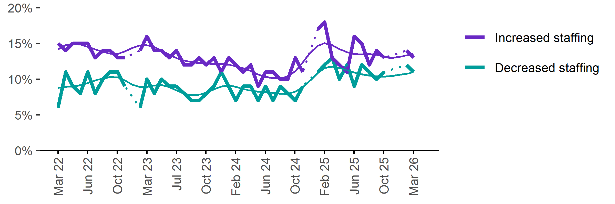
Date | Increased staff | Decreased staff | Smoothed - increased staff | Smoothed - decreased staff
Mar 2022 | 15% | 6% | 14% | 9%
Apr 2022 | 14% | 11% | 15% | 9%
May 2022 | 15% | 9% | 15% | 9%
Jun 2022 | 15% | 8% | 15% | 9%
Jul 2022 | 15% | 11% | 15% | 9%
Aug 2022 | 13% | 8% | 14% | 10%
Sep 2022 | 14% | 10% | 14% | 10%
Oct 2022 | 14% | 11% | 14% | 10%
Nov 2022 | 13% | 11% | 14% | 10%
Dec 2022 | 13% | 9% | 14% | 10%
Jan 2023 | n.p. | n.p. | 14% | 9%
Feb 2023 | 14% | 6% | 15% | 9%
Mar 2023 | 16% | 10% | 15% | 9%
Apr 2023 | 14% | 8% | 14% | 9%
May 2023 | 14% | 10% | 14% | 9%
Jun 2023 | 13% | 9% | 13% | 9%
Jul 2023 | 14% | 9% | 13% | 8%
Aug 2023 | 12% | 8% | 13% | 8%
Sep 2023 | 12% | 7% | 12% | 8%
Oct 2023 | 13% | 7% | 12% | 8%
Nov 2023 | 12% | 8% | 12% | 8%
Dec 2023 | 13% | 9% | 12% | 9%
Jan 2024 | 11% | 11% | 12% | 9%
Feb 2024 | 13% | 9% | 12% | 9%
Mar 2024 | 12% | 7% | 12% | 9%
Apr 2024 | 11% | 9% | 12% | 9%
May 2024 | 12% | 9% | 11% | 8%
Jun 2024 | 9% | 7% | 11% | 8%
Jul 2024 | 11% | 9% | 10% | 8%
Aug 2024 | 11% | 7% | 10% | 8%
Sep 2024 | 10% | 9% | 10% | 8%
Oct 2024 | 10% | 8% | 10% | 8%
Nov 2024 | 13% | 7% | 11% | 8%
Dec 2024 | 11% | 9% | 12% | 9%
Jan 2025 | n.p. | n.p. | 14% | 10%
Feb 2025 | 17% | 11% | 15% | 11%
Mar 2025 | 18% | 12% | 15% | 12%
Apr 2025 | 13% | 13% | 15% | 12%
May 2025 | 12% | 10% | 14% | 12%
Jun 2025 | 11% | 12% | 14% | 11%
Jul 2025 | 16% | 9% | 14% | 11%
Aug 2025 | 15% | 12% | 13% | 11%
Sep 2025 | 12% | 11% | 14% | 10%
Oct 2025 | 14% | 10% | 13% | 10%
Nov 2025 | 13% | 11% | 13% | 10%
Dec 2025 | n.p. | n.p. | 13% | 10%
Jan 2026 |  |  | 13% | 11%
Feb 2026 | 14% | 12% | 13% | 11%
Mar 2026 | 13% | 11% | 14% | 11%

Employers unable to fill vacancies within a month

Proportion of recruiting employers who were unable to fill their vacancies within a month.*
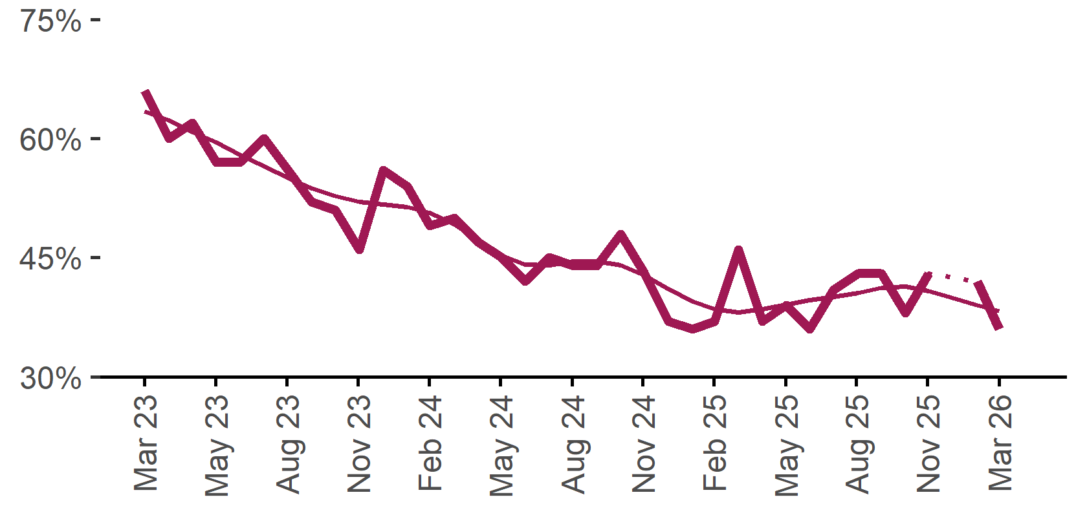 | 36%  Monthly change:  ▼ 6%pts  Annual change:  ▼ 1%pt
  Date | % unable to fill vacancies in a month | Smoothed - % unable to fill vacancies in a month
  Mar 2023 | 66% | 63%
  Apr 2023 | 60% | 62%
  May 2023 | 62% | 61%
  Jun 2023 | 57% | 60%
  Jul 2023 | 57% | 58%
  Aug 2023 | 60% | 56%
  Sep 2023 | 56% | 55%
  Oct 2023 | 52% | 54%
  Nov 2023 | 51% | 53%
  Dec 2023 | 46% | 52%
  Jan 2024 | 56% | 52%
  Feb 2024 | 54% | 51%
  Mar 2024 | 49% | 51%
  Apr 2024 | 50% | 49%
  May 2024 | 47% | 47%
  Jun 2024 | 45% | 45%
  Jul 2024 | 42% | 44%
  Aug 2024 | 45% | 44%
  Sep 2024 | 44% | 45%
  Oct 2024 | 44% | 45%
  Nov 2024 | 48% | 44%
  Dec 2024 | 43% | 43%
  Jan 2025 | 37% | 41%
  Feb 2025 | 36% | 40%
  Mar 2025 | 37% | 38%
  Apr 2025 | 46% | 38%
  May 2025 | 37% | 38%
  Jun 2025 | 39% | 39%
  Jul 2025 | 36% | 40%
  Aug 2025 | 41% | 40%
  Sep 2025 | 43% | 41%
  Oct 2025 | 43% | 41%
  Nov 2025 | 38% | 41%
  Dec 2025 | 43% | 41%
  Jan 2026 |  | 40%
  Feb 2026 | 42% | 39%
  Mar 2026 | 36% | 38%

* Excludes employers who have been recruiting for less than a month.

Background
Jobs and Skills Australia (JSA) conducts the Recruitment Experiences and Outlook Survey (REOS), a telephone administered survey with the business owner or other person in the business responsible for recruitment. Around 1000 employers are surveyed each month, with data published on the JSA website. While the data are indicative of recruitment activity, they may be subject to seasonal factors and other volatility and should therefore be used with a degree of caution. In addition, the survey is targeted towards employers with 5 or more employees and excludes many government organisations. Details of the survey methodology can be accessed from the JSA website.

Smoothed series in charts
Charts include Henderson-smoothed lines in addition to original data for most of our recruitment indicators. As the timeseries is not yet long enough for seasonal adjustment, a Henderson smoothed moving average with a 13-term filter (equating to 13 months) has been directly applied to the original series. This provides an indication of the general movement in each recruitment indicator relative to previous months. Due to using 13 months in the moving average, results for the most recent six months will be revised each month.

How to reference data from this report
Jobs and Skills Australia, Recruitment Insights Report, March 2026.

Contact us
For additional information, email REOS@jobsandskills.gov.au

Also available from the REOS

Data file with monthly and quarterly recruitment indicators
A REOS data file is available on the JSA website. Breakdowns by Capital City/Rest of State area, Business size, and ANZSCO Skill Level are included in the monthly results. Quarterly recruitment indicators provide detail by state, ARIA (ABS’ Accessibility and Remoteness Index of Australia) as well as selected industry and occupation groups.
Next Recruitment Insights Report release:
- April 2026 Recruitment Insights Report – May 2026

Stay up to date
JSA also releases semi-regular reports including spotlight articles, detailing aspects of the REOS that cannot be included in our monthly Recruitment Insights Report. Sign up and get the Recruitment Insights Report notifications sent straight to your inbox.
Upcoming spotlight:
- Recruitment experiences and outlook survey – March quarter 2026 results - April 2026
Recent spotlights:
- Employer attitudes toward disability inclusion in the Australian workforce – March 2026

A Henderson smoothed line has been included in the charts to reduce month to month volatility and illustrate long term patterns. See the explanatory note for more information.
Data are not available for January in some years. Data points have been joined by a dotted line between December and February to reflect this. ‘Rest of State’ refers to areas outside the capital cities.

