REOS Recruitment Insights Report - February 2026
Jobs and Skills Australia surveys around 1000 employers in the Recruitment Experiences and Outlook Survey (REOS) each month to find out their experiences recruiting staff, and whether they are expecting to increase staffing levels.
Due to operational reasons, no interviewing was undertaken in January 2026.

Key Findings
Recruitment activity has strengthened (up by 4 percentage points) while recruitment difficulty has eased (down by 7 percentage points) since the end of 2025. Over the same period, optimism about staffing eased, with the share of employers anticipating an increasing in staffing levels falling by 4 percentage points.
In smoothed terms, recruitment activity has been largely flat since mid-2025, and recruitment difficult appears to have stopped declining. There has been only slight movement in future staffing optimism over recent months. This has occurred against a backdrop of resilient labour market conditions. While employment is at a historical high, annual employment growth is below the decade average. The unemployment rate remains low and is at the same level as a year earlier. Online job advertisements remain at elevated levels in January 2026 but are slightly lower than a year earlier.

Recruitment activity
In February 2026, the recruitment rate was 51%. Compared with a year ago, the recruitment rate has increased by 2 percentage points. In the Capital Cities, 48% of employers recruited in February 2026, up by 2 percentage points over the year. In Rest of State areas, the recruitment rate was higher, at 56%, up by 1 percentage point over the year.

Recruitment difficulty
The recruitment difficulty rate was unchanged over the year to stand at 43% in February 2026. A lower proportion of recruiting employers experienced recruitment difficulty in the Capital Cities areas (41%), compared with Rest of State areas (47%).
Compared with February 2025, recruitment difficulty in Capital Cities was 3 percentage points higher, while it decreased by 5 percentage points in Rest of State areas over the same period.

Staffing outlook: employers expecting to increase staff
In February 2026, 21% of employers expected to increase their staffing numbers in the next three months, 1 percentage point higher than a year earlier. A higher proportion of employers in Capital Cities (23%) expected to increase their staffing levels in the next three months compared with Rest of State areas (17%). Over the year, this proportion increased by 3 percentage points in Capital Cities, while it decreased by 2 percentage points in Rest of State areas.

Reason for recruiting
Recruitment due to staff turnover only was the main reason employers recruited in February 2026, accounting for 58% of recruiting employers. Some 31% of recruiting employers aimed to fill new staff positions only, and the remaining 11% recruited to fill both new staff and staff turnover positions.

Staffing changes over the last month
In February 2026, some 14% of employers increased their staff, down from 17% at the same time last year. Over the month, 12% of employers reported a decrease in their staff numbers, compared with 11% a year ago.

Employers unable to fill vacancies in a month
The proportion of recruiting employers who were unable to fill their vacancies within a month stood at 42% in February 2026. This figure is 6 percentage points higher than the 36% recorded in February 2025.

REOS national indicators

Recruitment rate

Proportion of employers currently recruiting or who recruited in the previous month.
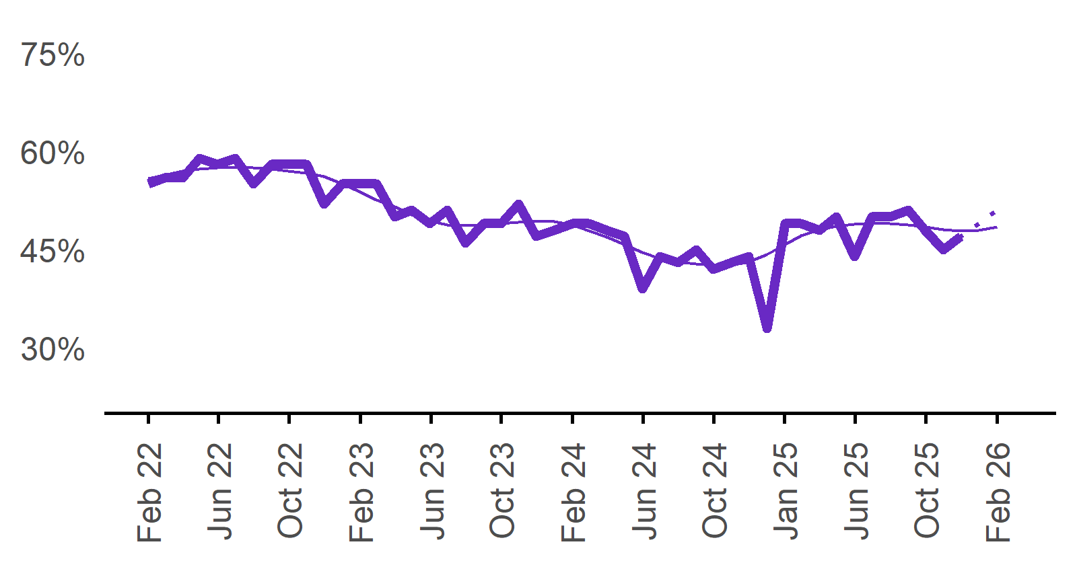 | 51%  Annual change:  ▲ 2%pts
  Date | Recruitment rate | Smoothed recruitment rate
  Feb 2022 | 55% | 55%
  Mar 2022 | 56% | 57%
  Apr 2022 | 56% | 57%
  May 2022 | 59% | 58%
  Jun 2022 | 58% | 58%
  Jul 2022 | 59% | 58%
  Aug 2022 | 55% | 58%
  Sep 2022 | 58% | 57%
  Oct 2022 | 58% | 57%
  Nov 2022 | 58% | 57%
  Dec 2022 | 52% | 56%
  Jan 2023 | 55% | 55%
  Feb 2023 | 55% | 54%
  Mar 2023 | 55% | 53%
  Apr 2023 | 50% | 52%
  May 2023 | 51% | 50%
  Jun 2023 | 49% | 49%
  Jul 2023 | 51% | 49%
  Aug 2023 | 46% | 49%
  Sep 2023 | 49% | 49%
  Oct 2023 | 49% | 49%
  Nov 2023 | 52% | 49%
  Dec 2023 | 47% | 49%
  Jan 2024 | 48% | 49%
  Feb 2024 | 49% | 49%
  Mar 2024 | 49% | 48%
  Apr 2024 | 48% | 47%
  May 2024 | 47% | 46%
  Jun 2024 | 39% | 45%
  Jul 2024 | 44% | 44%
  Aug 2024 | 43% | 43%
  Sep 2024 | 45% | 43%
  Oct 2024 | 42% | 43%
  Nov 2024 | 43% | 43%
  Dec 2024 | 44% | 43%
  Jan 2025 | 33% | 44%
  Feb 2025 | 49% | 46%
  Mar 2025 | 49% | 47%
  Apr 2025 | 48% | 48%
  May 2025 | 50% | 49%
  Jun 2025 | 44% | 49%
  Jul 2025 | 50% | 49%
  Aug 2025 | 50% | 49%
  Sep 2025 | 51% | 49%
  Oct 2025 | 48% | 48%
  Nov 2025 | 45% | 48%
  Dec 2025 | 47% | 48%
  Jan 2026 |  | 48%
  Feb 2026 | 51% | 49%

Recruitment difficulty rate

Proportion of recruiting employers who stated they had difficulty hiring staff.
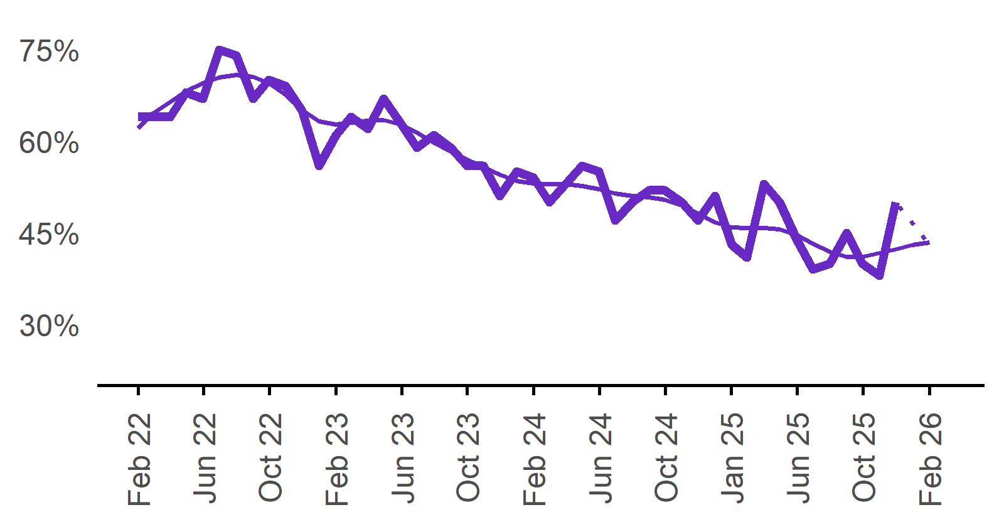 | 43%  Annual change:  0%pts
  Date | Recruitment difficulty rate | Smoothed recruitment difficulty rate
  Feb 2022 | 64% | 63%
  Mar 2022 | 64% | 65%
  Apr 2022 | 64% | 67%
  May 2022 | 68% | 68%
  Jun 2022 | 67% | 70%
  Jul 2022 | 75% | 70%
  Aug 2022 | 74% | 71%
  Sep 2022 | 67% | 71%
  Oct 2022 | 70% | 69%
  Nov 2022 | 69% | 68%
  Dec 2022 | 65% | 65%
  Jan 2023 | 56% | 63%
  Feb 2023 | 61% | 63%
  Mar 2023 | 64% | 63%
  Apr 2023 | 62% | 63%
  May 2023 | 67% | 63%
  Jun 2023 | 63% | 63%
  Jul 2023 | 59% | 61%
  Aug 2023 | 61% | 60%
  Sep 2023 | 59% | 58%
  Oct 2023 | 56% | 57%
  Nov 2023 | 56% | 56%
  Dec 2023 | 51% | 55%
  Jan 2024 | 55% | 54%
  Feb 2024 | 54% | 53%
  Mar 2024 | 50% | 53%
  Apr 2024 | 53% | 53%
  May 2024 | 56% | 53%
  Jun 2024 | 55% | 52%
  Jul 2024 | 47% | 51%
  Aug 2024 | 50% | 51%
  Sep 2024 | 52% | 51%
  Oct 2024 | 52% | 50%
  Nov 2024 | 50% | 50%
  Dec 2024 | 47% | 48%
  Jan 2025 | 51% | 47%
  Feb 2025 | 43% | 46%
  Mar 2025 | 41% | 46%
  Apr 2025 | 53% | 46%
  May 2025 | 50% | 46%
  Jun 2025 | 44% | 45%
  Jul 2025 | 39% | 43%
  Aug 2025 | 40% | 42%
  Sep 2025 | 45% | 41%
  Oct 2025 | 40% | 41%
  Nov 2025 | 38% | 42%
  Dec 2025 | 50% | 42%
  Jan 2026 |  | 43%
  Feb 2026 | 43% | 43%

Expecting to increase staff

Proportion of employers who expected to increase staffing numbers over the next three months.
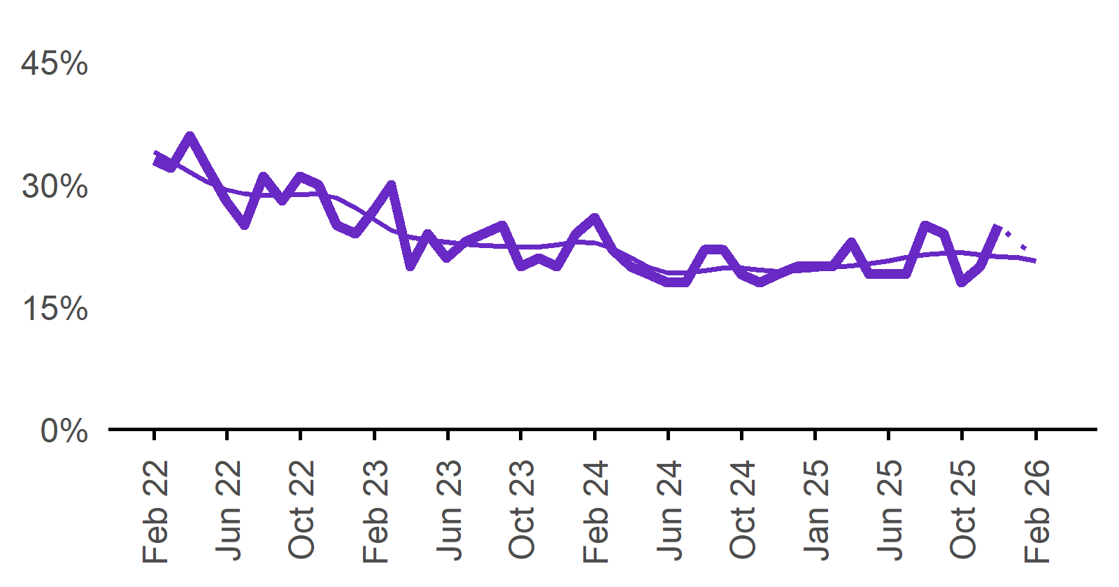 | 21%  Annual change:  ▲ 1%pt
  Date | Expect to increase | Smoothed expect to increase
  Feb 2022 | 33% | 32%
  Mar 2022 | 32% | 32%
  Apr 2022 | 36% | 31%
  May 2022 | 32% | 31%
  Jun 2022 | 28% | 30%
  Jul 2022 | 25% | 29%
  Aug 2022 | 31% | 29%
  Sep 2022 | 28% | 29%
  Oct 2022 | 31% | 29%
  Nov 2022 | 30% | 29%
  Dec 2022 | 25% | 28%
  Jan 2023 | 24% | 27%
  Feb 2023 | 27% | 26%
  Mar 2023 | 30% | 24%
  Apr 2023 | 20% | 24%
  May 2023 | 24% | 23%
  Jun 2023 | 21% | 23%
  Jul 2023 | 23% | 23%
  Aug 2023 | 24% | 23%
  Sep 2023 | 25% | 22%
  Oct 2023 | 20% | 22%
  Nov 2023 | 21% | 22%
  Dec 2023 | 20% | 23%
  Jan 2024 | 24% | 23%
  Feb 2024 | 26% | 23%
  Mar 2024 | 22% | 22%
  Apr 2024 | 20% | 21%
  May 2024 | 19% | 20%
  Jun 2024 | 18% | 19%
  Jul 2024 | 18% | 19%
  Aug 2024 | 22% | 19%
  Sep 2024 | 22% | 20%
  Oct 2024 | 19% | 20%
  Nov 2024 | 18% | 20%
  Dec 2024 | 19% | 19%
  Jan 2025 | 20% | 19%
  Feb 2025 | 20% | 20%
  Mar 2025 | 20% | 20%
  Apr 2025 | 23% | 20%
  May 2025 | 19% | 20%
  Jun 2025 | 19% | 21%
  Jul 2025 | 19% | 21%
  Aug 2025 | 25% | 21%
  Sep 2025 | 24% | 22%
  Oct 2025 | 18% | 22%
  Nov 2025 | 20% | 21%
  Dec 2025 | 25% | 21%
  Jan 2026 |  | 21%
  Feb 2026 | 21% | 21%

Capital City/Rest of State areas

Recruitment rate

Proportion of employers currently recruiting or who recruited in the previous month.
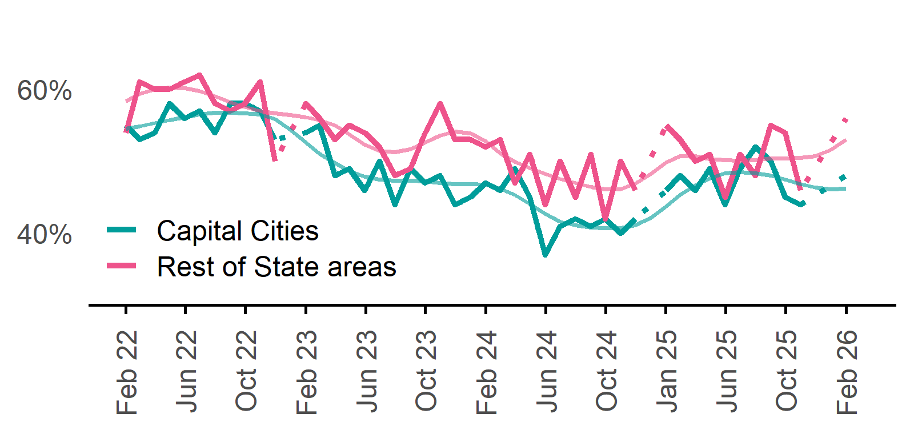 | Capital Cities: 48%  Annual change:  ▲ 2%pts  Rest of State: 56%  Annual change:  ▲ 1%pt
  Date | Capital Cities - Recruitment rate | Rest of State areas - Recruitment rate | Capital Cities - Smoothed recruitment rate | Rest of State areas - Smoothed recruitment rate
  Feb 2022 | 55% | 54% | 54% | 57%
  Mar 2022 | 53% | 61% | 55% | 60%
  Apr 2022 | 54% | 60% | 56% | 61%
  May 2022 | 58% | 60% | 56% | 61%
  Jun 2022 | 56% | 61% | 56% | 60%
  Jul 2022 | 57% | 62% | 57% | 60%
  Aug 2022 | 54% | 58% | 57% | 59%
  Sep 2022 | 58% | 57% | 57% | 58%
  Oct 2022 | 58% | 58% | 57% | 58%
  Nov 2022 | 57% | 61% | 56% | 57%
  Dec 2022 | 53% | 50% | 56% | 57%
  Jan 2023 | n.p. | n.p. | 54% | 56%
  Feb 2023 | 54% | 58% | 53% | 56%
  Mar 2023 | 55% | 56% | 51% | 56%
  Apr 2023 | 48% | 53% | 50% | 55%
  May 2023 | 49% | 55% | 49% | 54%
  Jun 2023 | 46% | 54% | 48% | 52%
  Jul 2023 | 50% | 52% | 47% | 51%
  Aug 2023 | 44% | 48% | 47% | 51%
  Sep 2023 | 49% | 49% | 47% | 52%
  Oct 2023 | 47% | 54% | 47% | 53%
  Nov 2023 | 48% | 58% | 47% | 54%
  Dec 2023 | 44% | 53% | 47% | 54%
  Jan 2024 | 45% | 53% | 47% | 54%
  Feb 2024 | 47% | 52% | 47% | 53%
  Mar 2024 | 46% | 53% | 46% | 51%
  Apr 2024 | 49% | 47% | 45% | 50%
  May 2024 | 45% | 51% | 44% | 49%
  Jun 2024 | 37% | 44% | 43% | 48%
  Jul 2024 | 41% | 50% | 42% | 48%
  Aug 2024 | 42% | 45% | 41% | 47%
  Sep 2024 | 41% | 51% | 41% | 46%
  Oct 2024 | 42% | 42% | 41% | 46%
  Nov 2024 | 40% | 50% | 41% | 46%
  Dec 2024 | 42% | 46% | 41% | 47%
  Jan 2025 | n.p. | n.p. | 42% | 48%
  Feb 2025 | 46% | 55% | 44% | 50%
  Mar 2025 | 48% | 53% | 45% | 51%
  Apr 2025 | 46% | 50% | 47% | 51%
  May 2025 | 49% | 51% | 48% | 50%
  Jun 2025 | 44% | 45% | 48% | 50%
  Jul 2025 | 49% | 51% | 48% | 50%
  Aug 2025 | 52% | 48% | 48% | 50%
  Sep 2025 | 50% | 55% | 48% | 50%
  Oct 2025 | 45% | 54% | 47% | 50%
  Nov 2025 | 44% | 46% | 47% | 50%
  Dec 2025 | n.p. | n.p. | 46% | 51%
  Jan 2026 |  |  | 46% | 52%
  Feb 2026 | 48% | 56% | 46% | 53%

Recruitment difficulty rate

Proportion of recruiting employers who stated they had difficulty hiring staff.
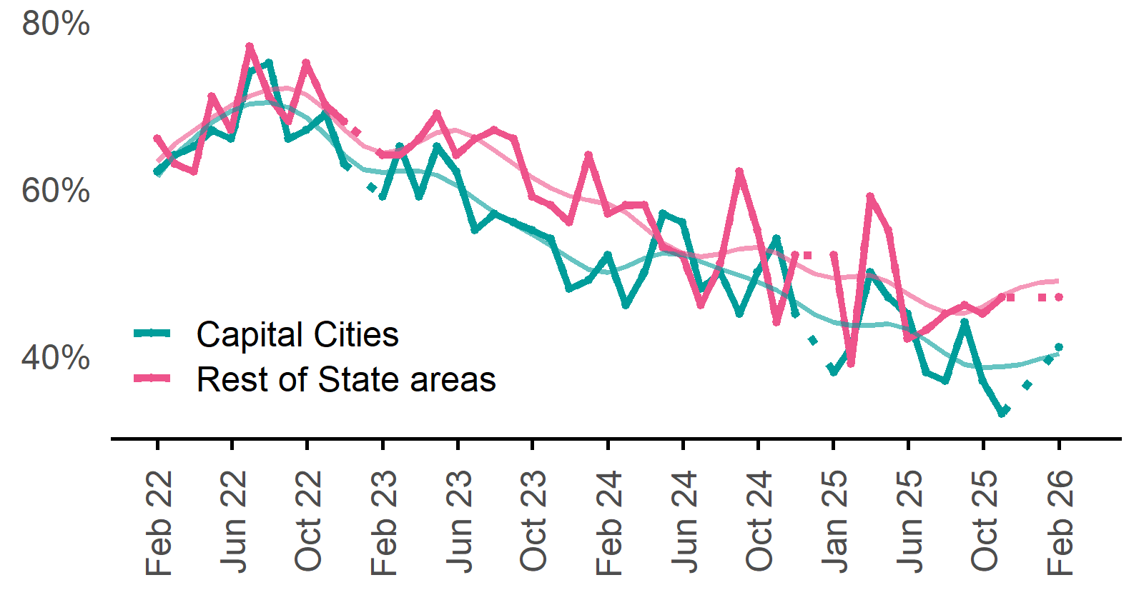 | Capital Cities: 41%  Annual change:  ▲ 3%pts  Rest of State: 47%  Annual change:  ▼ 5%pts
  Date | Capital Cities - Recruitment difficulty rate | Rest of State areas - Recruitment difficulty rate | Capital Cities - Smoothed recruitment difficulty rate | Rest of State areas - Smoothed recruitment difficulty rate
  Feb 2022 | 62% | 66% | 63% | 64%
  Mar 2022 | 64% | 63% | 65% | 65%
  Apr 2022 | 65% | 62% | 67% | 67%
  May 2022 | 67% | 71% | 68% | 69%
  Jun 2022 | 66% | 67% | 69% | 70%
  Jul 2022 | 74% | 77% | 70% | 71%
  Aug 2022 | 75% | 71% | 70% | 72%
  Sep 2022 | 66% | 68% | 70% | 72%
  Oct 2022 | 67% | 75% | 69% | 71%
  Nov 2022 | 69% | 70% | 66% | 69%
  Dec 2022 | 63% | 68% | 64% | 67%
  Jan 2023 | n.p. | n.p. | 62% | 65%
  Feb 2023 | 59% | 64% | 62% | 64%
  Mar 2023 | 65% | 64% | 62% | 65%
  Apr 2023 | 59% | 66% | 62% | 66%
  May 2023 | 65% | 69% | 62% | 67%
  Jun 2023 | 62% | 64% | 60% | 67%
  Jul 2023 | 55% | 66% | 59% | 66%
  Aug 2023 | 57% | 67% | 57% | 65%
  Sep 2023 | 56% | 66% | 56% | 63%
  Oct 2023 | 55% | 59% | 55% | 61%
  Nov 2023 | 54% | 58% | 53% | 60%
  Dec 2023 | 48% | 56% | 52% | 59%
  Jan 2024 | 49% | 64% | 50% | 59%
  Feb 2024 | 52% | 57% | 50% | 58%
  Mar 2024 | 46% | 58% | 51% | 57%
  Apr 2024 | 50% | 58% | 52% | 55%
  May 2024 | 57% | 53% | 52% | 53%
  Jun 2024 | 56% | 52% | 52% | 52%
  Jul 2024 | 48% | 46% | 51% | 52%
  Aug 2024 | 50% | 51% | 50% | 52%
  Sep 2024 | 45% | 62% | 50% | 53%
  Oct 2024 | 50% | 55% | 49% | 53%
  Nov 2024 | 54% | 44% | 48% | 52%
  Dec 2024 | 45% | 52% | 46% | 51%
  Jan 2025 | n.p. | n.p. | 45% | 50%
  Feb 2025 | 38% | 52% | 44% | 49%
  Mar 2025 | 41% | 39% | 44% | 49%
  Apr 2025 | 50% | 59% | 44% | 50%
  May 2025 | 47% | 55% | 44% | 49%
  Jun 2025 | 45% | 42% | 43% | 47%
  Jul 2025 | 38% | 43% | 42% | 46%
  Aug 2025 | 37% | 45% | 40% | 45%
  Sep 2025 | 44% | 46% | 39% | 45%
  Oct 2025 | 37% | 45% | 39% | 46%
  Nov 2025 | 33% | 47% | 39% | 47%
  Dec 2025 | n.p. | n.p. | 39% | 48%
  Jan 2026 |  |  | 40% | 49%
  Feb 2026 | 41% | 47% | 40% | 49%

Staffing outlook – Expecting to increase staff

Proportion of employers who expected to increase staffing numbers over the next three months.
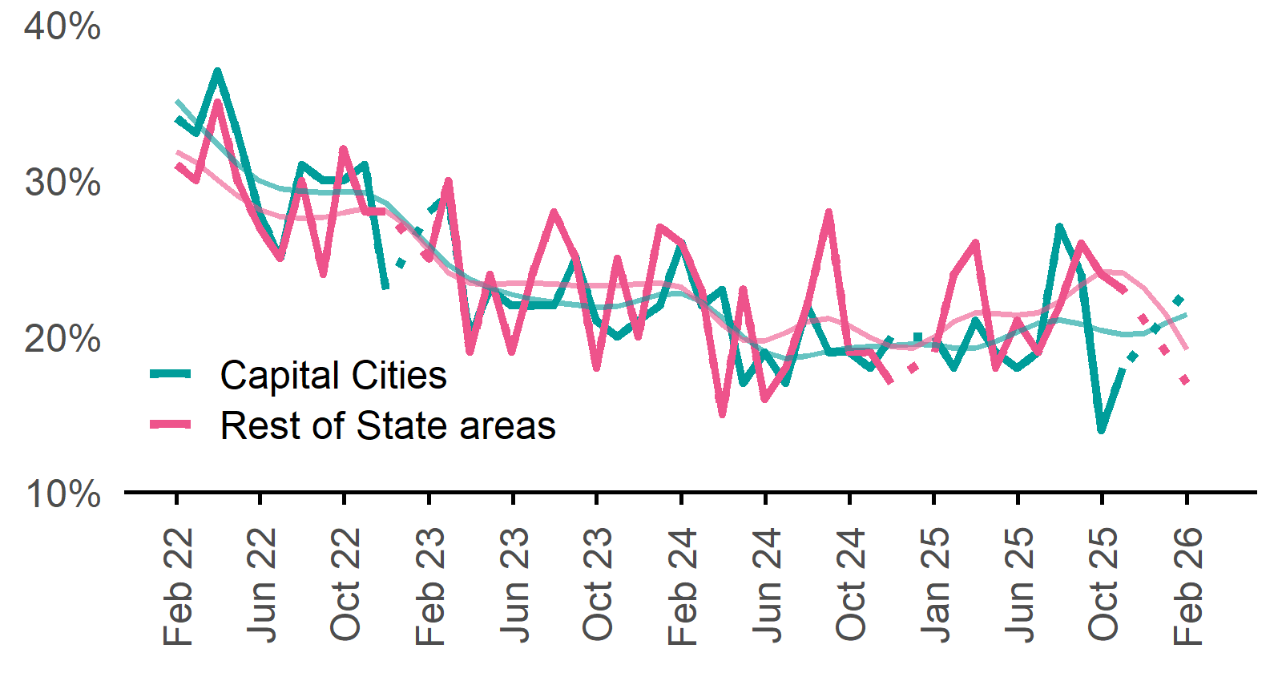 | Capital Cities: 23%  Annual change:  ▲ 3%pts  Rest of State: 17%  Annual change:  ▼ 2%pts
  Date | Capital Cities - % expecting to increase | Rest of State areas - % expecting to increase | Capital Cities - Smoothed % expecting to increase | Rest of State areas - Smoothed % expecting to increase
  Feb 2022 | 34% | 31% | 33% | 30%
  Mar 2022 | 33% | 30% | 33% | 30%
  Apr 2022 | 37% | 35% | 32% | 30%
  May 2022 | 33% | 30% | 31% | 29%
  Jun 2022 | 28% | 27% | 30% | 28%
  Jul 2022 | 25% | 25% | 30% | 28%
  Aug 2022 | 31% | 30% | 29% | 28%
  Sep 2022 | 30% | 24% | 29% | 28%
  Oct 2022 | 30% | 32% | 29% | 28%
  Nov 2022 | 31% | 28% | 29% | 28%
  Dec 2022 | 23% | 28% | 29% | 28%
  Jan 2023 | n.p. | n.p. | 27% | 27%
  Feb 2023 | 28% | 25% | 26% | 26%
  Mar 2023 | 29% | 30% | 25% | 24%
  Apr 2023 | 20% | 19% | 24% | 23%
  May 2023 | 23% | 24% | 23% | 23%
  Jun 2023 | 22% | 19% | 23% | 23%
  Jul 2023 | 22% | 24% | 22% | 23%
  Aug 2023 | 22% | 28% | 22% | 23%
  Sep 2023 | 25% | 25% | 22% | 23%
  Oct 2023 | 21% | 18% | 22% | 23%
  Nov 2023 | 20% | 25% | 22% | 23%
  Dec 2023 | 21% | 20% | 22% | 23%
  Jan 2024 | 22% | 27% | 23% | 23%
  Feb 2024 | 26% | 26% | 23% | 23%
  Mar 2024 | 22% | 23% | 22% | 22%
  Apr 2024 | 23% | 15% | 21% | 21%
  May 2024 | 17% | 23% | 20% | 20%
  Jun 2024 | 19% | 16% | 19% | 20%
  Jul 2024 | 17% | 18% | 19% | 20%
  Aug 2024 | 22% | 22% | 19% | 21%
  Sep 2024 | 19% | 28% | 19% | 21%
  Oct 2024 | 19% | 19% | 19% | 21%
  Nov 2024 | 18% | 19% | 19% | 20%
  Dec 2024 | 20% | 17% | 19% | 19%
  Jan 2025 | n.p. | n.p. | 20% | 19%
  Feb 2025 | 20% | 19% | 19% | 20%
  Mar 2025 | 18% | 24% | 19% | 21%
  Apr 2025 | 21% | 26% | 19% | 22%
  May 2025 | 19% | 18% | 20% | 21%
  Jun 2025 | 18% | 21% | 20% | 21%
  Jul 2025 | 19% | 19% | 21% | 22%
  Aug 2025 | 27% | 22% | 21% | 22%
  Sep 2025 | 24% | 26% | 21% | 23%
  Oct 2025 | 14% | 24% | 20% | 24%
  Nov 2025 | 18% | 23% | 20% | 24%
  Dec 2025 | n.p. | n.p. | 20% | 23%
  Jan 2026 |  |  | 21% | 21%
  Feb 2026 | 23% | 17% | 21% | 19%

Other recruitment indicators

Reason for recruiting

Proportion of employers currently recruiting or who recruited in the previous month.
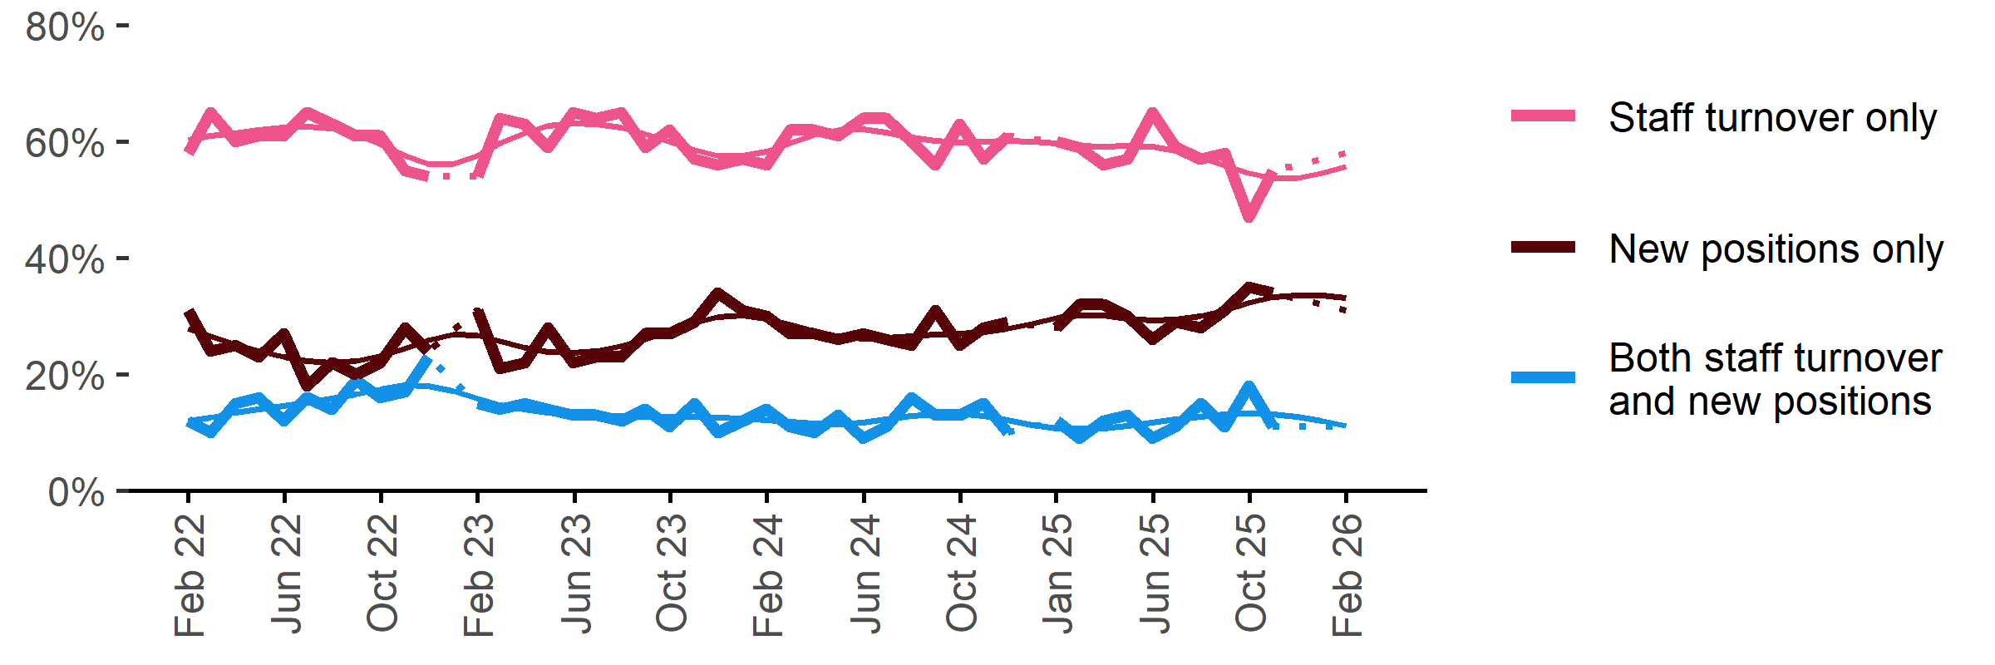
Date | Staff turnover only | Staff turnover and new positions | New positions only | Smoothed - staff turnover only | Smoothed - staff turnover and new positions | Smoothed - new positions only
Feb 2022 | 58% | 12% | 31% | 61% | 12% | 28%
Mar 2022 | 65% | 10% | 24% | 62% | 13% | 26%
Apr 2022 | 60% | 15% | 25% | 62% | 13% | 25%
May 2022 | 61% | 16% | 23% | 62% | 14% | 24%
Jun 2022 | 61% | 12% | 27% | 62% | 15% | 23%
Jul 2022 | 65% | 16% | 18% | 63% | 15% | 22%
Aug 2022 | 63% | 14% | 22% | 62% | 16% | 22%
Sep 2022 | 61% | 19% | 20% | 61% | 17% | 22%
Oct 2022 | 61% | 16% | 22% | 60% | 17% | 23%
Nov 2022 | 55% | 17% | 28% | 58% | 18% | 24%
Dec 2022 | 54% | 23% | 24% | 56% | 18% | 26%
Jan 2023 | n.p. | n.p. | n.p. | 56% | 17% | 27%
Feb 2023 | 54% | 15% | 31% | 58% | 16% | 27%
Mar 2023 | 64% | 14% | 21% | 60% | 15% | 26%
Apr 2023 | 63% | 15% | 22% | 61% | 14% | 25%
May 2023 | 59% | 14% | 28% | 63% | 13% | 24%
Jun 2023 | 65% | 13% | 22% | 63% | 13% | 24%
Jul 2023 | 64% | 13% | 23% | 63% | 13% | 24%
Aug 2023 | 65% | 12% | 23% | 62% | 13% | 25%
Sep 2023 | 59% | 14% | 27% | 61% | 13% | 26%
Oct 2023 | 62% | 11% | 27% | 60% | 13% | 27%
Nov 2023 | 57% | 15% | 29% | 59% | 13% | 29%
Dec 2023 | 56% | 10% | 34% | 58% | 13% | 30%
Jan 2024 | 57% | 12% | 31% | 57% | 12% | 30%
Feb 2024 | 56% | 14% | 30% | 58% | 12% | 30%
Mar 2024 | 62% | 11% | 27% | 60% | 12% | 28%
Apr 2024 | 62% | 10% | 27% | 61% | 12% | 27%
May 2024 | 61% | 13% | 26% | 62% | 11% | 27%
Jun 2024 | 64% | 9% | 27% | 62% | 12% | 26%
Jul 2024 | 64% | 11% | 26% | 62% | 12% | 26%
Aug 2024 | 60% | 16% | 25% | 61% | 13% | 27%
Sep 2024 | 56% | 13% | 31% | 60% | 13% | 27%
Oct 2024 | 63% | 13% | 25% | 60% | 13% | 27%
Nov 2024 | 57% | 15% | 28% | 60% | 13% | 27%
Dec 2024 | 61% | 10% | 29% | 60% | 12% | 28%
Jan 2025 | n.p. | n.p. | n.p. | 60% | 11% | 29%
Feb 2025 | 60% | 12% | 28% | 60% | 11% | 30%
Mar 2025 | 59% | 9% | 32% | 59% | 11% | 30%
Apr 2025 | 56% | 12% | 32% | 59% | 11% | 30%
May 2025 | 57% | 13% | 30% | 59% | 11% | 30%
Jun 2025 | 65% | 9% | 26% | 59% | 12% | 29%
Jul 2025 | 59% | 11% | 29% | 58% | 12% | 29%
Aug 2025 | 57% | 15% | 28% | 57% | 13% | 30%
Sep 2025 | 58% | 11% | 31% | 56% | 13% | 31%
Oct 2025 | 47% | 18% | 35% | 55% | 13% | 32%
Nov 2025 | 55% | 11% | 34% | 54% | 13% | 33%
Dec 2025 | n.p. | n.p. | n.p. | 54% | 13% | 34%
Jan 2026 |  |  |  | 54% | 12% | 34%
Feb 2026 | 58% | 11% | 31% | 56% | 11% | 33%

Staffing changes over the last month

Proportion of employers who said they increased or decreased staffing compared to the previous month.
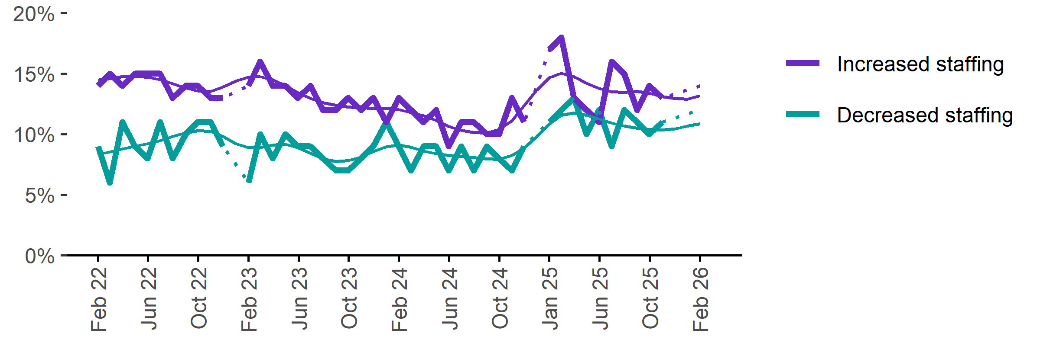
Date | Increased staff | Decreased staff | Smoothed - increased staff | Smoothed - decreased staff
Feb 2022 | 14% | 9% | 13% | 8%
Mar 2022 | 15% | 6% | 14% | 9%
Apr 2022 | 14% | 11% | 15% | 9%
May 2022 | 15% | 9% | 15% | 9%
Jun 2022 | 15% | 8% | 15% | 9%
Jul 2022 | 15% | 11% | 15% | 9%
Aug 2022 | 13% | 8% | 14% | 10%
Sep 2022 | 14% | 10% | 14% | 10%
Oct 2022 | 14% | 11% | 14% | 10%
Nov 2022 | 13% | 11% | 14% | 10%
Dec 2022 | 13% | 9% | 14% | 10%
Jan 2023 | n.p. | n.p. | 14% | 9%
Feb 2023 | 14% | 6% | 15% | 9%
Mar 2023 | 16% | 10% | 15% | 9%
Apr 2023 | 14% | 8% | 14% | 9%
May 2023 | 14% | 10% | 14% | 9%
Jun 2023 | 13% | 9% | 13% | 9%
Jul 2023 | 14% | 9% | 13% | 8%
Aug 2023 | 12% | 8% | 13% | 8%
Sep 2023 | 12% | 7% | 12% | 8%
Oct 2023 | 13% | 7% | 12% | 8%
Nov 2023 | 12% | 8% | 12% | 8%
Dec 2023 | 13% | 9% | 12% | 9%
Jan 2024 | 11% | 11% | 12% | 9%
Feb 2024 | 13% | 9% | 12% | 9%
Mar 2024 | 12% | 7% | 12% | 9%
Apr 2024 | 11% | 9% | 12% | 9%
May 2024 | 12% | 9% | 11% | 8%
Jun 2024 | 9% | 7% | 11% | 8%
Jul 2024 | 11% | 9% | 10% | 8%
Aug 2024 | 11% | 7% | 10% | 8%
Sep 2024 | 10% | 9% | 10% | 8%
Oct 2024 | 10% | 8% | 10% | 8%
Nov 2024 | 13% | 7% | 11% | 8%
Dec 2024 | 11% | 9% | 12% | 9%
Jan 2025 | n.p. | n.p. | 14% | 10%
Feb 2025 | 17% | 11% | 15% | 11%
Mar 2025 | 18% | 12% | 15% | 12%
Apr 2025 | 13% | 13% | 15% | 12%
May 2025 | 12% | 10% | 14% | 12%
Jun 2025 | 11% | 12% | 14% | 11%
Jul 2025 | 16% | 9% | 14% | 11%
Aug 2025 | 15% | 12% | 13% | 11%
Sep 2025 | 12% | 11% | 14% | 10%
Oct 2025 | 14% | 10% | 13% | 10%
Nov 2025 | 13% | 11% | 13% | 10%
Dec 2025 | n.p. | n.p. | 13% | 10%
Jan 2026 |  |  | 13% | 11%
Feb 2026 | 14% | 12% | 13% | 11%

Employers unable to fill vacancies within a month

Proportion of recruiting employers who were unable to fill their vacancies within a month.*
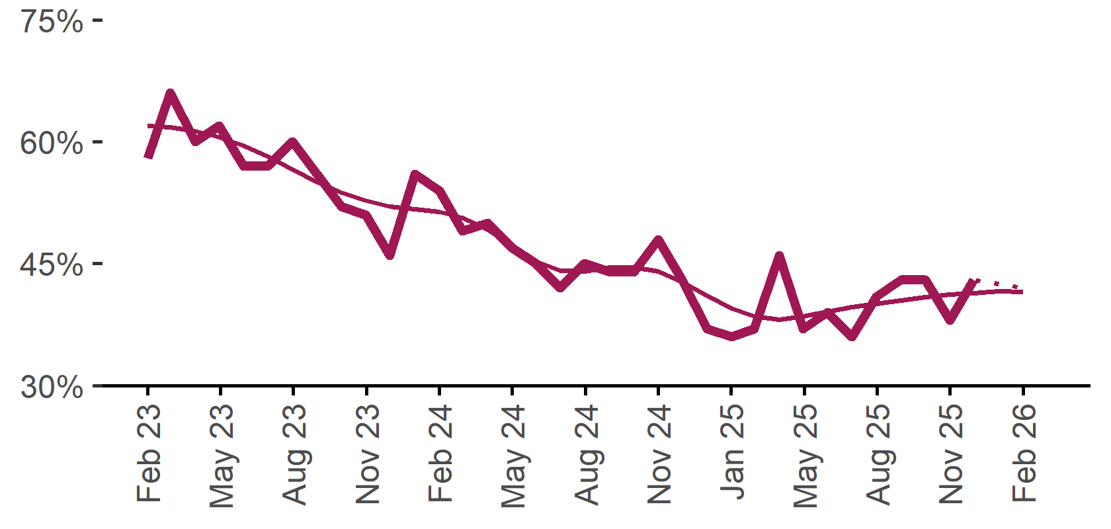 | 42%  Annual change:  ▲ 6%pts
  Date | % unable to fill vacancies in a month | Smoothed - % unable to fill vacancies in a month
  Feb 2023 | 58% | 62%
  Mar 2023 | 66% | 62%
  Apr 2023 | 60% | 61%
  May 2023 | 62% | 61%
  Jun 2023 | 57% | 60%
  Jul 2023 | 57% | 58%
  Aug 2023 | 60% | 57%
  Sep 2023 | 56% | 55%
  Oct 2023 | 52% | 54%
  Nov 2023 | 51% | 53%
  Dec 2023 | 46% | 52%
  Jan 2024 | 56% | 52%
  Feb 2024 | 54% | 51%
  Mar 2024 | 49% | 51%
  Apr 2024 | 50% | 49%
  May 2024 | 47% | 47%
  Jun 2024 | 45% | 45%
  Jul 2024 | 42% | 44%
  Aug 2024 | 45% | 44%
  Sep 2024 | 44% | 45%
  Oct 2024 | 44% | 45%
  Nov 2024 | 48% | 44%
  Dec 2024 | 43% | 43%
  Jan 2025 | 37% | 41%
  Feb 2025 | 36% | 40%
  Mar 2025 | 37% | 38%
  Apr 2025 | 46% | 38%
  May 2025 | 37% | 38%
  Jun 2025 | 39% | 39%
  Jul 2025 | 36% | 40%
  Aug 2025 | 41% | 40%
  Sep 2025 | 43% | 40%
  Oct 2025 | 43% | 41%
  Nov 2025 | 38% | 41%
  Dec 2025 | 43% | 41%
  Jan 2026 |  | 42%
  Feb 2026 | 42% | 42%
* Excludes employers who have been recruiting for less than a month.

Background
Jobs and Skills Australia (JSA) conducts the Recruitment Experiences and Outlook Survey (REOS), a telephone administered survey with the business owner or other person in the business responsible for recruitment. Around 1000 employers are surveyed each month, with data published on the JSA website. While the data are indicative of recruitment activity, they may be subject to seasonal factors and other volatility and should therefore be used with a degree of caution. In addition, the survey is targeted towards employers with 5 or more employees and excludes many government organisations. Details of the survey methodology can be accessed from the JSA website.

Smoothed series in charts
Charts include Henderson-smoothed lines in addition to original data for most of our recruitment indicators. As the timeseries is not yet long enough for seasonal adjustment, a Henderson smoothed moving average with a 13-term filter (equating to 13 months) has been directly applied to the original series. This provides an indication of the general movement in each recruitment indicator relative to previous months. Due to using 13 months in the moving average, results for the most recent six months will be revised each month.

How to reference data from this report
Jobs and Skills Australia, Recruitment Insights Report, February 2026.

Contact us
For additional information, email REOS@jobsandskills.gov.au

Also available from the REOS

Data file with monthly and quarterly recruitment indicators
A REOS data file is available on the JSA website. Breakdowns by Capital City/Rest of State area, Business size, and ANZSCO Skill Level are included in the monthly results. Quarterly recruitment indicators provide detail by state, ARIA (ABS’ Accessibility and Remoteness Index of Australia) as well as selected industry and occupation groups.
Next Recruitment Insights Report release:
- March 2025 Recruitment Insights Report – 21 April 2026

Stay up to date
JSA also releases semi-regular reports including spotlight articles, detailing aspects of the REOS that cannot be included in our monthly Recruitment Insights Report. Sign up and get the Recruitment Insights Report notifications sent straight to your inbox.
Upcoming spotlight:
- REOS research article - Employer attitudes toward disability inclusion in the Australian Workforce – late March 2026
Recent spotlights:
- Successful Methods of Recruitment – February 2026

No data are available for January 2026. A Henderson smoothed line has been included in the charts to reduce month to month volatility and illustrate long term patterns. See the explanatory note for more information.
Data are not available for selected months. Data points have been joined by a dotted line between December and February to reflect this. ‘Rest of State’ refers to areas outside the capital cities.

