

RLMI Results – December 2025

Key Findings
- The RLMI has been expanded to leverage 10 input indicators, including new measures of long‑term income support, job matching efficiency, skill underutilisation, wage outcomes, and vacancy pressure, enabling a more comprehensive measure of labour market performance across regions. This improvement has been reflected across the entire time series.
- The December 2025 release also introduces a combined rating for Northern Australia, reflecting that labour markets and mobility patterns in Northern Australia operate across State and Territory boundaries, providing a more integrated evidence base to guide cross-jurisdictional jobs and skills planning.
- The results show that Regional and remote areas continue to be more likely to experience relatively weaker labour market conditions than their major city counterparts.

A more comprehensive measure of labour market performance
The Regional Labour Market Indicator (RLMI) has been enhanced to include 5 additional factors, expanding the list of input factors to 10. This improvement allows the RLMI to capture a broader set of labour-market dynamics across labour supply, labour demand, and the interaction between the supply and demand.
Table 1: New RLMI Indicators – December 2025
Factor | Description | Factor Type
JobSeeker income support for 2 or more years rate | Proportion of the working age (15-64 years) population on JobSeeker Income Support for 2 or more years | Supply (structural)
Job vacancy rate | The number of new job vacancies as a proportion of the labour force (%) | Demand
Job matching efficiency rate | The efficiency with which available jobseekers and vacancies result in successful hires (%) | Intersection
Annual median wage growth rate | The percentage change in median total income over the past year (%) | Intersection
Skill underutilisation rate | Proportion of employed population working at a lower skill level than their qualification (%) | Intersection

The updates introduced in the December 2025 release reflect the continued development of the RLMI, and innovation in JSA data and methods, as JSA continues to review and refine the input factors included in the indicator. This ensures the RLMI is a highly robust and reliable measure of labour‑market strength.
For the job vacancy rate and the job matching efficiency rate, new data produced by JSA has enabled aspects reflecting employer-side pressures and the job-matching process to be reflected in the RLMI’s measurement of labour market strength.
Other additions, including long-term income-support reliance, median income growth and skill underutilisation, have been introduced to capture important dimensions of labour-market dynamics that were not previously captured, enabling RLMI to better capture the different ways spare capacity can appear across regions.
Together, the ten indicators provide a more comprehensive summary measure of labour-market performance by:
- capturing both current and persistent forms of spare capacity, including long-term income-support receipt and underutilised skills;
- reflecting employer-side pressures, such as elevated vacancy rates or difficulty filling roles;
- measuring how effectively jobseekers and employers are connected, through the job-matching process; and
- capturing how overall labour‑market pressures are reflected in wage outcomes, providing an additional signal of tightness or spare capacity.
Importantly, while the RLMI now draws on a wider set of indicators, its purpose is unchanged: it provides a single, easy‑to‑interpret summary measure that reflects relative labour‑market performance and spare capacity across regions.
Please refer to the RLMI Methodology Paper for more information on the RLMI, including its purpose and factor selection.
Northern Australia
New in the December 2025 RLMI release is the inclusion of a combined rating for Northern Australia, produced in addition to the standard SA4‑level ratings. This recognises Northern Australia as a single, multi‑jurisdictional labour market.
- Northern Australia comprises the following SA4 regions: Cairns, Central Queensland, Mackay – Isaac – Whitsunday, Queensland – Outback, Townsville, Western Australia – Outback (North), Darwin, and the Northern Territory – Outback.
This addition acknowledges that labour markets, workforce challenges and mobility patterns in Northern Australia routinely span State and Territory borders. This approach improves the consistency and quality of evidence available for Northern Australia, helping guide more effective, evidence-based planning and decision-making across the region.

Labour market challenges are more pronounced in many regional areas
The December 2025 RLMI results show that regional and remote areas continue to be more likely to experience relatively weaker labour market conditions than their major city counterparts, highlighting the additional challenges faced in many regional areas by both employers and jobseekers (see Chart 1, below).
- Almost half of the SA4’s (17 out of 37) located in regional areas were rated either ‘below average’ or ‘poor’ in December 2025, while all six (or 100%) remote areas were rated ‘poor’.
- Almost three quarters of the SA4’s (32 out of 44) located in major city areas were rated either ‘strong’ or ‘above average’ in December 2025.
Chart 1: RLMI ratings of relative labour market performance, December 2025
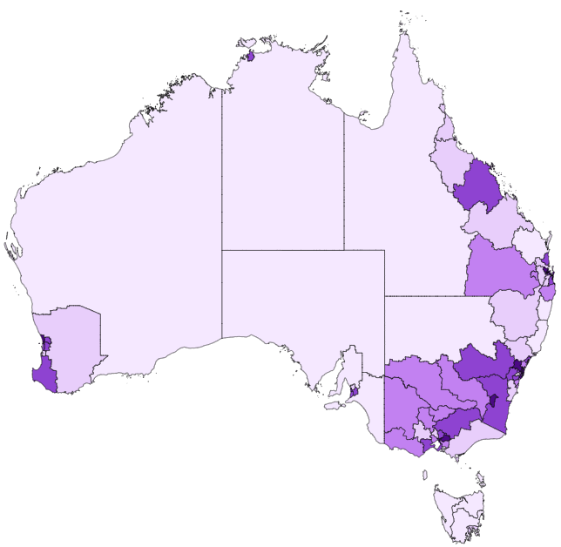

Source: JSA, Regional Labour Market Indicator (RLMI), December 2025

Chart 2: RLMI ratings of relative labour market performance, by selected Capital Cities, December 2025
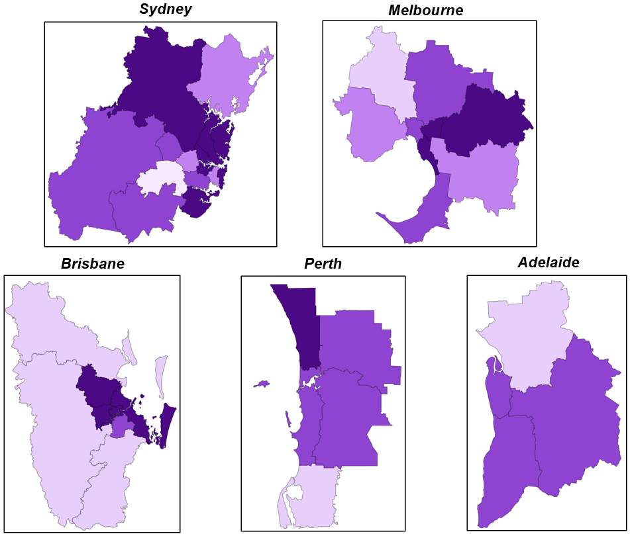
Source: JSA, Regional Labour Market Indicator (RLMI), December 2025

Labour Market Rating by SA4, December 2025
Statistical Area Level 4 (SA4) | Remoteness | Dec-24 | Dec-25 | Direction
Central Coast | Major City | Average | Average | Stable
Sydney - Baulkham Hills and Hawkesbury | Major City | Strong | Strong | Stable
Sydney - Blacktown | Major City | Above average | Above average | Stable
Sydney - City and Inner South | Major City | Above average | Average | Declined
Sydney - Eastern Suburbs | Major City | Strong | Strong | Stable
Sydney - Inner South West | Major City | Above average | Above average | Stable
Sydney - Inner West | Major City | Strong | Strong | Stable
Sydney - North Sydney and Hornsby | Major City | Strong | Strong | Stable
Sydney - Northern Beaches | Major City | Strong | Strong | Stable
Sydney - Outer South West | Major City | Above average | Above average | Stable
Sydney - Outer West and Blue Mountains | Major City | Above average | Above average | Stable
Sydney - Parramatta | Major City | Average | Average | Stable
Sydney - Ryde | Major City | Strong | Strong | Stable
Sydney - South West | Major City | Poor | Poor | Stable
Sydney - Sutherland | Major City | Strong | Strong | Stable
Capital Region | Regional | Above average | Above average | Stable
New South Wales - Central West | Regional | Above average | Above average | Stable
Coffs Harbour - Grafton | Regional | Poor | Poor | Stable
Far West and Orana | Remote | Poor | Poor | Stable
Hunter Valley exc Newcastle | Regional | Below average | Below average | Stable
Illawarra | Cities of Regional Australia | Average | Average | Stable
Mid North Coast | Regional | Poor | Poor | Stable
Murray | Regional | Average | Average | Stable
New England and North West | Regional | Below average | Below average | Stable
Newcastle and Lake Macquarie | Cities of Regional Australia | Above average | Above average | Stable
Richmond - Tweed | Regional | Below average | Average | Improved
Riverina | Regional | Average | Average | Stable
Southern Highlands and Shoalhaven | Regional | Below average | Below average | Stable
Melbourne - Inner | Major City | Above average | Above average | Stable
Melbourne - Inner East | Major City | Strong | Strong | Stable
Melbourne - Inner South | Major City | Strong | Strong | Stable
Melbourne - North East | Major City | Above average | Above average | Stable
Melbourne - North West | Major City | Below average | Below average | Stable
Melbourne - Outer East | Major City | Strong | Strong | Stable
Melbourne - South East | Major City | Above average | Average | Declined
Melbourne - West | Major City | Average | Average | Stable
Mornington Peninsula | Major City | Above average | Above average | Stable
Ballarat | Regional | Below average | Below average | Stable
Bendigo | Regional | Average | Average | Stable
Geelong | Cities of Regional Australia | Above average | Above average | Stable
Hume | Regional | Average | Above average | Improved
Latrobe - Gippsland | Regional | Below average | Below average | Stable
Victoria - North West | Regional | Below average | Average | Improved
Shepparton | Regional | Below average | Average | Improved
Warrnambool and South West | Regional | Average | Average | Stable

Statistical Area Level 4 (SA4) | Remoteness | Dec-24 | Dec-25 | Direction
Brisbane - East | Major City | Strong | Strong | Stable
Brisbane - North | Major City | Strong | Strong | Stable
Brisbane - South | Major City | Above average | Above average | Stable
Brisbane - West | Major City | Strong | Strong | Stable
Brisbane Inner City | Major City | Strong | Strong | Stable
Ipswich | Major City | Average | Below average | Declined
Logan - Beaudesert | Major City | Average | Below average | Declined
Moreton Bay - North | Major City | Below average | Below average | Stable
Moreton Bay - South | Major City | Strong | Strong | Stable
Cairns | Cities of Regional Australia | Below average | Below average | Stable
Darling Downs - Maranoa | Regional | Above average | Average | Declined
Central Queensland | Regional | Below average | Below average | Stable
Gold Coast | Cities of Regional Australia | Strong | Above average | Declined
Mackay - Isaac - Whitsunday | Regional | Above average | Above average | Stable
Queensland - Outback | Remote | Poor | Poor | Stable
Sunshine Coast | Cities of Regional Australia | Above average | Above average | Stable
Toowoomba | Cities of Regional Australia | Average | Average | Stable
Townsville | Cities of Regional Australia | Below average | Below average | Stable
Wide Bay | Regional | Poor | Poor | Stable
Adelaide - Central and Hills | Major City | Above average | Above average | Stable
Adelaide - North | Major City | Poor | Below average | Improved
Adelaide - South | Major City | Average | Above average | Improved
Adelaide - West | Major City | Average | Above average | Improved
Barossa - Yorke - Mid North | Regional | Poor | Poor | Stable
South Australia - Outback | Remote | Poor | Poor | Stable
South Australia - South East | Regional | Poor | Poor | Stable
Mandurah | Major City | Below average | Below average | Stable
Perth - Inner | Major City | Above average | Above average | Stable
Perth - North East | Major City | Above average | Above average | Stable
Perth - North West | Major City | Strong | Strong | Stable
Perth - South East | Major City | Above average | Above average | Stable
Perth - South West | Major City | Above average | Above average | Stable
Bunbury | Regional | Above average | Above average | Stable
Western Australia - Outback (North and South) | Remote | Poor | Poor | Stable
Western Australia - Wheat Belt | Regional | Average | Below average | Declined
Hobart | Cities of Regional Australia | Below average | Below average | Stable
Launceston and North East | Regional | Poor | Poor | Stable
Tasmania - South East | Regional | Poor | Poor | Stable
Tasmania - West and North West | Remote | Poor | Poor | Stable
Darwin | Cities of Regional Australia | Above average | Above average | Stable
Northern Territory - Outback | Remote | Poor | Poor | Stable
Australian Capital Territory | Major City | Strong | Strong | Stable
Northern Australia |  | Below average | Below average | Stable
Source: JSA, Regional Labour Market Indicator (RLMI), December 2025

RLMI Explanatory Notes

Overview
The Regional Labour Market Indicator (RLMI) combines key indicators of labour supply and demand, including several indicators capturing dynamics at the intersection of those dimensions, into a single, and easy to interpret, summary measure.
Regions are grouped into distinct categories of relative overall labour market performance, ranging from ‘poor’ to ‘strong’, which provides an accurate and reliable view of labour market performance, relative to the national average.
A strong labour market, that is characterised by a high rate of employment, where employers can attract, develop and retain sufficient suitable labour to meet current skills needs, and where employment opportunities are broadly accessible and secure, help drive a more productive economy that is central to building a prosperous and inclusive society.

Factors used to assess labour market performance
The 10 input factors currently included in the RLMI are listed below. The factors can be grouped into broader measures of labour supply, demand, with several indicators capturing dynamics at the intersection of these dimensions.
Factor | Description | Factor Type | Availability | Geography | Weight
Employment rate (15-64 years) | The number of employed persons as a proportion of the working age (15-64 years) population (%) | Supply | Monthly | SA4 | 20%
Unemployment rate | The number of unemployed persons as a proportion of the total labour force (%) | Supply | Monthly | SA4 | 5%
JobSeeker income support rate | Proportion of the working age (15-64 years) population on JobSeeker Income Support* | Supply | Monthly | SA4 | 15%
JobSeeker income support for 2 or more years rate | Proportion of the working age (15-64 years) population on JobSeeker Income Support for 2 or more years¹ | Supply (structural) | Monthly | SA4 | 20%
Underemployment rate | The number of underemployed persons as a proportion of the labour force (%) | Supply | Monthly | GCCSA | 4%
Job vacancy rate | The number of new job vacancies as a proportion of the labour force (%) | Demand | Monthly | SA4² | 10%
Job matching efficiency rate | The efficiency with which available jobseekers and vacancies result in successful hires (%) | Intersection | Monthly | SA4 | 20%
Vacancy fill rate | The percentage of vacancies that have been filled (%) | Intersection | Monthly | GCCSA | 4%
Annual median income growth rate | The percentage change in median total income over the past year (%) | Intersection | Yearly³ | SA4 | 1%
Skill underutilisation rate | Proportion of employed population working at a lower skill level than their qualification (%) | Intersection | 5-yearly³ | SA4 | 1%
¹ JobSeeker income support’ is a combination of the JobSeeker payment and Youth Allowance (other) payment
² Measured at the Greater Capital City Statistical Area (GCCSA) for Major Cities (Sydney, Melbourne, Brisbane, Adelaide, Perth)
³ Note, the data is released with a substantial delay (typically 1–2 years after collection), which limits its usefulness for assessing current labour market conditions.

Methodology
Please refer to the RLMI Methodology Paper for more information on the RLMI, including its purpose and factor selection.

Referencing this report
Data in this release should be referenced as: Jobs and Skills Australia, RLMI, December 2025

Contact us
For additional information, email RegionalWorkforceAssessment@jobsandskills.gov.au

JSA, Total New Vacancies

