

Finding “the One”: Methods and Successful Methods of Recruitment
Recruitment practices in Australia continue to evolve as employers draw on a wide range of methods to find the staff they need, from dominant digital tools such as online job boards to long‑standing informal approaches like word of mouth and direct contact from job seekers. Evidence from the Recruitment Experiences and Outlook Survey (REOS) shows that no single method works for all employers. Instead, recruitment choices are shaped by factors including occupation, industry, location, and the difficulty of filling a vacancy. This report examines the different methods and combinations used by employers, and identifies which methods were considered successful.

Key findings
- Online job boards remain the most widely used and most successful recruitment method, with more than half of employers using them and 40% reporting them as the method that led to a successful hire.
- Most employers rely on only one recruitment method to fill their vacancies, but those experiencing recruitment difficulty are far more likely to adopt multi‑method strategies to broaden their applicant pool.
- Informal recruitment methods remain highly effective, with word of mouth and direct approaches by job seekers achieving relatively high success rates across occupations and regions.
- Recruitment challenges are closely tied to skill level: higher‑skilled roles are frequently advertised on online job boards and often require multiple recruitment methods, while lower‑skilled roles are more often filled through informal or low‑cost channels.
- Employers’ recruitment patterns differ significantly by industries and regions, with city‑based employers favouring online methods and regional employers relying more on social media and personal networks.
- Job seekers benefit from using multiple search strategies, including proactive approaches outside traditional application processes, as these methods frequently result in successful hires.

How do employers find staff?
Recruitment methods play a critical role in shaping how employers connect with potential candidates and secure the future staff they need. There is, however, no hard-and-fast rule regarding the methods that employers use. Practices are influenced by factors such as the business location, industry and the occupation recruiting for, and the difficulty attracting suitable candidates. This variation reflects the complexity of the Australian labour market.
Figure 1 provides an overview of the recruitment methods most used by employers and highlights the dominance of certain channels. Online jobs boards are by far the most popular method, with over half of employers using them for their most recent recruitment round in 2025. These have become increasingly popular over the last decade, increasing by
12 percentage points since 2016 (from 46% to 58%). This figure is broadly aligned with the relationship between volumes of job ads that we see in JSA’s Internet Vacancy Index (IVI) and Total New Vacancies (NTV) data.
Other methods show more moderate usage. Word of mouth (25%) and direct approaches by job seekers (12%) also feature prominently, indicating that personal connections and proactive job-seeking continue to play a significant role in the labour market. Social media is also increasingly used by employers, particularly for businesses where community engagement is important. In 2025, 19% of recruiting employers used social media, up from 6% in 2016, reflecting its growing role in recruitment.
Recruitment agencies (13%), company websites (10%) and internal advertising (6%) are less common but still relevant for certain roles, while traditional methods such as newspapers (2%) and signs in windows (3%) have largely declined, underscoring a broader shift toward digital and network-based recruitment.
Figure 1: Proportion of employers recruiting by methods, 2025

Source: Jobs and Skills Australia, Recruitment Experiences and Outlook Survey, 2025.

Go with what works - Most employers only use one method of recruitment
In 2025, 63% of employers used only one method to fill their vacancies. About a quarter used two different methods, while 11% using three or more methods (Figure 2).
While single-method recruitment remains dominant, employers increasingly combine methods when facing recruitment difficulties. In these cases, over half (51%) of employers used more than one method of recruitment, suggesting that expanding sourcing to find more applicants may be critical to fill some vacancies. In contrast, when a method is working without difficulty, employers have little incentive to use other methods. In these cases, close to three quarters of employers (73%) used only one recruitment method. This also emphasises to job seekers the importance of searching for opportunities across multiple channels to better match the diverse ways that employers recruit.
Figure 2: Proportion of employers recruiting by number of methods used and whether difficult recruiting, 2025

Source: Jobs and Skills Australia, Recruitment Experiences and Outlook Survey, 2025.
There is a clear distinction between recruitment patterns of employers who rely on a single recruitment method and those who use multiple methods (Figure 3). Employers using only one method favour online job boards, which dominate as the most common standalone approach (49% of employers who used only one method). This suggests that for many employers, online platforms provide sufficient reach and efficiency to meet their recruitment needs without additional strategies. In contrast, employers who adopt two or more methods demonstrate a much broader and more diversified approach. While online job boards remain central (used by three quarters of multi-method recruiting employers), other methods such as social media and word of mouth show significantly higher usage when in combination with other methods.

Figure 3: Proportion of employers using methods of recruitment by total number of methods used, 2025

Source: Jobs and Skills Australia, Recruitment Experiences and Outlook Survey, 2025.
Social media, in particular, was rarely used in isolation but was used in 42% of multi-method recruitment, indicating that it primarily supplemented other recruitment methods. Similarly, methods such as word of mouth, recruitment agencies, and company website are used much more frequently as part of a multi-method strategy. While being also used by multi-method recruiting employers, being directly approached by job seekers does not see an increase in usage like the methods mentioned above.
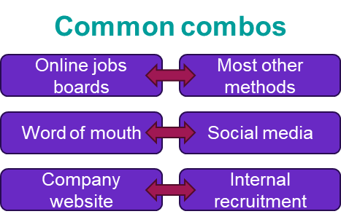
The extent to which employers combined different recruitment methods is illustrated in Figure 4. Online job boards dominate as the most frequently used method and show strong connections to nearly all other channels, indicating that they are often the foundation of multi-method recruitment strategies. Social media also features prominently, with substantial overlap with word of mouth, company websites, and internal advertising, suggesting that employers increasingly integrate digital platforms with informal networks to broaden their reach. Word of mouth remains a common component of recruitment, frequently paired with social media and online job boards.
Figure 4: Combinations of methods of recruitment when used in a multi-method strategy, 2025
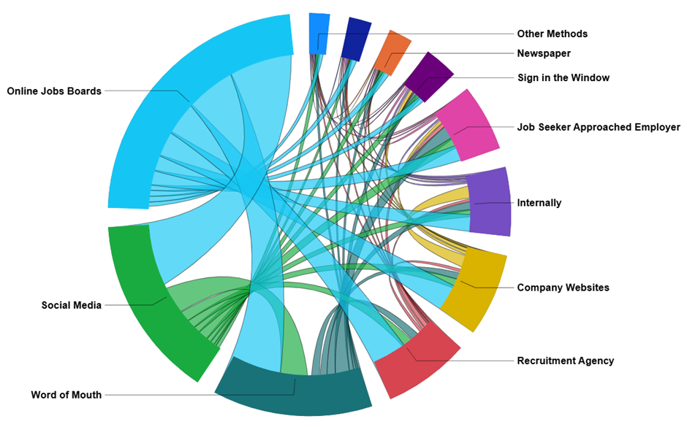
Source: Jobs and Skills Australia, Recruitment Experiences and Outlook Survey, 2025.

Employers recruit differently when it is difficult to find staff
Employers who have difficulty finding staff are far more likely to diversify their recruitment strategies. Online job boards dominate as the most common method across both easy-to-fill and difficult-to-fill vacancies, but the difference in usage is striking. Their use is significantly higher for hard-to-fill roles, with almost three quarters (73%) of employers recruiting for difficult-to-fill roles using online job boards, compared with 46% for roles that were not difficult to fill. This suggests a strong association between difficult-to-fill vacancies and advertising on online job boards.

Social media and recruitment agencies are notably more common for difficult-to-fill roles, at 28% and 20% respectively, compared with 13% and 8% for easier roles, reflecting employers’ efforts to widen their search. In contrast, word of mouth is used at similar rates regardless of recruitment difficulty (26% for difficult-to-fill roles and 25% for easy-to-fill roles), indicating that informal networks remain important across all recruitment contexts. Unsurprisingly, being directly approached by job seekers is far more common for easy-to-fill roles (18%) than for difficult-to-fill roles (5%).
Overall, the data highlight that employers facing recruitment challenges tend to rely more heavily on digital platforms and formal recruitment services, while informal and/or low-cost recruitment methods continues to play an important role regardless of difficulty.
Figure 5: Proportion of employers using methods of recruitment by whether the vacancy was difficult to fill, 2025
Source: Jobs and Skills Australia, Recruitment Experiences and Outlook Survey, 2025.

How employers recruit: by region
Clear differences in recruitment behaviour are evident between major cities and regional or remote areas (Table 1). Employers in major cities rely heavily on online job boards, with relatively low use of word of mouth and social media. Recruitment difficulty in these areas is generally low, suggesting that formal online channels are effective in attracting candidates where labour supply is higher.
In contrast, employers in inner, outer regional, and remote areas show a very different pattern. Online job board usage is low, while word of mouth and social media are used extensively. Recruitment difficulty remains high across all regional and remote areas, indicating persistent challenges in sourcing suitable candidates.
Table 1: Employer use of key methods of recruitment and difficulty rate, by ARIA regions, 2025
 | Employer use of: |  |  |  | Recruitment difficulty rate
 | Online jobs boards | Word of mouth | Social media |  | Recruitment difficulty rate
Major Cities of Australia | High | Average | Low |  | Low
Inner Regional Australia | Low | Average | High |  | High
Outer Regional Australia | Low | High | High |  | High
Remote and Very Remote Australia | Low | High | High |  | High
Source: Jobs and Skills Australia, Recruitment Experiences and Outlook Survey, 2025.

How employers recruit: by occupation
Recruitment methods vary significantly across different occupations. Broadly, REOS data show that employers do not adopt a uniform approach; instead, their choice of methods reflects the nature of the roles they are trying to fill. Even within a single occupation, there is considerable variation in how employers recruit (Table 2).
Managers and most professional occupations rely heavily on online job boards, with relatively low use of word of mouth or social media. Recruitment difficulty for these roles tends to be average or high, suggesting that even with strong reliance on formal online channels, employers face challenges in sourcing suitable candidates for higher-skilled positions. In contrast, occupations such as Technicians and Trades Workers also show high use of job boards but combine this with greater reliance on word of mouth, reflecting the importance of informal networks in trades-based recruitment. These roles consistently record high recruitment difficulty, indicating persistent shortages despite multi-channel strategies.
Lower-skilled occupations display a different pattern. While online job boards remain important for Community and Personal Service Workers, word of mouth and social media play a much larger role for these groups. Recruitment difficulty for these occupations is generally average or low, consistent with informal and locally focused methods being effective in attracting candidates for lower-skilled or service-oriented roles. Sales Workers and Labourers show low use of job boards and higher reliance on word of mouth, with recruitment difficulty mostly low, pointing to a relatively accessible labour supply.
Clerical and Administrative Workers also rely heavily on online jobs boards, but with low levels of difficulty the use of other methods is quite low.
Overall, recruitment strategies are strongly influenced by occupation characteristics, reinforcing the need for tailored recruitment approaches rather than one-size-fits-all solutions.
Table 2: Employer use of key methods of recruitment and difficulty rate, by Occupation Group and Sub-Group, 2023-2025
 | Employer use of: |  |  |  | Recruitment difficulty rate
 | Online jobs boards | Word of mouth | Social media |  | Recruitment difficulty rate
Managers | High | Low | Low |  | Average
Chief Executives, General Managers and Legislators | n.a. | n.a. | n.a. |  | n.a.
Farmers and Farm Managers | n.a. | n.a. | n.a. |  | n.a.
Specialist Managers | High | Average | Low |  | Average
Hospitality, Retail and Service Managers | High | Low | Average |  | Average
Professionals | High | Low | Low |  | High
Arts and Media Professionals | n.a. | n.a. | n.a. |  | n.a.
Business, Human Resource and Marketing Professionals | High | Low | Low |  | High
Design, Engineering, Science and Transport Professionals | High | Low | Low |  | High
Education Professionals | High | Low | High |  | High
Health Professionals | High | Low | Low |  | High
ICT Professionals | High | Average | Low |  | Low
Legal, Social and Welfare Professionals | High | Low | Low |  | High
Technicians and Trades Workers | High | High | High |  | High
Engineering, ICT and Science Technicians | High | Low | Low |  | Average
Automotive and Engineering Trades Workers | High | High | High |  | High
Construction Trades Workers | Average | High | High |  | High
Electrotechnology and Telecommunications Trades Workers | High | High | Low |  | High
Food Trades Workers | High | Average | High |  | High
Skilled Animal, Agricultural and Horticultural Workers | Average | Average | High |  | High
Other Technicians and Trades Workers | High | Average | High |  | High
Community and Personal Service Workers | Average | Average | High |  | Average
Health and Welfare Support Workers | High | Average | Low |  | Low
Carers and Aides | High | Average | High |  | High
Hospitality Workers | Low | Average | High |  | Low
Protective Service Workers | n.a. | n.a. | n.a. |  | n.a.
Sports and Personal Service Workers | Average | Average | High |  | Average
Clerical and Administrative Workers | High | Low | Low |  | Low
Office Managers and Program Administrators | High | High | Low |  | Low
Personal Assistants and Secretaries | High | Average | Low |  | Low
General Clerical Workers | High | Low | Low |  | Low
Inquiry Clerks and Receptionists | High | Average | Average |  | Low
Numerical Clerks | High | Low | Low |  | Low
Clerical and Office Support Workers | n.a. | n.a. | n.a. |  | n.a.
Other Clerical and Administrative Workers | High | Low | Low |  | Low
Sales Workers | Low | Average | Low |  | Low
Sales Representatives and Agents | High | Average | Average |  | Average
Sales Assistants and Salespersons | Low | Average | Low |  | Low
Sales Support Workers | Low | Average | Average |  | Low
Machinery Operators and Drivers | Average | Average | Average |  | High
Machine and Stationary Plant Operators | High | High | Average |  | High
Mobile Plant Operators | Average | High | Average |  | Average
Road and Rail Drivers | Average | High | High |  | High
Storepersons | High | Average | Low |  | Low
Labourers | Low | High | Average |  | Low
Cleaners and Laundry Workers | Low | Average | High |  | Low
Construction and Mining Labourers | Low | High | Average |  | High
Factory Process Workers | Low | High | Low |  | Low
Farm, Forestry and Garden Workers | Low | High | High |  | Average
Food Preparation Assistants | Low | Average | Average |  | Low
Other Labourers | Average | High | High |  | Average
n.a. - results not available
Source: Jobs and Skills Australia, Recruitment Experiences and Outlook Survey, 2025.

How employers recruit: by industry
Recruitment methods vary markedly across industries, reflecting differences in skill requirements, labour supply, and the nature of work. Industries such as Wholesale Trade, Education and Training and Health Care and Social Assistance show high reliance on online job boards, combined with average or low use of word of mouth. Recruitment difficulty for these sectors tends to be average, suggesting that formal online channels are effective but not without challenges (Table 3).
In contrast, industries like Accommodation and Food Services and Arts and Recreation Services rely heavily on word of mouth and social media, while their use of online job boards is low. These industries also report low levels of recruitment difficulty, indicating that informal and locally focused methods are adequate to find staff. Manufacturing and Construction display a mixed approach, depending on both online job boards and word of mouth, yet both face high recruitment difficulty rates.
Some industries often make greater use of methods not captured in this table, especially when job seekers can be attracted other ways. Professional, Scientific and Technical Services and Manufacturing, for example, can use recruitment agencies for hard to fill vacancies.
Taken together, the results highlight how the effectiveness of recruitment methods is closely linked to industry context. Sectors with higher skill requirements lean toward online platforms, while service-oriented and regional industries depend more on personal networks and social media.
Table 3: Employer use of key methods of recruitment and difficulty rate, by selected Industry Divisions, 2024-2025
 | Employer use of: |  |  |  | Recruitment difficulty rate
 | Online jobs boards | Word of mouth | Social media |  | Recruitment difficulty rate
Manufacturing | Average | Average | Low |  | High
Construction | Average | High | Low |  | High
Wholesale Trade | High | Average | Low |  | Average
Retail Trade | Low | Average | Average |  | Low
Accommodation and Food Services | Low | Average | High |  | Low
Transport, Postal and Warehousing | Average | High | High |  | High
Rental, Hiring and Real Estate Services | High | Average | Average |  | Average
Professional, Scientific and Technical Services | High | Low | Low |  | High
Administrative and Support Services | High | Low | Average |  | Average
Education and Training | High | Low | Average |  | Average
Health Care and Social Assistance | High | Low | Average |  | Average
Arts and Recreation Services | Low | High | High |  | Low
Other Services | Average | High | High |  | High
Source: Jobs and Skills Australia, Recruitment Experiences and Outlook Survey, 2025.

Successful method of recruitment
As part of the REOS, data was collected on what recruitment methods through which the new hire had applied. In this report, this is referred to as the successful method of recruitment.
A successful method of recruitment relates only to employers who had filled at least one vacancy. Excluding employers who have yet to fill any vacancy means these results are not directly comparable with those presented in previous sections. For example, 52% of employers who had filled at least one vacancy had advertised on an online jobs board, compared with 58% for all recruitment. Generally, the percentages are slightly lower, as employers who cannot fill any vacancies are more likely to use multiple methods to find staff (as discussed earlier).
Figure 6 shows, for employers who had filled at least one vacancy, the proportion that used each method, distinguishing between those reported as successful and those that were not. Given the majority of employers only used one recruitment method, the rate for a successful method is often close to the overall usage rate for that method.
Figure 6: Employers who successfully filled at least one vacancy – Proportion using methods and successful methods of recruitment, 2025
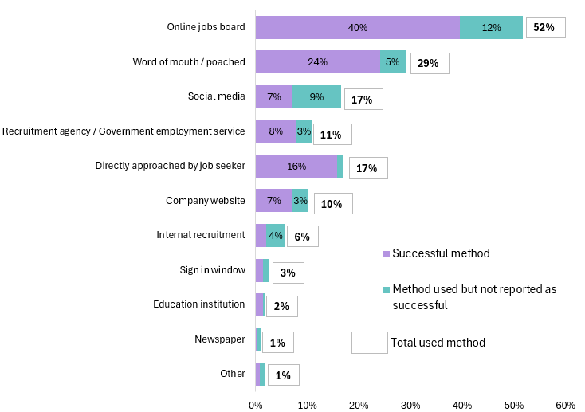
Source: Jobs and Skills Australia, Recruitment Experiences and Outlook Survey, 2025.
Most employers who were directly approached by a job seeker hired one of them. In contrast, fewer than half of employers who advertised on social media considered that a successful method. This indicator, referred to as the success rate, provides a useful analytical tool for understanding how employers recruit.

Online jobs boards
Used method | Successful method | Success rate
52% | 40% | Above average
Online job boards remain one of the most important recruitment methods - especially for hard-to-fill roles, where they are used by a strong majority of employers. They also record an above average success rate compared with other methods. Among employers who filled at least one vacancy, online job boards (40%) was by far the most frequently reported as leading to a hire, underscoring their effectiveness.
Figure 7: Employers who successfully filled at least one vacancy – Proportion using online jobs boards by whether difficult to fill vacancy, 2025
Source: Jobs and Skills Australia, Recruitment Experiences and Outlook Survey, 2025.
Focusing on vacancies that were difficult to fill, the earlier section showed that these roles are much more frequently advertised on online jobs boards. Among employers who eventually filled their vacancies - albeit with difficulty - just under half (47%) reported that online jobs boards was the successful method. However, the success rate was low, with 25% of employers advertising on jobs boards but filling their vacancy using other methods.
This illustrates that difficult-to-fill vacancies advertised on online jobs boards, the majority of which are higher skilled, generally force employers to rely on a broader mix of recruitment channels when facing skills shortages.
In contrast, fewer than half of employers who easily filled at least one vacancy advertised on online jobs boards. However, when they did, the success rate was very high. For these vacancies, the majority were lower skilled and online jobs boards were the only method of recruitment, indicating that they provide a convenient and effective way for many employers to find staff. Despite this relative ease of recruitment via online jobs boards, the majority of employers were still able to fill their vacancies through other, more informal methods
It is important to note that online job boards is often not the first step in a multi-method recruitment process, with many employers preferring low-cost or informal approaches initially. Around 31% of employers who used online job boards had initially tried other methods before advertising online. This was most common among employers recruiting Labourers (40%) and Technicians and Trades Workers (34%). Even when online job boards ultimately led to a successful hire, 25% of employers had first attempted other approaches, re-iterating that employers can turn to online jobs boards after other methods had been tried first.

Company websites
Used method | Successful method | Success rate
10% | 7% | Average
The use of company websites to find staff varies notably across industries. In some sectors, they are a key part of the hiring process, while in others they are rarely used at all. Where they are adopted, they tend to be effective.
For example, in the Takeaway Food Services industry, roughly 60% of employers who filled at least one vacancy reported that company website was the successful method, making it the go-to method in this sector. Other industries with above average rates reliance on company websites include School Education and Residential Care Services (which includes aged care facilities).

Social Media
Used method | Successful method | Success rate
17% | 7% | Low
Social media has become an increasingly common recruitment tool over the past decade, reflecting a quick and accessible way for employers to promote vacancies and reach a broad audience. Social media was widely used as part of a multi-method process (as shown in an earlier section) but was rarely the decisive factor in successful recruitment. Only 7% of employers who filled a at least one vacancy identified social media as the method that led to a hire, with a low success rate. This indicates that while social media is effective for raising awareness and generating interest, it is less likely to be the channel through which job seekers ultimately secure employment.

Recruitment Agencies
Used method | Successful method | Success rate
11% | 8% | Average
Recruitment agencies can be a comparatively costly option for employers, particularly when free or low‑cost alternatives are available. As a result, they tend to be used more selectively, often when employers require additional support to source suitable applicants.
This is reflected in their usage patterns across occupations. Recruitment agencies are relied upon far more frequently when employers are recruiting for higher skilled roles that are difficult to fill, where the need for broader search capacity outweighs the expense. Almost a quarter (24%) of Professionals recruited for difficult‑to‑fill roles were hired through recruitment agencies. By contrast, when suitable applicants are not difficult to find, recruitment agencies are often used to quickly fill vacancies for Machinery Operators and Drivers and for Labourers, where employers may turn to agencies to streamline recruitment processes.

Word of Mouth
Used method | Successful method | Success rate
29% | 24% | High
Word of mouth is the second most common method employers use to find staff, reflecting its low cost, speed, and adaptability across a wide range of recruitment needs. Also, the rate where word of mouth was the successful method was remarkably consistent: between 20% and 30% of employers across all occupation groups and regions stating that this method resulted in a successful hire, illustrating its ubiquity as a possible method for employers to use.
The high success rate for word of mouth reflects the targeted nature of informal referrals, where employers can approach known candidates directly or rely on trusted networks to recommend suitable applicants. The method’s effectiveness also suggests that, despite the growing availability of digital recruitment tools, personal connections and industry‑specific networks continue to play an integral role in matching employers with job seekers.

Directly approached by job seeker
Used method | Successful method | Success rate
17% | 16% | High
Being directly approached by a job seeker is one of the simplest and least costly recruitment methods available to employers, provided that suitable applicants can be identified. This method includes job seekers who proactively contact employers without knowing whether a vacancy exists, as well as those who are aware of open positions and approach the employer directly to increase their chances of being considered. With no advertising expenditure and minimal administrative effort, direct approaches can be an efficient way for employers to source candidates, particularly in industries or regions where potential workers are readily available.
For those recruiting employers who relied solely on being approached by job seekers as their only method of recruitment (and was hence successful), the difficulty rate was a very low at 5%, and 95% were filled within a month. In contrast, the difficulty rate rises to 34% when direct approaches were the culmination of a broader, multi‑method recruitment strategy, regardless of the ease of the final step in recruitment.
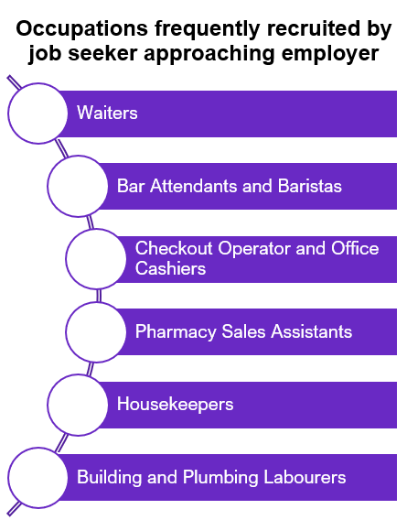
This recruitment method is used most frequently for lower‑skilled roles, particularly among Community and Personal Service Workers and Labourers. These occupations often have lower experience requirements and almost always only offer part‑time or casual employment (about 90% of the time).
About 20% of employers who hired for Technicians and Trades Workers roles found staff by being directly approached by job seekers, highlighting the ongoing importance of personal networks and industry connections in trades‑based occupations.

Background
The Recruitment Experiences and Outlook Survey (REOS) is an ongoing survey of employers across Australia. Approximately 1,000 employers are surveyed each month, with data published on the Jobs and Skills Australia website. While the data are indicative of recruitment activity, they may be subject to seasonal factors and other volatility and should therefore be used with caution. The survey is targeted towards employers with five or more employees and excludes many government organisations. Further information is available in the REOS methodology paper.
Data from the REOS are published monthly in the Recruitment Insights Report which is generally published on the third Tuesday of the month. Spotlights are also produced in most months, generally released in the first week of the month.

Technical notes
The REOS is a telephone administered survey with the business owner or other person in the business responsible for recruitment. All figures presented in this report have been weighted by location and workplace size, according to the Australian Bureau of Statistics Counts of Australian Businesses, including Entries and Exits (June 2018 to June 2022) publication. The weighted figures are intended to create nationally representative results by correcting for the oversampling of smaller regions compared with larger regions.
Data collected in the survey have been coded and reported according to the following ABS classifications:
- Industry is defined by the Australian and New Zealand Standard Industrial Classification (ANZSIC), 2006, Version 2.0.
- Occupation is defined by the Australian and New Zealand Standard Classification of Occupations (ANZSCO), 2022.
- Capital City and Rest of State areas are defined by the Australian Statistical Geography Standard (ASGS): Volume 1 - Main Structure and Greater Capital City Statistical Areas, July 2021.
Data in this release should be referenced as: Jobs and Skills Australia, REOS Spotlight, Finding “the One”: Methods and Successful Methods of Recruitment, February 2026.
For more information, email: reos@jobsandskills.gov.au

For more detailed information, please refer to Internet Vacancy Index (IVI) | Jobs and Skills Australia and Total New Vacancies | Jobs and Skills Australia.
Refers to employers who used a multi-method recruitment process.

