Recruitment Experiences and Outlook Survey: December quarter 2025
Jobs and Skills Australia conducts the Recruitment Experiences and Outlook Survey (REOS) to monitor recruitment activity and conditions across Australia. Key national indicators from the survey are released monthly. This quarterly report provides more detailed data, disaggregated by state, area, industry, and occupation. For definitions and further information on these data and the REOS, see the notes on the last page.

Recruitment rate - National level
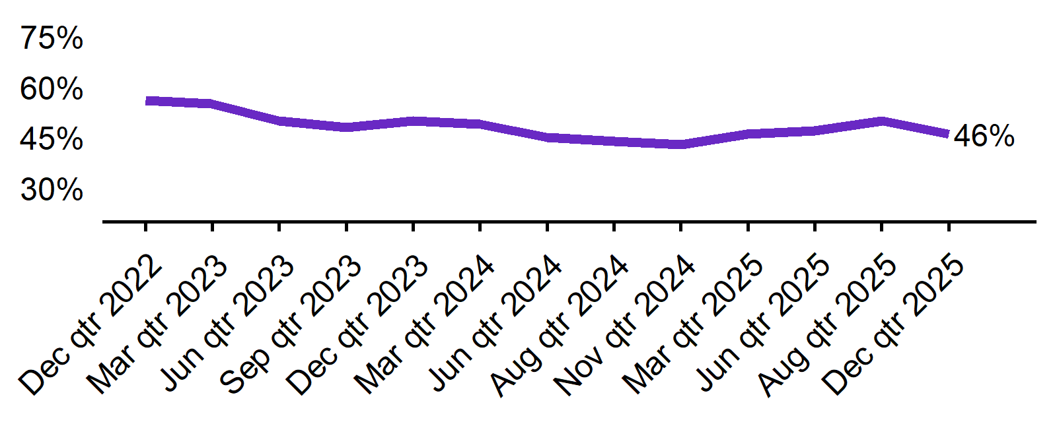 | - The recruitment rate in the December quarter 2025 was 46%.  - This was 3 percentage points higher than this time last year (43%).
  Dec qtr 2022 | Mar qtr 2023 | Jun qtr 2023 | Sep qtr 2023 | Dec qtr 2023 | Mar qtr 2024 | Jun qtr 2024 | Sep qtr 2024 | Dec qtr 2024 | Mar qtr 2025 | Jun qtr 2025 | Sep qtr 2025 | Dec qtr 2025
  56% | 55% | 50% | 48% | 50% | 49% | 45% | 44% | 43% | 46% | 47% | 50% | 46%

Recruitment difficulty rate - National level
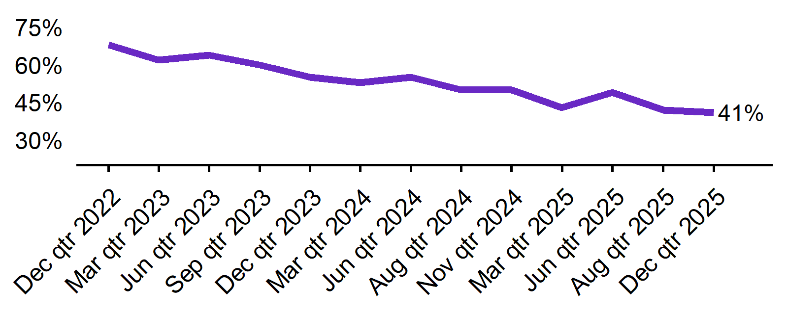 | - The recruitment difficulty rate in the December quarter 2025 was 41%.  - This was 9 percentage points lower than this time last year (50%).
  Dec qtr 2022 | Mar qtr 2023 | Jun qtr 2023 | Sep qtr 2023 | Dec qtr 2023 | Mar qtr 2024 | Jun qtr 2024 | Sep qtr 2024 | Dec qtr 2024 | Mar qtr 2025 | Jun qtr 2025 | Sep qtr 2025 | Dec qtr 2025
  68% | 62% | 64% | 60% | 55% | 53% | 55% | 50% | 50% | 43% | 49% | 42% | 41%

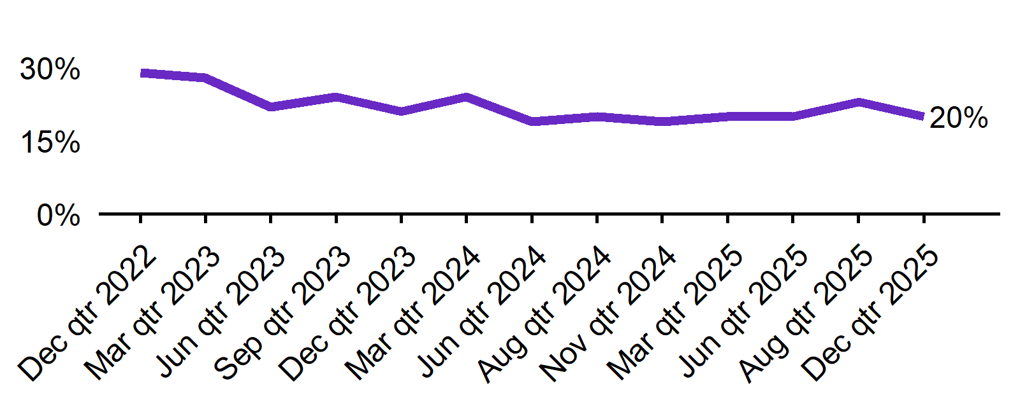
Expecting to increase staff - National level
 | - In the December quarter 2025, 20% of employers expected to increase staff. This was 1 percentage point higher than this time last year (19%).  - The proportion of employers who expected to decrease staff was 4% in the December quarter 2025.
  Dec qtr 2022 | Mar qtr 2023 | Jun qtr 2023 | Sep qtr 2023 | Dec qtr 2023 | Mar qtr 2024 | Jun qtr 2024 | Sep qtr 2024 | Dec qtr 2024 | Mar qtr 2025 | Jun qtr 2025 | Sep qtr 2025 | Dec qtr 2025
  29% | 28% | 22% | 24% | 21% | 24% | 19% | 20% | 19% | 20% | 20% | 23% | 20%

Key indicators by state/territory
In the December quarter 2025, recruitment activity in Queensland has continued to strengthen over the last four quarters, recording the highest recruitment rate (58%) of the six states. At 50%, Western Australia recorded the highest rate of state recruitment difficulty and was the only State to record an increase in difficulty over the year. Out of all states and territories, Northern Territory reported the highest recruitment rate (72%) , the highest recruitment difficulty rate (59%) and the highest optimism around future staffing (30%) in the December quarter 2025.

Table 1. Key indicators by state/territory, December quarter 2025
 | Recruitment rate |  | Recruitment difficulty rate |  | Expect to increase staff
 | % of employers | Annual change  (% points) | % of recruiting employers | Annual change  (% points) | % of employers | Annual change  (% points)
NSW | 42% | 3 pts | 37% | -13 pts | 20% | 1 pts
VIC | 41% | 2 pts | 34% | -9 pts | 17% | 0 pts
QLD | 58% | 9 pts | 48% | -11 pts | 25% | 6 pts
SA | 48% | 9 pts | 42%* | -10 pts* | 16% | -4 pts
WA | 49% | -5 pts | 50%* | 1 pts* | 19% | -1 pts
TAS | 43%* | -5 pts* | n.p | n.p | 25%* | 3 pts*
NT# | 72%* | 12 pts* | 59%* | -5 pts* | 30%* | 0 pts*
ACT# | 44% | 1 pts | 41%* | -2 pts* | 20% | -3 pts

# Due to smaller sample sizes, data for the NT and ACT are based on six-month average data (Sep qtr. to Dec qtr.).
* Interpret with caution due to low sample size, n.p – not published due to an insufficient sample.
Recruitment difficulty data for Tasmania are unavailable for the December quarter 2025 due to a limited sample size.

Figure 1. Recruitment rate by state, December quarter 2024 - December quarter 2025
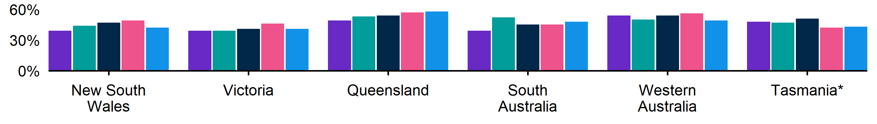
 | Dec qtr 2024 | Mar qtr 2025 | Jun qtr 2025 | Sep qtr 2025 | Dec qtr 2025
NSW | 39% | 44% | 47% | 49% | 42%
VIC | 39% | 39% | 41% | 46% | 41%
QLD | 49% | 53% | 54% | 57% | 58%
SA | 39% | 52% | 45% | 45% | 48%
WA | 54% | 50% | 54% | 56% | 49%
TAS | 48% | 47% | 51% | 42% | 43%*

Figure 2. Recruitment difficulty rate by state, December quarter 2024 - December quarter 2025
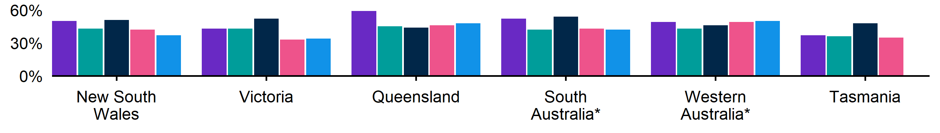
 | Dec qtr 2024 | Mar qtr 2025 | Jun qtr 2025 | Sep qtr 2025 | Dec qtr 2025
NSW | 50% | 43% | 51% | 42% | 37%
VIC | 43% | 43% | 52% | 33% | 34%
QLD | 59% | 45% | 44% | 46% | 48%
SA | 52% | 42%* | 54%* | 43%* | 42%*
WA | 49% | 43% | 46% | 49% | 50%*
TAS | 37%* | 36%* | 48%* | 35%* | n.p

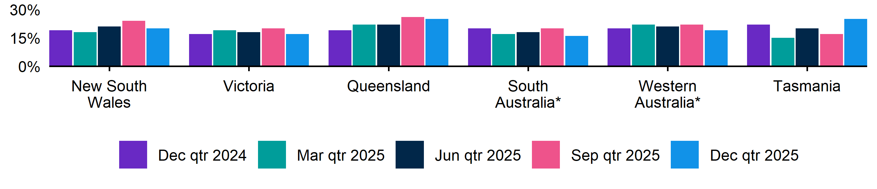
Figure 3. Expecting to increase staff numbers over the next 3 months by state, December quarter 2024 - December quarter 2025

 | Dec qtr 2024 | Mar qtr 2025 | Jun qtr 2025 | Sep qtr 2025 | Dec qtr 2025
NSW | 19% | 18% | 21% | 24% | 20%
VIC | 17% | 19% | 18% | 20% | 17%
QLD | 19% | 22% | 22% | 26% | 25%
SA | 20% | 17% | 18% | 20% | 16%
WA | 20% | 22% | 21% | 22% | 19%
TAS | 22% | 15% | 20% | 17% | 25%*

Key indicators by remoteness classification (ARIA location)
In the December quarter 2025, Outer Regional, Remote and Very Remote Australia recorded the highest recruitment rate of the ARIA regions, at 54%. This region also experienced the highest recruitment difficulty rate (52%). All three regions recorded an increase in recruitment activity and a decrease in recruitment difficulty over the year. Optimism around future staffing has been increasing over the last four quarters in Inner Regional Australia.

Table 2. Key indicators by ARIA location, December quarter 2025
 | Recruitment rate |  | Recruitment difficulty rate |  | Expect to increase staff
 | % of employers | Annual change  (% points) | % of recruiting employers | Annual change  (% points) | % of employers | Annual change  (% points)
Major Cities of Australia | 45% | 4 pts | 39% | -9 pts | 18% | -1 pts
Inner Regional Australia | 48% | 2 pts | 44% | -7 pts | 24% | 5 pts
Outer Regional, Remote and Very Remote Australia | 54% | 5 pts | 52% | -6 pts | 26% | 7 pts

* Interpret with caution due to low sample size. Accessibility and Remoteness Index of Australia (ARIA) classifications of Outer Regional Australia, Remote Australia, and Very Remote Australia have been combined into one category to increase sample size.

Figure 4. Recruitment rate by ARIA location, December quarter 2024 - December quarter 2025
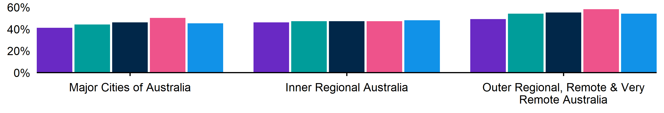
 | Dec qtr 2024 | Mar qtr 2025 | Jun qtr 2025 | Sep qtr 2025 | Dec qtr 2025
Major Cities of Australia | 41% | 44% | 46% | 50% | 45%
Inner Regional Australia | 46% | 47% | 47% | 47% | 48%
Outer Regional, Remote and Very Remote Australia | 49% | 54% | 55% | 58% | 54%

Figure 5. Recruitment difficulty rate by ARIA location, December quarter 2024 - December quarter 2025
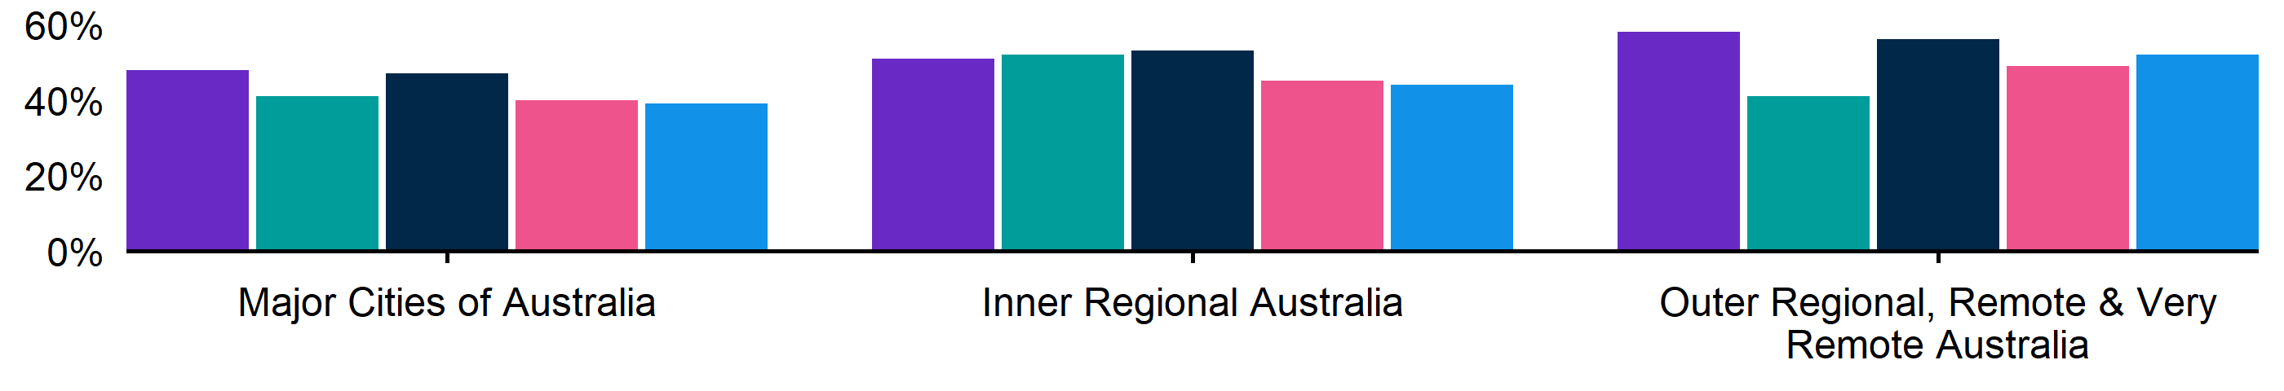
 | Dec qtr 2024 | Mar qtr 2025 | Jun qtr 2025 | Sep qtr 2025 | Dec qtr 2025
Major Cities of Australia | 48% | 41% | 47% | 40% | 39%
Inner Regional Australia | 51% | 52% | 53% | 45% | 44%
Outer Regional, Remote and Very Remote Australia | 58% | 41% | 56% | 49% | 52%

Figure 6. Expecting to increase staff numbers over the next 3 months by ARIA location, December quarter 2024 - December quarter 2025
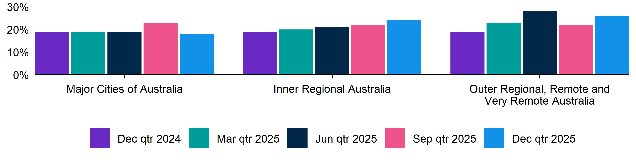
 | Dec qtr 2024 | Mar qtr 2025 | Jun qtr 2025 | Sep qtr 2025 | Dec qtr 2025
Major Cities of Australia | 19% | 19% | 19% | 23% | 18%
Inner Regional Australia | 19% | 20% | 21% | 22% | 24%
Outer Regional, Remote and Very Remote Australia | 19% | 23% | 28% | 22% | 26%

Key indicators by selected industries
In the December quarter 2025, Accommodation and Food Services recorded the highest recruitment rate (72%) of the selected industries. None of these industries recorded a decline in recruitment activity over the year. At 66%, Manufacturing experienced the highest rate of recruitment difficulty, increasing by 7 percentage points over the year (albeit with a smaller sample size). Notably, the Accommodation and Food Services industry reported the highest staffing optimism (35%).

Table 3. Key indicators by industry, December quarter 2025
 | Recruitment rate |  | Recruitment difficulty rate |  | Expect to increase staff
 | % of employers | Annual change  (% points) | % of recruiting employers | Annual change  (% points) | % of employers | Annual change  (% points)
Manufacturing | 41% | 2 pts | 66%* | 7 pts* | 20% | 4 pts
Construction | 48% | 6 pts | 49%* | -12 pts* | 18% | -1 pts
Wholesale Trade | 40%* | 7 pts* | n.p | n.p | 14%* | -1 pts*
Retail Trade | 41% | 0 pts | 41%* | 0 pts* | 14% | -3 pts
Accommodation and Food Services | 72% | 9 pts | 23%* | -4 pts* | 35% | 3 pts
Professional, Scientific and Technical Services | 36% | 5 pts | 31%* | -21 pts* | 21% | 3 pts
Health Care and Social Assistance | 59% | 8 pts | 41% | -6 pts | 23% | 7 pts

*Interpret with caution due to low sample size. No recruitment difficulty data for the Wholesale Trade industry are available in the December qtr 2025 due to a limited sample.

Figure 7. Recruitment rate by industry, December quarter 2024 - December quarter 2025
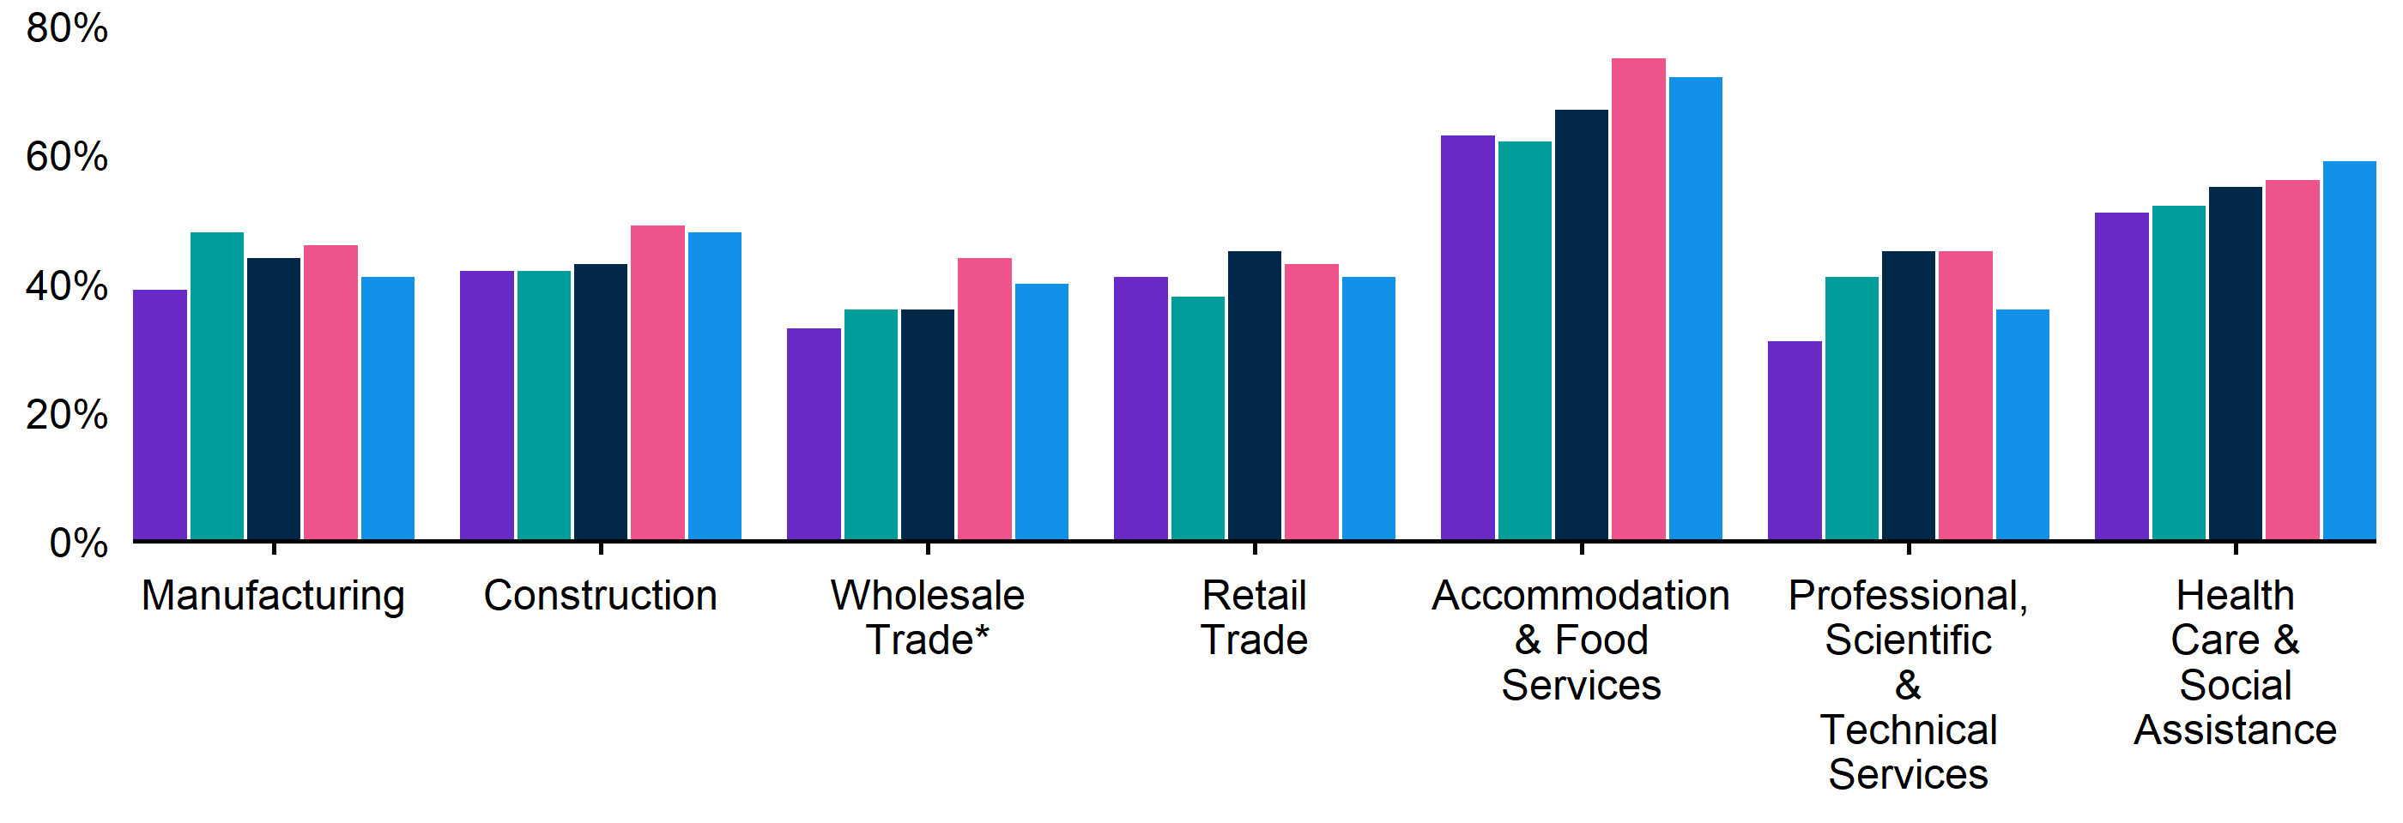
 | Dec qtr 2024 | Mar qtr 2025 | Jun qtr 2025 | Sep qtr 2025 | Dec qtr 2025
Manufacturing | 39% | 48% | 44% | 46% | 41%
Construction | 42% | 42% | 43% | 49% | 48%
Wholesale Trade | 33% | 36% | 36% | 44% | 40%*
Retail Trade | 41% | 38% | 45% | 43% | 41%
Accommodation and Food Services | 63% | 62% | 67% | 75% | 72%
Professional, Scientific and Technical Services | 31% | 41% | 45% | 45% | 36%
Health Care and Social Assistance | 51% | 52% | 55% | 56% | 59%

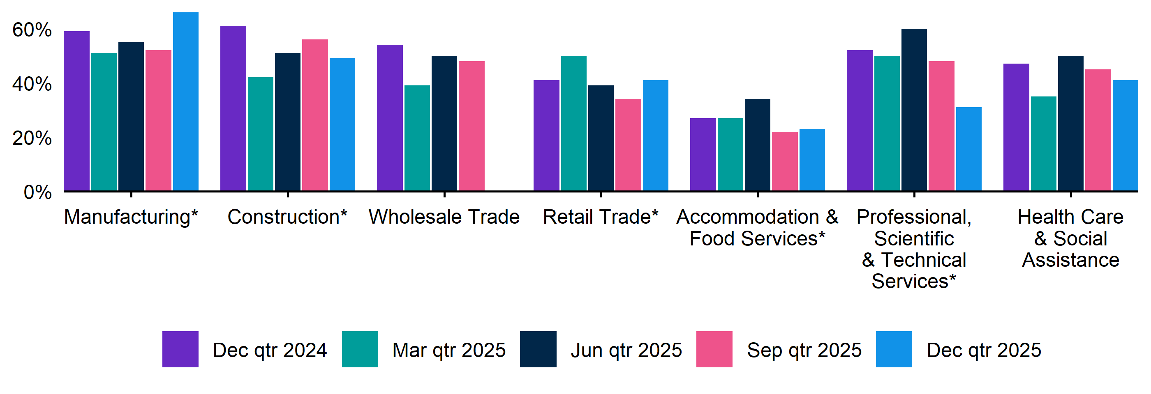
Figure 8. Recruitment difficulty rate by industry, December quarter 2024 - December quarter 2025

 | Dec qtr 2024 | Mar qtr 2025 | Jun qtr 2025 | Sep qtr 2025 | Dec qtr 2025
Manufacturing | 59% | 51% | 55% | 52% | 66%*
Construction | 61%* | 42%* | 51% | 56%* | 49%*
Wholesale Trade | 54%* | 39%* | 50%* | 48%*
Retail Trade | 41% | 50%* | 39%* | 34% | 41%*
Accommodation and Food Services | 27% | 27%* | 34%* | 22% | 23%*
Professional, Scientific and Technical Services | 52%* | 50%* | 60%* | 48%* | 31%*
Health Care and Social Assistance | 47% | 35% | 50% | 45% | 41%

Key indicators by selected occupation groups
In the December quarter 2025, Technicians and Trades Workers recorded the highest rate of recruitment difficulty, at 60%. All occupation groups, aside from Labourers, recorded a decrease in recruitment difficulty over the year. Machinery Operators and Drivers experienced the largest decrease in the recruitment difficulty rate (down 29 percentage points), aligning with the largest decrease in the proportion of vacancies remaining unfilled for over a month (down 20 percentage points), noting the smaller sample this quarter. At 64% (albeit with a smaller sample this quarter), employers recruiting for Professionals had the highest proportion of vacancies unfilled for longer than a month, a sharp increase of 11 percentage points over the year.

Table 4. Key indicators by occupation, December quarter 2025
 | Recruitment difficulty rate |  | Vacancies taking longer  than 1 month to fill
 | % of recruiting employers | Annual change  (% points) | % of recruiting employers | Annual change  (% points)
Professionals | 45%* | -9 pts* | 64%* | 11 pts*
Technicians and Trades Workers | 60% | -4 pts | 55% | -9 pts
Community and Personal Service Workers | 31% | -18 pts | 33% | -13 pts
Clerical and Administrative Workers | 29%* | -4 pts* | 33%* | -6 pts*
Sales Workers | 30% | -10 pts | 27%* | -8 pts*
Machinery Operators and Drivers | 42%* | -29 pts* | 31%* | -20 pts*
Labourers | 52%* | 13 pts* | 29%* | 5 pts*

*Interpret with caution due to low sample size.

Figure 9. Recruitment difficulty rate by occupation, December quarter 2024 - December quarter 2025
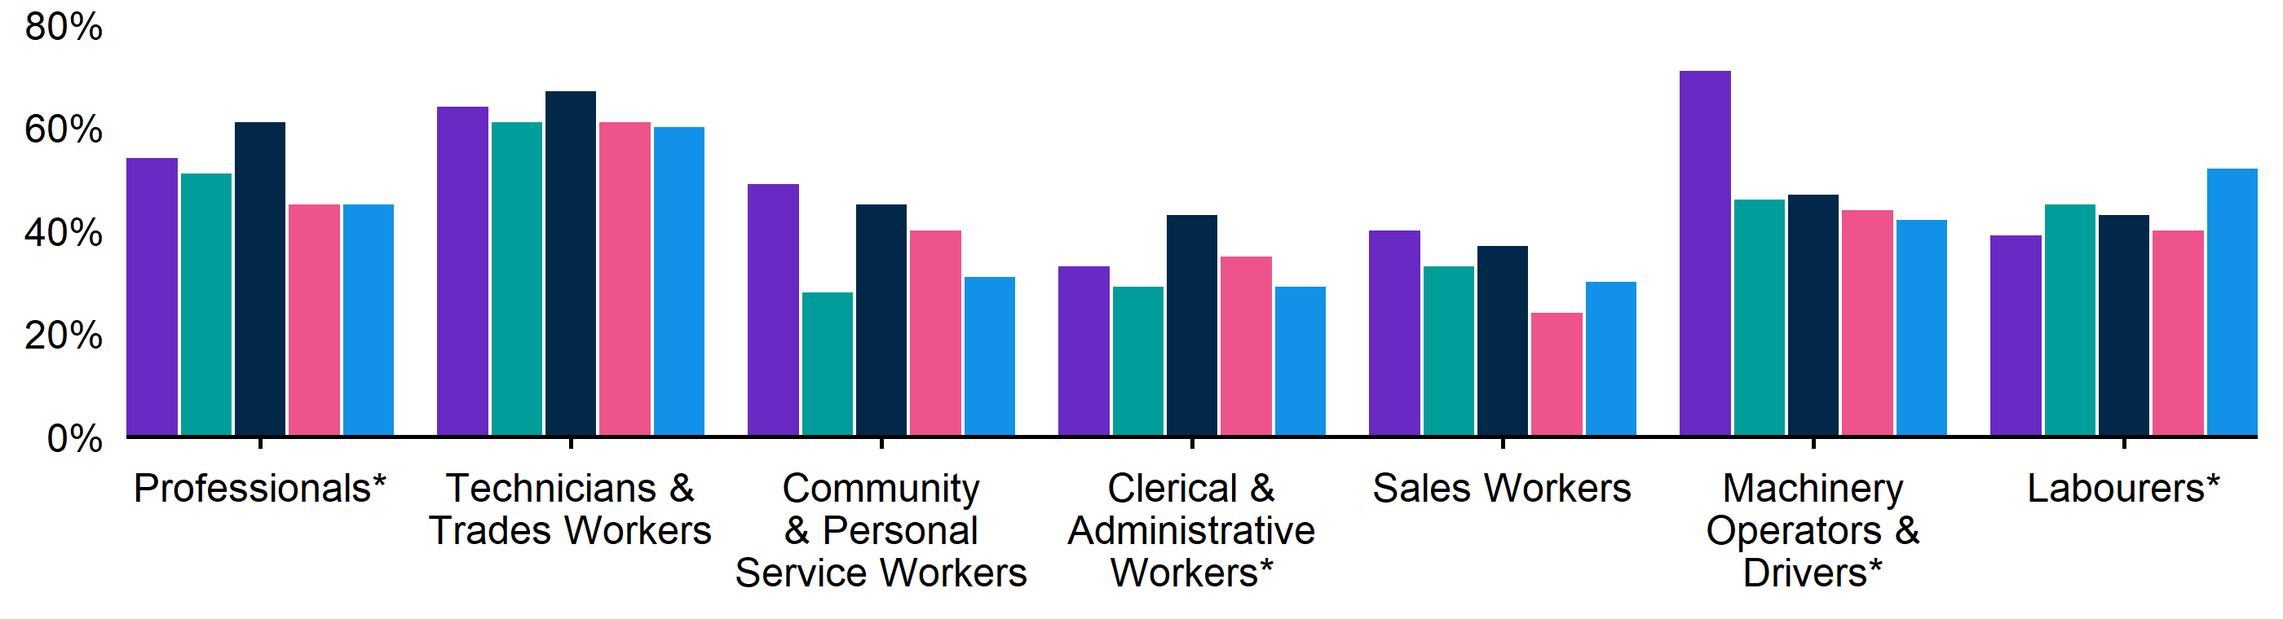
 | Dec qtr 2024 | Mar qtr 2025 | Jun qtr 2025 | Sep qtr 2025 | Dec qtr 2025
Professionals | 54%* | 51% | 61%* | 45% | 45%*
Technicians and Trades Workers | 64% | 61% | 67% | 61% | 60%
Community and Personal Service Workers | 49% | 28% | 45% | 40% | 31%
Clerical and Administrative Workers | 33% | 29%* | 43%* | 35%* | 29%*
Sales Workers | 40% | 33% | 37% | 24% | 30%
Machinery Operators and Drivers | 71%* | 46%* | 47%* | 44%* | 42%*
Labourers | 39% | 45% | 43% | 40% | 52%*

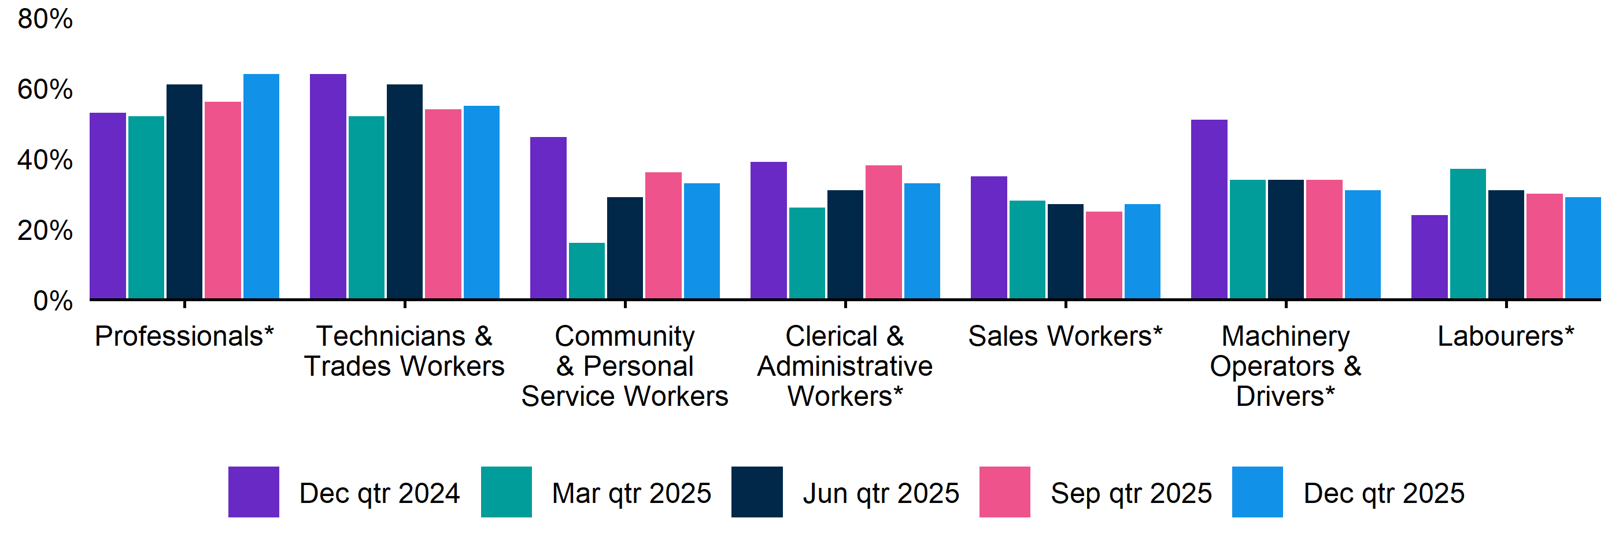
Figure 10. Vacancies taking longer than 1 month to fill, by occupation group, December quarter 2024 - December quarter 2025

 | Dec qtr 2024 | Mar qtr 2025 | Jun qtr 2025 | Sep qtr 2025 | Dec qtr 2025
Professionals | 53%* | 52%* | 61%* | 56% | 64%*
Technicians and Trades Workers | 64% | 52% | 61% | 54% | 55%
Community and Personal Service Workers | 46% | 16%* | 29%* | 36% | 33%
Clerical and Administrative Workers | 39%* | 26%* | 31%* | 38%* | 33%*
Sales Workers | 35% | 28% | 27% | 25% | 27%*
Machinery Operators and Drivers | 51%* | 34%* | 34%* | 34%* | 31%*
Labourers | 24% | 37%* | 31%* | 30%* | 29%*

REOS Background and Notes
Jobs and Skills Australia conducts the Recruitment Experiences and Outlook Survey (REOS), a telephone administered survey of at least 800 employers each month (except for December and January, during which fewer employers are surveyed). While the results are indicative of recruitment activity, they may be subject to seasonal factors and other volatility and should therefore be used with a degree of caution. In addition, the survey is targeted towards employers with 5 or more employees, and excludes many government organisations. More detail is available at https://www.jobsandskills.gov.au/work/reos-survey-methodology. REOS data are published on the Jobs and Skills Australia website.
Data in this release should be referenced as: Jobs and Skills Australia, Recruitment Experiences and Outlook Survey: December quarter 2025.

Data notations
* Interpret with caution due to low sample size.

Recruitment rate
The proportion of employers either currently recruiting or who had recruited in the previous month. It is calculated by dividing the number of employers who recruited or were attempting to recruit by the number of employers that responded to the survey (excluding ‘unsure’ responses).

Recruitment difficulty rate
The proportion of recruiting employers who experienced difficulty hiring staff. This indicator focusses on the most recent recruitment round in the month prior to being surveyed. The indicator is calculated as: employers who recruited and reported difficulty, divided by all employers who recruited (excluding ‘unsure’ responses).

Expectations to increase staffing levels over the next 3 months
This is calculated as the percentage of employers who expect to increase staff over the next 3 months, divided by all employers. Expectations to decrease staff is also collected.

Vacancies taking longer than 1 month to fill
The proportion of recruiting employers unable to fill all their vacancies within a month. It excludes employers with unfilled vacancies who have been recruiting for less than a month.

Recent REOS releases
The Jobs and Skills Australia website includes:
- The December 2025 detailed excel datafile. The datafile includes both the monthly results as well as the quarterly series. The quarterly estimates are aggregated results for the 3 months within each quarter.
- REOS Spotlight series featuring analysis on topics of interest not covered in the regular monthly. Recent spotlight releases cover entry level jobs by region, and employers’ experiences with retention issues.
For queries, contact: REOS@jobsandskills.gov.au

Australian Bureau of Statistics, Remoteness Areas, Australian Statistical Geography Standard (ASGS) Edition 3, https://www.abs.gov.au/statistics/standards/australian-statistical-geography-standard-asgs-edition-3/jul2021-jun2026/remoteness-structure/remoteness-areas

