


Total New Vacancies (TNV) series
  - Methodological note
November 2025

Overview
The new JSA Total New Vacancies (TNV) series offers quarterly estimates of the total number of new job vacancies across Australia, disaggregated by 2-digit ANZSCO occupation codes and SA4 regions.
Drawing on insights from JSA’s Recruitment Experiences and Outlook Survey (REOS), the TNV series adjusts data from the JSA Internet Vacancy Index (IVI) to account for changes in the use of online recruitment methods over time. The resultant series provides a new estimate of the total number of new vacancies (flow) each quarter. The TNV series serves as a valuable complement to existing labour market indicators, including the JSA IVI and the ABS Job Vacancy Series.
Users are advised to exercise caution when interpreting TNV data, as the methodology continues to evolve. Feedback and suggestions for improvement are welcomed to help refine and enhance the series.

Methodology overview
Understanding vacancy trends is a key component of labour market analysis. Job vacancies data can provide a leading indicator of employment growth and help identify differences in labour market conditions across regions and industries. Job vacancy rates are also a key component of Beveridge Curve analysis, which is useful to helping assess the efficiency of the labour market. As such, having an accurate measure of job vacancies is a key component of labour market analysis.
When it comes to recruitment, employers can use a wide range of methods during recruitment. This includes (but is not limited to) word of mouth, signs in shop windows, social media, newspaper advertisements and online job ads. Such methods may be used by employers as they seek to fill their job vacancies. While the JSA Internet Vacancy Index provides a useful count of the number of newly listed online job advertisements, it understates the total number of new vacancies due to the fact not all vacancies are advertised online. The use of online recruitment methods can also vary by region and industry/occupation. This can make identifying the total number of vacancies for a given occupation challenging.
To address this challenge, JSA has combined JSA IVI data with data from the JSA Recruitment Experiences and Outlook Survey (REOS). The JSA REOS is a continuous survey (of at least 1,000 employers each month) that provides a range of insights into employer behaviour, including how recruitment activities are changing over time. This includes surveying employers regarding whether they advertised their vacancies on the online job boards that contribute to the IVI (such as with Seek, CareerOne and/or Workforce Australia).
By way of example, according to insights on employer behaviour from the JSA REOS, the proportion of job vacancies advertised on IVI job boards rose from around 39% in 2016 to approximately 55% in 2024, reflecting the continued take-up of online job advertising by employers over time. Further, around 61% of vacancies for Professionals were listed on IVI job boards in 2024, compared with just 38% for Sales Workers, demonstrating the variation in employer preferences that can occur when recruiting for different occupations.
By combining JSA IVI data with JSA REOS data, the new JSA TNV dataset seeks to account for changes in the use of online recruitment methods over time, as well as differences in use between occupations (regions). This approach captures both temporal changes in the use of online job advertising and variations across occupations (regions). A straightforward adjustment factor is applied to reflect shifts in the proportion of vacancies advertised online, as well as differences in online recruitment usage across occupations (regions). To ensure the dataset is robust and suitable for analysis, standard smoothing and interpolation techniques are employed. These methods help mitigate point-to-point volatility present in the source data, enhancing the reliability and interpretability of the TNV series.

$$A_{t}=\left\{\begin{aligned}\frac{1}{k}\sum_{i=t}^{t+k-1}{x_{i}, if n≥100} \\ \frac{1}{k}\sum_{i=t}^{t+k-1}{H_{i}, if n<100}\end{aligned}\right.$$
Where:
$k$ is the window size
$x_{i}$ is the original mean series
$H_{i}$ is the aggregated mean series used when the sample size is insufficient

The adjustment factor $A_{t}$ creates a new total vacancy (TNV) measure by adjusting JSA IVI data according to the proportion of vacancies advertised online using the JSA REOS data ${v_{it}}/{A_{t}}$ where $v$ is the JSA IVI series. In simple terms, and by way of example, suppose that data from the JSA IVI shows that there are approximately 100 online job advertisements for a certain occupation in a given quarter. Suppose also that insights on employer behaviour from the JSA REOS show that for this occupation, around 60 per cent of all vacancies are advertised by employers on an IVI online job board, 40 per cent of vacancies managed through other recruitment methods. In simple terms, we can estimate the total number of vacancies in the labour market for this occupation as 100 / 0.6 = 167 total vacancies. This simple example demonstrates the type of approach taken to create the TNV.

Frequently Asked Questions

What led to JSA developing the TNV?
JSA’s role includes providing advice on the current, emerging and future skills needs of the economy. As part of this, JSA delivers a range of products that help to provide evidence of current trends in the labour market. The TNV complements these existing sources of labour market information by providing a new estimate of the total number of vacancies arising in the labour market each a quarter. The TNV was developed as part of a related modelling project undertaken by JSA.

Does the TNV represent total labour demand?
The TNV may help inform estimations of labour demand, noting that employment, wages, hours worked and labour productivity (among other factors) should also be considered when analysing labour demand. Seeking to gain a better understanding of the total level of vacancies in the labour market, and the resultant implications for estimating labour demand, was nonetheless a key factor that led to JSA’s development of the TNV.

How does the JSA TNV differ from the JSA Internet Vacancy Index and ABS Job Vacancy Series?
Table 1 below provides an overview of the key differences between the JSA TNV, JSA IVI and ABS JVS. This includes differences in the scope, frequency, disaggregation and length of the time series.
Table 1: Understanding the differences in various vacancy estimates
Vacancy series | Description | Source(s) | Freq. | Components | Start
JSA TNV | Modelled estimate of total new job vacancies that arose during the quarter | Online job boards data and employer surveys | Qtrly | - National  - 2-digit Occupation | 2016
 |  |  |  | - Region (SA4) | 2019
ABS JVS | A point-in-time stock estimate of vacancies (a count of currently open job vacancies) on the day of the survey (the Friday of the middle of the reference month) | Employer survey | Qtrly | - National  - State  - Industry | 1984
JSA IVI | Count of newly listed online job advertisements on the contributing online job boards during the calendar month | Online job boards data | Monthly | - National  - State  - IVI regions  - 4-digit Occupation | 2006
The estimate of vacancies from the JSA TNV is substantially larger than that of the JSA IVI. This is for two key reasons. First, the JSA TNV is a quarterly total, whereas the JSA IVI is a monthly total. And secondly, the JSA TNV has been calculated to take into account the fact that not all jobs are advertised online, unlike the JSA IVI which only counts online job advertisements from the job boards that contribute to the JSA IVI. As a result, the figures under the JSA TNV are substantially higher than that of the JSA IVI. Table 2 below provides the estimated levels from each of the relevant sources for May 2024.
Table 2: Different measures of vacancies in Australia – May 2024
Source (measure) |  | May-25 estimate
ABS | Job Vacancy Survey | 339,400
JSA | IVI online job advertisements - monthly | 210,095
JSA | IVI online job advertisements – qtrly total | 631,836
JSA | Total New Vacancies | 1,138,555

The difference between the JSA TNV and the ABS JVS can be understood as arising from the difference between point-in-time vacancy stock (as per the ABS JVS) and total vacancy flow (as per the JSA TNV) measures. The ABS Job Vacancy Survey provides a point-in-time estimate of the number of vacancies that are open on the day of the survey (the middle Friday of the reference month). In this way, the ABS JVS series is effectively a stock estimate of vacancies. By contrast, the JSA TNV estimates the total number of vacancies arising on any day point in the quarter. At the end of the quarter, some of these vacancies will remain open (similar to the ABS JVS measure), have been filled, or have been withdrawn from the market (i.e. gone unfilled). The difference between the two series can thus be explained by changes in the duration of time it takes for vacancies to be filled (including changes in the rate of vacancies going unfilled) as well as possible changes in the rate of job turnover. This helps explain the difference between the JSA TNV and ABS JVS series, as highlighted in Figure 2 below.
Figure 2: Comparison of ABS Job Vacancy Survey and JSA Total New Vacancies series over time
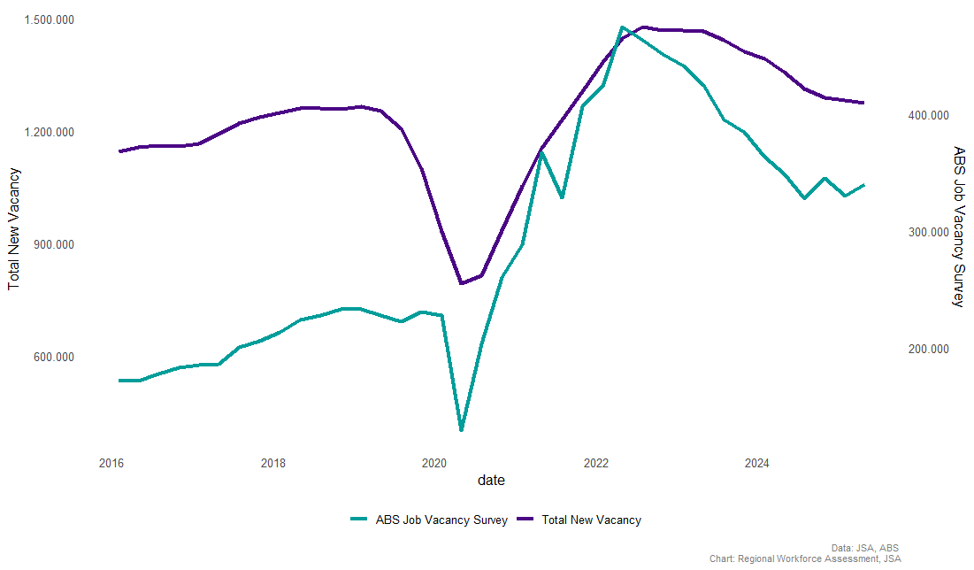

Figure 3: Understanding differences in vacancy measures, including stock and flow measures and sources – an illustrative example
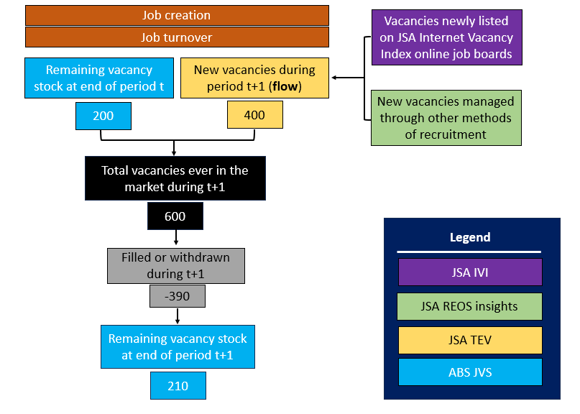

Does the TNV provide an indication of shortages?
Vacancy data alone does not provide an indication whether there is a labour market shortage, as the fill rates of vacancies can vary across the labour market. As such, caution should be exercised when using vacancy data to infer labour market conditions.

Is data available for the period prior to 2016?
Data is only available from 2016 onwards as the relevant supporting data from the JSA REOS only started being collected in 2016.

Is data on more detailed occupations and regions available?
The JSA Total New Vacancies (TNV) series is as an initial release, with data available for Australia and by 2-digit ANZSCO occupation and SA4 regions. JSA is continuing to review and develop the TNV series and may consider publishing the series on a regular basis and at more detailed levels of disaggregation in the future.

Feedback and future releases
JSA welcomes comments, feedback and questions to help improve the series, as well as feedback on the usefulness of the series for stakeholders. To provide feedback or submit an enquiry, please contact: JSA-Nowcasting@jobsandskills.gov.au

Acknowledgements
JSA would like to acknowledge and thank the following people and organisations for their engagement and feedback on the project to date:
- Seek, CareerOne and Workforce Australia for their ongoing contribution to the JSA Internet Vacancy Index.
- ABS, RBA, Treasury, e61 and Jeff Borland for their advice during the development of the TNV series.
- All other stakeholders and interested parties who have provided feedback following the initial release of the TNV series.

Further information on the concepts, methods and core questionnaire of the REOS survey can be found here noting that there are also additional questions asked in the survey beyond those in the core survey.
For reference, the average annual REOS sample size for Sales Workers vacancies was around 2,800 in 2021 and 2022, while for Professionals vacancies the average annual REOS sample size was 1,200.

