REOS Recruitment Insights Report - November 2025
Jobs and Skills Australia surveys around 800 employers in the Recruitment Experiences and Outlook Survey (REOS) each month to find out their experiences recruiting staff, and whether they are expecting to increase staffing levels.

Key Findings
Recruitment activity remained subdued in November 2025, with hiring levels lower than most months this year. Fewer employers were actively recruiting compared with October, and while activity was slightly above this time last year, there are signs of a slowdown compared to the early months of 2025. Both metropolitan and regional areas recorded similar declines compared to early 2025, reinforcing that this is a broad-based trend.
The easing in recruitment difficulty suggests that labour supply is improving, but this is occurring against a backdrop of reduced demand. Most hiring continues to be driven by staff turnover rather than business expansion, highlighting employers’ cautious approach to growth.
Vacancies are being filled more quickly, which points to better matching between jobseekers and employers. However, the low volume of recruitment means these improvements are occurring in a market where opportunities are more limited.
Overall, November reflects a labour market in transition— recruitment activity is at relatively low levels, growth intentions remain modest, and confidence is improving only gradually. Businesses appear focused on maintaining stability rather than pursuing significant workforce expansion.

Recruitment activity
Recruitment activity eased in November 2025, with the recruitment rate at 45%, down 3 percentage points from October but still 2 percentage points higher than November 2024. This decline suggests a cooling in demand after several months of stability, even as recruitment activity remains above last year’s level. The longer-term trend reinforces this moderation as the series peaked at 59% in May and July 2022 during the post-pandemic hiring surge, compared with a record low of 24% in June 2020.
Regional patterns show contrasting movements. Capital Cities recorded a recruitment rate of 44%, falling by 1 percentage point over the month but rising 4 percentage points compared with a year ago. Rest of State areas were slightly higher at 46%, yet this masks a sharper monthly decline of 8 percentage points and a 4-percentage point decline from November 2024. These shifts indicate that recruitment in metropolitan labour markets is more stable than in regional areas, where demand appears more sensitive to seasonal and economic pressures.
Overall, the data points to a labour market that is stabilising at relatively low recruitment levels compared to recent years. Employers remain active but cautious, with hiring focused on maintaining core staff rather than expansion. The divergence between city and regional trends suggests that growth opportunities are concentrated in metropolitan areas, while regional businesses are scaling back more significantly.

Recruitment difficulty
Recruitment difficulty continued to ease in November 2025, falling by 2 percentage points to 38% of recruiting employers. This marks a significant improvement compared with a year ago, when difficulty was 12 percentage points higher, and is well below the record high of 75% reached in July 2022. Historically, the series low was 37% in February 2021, placing current levels close to that trough.
Regional differences remain pronounced. In Capital Cities, 33% of recruiting employers reported difficulty, down 4 percentage points over the month and 21 percentage points lower than November 2024. This sustained improvement suggests metropolitan labour markets are benefiting from stronger candidate availability. In contrast, Rest of State areas recorded a difficulty rate of 47%, rising by 2 percentage points over the month and 3 percentage points above last year. This divergence indicates that regional employers are facing persistent challenges, even as overall conditions improve nationally.
These results point to a labour market where recruitment barriers are easing substantially, particularly in urban centres. However, the uptick in regional difficulty highlights uneven progress and suggests that location-specific factors continue to shape hiring conditions.

Staffing outlook: employers expecting to increase staff
Staffing outlook strengthened slightly in November 2025, with 20% of employers expecting to increase staff over the next three months, an increase of 2 percentage points from October and 2 percentage points higher than a year ago. While this marks a modest improvement, expectations remain well below the peak of 36% in April 2022 and are closer to pre-pandemic lows, where it reached the record low of 4% in April 2020.
Regional trends show mixed movements. In Capital Cities, 18% of employers anticipate hiring, a 4-percentage point increase over the month but unchanged from last year. This suggests a rebound in confidence after recent softness, though growth intentions remain modest. In contrast, Rest of State areas recorded 23%, down 1 percentage point from October but still 4 percentage points higher than a year ago, indicating that regional employers are maintaining a slightly stronger outlook despite short-term volatility over the year.
Overall, these figures point to cautious optimism rather than strong expansion. Employers appear willing to add staff selectively, but expectations remain subdued compared with historical highs, reflecting a labour market that is stabilising rather than accelerating.

Reason for recruiting
Recruitment in November 2025 was driven primarily by staff turnover, with 55% of employers hiring solely to replace departing employees. Expansionary hiring was less common, with 34% recruiting to fill new positions only. The remaining 11% were recruiting for both turnover and new roles. This pattern underscores a cautious approach to workforce growth, with most employers focused on maintaining existing staffing levels rather than pursuing significant expansion.

Staffing changes over the last month
In November 2025, 13% of employers reported increasing staff numbers, unchanged from the same time last year. Meanwhile, 11% reduced their workforce, up from 7% a year ago. This shift suggests that while growth remains subdued, workforce reductions are becoming more common, pointing to a cautious approach by employers and possible cost-containment measures in response to softer economic conditions.

Employers unable to fill vacancies in a month
The proportion of recruiting employers unable to fill vacancies within a month fell by 5 percentage points to 38% in November 2025. This is a notable improvement compared with November 2024, when the figure stood at 48%. These results suggest that labour supply and matching efficiency have improved significantly since the height of recruitment pressures.

REOS national indicators

Recruitment rate

Proportion of employers currently recruiting or who recruited in the previous month.
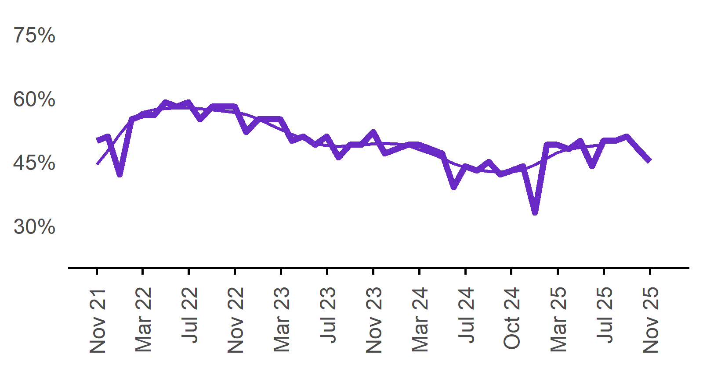 | 45%  Monthly change:  ▼ 3%pts  Annual change:  ▲ 2%pts
  Date | Recruitment rate | Smoothed recruitment rate
  Nov 2021 | 50% | 44%
  Dec 2021 | 51% | 48%
  Jan 2022 | 42% | 52%
  Feb 2022 | 55% | 55%
  Mar 2022 | 56% | 57%
  Apr 2022 | 56% | 57%
  May 2022 | 59% | 58%
  Jun 2022 | 58% | 58%
  Jul 2022 | 59% | 58%
  Aug 2022 | 55% | 58%
  Sep 2022 | 58% | 57%
  Oct 2022 | 58% | 57%
  Nov 2022 | 58% | 57%
  Dec 2022 | 52% | 56%
  Jan 2023 | 55% | 55%
  Feb 2023 | 55% | 54%
  Mar 2023 | 55% | 53%
  Apr 2023 | 50% | 52%
  May 2023 | 51% | 50%
  Jun 2023 | 49% | 49%
  Jul 2023 | 51% | 49%
  Aug 2023 | 46% | 49%
  Sep 2023 | 49% | 49%
  Oct 2023 | 49% | 49%
  Nov 2023 | 52% | 49%
  Dec 2023 | 47% | 49%
  Jan 2024 | 48% | 49%
  Feb 2024 | 49% | 49%
  Mar 2024 | 49% | 48%
  Apr 2024 | 48% | 47%
  May 2024 | 47% | 46%
  Jun 2024 | 39% | 45%
  Jul 2024 | 44% | 44%
  Aug 2024 | 43% | 43%
  Sep 2024 | 45% | 43%
  Oct 2024 | 42% | 43%
  Nov 2024 | 43% | 43%
  Dec 2024 | 44% | 43%
  Jan 2025 | 33% | 44%
  Feb 2025 | 49% | 46%
  Mar 2025 | 49% | 47%
  Apr 2025 | 48% | 48%
  May 2025 | 50% | 48%
  Jun 2025 | 44% | 49%
  Jul 2025 | 50% | 49%
  Aug 2025 | 50%
  Sep 2025 | 51%
  Oct 2025 | 48%
  Nov 2025 | 45%

Recruitment difficulty rate

Proportion of recruiting employers who stated they had difficulty hiring staff.
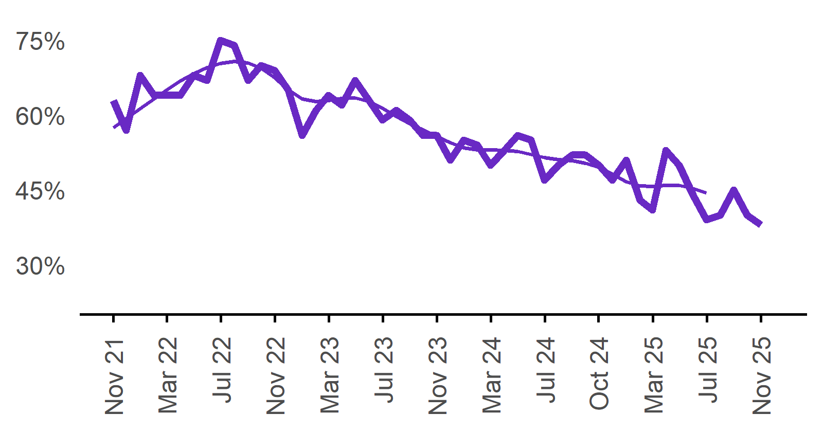 | 38%  Monthly change:  ▼ 2%pts  Annual change:  ▼ 12%pts
  Date | Recruitment difficulty rate | Smoothed recruitment difficulty rate
  Nov 2021 | 63% | 58%
  Dec 2021 | 57% | 59%
  Jan 2022 | 68%* | 61%
  Feb 2022 | 64% | 63%
  Mar 2022 | 64% | 65%
  Apr 2022 | 64% | 67%
  May 2022 | 68% | 68%
  Jun 2022 | 67% | 70%
  Jul 2022 | 75% | 70%
  Aug 2022 | 74% | 71%
  Sep 2022 | 67% | 71%
  Oct 2022 | 70% | 69%
  Nov 2022 | 69% | 68%
  Dec 2022 | 65% | 65%
  Jan 2023 | 56% | 63%
  Feb 2023 | 61% | 63%
  Mar 2023 | 64% | 63%
  Apr 2023 | 62% | 63%
  May 2023 | 67% | 63%
  Jun 2023 | 63% | 63%
  Jul 2023 | 59% | 61%
  Aug 2023 | 61% | 60%
  Sep 2023 | 59% | 58%
  Oct 2023 | 56% | 57%
  Nov 2023 | 56% | 56%
  Dec 2023 | 51% | 55%
  Jan 2024 | 55% | 54%
  Feb 2024 | 54% | 53%
  Mar 2024 | 50% | 53%
  Apr 2024 | 53% | 53%
  May 2024 | 56% | 53%
  Jun 2024 | 55% | 52%
  Jul 2024 | 47% | 51%
  Aug 2024 | 50% | 51%
  Sep 2024 | 52% | 51%
  Oct 2024 | 52% | 50%
  Nov 2024 | 50% | 50%
  Dec 2024 | 47% | 48%
  Jan 2025 | 51% | 47%
  Feb 2025 | 43% | 46%
  Mar 2025 | 41% | 46%
  Apr 2025 | 53% | 46%
  May 2025 | 50% | 46%
  Jun 2025 | 44% | 45%
  Jul 2025 | 39% | 44%
  Aug 2025 | 40%
  Sep 2025 | 45%
  Oct 2025 | 40%
  Nov 2025 | 38%

Expecting to increase staff

Proportion of employers who expected to increase staffing numbers over the next three months.
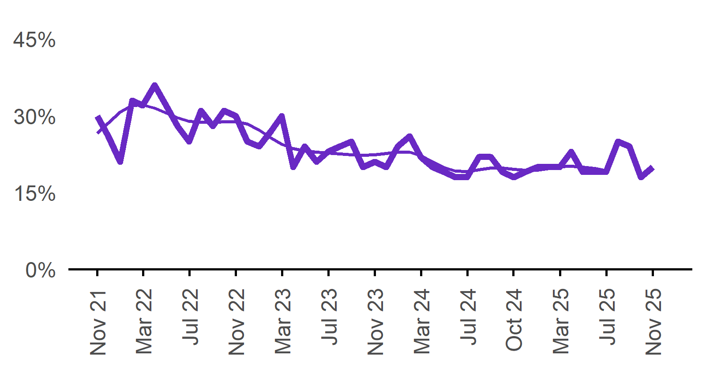 | 20%  Monthly change:  ▲ 2%pts  Annual change:  ▲ 2%pts
  Date | Expect to increase | Smoothed expect to increase
  Nov 2021 | 30% | 27%
  Dec 2021 | 26% | 29%
  Jan 2022 | 21% | 31%
  Feb 2022 | 33% | 32%
  Mar 2022 | 32% | 32%
  Apr 2022 | 36% | 31%
  May 2022 | 32% | 31%
  Jun 2022 | 28% | 30%
  Jul 2022 | 25% | 29%
  Aug 2022 | 31% | 29%
  Sep 2022 | 28% | 29%
  Oct 2022 | 31% | 29%
  Nov 2022 | 30% | 29%
  Dec 2022 | 25% | 28%
  Jan 2023 | 24% | 27%
  Feb 2023 | 27% | 26%
  Mar 2023 | 30% | 24%
  Apr 2023 | 20% | 24%
  May 2023 | 24% | 23%
  Jun 2023 | 21% | 23%
  Jul 2023 | 23% | 23%
  Aug 2023 | 24% | 23%
  Sep 2023 | 25% | 22%
  Oct 2023 | 20% | 22%
  Nov 2023 | 21% | 22%
  Dec 2023 | 20% | 23%
  Jan 2024 | 24% | 23%
  Feb 2024 | 26% | 23%
  Mar 2024 | 22% | 22%
  Apr 2024 | 20% | 21%
  May 2024 | 19% | 20%
  Jun 2024 | 18% | 19%
  Jul 2024 | 18% | 19%
  Aug 2024 | 22% | 19%
  Sep 2024 | 22% | 20%
  Oct 2024 | 19% | 20%
  Nov 2024 | 18% | 20%
  Dec 2024 | 19% | 19%
  Jan 2025 | 20% | 19%
  Feb 2025 | 20% | 20%
  Mar 2025 | 20% | 20%
  Apr 2025 | 23% | 20%
  May 2025 | 19% | 20%
  Jun 2025 | 19% | 20%
  Jul 2025 | 19% | 19%
  Aug 2025 | 25%
  Sep 2025 | 24%
  Oct 2025 | 18%
  Nov 2025 | 20%

Capital City/Rest of State areas

Recruitment rate

Proportion of employers currently recruiting or who recruited in the previous month.
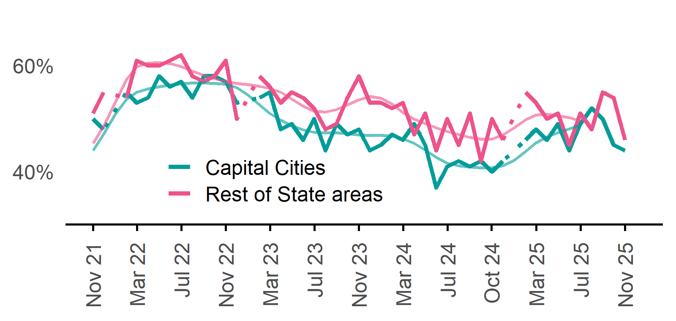 | Capital Cities: 44%  Monthly change:  ▼ 1%pts  Annual change:  ▲ 4%pts  Rest of State: 46%  Monthly change:  ▼ 8%pts  Annual change:  ▼ 4%pts
  Date | Capital Cities - Recruitment rate | Rest of State areas - Recruitment rate | Capital Cities - Smoothed recruitment rate | Rest of State areas - Smoothed recruitment rate
  Nov 2021 | 50% | 51% | 44% | 45%
  Dec 2021 | 48% | 55% | 47% | 49%
  Jan 2022 | n.p. | n.p. | 51% | 53%
  Feb 2022 | 55% | 54% | 54% | 57%
  Mar 2022 | 53% | 61% | 55% | 60%
  Apr 2022 | 54% | 60% | 56% | 61%
  May 2022 | 58% | 60% | 56% | 61%
  Jun 2022 | 56% | 61% | 56% | 60%
  Jul 2022 | 57% | 62% | 57% | 60%
  Aug 2022 | 54% | 58% | 57% | 59%
  Sep 2022 | 58% | 57% | 57% | 58%
  Oct 2022 | 58% | 58% | 57% | 58%
  Nov 2022 | 57% | 61% | 56% | 57%
  Dec 2022 | 53% | 50% | 56% | 57%
  Jan 2023 | n.p. | n.p. | 54% | 56%
  Feb 2023 | 54% | 58% | 53% | 56%
  Mar 2023 | 55% | 56% | 51% | 56%
  Apr 2023 | 48% | 53% | 50% | 55%
  May 2023 | 49% | 55% | 49% | 54%
  Jun 2023 | 46% | 54% | 48% | 52%
  Jul 2023 | 50% | 52% | 47% | 51%
  Aug 2023 | 44% | 48% | 47% | 51%
  Sep 2023 | 49% | 49% | 47% | 52%
  Oct 2023 | 47% | 54% | 47% | 53%
  Nov 2023 | 48% | 58% | 47% | 54%
  Dec 2023 | 44% | 53% | 47% | 54%
  Jan 2024 | 45% | 53% | 47% | 54%
  Feb 2024 | 47% | 52% | 47% | 53%
  Mar 2024 | 46% | 53% | 46% | 51%
  Apr 2024 | 49% | 47% | 45% | 50%
  May 2024 | 45% | 51% | 44% | 49%
  Jun 2024 | 37% | 44% | 43% | 48%
  Jul 2024 | 41% | 50% | 42% | 48%
  Aug 2024 | 42% | 45% | 41% | 47%
  Sep 2024 | 41% | 51% | 41% | 46%
  Oct 2024 | 42% | 42% | 41% | 46%
  Nov 2024 | 40% | 50% | 41% | 46%
  Dec 2024 | 42% | 46% | 41% | 47%
  Jan 2025 | n.p. | n.p. | 42% | 48%
  Feb 2025 | 46% | 55% | 44% | 50%
  Mar 2025 | 48% | 53% | 45% | 51%
  Apr 2025 | 46% | 50% | 47% | 51%
  May 2025 | 49% | 51% | 47% | 51%
  Jun 2025 | 44% | 45% | 48% | 50%
  Jul 2025 | 49% | 51% | 49% | 50%
  Aug 2025 | 52% | 48%
  Sep 2025 | 50% | 55%
  Oct 2025 | 45% | 54%
  Nov 2025 | 44% | 46%

Recruitment difficulty rate

Proportion of recruiting employers who stated they had difficulty hiring staff.
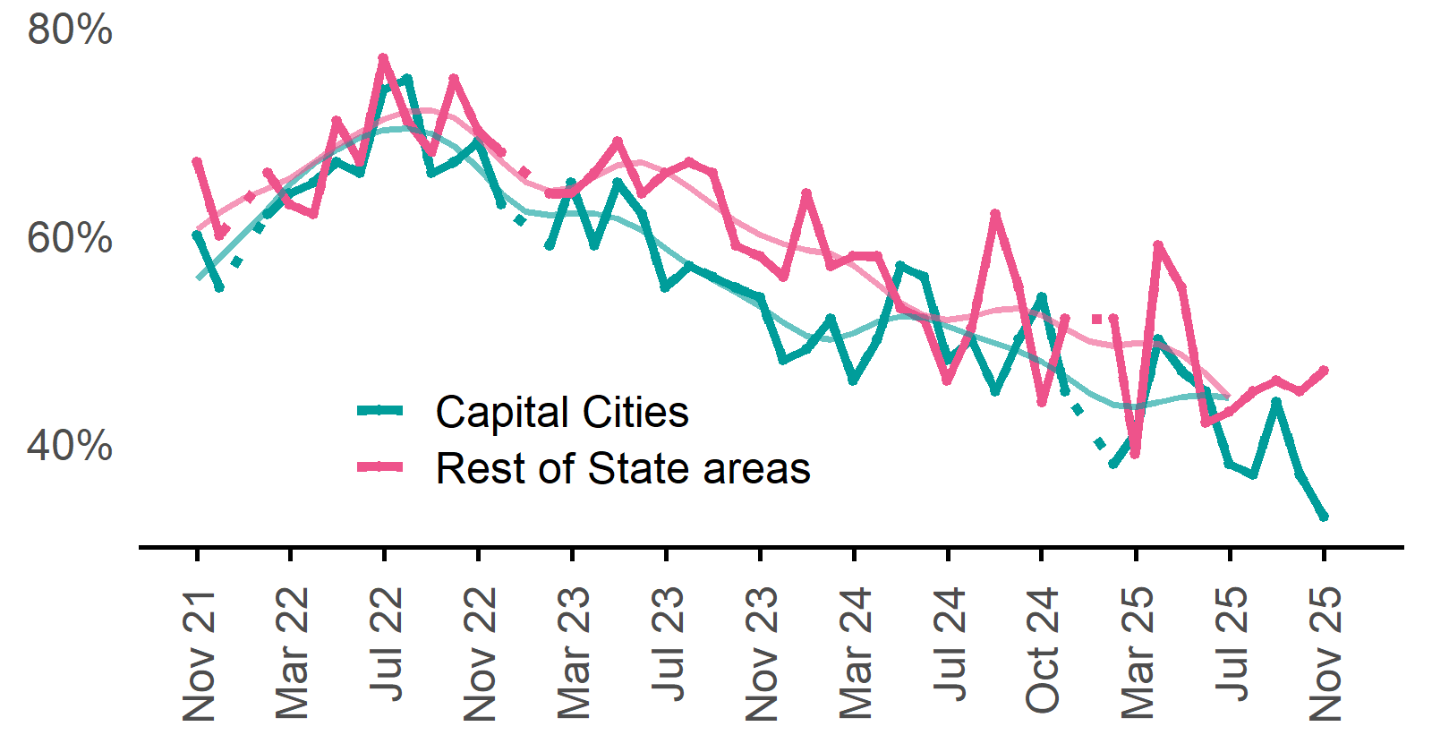 | Capital Cities: 33%  Monthly change:  ▼ 4%pts  Annual change:  ▼ 21%pts  Rest of State: 47%  Monthly change:  ▲ 2%pts  Annual change:  ▲ 3%pts
  Date | Capital Cities - Recruitment difficulty rate | Rest of State areas - Recruitment difficulty rate | Capital Cities - Smoothed recruitment difficulty rate | Rest of State areas - Smoothed recruitment difficulty rate
  Nov 2021 | 60% | 67% | 56% | 61%
  Dec 2021 | 55% | 60% | 58% | 62%
  Jan 2022 | n.p. | n.p. | 60% | 64%
  Feb 2022 | 62% | 66% | 63% | 64%
  Mar 2022 | 64% | 63% | 65% | 65%
  Apr 2022 | 65% | 62% | 67% | 67%
  May 2022 | 67% | 71% | 68% | 69%
  Jun 2022 | 66% | 67% | 69% | 70%
  Jul 2022 | 74% | 77% | 70% | 71%
  Aug 2022 | 75% | 71% | 70% | 72%
  Sep 2022 | 66% | 68% | 70% | 72%
  Oct 2022 | 67% | 75% | 69% | 71%
  Nov 2022 | 69% | 70% | 66% | 69%
  Dec 2022 | 63% | 68% | 64% | 67%
  Jan 2023 | n.p. | n.p. | 62% | 65%
  Feb 2023 | 59% | 64% | 62% | 64%
  Mar 2023 | 65% | 64% | 62% | 65%
  Apr 2023 | 59% | 66% | 62% | 66%
  May 2023 | 65% | 69% | 62% | 67%
  Jun 2023 | 62% | 64% | 60% | 67%
  Jul 2023 | 55% | 66% | 59% | 66%
  Aug 2023 | 57% | 67% | 57% | 65%
  Sep 2023 | 56% | 66% | 56% | 63%
  Oct 2023 | 55% | 59% | 55% | 61%
  Nov 2023 | 54% | 58% | 53% | 60%
  Dec 2023 | 48% | 56% | 52% | 59%
  Jan 2024 | 49% | 64% | 50% | 59%
  Feb 2024 | 52% | 57% | 50% | 58%
  Mar 2024 | 46% | 58% | 51% | 57%
  Apr 2024 | 50% | 58% | 52% | 55%
  May 2024 | 57% | 53% | 52% | 53%
  Jun 2024 | 56% | 52% | 52% | 52%
  Jul 2024 | 48% | 46% | 51% | 52%
  Aug 2024 | 50% | 51% | 50% | 52%
  Sep 2024 | 45% | 62% | 50% | 53%
  Oct 2024 | 50% | 55% | 49% | 53%
  Nov 2024 | 54% | 44% | 48% | 52%
  Dec 2024 | 45% | 52% | 46% | 51%
  Jan 2025 | n.p. | n.p. | 45% | 50%
  Feb 2025 | 38% | 52% | 44% | 49%
  Mar 2025 | 41% | 39% | 44% | 50%
  Apr 2025 | 50% | 59% | 44% | 50%
  May 2025 | 47% | 55% | 44% | 49%
  Jun 2025 | 45% | 42% | 45% | 47%
  Jul 2025 | 38% | 43% | 44% | 44%
  Aug 2025 | 37% | 45%
  Sep 2025 | 44% | 46%
  Oct 2025 | 37% | 45%
  Nov 2025 | 33% | 47%

Staffing outlook – Expecting to increase staff

Proportion of employers who expected to increase staffing numbers over the next three months.
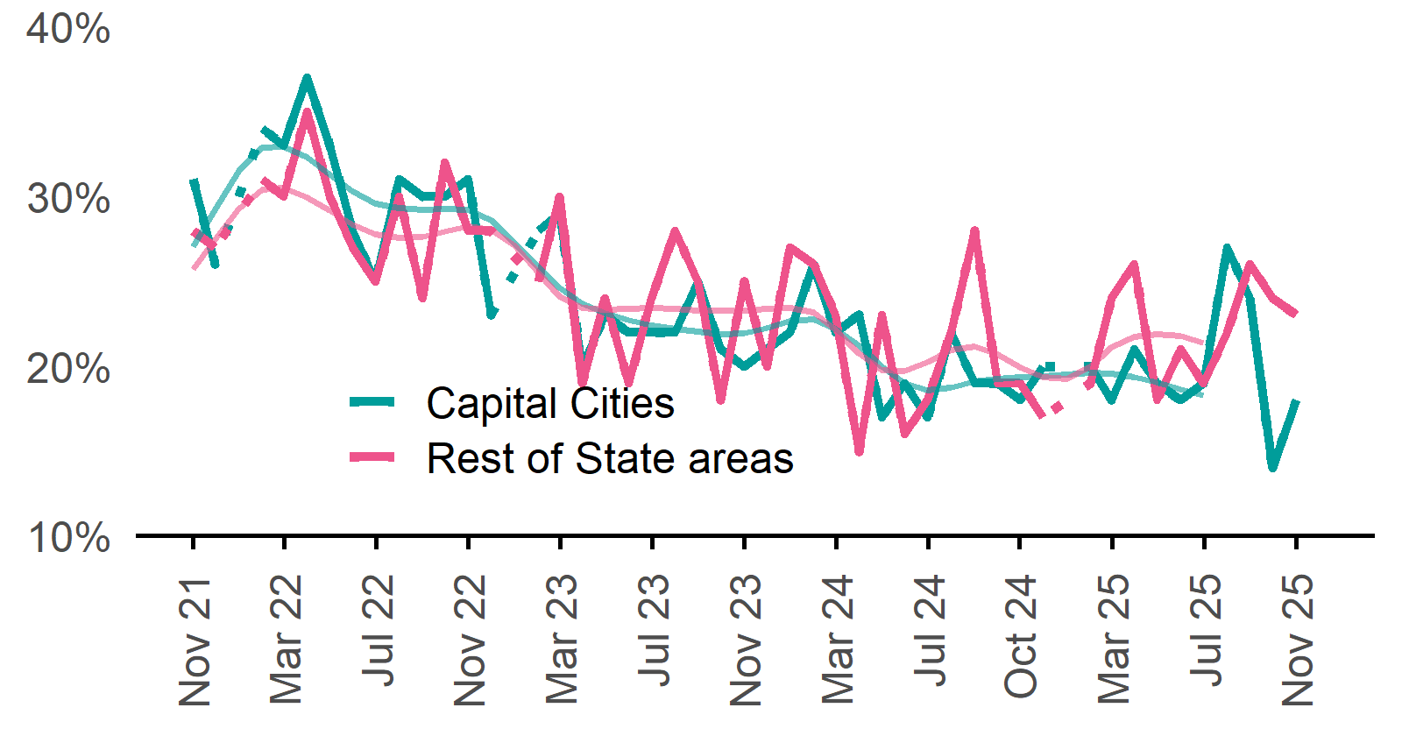 | Capital Cities: 18%  Monthly change:  ▲ 4%pts  Annual change:  ◄► 0%pts  Rest of State: 23%  Monthly change:  ▼ 1%pts  Annual change:  ▲ 4%pts
  Date | Capital Cities - % expecting to increase | Rest of State areas - % expecting to increase | Capital Cities - Smoothed % expecting to increase | Rest of State areas - Smoothed % expecting to increase
  Nov 2021 | 31% | 28% | 27% | 26%
  Dec 2021 | 26% | 27% | 29% | 27%
  Jan 2022 | n.p. | n.p. | 31% | 29%
  Feb 2022 | 34% | 31% | 33% | 30%
  Mar 2022 | 33% | 30% | 33% | 30%
  Apr 2022 | 37% | 35% | 32% | 30%
  May 2022 | 33% | 30% | 31% | 29%
  Jun 2022 | 28% | 27% | 30% | 28%
  Jul 2022 | 25% | 25% | 30% | 28%
  Aug 2022 | 31% | 30% | 29% | 28%
  Sep 2022 | 30% | 24% | 29% | 28%
  Oct 2022 | 30% | 32% | 29% | 28%
  Nov 2022 | 31% | 28% | 29% | 28%
  Dec 2022 | 23% | 28% | 29% | 28%
  Jan 2023 | n.p. | n.p. | 27% | 27%
  Feb 2023 | 28% | 25% | 26% | 26%
  Mar 2023 | 29% | 30% | 25% | 24%
  Apr 2023 | 20% | 19% | 24% | 23%
  May 2023 | 23% | 24% | 23% | 23%
  Jun 2023 | 22% | 19% | 23% | 23%
  Jul 2023 | 22% | 24% | 22% | 23%
  Aug 2023 | 22% | 28% | 22% | 23%
  Sep 2023 | 25% | 25% | 22% | 23%
  Oct 2023 | 21% | 18% | 22% | 23%
  Nov 2023 | 20% | 25% | 22% | 23%
  Dec 2023 | 21% | 20% | 22% | 23%
  Jan 2024 | 22% | 27% | 23% | 23%
  Feb 2024 | 26% | 26% | 23% | 23%
  Mar 2024 | 22% | 23% | 22% | 22%
  Apr 2024 | 23% | 15% | 21% | 21%
  May 2024 | 17% | 23% | 20% | 20%
  Jun 2024 | 19% | 16% | 19% | 20%
  Jul 2024 | 17% | 18% | 19% | 20%
  Aug 2024 | 22% | 22% | 19% | 21%
  Sep 2024 | 19% | 28% | 19% | 21%
  Oct 2024 | 19% | 19% | 19% | 21%
  Nov 2024 | 18% | 19% | 19% | 20%
  Dec 2024 | 20% | 17% | 19% | 19%
  Jan 2025 | n.p. | n.p. | 20% | 19%
  Feb 2025 | 20% | 19% | 20% | 20%
  Mar 2025 | 18% | 24% | 20% | 21%
  Apr 2025 | 21% | 26% | 19% | 22%
  May 2025 | 19% | 18% | 19% | 22%
  Jun 2025 | 18% | 21% | 19% | 22%
  Jul 2025 | 19% | 19% | 18% | 21%
  Aug 2025 | 27% | 22%
  Sep 2025 | 24% | 26%
  Oct 2025 | 14% | 24%
  Nov 2025 | 18% | 23%

Other recruitment indicators

Reason for recruiting

Proportion of employers currently recruiting or who recruited in the previous month.
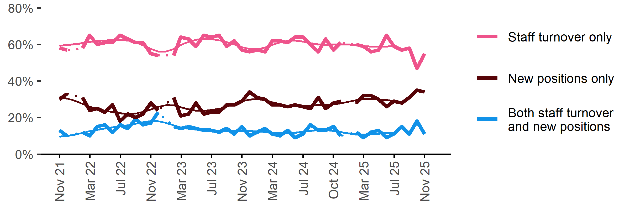
Date | Staff turnover only | Staff turnover and new positions | New positions only | Smoothed - staff turnover only | Smoothed - staff turnover and new positions | Smoothed - new positions only
Nov 2021 | 58% | 13% | 30% | 59% | 10% | 31%
Dec 2021 | 57% | 10% | 33% | 60% | 10% | 30%
Jan 2022 | n.p. | n.p. | n.p. | 60% | 11% | 29%
Feb 2022 | 58% | 12% | 31% | 61% | 12% | 28%
Mar 2022 | 65% | 10% | 24% | 62% | 13% | 26%
Apr 2022 | 60% | 15% | 25% | 62% | 13% | 25%
May 2022 | 61% | 16% | 23% | 62% | 14% | 24%
Jun 2022 | 61% | 12% | 27% | 62% | 15% | 23%
Jul 2022 | 65% | 16% | 18% | 63% | 15% | 22%
Aug 2022 | 63% | 14% | 22% | 62% | 16% | 22%
Sep 2022 | 61% | 19% | 20% | 61% | 17% | 22%
Oct 2022 | 61% | 16% | 22% | 60% | 17% | 23%
Nov 2022 | 55% | 17% | 28% | 58% | 18% | 24%
Dec 2022 | 54% | 23% | 24% | 56% | 18% | 26%
Jan 2023 | n.p. | n.p. | n.p. | 56% | 17% | 27%
Feb 2023 | 54% | 15% | 31% | 58% | 16% | 27%
Mar 2023 | 64% | 14% | 21% | 60% | 15% | 26%
Apr 2023 | 63% | 15% | 22% | 61% | 14% | 25%
May 2023 | 59% | 14% | 28% | 63% | 13% | 24%
Jun 2023 | 65% | 13% | 22% | 63% | 13% | 24%
Jul 2023 | 64% | 13% | 23% | 63% | 13% | 24%
Aug 2023 | 65% | 12% | 23% | 62% | 13% | 25%
Sep 2023 | 59% | 14% | 27% | 61% | 13% | 26%
Oct 2023 | 62% | 11% | 27% | 60% | 13% | 27%
Nov 2023 | 57% | 15% | 29% | 59% | 13% | 29%
Dec 2023 | 56% | 10% | 34% | 58% | 13% | 30%
Jan 2024 | 57% | 12% | 31% | 57% | 12% | 30%
Feb 2024 | 56% | 14% | 30% | 58% | 12% | 30%
Mar 2024 | 62% | 11% | 27% | 60% | 12% | 28%
Apr 2024 | 62% | 10% | 27% | 61% | 12% | 27%
May 2024 | 61% | 13% | 26% | 62% | 11% | 27%
Jun 2024 | 64% | 9% | 27% | 62% | 12% | 26%
Jul 2024 | 64% | 11% | 26% | 62% | 12% | 26%
Aug 2024 | 60% | 16% | 25% | 61% | 13% | 27%
Sep 2024 | 56% | 13% | 31% | 60% | 13% | 27%
Oct 2024 | 63% | 13% | 25% | 60% | 13% | 27%
Nov 2024 | 57% | 15% | 28% | 60% | 13% | 27%
Dec 2024 | 61% | 10% | 29% | 60% | 12% | 28%
Jan 2025 | n.p. | n.p. | n.p. | 60% | 11% | 29%
Feb 2025 | 60% | 12% | 28% | 60% | 11% | 30%
Mar 2025 | 59% | 9% | 32% | 59% | 11% | 30%
Apr 2025 | 56% | 12% | 32% | 59% | 11% | 30%
May 2025 | 57% | 13% | 30% | 59% | 11% | 30%
Jun 2025 | 65% | 9% | 26% | 59% | 12% | 30%
Jul 2025 | 59% | 11% | 29% | 59% | 12% | 29%
Aug 2025 | 57% | 15% | 28%
Sep 2025 | 58% | 11% | 31%
Oct 2025 | 47% | 18% | 35%
Nov 2025 | 55% | 11% | 34%

Staffing changes over the last month

Proportion of employers who said they increased or decreased staffing compared to the previous month.
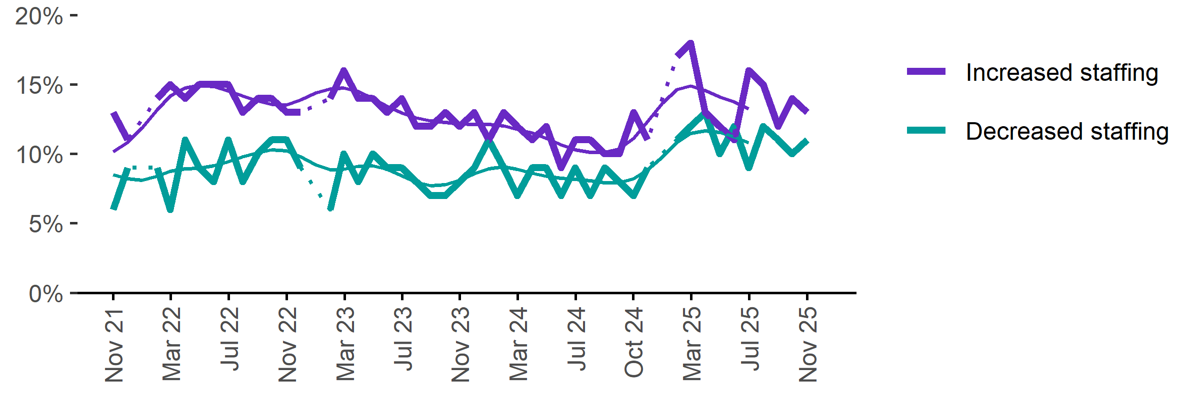
Date | Increased staff | Decreased staff | Smoothed - increased staff | Smoothed - decreased staff
Nov 2021 | 13% | 6% | 10% | 8%
Dec 2021 | 11% | 9% | 11% | 8%
Jan 2022 | n.p. | n.p. | 12% | 8%
Feb 2022 | 14% | 9% | 13% | 8%
Mar 2022 | 15% | 6% | 14% | 9%
Apr 2022 | 14% | 11% | 15% | 9%
May 2022 | 15% | 9% | 15% | 9%
Jun 2022 | 15% | 8% | 15% | 9%
Jul 2022 | 15% | 11% | 15% | 9%
Aug 2022 | 13% | 8% | 14% | 10%
Sep 2022 | 14% | 10% | 14% | 10%
Oct 2022 | 14% | 11% | 14% | 10%
Nov 2022 | 13% | 11% | 14% | 10%
Dec 2022 | 13% | 9% | 14% | 10%
Jan 2023 | n.p. | n.p. | 14% | 9%
Feb 2023 | 14% | 6% | 15% | 9%
Mar 2023 | 16% | 10% | 15% | 9%
Apr 2023 | 14% | 8% | 14% | 9%
May 2023 | 14% | 10% | 14% | 9%
Jun 2023 | 13% | 9% | 13% | 9%
Jul 2023 | 14% | 9% | 13% | 8%
Aug 2023 | 12% | 8% | 13% | 8%
Sep 2023 | 12% | 7% | 12% | 8%
Oct 2023 | 13% | 7% | 12% | 8%
Nov 2023 | 12% | 8% | 12% | 8%
Dec 2023 | 13% | 9% | 12% | 9%
Jan 2024 | 11% | 11% | 12% | 9%
Feb 2024 | 13% | 9% | 12% | 9%
Mar 2024 | 12% | 7% | 12% | 9%
Apr 2024 | 11% | 9% | 12% | 9%
May 2024 | 12% | 9% | 11% | 8%
Jun 2024 | 9% | 7% | 11% | 8%
Jul 2024 | 11% | 9% | 10% | 8%
Aug 2024 | 11% | 7% | 10% | 8%
Sep 2024 | 10% | 9% | 10% | 8%
Oct 2024 | 10% | 8% | 10% | 8%
Nov 2024 | 13% | 7% | 11% | 8%
Dec 2024 | 11% | 9% | 12% | 9%
Jan 2025 | n.p. | n.p. | 14% | 10%
Feb 2025 | 17% | 11% | 15% | 11%
Mar 2025 | 18% | 12% | 15% | 11%
Apr 2025 | 13% | 13% | 15% | 12%
May 2025 | 12% | 10% | 14% | 12%
Jun 2025 | 11% | 12% | 14% | 11%
Jul 2025 | 16% | 9% | 13% | 11%
Aug 2025 | 15% | 12%
Sep 2025 | 12% | 11%
Oct 2025 | 14% | 10%
Nov 2025 | 13% | 11%

Employers unable to fill vacancies within a month

Proportion of recruiting employers who were unable to fill their vacancies within a month.*
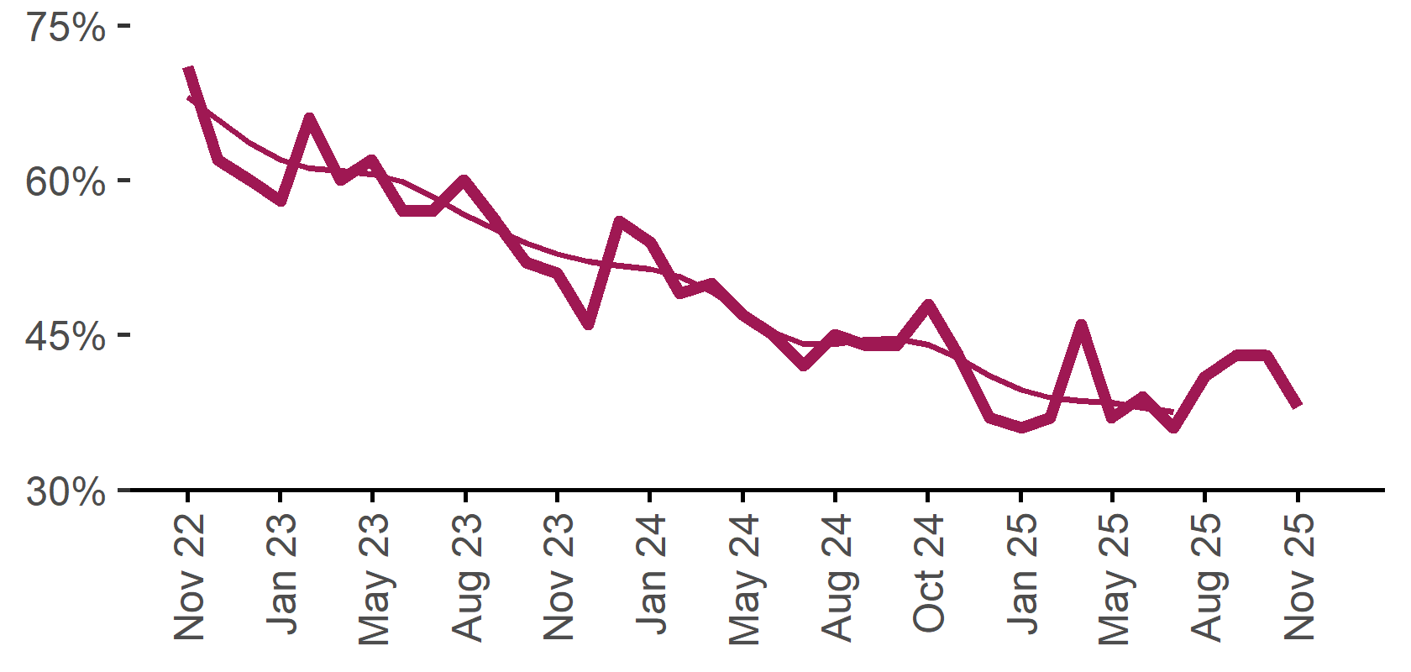 | 38%  Monthly change:  ▼ 5%pts  Annual change:  ▼ 10%pts
  Date | % unable to fill vacancies in a month | Smoothed - % unable to fill vacancies in a month
  Nov 2022 | 71% | 68%
  Dec 2022 | 62% | 66%
  Jan 2023 | 60% | 64%
  Feb 2023 | 58% | 62%
  Mar 2023 | 66% | 61%
  Apr 2023 | 60% | 61%
  May 2023 | 62% | 61%
  Jun 2023 | 57% | 60%
  Jul 2023 | 57% | 58%
  Aug 2023 | 60% | 57%
  Sep 2023 | 56% | 55%
  Oct 2023 | 52% | 54%
  Nov 2023 | 51% | 53%
  Dec 2023 | 46% | 52%
  Jan 2024 | 56% | 52%
  Feb 2024 | 54% | 51%
  Mar 2024 | 49% | 51%
  Apr 2024 | 50% | 49%
  May 2024 | 47% | 47%
  Jun 2024 | 45% | 45%
  Jul 2024 | 42% | 44%
  Aug 2024 | 45% | 44%
  Sep 2024 | 44% | 45%
  Oct 2024 | 44% | 45%
  Nov 2024 | 48% | 44%
  Dec 2024 | 43% | 43%
  Jan 2025 | 37% | 41%
  Feb 2025 | 36% | 40%
  Mar 2025 | 37% | 39%
  Apr 2025 | 46% | 39%
  May 2025 | 37% | 38%
  Jun 2025 | 39% | 38%
  Jul 2025 | 36% | 38%
  Aug 2025 | 41%
  Sep 2025 | 43%
  Oct 2025 | 43%
  Nov 2025 | 38%

* Excludes employers who have been recruiting for less than a month.

Background
Jobs and Skills Australia (JSA) conducts the Recruitment Experiences and Outlook Survey (REOS), a telephone administered survey with the business owner or other person in the business responsible for recruitment. Around 800 employers are surveyed each month, with data published on the JSA website. While the data are indicative of recruitment activity, they may be subject to seasonal factors and other volatility and should therefore be used with a degree of caution. In addition, the survey is targeted towards employers with 5 or more employees and excludes many government organisations. Details of the survey methodology can be accessed from the JSA website.

Smoothed series in charts
Charts include Henderson-smoothed lines in addition to original data for most of our recruitment indicators. As the timeseries is not yet long enough for seasonal adjustment, a Henderson smoothed moving average with a 13-term filter (equating to 13 months) has been directly applied to the original series. This provides an indication of the general movement in each recruitment indicator relative to previous months. Due to using 13 months in the moving average, results for the most recent six months will be revised each month.

How to reference data from this report
Jobs and Skills Australia, Recruitment Insights Report, November 2025.

Contact us
For additional information, email REOS@jobsandskills.gov.au

Also available from the REOS

Data file with monthly and quarterly recruitment indicators
A REOS data file is available on the JSA website. Breakdowns by Capital City/Rest of State area, Business size, and ANZSCO Skill Level are included in the monthly results. Quarterly recruitment indicators provide detail by state, ARIA (ABS’ Accessibility and Remoteness Index of Australia) as well as selected industry and occupation groups.
Next Recruitment Insights Report release:
- Month year Recruitment Insights Report – 17 March 2026

Stay up to date
JSA also releases semi-regular reports including spotlight articles, detailing aspects of the REOS that cannot be included in our monthly Recruitment Insights Report. Sign up and get the Recruitment Insights Report notifications sent straight to your inbox.
Upcoming spotlight:
- January spotlight-December Quarter 2025 Results – 20 January 2026
Recent spotlights:
- December spotlight – Entry level jobs across city, coastal, inland and remote regions
- September spotlight – September Quarter 2025 results

A Henderson smoothed line has been included in the charts to reduce month to month volatility and illustrate long term patterns. See the explanatory note for more information.
Data are not available for January in some years. Data points have been joined by a dotted line between December and February to reflect this. ‘Rest of State’ refers to areas outside the capital cities.

