


JSA Performance and Measurement Framework 2024-2027

July 2025

Contents
Key terms 1
Overview 2
Measuring JSA’s performance 2
Measuring Stage One – Quality 6
Measuring Stage Two - Relevance 6
Measuring Stage Three - Benefit 7
Appendix A Quality indicators 10
Appendix B Relevance indicators 11
Appendix C Benefit indicators 13

Key terms
Collaborate - Aligning the expertise of our partners to effectively define an issue, develop and/or deliver proposed projects.
Consult - Gathering views and feedback to inform understanding and development of initiatives, including the Jobs and Skills Australia annual work plan.
Jobs and Skills Councils (JSCs) - not-for-profit companies that provide leadership to address skills and workforce challenges for their industry, working closely with Jobs and Skills Australia (JSA) and in a tripartite arrangement.
Major in-depth studies - Each year we undertake several major in-depth studies that explore key issues impacting the Australian labour market and skills supply and demand. These include capacity and cohort studies. These are specialty projects commissioned with a defined purpose and timeframe.
Products - the final output of a project or regular releases.
Projects - work to produce a product.
Regular releases - ongoing business as usual (BAU) work including both data regular releases, and analysis and research products that do not contain strategic advice. They are broad business products that contribute to, and build on, Australia’s economic information assets.
Skills system partners - JSA operates on a tripartite basis, working in collaboration with government, business, and unions. Our skills system partners are those that can have direct influence or impact on the skills system and includes government, industry bodies and employers, training and education providers, and public and community groups.
Strategic advice projects - those that will provide advice to Government, or include findings or recommendations intended to influence skills system partners’ decisions.

Overview
The Jobs and Skills Australia – Performance and Measurement Framework (the framework) outlines Jobs and Skills Australia’s (JSA) approach to measuring our performance in the context of our purpose. The framework will provide annual feedback on the success of the JSA work plan.
The framework has been developed in alignment with the 2024-2027 Strategic Plan that outlines our strategic priorities and operational settings, as well as the annual JSA Work Plan that outlines work priorities for the year, developed in collaboration with stakeholders and agreed by our Ministerial Advisory Board and Government. These frameworks and planning documents are complementary to ensure our core operating principles are embedded across our work processes and resources are aligned to progressing our Commissioner’s outcomes. Together, these documents outline what we plan to achieve, how it will be achieved it, and what success looks like.
This reporting cycle is a central feature of the Public Governance, Performance and Accountability Act 2013 intended to strengthen the accountability and transparency Commonwealth agencies. This framework ensures JSA aligns with Australian Government reporting expectations as well as providing executive oversight of the use of our resources and standard of our work. It also aims to help embed a culture of reflective and evaluative thinking to ensure we get the best results from what we do and what we have.
The framework has been reviewed by Callida Consulting as part of their JSA Functional and Efficiency Review. Callida found the performance measures are comprehensive and aligned to the 2024-2027 Strategic Plan. Callida recommended some minor adjustments. These revisions, along with feedback from JSA staff have been incorporated where appropriate.

Measuring JSA’s performance
JSA contributes to the PBS outcome of promoting growth in economic productivity and social wellbeing through access to quality skills and training. Our purpose is activating the potential of all individuals to meet present and future skills needs within an inclusive labour market and a productive economy.
JSA is an advisory body. We do not administer government programs or exercise executive power. Our role is to advise and assist the Australian government and other stakeholders to make connected and well-informed decisions on the current, emerging, and future skills and workforce needs of the Australian economy.
We contribute by providing quality, independent advice and facilitating informed dialogue within a collaborative network of engaged stakeholders. Our outputs are expected to inform decisions across our skills system partners, noting the different levers each have for bringing about system influence.
JSA benefits Australia when our advice and analysis contribute to decisions that positively impact the drivers of productivity and inclusive economic growth. For our outputs to be accepted by our audience and inform dialogue and decisions they must be reliably high-quality and relevant to our stakeholders and partners.
The ultimate impact of our work can take years to flow through to realisation and depends on a multitude of actors activating their levers to influence the skills system. Performance across the outcomes is also affected by how students, employers, and education and training providers interact with the system and respond to policy settings. Results can be further obscured by actions of system participants and ‘noise’ from broader societal and economic conditions. These factors can make it difficult to attribute improvement on the drivers of productivity and economic growth directly to our work.
JSA does not have the ability to directly impact the skills system. As such, the framework is structured on the building blocks that maximise the likelihood of our work being influential: high quality outputs, that are relevant to our skills system partners. Excelling in our core operating principles is key for our products to influence the skills system and drive an inclusive and productive economy. From this foundation, we trust that our skills system partners will champion our work and bring about benefit to Australia. The performance framework outlines our three operating principles of quality, relevance, and benefit, as the building blocks to progressing our purpose, with each being an opportunity to check on our performance.
Figure 1 The building blocks of JSA's impact
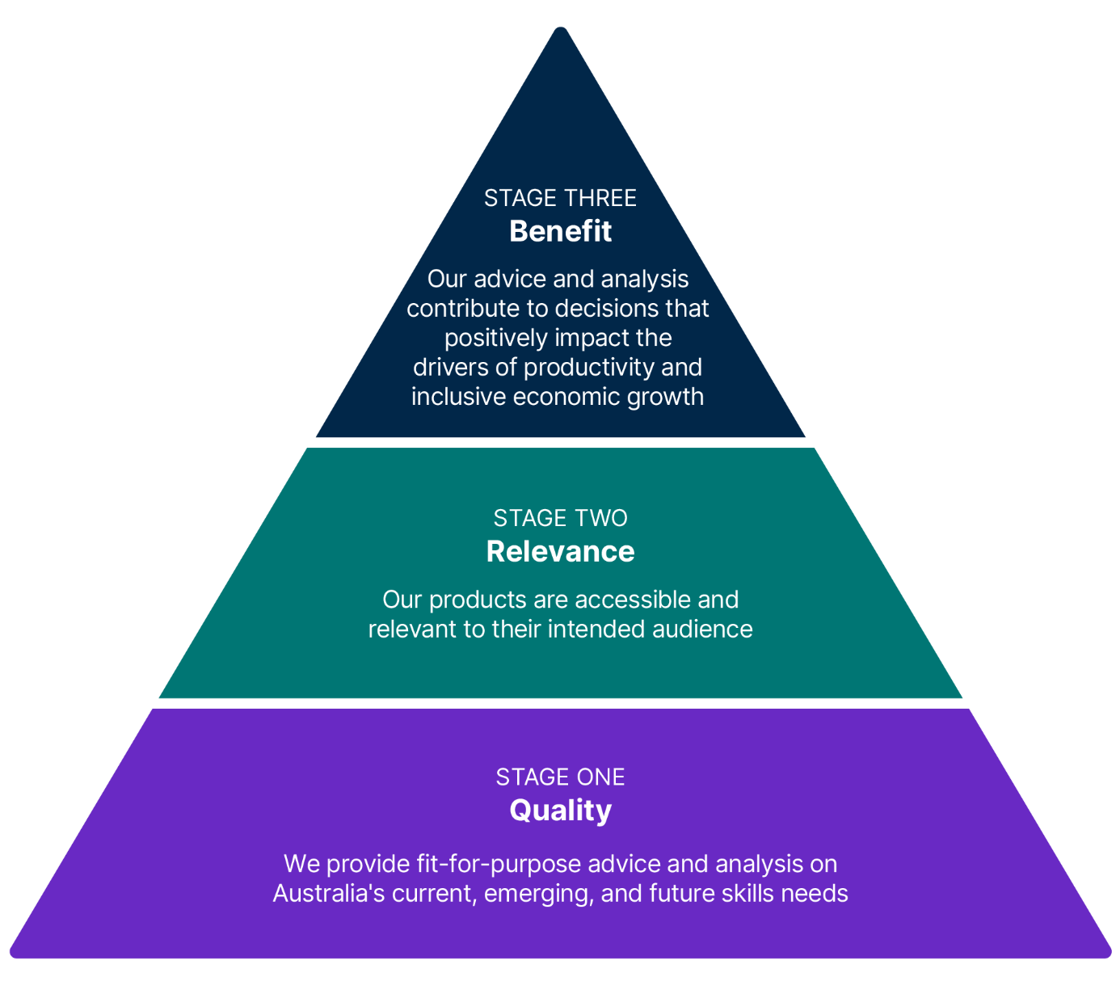
These are supported by a set of performance indicators that help us understand and measure performance against operating principles.
Below is a high-level summary of our performance framework.
Figure 2 Summary of our performance framework
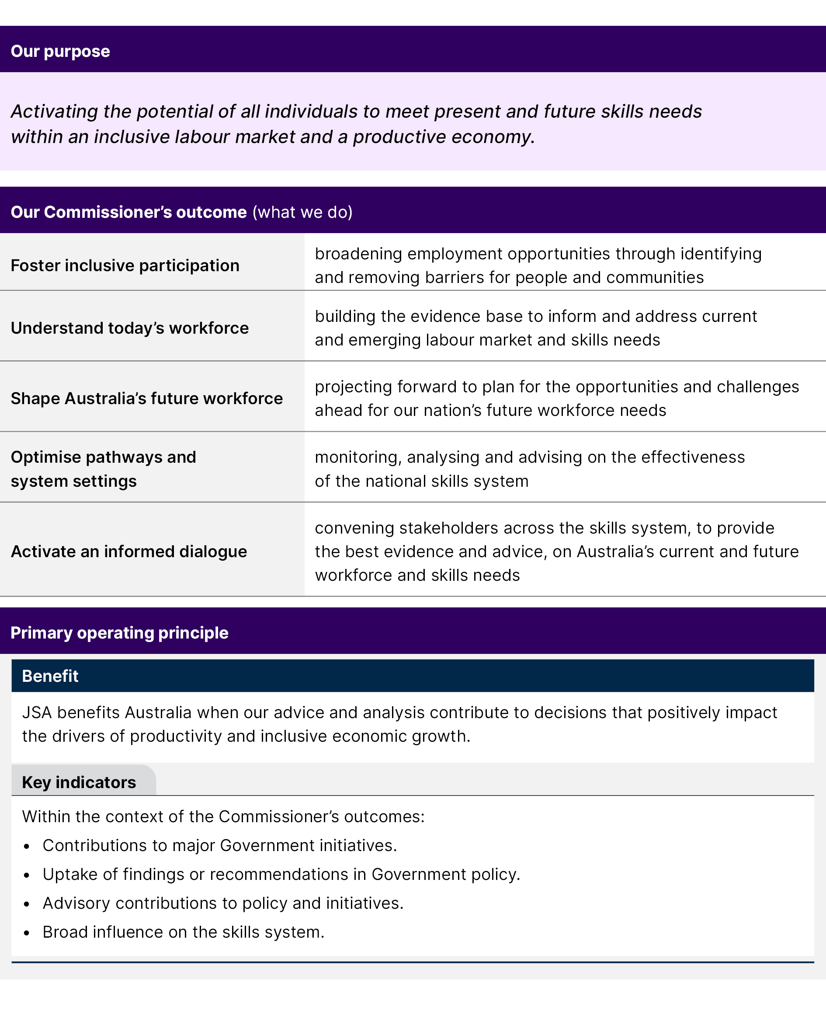
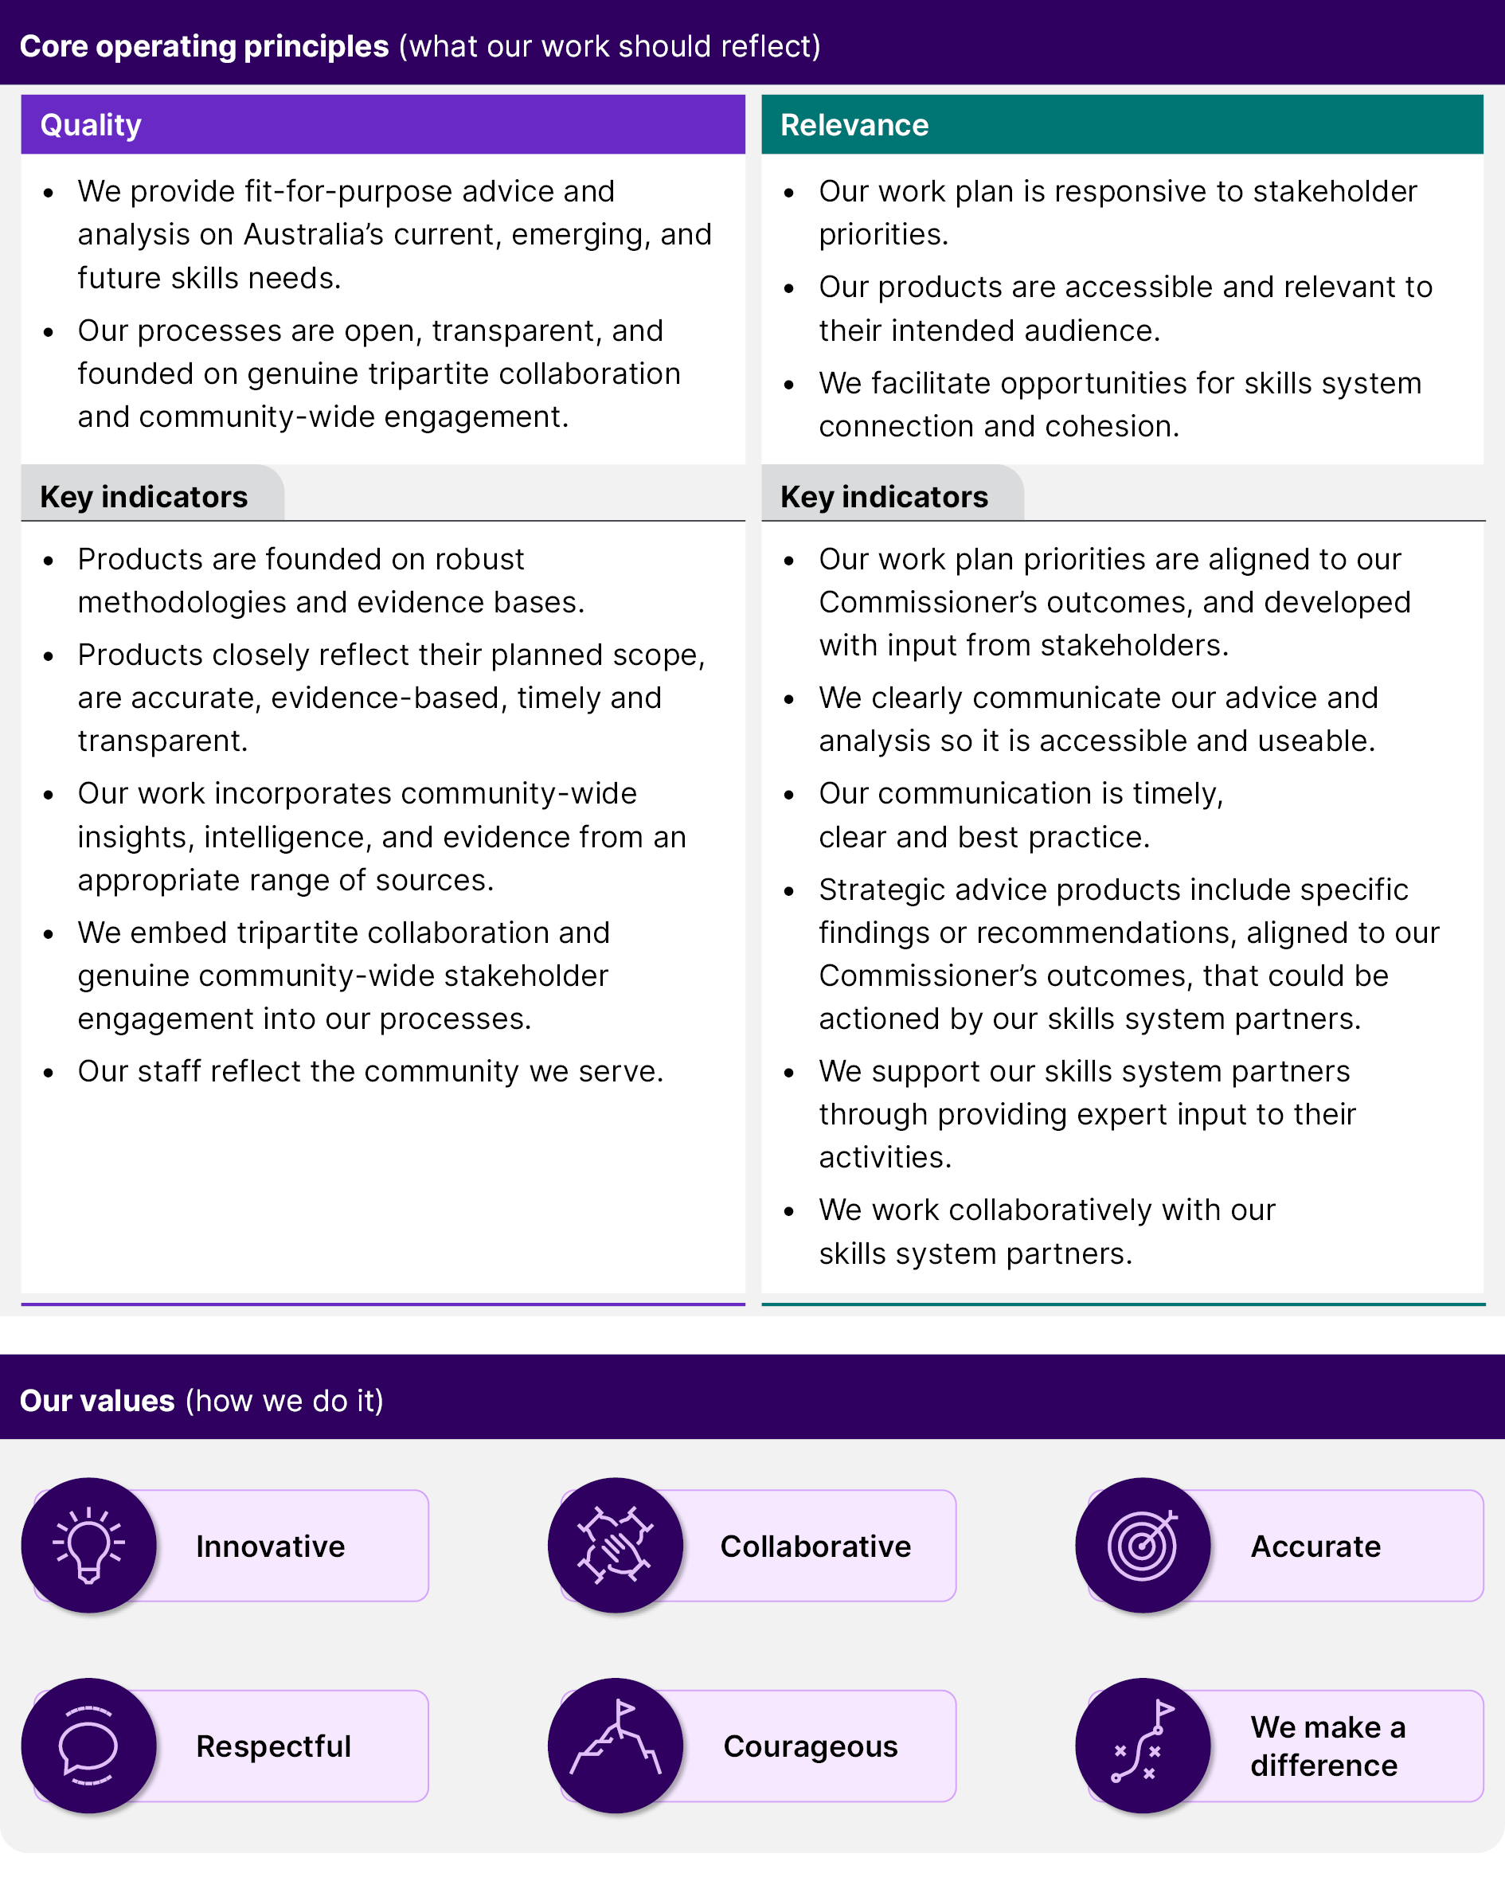
JSA’s work plan is a mixture of in-depth studies, ongoing analysis and research, and regular data releases, all underpinned by deep stakeholder engagement. Each has a different role in JSA’s work plan as well as different approaches to their delivery, engagement and success metrics. For the purposes of the metrics, we refer to strategic advice projects/products (those that will provide advice, or include findings or recommendations), regular releases projects/products (ongoing business as usual (BAU) work including both data, regular releases, and ongoing analysis and research products that do not contain strategic advice), products (the final output of a project or regular releases), and projects (work to produce a product).

Measuring Stage One – Quality
For our products to have influence with our stakeholders, they must be trustworthy and reliable, i.e. they must consistently be of high quality. Our core operating principles shaping the expected quality of our projects and products are:
- We provide fit-for-purpose advice and analysis on Australia's current, emerging, and future skills needs.
- Our processes are open, transparent, and founded on genuine tripartite collaboration and community-wide engagement.
The indicators used to monitor how well we deliver our products, are shown in the below Figure 3 Quality indicators. Further information on the indicators can be found at Appendix A.
Figure 3 Quality indicators
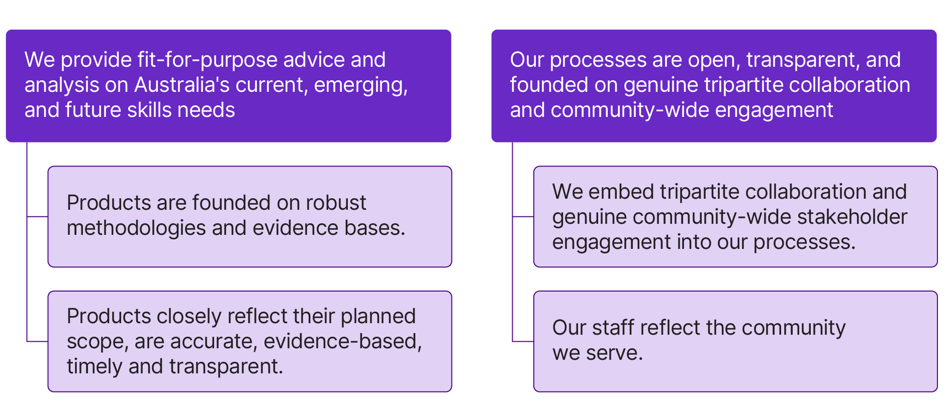

Measuring Stage Two - Relevance
For our products to have their intended benefit, they must be relevant to the stakeholders we seek to influence. Our core operating principles shaping the expected relevance of our projects and products are:
- Our work plan is responsive to stakeholder priorities.
- Our products are accessible and relevant to their intended audience.
- We facilitate opportunities for skills system connection and cohesion.
The indicators used to monitor the how well we deliver our products, are shown in the below Figure 4 Relevance indicators. Further information on the indicators can be found at Appendix B.
Figure 4 Relevance indicators
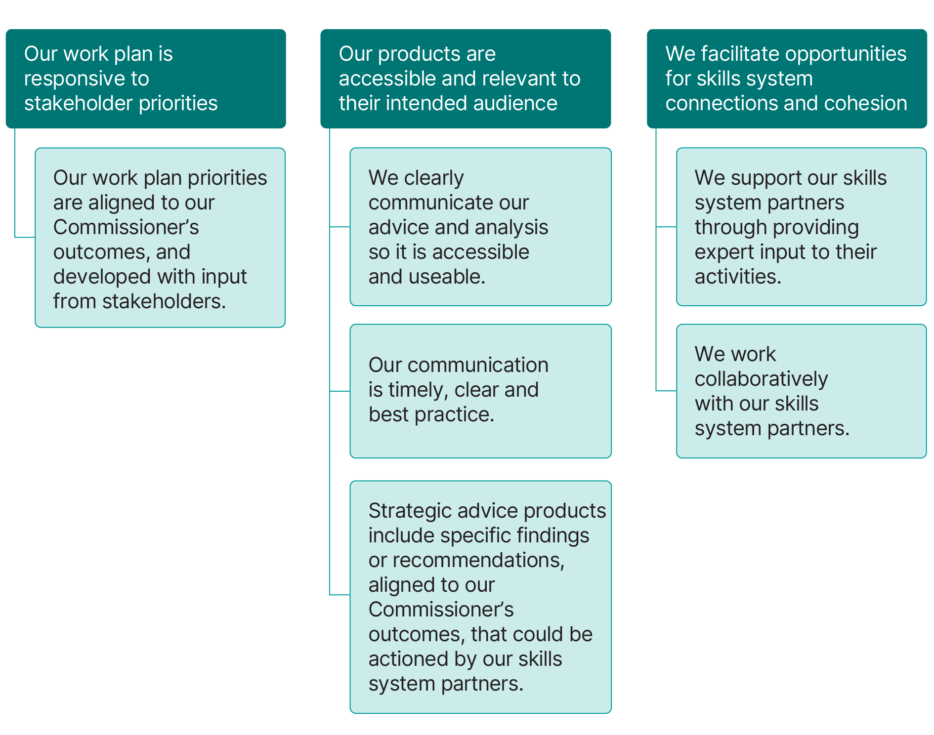

Measuring Stage Three - Benefit
Our Commissioner’s outcomes underpin our strategic objectives and work plans to focus our activities on our purpose and legislative remit. The strategic plan also outlines the ultimate impact JSA seeks to have by pursuing work against each of these outcomes.
Our impact on stakeholder decisions will translate to benefits for the Australian economy and its people, where we observe JSA’s influence on dialogue, policy, business endeavours, research, and other programs.
We have influence through our work with stakeholders, through regular analysis of the labour market, through input and advice that supports decision-making, and through targeted capacity and cohort studies that seek to expand the evidence base.
Long term impact would see improvement in labour market matching between people and jobs, skills and employment, a relevant and harmonised tertiary skills system, and inclusive of all individuals that can access education, training, and the labour market to meet their career and life goals.
As an advisory body, JSA does not have the ability to directly impact the skills system. The ultimate benefit of our work can take years to flow through to realisation, is dependent on our skills system partners, and subject to many external factors. Given this, it may be difficult to attribute movements in economic, population, or skills system settings to JSA.
The framework tracks evidence of the benefit of our work - when our advice and analysis has contributed to dialogue and decisions aligned to our Commissioner’s outcomes (the below Figure 5 Commissioner's outcomes refers).
Figure 5 Commissioner's outcomes
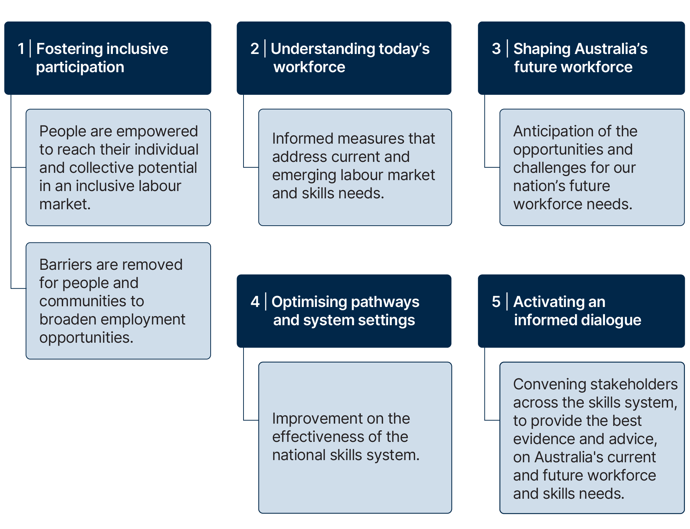

Our core operating principle shaping the expected benefit of our projects and products is:
- JSA benefits Australia when our advice and analysis contribute to decisions that positively impact the drivers of productivity and inclusive economic growth.
The indicators used to monitor the benefit of our work and products, are shown in the below Figure 6 Benefit indicators. Further information on the indicators can be found at Appendix C.
Figure 6 Benefit indicators
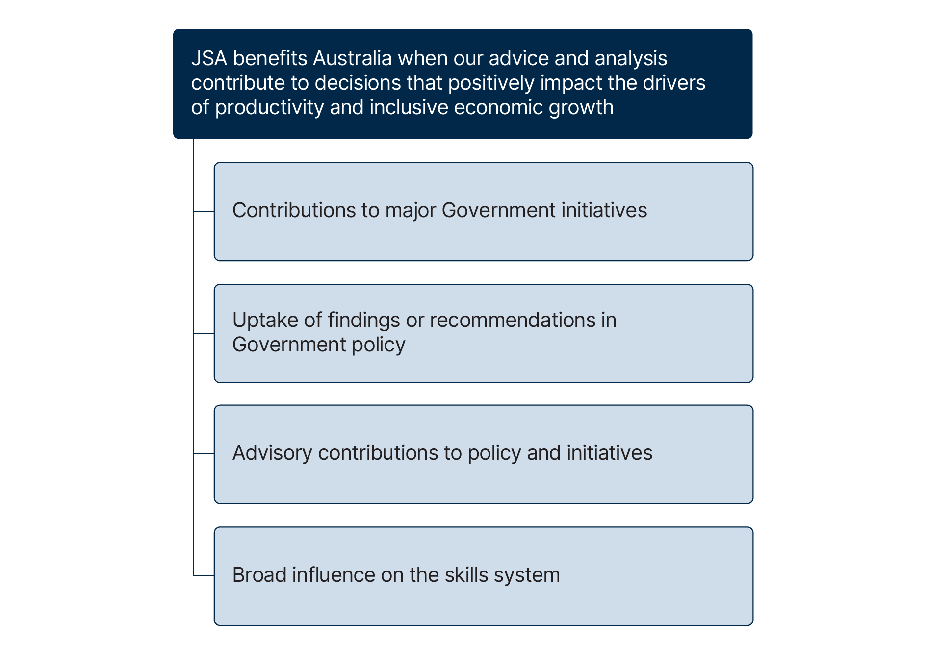

- Quality indicators
Table 1 Quality indicators and targets
Principles | Indicators | Targets
We provide fit-for-purpose advice and analysis on Australia's current, emerging, and future skills needs. | Products are founded on robust methodologies and evidence bases. | There is expert input to all substantive data development and improvement review processes involving the creation of evidence bases, new methodologies or data sources.
 |  | Project evidence bases are assessed as being fit for purpose as per the data quality assessment component of JSA’s Data Governance Framework. There is published explanation of project evidence base limitations and assumptions where these are identified through data quality assessments.
 |  | Supporting methodology or technical reports accompany the release of data and analysis, where appropriate.
 | Products closely reflect their planned scope, are accurate, evidence-based, timely and transparent. | 0% of published products and data require post-publication corrections due to non-minor errors.
 |  | >90% of projects and products outlined in the JSA work plan are delivered, or on track for delivery, within originally approved timeframes.
 |  | 100% of deliverables completed as per original scope.
 |  | Total number of reports published online over a defined period, with 100% being published within five business days of ministerial approval.
Our processes are open, transparent, and founded on genuine tripartite collaboration and community-wide engagement. | We embed tripartite collaboration and genuine community-wide stakeholder engagement into our processes. | >500 participants/ submissions in public consultation processes and submissions across the year.
 |  | 100% of strategic advice projects incorporate intelligence from JSA stakeholders, including input from, or representing, priority cohorts in line with the project scope.
 | Our staff reflect the community we serve. | JSA’s workforce demographics exceed the APS diversity targets.
 | Our staff reflect the community we serve. | Improvement in the yearly number of activities undertaken to promote and increase understanding of diversity across the organisation (including cultural awareness and psychosocial safety).

- Relevance indicators
Table 2 Relevance indicators and targets
Principles | Indicators | Targets
Our work plan is responsive to stakeholder priorities. | Our work plan priorities are aligned to our Commissioner’s outcomes, and developed with input from stakeholders | There is a consultation process to support the development of the annual JSA Work plan
Our products are accessible and relevant to their intended audience. | We clearly communicate our advice and analysis so it is accessible and useable | Sentiment analysis of user feedback and stakeholder survey indicates that 80% of users/respondents can access, understand, and utilise our analysis and products, and that outputs are delivered or socialised in the right formats and locations to support users.
 |  | >140,000 downloads of reports or data.
 |  | There is growth in the number of reported uses of our data releases and products.
 |  | Sentiment analysis of media and online commentary indicates >90% of mentions of the use of JSA outputs have a positive or neutral sentiment.
 | Our communication is timely, clear and best practice | 100% of published products and data releases are accessible and promoted through more than one channel.
 | Our communication is timely, clear and best practice | 10% growth in social media followers per year.
 | Strategic advice products include specific findings or recommendations, aligned to our Commissioner’s outcomes, that could be actioned by our skills system partners | 100% of strategic advice products include specific findings or recommendations, that if adopted, would contribute to our Commissioner’s outcomes.
We facilitate opportunities for skills system connection and cohesion. | We support our skills system partners through providing expert input to their activities. | JSA experts contribute to informed dialogue through delivering >150 speeches and >20 contributions to briefings, workshops, policy processes, forums, external projects, discussion papers, and conferences.
 |  | There is growth in requests for media interviews with JSA representatives to provide insightful commentary on our work and key issues.
 |  | >90 citations of JSA work in academic or research papers and publications.
 | We work collaboratively with our skills system partners. | >5 JSA contributions to JSC projects through collaborative work processes, participation on steering committees or other consultation processes.

- Benefit indicators
Table 3 Benefit indicators and targets
Principle | Indicators | Targets
JSA benefits Australia when our advice and analysis contribute to decisions that positively impact the drivers of productivity and inclusive economic growth | Contributions to major Government initiatives | Instances of collaborations and contributions to Commonwealth, and jurisdiction governments’ major initiatives.  2024-25 Areas of focus:  - Employment White paper  - Migration Strategy  - Apprenticeship Review  - Higher Education Accord  - Future Made in Australia  - AUKUS
 | Uptake of findings or recommendations in Government policy | Findings or recommendations reflected in Commonwealth, and jurisdiction governments’ budget announcements, papers, for two financial years post publication.  2024-25 Areas of focus:  - Skills and Training  - Higher Education  - Agriculture  - Early Childhood  - Clean Energy  - Office for Women (gender)  - States and Territories
 | Advisory contributions to policy and initiatives | Instances of acknowledged use of JSA products in Commonwealth, and jurisdiction governments’ tools or other policy settings.  2024-25 Areas of focus:  - CSOL  - Apprenticeship Priority List  - Employment services  - NSA Outcomes Framework  - ATEC
 | Broad influence on skills system | Tracked through reported citations, JSA expert quotations, replications of findings or recommendations, or other influence of JSA.

