

Total New Vacancies
August 2025
Released 20 November 2025
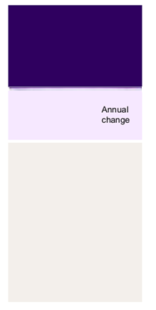

Uncovering hidden labour demand: Introducing JSA’s Total New Vacancies
Total New Vacancies (TNV) is a new quarterly data series from Jobs and Skills Australia which provides a more comprehensive view of job vacancy trends across Australia. While online recruitment methods are popular, their use can vary, including across regions and industries, and as labour market conditions change. This can make it difficult to accurately identify emerging trends in the economy and labour market.
JSA’s new TNV series helps address this challenge. The TNV estimates the total number of new vacancies created each quarter, offering insights into hiring activity beyond online job ads or point in time estimates. It combines data from JSA’s Internet Vacancy Index (IVI) with employer feedback on recruitment methods obtained from JSA’s Recruitment Experiences and Outlook Survey (REOS). Using these insights, the TNV estimates the total number of jobs that were available in a given quarter, including through informal channels such as word of mouth, signs in shop windows, and social media groups.
Improving the evidence base on regional and occupational labour demand is a core tenet of the Jobs and Skills Australia legislation. The TNV series plays a critical role in achieving this goal by providing a more complete picture of job opportunities across occupations and regions. This richer data will support the development of place-based initiatives and regional planning, ensuring industry policy responses are better tailored to emerging trends.

1,128,300
new vacancies
▼ 6.9%

Over the year to August 2025, vacancies decreased by 6.9% (or around 94,800 job advertisements) to stand at 1,128,300.
In some occupations and regions, over half of job vacancies are advertised online. The new TNV offers a broader measure, estimating total new vacancies across all recruitment methods.

Mind the gap: Understanding hidden occupational demand using the new TNV
The TNV can help fill gaps in understanding labour demand, particularly in sectors where online advertising is less common, such for occupational groups like Labourers and Technicians and Trades.
Table 1 provides a comparison between the TNV and the IVI over the year to August 2025 at the occupational level. The divergence between TNV and IVI underscores the importance of the new TNV series in better understanding labour demand.
This is demonstrated through the number of vacancies advertised for Labourers. For this key occupation group, the IVI indicates there were around 41,700 online job ads over the previous quarter (or around 13,900 job ads per month). However, analysis of JSA REOS data on recruitment behaviours by employers hiring for Labourers shows only around 40% to 45% of Labourer vacancies are advertised through an online job board captured in the IVI. Through the modelled estimates of the TNV, we can thus see that there were likely around 100,000 new vacancies added to the prospective job market in the three months to August 2025 – more than double the amount indicated by online job ads alone.

Fewer jobs or changes in recruitment methods? Improving our understanding of changes in labour demand
The TNV also helps account for changes in recruitment behaviour over time. For instance, during a tight labour market, employers may become more likely to try alternative methods of recruitment in an attempt to fill their vacancy. This suggests that the use of online job boards (as captured by the IVI) may vary depending on labour market conditions.
For example, looking at the occupation group Professionals. The TNV indicates vacancies for this group are down by 8.6% over the year, yet the IVI for the same group fell by 13.9%. A similar trend is noticed for Technicians and Trades Workers. Given the decline in the TNV is smaller than that of the IVI, this suggests that the reduction in online job ads as measured in the IVI may be a combination of both changes in labour demand but also changes in recruitment methods, pointing to a shift in recruitment practices as a strong contributing factor to current job advertisement trends as labour market conditions have softened in recent periods.
Table 1: Total New Vacancies by Occupation Group, August 2025
 | JSA Total New Vacancies |  | JSA Internet Vacancy Index
 | Qtrly total | Annual change (%) | Monthly total | Qtrly total | Annual change (%)
Managers | 123,900 | -7.5% | 24,100 | 74,800 | -13.0%
Professionals | 309,900 | -8.6% | 56,500 | 179,500 | -13.9%
Technicians and Trades Workers | 142,600 | -6.8% | 29,000 | 89,900 | -10.6%
Community and Personal Service Workers | 105,800 | -17.9% | 20,100 | 61,600 | -17.7%
Clerical and Administrative Workers | 161,200 | -9.2% | 30,600 | 94,300 | -13.1%
Sales Workers | 123,400 | -8.0% | 15,800 | 49,400 | -12.9%
Machinery Operators and Drivers | 60,100 | -1.3% | 12,100 | 36,600 | -1.5%
Labourers | 101,000 | -2.9% | 13,900 | 41,700 | -3.2%
Australia | 1,128,300 | -6.9% | 202,900 | 627,300 | -12.1%
Source: JSA, Total New Vacancies and Internet Vacancy Index.

Off the grid: Improving our understanding of vacancies beyond the city limits
While the JSA IVI is relatively representative of job advertisement trends in Australia’s capital cities, analysis from JSA’s REOS suggests it typically only captures a lower proportion of vacancies advertised within more regional and remote regions. This can make it difficult to better understand job vacancy trends in regional areas, where employers are more likely rely on local networks, word-of-mouth, signs in shop windows and community notice boards.
Table 2 provides a comparison between the TNV and the IVI over the year to August 2025 at the geographical level. The divergence between TNV and IVI underscores the importance of the new TNV series in better understanding labour demand.
To illustrate the scale of this gap, consider Queensland – Outback. During the quarter of August 2025, the IVI indicates there were roughly 2,300 vacancies advertised (or around 750 vacancies per month). However, with REOS insights indicating only around 15% to 20% of the vacancies within remote areas are captured on online job boards (compared with around 50% to 60% in areas like the Gold Coast). This suggests there were actually likely closer to 12,100 new vacancies in Queensland – Outback over the same the same period. This illustrates the powerful insights of the new TNV series.
Table 2: Total New Vacancies by GCCSA, August 2025
 | JSA Total New Vacancies |  | JSA Internet Vacancy Index
 | Qtrly total | Annual change (%) | Monthly total | Qtrly total | Annual change (%)
Greater Sydney | 269,600 | -2.9% | 44,400 | 129,400 | -7.5%
Rest of New South Wales | 126,300 | -2.7% | 17,100 | 48,500 | -0.2%
Greater Melbourne | 227,300 | -3.9% | 37,700 | 111,400 | -11.5%
Rest of Victoria | 80,500 | -11.4% | 7,700 | 22,800 | -6.4%
Greater Brisbane | 141,900 | -15.9% | 28,300 | 82,800 | -7.9%
Rest of Queensland | 130,700 | -4.1% | 22,400 | 63,900 | -2.0%
Greater Adelaide | 67,500 | -2.3% | 11,900 | 34,200 | 2.0%
Rest of South Australia | 35,200 | -1.7% | 1,900 | 5,700 | -1.4%
Greater Perth | 101,000 | -13.2% | 20,800 | 60,600 | -7.3%
Rest of Western Australia | 33,600 | -0.8% | 4,900 | 14,800 | -1.5%
Greater Hobart | 12,600 | -15.6% | 1,700 | 5,000 | -14.3%
Rest of Tasmania | 15,400 | -5.8% | 1,500 | 4,400 | -2.3%
Greater Darwin | 13,500 | -5.6% | 2,100 | 6,100 | -2.3%
Rest of Northern Territory | 10,800 | -10.1% | 900 | 2,800 | -7.8%
Australian Capital Territory | 22,300 | -26.8% | 4,700 | 14,600 | -23.1%
Australia | 1,128,300 | -6.9% | 202,900 | 627,300 | -12.1%

Source: JSA, Total New Vacancies and Internet Vacancy Index.

Figure 1: Total New Vacancies, February 2019 to August 2025
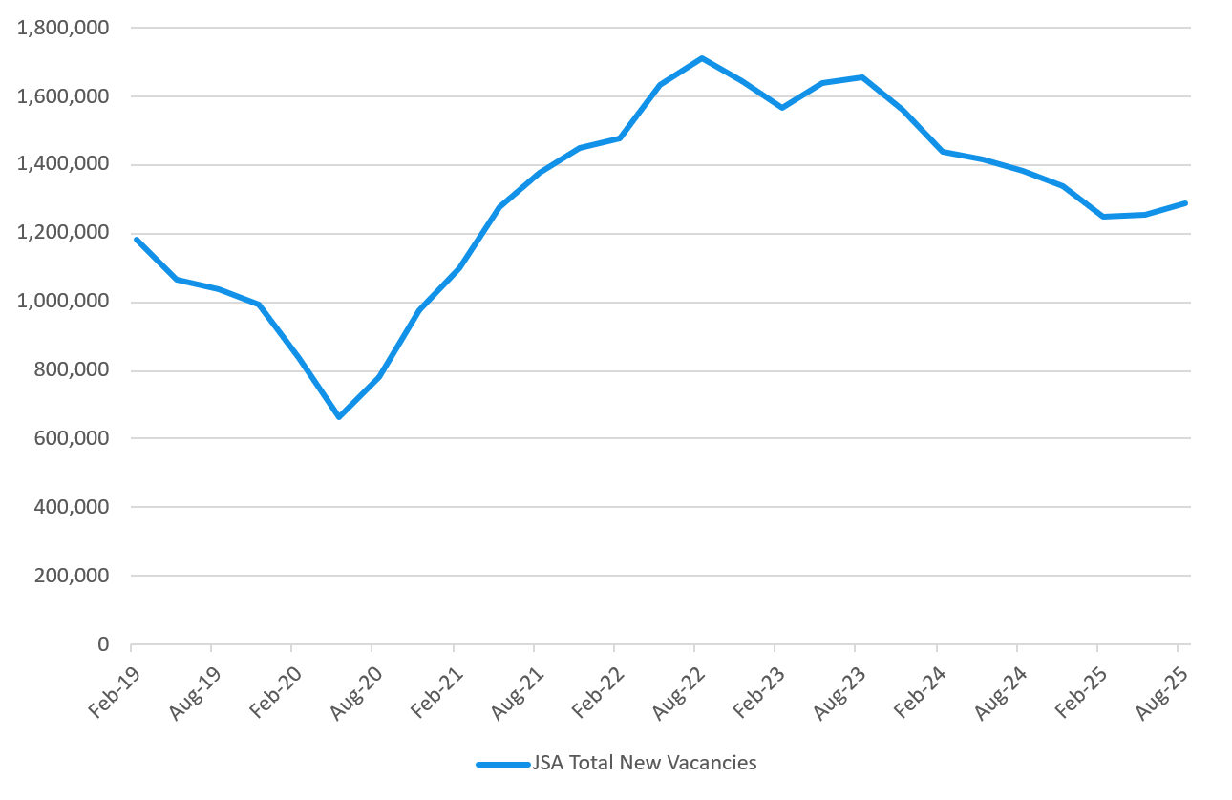
Source: JSA, Total New Vacancies.

The next TNV release is scheduled for February 2026. The TNV is published on the JSA website at jobsandskills.gov.au.
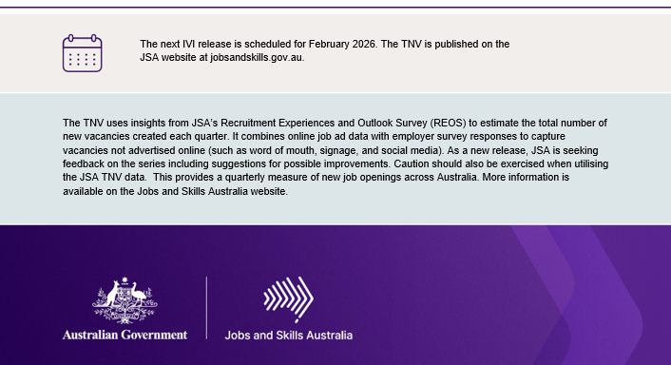
The TNV uses insights from JSA’s Recruitment Experiences and Outlook Survey (REOS) to estimate the total number of new vacancies created each quarter. It combines online job ad data with employer survey responses to capture vacancies not advertised online (such as word of mouth, signage, and social media). As a new release, JSA is seeking feedback on the series including suggestions for possible improvements. Caution should also be exercised when utilising the JSA TNV data. This provides a quarterly measure of new job openings across Australia. More information is available on the Jobs and Skills Australia website.

