

RLMI Results – September 2025

Key Findings
- Regional and remote areas continue to be more likely to experience relatively weaker labour market conditions than their major city counterparts.
- Highlighting the strength of many metropolitan regions are current strong conditions in Greater Adelaide, where overall conditions are strong despite persistent challenges in parts of the region.
- Analysis of JSA’s landmark Generative AI Capacity Study alongside RLMI data shows that exposure to Gen AI is highest in stronger performing labour markets in major cities.

Labour market challenges are more pronounced in many regional areas
The September 2025 RLMI results continue to show that regional and remote areas are more likely to experience weaker labour market conditions than their major city counterparts, highlighting the additional challenges faced in many regional areas by both employers and jobseekers (see Chart 1, below).
- Almost half of the SA4’s (17 out of 37) located in regional areas were rated either ‘below average’ or ‘poor’ in September 2025, while all six (or 100%) remote areas were rated either ‘below average’ or ‘poor’.
- Two-thirds of the SA4’s (29 out of 44) located in major city areas were rated either ‘strong’ or ‘above average’ in September 2025.
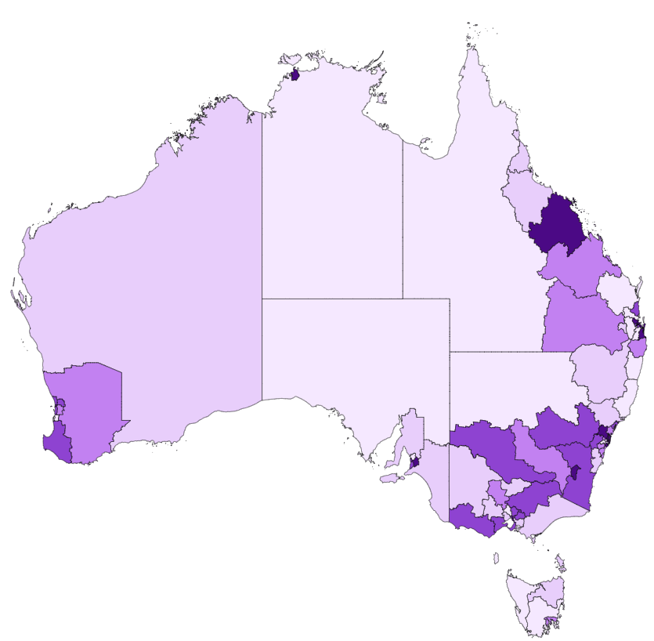
Chart 1: RLMI ratings of relative labour market performance, September 2025

Source: JSA, Regional Labour Market Indicator (RLMI), September 2025

Chart 2: RLMI ratings of relative labour market performance, by selected Capital Cities, September 2025
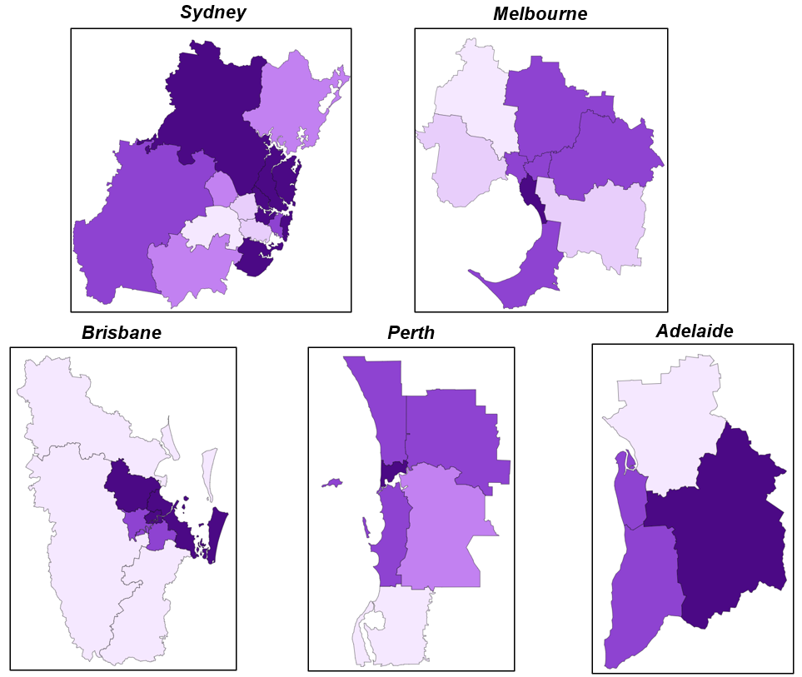

Source: JSA, Regional Labour Market Indicator (RLMI), September 2025

Recent trends in regional labour market performance

The latest RLMI results highlight areas of relative labour market strength and weakness across Australia’s regions, including Greater Adelaide, where overall conditions are strong despite persistent challenges in parts of the region.

In focus: Gather Round for Strong Labour Market Performance
A diverse economy, with strengths in health and medical research, education and training and retail trade, the latest RLMI results help to highlight strong overall labour market conditions in Greater Adelaide.
For instance, labour market conditions have been persistently strong in the Adelaide – South and Adelaide – Central and Hills (SA4) regions, having been regularly rated ‘above average’ and ‘strong’ over the last decade.
Chart 3: RLMI ratings of relative labour market performance for Greater Adelaide
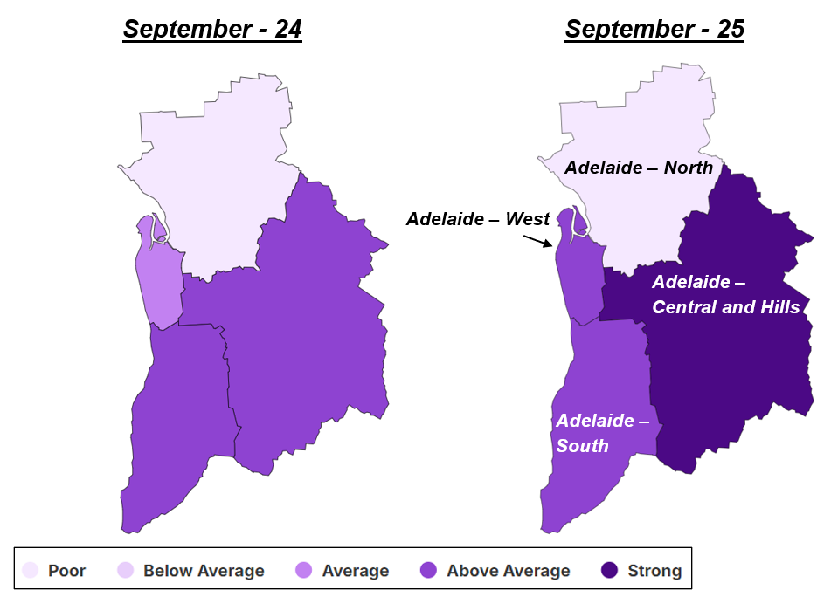
Source: JSA, Regional Labour Market Indicator (RLMI), September 2025
Additionally, the relative strength of the labour market in the Adelaide – West (SA4) region has improved from its long-term trend with several key indicators of spare labour market capacity having recently strengthened (see Table 1, below). As such, labour market conditions in the region were rated ‘above average’ in September 2025, up from its rating of ‘below average’ as recently as December 2019, indicating that conditions are reasonably tight when compared to the national average.
Table 1: Key labour market indicators for Adelaide – West (SA4)
 | Sep-24 | Sep-25 | Change in conditions
Employment Rate (15-64 years) (%) | 77.0 | 78.3 | Improved
JobSeeker Income Support Rate (%) | 5.9 | 5.9 | Stable
Unemployment Rate (%) | 3.6 | 3.9 | Softened
Vacancy Fill Rate (%) | 63.4 | 72.6 | Improved
Underemployment Rate (%) | 7.2 | 6.1 | Improved
Source: JSA, Regional Labour Market Indicator (RLMI), September 2025
In contrast to the strength seen elsewhere in Greater Adelaide, the Adelaide – North (SA4) region has a long history of labour market disadvantage, with conditions having been regularly rated as ‘poor’ over the last decade, relative to the national average.
- Contributing to persistently poor conditions in the region is a low rate of employment, a high proportion of the working age population on JobSeeker Income Support, and a high unemployment rate.
Taken together, these key measures of labour market performance indicate considerable spare capacity in the region’s labour market and highlight the pronounced difficulty for jobseekers.

Spotlight: Our (regional) Gen AI Transition
Generative AI (Gen AI) is one of the most significant shifts shaping Australia’s labour market. It can change how work is done—helping people work smarter, boosting productivity, and creating new opportunities across industries. Jobs and Skills Australia’s landmark Generative AI Capacity Study provides the first comprehensive view of Gen AI’s potential, its impact so far, and what’s needed to support the digital and AI transition.
Analysis of this study alongside RLMI data shows that exposure to Gen AI—through automation (AI doing tasks previously done by people) and augmentation (AI helping people do tasks better)—is highest in stronger performing labour markets in major cities (see Table 2, below). Regional and remote areas, however, have lower exposure, meaning less immediate disruption but also fewer short-term productivity gains or opportunities to develop experience with the new technology.
Table 2: AI Exposure (weighted occupations)
 | Automation exposure | Augmentation exposure
Major City average | 0.38 | 0.63
Regional average | 0.35 | 0.62
Remote average | 0.33 | 0.61
Source: JSA, Our Gen AI Transition: Generative AI Capacity Study, 2025
Note: See Appendix A for AI Exposure (weighted occupations) by SA4
Differences in AI exposure across regions reflect the types of jobs and industries that are common in local economies. Major city areas have more roles that involve tasks Gen AI can easily augment or automate. In contrast, regional and remote areas rely more on hands-on sectors like agriculture, trades, and tourism, where tasks are less suited to automation or augmentation. This occupational mix means cities face higher exposure to AI-driven change – both opportunities and challenges - while regional areas experience lower exposure and may see a slower pace of adoption.
This has important implications. Regions with higher augmentation exposure—typically major cities with stronger labour markets—may be better placed to use AI to drive innovation and growth. However, for regional and remote areas, lower AI exposure may offer valuable time to plan and invest in skills, ensuring workers are ready for gradual adoption. This transition offers a chance to shape AI adoption on regional terms—including focusing on sectors like health care, education, and construction. By building digital capability now, regions can unlock AI’s broad potential benefits while supporting inclusive growth across Australia.

Appendix A: AI exposure (weighted occupations) by SA4
Statistical Area Level 4 (SA4) | RLMI Rating | Automation exposure | Augmentation exposure
Major City average |  | 0.38 | 0.63
Sydney - City and Inner South | Above average | 0.45 | 0.68
Melbourne - Inner | Above average | 0.43 | 0.67
Brisbane Inner City | Strong | 0.43 | 0.67
Sydney - North Sydney and Hornsby | Strong | 0.42 | 0.67
Sydney - Ryde | Strong | 0.42 | 0.67
Perth - Inner | Strong | 0.42 | 0.67
Adelaide - Central and Hills | Strong | 0.41 | 0.65
Australian Capital Territory | Strong | 0.41 | 0.66
Sydney - Inner West | Strong | 0.40 | 0.65
Sydney - Parramatta | Below average | 0.40 | 0.65
Melbourne - Inner East | Above average | 0.40 | 0.65
Sydney - Baulkham Hills and Hawkesbury | Strong | 0.39 | 0.64
Sydney - Eastern Suburbs | Strong | 0.38 | 0.65
Sydney - Inner South West | Below average | 0.38 | 0.63
Sydney - Northern Beaches | Strong | 0.38 | 0.64
Melbourne - Inner South | Strong | 0.38 | 0.64
Brisbane - South | Above average | 0.38 | 0.63
Sydney - Blacktown | Average | 0.37 | 0.63
Sydney - South West | Poor | 0.37 | 0.63
Sydney - Sutherland | Strong | 0.37 | 0.63
Melbourne - Outer East | Above average | 0.37 | 0.63
Melbourne - South East | Below average | 0.37 | 0.63
Brisbane - North | Strong | 0.37 | 0.63
Brisbane - West | Above average | 0.37 | 0.63
Adelaide - West | Above average | 0.37 | 0.62
Perth - North West | Above average | 0.37 | 0.63
Central Coast | Average | 0.36 | 0.62
Sydney - Outer South West | Average | 0.36 | 0.62
Sydney - Outer West and Blue Mountains | Above average | 0.36 | 0.62
Melbourne - North East | Above average | 0.36 | 0.63
Melbourne - North West | Poor | 0.36 | 0.62
Melbourne - West | Below average | 0.36 | 0.62
Brisbane - East | Strong | 0.36 | 0.62
Logan - Beaudesert | Poor | 0.36 | 0.62
Moreton Bay - South | Strong | 0.36 | 0.62
Adelaide - South | Above average | 0.36 | 0.62
Perth - South East | Average | 0.36 | 0.62
Perth - South West | Above average | 0.36 | 0.62
Mornington Peninsula | Above average | 0.35 | 0.62
Ipswich | Poor | 0.35 | 0.61
Adelaide - North | Poor | 0.35 | 0.61
Mandurah | Poor | 0.35 | 0.61
Perth - North East | Above average | 0.35 | 0.62
Moreton Bay - North | Poor | 0.34 | 0.61

Statistical Area Level 4 (SA4) | RLMI Rating | Automation exposure | Augmentation exposure
Regional average |  | 0.35 | 0.62
Newcastle and Lake Macquarie | Above average | 0.37 | 0.63
Gold Coast | Strong | 0.37 | 0.63
Hobart | Average | 0.37 | 0.63
Darwin | Strong | 0.37 | 0.63
Illawarra | Average | 0.36 | 0.63
Ballarat | Below average | 0.36 | 0.62
Geelong | Above average | 0.36 | 0.62
Sunshine Coast | Above average | 0.36 | 0.62
Toowoomba | Below average | 0.36 | 0.62
New South Wales - Central West | Above average | 0.35 | 0.62
Coffs Harbour - Grafton | Poor | 0.35 | 0.62
Mid North Coast | Poor | 0.35 | 0.61
Murray | Above average | 0.35 | 0.62
New England and North West | Below average | 0.35 | 0.61
Richmond - Tweed | Average | 0.35 | 0.62
Southern Highlands and Shoalhaven | Below average | 0.35 | 0.62
Bendigo | Average | 0.35 | 0.62
Latrobe - Gippsland | Below average | 0.35 | 0.62
Cairns | Below average | 0.35 | 0.62
Townsville | Below average | 0.35 | 0.62
Launceston and North East | Below average | 0.35 | 0.62
Capital Region | Above average | 0.34 | 0.61
Hunter Valley exc Newcastle | Below average | 0.34 | 0.61
Riverina | Average | 0.34 | 0.61
Hume | Above average | 0.34 | 0.61
Victoria - North West | Below average | 0.34 | 0.61
Shepparton | Below average | 0.34 | 0.62
Warrnambool and South West | Above average | 0.34 | 0.61
Central Queensland | Average | 0.34 | 0.61
Wide Bay | Poor | 0.34 | 0.61
Barossa - Yorke - Mid North | Below average | 0.34 | 0.61
South Australia - South East | Below average | 0.34 | 0.61
Bunbury | Above average | 0.34 | 0.61
Western Australia - Wheat Belt | Average | 0.34 | 0.61
Darling Downs - Maranoa | Average | 0.33 | 0.61
Mackay - Isaac - Whitsunday | Strong | 0.33 | 0.60
Tasmania - South East | Poor | 0.32 | 0.60
Remote average |  | 0.33 | 0.61
Far West and Orana | Poor | 0.34 | 0.61
Tasmania - West and North West | Poor | 0.34 | 0.61
Northern Territory - Outback | Poor | 0.34 | 0.62
South Australia - Outback | Poor | 0.33 | 0.61
Queensland - Outback | Poor | 0.32 | 0.61
Western Australia - Outback (North and South) | Below average | 0.32 | 0.61

Appendix B: Labour Market Rating by SA4, September 2025
Statistical Area Level 4 (SA4) | Remoteness | Sep-24 | Sep-25 | Direction
Central Coast | Major City | Average | Average | Stable
Sydney - Baulkham Hills and Hawkesbury | Major City | Strong | Strong | Stable
Sydney - Blacktown | Major City | Average | Average | Stable
Sydney - City and Inner South | Major City | Above average | Above average | Stable
Sydney - Eastern Suburbs | Major City | Strong | Strong | Stable
Sydney - Inner South West | Major City | Average | Below average | Declined
Sydney - Inner West | Major City | Strong | Strong | Stable
Sydney - North Sydney and Hornsby | Major City | Strong | Strong | Stable
Sydney - Northern Beaches | Major City | Strong | Strong | Stable
Sydney - Outer South West | Major City | Average | Average | Stable
Sydney - Outer West and Blue Mountains | Major City | Above average | Above average | Stable
Sydney - Parramatta | Major City | Below average | Below average | Stable
Sydney - Ryde | Major City | Strong | Strong | Stable
Sydney - South West | Major City | Poor | Poor | Stable
Sydney - Sutherland | Major City | Strong | Strong | Stable
Capital Region | Regional | Above average | Above average | Stable
New South Wales - Central West | Regional | Above average | Above average | Stable
Coffs Harbour - Grafton | Regional | Poor | Poor | Stable
Far West and Orana | Remote | Poor | Poor | Stable
Hunter Valley exc Newcastle | Regional | Below average | Below average | Stable
Illawarra | Cities of Regional Australia | Average | Average | Stable
Mid North Coast | Regional | Poor | Poor | Stable
Murray | Regional | Above average | Above average | Stable
New England and North West | Regional | Below average | Below average | Stable
Newcastle and Lake Macquarie | Cities of Regional Australia | Above average | Above average | Stable
Richmond - Tweed | Regional | Average | Average | Stable
Riverina | Regional | Average | Average | Stable
Southern Highlands and Shoalhaven | Regional | Below average | Below average | Stable
Melbourne - Inner | Major City | Above average | Above average | Stable
Melbourne - Inner East | Major City | Above average | Above average | Stable
Melbourne - Inner South | Major City | Strong | Strong | Stable
Melbourne - North East | Major City | Above average | Above average | Stable
Melbourne - North West | Major City | Below average | Poor | Declined
Melbourne - Outer East | Major City | Strong | Above average | Declined
Melbourne - South East | Major City | Below average | Below average | Stable
Melbourne - West | Major City | Below average | Below average | Stable
Mornington Peninsula | Major City | Above average | Above average | Stable
Ballarat | Regional | Below average | Below average | Stable
Bendigo | Regional | Average | Average | Stable
Geelong | Cities of Regional Australia | Above average | Above average | Stable
Hume | Regional | Above average | Above average | Stable
Latrobe - Gippsland | Regional | Below average | Below average | Stable
Victoria - North West | Regional | Average | Below average | Declined
Shepparton | Regional | Below average | Below average | Stable
Warrnambool and South West | Regional | Above average | Above average | Stable

Statistical Area Level 4 (SA4) | Remoteness | Sep-24 | Sep-25 | Direction
Brisbane - East | Major City | Strong | Strong | Stable
Brisbane - North | Major City | Strong | Strong | Stable
Brisbane - South | Major City | Above average | Above average | Stable
Brisbane - West | Major City | Above average | Above average | Stable
Brisbane Inner City | Major City | Strong | Strong | Stable
Ipswich | Major City | Poor | Poor | Stable
Logan - Beaudesert | Major City | Poor | Poor | Stable
Moreton Bay - North | Major City | Poor | Poor | Stable
Moreton Bay - South | Major City | Strong | Strong | Stable
Cairns | Cities of Regional Australia | Below average | Below average | Stable
Darling Downs - Maranoa | Regional | Average | Average | Stable
Central Queensland | Regional | Average | Average | Stable
Gold Coast | Cities of Regional Australia | Strong | Strong | Stable
Mackay - Isaac - Whitsunday | Regional | Strong | Strong | Stable
Queensland - Outback | Remote | Poor | Poor | Stable
Sunshine Coast | Cities of Regional Australia | Above average | Above average | Stable
Toowoomba | Cities of Regional Australia | Below average | Below average | Stable
Townsville | Cities of Regional Australia | Below average | Below average | Stable
Wide Bay | Regional | Poor | Poor | Stable
Adelaide - Central and Hills | Major City | Above average | Strong | Improved
Adelaide - North | Major City | Poor | Poor | Stable
Adelaide - South | Major City | Above average | Above average | Stable
Adelaide - West | Major City | Average | Above average | Improved
Barossa - Yorke - Mid North | Regional | Poor | Below average | Improved
South Australia - Outback | Remote | Poor | Poor | Stable
South Australia - South East | Regional | Below average | Below average | Stable
Mandurah | Major City | Poor | Poor | Stable
Perth - Inner | Major City | Strong | Strong | Stable
Perth - North East | Major City | Above average | Above average | Stable
Perth - North West | Major City | Strong | Above average | Declined
Perth - South East | Major City | Average | Average | Stable
Perth - South West | Major City | Above average | Above average | Stable
Bunbury | Regional | Above average | Above average | Stable
Western Australia - Outback (North and South) | Remote | Below average | Below average | Stable
Western Australia - Wheat Belt | Regional | Average | Average | Stable
Hobart | Cities of Regional Australia | Below average | Average | Improved
Launceston and North East | Regional | Below average | Below average | Stable
Tasmania - South East | Regional | Poor | Poor | Stable
Tasmania - West and North West | Remote | Poor | Poor | Stable
Darwin | Cities of Regional Australia | Strong | Strong | Stable
Northern Territory - Outback | Remote | Poor | Poor | Stable
Australian Capital Territory | Major City | Strong | Strong | Stable
Source: JSA, Regional Labour Market Indicator (RLMI), September 2025

RLMI Explanatory Notes

Overview
The Regional Labour Market Indicator (RLMI) combines key indicators of spare labour market capacity, from both an employee and employer perspective, into a single, and easy to interpret, summary measure.
Regions are grouped into distinct categories of overall labour market performance, ranging from ‘poor’ to ‘strong’, which provides an accurate and reliable view of labour market performance, relative to the national average.
A strong labour market, that is characterised by a high rate of employment, where employment opportunities are extended to all who want them, is central to a strong economy and prosperous and inclusive society.

Factors used to assess labour market performance
The working age (15-64 years) employment rate is one of the most commonly used indicators for understanding conditions in the labour market and is a key measure of performance. It provides an insight into the extent to which available labour (some individual’s personal circumstances may prevent them from participating in the labour market) is being used and is unaffected by voluntary changes in labour force participation.
Along with the employment rate, the unemployment rate is one of the most commonly used indicators for understanding conditions in the labour market and is a key measure of spare capacity. It provides insights into the availability of unused labour that is willing and available for work.
The JobSeeker income support rate is a reliable measure of spare capacity in the labour market and is an important complement to other measures of spare capacity. It is a combination of the JobSeeker payment and Youth Allowance (other) payment, measured as a proportion of the working age population. These payments are designed to provide financial assistance to support those looking for working, including those who may be working part-time.
The underemployment rate takes a broad view of underutilisation by measuring the share of the labour force that is employed, but not fully utilised in terms of the amount of work people would like. It is an important complement to the unemployment rate in assessing how much spare capacity could be called upon in adapting to labour market strength and weakness.
The vacancy fill rate⁵ is a key measure of unmet demand for labour. A low fill rate indicates that the demand for labour is not matched by the supply of labour from workers. This may be due to a lack of suitable applicants or high search costs that reduce labour market matching efficiency. Poorer-performing regions experience more difficulty filling vacant positions, despite having a higher availability of unused labour willing and available to work.

Methodology
Please refer to the RLMI Methodology Paper for more information on the RLMI, including its purpose and factor selection.

Referencing this report
Data in this release should be referenced as: Jobs and Skills Australia, RLMI, September 2025

Contact us
For additional information, email RegionalWorkforceAssessment@jobsandskills.gov.au

June 2025 (latest available data).
Artificial intelligence that creates new content—such as text, images, or code—based on patterns learned from large datasets, enabling tasks that mimic human creativity and reasoning.
Automation occurs when artificial intelligence fully takes over a task previously performed by humans, eliminating the need for human involvement. In the context of generative AI, automation risk is relatively low and typically applies to routine, repetitive tasks.
Augmentation occurs when artificial intelligence enhances or supports human work rather than replacing it—improving productivity, creativity, and decision-making while keeping humans in the loop. Most jobs are expected to be augmented rather than automated.
See Appendix A for AI Exposure (weighted occupations) by SA4.
Measured at the Greater Capital City Statistical Area (GCCSA) level due to data quality issues with this factor at the SA4 level.

