REOS Recruitment Insights Report - October 2025
Jobs and Skills Australia surveys around 800 employers each month through the Recruitment Experiences and Outlook Survey (REOS) to understand their recruitment experiences and staffing expectations.

Due to operational reasons, fewer employers were surveyed in October 2025. As a result, this report and the associated datafile present data for key recruitment indicators at the national level only.

Key Findings
A smaller proportion of employers recruited in October 2025, though the smoothed trend indicates that the recruitment rate has been gradually increasing over the past six months. Recruitment difficulty also eased in October, continuing the downward trend (in smoothed terms) from the record high observed in 2022. The staffing outlook decreased over the month, with the smoothed trend indicating a gradual increase in this indicator since around October 2024.

Recruitment activity
In October 2025, 48% of employers recruited. This is 3 percentage points lower than last month, and 6 percentage points higher than in October 2024.

Recruitment difficulty
The recruitment difficulty rate decreased by 5 percentage points in October to 40% of recruiting employers. This figure is 12 percentage points lower than last year, and only 3 percentage points higher than the record low observed in February 2021 (37%).

Staffing outlook: employers expecting to increase staff
In October 2025, 18% of employers expected to increase staffing levels in the next three months. This is a 6 percentage point decrease from September and is 1 percentage point lower than a year ago.

REOS national indicators

Recruitment rate

Proportion of employers currently recruiting or who recruited in the previous month.
 | 48%  Monthly change:  ▼ 3% pts  Annual change:  ▲ 6% pts
  Date | Recruitment rate | Smoothed recruitment rate
  Oct 21 | 45% | 42%
  Nov 21 | 50% | 44%
  Dec 21 | 51% | 48%
  Jan 22 | 42% | 52%
  Feb 22 | 55% | 55%
  Mar 22 | 56% | 57%
  Apr 22 | 56% | 57%
  May 22 | 59% | 58%
  Jun 22 | 58% | 58%
  Jul 22 | 59% | 58%
  Aug 22 | 55% | 58%
  Sep 22 | 58% | 57%
  Oct 22 | 58% | 57%
  Nov 22 | 58% | 57%
  Dec 22 | 52% | 56%
  Jan 23 | 55% | 55%
  Feb 23 | 55% | 54%
  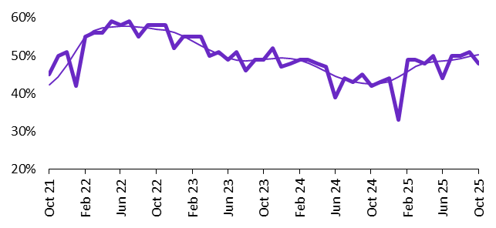  Mar 23 | 55% | 53%
  Apr 23 | 50% | 52%
  May 23 | 51% | 50%
  Jun 23 | 49% | 49%
  Jul 23 | 51% | 49%
  Aug 23 | 46% | 49%
  Sep 23 | 49% | 49%
  Oct 23 | 49% | 49%
  Nov 23 | 52% | 49%
  Dec 23 | 47% | 49%
  Jan 24 | 48% | 49%
  Feb 24 | 49% | 49%
  Mar 24 | 49% | 48%
  Apr 24 | 48% | 47%
  May 24 | 47% | 46%
  Jun 24 | 39% | 45%
  Jul 24 | 44% | 44%
  Aug 24 | 43% | 43%
  Sep 24 | 45% | 43%
  Oct 24 | 42% | 43%
  Nov 24 | 43% | 43%
  Dec 24 | 44% | 43%
  Jan 25 | 33% | 44%
  Feb 25 | 49% | 46%
  Mar 25 | 49% | 47%
  Apr 25 | 48% | 48%
  May 25 | 50% | 48%
  Jun 25 | 44% | 49%
  Jul 25 | 50% | 49%
  Aug 25 | 50% | 49%
  Sep 25 | 51% | 50%
  Oct 25 | 48% | 50%

Recruitment difficulty rate

Recruitment difficulty rate

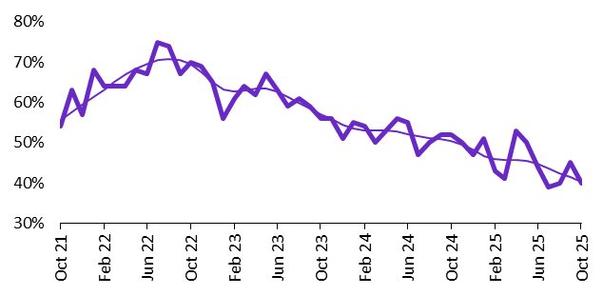
Proportion of recruiting employers who stated they had difficulty hiring staff.
 | 40%  Monthly change:  ▼ 5% pts  Annual change:  ▼ 12% pts
  Date | Recruitment difficulty rate | Smoothed recruitment difficulty rate
  Oct 21 | 54% | 56%
  Nov 21 | 63% | 58%
  Dec 21 | 57% | 59%
  Jan 22 | 68% | 61%
  Feb 22 | 64% | 63%
  Mar 22 | 64% | 65%
  Apr 22 | 64% | 67%
  May 22 | 68% | 68%
  Jun 22 | 67% | 70%
  Jul 22 | 75% | 70%
  Aug 22 | 74% | 71%
  Sep 22 | 67% | 71%
  Oct 22 | 70% | 69%
  Nov 22 | 69% | 68%
  Dec 22 | 65% | 65%
  Jan 23 | 56% | 63%
  Feb 23 | 61% | 63%
  Mar 23 | 64% | 63%
  Apr 23 | 62% | 63%
  May 23 | 67% | 63%
  Jun 23 | 63% | 63%
  Jul 23 | 59% | 61%
  Aug 23 | 61% | 60%
  Sep 23 | 59% | 58%
  Oct 23 | 56% | 57%
  Nov 23 | 56% | 56%
  Dec 23 | 51% | 55%
  Jan 24 | 55% | 54%
  Feb 24 | 54% | 53%
  Mar 24 | 50% | 53%
  Apr 24 | 53% | 53%
  May 24 | 56% | 53%
  Jun 24 | 55% | 52%
  Jul 24 | 47% | 51%
  Aug 24 | 50% | 51%
  Sep 24 | 52% | 51%
  Oct 24 | 52% | 50%
  Nov 24 | 50% | 50%
  Dec 24 | 47% | 48%
  Jan 25 | 51% | 47%
  Feb 25 | 43% | 46%
  Mar 25 | 41% | 46%
  Apr 25 | 53% | 46%
  May 25 | 50% | 45%
  Jun 25 | 44% | 45%
  Jul 25 | 39% | 43%
  Aug 25 | 40% | 42%
  Sep 25 | 45% | 41%
  Oct 25 | 40% | 40%

Expecting to increase staff

Proportion of employers who expected to increase staffing numbers over the next three months.
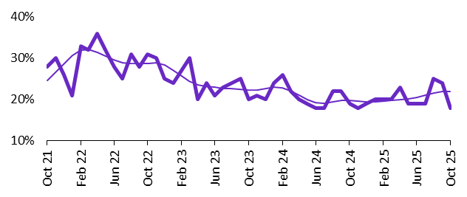 | 18%  Monthly change:  ▼ 6% pts  Annual change:  ▼ 1% pt
  Date | Expect to increase | Smoothed expect to increase
  Oct 21 | 28% | 25%
  Nov 21 | 30% | 27%
  Dec 21 | 26% | 29%
  Jan 22 | 21% | 31%
  Feb 22 | 33% | 32%
  Mar 22 | 32% | 32%
  Apr 22 | 36% | 31%
  May 22 | 32% | 31%
  Jun 22 | 28% | 30%
  Jul 22 | 25% | 29%
  Aug 22 | 31% | 29%
  Sep 22 | 28% | 29%
  Oct 22 | 31% | 29%
  Nov 22 | 30% | 29%
  Dec 22 | 25% | 28%
  Jan 23 | 24% | 27%
  Feb 23 | 27% | 26%
  Mar 23 | 30% | 24%
  Apr 23 | 20% | 24%
  May 23 | 24% | 23%
  Jun 23 | 21% | 23%
  Jul 23 | 23% | 23%
  Aug 23 | 24% | 23%
  Sep 23 | 25% | 22%
  Oct 23 | 20% | 22%
  Nov 23 | 21% | 22%
  Dec 23 | 20% | 23%
  Jan 24 | 24% | 23%
  Feb 24 | 26% | 23%
  Mar 24 | 22% | 22%
  Apr 24 | 20% | 21%
  May 24 | 19% | 20%
  Jun 24 | 18% | 19%
  Jul 24 | 18% | 19%
  Aug 24 | 22% | 19%
  Sep 24 | 22% | 20%
  Oct 24 | 19% | 20%
  Nov 24 | 18% | 20%
  Dec 24 | 19% | 19%
  Jan 25 | 20% | 19%
  Feb 25 | 20% | 20%
  Mar 25 | 20% | 20%
  Apr 25 | 23% | 20%
  May 25 | 19% | 20%
  Jun 25 | 19% | 21%
  Jul 25 | 19% | 21%
  Aug 25 | 25% | 22%
  Sep 25 | 24% | 22%
  Oct 25 | 18% | 22%

Background
Jobs and Skills Australia (JSA) conducts the Recruitment Experiences and Outlook Survey (REOS), a telephone administered survey with the business owner or other person in the business responsible for recruitment. Around 800 employers are surveyed each month, with data published on the JSA website. While the data are indicative of recruitment activity, they may be subject to seasonal factors and other volatility and should therefore be used with a degree of caution. In addition, the survey is targeted towards employers with 5 or more employees and excludes many government organisations.

Smoothed series in charts
Charts include Henderson-smoothed lines in addition to original data for most of our recruitment indicators. As the timeseries is not yet long enough for seasonal adjustment, a Henderson smoothed moving average with a 13-term filter (equating to 13 months) has been directly applied to the original series. This provides an indication of the general movement in each recruitment indicator relative to previous months. Due to using 13 months in the moving average, results for the most recent six months will be revised each month.

Referencing this report
Data in this release should be referenced as: Jobs and Skills Australia, Recruitment Insights Report, October 2025.

Contact us
For additional information, email REOS@jobsandskills.gov.au

Also available from the REOS

Data file with monthly and quarterly recruitment indicators
A REOS data file is available on the JSA website. Breakdowns by Capital City/Rest of State area, Business size, and ANZSCO Skill Level are included in the monthly results. Quarterly recruitment indicators provide additional detail by state, ARIA (ABS’ Accessibility and Remoteness Index of Australia) as well as selected industry and occupation groups.
Next Recruitment Insights Report release:
- November 2025 Recruitment Insights Report – 16th December 2025

Stay up to date
JSA also releases semi-regular reports including spotlight articles, detailing aspects of the REOS that cannot be included in our monthly Recruitment Insights Report. Sign up and get the Recruitment Insights Report notifications sent straight to your inbox.
Upcoming spotlight:
- Entry level jobs across city, coastal, inland and remote regions – 27th November 2025
Recent spotlights:
- September Quarter 2025 Recruitment Insights Report – October 2025
- July spotlight – Employers’ experiences with retention issue – July 2025

A Henderson smoothed line has been included in the charts to reduce month to month volatility and illustrate long term patterns. See the explanatory note for more information.

