Recruitment Experiences and Outlook Survey: September quarter 2025
Jobs and Skills Australia conducts the Recruitment Experiences and Outlook Survey (REOS) to monitor recruitment activity and conditions across Australia. Key national indicators from the survey are released monthly. This quarterly report provides more detailed data, disaggregated by state, area, industry, and occupation. For definitions and further information on these data and the REOS, see the notes on the last page.

Recruitment rate - National level
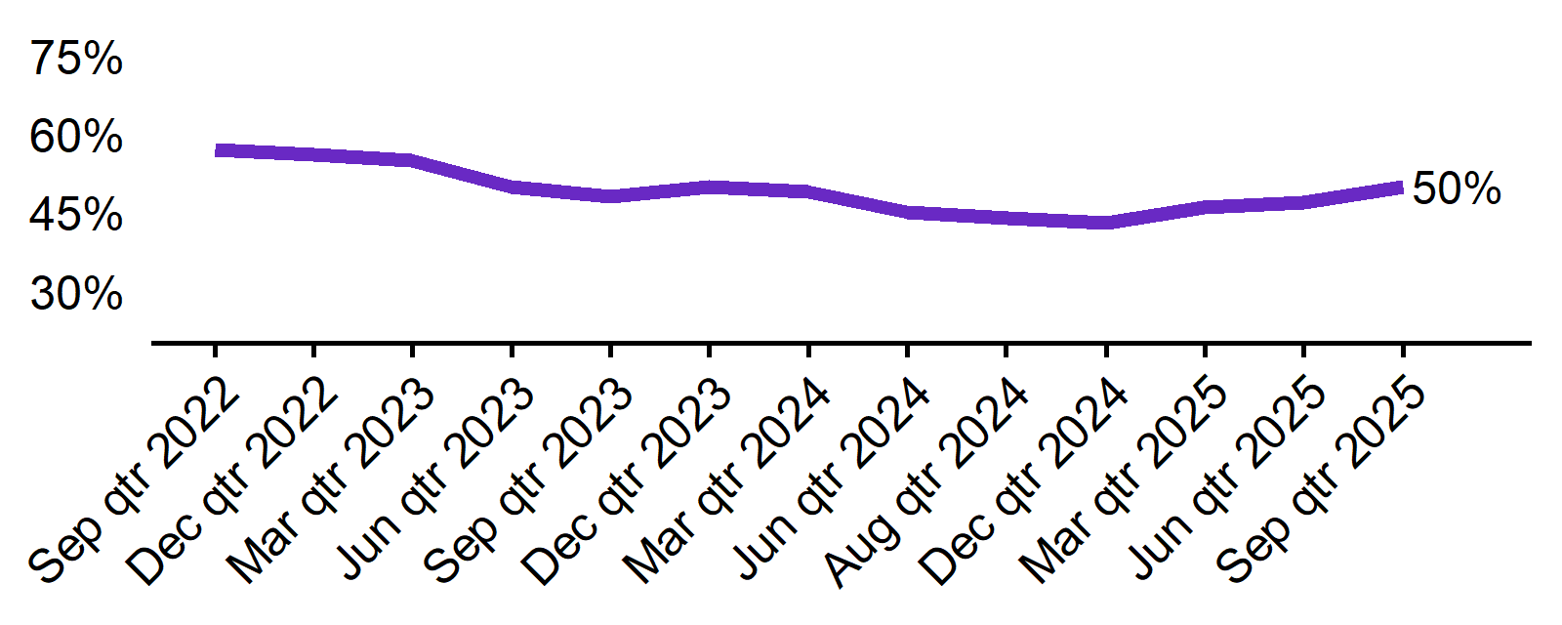 | - The recruitment rate in the September quarter 2025 was 50%.  - This was 6 percentage points higher than the September quarter 2024 (44%).
  Sep qtr 2022 | Dec qtr 2022 | Mar qtr 2023 | Jun qtr 2023 | Sep qtr 2023 | Dec qtr 2023 | Mar qtr 2024 | Jun qtr 2024 | Sep qtr 2024 | Dec qtr 2024 | Mar qtr 2025 | Jun qtr 2025 | Sep qtr 2025
  57% | 56% | 55% | 50% | 48% | 50% | 49% | 45% | 44% | 43% | 46% | 47% | 50%

Recruitment difficulty rate - National level
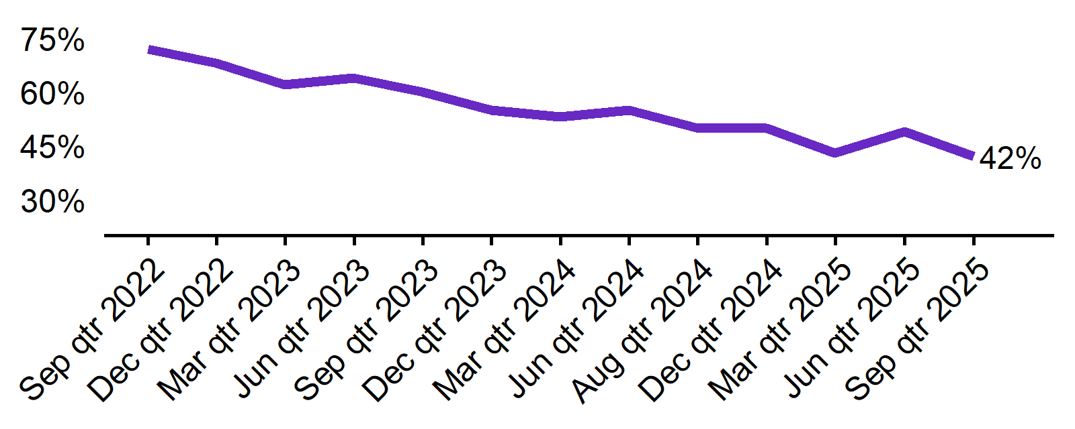 | - The recruitment difficulty rate in the September quarter 2025 was 42%.  - This was 8 percentage points lower than the same period last year (50%).
  Sep qtr 2022 | Dec qtr 2022 | Mar qtr 2023 | Jun qtr 2023 | Sep qtr 2023 | Dec qtr 2023 | Mar qtr 2024 | Jun qtr 2024 | Sep qtr 2024 | Dec qtr 2024 | Mar qtr 2025 | Jun qtr 2025 | Sep qtr 2025
  72% | 68% | 62% | 64% | 60% | 55% | 53% | 55% | 50% | 50% | 43% | 49% | 42%

Expecting to increase staff - National level
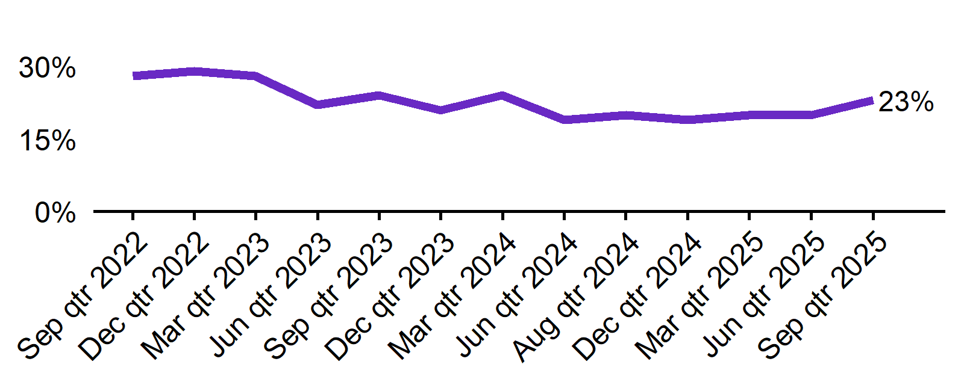 | - In the September quarter 2025, 23% of employers expected to increase staff - up 3 percentage points from the same time last year (20%).  - The proportion of employers who expected to decrease staff was 3% in the September quarter 2025.
  Sep qtr 2022 | Dec qtr 2022 | Mar qtr 2023 | Jun qtr 2023 | Sep qtr 2023 | Dec qtr 2023 | Mar qtr 2024 | Jun qtr 2024 | Sep qtr 2024 | Dec qtr 2024 | Mar qtr 2025 | Jun qtr 2025 | Sep qtr 2025
  28% | 29% | 28% | 22% | 24% | 21% | 24% | 19% | 20% | 19% | 20% | 20% | 23%

Key indicators by state/territory
In the September quarter 2025, Queensland recorded the highest recruitment rate among the six states, at 57%. Western Australia recorded the highest sate recruitment difficulty rate, with 49% of recruiting employers reporting hiring challenges. Out of all states and territories, Northern Territory continues to report the highest recruitment rate (69%*) and recruitment difficulty rate (57%*), though these figures should be interpreted with caution due to the small sample size. Queensland recorded the highest proportion of employers expecting to increase staff levels over the next three months, at 26%.

Table 1. Key indicators by state/territory, September quarter 2025
 | Recruitment rate |  | Recruitment difficulty rate |  | Expect to increase staff
 | % of employers | Annual change  (% points) | % of recruiting employers | Annual change  (% points) | % of employers | Annual change  (% points)
NSW | 49% | 5 pts | 42% | -6 pts | 24% | 7 pts
VIC | 46% | 9 pts | 33% | -15 pts | 20% | 0 pts
QLD | 57% | 5 pts | 46% | -8 pts | 26% | 3 pts
SA | 45% | 9 pts | 43%* | -8 pts* | 20% | 2 pts
WA | 56% | 5 pts | 49% | 0 pts | 22% | -4 pts
TAS | 42% | -1 pts | 35%* | -14 pts* | 17% | -8 pts
NT# | 69% | 3 pts | 57%* | 2 pts* | 23% | -10 pts
ACT# | 40% | -4 pts | 40%* | -8 pts* | 19% | -2 pts

# Due to smaller sample sizes, data for the NT and ACT are based on six-month average data (Jun qtr. to Sep qtr.).
* Interpret with caution due to low sample size.

Figure 1. Recruitment rate by state, September quarter 2024 - September quarter 2025
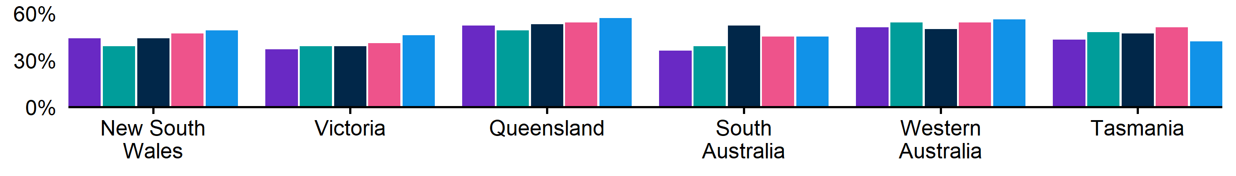
 | Sep qtr 2024 | Dec qtr 2024 | Mar qtr 2025 | Jun qtr 2025 | Sep qtr 2025
NSW | 44% | 39% | 44% | 47% | 49%
VIC | 37% | 39% | 39% | 41% | 46%
QLD | 52% | 49% | 53% | 54% | 57%
SA | 36% | 39% | 52% | 45% | 45%
WA | 51% | 54% | 50% | 54% | 56%
TAS | 43% | 48% | 47% | 51% | 42%

Figure 2. Recruitment difficulty rate by state, September quarter 2024 - September quarter 2025
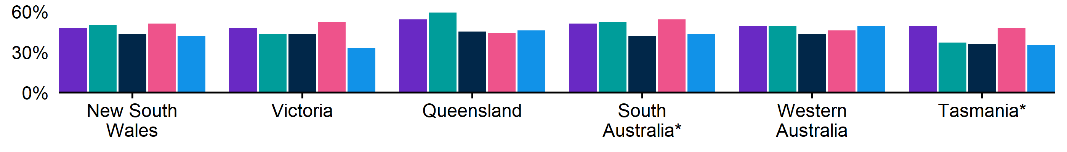
 | Sep qtr 2024 | Dec qtr 2024 | Mar qtr 2025 | Jun qtr 2025 | Sep qtr 2025
NSW | 48% | 50% | 43% | 51% | 42%
VIC | 48% | 43% | 43% | 52% | 33%
QLD | 54% | 59% | 45% | 44% | 46%
SA | 51%* | 52% | 42%* | 54%* | 43%*
WA | 49% | 49% | 43% | 46% | 49%
TAS | 49%* | 37%* | 36%* | 48%* | 35%*

Figure 3. Expecting to increase staff numbers over the next 3 months by state, September quarter 2024 - September quarter 2025
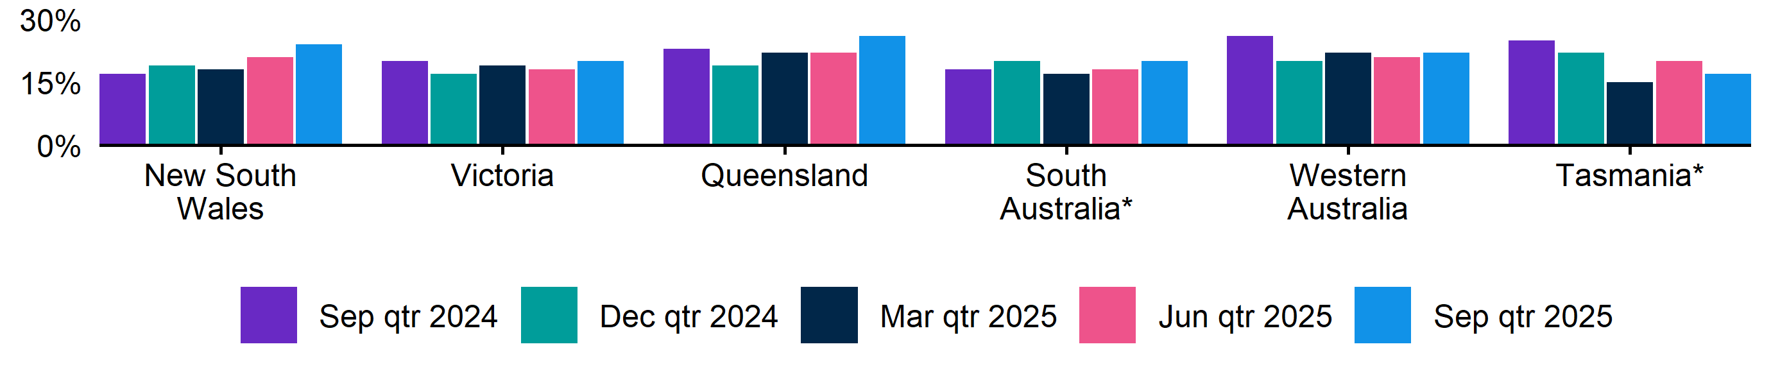
 | Sep qtr 2024 | Dec qtr 2024 | Mar qtr 2025 | Jun qtr 2025 | Sep qtr 2025
NSW | 17% | 19% | 18% | 21% | 24%
VIC | 20% | 17% | 19% | 18% | 20%
QLD | 23% | 19% | 22% | 22% | 26%
SA | 18% | 20% | 17% | 18% | 20%
WA | 26% | 20% | 22% | 21% | 22%
TAS | 25% | 22% | 15% | 20% | 17%

Key indicators by remoteness classification (ARIA location)
In the September quarter of 2025, Outer Regional, Remote, and Very Remote areas of Australia recorded the highest recruitment rate among the ARIA regions, at 58%. These regions also experienced the highest recruitment difficulty rate (49%). In Major Cities, the proportion of employers expecting to increase staff in the next three months rose by 4 percentage points over the year—the largest increase of any region—and this was aligned with a 7 percentage points decrease in recruitment difficulty rate in the same region.

Table 2. Key indicators by ARIA location, September quarter 2025
 | Recruitment rate |  | Recruitment difficulty rate |  | Expect to increase staff
 | % of employers | Annual change  (% points) | % of recruiting employers | Annual change  (% points) | % of employers | Annual change  (% points)
Major Cities of Australia | 50% | 8 pts | 40% | -7 pts | 23% | 4 pts
Inner Regional Australia | 47% | -1 pts | 45% | -12 pts | 22% | -2 pts
Outer Regional, Remote and Very Remote Australia | 58% | 8 pts | 49% | -4 pts | 22% | 0 pts

* Interpret with caution due to low sample size. Accessibility and Remoteness Index of Australia (ARIA) classifications of Outer Regional Australia, Remote Australia, and Very Remote Australia have been combined into one category to increase sample size.

Figure 4. Recruitment rate by ARIA location, September quarter 2024 - September quarter 2025
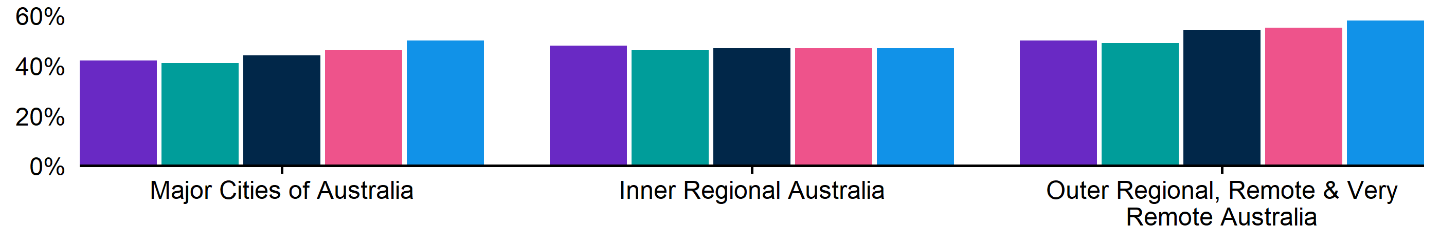
 | Sep qtr 2024 | Dec qtr 2024 | Mar qtr 2025 | Jun qtr 2025 | Sep qtr 2025
Major Cities of Australia | 42% | 41% | 44% | 46% | 50%
Inner Regional Australia | 48% | 46% | 47% | 47% | 47%
Outer Regional, Remote and Very Remote Australia | 50% | 49% | 54% | 55% | 58%

Figure 5. Recruitment difficulty rate by ARIA location, September quarter 2024 - September quarter 2025
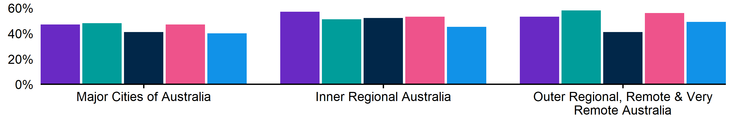
 | Sep qtr 2024 | Dec qtr 2024 | Mar qtr 2025 | Jun qtr 2025 | Sep qtr 2025
Major Cities of Australia | 47% | 48% | 41% | 47% | 40%
Inner Regional Australia | 57% | 51% | 52% | 53% | 45%
Outer Regional, Remote and Very Remote Australia | 53% | 58% | 41% | 56% | 49%

Figure 6. Expecting to increase staff numbers over the next 3 months by ARIA location, September quarter 2024 - September quarter 2025
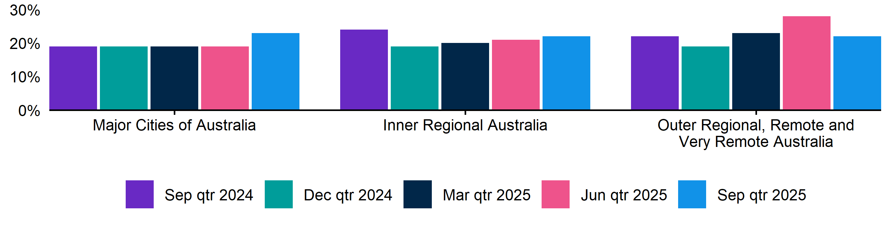
 | Sep qtr 2024 | Dec qtr 2024 | Mar qtr 2025 | Jun qtr 2025 | Sep qtr 2025
Major Cities of Australia | 19% | 19% | 19% | 19% | 23%
Inner Regional Australia | 24% | 19% | 20% | 21% | 22%
Outer Regional, Remote and Very Remote Australia | 22% | 19% | 23% | 28% | 22%

Key indicators by selected industries
In the September quarter 2025, Accommodation and Food Services recorded the highest recruitment rate (75%) and the lowest recruitment difficulty rate (22%) of the selected industries. Construction recorded the highest rate of recruitment difficulty, at 56%*. Notably, the Accommodation and Food Services industry reported an expectation to increase staff over the next three months (42%), well above the other industries.

Table 3. Key indicators by industry, September quarter 2025
 | Recruitment rate |  | Recruitment difficulty rate |  | Expect to increase staff
 | % of employers | Annual change  (% points) | % of recruiting employers | Annual change  (% points) | % of employers | Annual change  (% points)
Manufacturing | 46% | 7 pts | 52% | -5 pts | 23% | 5 pts
Construction | 49% | 7 pts | 56%* | -3 pts* | 21% | 7 pts
Wholesale Trade | 44% | 8 pts | 48%* | -5 pts* | 23% | 2 pts
Retail Trade | 43% | 5 pts | 34% | -10 pts | 15% | -4 pts
Accommodation and Food Services | 75% | 16 pts | 22% | -14 pts | 42% | 11 pts
Professional, Scientific and Technical Services | 45% | -2 pts | 48%* | -8 pts* | 20% | -4 pts
Health Care and Social Assistance | 56% | 5 pts | 45% | -10 pts | 23% | 1 pts

*Interpret with caution due to low sample size.

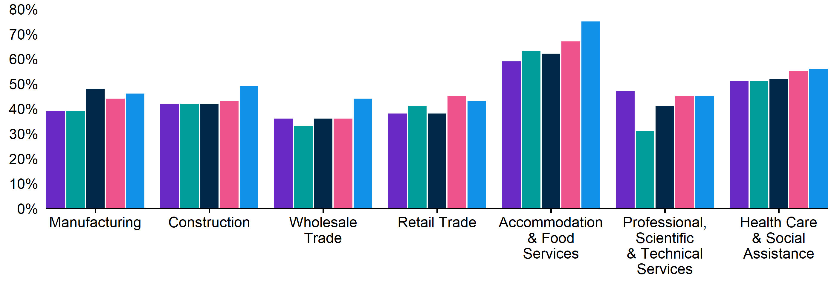
Figure 7. Recruitment rate by industry, September quarter 2024 - September quarter 2025

 | Sep qtr 2024 | Dec qtr 2024 | Mar qtr 2025 | Jun qtr 2025 | Sep qtr 2025
Manufacturing | 39% | 39% | 48% | 44% | 46%
Construction | 42% | 42% | 42% | 43% | 49%
Wholesale Trade | 36% | 33% | 36% | 36% | 44%
Retail Trade | 38% | 41% | 38% | 45% | 43%
Accommodation and Food Services | 59% | 63% | 62% | 67% | 75%
Professional, Scientific and Technical Services | 47% | 31% | 41% | 45% | 45%
Health Care and Social Assistance | 51% | 51% | 52% | 55% | 56%

Figure 8. Recruitment difficulty rate by industry, September quarter 2024 - September quarter 2025
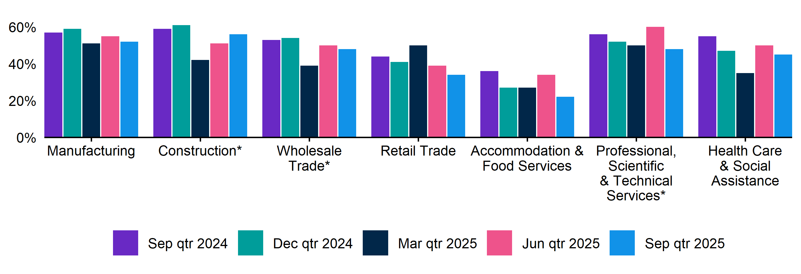
 | Sep qtr 2024 | Dec qtr 2024 | Mar qtr 2025 | Jun qtr 2025 | Sep qtr 2025
Manufacturing | 57% | 59% | 51% | 55% | 52%
Construction | 59% | 61%* | 42%* | 51% | 56%*
Wholesale Trade | 53%* | 54%* | 39%* | 50%* | 48%*
Retail Trade | 44% | 41% | 50%* | 39%* | 34%
Accommodation and Food Services | 36% | 27% | 27%* | 34%* | 22%
Professional, Scientific and Technical Services | 56%* | 52%* | 50%* | 60%* | 48%*
Health Care and Social Assistance | 55% | 47% | 35% | 50% | 45%

Key indicators by selected occupation groups
In the September quarter 2025, Technicians and Trades Workers recorded the highest recruitment difficulty rate at 61%. Employers recruiting for Professionals had the highest proportion of vacancies unfilled for over a month, at 56%*. Over the year, Professionals experienced the largest decrease in recruitment difficulty rate (down 19 percentage points), aligning with the largest decrease in the proportion of vacancies remaining unfilled for over a month (dropping by 11 percentage points).

Table 4. Key indicators by occupation, September quarter 2025
 | Recruitment difficulty rate |  | Vacancies taking longer  than 1 month to fill
 | % of recruiting employers | Annual change  (% points) | % of recruiting employers | Annual change  (% points)
Professionals | 45% | -19 pts | 56%* | -11 pts*
Technicians and Trades Workers | 61% | -2 pts | 53% | -7 pts
Community and Personal Service Workers | 40% | -13 pts | 36% | -9 pts
Clerical and Administrative Workers | 35%* | -2 pts* | 38%* | 6 pts*
Sales Workers | 24% | -8 pts | 25% | -5 pts
Machinery Operators and Drivers | 44%* | -8 pts* | 35%* | 0 pts*
Labourers | 40% | -4 pts | 30%* | 2 pts*

*Interpret with caution due to low sample size.

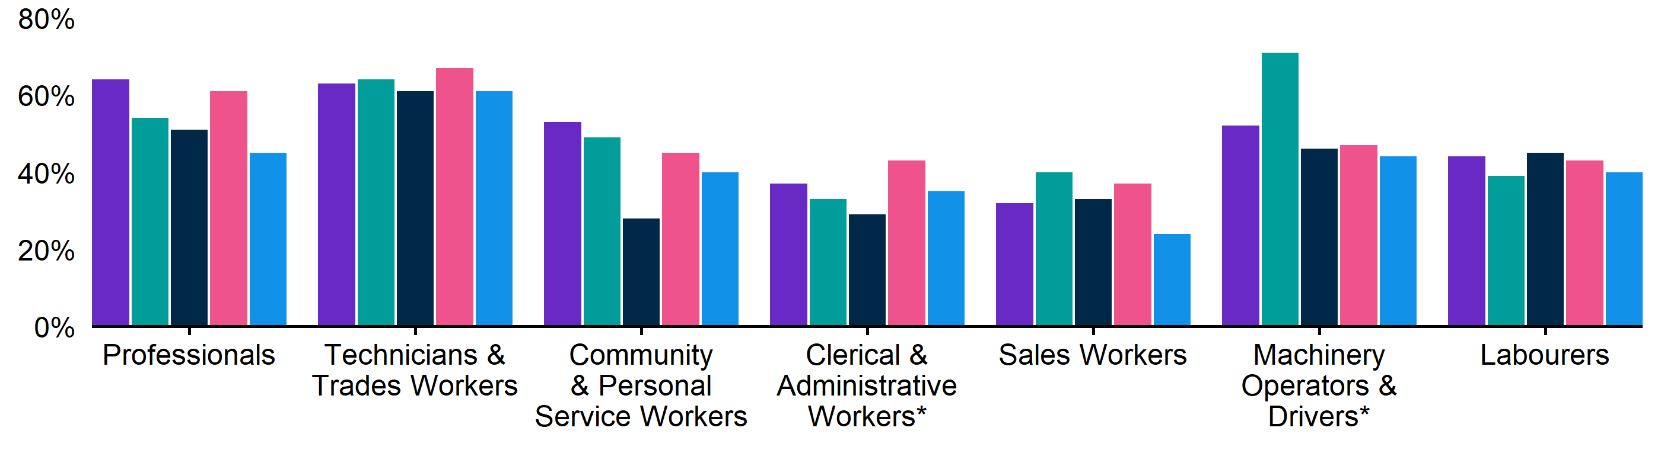
Figure 9. Recruitment difficulty rate by occupation, September quarter 2024 - September quarter 2025

 | Sep qtr 2024 | Dec qtr 2024 | Mar qtr 2025 | Jun qtr 2025 | Sep qtr 2025
Professionals | 64% | 54%* | 51% | 61%* | 45%
Technicians and Trades Workers | 63% | 64% | 61% | 67% | 61%
Community and Personal Service Workers | 53% | 49% | 28% | 45% | 40%
Clerical and Administrative Workers | 37% | 33% | 29%* | 43%* | 35%*
Sales Workers | 32% | 40% | 33% | 37% | 24%
Machinery Operators and Drivers | 52%* | 71%* | 46%* | 47%* | 44%*
Labourers | 44% | 39% | 45% | 43% | 40%

Figure 10. Vacancies taking longer than 1 month to fill, by occupation group, September quarter 2024 - September quarter 2025
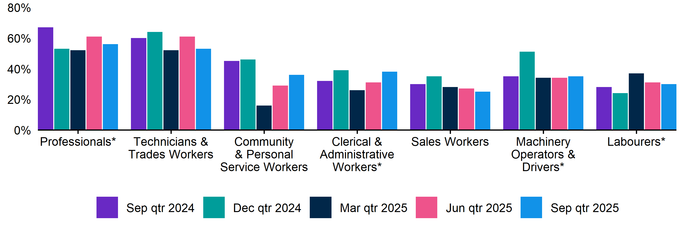
 | Sep qtr 2024 | Dec qtr 2024 | Mar qtr 2025 | Jun qtr 2025 | Sep qtr 2025
Professionals | 67%* | 53%* | 52%* | 61%* | 56%*
Technicians and Trades Workers | 60% | 64% | 52% | 61% | 53%
Community and Personal Service Workers | 45% | 46% | 16%* | 29%* | 36%
Clerical and Administrative Workers | 32%* | 39%* | 26%* | 31%* | 38%*
Sales Workers | 30% | 35% | 28% | 27% | 25%
Machinery Operators and Drivers | 35%* | 51%* | 34%* | 34%* | 35%*
Labourers | 28% | 24% | 37%* | 31%* | 30%*

REOS Background and Notes
Jobs and Skills Australia conducts the Recruitment Experiences and Outlook Survey (REOS), a telephone administered survey of at least 800 employers each month (except for December and January, during which fewer employers are surveyed). While the results are indicative of recruitment activity, they may be subject to seasonal factors and other volatility and should therefore be used with a degree of caution. In addition, the survey is targeted towards employers with 5 or more employees, and excludes many government organisations. More detail is available at https://www.jobsandskills.gov.au/work/reos-survey-methodology. REOS data are published on the Jobs and Skills Australia website.
Data in this release should be referenced as: Jobs and Skills Australia, Recruitment Experiences and Outlook Survey: September quarter 2025.

Data notations
* Interpret with caution due to low sample size.

Recruitment rate
The proportion of employers either currently recruiting or who had recruited in the previous month. It is calculated by dividing the number of employers who recruited or were attempting to recruit by the number of employers that responded to the survey (excluding ‘unsure’ responses).

Recruitment difficulty rate
The proportion of recruiting employers who experienced difficulty hiring staff. This indicator focusses on the most recent recruitment round in the month prior to being surveyed. The indicator is calculated as: employers who recruited and reported difficulty, divided by all employers who recruited (excluding ‘unsure’ responses).

Expectations to increase staffing levels over the next 3 months
The proportion of employers who expect to increase staff levels over the next 3 months. Expectations to decrease staff is also collected.

Vacancies taking longer than 1 month to fill
The proportion of recruiting employers unable to fill all their vacancies within a month. It excludes employers with unfilled vacancies who have been recruiting for less than a month.

Recent REOS releases
The Jobs and Skills Australia website includes:
- The September 2025 monthly REOS report, including a more detailed excel datafile. The datafile includes both the monthly results as well as the quarterly series. The quarterly estimates are aggregated results for the 3 months within each quarter.
- REOS Spotlight series featuring analysis on topics of interest not covered in the regular monthly. Recent spotlight releases cover employers who recruited jobless applicants, and employers’ greatest future concern.
For queries, contact: REOS@jobsandskills.gov.au

Australian Bureau of Statistics, Remoteness Areas, Australian Statistical Geography Standard (ASGS) Edition 3, https://www.abs.gov.au/statistics/standards/australian-statistical-geography-standard-asgs-edition-3/jul2021-jun2026/remoteness-structure/remoteness-areas

