REOS Recruitment Insights Report - September 2025
Jobs and Skills Australia surveys around 800 employers each month through the Recruitment Experiences and Outlook Survey (REOS) to understand their recruitment experiences and staffing expectations.

Key Findings
At the national level, recruitment indicators continue to reflect improving employer sentiment. The recruitment rate is continuing to trend upward, while recruitment difficulty continues a downward trend over the past year. This positive sentiment is also reflected in the long-term outlook, with more employers expecting to increase staff over the coming year.
Recent volatility in key indicators over the last few months has largely been driven by regional differences. However, the September 2025 results show similar trends across Capital Cities and Rest of State areas for most indicators - except for the recruitment rate, where differences remain.
Recruitment Activity
In September 2025, the national recruitment rate increased by 1 percentage point to 51%. This move continues an upward trend with the national recruitment rate increasing by 6 percentage points over the past 12 months.
Half of employers in Capital Cities (50%) recruited in September 2025, a decrease of 2 percentage points from the previous month. In contrast, the recruitment rate in Rest of State areas increased by 7 percentage points to 55%.
Compared to September 2024, recruitment activity increased more sharply in Capital Cities (up 9 percentage points) than in Rest of State areas (up 4 percentage points), indicating stronger growth in metropolitan recruitment over the past year.
Recruitment Difficulty
The recruitment difficulty rate increased by 5 percentage points in September to 45% of recruiting employers. Despite this monthly increase, the rate remains 7 percentage points lower than it was a year ago and 30 percentage points below the record high of 75% in July 2022.
In September 2025, a slightly lower proportion of recruiting employers experienced recruitment difficulty in Capital Cities (44%) compared with Rest of State areas (46%). Both experienced an increase in recruitment difficulty compared with the previous month, up 7 percentage points in Capital Cities and 1 percentage point in Rest of State areas. However, compared to September 2024, recruitment difficulty eased slightly in Capital Cities (down 1 percentage point) and more significantly in Rest of State areas (down 16 percentage points).
Staffing Outlook: employers expecting to increase staff
In September 2025, 24% of employers expected to increase staffing numbers in the next three months, a 1 percentage point decrease from August, but 2 percentage points higher than a year earlier.
Overall, staffing outlook was slightly weaker in Capital Cities compared to Rest of State areas. A lower proportion of employers in Capital Cities (24%) were expecting to increase their staffing levels in the next three months compared with Rest of State areas (26%). Over the month, staffing outlook fell by 3 percentage points in Capital Cities while Rest of State areas experienced an increase of 4 percentage points.
Reason for Recruiting
The primary reason for recruitment in September was staff turnover only, cited by 58% of recruiting employers. Meanwhile, 31% recruited to fill new positions only, and 11% recruited for both turnover and new roles.
Staffing Changes Over the Last Month
In September, 12% of employers increased staff - down 3 percentage points from August. The proportion of employers who decreased staff also fell down 1 percentage point to 11%.
Employers Unable to Fill Vacancies Within a Month

The proportion of employers unable to fill vacancies within a month rose by 2 percentage points to 44% in September. This figure is unchanged compared to September 2024.

REOS national indicators

Recruitment rate

Proportion of employers currently recruiting or who recruited in the previous month.
Date Recruitment rate Smoothed recruitment rate  Sep 2021 36% 42%  Oct 2021 45% 42%  Nov 2021 50% 44%  Dec 2021 51% 48%  Jan 2022 42% 52%  Feb 2022 55% 55%  Mar 2022 56% 57%  Apr 2022 56% 57%  May 2022 59% 58%  Jun 2022 58% 58%  Jul 2022 59% 58%  Aug 2022 55% 58%  Sep 2022 58% 57%  Oct 2022 58% 57%  Nov 2022 58% 57%  Dec 2022 52% 56%  Jan 2023 55% 55%  Feb 2023 55% 54%  Mar 2023 55% 53%  Apr 2023 50% 52%  May 2023 51% 50%  Jun 2023 49% 49%  Jul 2023 51% 49%  Aug 2023 46% 49%  Sep 2023 49% 49%  Oct 2023 49% 49%  Nov 2023 52% 49%  Dec 2023 47% 49%  Jan 2024 48% 49%  Feb 2024 49% 49%  Mar 2024 49% 48%  Apr 2024 48% 47%  May 2024 47% 46%  Jun 2024 39% 45%  Jul 2024 44% 44%  Aug 2024 43% 43%  Sep 2024 45% 43%  Oct 2024 42% 43%  Nov 2024 43% 43%  Dec 2024 44% 43%  Jan 2025 33% 44%  Feb 2025 49% 46%  Mar 2025 49% 47%  Apr 2025 48% 48%  May 2025 50% 48%  Jun 2025 44% 49%  Jul 2025 50% 49%  Aug 2025 50% 50%  Sep 2025 51% 50%  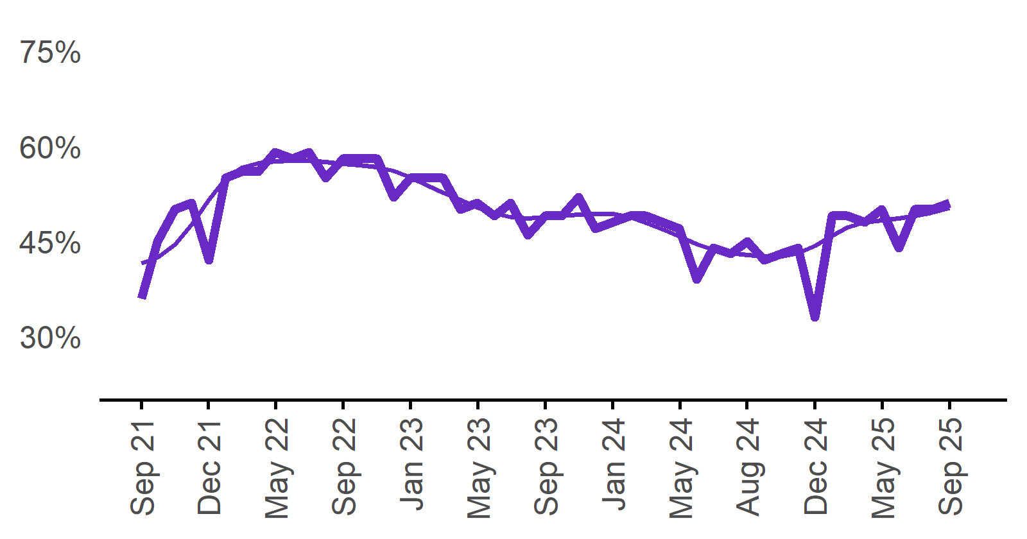 | 51%  Monthly change:  ▲ 1% pt  Annual change:  ▲ 6% pts

Recruitment difficulty rate

Proportion of recruiting employers who stated they had difficulty hiring staff.
Date Recruitment difficulty rate Smoothed recruitment difficulty rate  Sep 2021 52% 54%  Oct 2021 54% 56%  Nov 2021 63% 58%  Dec 2021 57% 59%  Jan 2022 68%* 61%  Feb 2022 64% 63%  Mar 2022 64% 65%  Apr 2022 64% 67%  May 2022 68% 68%  Jun 2022 67% 70%  Jul 2022 75% 70%  Aug 2022 74% 71%  Sep 2022 67% 71%  Oct 2022 70% 69%  Nov 2022 69% 68%  Dec 2022 65% 65%  Jan 2023 56% 63%  Feb 2023 61% 63%  Mar 2023 64% 63%  Apr 2023 62% 63%  May 2023 67% 63%  Jun 2023 63% 63%  Jul 2023 59% 61%  Aug 2023 61% 60%  Sep 2023 59% 58%  Oct 2023 56% 57%  Nov 2023 56% 56%  Dec 2023 51% 55%  Jan 2024 55% 54%  Feb 2024 54% 53%  Mar 2024 50% 53%  Apr 2024 53% 53%  May 2024 56% 53%  Jun 2024 55% 52%  Jul 2024 47% 51%  Aug 2024 50% 51%  Sep 2024 52% 51%  Oct 2024 52% 50%  Nov 2024 50% 50%  Dec 2024 47% 48%  Jan 2025 51% 47%  Feb 2025 43% 46%  Mar 2025 41% 46%  Apr 2025 53% 46%  May 2025 50% 46%  Jun 2025 44% 45%  Jul 2025 39% 44%  Aug 2025 40% 43%  Sep 2025 45% 42%  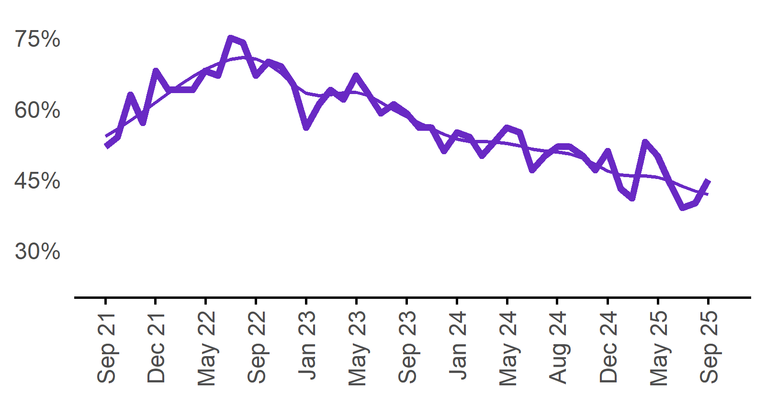 | 45%  Monthly change:  ▲ 5% pts  Annual change:  ▼ 7% pts

Expecting to increase staff

Proportion of employers who expected to increase staffing numbers over the next three months.
Date Expect to increase Smoothed expect to increase  Sep 2021 23% 23%  Oct 2021 28% 25%  Nov 2021 30% 27%  Dec 2021 26% 29%  Jan 2022 21% 31%  Feb 2022 33% 32%  Mar 2022 32% 32%  Apr 2022 36% 31%  May 2022 32% 31%  Jun 2022 28% 30%  Jul 2022 25% 29%  Aug 2022 31% 29%  Sep 2022 28% 29%  Oct 2022 31% 29%  Nov 2022 30% 29%  Dec 2022 25% 28%  Jan 2023 24% 27%  Feb 2023 27% 26%  Mar 2023 30% 24%  Apr 2023 20% 24%  May 2023 24% 23%  Jun 2023 21% 23%  Jul 2023 23% 23%  Aug 2023 24% 23%  Sep 2023 25% 22%  Oct 2023 20% 22%  Nov 2023 21% 22%  Dec 2023 20% 23%  Jan 2024 24% 23%  Feb 2024 26% 23%  Mar 2024 22% 22%  Apr 2024 20% 21%  May 2024 19% 20%  Jun 2024 18% 19%  Jul 2024 18% 19%  Aug 2024 22% 19%  Sep 2024 22% 20%  Oct 2024 19% 20%  Nov 2024 18% 20%  Dec 2024 19% 19%  Jan 2025 20% 19%  Feb 2025 20% 20%  Mar 2025 20% 20%  Apr 2025 23% 20%  May 2025 19% 20%  Jun 2025 19% 21%  Jul 2025 19% 21%  Aug 2025 25% 22%  Sep 2025 24% 23%  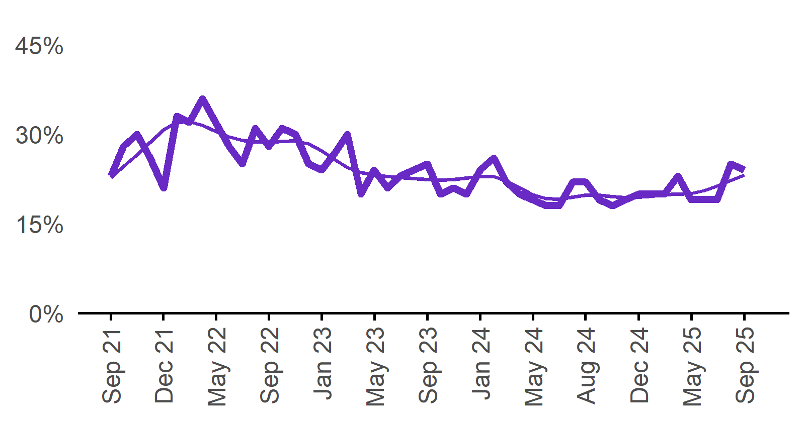 | 24%  Monthly change:  ▼ 1% pt  Annual change:  ▲ 2% pts

Capital City/Rest of State areas

Recruitment rate

Proportion of employers currently recruiting or who recruited in the previous month.
Date Capital Cities - Recruitment rate Rest of State areas - Recruitment rate Capital Cities - Smoothed recruitment rate Rest of State areas - Smoothed recruitment rate  Sep 2021 36% 36% 41% 43%  Oct 2021 45% 44% 42% 44%  Nov 2021 50% 51% 44% 45%  Dec 2021 48% 55% 47% 49%  Jan 2022 n.p. n.p. 51% 53%  Feb 2022 55% 54% 54% 57%  Mar 2022 53% 61% 55% 60%  Apr 2022 54% 60% 56% 61%  May 2022 58% 60% 56% 61%  Jun 2022 56% 61% 56% 60%  Jul 2022 57% 62% 57% 60%  Aug 2022 54% 58% 57% 59%  Sep 2022 58% 57% 57% 58%  Oct 2022 58% 58% 57% 58%  Nov 2022 57% 61% 56% 57%  Dec 2022 53% 50% 56% 57%  Jan 2023 n.p. n.p. 54% 56%  Feb 2023 54% 58% 53% 56%  Mar 2023 55% 56% 51% 56%  Apr 2023 48% 53% 50% 55%  May 2023 49% 55% 49% 54%  Jun 2023 46% 54% 48% 52%  Jul 2023 50% 52% 47% 51%  Aug 2023 44% 48% 47% 51%  Sep 2023 49% 49% 47% 52%  Oct 2023 47% 54% 47% 53%  Nov 2023 48% 58% 47% 54%  Dec 2023 44% 53% 47% 54%  Jan 2024 45% 53% 47% 54%  Feb 2024 47% 52% 47% 53%  Mar 2024 46% 53% 46% 51%  Apr 2024 49% 47% 45% 50%  May 2024 45% 51% 44% 49%  Jun 2024 37% 44% 43% 48%  Jul 2024 41% 50% 42% 48%  Aug 2024 42% 45% 41% 47%  Sep 2024 41% 51% 41% 46%  Oct 2024 42% 42% 41% 46%  Nov 2024 40% 50% 41% 46%  Dec 2024 42% 46% 41% 47%  Jan 2025 n.p. n.p. 42% 48%  Feb 2025 46% 55% 44% 50%  Mar 2025 48% 53% 45% 51%  Apr 2025 46% 50% 47% 51%  May 2025 49% 51% 47% 50%  Jun 2025 44% 45% 48% 50%  Jul 2025 49% 51% 49% 50%  Aug 2025 52% 48% 49% 50%  Sep 2025 50% 55% 50% 51%  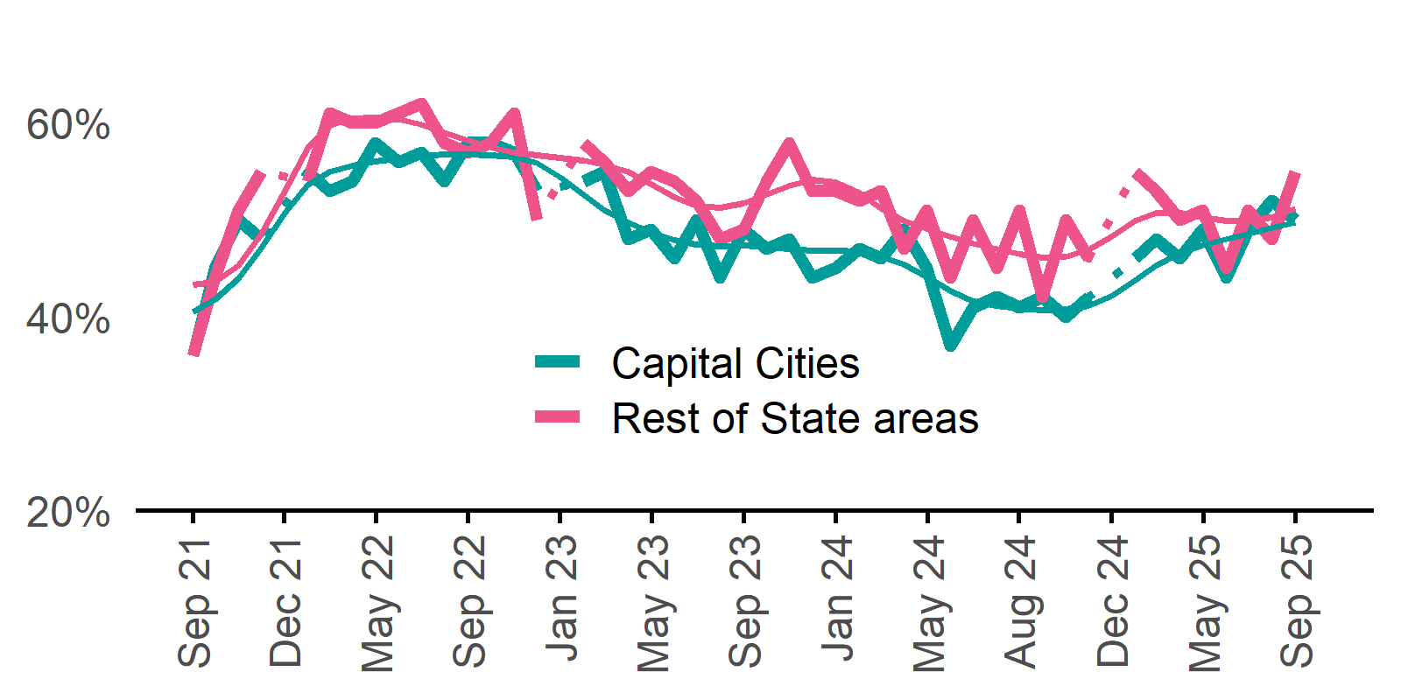 | Capital Cities: 50%  Monthly change:  ▼ 2% pts  Annual change:  ▲ 9% pts  Rest of State: 55%  Monthly change:  ▲ 7% pts  Annual change:  ▲ 4% pts

Recruitment difficulty rate

Proportion of recruiting employers who stated they had difficulty hiring staff.
Date Capital Cities - Recruitment difficulty rate Rest of State areas - Recruitment difficulty rate Capital Cities - Smoothed recruitment difficulty rate Rest of State areas - Smoothed recruitment difficulty rate  Sep 2021 54% 50% 52% 58%  Oct 2021 50% 62% 54% 59%  Nov 2021 60% 67% 56% 61%  Dec 2021 55% 60% 58% 62%  Jan 2022 n.p. n.p. 60% 64%  Feb 2022 62% 66% 63% 64%  Mar 2022 64% 63% 65% 65%  Apr 2022 65% 62% 67% 67%  May 2022 67% 71% 68% 69%  Jun 2022 66% 67% 69% 70%  Jul 2022 74% 77% 70% 71%  Aug 2022 75% 71% 70% 72%  Sep 2022 66% 68% 70% 72%  Oct 2022 67% 75% 69% 71%  Nov 2022 69% 70% 66% 69%  Dec 2022 63% 68% 64% 67%  Jan 2023 n.p. n.p. 62% 65%  Feb 2023 59% 64% 62% 64%  Mar 2023 65% 64% 62% 65%  Apr 2023 59% 66% 62% 66%  May 2023 65% 69% 62% 67%  Jun 2023 62% 64% 60% 67%  Jul 2023 55% 66% 59% 66%  Aug 2023 57% 67% 57% 65%  Sep 2023 56% 66% 56% 63%  Oct 2023 55% 59% 55% 61%  Nov 2023 54% 58% 53% 60%  Dec 2023 48% 56% 52% 59%  Jan 2024 49% 64% 50% 59%  Feb 2024 52% 57% 50% 58%  Mar 2024 46% 58% 51% 57%  Apr 2024 50% 58% 52% 55%  May 2024 57% 53% 52% 53%  Jun 2024 56% 52% 52% 52%  Jul 2024 48% 46% 51% 52%  Aug 2024 50% 51% 50% 52%  Sep 2024 45% 62% 50% 53%  Oct 2024 50% 55% 49% 53%  Nov 2024 54% 44% 48% 52%  Dec 2024 45% 52% 46% 51%  Jan 2025 n.p. n.p. 45% 50%  Feb 2025 38% 52% 44% 49%  Mar 2025 41% 39% 44% 49%  Apr 2025 50% 59% 44% 50%  May 2025 47% 55% 44% 49%  Jun 2025 45% 42% 43% 48%  Jul 2025 38% 43% 42% 46%  Aug 2025 37% 45% 41% 45%  Sep 2025 44% 46% 40% 45%  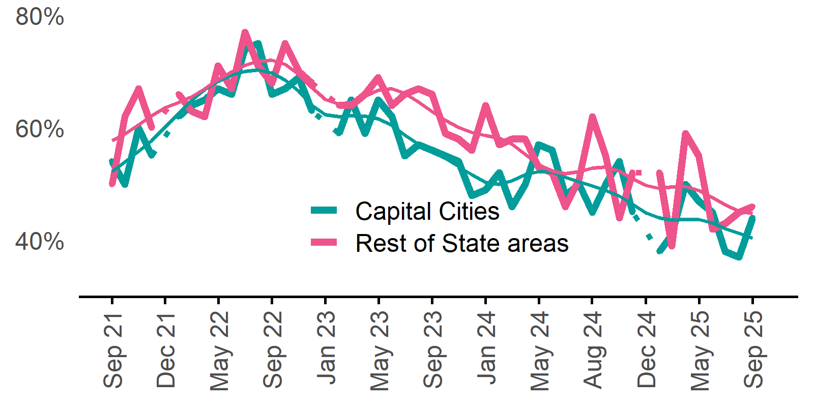 | Capital Cities: 44%  Monthly change:  ▲ 7% pts  Annual change:  ▼ 1% pt  Rest of State: 46%  Monthly change:  ▲ 1% pt  Annual change:  ▼ 16% pts

Staffing outlook – Expecting to increase staff

Proportion of employers who expected to increase staffing numbers over the next three months.
Date Capital Cities - % expecting to increase Rest of State areas - % expecting to increase Capital Cities - Smoothed % expecting to increase Rest of State areas - Smoothed % expecting to increase  Sep 2021 24% 22% 23% 22%  Oct 2021 28% 28% 25% 24%  Nov 2021 31% 28% 27% 26%  Dec 2021 26% 27% 29% 27%  Jan 2022 n.p. n.p. 31% 29%  Feb 2022 34% 31% 33% 30%  Mar 2022 33% 30% 33% 30%  Apr 2022 37% 35% 32% 30%  May 2022 33% 30% 31% 29%  Jun 2022 28% 27% 30% 28%  Jul 2022 25% 25% 30% 28%  Aug 2022 31% 30% 29% 28%  Sep 2022 30% 24% 29% 28%  Oct 2022 30% 32% 29% 28%  Nov 2022 31% 28% 29% 28%  Dec 2022 23% 28% 29% 28%  Jan 2023 n.p. n.p. 27% 27%  Feb 2023 28% 25% 26% 26%  Mar 2023 29% 30% 25% 24%  Apr 2023 20% 19% 24% 23%  May 2023 23% 24% 23% 23%  Jun 2023 22% 19% 23% 23%  Jul 2023 22% 24% 22% 23%  Aug 2023 22% 28% 22% 23%  Sep 2023 25% 25% 22% 23%  Oct 2023 21% 18% 22% 23%  Nov 2023 20% 25% 22% 23%  Dec 2023 21% 20% 22% 23%  Jan 2024 22% 27% 23% 23%  Feb 2024 26% 26% 23% 23%  Mar 2024 22% 23% 22% 22%  Apr 2024 23% 15% 21% 21%  May 2024 17% 23% 20% 20%  Jun 2024 19% 16% 19% 20%  Jul 2024 17% 18% 19% 20%  Aug 2024 22% 22% 19% 21%  Sep 2024 19% 28% 19% 21%  Oct 2024 19% 19% 19% 21%  Nov 2024 18% 19% 19% 20%  Dec 2024 20% 17% 19% 19%  Jan 2025 n.p. n.p. 20% 19%  Feb 2025 20% 19% 19% 20%  Mar 2025 18% 24% 19% 21%  Apr 2025 21% 26% 19% 22%  May 2025 19% 18% 19% 21%  Jun 2025 18% 21% 20% 21%  Jul 2025 19% 19% 21% 21%  Aug 2025 27% 22% 22% 22%  Sep 2025 24% 26% 24% 22% | Capital Cities: 24%  Monthly change:  ▼ 3% pts  Annual change:  ▲ 5% pts  Rest of State: 26%  Monthly change:  ▲ 4% pts  Annual change:  ▼ 2% pts

Other recruitment indicators

Reason for recruiting

Proportion of employers currently recruiting or who recruited in the previous month.
Date | Staff turnover only | Staff turnover and new positions | New positions only | Smoothed - staff turnover only | Smoothed - staff turnover and new positions | Smoothed - new positions only
Sep 2021 | 63% | 7% | 30% | 58% | 9% | 33%
Oct 2021 | 58% | 8% | 34% | 59% | 9% | 32%
Nov 2021 | 58% | 13% | 30% | 59% | 10% | 31%
Dec 2021 | 57% | 10% | 33% | 60% | 10% | 30%
Jan 2022 | n.p. | n.p. | n.p. | 60% | 11% | 29%
Feb 2022 | 58% | 12% | 31% | 61% | 12% | 28%
Mar 2022 | 65% | 10% | 24% | 62% | 13% | 26%
Apr 2022 | 60% | 15% | 25% | 62% | 13% | 25%
May 2022 | 61% | 16% | 23% | 62% | 14% | 24%
Jun 2022 | 61% | 12% | 27% | 62% | 15% | 23%
Jul 2022 | 65% | 16% | 18% | 63% | 15% | 22%
Aug 2022 | 63% | 14% | 22% | 62% | 16% | 22%
Sep 2022 | 61% | 19% | 20% | 61% | 17% | 22%
Oct 2022 | 61% | 16% | 22% | 60% | 17% | 23%
Nov 2022 | 55% | 17% | 28% | 58% | 18% | 24%
Dec 2022 | 54% | 23% | 24% | 56% | 18% | 26%
Jan 2023 | n.p. | n.p. | n.p. | 56% | 17% | 27%
Feb 2023 | 54% | 15% | 31% | 58% | 16% | 27%
Mar 2023 | 64% | 14% | 21% | 60% | 15% | 26%
Apr 2023 | 63% | 15% | 22% | 61% | 14% | 25%
May 2023 | 59% | 14% | 28% | 63% | 13% | 24%
Jun 2023 | 65% | 13% | 22% | 63% | 13% | 24%
Jul 2023 | 64% | 13% | 23% | 63% | 13% | 24%
Aug 2023 | 65% | 12% | 23% | 62% | 13% | 25%
Sep 2023 | 59% | 14% | 27% | 61% | 13% | 26%
Oct 2023 | 62% | 11% | 27% | 60% | 13% | 27%
Nov 2023 | 57% | 15% | 29% | 59% | 13% | 29%
Dec 2023 | 56% | 10% | 34% | 58% | 13% | 30%
Jan 2024 | 57% | 12% | 31% | 57% | 12% | 30%
Feb 2024 | 56% | 14% | 30% | 58% | 12% | 30%
Mar 2024 | 62% | 11% | 27% | 60% | 12% | 28%
Apr 2024 | 62% | 10% | 27% | 61% | 12% | 27%
May 2024 | 61% | 13% | 26% | 62% | 11% | 27%
Jun 2024 | 64% | 9% | 27% | 62% | 12% | 26%
Jul 2024 | 64% | 11% | 26% | 62% | 12% | 26%
Aug 2024 | 60% | 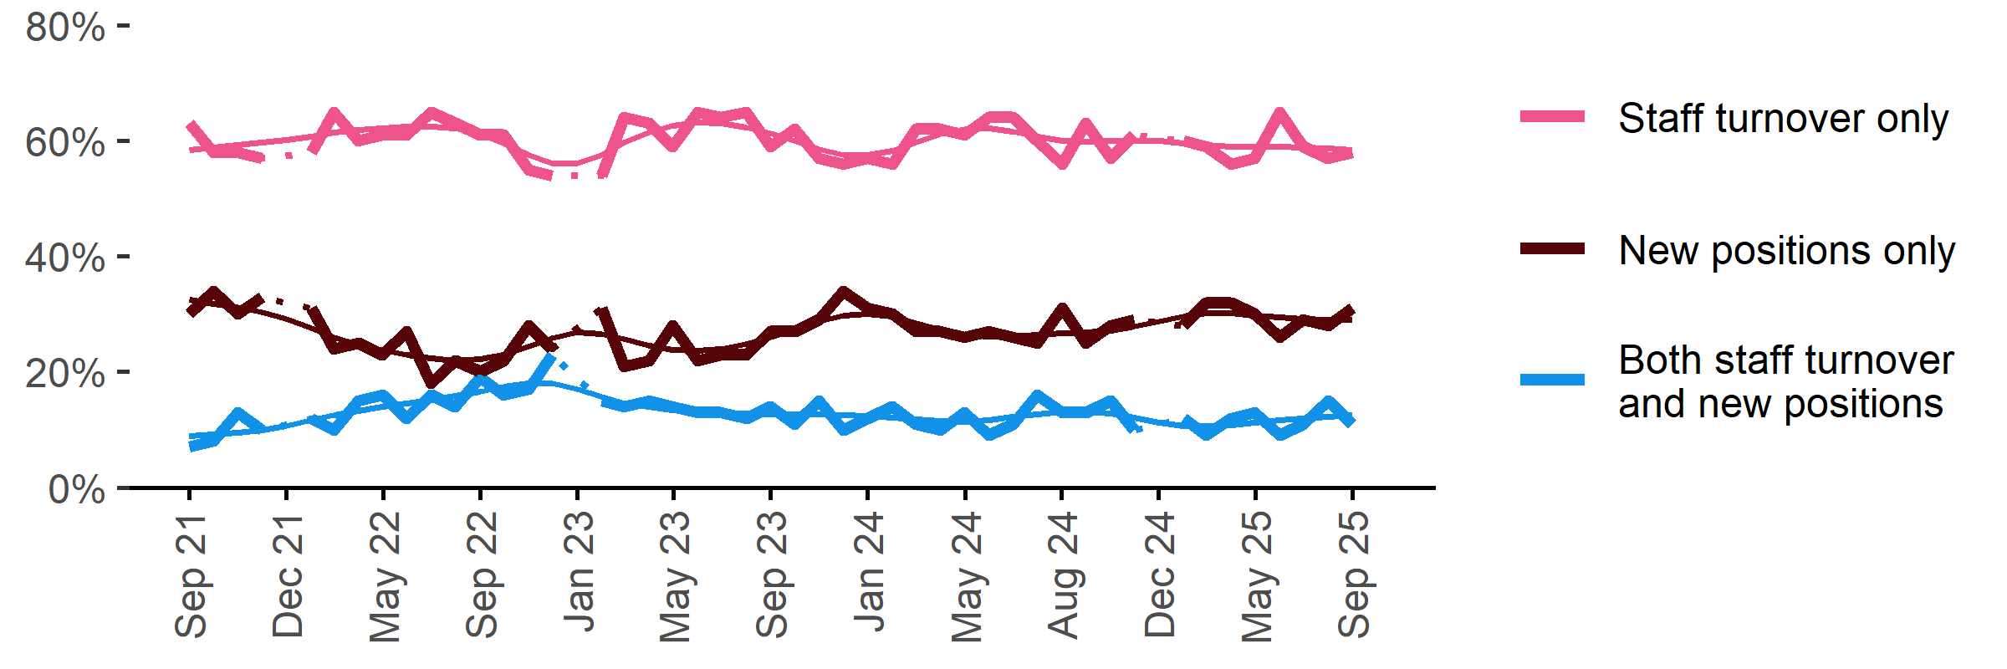  16% | 25% | 61% | 13% | 27%
Sep 2024 | 56% | 13% | 31% | 60% | 13% | 27%
Oct 2024 | 63% | 13% | 25% | 60% | 13% | 27%
Nov 2024 | 57% | 15% | 28% | 60% | 13% | 27%
Dec 2024 | 61% | 10% | 29% | 60% | 12% | 28%
Jan 2025 | n.p. | n.p. | n.p. | 60% | 11% | 29%
Feb 2025 | 60% | 12% | 28% | 60% | 11% | 30%
Mar 2025 | 59% | 9% | 32% | 59% | 11% | 30%
Apr 2025 | 56% | 12% | 32% | 59% | 11% | 30%
May 2025 | 57% | 13% | 30% | 59% | 11% | 30%
Jun 2025 | 65% | 9% | 26% | 59% | 12% | 29%
Jul 2025 | 59% | 11% | 29% | 59% | 12% | 29%
Aug 2025 | 57% | 15% | 28% | 59% | 12% | 29%
Sep 2025 | 58% | 11% | 31% | 58% | 13% | 29%

Staffing changes over the last month

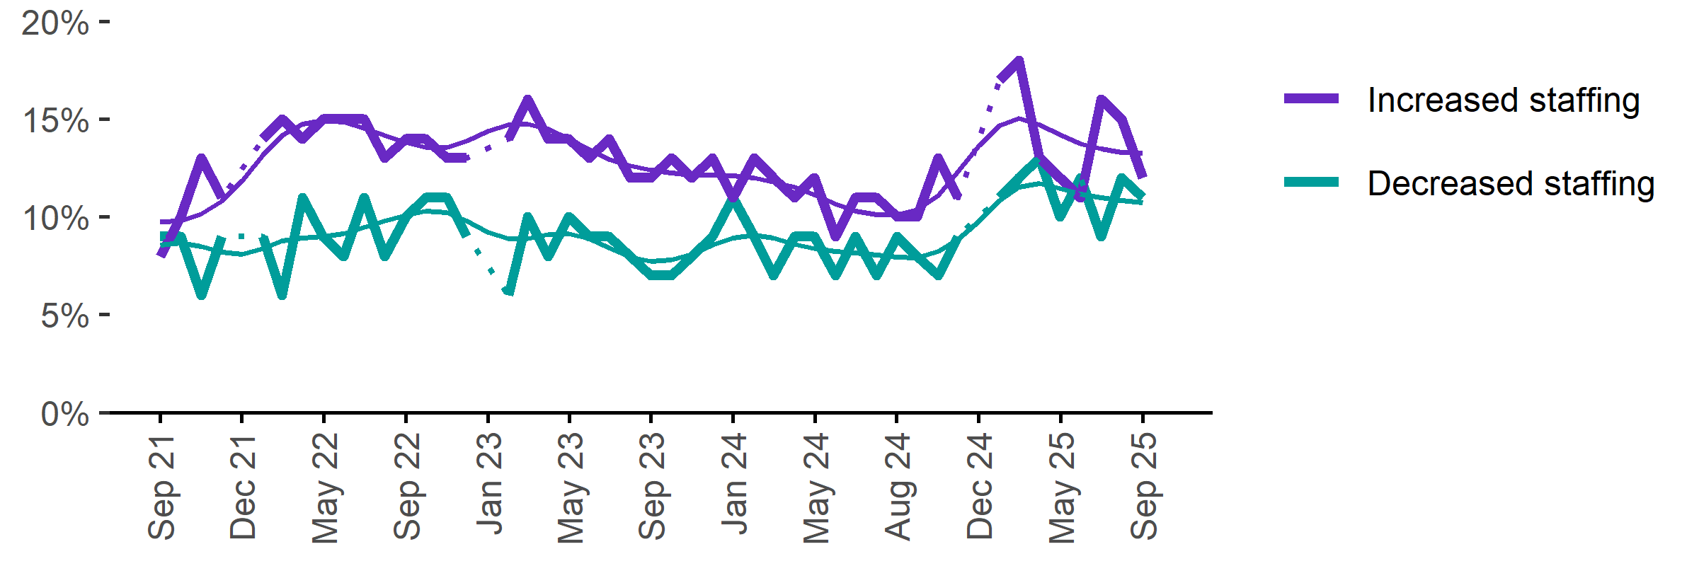
Proportion of employers who said they increased or decreased staffing compared to the previous month.
Date | Increased staff | Decreased staff | Smoothed - increased staff | Smoothed - decreased staff
Sep 2021 | 8% | 9% | 10% | 9%
Oct 2021 | 10% | 9% | 10% | 9%
Nov 2021 | 13% | 6% | 10% | 8%
Dec 2021 | 11% | 9% | 11% | 8%
Jan 2022 | n.p. | n.p. | 12% | 8%
Feb 2022 | 14% | 9% | 13% | 8%
Mar 2022 | 15% | 6% | 14% | 9%
Apr 2022 | 14% | 11% | 15% | 9%
May 2022 | 15% | 9% | 15% | 9%
Jun 2022 | 15% | 8% | 15% | 9%
Jul 2022 | 15% | 11% | 15% | 9%
Aug 2022 | 13% | 8% | 14% | 10%
Sep 2022 | 14% | 10% | 14% | 10%
Oct 2022 | 14% | 11% | 14% | 10%
Nov 2022 | 13% | 11% | 14% | 10%
Dec 2022 | 13% | 9% | 14% | 10%
Jan 2023 | n.p. | n.p. | 14% | 9%
Feb 2023 | 14% | 6% | 15% | 9%
Mar 2023 | 16% | 10% | 15% | 9%
Apr 2023 | 14% | 8% | 14% | 9%
May 2023 | 14% | 10% | 14% | 9%
Jun 2023 | 13% | 9% | 13% | 9%
Jul 2023 | 14% | 9% | 13% | 8%
Aug 2023 | 12% | 8% | 13% | 8%
Sep 2023 | 12% | 7% | 12% | 8%
Oct 2023 | 13% | 7% | 12% | 8%
Nov 2023 | 12% | 8% | 12% | 8%
Dec 2023 | 13% | 9% | 12% | 9%
Jan 2024 | 11% | 11% | 12% | 9%
Feb 2024 | 13% | 9% | 12% | 9%
Mar 2024 | 12% | 7% | 12% | 9%
Apr 2024 | 11% | 9% | 12% | 9%
May 2024 | 12% | 9% | 11% | 8%
Jun 2024 | 9% | 7% | 11% | 8%
Jul 2024 | 11% | 9% | 10% | 8%
Aug 2024 | 11% | 7% | 10% | 8%
Sep 2024 | 10% | 9% | 10% | 8%
Oct 2024 | 10% | 8% | 10% | 8%
Nov 2024 | 13% | 7% | 11% | 8%
Dec 2024 | 11% | 9% | 12% | 9%
Jan 2025 | n.p. | n.p. | 14% | 10%
Feb 2025 | 17% | 11% | 15% | 11%
Mar 2025 | 18% | 12% | 15% | 12%
Apr 2025 | 13% | 13% | 15% | 12%
May 2025 | 12% | 10% | 14% | 11%
Jun 2025 | 11% | 12% | 14% | 11%
Jul 2025 | 16% | 9% | 13% | 11%
Aug 2025 | 15% | 12% | 13% | 11%
Sep 2025 | 12% | 11% | 13% | 11%

Employers unable to fill vacancies within a month

Proportion of recruiting employers who were unable to fill their vacancies within a month.*
Date % unable to fill vacancies in a month Smoothed - % unable to fill vacancies in a month  Sep 2022 69% 70%  Oct 2022 70% 69%  Nov 2022 71% 68%  Dec 2022 62% 66%  Jan 2023 60% 64%  Feb 2023 58% 62%  Mar 2023 66% 61%  Apr 2023 60% 61%  May 2023 62% 61%  Jun 2023 57% 60%  Jul 2023 57% 58%  Aug 2023 60% 57%  Sep 2023 56% 55%  Oct 2023 53% 54%  Nov 2023 51% 53%  Dec 2023 46% 52%  Jan 2024 56% 52%  Feb 2024 54% 51%  Mar 2024 49% 51%  Apr 2024 50% 49%  May 2024 47% 47%  Jun 2024 45% 45%  Jul 2024 42% 44%  Aug 2024 45% 44%  Sep 2024 44% 45%  Oct 2024 44% 45%  Nov 2024 48% 44%  Dec 2024 43% 43%  Jan 2025 37% 41%  Feb 2025 36% 40%  Mar 2025 37% 39%  Apr 2025 46% 38%  May 2025 37% 39%  Jun 2025 39% 39%  Jul 2025 36% 40%  Aug 2025 42% 40%  Sep 2025 44% 41%  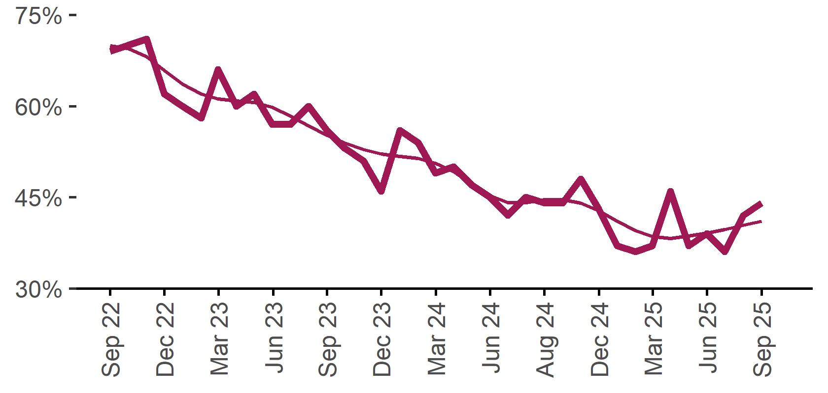 | 44%  Monthly change:  ▲ 2% pts  Annual change:  0% pts
* Excludes employers who have been recruiting for less than a month.

Background
Jobs and Skills Australia (JSA) conducts the Recruitment Experiences and Outlook Survey (REOS), a telephone administered survey with the business owner or other person in the business responsible for recruitment. Around 800 employers are surveyed each month, with data published on the JSA website. While the data are indicative of recruitment activity, they may be subject to seasonal factors and other volatility and should therefore be used with a degree of caution. In addition, the survey is targeted towards employers with 5 or more employees and excludes many government organisations.

Smoothed series in charts
Charts include Henderson-smoothed lines in addition to original data for most of our recruitment indicators. As the timeseries is not yet long enough for seasonal adjustment, a Henderson smoothed moving average with a 13-term filter (equating to 13 months) has been directly applied to the original series. This provides an indication of the general movement in each recruitment indicator relative to previous months. Due to using 13 months in the moving average, results for the most recent six months will be revised each month.

Referencing this report
Data in this release should be referenced as: Jobs and Skills Australia, Recruitment Insights Report, September 2025.

Contact us
For additional information, email REOS@jobsandskills.gov.au

Also available from the REOS

Data file with monthly and quarterly recruitment indicators
A REOS data file is available on the JSA website. Breakdowns by Capital City/Rest of State area, Business size, and ANZSCO Skill Level are included in the monthly results. Quarterly recruitment indicators provide detail by state, ARIA (ABS’ Accessibility and Remoteness Index of Australia) as well as selected industry and occupation groups.
Next Recruitment Insights Report release:
- October 2025 Recruitment Insights Report – 18 November 2025

Stay up to date
JSA also releases semi-regular reports including spotlight articles, detailing aspects of the REOS that cannot be included in our monthly Recruitment Insights Report. Sign up and get the latest notifications sent straight to your inbox.
Upcoming spotlight:
- September quarter 2025 quarterly report – 23 October 2025
Recent spotlights:
- June quarter 2025 results – 28 August 2025
- Update – Employers’ experiences with retention issues – 24 July 2025

A Henderson smoothed line has been included in the charts to reduce month to month volatility and illustrate long term patterns. See the explanatory note for more information.
Data are not available for January in some years. Data points have been joined by a dotted line between December and February to reflect this. ‘Rest of State’ refers to areas outside the capital cities.

