

International Students Outcomes and Pathways Study

August 2025



All content is provided under a Creative Commons Attribution 4.0 International Licence with the exception of:

* content supplied by third parties
* the Commonwealth Coat of Arms
* material protected by a trade mark
* any images and/or photographs.

Details of the Creative Commons BY 4.0 licence are available on the [Creative Commons website](https://creativecommons.org/).

Use of all or part of any material on this website must include the following attribution:

© Commonwealth of Australia

Terms under which the Commonwealth Coat of Arms can be used are set out on the [Department of the Prime Minister and Cabinet website](https://www.pmc.gov.au/).

Attribution

You may link to this website at your full expense and responsibility. In doing so you must not alter any of the website's contents, frame or reformat the files, pages, images, information and materials from this website on any other website. We reserve the right to prevent linking.

Other use

If you want to use material on this website in a way that is beyond the scope of the terms of use that apply to it, ask us for authorisation. You could infringe our copyright if you use anything on this website in a way that is not permitted or otherwise allowed under the Copyright Act 1968 (Cth).

Please email [copyright@dewr.gov.au](mailto:copyright@dewr.gov.au) or address requests and enquiries to:

The Copyright Officer

Department of Employment and Workplace Relations

GPO Box 9828 Canberra ACT 2601.

JSA acknowledges and thanks Commissioner Barney Glover, Deputy Commissioner Trevor Gauld, Executive Director David Turvey, Clifton Bingham and Joanna Reeve for overseeing the International Students Pathways and Outcomes Study; Alison Cleary and Moya Fyfe for leading the project team, Jane Press for support and guidance and JSA study team members who contributed over the life of the study, including Nicole Coggan, Denis Leonov and Courtney Smith and former JSA colleagues. The quality of support from JSA Skills Data Analytics team members Tram Le, Mohammad Seyani, Victor Gomez and Ehsan Mohebi is also reflected in the report. Lastly, JSA acknowledges the collaboration, expertise and input of colleagues from the Departments of Employment and Workplace Relations, Education and Home Affairs.

Acknowledgement of Country

Jobs and Skills Australia acknowledges the Traditional Owners of Country throughout Australia and recognises the continuing connection to lands, waters and communities. We pay our respect to Aboriginal and Torres Strait Islander cultures, and to Elders past and present.

Contents

Jobs and Skills Australia Commissioner’s foreword 8

Executive summary 10

Recommendations 13

Introduction 15

About the International Students Pathways and Outcomes Study 15

Why are we looking at international students? 15

What does the Study do? 16

Our approach 16

Chapter 1 – International education in Australia 18

Recommendations 18

Policy Observations 18

Shifting policy settings have shaped the sector and the behaviour of international students 19

International education in Australia 19

The emergence of the international education sector 19

Growth of an industry 20

Enhancing outcomes for international students and Australia 21

Recalibrating the sector 21

The composition of Australia’s international students is changing 21

There has been a shift in the weight of source countries 22

VET has increased in popularity, though higher education enrolments remain strong 22

VET and higher education cohorts have different age profiles, which may affect outcomes 22

Longer study duration has work and migration implications 23

For many students, migration aspirations are a primary goal 23

Chapter 2 - Pathways to permanence 27

Recommendations 27

Policy Observations 27

Choosing pathways 28

Seeking further visas following study has become more common 28

Successive Student visas have been the second most likely ‘next’ visa 30

Common visa pathways have depended on students’ initial qualifications 32

Temporary Graduate visas have been the most popular ‘next’ visa, particularly for higher education graduates 32

Temporary visa settings continue to favour higher education graduates over VET, but both are required to meet skills needs 34

Mismatch between available permanent residence visas and graduates’ aspirations 34

Permanent visas take time to achieve 35

‘Structural’ visa requirements are associated with higher permanent residency outcomes 35

Chapter 3 – Residency outcomes of graduates who stay 37

Recommendations 37

Policy observations 37

International graduates have become a significant part of Australia’s permanent migration program 38

Using linked datasets in PLIDA to support JSA analysis of international student pathways and outcomes 38

More graduates are staying than previously estimated 40

Describing whether international students are no longer in Australia 42

The likelihood of achieving permanent residency 43

The importance of the points test 45

Review of the points test 47

Chapter 4: Qualifications, skills and employment outcomes 48

Policy observations 48

International graduates’ employment outcomes often do not align with their qualifications 48

International graduates cluster in higher level qualifications 48

Graduates’ outcomes in income and achievement are lower than domestic comparators 49

Income growth rates differ over time for VET and higher education graduates 50

Occupational patterns after graduation 51

VET graduates appear more likely to work in an industry, skill level, and occupation matching their qualification 52

Higher education graduates report occupying lower skill level occupations 52

Comparative labour market outcomes 53

Retention rates within occupations 54

Chapter 5: Barriers to transitioning to skilled employment 56

Recommendation 56

Policy observations 56

Preparation for post-study employment is challenging 57

Australia’s in-study work settings are important to potential students 57

International students can experience exploitation at work 58

The need to work can be a barrier to study and preparing for a career 58

International students’ educational experience may not prepare them for employment success as graduates 59

English language proficiency affects outcomes 60

Access to occupations and occupational preparation offers challenges to international students and graduates 61

Labour market access barriers may be more challenging for international graduates 62

Employers are concerned international graduates are not sufficiently skilled and not here to stay 63

Bias can play a role in employment decisions 65

Glossary of terms 67

Appendix A Qualitative analysis and stakeholder engagement 71

Qualitative analysis 71

Interviews with employers and graduates 72

Broader JSA stakeholder engagement 73

Appendix B Methodology 74

Administrative data 74

Australian Bureau of Statistics: 74

Department of Education 75

Jobs and Skills Australia 75

Department of Home Affairs 75

Further details on longitudinal analysis of international students 76

Analysis of different international student cohorts over time 76

References 80

Table of Figures

Figure 1: International student enrolments for higher education and VET sectors in Australia, monthly data, December 2005 to December 2023 20

Figure 2: International student enrolment by age and education sector in 2021 23

Figure 3: Top 10 VET course enrolments for international VET students 2022 25

Figure 4: Top 10 VET enrolments by qualification for Student visa holders (2012-2023) and top 10 occupations for international student graduates by number of permanent residence (PR) visas granted (2013-2023)* 25

Figure 5: Top 10 higher education enrolments by qualification for Student visa holders (2012-2023) and top 10 occupations for international student graduates by number of permanent residence (PR) visas granted (2013-2023)* 26

Figure 6: Next visa destinations of Student visa (subclass 500) and Temporary Graduate visa (subclass 485) holders in 2022-2023 29

Figure 7: Number of visas granted by visa category where the last visa held was a Student visa 30

Figure 8: Subsequent Student visas granted by education sector in 2018-2019 and 2022-2023 (Proportion of visas granted) 31

Figure 9: 12-month average number of Student visa (subclass 500) and Temporary Graduate visa (subclass 485) holders, 2012-2023, ’000s 32

Figure 10: Number and stream of Temporary Graduate visas issued between 2013 and 2023 33

Figure 11: The next visa destinations for former Temporary Graduate visa holders, from FY 2017-2018 to FY 2022-2023 34

Figure 12: Skilled permanent residence (SPR) visas granted to Student visa holders, from FY 2013-2014 to FY 2022-2023 35

Figure 13: Comparison of Student visa grant records (Department of Home Affairs) against international student cohorts with income/tax records (ATO), Higher education and VET sectors combined 40

Figure 14: Comparison of Student visa grant records (Department of Home Affairs) against international student cohorts with income/tax records (ATO), VET sector only 41

Figure 15: Comparison of Student visa grant records (Department of Home Affairs) against international student cohorts with income/tax records (ATO), higher education sector only; a) China only b) All others excluding China 42

Figure 16: Mean annual income from highest paying job, Student visa holders, 2012-2013 cohort, unadjusted figures. 51

Figure 17: Proportion of Temporary Graduate visa (TGV) holders by largest industries of employment in 2021 52

Figure 18: Occupations of higher education graduates 53

Figure 19: Median annual income of fulltime employed domestic graduates and Temporary Graduate visa (TGV) holders, aged between 20-34 years, by VET and HE in 2021 54

Figure 20: Number of working Temporary Graduate visa (TGV) holders by occupation skill level in 2021, primary applicant 54

Tables

Table 1: Recommendations of the International Students Pathways and Outcomes Study 13

Table 2: Proportion of international Student visa cohorts between FY 2010-2011 and FY 2014-2015* who gained permanent residency (PR) over time 44

Table 3: Industry of employment for Student visa holders in 2021 (highest to lowest) 59

Table 4: International student enrolment in higher education courses with mandatory work-integrated learning components (courses scheduled for completion by year) 62

# Jobs and Skills Australia Commissioner’s foreword

I am pleased to present Jobs and Skills Australia’s (JSA) International Students Pathways and Outcomes Study.

In late 2023, the Australian Government commissioned Jobs and Skills Australia to undertake this cohort study, looking at how education, migration and employment systems can best work together to enhance the contribution made by international students to Australia’s skilled workforce.

International education plays a crucial role in Australia’s economic, social, and cultural prosperity. Its stakeholders are many, and the success of the sector and the students rely on all parts of the system working together well.

JSA has undertaken the study during a period of significant policy reform targeted at addressing issues of integrity and sustainability. This in turn has resulted in changes to some of the settings that help underpin the experience for international students.

This study looks at the experiences of international student cohorts who began their studies in Australia in 2010-2011 and subsequent years, with a focus on those cohorts who commenced their studies more than 10 years ago. It tracks their progress in the context of the education and migration settings that were in place up to the end of 2023. We have undertaken analysis of available data sets, qualitative research, literature and policy reviews and stakeholder insights from our targeted consultation to inform our observations.

Our lens has been firmly on how the settings in place to the end of 2023 have influenced the study choices of international students and their work experiences post-study. We have looked at any barriers they may have experienced participating in our labour market.

We have considered the differences in pathways and outcomes for higher education and VET students. We have assessed the differing motivations of students depending on their country of origin, the transition through temporary work visas, the qualifications, industries and occupations in which they ‘cluster’ and the pursuit of permanent residency. JSA’s analysis highlights that the likelihood of permanent residency has an impact on the decisions made by employers and employees alike. There are opportunities to reform permanent migration settings in the context of international students staying in Australia over the medium and long term.

We find that international VET graduates are more likely to work in occupations and earn incomes that are aligned with their qualifications than their higher education student counterparts. This is relevant when thinking about the critical role that TAFE plays in allowing international VET graduates to realise their full potential and maximise their contribution to meeting Australia’s skills needs, particularly given the priority afforded to TAFEs under current student visa processing arrangements, and the Australian Skills Quality Authority has high confidence in the integrity of international vocational education and training delivered through TAFE.

The study seeks to enable a system-wide view that builds greater visibility and understanding of the pathways and outcomes of international students who choose Australia as their study destination, and of how international graduates might better align to support Australia’s areas of skills needs. In this context, the study makes 11 recommendations which outline practical steps that could be taken to improve outcomes for international students as graduates as well as employers and the broader community.

Together with Deputy Commissioner Trevor Gauld, who has been guiding our consultation for the study, we would like to thank our stakeholders and research participants, including former international students, along with colleagues from the Departments of Home Affairs, Education and Employment and Workplace Relations, for their contributions to our study. Their perspectives and expertise have been invaluable to understanding the complexity of the system. I look forward to JSA continuing our engagement.

I am confident that this report and its recommendations will help inform ongoing policy development and help build a more nuanced understanding of international education and the role international students play in Australia’s social and economic future. In this context, I note that the Government’s Economic Reform Roundtable highlighted the criticality of skills to Australia’s future economic and productivity growth. I look forward to JSA’s ongoing engagement with the Australian Government on the contribution that skilled and highly capable domestic students, international students and migrants more broadly can make to Australia’s economic and social prosperity.

Professor Barney Glover AO

Commissioner

Jobs and Skills Australia

# Executive summary

Strong post-study employment outcomes for international students are essential to meeting Australia’s skills needs over the medium to long term. This means fully utilising the right skills of the right students, in the right locations at the right time, which in turn may require closer alignment of patterns of study choices, post-study work rights and enabling visas.

The future of Australia’s skilled workforce will be shaped by multiple interacting shifts, including climate change, technological advances and demographic changes, such as population ageing.

A significant proportion of Australia’s international students remain in Australia after completing their studies. If fully utilised, this cohort has the potential to make a significant contribution to meeting Australia’s future skills needs, along with reducing the impacts of population ageing.

This independent report supports the post-study outcomes of international students by:

* making 11 recommendations that target the Australian Government’s role in international education and migration policy setting
* providing new insights, analysis and data to support the activities led by education and training providers, businesses, unions, and state and territory governments, and
* developing the foundations for a shared vision for the international education sector that unites all parties through common interests, offering opportunities for collective advocacy and action.

Our recommendations span education, training, migration and other system settings and identify key opportunities to improve outcomes for international students and employers alike. These are grouped into 3 overarching themes:

* system-wide objectives and measures of success
* supporting policy infrastructure
* successful transitions from study into the skilled workforce.

While this study makes an important contribution, a single point-in-time report is unable to resolve all underlying challenges. Concerted and enduring action will be required by all parties, including governments, education and training providers, businesses and unions.

Changing characteristics of Australia’s international student cohort

The changing characteristics of Australia’s international student cohort and frequent transitions to other visas after graduation have meant that a significant proportion of international students remain in Australia after completing their studies.

Better access to integrated and linked datasets is progressively allowing more detailed analysis and insights into different international student cohorts over time, including longer-term analysis of labour market outcomes for students who stay in Australia over the longer term.

While data on the proportion of all international students (including higher education, VET and a range of other[1] student visa types) who remain in Australia in the longer-term is not readily available, JSA estimates that this figure was around 35-40% of all students commencing in the early 2010s who achieved permanent residency within 10 years, with an estimated likely decline in this figure (to around 25-30%) for students who commenced study in the late 2010s. This downward trend in JSA’s estimate is driven by a decline in the late 2010s in the proportion of Chinese higher education students who are identified in Person Level Integrated Data Asset (PLIDA) data, due to them appearing less likely to undertake paid employment while studying, coupled with JSA’s assumption that students who are not identifiable in PLIDA are more likely to leave Australia following graduation.

These estimates represent a significant increase on analysis published by the Treasury and the Department of Home Affairs in 2018, which found at the time that 16% of international students eventually transitioned to permanent residence - an evidence source cited by many stakeholders during JSA’s consultations on this study.

More data is readily available now to assess the likelihood of international students staying in Australia in the longer term for the group who seek paid employment while studying, as this decision to work while studying facilitates analysis of longitudinal tax and income records from the Person Level Integrated Data Asset (PLIDA). JSA’s analysis finds that more than 50% of higher education or VET international students arriving in Australia in the early 2010s who are also identifiable in PLIDA achieved permanent resident status within 10 years of commencing study. Conversely, JSA estimates a low likelihood of achieving permanent resident status for those students who are using other visa subtypes and/ or those who are not identifiable in PLIDA.

* This result is broadly supported by the recent analyses of 2 other agencies, which both found that more than 50% of higher education or VET international students who are identifiable in PLIDA or other administrative data arriving in Australia in 2006-2007 or 2010-2011 remained in Australia (with either temporary or permanent resident status) after 10 years.

The likelihood of international students remaining in Australia in the longer-term varies significantly across visa types and countries of origin. This increasing trend towards international students transitioning to permanent residence reflects numerous factors, including the weight of enrolment numbers moving from China to South Asian and other countries, as well as the opportunities for students to extend their stay provided by Australia’s migration settings over this period.

Post-study visa pathways

Few international students on a Student visa (subclass 500) have transitioned directly to permanent residence, instead relying on other (often successive) visas after graduation. These arrangements have not promoted a strong alignment between international students and Australia’s skills needs. While more recent policy reforms to reduce ‘visa hopping’ (such as Temporary Graduate Visa holders no longer being able to apply for Student Visas onshore) are likely to strengthen this alignment, reform to permanent migration visa settings present further opportunities.

With the number of skilled permanent residence (PR) places available each year being historically a fraction of the number international graduates, viable pathways to skilled employment have been limited to temporary sponsored and non-sponsored visa options for most graduates, regardless of course choice or employment experience.

VET graduates' pathways to permanent residence have been narrower than higher education graduates’ given their more limited eligibility under the Temporary Graduate visa conditions, but there are indications that a higher proportion are achieving permanent residence because of improved employment prospects post-study.

* Better outcomes are experienced by graduates using visas with migration sponsorship or occupational requirements rather than those on other temporary or visitor visas.
* Visa settings, such as skills lists and the points test, may ‘funnel’ students into courses and occupations outside their genuine interest and in which they may not choose to remain once PR is achieved.

Post-graduation employment outcomes

International graduates remaining in Australia after their study are less likely to secure employment in their field and at their qualification level and earn less than domestic counterparts. These effects are more exaggerated for higher education graduates than VET graduates and for more generic, less vocationally oriented fields of education. International VET graduates are more likely to work in occupations and earn incomes that are aligned with their qualifications than their higher education student counterparts. To maintain and improve upon these international VET graduate outcomes into the future, quality VET training is critical, so that students, industry, governments and the community have confidence in the integrity of qualifications issued by training providers.

Despite Australia’s diverse current and future skills needs, there is only a narrow band of occupations into which international graduates transition most successfully, such as Registered Nurses and Chefs. These occupations are characterised by an alignment of:

* ease of course access and completion for students
* available visa pathways via skills lists
* education settings that prioritise work readiness, and
* employer appetite for international graduates.

Barriers to international students transitioning to the skilled workforce

International graduates’ educational experience may not be preparing them as well for the workforce as it could, with variable assessments of their English language proficiency and limited exposure to work-relevant practical and cultural experiences.

Despite its importance to workforce success, English language proficiency may not be receiving sufficient attention during the recruitment and education of international students.

Employer sentiment, including a degree of uncertainty toward temporary work visas, limits uptake of graduates in skilled roles, which may blunt the ability of international students to contribute in some areas of skills shortage.

Indications are that there may not be parity of esteem between international and domestic graduates alongside concerns about English language and cultural proficiency.

## 

## Recommendations

This report includes 11 recommendations for the Australian Government to consider and are drawn from the observations in the Executive Summary and the report. The recommendations have been grouped into three overarching themes in the table below. The observations and the recommendations are summarised at the start of each of the five chapters. The themes are targeted to the Commonwealth’s role in workforce planning through the national skills system, which encompasses domestic students, international students and other forms of migration. Any responses to these recommendations should be genuinely tripartite and consider the perspectives of all relevant stakeholders.

Table 1: Recommendations of the International Students Pathways and Outcomes Study

| Theme | Recommendation |
| --- | --- |
| System-wide objectives and measures of success | 1. Develop a shared set of objectives for Australia’s international education sector, which should include its contribution to Australia’s total economic activity and its contribution to building Australia’s skilled workforce over the medium to long term. 2. Develop and publish sector- and provider-level performance data on international education, for use by policy makers, regulators, potential students and employers, including measures of Australian graduate labour market outcomes. 3. Consider the full range of study to work visa pathway settings for international VET to ensure they support students to study and contribute in areas of persistent national skills shortage. 4. Develop and agree a methodology to track over time the proportion of international students who remain in Australia over the medium and long term, with a focus on economic outcomes. 5. Consider reforms to permanent migration settings in the context of many international students staying in Australia over the medium and long term, with a focus on reforms to the number of points accrued for eight or more years of relevant skilled work experience. |
| Supporting policy infrastructure | 1. Monitor the impact of international student pathways and integrity measures implemented from 2024 onwards, with a focus on post-study economic outcomes. 2. Undertake further qualitative research with international students and graduates about their motivations and decision making in relation to labour market participation and fields of study. 3. Include Provider Registration and International Student Management System (PRISMS) data in the Person Level Integrated Data Asset (PLIDA), to enable better analysis of the experiences of international students. |
| Successful transitions from study into the skilled workforce | 1. Strengthen independent assessment of English language proficiency throughout the international student continuum to maximise preparedness for work, including assessment at study entry and exit. This should be informed by analysis of the impacts of changes implemented in 2024. 2. Identify and increase system incentives for the inclusion of opportunities for work integrated learning and increasing English language proficiency as a core element of study offerings to increase international graduate employability. 3. Grow employer appetite for international graduates by making resources available to support greater understanding of the value of international graduates over the medium and long term to the Australian workforce. |

# Introduction

## About the International Students Pathways and Outcomes Study

In late 2023, the Australian Government commissioned Jobs and Skills Australia to undertake a cohort study on the pathways and outcomes achieved by international students that remain in Australia after their study here. While many international students use their Australian qualification to enhance their careers in their home countries or other destinations, the study provides evidence and insights about the experience of the growing number of graduates who have pursued a career in Australia, and the policy settings that have shaped them.

As the Australian Government’s reform agenda reshapes Australia’s international education sector, the study provides insights into international education in Australia, the experience of international students as graduates and in employment in Australia, including the barriers they have faced to transitioning to skilled employment.

The study also contributes to supporting ongoing policy development and examines:

* what has motivated international students’ choices over time
* the vital role of education in preparing students for work
* the impact of differing policy settings for Vocational Education and Training (VET) and higher education
* success factors for the transition of international graduates into the Australian labour market, including permanent residence.

### Why are we looking at international students?

International education plays a crucial role in Australia’s economic, social, and cultural prosperity. Education has become one of the country’s largest export industries, contributing billions of dollars annually to the Australian economy. In 2023-2024 it added more than $50 billion to the Australian economy (Department of Education, 2025).

In addition to the economic value, international students enrich Australia’s campuses and communities by bringing cultural diversity and sharing new ideas and perspectives. Through people-to-people connections, international education links Australia with its region and with the rest of the world.

International students offer benefits not only to Australia but also to their home countries and beyond. When they return home, the knowledge, expertise, and work experience they have gained abroad can contribute to the development, including the economic growth, of their countries of origin.

Further to its value in exports and relationships, students represent a pool of young and qualified future workforce participants that can potentially support the socio-economic development of Australia. International graduates have become an important contributor to Australia’s permanent migration program.

The cohort of international students arriving in Australia annually and eventually becoming permanent residents is estimated to provide a fiscal dividend of up to $12 billion over their lifetimes, in addition to the $5.6 billion from international student tuition fees invested in university research annually (Coates et al, 2023). Encouraging the most talented international students to stay can also enhance Australia’s economic productivity growth, as skilled migrants have been shown to spur innovation.

However, Australia’s international graduates are often not achieving the outcomes that might be expected for them. More than 50% of international graduates working in Australia are employed well below their skill level and many are working outside the field of their qualification. On average, they are earning less than domestic graduates with the same qualifications.

Graduates’ ineffective transition to the skilled workforce blunts their contribution to meeting Australia’s skills needs and over time may damage Australia’s reputation for quality education and our relationships with neighbours in our region and beyond.

### What does the Study do?

The international education sector generates a wide range of benefits for Australia, including building people-to-people links and sharing Australia’s way of life with the world. Within this broader context, the International Students Outcomes and Pathways Study examined the experiences of international students and graduates to explore the barriers to more effective engagement with the skilled workforce. It takes a whole of system view, across education, employment and visa and migration settings to develop holistic observations that complement the portfolio-specific analyses undertaken in the Departments of Home Affairs, Education and Employment and Workplace Relations.

The study has examined the experiences of international students and graduates in the context of the policy settings that existed up to the end of December 2023. The study has not sought to analyse the impact of policy changes made from 2024 onwards but references the changes where appropriate for context and analysis throughout the Report.

Given the specific focus on employment outcomes, the study does not consider the breadth of benefits generated by Australia’s international education sector and is not an assessment of the sector more broadly. The outcomes of the study will support ongoing reforms across government, including work in response to the Migration Strategy, Employment White Paper, National Skills Agreement and the Universities Accord.

### Our approach

The Report includes observations from readily available data about international graduates’ experiences; qualitative research with stakeholders; and targeted quantitative analysis within the Person Level Integrated Data Asset (PLIDA), which is a data asset that is overseen by the Australian Bureau of Statistics. It includes overviews about a range of issues affecting the experiences of international students and graduates but is not intended to cover every aspect of all possible pathways.

#### Scope

The Report describes the outcomes achieved by primary holders of Student visas granted between 2011 and 2023 and offers an examination of the settings shaping those outcomes up until the end of 2023. As the Report is focused on post-study outcomes, some analyses are targeted to the cohorts of students who commenced study in the early 2010s and the outcomes they experience 10 years after commencing study.

It primarily uses analysis of readily available data including:

* enrolment data from the Department of Education
* visa data from the Department of Home Affairs
* outcomes data from Australian Bureau of Statistics datasets
  + Australian Census and Temporary Entrants Integrated Dataset (ACTEID)
  + Australian Census and Migrants Integrated Dataset (ACMID)
* survey data from Quality Indicators in Learning and Teaching
* JSA datasets on linkages between qualifications and occupations.

Publicly available data was supplemented by enrolment data from the Department of Education’s Provider Registration and International Student Management System (PRISMS), qualitative research conducted by JSA in partnership with the Australian Council of Educational Research (ACER) and quantitative data from PLIDA.

Methodological details are at Appendix B.

#### Limitations

International students and their experiences are not visible in some datasets, which have a focus on domestic policy needs. No single existing data asset includes all the elements needed to consider international student experiences across the full range of migration, education and labour market variables.

The Report examines pathways and outcomes arising from settings that applied between 2011 and 2023. The Government’s reform agendas across education and migration settings have changed and continue to change relevant settings.

#### Format

The Report is arranged in 5 chapters to consider key elements of international students’ experience:

1. context for Australia’s international education sector and how it influences behaviour
2. description of the visa pathways used by students and how they affect the availability of skilled labour
3. using better linked data to follow the outcomes of international graduates
4. exploring the employment choices made by international graduates
5. consideration of the barriers to graduates achieving success in the skilled workforce.

# Chapter 1 – International education in Australia

## Recommendations

|  |
| --- |
| * Develop a shared set of objectives for Australia’s international education sector, which should include its contribution to Australia’s total economic activity and its contribution to building Australia’s skilled workforce over the medium to long term. (Recommendation 1) |
| * Develop and publish sector- and provider-level performance data on for international education, for use by policy makers, regulators, potential students and employers, including measures of Australian graduate labour market outcomes. (Recommendation 2) |
| * Monitor the impact of international student pathways and integrity measures implemented from 2024 onwards, with a focus on post-study economic outcomes. (Recommendation 6) |

## Policy Observations

|  |
| --- |
| The characteristics of Australia’s international student cohort are changing. There is a growing proportion of students pursuing work and migration aspirations, alongside greater engagement in VET pathways.   * Changing enrolment patterns indicate this trend will strengthen as the weight of enrolment numbers moves from China to South Asian and other countries. * These trends also influence patterns of course selection, based on post-study visa settings. |

## Shifting policy settings have shaped the sector and the behaviour of international students

### International education in Australia

Over the past 30 years, Australia has been welcoming increasing numbers of international students to study, and often, to come here to stay. Australia is one of the most highly sought destinations for international students worldwide. The decisions of international students to come here have been informed by Australia’s reputation for high-quality education offerings as well as the enabling visa policy settings. Their time in Australia has been governed by these settings. This Chapter explores the growth of the international education sector over time and begins to detail those pathways and outcomes for international students under the settings that were in place until the end of 2023.

International education serves many purposes that contribute positively to Australia’s social and economic outcomes. Australia’s international education sector also has many stakeholders, including across Commonwealth and state governments, from the higher education and vocational education and training (VET) sectors, to business, industry and community interests. As part of this study, stakeholders from across these sectors participated in consultation and qualitative research. They affirmed strong support for the sector and willingness to contribute to its success. However, stakeholders reflected the tension that exists between the differing purposes and the challenges that the sometimes-competing purposes of the international education sector can present.

### The emergence of the international education sector

Since the mid-1980s, Australia shifted its education policy from viewing international education as “aid” to treating it as “trade”, encouraging Australian institutions to admit international students on a full-fee basis to generate revenue (Industry Commission 1991; Gribble et al., 2015).

In the 1990s, Australian migration policy sought to help to address skill shortages by encouraging fee-paying international students to apply for permanent residence, an additional attraction factor for international students. This policy was further reinforced in 1999 with the introduction of additional points towards permanent residency for international students holding Australian credentials (Gribble et al., 2015; Blackmore et al., 2015; Nguyen and Hartz, 2020). In response, enrolments grew, and international students began to dominate applications for skilled migration (Hawthorne, 2010).

By the early 2000s, concerns were beginning to emerge about graduates’ employment outcomes, poor matching of Australia’s skills needs and reports of visa rorting in the vocational education and training (VET) system. The Australian Government responded in 2007 by tightening permanent residence requirements, increasing English proficiency standards, and ending work experience exemptions. In 2009, Government further responded by prioritising employer-sponsored migration, reviewing migration occupation skills lists, and further tightening English language requirements and skills assessment requirements (Blackmore et al., 2014, Gribble et al., 2015, Blackmore et al., 2015).

Between 2009 and 2012, international student numbers began to fall. The drop in international student enrolments can be attributed to several factors, including the appreciation of the Australian dollar, the global financial crisis, heightened concerns at that time about student safety, and tighter visa regulations in Australia (Department of Education and Training, 2015, p.6). As student numbers declined, employers reported that these revised settings were not working to match skills shortages. In 2010, a new skills list was introduced, the pathway between Australian study and permanent residence was severed, and work experience and higher qualifications were incentivised in visa settings (Bowen, 2010, Koleth and Spinks, 2015). The 2011 Knight Review recommended streamlining student visas to make it easier, cheaper, and faster to obtain them, along with the introduction of post-study work rights for all higher education graduates. However, there was no direct route to permanent residence (Knight, 2011).

### Growth of an industry

Implementation of the Knight Review’s recommendations boosted international enrolments, especially in postgraduate programs like accounting, IT, and engineering, mainly driven by Chinese and Indian students (Tran et al., 2020). The establishment of post-study work rights for all higher education graduates, for work in any job, was intended as a competitive measure (Knight, 2011) and boosted the number of students seeking eventual access to the Australian workforce. The Simplified Student Visa Framework (SSVF) introduced by the Department of Home Affairs in 2016 streamlined processing of Student visa applications and reduced processing times.

Between 2013 and 2023, international enrolments in both VET and higher education grew from just over 410,000 to just under 787,000 students, with annual growth of over 5% averaged across the period. Enrolments fell by 12.6% between 2019 and 2022 during the COVID-19 pandemic but had recovered by the end of 2023 (Figure 1).

Figure 1: International student enrolments for higher education and VET sectors in Australia, monthly data, December 2005 to December 2023

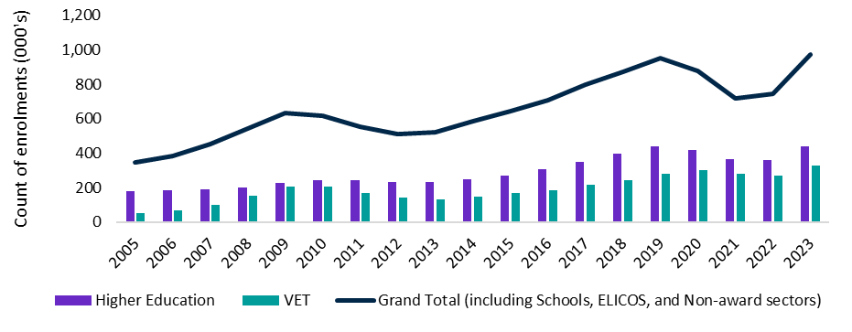

Note: Student enrolments include new and existing students who enrol in a new or subsequent study course. One student may be enrolled in more than one course.

Source: Department of Education (2024). International student monthly summary and data tables - Department of Education, Australian Government, full year data based on data finalised in December 2023. Modified 02 April 2024.

In 2023, the Rapid Review into the Exploitation of Australia’s Visa System (the Nixon Review) found that some training providers and students were working with disreputable agents and sometimes with complicit students to exploit the Student visa system. It also found that as temporary migrants, international students were at risk of being criminally exploited. The Review noted the gap between capped permanent migration places and the demand-driven Student visa system (Nixon, C., 2023). The Government responded to these reports with an initial suite of integrity measures announced in October 2023 (Department of Education, 2023) and continuing in 2024 (Department of Home Affairs, 2024).

### Enhancing outcomes for international students and Australia

Working Future: The Australian Government’s White Paper on Jobs and Opportunities, released in September 2023 noted:

* current migration settings can better support international students to reach their potential in the labour market
* more than 50% of international graduates working in Australia are employed well below their skill level
* the need to identify and resolve barriers preventing international students with skills in high demand transitioning into the Australian labour market (The Treasury, 2023a).

Similarly, the Government’s Migration Strategy released in December 2023 recommended visa and policy changes to address:

the issue of “permanent temporariness” for international graduates who access multiple visas to stay long-term in Australia but are unlikely to gain permanent residence

* improvements to integrity and quality in the international education sector
* better targeting to allow skilled migration to match to the needs of the Australian labour market and how the skills of international graduates can be better leveraged (Department of Home Affairs, 2023a).

### Recalibrating the sector

Ministerial Direction 107 was introduced in December 2023 to formalise processing priorities for the Student visa program as part of strengthening integrity measures for the international education sector. In the first part of 2024, the Government announced further measures to increase financial and eligibility requirements including a second suite of integrity measures. English language requirements were increased, new genuine student requirements were introduced, and the financial capacity requirements were increased for Student visa holders.

In May 2024, the Government announced its plans to cap the numbers of international students each education provider would be allowed to enrol. Australia’s draft International Education and Skills Strategic Framework was released for consultation, seeking to transition the sector to managed growth, with an emphasis on diversification, graduate readiness, regional delivery and meeting Australia’s skills needs (Department of Education, 2024b). When the associated legislation was not passed by the Parliament, further visa processing changes were implemented by Ministerial Direction No. 111.

## The composition of Australia’s international students is changing

Australia is one of the top study destinations for international students, with its tertiary institutions enrolling the second highest share of international students among the Organisation for Economic Co-operation and Development (OECD) and partner countries (OECD, 2023). Australia’s strong reputation for the quality of its education is highly valued at home and internationally, including by the source countries of the students. A recent report published by the University of Sydney, Bridging the Skills Gap - Enhancing the Employability of International Chinese Students noted a high regard for the English communication skills and global perspective of returned international students by multi-national companies in China (Li et al., 2025).

### There has been a shift in the weight of source countries

China historically has been a major source of Australia’s international student intake, with students favouring higher education pathways instead of VET. In recent years, student enrolments from India and other countries such as Pakistan and The Philippines have increased, with higher education remaining the main study pathway (Department of Education, 2023). Understanding how globally mobile students view and interact with Australia’s overall education offering is vital to assuring the sector’s effectiveness and sustainability as a tool for outreach and skills development in Australia and elsewhere.

### VET has increased in popularity, though higher education enrolments remain strong

Analysis of enrolment data shows that there was a cumulative increase of almost 90% in the number of VET enrolments in the years to 2022 compared to those in 2012 (Department of Education, PRISMS data). While higher education courses remained the more popular type of qualification amongst international students in the early 2020s, a growing number are favouring VET qualifications when they apply to study in Australia.

The reasons for the growth in VET enrolments are not clear-cut. As with other avenues of international study, opportunities to work in, and/or migrate to Australia may contribute to the reasons why more students are choosing VET pathways and are sometimes staying for longer periods of time.

### VET and higher education cohorts have different age profiles, which may affect outcomes

While a significant proportion of the international student population is aged between 18 and 30, the concentration and median student age of international higher education and VET students differ significantly.

According to Australian Census and Temporary Entrants Integrated Dataset (ACTEID), 2021 data, VET students are more than 3 years older on average, with a ‘double peak’ in the age distribution that has persisted over time and a larger student cohort aged in their 30s. By comparison, a much larger proportion of higher education students are aged in their early to mid-20s (Figure 2). Further analysis of what drives the age profile of international VET students is needed but this pattern may indicate:

* completion of a further VET qualification after an initial qualification
* graduates returning to a Student visa (subclass 500) after a Temporary Graduate visa (subclass 485). This is prior to changes to the Temporary Graduate visa from 1 July 2024 which made this pathway unavailable
* transfers from higher education to VET while on a Student visa (where there may be a requirement to apply for another Student visa).

Figure 2: International student enrolment by age and education sector in 2021

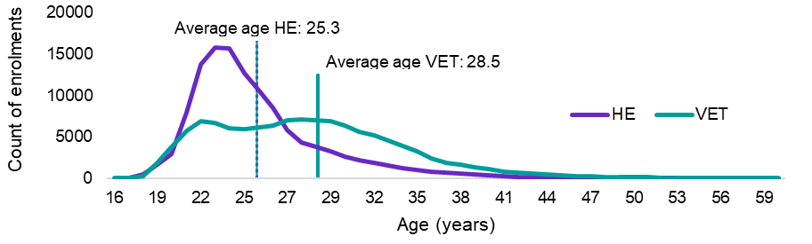

Source: JSA analysis of Australian Bureau of Statistics, Australian Census and Temporary Entrants Integrated Dataset (ACTEID), 2021. Primary applicants, extracted August 2024.

### Longer study duration has work and migration implications

Staying longer in Australia lifts the possible earnings from working and can contribute to meeting Australia’s conditions for permanent visas, as long as it is relevant work experience in nominated occupations. There are indications that students make choices accordingly.

Many international students package multiple courses together under their Student visa, which is issued for the cumulative duration of all the bundled courses. Department of Education data about course packaging between 2018 and 2021 shows that around 35% of all Student visas issued covered a package of courses.

Course packaging was more prevalent in VET during this period, where course durations were generally shorter than the two academic years of study required to meet the Australian Study Requirement (ASR) that underpins post-study work rights. Department of Education data shows that around 66% of all VET-based Student visas issued included a package. Package median duration was just over 26 months. This duration indicates that the most graduates would thus meet the ASR requirement for a Temporary Graduate visa, and subsequently for points-tested permanent visas.

### For many students, migration aspirations are a primary goal

Globally mobile students take notice of migration opportunities in potential study destinations and, over time, the international students and graduates who have chosen Australia, have become an important pipeline to the permanent skilled visa program. Undertaking a local qualification and participating in their local community offers many students the opportunity to consider staying on in Australia and continuing to contribute to the workforce.

In 2022, nearly 70% of international higher education students reported that the possibility to migrate was a reason for choosing to study in Australia, rising to 77% of Indian and 79% of Nepali higher education students[2] (Social Research Centre, 2023a). Comparable data is not captured for international VET students.

During JSA’s qualitative research, international graduates, providers, and other stakeholders similarly reported that the purpose underlying the choices of many students was to seek permanent residence (PR) in Australia.

|  |
| --- |
| From the student’s point of view, all they care about is the PR. I’ve had students say to me when trying to place them. ‘Make it something simple and easy because I’ll never work in this discipline.’.  Internship provider, focus group |

Employment in field of study may not necessarily be the goal of study; study may also be a lower-barrier pathway to business ownership than dedicated business and investment visas. (Tran et al, 2020).

|  |
| --- |
| I had a discussion the other day with a fellow that I’ve employed to work with me. He's a lovely bloke, but he told me a lot of his mates just come here to earn the money, drive the Uber. Some of them are looking to buy businesses. It's quite common that they're looking for things like laundromats and car washes and so on, and the only way they can get in is to enrol in education.  Engineering employer, interview #8 |

As well as affecting choice of study destination, migration aspirations affect course and occupation choice. In its submission to the Migration Review, the International Student Education Agent Association wrote that “the fact that skills and occupations lists exist will lead students to choose certain occupations” (ISEAA, 2022 p.4).

|  |
| --- |
| I thought about getting skills that would allow me to stay and work [in Australia].  I had to check the occupation list and it allows people to migrate and live here. So, I chose nursing because I thought it’s something that I probably could do compared to other occupations.  Nursing graduate, interview #2 |

VET course enrolment data illustrates this effect in course choice, which shows a combination of courses focused on the Accommodation and Food Services industry (one of the largest industries of employment for international VET graduates), and courses with no placements or specialist equipment (Figure 3). These courses can be offered more flexibly and cheaply and may be offered by providers specifically to meet students’ desire to maximise working hours. In Figure 3, those courses are marked with a circle. In addition, the hospitality and trade-qualified cooking courses target occupations which are included in migration occupation lists and thus are relevant to students with migration aspirations. In Figure 3, those courses are marked with a triangle.

Figure 3: Top 10 VET course enrolments for international VET students 2022

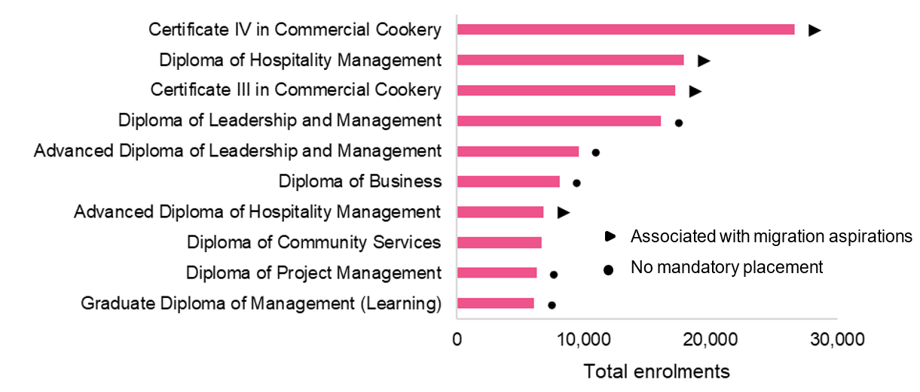

Source: Department of Education, PRISMS data extracted April 2024.

There is further indirect evidence of consistent enrolment patterns in both VET and higher education favouring courses linked to skilled occupations included in permanent visa lists. Specifically, course choices which funnelled graduates towards skilled occupations in shortage had a high proportion of persons gaining a permanent residence visa. As an example, VET enrolments across the period from 2012-2023 included numerous enrolments in Commercial Cookery courses that are linked to the occupations of Cook and Chef. In the same period, Cooks and Chefs were among the top two VET-qualified occupations of those achieving permanent residence status (Figure 4).

Figure 4: Top 10 VET enrolments by qualification for Student visa holders (2012-2023) and top 10 occupations for international student graduates by number of permanent residence (PR) visas granted (2013-2023)*

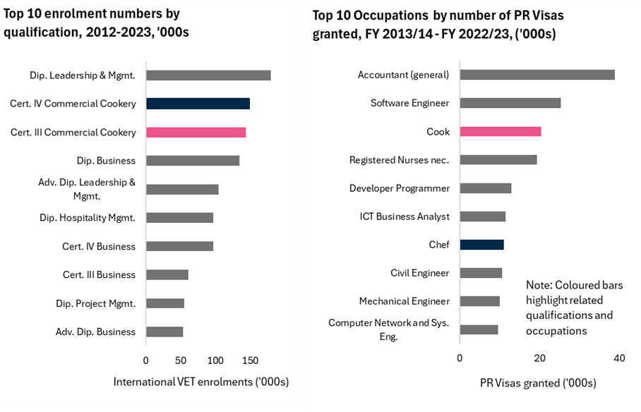

*Note: coloured bars show Cook and Chef (right hand side) as occupations that require VET qualifications (left hand side). Source: Department of Education, PRISMS data extracted April 2024; Department of Home Affairs data, Temporary visa holders in Australia dataset, March 2024.

In higher education during the same period, the most popular qualifications list was dominated by courses related to nursing, accounting, IT and engineering. The top higher education-qualified occupations of those achieving permanent residence included Accountants, ‘ICT Professional’ occupations, Registered Nurses and both Civil and Mechanical Engineers (Figure 5). This indicates that, in some cases, courses are chosen to match an identified pathway. This was confirmed by students and providers in JSA’s qualitative research and echoed in a recent study of international students conducted by the Migrant Workers Centre (Migrant Workers Centre, 2024).

Figure 5: Top 10 higher education enrolments by qualification for Student visa holders (2012-2023) and top 10 occupations for international student graduates by number of permanent residence (PR) visas granted (2013-2023)*

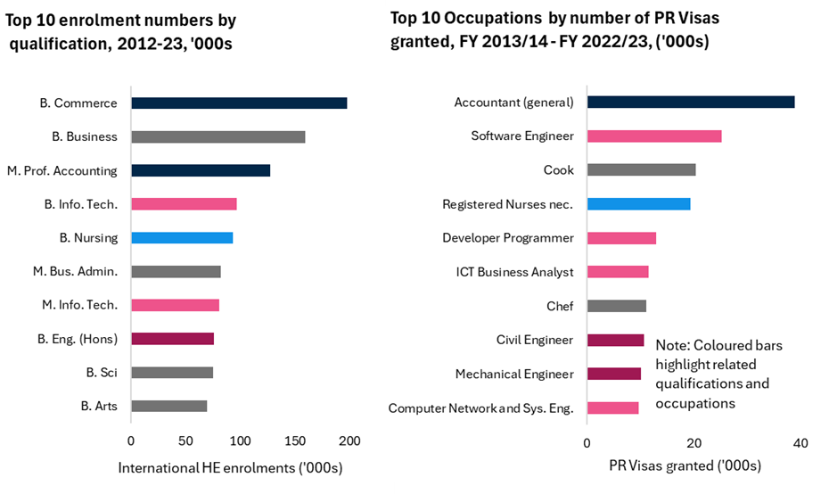

*Note: coloured bars show occupations (right hand side) requiring higher education qualifications (left hand side). Source: Department of Education, PRISMS data extracted April 2024; Department of Home Affairs data, Temporary visa holders in Australia dataset, March 2024.

# Chapter 2 - Pathways to permanence

## Recommendations

|  |
| --- |
| * Consider the full range of study to work visa pathway settings for international Vocational Education and Training (VET) to ensure they support students to study and contribute in areas of persistent national skills shortage. (Recommendation 3) |
| * Undertake further qualitative research with international students and graduates about their motivations and decision making in relation to labour market participation and fields of study. (Recommendation 7) |

## Policy Observations

|  |
| --- |
| The changing characteristics of Australia’s international student cohort and frequent transitions to other visas after graduation have meant that a significant proportion of students remain in Australia after completing their studies.   * With the number of permanent residence (PR) places available each year historically being a fraction of the number of international graduates, viable pathways to skilled employment have been limited to temporary sponsored and non-sponsored visa options for most graduates, regardless of course choice or employment experience. * VET graduates' pathways to permanent residence have been narrower than higher education graduates’ given their restricted Temporary Graduate visa eligibility but there are indications that a higher proportion are achieving permanent residence. * Better outcomes are experienced by graduates using visas with structural sponsorship or occupational requirements rather than those on other temporary or visitor visas. * Visa settings, such as skills lists and the points test, may ‘funnel’ students into courses and occupations outside their genuine interest and in which they may not choose to remain once PR is achieved. |

## Choosing pathways

Most international students apply for a Student visa (subclass 500) to study a higher education or VET course at an Australian education provider. The course needs to be one that is registered on the Australian Commonwealth Register of Institutions and Courses for Overseas Students (CRICOS). After completing their studies, eligible graduates can apply for a Temporary Graduate visa (subclass 485) to continue living and working in Australia. Temporary Graduate visas are considered a skilled visa type. While Temporary Graduate visas can be used for a variety of purposes, this visa enables graduates to demonstrate their eligibility to move into skilled and permanent pathways.

Some international students have chosen to stay for a short time, before leaving Australia after graduating or after gaining invaluable work experience using their freshly acquired qualifications. Others have chosen to stay for longer. Many international students have moved from one temporary visa to another, extending their time in Australia along the way. Some have pursued a pathway that tracks a course to permanent residency. However, the motivations that have sat behind the choices made along these pathways are not always visible from data and research. As the international education sector has grown, so too has the importance of international graduates to Australia’s skilled migration, contributing to a skilled pipeline to Australia’s capped permanent migration program. Overall, international students have been achieving permanent residence in increasingly higher proportions, particularly over the past 20 years.

Government reforms to strengthen the integrity of the Student and other temporary visa programs that underpin the sector have been implemented across the period from 2023 to 2025. Some of the patterns of visa use highlighted in this Chapter are now restricted and will not be possible moving forward. Further work will be required in the future to analyse the impact of the most recent changes to Student, Temporary Graduate, temporary skill visas and other temporary visas on the observed behaviours of international students and their post-study labour market outcomes.

### Seeking further visas following study has become more common

Many international students look to continue their stay in Australia after graduation, seeking to join Australia’s workforce to apply the skills acquired during their education. Australia’s visa settings have provided options for students to remain in Australia after their graduation. Many take up opportunities for post-study work to defray the costs of their education and to boost their employability with Australian work experience (Tran et al., 2020). Australian businesses benefit from the availability of this motivated and educated workforce as international graduates take up roles across the economy.

There also are clear indications that many international graduates are pursuing study, post-study work and extended time in Australia to support aspirations for permanent residence.

While not all graduates sought to stay on, 53% of international graduates were granted a further visa after their Student visa in 2022-2023, compared to around 40% of international graduates being granted another visa in the pre-COVID-19 pandemic years from 2017-2018. Noting that the impact of the COVID-19 pandemic on patterns of visa use made this period unusual, temporary visas that allowed work were the most favoured choice.

In 2022-2023, most graduates who moved to other visas transitioned to a relatively small handful of subsequent visas, with 45% taking up a Temporary Graduate visa (subclass 485) and almost 17% taking up the now closed Pandemic Event visa (subclass 408) (Department of Home Affairs, 2023b). A subsequent Student visa (subclass 500) and a Visitor visa (subclass 600) were the next most prominent options. Much smaller numbers of graduates moved onto other visas, including permanent visas (Figure 6).

Figure 6: Next visa destinations of Student visa (subclass 500) and Temporary Graduate visa (subclass 485) holders in 2022-2023

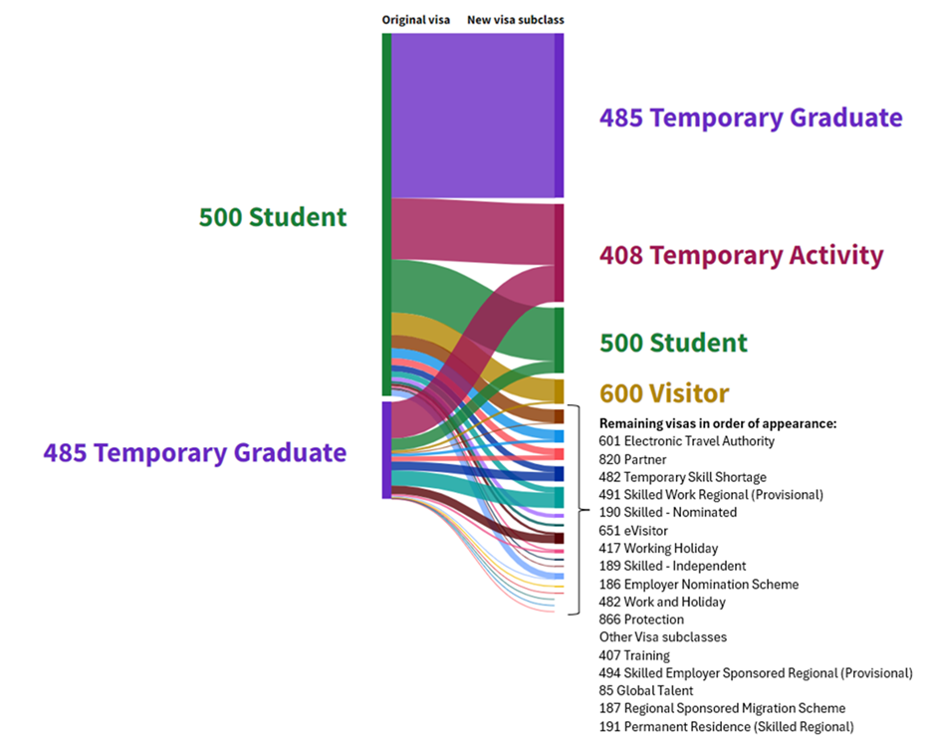

Source: Department of Home Affairs data, Temporary visa holders in Australia dataset, June 2024.

Overall, graduates tended to converge on visas that allow them partial or full work rights (Figure 7). The sharp rise in temporary resident working visas in 2022-2023 may be attributable to the realisation of pent-up demand following the closed borders of the COVID‑19 pandemic period. It nevertheless follows an increasing prevalence of these visas over the other popular alternatives.

Figure 7: Number of visas granted by visa category where the last visa held was a Student visa

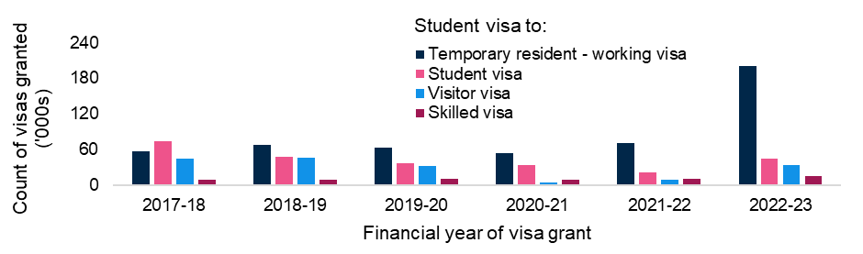

Source: Department of Home Affairs data, Temporary visa holders in Australia dataset, June 2024.

### Successive Student visas have been the second most likely ‘next’ visa

Around 15% (45,000) of all Student visa holders opted for a successive Student visa in 2022-2023 after completing their first, although this choice is becoming less popular with the increase in ‘Temporary resident– working’ visas (Figure 7, above).

More higher education graduates opted to enrol in a subsequent VET course following the COVID-19 pandemic. In 2022-2023, the proportion of higher education graduates moving to a VET course increased to nearly 35% (14,000) of all Student visa holders who moved to a Student visa in another sector, compared to 15% following the same path in 2018-2019 (Figure 8)[3]. Rather than meeting educational aspirations, moving from a higher education to a VET qualification may be a stay-prolonging behaviour that also supports work availability.

As noted, integrity measures introduced during 2024 restrict many of the patterns of visa use described and illustrated in this Chapter.

Figure 8: Subsequent Student visas granted by education sector in 2018-2019 and 2022-2023 (Proportion of visas granted)

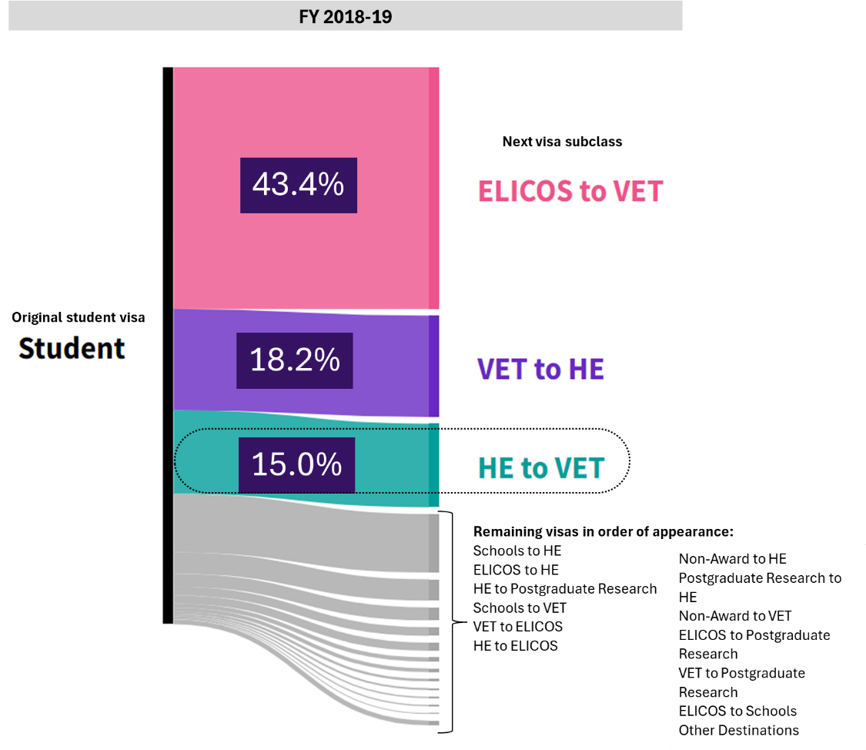

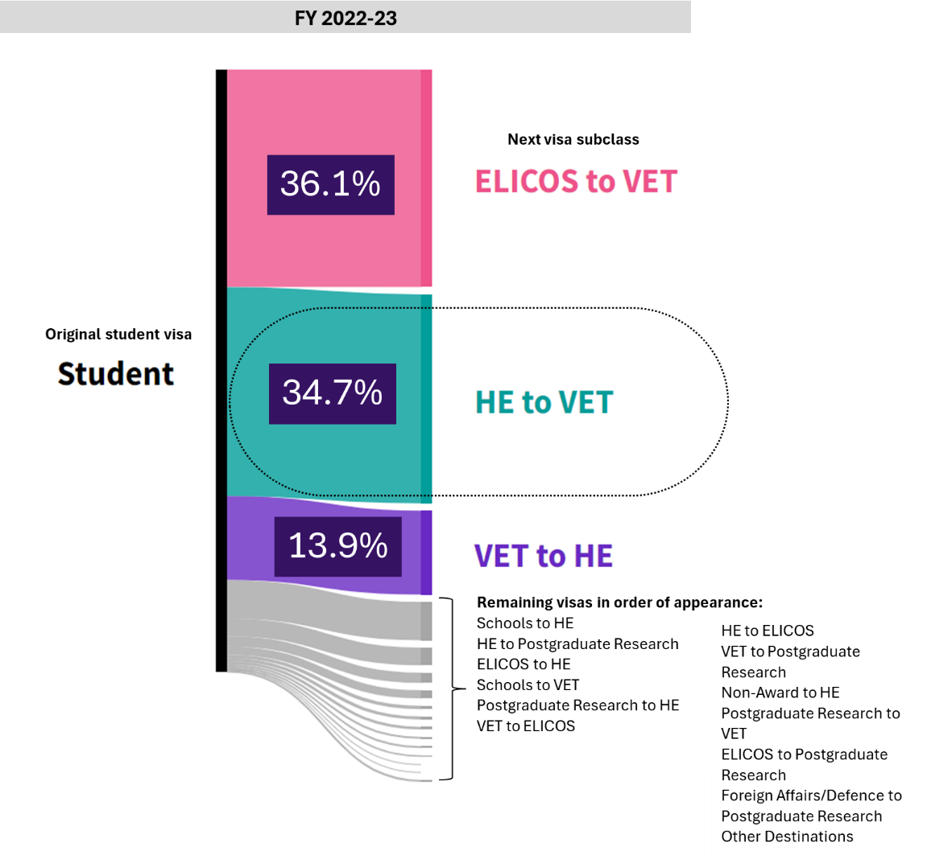

## Common visa pathways have depended on students’ initial qualifications

While a significant proportion of former international students are granted further visas that allow them to remain in Australia, the type and duration of those visas is dependent on the initial qualification studied.

### Temporary Graduate visas have been the most popular ‘next’ visa, particularly for higher education graduates

Overall, Temporary Graduate visa numbers have been increasing since 2014. The proportion of Temporary Graduate visa holders to Student visa holders has increased from around 9% in March 2014 to 27% in March 2023, reflecting a significant increase in the proportion of students seeking to extend their stay, and presumably work, in Australia (Figure 9).

Figure 9: 12-month average number of Student visa (subclass 500) and Temporary Graduate visa (subclass 485) holders, 2012-2023, ’000s

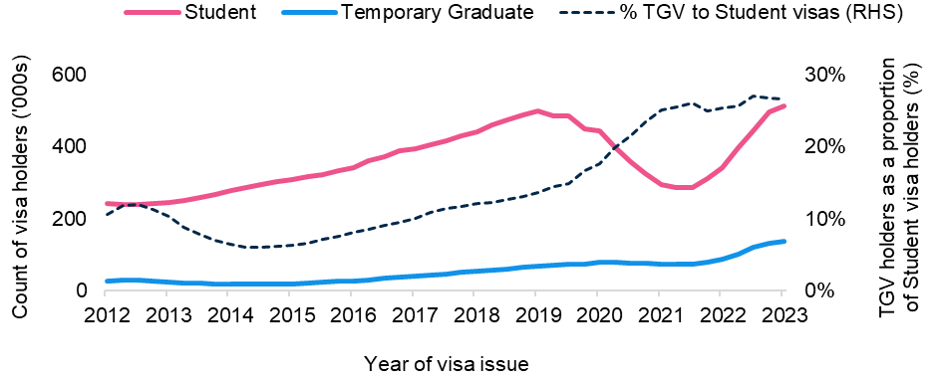

Source: Department of Home Affairs data, Temporary visa holders in Australia dataset, June 2024

#### Higher education pathways

For higher education students, the Temporary Graduate visa has been the most common subsequent temporary visa following graduation. The ‘Post-Study Work’[4] stream of this visa, for which only higher education graduates have been eligible, enables the holder to stay and work in Australia in any job, in any field, for durations of up to 4 years (for a doctoral graduate), with an additional year added if the graduate had studied and worked in a regional area. A further 2-year extension was possible between 1 July 2023 and 30 June 2024 for graduates qualified in areas of skills shortage.

The popularity of the ‘Post-Study Work’ stream with higher education graduates has led to this being the most common subsequent form of Temporary Graduate visa for former Student visa holders overall. However, VET graduates have been much less likely than higher education graduates to use their stream of the Temporary Graduate visa, the Graduate Work stream, particularly in recent years (Figure 10).

Figure 10: Number and stream of Temporary Graduate visas issued between 2013 and 2023

Figure 10. Stacked area chart. Count of temporary graduate visas issued from Financial Year 2013-2014 to Financial Year 2022-2023, by Post study work or Graduate work visa. Discussion under Higher education pathways page 32. 


#### VET pathways

In contrast to the higher education experience, VET graduates (‘Graduate’ work stream of the Temporary Graduate visa[5]) have the same post-study work opportunities as they did in 2008. The Graduate Work stream allows a maximum of 18 months of further stay. Meeting the requirements of this stream has been contingent on the graduate's VET qualification being linked to an area of skills shortage and the graduate commencing a skills assessment process undertaken by a relevant skills assessing authority.

These limitations contribute substantially to the concentration of VET students in courses, such as Commercial Cookery, that suit this constrained pathway. As noted previously, graduates may not intend to work in the field in which they are studying, so despite a supply of graduates ready to enter the labour force, shortages may persist. Further work would be required to consider other courses that do not currently suit the constrained VET pathway in the context of addressing persistent skill shortages.

|  |
| --- |
| Before arriving in Australia, I was a high school teacher, but I had to enrol in various cookery certificates or diploma courses to extend my stay before transitioning to the skilled migration scheme.  International student graduate, ‘Sinsin’ - interview as part of the Migrant Workers Centre report, Carrot or Stick (2024) |

As a result of these settings, VET graduates are more likely to move to a further Student visa than take up a Temporary Graduate visa. A small group secure a Temporary Skills Shortage visa (subclass 482)[6], which also is available only for occupations included on the relevant skills shortages list.

### Temporary visa settings continue to favour higher education graduates over VET, but both are required to meet skills needs

Although a stronger pipeline of international VET graduates may help meet Australian skills shortages, temporary visa settings create higher barriers to participation, including:

* Student visa grant rates for VET are lower, discouraging some potential students and possibly contributing to artificial choices of higher education courses over VET
* VET courses tend to be shorter and thus less suited to the Australian Study Requirement for Temporary Graduate visas (TGV) and points-based permanent visas, requiring students to package courses to meet time thresholds
* The Temporary Graduate visa’s Post-Vocational Education Work Stream (formerly Graduate Work Stream) is limited in duration and occupations; and has skill assessment requirements that make it more expensive and difficult to get
* Completion of VET courses generally attracts a lower number of points in the points test required for many skilled permanent visas.

|  |
| --- |
| Many employers are reluctant to invest time and money into recruiting and upskilling VET graduates with a post-study stay period of only 18 months.  VET provider peak body representative, focus group |

### Mismatch between available permanent residence visas and graduates’ aspirations

With the share of permanent skilled migration visas to Student visas declining, graduates have been increasingly seeking out further temporary visa options, such as those for temporary residence, including temporary resident (other employment) and temporary resident (skilled employment), (Figure 11).

Figure 11: The next visa destinations for former Temporary Graduate visa holders, from FY 2017-2018 to FY 2022-2023

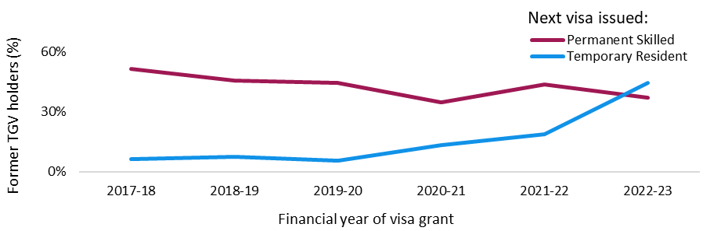

Source: Department of Home Affairs data, Temporary visa holders in Australia dataset, June 2024.

Each year, Australia sets the number of skilled permanent migration places for that year’s Migration Program. In 2024, it was set at 132,200 places, or approximately 71% of the total permanent migration program. In 2022-2023, approximately 17% of all higher education and VET Student visa holders transitioned directly from a Student visa to a permanent residence visa (Figure 12).

Altogether that year, 305,000 Student visa holders transitioned to other visas, including approximately 140,000 to a Temporary Graduate visa and 45,000 to a Student visa in another sector (both of which are temporary visas). Each year, those international graduates who transition to a temporary work visa join previous years’ graduates – many of whom transitioned to temporary work stream visas in previous years – that they may be competing against for permanent migration places in the future.

Figure 12: Skilled permanent residence (SPR) visas granted to Student visa holders, from FY 2013-2014 to FY 2022-2023

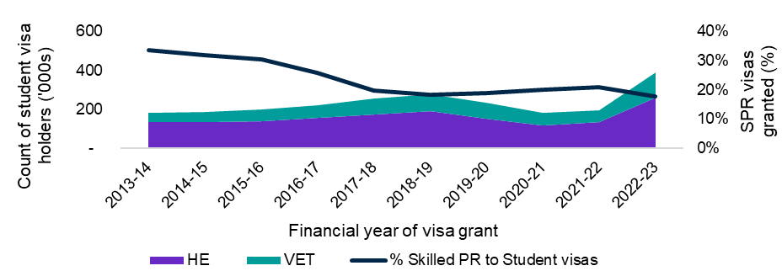

Source: Department of Home Affairs data, Temporary visa holders in Australia dataset, June 2024.

### Permanent visas take time to achieve

Analysis of the Australian Census and Migrants Integrated Dataset (ACMID) data from 2021 indicates that many graduates who achieved a permanent residence visa required around

2 or 3 consecutive visas before they gained a permanent residence visa, with a smaller proportion going through 5 or 6 different visas before being granted permanent residence. Permanent residence required around 5 years to attain post-graduation, with higher education graduates generally achieving permanent residence faster than their VET graduate counterparts (higher education graduate median: 4.7 years, VET graduate median: 6.0 years).

The most significant pathway to permanent residence is through a work stream visa, but there are other routes including a family stream visa (which is on average a shorter pathway, rather than through a skilled visa pathway).

### ‘Structural’ visa requirements are associated with higher permanent residency outcomes

There are indications that visas that include constraints requiring applicants and holders to work in identified occupations, or to be sponsored by a state or territory or employer, are linked to better labour market outcomes than visas that do not.

In the temporary visa sphere, Temporary Skills Shortage visa holders experienced better employment and income than Student and Temporary Graduate visa holders overall. VET graduates whose visa pathways often include structural requirements (such as the graduate or post-vocational stream of the Temporary Graduate visa and Temporary Skills Shortage visas), are more likely to work in a job and at a skill level commensurate with their completed qualification (Varela and Breunig, 2023).

# Chapter 3 – Residency outcomes of graduates who stay

## Recommendations

|  |
| --- |
| * Develop and agree a methodology to track over time the proportion of international students who remain in Australia over the medium and long term, with a focus on economic outcomes. (Recommendation 4) |
| * Consider reforms to permanent migration settings in the context of many international students staying in Australia over the medium and long term, with a focus on reforms to the number of points accrued for eight or more years of relevant skilled work experience. (Recommendation 5) |
| * Include Provider Registration and International Student Management System (PRISMS) data in the Person Level Integrated Data Asset (PLIDA), to enable better analysis of the experiences of international students. (Recommendation 8) |

## Policy observations

|  |
| --- |
| Better access to integrated and linked datasets is progressively allowing more detailed analysis and insights into different international student cohorts over time.   * While data on the proportion of all international students who remain in Australia in the longer-term is not readily available, JSA estimates that this figure was around 35-40% of all students who commenced in the early 2010s achieved permanent residency within 10 years, with an estimated likely decline in this figure (to around 25-30%) for students who commenced study in the late 2010s. * This finding is a significant increase on analysis published by the Treasury and the Department of Home Affairs in 2018, which found at the time that 16% of international students eventually transitioned to permanent residence - an evidence source cited by many stakeholders during JSA’s consultations on this study. * More data is readily available to assess the likelihood of international students staying in Australia in the longer term for the group who seek paid employment while studying, as this decision to work while studying facilitates analysis of longitudinal tax and income records from the Person Level Integrated Data Asset (PLIDA). * JSA’s analysis finds that more than 50% of higher education or VET international students who are identifiable in PLIDA arriving in Australia in the early 2010s achieved permanent resident status within 10 years of commencing study. * This result is broadly supported by the recent analyses of two other agencies, which both found that more than 50% of higher education or VET international students who are identifiable in PLIDA or other administrative data arriving in Australia in 2006-2007 or 2010-2011 remained in Australia (with either temporary or permanent resident status) after 10 years. * The likelihood of international students remaining in Australia in the longer-term varies significantly across visa types and countries of origin. |

## International graduates have become a significant part of Australia’s permanent migration program

While it is not possible to accurately predict how many international students stay in the short-term, longer-term analysis shows that more graduates are staying than previously estimated. As noted above, many international students remain in Australia as graduates for significant periods following their study and seek permanent residency. The likelihood of staying in Australia long-term varies significantly across visa classes and countries of origin.

Although there is no direct path to permanent residence, graduates’ persistence means they have become an important feeder group to Australia’s permanent migration program. The Review of the Migration System noted that while international education had supported strong growth in the education export sector, Australia had not focused enough on “capturing the best and brightest international students”, and that the Student visa program should be an important source of high-performing skilled migrants. (Parkinson et al, 2023).

Yet as outlined earlier, international students and their experiences traditionally have not been very visible in most government datasets, which have a focus on domestic policy needs. No single existing data asset includes all the elements needed to consider international student experiences across the full range of migration, education, and labour market variables. Progressively improved access to linked data sets and more sophisticated tools and approaches to extracting insights is undoubtedly promoting that visibility.

### Using linked datasets in PLIDA to support JSA analysis of international student pathways and outcomes

For more comprehensive insights of international student pathways and outcomes, JSA followed cohorts of international students who held a Student visa as primary applicants in 2010-2011 through to 2022-2023 using Person Level Integrated Data Asset (PLIDA) data. PLIDA is a data asset that is overseen by the Australian Bureau of Statistics. PLIDA uses combined information across Commonwealth departments, including on health, education, government payments, income and taxation, employment, and population demographics over time, including the Census. In this way, it allows the opportunity to examine long-term cohort outcomes, such as for international students.

Similar to domestic students, many international students seek paid employment while studying. This allowed JSA to analyse international student cohorts using PLIDA-linked tax and income records for those students who did take on work at some stage.

* For the purposes of this study, the Department of Home Affairs migration data and Australian Taxation Office (ATO) income records were combined through PLIDA. The objective was to examine permanent residence, income, occupation, and visa pathways followed by international student cohorts who studied in Australia between the 2010-2011 and 2022-2023 financial years.
* This dataset allows for the tracking of outcomes for students who followed higher education or VET pathways more completely than those on ‘Other’ pathways (ELICOS, Defence, Postgraduate, or Non-Award).
* JSA’s analysis of PLIDA data extracted people who were granted a temporary Student visa (subclasses 500 or equivalents that were in place) as primary applicants from the 2010-2011 to 2022-2023 financial years. This dataset was further filtered to include those who had recorded labour market activity via ATO payment summaries and tax returns.

However, not all international students work while studying[7]. To assess how representative PLIDA data is of the broader international student population, the numbers of unique international students identified in PLIDA findings were compared to Student visa grants data published by the Department of Home Affairs.

* Analysing these comparisons by education sector and country of origin reveals potential behavioural differences.
* The Department of Home Affairs Student visa grant headcount is almost entirely matched by the PLIDA headcount, albeit with a time lag of around 2 years, for both international VET students and international higher education students from countries other than China. This suggests that the PLIDA data provides an appropriate representation of these overall international student populations.
* For higher education students from China, the Department of Home Affairs Student visa grant headcount is almost fully matched by the (lagged) PLIDA headcount for a brief period in the early 2010s. However, in later years, the Department of Home Affairs Student visa grant headcount significantly exceeds the PLIDA headcount, suggesting that PLIDA coverage has become less representative of the overall Chinese higher education student population over time. One hypothesis supported in research is that a greater proportion of Chinese international students leave Australia to use their qualifications in other labour markets (Li et al., 2025).

For other Student visa subtypes (such as ELICOS, Defence, Schools, and Non-Award), the Department of Home Affairs student visas grant headcount is around 4 times the PLIDA headcount, suggesting that PLIDA does not represent these student populations well.

## More graduates are staying than previously estimated

A comparison of Student visa grants against graduate participation in the workforce from ATO records strongly indicates that international students are staying long-term and that there are nuances in their behaviour based on their countries of origin. Figure 13 suggests that those included in the PLIDA sample within the higher education and VET sectors appeared to lag around 2 years behind the Student visa grant numbers, as well as representing a declining share of total Student visa grants in the mid to late 2010s. The lagged nature of the PLIDA data is likely to reflect the time gap between a Student visa being granted and that student first finding work while studying in Australia.

Figure 13: Comparison of Student visa grant records (Department of Home Affairs) against international student cohorts with income/tax records (ATO), Higher education and VET sectors combined

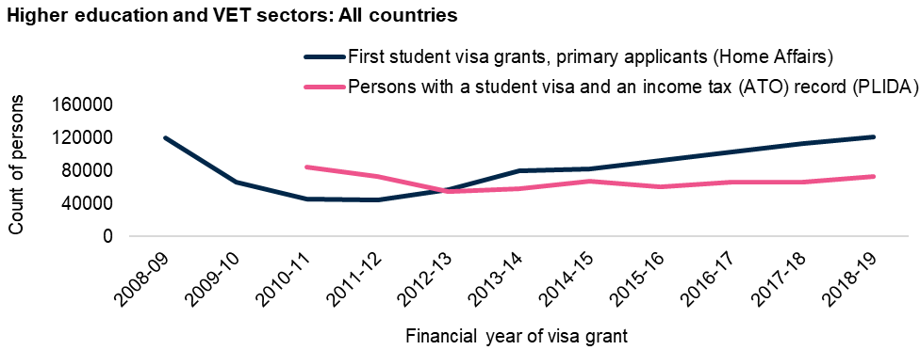

Sources: JSA analysis of PLIDA dataset, primary applicants for Student visas who lodged a tax or income report to the ATO from FY 2010-2011 to FY 2022-2023, extracted December 2024. Home Affairs data, Student visa grants, first Student visa issued to international students aged 15+ years, primary applicants, downloaded March 2025.

Separating the comparisons of PLIDA and Student visa grant headcount data by sector and country of origin reveals potential behavioural differences.

For the VET sector, the Department of Home Affairs Student visa grant headcount is almost entirely matched by the PLIDA headcount over time, albeit with a time lag of around 2 years (Figure 14). This suggests that the PLIDA data provides an appropriate representation of the overall international VET student population.

Figure 14: Comparison of Student visa grant records (Department of Home Affairs) against international student cohorts with income/tax records (ATO), VET sector only

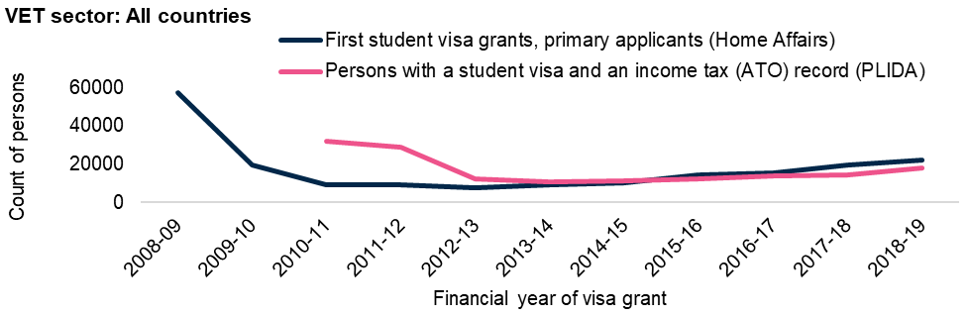

Sources: JSA analysis of PLIDA dataset, primary applicants for Student visa who lodged a tax or income report to the ATO from FY 2010-2011 to FY 2022-2023, extracted December 2024. Home Affairs data, Student visa grants, first Student visa issued to international students aged 15+ years, primary applicants, downloaded March 2025.

Patterns in the equivalent comparison for the higher education sector show regional nuance. Of particular note is the comparison for international students from China, where the PLIDA headcount broadly matches the (lagged) Department of Home Affairs’ Student visa grants data for a period in the early 2010s, before a significant gap between the two series emerges from 2013-2014 onwards (Figure 15a). While JSA analysis was not able to provide a direct explanation of what drove the difference between the two datasets, this result suggests that many Chinese higher education students may not engage in work while studying in Australia, and that PLIDA analysis cannot measure that part of the cohort given the dataset’s restriction to people with both a past student visa and with income reported to the ATO.

In comparison, the working aspirations of international higher education students coming from other countries appear consistent with the pattern of students who engaged with the VET sector (Figure 15b). That is, the Department of Home Affairs Student visa grant headcount is almost fully mirrored by the PLIDA headcount over time, again with a time lag of around 2 years. This suggests that the PLIDA data provides an appropriate representation of the overall international higher education student population, when those students go on to work in Australia and engage with the ATO. For example, when considering higher education students from all countries excluding China in 2015-2016, there were almost 44,500 first Student visa grants to primary applicants. Two years later, in 2017-2018, there were just over 43,000 people identified for the first time in PLIDA with a Student visa and an ATO income tax record.

Figure 15: Comparison of Student visa grant records (Department of Home Affairs) against international student cohorts with income/tax records (ATO), higher education sector only; a) China only b) All others excluding China

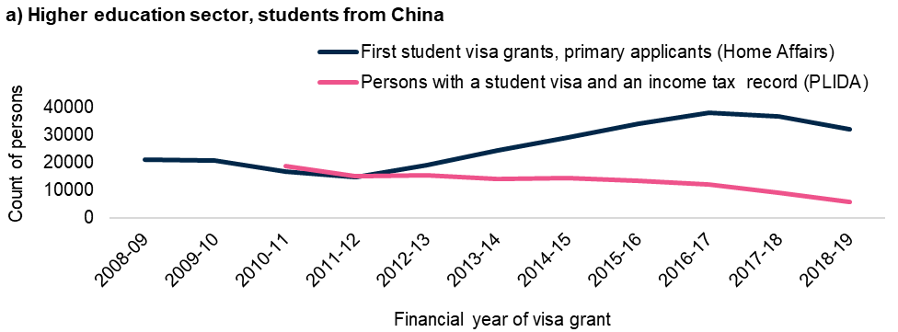

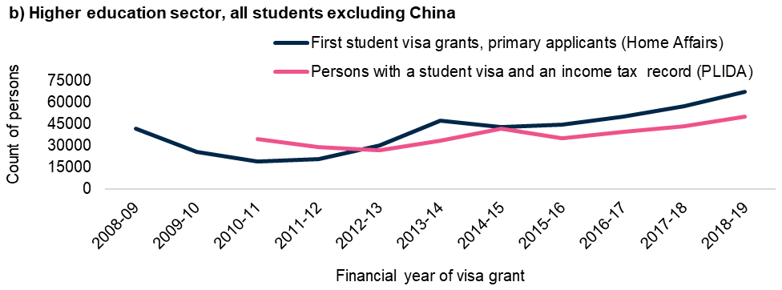

Sources: JSA analysis of PLIDA dataset, primary applicants for Student visas who lodged a tax or income report to the ATO from FY 2010-2011 to FY 2022-2023, extracted December 2024. Home Affairs data, Student visa grants, first Student visa issued to international students aged 15+ years, primary applicants, downloaded March 2025.

### Describing whether international students are no longer in Australia

There are complexities to describing whether and when international students leave Australia. There is no established measure of what proportion of international students from a particular cohort at a particular point in time have departed Australia. Their length of time in Australia is dependent on what pathways international students take as graduates, including visa type, if they choose to stay in Australia.

As policy consideration continues regarding the value and impacts of international education, a data- and sector-informed methodology to enable a standardised measure of student departure would support a more rounded understanding of students’ behaviour post-study, and of migration patterns, as well as better visibility of labour market outcomes.

A frequently cited Australian Government report from 2018, Shaping A Nation - Population growth and immigration over time, estimated that 84% of students returned home after their study (The Treasury and Department of Home Affairs, 2018).

However, subsequent analyses using different student cohorts and methodologies, have found that the percentage of Student visa holders remaining in Australia post-study is much higher than the 2018 analysis that was frequently cited by stakeholders during this Study. More specifically:

* The Department of the Treasury’s Centre for Population 2023 publication, Pathways from temporary visas to permanent residency: a case study of migrants that arrived in 2006 -07, found that of the 2006-2007 international student cohort, 39% transitioned to permanent residency after 10 years in Australia, with a further 17% remaining on temporary visas after that period, and only 44% having departed Australia after 10 years.
* Unpublished 2024 analysis undertaken by the Department of Education of international students who were present in 2010-2011, found that 45% of higher education Student visa holders and 56% of VET Student visa holders who were identifiable in PLIDA had achieved permanent residency within 10 years.
* More detail on the two longitudinal analyses of international students referenced above is provided in Appendix B.

### The likelihood of achieving permanent residency

With these comparisons in mind, JSA’s analysis of PLIDA outcomes has been targeted towards higher education and VET sector students, including analysis of the likelihood of achieving permanent residency.

The permanent residency status of these two cohorts was recorded at the 3rd, 5th, and 10th-year after each cohort’s Student visas were granted (Table 2). As 2022-2023 data was the most recent data available at the time of the analysis, this was used as the endpoint substitute for students who commenced in 2013-2014 and 2014-2015, recognising that this shortens the period analysed to less than 10 years for both cohorts.

On average for the 5 student cohorts commencing from 2010-2011 to 2014-2015 inclusive, 55% of higher education and 56% of VET students had gained permanent residency within 10 years of commencing study.

Unsurprisingly, only a small percentage of international students gained permanent residency after less than 3 years of holding a Student visa. For both higher education and VET sectors, the likelihood of gaining permanent residency increases in years 3 to 5 after commencing study. On average over the 5 student cohorts from 2010-2011 to 2014-2015 inclusive, around 19% of higher education and 16% of VET students cohorts had gained permanent residence status during this period. This broadly aligns with the expected time needed to complete many types of tertiary study.

In Years 6 to 10 after commencing study, a further 28% of international students who had studied in higher education and 31% of those who had studied VET had gained permanent residence.

Table 2: Proportion of international Student visa cohorts between FY 2010-2011 and FY 2014-2015* who gained permanent residency (PR) over time

|  |  |  |  |  |  |
| --- | --- | --- | --- | --- | --- |
| **All studies** | **Financial year of identification in PLIDA** | **Less than 3 years** | **3 to 5 years** | **6 to 10 years** | **PR recorded after 10 years (or at financial year 2022-2023)** |
| **Studied higher education** | 2010-2011 | 8% | 24% | 28% | 60% |
| 2011-2012 | 7% | 21% | 30% | 58% |
| 2012-2013 | 8% | 19% | 29% | 56% |
| 2013-2014* | 8% | 18% | 28%* | 54%* |
| 2014-2015* | 7% | 16% | 25%* | 48%* |
| Overall | 8% | 19% | 28% | 55% |
| **Studied VET** | 2010-2011 | 7% | 17% | 32% | 56% |
| 2011-2012 | 6% | 16% | 36% | 57% |
| 2012-2013 | 12% | 16% | 28% | 56% |
| 2013-2014* | 15% | 16% | 26%* | 57%* |
| 2014-2015* | 13% | 18% | 22%* | 53%* |
| Overall | 9% | 16% | 31% | 56% |

*Note: FY 2013-2014 and FY 2014-2015 are in their 9th year and 8th year (respectively) since commencing study in 2022-23. Instances of gaining permanent residency have been counted in the ‘6 to 10 years’ range where relevant.

Source: JSA analysis of PLIDA dataset, primary applicants for Student visas who lodged a tax or income report to the ATO from FY 2010-2011 to FY 2022-2023, extracted December 2024.

#### Developing a measure of when and whether international students have ‘returned home’

As international student arrivals have continued to increase, so has the proportion seeking to stay and achieving permanent residency. Over the past 20 years, the most common visa pathway of migrants who arrived on a temporary visa was a Student visa to a Permanent skilled visa (453,000 or 36%) (Australian Bureau of Statistics, 2023).

However, with the increasing gap between the number of international student enrolments and the number of permanent residence visas available, it is likely that the proportion of graduates attaining permanency may not continue to follow this pattern.

JSA estimates that around 35-40% of all international students who commenced study in the early 2010s achieved permanent residency within 10 years. This estimate is based on the two key data sources noted earlier in this chapter, that is: (1) the comparison of unique international students identified in PLIDA to Student visa grants data published by the Department of Home Affairs; and (2) the proportion of international students identifiable in PLIDA who achieve permanent residency within 10 years,

* Specifically, this estimate reflects around 70-80% of student visa grants in the early 2010s being subsequently identified in PLIDA (with an average lag time of around two years), with just over half of the students who were identified in PLIDA achieving permanent residency within 10 years.
* It is important to note that this estimate relies on an assumption that only a very small proportion of students who are never identified in PLIDA manage to achieve permanent residency. It can therefore be considered as a lower bound estimate.

However, as Figure 13 highlights (p.40, above), the proportion of all international student visa grants that are subsequently identified in PLIDA appears to decline over the mid-to-late 2010s, primarily driven by a decline in identifying Chinese higher education students. This has implications for JSA’s estimate of the proportion of these students who will have achieved permanent residency within 10 years of commencing study.

By the late 2010s, only around 50-55% of student visa grants were subsequently identified in PLIDA (again, with an average lag time of around two years).

* Data is not yet available to assess the proportion of students identifiable in PLIDA who commenced study in the late 2010s and achieved permanent residency within 10 years (as 2022-23 represents the most recent available year of PLIDA data). However, patterns of achieving permanent residency within the first five years for these cohorts are similar to those observed for the early 2010s cohorts.
* This leads to JSA estimating that around 25-30% of all international students who commenced study in the late 2010s will achieve permanent residency within 10 years, which represents a decline of around 10 percentage points when compared to the cohorts who commenced study in the early 2010s.

The challenge of not having a single definitive and robust measure of when and whether international students leave Australia was raised consistently by stakeholders as part of this study’s consultation. One of the key recommendations of this study is to propose the development of a measure of whether international students depart Australia after their study and post-study work experiences.

Data to inform the methodology could include the number of former Student visa holders who, at the time of measurement:

* do not hold a permanent visa or citizenship
* do not hold a temporary visa, and
* were not in Australia for 12 of the previous 16 months.

### The importance of the points test

Many of the permanent visas accessed by former international students require applicants to satisfy a point test as part of the visa application process.

The current test includes points for age, English proficiency, work experience, Australian study, and educational qualifications. Judicious educational choices by international students will support meeting the occupational requirement and garner a significant portion of the required points.

Holding a bachelor’s or higher degree, spending 16 months in Australia studying an Australian qualification, completing a professional year, studying in a regional area and using post-study work rights to achieve 3 years of skilled Australian work experience will deliver around half the required points. Being aged below 40 years and having proficient English will deliver the remaining points - acknowledging that for the points tested skill visa programs, applications are typically considered within an occupation, and higher aggregate points are not the sole determinant for an invitation to apply for a visa.

#### The points test drives behaviours

In JSA’s qualitative research, graduates reported matching their choices and behaviours to the requirements of the points test.

For graduates with aspirations to remain permanently in Australia, the time in Australia afforded by study-subsequent visas can be used to meet the requirements of permanent visas. Graduates told JSA that they spent time following graduation in undertaking activities to boost their eligibility for permanent residence, by:

* undertaking further study, including changing their field of study, to extend their time working in Australia (up to 20 points for 8 years of work experience)
* completing a Professional Year Program (available for accounting, IT and engineering graduates only) to gain visa points (5 points)
* completing training courses with the National Accreditation Authority for Translators and Interpreters (NAATI) to gain visa points (5 points)
* studying for International English Language Testing System (IELTS) testing to lift their English language proficiency for more points (10-20 points)
* relocating to a regional area for more points (10 points).

|  |
| --- |
| I had to do Professional Year, which gave [sic] points. I had to do NAATI. It's a translating course which gives points.  Accounting graduate, interview #8 |

|  |
| --- |
| They were coming to Tasmania for the 10 extra points. We don't actually have very many people that can find jobs. So they go back to the mainland because there's more people of there [sic] of their own community.  Accounting employer, interview #5 |

For students and graduates with migration aspirations, the points test and skills lists may contribute to ‘funnelling’ students and graduates into courses which may fall outside of their genuine interests and in which they may not be motivated to remain.

|  |
| --- |
| A lot of people who did accounting with me have not managed to get 90 points. They switched into teaching and then to nursing.  Accounting graduate, interview #9 |

The points test may also incentivise accumulating eight years of work experience to gain more points. One of the key recommendations of this study is that the review of the points test (as outlined below) considers the significant proportion of international students seeking permanent residency who are currently incentivised to stay in Australia over the medium and long term to accrue more points, and the implications of these current settings for the “permanent temporariness” of some international graduates that was outlined in the Migration Strategy.

### Review of the points test

In 2023, the Migration Strategy included a commitment to explore a reformed points test and in April 2024, a Discussion Paper was released to inform consultation on the reformed test. The Discussion Paper reinforced the Migration Review’s recommendation that the points test better identify migrants that will contribute to Australia’s long-term success (Department of Home Affairs, 2024a). It also noted work commissioned to analyse the factors that drive permanent migrant success in Australia, including in the workforce (Varela and Breunig, 2023). This work, by the Tax and Transfer Policy Institute at the Australian National University, identified key success factors for migrants, including international graduates. These factors inform the analysis of challenges faced by graduates in Chapter 4: Qualifications and employment outcomes.

# Chapter 4: Qualifications, skills and employment outcomes

## Policy observations

|  |
| --- |
| International graduates remaining in Australia after their study are less likely to secure employment in their field and at their qualification level and earn less than domestic counterparts.   * These effects are more exaggerated for higher education graduates than VET graduates and for more generic, less vocationally oriented fields of education. * VET graduates more likely to work and earn in line with their qualification * There is a narrow band of occupations into which graduates transition most successfully, such as Registered Nurses and Chefs. These occupations are characterised by an alignment of   + ease of course access and completion for students   + available visa pathways via skills lists   + education settings that prioritise work readiness. * Pathways which support these attributes may offer stronger economic returns on students’ education investment longer term. |

## International graduates’ employment outcomes often do not align with their qualifications

International students become a part of the Australian community as they study, work and live here. Following graduation, many former students will take up the opportunity to join Australia’s workforce temporarily or permanently. For some graduates, joining the workforce is a rite of passage, with the acquisition of Australian work experience part of what they take home or on to other countries. For others, working after graduation is part of what they hope will be a new life in Australia. This Chapter considers the outcomes that international graduates achieve and how these might be influenced by factors in the education, visa and work environments.

### International graduates cluster in higher level qualifications

The Australian and New Zealand Standard Classification of Occupations (ANZSCO)[8] skill‑based classification system assigns occupations one of 5 skill levels. The classification system has been informed by advice from employers, industry training bodies and professional organisations among others. The highest skill level is Skill Level 1. This indicates occupations that have a level of skill commensurate with a bachelor’s degree or higher qualification. The lowest skill level is Skill Level 5, which indicates occupations that typically require a Certificate I or compulsory secondary education (Australian Bureau of Statistics, 2021).

Most domestic and international graduates entering the workforce for the first time will seek to work in an industry, at a skill level, and in an occupation matching their qualification. Many international students enrol in, and complete qualifications associated with higher skilled occupations (Skill Levels 1-3), and so might expect to transition to jobs that match the skill level of their qualification, with incomes to match. Historically, international student enrolments have clustered in qualifications associated with Skill Level 1 (bachelor’s degrees and higher). In 2021, 61% of enrolments fell into this category, with 22% of enrolments in qualifications associated with Skill Level 2 (associate degrees, diplomas and advanced diplomas) and 9% in Skill Level 3 qualifications (Certificate IV).

Similarly, graduates might expect to work in jobs that match the field of study of their qualification. International enrolments in both VET and higher education are concentrated in a relatively small number of fields of study:

* In higher education, enrolments were concentrated in business, commerce, IT, accounting and engineering in 2024 (22%, 18%, 11%, 10% and 9% of enrolments respectively).
* In the VET sector, 2024 enrolments were concentrated in management, business, cooking, marketing, and mechanic/automotive courses (20%, 18%, 15%, 6%, and 4% of enrolments respectively), (Department of Education, PRISMS data, 2024).

### Graduates’ outcomes in income and achievement are lower than domestic comparators

The experience of graduates does not always align with their qualifications. The Government’s 2023 Employment White Paper noted that over half of the international student graduates who have qualified at Skill Level 1 are employed at Skill Levels 4 and 5. In comparison only 20% to 30% of domestic graduates struggle to find employment at their skill level.

International graduates, especially those on Temporary Graduate visas, tend to earn less than the income reported by local graduates with a bachelor’s degree or higher. Coates et al. (2023) noted that the median earnings of Temporary Graduate visa holders were $53,300, versus a median income of $64,400 for all domestic students aged 20 to 29 years holding a bachelor's degree or higher. The discrepancy was especially pronounced for postgraduate coursework degree holders, with international graduates in business and management earning $58,100 less annually than their domestic counterparts. In engineering and computing postgraduate coursework, international graduates earned about $40,000 less (Coates et al., 2023).

This is a common finding across different data sources. According to the 2022 Graduate Outcomes Survey (GOS) (a higher education only survey), across the study areas, international graduates consistently earned less than domestic graduates. Significant differences were observed in business and management, despite these areas being the largest category of higher education international students. The salary gap was distinct for this group, with international graduates earning a median of $56,900 compared to $115,000 for domestic graduates. In fields like engineering and computing, in 2022 the median salary for international graduates was $60,000, while domestic graduates earned $100,000 in full-time roles (Social Research Centre, 2022, pp.10-11). GOS longitudinal survey results show this disparity continues over the medium term, particularly for graduates from postgraduate coursework programs.

The reasons for the disparity between international and domestic graduates are diverse. They can include the period of relevant work experience completed in their area of qualification, comparable time in the workforce post-graduation between domestic and international graduates, as well as potential bias against employing international graduates. Graduates themselves point to often not having relevant work experience, having to start at their very bottom of entry to their field despite having relevant overseas experience, or realising that they had unrealistic expectations of their work-readiness regarding the jobs they thought they could apply for after graduating. More detailed consideration of the underlying causes is explored in Chapter 5: Barriers to transitioning to skilled employment.

|  |
| --- |
| A lot of people expect that once they graduate they will straight away become managers. It doesn’t work like that in real life. You have to start at the bottom.  Accounting graduate, interview #6 |

|  |
| --- |
| So like [training provider] would train you to become a nurse but they don't train you how to how to search for a job for your skill set.  Nursing graduate, interview #1 |

### Income growth rates differ over time for VET and higher education graduates

Through the provision of Person Level Integrated Data Asset (PLIDA) data for the study, JSA was able to examine tax return data from the highest-paying job of international student cohorts who had been granted their first Student visa in 2010-2011 through to 2012-2013. JSA compared annual earnings from the highest paying job for each cohort for students who had followed higher education or VET study pathways. Figure 16 below is an example of the increases observed in visa holders’ mean annual income from the 2012-2013 cohort, with similar patterns observed for other cohorts.

Annual, unadjusted income from graduate’s highest paying job was similar across study pathways 5 years after each cohort’s first Student visas were granted, in both VET and higher education pathways. Income levels at year 5 will often reflect employment outcomes in the period shortly after completion of studies. Growth in income levels over subsequent years is also an important factor to consider in evaluating post-study labour market outcomes. Annualised income growth was significantly stronger for each of the 2010-2011 to 2012-2013 cohorts in both VET and higher education pathways, than observed for many indicators of wage growth for Australian workers. This outcome is likely to reflect a combination of early career progression for these cohorts, coupled with more typical annual wages growth.

While annualised income growth for VET pathway students over years 5 to 10 was slower than the higher education pathway, mean incomes still grew by at least 8.3% per annum for each of the 2010-2011 to 2012-2013 cohorts.

Annualised income growth for higher education pathway students over years 5 to 10 was at least 11.6% per annum for each of the 2010-2011 to 2012-2013 cohorts, with mean annual incomes at year 10 exceeding $70,000 (in nominal terms) across cohorts.

The difference in income growth rates between higher education and VET pathways over years 5 to 10 meant that while incomes for these two pathways were quite similar at year 5 (with gaps that were consistently less than 10%), they had diverged significantly by year 10 (with income gaps that were consistently more than 20%). Figure 16 highlights a gap in mean annual income between higher education pathway and VET pathway students of around 5% (or less than $2,000) at year 5 in 2017-2018, which grew to 21% (or almost $17,000) by year 10 in 2022-2023.

Figure 16: Mean annual income from highest paying job, Student visa holders, 2012-2013 cohort, unadjusted figures.

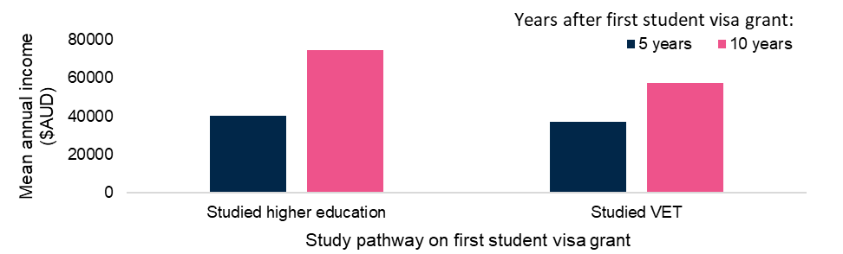

Source: PLIDA (Person Level Integrated Data Asset), Primary applicant international student visa holders who lodged a tax return, mean income presented in nominal terms for year 5 (2017-2018) and year 10 (2022-2023). Australian Bureau of Statistics extracted December 2024.

## Occupational patterns after graduation

Varela and Breunig (2023) noted that the determinants of migrants’ economic success in Australia defy simple characterisation. Influential factors include education, English language skills, occupation, demographics, visa characteristics, country of birth and their temporary visa history. For example, Student visa holders’ outcomes are strongly influenced by the type of education completed, with higher levels of education bolstering earnings (relative to other migrants) by up to 11% for undergraduates, and by 41% for PhD graduates. Visas held after studying also influence economic outcomes. Better earnings are associated with previous possession of a temporary skilled visa (compared against those who held a different temporary visa or had no temporary visa). In the long run, the type of education completed has a greater impact on long-term economic outcomes versus the visa pathway followed, which is more influential in the short-term.

### VET graduates appear more likely to work in an industry, skill level, and occupation matching their qualification

Census data shows that in 2021, nearly 60% of VET Temporary Graduate visa holders worked in the Accommodation and Food Services industry, which aligns to the field of education for most enrolled VET qualifications (Chapter 1: International education in Australia), such as those which require training as a Chef or a Cook.

For VET Temporary Graduate visa holders, Accommodation and Food Services and Construction were the most prevalent industries of employment in 2021. These post-study employment outcomes broadly align with VET field of education enrolment patterns (Chapter 1). Among higher education Temporary Graduate visa holders, Healthcare and Social Assistance as well as Professional, Scientific and Technical Services were most common industries of employment. Retail Trade and Accommodation and Food Services were relatively common in this group (Figure 17).

Figure 17: Proportion of Temporary Graduate visa (TGV) holders by largest industries of employment in 2021

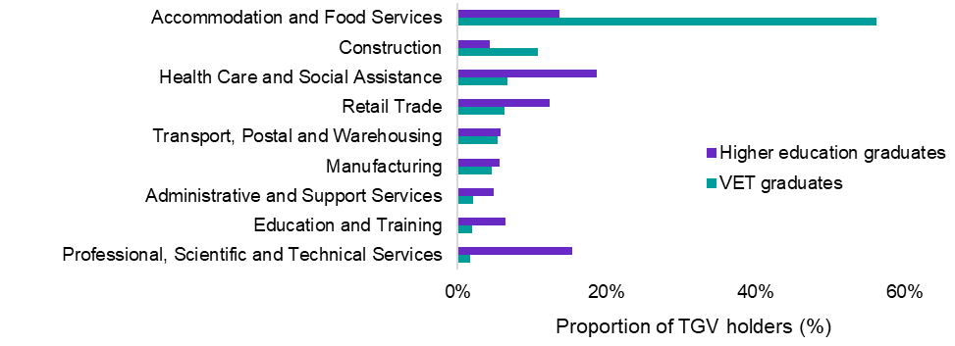

Source: JSA analysis of Australian Bureau of Statistics, Australian Census and Temporary Entrants Integrated Dataset (ACTEID), 2021. Primary applicants, extracted August 2024.

### Higher education graduates report occupying lower skill level occupations

Many higher education graduates remain employed in sectors that may have minimal long-term benefit to employability in their field of qualification (e.g. Retail Trade). While Accountants and Registered Nurses are the most common occupation for Temporary Graduate visa holders, some of the most common jobs held by these graduates are at Skill Level 3, 4 or 5. A Department of Education analysis in 2022 found growing numbers of higher education graduates were employed in occupations such as sales assistants and call centre operators in line with growth in Temporary Graduate visas granted (Figure 18). The heavy concentration of VET graduates in one industry, and the difficulty of higher education graduates outside of a few occupations to translate their qualification into related skilled occupations, also means that areas of skill shortage that could be filled, are not.

Figure 18: Occupations of higher education graduates

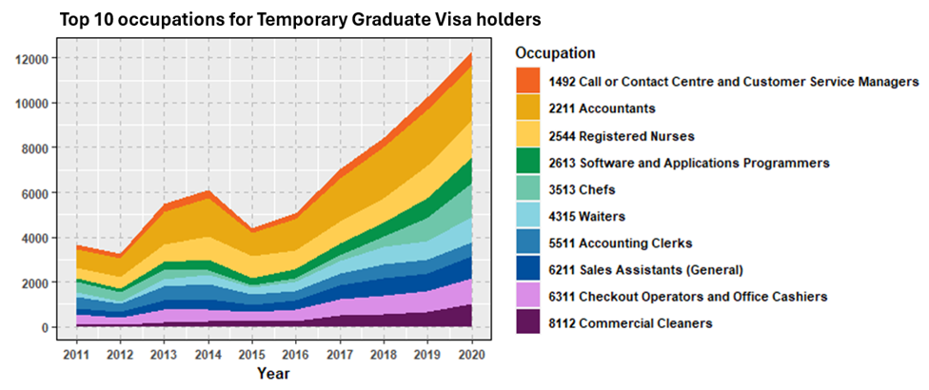

Source: Department of Education, 2022, Temporary Graduate visa (485) Holders using Multi-Agency Data Integration Project (MADIP).

### Comparative labour market outcomes

Relationships between labour market outcomes and educational investment appear stronger for some international graduates, but their results are weaker against domestic graduate outcomes. International student and graduate cohorts theoretically should have strong labour market outcomes given their concentration at higher educational levels, because higher education qualifications align with higher skilled occupations.

Census data from 2021 showed that on average, Temporary Graduate visa holders from higher education and VET pathways earn less than domestic graduates with the same qualifications. Domestic graduates with higher education qualifications earned more than those with VET qualifications, which is unsurprising, while international graduates on Temporary Graduate visas had roughly similar incomes regardless of their education pathway and age range (Figure 19). In terms of employment at expected occupational skill levels, international VET graduates on Temporary Graduate visas are more likely to work at their Skill Level (2 or 3), whereas higher education graduates on temporary graduate visas had high numbers working in Skill Level 4 and 5 occupations in addition to the expected concentration at Skill Level 1 (Figure 20).

Figure 19: Median annual income of fulltime employed domestic graduates and Temporary Graduate visa (TGV) holders, aged between 20-34 years, by VET and HE in 2021

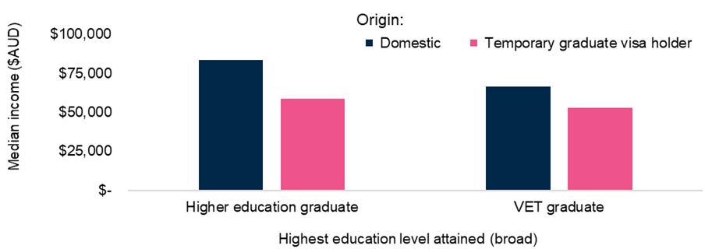

Note: Domestic refers to Australian citizens. Source: JSA analysis of Australian Bureau of Statistics, Australian Census and Temporary Entrants Integrated Dataset (ACTEID), 2021. Primary applicants, extracted August 2024.

Figure 20: Number of working Temporary Graduate visa (TGV) holders by occupation skill level in 2021, primary applicant

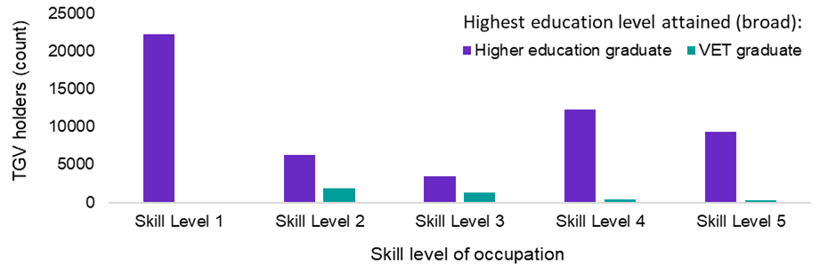

Note: Skill Levels 4 and 5 are equivalent to an Australian Qualifications Framework Certificate Level I-III. Skill Level 1 is commensurate to a bachelor’s degree. Source: JSA analysis of Australian Bureau of Statistics, Australian Census and Temporary Entrants Integrated Dataset (ACTEID), 2021. Primary applicants, extracted August 2024.

### Retention rates within occupations

Although the economic outcomes for some international graduate cohorts don’t always match those of non-migrants with the same qualifications and/or relevant work experience, it is evident that international graduates do choose and follow occupational pathways with the same, if not more tenacity (given the additional hurdles) as the domestic workforce.

JSA analysis of the study’s PLIDA data also examined the 10 most populous occupations of international students and graduates in cohorts running from the financial year 2010-2011, though to 2012-2013, at 5 and 10 years after their first Student visa was granted.

While transitions between occupations would be expected more frequently in the first 5 years of study – particularly as students transition from part-time work whilst studying into their post-study careers – occupational retention rates in the period from year 5 to year 10 after commencing study offer greater insight into the sustainability of labour market outcomes for students.

Regardless of study pathways, there were some occupations in which retention rates were much stronger than others.

For example, Registered Nurses had high retention rates amongst visa holders over time. At least three quarters of those who had held a Student visa remained in that occupation for the period between year 5 and year 10 across all cohorts analysed, with retention rates increasing to around 90% in some cohorts. Put another way, the attrition rate (i.e. those leaving the occupation) was between 10% and 25% over a 5-year period, or an annual average of between 2% and 5%.

Conversely, the retention rate for Chefs was lower, with just over half of those followed reporting ‘Chef’ as their occupation at both year 5 and year 10. This indicates that the attrition rate for Chefs was just under 50% over a 5-year period, or an annual average of just under 10%. This is broadly consistent with domestic data sources (such as the Australian Bureau of Statistics’ annual Participation, Job Search and Mobility survey) which indicates that retention rates for Registered Nurses are consistently stronger than those observed for Chefs.

These results support the observation of the study that there is a narrow band of occupations into which graduates transition most successfully. These occupations are characterised by an alignment of ease of course access and completion for students, education settings that prioritise work readiness and available visa pathways via skills lists post-study, often offering a better return on education investment longer term. More work is needed to fully understand the impact of those occupational characteristics and include, although are not limited to, opportunities for work integrated learning and increasing English language proficiency.

# Chapter 5: Barriers to transitioning to skilled employment

## Recommendation

|  |
| --- |
| * Strengthen independent assessment of English language proficiency throughout the international student continuum to maximise preparedness for work, including assessment at study entry and exit. This should be informed by analysis of the impacts of changes implemented in 2024. (Recommendation 9) * Identify and increase system incentives for the inclusion of opportunities for work integrated learning and increasing English language proficiency as a core element of study offerings to increase international graduate employability. (Recommendation 10) * Grow employer appetite for international graduates by making resources available to support greater understanding of the value of international graduates over the medium and long term to the Australian workforce. (Recommendation 11) |

## Policy observations

|  |
| --- |
| Many international students lack opportunities to develop English language proficiency and to have work-relevant practical and cultural experiences while studying. Attitudes towards international graduates may further restrict opportunities in the workforce.   * Financially pressured students and graduates, who cannot gain a foothold in their qualified fields, often have to take up lower skilled jobs, which do not build employability in their fields of study, sometimes trapping them in a low skilled employment cycle. They also are more vulnerable to exploitation. * Despite its importance to workforce success, English language proficiency may not be receiving sufficient attention during the recruitment and education of international students. * Employer sentiment toward temporary work visas limits uptake of graduates in skilled roles, which may blunt their ability to contribute in some areas of skills shortage. * Indications are that there may not be parity of esteem between international and domestic graduates alongside concerns about English language and cultural proficiency. |

This Chapter explores factors that may underlie the poorer employment outcomes for international graduates. As well as the determinants for migrant outcomes noted by Varela and Breunig outlined in the previous chapter, it considers additional factors, including those presented by employers and graduates in this study’s qualitative work, that can contribute to barriers experienced by international graduates as they seek to apply their qualification in the Australian workforce.

## Preparation for post-study employment is challenging

### Australia’s in-study work settings are important to potential students

Many international students take on work during their study. Although Student visa eligibility requires that applicants have sufficient funds to support themselves during their stay (Department of Home Affairs 2024b), the ability to work is vital to many students to allow them to meet their tuition and living costs. Allowing students to work also makes an Australian education affordable to a larger number of globally mobile students and contributes significantly to Australia’s casual workforce during their studies.

Work motivation influences choice of study destination, course and visa. The QILT 2022 Student Experience Survey International Report shows that just over 78% of international higher education students reported the ability to work part time during their study as a reason for choosing to study in Australia. The rapidly growing cohort from countries other than China have a particularly strong interest in being able to work. Over 90% of Indian and nearly 96% of Nepali higher education students cited the ability to work while studying as one of the reasons they chose Australia, while a smaller 63% of Chinese students said ability to work was a motivational factor (Social Research Centre, 2023a).

JSA’s qualitative research for this study and quantitative enrolment data both support this position. Within focus groups, international graduates confirmed making course choices that supported their ability to work while studying.

|  |
| --- |
| Meanwhile, my studies were happening. I was also working part time as we were allowed to work part time. […] I used to do night shifts so that used to accommodate with my studies.  Accounting graduate, interview #8 |

Aligning with JSA observations on visa grant/income record patterns between PLIDA and Home Affairs data outlined in Chapter 3: Residency outcomes of graduates who stay, is research from the Australian National University. In its publication, Migration Hub Insights it noted that in May 2023, 80% of students from South and Central Asia (including India and Nepal) were working during study, while only 24% of students from North East Asia, including China were engaged in our workforce (Norton, 2024).

When working hour limitations were lifted during the COVID-19 pandemic, international students responded by taking on more jobs. The Australian Bureau of Statistics reported that the number of students on temporary visas working increased by more than 45,000 in 2020-2021 to over 520,000 before falling again to 490,000 the following year. Those working on temporary skilled and working holiday visas fell across both years (Australian Bureau of Statistics, 2024).

### International students can experience exploitation at work

Despite their contribution to Australia’s workforce, international students can be vulnerable in the labour market. Their temporary visa status, youth and sometimes lower English language proficiency lead to their concentration in lower-skilled work and in the shadow economy, and contribute to labour market precarity (Howe, 2019) and wage exploitation (Australian Government, 2019, Berg and Farbenblum, 2017). A study commissioned by the Fair Work Ombudsman found that students did not report underpayment for a range of reasons, including limited knowledge about their workplace rights and a fear of the consequences if they reported against their employers (Reilly et al, 2017). Students also report a belief that poor treatment is endemic among their peers, increasing a feeling of powerlessness that is exploited by employers (Clibborn, 2018).

As noted in Chapter 1: International education in Australia, in 2023, the Rapid Review into the Exploitation of Australia’s Visa System (the Nixon Review) found that some training providers and students were working with disreputable agents and sometimes with complicit students to exploit the Student visa system. It also found that as temporary migrants, international students were at risk of being criminally exploited. The Government responded to these reports with an initial suite of integrity measures announced in October 2023 (Department of Education, 2023) and continuing in 2024 (Department of Home Affairs, 2024).

### The need to work can be a barrier to study and preparing for a career

While students are required to meet financial capacity tests to secure a Student visa, this capacity is generally not assessed by the Department of Home Affairs due to the operation of the Simplified Student Visa Framework, which sees most capacity assessments made by ostensibly low-risk providers.

Students report using loans to meet the capacity test, which are often repaid upon securing a visa, leaving the student to meet all expenses from what they can earn. In the qualitative research undertaken for this study, and as consistently reported across the Australian media in recent years, cost of living pressures are felt strongly by students with limited working hours available to earn an income.

As well as supporting themselves, the ability to send money home is also important for students. In the qualitative research, stakeholders told JSA that students routinely send money home to support family and friends. While data specific to students’ remittance flows is not available, overall remittance flows indicate the significance of temporary migrants’, including students’, remittances. For example, in 2019 Australia sent USD $7.439 billion in remittances – with China, India, Vietnam and the Philippines the main recipients (Global Partnership for Financial Inclusion in Australia, 2021).

|  |
| --- |
| Students are not necessarily able to be funded well from their home country. In fact, it’s probably expected it’s the other way round, that they’ve got to send some support back.  Engineering employer, interview #7 |

Students and providers reported to JSA that students prioritise jobs that maximise their earnings while aligning with their study commitments. This focus means that students are less likely to prioritise work that will best prepare them for industry entry on graduation. ACTEID data from 2021 covers the period of unrestricted working hours for international students during the COVID-19 pandemic and provides insights into the potential industries of employment that students accessed when the opportunity arose. International students in paid employment during that period were concentrated in a relatively small group of industries (Table 3). The data suggests that while there may be some alignment of students’ opportunities to work within their field of qualification, many employment opportunities which fit around coursework hours are unlikely to translate into relevant work experience.

The overall effect of an emphasis on earning during study is likely to reduce graduates’ work-readiness. Students who cannot secure part-time work in their field, and who are not required to undertake work placements as part of their course, graduate without any relevant experience or connections with employers.

Table 3: Industry of employment for Student visa holders in 2021 (highest to lowest)

|  |  |
| --- | --- |
| Industry of employment for Student visa holders | Student visa holders |
| Food and Beverage Services | 48,615 |
| Building Cleaning, Pest Control and Other Support Services | 17,061 |
| Residential Care Services | 14,853 |
| Food Retailing | 13,060 |
| Postal and Courier Pick-up and Delivery Services | 9,606 |
| Social Assistance Services | 8,516 |
| Inadequately described | 8,163 |
| Other Store-Based Retailing | 6,393 |
| Road Transport | 6,127 |
| Tertiary Education | 6,035 |
| Construction Services | 5,774 |
| Professional, Scientific and Technical Services (except Computer System Design and Related Services) | 5,546 |
| Total | 218,919 |

Source: JSA analysis of Australian Bureau of Statistics, Australian Census and Temporary Entrants Integrated Dataset (ACTEID), 2021. Primary applicants, extracted August 2024.

### International students’ educational experience may not prepare them for employment success as graduates

Generally, higher levels of education are associated with higher levels of income when compared to less-well educated segments of the migrant cohort, with this effect increasing over time. Migrants, including international graduates, experienced poorer labour market outcomes on average than non-migrants. Chapter 4: Qualifications, skills and employment outcomes describes this effect for international graduates, noting that the international student and graduate cohort is strongly represented at higher educational levels and thus can be expected to perform well compared to migrants with other forms of education. However, when compared to the non-migrant population, international graduates’ incomes remained lower.

### English language proficiency affects outcomes

Permanent migrants from some countries of origin are advantaged over the broader migrant population. Generally, such advantage is linked to English speaking ability from regions and countries such as North America and the United Kingdom, and extends, though more weakly, to migrants from India. Migrants from non-English-speaking countries that are also sources of international students to Australia, such as Indonesia and Vietnam, experience some comparative disadvantage predominantly driven by their English language ability.

#### English language proficiency receives uneven attention

English language proficiency is a key driver of positive economic outcomes for migrants, including international graduates, but current visa and educational settings may not adequately reflect that importance. Under the Streamlined Student Visa Framework, the Department of Home Affairs does not verify English language proficiency for students enrolled with “low risk” providers. In 2016-2017, 85% of Student visa applications were processed under these streamlined evidentiary requirements (Department of Home Affairs, 2018).

Low risk education providers have primary responsibility for assessing English proficiency in respect of their enrolments. Evidence is incomplete but suggests VET providers favour the testing options nominated by the Department of Home Affairs, while higher education providers use a wider variety of assessments including interviews, previous study pathways and international qualification recognition (Department of Education, PRISMS data).

Student visa applicants with lower English language proficiency (International English Language Testing System (IELTS) of 6.0 rather than 6.5) can still achieve a visa by bundling English Language Intensive Courses for Overseas Students (ELICOS) with their course. English language proficiency is not tested on graduation from the ELICOS course, with students progressing to their next course without assessment.

It is possible that varying approaches may lead to inconsistent outcomes for students across different providers or qualifications. In the past 10 years, concerns have been reported by two States’ Independent Commissions Against Corruption about universities' assessment of English language proficiency among international students (SA ICAC, 2020; NSW ICAC, 2015).

The Australian Government made changes to English language requirements for student and Temporary Graduate visa holders, with increases to minimum scores for IELTs in place from early 2024.

#### Students may not have opportunity to practice their English

Academic reporting further notes that international students are not often well supported to continue to improve their language skills while studying. They do not regularly engage with Australians, often living and working with people from their own culture, which limits their exposure to Australian working and communication habits and may degrade their language skills (Szego 2020; Gill and Jakobsen, 2017).

|  |
| --- |
| There's a lot more training [in the workplace] that happens with the international students than with the domestic student, and that's because of the language.  Accounting employer, interview #4 |

### Access to occupations and occupational preparation offers challenges to international students and graduates

Intuitively, migrants’ economic outcomes are largely determined by the occupations they secure (Varela and Breunig, 2023). The occupations that international graduates access may be constrained by their availability for work, the jobs they undertook while studying, their visa conditions, and whether they have migration aspirations. Also, the role of occupation lists in the design of the Australian migration program has been criticised. For instance, the recent review of the Australian migration system (Parkinson et al. 2023) found that “the occupation lists underpinning the employer sponsored visas are unresponsive and outdated”. Overall, international graduates are often not well positioned to achieve higher earning positions, starting from their period of study.

#### Access to work integrated learning (WIL) opportunities during study is not universal

Education providers and employers widely acknowledged that courses incorporating professional practice led to better graduate outcomes for both international and domestic students. Some courses available to international students include mandatory work placements to meet registration or training package requirements. It is also open to education providers to include a work-integrated learning (WIL) component in courses undertaken by international students and doing so is regarded as being good practice (Blackmore et al., 2014).

Many universities report providing WIL opportunities, with examples of high-quality WIL programs that support international students in acquiring field-relevant work experience during their studies. These include volunteer programs, industry experience internships, and the development of professional portfolios involving placements, workshops and capstone projects. However, Universities Australia (UA) acknowledges that WIL varies widely in terms of industry sector, geographical location, and whether the WIL component is mandatory or optional. UA suggests there is an opportunity for expanded data collection and analysis to understand international students’ engagement with WIL, the barriers preventing greater uptake, and whether WIL programs are adequately tailored to industry sectors. This will lead to a better understanding of the impact of WIL on graduate employment outcomes, whether for the Australian job market or for employment in the graduates’ home countries.

Data from the Department of Education highlights a growing percentage of international student enrolments in both higher education and VET courses that included mandatory work-integrated learning components over the period from 2019 to 2023 (Table 4). This does not mean that other students were not able to access WIL, but that it was not registered by education providers as being an essential part of the course.

Table 4: International student enrolment in higher education courses with mandatory work-integrated learning components (courses scheduled for completion by year)

|  |  |  |  |  |  |  |  |  |  |  |
| --- | --- | --- | --- | --- | --- | --- | --- | --- | --- | --- |
|  | Higher education enrolments | | | | | VET enrolments | | | | |
|  | With mandatory WIL | | Without mandatory WIL | | Total | With mandatory WIL | | Without mandatory WIL | | Total |
| Year | # | % | # | % | # | # | % | # | % | # |
| 2019 | 55,469 | 19 | 231,316 | 81 | 286,785 | 53,355 | 21 | 202,598 | 79 | 255,953 |
| 2020 | 62,689 | 20 | 248,435 | 80 | 311,133 | 66,983 | 22 | 239,908 | 78 | 306,891 |
| 2021 | 68,068 | 21 | 252,777 | 79 | 320,845 | 78,528 | 25 | 231,349 | 75 | 309,877 |
| 2022 | 63,164 | 24 | 202,591 | 76 | 265,755 | 68,279 | 26 | 198,847 | 74 | 267,126 |
| 2023 | 58,218 | 24 | 183,573 | 76 | 241,791 | 77,933 | 28 | 199,800 | 72 | 277,733 |

Source: Department of Education PRISMS, data extracted April 2024.

Despite this increase, more than 70% of international student enrolments in both sectors do not include a mandatory WIL component. However, in focus groups of the study’s qualitative research, many education providers highlighted the challenge of securing sufficient work placements for all students. A key issue identified was the limited availability of adequately supervised placements for the large number of students undertaking such courses.

One higher education provider reported offering a WIL subject within a master’s program, specifically designed for international students with non-accredited bachelor’s degrees in engineering. This year-long subject focuses on solving real-world problems, with students presenting their solutions to external stakeholders at the start and end of the semester. While this approach has been successful, the provider acknowledged scalability challenges due to funding constraints and the limited time industry partners can commit.

Education providers also reported that international students are unlikely to take up work placement opportunities that are not mandatory – due to preferencing paid employment in any field to support themselves – and struggle to find placement opportunities due to challenges networking outside of their communities.

For example, most accounting programs do not include structured work placements, and those that do include WIL report lower participation rates among international students compared to domestic students. Providers attribute this to international student’s need to put paid work ahead of unpaid work-related learning. Additionally, some providers indicated that students are responsible for establishing their own industry connections rather than this being a provider responsibility.

## Labour market access barriers may be more challenging for international graduates

Many Australian occupations include barriers to entry, often to promote efficiency in market operation or the safety of workers and the community. When responding to JSA or taking part in other feedback mechanisms such as the Job Ready Program review, international graduates report finding these barriers difficult to navigate with their less developed understanding of the Australian workplace context. Graduates describe frustration at the lack of recognition of qualifications and experience obtained overseas and reported the costs of meeting regulatory requirements as being daunting, such as having to pay fees for relevant exams.

Access barriers include eligibility for any element of the preparatory pathway for an occupation.

### Employers are concerned international graduates are not sufficiently skilled and not here to stay

Research that includes exploration of employers’ attitudes to international graduates – including JSA qualitative research in collaboration with ACER, the QILT Graduate Outcomes Survey (GOS) and the Evaluation of the Job Ready program – identified several concerns among employers when considering recruitment of international graduates (Social Research Centre, 2023 and Department of Employment and Workplace Relations, 2024).

#### Employer perceptions that graduates are not ‘job-ready’ can be heightened for international graduates

Some employers reported generalised concerns about international graduates’ work readiness, citing limited practical Australian work experience and no or limited exposure to the technology, tools and processes that are used in workplaces. In many ways this mirrors feedback that employers provide about graduates more generally. For example, the Quality Indicators of Learning and Teaching (QILT) 2023 Employer Satisfaction Survey reported that 38.4% of responding employers agreed that more domain-specific skills and knowledge would have better prepared graduates for the workplace (Social Research Centre, 2024).

|  |
| --- |
| Accounting is a commodity, it’s not good enough to teach just accounting. More and more employers need people who can do more than accounting. It should be bolted on. Skills in data analytics, that goes hand in hand with automated systems to do the accounting.  Employer of accounting, engineering and IT graduates, interview #6 |

#### Concerns about eligibility and ongoing availability

Employers feel less than expert in understanding visas and their conditions and feel concerned at the potential implications if they “make a mistake”. They report not understanding the conditions that might apply to particular visas, including whether the holder is entitled to work and in what circumstances. They feel reluctant to invest their own time in becoming a ‘visa expert’ and consequentially appear to resist engaging with temporary skilled visa holders. This can particularly be the case in smaller organisations without standalone human resources functions and expertise.

|  |
| --- |
| Most businesses won’t hire me because I’ve got restriction. There’s no option for us except to go to all these random jobs. I’m not saying it’s wrong. I’ve been there, done that, but it doesn’t count in your experience for what you actually wanted to do.  Accounting graduate; interview #9 |

Even where employers may feel more confident, they report that the time-limited nature of temporary visas makes holders less attractive as an employment prospect. Employers note that many jobs include ongoing or project work that benefits from having the same employees’ attention for relatively extended timeframes, particularly in more complex or senior roles. A lack of clarity on visa eligibility and therefore an employee’s ability to remain in Australia long term is considered inconsistent with these types of roles.

|  |
| --- |
| The longevity of the current visa within Australia, that's a big factor for us, especially if we do have longer projects that we need people in those projects.  Engineering employer, interview #2 |

Similarly, employers report a reluctance to invest in talent that may need to leave their organisation before the organisation can achieve a return on that investment.

|  |
| --- |
| If I make you an offer, at least you should tell me that you decided to go elsewhere. I understand that you keep your options open, but telling me that you have to go back home for a family emergency, and you don’t know when you’re gonna come back? It just feels like it’s a bit unnecessary and taints the experience a bit, which could then lead to bias.  Health employer, interview #1 |

As a result of employers’ needs and attitudes toward temporary visa, both employers and international graduates report employers’ strong preference for permanent visas. This contributes to a desire by many graduates to seek out a permanent visa.

#### Concerns about English language proficiency can be multi-faceted

Employers perceive that international students may not have the English proficiency that is needed to thrive in their workplace, though some employers note that sometimes concerns about an accent are incorrectly reported as concerns about proficiency.

In addition to generalised concerns about language proficiency, employers gave JSA more examples of how a lack of ‘Australian’ English proficiency could limit the workplace effectiveness of international graduates. Employers reported that international graduates may not have a good grasp of relevant work terms and phrasing and are not able to comfortably communicate in ‘Australian’ terms and nuances. This is reported as being potentially problematic when communicating inside the organisation but also when dealing with customers and clients.

|  |
| --- |
| Making small talk is a real skill, and if you're not strong in your English communication, that's a whole other level of challenge again.  Aged and Community Care employer, interview #3 |

#### Poor understanding of offshore qualifications and work experiences

Graduates report having their skills and qualifications minimised or misunderstood.

Employers report feeling underprepared to assess the value offered by international graduates’ work experience or qualifications when these happened outside of Australia. The lack of confidence can lead to employers avoiding such assessments or forming a negative view. This can contribute to an avoidance of recruiting international graduates as employees.

|  |
| --- |
| I had a really good teacher when I was doing the professional year. He told me, show me your resume. When I showed him, he said to make sure you remove your overseas education. Don't say that you did your schooling and college in [outside Australia]. There's this thing called unconscious bias when the HR person, they don't have to be racist, but when they see that you have schooling from overseas, their mind already calculates that this person is not local, so they don't pay attention to the resume.  Accounting graduate, interview #6 |

### Bias can play a role in employment decisions

Employers report a preference for domestic graduates for which they describe differing bases, including the comparative quality of international graduates, misapprehensions about their behaviour and the applicability of their experience. It is challenging to derive robust evidence points for bias, as often those manifesting it are unaware of it or are unwilling to acknowledge it. However, research has pointed to international graduates being the subject of bias in their employment outcomes (Tran et al., 2022, Fang et al., 2022, Cameron et al., 2019).

With hiring decisions often centred around ‘cultural fit’ and assumptions that employee and environment should closely align, bias can appear when hiring international graduates. Although employers attempt to be objective, cultural fit decisions are often made on a person’s own lived perceptions, which can lead to international graduates more easily not being seen as fit during an interview process (Coffey et al, 2021).

|  |
| --- |
| If we had enough Australian citizens or permanent residents, we probably wouldn't hire any international students.  Accounting employer, interview #1 |

While evidence is limited, there is a consideration that employers have been recorded as discriminating against international graduates when hiring, based on having non-English surnames (Nguyen and Hartz, 2020). Graduates reported to JSA that they experienced bias in their employment experiences, and employers confirmed that they often preferred Australian candidates.

|  |
| --- |
| If I see 2 CVs in front of me, one has got 3 years of Australian experience in the job that we have available versus someone who has got 3 years of international experience, we will probably have a slight preference for the Australian experience simply because of the preparedness and readiness to transition into our organisation.  Engineering employer, interview #3 |

# Glossary of terms

|  |  |
| --- | --- |
| Australian Census and Temporary Entrants Integrated Dataset (ACTEID) | ACTEID links Census data with temporary visa holder data from the Department of Home Affairs to provide insights in the characteristics of temporary residents in Australia. |
| [The Australian Government’s White Paper on Jobs and Opportunities](https://treasury.gov.au/employment-whitepaper/final-report) | A 2023 policy statement by the Australian Government outlining a vision for a labour market that prioritises employment; secure and well-paid jobs; productivity growth; meeting current and future skills needs; and overcoming barriers to employment. |
| [Australian Strategy for International Education 2021-2030](https://www.education.gov.au/australian-strategy-international-education-2021-2030) | A 2021 policy statement by the Australian Government outlining priorities and plans for the stewardship of Australia’s international education sector. |
| Australian Study Requirement (ASR) | An element of the application process for some temporary visas. To meet the ASR, the visa applicant must have completed a qualification or qualifications:   * included on the Commonwealth Register of Institutions and Courses for Overseas Students * requiring at least 2 academic years of study * undertaken in Australia while holding a visa authorising the holder to study. |
| China | Excludes Taiwan and the Special Administrative Regions (Hong Kong and Macau) |
| Commonwealth Register of Institutions and Courses for Overseas Students (CRICOS) | Register of education providers and courses that have been granted permission to educate overseas students. Managed by the Australian Government Department of Education. |
| Council for International Education | The Council sets the direction for Australia’s role in international education and training. It comprises Australian Government Ministers with portfolio responsibilities in international education and experienced international education experts and practitioners. |
| Course packaging | The practice of bundling 2 or more courses on one Student visa where there is progression from one course to another. |
| English Language Intensive Courses for Overseas Students (ELICOS) | English Language Intensive Courses for Overseas Students (ELICOS). An ELICOS course is a course in English language provided to an overseas student holding a Student visa to study in Australia. |
| Employment White Paper | see The Australian Government’s White Paper on Jobs and Opportunities |
| Evidence level | Measure of risk assessed as part of the Simplified Student Visa Framework. Applied to education providers and source countries and calculated by the rates of visa cancellations, visa refusals, students becoming unlawful non-citizens and Protection visa applications. |
| Financial capacity requirement | A requirement for a Student visa. Applicants must provide evidence to the Department of Home Affairs that they have enough funds to cover their travel, tuition and living costs for twelve months. |
| Globally mobile students | People who have physically crossed an international border with the objective to participate in educational activities in the country of destination. |
| International English Language Testing System (IELTS) | An international standardised test of English language proficiency for non-native English language speakers. It is jointly managed by the British Council, IDP and Cambridge English. IELTS is one of the tests accepted by the Department of Home Affairs for the purposes of meeting English language visa requirements. |
| International graduates | Previous holders of a Student visa (subclass 500) that have completed their course of study. |
| International students | Holders of a Student visa (subclass 500). |
| Knight Review | The Knight Review was delivered to Government in June 2011 following the appointment of the Hon Michael Knight AO to conduct the first independent review of the Student visa program. |
| MADIP | The Australian Statistician announced the rename of the Multi-Agency Data Integration Project (MADIP) to the Person Level Integrated Data Asset (PLIDA) in 2023. Historical documents and projects retain their references to MADIP. |
| Migration Program planning levels | Each year the Australian Government sets the planning levels for the permanent Migration Program. |
| Migration policy | Australia’s migration policy allows temporary migration for short-term purposes including study, and permanent migration for skilled, family and humanitarian reasons. Australia’s has a capped permanent migration program. |
| Migration Review (see A Migration System for Australia’s Future) | A comprehensive review of Australia's migration system, including the operation of temporary and permanent visa programs, was delivered to Government in March 2023. The reviewers were Dr Martin Parkinson AC PSM, Professor Joanna Howe and Mr John Azarias. |
| Migration Strategy: working for the nation | A 2023 policy statement by the Australian Government outlining plans to reform Australia’s migration approach to maximise its value to the economy, businesses, communities and migrants. |
| National Strategy for International Education (see Australian Strategy for International Education 2021-2030) | The Australian Strategy for International Education was released in November 2021, to help chart the sector’s post COVID-19 pandemic recovery. Implementation of the Strategy is being overseen by the Council for International Education. |
| Nixon Review (see Rapid Review Into the Exploitation of Australia’s Visa System) | The Nixon Review was delivered to Government in March 2023 following the appointment of Ms Christine Nixon AO, APM to identify proposals for both systemic reform and discrete measures to prevent exploitation of the system. |
| Parliamentary Inquiry into Australia’s Tourism and International Education Sectors (see ‘Quality and Integrity – the Quest for Sustainable Growth’: Interim Report into International Education’) | The inquiry was conducted by the Joint Standing Committee on Foreign Affairs, Defence and Trade (JSCFADT), through its Trade Subcommittee. The interim report, ‘Quality and Integrity – the Quest for Sustainable Growth’: Interim Report into International Education’ was tabled in October 2023. |
| Permanent Migration Program | Australia's permanent Migration Program includes economic and family migration. The program is the main pathway to permanent residence. It includes the Skill stream, Family stream and Special Eligibility visas. |
| Permanent resident | A holder of a permanent visa that allows them to stay in Australia indefinitely; to work, study. |
| ‘Permanent temporariness’ | Describes some temporary visa holders who do not meet the criteria for permanent residency but instead apply for a series of continuing temporary visas to extend their stay in Australia. |
| PLIDA | The Person Level Integrated Data Asset (PLIDA) is a secure data asset combining information on health, education, government payments, income and taxation, employment, and population demographics (including the Census) over time. PLIDA data supports government decision making and academic research.  The Australian Bureau of Statistics (ABS) collects data for PLIDA from a range of different data custodians. Government agencies need permission and powers (legislative authority) to share data with the ABS. |
| Post-study work rights | A visa entitlement that allows the visa holder to remain in Australia and work at the completion of their study.  The Temporary Graduate visa (subclass 485) allows international students who have recently graduated with a degree from an Australian institution to live, work and study in Australia temporarily. The Temporary Graduate visa is divided into 2 streams:   * Post-Higher Education Work stream * Post-Vocational Education Work stream |
| Professional Year Programs | The Professional Year is a work readiness program, approved by the Department of Home Affairs, which is delivered by external providers accredited by Chartered Accountants Australia and New Zealand (CA ANZ), Engineers Australia (EA) and the Australian Computer Society. |
| Provider Registration and International Student Management System (PRISMS) | Database of past and present international students. Managed by the Australian Government Department of Education |
| Quality Indicators for Learning and Teaching (QILT) | The Quality Indicators for Learning and Teaching (QILT) are government endorsed surveys for higher education, across the student life cycle from commencement to employment. Managed by the Australian Government Department of Education. |
| Rapid Review Into the Exploitation of Australia’s Visa System | The review was established to identify proposals for both systemic reform and discrete measures to prevent, deter and sanction individuals who seek to abuse Australia's visa system to exploit vulnerable migrants. |
| Remittances | Remittances are person-to-person payments of a relatively low value, primarily between a migrant worker to relatives in their home countries. |
| Skilled occupation lists | Skilled occupation lists summarise the occupations Australia needs to fill skill shortages and eligibility for certain visa types. |
| Skills shortages | Skills shortages refer to a shortfall in the supply of skilled workers to meet labour market demand. |
| South Asia | South Asia in the context of this report refers to Bangladesh, Nepal, Pakistan, Bhutan, Sri Lanka and Maldives. India, while geographically part of the region, is treated separately. |
| Stay-prolongation behaviour | Behaviour by some Student visa holders who apply for further visas, including subsequent Student visas, to prolong their stay in Australia. |
| Simplified Student Visa Framework (SSVF) | A framework managed by the Australian Government Department of Home Affairs to streamline processing of Student visa applications. The SSVF uses assessments of the risks presented by the student’s education provider and home country to guide whether the student needs to provide evidence of financial and English language capacity with their visa application. |
| Student enrolments | Student enrolments refer to the number of courses students are enrolled in. Students may be enrolled in more than one course, so enrolments are not equivalent to a head count of students. |
| Student Experience Survey | A comprehensive survey of current higher education students in Australia. It is part of the QILT suite of surveys, and it is undertaken by The Social Research Centre. |
| Student numbers | Student numbers refer to the international student head count for students studying on a Student visa (Subclass 500). |
| Student visa (Subclass 500) | This visa allows international students to participate in an eligible course of study in Australia, including working up to 48 hours a fortnight. It is up to 5 years duration, depending on the type of course. |
| Study destinations | Study destinations are countries that accept international students to enrol in courses at higher education and vocational education institutions. |
| Temporary Graduate visa (subclass 485) | This visa is for international student graduates who wish to stay in Australia following the completion of their course. There are 3 types. The Post-Vocational Education Work stream (formerly Graduate Work stream) for VET graduates, Post-Higher Education Work stream (formerly Post-Study Work stream) for higher education graduates and Second Post-Higher Education Work stream. |
| Temporary resident | Refers to those people in Australia on a temporary visa. |
| Visa settings | Refers to the type and eligibility criteria for temporary and permanent entry visas. |
| Vocational education and training (VET) | VET is learning designed to teach knowledge and specific practical skills to help students in the workplace. In Australia, Nationally Recognised Training is developed jointly by industry and government and delivered by Registered Training Organisations. |

1. Qualitative analysis and stakeholder engagement

## Qualitative analysis

ACER was commissioned by JSA to conduct a series of focus groups to gain insight into broader issues and questions about education sector offerings, migration and visa settings and workforce models that could be further explored through interviews. Focus groups were also used to seek assistance from participants in reaching potential participants for employer interviews.

To capture insights from the perspective of education providers, industry bodies and unions, 6 focus group sessions were held, as follows:

Table A: Focus group sessions

|  |  |  |
| --- | --- | --- |
| Session focus | Date | Number of participants |
| Education providers – Health | 20/05/2024 | 16 |
| Education providers – Accounting | 21/05/2024 | 11 |
| Education Providers – Engineering | 23/05/2024 | 13 |
| Industry bodies – Health | 22/05/2024 | 5 |
| Industry bodies – Engineering | 23/05/2024 | 6 |
| Unions | 06/06/2024 | 5 |

Each focus group session was led by an ACER facilitator for a duration of 90 minutes.

In addition to the focus groups, ACER conducted targeted discussions with a range of organisations and individuals where participants were unable to attend a focus group and/or where they had unique perspectives to share. Targeted discussions were held by ACER with individuals from the following organisations:

* Australian Association of Graduate Employers
* Australian Industry Group
* International Education Association of Australia
* Engineers Australia
* Future Skills Organisation
* Powering Skills Organisation
* Australian Health Care Nurses Association
* Health Services Skills Organisation
* Chartered Accountants Australia and New Zealand.

Following the focus groups, some educators provided further information to elaborate on examples and experiences shared in the focus group discussions.

### Interviews with employers and graduates

ACER researchers conducted interviews of approximately 60 minutes’ duration with employers and international graduates.

Table B: Summary information for employer interviewees

|  |  |  |  |  |
| --- | --- | --- | --- | --- |
| Interviewee characteristics1 | Engineering | Health Care and Social Assistance | Accounting | All employers |
| Business size |  |  |  |  |
| Large (more than 200) | 4 | 4 | 3 | 11 |
| Medium (20 to 200) | 2 | 1 | - | 3 |
| Small (less than 20) | 2 | 1 | 3 | 6 |
| New South Wales | 2 | 1 | - | 3 |
| Queensland | 1 | 4 | - | 5 |
| Tasmania | - | - | 1 | 1 |
| Victoria | 4 | 1 | 5 | 10 |
| Western Australia | 1 | - | - | 1 |
| Metropolitan | 7 | 5 | 6 | 18 |
| Regional | 1 | 1 | - | 2 |
| Yes | 7 | 6 | 5 | 18 |
| No | 1 | - | 1 | 2 |

Table C: Summary information for graduate interviewees

|  |  |  |  |  |
| --- | --- | --- | --- | --- |
| Interviewee characteristics | Engineering | Health Care and Social Assistance | Accounting | All graduates |
| Course level |  |  |  |  |
| Master’s Degree (Coursework) | 2 | - | 4 | 6 |
| Bachelor Honours Degree | 1 | - | - | 1 |
| Bachelor Degree | 2 | 9 | 6 | 17 |
| Advanced Diploma | 2 | - | - | 2 |
| Diploma | 1 | 1 | - | 2 |
| Certificate III | 2 | - | - | 2 |
| Gender |  |  |  |  |
| Male | 8 | 3 | 8 | 19 |
| Female | 2 | 7 | 2 | 11 |

### Broader JSA stakeholder engagement

Alongside a dedicated qualitative research and analysis stream, JSA conducted targeted consultation with international education sector stakeholders, including: JSA’s Ministerial Advisory Board and its Education and Training Reference Group sub-committee; State and Territory government officials; the Ministerial Advisory Council on Skilled Migration’s expert sub-committee; the Council for International Education expert sub-committee; Australian Chamber of Commerce and Industry; Australian Industry Group; the Australian Council of Trade Unions’ VET Committee; Business Council of Australia; Jobs and Skills Councils; Migrant Works Centre; Migrant Justice Institute; and Universities Australia Deputy Vice-Chancellors (International). JSA would like to thank our stakeholders and research participants, including former international students, for their contributions to our study.

1. Methodology

## Administrative data

Observations used administrative data from the following resources.

### Australian Bureau of Statistics:

#### [Australian Census and Migrants Integrated Dataset (ACMID)](https://www.abs.gov.au/about/data-services/data-integration/integrated-data/australian-census-and-migrants-integrated-dataset-acmid)

#### [Australian Census and Temporary Entrants Integrated Dataset (ACTEID)](https://www.abs.gov.au/about/data-services/data-integration/integrated-data/australian-census-and-temporary-entrants-integrated-dataset-acteid)

Data from the Australian Bureau of Statistics included tables from the 2016 and 2021 ACMID and ACTEID. Data drawn from ACTEID and ACMID was filtered to include respondents who were primary visa applicants, aged 15 and over at the time of census.

ACMID links Census data with the Department of Home Affairs Settlement Database. It includes information on people granted permanent visas who arrived in Australia between 1 January 2000 and Census night. ACMID provides insights into permanent migrants’ demographics, visa details, mobility, employment, education, income, and cultural diversity.

ACTEID links Census data with temporary visa holder information from the Department of Home Affairs. It provides insights into the demographics, visa details, mobility, employment, education, income, and cultural diversity of temporary residents in Australia. ACTEID enhances understanding of the socio-economic outcomes of temporary visa holders.

#### Person Level Integrated Data Asset (PLIDA) (aka MADIP)

PLIDA is a secure data asset combining information on health, education, government payments, income and taxation, employment, and population demographics (including the Census) over time.

It provides whole-of-life insights about various population groups in Australia, such as the interactions between their characteristics, use of services like healthcare and education, and outcomes like improved health and employment.

Migration and labour market data were extracted to assess Student visa pathways followed across a 10-year interval (where applicable) for cohorts spanning the 2010-2011 through to 2022-2023 financial years. Variables included Student visa study pathways and subsequent visas, occupational pathways, and annual income from their highest paying, and across all jobs.

The JSA sample included international students who were granted a temporary Student visa (subclass 500 to 576). All persons were primary applicants and had been ‘onshore’ at least once during the span of the 2010-2011 through to the 2022-2023 financial years. All persons in the sample were also required to have recorded labour market activity within one of those financial years listed above in the form of an ATO payment summary or tax return.

The Department of Education notes further analysis on international student outcomes at varying time points including income, occupation, geographic location, and visa pathways, is planned using existing data from their analysis. When Provider Registration and International Student Management Systems (PRISMS) data becomes available this data could be expanded to include course information, such as field of education and expected completion date.

### Department of Education

#### Higher Education Statistics Student data

#### Provider Registration and International Student Management System (PRISMS)

The Higher Education student data collection encompasses enrolments, equivalent full-time student load (unit of study data) and completions, and includes all Higher Education Institutions that have been approved under the Higher Education Support Act 2003.

Higher Education student data was compiled from the Department of Education, Skills and Employment's Higher Education Statistics Collection. The collection includes the latest 5-year selected data for students undertaking higher education courses at approved higher education providers. Default student enrolment pivot tables counted the sum of Student Enrolments by year, state and institution.

PRISMS enables Student Management System (SMS) vendors, Administration Management Systems (AMS) vendors and Education providers to connect their systems directly to PRISMS to provide enrolment data as required under the Education Services for Overseas Students (ESOS) legislation.

### Jobs and Skills Australia

#### [Higher Education Routes to Occupation (HERO)](https://www.jobsandskills.gov.au/data/nero) national language processing model

HERO produces a list of occupations that used the skills taught in each field of education. It does this by analysing text-based data to match fields of education from the Australian Standard Classification of Education and the topics taught under them with the most similar occupations as described by the Australian and New Zealand Standard Classification of Occupations.

### Department of Home Affairs

#### [Migration data and Visa Grants](https://www.homeaffairs.gov.au/)

Home Affairs data was based on grant rates; defined as the number of visas granted divided by the sum of visas granted and refused (decisions) recorded for visa subclass 500 and subclass 570 to 576 in the current financial year (2023-2024) and the previous financial years.

Data was sourced from several departmental visa processing and recording systems. Ages were assigned as the person’s age at the time of their visa decision. Education provider registered state was based on Student visa holder's confirmation of enrolment (CoE). Where more than one CoE was recorded on the visa application, the education provider registered state was based on the primary CoE.

## Further details on longitudinal analysis of international students

The JSA analysis presented in Chapter 2: Pathways to Permanence of this report is consistent with analyses from the Treasury, Centre for Population in the 2022 publication, Pathways from temporary visas to permanent residency: a case study of migrants that arrived in 2006-07, and previously unpublished analysis of the 2010-2011 international student cohort by the Department of Education undertaken in 2024. Each describes the number of international students still in Australia after 10 years at more than 50% for each of the cohort years studied. Both used data that was not available to Shaping A Nation in 2018.

### Analysis of different international student cohorts over time

The different analyses of distinct international student cohorts are summarised and outlined following, including the approach used to the analysis of the data in each example. As outlined earlier, international students and their experiences traditionally have not been very visible in most government datasets, which have a focus on domestic policy needs. No single existing data asset includes all the elements needed to consider international student experiences across the full range of migration, education and labour market variables. Progressively improved access to linked data sets and more sophisticated tools and approaches to extracting insights is no doubt improving that visibility.

#### Shaping A Nation - Population growth and immigration over time.

Shaping A Nation was published in 2018. It traced the growth and changes in Australia’s population and migration, including social, economic and fiscal impacts from 2000-2001 to 2013-2014. It was produced by the Treasury and Department of Home Affairs.

In its analysis of pathways to permanent residence, Shaping A Nation used an average of the international student cohorts from 2000-2001 to 2013-2014. This included 1.6 million individuals who had been international students during that time. The report concluded from data available at the time that 16%, or an estimated 256,000 international students, eventually transitioned to permanent residence.

The report noted that in line with the time taken in their studies, international students took longer than those on a Temporary Work (Skilled) visa (subclass 457) visa to transition to permanent residence. The report found that 25% of international students had transitioned to permanent residence within 2.5 years, and 75% within just under 5.5 years.

By contrast, the report found that of the 946,000 individuals who were employed on a 457 visa between 2000-2001 and 2013-2014, 55% eventually transitioned to permanent residence[9]. For those who transitioned to permanent residence, 25% did so within around one and a half years, and 75% did so in under 4 years (The Treasury and Department of Home Affairs, 2018).

#### Pathways from temporary visas to permanent residence: a case study of migrants that arrived in 2006 -2007

Pathways from temporary visas to permanent residence was published by the Treasury’s Centre for Population in 2022. The report in part examined the visa outcomes for the 2006 2007 cohort of international students (The Treasury, 2023b). The overall report considered migrants arriving in Australia on a student, temporary skilled or a working holiday maker visa in 2006–2007, tracking the visa transitions of this cohort over the following decade until the end of 2016–2017.

The analysis concluded that by 2016-2017, 56% of the international student cohort which had arrived in 2006-2007 had remained in Australia; 39% or approximately 40,000, had transitioned to permanent residence and 17% remained on temporary visas. Approximately 44% had completed their studies and returned offshore. The most common permanent visas for those that become permanent were Skilled Independent (50%), Family (17%) and Employer Sponsored (12%).

The report found that international students had taken an average of 5.6 years to become permanent residents, and that 17% of the 2006-2007 cohort had remained as temporary residents after 10 years in Australia.

The report noted that a pathway was considered complete once an individual was granted a permanent visa or if they had left the estimated resident population by departing Australia (and not returned by the end of 2016–2017). Those that remain onshore and had not transitioned to a permanent visa by the end of 2016-2017 were deemed to “remain temporary”.

Importantly, the report highlighted that its methodology differed to the previous analysis of visa transitions in Shaping A Nation in the following key ways:

* it used data that was not available at the time of Shaping A Nation
* it focussed on the transitions of the 2006–2007 cohort of temporary migrants, whereas Shaping A Nation took an average of cohorts from 2000–2001 and 2013–2014
* it limited its analysis to a population of individuals who entered Australia's resident population (i.e. those that spent 12 of 16 months in Australia), whereas Shaping A Nation began with anyone who was granted a visa whether or not they actually joined Australia’s population.

Exclusion of these short-term arrivals who left Australia without ever becoming residents increased the proportion of temporary arrivals that ultimately transition to permanency (The Treasury 2023b).

#### International Student Outcomes, Department of Education

In late 2024, the Department of Education analysed the outcomes of a 2010–2011 cohort of international higher education and vocational education (VET) students who were working age (15–64 years) using migration data from the Person Level Integrated Data Asset (PLIDA). Their residency status was then assessed at the end of the 2021-2022 financial year, approximately 10 years later. (see Residency status of 2010–2011 international students below).

By the end of the 2021–2022 financial year, 55% of the 2010–2011 higher education and VET students remained in Australia; 48% had gained permanent residence or Australian citizenship, and 7% remained on a temporary visa.

For higher education students, out of 243,640 visa holders in 2010–2011, approximately 50% had left Australia, 45% had obtained permanent residence or Australian citizenship, and 5% remained on temporary visas by 2021–2022. This meant that 50% of the higher education student cohort from 2010–2011 remained in Australia after a decade.

In contrast, for VET students, out of 119,190 visa holders in 2010–2011, around 35% had left Australia, 56% had obtained permanent residence or Australian citizenship, and 10% remained on temporary visas by 2021–2022. This indicates that 65% of the VET student cohort from 2010–2011 remained in Australia after a decade.

Residency status of 2010–2011 international students in 2021-2022

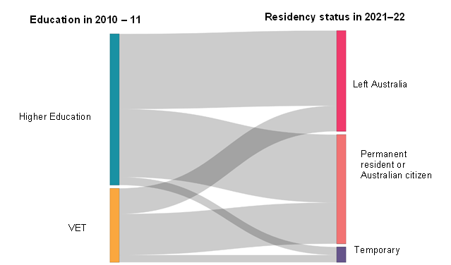

Source: Department of Education analysis of migration data from PLIDA, extracted December 2024

|  |
| --- |
| Starting cohort definition  The cohort for the 2010–2011 financial year was defined based on the following criteria:   1. Held a Student visa subclass linked to a higher education or vocational education and training course 2. Were the primary visa holder (i.e. not a dependent) 3. Were aged 15 to 64 years at the time of the visa grant 4. The Student visa was granted before 30 June 2011 (end of the 2010–2011 financial year) 5. The visa remained active after 1 July 2010 (not ceased prior to the financial year) 6. Were physically present in Australia for at least 5 months during the 2010–2011 financial year. |

|  |
| --- |
| Status at end of the 2021–2022 financial year  An individual was classified as having left Australia, held permanent residency, or held a temporary visa based on the following criteria:   1. Left Australia:    1. They were not an Australian citizen, and    2. They did not hold a current permanent visa as of 30 June 2022, and    3. They were physically present in Australia for 9 months or less during the 2021–2022 financial year. 2. Permanent residency:    1. They were an Australian citizen, or    2. They held any other permanent visa as of 30 June 2022. 3. Temporary visa:    1. They held a temporary visa that was:       1. Granted on or before 30 June 2022, and       2. That visa was in effect from 1 July 2021, and    2. They were physically present in Australia for more than 9 months during the 2021–2022 financial year. |

References

1. Australian Bureau of Statistics, (2021) How ANZSCO works, Australian Government.
2. Australian Bureau of Statistics, (2023) [Pathways to permanency – Visa pathways and characteristics of permanent migrants](https://www.abs.gov.au/articles/pathways-permanency#:~:text=For%20the%20student%2Dto%2Dskilled,visas%20prior%20to%20reaching%20permanency.), 2023, Australian Government.
3. Australian Bureau of Statistics (2024), [Jobs in Australia](https://www.abs.gov.au/statistics/labour/jobs/jobs-australia/latest-release), 2021-2022 financial year, Australian Government.
4. Australian Bureau of Statistics (2016, 2021), Australian Census and Migrants Integrated Dataset (ACMID). Australian Government.
5. Australian Bureau of Statistics (2016, 2021), Australian Census and Temporary Entrants Integrated Dataset (ACTEID), Australian Government.
6. Berg, L., & Farbenblum, B. (2017[) Wage Theft in Australia: Findings of the National Temporary Migrant Work Survey](https://static1.squarespace.com/static/593f6d9fe4fcb5c458624206/t/5a11ff31ec212df525ad231d/1511128887089/Wage+theft+in+Australia+Report_final_web.pdf) Migrant Worker Justice Initiative.
7. Blackmore, J., Gribble, C., Farrell, L., Rahimi, M., Arber, R. & Devlin, M. (2014), [International Graduates and the transition to employment](https://www.deakin.edu.au/__data/assets/pdf_file/0010/365194/international-graduates-employment.pdf), Deakin University.
8. Blackmore, J., Gribble, C. & Rahimi, M. (2015[), International education, the formation of capital and graduate employment: Chinese accounting graduates’ experiences of the Australian labour market](https://www.researchgate.net/deref/http%3A%2F%2Fdx.doi.org%2F10.1080%2F17508487.2015.1117505?_tp=eyJjb250ZXh0Ijp7ImZpcnN0UGFnZSI6InB1YmxpY2F0aW9uIiwicGFnZSI6InB1YmxpY2F0aW9uIn19), Critical Studies in Education, Vol. 58, No.1, p69-88.
9. Bowen, C., (2010), [New migration points test to better address Australia’s skills needs](https://parlinfo.aph.gov.au/parlInfo/search/display/display.w3p;adv=yes;page=0;query=Id%3A%22media%2Fpressrel%2F371734%22;rec=0;resCount=29), Australia Government, accessed 15 August 2024.
10. Cameron, R., Farivar, F. & Jane Coffey (2019) International graduates host country employment intentions and outcomes: Evidence from two Australian universities, Journal of Higher Education Policy and Management, 41:5, 550-568.
11. Clibborn, S., (2018), ‘[Multiple frames of reference: Why international student workers in Australia tolerate underpayment](file:///C:/Users/ac3730/Downloads/Submission%2089.3%20-%20Dr%20Stephen%20Clibborn.pdf)’ Economic and Industrial Democracy, 1-19.
12. Coates, B., Wiltshire, T., & Reysenbach, T. (2023), [*Graduates in limbo: International student visa pathways after graduation*](https://grattan.edu.au/wp-content/uploads/2023/10/Graduates-in-limbo-Grattan-Institute-Report.pdf), Grattan Institute.
13. Coates, B., Wiltshire, T., & Bradshaw, N., (2024), [*It all adds up: Reforming points-tested visas*](https://grattan.edu.au/wp-content/uploads/2024/05/It-all-adds-up-Reforming-points-tested-visas-Grattan-Institute-Report.pdf), Grattan Institute.
14. Coffey, J., Farivar, F., & Cameron, R., (2021), The Job Seeking Experiences of International Graduates in the Host Country: Australia’s Lost Opportunity?, The International Journal of Human Resource Management, Vol. 32, No.4 846-870.
15. Department of Education and Training, (2015), [Value of International Education to Australia](https://internationaleducation.gov.au/research/research-papers/Documents/ValueInternationalEd.pdf), Australian Government, accessed 30 September 2024.
16. Department of Education, (2022), Temporary Graduate visa (485) holders using MADIP, Integrated Data Analytics, Australian Government.
17. Department of Education, (2023) [Next steps to strengthen the integrity of international education | Ministers' Media Centre](https://ministers.education.gov.au/clare/next-steps-strengthen-integrity-international-education), Australian Government, accessed 13 June 2024.
18. Department of Education, (2025), [Education export income - Financial Year](https://www.education.gov.au/international-education-data-and-research/education-export-income-financial-year), Australian Government, accessed, 23 May, 2025.
19. Department of Employment and Workplace Relations (2024), Evaluation of the Job Ready Program, Australian Government, May 2024.
20. Department of Home Affairs, (2018), [Simplified Student Visa Framework](https://immi.homeaffairs.gov.au/what-we-do/education-program/overview), Australian Government, accessed 15 May 2024.
21. Department of Home Affairs, (2023a), [Migration Strategy](https://immi.homeaffairs.gov.au/programs-subsite/migration-strategy/Documents/migration-strategy.pdf), Australian Government.
22. Department of Home Affairs, (2023b), [BR0097 Student visa and Temporary Graduate visa Program Report (homeaffairs.gov.au)](https://www.homeaffairs.gov.au/research-and-stats/files/student-temporary-grad-program-report-june-2023.pdf), Australian Government.
23. Department of Home Affairs (2024a), [Review of the points test Discussion Paper](https://www.homeaffairs.gov.au/reports-and-pubs/PDFs/points-test-discussion-paper-april-2024.pdf), Australian Government accessed 3 October 2024.
24. Department of Home Affairs (2024b), [Eligibility requirements for Student visa](https://immi.homeaffairs.gov.au/visas/getting-a-visa/visa-listing/student-500#Eligibility), Australian Government, accessed on 9 December 2024.
25. Fang, T., Xiao, N., Zhu, J. & Hartley, J., (2022) Employer Attitudes and the Hiring of Immigrants and International Students: Evidence from a Survey of Employers in Canada, IZA Institute of Labor Economics.
26. Gill, B. & Jakobsen, L., (2017), [“Is there a problem with Chinese International Students?”](https://apo.org.au/sites/default/files/resource-files/2017-09/apo-nid107736.pdf), China Matters.
27. Global Partnership for Financial Inclusion Australia Biennial Update, (2021), [G20 National Remittance Plan Australia 2021](https://www.gpfi.org/sites/gpfi/files/sites/default/files/Australia.pdf), accessed 17 May 2024.
28. Gribble, C., Blackmore, J. & Rahimi, M., (2015), [Challenges to providing work integrated learning to international business students at Australian universities](https://doi.org/10.1108/HESWBL-04-2015-0015), Higher Education, Skills and Work-Based Learning, Vol. 5 No. 4, pp. 401-416.
29. Hawthorne, L., (2010), ‘[Demography, Migration and Demand for International Students’](https://scholars.wlu.ca/cgi/viewcontent.cgi?article=1030&context=imrc) in Globalisation and Tertiary Education in the Asia-Pacific (Findlay C.G. and Tierney, W. G eds), World Scientific.
30. Howe, J., (2019) ‘A Legally Constructed Underclass of Workers? The Deportability and Limited Work Rights of International Students in Australia and the United Kingdom’, Industrial Law Journal, Volume 48, Issue 3, September 2019.
31. Industry Commission (1991), [Exports of Education Services, Report No 12](https://www.pc.gov.au/inquiries/completed/export-education-services/12educationservices.pdf), Australian Government 1991.
32. International Students Education Agents Association (2022), p.4 [Submission - A migration system for Australia’s future](https://www.homeaffairs.gov.au/reports-and-pubs/files/migration-system-aust-future-submissions/g-l/ISEAA_International_Student_Education_Agent_Association.pdf), to the Australian Government Review of Australia's migration system.
33. Koleth, E. & Spinks, H., (2016), [Overseas students: immigration policy changes 1997-2015](https://parlinfo.aph.gov.au/parlInfo/download/library/prspub/4390265/upload_binary/4390265.pdf;fileType=application%2Fpdf#search=%22international%20students%201997-2015%22), Parliament of Australia.
34. Knight, M., (2011), [Strategic Review of the Student Visa Program](https://www.homeaffairs.gov.au/reports-and-pubs/files/2011-knight-review.pdf), Australian Government 2011.
35. Li, W., Hains-Wesson, R., Ji, K. & Shen, B. (2025), [Bridging the Skills Gap Enhancing the Employability of International Chinese Students](https://www.sydney.edu.au/content/dam/corporate/documents/china-studies-centre/employability-report.pdf), China Studies Centre, University of Sydney.
36. Migrant Workers Centre, (2024), Carrot or Stick: When Academic Degrees Become Bargaining Chips for Migration Pathways, August 2024.
37. New South Wales Independent Commission Against Corruption (2015), [Learning the Hard Way: Managing Corruption Risks Associated with International Students at Universities in NSW](https://www.icac.nsw.gov.au/ArticleDocuments/232/Learning%20the%20hard%20way,%20managing%20corruption%20risks%20associated%20with%20international%20students.pdf.aspx), NSW ICAC 2015.
38. Nguyen, T. & Hartz, D., (2020), ‘International students in Australia, employability and cultural competence’ in Cultural Competence and the Higher Education Sector Australian Perspectives, Policies and Practice.
39. Nixon, C., (2023), [Rapid Review into the Exploitation of Australia’s Visa System](https://www.homeaffairs.gov.au/reports-and-pubs/files/nixon-review/nixon-review-exploitation-australia-visa-system.pdf), Australian Government, 2023.
40. Norton, A., (2024), International students: a government changes its mind, ANU Migration Hub Insights No. 24/3, Australian National University, 2024.
41. Organisation for Economic Co-operation and Development (OECD) (2023), Education at a Glance 2023: OECD Indicators, OECD Publishing, Paris, <https://doi.org/10.1787/e13bef63-en>.
42. Parkinson, M., Howe, J.; & Azarias, J., Review of the Migration System, Final Report 2023, Australian Government.
43. Reilly, A., Howe, J., Berg, L. et al (2017) International Students and the Fair Work Ombudsman, Melbourne Fair Work Ombudsman.
44. South Australia Independent Commissioner Against Corruption, (2020), [ICAC University Integrity Survey 2020](https://www.icac.sa.gov.au/__data/assets/pdf_file/0010/387811/ICAC_University_Integrity_Survey.pdf), SA ICAC Office of Public Integrity.
45. Social Research Centre, (2022), [2022 Graduate Outcomes Survey (GOS) International Report](https://www.qilt.edu.au/docs/default-source/default-document-library/2022-gos-international-report.pdf?sfvrsn=c15300c7_2), Quality Indicators for Learning and Teaching (QILT), Australian Government, accessed on 1 October 2024.
46. Social Research Centre, (2023), [Student Experience Survey - Social Research Centre,](https://srcentre.com.au/project/student-experience-survey/) The Social Research Centre, accessed 14 June 2024.
47. Social Research Centre (2024), Employer Satisfaction Survey, May 2024, accessed 19 November 2024.
48. Szego, J., (2020), [Australia’s Chinese lesson: The nation’s urgent need to engage with international students from China](https://scanloninstitute.org.au/sites/default/files/2020-01/2020-01-06_Scanlon_Scanlon-Institute_Narrative-4_FA_DIGITAL.pdf) Scanlon Research Institute.
49. Tran, LT., Rahimi, M., Tan, G., Dang. XT., & Le, N., (2020), [Post-study work for international graduates in Australia: opportunity to enhance employability, get a return on investment or secure migration?](https://doi.org/10.1080/14767724.2020.1789449) In Globalisation, Societies and Education, Routledge.
50. Tran, LT., Tan, G., Huyen, B. & Rahimi M., (2022), International graduates on temporary post-graduation visas in Australia: Employment Experiences and Outcomes. In Population, Space and Place Volume 29 Issue 1, https://doi.org/10.1002/psp.2602.
51. The Treasury and the Department of Home Affairs (2018), Shaping a Nation: Population growth and immigration over time, p. 21, Australian Government.
52. The Treasury, (2023a), [Working Future: The Australian Government’s White Paper on Jobs and Opportunities](https://treasury.gov.au/employment-whitepaper/final-report), Australian Government, accessed 10 April 2024.
53. The Treasury, (2023b), [Pathways from temporary visas to permanent residency: a case study of migrants that arrived in 2006-07](https://population.gov.au/sites/population.gov.au/files/2023-02/fundamentals-pathways.pdf), p3, Centre for Population, Australian Government.
54. Varela, P. & Breunig, R. (2023) [Determinants of the economic outcomes of Australian permanent migrants](https://population.gov.au/sites/population.gov.au/files/2024-07/determinants-outcomes-permanent-migrants.pdf), Tax and Transfer Policy Institute, Crawford School of Public Policy, Australian National University.

1. Other Student visa subtypes include categories for students such as English Language Intensive Courses for Overseas Students (ELICOS), Defence, Schools, and Non-Award, none of which are represented well in PLIDA data sets.
2. The reported desire to seek migration may have been higher if Australia did not specifically preclude seeking migration as one of the conditions of securing a Student visa: between 2011 and 2023, the Genuine Temporary Entrant condition meant that students openly admitting their intention to stay in Australia would have likely been denied a visa.
3. This figure does not include those students needing to obtain a bridging visa while their subsequent Student visa application was considered and therefore may understate the true number of international students opting for a successive Student visa.
4. From 1 July 2024, this stream of subclass 485 visa was renamed the “Post-Higher Education Work stream”.
5. From1 July 2024, this stream of the subclass 485 visa was renamed the “Post-Vocational Education Work stream”.
6. On December 7, 2024, the Skills in Demand (SID) visa replaced the Temporary Skills Shortage (TSS) (subclass 482) visa with a single consolidated occupation list for the Core Skills Stream, reduced work experience requirements, and increased and annually indexed income thresholds. These reforms simplified and better focused the occupation list and removed the occupation list for the specialist skills stream of the visa.
7. The analysis of the PLIDA dataset does not cover Student and other visa holders who are not working while studying and/or who are engaged in the informal economy.
8. Since the end of 2024, ANZSCO has been replaced by a new Australian occupation classification called the Occupation Standard Classification for Australia (OSCA).
9. The Temporary Work (Skilled) visa (subclass 457) was abolished in 2017 and replaced with the new Temporary Skill Shortage (TSS) visa (subclass 482).