

Education and training divides

Gendered skills, pathways and outcomes



All content is provided under a Creative Commons Attribution 4.0 International Licence with the exception of:

* content supplied by third parties
* the Commonwealth Coat of Arms
* material protected by a trade mark
* any images and/or photographs.

Details of the Creative Commons BY 4.0 licence are available on the [Creative Commons website](https://creativecommons.org/).

Use of all or part of any material on this website must include the following attribution:

© Commonwealth of Australia

Terms under which the Commonwealth Coat of Arms can be used are set out on the [Department of the Prime Minister and Cabinet website](https://www.pmc.gov.au/).

Attribution

You may link to this website at your full expense and responsibility. In doing so you must not alter any of the website's contents, frame or reformat the files, pages, images, information and materials from this website on any other website. We reserve the right to prevent linking.

Other use

If you want to use material on this website in a way that is beyond the scope of the terms of use that apply to it, ask us for authorisation. You could infringe our copyright if you use anything on this website in a way that is not permitted or otherwise allowed under the Copyright Act 1968 (Cth).

Please email [copyright@dewr.gov.au](mailto:copyright@dewr.gov.au) or address requests and enquiries to:

The Copyright Officer  
Department of Employment and Workplace Relations  
GPO Box 9828 Canberra ACT 2601.

JSA acknowledges and thanks Deputy Commissioner Megan Lilly, and Bjorn Jarvis for overseeing the study; Dr Emma Cannen for leading the project; and team members Lachlan Camilleri, Dr Andrew Fyfe, Amy Gao, Leigh Harlow, Professor Troy Heffernan, Tamsyn Kinchant, Mel Ochocki, Brinthan Sabalingam, Dr Camilla Stonier and Luke Wilson for their contributions to this Paper. JSA also acknowledges former Gender Equality Study Team members as well as Tianli Qi, Natasha Yemm, Athos Nicolaou, Tram Le, Kirsty Leslie, and Dr Elizabeth Knight for their contributions to this publication.

Acknowledgement of Country

Jobs and Skills Australia acknowledges the Traditional Owners of Country throughout Australia and recognises the continuing connection to lands, waters and communities. We pay our respect to Aboriginal and Torres Strait Islander cultures, and to Elders past, present and emerging.

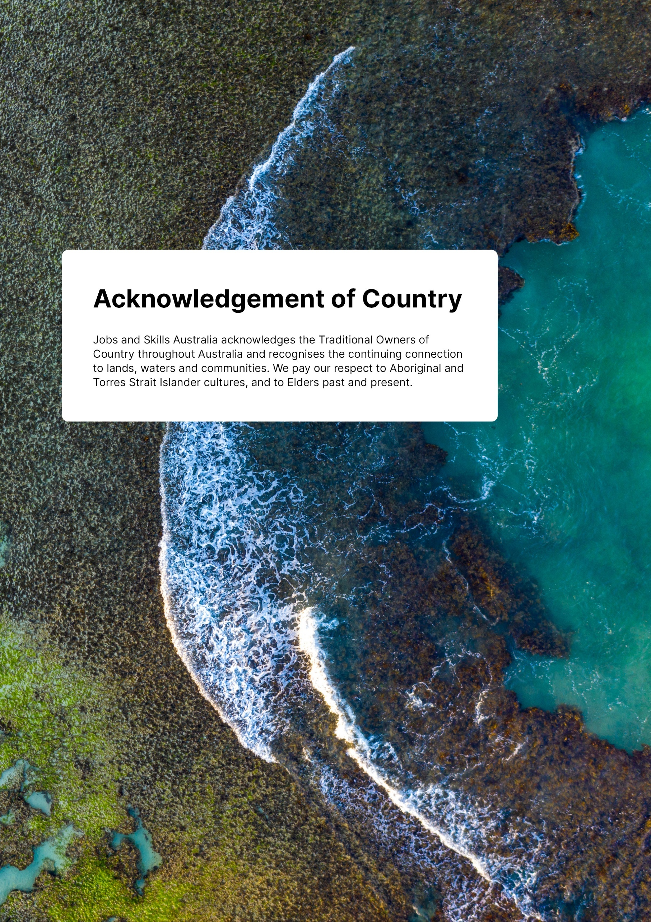

Contents

Executive Summary 6

Part 1: New perspectives on education and training choices, skills mismatches and outcomes 7

Part 2: Gendered divides across highly gendered training and occupational pathways 10

Part 3: New perspectives on describing jobs and recognising skills 11

What's coming next? From data and findings to recommendations for change in Paper 3 12

# Executive Summary

Education and training choices, skills, outcomes and pathways—like jobs, work, and pay—are highly gendered in Australia, and contribute to both ongoing gender economic inequalities and high levels of gender occupational segregation intensity. In this second data findings paper of the study, we focus on how the skills system intersects with and contributes to maintaining gendered work and pay in Australia.

We highlight further links between segregation intensity and skill trends. This includes skill mismatches, which can lead to the underutilisation of workers full skill potential, impacting productivity and reinforcing structural barriers, bias and discrimination in the labour market. We also identify how these skills trends have links to occupation shortages and the return on investment for education pathways and careers, including across the Gender Segregation Intensity Scale (GSIS) that we introduced in [Paper 1](https://www.jobsandskills.gov.au/research/studies/gender-economic-equality-study#paper1newperspecti).

Figure 1: Gender Economic Equality Study publications

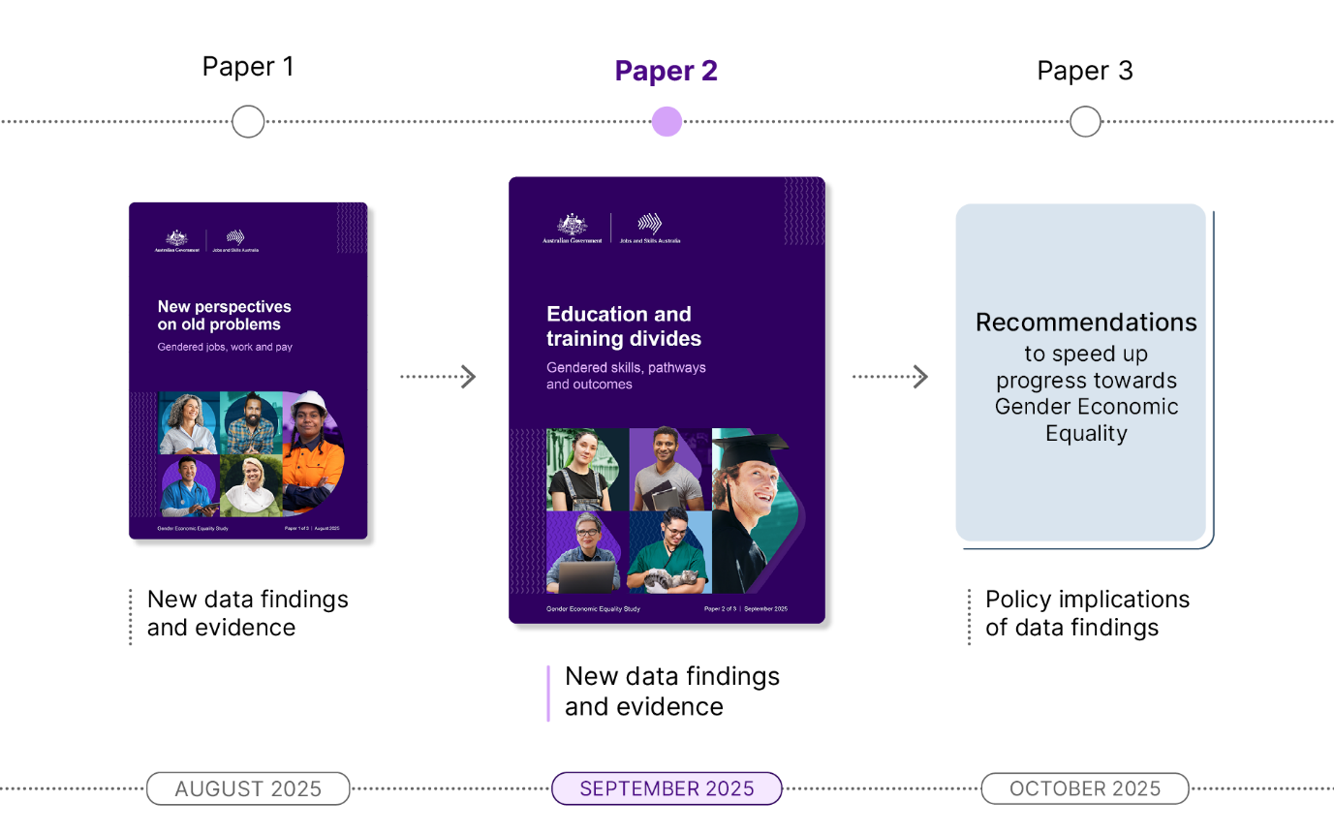

As [Paper 1](https://www.jobsandskills.gov.au/research/studies/gender-economic-equality-study#paper1newperspecti) findings demonstrated, women are now more highly qualified than men in Australia but are still earning less, on average, in almost all occupations. Throughout our analysis, we flag the policy implications of these links for discussion in our third and final recommendations focused Gender Economic Equality Study Paper 3.

In this paper we provide new perspectives on Australia's education and training gender divides, including intersectional and longitudinal insights into gendered skills, training pathways and outcomes. We provide further insights on CALD and First Nations workers but expand our analysis to people with disability, to extend our intersectional approach. We put a spotlight on highly gendered training pathways to identify trends, challenges and opportunities across the skills system. For example, how the choices people make in what education and training pathways and areas of study they pursue and the employment, economic and return on investment outcomes this leads to post-training over different time periods.

## Part 1: New perspectives on education and training choices, skills mismatches and outcomes

In this opening section of Paper 2, we summarise the current gendered segregation patterns in education and training in Australia through a snapshot of both enrolments and completions across Vocational Education and Training (VET) and higher education. We apply the GSIS to Australia's top 20 areas of study, more technically classified as [Fields of Education](https://www.abs.gov.au/statistics/classifications/australian-standard-classification-education-asced/2001/field-education-structure-and-definitions) illustrating an additional use of the new GSIS measure.

Our key findings across education and training choices are:

* Recent VET and higher education program enrolments and completions indicate current training pipelines will not significantly improve existing gendered labour market segregation and occupational shortages.
* Likewise, pronounced gender segregation patterns are seen in training pipelines for key reform areas, such the Net Zero transition; digital transformation; and qualifications that support a high quality and efficient care sector.
* Distinct gender divides persist across study choices. This continues to be seen across the VET training pathways into Australia's top 20 growing occupations. In higher education, only three of the 12 broad fields of education (25%) had gender balanced enrolments in 2023.
* When looking at higher education and VET completions across the 69 narrow fields of education with available data, only 14 (20%) had gender balanced completions across the three years of 2015-2017. This is a similar finding to [Paper 1's](https://www.jobsandskills.gov.au/research/studies/gender-economic-equality-study#paper1newperspecti) headline finding that only one in five workers work in gender balanced occupations.
* There are also only three gender balanced areas of study across the top 10 largest narrow fields of education.

We also found that social and cultural norms have a significant influence on shaping education and training choices, careers and pathways from an early age. These ultimately influence and reinforce gender stereotypes and biases about which jobs men and women are suited or should aspire to. It is clear that intervening early in gendered education and training choices is key to addressing occupational segregation.

We provide insights on the gendered divides across skills mismatches and education and training outcomes. For the skills mismatch analysis, we identify how 'skill underutilisation' or job 'mismatching' is gendered across both the workforce and top 10 areas of study. We include intersectional insights across both on First Nations and CALD graduates as well as people with disability.

Our key findings on gendered divides across skills mismatches are:

* Females are more likely than males to be working in Skill Level 1 roles, the highest Skill Level of any occupation, but they are also more likely to be skills mismatched. This means women's skill potential is more commonly underutilised than males.
* Overall, people with disability with higher qualifications and higher skill level jobs had the lowest skills mismatching rates across cohorts with little gendered differences between males and females.
* Generally, CALD workers and First Nations workers had similar rates of skills mismatching compared to the broader population of graduates and all female graduates. However, gendered mismatching rates within these cohorts paint a different picture, with skills matching highest for CALD females and First Nations males at 35%.
* Across Bachelor Degree and above qualifications (AQF 7+), skills mismatches were low across all cohorts and between genders. The most pronounced gender skills mismatches were seen at the Diploma, Advanced Diploma and Associate Degree levels (AQF 5 and 6).
* Across the top 10 areas of study for Bachelor or above qualification graduates:
  + The lowest skill mismatching was in Teacher Education, Nursing and Rehabilitation Therapies.
  + The highest skills mismatching was in Business Management, Communication and Media Studies, Behavioural Science, Other Health and Other Natural and Physical Sciences.

We explored gendered divides across education and training outcomes using two different approaches and datasets. Across both we find that education and training does not guarantee improved economic equality, despite women surging ahead with qualifications.

In considering economic inequalities seen 5 and 10 years after training, we find that, despite similar education qualifications, women are consistently more likely to be out of the labour force and earn less than men, with income gaps widening over time. We look at people with non-English speaking backgrounds more closely and follow cohorts of workers from early in the careers at age 25 as they age into their thirties, forties and fifties.

Our headline findings are:

* Males have slightly better employment outcomes across all levels of education, and this remains the case as workers age into their mid and late thirties.
* There are few gender differences for unemployed people regardless of education level but much larger gender disparities across people who aren't in the labour force, especially for women with lower levels of education.
* Regardless of a worker's education attainment or qualification level, there is significant gendered economic inequality when looking at incomes, and this becomes more pronounced as people age.
  + Males are almost twice as likely to earn incomes over $100,000 than females at 35-40 years across all levels of education.
  + Even when workers have completed a Bachelor Degree or higher, there remains significant income disparity between males and females.
* When exploring divides across incomes for First Nations people and migrants arriving from countries with either English or Non-English speaking backgrounds, we found significant disparities compared to the total population.
* Employed males born overseas in a country with a Main English-Speaking Background (MESC) are far more likely to have higher incomes than those born in Other Than Main English-Speaking Countries (OTMESC). First Nations males and females also have worse income disparity than their MESC and OTMESC counterparts.
* Disparities worsen further when looking at gendered differences within cohorts.

As with [Paper 1](https://www.jobsandskills.gov.au/research/studies/gender-economic-equality-study#paper1newperspecti) findings, this income disparity compounds over time, particularly for females in their mid-thirties to fifties. While caring responsibilities are one factor, structural gender and racial economic inequality are also factors. These findings highlight the current structural inequities in Australia’s labour market and the need for inclusive policy interventions.

This paper also explores VET outcomes and how students with compounding forms of disadvantage fair across the top 100 VET qualifications one year after training. We provide new perspectives and intersectional insights on the gendered trends across VET graduates with disability, of First Nations status, and CALD identity. These insights are an extension of JSA's [Strong and Responsive VET Pathways | Jobs and Skills Australia](https://www.jobsandskills.gov.au/publications/strong-and-responsive-vet-pathways).

Our headline findings are that:

* Males have better economic outcomes than females, but females had slightly better employment outcomes. Across the top 100 VET qualifications at Certificate III level or above:
  + Males had higher median incomes in 82% of the qualifications.
  + Females had better employment outcomes than males in just under half (47%) of the qualifications.
* Female graduates tend to earn higher incomes in fields that are generally associated with lower overall earnings. However, they also earnt significantly more than males one year after training in some almost completely male dominated training pathways, such as the pathway to an Electrician, and Mechanical Engineering.
* CALD female graduates experience comparatively weaker economic outcomes post-training.
* Reflecting [Paper 1](https://www.jobsandskills.gov.au/research/studies/gender-economic-equality-study#paper1newperspecti) findings, CALD male and female graduates earned more than other workers within aged care and disability support related occupations.
* People with disability had the lowest economic and employment outcomes overall but secured relatively good outcomes in several courses.
  + Females with disability had good employment outcomes in selected Hospitality, Veterinary Nursing, and Early Childhood Education and Care qualifications.
  + Males with disability had good employment outcomes in selected Carpentry, and Mechanical Trade qualifications.
* Policymaker attention in VET training pathways in IT, community service, and sports and aquatics qualifications is needed to improve outcomes for students with disability.
* First Nations females appear to fare better in education and training pathways that lead to gender balanced and female dominated occupations, while First Nations males' outcomes are better in training pathways leading to male dominated occupations, such as trades.

This can be explored further through the study's third dashboard: Intersectional VET Outcomes Dashboard.

## Part 2: Gendered divides across highly gendered training and occupational pathways

In Part 2 of Paper 2, we use the GSIS to provide intersectional insights on VET outcomes; occupational pathways across different areas of study; and gendered trends across the length of time workers stay in a job. All three contribute to new evidence for gendered divides across career trajectories and the 'leaky pipeline' post-training, which is one of the reasons occupational segregation is so hard to shift.

It is crucial to look at longitudinal pathways across, into and out of jobs to make sense of the career decisions and transitions that different types of workers are more or less likely to make. Understanding this can assist in policies to address occupational gender segregation.

Our key GSIS insights on VET outcomes and training pathways into top growing occupations are:

* Males generally have better economic outcomes in post-training, regardless of the gender segregation intensity occupation the training pathway leads into, even those that are female dominated.
* First Nations females and males have positive employment and economic outcomes in selected gender balanced Real Estate and Commercial Cookery training pathways.
* First Nations males secured relatively positive outcomes in male dominated trade training pathways, such as Electrical, Carpentry and Mechanical Engineering trades, but not in qualifications tied to mining. Likewise, better support for males with disability studying to become electricians, an important qualification for Australia’s Net Zero Transition, is needed.
* There are positive shifts in enrolments and median income outcomes for females and First Nations males.

Our key GSIS insights on different occupation pathways and economic outcomes three years post-completion in different areas of study are:

* Despite the female dominated occupation pathways in Human Welfare Studies and Service, males are paid more in each of the related occupations.
* Female law graduates are more likely to become Solicitors but they earn slightly less than males three years post-completion, within this gender balanced occupation.
* In IT related fields of study, females and CALD females are generally securing relatively good economic outcomes and even the highest median incomes in some occupations, such as Software and Applications Programmer after studying Computer Science or IT Manager after studying Information Systems.

This indicates a strong return on investment for this field of study, at least early in women's careers but our qualitative findings still point to gender bias, discrimination and barriers in workplaces across this industry.

Lastly, we use the GSIS to explore gendered trends across time in jobs to further reveal the relationship between these trends, segregation intensity, occupation shortages, and skill level. We consider differences in time in jobs, retention and turnover patterns seen at different levels of occupational gender segregation intensity.

Our key GSIS insights on different gendered divides across time in jobs are:

* Males and females stay longer in occupations that are dominated by their own gender across the GSIS.
* Unlike occupation shortages, time in job is more closely tied to Skill Level than gender segregation intensity. Males and females generally stay similar lengths of time in higher skilled professional jobs regardless of gender segregation intensity.
* Across Skill Level 1 occupations with high CALD representation such as Pharmacists, Veterinarians, Accountants, and Other Medical or Dental Practitioners, males and females also have similar time in job patterns.
* Females do stay longer than males in lower skilled gender balanced roles like Kitchenhands, Cooks, and Packers and this lines up with [Paper 1](https://www.jobsandskills.gov.au/research/studies/gender-economic-equality-study#paper1newperspecti) findings that in some lower skilled jobs like these become increasingly female dominated as workers age.
* In top growing occupations, females stayed longer in health and care roles and males stayed longer in jobs like Chefs, and Ambulance Officers and Paramedics.
* Some of the occupations at Skill Level 3 with the largest gendered differences in time in job are Auctioneers, and Stock and Station Agents, and Fire and Emergency Workers, in which males stay on average more than two years longer than females.
* Females generally stay longer in jobs in health, education and social work.

## Part 3: New perspectives on describing jobs and recognising skills

Part 3 provides Australia's first insights using OSCA and how it increases our understanding of Australia's gendered jobs, work and pay and better recognises and values women's skills.

Our key findings on OSCA include that it has:

* Improved the gendered language that was present in ANZSCO, which is important for tackling persistent gendered norms that play a role in perpetuating occupational gender segregation.
* Improved the recognition of leadership roles (and invisible skills) within female dominated occupations. Overall, the number of leadership occupations in the highly female dominated or almost completely female dominated segregation intensity has increased substantially, rising from 11% of leadership occupations in ANZSCO to 17% in OSCA.
* Increased identification of vertical segregation in workforces with the addition of new occupations, such as the Assistant School Principal, which has a higher percentage of females than School Principals.
* Significantly improved the identification and recognition of female dominated jobs, and therefore also women's skills across Australia. There are also new female dominated occupations being captured in OSCA outside of leadership positions.
* moved towards the recognition and valuation of cultural skills through the further identification of First Nations occupations.

Other key findings include:

* While OSCA has significantly improved the identifying and recognition of female dominated jobs, and women's skills across Australia, there is still gender bias in how we describe female dominated occupations compared with male dominated occupations, which should be considered in future updates.
* Of the new occupations in OSCA that have increased in Skill Level, most of these are male dominated occupations.

## What's coming next? From data and findings to recommendations for change in Paper 3

The data and findings in this paper point to the need for change if we are to accelerate progress towards gender economic equality. In Paper 3, we will present recommendations, drawing on the themes that have emerged throughout both [Paper 1](https://www.jobsandskills.gov.au/research/studies/gender-economic-equality-study#paper1newperspecti) and Paper 2. Government efforts and policy interventions are one part of this change but insights from these papers point to changes that are needed across workplaces, educational institutions, employers, and society more broadly.

In this paper the following reform themes which focus on education, training and skills have emerged:

* The potential role for system-wide occupational awareness or career education to influence early gendered study choices, which contribute to persistent gendered occupational segregation.
* The need for specific scholarships, funding and wrap-around supports for trainers (and potentially students in combination with existing Government efforts) in highly gendered training pathways. The aim is to increase the number of women in male dominated teaching fields (and vice versa) and to build the capability and capacity of all trainers to better support underrepresented cohorts in learning environments.
* Developing resources and supports for education and training institutions and providers in highly gendered pathways.
* A focus on collaboration with, and capacity building for, the workers, employers, organisations and actors involved in system-level changes in recommendations.
* What monitoring, reporting and evaluation on gender differences in working arrangements should be done next, based on the new OSCA and GSIS evidence. For example, our new evidence will allow new data collection and analysis on new almost completely female dominated occupations that would meet criteria in the National Gender Segregation Profile (Cortis et al. 2023).
* The need to address gender bias in ongoing labour market frames and concepts such as skill recognition and occupation and industry classifications.

This paper has also identified emerging themes that are consistent with and related to those highlighted in [Paper 1](https://www.jobsandskills.gov.au/research/studies/gender-economic-equality-study#paper1newperspecti):

* Firmer links between occupation shortages and selected skill mismatch trends.
* Further evidence on occupations and training pathways with more significant gender disparities in income 3 years after training, which align with insights into gender pay gaps.
* Identification of qualifications where more disadvantaged cohorts such as people with disability have good outcomes and the policy implications of those including for apprenticeship policy design.
* The need for better supports across the life course to support unpaid care, community support and other work beyond younger children.
* Further evidence on compounding inequalities for First Nations and CALD workers in relation to the return on investment in skills and education, in addition to the pay gaps.