

# RLMI Results – June 2025

## Key Findings

1. Regional and remote areas continue to be more likely to experience relatively weaker labour market conditions than their major city counterparts.
2. With that said, the June 2025 Regional Labour Market Indicator (RLMI) results highlight some current areas of considerable labour market strength in parts of regional Australia, including in regional Queensland and southern regional New South Wales.
3. All six remote regions covered in the JSA RLMI continue to be rated as either ‘below average’ or ‘poor’, reflecting more pronounced labour market challenges experienced in remote areas.

|  |
| --- |
| Update to methodology: Inclusion of ABS Modelled Estimates  In June 2025, the ABS modelled estimates of employment rates (working age) were incorporated into the RLMI model, replacing the ABS direct survey unemployment rate estimates that were previously used. The modelled estimates are more stable and reliable than the direct survey estimates.[1] |

### Labour market challenges are more pronounced in many regional areas

The June 2025 RLMI results continue to show that regional and remote areas are more likely to experience weaker labour market conditions than their major city counterparts, highlighting the additional challenges faced in many regional areas by both employers and jobseekers (see Chart 1, below).

* Around half of the SA4’s (13 out of 28) located in regional areas were rated either ‘below average’ or ‘poor’ in June 2025, while all six (or 100%) remote areas were rated either ‘below average’ or ‘poor’.
* Almost two-thirds of the SA4’s (28 out of 44) located in major city areas were rated either ‘strong’ or ‘above average’ in June 2025.

Chart 1: RLMI ratings of relative labour market performance, June 2025

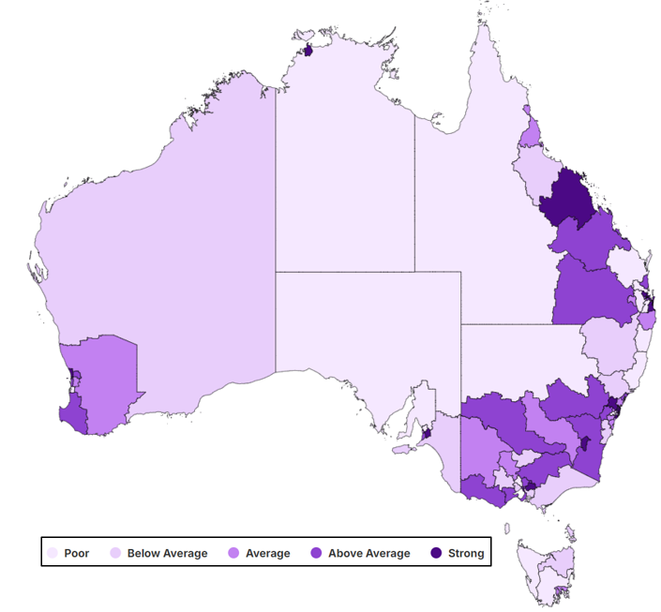

Source: JSA, *Regional Labour Market Indicator (RLMI)*, June 2025

Chart 2: RLMI ratings of relative labour market performance, by selected Capital Cities, June 2025

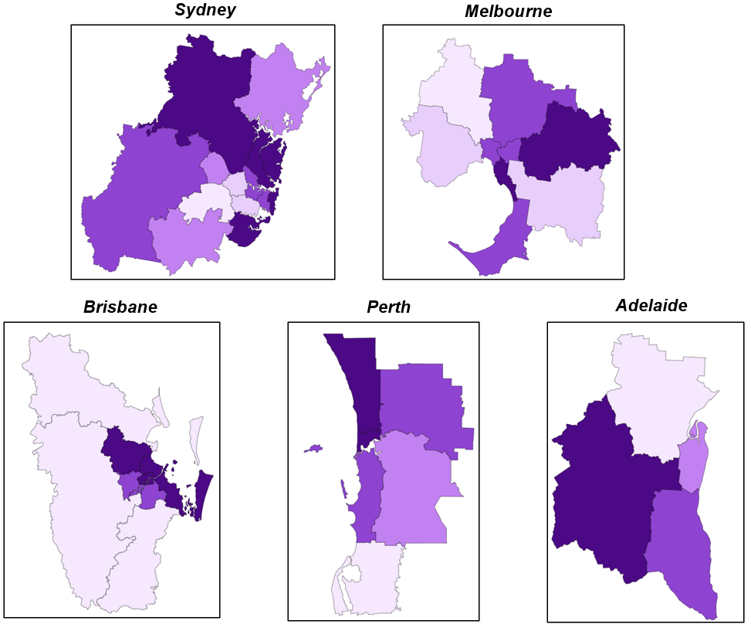

Source: JSA, *Regional Labour Market Indicator (RLMI)*, June 2025

### Recent trends in regional labour market performance

Although labour market challenges are typically more pronounced in many regional and remote areas, the latest RLMI results help to highlight some current areas of considerable labour market strength in parts of regional Australia.

##### Spotlight: Regional areas surrounding Greater Brisbane[2] One example of strong labour market conditions in regional Australia is in the cluster of regional areas that surround Greater Brisbane. The regional areas surrounding Greater Brisbane cover a vast area and make a substantial contribution to the social and economic wellbeing of Australia through key sectors such as agriculture, mining, construction, manufacturing, health care and transport.

The latest RLMI results show that labour market conditions have improved in the region over the last year.

* For instance, labour market conditions in the Central Queensland and Darling Downs – Maranoa SA4 regions were rated ‘above average’ in June 2025, up from their rating of ‘average’ a year ago (see Chart 3, below).
* Furthermore, labour market conditions were rated ‘average’ in Toowoomba and the Richmond – Tweed SA4 regions in June 2025, improving from their rating of ‘below average’ 12-months prior.

**Chart 3: RLMI ratings of relative labour market performance for the regional areas surrounding Greater Brisbane**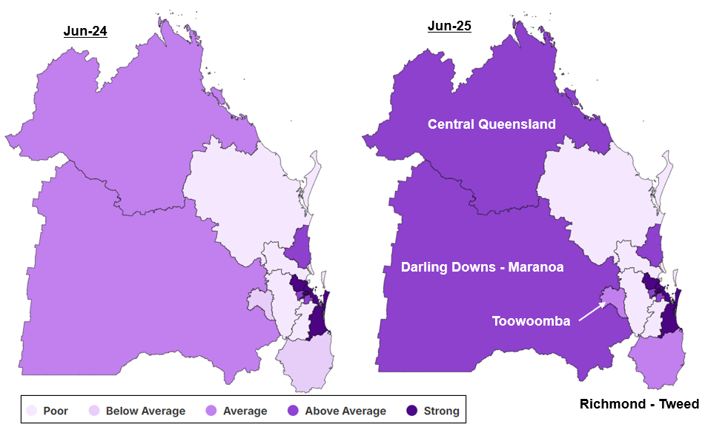

Source: JSA, *Regional Labour Market Indicator (RLMI)*, June 2025

Contributing to improved labour market conditions in the regional areas surrounding Greater Brisbane is a number of key labour market indicators which have strengthened over the last year.

**Table 1: Key labour market indicators for the regional areas surrounding Greater Brisbane**

|  |  |  |  |
| --- | --- | --- | --- |
|  | **Jun-24** | **Jun-25** | **Change** |
| Employment Rate (15-64 years) (%) | 77.4 | 78.1 | **Improved** |
| Prop. on JobSeeker Income Support (%) | 7.1 | 7.5 | **Softened** |
| Unemployment Rate (%) | 3.8 | 3.8 | **Stable** |
| Vacancy Fill Rate (%) | 61.4 | 67.4 | **Improved** |
| Underemployment Rate (%) | 6.9 | 6.3 | **Improved** |

### In focus: Northern Queensland[3]

Northern Queensland enjoys a stunning natural environment of reef, rainforest and outback which provides an attractive lifestyle for its residents. The region also contributes significantly towards the Australian economy through key industries such as manufacturing, construction, mining and defence. The latest RLMI results show, however, that labour market conditions vary significantly within Northern Queensland, highlighting the importance of granular, region-specific data that identifies areas of relative strength and weakness.

**Chart 4: RLMI ratings of relative labour market performance, June 2025**

## A map of Cairns, Townsville and Mackay - Isaac - Whitsunday SA4 regions displaying the RLMI ratings of labour market performance (strong, above average, average, below average and poor). The map shows that labour market conditions vary significantly across the three regions in Northern Queensland. *Source: JSA, Regional Labour Market Indicator (RLMI), June 2025*

For instance, labour market conditions in Cairns and Townsville were rated ‘average’ and ‘below average’, respectively, in June 2025, highlighting the additional challenges faced by employers and jobseekers in these regions.

By contrast, Mackay – Isaac – Whitsunday was rated ‘strong’ in June 2025, indicating that labour market conditions are reasonably tight when compared to the national average.

Although Cairns, Townsville and the Mackay – Isaac – Whitsunday SA4 regions might be considered as part of the broader the Northern Queensland region, the workforce needs vary significantly between regions.

**Chart 5: Employment by type of occupation[4], May 2025**

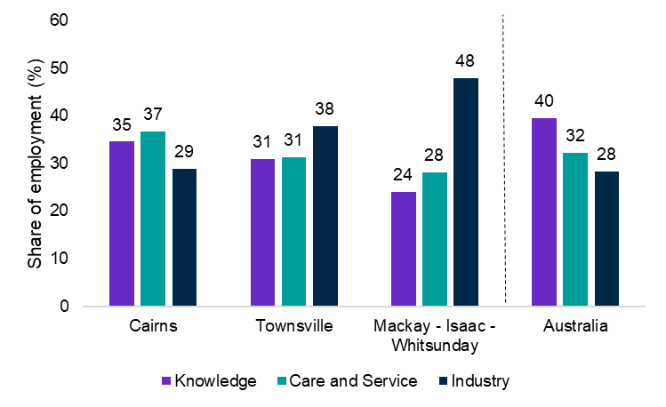

*Source: ABS, 2025*

**Chart 6: Employment by type of Industry, May 2025**

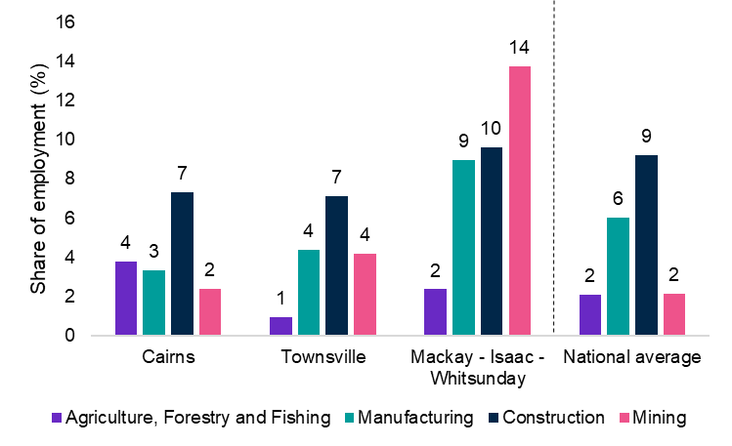

*Source: ABS, 2025*

For instance, industry jobs accounted for almost half (48%) of total employment in the Mackay – Isaac – Whitsunday SA4 in May 2025, well above the rate recorded for Cairns (29%) and Townsville (38%) (see Chart 5, above).

* Mining is the largest employing industry in the Mackay – Isaac – Whitsunday SA4, accounting for 14% of total employment in May 2025 (see Chart 6, above).

The importance of key industries, most notably mining, in the Mackay – Isaac – Whitsunday SA4 region has enabled more employment opportunities for its residents, as well as residents from other regions (‘fly-in-fly-out’ or ‘drive-in-drive out’ workers).

* 97% of **residents** in the Mackay – Isaac – Whitsunday SA4 region **work in the region**.
* 12% of the **workforce** in the Mackay – Isaac – Whitsunday SA4 **region live in another region** (‘fly-in-fly-out’ or ‘drive-in-drive-out’ workers).

**Table 2: ‘Fly-in-fly-out’ or ‘drive-in-drive-out’ workforce, 2021**

|  |  |  |  |  |
| --- | --- | --- | --- | --- |
|  | **Cairns** | **Townsville** | **Mackay - Isaac - Whitsunday** | **Regional Australia** |
| Prop. of the local workforce that live in another region ('fly-in-fly-out' or ‘drive-in-drive-out’ workers) (%) | 3% | 2% | 12% | 9% |

*Source: ABS Census, 2021.*

## Labour Market Rating by SA4, June 2025

|  |  |  |  |  |
| --- | --- | --- | --- | --- |
| **Statistical Area Level 4 (SA4)** | **Remoteness** | **Jun-24** | **Jun-25** | **Direction** |
| Central Coast | Major City | Average | Average | Stable |
| Sydney - Baulkham Hills and Hawkesbury | Major City | Strong | Strong | Stable |
| Sydney - Blacktown | Major City | Average | Average | Stable |
| Sydney - City and Inner South | Major City | Above average | Above average | Stable |
| Sydney - Eastern Suburbs | Major City | Strong | Strong | Stable |
| Sydney - Inner South West | Major City | Below average | Below average | Stable |
| Sydney - Inner West | Major City | Strong | Above average | Declined |
| Sydney - North Sydney and Hornsby | Major City | Strong | Strong | Stable |
| Sydney - Northern Beaches | Major City | Strong | Strong | Stable |
| Sydney - Outer South West | Major City | Average | Average | Stable |
| Sydney - Outer West and Blue Mountains | Major City | Above average | Above average | Stable |
| Sydney - Parramatta | Major City | Below average | Below average | Stable |
| Sydney - Ryde | Major City | Strong | Above average | Declined |
| Sydney - South West | Major City | Poor | Poor | Stable |
| Sydney - Sutherland | Major City | Strong | Strong | Stable |
| Capital Region | Regional | Above average | Above average | Stable |
| New South Wales - Central West | Regional | Above average | Above average | Stable |
| Coffs Harbour - Grafton | Regional | Poor | Poor | Stable |
| Far West and Orana | Remote | Poor | Poor | Stable |
| Hunter Valley exc Newcastle | Regional | Below average | Below average | Stable |
| Illawarra | Cities of Regional Australia | Average | Average | Stable |
| Mid North Coast | Regional | Poor | Poor | Stable |
| Murray | Regional | Above average | Above average | Stable |
| New England and North West | Regional | Below average | Below average | Stable |
| Newcastle and Lake Macquarie | Cities of Regional Australia | Above average | Above average | Stable |
| Richmond - Tweed | Regional | Below average | Average | Improved |
| Riverina | Regional | Average | Average | Stable |
| Southern Highlands and Shoalhaven | Regional | Below average | Below average | Stable |
| Melbourne - Inner | Major City | Above average | Above average | Stable |
| Melbourne - Inner East | Major City | Above average | Above average | Stable |
| Melbourne - Inner South | Major City | Strong | Strong | Stable |
| Melbourne - North East | Major City | Above average | Above average | Stable |
| Melbourne - North West | Major City | Poor | Poor | Stable |
| Melbourne - Outer East | Major City | Strong | Strong | Stable |
| Melbourne - South East | Major City | Below average | Below average | Stable |
| Melbourne - West | Major City | Below average | Below average | Stable |
| Mornington Peninsula | Major City | Above average | Above average | Stable |
| Ballarat | Regional | Below average | Below average | Stable |
| Bendigo | Regional | Average | Average | Stable |
| Geelong | Cities of Regional Australia | Above average | Above average | Stable |
| Hume | Regional | Above average | Above average | Stable |
| Latrobe - Gippsland | Regional | Below average | Below average | Stable |
| Victoria - North West | Regional | Average | Average | Stable |
| Shepparton | Regional | Average | Below average | Declined |
| Warrnambool and South West | Regional | Above average | Above average | Stable |

|  |  |  |  |  |
| --- | --- | --- | --- | --- |
| **Statistical Area Level 4 (SA4)** | **Remoteness** | **Jun-24** | **Jun-25** | **Direction** |
| Brisbane - East | Major City | Strong | Strong | Stable |
| Brisbane - North | Major City | Strong | Strong | Stable |
| Brisbane - South | Major City | Above average | Above average | Stable |
| Brisbane - West | Major City | Above average | Above average | Stable |
| Brisbane Inner City | Major City | Strong | Strong | Stable |
| Ipswich | Major City | Poor | Poor | Stable |
| Logan - Beaudesert | Major City | Poor | Poor | Stable |
| Moreton Bay - North | Major City | Poor | Poor | Stable |
| Moreton Bay - South | Major City | Strong | Strong | Stable |
| Cairns | Cities of Regional Australia | Average | Average | Stable |
| Darling Downs - Maranoa | Regional | Average | Above average | Improved |
| Central Queensland | Regional | Average | Above average | Improved |
| Gold Coast | Cities of Regional Australia | Strong | Strong | Stable |
| Mackay - Isaac - Whitsunday | Regional | Strong | Strong | Stable |
| Queensland - Outback | Remote | Poor | Poor | Stable |
| Sunshine Coast | Cities of Regional Australia | Above average | Above average | Stable |
| Toowoomba | Regional | Below average | Average | Improved |
| Townsville | Cities of Regional Australia | Below average | Below average | Stable |
| Wide Bay | Regional | Poor | Poor | Stable |
| Adelaide - Central and Hills | Major City | Above average | Strong | Improved |
| Adelaide - North | Major City | Poor | Poor | Stable |
| Adelaide - South | Major City | Average | Above average | Improved |
| Adelaide - West | Major City | Average | Average | Stable |
| Barossa - Yorke - Mid North | Regional | Poor | Poor | Stable |
| South Australia - Outback | Remote | Poor | Poor | Stable |
| South Australia - South East | Regional | Below average | Below average | Stable |
| Mandurah | Major City | Poor | Poor | Stable |
| Perth - Inner | Major City | Strong | Strong | Stable |
| Perth - North East | Major City | Above average | Above average | Stable |
| Perth - North West | Major City | Strong | Strong | Stable |
| Perth - South East | Major City | Average | Average | Stable |
| Perth - South West | Major City | Above average | Above average | Stable |
| Bunbury | Regional | Above average | Above average | Stable |
| Western Australia - Outback | Remote | Below average | Below average | Stable |
| Western Australia - Wheat Belt | Regional | Average | Average | Stable |
| Hobart | Cities of Regional Australia | Average | Average | Stable |
| Launceston and North East | Regional | Below average | Below average | Stable |
| Tasmania - South East | Regional | Poor | Poor | Stable |
| Tasmania - West and North West | Remote | Poor | Poor | Stable |
| Darwin | Cities of Regional Australia | Strong | Strong | Stable |
| Northern Territory - Outback | Remote | Poor | Poor | Stable |
| Australian Capital Territory | Major City | Strong | Strong | Stable |

*Source: JSA, Regional Labour Market Indicator (RLMI), June 2025*

## RLMI Explanatory Notes

### Overview

The Regional Labour Market Indicator (RLMI) combines key indicators of spare labour market capacity, from both an employee and employer perspective, into a single, and easy to interpret, summary measure.

Regions are grouped into distinct categories of overall labour market performance, ranging from ‘poor’ to ‘strong’, which provides an accurate and reliable view of labour market performance, relative to the national average.

A strong labour market, that is characterised by a high rate of employment, where employment opportunities are extended to all who want them, is central to a strong economy and prosperous and inclusive society.

**Factors used to assess labour market performance**

The **working age (15-64 years) employment rate**[5] is one of the most commonly used indicators for understanding conditions in the labour market and is a key measure of performance. It provides an insight into the extent to which available labour (some individual’s personal circumstances may prevent them from participating in the labour market) is being used and is unaffected by voluntary changes in labour force participation.

Along with the employment rate, the **unemployment rate** is one of the most commonly used indicators for understanding conditions in the labour market and is a key measure of spare capacity. It provides insights into the availability of unused labour that is willing and available for work.

The **JobSeeker income support rate** is a reliable measure of spare capacity in the labour market and is an important complement to other measures of spare capacity. It is a combination of the JobSeeker payment and Youth Allowance (other) payment, measured as a proportion of the working age population. These payments are designed to provide financial assistance to support those looking for working, including those who may be working part-time.

The **underemployment rate**[6] takes a broad view of underutilisation by measuring the share of the labour force that is employed, but not fully utilised in terms of the amount of work people would like. It is an important complement to the unemployment rate in assessing how much spare capacity could be called upon in adapting to labour market strength and weakness.

The **vacancy fill rate**2is a key measure of unmet demand for labour. A low fill rate indicates that the demand for labour is not matched by the supply of labour from workers. This may be due to a lack of suitable applicants or high search costs that reduce labour market matching efficiency. Poorer-performing regions experience more difficulty filling vacant positions, despite having a higher availability of unused labour willing and available to work.

### Methodology

Please refer to the [RLMI Methodology Paper](https://www.jobsandskills.gov.au/data/regional-labour-market-indicator#methodology) for more information on the RLMI, including its purpose and factor selection.

### Referencing this report

Data in this release should be referenced as: Jobs and Skills Australia, RLMI, June 2025

### Contact us

For additional information, email [RegionalWorkforceAssessment@jobsandskills.gov.au](mailto:RegionalWorkforceAssessment@jobsandskills.gov.au)

1. Further information regarding the ABS modelled regional labour market statistics can be found from the [ABS](https://www.abs.gov.au/media-centre/media-releases/better-monthly-regional-labour-market-data-now-available).
2. Includes the SA4 regions of Central Queensland, Darling Downs – Maranoa, Toowoomba and Richmond – Tweed (New South Wales)
3. Includes the SA4 regions of Cairns, Townsville and Mackay – Isaac – Whitsunday
4. Knowledge workers include managers and professionals. Industry workers include machinery operators & drivers, technicians & trades workers and labourers. Care and service workers include community & personal service workers, clerical & administrative workers and sales workers.
5. In June 2025, the ABS modelled estimates of employment rates (working age) were incorporated into the RLMI model replacing the ABS direct survey unemployment rate estimates that were previously used. The modelled estimates are more stable and reliable than the direct survey estimates.
6. Measured at the Greater Capital City Statistical Area (GCCSA) level due to data quality issues with this factor at the SA4 level.