Recruitment Experiences and Outlook Survey: June quarter 2025
Jobs and Skills Australia conducts the Recruitment Experiences and Outlook Survey (REOS) to monitor recruitment activity and conditions across Australia. Key national indicators from the survey are released monthly; more detailed data disaggregated by state, area, industry, and occupation are released in this quarterly report. For definitions, further information on these data and the REOS, please refer to the notes on the last page.

Recruitment rate - National level
Jun qtr 2022 Sep qtr 2022 Dec qtr 2022 Mar qtr 2023 Jun qtr 2023 Sep qtr 2023 Dec qtr 2023 Mar qtr 2024 Jun qtr 2024 Sep qtr 2024 Dec qtr 2024 Mar qtr 2025 Jun qtr 2025  58% 57% 56% 55% 50% 48% 50% 49% 45% 44% 43% 46% 47%  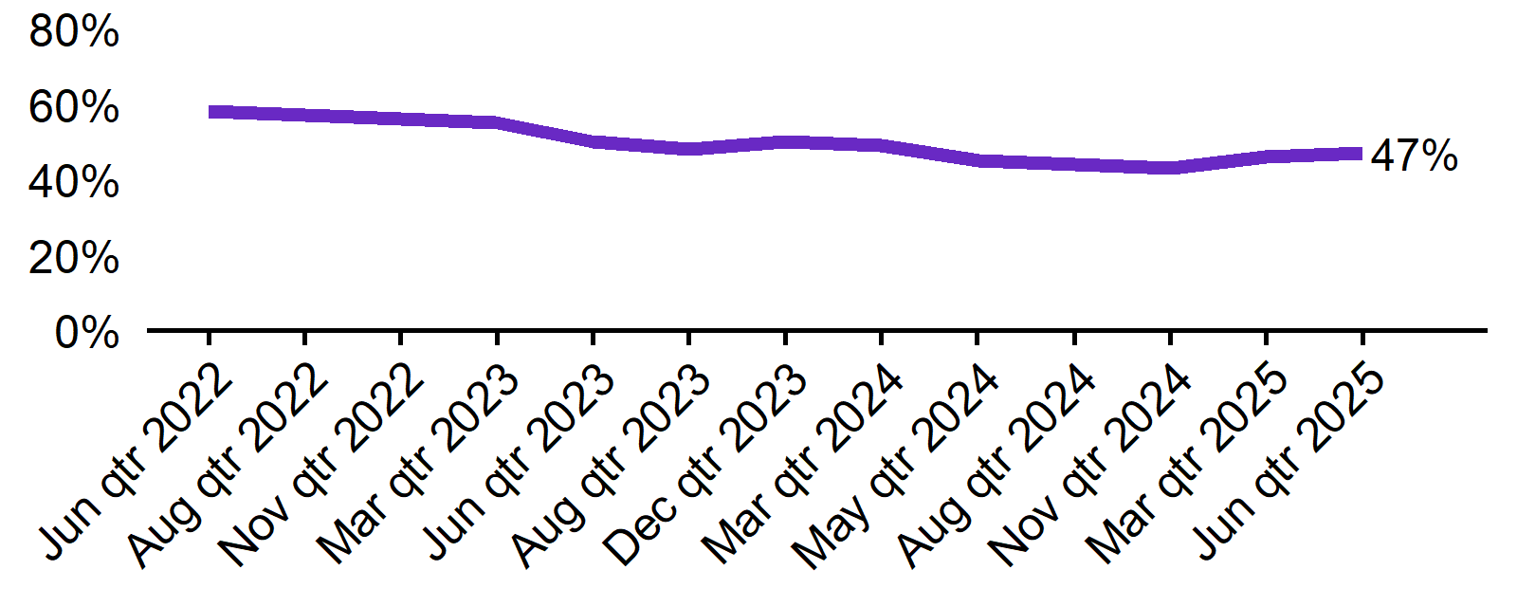 | - The recruitment rate in the June quarter 2025 was 47%.  - This was 2 percentage points higher than a year prior (45%).

Recruitment difficulty rate - National level
Jun qtr 2022 Sep qtr 2022 Dec qtr 2022 Mar qtr 2023 Jun qtr 2023 Sep qtr 2023 Dec qtr 2023 Mar qtr 2024 Jun qtr 2024 Sep qtr 2024 Dec qtr 2024 Mar qtr 2025 Jun qtr 2025  67% 72% 68% 62% 64% 60% 55% 53% 55% 50% 50% 43% 49%  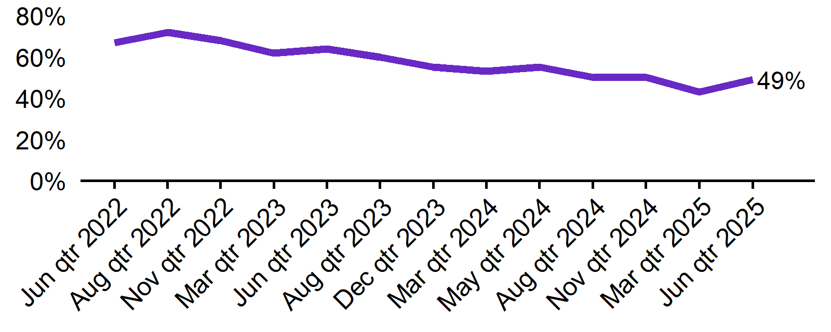 | - The recruitment difficulty rate in the June quarter 2025 was 49%.  - This was 6 percentage points lower than a year prior (55%).

Expecting to increase staff - National level
Jun qtr 2022 Sep qtr 2022 Dec qtr 2022 Mar qtr 2023 Jun qtr 2023 Sep qtr 2023 Dec qtr 2023 Mar qtr 2024 Jun qtr 2024 Sep qtr 2024 Dec qtr 2024 Mar qtr 2025 Jun qtr 2025  31% 28% 29% 28% 22% 24% 21% 24% 19% 20% 19% 20% 20%  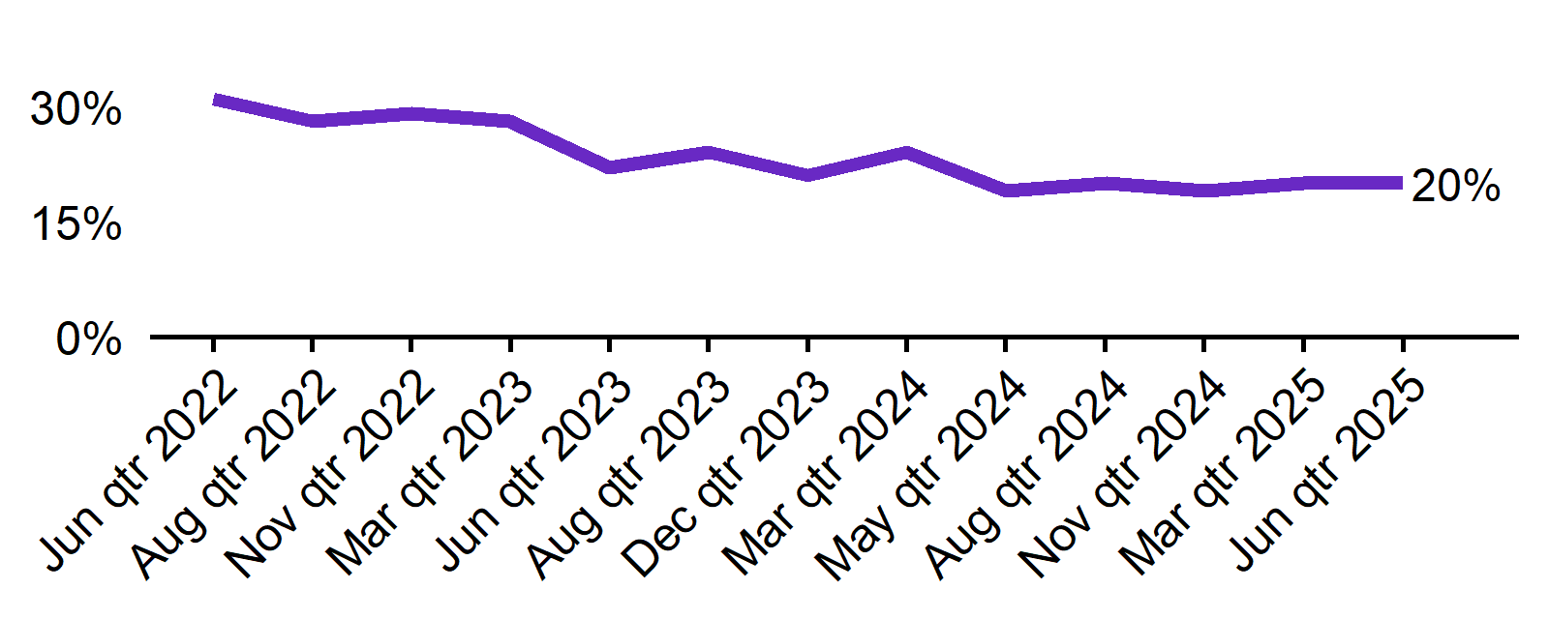 | - In the June quarter 2025, 20% of employers expected to increase staff. This was 1 percentage point higher than a year prior (19%).  - The proportion of employers who expected to decrease staff was 3% in the June quarter 2025.

Key indicators by state/territory
In the June quarter 2025, Queensland and Western Australia recorded the highest recruitment rate (both 54%) of the six states. At 54%*, South Australia recorded the highest rate of recruitment difficulty among the states. Out of all states and territories, Northern Territory reported both the highest recruitment rate (65%) and the highest recruitment difficulty (56%*) in the June quarter 2025. The most significant change in recruitment difficulty was observed in Tasmania, where a decrease of 13 percentage points was recorded compared to June quarter 2024. For future staffing outlook, most states reported a similar proportion of employers expecting to increase staff levels over the next three months (around 18–22%). The NT stood out with the highest at 31%, while the ACT was lowest at 14%.

Table 1. Key indicators by state/territory, June quarter 2025
 | Recruitment rate |  | Recruitment difficulty rate |  | Expect to increase staff
 | % of employers | Annual change  (% points) | % of recruiting employers | Annual change  (% points) | % of employers | Annual change  (% points)
NSW | 47% | 3 pts | 51% | -7 pts | 21% | 1 pt
VIC | 41% | -1 pt | 52% | -6 pts | 18% | -1 pt
QLD | 54% | 6 pts | 44% | -4 pts | 22% | 4 pts
SA | 45% | -1 pt | 54%* | -1 pt* | 18% | 3 pts
WA | 54% | 6 pts | 46% | -5 pts | 21% | 1 pt
TAS | 51% | 7 pts | 48%* | -13 pts* | 20% | 1 pt
NT# | 65% | -5 pts | 56%* | 0 pts* | 31% | -6 pts
ACT# | 42% | -9 pts | 37%* | -6 pts* | 14% | -8 pts

# Due to smaller sample sizes, data for the NT and ACT are based on six-month average data (Mar qtr. 2025 to Jun qtr. 2025).
* Interpret with caution due to low sample size.

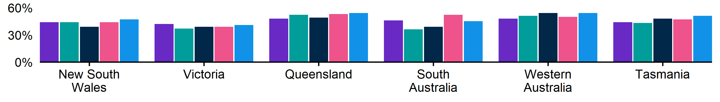
Figure 1. Recruitment rate by state, June quarter 2024 - June quarter 2025
 | Jun qtr 2024 | Sep qtr 2024 | Dec qtr 2024 | Mar qtr 2025 | Jun qtr 2025
NSW | 44% | 44% | 39% | 44% | 47%
VIC | 42% | 37% | 39% | 39% | 41%
QLD | 48% | 52% | 49% | 53% | 54%
SA | 46% | 36% | 39% | 52% | 45%
WA | 48% | 51% | 54% | 50% | 54%
TAS | 44% | 43% | 48% | 47% | 51%

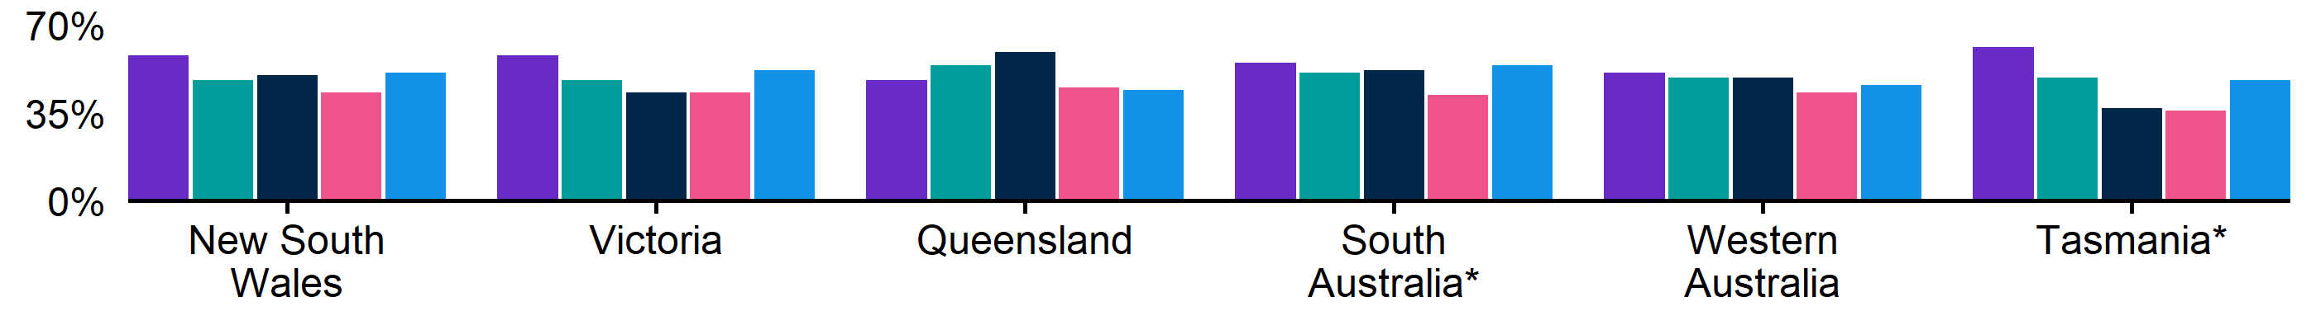
Figure 2. Recruitment difficulty rate by state, June quarter 2024 - June quarter 2025
 | Jun qtr 2024 | Sep qtr 2024 | Dec qtr 2024 | Mar qtr 2025 | Jun qtr 2025
NSW | 58% | 48% | 50% | 43% | 51%
VIC | 58% | 48% | 43% | 43% | 52%
QLD | 48% | 54% | 59% | 45% | 44%
SA | 55% | 51%* | 52% | 42%* | 54%*
WA | 51% | 49% | 49% | 43% | 46%
TAS | 61%* | 49%* | 37%* | 36%* | 48%*

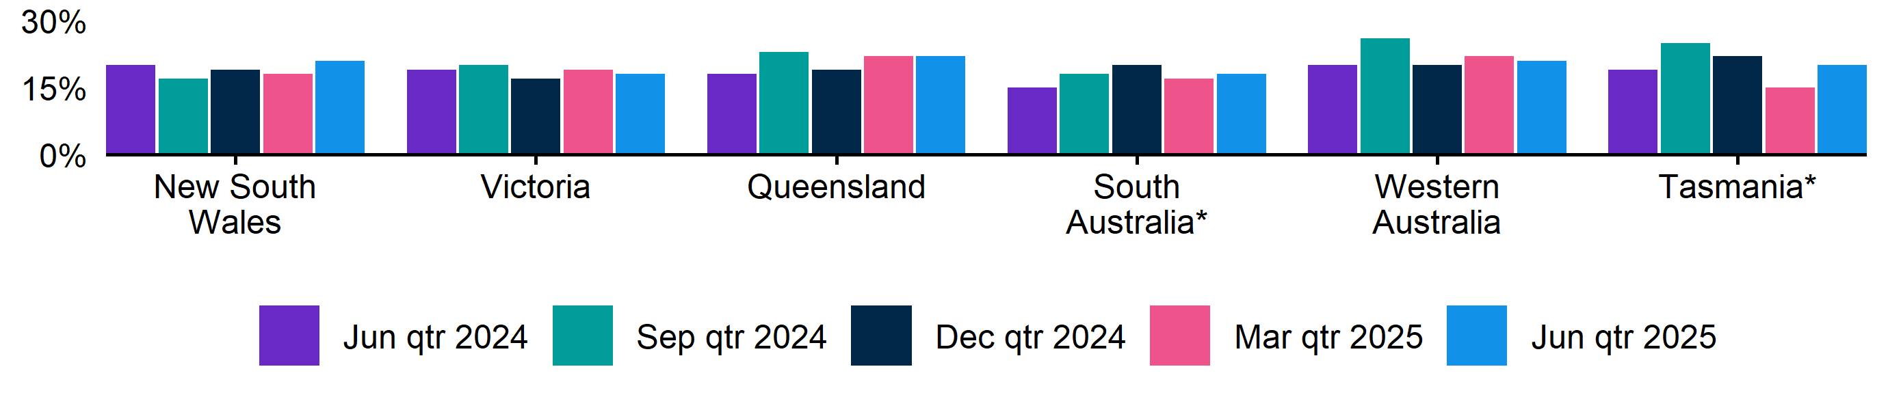
Figure 3. Expecting to increase staff numbers over the next 3 months by state, June quarter 2024 - June quarter 2025
 | Jun qtr 2024 | Sep qtr 2024 | Dec qtr 2024 | Mar qtr 2025 | Jun qtr 2025
NSW | 20% | 17% | 19% | 18% | 21%
VIC | 19% | 20% | 17% | 19% | 18%
QLD | 18% | 23% | 19% | 22% | 22%
SA | 15% | 18% | 20% | 17% | 18%
WA | 20% | 26% | 20% | 22% | 21%
TAS | 19% | 25% | 22% | 15% | 20%

Key indicators by remoteness classification (ARIA location)
In the June quarter 2025, Outer Regional, Remote and Very Remote Australia recorded the highest recruitment rate (55%), the highest rate of recruitment difficulty (56%), and the highest proportion of employers expecting to increase their staff levels over the next 3 months (28%). Conversely, the Major Cities of Australia reported the lowest rates of recruitment, recruitment difficulty, and expectations to increase staffing levels (46%, 47%, and 19% respectively).

Table 2. Key indicators by ARIA location, June quarter 2025
 | Recruitment rate |  | Recruitment difficulty rate |  | Expect to increase staff
 | % of employers | Annual change  (% points) | % of recruiting employers | Annual change  (% points) | % of employers | Annual change  (% points)
Major Cities of Australia | 46% | 3 pts | 47% | -6 pts | 19% | 0 pts
Inner Regional Australia | 47% | -5 pts | 53% | -6 pts | 21% | 3 pts
Outer Regional, Remote and Very Remote Australia | 55% | 8 pts | 56% | -1 pt | 28% | 9 pts

* Interpret with caution due to low sample size. Accessibility and Remoteness Index of Australia (ARIA) classifications of Outer Regional Australia, Remote Australia, and Very Remote Australia have been combined into one category to increase sample size.

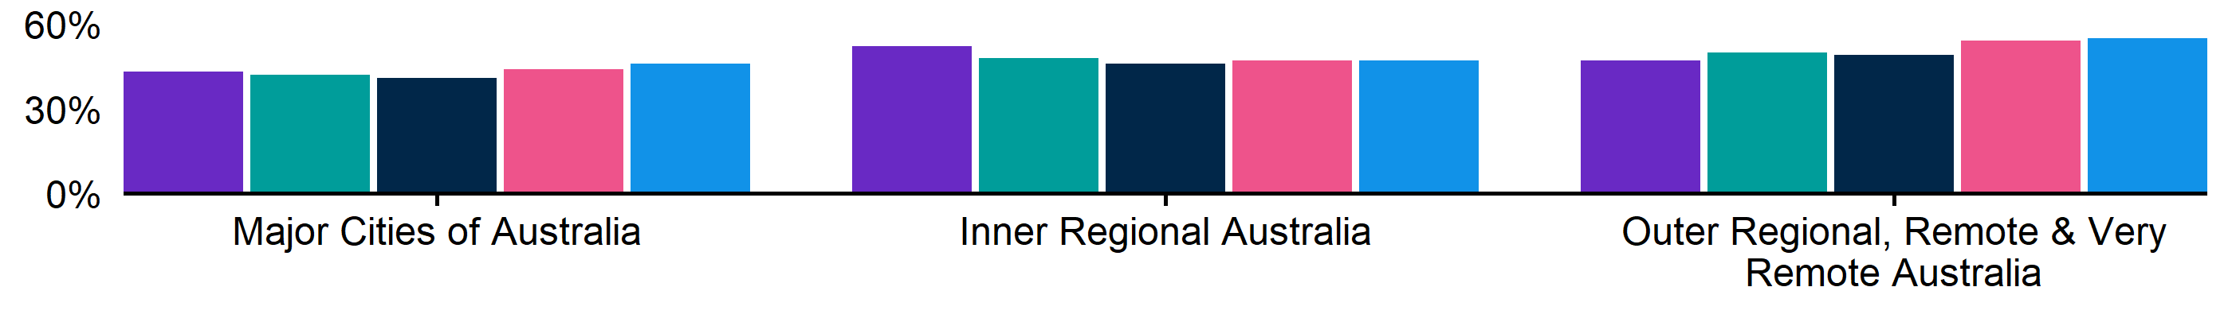
Figure 4. Recruitment rate by ARIA location, June quarter 2024 - June quarter 2025
 | Jun qtr 2024 | Sep qtr 2024 | Dec qtr 2024 | Mar qtr 2025 | Jun qtr 2025
Major Cities of Australia | 43% | 42% | 41% | 44% | 46%
Inner Regional Australia | 52% | 48% | 46% | 47% | 47%
Outer Regional, Remote and Very Remote Australia | 47% | 50% | 49% | 54% | 55%

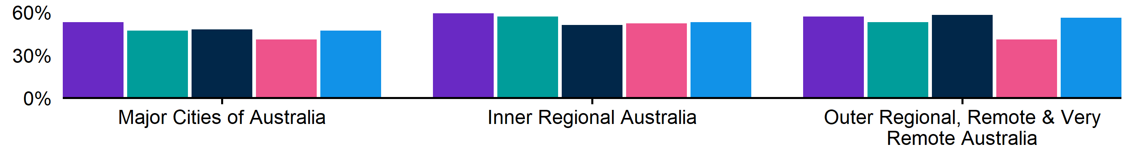
Figure 5. Recruitment difficulty rate by ARIA location, June quarter 2024 - June quarter 2025
 | Jun qtr 2024 | Sep qtr 2024 | Dec qtr 2024 | Mar qtr 2025 | Jun qtr 2025
Major Cities of Australia | 53% | 47% | 48% | 41% | 47%
Inner Regional Australia | 59% | 57% | 51% | 52% | 53%
Outer Regional, Remote and Very Remote Australia | 57% | 53% | 58% | 41% | 56%

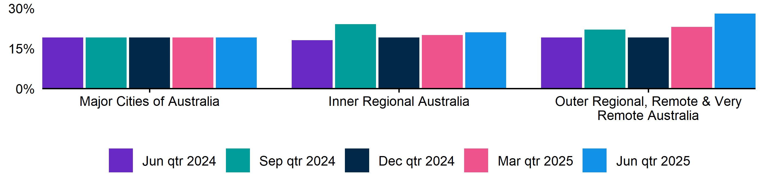
Figure 6. Expecting to increase staff numbers over the next 3 months by ARIA location, June quarter 2024 - June quarter 2025
 | Jun qtr 2024 | Sep qtr 2024 | Dec qtr 2024 | Mar qtr 2025 | Jun qtr 2025
Major Cities of Australia | 19% | 19% | 19% | 19% | 19%
Inner Regional Australia | 18% | 24% | 19% | 20% | 21%
Outer Regional, Remote and Very Remote Australia | 19% | 22% | 19% | 23% | 28%

Key indicators by selected industries
In the June quarter 2025, Accommodation and Food Services recorded the highest recruitment rate (67%) of the selected industries. At 60%*, Professional, Scientific and Technical Services recorded the highest rate of recruitment difficulty. Notably, the Accommodation and Food Services industry continues to record the lowest recruitment difficulty rate among the selected industries, while also having the highest proportion of employers expecting to increase staff (27%).

Table 3. Key indicators by industry, June quarter 2025
 | Recruitment rate |  | Recruitment difficulty rate |  | Expect to increase staff
 | % of employers | Annual change  (% points) | % of recruiting employers | Annual change  (% points) | % of employers | Annual change  (% points)
Manufacturing | 44% | 3 pts | 55% | -8 pts | 23% | 4 pts
Construction | 43% | 0 pts | 51% | -8 pts | 21% | 4 pts
Wholesale Trade | 36% | -2 pts | 50%* | -11 pts* | 16% | 3 pts
Retail Trade | 45% | 2 pts | 39%* | -5 pts* | 16% | 0 pts
Accommodation and Food Services | 67% | 8 pts | 34%* | -2 pts* | 27% | -1 pt
Professional, Scientific and Technical Services | 45% | 8 pts | 60%* | 2 pts* | 17% | -1 pt
Health Care and Social Assistance | 55% | -5 pts | 50% | -10 pts | 20% | -2 pts

*Interpret with caution due to low sample size.

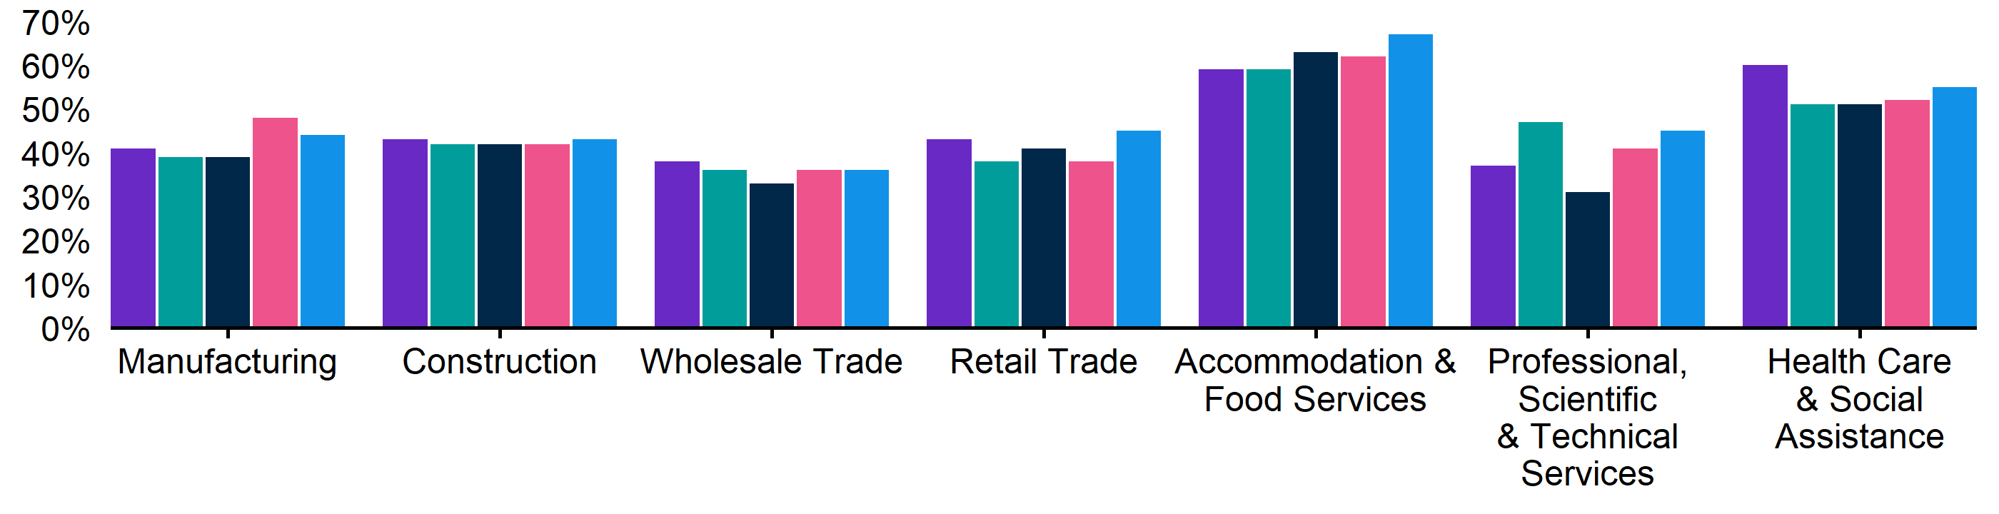
Figure 7. Recruitment rate by industry, June quarter 2024 - June quarter 2025
 | Jun qtr 2024 | Sep qtr 2024 | Dec qtr 2024 | Mar qtr 2025 | Jun qtr 2025
Manufacturing | 41% | 39% | 39% | 48% | 44%
Construction | 43% | 42% | 42% | 42% | 43%
Wholesale Trade | 38% | 36% | 33% | 36% | 36%
Retail Trade | 43% | 38% | 41% | 38% | 45%
Accommodation and Food Services | 59% | 59% | 63% | 62% | 67%
Professional, Scientific and Technical Services | 37% | 47% | 31% | 41% | 45%
Health Care and Social Assistance | 60% | 51% | 51% | 52% | 55%

Figure 8. Recruitment difficulty rate by industry, June quarter 2024 - June quarter 2025
 | Jun qtr 2024 | Sep qtr 2024 | Dec qtr 2024 | Mar qtr 2025 | Jun qtr 2025
Manufacturing | 63% | 57% | 59% | 51% | 55%
Construction | 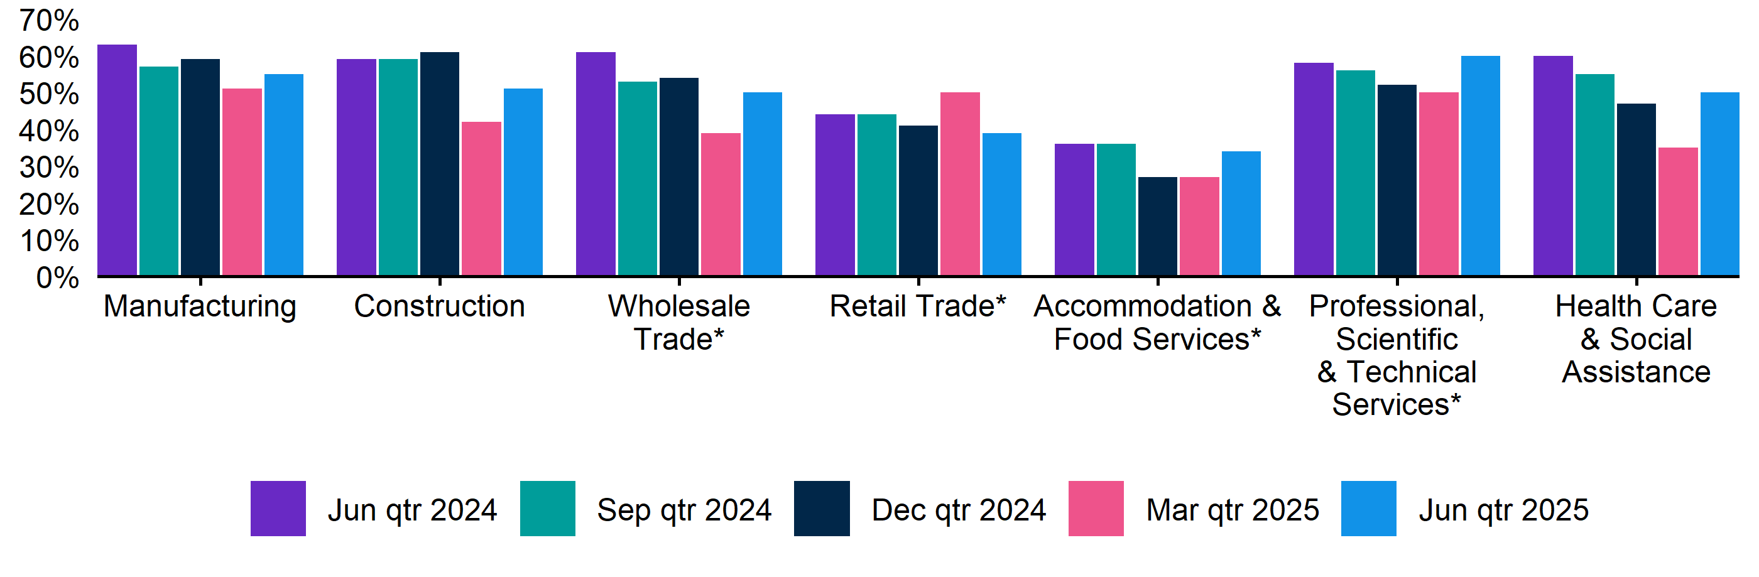  59%* | 59% | 61%* | 42%* | 51%
Wholesale Trade | 61%* | 53%* | 54%* | 39%* | 50%*
Retail Trade | 44% | 44% | 41% | 50%* | 39%*
Accommodation and Food Services | 36% | 36% | 27% | 27%* | 34%*
Professional, Scientific and Technical Services | 58%* | 56%* | 52%* | 50%* | 60%*
Health Care and Social Assistance | 60% | 55% | 47% | 35% | 50%

Key indicators by selected occupation groups
In the June quarter 2025, Technicians and Trades Workers recorded the highest recruitment difficulty rate (67%) — though it has fallen 8 percentage points from 75% in the same quarter last year. The greatest proportions of recruiting employers with vacancies remaining unfilled for over a month were among those recruiting for Professionals, and Technicians and Trades Workers (both 61%).

Table 4. Key indicators by occupation, June quarter 2025
 | Recruitment difficulty rate |  | Vacancies taking longer  than 1 month to fill
 | % of recruiting employers | Annual change  (% points) | % of recruiting employers | Annual change  (% points)
Professionals | 61%* | -3 pts* | 61%* | 4 pts*
Technicians and Trades Workers | 67% | -8 pts | 61% | -11 pts
Community and Personal Service Workers | 45% | -10 pts | 29%* | -15 pts*
Clerical and Administrative Workers | 43%* | 12 pts* | 31%* | 2 pts*
Sales Workers | 37% | -6 pts | 27% | -5 pts
Machinery Operators and Drivers | 47%* | -6 pts* | 34%* | -8 pts*
Labourers | 43% | -2 pts | 31%* | -1 pt*

*Interpret with caution due to low sample size.

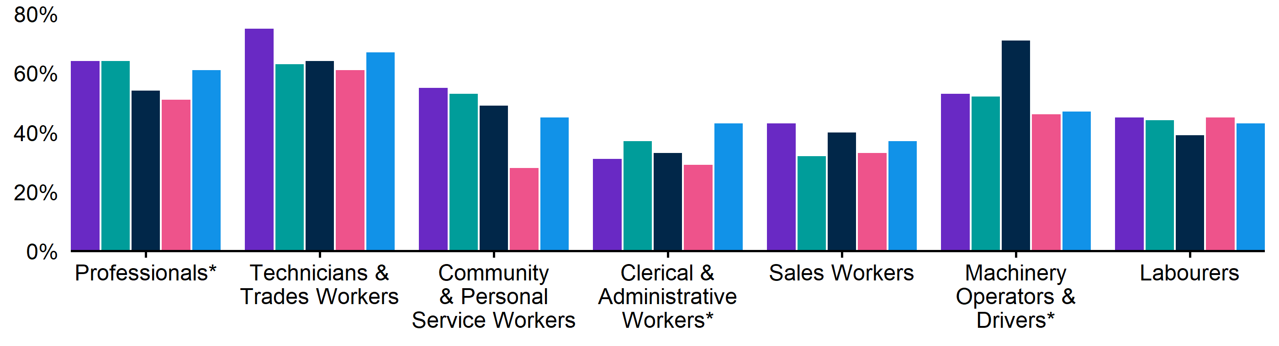
Figure 9. Recruitment difficulty rate by occupation, June quarter 2024 - June quarter 2025
 | Jun qtr 2024 | Sep qtr 2024 | Dec qtr 2024 | Mar qtr 2025 | Jun qtr 2025
Professionals | 64% | 64% | 54%* | 51% | 61%*
Technicians and Trades Workers | 75% | 63% | 64% | 61% | 67%
Community and Personal Service Workers | 55% | 53% | 49% | 28% | 45%
Clerical and Administrative Workers | 31% | 37% | 33% | 29%* | 43%*
Sales Workers | 43% | 32% | 40% | 33% | 37%
Machinery Operators and Drivers | 53%* | 52%* | 71%* | 46%* | 47%*
Labourers | 45% | 44% | 39% | 45% | 43%

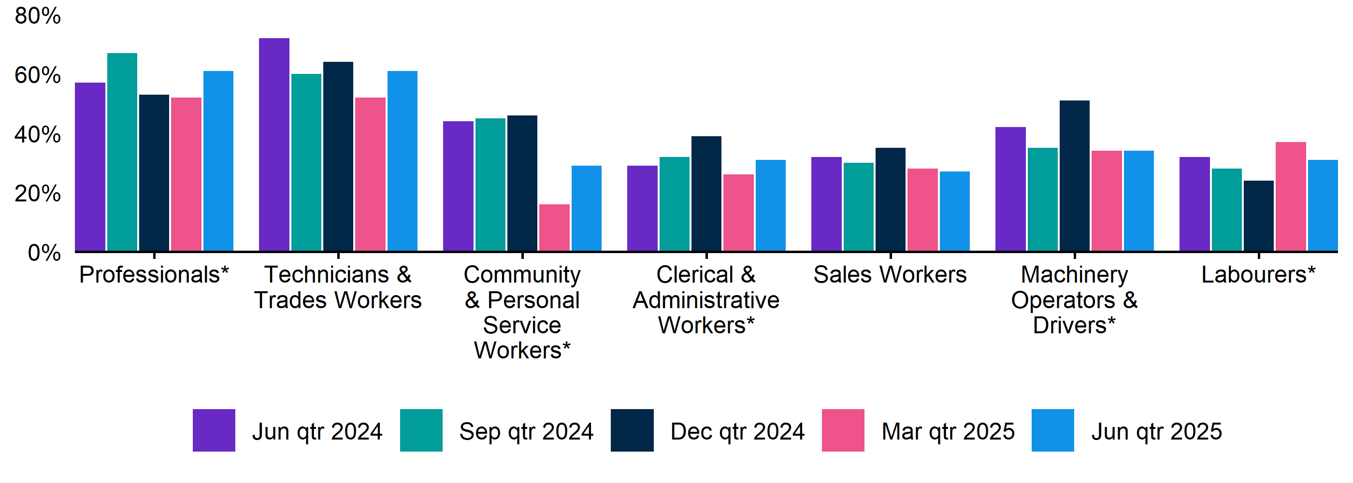
Figure 10. Vacancies taking longer than 1 month to fill, by occupation group, June quarter 2024 - June quarter 2025
 | Jun qtr 2024 | Sep qtr 2024 | Dec qtr 2024 | Mar qtr 2025 | Jun qtr 2025
Professionals | 57%* | 67%* | 53%* | 52%* | 61%*
Technicians and Trades Workers | 72% | 60% | 64% | 52% | 61%
Community and Personal Service Workers | 44% | 45% | 46% | 16%* | 29%*
Clerical and Administrative Workers | 29%* | 32%* | 39%* | 26%* | 31%*
Sales Workers | 32% | 30% | 35% | 28% | 27%
Machinery Operators and Drivers | 42%* | 35%* | 51%* | 34%* | 34%*
Labourers | 32% | 28% | 24% | 37%* | 31%*

REOS Background and Notes
Jobs and Skills Australia conducts the Recruitment Experiences and Outlook Survey (REOS), a telephone administered survey of at least 800 employers each month (except for December and January, during which fewer employers are surveyed). While the results are indicative of recruitment activity, they may be subject to seasonal factors and other volatility and should therefore be used with a degree of caution. In addition, the survey is targeted towards employers with 5 or more employees, and excludes many government organisations. More detail is available at https://www.jobsandskills.gov.au/work/reos-survey-methodology. REOS data are published on the Jobs and Skills Australia website.
Data in this release should be referenced as: Jobs and Skills Australia, Recruitment Experiences and Outlook Survey: June quarter 2025.

Data notations
* Interpret with caution due to low sample size.

Recruitment rate
The proportion of employers either currently recruiting or who had recruited in the previous month. It is calculated by dividing the number of employers who recruited or were attempting to recruit by the number of employers that responded to the survey (excluding ‘unsure’ responses).

Recruitment difficulty rate
The proportion of recruiting employers who experienced difficulty hiring staff. This indicator focuses on the most recent recruitment round in the month prior to being surveyed. The indicator is calculated as: employers who recruited and reported difficulty, divided by all employers who recruited (excluding ‘unsure’ responses).

Expectations to increase staffing levels over the next 3 months
The proportion of employers who expect to increase staff levels over the next 3 months. Expectations to decrease staff is also collected.

Vacancies taking longer than 1 month to fill
The proportion of recruiting employers unable to fill all their vacancies within a month. It excludes employers with unfilled vacancies who have been recruiting for less than a month.

Recent REOS releases
The Jobs and Skills Australia website includes:
- The July 2025 monthly REOS report, including a more detailed excel datafile. The datafile includes both the monthly results as well as the quarterly series. The quarterly estimates are aggregated results for the 3 months within each quarter.
- REOS Spotlight series featuring analysis on topics of interest not covered in the regular monthly REOS report. Recent spotlight releases cover employers’ experiences with retention issues, and how recruitment challenges affect businesses.
For queries, contact: REOS@jobsandskills.gov.au

Australian Bureau of Statistics, Remoteness Areas, Australian Statistical Geography Standard (ASGS) Edition 3, https://www.abs.gov.au/statistics/standards/australian-statistical-geography-standard-asgs-edition-3/jul2021-jun2026/remoteness-structure/remoteness-areas

