

# RLMI Results – March 2025

## Key Findings

Labour market challenges are more pronounced in many regional and remote areas as they are more likely to experience weaker labour market conditions than their major city counterparts. With that said, the March 2025 Regional Labour Market Indicator (RLMI) results help to highlight many regions have benefited from recent strong labour market conditions, although persistent disparity exists between the stronger and poorer-performing regions.

### Labour market challenges are more pronounced in many regional areas

The March 2025 RLMI results confirm that regional and remote areas are more likely to experience weaker labour market conditions than their major city counterparts, highlighting the additional challenges faced in many regional areas by both employers and jobseekers (see Chart 1, below).

* Around half of the SA4’s (15 out of 29) located in regional areas were rated either ‘below average’ or ‘poor’ in March 2025, while all four (or 100%) remote areas were rated either ‘below average’ or ‘poor’.
* Almost two-thirds of the SA4’s (27 out of 44) located in major city areas were rated either ‘strong’ or ‘above average’ in March 2025.

Chart 1: RLMI ratings of relative labour market performance, March 2025

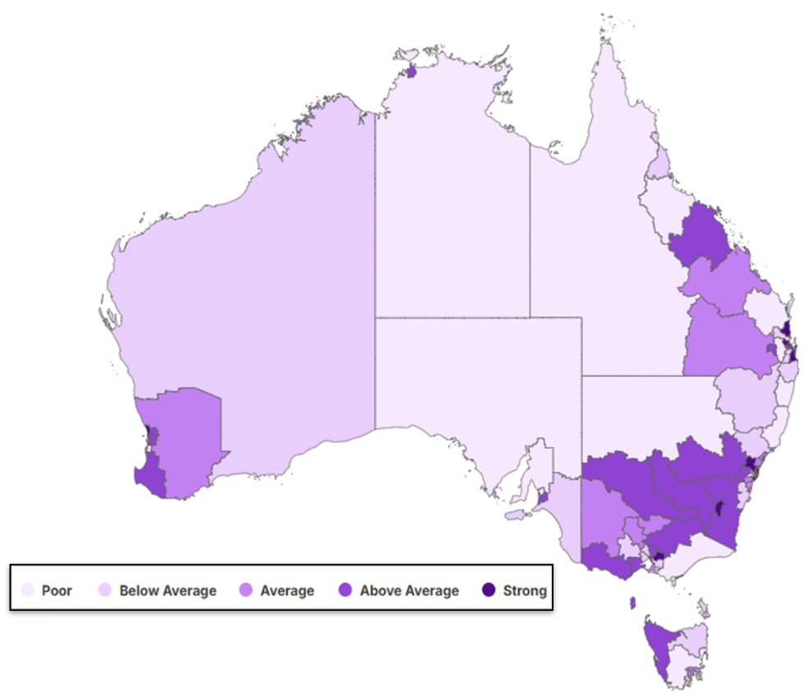

Source: JSA, *Regional Labour Market Indicator (RLMI)*, March 2025

Chart 2: RLMI ratings of relative labour market performance, by selected Capital Cities, March 2025

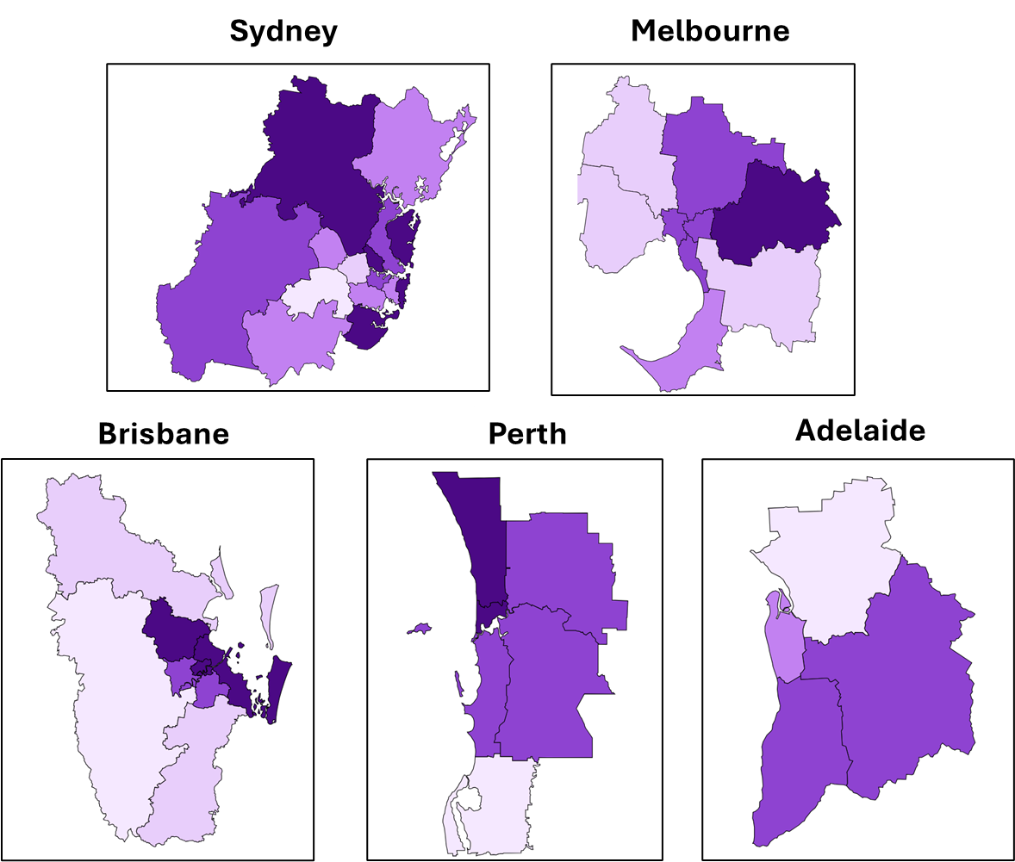

### Recent trends in regional labour market performance

Although labour market challenges are typically more pronounced in many regional and remote areas, the latest RLMI results help to highlight cluster of regions that are currently displaying considerable labour market strength in parts of regional Australia including the Southern Murray-Darling Basin (an area often known as a key part of Australia’s Food Bowl) and the Surf Coast region of Victoria.

### Southern Murray-Darling Basin

**Surf Coast of Victoria** 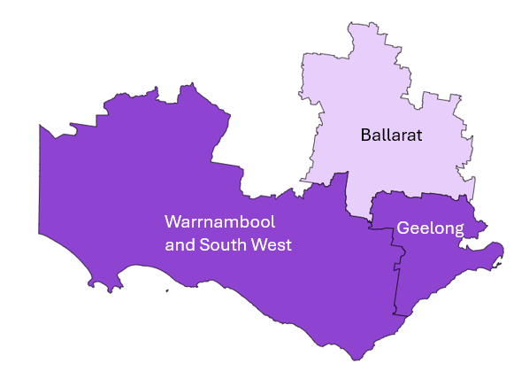

### Many regions have benefited from recent strong conditions, although persistent disparity remains

The recent strength in the Australian labour market has enabled more opportunities for people to find work, including for those regions where labour market challenges are more pronounced.

* For instance, the working age employment rate for regions rated ‘poor’ or ‘below average’ has increased considerably in recent years and remains well above the long-term average recorded prior to the onset of COVID-19 (see Chart 3, below).
  + 79 SA4’s (or 91%) recorded an employment rate of more than 70% in March 2025, well above the 54 SA4’s (or 62%) recorded a decade ago.
* Similarly, the unemployment rate for regions rated ‘poor’ or ‘below average’ has fallen sharply in recent years and remains well below the long-term average recorded prior to the onset of COVID-19 (see Chart 4, below).
  + 72 SA4’s (or 83%) recorded an unemployment rate of less than 5% in March 2025, well above the 13 (or 15%) recorded a decade ago.

While these findings show how conditions for many regions have improved in recent years, relative to their historical performance, they also highlight the persistent disparity that exists between the stronger and poorer-performing regions.

**Chart 3: Employment rate by RLMI rating, 10 years to March 2025**

Source: ABS, Labour Force, Detailed, March 2025, 12-month averages of original estimates.

**Chart 4: Unemployment rate by RLMI rating, 10 years to March 2025**

Source: ABS, Labour Force, Detailed, March 2025, modelled estimates.

### In focus: Western Australia

The Western Australian labour market has been particularly strong over the last few years, supported by a high performing domestic economy, stronger than expected population growth and high demand for workers, which have kept the labour market tight.

Western Australia has been rated Australia’s top performing economy for 3 quarters in a row by CommSec in their *State of the State* reports, with the commodities and tourism-heavy state continuing to outperform the rest of the nation.

* Western Australia ranked first on five economic indicators including retail spending, unemployment, population growth, housing finance and dwelling approvals.

The latest RLMI result also highlight the strength of the labour market in Western Australian. Of the 9 SA4s in Western Australia, 6 were rated ‘above average’ or ‘strong’ in March 2025. This was an increase from 4 regions one year ago and just 3 regions 5 years ago. A high employment rate and low unemployment rate have driven the improvement in labour market conditions in the state.

* Despite the overall improvement at the state level, the SA4 of Mandurah, in Greater Perth, has a long history of poor labour market outcomes, with the region experiencing a persistently high relative rate of unemployment that is exacerbated by limited employment opportunities and a mismatch between potential workers and available work. Improving labour market outcomes in a region that has persistent and ongoing disadvantage, like Mandurah, will require a focused and nuanced approach to addressing structural sources of underutilisation.

## Labour Market Rating by SA4, March 2025

|  |  |  |  |  |
| --- | --- | --- | --- | --- |
| **Statistical Area Level 4 (SA4)** | **Remoteness** | **Mar-24** | **Mar-25** | **Direction** |
| Central Coast | Major City | Average | Average | Stable |
| Sydney - Baulkham Hills and Hawkesbury | Major City | Strong | Strong | Stable |
| Sydney - Blacktown | Major City | Average | Average | Stable |
| Sydney - City and Inner South | Major City | Above average | Average | Declined |
| Sydney - Eastern Suburbs | Major City | Strong | Strong | Stable |
| Sydney - Inner South West | Major City | Average | Average | Stable |
| Sydney - Inner West | Major City | Strong | Above average | Declined |
| Sydney - North Sydney and Hornsby | Major City | Strong | Above average | Declined |
| Sydney - Northern Beaches | Major City | Strong | Strong | Stable |
| Sydney - Outer South West | Major City | Average | Average | Stable |
| Sydney - Outer West and Blue Mountains | Major City | Strong | Above average | Declined |
| Sydney - Parramatta | Major City | Below average | Below average | Stable |
| Sydney - Ryde | Major City | Above average | Strong | Improved |
| Sydney - South West | Major City | Poor | Poor | Stable |
| Sydney - Sutherland | Major City | Strong | Strong | Stable |
| Capital Region | Regional | Above average | Above average | Stable |
| New South Wales - Central West | Regional | Above average | Above average | Stable |
| Coffs Harbour - Grafton | Regional | Poor | Poor | Stable |
| Far West and Orana | Regional | Poor | Poor | Stable |
| Hunter Valley exc Newcastle | Regional | Average | Below average | Declined |
| Illawarra | Cities of Regional Australia | Average | Average | Stable |
| Mid North Coast | Regional | Poor | Poor | Stable |
| Murray | Regional | Above average | Above average | Stable |
| New England and North West | Regional | Average | Below average | Declined |
| Newcastle and Lake Macquarie | Cities of Regional Australia | Above average | Average | Declined |
| Richmond - Tweed | Regional | Average | Below average | Declined |
| Riverina | Regional | Below average | Above average | Improved |
| Southern Highlands and Shoalhaven | Regional | Below average | Below average | Stable |
| Melbourne - Inner | Major City | Above average | Above average | Stable |
| Melbourne - Inner East | Major City | Above average | Above average | Stable |
| Melbourne - Inner South | Major City | Strong | Above average | Declined |
| Melbourne - North East | Major City | Average | Above average | Improved |
| Melbourne - North West | Major City | Below average | Below average | Stable |
| Melbourne - Outer East | Major City | Strong | Strong | Stable |
| Melbourne - South East | Major City | Below average | Below average | Stable |
| Melbourne - West | Major City | Below average | Below average | Stable |
| Mornington Peninsula | Major City | Average | Average | Stable |
| Ballarat | Regional | Poor | Below average | Improved |
| Bendigo | Regional | Average | Average | Stable |
| Geelong | Cities of Regional Australia | Strong | Above average | Declined |
| Hume | Regional | Above average | Above average | Stable |
| Latrobe - Gippsland | Regional | Below average | Poor | Declined |
| Victoria - North West | Regional | Average | Average | Stable |
| Shepparton | Regional | Above average | Average | Declined |
| Warrnambool and South West | Regional | Above average | Above average | Stable |

|  |  |  |  |  |
| --- | --- | --- | --- | --- |
| **Statistical Area Level 4 (SA4)** | **Remoteness** | **Mar-24** | **Mar-25** | **Direction** |
| Brisbane - East | Major City | Above average | Strong | Improved |
| Brisbane - North | Major City | Above average | Strong | Improved |
| Brisbane - South | Major City | Above average | Above average | Stable |
| Brisbane - West | Major City | Strong | Above average | Declined |
| Brisbane Inner City | Major City | Strong | Strong | Stable |
| Ipswich | Major City | Poor | Poor | Stable |
| Logan - Beaudesert | Major City | Poor | Below average | Improved |
| Moreton Bay - North | Major City | Poor | Below average | Improved |
| Moreton Bay - South | Major City | Above average | Strong | Improved |
| Cairns | Cities of Regional Australia | Below average | Below average | Stable |
| Darling Downs - Maranoa | Regional | Average | Average | Stable |
| Central Queensland | Regional | Below average | Average | Improved |
| Gold Coast | Cities of Regional Australia | Above average | Strong | Improved |
| Mackay - Isaac - Whitsunday | Regional | Above average | Above average | Stable |
| Queensland - Outback | Remote | Poor | Poor | Stable |
| Sunshine Coast | Cities of Regional Australia | Above average | Strong | Improved |
| Toowoomba | Cities of Regional Australia | Below average | Above average | Improved |
| Townsville | Cities of Regional Australia | Average | Poor | Declined |
| Wide Bay | Regional | Poor | Poor | Stable |
| Adelaide - Central and Hills | Major City | Strong | Above average | Declined |
| Adelaide - North | Major City | Poor | Poor | Stable |
| Adelaide - South | Major City | Above average | Above average | Stable |
| Adelaide - West | Major City | Average | Average | Stable |
| Barossa - Yorke - Mid North | Regional | Poor | Poor | Stable |
| South Australia - Outback | Remote | Poor | Poor | Stable |
| South Australia - South East | Regional | Average | Below average | Declined |
| Mandurah | Major City | Below average | Poor | Declined |
| Perth - Inner | Major City | Strong | Strong | Stable |
| Perth - North East | Major City | Above average | Above average | Stable |
| Perth - North West | Major City | Strong | Strong | Stable |
| Perth - South East | Major City | Average | Above average | Improved |
| Perth - South West | Major City | Above average | Above average | Stable |
| Bunbury | Regional | Above average | Above average | Stable |
| Western Australia - Outback (North and South) | Remote | Below average | Below average | Stable |
| Western Australia - Wheat Belt | Regional | Average | Average | Stable |
| Hobart | Cities of Regional Australia | Average | Average | Stable |
| Launceston and North East | Regional | Below average | Below average | Stable |
| Tasmania - South East | Regional | Poor | Poor | Stable |
| Tasmania - West and North West | Regional | Below average | Poor | Declined |
| Darwin | Cities of Regional Australia | Above average | Above average | Stable |
| Northern Territory - Outback | Remote | Poor | Poor | Stable |
| Australian Capital Territory | Major City | Strong | Strong | Stable |

Source: JSA, *Regional Labour Market Indicator (RLMI)*, March 2025

## RLMI Explanatory Notes

### Overview

The Regional Labour Market Indicator (RLMI) combines key indicators of spare labour market capacity, from both an employee and employer perspective, into a single, and easy to interpret, summary measure.

Regions are grouped into distinct categories of overall labour market performance, ranging from ‘poor’ to ‘strong’, which provides an accurate and reliable view of labour market performance, relative to the national average.

A strong labour market, that is characterised by a high rate of employment, where employment opportunities are extended to all who want them, is central to a strong economy and prosperous and inclusive society.

**Factors used to assess labour market performance**

The **working age (15-64 years) employment rate** is one of the most commonly used indicators for understanding conditions in the labour market and is a key measure of performance. It provides an insight into the extent to which available labour (some individual’s personal circumstances may prevent them from participating in the labour market) is being used and is unaffected by voluntary changes in labour force participation.

Along with the employment rate, the **unemployment rate** is one of the most commonly used indicators for understanding conditions in the labour market and is a key measure of spare capacity. It provides insights into the availability of unused labour that is willing and available for work.

The **JobSeeker income support rate** is a reliable measure of spare capacity in the labour market and is an important complement to other measures of spare capacity. It is a combination of the JobSeeker payment and Youth Allowance (other) payment, measured as a proportion of the working age population. These payments are designed to provide financial assistance to support those looking for working, including those who may be working part-time.

The **underemployment rate**[1] takes a broad view of underutilisation by measuring the share of the labour force that is employed, but not fully utilised in terms of the amount of work people would like. It is an important complement to the unemployment rate in assessing how much spare capacity could be called upon in adapting to labour market strength and weakness.

The **vacancy fill rate**2is a key measure of unmet demand for labour. A low fill rate indicates that the demand for labour is not matched by the supply of labour from workers. This may be due to a lack of suitable applicants or high search costs that reduce labour market matching efficiency. Poorer-performing regions experience more difficulty filling vacant positions, despite having a higher availability of unused labour willing and available to work.

### Methodology

Please refer to the [RLMI Methodology Paper](https://www.jobsandskills.gov.au/data/regional-labour-market-indicator#methodology) for more information on the RLMI, including its purpose and factor selection.

### Referencing this report

Data in this release should be referenced as: Jobs and Skills Australia, RLMI, March 2025

### Contact us

For additional information, email [RegionalWorkforceAssessment@jobsandskills.gov.au](mailto:RegionalWorkforceAssessment@jobsandskills.gov.au)

1. Measured at the Greater Capital City Statistical Area (GCCSA) level due to data quality issues with this factor at the SA4 level.