Recruitment Experiences and Outlook Survey: March quarter 2025
Jobs and Skills Australia conducts the Recruitment Experiences and Outlook Survey (REOS) to monitor recruitment activity and conditions across Australia. Key national indicators from the survey are released monthly; more detailed data disaggregated by state, area, industry, and occupation are released in this quarterly report. For definitions, further information on these data and the REOS, please refer to the notes on the last page.

Recruitment rate - National level
Mar qtr 2022 Jun qtr 2022 Sep qtr 2022 Dec qtr 2022 Mar qtr 2023 Jun qtr 2023 Sep qtr 2023 Dec qtr 2023 Mar qtr 2024 Jun qtr 2024 Sep qtr 2024 Dec qtr 2024 Mar qtr 2025  53% 58% 57% 56% 55% 50% 48% 50% 49% 45% 44% 43% 46%  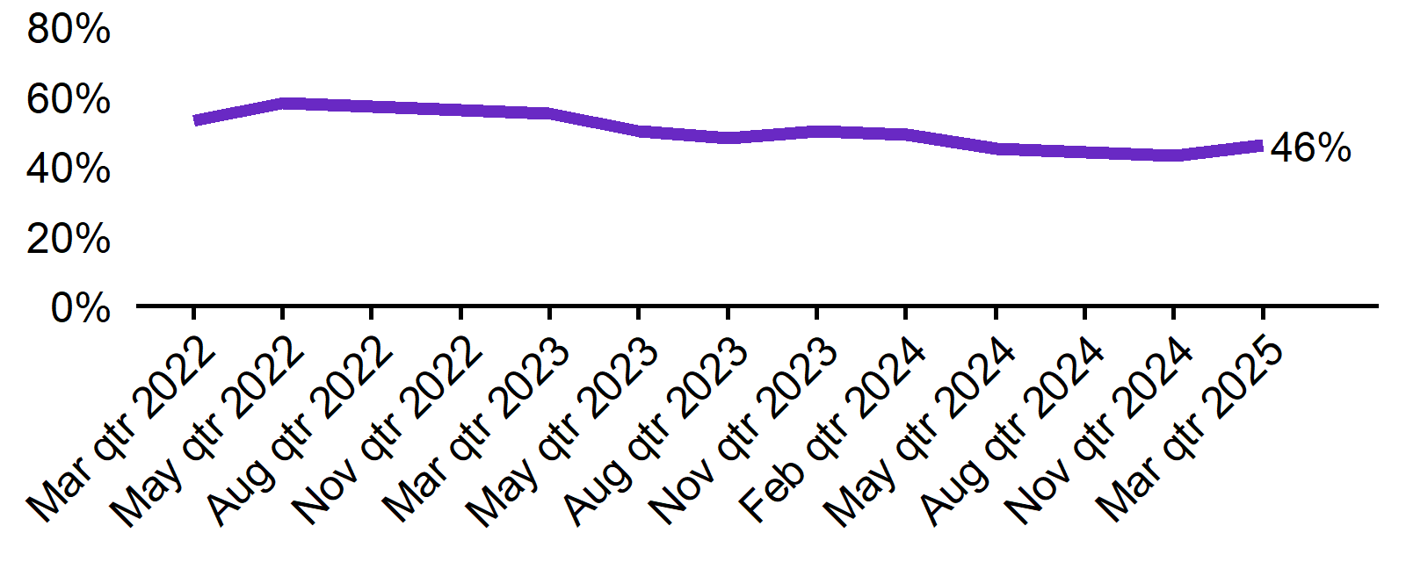 | - The recruitment rate in the March quarter 2025 was 46%.  - This was 3 percentage points lower than this time last year (49%).

Recruitment difficulty rate - National level
Mar qtr 2022 Jun qtr 2022 Sep qtr 2022 Dec qtr 2022 Mar qtr 2023 Jun qtr 2023 Sep qtr 2023 Dec qtr 2023 Mar qtr 2024 Jun qtr 2024 Sep qtr 2024 Dec qtr 2024 Mar qtr 2025  64% 67% 72% 68% 62% 64% 60% 55% 53% 55% 50% 50% 43%  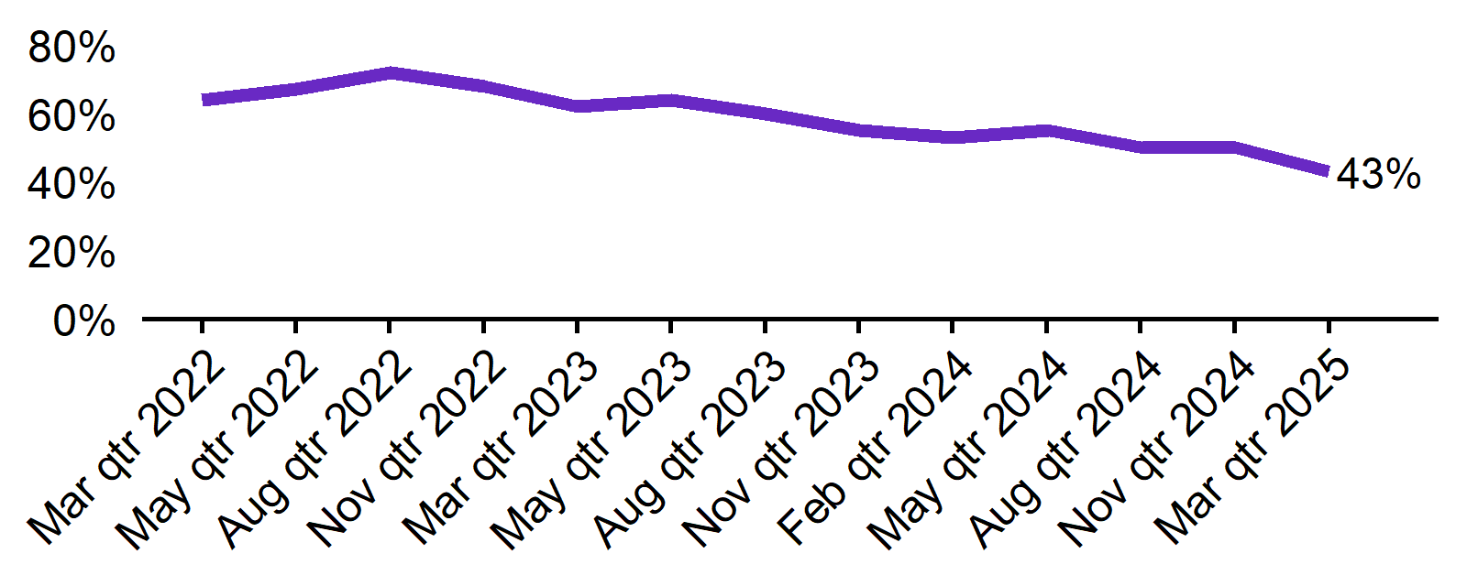 | - The recruitment difficulty rate in the March quarter 2025 was 43%.  - This was 10 percentage points lower than this time last year (53%).

Expecting to increase staff - National level
Mar qtr 2022 Jun qtr 2022 Sep qtr 2022 Dec qtr 2022 Mar qtr 2023 Jun qtr 2023 Sep qtr 2023 Dec qtr 2023 Mar qtr 2024 Jun qtr 2024 Sep qtr 2024 Dec qtr 2024 Mar qtr 2025  30% 31% 28% 29% 28% 22% 24% 21% 24% 19% 20% 19% 20%  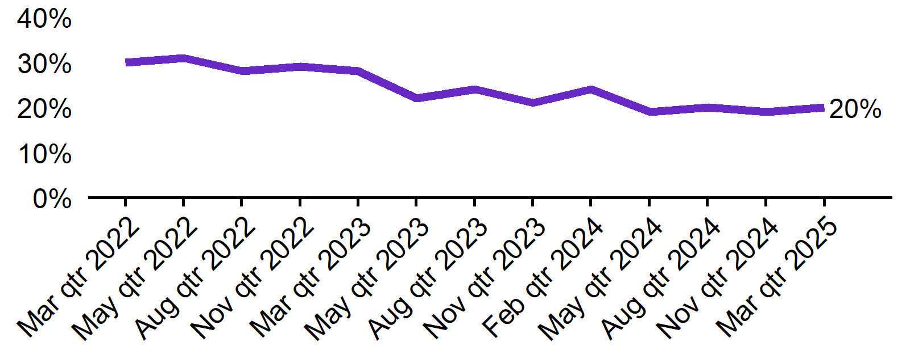 | - In the March quarter 2025, 20% of employers expected to increase staff. This was 4 percentage points lower than this time last year (24%).  - The proportion of employers who expected to decrease staff was 4% in the March quarter 2025.

Key indicators by state/territory
In the March quarter 2025, Queensland recorded the highest recruitment rate (53%) of the six states. At 45%, Queensland also recorded the highest rate of state recruitment difficulty. Out of all states and territories, Northern Territory reported both the highest recruitment rate (61%) and the highest recruitment difficulty (57%*) in the March quarter 2025. The most significant changes in both indicators were observed in ACT, with 10 percentage points decrease in recruitment rate and 18 percentage points decrease in recruitment difficulty rate compared to the same period last year.
The proportion of employers expecting to increase staff also decreased in all states and territories over the year, with the largest drop observed in Tasmania (10 percentage points).

Table 1. Key indicators by state/territory, March quarter 2025
 | Recruitment rate |  | Recruitment difficulty rate |  | Expect to increase staff
 | % of employers | Annual change  (% points) | % of recruiting employers | Annual change  (% points) | % of employers | Annual change  (% points)
NSW | 44% | -1 pt | 43% | -9 pts | 18% | -5 pts
VIC | 39% | -7 pts | 43% | -9 pts | 19% | -5 pts
QLD | 53% | -3 pts | 45% | -11 pts | 22% | -2 pts
SA | 52% | 7 pts | 42%* | -9 pts* | 17% | -7 pts
WA | 50% | -2 pts | 43% | -11 pts | 22% | -4 pts
TAS | 47% | -3 pts | 36%* | -15 pts* | 15% | -10 pts
NT# | 61% | -9 pts | 57%* | -2 pts* | 32% | -4 pts
ACT# | 45% | -10 pts | 31%* | -18 pts* | 18% | -9 pts

# Due to smaller sample sizes, data for the NT and ACT are based on six-month average data (Dec qtr. 2024 to Mar qtr. 2025).
* Interpret with caution due to low sample size.

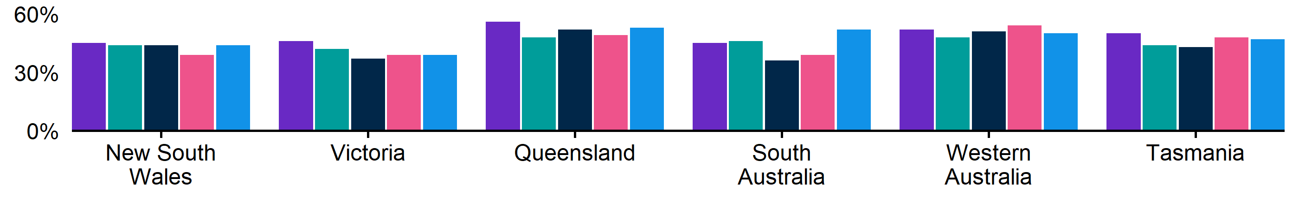
Figure 1. Recruitment rate by state, March quarter 2024 - March quarter 2025
 | Mar qtr 2024 | Jun qtr 2024 | Sep qtr 2024 | Dec qtr 2024 | Mar qtr 2025
NSW | 45% | 44% | 44% | 39% | 44%
VIC | 46% | 42% | 37% | 39% | 39%
QLD | 56% | 48% | 52% | 49% | 53%
SA | 45% | 46% | 36% | 39% | 52%
WA | 52% | 48% | 51% | 54% | 50%
TAS | 50% | 44% | 43% | 48% | 47%

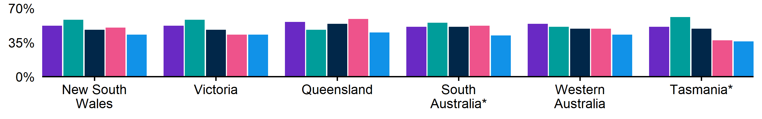
Figure 2. Recruitment difficulty rate by state, March quarter 2024 - March quarter 2025
 | Mar qtr 2024 | Jun qtr 2024 | Sep qtr 2024 | Dec qtr 2024 | Mar qtr 2025
NSW | 52% | 58% | 48% | 50% | 43%
VIC | 52% | 58% | 48% | 43% | 43%
QLD | 56% | 48% | 54% | 59% | 45%
SA | 51% | 55% | 51%* | 52% | 42%*
WA | 54% | 51% | 49% | 49% | 43%
TAS | 51% | 61%* | 49%* | 37%* | 36%*

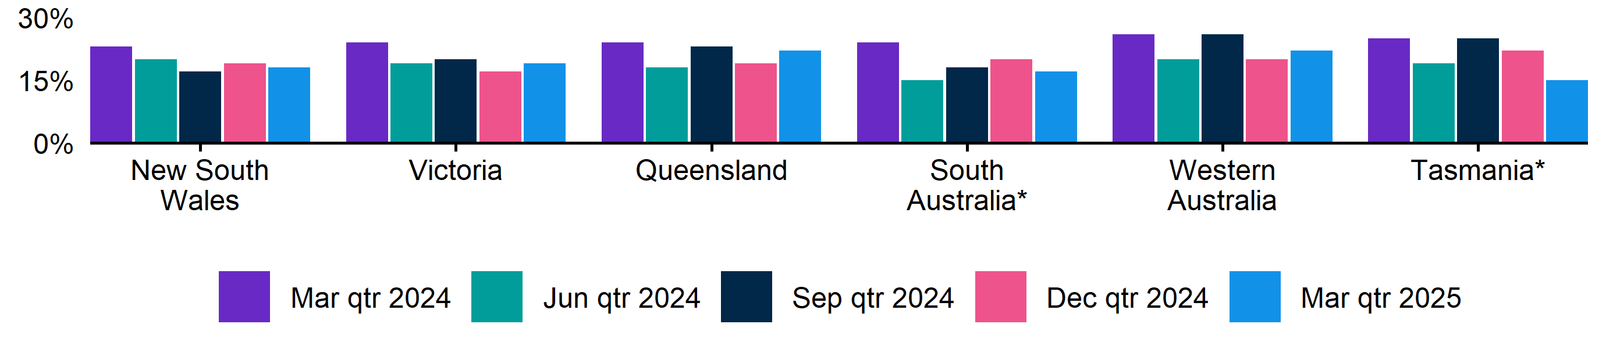
Figure 3. Expecting to increase staff numbers over the next 3 months by state, March quarter 2024 - March quarter 2025
 | Mar qtr 2024 | Jun qtr 2024 | Sep qtr 2024 | Dec qtr 2024 | Mar qtr 2025
NSW | 23% | 20% | 17% | 19% | 18%
VIC | 24% | 19% | 20% | 17% | 19%
QLD | 24% | 18% | 23% | 19% | 22%
SA | 24% | 15% | 18% | 20% | 17%
WA | 26% | 20% | 26% | 20% | 22%
TAS | 25% | 19% | 25% | 22% | 15%

Key indicators by remoteness classification (ARIA location)
In the March quarter 2025, Outer Regional, Remote and Very Remote Australia recorded the highest recruitment rate (54%) of the ARIA locations. At 52%, Inner Regional Australia recorded the highest rate of recruitment difficulty. Outer Regional, Remote and Very Remote Australia experienced the largest drop in recruitment difficulty rate (24 percentage points lower compared to the same period last year). The region also had the highest proportion of employers with an expectation to increase staffing level in the next three months (23%).

Table 2. Key indicators by ARIA location, March quarter 2025
 | Recruitment rate |  | Recruitment difficulty rate |  | Expect to increase staff
 | % of employers | Annual change  (% points) | % of recruiting employers | Annual change  (% points) | % of employers | Annual change  (% points)
Major Cities of Australia | 44% | -2 pts | 41% | -8 pts | 19% | -5 pts
Inner Regional Australia | 47% | -7 pts | 52% | -7 pts | 20% | -4 pts
Outer Regional, Remote and Very Remote Australia | 54% | 0 pts | 41% | -24 pts | 23% | -5 pts

* Interpret with caution due to low sample size. Accessibility and Remoteness Index of Australia (ARIA) classifications of Outer Regional Australia, Remote Australia, and Very Remote Australia have been combined into one category to increase sample size.

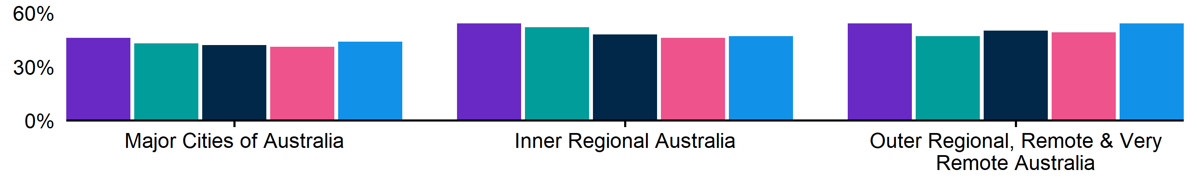
Figure 4. Recruitment rate by ARIA location, March quarter 2024 - March quarter 2025
 | Mar qtr 2024 | Jun qtr 2024 | Sep qtr 2024 | Dec qtr 2024 | Mar qtr 2025
Major Cities of Australia | 46% | 43% | 42% | 41% | 44%
Inner Regional Australia | 54% | 52% | 48% | 46% | 47%
Outer Regional, Remote and Very Remote Australia | 54% | 47% | 50% | 49% | 54%

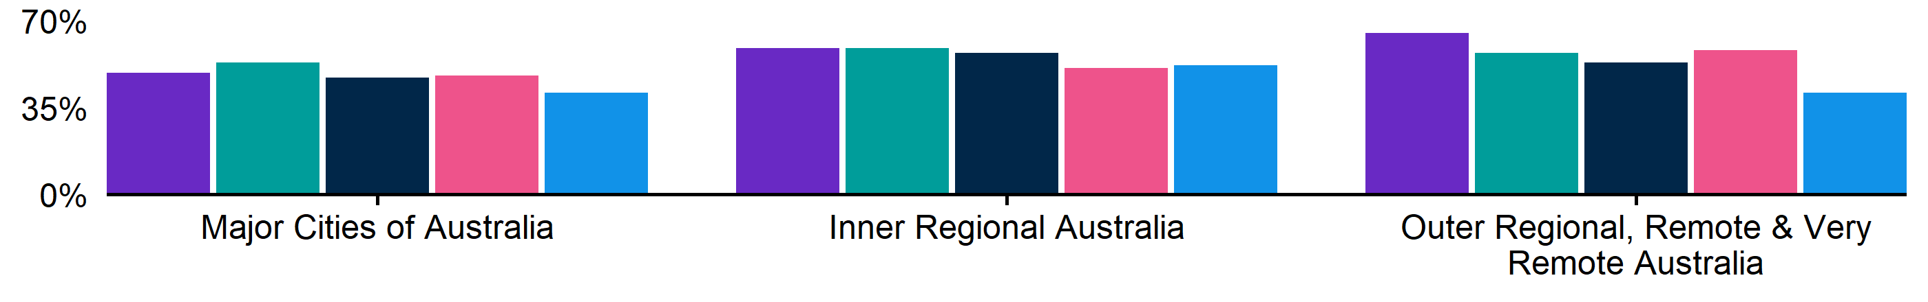
Figure 5. Recruitment difficulty rate by ARIA location, March quarter 2024 - March quarter 2025
 | Mar qtr 2024 | Jun qtr 2024 | Sep qtr 2024 | Dec qtr 2024 | Mar qtr 2025
Major Cities of Australia | 49% | 53% | 47% | 48% | 41%
Inner Regional Australia | 59% | 59% | 57% | 51% | 52%
Outer Regional, Remote and Very Remote Australia | 65% | 57% | 53% | 58% | 41%

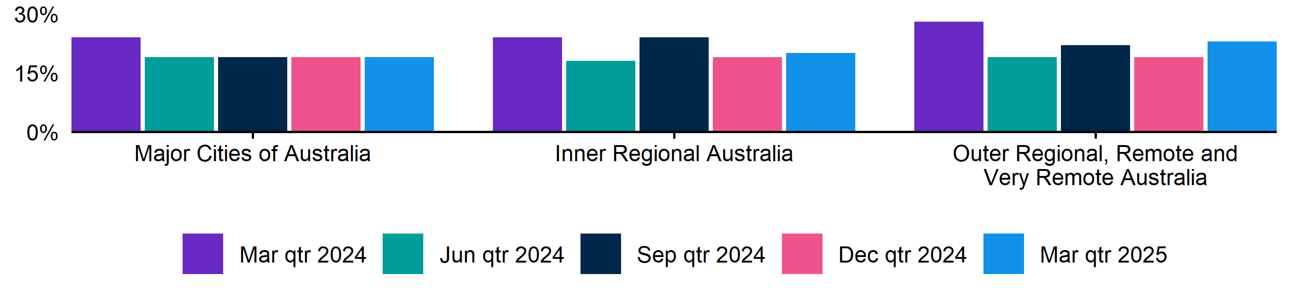
Figure 6. Expecting to increase staff numbers over the next 3 months by ARIA location, March quarter 2024 - March quarter 2025
 | Mar qtr 2024 | Jun qtr 2024 | Sep qtr 2024 | Dec qtr 2024 | Mar qtr 2025
Major Cities of Australia | 24% | 19% | 19% | 19% | 19%
Inner Regional Australia | 24% | 18% | 24% | 19% | 20%
Outer Regional, Remote and Very Remote Australia | 28% | 19% | 22% | 19% | 23%

Key indicators by selected industries
In the March quarter 2025, Accommodation and Food Services (62%) recorded the highest recruitment rate of the selected industries. At 51%, Manufacturing recorded the highest rate of recruitment difficulty. It is important to note that the Accommodation and Food Services industry reported the lowest recruitment difficulty rate for the quarter (27%) and at the same time, the greatest proportion of employers expecting to increase staff (23%). Both the Construction and Manufacturing industries indicated a comparably high expected increase in future staffing levels, with 23% and 22% respectively.

Table 3. Key indicators by industry, March quarter 2025
 | Recruitment rate |  | Recruitment difficulty rate |  | Expect to increase staff
 | % of employers | Annual change  (% points) | % of recruiting employers | Annual change  (% points) | % of employers | Annual change  (% points)
Manufacturing | 48% | 2 pts | 51% | -10 pts | 22% | -3 pts
Construction | 42% | -6 pts | 42%* | -13 pts* | 23% | 0 pts
Wholesale Trade | 36% | -7 pts | 39%* | -8 pts* | 16% | -5 pts
Retail Trade | 38% | -5 pts | 50%* | -2 pts* | 18% | -5 pts
Accommodation and Food Services | 62% | -2 pts | 27%* | -9 pts* | 23% | -3 pts
Professional, Scientific and Technical Services | 41% | 0 pts | 50%* | -4 pts* | 17% | -6 pts
Health Care and Social Assistance | 52% | -3 pts | 35% | -15 pts | 17% | -8 pts

*Interpret with caution due to low sample size.

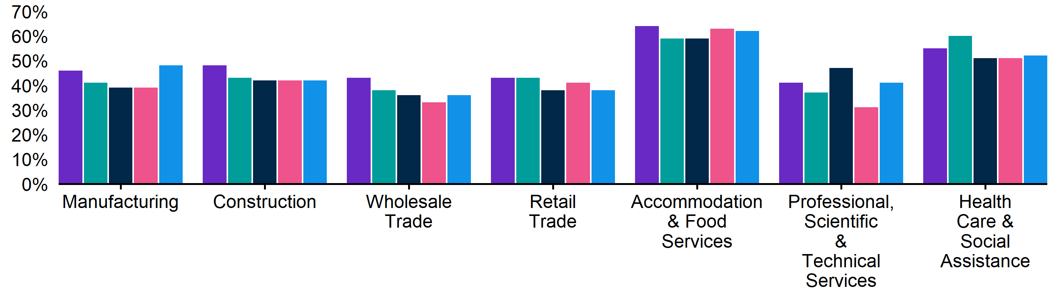
Figure 7. Recruitment rate by industry, March quarter 2024 - March quarter 2025
 | Mar qtr 2024 | Jun qtr 2024 | Sep qtr 2024 | Dec qtr 2024 | Mar qtr 2025
Manufacturing | 46% | 41% | 39% | 39% | 48%
Construction | 48% | 43% | 42% | 42% | 42%
Wholesale Trade | 43% | 38% | 36% | 33% | 36%
Retail Trade | 43% | 43% | 38% | 41% | 38%
Accommodation and Food Services | 64% | 59% | 59% | 63% | 62%
Professional, Scientific and Technical Services | 41% | 37% | 47% | 31% | 41%
Health Care and Social Assistance | 55% | 60% | 51% | 51% | 52%

Figure 8. Recruitment difficulty rate by industry, March quarter 2024 - March quarter 2025
 | Mar qtr 2024 | Jun qtr 2024 | Sep qtr 2024 | Dec qtr 2024 | Mar qtr 2025
Manufacturing | 61% | 63% | 57% | 59% | 51%
Construction | 55% | 59%* | 59% | 61%* | 42%*
Wholesale Trade | 47%* | 61%* | 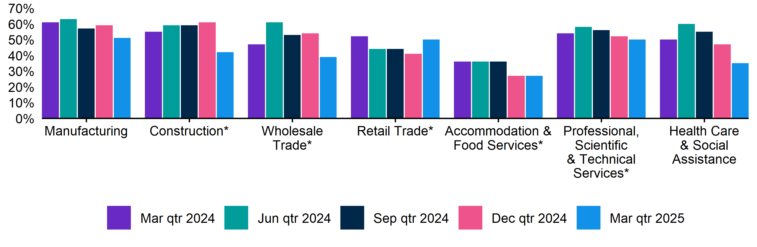  53%* | 54%* | 39%*
Retail Trade | 52% | 44% | 44% | 41% | 50%*
Accommodation and Food Services | 36% | 36% | 36% | 27% | 27%*
Professional, Scientific and Technical Services | 54% | 58%* | 56%* | 52%* | 50%*
Health Care and Social Assistance | 50% | 60% | 55% | 47% | 35%

Key indicators by selected occupation groups
In the March quarter 2025, Technicians and Trades Workers (61%), recorded the highest rate of recruitment difficulty. Employers recruiting for Professionals (52%*) and Technicians and Trades Workers (52%) had the highest proportion of employers with vacancies that have remained unfilled for longer than a month. Compared with a year ago, there are declines in both the recruitment difficulty rate and the share of vacancies taking longer than one month to fill across six out of the seven reported occupation groups.

Table 4. Key indicators by occupation, March quarter 2025
 | Recruitment difficulty rate |  | Vacancies taking longer  than 1 month to fill
 | % of recruiting employers | Annual change  (% points) | % of recruiting employers | Annual change  (% points)
Professionals | 51% | -12 pts | 52%* | -19 pts*
Technicians and Trades Workers | 61% | -10 pts | 52% | -15 pts
Community and Personal Service Workers | 28% | -20 pts | 16%* | -31 pts*
Clerical and Administrative Workers | 29%* | -4 pts* | 26%* | -15 pts*
Sales Workers | 33% | -16 pts | 28% | -21 pts
Machinery Operators and Drivers | 46%* | -10 pts* | 34%* | -13 pts*
Labourers | 45% | 7 pts | 37%* | 6 pts*

*Interpret with caution due to low sample size.

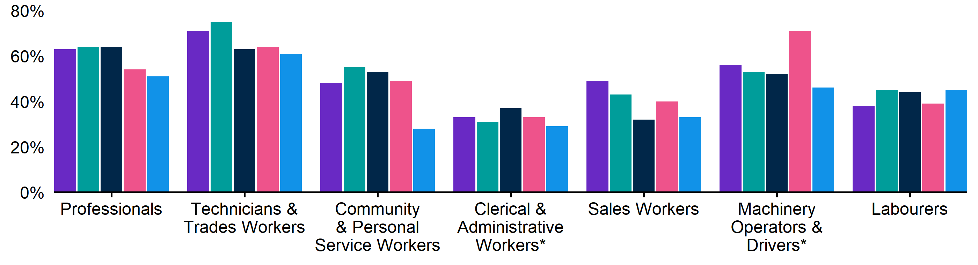
Figure 9. Recruitment difficulty rate by occupation, March quarter 2024 - March quarter 2025
 | Mar qtr 2024 | Jun qtr 2024 | Sep qtr 2024 | Dec qtr 2024 | Mar qtr 2025
Professionals | 63% | 64% | 64% | 54%* | 51%
Technicians and Trades Workers | 71% | 75% | 63% | 64% | 61%
Community and Personal Service Workers | 48% | 55% | 53% | 49% | 28%
Clerical and Administrative Workers | 33% | 31% | 37% | 33% | 29%*
Sales Workers | 49% | 43% | 32% | 40% | 33%
Machinery Operators and Drivers | 56%* | 53%* | 52%* | 71%* | 46%*
Labourers | 38% | 45% | 44% | 39% | 45%

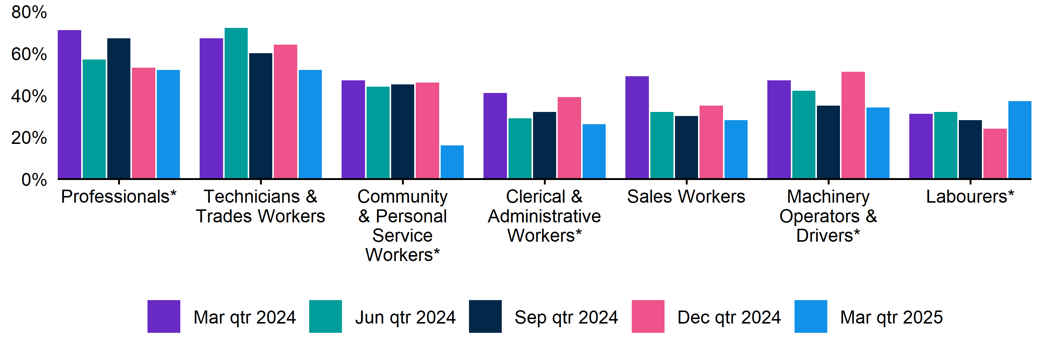
Figure 10. Vacancies taking longer than 1 month to fill, by occupation group, March quarter 2024 - March quarter 2025
 | Mar qtr 2024 | Jun qtr 2024 | Sep qtr 2024 | Dec qtr 2024 | Mar qtr 2025
Professionals | 71% | 57%* | 67%* | 53%* | 52%*
Technicians and Trades Workers | 67% | 72% | 60% | 64% | 52%
Community and Personal Service Workers | 47% | 44% | 45% | 46% | 16%*
Clerical and Administrative Workers | 41% | 29%* | 32%* | 39%* | 26%*
Sales Workers | 49% | 32% | 30% | 35% | 28%
Machinery Operators and Drivers | 47%* | 42%* | 35%* | 51%* | 34%*
Labourers | 31% | 32% | 28% | 24% | 37%*

REOS Background and Notes
Jobs and Skills Australia conducts the Recruitment Experiences and Outlook Survey (REOS), a telephone administered survey of at least 1,000 employers each month (except for December and January, during which fewer employers are surveyed). While the results are indicative of recruitment activity, they may be subject to seasonal factors and other volatility and should therefore be used with a degree of caution. In addition, the survey is targeted towards employers with 5 or more employees, and excludes many government organisations. More detail is available at https://www.jobsandskills.gov.au/work/reos-survey-methodology. REOS data are published on the Jobs and Skills Australia website.
Data in this release should be referenced as: Jobs and Skills Australia, Recruitment Experiences and Outlook Survey: March quarter 2025.

Data notations
* Interpret with caution due to low sample size.

Recruitment rate
The proportion of employers either currently recruiting or who had recruited in the previous month. It is calculated by dividing the number of employers who recruited or were attempting to recruit by the number of employers that responded to the survey (excluding ‘unsure’ responses).

Recruitment difficulty rate
The proportion of recruiting employers who experienced difficulty hiring staff. This indicator focusses on the most recent recruitment round in the month prior to being surveyed. The indicator is calculated as: employers who recruited and reported difficulty, divided by all employers who recruited (excluding ‘unsure’ responses).

Expectations to increase staffing levels over the next 3 months
This is calculated as the percentage of employers who expect to increase staff over the next 3 months, divided by all employers. Expectations to decrease staff is also collected.

Vacancies taking longer than 1 month to fill
The proportion of recruiting employers unable to fill all their vacancies within a month. It excludes employers with unfilled vacancies who have been recruiting for less than a month.

Recent REOS releases
The Jobs and Skills Australia website includes:
- The March 2025 monthly REOS report, including a more detailed excel datafile. The datafile includes both the monthly results as well as the quarterly series. The quarterly estimates are aggregated results for the 3 months within each quarter.
- REOS Spotlight series featuring analysis on topics of interest not covered in the regular monthly report. Recent spotlight releases cover the trends and changes in recruitment difficulty, and recruitment experiences in the Construction industry.
For queries, contact: REOS@jobsandskills.gov.au

Australian Bureau of Statistics, Remoteness Areas, Australian Statistical Geography Standard (ASGS) Edition 3, https://www.abs.gov.au/statistics/standards/australian-statistical-geography-standard-asgs-edition-3/jul2021-jun2026/remoteness-structure/remoteness-areas

