REOS Recruitment Insights Report - April 2025

Jobs and Skills Australia surveys around 1,000 employers in the Recruitment Experiences and Outlook Survey (REOS) each month to find out their experiences recruiting staff, and whether they are expecting to increase staffing levels.

## Key Findings

REOS results for April 2025 saw the recruitment rate decline marginally over the month. Despite this slight fall, recruitment activity has picked up over the last three months and remains similar to levels recorded a year ago. In smoothed terms, the recruitment rate is now trending upwards following the stronger results over the last three months. Employers were also more optimistic in April about increasing their staffing in the three months ahead.

This month, there was a sharp rise in the proportion of employers having difficulty recruiting. The smoothed recruitment difficulty rate (which provides a better sense of the overall movement in the series) has remained essentially unchanged over the past month (despite the large increase in original terms), after steadily declining since mid-2024.

More broadly, the unemployment rate remains low, and the number of online vacancies continues to stand at elevated levels. However, it is uncertain whether the recruitment activity and challenges observed in April will persist in the coming months, given that trend jobs growth has been gradually slowing, and there are expectations that the labour market will soften further in the near future.

## Recruitment activity

In April 2025, the recruitment rate was 48%. This was 1 percentage point lower than last month. Compared with a year ago (April 2024), the recruitment rate has remained unchanged.

In the Capital Cities, 46% of employers recruited in April 2025, below the 50% in Rest of State areas. Over the month, the recruitment rate has decreased by 2 percentage points in the Capital Cities and by 3 percentage points in Rest of State areas. Compared to a year ago (April 2024), the recruitment rate in Capital Cities has decreased by 3 percentage points, while in Rest of State areas, it has increased by 3 percentage points.

## Recruitment difficulty

The recruitment difficulty rate increased sharply, up by 12 percentage points to 53% of recruiting employers in April 2025 and currently stands at the same level it was a year ago. The increase in recruitment difficulty over the month was particularly evident in Rest of State areas and for employers recruiting for higher skilled positions.

A lower proportion of recruiting employers experienced recruitment difficulty in the Capital Cities areas (50%), compared with Rest of State areas (59%) in April 2025.

Recruitment difficulty increased by 9 percentage points over the month in the Capital Cities and is now at the same level relative to a year ago (April 2024).

In Rest of State areas, recruitment difficulty increased by 20 percentage points over the month, 1 percentage point higher than in April 2024.

## Staffing outlook: employers expecting to increase staff

Compared with a month ago, the proportion of employers expecting to increase their staffing numbers in the next three months increased by 3 percentage points, reaching 23% in April 2025. This was 3 percentage points higher than it was a year earlier.

A lower proportion of employers in Capital Cities (21%) were expecting to increase their staffing levels in the next three months compared to those in Rest of State areas (26%).

Over the month, this figure increased by 3 percentage points in the Capital Cities and now stands 2 percentage points lower than a year ago.

In Rest of State areas, this figure increased by 2 percentage points over the month to stand 11 percentage points higher than a year ago.

## Reason for recruiting

Recruitment due to staff turnover only was the main reason why employers recruited in April 2025 (accounting for 56% of recruiting employers). Some 32% of recruiting employers aimed to fill new staff positions only and the remaining 12% were recruiting to fill both new staff and staff turnover positions.

## Staffing changes over the last month

While noting that this indicator has been variable over recent months, 13% of employers increased their staff in April 2025, which was 2 percentage points higher than a year ago. Around 13% of employers reported a decrease in their staff numbers over the month, an increase of 4 percentage points over the year.

In the three months to April 2025, 5.5% of surveyed employers decreased their staffing levels over the month and were not recruiting. This figure, which would exclude any employers who had decreased staffing but were currently recruiting to try replace them, is the highest since the 6.8% recorded in September 2020.

## Employers unable to fill vacancies in a month

The proportion of recruiting employers who were unable to fill their vacancies within a month increased by 9 percentage points to 46% in April 2025. This figure is 4 percentage points lower than the 50% recorded in April 2024.

# REOS national indicators [1]

## Recruitment rate

### Proportion of employers currently recruiting or who recruited in the previous month.

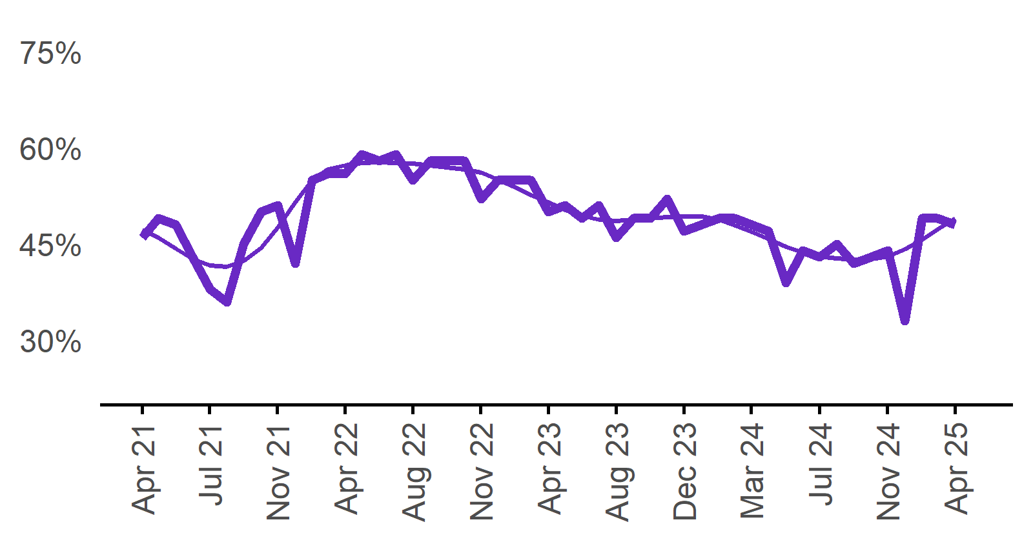

| **Date** | **Recruitment rate** | **Smoothed recruitment rate** |
| --- | --- | --- |
| Apr 2021 | 46% | 47% |
| May 2021 | 49% | 46% |
| Jun 2021 | 48% | 44% |
| Jul 2021 | 43% | 43% |
| Aug 2021 | 38% | 42% |
| Sep 2021 | 36% | 42% |
| Oct 2021 | 45% | 42% |
| Nov 2021 | 50% | 44% |
| Dec 2021 | 51% | 48% |
| Jan 2022 | 42% | 52% |
| Feb 2022 | 55% | 55% |
| Mar 2022 | 56% | 57% |
| Apr 2022 | 56% | 57% |
| May 2022 | 59% | 58% |
| Jun 2022 | 58% | 58% |
| Jul 2022 | 59% | 58% |
| Aug 2022 | 55% | 58% |
| Sep 2022 | 58% | 57% |
| Oct 2022 | 58% | 57% |
| Nov 2022 | 58% | 57% |
| Dec 2022 | 52% | 56% |
| Jan 2023 | 55% | 55% |
| Feb 2023 | 55% | 54% |
| Mar 2023 | 55% | 53% |
| Apr 2023 | 50% | 52% |
| May 2023 | 51% | 50% |
| Jun 2023 | 49% | 49% |
| Jul 2023 | 51% | 49% |
| Aug 2023 | 46% | 49% |
| Sep 2023 | 49% | 49% |
| Oct 2023 | 49% | 49% |
| Nov 2023 | 52% | 49% |
| Dec 2023 | 47% | 49% |
| Jan 2024 | 48% | 49% |
| Feb 2024 | 49% | 49% |
| Mar 2024 | 49% | 48% |
| Apr 2024 | 48% | 47% |
| May 2024 | 47% | 46% |
| Jun 2024 | 39% | 45% |
| Jul 2024 | 44% | 44% |
| Aug 2024 | 43% | 43% |
| Sep 2024 | 45% | 43% |
| Oct 2024 | 42% | 43% |
| Nov 2024 | 43% | 43% |
| Dec 2024 | 44% | 43% |
| Jan 2025 | 33% | 44% |
| Feb 2025 | 49% | 46% |
| Mar 2025 | 49% | 47% |
| Apr 2025 | 48% | 49% |

48%  
**Monthly change:**  
▼ 1%pt  
**Annual change:**  
0%pts

## Recruitment difficulty rate

### Proportion of recruiting employers who stated they had difficulty hiring staff.

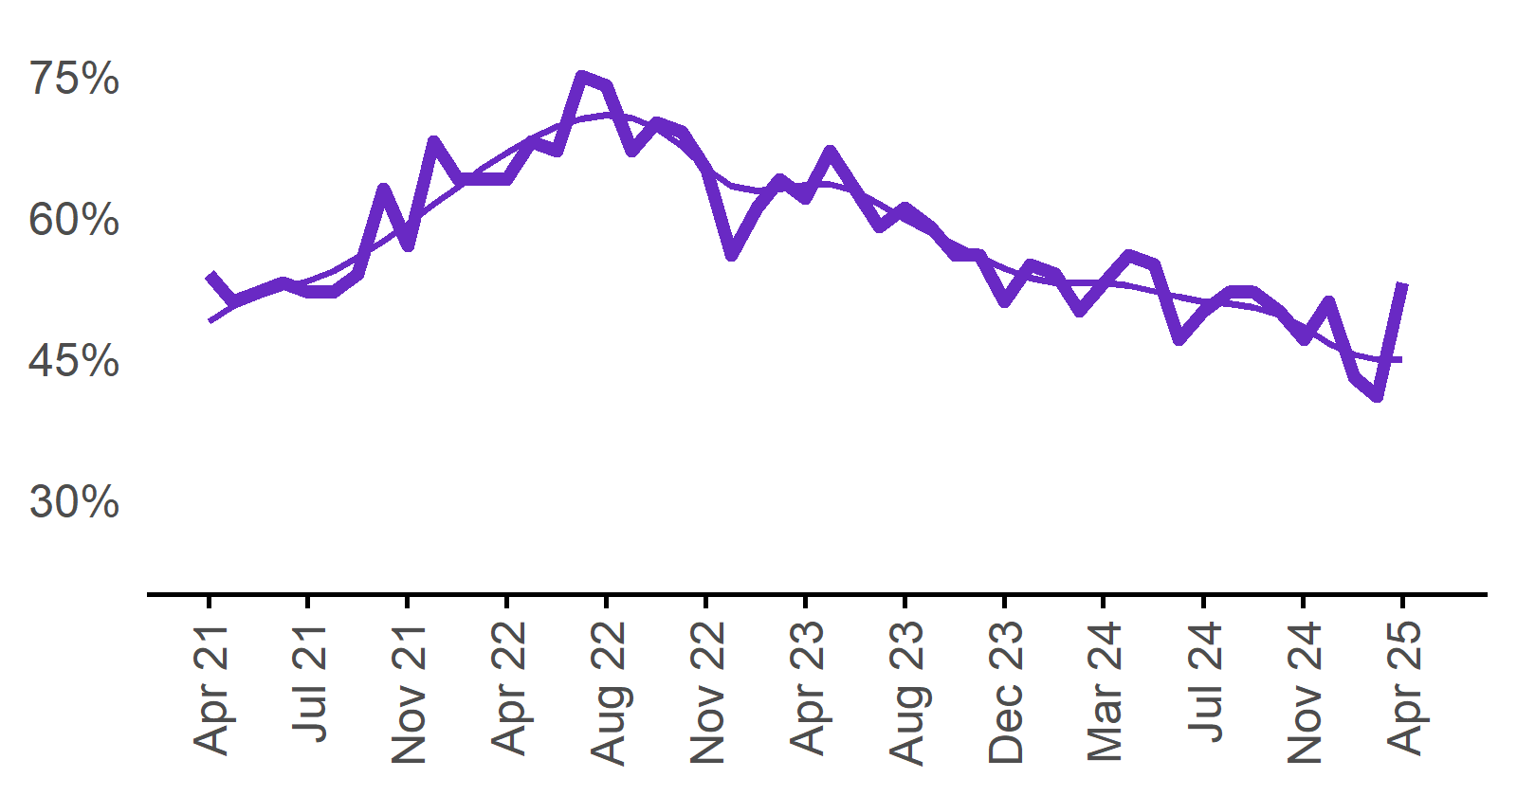

| **Date** | **Recruitment difficulty rate** | **Smoothed recruitment difficulty rate** |
| --- | --- | --- |
| Apr 2021 | 54% | 49% |
| May 2021 | 51% | 51% |
| Jun 2021 | 52% | 52% |
| Jul 2021 | 53% | 52% |
| Aug 2021 | 52% | 53% |
| Sep 2021 | 52% | 54% |
| Oct 2021 | 54% | 56% |
| Nov 2021 | 63% | 58% |
| Dec 2021 | 57% | 59% |
| Jan 2022 | 68%* | 61% |
| Feb 2022 | 64% | 63% |
| Mar 2022 | 64% | 65% |
| Apr 2022 | 64% | 67% |
| May 2022 | 68% | 68% |
| Jun 2022 | 67% | 70% |
| Jul 2022 | 75% | 70% |
| Aug 2022 | 74% | 71% |
| Sep 2022 | 67% | 71% |
| Oct 2022 | 70% | 69% |
| Nov 2022 | 69% | 68% |
| Dec 2022 | 65% | 65% |
| Jan 2023 | 56% | 63% |
| Feb 2023 | 61% | 63% |
| Mar 2023 | 64% | 63% |
| Apr 2023 | 62% | 63% |
| May 2023 | 67% | 63% |
| Jun 2023 | 63% | 63% |
| Jul 2023 | 59% | 61% |
| Aug 2023 | 61% | 60% |
| Sep 2023 | 59% | 58% |
| Oct 2023 | 56% | 57% |
| Nov 2023 | 56% | 56% |
| Dec 2023 | 51% | 55% |
| Jan 2024 | 55% | 54% |
| Feb 2024 | 54% | 53% |
| Mar 2024 | 50% | 53% |
| Apr 2024 | 53% | 53% |
| May 2024 | 56% | 53% |
| Jun 2024 | 55% | 52% |
| Jul 2024 | 47% | 51% |
| Aug 2024 | 50% | 51% |
| Sep 2024 | 52% | 51% |
| Oct 2024 | 52% | 50% |
| Nov 2024 | 50% | 50% |
| Dec 2024 | 47% | 48% |
| Jan 2025 | 51% | 47% |
| Feb 2025 | 43% | 45% |
| Mar 2025 | 41% | 45% |
| Apr 2025 | 53% | 45% |

53%  
**Monthly change:**  
▲ 12%pts  
**Annual change:**  
0%pts

## Expecting to increase staff

### Proportion of employers who expected to increase staffing numbers over the next three months.

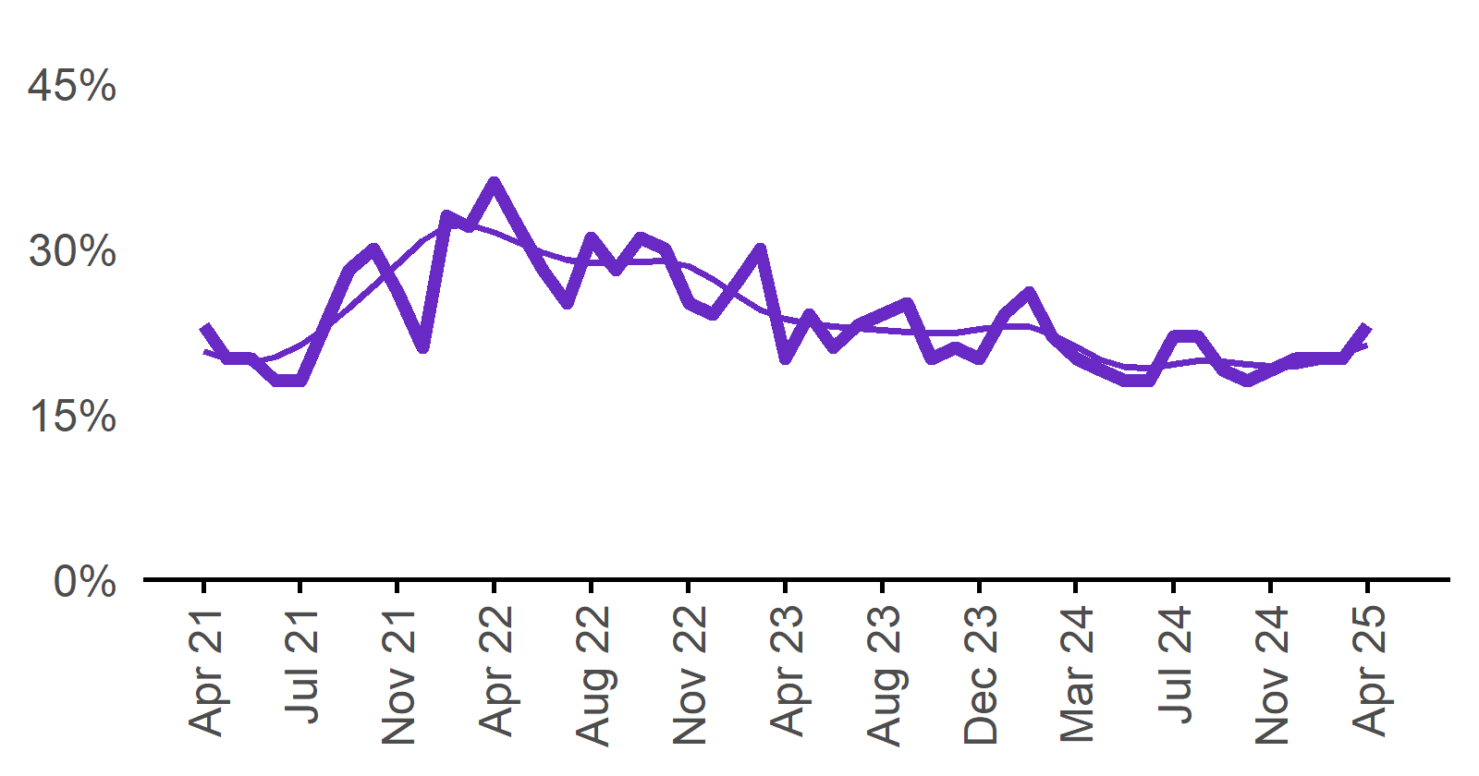

| **Date** | **Expect to increase** | **Smoothed expect to increase** |
| --- | --- | --- |
| Apr 2021 | 23% | 21% |
| May 2021 | 20% | 20% |
| Jun 2021 | 20% | 20% |
| Jul 2021 | 18% | 20% |
| Aug 2021 | 18% | 21% |
| Sep 2021 | 23% | 23% |
| Oct 2021 | 28% | 25% |
| Nov 2021 | 30% | 27% |
| Dec 2021 | 26% | 29% |
| Jan 2022 | 21% | 31% |
| Feb 2022 | 33% | 32% |
| Mar 2022 | 32% | 32% |
| Apr 2022 | 36% | 31% |
| May 2022 | 32% | 31% |
| Jun 2022 | 28% | 30% |
| Jul 2022 | 25% | 29% |
| Aug 2022 | 31% | 29% |
| Sep 2022 | 28% | 29% |
| Oct 2022 | 31% | 29% |
| Nov 2022 | 30% | 29% |
| Dec 2022 | 25% | 28% |
| Jan 2023 | 24% | 27% |
| Feb 2023 | 27% | 26% |
| Mar 2023 | 30% | 24% |
| Apr 2023 | 20% | 24% |
| May 2023 | 24% | 23% |
| Jun 2023 | 21% | 23% |
| Jul 2023 | 23% | 23% |
| Aug 2023 | 24% | 23% |
| Sep 2023 | 25% | 22% |
| Oct 2023 | 20% | 22% |
| Nov 2023 | 21% | 22% |
| Dec 2023 | 20% | 23% |
| Jan 2024 | 24% | 23% |
| Feb 2024 | 26% | 23% |
| Mar 2024 | 22% | 22% |
| Apr 2024 | 20% | 21% |
| May 2024 | 19% | 20% |
| Jun 2024 | 18% | 19% |
| Jul 2024 | 18% | 19% |
| Aug 2024 | 22% | 19% |
| Sep 2024 | 22% | 20% |
| Oct 2024 | 19% | 20% |
| Nov 2024 | 18% | 20% |
| Dec 2024 | 19% | 19% |
| Jan 2025 | 20% | 19% |
| Feb 2025 | 20% | 20% |
| Mar 2025 | 20% | 20% |
| Apr 2025 | 23% | 21% |

23%  
**Monthly change:**  
▲ 3%pts  
**Annual change:**  
▲ 3%pts

# Capital City/Rest of State areas[2]

## Recruitment rate

### Proportion of employers currently recruiting or who recruited in the previous month.

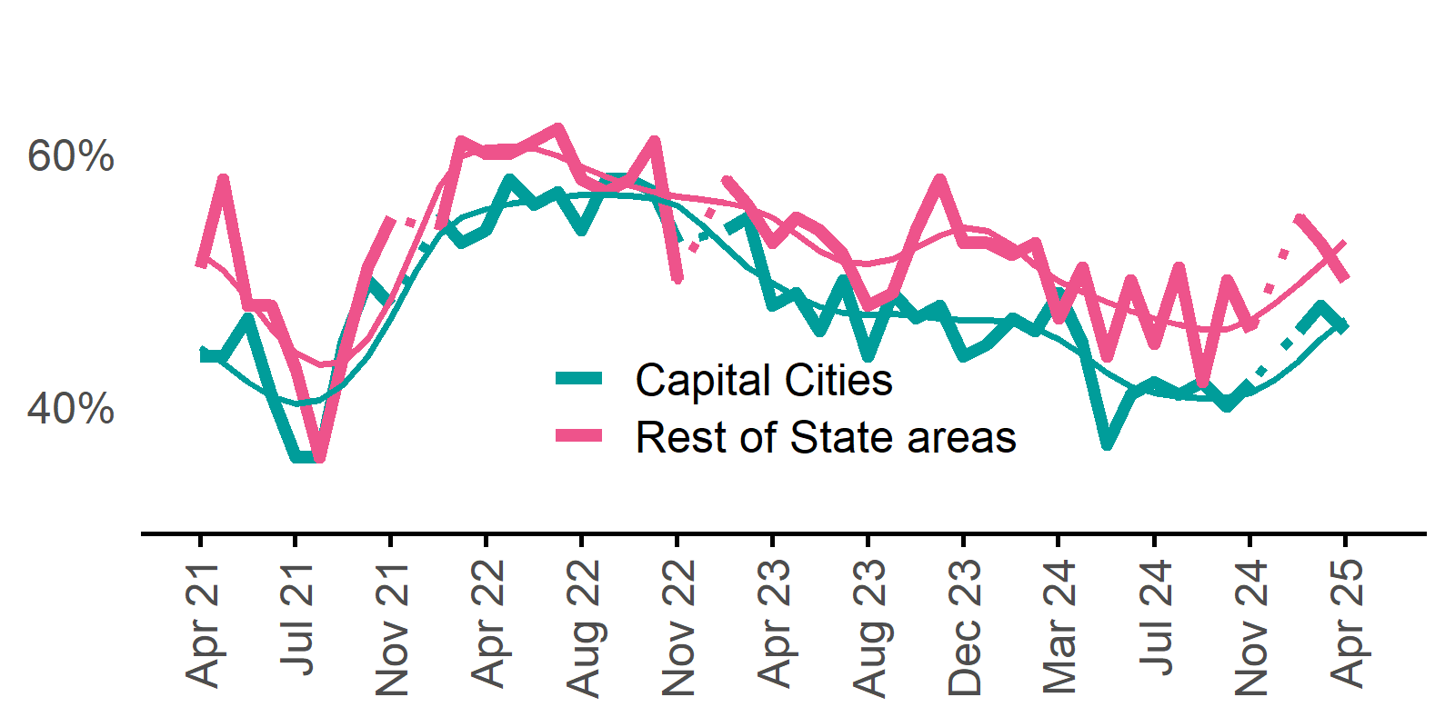

| **Date** | **Capital Cities - Recruitment rate** | **Rest of State areas - Recruitment rate** | **Capital Cities - Smoothed recruitment rate** | **Rest of State areas - Smoothed recruitment rate** |
| --- | --- | --- | --- | --- |
| Apr 2021 | 44% | 51% | 45% | 52% |
| May 2021 | 44% | 58% | 44% | 51% |
| Jun 2021 | 47% | 48% | 42% | 49% |
| Jul 2021 | 41% | 48% | 41% | 46% |
| Aug 2021 | 36% | 43% | 40% | 44% |
| Sep 2021 | 36% | 36% | 41% | 43% |
| Oct 2021 | 45% | 44% | 42% | 44% |
| Nov 2021 | 50% | 51% | 44% | 45% |
| Dec 2021 | 48% | 55% | 47% | 49% |
| Jan 2022 | n.p. | n.p. | 51% | 53% |
| Feb 2022 | 55% | 54% | 54% | 57% |
| Mar 2022 | 53% | 61% | 55% | 60% |
| Apr 2022 | 54% | 60% | 56% | 61% |
| May 2022 | 58% | 60% | 56% | 61% |
| Jun 2022 | 56% | 61% | 56% | 60% |
| Jul 2022 | 57% | 62% | 57% | 60% |
| Aug 2022 | 54% | 58% | 57% | 59% |
| Sep 2022 | 58% | 57% | 57% | 58% |
| Oct 2022 | 58% | 58% | 57% | 58% |
| Nov 2022 | 57% | 61% | 56% | 57% |
| Dec 2022 | 53% | 50% | 56% | 57% |
| Jan 2023 | n.p. | n.p. | 54% | 56% |
| Feb 2023 | 54% | 58% | 53% | 56% |
| Mar 2023 | 55% | 56% | 51% | 56% |
| Apr 2023 | 48% | 53% | 50% | 55% |
| May 2023 | 49% | 55% | 49% | 54% |
| Jun 2023 | 46% | 54% | 48% | 52% |
| Jul 2023 | 50% | 52% | 47% | 51% |
| Aug 2023 | 44% | 48% | 47% | 51% |
| Sep 2023 | 49% | 49% | 47% | 52% |
| Oct 2023 | 47% | 54% | 47% | 53% |
| Nov 2023 | 48% | 58% | 47% | 54% |
| Dec 2023 | 44% | 53% | 47% | 54% |
| Jan 2024 | 45% | 53% | 47% | 54% |
| Feb 2024 | 47% | 52% | 47% | 53% |
| Mar 2024 | 46% | 53% | 46% | 51% |
| Apr 2024 | 49% | 47% | 45% | 50% |
| May 2024 | 45% | 51% | 44% | 49% |
| Jun 2024 | 37% | 44% | 43% | 48% |
| Jul 2024 | 41% | 50% | 42% | 48% |
| Aug 2024 | 42% | 45% | 41% | 47% |
| Sep 2024 | 41% | 51% | 41% | 46% |
| Oct 2024 | 42% | 42% | 41% | 46% |
| Nov 2024 | 40% | 50% | 41% | 46% |
| Dec 2024 | 42% | 46% | 41% | 47% |
| Jan 2025 | n.p. | n.p. | 42% | 48% |
| Feb 2025 | 46% | 55% | 44% | 50% |
| Mar 2025 | 48% | 53% | 45% | 51% |
| Apr 2025 | 46% | 50% | 47% | 53% |

**Capital Cities**: **46%**  
Monthly change:  
▼ 2%pts  
Annual change:  
▼ 3%pts  
**Rest of State**: **50%**  
Monthly change:  
▼ 3%pts  
Annual change:  
▲ 3%pts

## Recruitment difficulty rate

### Proportion of recruiting employers who stated they had difficulty hiring staff.

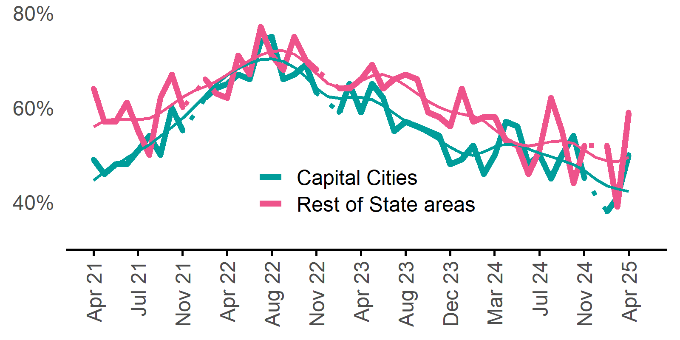

| **Date** | **Capital Cities - Recruitment difficulty rate** | **Rest of State areas - Recruitment difficulty rate** | **Capital Cities - Smoothed recruitment difficulty rate** | **Rest of State areas - Smoothed recruitment difficulty rate** |
| --- | --- | --- | --- | --- |
| Apr 2021 | 49% | 64% | 45% | 56% |
| May 2021 | 46% | 57% | 46% | 57% |
| Jun 2021 | 48% | 57% | 48% | 58% |
| Jul 2021 | 48% | 61% | 49% | 58% |
| Aug 2021 | 51% | 55% | 51% | 57% |
| Sep 2021 | 54% | 50% | 52% | 58% |
| Oct 2021 | 50% | 62% | 54% | 59% |
| Nov 2021 | 60% | 67% | 56% | 61% |
| Dec 2021 | 55% | 60% | 58% | 62% |
| Jan 2022 | n.p. | n.p. | 60% | 64% |
| Feb 2022 | 62% | 66% | 63% | 64% |
| Mar 2022 | 64% | 63% | 65% | 65% |
| Apr 2022 | 65% | 62% | 67% | 67% |
| May 2022 | 67% | 71% | 68% | 69% |
| Jun 2022 | 66% | 67% | 69% | 70% |
| Jul 2022 | 74% | 77% | 70% | 71% |
| Aug 2022 | 75% | 71% | 70% | 72% |
| Sep 2022 | 66% | 68% | 70% | 72% |
| Oct 2022 | 67% | 75% | 69% | 71% |
| Nov 2022 | 69% | 70% | 66% | 69% |
| Dec 2022 | 63% | 68% | 64% | 67% |
| Jan 2023 | n.p. | n.p. | 62% | 65% |
| Feb 2023 | 59% | 64% | 62% | 64% |
| Mar 2023 | 65% | 64% | 62% | 65% |
| Apr 2023 | 59% | 66% | 62% | 66% |
| May 2023 | 65% | 69% | 62% | 67% |
| Jun 2023 | 62% | 64% | 60% | 67% |
| Jul 2023 | 55% | 66% | 59% | 66% |
| Aug 2023 | 57% | 67% | 57% | 65% |
| Sep 2023 | 56% | 66% | 56% | 63% |
| Oct 2023 | 55% | 59% | 55% | 61% |
| Nov 2023 | 54% | 58% | 53% | 60% |
| Dec 2023 | 48% | 56% | 52% | 59% |
| Jan 2024 | 49% | 64% | 50% | 59% |
| Feb 2024 | 52% | 57% | 50% | 58% |
| Mar 2024 | 46% | 58% | 51% | 57% |
| Apr 2024 | 50% | 58% | 52% | 55% |
| May 2024 | 57% | 53% | 52% | 53% |
| Jun 2024 | 56% | 52% | 52% | 52% |
| Jul 2024 | 48% | 46% | 51% | 52% |
| Aug 2024 | 50% | 51% | 50% | 52% |
| Sep 2024 | 45% | 62% | 50% | 53% |
| Oct 2024 | 50% | 55% | 49% | 53% |
| Nov 2024 | 54% | 44% | 48% | 52% |
| Dec 2024 | 45% | 52% | 47% | 51% |
| Jan 2025 | n.p. | n.p. | 45% | 49% |
| Feb 2025 | 38% | 52% | 43% | 49% |
| Mar 2025 | 41% | 39% | 43% | 49% |
| Apr 2025 | 50% | 59% | 42% | 49% |

**Capital Cities**: **50%**  
Monthly change:  
▲ 9%pts  
Annual change:  
0%pts  
**Rest of State**: **59%**  
Monthly change:  
▲ 20%pts  
Annual change:  
▲ 1%pt

## Staffing outlook – Expecting to increase staff

### Proportion of employers who expected to increase staffing numbers over the next three months.

| **Date** | **Capital Cities - % expecting to increase** | **Rest of State areas - % expecting to increase** | **Capital Cities - Smoothed % expecting to increase** | **Rest of State areas - Smoothed % expecting to increase** |
| --- | --- | --- | --- | --- |
| Apr 2021 | 22% | 24% | 20% | 22% |
| May 2021 | 21% | 20% | 20% | 21% |
| Jun 2021 | 20% | 20% | 19% | 20% |
| Jul 2021 | 18% | 19% | 20% | 20% |
| Aug 2021 | 18% | 19% | 21% | 21% |
| Sep 2021 | 24% | 22% | 23% | 22% |
| Oct 2021 | 28% | 28% | 25% | 24% |
| Nov 2021 | 31% | 28% | 27% | 26% |
| Dec 2021 | 26% | 27% | 29% | 27% |
| Jan 2022 | n.p. | n.p. | 31% | 29% |
| Feb 2022 | 34% | 31% | 33% | 30% |
| Mar 2022 | 33% | 30% | 33% | 30% |
| Apr 2022 | 37% | 35% | 32% | 30% |
| May 2022 | 33% | 30% | 31% | 29% |
| Jun 2022 | 28% | 27% | 30% | 28% |
| Jul 2022 | 25% | 25% | 30% | 28% |
| Aug 2022 | 31% | 30% | 29% | 28% |
| Sep 2022 | 30% | 24% | 29% | 28% |
| Oct 2022 | 30% | 32% | 29% | 28% |
| Nov 2022 | 31% | 28% | 29% | 28% |
| Dec 2022 | 23% | 28% | 29% | 28% |
| Jan 2023 | n.p. | n.p. | 27% | 27% |
| Feb 2023 | 28% | 25% | 26% | 26% |
| Mar 2023 | 29% | 30% | 25% | 24% |
| Apr 2023 | 20% | 19% | 24% | 23% |
| May 2023 | 23% | 24% | 23% | 23% |
| Jun 2023 | 22% | 19% | 23% | 23% |
| Jul 2023 | 22% | 24% | 22% | 23% |
| Aug 2023 | 22% | 28% | 22% | 23% |
| Sep 2023 | 25% | 25% | 22% | 23% |
| Oct 2023 | 21% | 18% | 22% | 23% |
| Nov 2023 | 20% | 25% | 22% | 23% |
| Dec 2023 | 21% | 20% | 22% | 23% |
| Jan 2024 | 22% | 27% | 23% | 23% |
| Feb 2024 | 26% | 26% | 23% | 23% |
| Mar 2024 | 22% | 23% | 22% | 22% |
| Apr 2024 | 23% | 15% | 21% | 21% |
| May 2024 | 17% | 23% | 20% | 20% |
| Jun 2024 | 19% | 16% | 19% | 20% |
| Jul 2024 | 17% | 18% | 19% | 20% |
| Aug 2024 | 22% | 22% | 19% | 21% |
| Sep 2024 | 19% | 28% | 19% | 21% |
| Oct 2024 | 19% | 19% | 19% | 21% |
| Nov 2024 | 18% | 19% | 19% | 20% |
| Dec 2024 | 20% | 17% | 19% | 19% |
| Jan 2025 | n.p. | n.p. | 19% | 19% |
| Feb 2025 | 20% | 19% | 20% | 20% |
| Mar 2025 | 18% | 24% | 20% | 21% |
| Apr 2025 | 21% | 26% | 20% | 24% |

**Capital Cities**: **21%**  
Monthly change:  
▲ 3%pts  
Annual change:  
▼ 2%pts  
**Rest of State**: **26%**  
Monthly change:  
▲ 2%pts  
Annual change:  
▲ 11%pts

# Other recruitment indicators

## Reason for recruiting

### Proportion of employers currently recruiting or who recruited in the previous month.

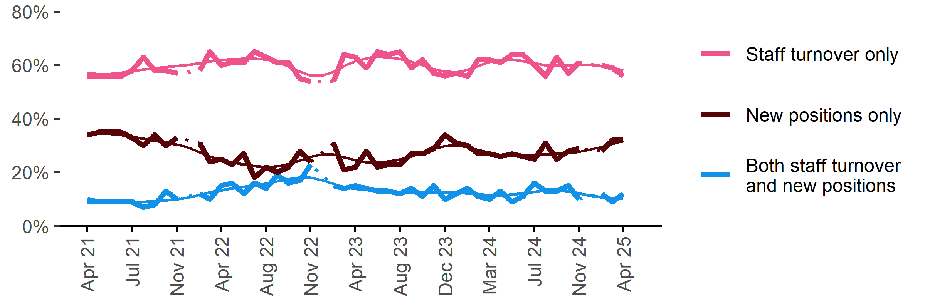

| **Date** | **Staff turnover only** | **Staff turnover and new positions** | **New positions only** | **Smoothed - staff turnover only** | **Smoothed - staff turnover and new positions** | **Smoothed - new positions only** |
| --- | --- | --- | --- | --- | --- | --- |
| Apr 2021 | 56% | 10% | 34% | 57% | 9% | 34% |
| May 2021 | 56% | 9% | 35% | 57% | 9% | 34% |
| Jun 2021 | 56% | 9% | 35% | 57% | 9% | 34% |
| Jul 2021 | 56% | 9% | 35% | 57% | 9% | 34% |
| Aug 2021 | 58% | 9% | 33% | 58% | 9% | 33% |
| Sep 2021 | 63% | 7% | 30% | 58% | 9% | 33% |
| Oct 2021 | 58% | 8% | 34% | 59% | 9% | 32% |
| Nov 2021 | 58% | 13% | 30% | 59% | 10% | 31% |
| Dec 2021 | 57% | 10% | 33% | 60% | 10% | 30% |
| Jan 2022 | n.p. | n.p. | n.p. | 60% | 11% | 29% |
| Feb 2022 | 58% | 12% | 31% | 61% | 12% | 28% |
| Mar 2022 | 65% | 10% | 24% | 62% | 13% | 26% |
| Apr 2022 | 60% | 15% | 25% | 62% | 13% | 25% |
| May 2022 | 61% | 16% | 23% | 62% | 14% | 24% |
| Jun 2022 | 61% | 12% | 27% | 62% | 15% | 23% |
| Jul 2022 | 65% | 16% | 18% | 63% | 15% | 22% |
| Aug 2022 | 63% | 14% | 22% | 62% | 16% | 22% |
| Sep 2022 | 61% | 19% | 20% | 61% | 17% | 22% |
| Oct 2022 | 61% | 16% | 22% | 60% | 17% | 23% |
| Nov 2022 | 55% | 17% | 28% | 58% | 18% | 24% |
| Dec 2022 | 54% | 23% | 24% | 56% | 18% | 26% |
| Jan 2023 | n.p. | n.p. | n.p. | 56% | 17% | 27% |
| Feb 2023 | 54% | 15% | 31% | 58% | 16% | 27% |
| Mar 2023 | 64% | 14% | 21% | 60% | 15% | 26% |
| Apr 2023 | 63% | 15% | 22% | 61% | 14% | 25% |
| May 2023 | 59% | 14% | 28% | 63% | 13% | 24% |
| Jun 2023 | 65% | 13% | 22% | 63% | 13% | 24% |
| Jul 2023 | 64% | 13% | 23% | 63% | 13% | 24% |
| Aug 2023 | 65% | 12% | 23% | 62% | 13% | 25% |
| Sep 2023 | 59% | 14% | 27% | 61% | 13% | 26% |
| Oct 2023 | 62% | 11% | 27% | 60% | 13% | 27% |
| Nov 2023 | 57% | 15% | 29% | 59% | 13% | 29% |
| Dec 2023 | 56% | 10% | 34% | 58% | 13% | 30% |
| Jan 2024 | 57% | 12% | 31% | 57% | 12% | 30% |
| Feb 2024 | 56% | 14% | 30% | 58% | 12% | 30% |
| Mar 2024 | 62% | 11% | 27% | 60% | 12% | 28% |
| Apr 2024 | 62% | 10% | 27% | 61% | 12% | 27% |
| May 2024 | 61% | 13% | 26% | 62% | 11% | 27% |
| Jun 2024 | 64% | 9% | 27% | 62% | 12% | 26% |
| Jul 2024 | 64% | 11% | 26% | 62% | 12% | 26% |
| Aug 2024 | 60% | 16% | 25% | 61% | 13% | 27% |
| Sep 2024 | 56% | 13% | 31% | 60% | 13% | 27% |
| Oct 2024 | 63% | 13% | 25% | 60% | 13% | 27% |
| Nov 2024 | 57% | 15% | 28% | 60% | 13% | 27% |
| Dec 2024 | 61% | 10% | 29% | 60% | 12% | 28% |
| Jan 2025 | n.p. | n.p. | n.p. | 60% | 11% | 29% |
| Feb 2025 | 60% | 12% | 28% | 60% | 11% | 30% |
| Mar 2025 | 59% | 9% | 32% | 59% | 10% | 31% |
| Apr 2025 | 56% | 12% | 32% | 58% | 10% | 32% |

## Staffing changes over the last month

### Proportion of employers who said they increased or decreased staffing compared to the previous month.

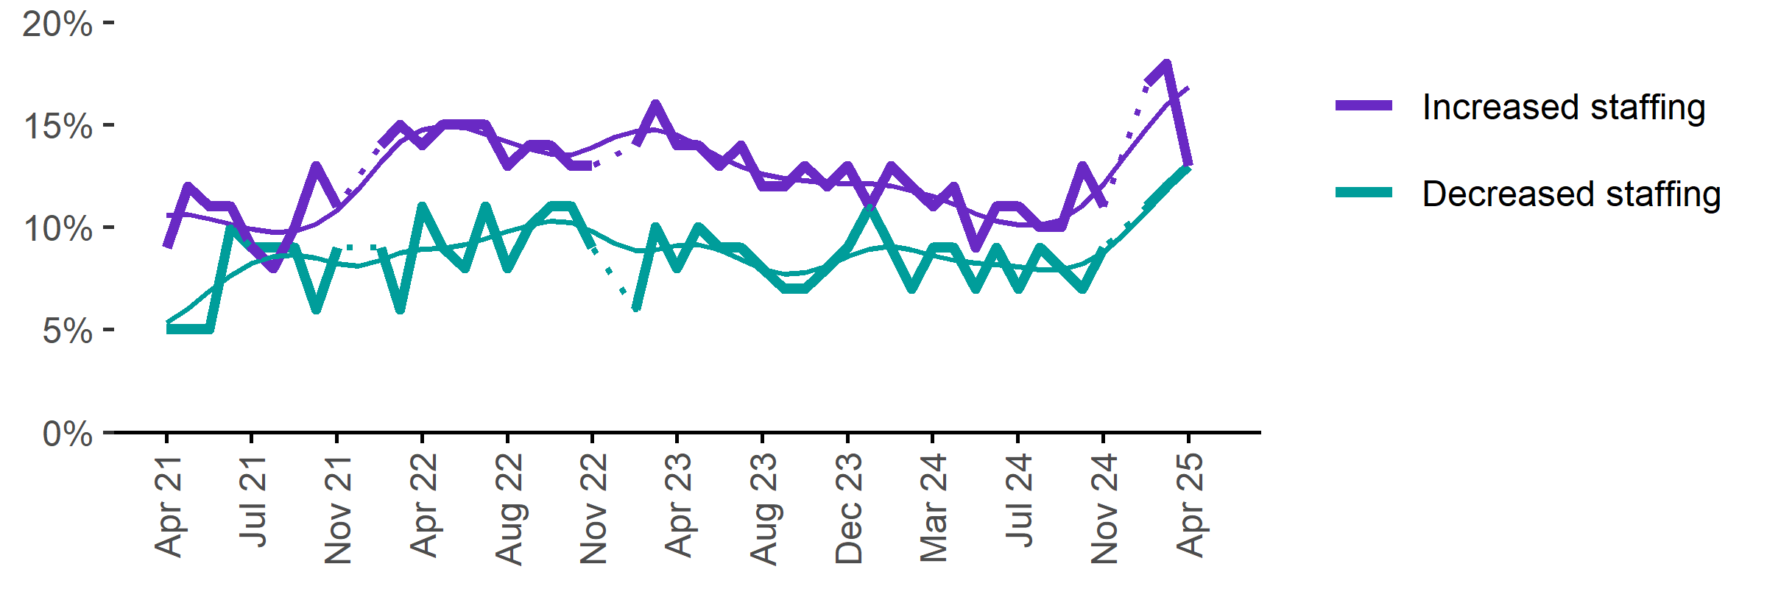

| **Date** | **Increased staff** | **Decreased staff** | **Smoothed - increased staff** | **Smoothed - decreased staff** |
| --- | --- | --- | --- | --- |
| Apr 2021 | 9% | 5% | 11% | 5% |
| May 2021 | 12% | 5% | 11% | 6% |
| Jun 2021 | 11% | 5% | 10% | 7% |
| Jul 2021 | 11% | 10% | 10% | 8% |
| Aug 2021 | 9% | 9% | 10% | 8% |
| Sep 2021 | 8% | 9% | 10% | 9% |
| Oct 2021 | 10% | 9% | 10% | 9% |
| Nov 2021 | 13% | 6% | 10% | 8% |
| Dec 2021 | 11% | 9% | 11% | 8% |
| Jan 2022 | n.p. | n.p. | 12% | 8% |
| Feb 2022 | 14% | 9% | 13% | 8% |
| Mar 2022 | 15% | 6% | 14% | 9% |
| Apr 2022 | 14% | 11% | 15% | 9% |
| May 2022 | 15% | 9% | 15% | 9% |
| Jun 2022 | 15% | 8% | 15% | 9% |
| Jul 2022 | 15% | 11% | 15% | 9% |
| Aug 2022 | 13% | 8% | 14% | 10% |
| Sep 2022 | 14% | 10% | 14% | 10% |
| Oct 2022 | 14% | 11% | 14% | 10% |
| Nov 2022 | 13% | 11% | 14% | 10% |
| Dec 2022 | 13% | 9% | 14% | 10% |
| Jan 2023 | n.p. | n.p. | 14% | 9% |
| Feb 2023 | 14% | 6% | 15% | 9% |
| Mar 2023 | 16% | 10% | 15% | 9% |
| Apr 2023 | 14% | 8% | 14% | 9% |
| May 2023 | 14% | 10% | 14% | 9% |
| Jun 2023 | 13% | 9% | 13% | 9% |
| Jul 2023 | 14% | 9% | 13% | 8% |
| Aug 2023 | 12% | 8% | 13% | 8% |
| Sep 2023 | 12% | 7% | 12% | 8% |
| Oct 2023 | 13% | 7% | 12% | 8% |
| Nov 2023 | 12% | 8% | 12% | 8% |
| Dec 2023 | 13% | 9% | 12% | 9% |
| Jan 2024 | 11% | 11% | 12% | 9% |
| Feb 2024 | 13% | 9% | 12% | 9% |
| Mar 2024 | 12% | 7% | 12% | 9% |
| Apr 2024 | 11% | 9% | 12% | 9% |
| May 2024 | 12% | 9% | 11% | 8% |
| Jun 2024 | 9% | 7% | 11% | 8% |
| Jul 2024 | 11% | 9% | 10% | 8% |
| Aug 2024 | 11% | 7% | 10% | 8% |
| Sep 2024 | 10% | 9% | 10% | 8% |
| Oct 2024 | 10% | 8% | 10% | 8% |
| Nov 2024 | 13% | 7% | 11% | 8% |
| Dec 2024 | 11% | 9% | 12% | 9% |
| Jan 2025 | n.p. | n.p. | 14% | 10% |
| Feb 2025 | 17% | 11% | 15% | 11% |
| Mar 2025 | 18% | 12% | 16% | 12% |
| Apr 2025 | 13% | 13% | 17% | 13% |

## Employers unable to fill vacancies within a month

### Proportion of recruiting employers who were unable to fill their vacancies within a month.*

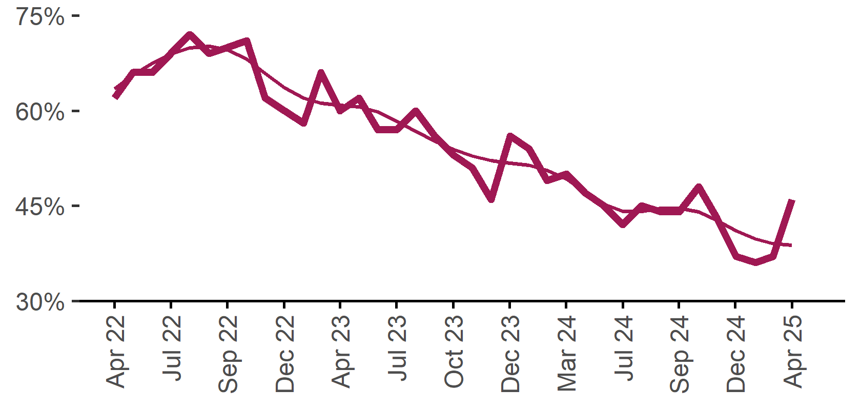

| **Date** | **% unable to fill vacancies in a month** | **Smoothed - % unable to fill vacancies in a month** |
| --- | --- | --- |
| Apr 2022 | 62% | 63% |
| May 2022 | 66% | 66% |
| Jun 2022 | 66% | 67% |
| Jul 2022 | 69% | 69% |
| Aug 2022 | 72% | 70% |
| Sep 2022 | 69% | 70% |
| Oct 2022 | 70% | 70% |
| Nov 2022 | 71% | 68% |
| Dec 2022 | 62% | 66% |
| Jan 2023 | 60% | 64% |
| Feb 2023 | 58% | 62% |
| Mar 2023 | 66% | 61% |
| Apr 2023 | 60% | 61% |
| May 2023 | 62% | 61% |
| Jun 2023 | 57% | 60% |
| Jul 2023 | 57% | 58% |
| Aug 2023 | 60% | 57% |
| Sep 2023 | 56% | 55% |
| Oct 2023 | 53% | 54% |
| Nov 2023 | 51% | 53% |
| Dec 2023 | 46% | 52% |
| Jan 2024 | 56% | 52% |
| Feb 2024 | 54% | 51% |
| Mar 2024 | 49% | 51% |
| Apr 2024 | 50% | 49% |
| May 2024 | 47% | 47% |
| Jun 2024 | 45% | 45% |
| Jul 2024 | 42% | 44% |
| Aug 2024 | 45% | 44% |
| Sep 2024 | 44% | 45% |
| Oct 2024 | 44% | 45% |
| Nov 2024 | 48% | 44% |
| Dec 2024 | 43% | 43% |
| Jan 2025 | 37% | 41% |
| Feb 2025 | 36% | 40% |
| Mar 2025 | 37% | 39% |
| Apr 2025 | 46% | 39% |

46%  
**Monthly change:**  
▲ 9%pts  
**Annual change:**  
▼ 4%pts

* Excludes employers who have been recruiting for less than a month.

## Background

Jobs and Skills Australia (JSA) conducts the Recruitment Experiences and Outlook Survey (REOS), a telephone administered survey with the business owner or other person in the business responsible for recruitment. Around 1000 employers are surveyed each month, with data published on the [JSA website](https://www.jobsandskills.gov.au/data/recruitment-experiences-and-outlook-survey). While the data are indicative of recruitment activity, they may be subject to seasonal factors and other volatility and should therefore be used with a degree of caution. In addition, the survey is targeted towards employers with 5 or more employees and excludes many government organisations. Details of the survey methodology can be accessed from the [JSA website](https://www.jobsandskills.gov.au/data/recruitment-experiences-and-outlook-survey/reos-survey-methodology).

## Smoothed series in charts

Charts include Henderson-smoothed lines in addition to original data for most of our recruitment indicators. As the timeseries is not yet long enough for seasonal adjustment, a Henderson smoothed moving average with a 13-term filter (equating to 13 months) has been directly applied to the original series. This provides an indication of the general movement in each recruitment indicator relative to previous months. Due to using 13 months in the moving average, results for the most recent six months will be revised each month.

## How to reference data from this report

Jobs and Skills Australia, Recruitment Insights Report, April 2025.

## Contact us

For additional information, email [REOS@jobsandskills.gov.au](mailto:REOS@jobsandskills.gov.au)

# Also available from the REOS

## Data file with monthly and quarterly recruitment indicators

A REOS data file is available on the [JSA website](https://www.jobsandskills.gov.au/data/recruitment-experiences-and-outlook-survey). Breakdowns by Capital City/Rest of State area, Business size, and ANZSCO Skill Level are included in the monthly results. Quarterly recruitment indicators provide detail by state, [ARIA](https://www.abs.gov.au/statistics/standards/australian-statistical-geography-standard-asgs-edition-3/jul2021-jun2026/main-structure-and-greater-capital-city-statistical-areas/greater-capital-city-statistical-areas) (ABS’ Accessibility and Remoteness Index of Australia) as well as selected industry and occupation groups.

Next Recruitment Insights Report release:

May 2025 Recruitment Insights Report – 17 June 2025

## Stay up to date

JSA also releases semi-regular reports including spotlight articles, detailing aspects of the REOS that cannot be included in our monthly Recruitment Insights Report. Sign up and get the Recruitment Insights Report notifications sent straight to your inbox.

Upcoming spotlight:

Impacts of recruitment difficulty on businesses – June 2025

Recent spotlights and research articles:

REOS Spotlight - March quarter 2025 results – 8 May 2025

Employers’ experiences of young job applicants – 6 March 2025

1. A Henderson smoothed line has been included in the charts to reduce month to month volatility and illustrate long term patterns. See the explanatory note for more information.
2. Data are not available for January in some years. Data points have been joined by a dotted line between December and February to reflect this. ‘Rest of State’ refers to areas outside the capital cities.