

Labour Force Trending Methodology

Industry and Occupation Section

**15 May 2025**

Contents

Summary 2

Use of JSA trend series 3

Methodology 3

Input Series 3

Smoothing Parameter 4

Smoothing Parameter Changes 7

Adjusting for COVID-19 7

Managing End Point Issues 9

Other Considerations 13

Series Comparison 13

Census Comparison 13

ABS Industry Division (1-digit) Trend Comparison 15

Rolling Averages Comparison 17

Appendix 18

References 21

# Summary

Jobs and Skills Australia (JSA) has developed a methodology for producing trended estimates for detailed industry and occupation employment data.

The Labour Force Survey (LFS) produced by the Australian Bureau of Statistics (ABS) provides a wide range of indicators of labour market activity in Australia, underpinned by a large survey sample and a high response rate. While the LFS focusses on producing more aggregate or headline data on the labour market (such as the national unemployment rate), one of the benefits of having a high-quality Labour Force Survey is that it also allows the ABS to produce employment data by detailed industry and occupation employment data. Such data are produced at the Australian and New Zealand Standard Industrial Classification (ANZSIC) 3-digit level and Australian and New Zealand Standard Classification of Occupations (ANZSCO) 4-digit level respectively, as part of the detailed Labour Force Survey. However, due to the large number of occupations and industries estimated at the detailed level, the unadjusted data at more granular levels, such as occupation unit group (ANZSCO 4-digit), is highly volatile. Quarter on quarter change will often vary significantly and is primarily driven by sample variation rather than a reflection of real labour market movement.

At more aggregate levels, the ABS undertakes seasonal adjustment and trending, however detailed industry and occupation data are released as original data series only. While the ABS would ideally prefer to produce a range of ABS trend series (potentially optimised around a short-term, medium-term and long-term focus), the ABS is limited in what it is able to produce given its critical responsibility to produce a broad remit of statistical indicators (including beyond just the Labour Force Survey). This provides an opportunity for JSA to estimate complementary trended data for more detailed labour force estimates, with the intent of more accurately identifying long-term labour market trends at disaggregated levels and maximising the utility of the ABS LFS.

Currently the ABS uses a Henderson seven term moving average filter to trend the ANZSIC 1-digit level one series. However, this methodology applies relatively limited smoothing and is not suitable to be applied to smaller industry and occupation series. To resolve this issue, JSA implements a methodology that utilises a Hodrick-Prescott Filter (HPF)[1] . The HPF separates out relatively long cycles and produce a heavily smoothed long-term trend. This means that the series released by JSA provide an indication of long-term trends and movements within an industry or occupation but will not capture some smaller short-term movements, particularly in series with high noise to signal ratios. Filter-based methods for trend estimation work on the assumption that a time series is made up of different cycles taking varying amounts of time to repeat. Cycles that repeat within the length of the filter used are removed, meaning that a longer filter will remove more cycles and produce a smoother trend.

## Use of JSA trend series

The purpose of the JSA trend series is primarily to provide an indication of the long-term trends in employment at detailed (disaggregated) levels of industry and occupation. Such trends can be otherwise difficult to identify given the level of volatility often seen in the raw (original) data published by the ABS. The trended data contributes to JSA’s role of providing high quality data that helps users understand Australia’s labour market and may be particularly useful to those undertaking long-term workforce planning and analysis. Its usefulness may also be enhanced by combining the data with other sources of labour market information, such as the JSA Internet Vacancy Index[2] . The data should be considered complementary to the original detailed ABS Labour Force Survey data, with the original ABS Labour Force Survey data remaining particularly useful during times of rapid labour market change (such as those experienced following the onset of COVID-19) when long-term trended series (as per JSA’s methodology) can take time to adjust (or indeed fail to sufficiently capture at all, due to their long-term focus).

The JSA trend series is best suited for understanding longer-term changes within a given industry or occupation (for example, twelve-month changes or longer). It is not suited to capturing smaller short-term movements within a given industry or occupation (for example, quarterly changes), or movements in very small industries or occupations.

Due to issues with sampling variability and highly disaggregated (e.g. state/territory by industry group) estimates, sub-populations (e.g. 3-digit industries) are modelled to show some contribution to higher level aggregates. Refer to <https://www.abs.gov.au/articles/revisions-improvements-labour-force-estimation-method>

Due to sub-populations showing as zero in some quarters in the ABS source dataset (e.g. no sample in the given quarter month) the JSA trending method defaults these populations to 100 prior to trending. Therefore, JSA recommends trended figures of less than 1,000 are indicative at best, and those less than 5,000 should be used with caution.

# Methodology

The key steps of trending the LFS that JSA applies are:

* Adjust the series to account for the Australian Bureau of Statistics (ABS) supplementary surveys.
* Assign smoothing parameters based on the size of the series being trended.
* Impute values for series that were significantly impacted by COVID-19.
* Project each series 3 quarters into the future using an autoregressive integrated moving average (ARIMA) forecasting model.
* Trend the series (including the forecasts) using a Hodrick-Prescott Filter (HPF) with the previously assigned smoothing parameter.

Note: This methodology is very similar to methods utilised as part of the time-series forecasting approaches that were previously utilised to develop employment projections by industry, occupation and region.

## Input Series

For trending LFS data, there are three potential series which can be used as inputs:

* Original LFS data
* LFS data adjusted to account for ABS supplementary surveys or
* A seasonally adjusted LFS series that also accounts for ABS supplementary surveys.

The ABS conducts supplementary surveys where a series of additional questions are asked at the end of each LFS interview. The ABS has found that these supplementary surveys can impact on the responses to the LFS. As these supplementary surveys are typically annual or irregular, they can create distortions in the series over time. There was also a significant shift in these supplementary surveys in 2014 when the ABS improved and consolidated their content into fewer supplementary surveys. Given the potential impact to the data, particularly around the 2014 change, it is important to adjust the series prior to trending[3]. Overall, the impact of this adjustment is relatively small especially after trending[4].

## Smoothing Parameter

The HPF function includes a smoothing parameter, usually identified as λ, which will dictate the length of the filter and the cycles that are removed. In practice this means that a higher λ will remove more cycles resulting in a smoother trend with less noise but greater loss of signals of interest. In choosing an appropriate λ, the objective was to remove all noise while minimising the loss of signal. The generally recommended λ to use on quarterly data is 1600 (Mohr 2005). From testing this parameter and series with varying volatility, this smoothing parameter was found to be sufficient for removing noise in all series of the LFS.

In series with a very low signal to noise ratio, the HPF (λ = 1600) generally produces relatively flat curves with only very long-term minor changes in trend present (Figure 1). Given the volatility of these series it is unlikely that anything more meaningful can be extracted from the LFS data. However, in series with higher level estimates and a significantly greater signal to noise ratio, a λ of 1600 causes unnecessary loss of signal. Therefore, different smoothing parameters were applied for each individual series based on the size of their level estimates. While size of the series does not directly correlate with the signal to noise ratio, it served as a strong indicator of volatility within each series.

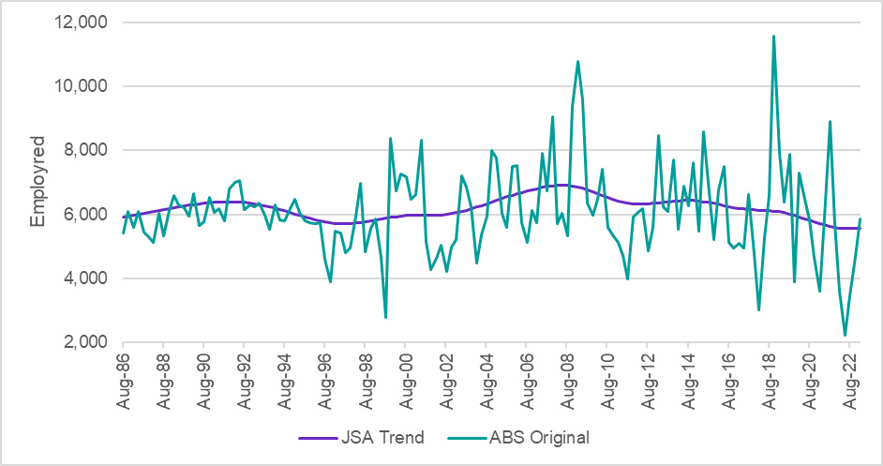

Figure 1: HPF (λ = 1600) Output on Highly Volatile Series (Signwriters)

To keep the smoothing process relatively streamlined, the series were split into three different groups based on their average size in the last two years of the original series (after adjusting for the ABS supplementary surveys). A recent two-year average is used over a longer term one to ensure that the smoothing parameter chosen is most appropriate for updates going forward rather than prioritising the refinement of historical data. Additionally, limiting the period to two years avoids the main COVID-19 shocks that occurred in 2020. This method does mean that a shorter filter will be applied to some series historically, when they were significantly smaller. However, due to the representative proportion of the LFS shrinking over time as population grows, the historical data is not as volatile and hence a shorter filter length is generally suitable despite the values often being significantly below the modern thresholds applied.

The lowest smoothing parameter λ = 6.25 was chosen based on experimentation on all occupation major group (1-digit) level series. This was then applied iteratively to increasingly smaller series to determine when noise become apparent. Based on this, an employment estimate cut-off of 500 000 was chosen for the first group. A λ of 400 was then applied to the second group and a similar iterative process was used to determine a second employment estimate cut-off of 200 000. All series with a two-year average employment estimate of below 200 000 were assigned the default λ = 1600. Figure 2 and Figure 3 demonstrate the difference in these smoothing parameters for series of varying size. Most series, particularly at 4-digit level occupation and 3-digit industry fall within the last category of λ = 1600 (Figure4). For a list of industries and occupations where the λ value applied is 6.25 or 400 at the national level, see the Appendix.

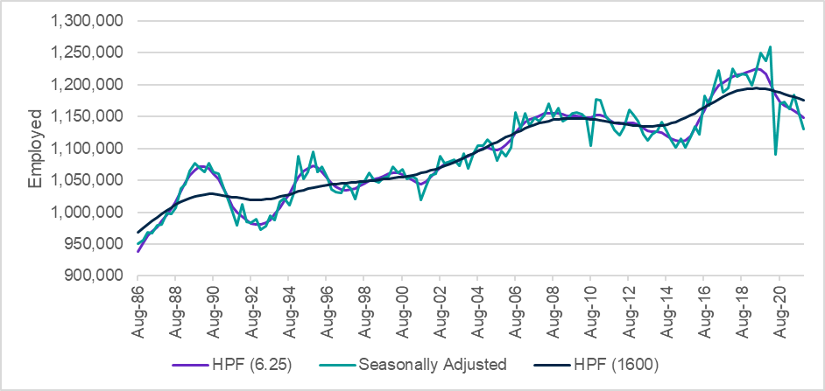

Figure 2: Labourers (major group – 1-digit) (λ = 6.25 is used)

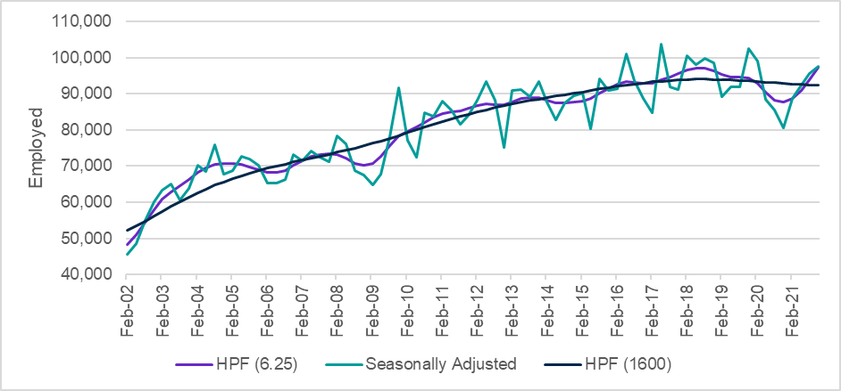

Figure 3: Nursing Support and Personal Care Workers (unit group – 4-digit) (λ = 1600 is used)

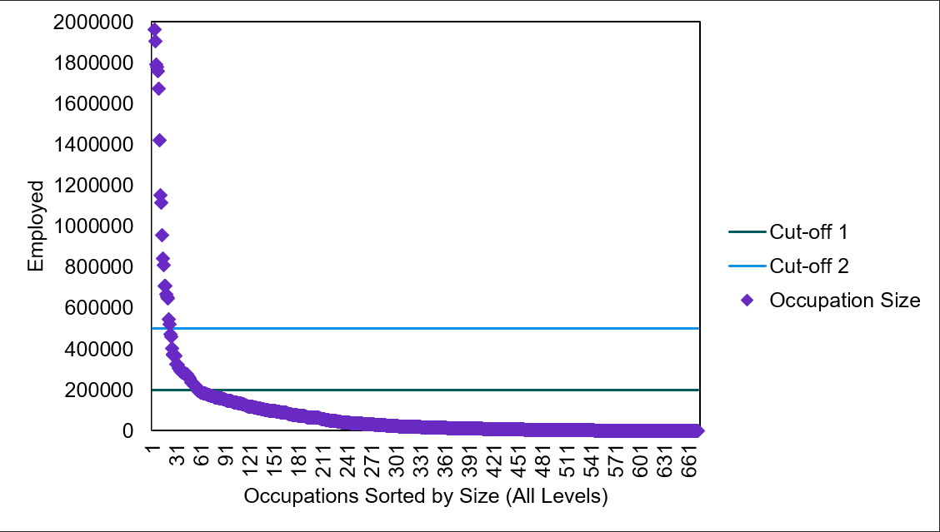

Figure 4: Two-year average employment estimate for all occupations

### Smoothing Parameter Changes

Sensitivity analysis was conducted around how frequently occupations and industries would move between these categories. It was found that movement was limited with an average of three series moving between groups over a period of two years. In general, although occupations and industries will rise above these thresholds over time, unless the LFS sample size increases it is unlikely that the signal to noise ratio will change significantly. Therefore, there should be limited need to change smoothing parameters moving forward. Moving a series from one smoothing parameter to another will result in significant historical revisions and will only be done after careful experimentation and testing.

## Adjusting for COVID-19

The COVID-19 pandemic and related lockdowns had a significant impact on a range of different industries and occupations. These impacts were not uniform, with varying shocks and recovery profiles occurring over 2020 and 2021. The majority of COVID impacted occupations were those with obvious links to lockdowns (hospitality, transport etc.). The largest impact occurred during the initial COVID lockdowns in 2020 with subsequent dampened effects from the Delta strain lockdown. In general, by 2022 when lockdowns were no longer in effect most series returned to near pre-COVID levels. However, applying the HPF to a COVID impacted series causes the following issues:

* Values prior to COVID are trended down, solely due to the future impact of COVID and not because of any real labour market trend occurring at the time.
* Values during the height of COVID (2020 for most series) are very far off the original values. On a macro scale this results in a significant difference in the total number of people employed across all industries and occupations between the trend and original adjusted series.
* The HPF is too slow to capture the rapid post-COVID recovery and produces an unrealistic series from 2022 onwards.

To solve these issues, values over this period for industries and occupations impacted by COVID were imputed based on historical and post-COVID values. To account for the differing COVID profiles of each series, they were individually assessed and assigned to one of five categories based on the significance and longevity of the COVID impact. The imputations were limited to each category’s relevant period:

* No COVID impact
* Short term COVID impact (May 2020 quarter only)
* Medium term COVID impact (May 2020 – Nov 2020 quarters)
* Long Term COVID impact (May 2020 – Nov 2021 quarters)
* Permanent COVID impact (May 2020 onwards)

To be assigned as being impacted by COVID, there had to be an observed decrease in the series that was substantially greater than the typical noise present in the historical data. This meant that it was very difficult to properly identify whether very small series (<10 000) had a substantial impact from COVID. Overall, around 20% of industries and occupations at the national level were observed to have COVID impacts that were significant enough to observe amongst the noise in the original data. Figure 5 provides an example of how these COVID imputations improved these series.

Series that fell into category 5 (permanent impact) had their trend broken and restarted at the May 2020 quarter. Only two 4-digit occupations and two 3-digit industries fell into this category at the national level[5]. Due to the limited post-COVID data, the trended series are likely to remain highly volatile in these occupations and industries for the next few years.

The COVID impacts at the state/territory level did not always align with the national level due to varying lockdown phases within jurisdictions. As a result, industries and occupations had different imputation periods for each state and territory. In general, the bulk of observable COVID related impacts were limited to the major eastern states, primarily in NSW and Victoria.

For series that were impacted by COVID, the values imputed over the COVID period are supressed in the series released by JSA as they are not a real reflection of the labour market. For these time periods, the original data released by the ABS is likely a more accurate estimation of employment in these occupations and industries for these time periods. Comparisons of original data in this period and longer-term trend data should be treated with great caution.

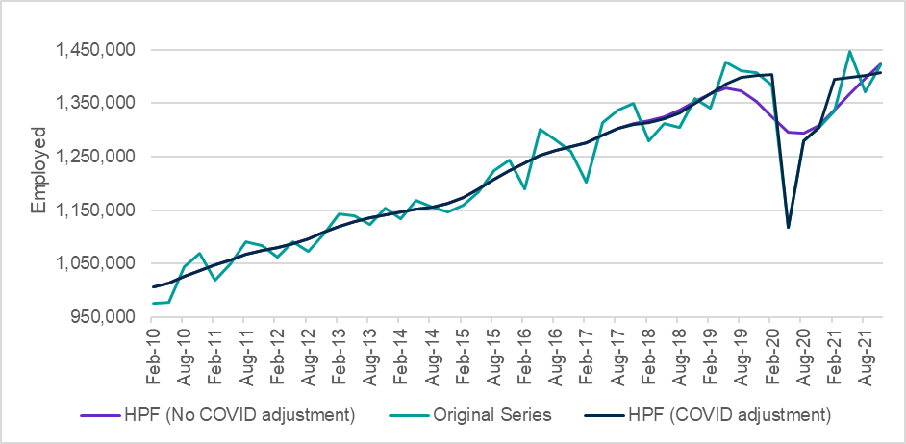

Figure 5: COVID Adjustment of Community and Personal Service Workers (Category 3)

While the variations in parameters can result in various trend series being produced for the COVID period, JSA’s priority remains on identifying long-term trends in the labour market. As such, JSA does not recommend focusing too much on trend analysis of that period specifically, given the labour market shocks and how unique labour market conditions were during and in the period immediately after the COVID period (which are thus arguably more suitably analysed using original data).

## Managing End Point Issues

In producing a trend component, the HPF will look at both past and future values in the input series. This is not possible at the start and end of the series, and as a result several problems can arise. In general, these are known as end point issues. The start of the series will never have any new data added to it and hence those values cannot be improved over time. While the ABS releases industry and occupation data starting in 1984 and 1986 respectively, JSA publishes its time series starting 1986 for both series. Care should be taken when using any values from the first few years of the trend series. Contrasting this, a significant effort has been made to improve the end point issues that arise at the end of the series. However, changes in trend at the end of a series should still be treated with caution.

One end point issue is that, in general, without adjustment the HPF is very slow to respond to real changes in trend. Even when the input series have relatively clearly defined turning points, the HPF will often require a further 6-8 quarters of data after the turning point to properly adjust. This can result in significant revisions to historical data from quarter to quarter (Figure 6). These variations can be up to around 10%, even for occupations/industries larger than 100,000.

Another end point issue that may arise is that the HPF can sometimes capture a change in trend when there isn’t one due to the appearance of a false turning point. When subsequent quarters are added this change in trend is completely supressed, resulting in large historical revisions (Figure 7). Additionally, in smaller occupations and industries (especially with level estimates lower than 20 000) outliers near the end of the series can adversely impact the HPF (Figure 8).

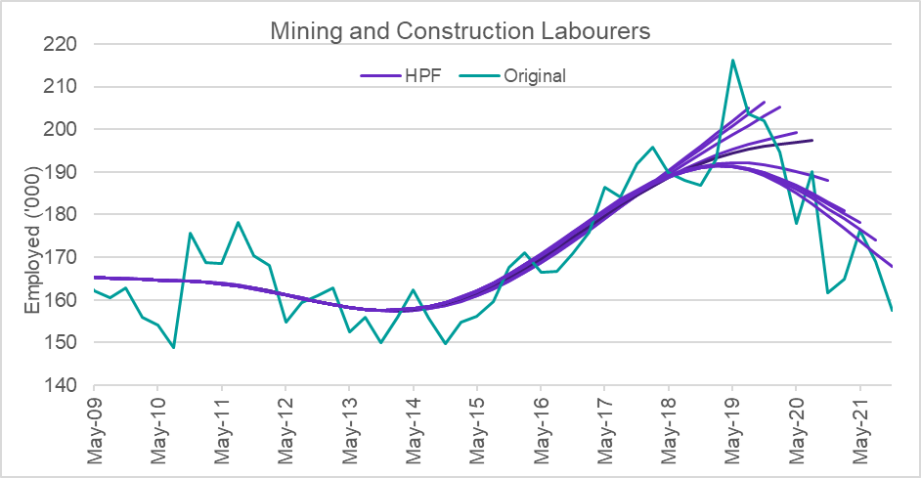

Figure 6: Example of End Point Issue with Turning Points

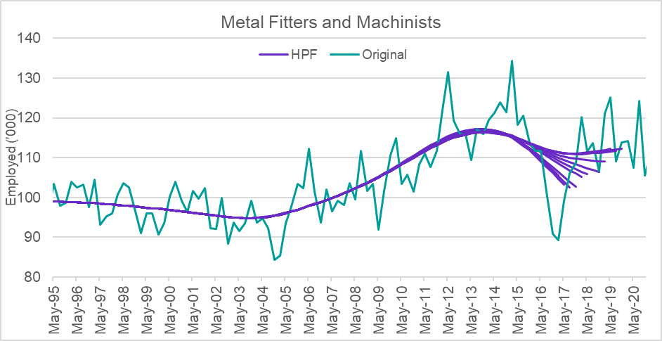

Figure 7: Example of End Point Issue with False Turning Points

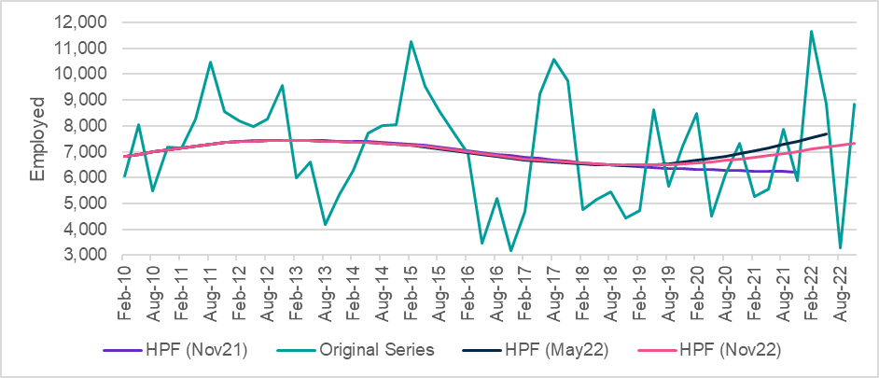

Figure 8: Example of End Point Issue with Outliers (Licensed Club Managers)

JSA has investigated a range of different methods to handle these end points issues. Initial approaches primarily focused on the use of alternate series with various filter lengths to try to capture recent changes in trend. While these methods had some success at handling these end point issues, the change in smoothing parameter often introduced other artefacts into the data, such as rapid changes in gradient that caused it to appear that the series was undergoing unprecedented change.

The primary solution that was thoroughly investigated was the use of an Autoregressive Integrated Moving Average (ARIMA) model to forecast several quarters ahead and include these in the HPF. To test the impact of ARIMA forecasting, 10 turning points and 10 false turning points were identified and ARIMA forecasting was done quarter by quarter through the turning point. Two iterative trend series were then produced, with and without the ARIMA forecasting and compared for each quarter. The impact on outlier end point issues was also assessed. Initial testing was done by forecasting 3 quarters ahead, but alternative simulations with 5 quarters of forecasts were also compared.

Broadly speaking, the ARIMA forecasting moderately improved the time it took for the filter to properly capture real turning points (Figure 9). The significance of the forecasting impact varied depending on how rapid the change in gradient occurred. Generally, the forecasting worked best for series that experienced a rapid change in trend as opposed to those that occurred more gradually.

The ARIMA forecasting produced more mixed results for false turning points, sometimes overemphasising that apparent change in trend, and leading to even larger historical revisions (Figure 10). However, for around half the false turning points the ARIMA forecasting had a relatively negligible impact. Additionally, while the ARIMA forecasting was worse for the initial quarters around the false turning point it often re-adjusted quicker and produced a better result in subsequent quarters. ARIMA forecasting was also successful at dampening the impact of outliers at the end of smaller series with high volatility. The investigations found that including additional forecasts beyond three quarters tended to worsen the false turning point issue and did not provide significant improvement to the filter’s ability to capture real turning points. As a result, JSA has decided to implement three quarters of ARIMA forecasts to help mitigate end point issues.

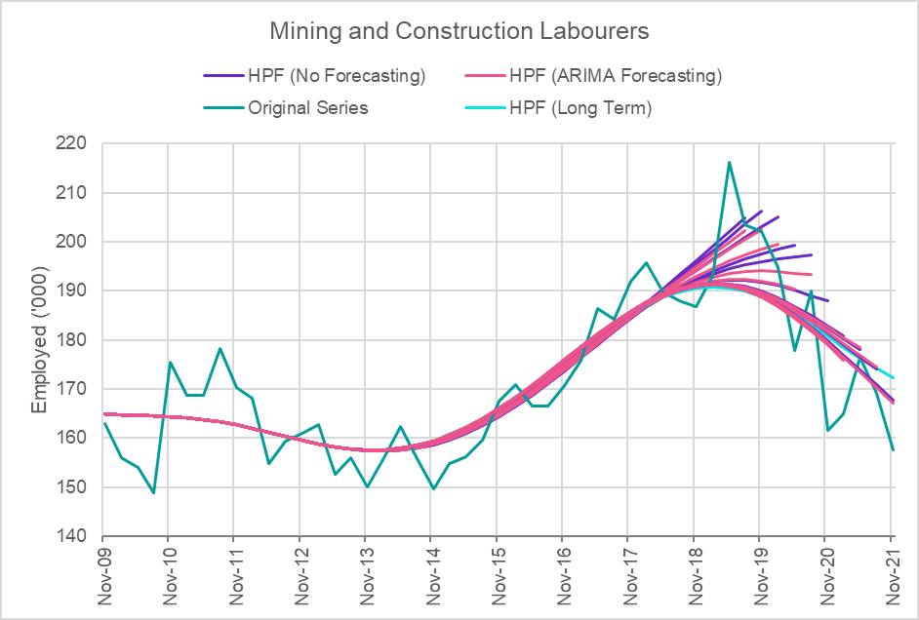

Figure 9: ARIMA Forecasting Impact on Turning Points

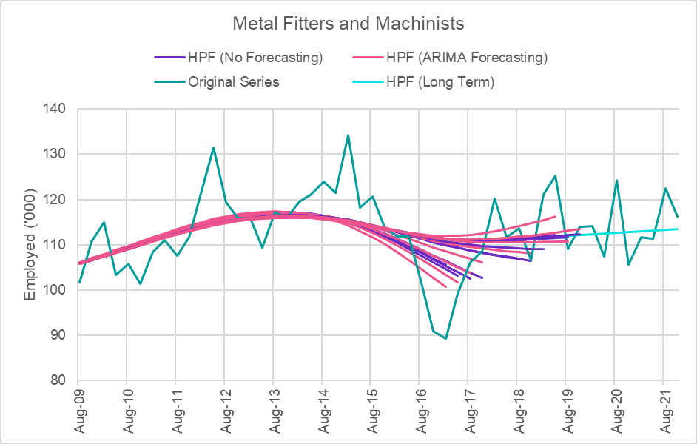

Figure 10: ARIMA Forecasting Impact on False Turning Points

## Other Considerations

One important thing to note with this methodology is that sub-level series will not add to parent level series and total employment numbers across all occupations and industries will differ from those released by the ABS. Analysis has shown that, outside of some COVID related anomalies, additive issues are generally not greatly significant with almost all sub-series adding up to within 5% of the parent. Total employment within each level has been within 1% of ABS total employment for all quarters outside of COVID. While benchmarking numbers to parent series and ABS total employment would remove this additive problem, it has the potential to introduce artefacts into the data and cause individual series to be worse estimations of employment for a specific industry or occupation.

In general, not further defined (NFD) series often have numerous artefacts in their data which relate to how the ABS assigns industry and occupation codes. These artefacts, as well as numerous periods of missing data, cause significant issues when trying to adjust the series for the ABS supplementary survey effect, analyse COVID impacts or forecast using an ARIMA model. Additionally, several implied assumptions in these manipulations do not apply to NFDs. Therefore, these processes are skipped for all NFD series. The NFD series themselves are still trended to account for volatility and avoid major additive issues that occur when using original data for these series.

# Series Comparison

## Census Comparison

In general, there are limited datasets publicly available to validate these industry and occupation trend series. Outside of professions like health workforce that have publicly available registration numbers, the only reliable data set in the public domain is the ABS Census. Given the different collection and estimation methodologies of the LFS and the Census, JSA does not expect them to agree on point-in-time counts of employment or share of employment. On the other hand, JSA would expect them to agree on longer-term trends and hence is a comparison suitable to help validate this trending methodology.

Both the percentage change and percentage difference in share of employment over 5-year periods was compared between the new LFS trend series and the Census between 2006 and 2021 (Figure 11). In general, the growth rates matched well for most industries and occupations with only a small number of outliers. The consistency between the two series was noticeably worse comparing the growth from 2016 to 2021 due to the August 2021 Census occurring in the middle of the COVID-Delta lockdown. The largest outliers were generally associated with changes in ANZSCO and ANZSIC definitions.

For example, in August 2006 there was a definition change in ANZSCO that introduced the ICT Support and Test Engineers occupation. This population is entirely counted in the 2006 Census and hence the growth rate from 2006 to 2011 is normal. However, due to the nature of the LFS survey sample methodology rotations and end point issues at the start of a series, it takes several years before the trend series has stabilised (Figure 12). For subsequent Census periods these effects have passed, and they are no longer outliers.

The largest absolute difference in share growth occurs in the Manager major group occupation. However, this is primarily due to the occupation’s size, and the longer-term trend between the two series still generally aligns (Figure 13).

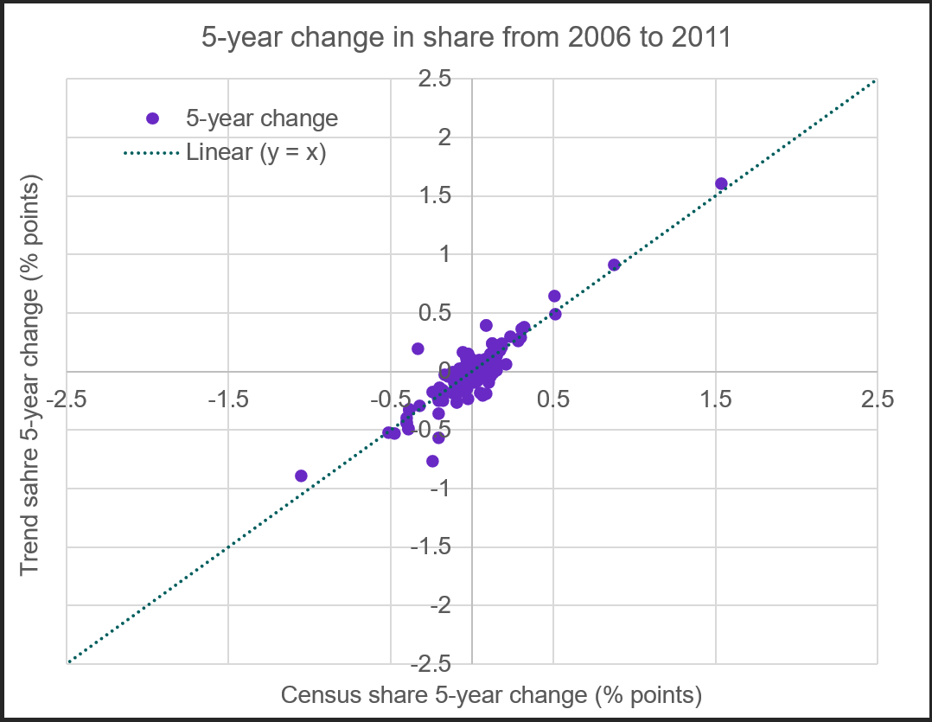

Figure 11: Comparison of 5-Year Share of Employment Growth

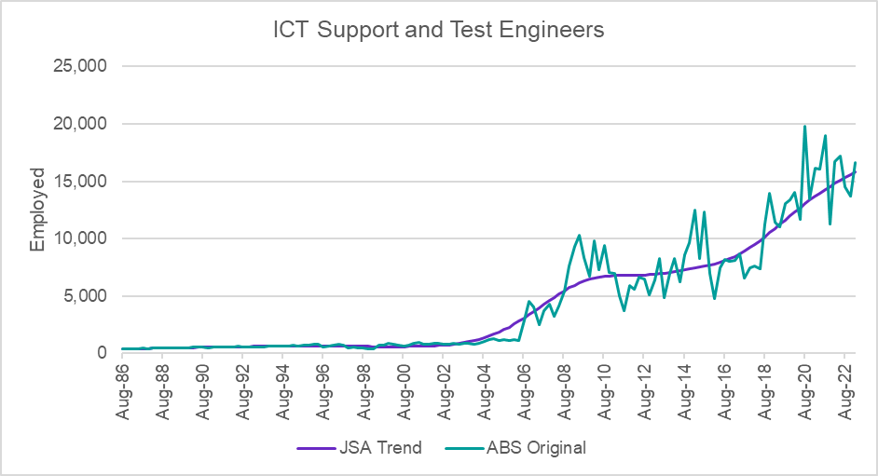

Figure 12: ICT Support and Test Engineers ANZSCO Definition Change

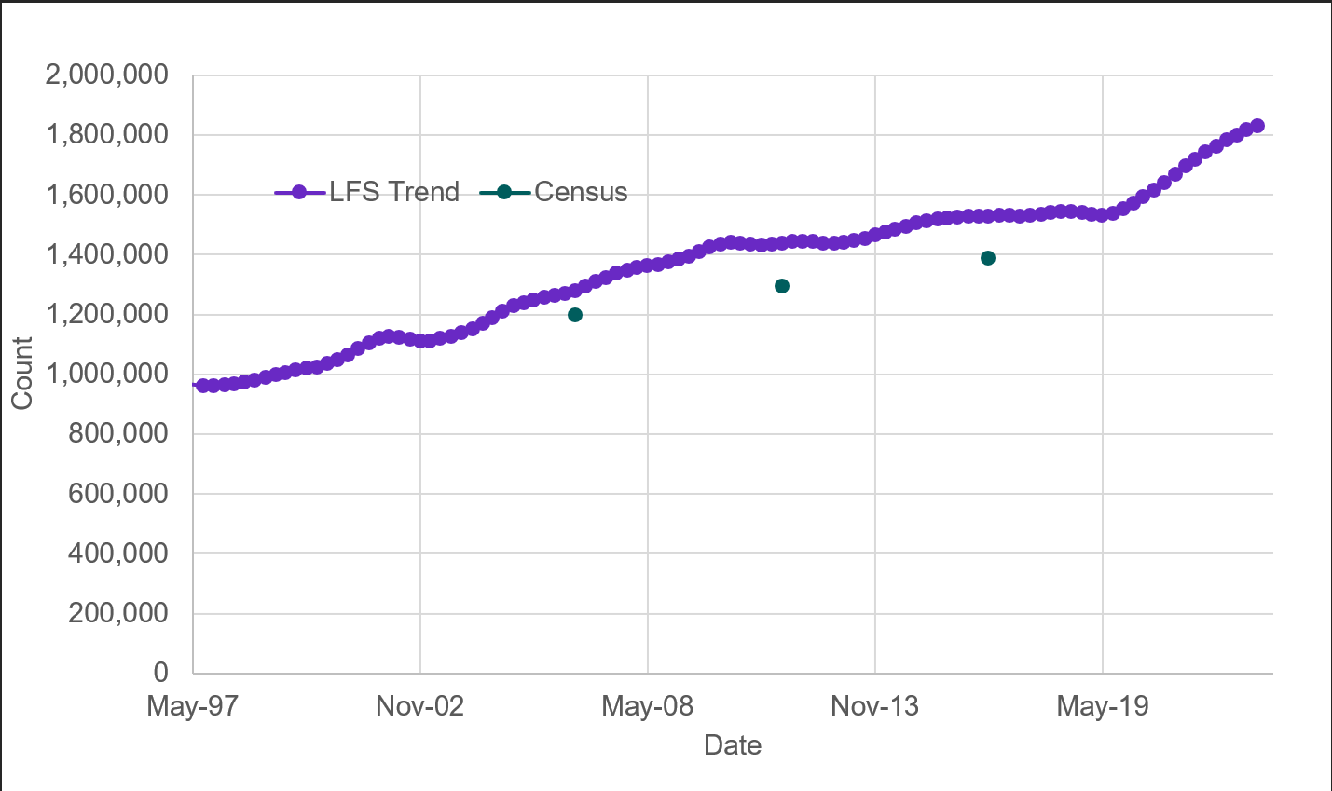

Figure 13: Comparison of the Manager Occupation (major group) between LFS Trend and Census

## ABS Industry Division (1-digit) Trend Comparison

Due to the difference in trending methodology between JSA and the ABS, trend estimations for level 1 industries may vary significantly, especially over short to medium timeframes. The use of the Henderson Filter by the ABS means that it is significantly more subject to quarter-on-quarter changes resulting from both real short term labour market trends and noise. Figure 14 compares the JSA trend series to the 3 available series released by the ABS for a given industry. Overall, the JSA series should be more adept at capturing longer-term trends whereas the ABS series is better suited to trying to identify shorter term cycles and trends. Both series can be used for data reporting, analysis or modelling depending on the use purpose. It is generally recommended that the ABS trend series is used when interested in quarterly movements (keeping alert to the possibility of incorrect signals due to noise), and the JSA trend series for longer term movements.

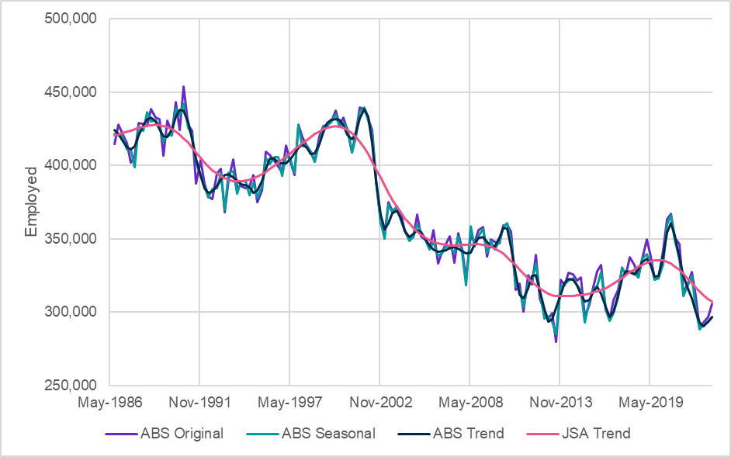

Figure 14: Comparison of Industry Division (1-digit) Series (Agriculture, Forestry and Fishing)

The following examples demonstrate some of the differences between these series:

* Example 1: Wholesale Trade industry (ANZSIC 1-digit) series comparison

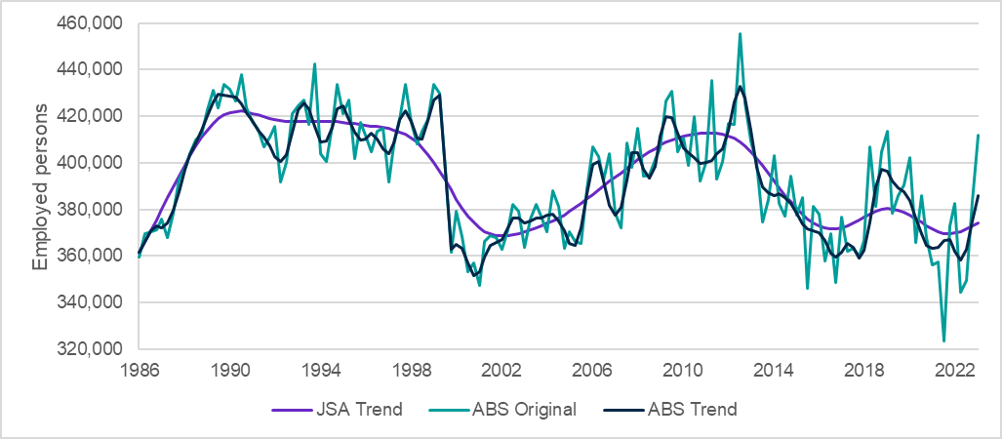

Figure 15: Comparison of ABS original and trend data, and JSA trend data - Wholesale Trade

In the Wholesale Trade series (Figure 15), volatility related to sample size issues in the LFS causes the estimates of employment in the original data to move up to +/-10% from quarter to quarter.

Given the relative standard error of the data, magnitude of the movements, and frequency of directional change it is unlikely that these quarterly shifts reflect real labour market movements but rather are just a function of statistical variability or noise. The ABS trend series reflects these movements to a significant extent and there is a danger that reporting quarterly movements will reflect noise and not a real labour market trend. However, the ABS series is adept at capturing rapid changes in trend and large shocks to employment such as the drops which occurred around the year 2000.

The JSA trend series better reflects long-term trends, such as the increase in employment between 2002 and 2010 with very minimal change in gradient. It should be noted that the quarterly changes in the JSA series simply reflect the longer-term growth rate and would not necessarily be a good reflection of the movement in each quarter specifically. Whilst the JSA series is better at removing noise it is not as effective at capturing rapid changes in trend, evident with the drop in employment around 2000 where the JSA series transitions over a 3-year period rather than reflecting the more rapid drop that appears to have occurred.

* Example 2: Construction industry (ANZSIC 1-digit) series comparison

It should be noted that when analysing the most recent quarter it can often be possible that neither series is effectively capturing a recent change in trend. To get a better understanding of current conditions it can be helpful to look for other indicators where possible. A good example of this is in the Construction industry.

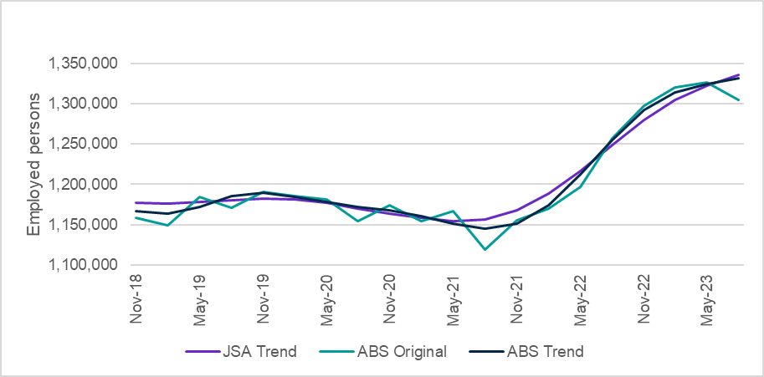

Figure 16: Comparison of ABS original and trend data, and JSA trend data - Construction

Other economic indicators suggest that the Construction industry may be experiencing uncertain conditions after strong growth since 2021 (Figure 16). While infrastructure projects continue to contribute to growth in the industry, dwelling investment has declined by 5% over the past year, with easing demand particularly for residential construction.

While there has been a decrease in the original data for the latest quarter, the ABS series has only plateaued and the JSA series is still maintaining the growth trend. This reflects the somewhat limited capacity of the LFS to identify changes in labour market conditions quickly, even at a highly aggregated level. The difference in responsivity between the series reflects the ABS series greater sensitivity to recent data points.

## Rolling Averages Comparison

Historical Averages:

* Historical averages (Figure 17) are a simplified method of removing seasonal impacts and reducing volatility (by averaging multiple data points - e.g. taking a 4 or 8 quarter average).
* However, historical averages can dilute the trend component and introduce a lag component.

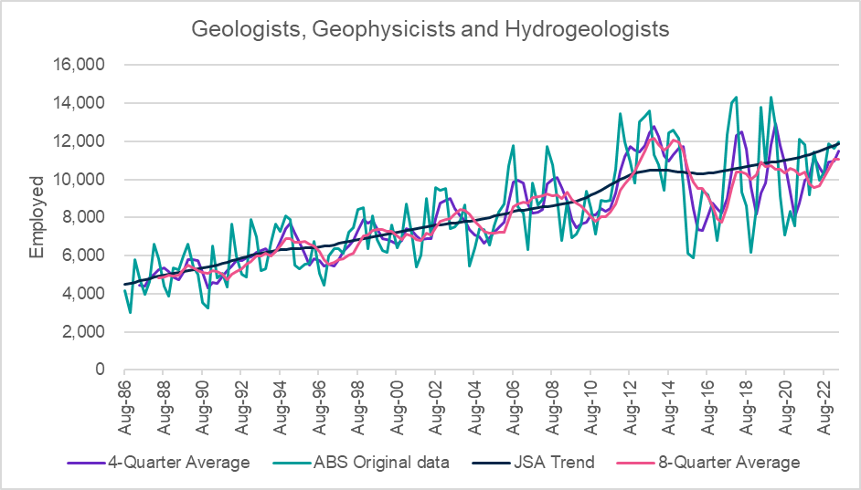

Figure 17: Comparison of ABS original, JSA Trend and Historical Averages

# Appendix

**Table 1: Industries where λ value is 6.25 or 400 at the national level**

| Industry | λ value |
| --- | --- |
| A Agriculture, Forestry and Fishing | 400 |
| 01 Agriculture | 400 |
| B Mining | 400 |
| C Manufacturing | 6.25 |
| 11 Food Product Manufacturing | 400 |
| E Construction | 6.25 |
| 30 Building Construction | 400 |
| 32 Construction Services | 6.25 |
| 323 Building Installation Services | 400 |
| 324 Building Completion Services | 400 |
| F Wholesale Trade | 400 |
| G Retail Trade | 6.25 |
| 41 Food Retailing | 400 |
| 411 Supermarket and Grocery Stores | 400 |
| 42 Other Store-Based Retailing | 6.25 |
| H Accommodation and Food Services | 6.25 |
| 45 Food and Beverage Services | 6.25 |
| 451 Cafes, Restaurants and Takeaway Food Services | 6.25 |
| I Transport, Postal and Warehousing | 6.25 |
| 46 Road Transport | 400 |
| K Financial and Insurance Services | 6.25 |
| 62 Finance | 400 |
| L Rental, Hiring and Real Estate Services | 400 |
| M Professional, Scientific and Technical Services | 6.25 |
| 69 Professional, Scientific and Technical Services (Except Computer System Design and Related Services) | 6.25 |
| 692 Architectural, Engineering and Technical Services | 400 |
| 693 Legal and Accounting Services | 400 |
| 70 Computer System Design and Related Services | 400 |
| 700 Computer System Design and Related Services | 400 |
| N Administrative and Support Services | 400 |
| 73 Building Cleaning, Pest Control and Other Support Services | 400 |
| 731 Building Cleaning, Pest Control and Gardening Services | 400 |
| O Public Administration and Safety | 6.25 |
| 75 Public Administration | 6.25 |
| 752 State Government Administration | 400 |
| 77 Public Order, Safety and Regulatory Services | 400 |
| 771 Public Order and Safety Services | 400 |
| P Education and Training | 6.25 |
| 80 Preschool and School Education | 6.25 |
| 802 School Education | 6.25 |
| 81 Tertiary Education | 400 |
| 810 Tertiary Education | 400 |
| 82 Adult, Community and Other Education | 400 |
| 821 Adult, Community and Other Education | 400 |
| Q Health Care and Social Assistance | 6.25 |
| 84 Hospitals | 6.25 |
| 840 Hospitals | 6.25 |
| 85 Medical and Other Health Care Services | 6.25 |
| 851 Medical Services | 400 |
| 853 Allied Health Services | 400 |
| 86 Residential Care Services | 400 |
| 860 Residential Care Services | 400 |
| 87 Social Assistance Services | 6.25 |
| 879 Other Social Assistance Services | 400 |
| R Arts and Recreation Services | 400 |
| S Other Services | 6.25 |
| 94 Repair and Maintenance | 400 |
| 95 Personal and Other Services | 400 |

**Table 2: Occupations where λ value is 6.25 or 400 at the national level**

| Occupation | λ value |
| --- | --- |
| 1 Managers | 6.25 |
| 13 Specialist Managers | 6.25 |
| 132 Business Administration Managers | 400 |
| 133 Construction, Distribution and Production Managers | 400 |
| 14 Hospitality, Retail and Service Managers | 6.25 |
| 142 Retail Managers | 400 |
| 1421 Retail Managers | 400 |
| 2 Professionals | 6.25 |
| 22 Business, Human Resource and Marketing Professionals | 6.25 |
| 221 Accountants, Auditors and Company Secretaries | 400 |
| 2211 Accountants | 400 |
| 224 Information and Organisation Professionals | 400 |
| 23 Design, Engineering, Science and Transport Professionals | 400 |
| 24 Education Professionals | 6.25 |
| 241 School Teachers | 400 |
| 25 Health Professionals | 6.25 |
| 254 Midwifery and Nursing Professionals | 400 |
| 2544 Registered Nurses | 400 |
| 26 ICT Professionals | 400 |
| 261 Business and Systems Analysts, and Programmers | 400 |
| 27 Legal, Social and Welfare Professionals | 400 |
| 3 Technicians and Trades Workers | 6.25 |
| 31 Engineering, ICT and Science Technicians | 400 |
| 32 Automotive and Engineering Trades Workers | 400 |
| 33 Construction Trades Workers | 400 |
| 34 Electrotechnology and Telecommunications Trades Workers | 400 |
| 4 Community and Personal Service Workers | 6.25 |
| 42 Carers and Aides | 6.25 |
| 423 Personal Carers and Assistants | 400 |
| 4231 Aged and Disabled Carers | 400 |
| 43 Hospitality Workers | 400 |
| 431 Hospitality Workers | 400 |
| 5 Clerical and Administrative Workers | 6.25 |
| 51 Office Managers and Program Administrators | 400 |
| 53 General Clerical Workers | 400 |
| 531 General Clerks | 400 |
| 5311 General Clerks | 400 |
| 54 Inquiry Clerks and Receptionists | 400 |
| 55 Numerical Clerks | 400 |
| 551 Accounting Clerks and Bookkeepers | 400 |
| 59 Other Clerical and Administrative Workers | 400 |
| 6 Sales Workers | 6.25 |
| 62 Sales Assistants and Salespersons | 6.25 |
| 621 Sales Assistants and Salespersons | 6.25 |
| 6211 Sales Assistants (General) | 6.25 |
| 7 Machinery Operators and Drivers | 6.25 |
| 73 Road and Rail Drivers | 400 |
| 8 Labourers | 6.25 |
| 81 Cleaners and Laundry Workers | 400 |
| 811 Cleaners and Laundry Workers | 400 |
| 85 Food Preparation Assistants | 400 |
| 851 Food Preparation Assistants | 400 |
| 89 Other Labourers | 400 |

# References

Hamilton J D (2018) ‘Why You Should Never Use the Hodrick-Prescott Filter’, *The Review of Economics and Statistics*, 100, issue 5, p. 831-843, <https://EconPapers.repec.org/RePEc:tpr:restat:v:100:y:2018:i:5:p:831-843>.

Mohr M (2005), ‘A Trend-Cycle(-Season) Filter’. *European Central Bank, Working Paper Series*, No. 499. <https://www.ecb.europa.eu/pub/pdf/scpwps/ecbwp499.pdf?f7a44f3027ec90c1e2448c04050e872f>

1. The design choice of using HPF is focused on providing a high degree of smoothing to support longer term trend analysis. While no specific trending methodology is perfect and there are limitations with the HPF, this approach is nonetheless considered robust to assist in identifying long-term trends in the labour market. JSA acknowledges that a number of research papers propose alternative methods to the HPF such as Hamilton (2018). However, as Hamilton (2018) states, ‘although drawbacks to their [Hodrick and Prescott’s] approach have been known for some time, the method [HPF] continues today to be very widely adopted in academic research, policy studies, and analysis by private-sector economists’. In this context, JSA is continuing to examine and review potential alternate (or improved) approaches as they emerge and welcomes further feedback and ideas from users.
2. https://www.jobsandskills.gov.au/data/internet-vacancy-index
3. The JSA trend methodology is consistent with ABS’ management of these small measurement effects, whereby the ABS seek to explicitly account for the systematic nature of supplementary survey effects in effectively managing time series veracity.
4. Note: Not Further Defined (NFD) series and a small number of series with historical artefacts in the original data are excluded from this process.
5. The 3-digit industries in this category are 561 Radio Broadcasting and 722 Travel Agency and Tour Arrangement Services. The 4-digit occupations in this category are 6391 Models and Sales Demonstrators and 6394 Ticket Salespersons.