



2024 Occupation Shortage List

Key Findings and Insights Report

**14 October 2024**

Contents

Introduction 4

Overview 4

Current state of the labour market 5

2024 OSL results 7

Summary of national level findings 7

A high-level breakdown 9

Additional insights 14

Many large employing occupations are in national Shortage 14

Gender-skew in occupations could impact shortages 16

Age distribution among occupations in Shortage 18

Occupation shortage pressures in industries 19

Employers rarely adjust wages to fill vacancies 20

**List of figures**

Figure 1: Unemployment rate (%) and full-time employment growth (%), 2014–24 5

Figure 2: Fill rate (%), recruitment difficulty rate (%) and Internet Vacancy Index (000’s), 2022–24 6

Figure 3: Monthly hours worked (left, millions) and employment-to-population ratio (right, %), seasonally adjusted, 2022–24 6

Figure 4: Percentage of occupations in Shortage (%) in 2021 to 2024 OSL 7

Figure 5: Density plot of predicted fill rates (%) for the 2023 and 2024 OSLs 8

Figure 6: Number of applicants, qualified applicants and suitable applicants per vacancy (No.), 2020–21 to 2023–24 financial years 9

Figure 7: Percentage of occupations in Shortage (%), by major group, 2021–24 11

Figure 8: Recruitment difficulty rate (%), by high and low skilled occupations, 2021–24 12

Figure 9: Percentage of occupations in Shortage (%), by Skill Level, 2021–24 13

Figure 10: Percentage of gender-imbalanced occupations that were in Shortage (%), 2021–24 16

Figure 11: Gender breakdown of the percentage of occupations in Shortage (%), by major group, 2024 17

Figure 12: Age distribution of workers in occupations (%), by shortage rating, by major group, 2024 18

Figure 13: Percentage of occupations in Shortage (%), by mature age worker composition, 2021-2024 19

Figure 14: Workforce shortage pressures (%), by industry, 2021–24 20

Figure 15: Percentage of employers’ responses to unfilled vacancies (%), 2021–24 21

Figure 16: Correlation of annual wage growth (2021–23) and fill rates lagged by 1-year (2020–22), at ANZSCO unit group 22

**List of tables**

Table 1: Summary of occupation rating changes between 2023 and 2024 OSLs 9

Table 2: Summary of major groups in persistent Shortage in the 2021–24 OSLs 10

Table 3: Top 20 largest employing occupations in Shortage in the 2024 OSL 15

# Introduction

## Overview

The Occupation Shortage List (OSL), produced by Jobs and Skills Australia, provides a list of occupations in shortage in Australia and in each state and territory.[1] The OSL is released annually and is a point-in-time assessment of the shortage status of occupations in the labour market. The findings and insights derived from the OSL products can be useful for informing, along with other sources of information, labour market policies and program.

The OSL was formerly known as the Skills Priority List. The product has been rebranded to better align to the definition of occupation shortage used and the insights generated.[2]

The OSL Key Findings and Insights Report provides an overview of the 2024 OSL results.[3] The report also presents additional analyses to assist with the interpretation of the 2024 OSL results and reveals important insights related to occupation shortages in the labour market.

The OSL covers over 900 occupations, defined in the 2022 *Australian and New Zealand Standard Classification of Occupations* (ANZSCO) at the occupation level.[4] Only ANZSCO Skill Levels 1 to 4 are included in the OSL because of their links to tertiary education and training.[5] Occupations in shortage for several years, particularly those where qualifications are mandatory, have implications for the education and training sector in Australia.

Jobs and Skills Australia uses the following definition of occupation shortages:

* An occupation is in shortage when employers are *unable to fill or have considerable difficulty filling vacancies for an occupation or cannot meet significant specialised skill needs* within that occupation, at current levels of remuneration and conditions of employment and in reasonably accessible locations.

Based on this definition, the primary measure of an occupation shortage is the ability of employers to fill vacancies (the fill rate). The fill rate is converted into occupation shortage ratings using a set of rules, including rules applied to other modelling outputs and data. A threshold fill rate of 67% is used to ascertain the likelihood of an occupation shortage. That is, there is a higher chance of an occupation in shortage when the fill rate is below 67%.[6]

The sources used to assess occupation shortages include data modelling, statistical analysis of the labour market, employer and stakeholder surveys, and additional engagements with various stakeholder groups. These groups consist of peak bodies, industry groups, professional associations, unions, education providers and regional representative bodies in the Australian labour market. Feedback is also sought from the Commonwealth Government, state and territory governments, as well as Jobs and Skills Councils.[7]

Jobs and Skills Australia appreciates the time, effort and expertise that stakeholders provided to enhance the quality of the analysis that underpins the OSL outcomes.

## Current state of the labour market

Over the course of 2023–24, labour market indicators show that the Australian labour market continued to show resilience, albeit with emerging signs that it has begun to soften. In June 2024, the unemployment rate increased to 4.1% from its historical low of 3.5% in June 2023, though the rise has been gradual and remains low compared to the rate in the last 10 years (Figure 1). With respect to signs of softening conditions, the annual pace of full-time employment growth has slowed, from 4.2% recorded in June 2023 to 1.2% in June 2024.

Figure 1: Unemployment rate (%) and full-time employment growth (%), 2014–24

Source: Australian Bureau of Statistics, Labour Force, Australia, July 2024, seasonally adjusted.

In addition, one of the partial forward indicators of labour demand, the Jobs and Skills Australia’s *Internet Vacancy Index* (IVI), showed that monthly online job advertisements fell by 18.2% during 2023–24, from 276,500 in June 2023 to 226,200 in June 2024 (Figure 2). Similarly, results from the Jobs and Skills Australia’s *Recruitment Experiences and Outlook Survey* (REOS) indicated that the recruitment difficulty rate fell from 63% in June 2023 to 55% in June 2024.[8]

Further, the *Survey of Employers who have Recently Advertised* (SERA), produced by Jobs and Skills Australia, showed that the percentage of advertised vacancies filled (the fill rate) increased to 69.5% in June 2024, from 59.4% in June 2023.

Figure 2: Fill rate (%), recruitment difficulty rate (%) and Internet Vacancy Index (000’s), 2022–24

Source: Jobs and Skills Australia, Internet Vacancy Index, Survey of Employers who have Recently Advertised, Recruitment Experiences and Outlook Survey, 2022–24.

The employment-to-population ratio, for June 2024, remained largely unchanged at around 64.2%, which is close to the peak level reached in late 2023 (Figure 3, right). Even though vacancies have been falling, employment growth has continued, which is consistent with improved fill rates and possibly due to the large backlog of vacancies accumulated during the 2022 to 2023 period. In addition, in June 2024, monthly hours worked in all jobs increased by only 0.6% from June 2023 and is below the peak recorded in April 2023   
(Figure 3, left).

Figure 3: Monthly hours worked (left, millions) and employment-to-population ratio (right, %), seasonally adjusted, 2022–24

Source: Australian Bureau of Statistics, Labour Force, Australia, July 2024.

# 2024 OSL results

## Summary of national level findings

The 2024 OSL results showed that 33% of occupations (303 out of 916 assessed occupations) are in national level Shortage (Figure 4).[9] This is 3 percentage points less than the result in 2023 (36%) but is 1 percentage point higher than the 2022 result (32%).[10]

Figure 4: Percentage of occupations in Shortage (%) in 2021 to 2024 OSL

Source: Jobs and Skills Australia, Occupation Shortage List, 2021–24.

From a macro labour market context, the result most likely reflect the 2024 OSL assessment period, which encompassed periods of 2023, where labour market conditions were tight.[11] Conditions started to ease from late 2023.

Reflecting the changes in labour market conditions, the distribution of estimated occupation fill rates in the 2024 OSL shifted slightly to the right compared to that of the 2023 OSL (Figure 5). This means that the average estimated fill rates in the labour market have increased from 65.9% in the 2023 OSL to 67.1% in the 2024 OSL.[12] The median fill rates also increased from 59.2% to 61.7% over the two OSL periods.

The change in the distribution of estimated fill rates in 2024 OSL suggested there were fewer occupations with fill rates below 60% and a greater concentration of occupations with fill rates between 60% and 80%. Therefore, there were fewer occupations with lower fill rates in the 2024 OSL than the 2023 OSL.[13]

Figure 5: Density plot of predicted[14] fill rates (%) for the 2023 and 2024 OSLs

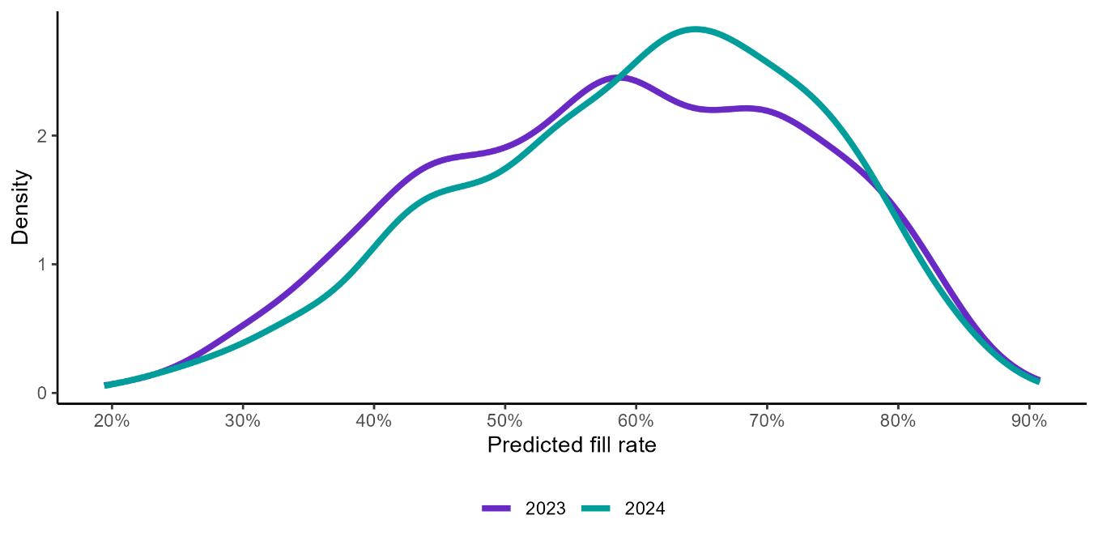Source: Jobs and Skills Australia.

Moreover, the number of total applicants, qualified applicants and suitable applicants per vacancy increased in 2023–24 compared to 2022–23 (Figure 6). In particular, the number of total and qualified applicants per vacancy increased by 8.1 and 1.9 persons per vacancy, respectively.[15]

Figure 6: Number of applicants, qualified applicants and suitable applicants per vacancy (No.), 2020–21 to 2023–24 financial years

Source: Jobs and Skills Australia, Survey of Employers who have Recently Advertised, 2020–24.

## A high-level breakdown

In the 2024 OSL, 8 occupations were newly classified as in Shortage when compared to the 2023 OSL (Table 1).[16] Conversely, 37 occupations transitioned from Shortage in 2023 to No Shortage in 2024. Among these,15 occupations were concentrated in Skill Level 4 occupations within the Machinery Operators and Drivers and Labourers major groups.[17]

Table 1: Summary of occupation rating changes between 2023 and 2024 OSLs

|  |  |  |
| --- | --- | --- |
| Change from 2023 to 2024 | Occupations (No.) | Occupations (%) |
| Still in Shortage | 295 | 32 |
| No Shortage (2023) to Shortage (2024) | 8 | 1 |
| Shortage (2023) to No Shortage (2024) | 37 | 4 |
| Still in No Shortage | 576 | 63 |
| **All occupations** | **916** | **100** |

Source: Jobs and Skills Australia, Occupation Shortage List, 2021–24.

Just under a third of occupations (32%) were in Shortage in both the 2023 and 2024 OSLs:

* Many (143 occupations or 48%) of these were in the Professionals major group which included many related to health, engineering, teaching and information communication and technology (ICT).
* Another 102 occupations (35%) were in the Technicians and Trades Workers major group.
* Most of the remaining 50 occupations in Shortage in 2023 and 2024 OSLs comprised Community and Personal Service Workers and Machinery Operators and Drivers.[18]

In 2024 OSL, no occupations in Shortage were confined to only metropolitan areas (though there were some examples of this type of shortage for individual states and territories). However, 1% (or 10 occupations) were assessed as being in Regional Shortage.[19],[20]

Occupation ratings for states and territories were based on the feedback received from Jobs and Skills Councils and state and territory government stakeholders.[21] Generally, occupations assessed as Shortage, nationally, were also rated as Shortage in each state and territory. Variations in ratings reflect the unique labour market characteristics of the states and territories, different methodologies used by each state and territory government stakeholder to assess occupation shortages and differences in stakeholder inputs they each received when conducting their own analysis.

Table 2: Summary of major groups in persistent Shortage in the 2021–24 OSLs

|  |  |  |
| --- | --- | --- |
| In Shortage from 2021 to 2024 | Occupations (No.) | Occupations (%) |
| Managers | 3 | 2 |
| Professionals | 55 | 40 |
| Technicians and Trades Workers | 67 | 49 |
| Community and Personal Service Workers | 4 | 3 |
| Machinery Operators and Drivers | 7 | 5 |
| **All occupations** | **136** | **100** |

Source: Jobs and Skills Australia, Occupation Shortage List, 2021–24.

There were 136 occupations in persistent Shortage from 2021 to 2024 (Table 2).[22] Of these, 49% (67 out of 136) were in the Technicians and Trades Workers major group, while occupations in the Professionals major group made up 40% (55 out of 136).[23]

Figure 7 presents the percentage of occupations in Shortage by major group over time.

In 2024, Professionals (45%) and Technicians and Trades Workers (50%) major groups had the highest percentage of occupations in Shortage. Similar to 2023, there were no occupations in Shortage in the Sales Workers major group.

The change from 36% of occupations in Shortage in 2023 to 33% in 2024, was largely driven by occupations no longer in Shortage within the Machinery Operators and Drivers and Labourers major groups. There were 10 percentage points and 18 percentage points fewer occupations in Shortage in these major groups, respectively.

Figure 7: Percentage of occupations in Shortage (%), by major group, 2021–24

Source: Jobs and Skills Australia, Occupation Shortage List, 2021–24.

The above results indicate that the easing labour market conditions primarily impacted on the major groups which have a higher concentration of lower skill level occupations. They also indicate that challenges remain for occupations in the Professionals and Technicians and Trades Workers major groups, especially given the results were highly congruent to the 2023 OSL.

This is also evident in Figure 8. The recruitment difficulty rates for higher skilled occupations (Skill Levels 1–3), while below the peak recorded in the second half of 2022, remained mostly elevated over 2023 and parts of 2024. In contrast, the recruitment difficulty rates for lower skilled occupations (Skill Levels 4–5) fell over the same period.

Figure 8: Recruitment difficulty rate (%), by high and low skilled occupations, 2021–24

Source: Jobs and Skills Australia, Recruiting Employer Outlook Survey, July 2024.

Figure 9 shows the percentage of occupations in Shortage in the 2024 OSL, by Skill Levels 1 to 4.[24] The results generally mirror those of the occupations by major groups shown in Figure 7.

Compared to 2023, the percentage of occupations in Shortage for Skill Level 4 were lower in 2024 by over 7 percentage points; that is, it fell from 23% to 15%.[25]

Figure 9 shows that occupations with Vocational Education and Training (VET) as the primary pathway to the labour market had a large percentage of occupations in Shortage. About half of Skill Level 3 occupations (46%) – which typically require a Certificate III/IV – were in Shortage. Nearly a quarter of Skill Level 2 occupations (24%) were also in Shortage. In addition, 39% of Skill Level 1 occupations, which usually require a bachelor’s degree or higher, were in Shortage.

The results for Skill Levels 1 to 3 were very similar to the 2023 OSL.

Figure 9: Percentage of occupations in Shortage (%), by Skill Level, 2021–24

Source: Jobs and Skills Australia, Occupation Shortage List, 2021–24.

The results indicate that there is a large cluster of occupations in Shortage that have a long lead time for training. That is, there is a long lag before qualified workers can enter the labour market for these occupations. These outcomes demonstrate the importance of the VET and higher education sectors in supporting the pipeline of qualified and skilled workers in the labour market.

# Additional insights

## Many large employing occupations are in national Shortage

Table 3 shows the top 20 largest employing occupations in Shortage in the 2024 OSL. They comprise a diverse range of occupations with an employment base across various sectors, including health, aged care, education, construction, professional and business services.

The top 20 occupations in Shortage employed 20.3% of workers that were within the scope of the OSL.[26]

The 5 largest occupations in Shortage were Aged or Disabled Carer, Primary School Teacher, Secondary School Teacher, Truck Driver (General) and Electrician (General). Together, they made up 8.9% (or 824,973 people) of total employment in occupations within scope of the OSL. In addition to their share and level of employment, these occupations play a vital role in the economy.

Most of these occupations have been in Shortage for at least 3 years. Some of the largest employing occupations, such as Aged or Disabled Carer, Electrician (General), Child Care Worker and Carpenter, have been in Shortage from 2021. Of the top 20 employing occupations that were in Shortage for 4 years, most were in the Technicians and Trades Workers and Community and Personal Service Workers major groups. However, General Practitioners and Developer Programmer, which are within the Professionals major group, were also in Shortage for 4 years.

The reasons for persistent shortages are likely to be multifaceted. They include population ageing, technology advances, and other impacts of structural changes in the labour market, such as, constraints in the supply of qualified and experienced workers, working conditions and pay, and government policies and regulations. Any future solutions to address persistent shortages will, therefore, likely need to be long-term and holistic.

Another noticeable feature of the occupations in persistent Shortage in Table 3 is that they are highly gender skewed. Only a few, such as Solicitor and General Practitioner had a more balanced distribution of men and women. This is elaborated in the following section.

Table 3: Top 20 largest employing occupations in Shortage in the 2024 OSL

|  |  |  |  |  |  |
| --- | --- | --- | --- | --- | --- |
| 2022 ANZSCO Code | Occupation title | Years in Shortage  (from 2021 to 2024) | Men employed (%) (2021 Census) | Women employed (%) (2021 Census) | Total employed (2021 Census) |
| 423111 | Aged or Disabled Carer | 4 | 23.3% | 76.7% | 227,542 |
| 241213 | Primary School Teacher | 3 | 14.9% | 85.1% | 164,895 |
| 241411 | Secondary School Teacher | 3 | 37.8% | 62.2% | 155,850 |
| 733111 | Truck Driver (General) | 3 | 95.6% | 4.4% | 148,401 |
| 341111 | Electrician (General) | 4 | 97.9% | 2.1% | 128,285 |
| 421111 | Child Care Worker | 4 | 3.2% | 96.8% | 123,815 |
| 131112 | Sales and Marketing Manager | 2 | 58.3% | 41.7% | 119,702 |
| 331212 | Carpenter | 4 | 99.0% | 1.0% | 104,859 |
| 351311 | Chef | 4 | 72.8% | 27.2% | 90,453 |
| 321211 | Motor Mechanic (General) | 4 | 98.1% | 1.9% | 79,296 |
| 271311 | Solicitor | 2 | 45.8% | 54.2% | 69,704 |
| 323211 | Fitter (General) | 4 | 97.9% | 2.1% | 68,498 |
| 133111 | Construction Project Manager | 4 | 86.0% | 14.0% | 64,866 |
| 261313 | Software Engineer | 4 | 84.4% | 15.6% | 54,294 |
| 391111 | Hairdresser | 4 | 16.3% | 83.7% | 53,579 |
| 253111 | General Practitioner | 4 | 52.3% | 47.7% | 48,705 |
| 133112 | Project Builder | 4 | 95.2% | 4.8% | 47,845 |
| 261312 | Developer Programmer | 4 | 83.5% | 16.5% | 43,946 |
| 322311 | Metal Fabricator | 4 | 98.9% | 1.1% | 42,572 |
| 423313 | Personal Care Assistant | 4 | 13.6% | 86.4% | 42,336 |

Source: Jobs and Skills Australia, Occupation Shortage List, 2021–24; Australian Bureau of Statistics, 2021 Census of Population and Housing.

## Gender-skew in occupations could impact shortages

At the national level, employment by gender is almost even (52% men versus 48% women), but some occupations have significant gender imbalances.

Analysis of the 2024 OSL results showed that occupations with a gender-skewed workforce were more likely to be in Shortage (Figure 10).

* Half (50%) of the occupations where men constituted at least 80% of the workforce were in Shortage. These occupations were concentrated in the Technicians and Trades Workers, Machinery Operators and Drivers, and Labourers major groups. However, many ICT-based occupations, within the Professionals major group, employed men predominately and were also in Shortage.
* Further, 39% of occupations where women were at least 80% of the workforce were in Shortage. These were concentrated in health-related occupations (for example, Registered Nurses), early education and care-based occupations. They were also found in other occupations within the Community and Personal Service Workers major group.
* In contrast, only 22% of occupations with more gender balanced workforces were in Shortage. Occupations that had a No Shortage rating were more likely to have workforces that had at least 20% of both genders. These occupations were commonly managerial and professional roles.

Figure 10: Percentage of gender-imbalanced occupations that were in Shortage (%), 2021–24[27]

Source: Jobs and Skills Australia, Occupation Shortage List, 2021–24; Australian Bureau of Statistics, 2021 Census of Population and Housing.

Table 3 (in the previous section) highlights the relationship between gender imbalances and likely occupation shortages. Within the top 20 employing occupations, 14 have gender imbalances (that is, occupations with at least 80% men or women in the workforce).

* The imbalance towards more women is seen in Child Care Worker (97% women employed), Personal Care Assistant (86%), Primary School Teacher (85%) and Hairdresser (84%) occupations.
* For men it is seen in Carpenter (99% men employed), Metal Fabricator (99%), Motor Mechanic (General) (98%), Fitter (General) (98%), Electrician (General) (98%), Truck Driver (96%), Project Builder (95%), Construction Project Manager (86%), Software Engineer (84%) and Developer Programmer (84%) occupations.

As these results suggest, occupations in Shortage and with a large gender skew towards men were noticeably within the Machinery Operators and Drivers, Labourers, and Technicians and Trades Workers major groups. This is more clearly illustrated in Figure 11.

The figure shows the percentage of occupations in Shortage, within each major group, where:

* women constituted less than 20% of the occupation workforce
* women and men, separately, constituted at least 20% of the occupation workforce
* men constituted less than 20% of the occupation workforce.

For the Machinery Operators and Drivers and Labourers major groups, most occupations (94% and 86%, respectively) had workforces where women constituted less than 20% of the workers. In 81% of occupations within the Technicians and Trades Workers major group, women constituted less than 20% of each workforce.

Figure 11: Gender breakdown of the percentage of occupations in Shortage (%), by major group, 2024

Source: Jobs and Skills Australia, Occupation Shortage List, 2024; Australian Bureau of Statistics, 2021 Census of Population and Housing.

Therefore, heavily gender-skewed workforces may inadvertently constrain the labour supply, thereby increasing the likelihood of entrenched shortages. Addressing the gender imbalance of occupations may be a sound long-term strategy to mitigate occupation shortages in the labour market.

## Age distribution among occupations in Shortage

Figure 12 shows the age distribution of workers in occupations that were in Shortage (top panel) and those that had No Shortage ratings (bottom panel), by major occupation group.

The figure shows occupations that were rated as No Shortage had a higher proportion of mature aged workers (aged 55 and above) than those that were in Shortage (25% versus 20%). This pattern is consistent across all major groups, with differences ranging from 1 percentage point (for Professionals) to 11 percentage points (for Labourers). Unsurprisingly, whether rated as Shortage or No Shortage, the highest concentration of workers for all major groups was in the primary working age group (between 25 and 44 years of age).

Figure 12: Age distribution of workers in occupations (%), by shortage rating, by major group, 2024

Source: Jobs and Skills Australia, Occupation Shortage List, 2024; Australian Bureau of Statistics, 2021 Census of Population and Housing.

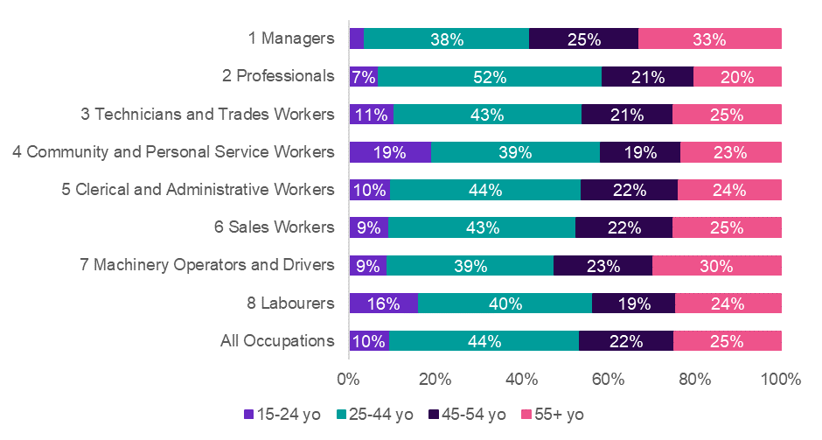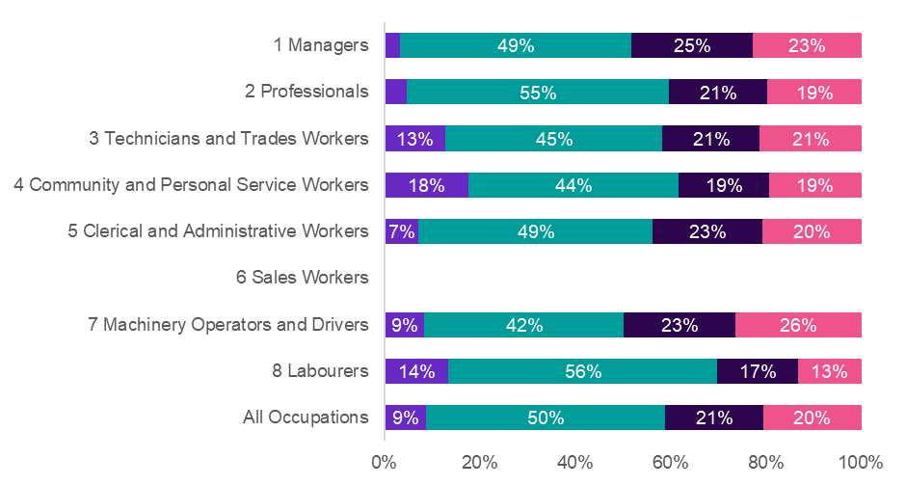

**Shortage**

**No Shortage**

Figure 13 shows the percentage of occupations in Shortage, by the composition of mature aged workers (aged 55 or older). Each occupation has been categorised into 1 of 3 groups:

* less than 10% of mature aged workers
* between 10% and 30% of mature aged workers
* more than 30% of mature aged workers.

Figure 13: Percentage of occupations in Shortage (%), by mature age worker composition, 2021-2024

Source: Jobs and Skills Australia, Occupation Shortage List, 2021–24; Australian Bureau of Statistics, 2021 Census of Population and Housing.

Consistent with previous insights, Figure 13 implies that an occupation that has a larger proportion of its workforce aged 55 years or older were less likely to have a Shortage rating:

* For occupations with at least 30% of workers aged 55 and above, 19% were in Shortage.
* For occupations with no more than 10% of workers aged 55 and above, 44% were in Shortage.

The above results points to the importance of age-inclusiveness in employment particularly in an ageing population as increasing employment for older workers may help to alleviate occupations in shortage.

## Occupation shortage pressures in industries

An industry is likely to feel shortage pressures when the largest employing occupations within that industry are in shortage. To explore this, employment sizes of occupations within an industry that were in Shortage in the 2024 OSL were summed and divided by the total employment size of that industry.[28] Essentially, occupation shortage ratings at the national level were weighted by the within-industry distribution of employment. This was used to calculate a proxy for the percentage of workforce shortage in an industry.

Figure 14: Workforce shortage pressures (%), by industry, 2021–24

Source: Jobs and Skills Australia, Occupation Shortage List, 2021–24; Australian Bureau of Statistics, 2021 Census of Population and Housing.

Compared to other industries, Construction, Health Care and Social Assistance, Mining, Other Services, and Education and Training appear to have acute shortage pressures (Figure 14).[29] All 5 of these industries have had shortage pressures of 51% to 72%, since 2022.

The results reflect the percentage of health and teacher professional occupations in Shortage and concentrated in Health Care and Social Assistance and Education and Training industries, respectively. It also reflects the concentration of Technicians and Trades Workers in Shortage and employed in Construction and Mining.

The results also align with the expected impacts of population ageing and the flow on increasing demand for health services, and the impact of backlog of infrastructure projects on the Construction industry.

## Employers rarely adjust wages to fill vacancies

Data from SERA, for the 2024 OSL period, indicated that 73% of employers continued to advertise in the same place in response to unfilled vacancies, over the course of a year (Figure 15). Other common actions included seeking applicants through different channels, such as word of mouth (24%) and advertising on different sites or places (15%). Figure 15 shows the most common actions for the 2021 to 2024 OSL periods.

Figure 15: Percentage of employers’ responses to unfilled vacancies (%), 2021–24

Source: Jobs and Skills Australia, Survey of Employers who have Recently Advertised, 2021–24.

Over the 4 years from 2021 to 2024, few employers (between 0 and 1%) changed remuneration in response to unfilled vacancies. In the 2024 OSL period, around 1% of employers adjusted remuneration to attract suitably skilled workers to fill vacancies. The percentage of employers with this response was unchanged from 2023.

This result is supported by weak relationships between wage growth and vacancy fill rates of occupations (Figure 16).

Figure 16 displays the relationship between wages growth and fill rates lagged by one year. The fill rates were lagged due to the common finding that employers do not immediately respond to skill shortages or unfilled vacancies by raising wages. The figure reveals that wages growth is negatively associated with fill rates and that the correlation is weak and statistically insignificant. This analysis suggests that employers may seek other strategies first before seeking to adjustment wages to fill vacancies.

Further, previous research undertaken by the Reserve Bank of Australia showed limited evidence that firms raised wages in response to firm-wide or job-level skill shortages, at least in the short-term.[30]

Figure 16: Correlation of annual wage growth (2021–23) and fill rates lagged by 1-year (2020–22), at ANZSCO unit group

Source: Jobs and Skills Australia, Survey of Employers who have Recently Advertised (SERA), 2020–22 financial years; Australian Bureau of Statistics, Characteristics of Employment, August 2023, TableBuilder.

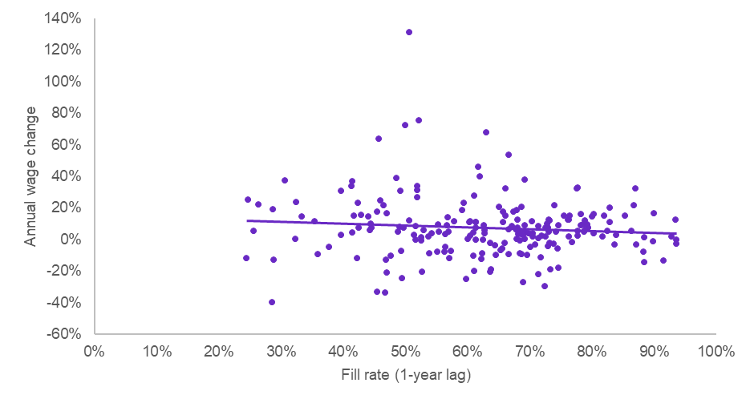

*R = -0.094, p = 0.18*

1. In this report, Shortage (with a capital S) is used to indicate an OSL rating. When referring to a labour market condition, lowercase s for shortage is used.
2. Only the product branding has changed. To be consistent with the current title of the report, all reports published in previous years will be referred to as the OSL in this report and other 2024 OSL outputs.
3. The 2024 OSL assessment period includes data from April 2023 to June 2024. The 2023 OSL assessment period is similar.
4. ANZSCO is a skill-based classification used to classify all occupations and jobs in the Australian and New Zealand labour markets. It is organised into a 5-level hierarchy: major groups, sub-major groups, minor groups, unit groups and occupations. Occupation level refers to the most granular 6 digit ANZSCO. For more details on ANZSCO refer to the [Australian Bureau of Statistics (ABS) website](https://www.abs.gov.au/statistics/classifications/anzsco-australian-and-new-zealand-standard-classification-occupations/latest-release).
5. Skill Level 5 occupations only require the equivalent of compulsory school education.
6. Refer to the 2024 OSL Methodology Paper for more details.
7. As above.
8. The recruitment difficulty rate is the proportion of all recruiting employers who reported experiencing difficulty hiring. The indicator is calculated as: employers who recruited and reported difficulty, divided by all employers who recruited (excluding ‘unsure’ responses). See detailed explanation in [REOS - concepts methods and questionnaire](https://www.jobsandskills.gov.au/data/recruitment-experiences-and-outlook-survey#methodology).
9. The OSL has four ratings to classify the shortage status on a specific occupation. Shortage: An occupation is in national shortage or overall shortage; Metropolitan Shortage: An occupation is in shortage in a metropolitan area; Regional Shortage: An occupation is in shortage in a regional area; No Shortage: An occupation is not in shortage.
10. All analyses in this report are based on the ABS ANZSCO 2022 version.
11. The 2024 OSL assessment period includes data from April 2023 to June 2024. The 2023 OSL assessment period is similar.
12. These fill rates are generated by a Gradient Boosting Machine learning model, which produces fill rates for all ANZSCO Skill Level 1 to 4 occupations. These fill rates differ from those based only on SERA data, reported on page 5.
13. Analysis also shows that the percentage of occupations with fill rates below 67% at an 80% confidence interval has fallen in the 2024 OSL compared to the 2023 OSL. A confidence interval is the range of values a measure (in this case the fill rate) is expected to lie within, with a certain level of confidence or certainty. An occupation can have a range of fill rates within the year, from low to high. The analysis shows that for occupations, generally, more fill rates were above 67% and fewer with fill rates less than 67%. Jobs and Skills Australia uses a fill rate threshold of 67% to determine the likelihood of an occupation shortage, with fill rates below 67% implying a higher likelihood of an occupation in shortage.
14. A Gradient Boosting Machine learning model is used to predict fill rates for the 916 occupations used in this analysis.
15. The difference in the total applicants per vacancy, 8.1, is rounded. It is derived by subtracting 16.05 in 2022–23 from 24.12 in 2023–24.
16. The full list of occupations in No Shortage in 2023 and Shortage in 2024 is in Appendix A of the 2024 OSL Key Findings Report Appendices.
17. The full list of occupations in Shortage in 2023 and No Shortage in 2024 is in Appendix B of the 2024 OSL Key Findings Report Appendices.
18. The full list of occupations in Shortage in both 2023 and 2024 is in Appendix C of the 2024 OSL Key Findings Report Appendices.
19. The full list of occupations in Regional Shortage only is in Appendix E of the 2024 OSL Key Findings Report Appendices.
20. As per Footnote 9, Metropolitan Shortage refers to shortages in a metropolitan area, while Regional Shortage refers to shortages in a regional area. The term metropolitan area refers to state and territory Capital City, while regional refers to the Rest of the State as defined by the ABS *Australian Statistical Geography Standard* (ASGS).
21. For details on how feedback was incorporated, refer to the 2024 OSL Methodology Paper.
22. Persistent shortage is defined as occupations being in Shortage for 3 or more years.
23. The full list of occupations in Shortage across all 2021–24 OSLs is in Appendix D of the 2024 OSL Key Findings Report Appendices.
24. The Australian Bureau of Statistics provides information on the concept of Skill Levels as part of its [Conceptual basis of ANZSCO](https://www.abs.gov.au/statistics/classifications/anzsco-australian-and-new-zealand-standard-classification-occupations/2021/conceptual-basis-anzsco).
25. The percentage of occupations in Shortage for Skill Level 4 occupations fell from 22.6% to 15.4%, making the difference 7.2 percentage points.
26. There are 916 occupations at Skill Levels 1 to 4 in the 2024 OSL. For full details on occupation inclusions/exclusions, refer to the 2024 OSL Methodology Paper.
27. Historical data has been updated to align with the current scope of occupations included in the 2024 OSL. For example, Detectives were not included within the 2024 OSL occupations but were so in the 2022 OSL. The change has resulted in a minor difference in the data reported on the percentage of men dominated occupations in Shortage in 2022, which changes from 49% (as reported in 2023 OSL) to 50% (as shown in Figure 10).
28. The definition of industry is based on *Australian and New Zealand Standard Industrial Classification* (ANZSIC), see the [ABS website](https://www.abs.gov.au/statistics/classifications/australian-and-new-zealand-standard-industrial-classification-anzsic/2006-revision-2-0/introduction#anzsic-structure).
29. Other Services includes a broad range of services like hairdressing and beauty services; diet and weight management centres; funerals, crematoriums and cemeteries; religious services; car repair and maintenance; machinery repair services; private households employing staff; and other personal services. For more information, see the [ABS webpage on ANZISC](https://www.abs.gov.au/statistics/classifications/australian-and-new-zealand-standard-industrial-classification-anzsic/2006-revision-2-0/introduction#anzsic-structure).
30. Leal H (2019), [*Firm-level insights into skills shortages and wages growth*](https://www.rba.gov.au/publications/bulletin/2019/mar/pdf/firm-level-insights-into-skills-shortages-and-wages-growth.pdf), RBA (Reserve Bank Australia), accessed 4 September 2022; Agarwal N, Bishop J (2023), *Do firms respond to skill shortages with wages increases?* (Unpublished presentation), RBA (Reserve Bank Australia), accessed 6 September 2023.