

Recruitment methods used by employers
Findings from the Recruitment Experiences and Outlook Survey, 2021-2022
Northern Territory

Contents

Background and definitions 2
Methods of recruitment: definitions 2
Employers that advertised and didn’t advertise 3
Methods of Recruitment: Northern Territory 3
Greater Darwin and Rest of Northern Territory 4
Skill Levels 4
Use of social media continues to rise 6

Background and definitions
This paper is the first in a series reporting on methods of recruitment data collected as part of Jobs and Skills Australia’s Recruitment Experiences and Outlook Survey. This report provides a summary of recruitment methods used by employers during 2021 and 2022 for Northern Territory. Separate reports are available for each state and territory.
Jobs and Skills Australia (JSA) conducts the Recruitment Experiences and Outlook Survey (REOS) to monitor recruitment activity and conditions across Australia. Approximately 1,000 employers are surveyed each month to collect information on recruitment activity, recruitment difficulty and staffing outlook. Data are released as close to collection as possible, providing a current view of recruitment activity across Australia. The REOS covers a core set of questions asked each month, including:
- Current staff levels and recent changes
- Recruitment and retention difficulties
- Recruitment methods used; and
- Future staffing expectations.
The REOS provides insights about labour market conditions to help policy makers and analysts monitor and understand current and emerging labour market conditions, and to develop resources to help job seekers understand what employers are looking for. More information on the REOS questionnaire, methodology and key concepts can be found here.
The Recruitment Experiences and Outlook Survey (REOS) is one of a number of JSA sources of labour market information. Others include the Internet Vacancy Index (IVI), Small Area Labour Markets (SALM), the Monthly Labour Market Dashboards, the Nowcast of Employment by Region and Occupation (NERO), and Five-Year Employment Projections.
Any data in this report should be referenced as: Jobs and Skills Australia, Recruitment Experiences and Outlook Survey. For any queries about the findings in this paper or the REOS, please contact reos@jobsandskills.gov.au.

Methods of recruitment: definitions
Recruitment methods reflect the steps employers took to fill their vacancies. The recruitment methods most often reported by employers include advertising on the internet, promoting jobs by ‘word of mouth’, social media, use of recruitment agencies, company websites, and newspapers. The survey does not take into account the role that other parties (such as recruitment agencies or job aggregating websites) may have played in promoting the vacancy.
For their most recent recruitment round, we ask employers “What occupation have you most recently hired or replaced new staff for?”. Employers can provide multiple responses and often use multiple recruitment methods. Where multiple methods are used, the successful method of recruitment used by recruiting employers is not currently collected.

Employers that advertised and didn’t advertise
Recruitment methods can be broadly defined as ‘advertised’ or ‘not advertised’:
- advertised recruitment methods include using the internet (job boards, company websites), newspapers, employment agencies, social media, sign in window, internally advertised/promoted, and ‘other’ formal methods.
- not advertised recruitment methods include word of mouth and job seekers who have directly approached employers.
The JSA defines recruiting employers as ‘not advertising’ if they only use word of mouth and/or consider job seekers who approached the business directly.
The data about these employers have important implications for job seekers looking to maximise their job opportunities: that developing and maintaining social connections is beneficial to the job-search process, and being proactive by calling or approaching employers for work is likely to help to find vacancies that aren’t advertised.

Methods of Recruitment: Northern Territory
In the Northern Territory, employers use a wide range of methods to find staff. Advertising on internet job boards was the most common method of finding workers with 63% of recruiting employers using this method in 2022, up from 56% in 2021. A third of employers used social media in 2022, a slight decrease from 35% in 2021. While a quarter of employers used word of mouth in 2022, this dropped markedly from 37% in 2021.

Figure 1. Recruitment methods used by employers, Northern Territory, 2021 and 2022*
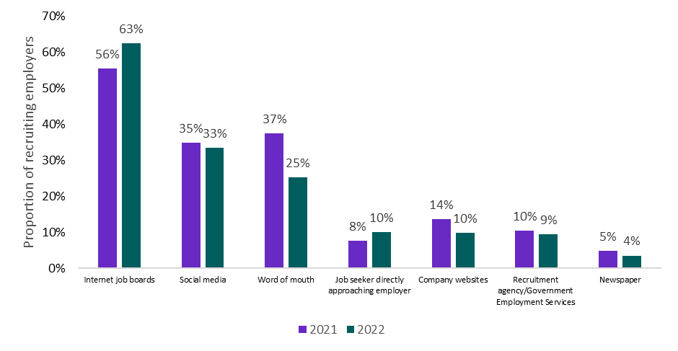
*Note: Employers can report multiple methods so numbers may not add to 100%.

Greater Darwin and Rest of Northern Territory
Recruiting employers in Greater Darwin and Rest of Northern Territory were most likely to use Internet jobs boards to recruit staff, 63% and 61% respectively. Notably, 59% of regional employers in the Northern Territory used social media to recruit, the highest use of this method in the country. About a quarter of recruiting employers used word of mouth in both Darwin and Rest of NT.

Figure 2. Recruitment methods used by employers, Greater Darwin and Rest of Northern Territory, 2022*
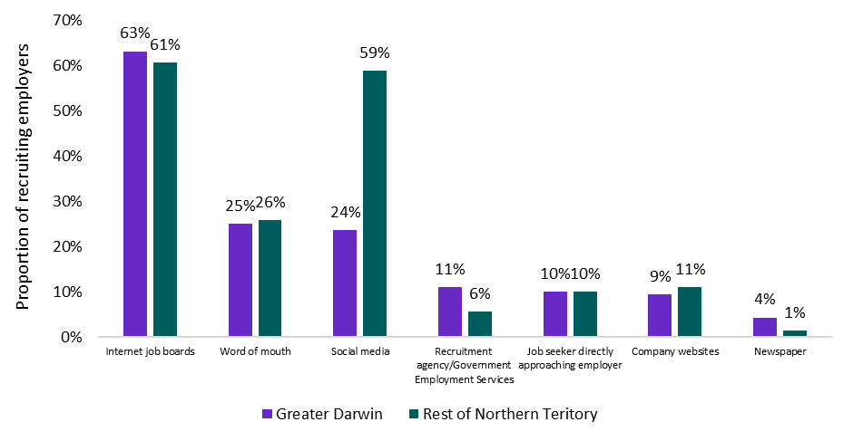
*Note: Employers can report multiple methods so numbers may not add to 100%.

Skill Levels
Each occupation is assigned a Skill Level which is based on the ABS ANZSCO Skill Level classification (see this ABS article for more information). Skill Levels reflect the range and complexity of the tasks undertaken in the occupation, based on required levels of formal education and training, previous experience, and the amount of on-the-job training required. For this report, higher skilled vacancies are defined as ANZSCO Skill Levels 1-3; and lower skilled vacancies as ANZSCO Skill Levels 4-5. Recruitment methods often vary depending on the skill level required for the advertised job.

Greater Darwin
In Darwin, 66% of employers advertised on internet job boards for lower skilled vacancies compared with 61% recruiting for higher skill level positions.
Word of mouth was used by 31% of employers recruiting for lower skilled positions, significantly higher than the 20% recruiting for higher skilled jobs. Similar proportions of employers used social media for their recruitment, for both higher and lower skilled vacancies.

Figure 3. Recruitment methods used by employers, by skill level, Greater Darwin, 2022*
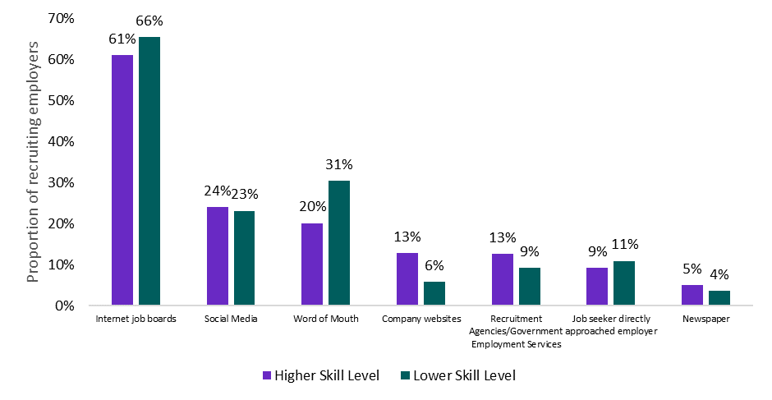
*Note: Employers can report multiple methods so numbers may not add to 100%.

Rest of Northern Territory
For higher skilled positions in regional NT, 84% of employers advertised on internet job boards – the highest use of this method anywhere in the country. Interestingly, employers recruiting for higher skilled jobs also utilised other methods, with 49% using social media and 34% using word of mouth.
For lower skilled positions, employers outside Darwin relied most heavily on social media (66%), while 45% used internet jobs boards. Only 21% used word of mouth, quite low compared with their regional counterparts in other states recruiting for lower skilled jobs.

Figure 4. Recruitment methods used by employers, by skill level, Rest of Northern Territory, 2022*
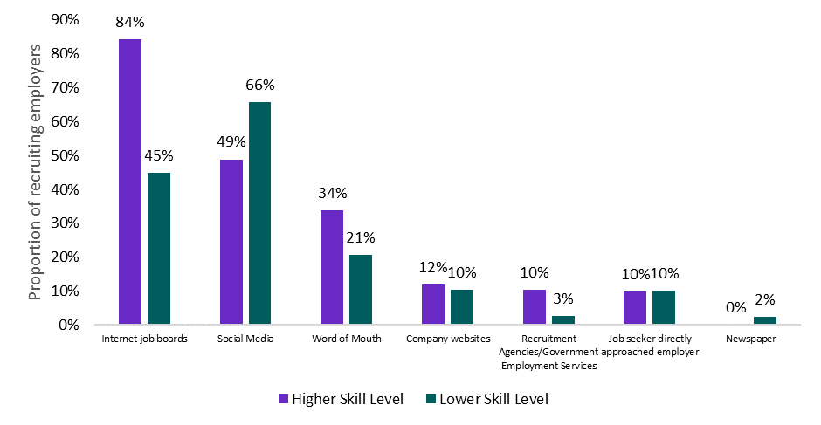
*Note: Employers can report multiple methods so numbers may not add to 100%.

Use of social media continues to rise
An emerging trend over recent years has been the increasing use of social media for recruitment. This involves advertising vacant positions on a social media platform, including advertising on Facebook job groups, Instagram or LinkedIn. Employers use social media for recruitment as it is inexpensive, fast, and allows job ads to have wide exposure amongst job seekers.
Employers in Rest of Northern Territory have clearly embraced social media as a method to recruit staff, and at 59%, their use of this medium was the highest in the country in 2022. This compares with only a quarter of employers in Darwin using social media to recruit in 2022, Previous REOS findings also reveal that social media is more commonly used when recruiting for lower skilled positions.

Figure 5. Employers using social media for recruitment, Northern Territory, 2016 to 2022* 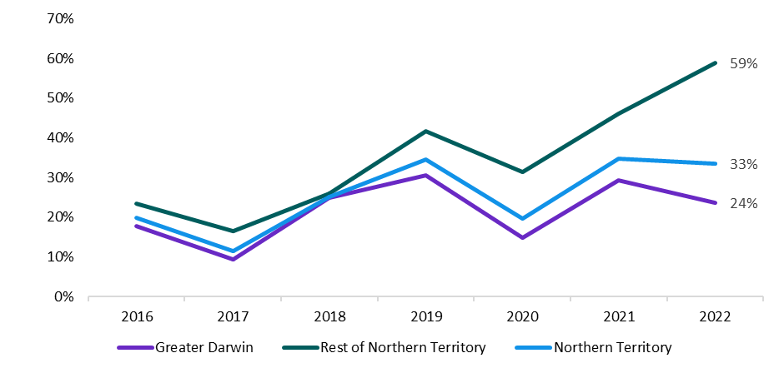
*Note: Data from 2016 to 2019 are from the Survey of Employers’ Recruitment Experiences (SERE). Due to changes in questions and methodology from the SERE (2016-19) and the REOS (2020-2022), comparisons with 2019 and prior should be treated with some caution. From November 2019 to March 2020 the survey was suspended due to the COVID-19 pandemic, therefore the data for this time period is imputed. Employers can report multiple methods so numbers may not add to 100%.

