

JSA submission to the Inquiry into the Perceptions and Status of Vocational Education and Training

8 March 2023

# Introduction

### Jobs and Skills Australia remit relevant to this Inquiry

Jobs and Skills Australia (JSA) welcomes the opportunity to make a submission to the House of Representatives Standing Committee on Employment, Education and Training on the perceptions and status of vocational education and training (VET). The submission is supplementary to that provided by the Department of Employment and Workplace Relations.

JSA was established in November 2022 as an independent agency responsible for providing advice to the Australian Government to underpin Australia’s response to current, emerging, and future labour market and workforce skills and training needs. JSA has been established with a core commitment to tripartite engagement and partnerships with unions, industry, governments, and education and training providers in providing this advice. JSA will have a strong association with the newly established Jobs and Skills Councils who are expected to identify, forecast and respond to current and emerging skills needs and workforce challenges of industry.

This submission will focus on JSA’s core role which is to provide evidence-based advice on Australia’s skill needs and the adequacy of the skills system in meeting those needs. Specifically, the submission will focus on providing new evidence on the role VET plays in providing the skills needed across the labour market at the economywide and occupational level. This includes early JSA analysis highlighting the role VET plays in addressing current and future skills shortages. This work will continue in more rigour under JSA’s remit to advise on the adequacy of VET to meet Australia’s skills needs now and into the future.

### Jobs and Skills Australia broader role

As a national agency, JSA’s focus on the Australian skills system is economywide and broader than the terms of this Inquiry. This enables a bird’s eye view of how the component parts of the education and training system are working together to meet Australia’s skills needs and how to improve them.

JSA has a role in analysing pathways into VET and pathways between VET and higher education. This work will aim to improve students’ ability to navigate the education and training system and obtain the knowledge, skills and capabilities needed to succeed in the labour market, regardless of origin.

Early work on analysing career pathways has been used by the National Careers Institute’s Your Career website to provide careers advice and information to help students identify what skills they need for different career paths and what qualifications (from VET and Higher Education) will help them obtain those skills. JSA will continue to work in close partnership with the National Carers Institute to ensure a consistent understanding of the evolving skills landscape and labour market.

# Role of VET in the labour market

### The diverse role VET plays in the labour market

VET continues to be a critical source of skills in the Australian labour market. The February 2023 Labour Market Update completed by JSA indicates over the past year around 36% of total employment growth has been in occupations where university qualifications are the primary pathway, while just over 60% of total employment growth has been in occupations where VET qualifications are the primary pathway.[1]

One misperception is the assumption that VET is largely for training trades workers. Another is the view that trades are lower status qualifications than university even though key industries with major skills shortages are in the trades like construction.

Recent JSA analysis of the concentration of VET qualifications within occupations using data from the 2021 Census challenges the perception of VET largely being for trades workers by showing a more diverse picture about the role of VET in the labour market.

On average in 2021, 34.5% of employed persons across all occupations had a VET qualification as their highest education level.[2] Figure 1 shows VET qualified workers are found across all broad occupational groups. They are more prominent in the Technicians and Trades Workers and the Community and Personal Service Workers occupations, but it is important to recognise that VET-qualified workers account for more than 30% of those employed in all broad occupational groups except Sales Workers and Professionals.

**Figure 1:** VET and non-VET education distribution across occupations (1-digit level)

Starting with the highest, figure 1 shows.
Technicians and trade workers 65.2%
Community and personal service workers 49.2%
Clerical and administrative workers 37.8%
Machinery operators and drivers 35.8%
Managers 32.7%
Labourers 30.5%
Sales workers 28%
Professionals 13.6%
End figure 1.

Note: VET includes all Certificates level to Advanced Diploma. Higher Education includes Bachelor to Postgraduate Degrees.

*Source: ABS Census 2021, JSA analysis*

Looking at the extremes of the distribution at the more in-depth (4-digit) occupational level illustrates where VET qualified workers account for more than 80% of people employed in that occupation (Figure 2).[3] Enrolled and Mothercraft Nurses has the highest concentration of VET qualified workers at 87% and traditional trades are well represented.

**Figure 2:** Top 10 occupations with the highest concentration of VET-qualified workers (4-digit level) The top 10 range from 87% for enrolled and mothercraft nurses to 78.6% for automotive and engineering trades workers. 
End figure 2. 


*Source: ABS Census 2021, JSA analysis*

### The gendered nature of VET

The importance of VET for females working in Community and Personal Service occupations becomes more apparent when looking at the top 10 occupations associated with the highest prevalence of VET for females (Figure 3). This list includes occupations such as Enrolled Nurses, Hairdressers, Veterinary Nurses, Diversional Therapists, Beauty Therapists and Indigenous Health Workers.

**Figure 3:** Top 10 occupations associated with the highest concentration of VET-qualified workers (4-digit level) - Females

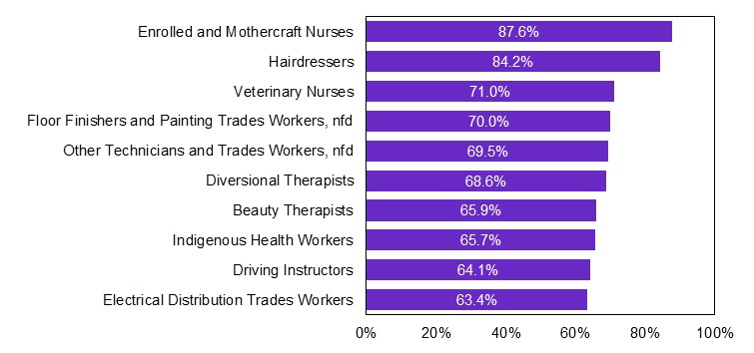

*Source: ABS Census 2021, JSA analysis*

By contrast, the top 10 occupations associated with the highest prevalence of VET for males contains nine occupations within the Technicians and Trades Worker occupations (Figure 4).

**Figure 4:** Top 10 occupations associated with the highest concentration of VET-qualified workers (4-digit level) - Males

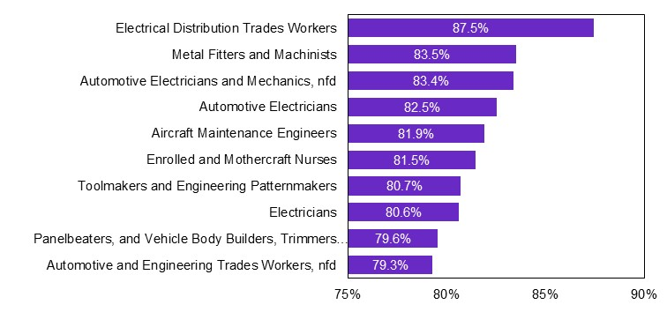

*Source: ABS Census 2021, JSA analysis*

### The aggregate picture of VET completions

Gaining a better understanding of how vocational training leads to labour market outcomes is one way of understanding the actual and perceived performance of the VET sector. JSA analysis of ABS population statistics and VET completions indicates that at an aggregate level VET completions as a share of the working age population have increased over the last five years, from 2016 to 2021. This indicates that holding at least one VET qualification is becoming more common in the labour force. Figure 5 shows the steady increase of VET completions from 2016, with the reduction in VET completions in 2020 recovered in 2021.

**Figure 5**: VET completions total and as a share of the total working age population

*Source: ABS population statistics, 2016-2021; NCVER Completions, 2016-2021, JSA analysis*

### VET completions at the occupation level

Understanding and analysing VET completions and how these link to the occupations people are employed in adds depth to the aggregate picture described above. To do this JSA has developed a one-to-many mapping from qualification to occupation that has been used for internal analysis to date.[4] This mapping compares the description of skills in occupations to the descriptions of skills in qualifications to provide the best matches. It also adds in labour market frictions to ensure the best matches based on skills descriptions are both relevant and realistic.[5]

Figure 6 below shows alignment between VET completions as a source of future labour supply and current demand for a VET qualified workforce. It shows more VET completions are in occupations with higher VET shares of employment (i.e., those occupations where there is current demand for a VET-qualified workforce) and that completions broadly follow those occupations with strong employment growth (indicating future demand) that are high-VET occupations.

**Figure 6:** VET employment, employment growth, and completions by 1-digit occupation

This figure shows the alignment between VET completions, employment and occupations that are growing. The figure shows the numbers of VET completions are higher for Technicians and Trades Workers and Community and Personal Service Workers than for other occupations. The figure also shows that people with VET qualifications are more likely to be employed as Technicians and Trades Workers and Community and Personal Service Workers. The figure also shows that the highest rates of employment growth are associated with the following occupations: Managers, Community and Personal Service Workers and Machinery Operators and Drivers.



*Source: ABS SEW, ABS Census 2021, JSA analysis*

For example, there is a relatively tight alignment between the number of completions flowing towards the Technicians and Trades Workers occupation group and its high VET share of employment. Around 145,000 completions are estimated to be linked with Technicians and Trades Workers occupation group, around one-fifth of all VET completions. This occupation group has a high VET employment share (64%) and relatively high employment growth (5%).

In contrast, many completions (over 200,000, or one-third of total completions) flow towards the Community and Personal Service Workers occupation group. This is an occupation group with a relatively high VET share of employment (46%) and very high recent employment growth (8%). While completions seem out of proportion with past employment, this suggests that recent completions are meeting the additional skills needs of high-growth, high-priority occupations (almost two-thirds of completions in the Community and Personal Service Workers occupation are aligned with Health and Welfare Support Workers and Carers and Aides).

### The importance of VET in addressing skills shortages

As outlined earlier, 60% of total employment growth over the last year has been in occupations where VET qualifications are the primary pathway. In a tight labour market, drilling down to gain an understanding of occupations in skills shortage with VET pathways provides a marker of the importance of VET in the current labour market.

The 2022 Skills Priority Listproduced by JSA’s predecessor, the National Skills Commission, identified the proportion of occupations assessed as being in shortage increasing from 19% in 2021 to 31% in 2022.[6] While skills shortages are currently observed in a wide range of occupations, there are several key areas of the labour market, notably caring occupations and digital and data occupations, where shortages may be more pressing. Many of these are occupations with VET pathways or dual pathways across VET and Higher Education pathways.

JSA analysis of occupations in skills shortage with VET pathways indicates a mixed picture of how well vocational training is responding to creating a future supply of workers for occupations in shortage now and into the future.[7] The concentration of VET qualified persons across occupations listed as experiencing a shortage on the Skills Priority List is 39.8%. This is higher than the 34.5% VET concentration when considering all occupations. By contrast, the average VET concentration across occupations not listed as experiencing a shortage on the Skills Priority List is 33.2%, which is much lower than the VET concentration for occupations that are experiencing a shortage.[8]

However, drilling down further Figure 7 illustrates the link is weaker between occupations identified as being in skills shortage on the Skills Priority List and VET qualification completions. Apart from occupations for Technicians and Trades Workers, there are more VET qualification completions in qualifications not in skills shortage than those that are in shortage.

**Figure 7:** Qualification completions by 1-digit occupation and SPL shortage status

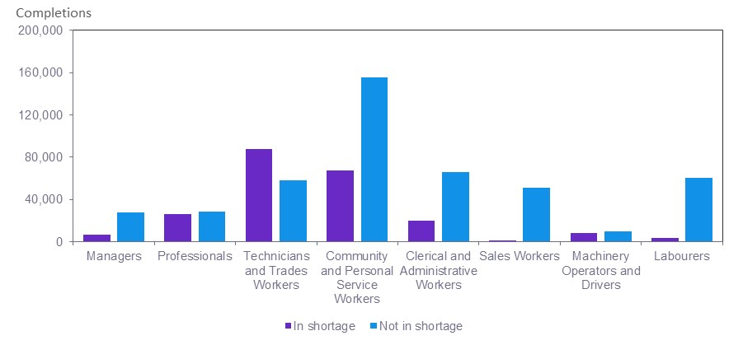

*Source: NCVER TVA program completions 2021, JSA analysis*

Breaking down completions flowing into the Technicians and Trades Workers occupation illustrates a more diverse picture of skills needs. Figure 8 below shows strong alignment between completions and occupations in shortage such as automotive and engineering trades workers, construction trades, electrotechnology and telecommunications workers and food trades workers. Further work is required to unpack why this is not the case for other occupations, including engineering, ICT and science technicians.

**Figure 8:** Qualification completions for 2-digit Technicians and Trades Workers by SPL shortage status

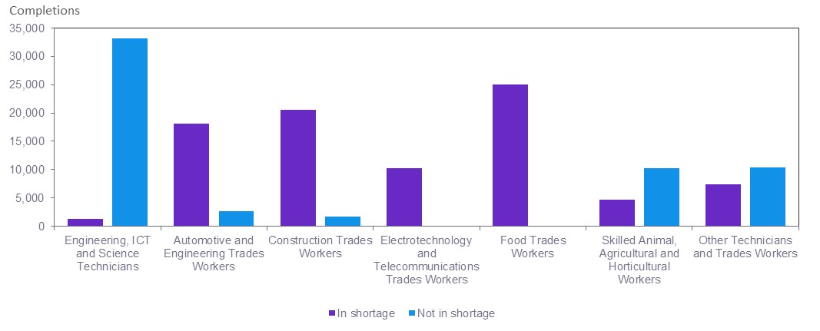

*Source: NCVER TVA program completions 2021, JSA analysis*

Furthermore, breaking down completions flowing into the Community and Personal Service Workers occupation in Figure 9 below indicates VET completions for carers and aids are linked to occupations in shortage, but this is not the case for health and welfare support workers and sports and personal service workers.

**Figure 9:** Qualification completions for 2-digit Community and Personal Service Workers by SPL shortage status

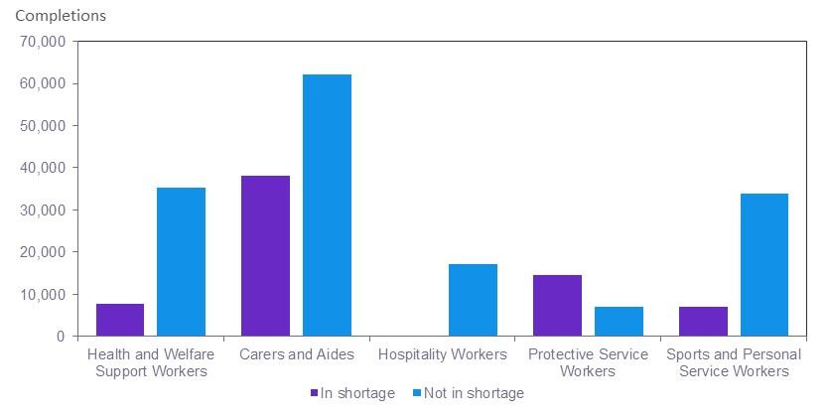

*Source: NCVER TVA program completions 2021, JSA analysis*

### The importance of VET in regional, rural and remote areas

JSA recently examined the role VET plays in Australia’s regional, rural and remote areas.[9] The report found that VET plays an important role in Australia’s regions due to its relevance and applicability to regional-focused industries, as well as the role it plays in delivering core skills to those who have not been able to gain these skills in other settings.

Analysis at an aggregate level did not point towards significant issues in relation to accessing VET study options in regional and remote areas, but it did find that engagement with local study options increases with remoteness. Figure 10 shows the share of program enrolments based on location of delivery. This illustrates that a higher share of students in regional and particularly remote areas access training providers located in the same Statistical Area 2 when compared to those students located in major cities.

An implication is that there may be latent demand for training that is not being met in regional and remote areas because people lack access to transport or because of the absence of a local provider.

**Figure 10:** Share of program enrolments that are local delivery, 2020

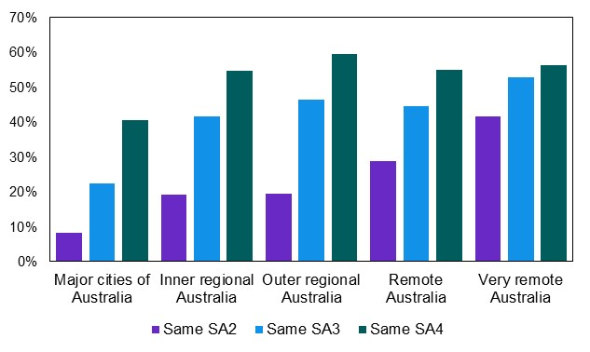

Note: Students may attend more than one delivery location. These figures identify only the closest delivery location to a student’s usual residential address and do not capture all potential delivery locations they attend, defined at the SA2 level.

*Source: NCVER Total VET students and courses, 2020-21*

### The future importance of VET to the labour market

JSA projections shown in Figure 11 affirm the importance of VET to the labour market will remain steady over the near term. Between 2021 and 2026 total employment at skill levels 2-4 (those skill levels commensurate with VET qualifications from Certificate II to Advanced Diploma level) will grow by 7% and account for just over half of all jobs. The skill level with the projected strongest employment growth is for skill level 1 (commensurate with a Bachelor degree or higher), growing by 13.5% between 2021 and 2026.[10] While skill level 1 is the fastest growing category, it accounts for 35% per cent of all jobs, 16% percentage points less than the share accounted for by VET.

**Figure 11:** JSA projections, employment level and growth by skill level - 2026

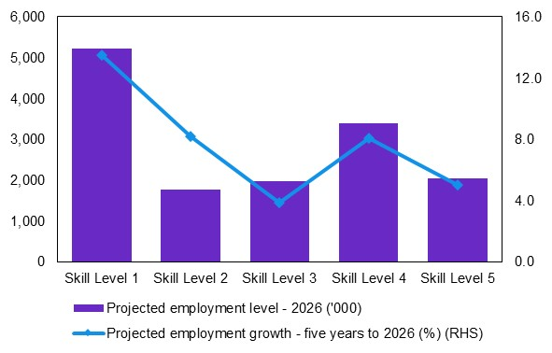

Note: Skill Level 1 is commensurate with a Bachelor degree or higher qualification. Skill Level 2 is commensurate with an Advanced Diploma or Diploma. Skill Level 3 is commensurate with a Certificate IV or III (including at least 2 years on-the-job training). Skill Level 4 is commensurate with a Certificate II or III. Skill Level 5 is commensurate with a Certificate I or secondary education.

*Source: 2021 NSC Employment Projections*

# Looking forward

In line with the requirements of the JSA Act, work is underway relevant to understanding and lifting the perceptions and status of VET. Three important but different pieces of work are outlined below.

### Foundation Skills study

One of the areas of interest for the Inquiry is how the perceptions and status of VET impact the education and training choices of students, particularly those who lack necessary foundation skills.

JSA has been tasked with a new national study of adult literacy, numeracy and digital literacy skills, consisting of three elements:

* A survey of Australian adults to assess their current skills levels.
* Analysis of Commonwealth administrative and other data to ‘drill down’ into the results for priority groups.
* A study into the feasibility of assessing the skill levels of Aboriginal and Torres Strait Islanders, including those in regional and remote areas.

The timing of these outputs will be staggered; the first outputs are expected in late 2024.

The latest national data on adult literacy and numeracy is from 2011/12. The findings indicated almost three million Australians lack basic literacy or numeracy skills. The outputs of this new survey will create an up-to date national evidence base on foundation skills levels to help key stakeholders in the system improve services nationally. This could include identifying how the VET system could better support students with low language, literacy and numeracy skills to access VET and complete their training.

### VET National Data Asset (VNDA)

A data product JSA has underway to help inform discussions on career pathways and post-training outcomes is VNDA.

VNDA brings together VET activity data with a range of outcomes related data (employee income, employment status, progression to further study, receipt of government assistance) from key government administrative sources. It forms an evidence base of student outcomes from VET using NCVER Total VET Activity data linked through to the Multi-Agency Data Integration Project hosted by the Australian Bureau of Statistics.

VNDA is an expansion in coverage of currently available national student outcomes information (i.e., NCVER’s Student Outcomes Survey). It is the first national project in Australia to link unit record data for students participating in VET using administrative datasets relating to student outcomes.

It is intended for VNDA to contribute directly to informing students, educators, and employers about the potential benefits of engaging in specific courses and qualifications.

### Status of VET Qualifications

JSA’s broader economywide role in providing advice will require deeper analysis into the dichotomy between VET focusing on skills needed in the workplace and higher education focusing on knowledge attainment.

Knowledge and skills are often treated as separate and hierarchically distinct realms of training, with knowledge perceived as being of higher value than skills. As Higher Education courses tend to place more emphasis on knowledge and VET on skills, this dichotomous thinking can contribute to negative perceptions of vocational training. It can also make navigating the tertiary education system complicated for students and employers.

# Conclusion

The VET sector plays a vital role in preparing Australians for their future careers. New analysis undertaken by JSA paints a more nuanced picture of vocational training than many in the community perceive. The submission has shown that vocational training offers a diverse range of skills across many fields of study and from introductory level to advanced.

While prestige continues to be attached to Higher Education, VET qualifications are associated with occupations that are in shortage and with strong future job prospects; and VET occupations have recently accounted for a large share of jobs growth.

JSA will continue to provide deeper analysis of the evidence to underpin Australia’s response to the current, emerging and future labour market and workforce skills and training needs with our partners. JSA will also seek to deepen the understanding of the links between VET and Higher Education and the connection between skills, training and occupations in shortage.

Having the right mix of skills offered across the VET and Higher Education system and attained as part of on-the-job training and lifelong learning is critical to the functioning of our economy and to an individual’s success in the labour market.

1. February 2023 quarterly Labour Market Updates - JSA analysis based on ABS data
2. These figures have not changed substantially since the 2016 Census, where 35.4% of employed persons across all occupations had a VET qualification. Labourers and Clerical and Administrative Workers are marginally more VET qualified (increasing 1.3pp and 1.8pp, respectively); while Managers, Professionals, and Technicians and Trades Workers are marginally less VET qualified (decreasing 1.1pp, 2.2pp, and 2.4pp, respectively). The remaining occupations shifted less than a percentage point.
3. Panelbeaters is the only occupation in the top 10 occupations by VET share in 2016 not in 2021.
4. The one-to-many mapping from qualification to occupation was also used as one of the inputs of the JobTrainer methodology. It also underpins the development of tools designed to assist job seekers and people identify future career options.
5. The mapping supplements the qualification-occupation mapping by training.gov.au. It also incorporates some more realistic labour market frictions (e.g., low AQF qualifications not flowing to high-skilled occupations) to better capture patterns of skills supply. The mapping model omits completions from qualifications that are not in the AQF (i.e., that are pre-vocational or short courses).
6. NSC (2022) *2022 Skills Priority List: Key Findings Report*, 6 October 2022.
7. Qualification completions were mapped to 4-digit occupations using JSA’s one-to-many occupation to qualification concordance, which assigns a score to reflects how the skills acquired in each occupation match with the requirements of different occupations. Then, VET completions in 2021 were analysed using data from NCVER VOCSTATS. . Occupations on the SPL were analysed by matching 4-digit ANZSCO occupation codes to the 6-digit ANZSCO codes as presented on the SPL List. Occupations were identified as ‘in shortage on the SPL’ if at least one state and territory at the 6-digit ANZSCO level experienced a shortage.
8. These differences are statistically significant. The difference in VET concentration between occupations with no shortage and occupations in shortage (6.7 percentage points) amounts to approximately 360,000 VET qualified workers*.*
9. [Vocational education and training in regional, rural and remote Australia | Jobs and Skills Australia](https://www.jobsandskills.gov.au/reports/vocational-education-and-training-regional-rural-and-remote-australia)
10. 2021 NSC Employment Projections, Skill Level Projections.