**Employment Outlook to November 2025**

*Based on the National Skills Commission’s 2020 employment projections*

Table of Contents

Setting the scene 2

What industries are driving growth? 4

Jobs and skills on the increase 7

The path to labour market recovery 8

Where will the new jobs be located? 11

Background and methodology 14

# Setting the scene

The employment projections presented in this paper give insight into the change the Australian labour market faces over the medium term as it recovers from the impacts of the COVID-19 pandemic. As with all such exercises, these employment projections are subject to an inherent degree of uncertainty, which has been exacerbated by both the volatility resulting from the initial outbreak of the COVID-19 pandemic and from the recent re-introduction of restrictions, which has impacted a large proportion of Australia’s population. These employment projections are based on forecast and projected total employment growth rates published in the 2020−21 Mid-Year Economic and Fiscal Outlook (MYEFO) and implicitly follow the assumptions made in that publication.

The employment projections provide data and insights about the likely trajectory of employment in sectors and occupations in the labour market. The data help employers, job seekers and policy makers understand where the job opportunities are likely to be in the future to make informed planning decisions. The Employment Outlook to November 2025 is based on employment projections produced by the National Skills Commission for the period November 2020 to November 2025. The report outlines the employment outlook across industries, occupations, skill levels, states and territories, and regions.

*Recent employment growth*

Over the five years to July 2021 (latest available data at time of publication), employment increased by 1,154,700 (or 9.6 per cent), or 1.9 per cent per annum, above the rate of growth recorded over the last decade (of 1.6 per cent). In seasonally adjusted terms, employment growth has risen strongly over the last year (up by 5.4 per cent or 676,600) to stand at a record high of 13,156,400 in July 2021, as the labour market has continued to recover from the trough in employment in May 2020, due to the initial impact of COVID-19. Considerable uncertainty, however, continues to surround the short to medium-term outlook for the labour market, given the recent escalation in COVID-19 cases across some Australian jurisdictions.

A number of services industries made large contributions to employment growth over the five years to May 2021 (latest available industry employment data), led by the Health Care and Social Assistance industry (up by 267,900 or 17.1 per cent), followed by Professional, Scientific and Technical Services (263,700 or 26.9 per cent), Education and Training (206,900 or 22.0 per cent), and Public Administration and Safety (103,500 or 13.6 per cent). By contrast, the largest falls in employment were in the Agriculture, Forestry and Fishing industry (down by 24,300 or 7.4 per cent) and Information Media and Telecommunications (15,900 or 8.2 per cent).

The National Skills Commission’s (NSC’s) five year employment projections to November 2025 used in this analysis are based on forecast and projected total employment growth rates published in the 2020−21 MYEFO and Labour Force Survey employment data to November 2020.[1] Based on these data, Figure 1 shows that total employment is projected to increase by 991,600 (or 7.8 per cent) over the five years to November 2025. At this stage of the recovery, it appears that long-term, pre-COVID‑19 trends will continue to reassert themselves as the main drivers of employment growth. Employment has rebounded sharply to pre-COVID‑19 levels and this growth is beginning to moderate, reinforcing the structural shift towards services-based industries and skilled occupations.

**Figure 1: Employment level, past and projected growth to November 2025, Australia (‘000)**

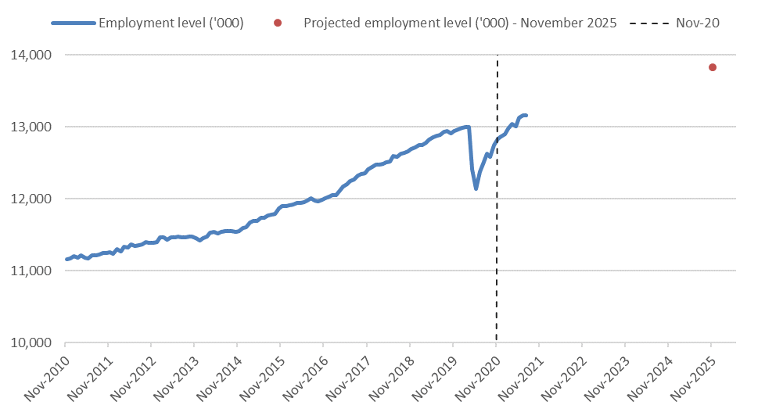

Source: ABS, Labour Force, Australia, seasonally adjusted, and NSC Employment Projections, five years to November 2025

# What industries are driving growth?

Reflecting a diverse and resilient labour market, employment is projected to increase in 17 of the 19 broad industries over the five years to November 2025 (Figure 2). In November 2020, employment exceeded pre-COVID-19 levels in eight of these industries and is projected to exceed this level in a further seven industries .[2] Small declines in employment are projected for Manufacturing (down 5,900) and Information Media and Telecommunications (down 7,500).

**Figure 2: Industry contribution to projected employment growth – five years to November 2025**

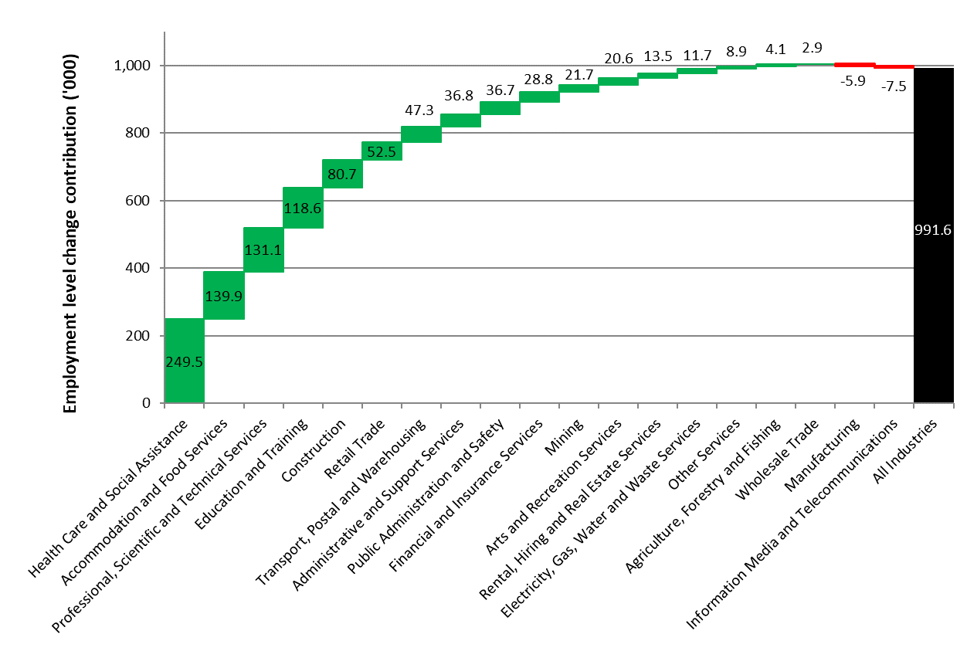

Source: NSC, 2020 Employment Projections, five years to November 2025

The long-term structural shift in employment towards services industries is projected to continue with four services industries – Health Care and Social Assistance, Accommodation and Food Services, Professional, Scientific and Technical Services and Education and Training – expected to generate more than three-fifths (or 64.4 per cent) of the total projected employment growth.

* **Health Care and Social Assistance,** the primary provider of new jobs in the Australian labour market since the 1990s, is projected to make the largest contribution to employment growth over the period (increasing by 249,500 or 14.2 per cent). This growth is supported by continued investment in public health care at the state and federal levels along with ongoing demand generated by the National Disability Insurance Scheme. Increasing demand for childcare and Australia’s ageing population also contribute to this strong projected growth, with employment in this industry having been relatively resilient to the impacts of COVID-19.
  + Australia’s ageing population, the NDIS rollout and increased demand for childcare services can be seen in the large projected increases in employment for Hospitals (up by 68,500 or 14.1 per cent), Other Social Assistance Services[3] (58,300 or 17.9 per cent), Allied Health Services[4] (up by 35,200 or 15.9 per cent), Residential Care Services (25,600 or 10.8 per cent), Medical Services (34,600 or 15.7 per cent) and Child Care Services (14,200 or 10.2 per cent).
  + The industry’s projected employment growth is broad-based across Australia, with the industry contributing the largest share to projected employment growth for all states, territories, capital cities and regional areas (except for regional WA).
* **Accommodation and Food Services** employment is projected to recover from the major impact of COVID-19 and associated restrictions. Employment in the industry declinedby 105,400 (or 11.2 per cent) from February to November 2020, but is projected to rebound strongly, increasing by 139,900 (or 16.8 per cent) over the five years to November 2025.
  + It is anticipated that this rebound will predominantly be due to strong growth in Cafes, Restaurants and Takeaway Food Services (up by 114,100 or 19.6 per cent) and Accommodation (up by 23,800 or 30.9 per cent), offsetting the losses experienced by these sectors during the COVID-19 pandemic.
  + Employment has already made a strong recovery in some sectors within the industry, with Pubs, Taverns and Bars exceeding its February 2020 seasonally adjusted level by November 2020.
* Employment in **Professional, Scientific and Technical Services** is projected to increase by 131,100 (or 11.0 per cent) over the five years to November 2025, reflecting ongoing strength in demand for the services of qualified and highly educated workers throughout the economy.
  + Major contributions to the industry’s employment growth are expected to come from Computer System Design and Related Services (projected to grow by 47,200 or 16.0 per cent), Architectural, Engineering and Technical Services (25,700 or 9.0 per cent) and Legal and Accounting Services (25,300 or 8.6 per cent), reflecting continuing strong demand for business services.
* Employment in **Education and Training** is projected to increase by 118,600 (or 10.8 per cent) over the five years to November 2025. While the tertiary education sector is expected to record subdued employment growth (up by 11,400 or 4.5 per cent) as education exports recover slowly, this is expected to be offset by a larger school aged population and growing demand for adult and community education.
  + Strong growth is projected for the School Education (57,900 or 9.7 per cent) and for the Adult, Community and Other Education (36,200 or 23.0 per cent) sectors.

By contrast, declines in employment are projected for the Manufacturing and Information Media and Telecommunications industries. The total employment growth rate, however, declines by less than 0.5 of a percentage point as a result of the projected employment in these two industries.

* Employment in **Manufacturing** is projected to fall by 5900 (or 0.7 per cent) over the five years to November 2025. The long-term decline in some Manufacturing sectors is expected continue, with employment in the Transport Equipment Manufacturing sector projected to decline by 5200 (or 9.0 per cent) and in the Textile, Leather, Clothing and Footwear Manufacturing sector by 4,700 (or 15.3 per cent). Even so, there are positive signs within the industry, with projected employment growth of 6,400 (or 8.5 per cent) in the Primary Metal and Metal Product Manufacturing sector, supported by significant domestic infrastructure investment and the redevelopment of modern manufacturing in Australia.
* Employment in the **Information Media and Telecommunications** industry is projected to fall by 7500 (or 3.9 per cent), reflecting market consolidation and the shift towards non-physical media, with employment in Newspaper, Periodical, Book and Directory Publishing projected to decline by 3900 (or 25.0 per cent). Increased competitive pressures, particularly in the Telecommunications sector, see employment projected to fall by 6000 (or 6.8 per cent).On the other hand, employment in Motion Picture and Video Activities is projected to grow by 2300 (or 7.2 per cent).

At the detailed level, as identified above, sectors from industries with high or negative projected growth are particularly prominent amongst the strongest changes at more detailed levels of the industry classification. There is, however, strong employment growth projected for some sectors in industries where employment growth is expected to be below average (7.8 per cent).

* While **Construction** employment is projected to rise by 6.8 per cent (or 80,700) over the five years to November 2025, there is strong projected employment growth in Building Installation Services (up 23,900 or 8.4 per cent) and in Residential Construction (16,300 or 10.6 per cent), initially supported by Government stimulus measures and reflected in the surge in dwelling approvals since mid-2020. In addition, significant investment in infrastructure is reflected in the above average projected growth in the Heavy and Civil Engineering Construction sector (9,900 or 8.8 per cent).
* Strong employment growth is projected in the Pharmaceutical and Other Store-Based Retailing sector (up by 24,000 or 10.4 per cent) despite projected employment growth in the **Retail Trade** industry of 4.1 per cent.

The converse is also the case with employment declines projected for some sectors in industries that are projected to experience employment growth.

* Notably, the large projected employment declines in Department Stores (down by 4100 or 5.3 per cent), Clothing, Footwear and Personal Accessory Retailing (down by 2400 or 1.5 per cent) and Fuel Retailing (down by 1400 or 4.2 per cent) reflect increased competitive pressures within the **Retail Trade** industry.
* The projected employment declines in the Agriculture and Fishing Support Services (by 2200 or 13.3 per cent) and Dairy Cattle Farming (by 1700 or 9.4 per cent) sectors within the **Agriculture, Forestry and Fishing** industry.
* Other large projected declines include Building Completion Services (down by 8400 or 7.0 per cent) in the **Construction** industry and Machinery and Equipment Repair and Maintenance (down by 2200 or 3.5 per cent) in the **Other Services** industry.

Projected employment growth by industry and detailed sector can be explored using the Employment Outlook dashboard, which can be found on the [Labour Market Information Portal Tableau page](https://public.tableau.com/app/profile/occupation.and.industry.analysis/viz/EmploymentOutlookDashboard/Coverpage).

# Jobs and skills on the increase

Employment is projected to increase across all eight of the broad occupational groups and all five skill levels over the five years to November 2025 (Figure 3). Very strong employment growth is projected to continue for **Professionals** (up by 439,500 or 13.2 per cent) and **Community and Personal Service Workers** (up by 186,400 or 14.6 per cent), consistent with strong projected growth in the service industries that are leading employers of these occupational groups. The strong projected employment growth in Community and Personal Service Workers is, at least in part, a product of the labour market recovery to be made in the occupation group, as it was the most impacted by the COVID-19 pandemic[5]. Together, these two occupational groups are expected to account for 63.1 per cent of the total growth in employment over the next five years.

Below average employment growth (the average projected employment growth rate being 7.8 per cent) is projected for all other broad occupation groups. **Managers** are projected to grow by 98,300 (or 6.1 per cent), **Technicians and Trades Workers** (by 96,300 or 5.4 per cent), **Labourers** (51,700 or 4.4 per cent), **Machinery Operators and Drivers** (36,100 or 4.4 per cent) and **Clerical and Administrative Workers** (up by 61,500 or 3.5 per cent), while the lowest rate of employment growth is projected for **Sales Workers** (21,800 or 2.0 per cent).

**Figure 3: Projected employment growth to November 2025 (‘000), by major occupational group and skill level**[6]

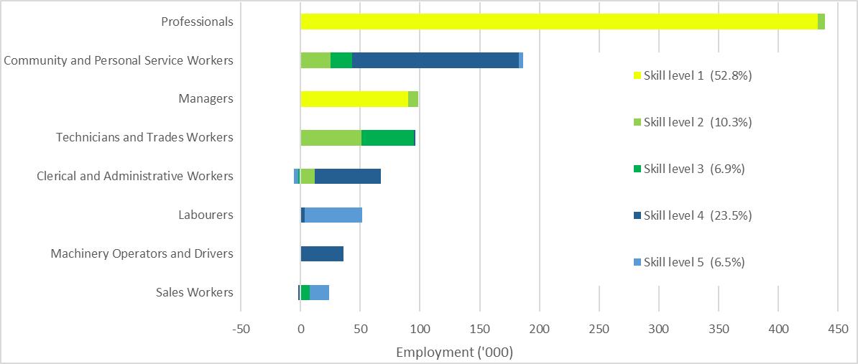

More than nine-in-ten new jobs are projected to require post-school qualifications, reflecting the importance of tertiary education and skills development beyond secondary school.

As shown in Figure 3, projected employment growth in **skill level 1 occupations** (up by 523,100 or 11.8 per cent) alone accounts for over half (52.8 per cent) of the projected total employment growth over the five years to November 2025. While all skill level 1 occupations fall within the Managers and Professionals occupation groups, over four-fifths (82.8 per cent) of employment growth in skill level 1 occupations is delivered by the Professionals occupation group.

* Over the five years to November 2025, employment in STEM occupations – using science, technology, engineering and maths – is projected to grow by 12.9 per cent. This is well above the all occupations average (of 7.8 per cent) and more than twice as fast as non-STEM occupations (6.2 per cent).

The importance of skills and training in the labour market is also evident, with projected employment growth for **skill level 4 occupations** (up by 233,700 or 7.7 per cent) making the second largest contribution to total employment growth. Skill level 4 occupations are found in all broad occupation groups except Managers and Professionals. The Community and Personal Service Workers occupation group makes up almost two-thirds (59.8 per cent) of projected employment growth in skill level 4 occupations while projected employment growth is moderated marginally by declines in Sales Workers, resulting in a negative contribution from this occupation group.

Robust growth is projected for **skill level 2 occupations** (up by 102,300 or 6.6 per cent). Almost half of employment growth (49.6 per cent) at this skill level is delivered by the Technician and Trade Workers occupation group.

Subdued employment growth (of 67,900 or 3.6 per cent) is projected for **skill level 3 occupations**, almost two-thirds (65.3 per cent) of which is delivered by the Technician and Trade Workers occupation group. The weakest employment growth is projected for **skill level 5 occupations** (up by 64,600 or 3.3 per cent), most of which (74.7 per cent) is delivered by occupations from the Labourers occupation group. At both these skill levels, employment growth is moderated by projected employment declines in Clerical and Administrative workers, resulting in negative contributions from this occupation group.

# The path to labour market recovery

The impact of COVID‑19 and the subsequent recovery is a strong driver of projected employment growth. At the more detailed occupation level, employment is projected to grow in 255 out of 358 occupations over the five years to November 2025, with employment projected to exceed pre-COVID‑19 levels for 197 occupations.[7]

Of the 214 occupations that experienced decreases in employment over the May 2020 quarter, over two-thirds (70.1 per cent) have employment projected to grow and nearly a third are projected to grow at a faster rate than the average across all occupations. For example, Waiters experienced the largest decline over the May 2020 quarter, declining by 73.7 per cent, but employment for this occupation is projected to increase by 42.3 per cent over the five years to November 2025 to stand 0.5 per cent below its pre-COVID‑19 level. Similarly, employment for Chefs declined by 33.9 per cent over the May 2020 quarter and is projected to increase by 19.4 per cent to stand 1.3 per cent below its pre-COVID‑19 level.

In occupations projected to have employment fall the fastest over the five years, the impact of COVID‑19 has reinforced existing negative structural trends. Employment in these occupations has been subject to long-term declines as they are particularly exposed to structural trends such as automation and globalisation. The fastest projected declines are for Graphic Pre-press Trades Workers (projected to decline by 30.2 per cent), followed by Secretaries (down by 25.7 per cent), Street Vendors and Related Salespersons (down by 21.4 per cent) and Switchboard Operators (down by 20.2 per cent). Employment for each of these occupations has declined by 30 per cent or more over the 10 years to February 2020 (pre-COVID‑19).

The two occupations projected to have the largest increases in employment (top right quadrant of Figure 4) – the skill level 4 occupation Aged and Disabled Carers (projected to grow by 54,700 or 24.7 per cent) and the skill level 1 occupation Registered Nurses (46,500 or 15.6 per cent) – almost all work in the Health Care and Social Assistance industry. The majority of the skill level 3 occupation Child Carers (up by 13,300 or 10.2 per cent) and the skill level 4 occupations Welfare Support Workers (11,000 or 17.7 per cent) and Social Workers (4600 or 15.2 per cent) also work mostly in the Health Care and Social Assistance industry. Registered Nurses are in the Professionals occupation group while the rest of these occupations belong to the Community and Personal Service Workers occupation group.

**Figure 4: Projected employment changes by occupation group and skill level (‘000s and percentage growth)**

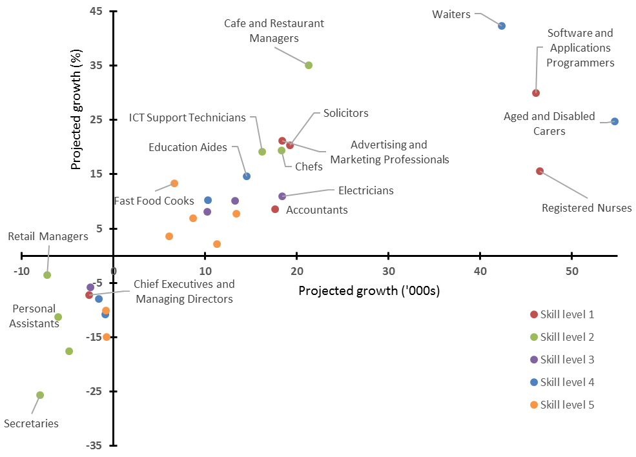

Occupations largely employed in the Accommodation and Food Services industry include Waiters (projected to grow by 42,300 or 42.3 per cent), Cafe and Restaurant Managers (21,300 or 35.0 per cent), chefs (18,300 or 19.4 per cent) and Bar Attendants and Baristas (10,300 or 10.2 per cent). Waiters and Bar Attendants and Baristas are skill level 4 occupations in the Community and Personal Service Workers occupation group. Cafe and Restaurant Managers and Chefs are skill level 2 occupations in the Managers and Technicians and Trade Workers occupation groups respectively.

In addition, a number of skill level 5 occupations are projected to record strong employment growth over the period, including Commercial Cleaners (up by 13,400 or 7.8 per cent) – half of whom are employed in the Administrative and Support Services industry, Sales Assistants (11,300 or 2.2 per cent) – mostly employed in Retail Trade, and Kitchenhands (8700 or 6.9 per cent) – mostly employed in Accommodation and Food Services. The strong projected employment growth of such occupations, along with Fast Food Cooks, Checkout Operators and Cashiers and Handypersons, reflects the many opportunities available in skill level 5 occupations, providing career platforms for job seekers and those looking to enter the labour force.

The occupations with the weakest projected employment growth, in the bottom left quadrant of Figure 4, face ongoing challenges, such as from globalisation and technological change.[8] Some of these occupations are from the Clerical and Administrative workers and skill level 2 groups, where work is routine in nature and susceptible to automation, such as Secretaries (projected to fall by 8000 or 25.7 per cent), Retail Managers (7200 or 3.5 per cent), Personal Assistants (6000 or 11.3 per cent) and Call or Contact Centre and Customer Service Managers (4800 or 17.6 per cent).

The impact of continuing structural change on the Manufacturing industry is expected to sustain the pre-existing trend of falling employment in occupations such as Engineering Production Workers (projected to fall by 1600 or 8.0 per cent), Printers (1100 or 11.2 per cent), Plastics and Rubber Production Machine Operators (900 or 10.8 per cent), Timber and Wood Process Workers (800 or 14.9 per cent), Metal Engineering Process Workers (800 or 10.1 per cent), Clothing Trades Workers (800 or 7.7 per cent), Wood Machinists and Other Wood Trades Workers (600 or 14.2 per cent) and Print Finishers and Screen Printers (400 or 11.2 per cent). These occupations range across skill levels 3, 4 and 5.

Figure 4 shows that projected employment growth differs greatly within each skill level and there are many opportunities available within each skill level.[9] Occupations with the strongest projected employment growth are dominated by higher skilled occupations (skill levels 1 and 2) or require some training but having a strong emphasis on human interactions (skill level 4).

Projected employment growth by occupation and skill level can be explored further using the Employment Outlook dashboard, which can be found on the [Labour Market Information Portal Tableau page](https://public.tableau.com/app/profile/occupation.and.industry.analysis/viz/EmploymentOutlookDashboard/Coverpage).

# Where will the new jobs be located?

Over the five years to November 2025, employment is projected to increase in all states and territories and in all major statistical areas.

New South Wales, Victoria and Queensland are projected to make the largest contributions to employment growth over the five years to November 2025, with employment projected to increase by 327,000 (or 8.0 per cent) in **New South Wales**, by 303,800 (or 9.0 per cent) in **Victoria**, and by 203,100 (or 8.1 per cent) in **Queensland**. In these states, as in all states, territories, capital cities and regional areas (except for regional WA), the largest contribution to projected employment growth is made by Health Care and Social Assistance. Professional, Scientific and Technical Services is the second largest contributor to projected employment growth in Victoria and New South Wales (15.3 per cent and 15.9 per cent respectively, compared with 13.2 per cent nationally), while Accommodation and Food Services makes the second largest contribution to projected employment growth in Queensland (17.1 per cent compared with 14.1 per cent nationally).

Employment growth over the five years to November 2025 is projected to be slowest in **Tasmania** (up by 9900 or 4.0 per cent), followed by the **Northern Territory** (up by 5300 or 4.1 per cent) and **South Australia** (up by 42,600 or 5.0 per cent). In Tasmania (36.3 per cent) and in the Northern Territory (49.9 per cent), the contribution of the Health Care and Social Assistance industry to projected total employment growth is well above the national average (25.2 per cent), while the contribution of the Professional, Scientific and Technical Services industry in South Australia (10.3 per cent) and the Northern Territory (1.8 per cent), is well below the 13.2 per cent contribution at the national level.

**Western Australia** (up by 86,600 or 6.4 per cent) and the **Australian Capital Territory** (up by 13,300 or 5.8 per cent) are also projected to record below average rates of employment growth. In Western Australia, Mining, where employment is expected to increase by 16,200, makes the second largest contribution to projected employment growth (18.7 per cent). As in Victoria and New South Wales, Professional, Scientific and Technical Services makes the second largest contribution to projected employment growth in the Australian Capital Territory (23.0 per cent), while the contribution of the Public Administration and Safety industry to projected employment growth is also significant (22.5 per cent, compared with 3.7 per cent nationally).

**Figure 5: Projected employment growth by state/territory – five years to November 2025 (’000 and per cent)**

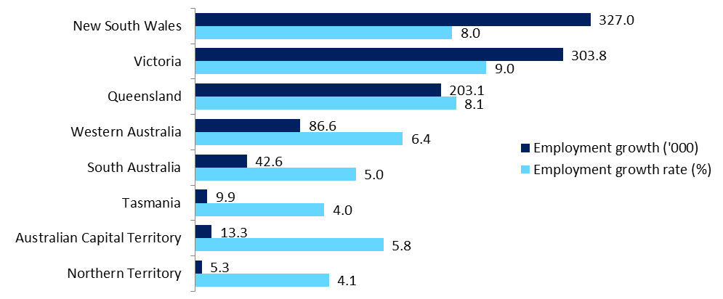

Employment in **capital cities** is projected to grow by 746,800 (or 8.4 per cent) over the five years to November 2025, making up 75.3 per cent of total projected growth. This growth is driven by the concentration of high growth industries in capital cities. The Health Care and Social Assistance industry is the largest driver of growth in capital cities (22.9 per cent of total growth in capital cities), followed by Professional, Scientific and Technical Services (15.0 per cent) and Accommodation and Food Services (13.3 per cent).

In six of the seven industries that are projected to grow above the national average growth rate, the majority of employment is located in the capital cities, with the Mining industry being the only exception. Five of the seven high-growth industries are projected to further increase their concentration in capital cities, with only the Administrative and Support Services and Arts and Recreation Services having higher growth rates in regional areas.

Employment is projected to grow at a higher rate in the capital cities than in the rest of the state or territory region within each state and territory except for Queensland and the Northern Territory. The highest capital city concentration of projected employment growth is in Western Australia (92.8 per cent), and the lowest in Queensland (48.0 per cent).

Employment in **regional Australia** is projected to grow by 244,800 (or 6.2 per cent) over the five years to November 2025, making up 24.7 per cent of total projected growth. The Health Care and Social Assistance industry is the largest driver of growth in regional areas (32.0 per cent of total growth in regional areas), followed by Accommodation and Food Services (16.5 per cent) and Education and Training (10.6 per cent).

The regions where employment is projected to grow fastest are regional Queensland (up by 8.4 per cent), regional Victoria (up by 6.4 per cent) and regional New South Wales (up by 5.9 per cent). The regional areas of Victoria and Queensland are also projected to have employment growth stronger than metropolitan areas in most of the smaller states. Employment in the Rest of Victoria (up by 6.4 per cent or 46,700) and the Rest of Queensland (8.4 per cent or 105,600) are both projected to grow at higher rates than is employment in the Australian Capital Territory (5.8 per cent or 13,300), Greater Adelaide (5.9 per cent or 39,300) and Greater Hobart (6.3 per cent or 7200).

Projected employment growth by state and major statistical areas can be explored using the Employment Outlook dashboard, which can be found on the [Labour Market Information Portal Tableau page](https://public.tableau.com/app/profile/occupation.and.industry.analysis/viz/EmploymentOutlookDashboard/Coverpage).

Employment is projected to exceed pre-COVID-19 levels by November 2025 in all states and territories. Employment in November 2020 exceeded pre-COVID-19 levels in Greater Perth and the Rest of Western Australia only. As shown in Figure 6, at the metro and regional level, employment is projected to exceed pre-COVID-19 levels by November 2025 everywhere except for the Rest of South Australia and Darwin.

**Figure 6: Pre-COVID‑19, projection base and projected employment levels for metro and regional areas**

*Source: National Skills Commission, 2020 Employment Projections, five years to November 2025 and ABS, Labour Force, Australia, Detailed, National Skills Commission seasonally adjusted*

# Background and methodology

Each year, the National Skills Commission produces employment projections by industry, occupation, skill level and region for the following five years, the latest being the five years to November 2025. These projections are designed to provide a guide to the future direction of the labour market. However, like all such exercises, they are subject to an inherent degree of uncertainty. Caution should be exercised when using these projections. All efforts have been made to ensure these projections are as accurate as possible, however, the data used is inherently volatile and there are a large number of small series. Please note that due to the unprecedented changes in labour market indicators as a result of COVID-19, the ABS ceased the publication of trend estimates in March 2020, which have in the past been a key component for the employment projections. Seasonally adjusted data, which are more variable, have been used instead.

The projections have been derived from best practice time series models that summarise the information that is in a time series and convert it into a forecast. The projections are made by combining forecasts from autoregressive integrated moving average (ARIMA) and exponential smoothing with damped trend (ESWDT) models, with some adjustments made to take account of research undertaken by the National Skills Commission and known future industry developments. The projection for total employment growth is consistent with employment growth to November 2020 and the Government’s forecasts and projections for total employment growth from 2020-21 onwards, as published in the 2020-21 MYEFO.

The projections for total employment by state and territory are not directly comparable with the forecasts and projections published in state and territory budgets, which typically have shorter forecast horizons and different base periods. The National Skills Commission’s projections are also medium term and point-in-time projections, and are thus not indicative of expected employment growth in the short term.

Further information on National Skills Commission’s projections, including downloadable spreadsheets, can be found at: [Employment Projections](https://lmip.gov.au/default.aspx?LMIP/GainInsights/EmploymentProjections).

Additional labour market information can be obtained from the following links:

* Job Outlook ([joboutlook.gov.au](http://joboutlook.gov.au/)), the Department’s occupational information website
* Labour Market Information Portal (LMIP) ([lmip.gov.au](http://lmip.gov.au)), for labour market data, reporting and analysis

For further information, please contact Phillip Wise (02 6121 8871) or email [phillip.wise@skillscommission.gov.au](mailto:phillip.wise@skillscommission.gov.au). Any media enquiries should be directed to the National Skills Commission media unit ([media@skillscommission.gov.au](mailto:media@skillscommission.gov.au)).

Labour Market Research and Analysis Branch

National Skills Commission

August 2021

1. Applying the forecast and projected employment growth rates from the 2021-22 Budget, published on 11 May 2021, to the November 2020 detailed LFS data results in no material difference to the future outlook for employment over this five-year period.
2. It is important to note that the employment projections are a point forecast for November 2025 and provide no data for employment in the intervening five-year period. That is, the recovery path of employment for occupations can only be implied by the NSC’s employment projections. Low projected employment growth may indicate a slow recovery. However, it is entirely possible that employment will exceed pre-COVID-19 levels in the five-year period before settling at a lower point as longer-term trends unrelated to COVID-19 impact employment levels.
3. Other Social Assistance Services includes Aged Care Assistance Services, Disabilities Assistance Services, Youth Welfare Services and Welfare Counselling Services.
4. Allied Health Services includes Dental Services, Optometry and Optical Dispensing, Physiotherapy Services and Chiropractic and Osteopathic Services.
5. Employment in Community and Personal Service Workers fell by 21.9 per cent over the quarter to May 2020 and remained 10.3 per cent below its pre-COVID-19 level in November 2020.
6. The Australian Bureau of Statistics (ABS) classifies occupations according to five skill levels commensurate with the following qualification(s) or where relevant work experience with training may be a substitute for formal qualifications:

   • Skill level 1: Bachelor degree or higher qualification

   • Skill level 2: Advanced Diploma or Diploma

   • Skill level 3: Certificate IV or Certificate III with at least two years on-the-job training

   • Skill level 4: Certificate II or III

   • Skill level 5: Certificate I or secondary education
7. It is important to note that the employment projections are a point forecast for November 2025 and provide no data for employment in the intervening five-year period. That is, the recovery path of employment for occupations can only be implied by the NSC’s employment projections. Low projected employment growth may indicate a slow recovery, however, it is entirely possible that employment will exceed pre-COVID‑19 levels in the five-year period prior to settling at a lower point as longer term trends unrelated to COVID‑19 impact employment levels.
8. For more on this topic see ‘Trends in automatability’ in Chapter 2 of *State of Australia’s Skills*, NSC, 2021.
9. These projections only account for net employment growth, with many opportunities presented through the replacement of people leaving occupations and the workforce entirely. The National Skills Commission estimates that there were more than 4.2 million jobs created through turnover over the year to February 2020 (pre-COVID-19).