

Employers’ experiences of First Nations job applicants

Findings from the Recruitment Experiences and Outlook Survey

June 2023

Contents

Acknowledgement of Country 2

Overview 2

Background to the REOS and First Nations module 2

Labour market outcomes and educational attainment for the First Nations population 2

Key questions in the First Nations module 3

Key findings 3

Detailed findings 4

Who responded to the survey? 4

Occupation and skill level of positions applied for by First Nations applicants 5

Reasons First Nations applicants were successful and unsuccessful 6

Strategies to assist First Nations workers into the workplace 7

Accessing programs or subsidies when recruiting First Nations applicants 8

How well did First Nations applicants transition into the job? 9

Methodology notes 9

## Acknowledgement of Country

We acknowledge the traditional owners and custodians of Country throughout Australia and acknowledge their continuing connection to land, sea, and community. We pay our respects to the people, their cultures and to Elders, past, present and emerging.

## Overview

To date, there has been a lack of timely data on education and employment outcomes to support and inform First Nations policy development outside the five yearly Census.

Jobs and Skills Australia (JSA) has been working towards Closing the Gap targets in education and employment by conducting research to inform policy development. JSA has produced a First Nations People Workforce Analysis report which provides insights into the disparities with First Nations employment and educational outcomes[1].

Additionally, data was collected from employers across Australia on their experiences with First Nations job applicants when they enter the workforce, which is summarised in this report.

### Background to the REOS and First Nations module

JSA conducts the Recruitment Experiences and Outlook Survey (REOS). The REOS contacts approximately 1,000 employers each month across Australia to learn about their recruitment experiences and activity. Key findings can be found on the JSA website at: <https://www.jobsandskills.gov.au/work/recruitment-experiences-and-outlook-survey>.

While the core REOS questionnaire generally doesn’t change, from time to time we add short question modules on topics of interest. The module which focused on First Nations people was conducted between April and July 2022. The module was designed to capture employers’ experiences with First Nations job applicants and the kinds of strategies and programs employers typically used to assist successful First Nations applicants into the workplace.

* At the completion of the module, 3,579 employers had been asked if they had a First Nations applicant over the past 12 months. Of these, 412 or 12% reported having a First Nations applicant.

A key issue to consider as part of this research is the ability of employers to be able to identify the background characteristics of job applicants, and whether they would know if an applicant was a First Nations person. It is important to note that these findings reflect employer perceptions and experiences, and some caution needs to be applied when interpreting the results (see the Methodology notes for more information).

### Labour market outcomes and educational attainment for the First Nations population[2]

Labour market outcomes for First Nations Australians are well below those of non-Indigenous Australians. At the time of the 2021 Census, the unemployment rate for First Nation Australians (15+ years) was 12.2%. While down from 18.2% in 2016, by contrast, the non-Indigenous unemployment rate was 4.9% in 2021. The participation rate for First Nations Australians was also substantially lower than non-Indigenous Australians in 2021, at 55.8% and 65.2%, respectively.

Levels of educational attainment are strongly aligned with labour market outcomes. In this regard, the level of educational attainment of First Nations Australians is much lower than non-Indigenous Australians. At the time of the 2021 Census, only 38.1% of the First Nations working age population (15 to 64 years) had attained a post-school qualification (Certificate III and above), with only 8.2% having attained a university degree or higher. The comparative figures for the non-Indigenous Australian working age population were 62.8% who had attained a post-school qualification (Certificate III and above), and 33.2% having attained a university degree or higher.

The disparity in educational outcomes between the First Nations and non-Indigenous populations is reflected in the types of occupations and skill level in which they are employed. At the time of the 2021 Census,

* the three most common occupations for First Nations persons (15+ years) were Community and Personal Service Workers (18%), Labourers (15%), and Professionals (14%).
* In comparison, the top three occupations for the non-First Nation population were Professionals (25%), Managers (14%), and Technicians and Trades Workers (13%).

### Key questions in the First Nations module

The questions asked in the First Nations module provide findings for seven key questions:

* Whether the business had had any First Nations applicants over the past 12 months
* The occupation of the vacancy the First Nations job seeker applied for
* If successful,
  + What made the First Nations applicant successful during the recruitment process?
  + How well they transitioned into the workplace
  + Whether any strategies or support were used to transition the applicant into the workplace
  + Whether they accessed any government programs or incentives to help take on the applicant
* If unsuccessful, the reasons the First Nations applicant was unsuccessful during the recruitment process.

## Key findings

* Some 52% of businesses used strategies to assist First Nations applicants to transition into the job, with a buddy or mentoring system being most common. However, employers rarely adopted strategies specifically geared toward First Nations employment transitions, such as Reconciliation Action Plans (RAPs) or cultural competency training for staff. Large businesses were more likely to adopt strategies (68% of large businesses) than medium size and small businesses (50% and 49%, respectively).
* Only 10% of businesses accessed programs and subsidies when taking on a First Nations applicant. The 93% success rate of transitions into the job suggests the lack of an uptake of programs or subsidies is not impacting the transition of job applicants once they are found suitable and start their employment. Medium to small sized businesses were more likely to access a program and/or subsidy (12% and 11%, respectively) than large businesses (5%).
* Even though the transitions of applicants into small business’ workplaces are good (92%), they are less likely to be successful in getting a job in small businesses (61% of applicants) than in medium to large businesses (82% and 73% respectively).
* Some occupations were targeted by First Nations jobseekers more than others, and applicants for these had a higher rate of success. The three most common occupations were Labourers, Community and Personal Service Workers, and Machinery Operators and Drivers. These findings align with data from the ABS Census and those in the report by Jobs and Skills Australia, which show that these occupations are commonly held by First Nations workers.

Aside from the usual prerequisite skills and attributes for the job, employers placed a high value on the applicant demonstrating keen interest in the job, and a willingness to be engaged in work (15% of businesses with a successful applicant).

## Detailed findings

### Who responded to the survey?

Some 3,579 businesses were surveyed from April to July 2022. Of these, 412 or 12% reported having a First Nations applicant. Large businesses were more likely to report having a First Nations applicant (Figure. 1).

**Figure 1. Businesses with a First Nations applicant in the past 12 months,  
 by business size (proportion of surveyed employers)**

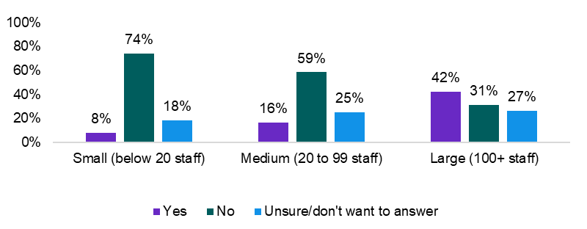

Of the 412 who responded ‘yes’ to having a First Nations applicant, 290 (70%) reported that the applicant was successful, 101 (25%) reported that the applicant was unsuccessful, and 21 (5%) were unsure whether the applicant was successful. Leaving aside those who were unsure, 74% of those with a First Nations applicant said that the applicant was successful. Notably, those First Nations applicants applying for jobs at medium to large businesses were more likely to be successful than those applying for jobs at small businesses (Figure. 2).

**Figure 2. Success of First Nations applicant, by business size   
(proportion of employers with a First Nations applicant)**

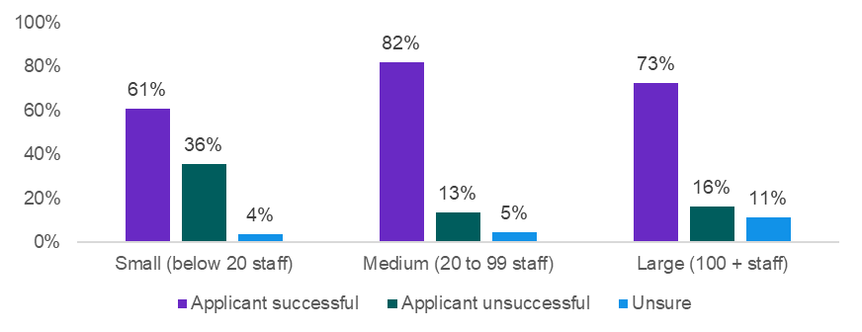

### Occupation and skill level of positions applied for by First Nations applicants

Labourers, Community and Personal Service Workers, and Technicians and Trades Workers were the three occupation groups with the highest numbers of First Nations applicants. Labourers and Community and Personal Service Workers also had applicant success rates above the average of 74%. Sales Workers was another common occupation and, while providing fewer opportunities, Machinery Operators and Driver jobs had a high success rate for applicants. Not only were there fewer First Nations applicants for Clerical and Administrative Workers and Professionals, but the applicants’ success rate was also far below average. Despite the relatively small sample, other data similarly show that First Nations people tend to apply for lower skilled jobs.[3]

### Reasons First Nations applicants were successful and unsuccessful

When asked for reasons why the First Nations applicant was successful in getting the job, the top three responses were their qualifications and skills; their experience; and the quality of their job application and/or interview (Figure. 3). Another common reason was the applicant demonstrated a positive attitude towards the job and a willingness to work (15%). The value of networks and having good work references was also evident in the number of responses that mentioned the applicant was known or had been recommended (8%).

**Figure 3. Reasons First Nations applicants were successful in getting the job  
(proportion of employers, multiple responses allowed)**

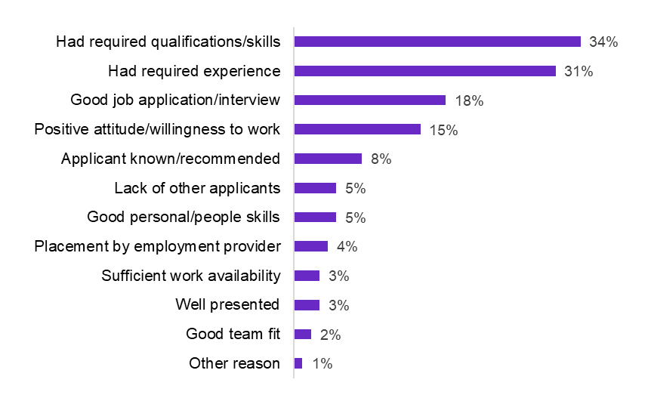

The reasons that the applicant was unsuccessful are shown below (Figure. 4). A lack of experience was the most common reason, along with a lack of interest in the job (20% each) or a willingness to work, closely followed by a lack of qualifications and skills relevant to the position. Some 8% of employers reported that the position had become unavailable, either because the job was filled with someone else, or the business had reviewed its need for the role. Poor availability of the job applicant was mentioned by 6% of respondents, and issues with location or a lack of transport noted by 5% of respondents.

**Figure 4. Reasons First Nations’ applicants were unsuccessful in getting the job  
(proportion of employers, multiple responses allowed)**

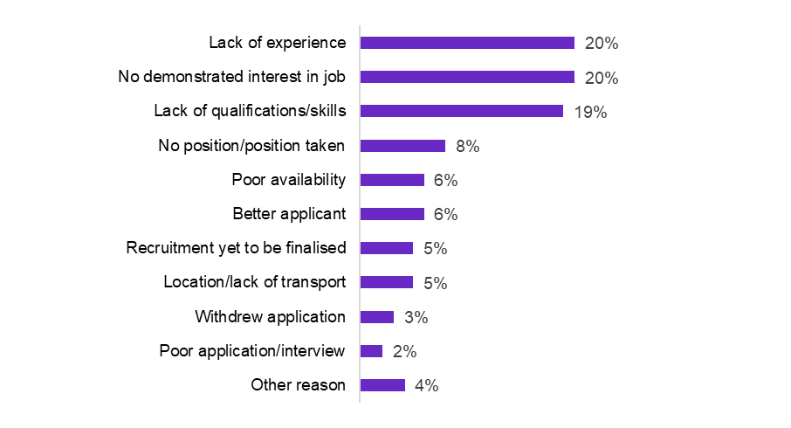

### Strategies to assist First Nations workers into the workplace

Some 141 (52%) of businesses used a strategy to support successful First Nations job applicants to transition into the job (Figure. 5).

**Figure 5.** **Strategies adopted to help First Nations workers transition into the workplace  
(proportion of employers, multiple responses allowed)**

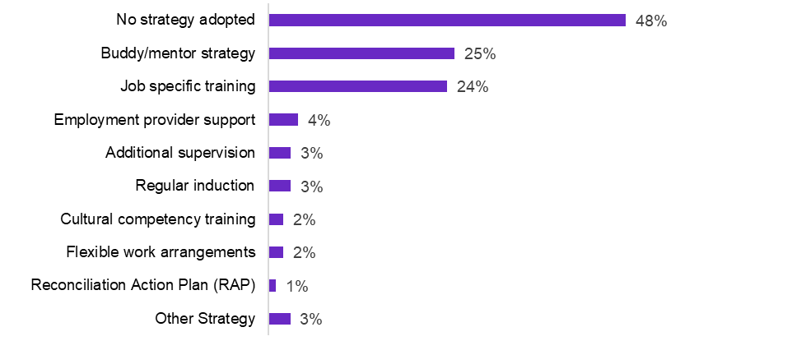

The use of a buddy or mentoring strategy was the highest strategy mentioned, followed by job specific training. All other strategies mentioned were used by 4% or less of employers. The adoption of cultural competency training for staff or actively creating a culturally welcoming environment was low, as was the use of Reconciliation Action Plans. Large businesses were more likely to adopt such strategies than small to medium size businesses (Figure. 6).

**Figure 6. Employers adopting strategies to assist transition into the workplace   
by business size (proportion of employers)**

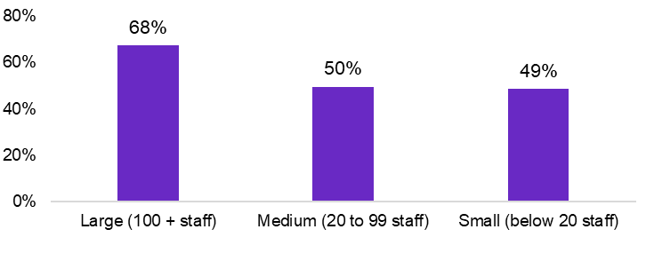

### Accessing programs or subsidies when recruiting First Nations applicants

Some 10% of responding employers accessed a program and/or subsidy when taking on the First Nations job applicant (Figure. 7). The access of jobactive programs and subsidies was most common (7%). There were no responses for accessing Community Development Programs and only a small number of employers mentioned other programs.

**Figure 7. Employer access of programs or subsidies when recruiting a First Nations applicant,   
(proportion of employers, multiple responses allowed)**

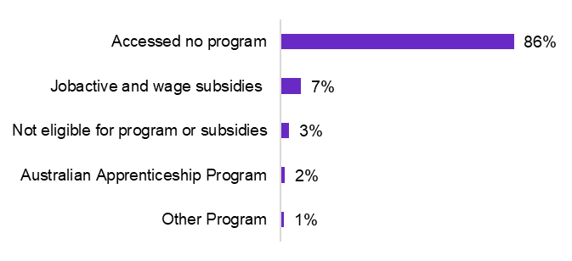

Small to medium sized businesses were more likely to access a program and/or subsidy than large businesses (Figure. 8). Businesses in metro areas were also more likely to access a program and/or subsidy (14%) than regional businesses (8%).

**Figure 8. Employer access of programs or subsidies when recruiting a First Nations applicant,   
by business size (proportion of employers, multiple responses allowed)**

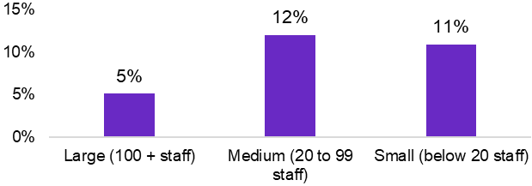

Note that these findings need to be considered with some caution due to relatively small sample sizes.

### How well did First Nations applicants transition into the job?

Successful First Nations applicants largely transitioned well into the job. Some 277 businesses provided a response to this question and 93% said the transitions went well. The figures were similar regardless of business size, with 92% of large and small businesses reporting that the transition went well, and 94% of medium businesses reporting the same. Some 92% of businesses that had adopted a strategy stated that the transition went well, while 96% of businesses that did not adopt a strategy stated that the transition went well. For those that did access a program or subsidy, 96% stated that the transition went well, while 93% of employers who did not adopt a program, stated that the transition went well.

### Methodology notes

The First Nations survey module was asked of 3,579 employers and of these, 412 respondents or 12%, reported having a First Nations job applicant in the previous 12 months. The sample was not adjusted to target businesses or regions that may be more likely to attract greater proportions of First Nations applicants, nor was it adjusted to be representative of First Nations population distribution. For this reason, data are not able to be disaggregated by area. Similarly, industry comparisons are not available due to small sample sizes and disproportionate sample representation.

The survey relied on the respondent knowing whether a job applicant was First Nations or not. Some caution needs to be applied interpreting the findings as the sample is likely to be biased towards First Nations applicants that self-identify as part of the recruitment process.

There were 706 respondents (20% of the total asked) who were unsure of whether they had a First Nations applicant over the past 12 months prior to the time of the survey. Many businesses conduct large recruitment rounds and recruiters wouldn’t be able to identify the background characteristics of all job applicants. Around 18 respondents refused to answer the question.

Furthermore, respondents were not asked whether there was more than one (multiple) First Nations applicant for any given position. It is possible that more than one First Nations applicants applied for some of the jobs.

The survey is conducted by an in-house call centre by well trained interviewers. The survey module was tested and adjusted before the final set of questions were put into the field. However, the module is based on a short set of questions following on from the core Recruitment Experiences and Outlook Survey. In depth questioning is not possible due to respondent burden considerations.

1. JSA, First Nations People Workforce Analysis, 2023.
2. ABS, Census of Population and Housing, 2016 and 2021. Census data provides the most reliable data for labour market and educational attainment for the First Nation population.
3. While the sample is low, the high reliance on lower skilled job aligns with the 2021 ABS Census figures.