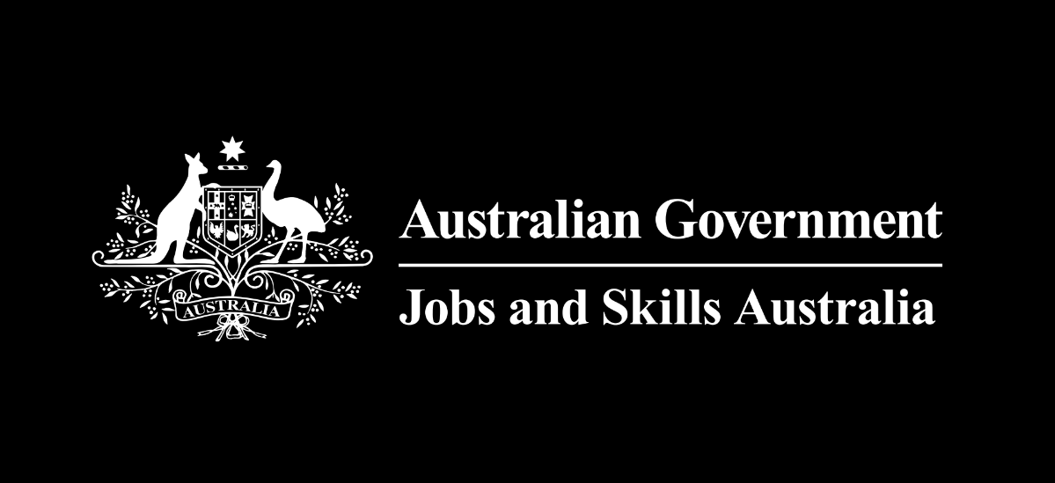


First Nations People
Workforce Analysis

Contents
Key Findings 1
Labour force composition 1
Education outcomes 2
Apprenticeships 2
Labour Force Composition 3
Demographic Information 3
Geographic Information 3
Age Profiles 4
Gender 5
First Nations Employment 6
COVID-19 impacts 6
Occupational profile 10
People receiving working age social security benefits 17
Skills informed re-employment options 19
Educational Profile 20
Level of Education 20
Field of Education 22
Field of Education compared to labour market demand 25
Field of Education pathways to employment 26
Case study: Information Technology field of education 29
Apprenticeships 30
Apprenticeship Outcomes 31
Apprenticeship profile: age, location and prior education 31
Commencements and completions by occupation 33
Commencements 33
Completions 35
Outcomes by Gender 36
Conclusion 38
Table of Figures 39
Appendix 1: Data Methodology 41

Foreword
While First Nations people make diverse and important contributions to Australia’s workforce and are leading the way at the pinnacle of many sectors, unacceptable gaps persist in education and employment outcomes at the population level. First Nations people continue to face additional barriers to work and study compared to other Australians.
To date, there has been a lack of timely data on education and employment outcomes to support First Nations policy development because detailed information is only collected and reported comprehensively every five years, through the Census. In between these years it is difficult to understand the impact of policy decisions and to measure progress towards the Closing the Gap targets.
Jobs and Skills Australia and the Australian Bureau of Statistics (ABS) are working towards bridging this gap with a linked data set called Skills Tracker, a Multi-Agency Data Integration Project (MADIP) which links data from Census, the Department of Social Services, the Australian Taxation Office, and the tertiary education sector. This approach enables estimates to be derived using recent data (May 2022) on labour market participation, employment and education pathways of First Nations people and the impact of the COVID-19 pandemic.
This research has benefited greatly from insight and feedback from many people. In particular, we would like to thank the Minderoo Foundation, the National Indigenous Employment and Training Alliance, the ABS and the National Indigenous Australians Agency for their invaluable contributions.
There are limitations to the data, including its size and complexity and the inability to measure important skills like cultural knowledge and resilience. When interpreting results, it is important to note many First Nations people face individual and systemic barriers which affect their education and employment outcomes. These barriers may be complex and can compound on one another; and may be invisible in available data. This report sets out to measure outcomes, but further research is needed to understand why those outcomes occur.
Despite these limitations the report provides new evidence that can be critiqued and debated to help progress further conversations about supporting First Nations people to thrive in Australia’s workforce.
Authors

Athos Nicolaou
Rachel Neumann
Simon Parker
Mohammad Seyani
Nicolas Ryan
Alicia Gransden
Natasha Yemm
Angela Hope

Key Findings
This report uses linked administrative data from May 2022 from Skills Tracker, a Multi-Agency Data Integration Project (MADIP) to explore the employment and education pathways of First Nations people. The findings are split into three parts - labour force composition, education outcomes and a deep dive into apprenticeships.

Labour force composition
Within our available data, First Nations women were more likely to be employed than men across all age cohorts (though their employment was more likely to be on a part time basis). Higher rates of employment were particularly noticeable for younger First Nations women.
There is a mixed story when it comes to the occupations of First Nations people and their growth prospects into the future. Occupations such as Aged and Disabled Carers and Education Aides are expected to experience healthy growth. On the other hand, some occupations like Sales Assistants are likely to experience minimal growth in the future. This may already be having an impact on employment outcomes, Sales Assistants was one of the most common previous occupations of First Nations people receiving working age income support payments (a group likely to be unemployed, have a decreased capacity to work or marginal attachment to the workforce).
Even though employment losses were disproportionately higher for First Nations people early in the COVID-19 pandemic, evidence from tax data suggests that the number of First Nations people in employment rose more quickly than in the wider workforce. This was led by rising employment in the Public Administration sector and helped by a lower reliance on hospitality jobs.
A further indicator of the importance of public sector employment was a noticeable increase in First Nations people working as Contract, Program and Project Administrators, an expansion of over 40% between 2017 and 2022.

Education outcomes
First Nations tertiary educational attainment was lower than for non-Indigenous people across all age groups and regions and this gap increased with remoteness.
First Nations people with qualifications in high-demand fields were likely to be employed and to be working in a role directly relevant to their study. For example, 71% of First Nations people who studied Education were employed in an occupation which utilised these skills (similar to the rate for non-Indigenous people of 75%).
On the other hand, the level of qualification gained for some high-demand fields appeared to be insufficient to secure employment. For example, the data showed First Nations people who had studied Information Technology were unlikely to be working in this field. This was likely because over a third had completed Certificate II level training or below, which is insufficient for many entry-level jobs in the sector. This suggests there is a role for bridging programs to help people build on their training and acquire higher level skills.

Apprenticeships
Apprenticeships are common among young First Nations people, 3.2% of the general Australian population identify as Aboriginal or Torres Strait Islander, but this proportion was over double (7%) for commencing apprentices.
Completion rates for First Nations people who undertook apprenticeships in the Hospitality, Retail, and Service Managers and Inquiry Clerks and Receptionists occupations were higher than their non-Indigenous counterparts. However, First Nations apprentices in trades occupations consistently had significantly lower completion rates than their non-Indigenous counterparts in the same occupation. Qualitative research into the reasons for this gap is needed. Factors such as structural problems, access to opportunities and employer cultural competence may be at play.

Labour Force Composition

Demographic Information

Geographic Information
Current estimates for the First Nations population from Skills Tracker mirror ABS population projections for 2021. About 6 out of 10 First Nations people of working age in the data lived outside of metropolitan centres, with about 11% residing in areas classified as remote or very remote.
Figure 1: Comparison of total First Nations and non-Indigenous people employed or receiving working age income support payments, by geographical remoteness
Source: MADIP: DOMINO (2022), STP (2022)​. Note: Estimates of the number of employed and people on-benefits are identified by membership to either the DOMINO or Single Touch Payroll data extracts. The data is correct as of 7 May 2022.

Figure 1 shows First Nations people who lived further from major cities were significantly less likely to appear employed in Australian Taxation Office (ATO) Single Touch Payroll (STP) data. This is consistent with recent research finding First Nations people living remotely often face high levels of disadvantage and lack access to services and employment opportunities.
We found evidence of employment for approximately 74% of First Nations people in the labour force from major cities (or roughly 100,000 of the 135,000 people captured in the data). This figure fell to 68% of those in inner and outer regional areas, 60% in remote areas, and 51% in very remote areas (amounting to 8,700 of the nearly 16,000 First Nations people employed or on benefit) . In contrast, there was evidence of employment for 94% of non-Indigenous people in very remote regions. Labour market conditions across very remote Australia are diverse and a current lack of genuine and sustainable employment in many remote First Nations communities likely explains much of this difference.

Age Profiles
The gap between First Nations and non-Indigenous employment was relatively stable across age groups with a slightly smaller gap for the 15 to 24 age group (20 percentage points) than the 25-34 (24 percentage points) and 35-64 (22 percentage points) age groups.
Figure 2: Differences between First Nations and non-Indigenous employment rate in Single Touch Payroll, by age
Source: MADIP: DOMINO (2021), STP (2021)​.

Gender
Figure 3 shows the gap between First Nations and non-Indigenous employment rates for different age groups by gender (smaller values denote a smaller negative difference in employment rates). Within our sample, employment appeared to be higher among younger First Nations people (aged 15-24) compared to those in the next oldest age group (73% compared to 68%). This trend was most evident for younger females, where the gap with their non-Indigenous peers was smallest (17 percentage points compared to 23 percentage points for males). This may be related to a higher level of year 12 completions among First Nations females.
We saw a lower gap between First Nations and non-Indigenous employment rates for females across all age groups, albeit less apparent after the age of 35. However, it must be noted, First Nations women are more likely to be employed on a part time basis than First Nations men and evidence of employment is not necessarily evidence of economic stability.
Figure 3: Difference between First Nations and non-Indigenous employment rate for gender, by agegroup

Source: MADIP: DOMINO (2022), STP (2022)​.

First Nations Employment

COVID-19 impacts
Using data from employers we can see evolving employment trends and assess the -nearer-term macroeconomic effects of the COVID-19 pandemic on First Nations people.
Figure 4 uses Single Touch Payroll (STP) data to chart movements in employment of First Nations and non-Indigenous people from the initial stages of the pandemic in March 2020 through to May 2022. When lockdown measures came into effect in 2020, the decline in employment experienced by First Nations people was greater, falling to its lowest level throughout April and May. Following the easing of lockdown measures after the first wave, First Nations and non-Indigenous employment moved in relative sync with evidence of employment in STP data returning to pre-pandemic levels (and beyond) from July 2020.
Figure 4: First Nations and non-Indigenous STP employment index, from February 2020 to May 2022
Source: MADIP 2022: Single Touch Payroll data, ABN information sourced from the ABS Business Register: Note: Only the primary ABN employer-employee is counted here to avoid double-counting those with multiple jobs. Some of the peaks in December and dips in January 2020 and 2021 may be related to altered patterns of reporting over Christmas.

From 2021 onwards, a divergence appeared as the First Nations employment index increased beyond that for non-Indigenous people. By July 2021, evidence of employment in STP for First Nations people was sitting about 10% above pre-pandemic levels, reaching a further peak of 14% above by December 2021. This is consistent with the overall strength of the labour market, with the unemployment rate at its lowest rate since the 1970s.
Despite evidence of increased First Nations employment in STP, employment services program monitoring shows that a record number of First Nations people were connected with the jobactive service before the pandemic in February 2020; and program exit rates for First Nations participants were significantly lower than average during and after the pandemic.
The apparent paradox of increasing jobactive caseload numbers concurrent with an increasing employment to population ratio is not unique to First Nations people, the same trend occurred with the general population. People on the caseload can be employed – often working part time with earnings low enough to be receiving Income Support Payments. Accordingly, the caseload count was higher than the ABS estimate of unemployment throughout the pandemic. This shows that, while having some level of employment is positive, it does not necessarily represent economic stability.

The Public Administration sector, which encompasses federal, state and local government administration services, was the largest employer of First Nations people at the start of the pandemic (27,500). Figure 5 shows it also saw the highest employment gains, barely declining in the early days of the pandemic and reaching a peak of 27% above pre-pandemic levels (7,500 additional First Nations people) in December 2021. By May 2022, the Professional Scientific and Technical Services sector accounted for the second largest gain in First Nations employment (1,400 people or 16%), but this sector recovered more slowly, reaching pre-pandemic levels in September 2020.
Figure 5: First Nations STP employment index by industry, for highest employing industries
(at the ANZSIC subdivision level)
Source: MADIP 2022: Single Touch Payroll data (March 2020 to May 2022), Business information including ANZSIC sourced from the ABS Business Register. Note: some of the dips in December 2020 and 2021 may be related to altered patterns of reporting over Christmas.

First Nations employment in the Construction industry also grew, with May 2022 levels sitting at about 9% above pre-pandemic levels. Similar gains were made in the Other Store-Based Retailing sector, which includes pharmacies and hardware stores. As expected, employees in Food and Beverage Services were the worst affected with employment in May 2022 remaining well below pre-pandemic levels (more than 20% less or 3,200 people).

Occupational profile
Self-reported occupation information collected annually by the Australian Taxation Office, from sources like income tax returns, provides a detailed picture of First Nations people’s occupations. First Nations people tended to be concentrated in a range of Social Support, Clerical or Labourer related job roles.
Figure 6: Cumulative employment shares for the 30 highest First Nations employing occupations
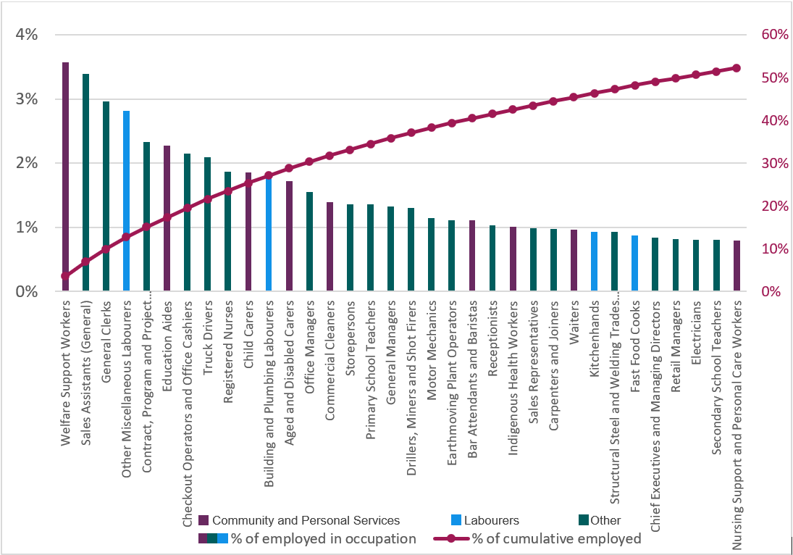
Source: MADIP 2022: ATO Personal Income Tax (PIT) (19-20 financial year). Single Touch Payroll (STP) May 2022.

The Australian and New Zealand Standard Classification of Occupations (ANZSCO) categorises occupations according to one of 8 major groups and then into increasingly smaller sub-categories. Figure 6 shows the cumulative percentage of First Nations people in our data by occupation and major group.
At the major group level, the largest proportion of First Nations people was employed as Community and Personal Services Workers (19% compared with 12% of non-Indigenous people). These results were similar to the 2021 Census where 18% of First Nations people and 12% of non-Indigenous people were coded as Community and Personal Services Workers. By comparison, non-Indigenous people were most likely to be employed in the Professionals major group (24% of people compared with 13% of First Nations people)
The Community and Personal Service Workers major group encompasses Carers and Aides, Hospitality Workers, and Welfare Support Workers. The largest occupational unit group (4-digit ANZSCO) within this group was Welfare Support Workers, which included just under 4% of all First Nations people in our Skills Tracker data. This is a higher rate than in the 2021 Census, where 2% of First Nations people were coded as Welfare Support Workers. Different approaches to coding people’s job titles to ANZSCO occupations across the two data sets may have contributed to this difference.
Other common occupations for First Nations people in Community and Personal Services were Education Aides, Child Carers and Aged and Disabled Carers, each with approximately 2% of all First Nations people and similar percentages in the 2021 Census. While not in the same major group, the related occupation Registered Nurses was of a similar size (2%). These occupations are a large and growing part of the workforce.
In Skills Tracker data, the second largest proportion of First Nations people was employed as Labourers (17% compared with 9% of non-Indigenous people). This was also the second most common occupation group the 2021 Census, but the percentage recorded was lower (14% of First Nations people).
First Nations and Non-Indigenous people were equally likely (12%) to be employed in the Technicians and Trades Workers set of occupations. Within this group, First Nations people were more likely to be employed as Automotive and Engineering Trades Workers than non-Indigenous people (27% compared to 21%). There was a slightly smaller gap in the 2021 Census where 24% of First Nations people and 20% of non-Indigenous people were coded as Automotive and Engineering Trades Workers. Non-Indigenous people were more likely to be employed as Electrotechnology and Telecommunications Trades Workers or Engineering, ICT and Science Technicians. Motor Mechanics was the most common unit group in this category among First Nations people with about 1% of the total employed in our data and a similar percentage in the 2021 Census.
Although the distribution of occupations was similar across regions, there were some notable exceptions. Figure 7 shows the share of First Nations employment by occupation and major group, as well as the workforce composition between metro and regional and remote areas. As shown in Figure 7, for example, a greater proportion of First Nations people were employed as Health and Welfare Support Workers (7%) in regional and remote areas compared to 4% in metropolitan areas.
Figure 7: First Nations occupational shares for Metropolitan and Regional and Remote Australia
Source: MADIP 2022: ATO Personal Income Tax (PIT) (19-20 financial year). Single Touch Payroll (May 2022).

First Nations employment as Carers and Aides, Farm, Forestry and Garden Workers and Cleaners and Laundry Workers was more common in regional and remote areas. Occupation groups such as Professionals and Managers were more common in the First Nations workforce in Metro areas.

First Nations employment growth by occupation
This section tracks the occupations where First Nations employment is growing using multiple years of Australian Taxation Office data on employment and occupations. This discussion is focused on both younger and older First Nations people in Metro and Regional or Remote areas.
Figures 8 and 9 show Welfare Support Workers and Contract, Program and Project Administrators have been large and growing sources of employment in our data for younger and older First Nations people alike. Growing numbers of younger First Nations people were employed as Child Carers and Fast Food Cooks across both metro and regional Australia. Aged and Disabled Carers had strong growth among older First Nations people in all areas.
Contract, Program and Project Administrators, a common public sector occupation, was among the top five growing occupations across all age cohorts and areas of remoteness, with total numbers employed in our data expanding by 42% between 2017 and 2022, accounting for an additional 1,133 First Nations people over the four years (a higher figure than the 27% employment growth seen for this occupation in the non-Indigenous workforce). This could partly be because of targeted initiatives such as the Indigenous Cadetship Support Program (ICS), which appear to have opened viable employment pathways into policy and administrative roles within government.
There were also positive trends for some skilled trade occupations in metropolitan areas, with a larger number of younger First Nations people working as Plumbers (24% an increase to 341 people) than four years ago, and older Indigenous people working as Electricians (increasing by 24% to 196). Other occupations like Drillers, Miners and Shot Firers grew strongly in regional and remote areas across both age groups, experiencing a rise in employment of over a third in the four years to 2022.

Figure 8: Fastest growing occupations (between 2017 and May 2022) for First Nations people aged 15 to 34, Metropolitan (left) and Regional & Remote (right) areas
Ordered by percentage growth
Ordered by percentage growth
Figure 9. Fastest growing occupations and current level of employment for First nations people aged 35 to 64, Metropolitan (left) and Regional & Remote (right) areas
Ordered by percentage growth
Ordered by percentage growth
Note: Occupations with employment levels below 100 were not considered for this analysis. Occupations are ordered by the highest percentage increase or growth rate from 2017 to 2022.

Recent First Nations employment growth compared to the Skills Priority List
The intersection between the occupations where First Nations employment is growing and the occupations in demand according to the Skills Priority List is explored in Figure 10. It shows the employment growth rates (from 2017 to 2022) for Skills Priority List occupations for young First Nations (blue) and non-Indigenous people (green) by the total number of people employed in each occupation in May 2022. The chart shows the differences between metropolitan, regional, and remote Australia.
Figure 10: Employment growth rates by region for Skills Priority List occupations, for First Nations and non-Indigenous people aged 15 to 34
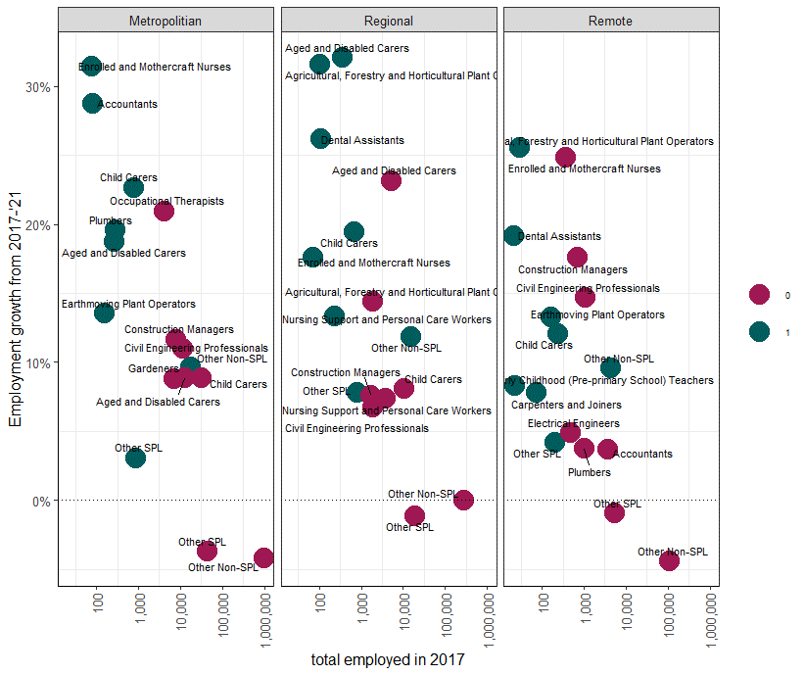
Non-Indigenous
First Nations
Employment growth from 2017 to 2022
Source: MADIP Census (2016), Personal Income Tax (2017-2019), Single Touch Payroll data (April 2021): Skills Priority List. Note: Other non-SPL and Other SPL are grouped categories which contain the growth rate for all other occupations with employment counts less than 100.
Employment growth rates for Skills Priority List occupations were generally higher for First Nations people than non-Indigenous people. Aged and Disabled Carers, a sector in which skill shortages are often reported, was among the highest growing occupations among younger First Nations people with employment in regional areas increasing by over a third of its 2017 levels.
Strong First Nations employment growth in regional and remote areas was also seen in Agricultural, Forestry and Horticultural Plant Operators (34% in regional areas and 26% in remote) and Dental Assistants (26% in regional areas and 19% in remote).

Future employment growth rates
The most common occupations of First Nations people and their projected growth rates using the five-yearly employment projections (growth to 2026) are shown in Figure 11.
Figure 11: Most common occupations of First Nations people and their projected growth rates to 2026

Source: MADIP 2021: ATO Personal Income Tax (PIT) (19-20 financial year).STP (2022) 5-yearly employment projections.
Average economy wide growth

In keeping with the earlier occupation profile analysis, particularly healthy growth is expected in some care and community-based occupations such as Aged and Disabled Carers (28%), Welfare Support Workers (25%) and Education Aides (17%). Minimal growth is expected in other common occupations employing First Nations people like Truck Drivers and Sales Assistants.

People receiving working age social security benefits
Our analysis focused on identifying the most recent reported occupations of First Nations and non-Indigenous people who were receiving working age income support payments in May 2022, a potential indicator of unemployment, decreased capacity to work or marginal attachment to the workforce. Figure 12 shows that, nationally, 56% of all First Nations people visible in our Social Security data with an employment history had previously worked as either Labourers (31%) or Community and Personal Service Workers (25%) compared to 43% of non-Indigenous people (24% for Labourers and 19% for Community and Personal Service Workers).
Within the Labourers occupation category, most First Nations people in the Social Security data had previously worked in the sub-group Other Labourers (11% compared to 8% of non-Indigenous people). The largest unit group was Other Miscellaneous Labourers (6% compared to 3% of non-Indigenous people). This is a broad group of labouring occupations including Mechanic's Assistants, Road Traffic Controllers and Electrical or Telecommunications Trades Assistants.
The largest sub-group in the Community and Personal Service Workers occupation category was Carers and Aides (10% of all First Nations people in the Social Security data, compared to 8% of their non-Indigenous counterparts). The largest unit groups in this sub-group were Aged and Disabled Carers, Child Carers and Education Aids, each with 3%, similar proportions to non-Indigenous people. The largest unit group across Community and Personal Service Workers was Welfare Support Workers; 6% of all First Nations people in the Social Security data had previously worked in this occupation, compared to 2% of their non-Indigenous counterparts).
While multiple factors may contribute to a person requiring a working age social security benefit, analysing the previous occupations of people visible in Social Security data is one way to identify potential areas for policy intervention. Where there appears to be an available pool of workers with experience in high demand occupations, such as Aged and Disabled Carers, it may indicate employers need to work on attraction and retention strategies. Where shifts in the labour market may be affecting employment opportunities, like automation and online sales affecting retail positions, it may indicate a need for investment in reskilling.

Figure 12: Most recent occupation of First Nations and non-Indigenous people receiving working age income support payments at the 1 and 2-digit ANZSCO level
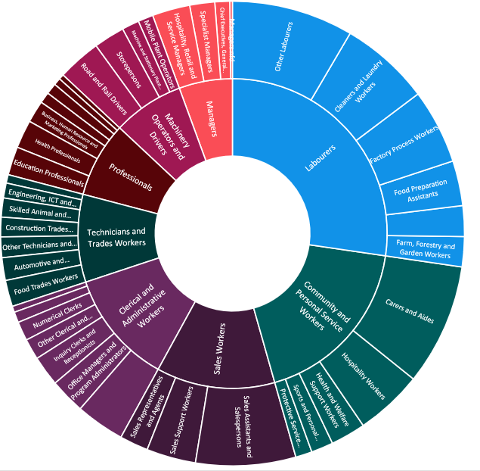
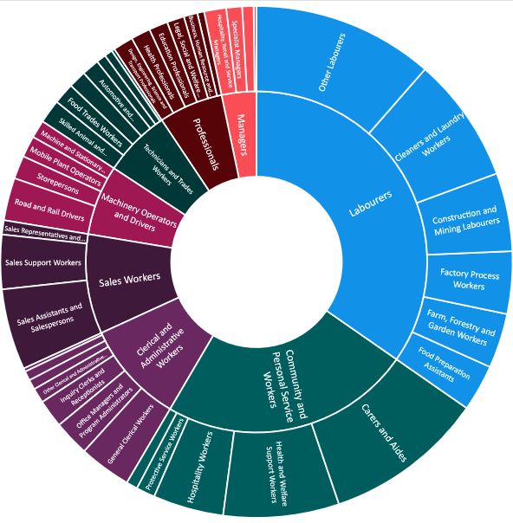

First Nations
Non-Indigenous

Source: MADIP (2022), DSS income support data (DOMINO 2022), ATO tax records (2019-20 financial).
Note: 55% of First Nations people and just less than half of non-Indigenous people on a related benefit type did not have a valid occupation in PIT data. The above graphs are therefore only representative of those receiving working age income support payments with an identifiable employment history and should not be interpreted as a proportion of the overall unemployed.

Skills informed re-employment options
First Nations people, both those who were employed and those receiving benefits, tended to be grouped into a narrower range of occupations than non-Indigenous people; and some of those occupations tended to have poorer labour market outcomes.
A common previous occupation for First Nations people who were receiving benefits was Sales Assistants (General) (4%). Employment prospects for this occupation are relatively weak, with slow growth of 1.7% predicted to 2026.
There are opportunities for people with experience working as Sales Assistants to build on their existing skills and move into roles where stronger growth is predicted. Similarity between occupations can be measured based on their underlying skill requirements. Figure 13 shows a range of similar occupations that Sales Assistants could consider in broadening their job search options.
Figure 13: Re-employment options for Sales Assistants (General) considering job similarity scores and future growth prospects
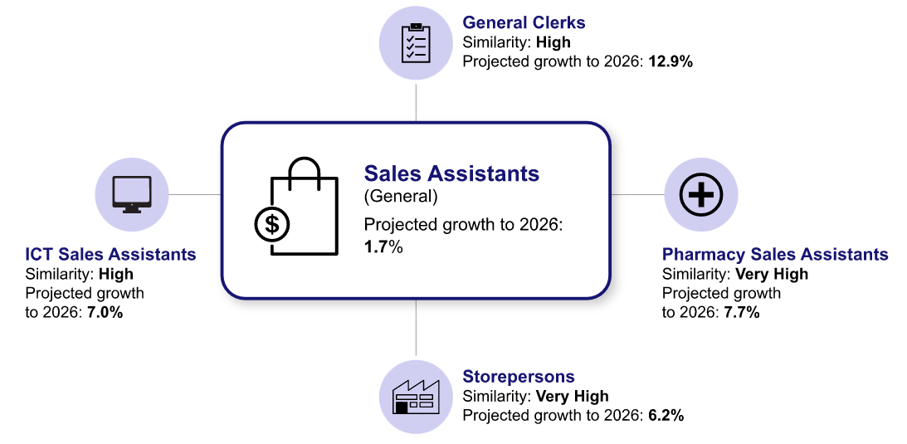

Source: Internet Vacancy Index (IVI) for May 2022; MADIP (2022): DSS income support data (DOMINO 2022), ATO tax records (2018-19 financial year), internal analysis products.

Educational Profile
This section focuses on education outcomes as measured in administrative data. It cannot provide insight into the cultural education many First Nations people receive, or levels of specific skills and attributes taught in many First Nations communities such as resilience, systems thinking and conflict resolution. We acknowledge the importance of these skills and hope that future research may be better able to capture them.
First Nations educational attainment has shown signs of improvement in recent times. There have been increases in First Nations students continuing onto secondary education, year 12 (and equivalent) attainment and post-school study. Despite this, First Nations’ formal tertiary qualification attainment levels remain lower than those of non-Indigenous people. Education data from Skills Tracker indicated there was less diversity in the types of study First Nations people had undertaken. Some common fields of study for First Nations people were associated with a higher likelihood of being unemployed, under-employed of facing barriers to work.
The data also indicated that employment outcomes for First Nations people tended to be much more linked to their education background compared to non-Indigenous people, emphasising the importance of accessible and targeted tertiary education (at Certificate III level or higher) in broadening First Nations employment opportunities.

Level of Education
Post-secondary education has historically been an important determinant of employment outcomes. Analysis of ABS Labour Force data indicate that post-year12 qualifications significantly improve job prospects and reduce unemployment for the general population. The unemployment rate for people who have not completed Year 12 is 8%, but this drops to less than 3% for those with a Certificate III qualification or higher.
Analysis from Skills Tracker data showed First Nations tertiary educational attainment remained lower than for non-Indigenous people, across all age groups and regions. This gap increased with remoteness. First Nations educational attainment was lower in remote and very remote areas than in metropolitan and regional areas across all age groups.
Educational attainment was lowest for First Nations people in remote or very remote areas, where only a third (of all age groups) held a year 12 or equivalent qualification. While the number of First Nations people obtaining year 12 qualifications is increasing, many First Nations children living in remote communities face difficulties in accessing education to year 12. Many remote First Nations communities in the Northern Territory, Queensland, Western Australia and South Australia are more than 100 km from a school with a full secondary education program.
Figure 14 shows the percentage of people with a Certificate III level certification or higher across different age groups and regions. It shows that, in 2019, tertiary educational attainment was highest for First Nations people who lived in Major Cities and were aged between 35 and 44, with about 59% having attained a Certificate III or higher. This was considerably lower than the corresponding non-Indigenous group at 78%. This finding is very similar to 2021 Census results, where 59% of First Nations people in this group had a Certificate III or higher, compared to 79% for non-Indigenous people.
Figure 14: Highest level of educational attainment, by age and region, for First Nations and non-Indigenous people

Source: MADIP Census (2016), Total VET Activity (2017-2020), Higher Education Information Management System (HEIMS) (2017-2019), DSS Combined Demographics (2021).
*Reference line indicates the closing the gap socioeconomic target 6 of a 70% indigenous education attainment for people aged 25-34-year of Cert III or above.

The 2021 Census results showed the same overall trends as Skills Tracker data, with similar education gaps across age groups and regions; however, there were some differences, particularly in very remote areas. For example, Census 2021 results indicate that 18% of First Nations people had a Certificate III or higher, compared to 31% in our study.

Field of Education
Based on Skills Tracker data, the most common area of study for First Nations people was Society and Culture – 10% of First Nations people aged 15 to 65 had a qualification in this broad field of education. This was followed by Management and Commerce (9%) and Engineering and Related Technologies (8%). These results were similar to those reported in the 2021 Census, where the most common areas of study for First Nations people were Society and Culture (9%), Management and Commerce (8%) and Engineering and Related Technologies (6%).
While levels of enrolment in these areas of study were similar for non-Indigenous people, i.e. Management and Commerce (15%), followed by Engineering and Related Technologies (10%) and Society and Culture (10%), differences between First Nations people and non-Indigenous people became more apparent at the more detailed two-digit level field of education (Figure 15).
Of the First Nations people who had completed studies in the Society and Culture Field of Education, over half specialised in Human Welfare Studies (54%) which is associated with occupations like Welfare Support Workers. Previous analysis in this report has noted that this group of occupations is associated with a higher likelihood of receiving social security benefits, despite robust future growth prospects. The second most common specialisation for First Nations students was Sport and Recreation (14%). Non-Indigenous people who studied Society and Culture were less likely to specialise in Human Welfare Studies (36%) and Sports and Recreation (10%); and more likely to have studied Law (10% of non-Indigenous compared to 3% of First Nations people).
Both First Nations and non-Indigenous people who studied Management and Commerce were most likely to have specialised in Business and Management, 46% and 45% respectively; but First Nations people were more likely to have specialised in Office Studies (19% compared to 7% for non-Indigenous people). Non-Indigenous people were more likely to have specialised in Accounting (17% compared to 4% for First Nations people).
First Nations people were particularly under-represented in Natural and Physical Sciences, Health, Information Technology and in some specialisations such as Architecture and Urban Environment and Behavioral Sciences.

Figure 15: Field of Education studied by First Nations and non-Indigenous people
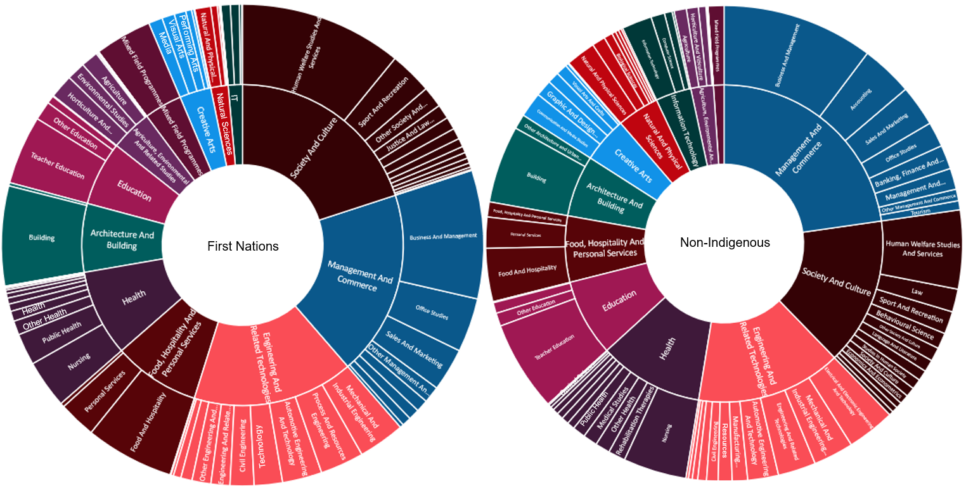

Source: MADIP Census (2016), Total VET Activity (2017-2020), HEIMS (2017-2019), DSS Combined Demographics (2021).
Note: Around 49 per cent of First Nations people identified through Skills tracker had a valid Field of Education recorded in any of the above datasets. This compared with about two thirds of non-Indigenous people.

Field of Education compared to labour market demand
Figure 16 compares educational attainment with labour market demand, based on the Fields of Education associated with occupations frequently advertised online. While the distribution of fields of study in the population roughly mirrored the pattern in internet job advertisements for both First Nations and non-Indigenous people, there were some notable exceptions.
Less than 1% of First Nations people had a qualification in IT, compared to 2% of non-Indigenous people, yet IT jobs comprised 8% of all online vacancies. It is likely that structural barriers are contributing to lower take-up of IT for many First Nations people; for example, on average, digital inclusion of First Nations people is 7.9 points below the national score (this measure includes digital access, digital ability and affordability).
First Nations and non-Indigenous people were also less likely to have a qualification in Management and Commerce (9% and 15% respectively), than the 32% of online vacancies for occupations that had a pathway related to this field. This suggests a strong role for careers advice and an emphasis on the importance of policy settings to support First Nations educational attainment in areas of labour market demand.
Figure 16: Broad Field of Education attainment for First Nations and non-Indigenous people, compared to online job vacancies

Source: MADIP Census (2016), Total VET Activity (2017-2020), HEIMS (2017-2019), DSS Combined Demographics (2021), Internet Vacancy Index 12-month averages (2021)., JEDI Occupation-Field of Education concordance. Note the measure for First Nations/non--Indigenous represents proportion of field of education by Indigeneity, rather than a distribution adding to a 100%.

Field of Education pathways to employment

One way to measure employment outcomes is to determine how likely a field of education is to lead to any job. As Figure 17 shows both First Nations and non-Indigenous people had high rates of employment if they studied Education, Natural and Physical Sciences or Health. For example, 90% of First Nations people and 96% of non-Indigenous people who had a qualification in Education were in employment.
However, First Nations people with educational attainment in Agriculture, IT, Food, Hospitality and Personal Services or Creative Arts, tended to have much lower employment rates. In Agriculture for instance, 68% of First Nations people were employed in any role, compared to 91% of non-Indigenous people.
Figure 17: Comparison of First Nations and non-Indigenous employment rate to Field of Education

Source: MADIP Census (2016), Total VET Activity (2017-2020), HEIMS (2017-2019), Single Touch Payroll (STP) (May 2022), DOMINO (May 2022), DSS Combined Demographics.

While the likelihood of gaining any type of employment after study is a useful measure, the likelihood of finding a job that is directly relevant to the chosen Field of Study is more meaningful information to most students.
Figure 18 shows the extent to which First Nations and non-Indigenous people went on to work in occupations related to what they had studied. Generally, First Nations education to employment relevance was comparable with non-Indigenous people, but this was especially true in fields of study that generally had high relevance rates such as Education, Management and Commerce, Engineering and Related Technologies and Health. For example, 71% of First Nations people who studied Education were employed in an occupation which utilised these skills. This was only marginally lower than the 75% of non-Indigenous students who went on to become employed in the field.
First Nations people had noticeably lower education-to-employment relevance than non-Indigenous people after completing qualifications in Information Technology (21% compared to 46%), Natural and Physical Sciences (17% compared to 26%) and Creative Arts (21% compared to 30%), meaning fewer went on to work in an occupation relevant to their study.
Figure 18: Comparison of First Nations and non-Indigenous employment to education skill utilisation by Field of Education

Source: MADIP Census (2016), Total VET Activity (2017-2020), HEIMS (2017-2019), ATO Tax Records (2019-20), JEDI Occupation-Field of Education concordance, Occupation – Field of Education concordance.

The First Nations education profile analysis shows the important role that educational attainment plays, at any level, in First Nations employment outcomes. However, the level of education and the field of study chosen play a role in increasing employment opportunities, as highlighted in the following Information Technology case study.
While further research into barriers faced by First Nations people in accessing training for higher level skills is required; there is value in bridging programs to address mismatches with labour market expectations, for example to take people from Certificate III and IV training to Diplomas and Degrees. Alternative qualification pathways, such as professional apprenticeships like the Digital Apprenticeship Program, may be helpful for people who prefer more applied learning environments than are typically offered in university courses.

Case study: Information Technology field of education

First Nations people who studied IT were much less likely to work in related occupations than non-Indigenous people. The underlying reason for this was lower-level educational attainment. As Figure 19 shows, nearly two-thirds of non-Indigenous people (62%) with a qualification in IT had a Bachelor’s Degree or higher, compared with 18% of First Nations completers. In contrast, over a third of First Nations people’s IT qualifications were at Certificate II or below (38%), compared to 8% for non-Indigenous students.

Figure 19: Comparison of First Nations and non-Indigenous level of education for those who had studied IT

Apprenticeships
This section examines trends in participation from commencements and completions data sourced from the Australian Apprenticeship Incentive Program (AAIP) dataset for the period from 2013 to 2019. The dataset includes apprenticeships and traineeships, which we will refer to collectively as apprenticeships throughout the section.
Apprenticeships are common among First Nations people. Between 2013 and 2019, 7% of commencing apprentices identified as Aboriginal or Torres Strait Islander, just over double the proportion of the general Australian population who identified as such (3.2%).
Analysis of our data confirmed findings from earlier research, that overall completion rates were lower for First Nations apprentices than non-Indigenous apprentices; and for trade apprentices than other apprentices. Despite these general trends, there were some occupations, such as Hospitality, Retail and Service Managers and Inquiry Clerks and Receptionists for which First Nations people were more likely to successfully complete an apprenticeship than their non-Indigenous counterparts.
Further research is required to understand the reasons for these differences. In particular, a detailed study of the differences between apprenticeship programs that tend to have high success rates for First Nations people and those that do not, could help to identify and spread best practice.

Apprenticeship Outcomes
Overall, 40% of First Nations apprentices completed their apprenticeships visible in our data, slightly lower than the completion rate for non-Indigenous apprentices, at 45%. While completion rates were mostly lower for First Nations people, there were some exceptions across occupations.

Apprenticeship profile: age, location and prior education
Figure 20 shows the prior education levels of apprentices in the data analysed. While a similar proportion of First Nations and non-Indigenous apprentices had completed Year 11, more non-Indigenous apprentices had completed secondary schooling compared to their First Nations counterparts (55% and 38% respectively). Findings in other research on youth transitions indicate apprenticeships can represent a positive alternative for some students who choose a vocational pathway over completing year 12.
Figure 20: Highest Level of Education among First Nations and non-Indigenous apprentices

Source: MADIP (2021), AAIP datasets (2006-2019), Combined Demographics (2021).

The lower educational attainment may be explained in part by the age of the apprentices. First Nations apprentices were slightly younger than non-Indigenous apprentices, and may not yet have been expected to have finished school. In line with the general First Nations population, 44% of First Nations apprentices in our sample were aged between 15 and 24, compared to 36% of non-Indigenous people.
Figure 21: Proportion of apprentices by remoteness
Source: MADIP (2021), AAIP datasets (2006-2019), Combined Demographics (2021).

The geographic profile of First Nations apprentices outlined in Figure 21 closely follows that of the overall First Nations labour force. A similar proportion of First Nations apprentices resided in Metropolitan areas as in Inner and Outer areas of Regional Australia (45% and 44%, respectively).

Commencements and completions by occupation

Commencements
The differences in the broader study choices made by First Nations people described in earlier sections of this report extend to study selection for apprentices. Figure 22 compares the proportion of apprenticeship commencements by occupation at the broad ANZSCO sub-major (2-digit) level. It shows that First Nations people were more likely to commence apprenticeships leading to jobs in the General Clerical Worker occupation group (10% for First Nations apprentices compared to 3% for non-Indigenous apprentices) as well as in the Carers and Aides group (8% compared to 6%).
Although First Nations people often appeared to take up apprenticeships in similar industries to non-Indigenous apprentices, they tended to do so at a lower skill level. For example, First Nations people were more likely to take on apprenticeships in occupations such as Construction and Mining Labourers (3% compared to 1% of non-Indigenous apprentices) with a predominant skill level of 4 and 5; and less likely to take on apprenticeships in Construction Trades Workers (12% compared to 15% of non--Indigenous apprentices) with a predominant skill level of 3.
First Nations people were equally as likely to commence apprenticeships in a wide range of less common occupations including Health Professionals, Protective Service Workers and Food Preparation Assistants as their non-Indigenous counterparts.

Figure 22: Commencements by Occupation for First Nations and non-Indigenous Apprentices

Source: MADIP (2021), AAIP datasets (2006-2019), Combined Demographics (2021).

Completions
Completion rates between First Nations and non-Indigenous people varied greatly by occupation, but First Nations apprentices had lower completion rates for most occupational groups. It is important to note that reasons for participation in Apprenticeships can vary and completions shouldn’t be viewed as the only measure of success. For example, some apprentices choose not to complete their apprenticeship because they have accepted other employment. It is also important to note many factors, such as access to opportunities, available support, workplace cultures and systemic racism likely affect completion rates.
The difference between First Nations and non-Indigenous completion rates tended to be higher for trades occupations. As Figure 23 shows, completion rates were lower for trades occupations than non-trades occupations for both groups, but the difference was slightly more pronounced for First Nations people.
Figure 23: Completions by Gender and Trades and Non-Trade Occupations

Source: MADIP (2022), AAIP datasets (2006-2019), Combined Demographics (2022).

Further qualitative research into the reasons for differences in completion rates could assist in improving retention of First Nations apprentices. Factors such as structural problems, barriers to access, lack of co-ordinated support and low employer cultural competence may be at play.

Outcomes by Gender
Figure 24 shows higher female completion rates across both First Nations and non-Indigenous people, but this appears to be driven at least in part by a higher female concentration in non-trades-based apprenticeships and traineeships, which have higher overall completion rates.
Figure 24: Completions by Gender for First Nations and non-Indigenous Apprentices

Source: MADIP (2022), AAIP datasets (2006-2019), Combined Demographics (2022).

Drilling down further, Figure 25 shows some positive trends for both male and female First Nations apprentices in specific occupations. Those who undertook an apprenticeship in the Hospitality, Retail, and Service Managers and Inquiry Clerks and Receptionists occupations were more likely than their non-Indigenous counterparts to successfully complete their apprenticeship.

Completions in the Hospitality, Retail, and Service Managers occupations for female First Nations apprentices were 11 percentage points higher than for non-Indigenous female apprentices. Male First Nations apprentices were more likely to complete their apprenticeship than their non-Indigenous counterparts in three occupations – including Inquiry Clerks and Receptionists, Hospitality, Retail and Service Managers and Office Managers and Program Administrators (all 6 percentage points higher).
Figure 25: Difference in First Nations and non-Indignous completion rates by occupation and gender

Source: MADIP (2021), AAIP datasets (2006-2019), Combined Demographics (2021). * Note: Graph is ordered by the largest positive net difference in completion rates for First Nations people.

Detailed qualitative research into apprenticeship programs and apprentices’ experiences would be useful in better understanding these differences. In particular, identifying the factors driving higher First Nations retention rates in Hospitality, Retail, and Service Managers and Inquiry Clerks and Receptionists apprenticeships may be useful in spreading best practice.

Conclusion
While First Nations people are a diverse population, each with unique skills, qualifications, and experience to contribute to the labour market, there are advantages in looking at population data to identify common patterns that might inform policy development and identify opportunities.
This report has attempted to use administrative data to present more detailed and more current observations than have previously been possible. It must be acknowledged that there are limitations to this approach. The data are complex, do not include all Australians; and can be open to misinterpretation. Where possible, we have tried to acknowledge these limitations explicitly and quantify them. A further limitation is that many important skills strengths frequently attributed to First Nations people are not easily identifiable in currently available data, such as resilience, cultural knowledge and systems thinking. Although we have not been able to measure these strengths, we acknowledge the importance of these skills in the emerging labour market.
First Nations people’s work and study choices tended to be more concentrated in particular sectors than the non-Indigenous population. After the COVID-19 pandemic, this contributed to First Nations employment rebounding more quickly due to less dependence on highly exposed sectors like hospitality.
Some of the concentration in particular sectors may be the result of programs which aim to increase recruitment of First Nations people. This is particularly likely for government roles, given increasing uptake of program administration roles and general clerical apprenticeships by First Nations people.
While First Nations educational attainment has shown signs of improvement, the education gap persists. Education attainment plays a strong role in First Nations outcomes, both in terms of level of education and field of education. The field of education studied is more important in determining employment outcomes for First Nations people than non-Indigenous people. First Nations people with qualifications in high demand fields were likely to be employed and to be working in roles directly relevant to their study.
We hope the insights in this report will spark collaborative conversations between First Nations communities, service providers, industry and government to promote better outcomes for our First Nations students and workers.

Table of Figures
Figure 1: Comparison of total First Nations and non-Indigenous people employed or receiving working age income support payments, by geographical remoteness 3
Figure 2: Differences between First Nations and non-Indigenous employment rate in Single Touch Payroll, by age 4
Figure 3: Difference between First Nations and non-Indigenous employment rate for gender, by agegroup 5
Figure 4: First Nations and non-Indigenous STP employment index, from February 2020 to May 2022 6
Figure 5: First Nations STP employment index by industry, for highest employing industries (at the ANZSIC subdivision level) 8
Figure 6: Cumulative employment shares for the 30 highest First Nations employing occupations 10
Figure 7: First Nations occupational shares for Metropolitan and Regional and Remote Australia 12
Figure 8: Fastest growing occupations (between 2017 and May 2022) for First Nations people aged 15 to 34, Metropolitan (left) and Regional & Remote (right) areas 14
Figure 9. Fastest growing occupations and current level of employment for First nations people aged 35 to 64, Metropolitan (left) and Regional & Remote (right) areas 14
Figure 10: Employment growth rates by region for Skills Priority List occupations, for First Nations and non-Indigenous people aged 15 to 34 15
Figure 11: Most common occupations of First Nations people and their projected growth rates to 2026 16
Figure 12: Most recent occupation of First Nations and non-Indigenous people receiving working age income support payments at the 1 and 2-digit ANZSCO level 18
Figure 13: Re-employment options for Sales Assistants (General) considering job similarity scores and future growth prospects 19
Figure 14: Highest level of educational attainment, by age and region, for First Nations and non-Indigenous people 21
Figure 15: Field of Education studied by First Nations and non-Indigenous people 24
Figure 16: Broad Field of Education attainment for First Nations and non-Indigenous people, compared to online job vacancies 26
Figure 17: Comparison of First Nations and non-Indigenous employment rate to Field of Education 27
Figure 18: Comparison of First Nations and non-Indigenous employment to education skill utilisation by Field of Education 28
Figure 19: Comparison of First Nations and non-Indigenous level of education for those who had studied IT 29
Figure 20: Highest Level of Education among First Nations and non-Indigenous apprentices 31
Figure 21: Proportion of apprentices by remoteness 32
Figure 22: Commencements by Occupation for First Nations and non-Indigenous Apprentices 34
Figure 23: Completions by Gender and Trades and Non-Trade Occupations 35
Figure 24: Completions by Gender for First Nations and non-Indigenous Apprentices 36
Figure 25: Difference in First Nations and non-Indignous completion rates by occupation and gender 37

Appendix 1: Data Methodology
Data Source | Description
Demographic Information
MADIP Combined demographics table (2022) – Australian Bureau of Statistics (ABS) | MADIP spine combined demographic information is updated periodically by the ABS from three core datasets: The Medicare Consumer Directory (MCD), DOMINO Centrelink Administrative Data, DSS and Personal Income Tax (PIT) – ATO.  Criteria for determining First Nations and non-Indigenous people were derived from the EVER_INDIGENOUS_FLAG which captures whether a person has ever identified as being of Aboriginal or Torres Strait Islander descent across any one of these datasets. This is the basis for determining First Nations status across all other datasets.  Using this method, 617,482 First Nations people of working age were identified.
Labour force
DOMINO Centrelink Administrative Data (DOMINO CAD) - Department of Social Services (DSS) | On-benefit status is defined as all income support recipients who were in receipt of one of six working age payments – JobSeeker (and former NewStart), Parenting Payment Single, Parenting Payment Partnered, Youth Allowance Other and the Disability Support Pension, on 07 May 2022.  Using this method, we identified 98,005 First Nations people of working age receiving benefits.  Some participants of these payments may have requirements to look for work or build their capacity to be able to look for work in future. However, a large proportion of Parenting Payment and Disability Support Pension recipients do not have requirements. Further people who do have requirements can meet them through a range of activities or may be exempt. All payment types also allow recipients to receive some income from work while remaining on payment.  For these reasons our rules for inclusion are broader than official definitions of unemployment such as those used by the ABS.  It is worth noting the link between the official definition of unemployment and the income support recipient caseload became less clear over COVID, with the total number of people in receipt of benefit increasing dramatically and remaining elevated. While at the same time the unemployment rate and number of people looking and able to take up work had decreased.  For more information on conceptual differences between the two concepts see the ABS Labour Force Explained link
Single Touch Payroll (STP) | Data on employed people were compiled from the Single Touch Payroll dataset. STP is used by employers to report employee’s payroll information. We considered all people with an active employee-employer connection i.e., between an individual and a business as at the week ending 07 May 2022 as employed.  About 10.6 of the presently estimated 13 million employed people in Australia are covered by STP. STP excludes all self-employed people including owner-managers of businesses that might have other employees, sole-traders, independent contractors etc.  Using this method, we were able to identify 263,000 First Nations people who were employed at the snapshot date.
Personal Income Tax (PIT), Australian Taxation Office (ATO) | Details on occupation are primarily derived from the Individual Tax Return (ITR) dataset compiled as part of the PIT data collection and are joined to our employed and on-benefit populations, this is a self-reported measure of occupation provided annually by all those who earned combined wage income over the $18,000 tax-free threshold. If a person had not submitted a tax return in the most recent financial year of available data (2019-20), tax return data from preceding years was used to supplement the analysis.  Using this approach, about 80% of employed First Nation’s people and 48% of those receiving unemployment related benefits had a valid reported current or past occupation. For non-Indigenous people the percentages were 85% and 55% respectively.
Census (2021) | Detailed occupational data was accessed through ABS Tablebuilder from the 2021 Census, and was used to draw comparisons with our administrative data results where possible.  For results relating to Figure 6 of the report - Cumulative employment shares for the 30 highest First Nations employing occupations, Census 2021 comparison figures were derived by cross tabbing the OCCP and INGP variables in ABS Tablebuilder.  OCCP is mainly coded based on the write-in responses to questions asking for the person’s occupation title and main tasks performed.  INGP asks about a respondent’s Indigenous status, to match as closely as possible to our derived First Nations administrative data flag, we combined all respondents who identified themselves as either Aboriginal, Torres Strait Islander, or both.  The Census was conducted on 10 August 2021. The different time periods, coverage of the data sets and minor differences in coding methods contribute to the differences in results to those in Skills Tracker administrative data.
First Nations Educational profile
Combined Demographics (2021) | Demographic information derived from ATO Client Register, Census, Death Registrations, DOMINO Centrelink Administrative Data, Medicare Consumer Directory. This is used as the base file for defining First Nations and non-Indigenous populations.  Used to identify whether a person has ever identified as an Aboriginal or Torres Strait Islander as a marker of First Nations profile. Other demographic characteristics are used to restrict the population to working age group (15-65), not deceased, and with a valid home address in Australia in 2021.
Census (2016) | Used as the primary source of information for non-school qualification field of study at the two-digit level (QALFP) and non-school qualification level of education at the one-digit level (QALLP). The analysis excludes individuals where their certificate level is not further defined, inadequately described or not stated in Census and where they are not present in HEIMS or TVA data files.
Total VET Activity (2015-2020) | Used as a supplementary source of information using ‘program completions’ files for level and field of education, mapped to Census definitions of level and field of education.
Higher Education (HEIMS) (2005-2020) | Used as a supplementary source of information using ‘course completions’ files for level and field of education, mapped to Census level and field of education definitions.
Employment and on benefits status  Single Touch Payroll (May 2022) and DOMINO (May 2022) | Used to calculate employment/on-benefit status by field of education. Where a Single Touch Payroll record exists in the reference week in May 2022 this is an indicator of a person in current employment.  Where a person is in receipt of JobSeeker Payment, Youth Allowance, Disability Support Pension, Parenting Payment or Newstart Allowance in the reference period this is indicative of on benefits status where a single to touch payroll doesn’t exist in the reference period. Note that while Newstart Allowance was replaced by JobSeeker Payment in March 2020, DOMINO data as at March 2022 listed some people as in receipt of this benefit. They were not excluded from our sample.
Personal Income Tax (PIT) (2011-12 to 2018-19) | Personal Income Tax records are used to derive the latest available occupation declared in their annual tax returns to measure relevance of field of education to their main occupation of employment (at the ANZSCO Minor group (3-digit) level).
JEDI Occupation to Field of Education concordance | Used to concord vacancies advertised in terms of occupations to field of education, and to measure relevance of an individuals field of education to the person’s stated occupation in their income tax record at the ANZSCO Minor Group (3-digit) to Field of Education (1-digit) level.
Apprenticeships
Australian Apprenticeship Incentive Program (2013-2019 sample) | Data is compiled from the AAIP datasets, the sample referred to in this study (2013-2019) considers all apprentices and trainees who had a contract commence in the calendar year of 2013, whose contracts had not been rejected, and whose demographic information (Indigenous status and age, specifically), could be reconciled with information from the MADIP Combined Demographics file. All other variables considered in the study are present in one of the AAIP datasets. Apprenticeships are administered differently by each state, so the duration and qualification associated with an apprenticeship can vary. The AAIP dataset contains information on apprenticeships for Certificates I, II, III, and IV, as well as Advanced Diplomas with the institution-prescribed duration of the apprenticeships varying from 6 to 48 months.
Estimates and Projections, Aboriginal and Torres Strait Islander Australians | Estimates and projections of the Aboriginal and Torres Strait Islander population for 2006 to 2031. Includes projections by sex and age groups.
NCVER - Indigenous VET Participation, completion and outcomes: change over the past decade | This research report examines how Indigenous participation in VET and outcomes have changed over the last decade.
NCVER - Completion and Attrition rates for Apprentices and Trainees 2020 | This publication presents completion and attrition rates for apprentices and trainees using three different methodologies:  - contract completion and attrition rates: based on the outcomes of contracts of training  - individual completion rates: based on contract completion rates and adjusted for recommencement factor  - projected contract completion and attrition rates for the latest commencing apprentice and trainee cohorts: based on a 'life tables' methodology.

The ABS links data together in MADIP using an anonymous identifying ‘spine’, ensuring privacy and security. MADIP includes administrative data, presenting a richer picture than is available from traditional survey data; however, it is not comprehensive. Not every Australian has contact with each of the contributing agencies, and the data sets are refreshed at different intervals, creating some limitations. As a result, the numbers presented in this report are different to other published data.
The total number of First Nations people in our analysis is higher than the 2021 Australian Census. A direct comparison made between MADIP and Census First Nations population estimates found that the total population is about 15% larger in the administrative data. This may be partially explained by an understatement of the First Nations population in the 2021 Census, resulting from lower overall response rates. Responses to the Post Enumeration Survey indicate the First Nations population may have been undercounted by around 170,752 people, or a rate of 17.4% on Census night (ABS, 2022, Census Statistical Independent Assurance Panel findings). MADIP administrative data may also overestimate the First Nations population, as it includes all people who have identified as Aboriginal or Torres Strait Islander in any of the underlying data sets.
Census 2021 results indicate the First Nations working age population was almost 500,000 people. The data used in this report includes information on 318,000 employed and on-benefit First Nations people of working age; of these 212,500 had a valid occupation profile and were included in our analysis. In addition, we also analysed the education profile of 350,000 First Nations people who had completed post-secondary education and 51,000 First Nations people who had commenced an apprenticeship or traineeship.
Aboriginal and Torres Strait Islander people: Census, 2021 Population: Census, 2021. Canberra: ABS.
More than 5 percentage points difference.
Indigenous status was taken from the MADIP Combined Demographics file (2021) which is derived from a range of MADIP sources. It identifies whether a person has ever identified as an Aboriginal or Torres Strait Islander across all the source data.
Based on population projections for 2021 (ABS) for First Nations Australians, 38% (337,400) expected to live in Major cities; 44% (389,200) expected to live in Inner and outer regional areas; 18% (154,900) expected to live in Remote and very remote areas.
About 10.6 of the 13 million employed Australians are covered by STP, as it excludes self-employed people. Using this method, we were able to identify 263,000 First Nations people who were employed.
Wiyi Yani U Thangani (Women’s Voices), Australian Human Rights Commissioner, 2020
From Single Touch Payroll (STP) data in May 2022. STP is used by employers to report employee’s payroll information. This analysis aggregates the number of employee-employer connections between an individual and business. About 10.6 of the presently estimated 13 million employed people in Australia are covered by STP.
Education in remote and complex environments, House of Representatives Standing Committee on Employment, Education and Training, 2020
Australian Aboriginal and Torres Strait Islander Health Survey 2018–19, Census 2016
Wiyi Yani U Thangani (Women’s Voices), Australian Human Rights Commissioner, 2020
Some of the peaks in December and dips in January 2020 and 2021 may be related to seasonal employment patterns and altered patterns of reporting over Christmas.
In February 2020 there were 77,131 First Nations people in jobactive, representing 12.2% of the program caseload (the highest percentage since jobactive began in July 2015). While the number of both First Nations and non-Indigenous participants increased dramatically over the following six months, in relative terms First Nations representation fell to 7.2% in August 2020. However, since then program exit rates for Indigenous participants have been significantly lower than average and as a result the percentage of the caseload identifying as Indigenous steadily rose to equal the previous high of 12.2% in July 2022.
Some of the spike in Public Administration employment in June 2020 may be the result of additional ABNs being coded to this industry. Onboarding of public sector organisations into STP continued until July 2021.
The 2021 Census was conducted on 10 August 2021, with employment status and occupation recorded as at that date. The Skills Tracker analysis is based on employment status as recorded in Single Touch Payroll data as of May 2022 and occupation as recorded in 19-20 financial year Personal Income Tax data. This methodology was chosen to ensure consistency of approach with the analysis of People receiving working age social security benefits later in this report. The different time periods, coverage of the data sets and minor differences in occupational coding methods contribute to the differences in results on occupation employment shares. Census results are included as a point of comparison with the Skills Tracker administrative data.
Coding free-text survey responses requires some judgment, the same job title may be coded differently by different people or models. When a census respondent does not provide enough information determine which occupation they should be placed in, the ABS assigns a “not further defined” or nfd code to avoid erroneous coding. This approach is generally not used in administrative data sets. Health and Welfare Support Workers nfd was the second largest nfd category for First Nations people in the 2021 Census.
ATO tax record data on individuals and their self-reported occupations are used to calculate changes in employment totals by occupation. Growth is calculated by taking the percentage difference between occupation counts for the initial (16-17) and most recent tax years (19-20), using May 2022 STP data to determine the currently employed. Because a person’s occupation is only known as recently as 2019-20 any changes in occupations after this period are not reflected in our results.
ATO data in Skills Tracker indicates First Nations employment grew at about 14% nationally between 2017 and 2022. This was slightly higher in Regional and Remote areas (14.2%) than in Metro areas (12.8%).
ICS ceased in 2018, but funding for cadetship programs continued under the Tailored Assistance Employment Grants (TAEG), which is part of a suite of Commonwealth-funded Indigenous Employment Programs (IEPs).
Program data from the ICS evaluation showed a total of 1,905 cadetship placements were facilitated by employers and providers across ICS and TAEG combined between 2014 to 2019.
The Skills Priority List (SPL) is an annually published list that highlights skill priorities. It is a data-driven approach to measuring skills and occupational demand in the labour market.
Employment growth across all occupations for the five years from 2021 to 2026 is forecasted to be 9.1%. High growth occupations are those expected to grow in the top quartile of all jobs.
This included all people in receipt of one of six working age payments – JobSeeker (and former NewStart), Parenting Payment Single, Parenting Payment Partnered, Youth Allowance Other and the Disability Support Pension as at 07 May 2022. We identified 98,005 people who had identified as Indigenous in this group as of May 2022. Of these, we could identify a current or past occupation for 44,265 (45%), leaving about 55% without an identified occupation or history of employment. This was slightly lower than for non-Indigenous people where an occupation was identified for about 52%.
Employment growth across all occupations for the five years from 2021 to 2026 is forecast to be 9.1%.
Australian Bureau of Statistics, 2019, Australian Aboriginal and Torres Strait Islander Health Survey 2018–19, Cat. no. 4715.0.
Analysis using Australian Bureau of Statistics Labour Force Survey, original data, May 2020.
Includes highest education attainment data from 2016 Census, Higher Education (from HEIMS completions) and VET (from TVA Datamart completions) for the years (2017-2019), yielding the education profile for 350,000 First Nations people. Excluding records where certificate level is not further defined, inadequately described, or not stated in Census.
ANU School Education, H Crawford and D Venn, 2016 Census papers,
Education in remote and complex environments, House of Representatives Standing Committee on Employment, Education and Training, 2020
Definition of business rules are consistent with those produced by the Productivity Commission’s official closing the gap statistics (https://www.pc.gov.au/closing-the-gap-data/dashboard/socioeconomic/outcome-area6). This involves excluding records where certificate level is not further defined, inadequately described or not stated.
Census results are included as a point of comparison with the Skills Tracker administrative data. The different time periods and coverage of the data sets contribute to the differences in results. These differences are likely most noticeable in very remote areas due to low population levels, a smaller number of individuals make a significant difference in percentages.
32 % of Welfare Support Workers visible in Skills Tracker data were receiving an unemployment related benefit, compared with an average of 21% across all occupations. Welfare Support Workers are expected to see growth of 25.2% over the next five years. A figure considerably higher than projected for the broader workforce (9.1%).
Based on the Internet Vacancy Index (IVI) 3-month averages (2021). It should be noted that not all vacancies are advertised online and so this measure will underestimate demand for some fields of study, such as Agriculture, and over-estimate others, such as Information Technology.
National Indigenous Australian Agency, Indigenous Digital Inclusion Plan Discussion paper – September 2021
For this we examine those who were employed (from Single Touch Payroll) as a proportion of those that were employed or on-benefits (from Single Touch Payroll and receipt of an unemployment related benefit). Therefore, those that are not receiving any benefit or not in payroll employment, such as those not in the labour force, are excluded from the analysis.
The Woort Koorliny (2022) report found these programs can help Indigenous workers transition from education/training into employment, as well as provide work experience that match the organisation’s needs and act as a valuable attraction and retention tool for employers. 81% of employers participating in the study were involved in education-related programs.
Data is compiled from the AAIP datasets, the sample referred to in this study (2013-2019) considers all apprentices and trainees who had a contract commence in the calendar year of 2013, whose contracts had not been rejected, and whose demographic information (Indigenous status and age, specifically), could be reconciled with information from the MADIP Combined Demographics file. All other variables considered in the study are present in one of the AAIP datasets. Apprenticeships are administered differently by each state, so the duration and qualification associated with an apprenticeship can vary. The AAIP dataset contains information on apprenticeships for Certificates I, II, III, and IV, as well as Advanced Diplomas with the institution-prescribed duration of the apprenticeships varying from 6 to 48 months.
Aboriginal and Torres Strait Islander people: Census, 2021 Population: Census, 2021. Canberra: ABS.
NCVER, 2017. Georgina Windley, Indigenous VET Participation, completion and outcomes: change over the past decade.
NCVER (2021). Completion and Attrition rates for Apprentices and Trainees 2020.
We measure outcomes for apprentices by examining the completion rates of apprenticeship contracts for various groups. We define completion rates as the number of completed apprenticeship contracts as a proportion of commenced apprenticeship contracts since 2013. Any contracts whose most recent status was marked as ‘active’ are excluded as at the time of data collection, these contracts were still being completed. Note that in a small number of cases, a completed apprenticeship contract does not imply a completed apprenticeship. Where an apprentice has placements with multiple employers (which can happen, for example, when a business changes their name, or under a specific qualification’s arrangement), it is possible to have multiple successful apprenticeship contracts within the same apprenticeship. For the purposes of this report, we focus only on successful apprenticeship contracts and acknowledge that these statistics may slightly overrepresent the proportion of successful apprentices.
The 15 going on 25 Departmental report analysed 25 years of nationally representative longitudinal data on 15 year olds and found increasing participation in apprenticeships by the age of 22 among lower achievers and those who left school prior to the completion of a year 12 or equivalent certificate from the 2003 cohort of the study onwards.
83% of First Nations apprentices were under 35 years old, whereas only 74% of non-Indigenous apprentices were younger than 35 years old.
According to the ABS (2018), the median age of First Nations Australians at the 2016 census was 20.3 years old, 17.5 years younger than the median age for non-Indigenous Australians, at 37.8 years. (ABS, 2018. Estimates of Aboriginal and Torres Strait Islander Australians.)
In ANZSCO, skill level is defined as a function of the range and complexity of the set of tasks performed in a particular occupation. Occupations are assigned to one of five skill levels where Skill Level 1 is commensurate with a Bachelor degree or higher and Skill Level 5 is commensurate with a Certificate I or compulsory secondary education.
A 2013 AIHW report into Apprenticeships found First Nation people are equally likely to report personally benefiting from participating in an Apprenticeship irrespective of if they completed as Non-Indigenous people. The most commonly reported benefit by participants was it allowed them to “Advance my skills generally”.
Trade occupations are classified as being in the ANZSCO 1 digit family of Technicians and Trades Workers (3). This definition is consistent with internal Departmental definitions and that of NCVER.
While there is little research into these factors that is specific to apprenticeships, The Woort Koorliny (2022) report found that Having Indigenous employee networks can lead to higher Indigenous employment outcomes. For example, employers with a network reported a 2.6% average share of Indigenous employees compared to 1% average share for employers with no networks. Indigenous employment networks are also valued by Indigenous employees because they provide mob supporting mob, opportunity to report directly to the executive leadership team, and networking and connecting with other Indigenous employees in physical space and online.

