


Construction profile
  - Industry insights
October 2026

Contents
Contents 1
Construction industry overview 2
The Construction Industry 3
Employment and jobs 3
Jobs in Construction 5
State/territory employment 5
Top employing occupations 6
Job vacancies, recruitment and shortages 7
Employment Projections 8
Occupations 9
Employment characteristics 10
Demographics 11
Earnings and hours 12
Occupations 13
Educational attainment 14
Apprentices and trainees 15
Businesses 16
Gross value added and productivity 17
Conclusion 18

Construction industry overview
The Construction industry is a major employer and a key driver of economic activity in Australia. It is characterised by strong long-term employment growth, a high concentration of trade occupations, and a business structure dominated by small firms and sub-contracting. It is an important contributor to a number of national priorities including the Housing Accord, Clean Energy transition, Data Centres and infrastructure construction more generally.
While demand for construction activity and labour has remained strong, recent trends and projections point to a moderation in employment growth and ongoing skill shortages in key trades. Productivity performance has also been weak, suggesting recent growth has been driven more by increased labour and inputs than efficiency gains.
This Insights Paper provides a snapshot of the industry and can help monitor the state of the work force and inform policy in the industry. This profile primarily presents data at the Construction industry (ANZSIC 1-digit) division level. Where available, analysis is supplemented with more detailed industry groups (ANZSIC 3-digit) and occupation-level data (ANZSCO unit group (4-digit)) to provide greater insight into workforce dynamics.
The indicators below (Table 1) provide a snapshot of the industry.
Table 1: Construction industry snapshot
Employment (main job)  1,371,500  (9.3% total employment)  February 2026 | Employment projections  Five years to May 2030  + 93,500 (or 6.9%)  May 2025 | Largest occupation  Carpenters and Joiners  2025
Median weekly earnings  Full-time  $2,019  May 2025 | Full-time status  86%  2025 | Male share  87%  2025
Median age  37 years  2025 | Gross value added (GVA)  $189.2b  June 2025 | Active businesses  478,651  2025-26
Sources:
Employed persons: ABS, Labour Force, Australia, Detailed (Table EQ06), February 2026, Jobs and Skills Australia (JSA) Trend
Employment projections: Employment projections (May 2025 to May 2030 and May 2035) produced by Victoria University for Jobs and Skills Australia (JSA). Largest occupation, Full-time status, Male share & Median age: ABS, Labour Force Survey, 2025, four-quarter average data, customised report. Median weekly full-time earnings: ABS, Employee Earnings and Hours (EEH), Australia, May 2025 (TableBuilder extract). Gross value added (GVA): ABS, National Accounts, 2024-25 financial year.
Active businesses: ABS, Counts of Australian Businesses, including Entries and Exits (CABEE), June 2026.
Jobs and Skills Councils and Workforce Planning
Jobs and Skills Councils (JSCs) are not-for-profit companies that are industry-owned and industry-led, providing leadership to address skills and workforce challenges for their industries. JSCs undertake workforce planning for their industry sectors, and these plans also contain workforce and skills system data analysis and evidence.
The Construction industry cuts across the remit of two JSCs – BuildSkills Australia which has responsibility for the Construction industry with the exception of Electrical Services and Air Conditioning and Heating Services, which is within the remit of Powering Skills Organisation.
The workforce plans for these two JSCs are:
- BuildSkills Australia
- Powering Skills Organisation

The Construction Industry
The Construction industry is defined through the Australian and New Zealand Standard Industrial Classification (ANZSIC). It includes businesses that build and maintain buildings and infrastructure. This covers new construction, renovations, repairs, demolition, and site preparation activities such as excavation and earthmoving.
Work is typically carried out on project sites, both outdoors and indoors, and spans building, engineering, and specialised services. It relies on skilled workers, including hands-on labour, equipment and materials to deliver construction projects across the economy.
Workers in the Construction industry often face risky working conditions, and this is seen through Construction accounting for 12% of serious claims for work-related injuries or illness in 2023-24 and having the second highest incidence rate of 17.7 serious claims per thousand workers.

Employment and jobs
Construction is Australia’s third largest employing industry, with 1,371,500 people (based on their main job) in February 2026, and representing 9.3% of total national employment. Employment has grown strongly over the past 20 years, increasing by around half a million people or 57.2%, which is above the national average of 47.8%. High population growth, public infrastructure investment, and sustained demand for residential housing have contributed to long-term employment growth.
- Medium-term employment has also been robust, with growth over the past five and 10 years outpacing the national average (see Table 2).
- More recently, the rate of growth has slowed, with employment increasing by 22,000 people or 1.6% over the year to February 2026, which suggests the pace of growth is easing following recent strength.
Chart 1: Employment in Construction, timeseries, February 2006 to February 2026
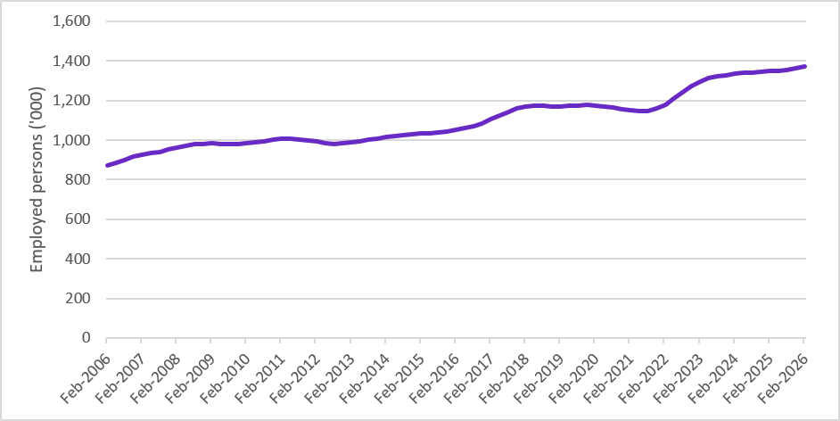
Source: ABS, Labour Force, Australia, Detailed (Table EQ06), February 2026, Jobs and Skills Australia (JSA) Trend
Building Installation Services is the largest employing group (ANZSIC 3-digit) within the industry, employing 342,900 people. Other large employing groups are Building Completion Services (216,000), Residential Building Construction (166,100) and Other Construction Services (139,100).
- The Non-Residential Building Construction group recorded the strongest rate of growth over the past one and five years, up by 6.7% and 30.0% respectively, well above the industry and national averages. Growth in this group has likely been driven by large scale infrastructure projects.

Table 2: Employment growth Construction Industry, February 2026
Industry classification (ANZSIC) level | Industry name | Employment – Feb-2026 ('000) | 1-year change (to Feb-2026) |  | 5-year change (to Feb-2026)
Industry classification (ANZSIC) level | Industry name | Employment – Feb-2026 ('000) | ('000) | (%) | ('000) | (%)
1 | Construction | 1,371.5 | 22.0 | 1.6 | 219.7 | 19.1
2 | Building Construction | 382.4 | 8.3 | 2.2 | 60.6 | 18.8
3 | Residential Building Construction | 166.1 | 2.4 | 1.5 | 18.8 | 12.8
3 | Non-Residential Building Construction | 80.0 | 5.0 | 6.7 | 18.4 | 30.0
2 | Heavy and Civil Engineering Construction | 128.4 | 0.6 | 0.5 | 9.7 | 8.2
3 | Heavy and Civil Engineering Construction | 128.4 | 0.6 | 0.5 | 9.7 | 8.2
2 | Construction Services | 865.4 | 16.2 | 1.9 | 155.0 | 21.8
3 | Land Development and Site Preparation Services | 58.0 | 0.8 | 1.5 | 3.8 | 7.1
3 | Building Structure Services | 108.9 | 3.5 | 3.3 | 12.7 | 13.2
3 | Building Installation Services | 324.9 | 9.2 | 2.9 | 52.5 | 19.3
3 | Building Completion Services | 216.0 | 1.1 | 0.5 | * | 0.0
3 | Other Construction Services | 139.1 | 3.5 | 2.6 | 17.5 | 14.3
- | Total employment (all industries) | 14,766.3 | 223.7 | 1.5 | 1,903.5 | 14.8
Sources:
Construction (ANZSIC 1-3): ABS, Labour Force, Australia, Detailed (Table EQ06), February 2026, Jobs and Skills Australia (JSA) Trend
Total employment (all industries): ABS, Labour Force, Australia, Detailed (Table 04), February 2026, ABS Trend
* Data not available due to suppression of COVID-19 era (May 2020 to November 2021) estimates.
Note: the sum of the constituent subdivisions and groups (ANZSIC 2- and 3-digit classifications) will not equal the Construction total (ANZSIC 1-digit classification) due to each ANZSIC classification being trended separately, and the exclusion of nfd (not further defined) classifications.

Jobs in Construction
ABS Labour Account data showed there were 1,352,800 filled jobs in Construction in June 2026 (latest data), representing 8.3% of all filled jobs nationally. This figure includes both main and secondary jobs held by individuals, with secondary jobs accounting for 2.8% of jobs in the industry.

State/territory employment
In February 2026 (latest data), ABS Labour Force Survey showed the distribution of state and territory employment broadly reflects population size: New South Wales (31.3%), Victoria (25.2%) and Queensland (21.0%) together account for over three quarters of Construction employment.
- The rate of employment growth in Western Australia has been considerably higher than all other jurisdictions over the past one and five years, up by 5.9% and 27.8% respectively. This reflects the highest rate of population growth among all states and territories, large‑scale mining and infrastructure projects, state government investment, and housing demand.
Table 3: Employment growth in Construction, by State/Territory February 2026
State/territory | Employment – Feb-2026 ('000) | 1-year change (to Feb-2026) |  | 5-year change (to Feb-2026)
State/territory | Employment – Feb-2026 ('000) | ('000) | (%) | ('000) | (%)
New South Wales | 431.9 | 11.5 | 2.7 | 60.6 | 16.3
Victoria | 347.3 | -1.3 | -0.4 | 28.7 | 9.0
Queensland | 289.5 | 6.2 | 2.2 | 47.1 | 19.4
Western Australia | 168.0 | 9.3 | 5.9 | 36.5 | 27.8
South Australia | 86.1 | 2.2 | 2.6 | 12.4 | 16.9
Tasmania | 26.0 | 0.7 | 2.7 | 3.7 | 16.5
Australian Capital Territory | 18.3 | 0.4 | 2.5 | 1.2 | 6.8
Northern Territory | 12.0 | 0.5 | 4.5 | 1.5 | 14.1
Source: ABS, Labour Force, Australia, Detailed (Table EQ06), February 2026, Jobs and Skills Australia (JSA) Trend

Top employing occupations
The Construction industry is dominated by trade and technical occupations. According to ABS Labour Force Survey data, Carpenters and Joiners, Electricians, Construction Managers and Plumbers are the largest employing occupations, together accounting for over a third of Construction employment.
- All top 10 employing occupations, except Gardeners (40.4%), have a majority of their workforce concentrated in the Construction industry.
- The top 10 employing occupations within the Construction industry offer job opportunities for workers across all skill levels: from highly skilled Construction Managers, multiple trade-qualified occupations, through to lower skilled occupations such as Concreters and Building and Plumbing Labourers.
- The occupational profile of male and female workers differs markedly. Male employment is concentrated in trades and onsite occupations, such as Carpenters and Joiners, Electricians and Plumbers, while female employment is more commonly found in administrative, finance and office support roles, including Office Managers, General Clerks, Accounting Clerks and Bookkeepers.

Table 4: Top 10 employing occupations in the Construction industry, 2025
Occupation (ANZSCO unit group (4-digit)) | Skill level | Employed in Construction 2025 (‘000) | Share of occupation employed in Construction (%)
Carpenters and Joiners | 3 | 135.2 | 89.6
Electricians | 3 | 131.7 | 67.3
Construction Managers | 1 | 101.1 | 78.7
Plumbers | 3 | 98.2 | 90.4
Building and Plumbing Labourers | 5 | 55.4 | 79.5
Architectural, Building and Surveying Technicians | 2 | 46.6 | 59.2
Painting Trades Workers | 3 | 43.3 | 97.4
Concreters | 5 | 38.9 | 92.0
Gardeners | 3 | 34.8 | 40.4
Earthmoving Plant Operators | 4 | 32.9 | 66.7
Source: ABS, Labour Force Survey, 2025, four-quarter average data, customised report.
Skill Level 1 is commensurate with a Bachelor degree or higher qualification; Skill Level 2 is commensurate with an Advanced Diploma or Diploma; Skill Level 3 is commensurate with a Certificate IV or III (including at least 2 years’ on-the-job training); Skill Level 4 is commensurate with a Certificate II or III; Skill Level 5 is commensurate with a Certificate I or secondary education. Note: While Skill levels are described using formal education levels, some people use a combination of informal learning, on-the-job-training and personal experience to achieve an equivalent level.

Job vacancies, recruitment and shortages
According to the ABS Job Vacancies Survey, there were 19,900 job vacancies in the Construction industry in May 2026, down 2,400 (-10.8%) from May 2025.
The JSA Internet Vacancy Index (IVI), a count of online job advertisements by occupation, showed over 15,800 online job advertisements for the top 10 employing construction occupations in July 2026.
- Online job advertisements for 6 of the 10 occupations recorded annual growth rates well above the national average (which showed a decline of 2.0%) in July 2026, with strong demand for Electricians (up by 16.0%), Earthmoving Plant Operators (up by 11.6%), Architectural, Building and Surveying Technicians (up by 9.6%) and Construction Managers (up by 8.9%).
The latest JSA Recruitment Experiences and Outlook Survey (REOS) data illustrate current recruitment experiences and future intentions of Construction employers.
- Almost half of Construction employers (47%) are either currently recruiting or have recruited in the previous month, slightly lower than the national average (48%).
- Half of Construction employers experienced difficulty hiring staff over the previous quarter (50%), which is above the national average of 44%. Looking ahead, 20% of employers expect to increase their staff over the next three months.
The JSA 2025 Occupation Shortage List (OSL) shows several key trade occupations, including Carpenters, Electricians, and Plumbers are in national shortage, with retention, suitability and long training gaps being the predominant shortage drivers. Ongoing shortages in these key trades reflect both strong demand and the time required to train new entrants through the VET system.
- Five of the top 10 employing occupations experienced shortages across all jurisdictions in 2025, indicating widespread recruitment difficulties for key trades and technical roles within the Construction industry. Note that two of the top employing occupations are out of scope of the OSL as they are skill level 5.
Table 5: Online job vacancies and shortage status, selected occupations
Occupation (ANZSCO unit group (4-digit)) | Online job advertisements |  | Occupation shortages
Occupation (ANZSCO unit group (4-digit)) | Job ads in July-2026 | 1-year change to July-2026 (%) | Shortage status – 2025 | Shortage jurisdictions | Shortage driver
Carpenters and Joiners | 1011 | -4.8 | Shortage | All | Retention gap
Electricians | 3337 | 16.0 | Shortage | All | Suitability gap
Construction Managers | 3938 | 8.9 | Shortage | Tasmania | Suitability gap
Plumbers | 1449 | 3.1 | Shortage | All | Long training gap
Building and Plumbing Labourers | 928 | 8.5 | N/A | N/A | N/A
Architectural, Building and Surveying Technicians | 2244 | 9.6 | No shortage | Northern Territory | –
Painting Trades Workers | 543 | -8.5 | Shortage | All | Retention gap
Concreters | 163 | -0.2 | N/A | N/A | N/A
Gardeners | 866 | -2.1 | No shortage | – | –
Earthmoving Plant Operators | 1342 | 11.6 | Shortage | All | Uncertain
Sources:
Online job advertisements: JSA Internet Vacancy Index (IVI), July 2026, three-month average data.
Occupation shortages: JSA Occupation Shortage List (OSL), 2025.
N/A depicts data not available

Employment Projections
Employment in the Construction industry is projected to continue growing over the next decade, albeit at a slower pace than the strong gains recorded in recent years. According to JSA’s latest 2025 Employment Projections, Construction employment, where projected demand is likely to be met by available supply, is projected to increase by 93,500 (6.9%) over the five years to May 2030, and by 160,900 (11.9%) over the 10 years to May 2035. Projected growth is expected to be driven by ongoing demand for new housing, infrastructure investment, and population growth, building on the industry’s strong performance over the past 20-years.
- All Construction industry groups are projected to grow over the next five years to May 2030, and 10 years to May 2035.
- Growth in the Residential Building Construction group is projected to record the strongest growth across both periods, supported by ongoing demand for new housing and policy initiatives aimed at increasing housing supply, including the National Housing Accord target of 1.2 million new homes.
- The Building Installation Services group is projected to grow at a rate on par with total Construction employment, while all other groups are projected to increase at a slower rate.
Table 6: Industry Employment Projections to May 2030 and May 2035
Industry classification (ANZSIC) level | Industry name | 5-year change (to May 2030) |  | 10-year change (to May 2035)
Industry classification (ANZSIC) level | Industry name | ('000) | (%) | ('000) | (%)
1 | Construction | 93.5 | 6.9 | 160.9 | 11.9
2 | Building Construction | 50.3 | 13.2 | 71.1 | 18.7
3 | Residential Building Construction | 36.3 | 22.9 | 44.9 | 28.2
3 | Non-Residential Building Construction | 0.6 | 0.9 | 5.0 | 6.8
2 | Heavy and Civil Engineering Construction | 0.5 | 0.4 | 7.1 | 5.9
3 | Heavy and Civil Engineering Construction | 0.5 | 0.4 | 7.1 | 5.9
2 | Construction Services | 42.5 | 5.0 | 82.3 | 9.8
3 | Land Development and Site Preparation Services | 2.7 | 4.8 | 5.1 | 9.3
3 | Building Structure Services | 3.5 | 3.6 | 7.7 | 7.8
3 | Building Installation Services | 21.5 | 6.7 | 38.6 | 12.0
3 | Building Completion Services | 7.3 | 3.3 | 16.8 | 7.6
3 | Other Construction Services | 6.1 | 4.7 | 11.8 | 9.1
- | Total employment (all industries) | 961.0 | 6.5 | 1,954.5 | 13.3
Source: Employment projections (May 2025 to May 2030 and May 2035) produced by Victoria University for Jobs and Skills Australia (JSA).

Occupations
All the top employing occupations in Construction are projected to grow over the next decade, reflecting the industry’s ongoing expansion and the continued need for skilled trades and technical roles.
- Construction Managers are projected to see the largest increase, with employment rising by 19,100 (14.9%) over five years and 28,400 (22.2%) over 10 years, reflecting strong current vacancy demand.
- Strong growth is also expected for Electricians (up by 13,000 or 6.7% over five years) and Carpenters and Joiners (up 9,600 or 6.4%), which is consistent with ongoing shortages and high vacancy rates.

Table 7: Occupation Employment Projections (selected occupations) to May 2030 and May 2035
Occupation (ANZSCO unit group (4-digit)) | 5-year change (to May 2030) |  | 10-year change (to May 2035)
Occupation (ANZSCO unit group (4-digit)) | ('000) | (%) | ('000) | (%)
Carpenters and Joiners | 9.6 | 6.4 | 16.3 | 10.9
Electricians | 13.0 | 6.7 | 23.4 | 12.0
Construction Managers | 19.1 | 14.9 | 28.4 | 22.2
Plumbers | 5.4 | 5.2 | 10.6 | 10.2
Building and Plumbing Labourers | 2.2 | 3.0 | 4.7 | 6.4
Architectural, Building and Surveying Technicians | 7.0 | 8.3 | 11.9 | 14.2
Painting Trades Workers | 2.0 | 3.6 | 4.2 | 7.9
Concreters | 0.9 | 2.3 | 2.1 | 5.7
Gardeners | 3.6 | 4.2 | 7.7 | 8.8
Earthmoving Plant Operators | 0.6 | 1.2 | 2.1 | 4.3
Source: Employment projections (May 2025 to May 2030 and May 2035) produced by Victoria University for Jobs and Skills Australia (JSA).
JSA commissioned Victoria University (VU) to produce employment projections to May 2030 and May 2035, using the Victoria University Employment Forecasting (VUEF) model. The employment projections have been calibrated to the macroeconomic and labour market outlook provided by the Australian Treasury.

Employment characteristics
The latest ABS Characteristics of Employment data show the Construction workforce has a substantially different employment structure to the broader labour market. Employees account for around two-thirds (68%) of workers, compared with 85% across total employment. In contrast, Construction has a much higher share of independent contractors (21% compared with 8%) and other business operators (11% compared with 7%) than across total employment. This reflects the industry's reliance on small businesses, subcontracting arrangements and self-employment.
- Construction industry employment is dominated by males working full-time hours. All Construction groups, except Other Construction Services (76.3% full-time share), have a concentration of male and full-time shares above 80%.
- In February 2026, 19.2% of employees in the Construction industry were casual employees (did not have paid leave entitlements), below the national average of 21.0%. Rates vary across the industry, ranging from 10.4% in Non-residential Building Construction to 28.3% in Other Construction Services.

Chart 2: Form of employment, Construction and total employment, August 2025
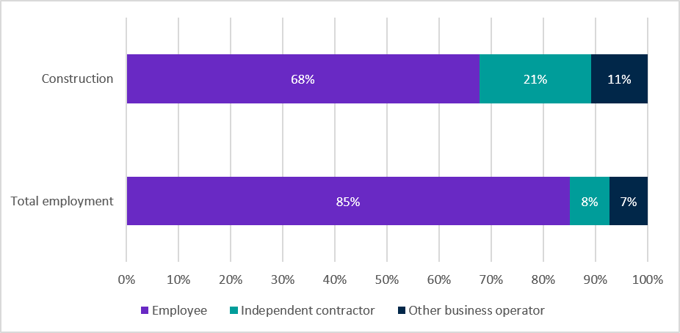
Sources: ABS, Characteristics of Employment, Australia, August 2025 (TableBuilder extract).
Note: Totals may not sum to 100% due to rounding and perturbation.

Demographics
The Construction workforce has a distinct demographic profile compared with total employment, characterised by a younger age profile, a high concentration of male workers, and lower rates of disability. Indigenous representation is broadly in line with the national workforce.
- Construction remains one of Australia's most male-dominated industries, with males accounting for 87.1% of employment, compared with 51.9% across total employment. The top employing Construction occupations are predominantly trade and technical roles and are heavily male dominated, with men accounting for more than 90% of employment in each occupation.
- The median age of workers in Construction is 37 years, which is slightly younger than total employment (39 years).
  - The youngest cohort of workers, with a median age of 34, is concentrated in the largest employing industry group: Building Installation Services.
- At the time of the 2021 census, Indigenous workers comprised 2.4% of the Construction industry, broadly in line with total employment (2.2%). At the industry group level, the highest share of Indigenous workers was employed in Building Structure Services, accounting for 3.6% of employment.
- In 2022, 8.5% of Construction workers aged 15-64 had a disability compared with 11.6% for total employment.

Table 8: Industry demographics
Industry classification (ANZSIC) level | Industry name | Male share (%) | Median age (years) | Indigenous share  (%)
1 | Construction | 87.1 | 37 | 2.4
2 | Building Construction | 84.3 | 39 | 1.8
3 | Residential Building Construction | 86.7 | 39 | 1.7
3 | Non-Residential Building Construction | 85.1 | 39 | 1.9
2 | Heavy and Civil Engineering Construction | 83.6 | 40 | 3.3
3 | Heavy and Civil Engineering Construction | 83.6 | 40 | 3.3
2 | Construction Services | 88.8 | 36 | 2.5
3 | Land Development and Site Preparation Services | 85.6 | 41 | 3.0
3 | Building Structure Services | 89.6 | 37 | 3.6
3 | Building Installation Services | 89.1 | 34 | 2.0
3 | Building Completion Services | 89.2 | 36 | 2.4
3 | Other Construction Services | 89.3 | 40 | 2.8
- | Total employment (all industries) | 51.9 | 39 | 2.2
Sources:
Male share & Median age: ABS, Labour Force Survey, 2025, four-quarter average data, customised report.
Indigenous share: ABS, 2021 Census of Population and Housing based on place of usual residence (TableBuilder extract).

Earnings and hours
ABS Employee Earnings and Hours data show that median weekly full-time earnings for Construction workers ($2,019) were considerably higher than total employment ($1,852) in May 2025. The industry has a high concentration of Certificate III/IV-qualified workers, and the higher-than-average earnings reflect the strong labour market value of trade and technical qualifications within the Construction industry and the nature of the work in the industry.
- Males earn 27.9% more than their female counterparts: $2,065 compared with $1,614 in May 2025, and the difference has improved considerably from 2018 where male earnings were 48.5% higher than female earnings. The difference in 2025 was higher than for total employment (13.7%).
- Workers in Construction work 1.5 hours more per week than the national average: 40.6 hours compared with 39.1 hours respectively.
  - Males work 8.3% more hours per week than females (40.9 hours compared with 37.7 for females).
- Differences in hours worked and occupational composition may partially explain the gender earnings gap within the Construction industry, with female workers more concentrated in administrative and business support roles and male workers in trade and technical occupations.
Chart 3: Nominal median weekly earnings, Construction and all industries, selected years
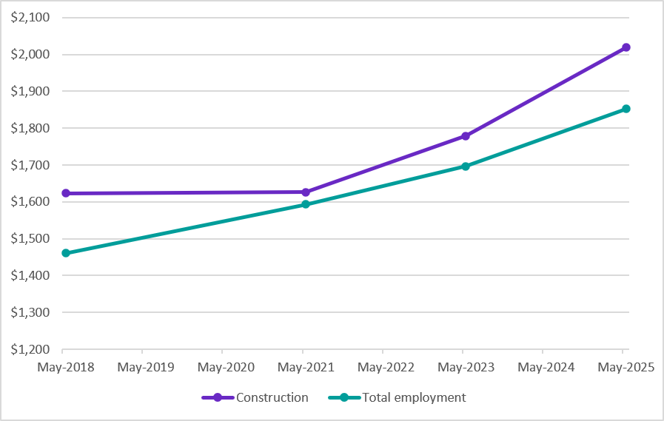
Source: ABS, Employee Earnings and Hours (EEH), Australia, May 2025 (TableBuilder extract).
Note: This is the median pay for full–time non–managerial employees paid at the adult rate before tax and salary sacrificed amounts. The full–time non–managerial employees paid at the adult rate population has been used because it excludes people paid unusually high or low amounts (for example managers, part–time employees and youths). These figures are a guide only and should not be used to determine a wage rate as they do not consider years of experience or other factors may influence a person’s wage. Total employment earnings exclude the Agriculture, Forestry and Fishing industry.
Data are from selected EEH reference years only. The series has a break between 2018 and 2021 due to the absence of a 2020 release. Changes over time should be interpreted with caution and are not adjusted for inflation.

Occupations
Occupation earnings broadly align with their corresponding skill levels.
- Construction Managers ($3,751), the highest skilled occupation, earn significantly more than other top employing Construction occupations.
- There is considerable earnings variance among the trades, for instance, the median earnings for Electricians is $2,191, Plumbers ($1,990) and Painting Trades Workers ($1,379).
Table 9: Occupation median weekly full-time earnings, May 2025
Occupation | Skill level | Median weekly full-time earnings | Male share of occupation (%)
Carpenters and Joiners | 3 | $1,760 | 97.9
Electricians | 3 | $2,191 | 98.1
Construction Managers | 1 | $3,751 | 90.9
Plumbers | 3 | $1,990 | 97.4
Building and Plumbing Labourers | 5 | $1,827 | 95.1
Architectural, Building and Surveying Technicians | 2 | $2,280 | 90.1
Painting Trades Workers | 3 | $1,379 | 92.4
Concreters | 5 | $2,209 | 97.7
Gardeners | 3 | $1,291 | 93.0
Earthmoving Plant Operators | 4 | $1,900 | 96.6
Sources:
Median weekly full-time earnings: ABS Survey of Employee Earnings and Hours, May 2025, customised report.
Male share of occupation: ABS, Labour Force Survey, 2025, four-quarter average data, customised report.
Note: Earnings data is the median pay for full–time non–managerial employees paid at the adult rate before tax and salary sacrificed amounts. The full–time non–managerial employees paid at the adult rate population has been used because it excludes people paid unusually high or low amounts (for example managers, part–time employees and youths). These figures are a guide only and should not be used to determine a wage rate as they do not consider years of experience or other factors may influence a person’s wage.

Educational attainment
The Construction industry has a high concentration of trade-qualified workers compared with the wider economy, which is indicative of trade and labour related roles.
- Over one third (35.9%) of all construction workers hold a Certificate III/IV as their highest level of educational attainment, more than double the national average (16.6%), reflecting the prevalence of trade qualified workers in the industry.
- A further 16.3% hold a Bachelor degree or higher qualification, compared with 38.8% of total employment.
- Architecture and Building is the most common field of study of highest qualification among Construction workers (28.0%), followed by Engineering and Related Technologies (19.4%), reflecting the industry's strong concentration of trade, technical and construction-related occupations.
- Educational attainment differs markedly by gender. Male workers are much more likely to hold a Certificate III/IV qualification (39.4% compared with 13.5% for females), reflecting the industry's concentration of male dominated trade occupations. In contrast, females are more likely to hold a Bachelor degree or higher qualification (30.8% compared with 13.9% for males).
- Field of study patterns also differ substantially by gender. Male workers are concentrated in Architecture and Building (30.9%) and Engineering and Related Technologies (21.4%), while female workers are more likely to hold qualifications in Management and Commerce (24.0%) and Society and Culture (9.3%). These differences align with the industry's occupational profile, where men are more commonly employed in trade and technical occupations and women in administrative, business support and professional roles.
Chart 4: Level of highest educational attainment of those employed in Construction, August 2025
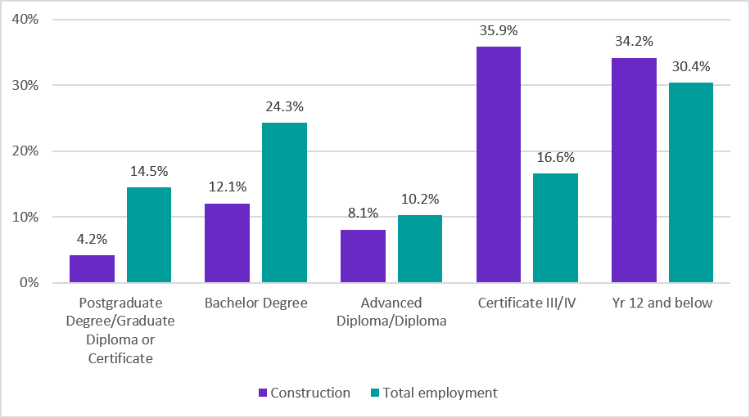
Source: ABS, Characteristics of Employment, August 2025 (TableBuilder extract).
Note: Percentages may not sum to 100% because the ‘Level not determined’ category is not displayed but remains included in the denominator. Differences may also arise due to perturbation and rounding.

Apprentices and trainees
Apprenticeships and traineeships are the primary entry pathway into construction-dominant trade occupations, such as Carpenters and Joiners, Electricians, Plumbers and Painting Trades Workers (four of the top employing occupations). The dot points and charts below show apprentice and trainee commencements, completions and in-training cohorts for these occupations across all industries, reflecting the pipeline of workers entering these trades.
- The size of apprentice and trainee pipelines across all industries broadly reflects employment patterns within the Construction industry. Electricians and Carpenters and Joiners recorded the highest numbers of apprentices, while Painting Trades Workers had a comparatively small training pipeline.
- Electricians had the largest in-training cohort in 2025, averaging around 44,400 apprentices and trainees over the year, followed by Carpenters and Joiners (31,200) and Plumbers (21,900).
- Across these occupations, commencements have a cyclical pattern with larger cohorts commencing in the first quarter of the year, whereas completions generally occur more consistently across the year.

Chart 5: Apprentice commencements, completions and in-training, Electricians, 2021-2025
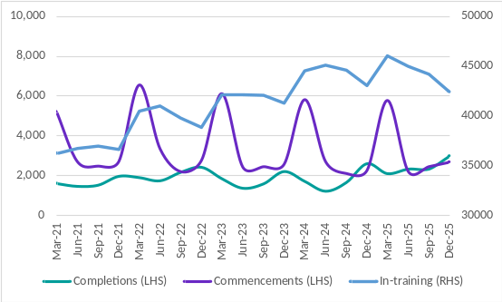
Source: NCVER 2026, Apprentices and trainees 2025 - December quarter (DataBuilder extract)
Chart 7: Apprentice commencements, completions and in-training, Carpenters and Joiners, 2021-2025
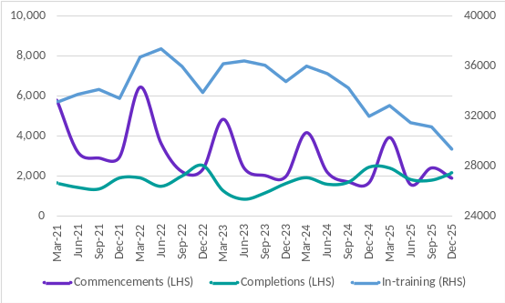
Source: NCVER 2026, Apprentices and trainees 2025 - December quarter (DataBuilder extract)
Chart 6: Apprentice, commencements, completions and in-training, Plumbers, 2021-2025
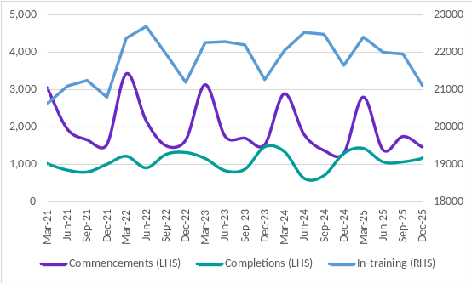
Source: NCVER 2026, Apprentices and trainees 2025 - December quarter (DataBuilder extract)
Chart 8: Apprentice commencements, completions and in-training, Painting Trades Workers, 2021-2025
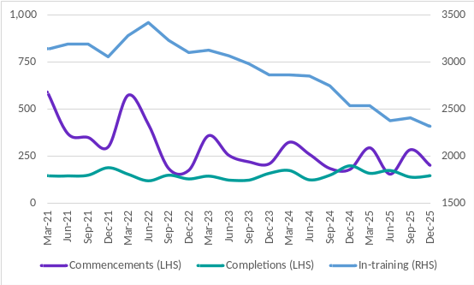
Source: NCVER 2026, Apprentices and trainees 2025 - December quarter (DataBuilder extract)

Electricians have the highest 6-year apprentice completion rate of the top 10 trade occupations (by enrolment size), 71.7% for the 2019 commencing cohort. Carpenters and Joiners (63.7%) and Plumbers (62.0%) also had completion rates higher than for all occupations (56.5%).
While some apprentices don’t complete their training, data from JSA’s VET National Data Asset on partial completions shows positive outcomes from undertaking some training. For example, for people who started, but did not complete, a Certificate III in Plumbing there was a 13 percentage point increase in the proportion employed from before training to after training, and those who started, but did not complete, a Certificate III in Carpentry saw a 12 percentage point increase in the proportion employed.

Businesses
ABS Counts of Businesses data show that Construction had 478,651 businesses operating at the end of 2025-26, up from 463,048 in 2024-25. Entry rates (17.9%) exceeded exit rates (14.6%), resulting in continued growth in Construction businesses. Construction accounted for around 17% of all Australian businesses in 2025-26, the highest share of all industries. Construction has a high proportion of micro and small business (with fewer than 20 employees), 38.4% as of end of 2024-25, with a further 60.2% of businesses being non-employing businesses.
Chart 9: Counts of Construction businesses, June 2022 to June 2026
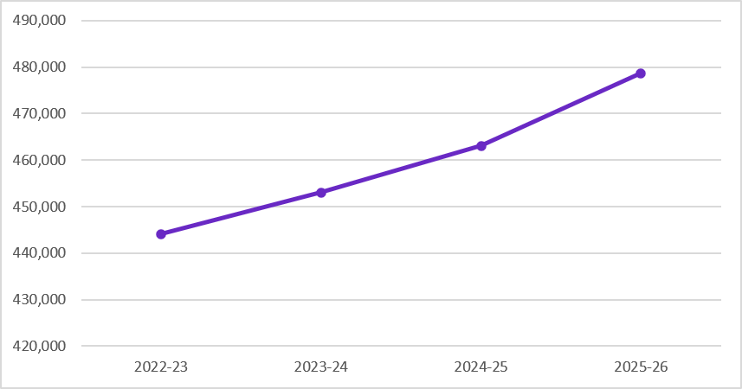
Source: ABS, Counts of Australian Businesses, including Entries and Exits (CABEE), June 2022 to June 2026.

Gross value added and productivity
Beyond its importance as a major employer, the Construction industry is also a significant contributor to Australia's economy, generating $189.2 billion in gross value added (GVA) in 2024-25 and accounting for 7.6% of total Australian GVA. Over the past 20 years, output has grown steadily, supported by population growth, residential building activity and infrastructure investment, broadly in line with employment growth.
- Construction's share of national GVA remains below its 2014 peak, indicating the industry has grown more slowly than the broader economy in recent years.
- Labour productivity has shown limited long-term improvement and declined in 2024-25, as labour and capital inputs increased while output remained relatively flat.

Chart 10: Gross value added (GVA) by the Construction industry, June 2005 to June 2025
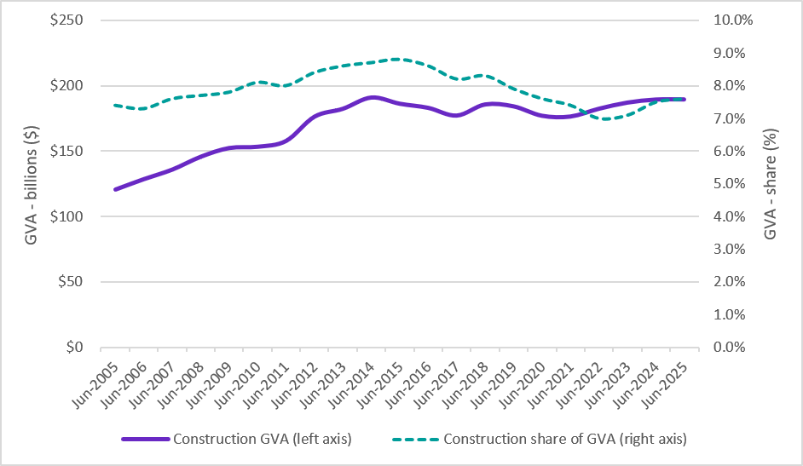
Source: ABS, National Accounts, 2024-25 financial year
Note: Gross value added (GVA) is measured in chain volume terms (real dollars), which removes the effect of price changes over time.

Conclusion
Construction is a major source of employment and economic activity in Australia. The industry has grown strongly over the longer term, supported by demand for housing and infrastructure, and employment is expected to continue growing over the next decade. Its workforce is concentrated in trade and technical occupations, supported by apprenticeship pathways and relatively high earnings. The industry also has a distinctive structure, with a high proportion of small businesses, independent contractors and subcontracting arrangements.
However, the outlook also presents challenges. Employment growth has slowed, employers continue to report difficulty finding suitable workers, and shortages remain widespread in key trades. Maintaining apprenticeship commencements and improving completion outcomes will be critical to supporting the supply of skilled workers in key trades.

Source: Safe Work Australia, Key Work Health and Safety Statistics Australia, 2025. Note: Data for 2023-24 are preliminary and subject to revision in future years as further claims are finalised.
ABS, Labour Force, Australia, Detailed (Table EQ06), February 2026, Jobs and Skills Australia (JSA) Trend
National average: ABS, Labour Force, Australia, Detailed (Table 04), February 2026, ABS Trend
ABS, Labour Account Australia, June 2026, ABS Trend
ABS, Estimated Resident Population (ERP), December 2025
ABS, Job Vacancies, Australia, May 2026, original data
ABS Job Vacancies and the JSA Internet Vacancy Index (IVI) are not directly comparable, as they differ in methodology and coverage. ABS data are survey-based and quarterly, while the IVI is a monthly count of online job advertisements.
JSA, Recruitment Experiences and Outlook Survey (REOS), quarterly, June 2026
ABS, Labour Force Survey, 2025, four-quarter average data, customised report.
ABS, Labour Force Australia, Detailed, February 2026, EQ05. Casual employees are those who did not have paid leave entitlements in their main job. It is not directly comparable with the full-time employment share, which is based on hours usually worked and covers all employed people.
ABS, Characteristics of Employment, Australia, August 2025 (TableBuilder extract).
ABS, Survey of Disability, Ageing and Carers (SDAC), 2022 (TableBuilder extract).
Employee Earnings and Hours data do not cover the Agriculture, Forestry and Fishing industry. Consequently, total employment estimates exclude this industry.
ABS, Labour Force, Australia, Detailed (Table EQ06), February 2026, Four-Quarter Average.
Sources: Industry earnings, ABS, Employee Earnings and Hours, May 2025 (TableBuilder extract); Occupation earnings, ABS, Employee Earnings and Hours, May 2025, customised dataset. Comparisons should be interpreted with caution, as many workers in these occupations are employed outside the Construction industry.
Source: ABS, Characteristics of Employment, August 2025 (TableBuilder extract). Percentages include persons whose highest level of educational attainment was ‘Level not determined’ in the denominator.
Source: ABS, Education and Work, 2025 (TableBuilder extract). Percentages include ‘Not Applicable’ and ‘Field Information Inadequate’ responses in the denominator.
Source: NCVER, Apprentice and Trainee Completion Rates, 2025. As trade apprenticeships can take up to six (or more) years to complete, the most recent commencing cohort for which a 6-year completion rate can be reported is the 2019 cohort.
Source: Person Level Integrated Data Asset (PLIDA), 2002 – 2023, VET National Data Asset, ABS DataLab. Partial completers are domestic, non-school students, who partially completed a nationally recognised VET qualification with enrolment records between 2015-16 to 2018-19 and an absence of a completion record.
Source: ABS, Counts of Australian Businesses, including Entries and Exits (CABEE), June 2021 to June 2025.
ABS Estimates of Industry Multifactor Productivity, Australia (Labour productivity index, Construction industry).

