



Pathways to Success:
  - Jobs and Skills Report 2026
October 2026




All content is provided under a Creative Commons Attribution 4.0 International Licence with the exception of:
- content supplied by third parties
- the Commonwealth Coat of Arms
- material protected by a trade mark
- any images and/or photographs.
Details of the Creative Commons BY 4.0 licence are available on the Creative Commons website.
Use of all or part of any material presented in this document must include the following attribution:
© Commonwealth of Australia
Terms under which the Commonwealth Coat of Arms can be used are set out on the Department of the Prime Minister and Cabinet website.
Attribution
When reproducing or sharing material from this document, you must not alter the meaning or context of the content, or misrepresent it as your own work. Appropriate attribution to the Commonwealth of Australia must be included.
Other use
If you wish to use material from this document in a way that is beyond the scope of the licence or terms that apply to it, you must seek authorisation. You may infringe copyright if you use material from this document in a way that is not permitted by the licence or otherwise allowed under the Copyright Act 1968 (Cth).
Please email copyright@dewr.gov.au or address requests and enquiries to:
The Copyright Officer
Department of Employment and Workplace Relations
GPO Box 9828 Canberra ACT 2601.


Acknowledgement of Country
Jobs and Skills Australia acknowledges the Traditional Owners of Country throughout Australia and recognises the continuing connection to lands, waters and communities. We pay our respects to Aboriginal and Torres Strait Islander cultures, and to Elders past, present and emerging.
The background image is an aerial view of the country of the Peerapper people, showing the tidal channels of Robbins Passage near Smithton, TAS.

Contents
Chapter 1 Cross-cutting forces shaping Australia’s labour market 5
1.1 Demographic change is shifting employment towards care, services and longer working lives 7
1.1.1 Australia’s ageing population is driving growth in health and care jobs 7
1.1.2 Longer working lives will increase the need for lifelong skill adaptation 8
1.2 AI, geopolitics, and net zero ambitions are changing work in Australia 9
1.2.1 AI use is becoming mainstream among working-age Australians 9
1.2.2 AI adoption in the workplace is uneven across industries and regions 10
1.2.3 Global supply chain pressures are raising business costs and influencing workforce decisions 13
1.2.4 The net zero transition will require new workforce capability, not just additional capacity 15
1.3 Labour market opportunities are uneven 15
1.3.1 Multiple job holdings have increased over the last decade 16
1.3.2 Technology and demographic changes are shaping a labour market that is balanced between knowledge, practical and human-centred work 17
1.3.3 Regional labour markets remain uneven, despite signs of resilience outside major cities 18
Chapter 2 Workforce demand – creating attractive, productive jobs 22
2.1 Policy-driven investment is concentrating future workforce demand in sectors already under pressure 24
2.1.1 Australia’s employment growth will be concentrated in skilled and qualified work—led by care, professional and trade occupations 24
2.1.2 Many of tomorrow’s critical occupations are already experiencing shortages today 29
2.1.3 The alternative projections scenario demonstrates these pressures 30
2.1.4 Increased investment in housing, clean energy, healthcare and technology will increase demand for skilled workers 30
2.2 Meeting future labour demand requires consideration of job design, not just more workers 31
2.2.1 Future jobs will increasingly rely on problem-solving, judgement and adaptability 32
2.2.2 Workers are choosing jobs based on quality, progression and working conditions 33
2.2.3 Retention will become as important as recruitment in high-demand sectors 34
2.3 Inclusive job design can unlock underutilised workforce capability 35
2.3.1 Better job design can support stronger employment outcomes for First Nations Australians 35
2.3.2 People with disability represent an underutilised source of workforce capability 36
Chapter 3 Skills supply – building and using workforce capability 39
3.1 Australia’s skills pipeline 41
3.1.1 A large cohort of school leavers is flowing through with a plateau on the horizon 41
3.1.2 School leavers have a strong preference for higher education pathways 42
3.1.3 There is unmet demand for tertiary education with time and cost the biggest barriers to participation 43
3.2 The tertiary system is producing positive outcomes for learners and employers, but utilisation of the skills formed remains uneven 45
3.2.1 Higher education delivers strong employment outcomes. However, graduate earnings still lag behind inflation 45
3.2.2 Higher education supports entry into high skilled work, but recent graduates may not be fully utilising their skills 47
3.2.3 VET improves employment and earning outcomes, particularly for cohorts who have been historically disadvantaged 48
3.2.4 VET can be a pillar for lifelong learning, but available outcome measures reveal less about how acquired skills are used for older learners 49
3.2.5 Temporary skilled migration is helping to address labour market shortages 51
3.3 VET system responsiveness depends on coordinated action, teaching capacity and adaptable qualifications 53
3.3.1 The National Skills Agreement implements an ambitious model of shared stewardship and action 53
3.3.2 A constrained VET workforce may limit the system’s ability to expand supply in priority occupations 55
3.3.3 Progressing VET Qualification reform will support better labour market outcomes 57
Chapter 4 Skills pathways and enablers 58
4.1 Meeting future workforce needs will require diverse skills pathways 60
4.1.1 Higher education is a valuable pathway to high skilled work; however, adaptability will become more important in the face of AI 60
4.1.2 Apprenticeships remain critical to meeting growing demand in construction and electrotechnology occupations across multiple industry sectors 61
4.1.3 Female participation in apprenticeship pathways is rising, but retention remains critical to expanding the construction and electrical workforce 63
4.2 Strong pathways support successful transitions and workforce outcomes 64
4.2.1 Completion matters and part completion can also provide benefit 64
4.2.2 Pathways between higher education and VET can enable learning and skill development at all stages of life 66
4.3 Effective skills pathways expand opportunities and strengthen workforce participation 67
4.3.1 Adult and community education plays an important role in enabling further learning, employment and community participation 68
4.3.2 VET creates pathways for lifelong learning and skill progression, particularly for learners facing barriers to workforce participation 68
4.3.3 Pathways are not only about ‘what’ and ‘when’, it’s also a matter of ‘where’ – study options close to home may be important for skilling regional workers 69
Chapter 5 Careers and capability deepening – building skills, expertise and economic agency 72
5.1 Career mobility is becoming more important as work and skill needs change 74
5.1.1 Workers are becoming less mobile, but for those who move, the shifts depend on the stages of working life 74
5.1.2 Occupation mobility reflects the economic structure and workforce needs of regions 77
5.2 Lifelong learning enables workers to deepen capability across longer careers 78
5.2.1 Work-related training is essential for capability deepening, but participation and time spent have stagnated or declined 78
5.3 A skills-first approach to recognising capabilities supports mobility and lifelong learning 80
5.3.1 A stronger credit transfer system can reduce duplication and make reskilling easier 81
5.3.2 Recognition of prior learning and experience can make existing capability more visible 82
5.3.3 A National Skills Taxonomy can provide a common language for skills mobility 83
Chapter 6 Building an adaptive system for capability across working lives 87
6.1 Signals: Seeing change more clearly and earlier 88
6.2 Decision support: Understanding problems before choosing solutions 88
6.3 Coordination: Stewardship across a distributed system 89
6.4 Reform: Removing friction from learning, work and mobility 89
6.5 The pathway to success: adaptive capability across working lives 90

Tables
Table 1: National skills investment strengthens system capacity, but clear and measurable outcomes can help guide how the system should respond - Summary table of select measures, current performance and targets in the balanced score card for NSA outcomes framework 55
Table 2: VET workforce renewal is essential to expanding skills supply 56
Table 3: Qualification reform shifts responsibility from detailed prescription to purposeful design and provider capability 57
Table 4: Top 5 occupation pathways for Society and Culture graduates 5 years after completion, 2011-2022 including average Generative AI automation and augmentation exposure of occupation groups 61
Table 5: Top 5 occupation pathways for Management and Commerce graduates 5 years after completion, 2011-2022 including average Generative AI automation and augmentation exposure of occupation groups 61
Table 6: Students with prior higher education use VET to build new capabilities and support lifelong learning 67
Table 7: Occupation transitions differ across regions, reflecting local workforce demand 77
Table 8: Benefits of a National Credit Transfer System. Supporting career mobility through reducing duplication of learning 81
Table 9: A multi-directional credit transfer system can better support the recognition of learning and experience 83
Figures
Figure 1: The Health Care and Social Assistance industry contributed the largest share of long-term job growth over the last decade. 7
Figure 2: Older Australians are participating more in work, increasing the importance of flexible upskilling across working life 8
Figure 3: AI use is highest among prime working-age Australians 10
Figure 4: Large and metropolitan businesses are adopting AI at higher rates than smaller and regional businesses 11
Figure 5: The Services and Mining sectors are leading the way in AI adoption in Australia 12
Figure 6: Supply chain disruptions are increasing business costs and beginning to affect workforce decisions 13
Figure 7: Small and medium-sized businesses were more likely to report reducing their workforce compared to large businesses 14
Figure 8: Women working in health care and social assistance account for a large share of multiple job-holders 16
Figure 9: Women holding multiple jobs work fewer hours in their primary job compared to men 17
Figure 10: Beyond the care workforce, digital, education and skilled trades have also grown in line with population growth and technological advancement 18
Figure 11: Weak labour market conditions remain more common outside major cities with all remote areas in Australia showing weakness 19
Figure 12: Some regional labour markets are showing resilience despite broader geographic divergence 20
Figure 13: The industry structure of the Australian labour market is projected to remain unchanged over the next decade. 25
Figure 14: Professionals are projected to grow the fastest and remain the largest occupation major group over the next decade 26
Figure 15: In an 'unconstrained skill supply' scenario, the employment outlook deviates towards skill level 3 and 4 occupations and away from skill level 1 occupations compared to the baseline scenario. 28
Figure 16: Workforce shortages are concentrated in occupations that are critical to housing, infrastructure and healthcare 29
Figure 17: Beyond health care and social assistance, investments in technology, energy and housing will also be a key driver of job creation 31
Figure 18: Growing demand for critical thinking and problem-solving skills highlights the changing nature of the construction trades including apprentices 32
Figure 19: Demand for professional roles in construction and infrastructure is shifting towards jobs that combine technical expertise with leadership capability 33
Figure 20: Better job opportunities and working conditions are key drivers of workforce turnover 34
Figure 21: Mobility and progression pathways are critical to retaining workers in health and care 34
Figure 22: Australia is on track to meet its Closing the Gap employment targets, but there is still a long way to go 36
Figure 23: People with disability represent an underutilised source of workforce participation 37
Figure 24: Australia is on the verge of experiencing a large growth in school leavers - caused by the baby boom of the early 2000s 42
Figure 25: Among young Australians who are currently studying, more than 2 in 3 are studying a higher education degree compared to just under 1 in 4 studying VET at Certificate III or higher 43
Figure 26: Unmet demand for VET has increased slightly over the last 4 years, with more than 2 in 5 adults unable to participate in VET 44
Figure 27: The unmet demand for higher education increases as adults get older with time being the biggest barrier to participation 45
Figure 28: Higher education delivers sustained employment and earnings gains for undergraduates over 30, however this has lagged inflation for graduates over 30 regardless of qualification level 46
Figure 29: A persistent gap exists between graduates and supervisors in perceptions of the importance of qualifications for current work 47
Figure 30: VET completion is associated with substantial earnings gains across selected cohorts, with particularly strong income gains for First Nations completers 48
Figure 31: More than 2 in 5 VET completers who were on income support prior to commencement, exited income support on completion 49
Figure 32: The utilisation of VET remains high, with almost 9 in 10 graduates reporting their qualifications are relevant to their jobs 50
Figure 33: Specialist Stream SID visas are concentrated in professional occupations as well as high growth sectors such as health care and social assistance 52
Figure 34: Primary temporary skilled visa grants continued an upward trend since the opening of Australia’s international borders following the pandemic 53
Figure 35: Apprenticeship uptake has softened in construction and electrotechnology trades; however, the number of completions has strengthened 62
Figure 36: The number of female construction and electrotechnology trade apprentices in training has increased since the COVID-19 pandemic, however cancellations or withdrawals have also slightly risen 63
Figure 37: Completing a VET qualification improves employment status with the strongest improvements seen in electrotechnology, construction and automotive qualifications 65
Figure 38: More than half of VET students who had prior studies in higher education enrolled in Certificate III or Certificate IV level qualifications 66
Figure 39: VET supports ongoing skill development, with strong progression rates among First Nations learners and people with disability 69
Figure 40: Local tertiary pathways may help retain skilled workers in regional communities 70
Figure 41: Upward occupation mobility is becoming more concentrated
early in working life 75
Figure 42: The transitions into most occupation groups are made by early career individuals, while transitions into professional and managerial roles are mid-career moves 76
Figure 43: Since 2004, adults are spending less time on work-related training 79
Figure 44: Most adults apply the skills gained through work-related training in their jobs 80
Figure 45: A skills-first system cannot work without a human-centered definition of skill 84
Figure 46: A common skills language can connect workers, employers, educators and occupations 85
Appendices
Appendix A Glossary 91
Appendix B References 96

Executive summary
Australia’s future labour market strength depends on developing, using and deepening people’s capabilities throughout their working lives. The challenge is not only to produce enough skilled people, but to match skills and changing demand, help people move between opportunities, recognise skills wherever they are gained, design jobs that use them well and support sustained workforce participation.
Australia starts from a position of strength. Workforce participation is near record highs, and unemployment has remained at or below 4.5% since December 2021 - the longest such period since the 1970s. The jobs and skills system has strong foundations: well established education and training pathways, skilled migration channels and increasingly sophisticated labour market evidence.
While the proportion of occupations facing skills shortages has declined from a peak in 2023 of 36% to 29% in 2025, there remain long-standing shortages (JSA 2025d). Solutions will continue to be needed to sustainably meet workforce demands, including in areas of national priority. The evidence suggests not all shortages have the same cause. Some reflect genuine pipeline constraints, where the solution may be to increase the supply of education and training, and apprenticeship opportunities. However, other shortages cannot be solved by the skills system alone. They may reflect job attractiveness or design, undervaluing of skills, systemic participation barriers or rapid change in the nature of work.
Responses must therefore address both skills supply and how workforce demand is expressed through jobs. Formal and non-formal workplace learning is central to this task, helping people build and deepen skills and adapt to new technologies, practices and job requirements while staying in work. This also means making jobs more attractive, improving the match between workers and jobs, and removing barriers that prevent people from participating or using their skills fully. These barriers include skills that are hard to recognise or transfer, geographic mismatches, disadvantage and discrimination.
A skilled and adaptable workforce is a core driver of productivity, which is improved when people are performing the jobs for which they have the most appropriate skills. The central opportunity is to move beyond a narrow focus on forming skills. Productivity, inclusion and national resilience are all improved when capability is created, directed to areas of need, used effectively at work and renewed throughout working life.

Productivity, inclusion and resilience
This report examines Australia's jobs and skills system through three inter-connected lenses: productivity, inclusion and national resilience.
Australia's future productivity growth requires effective use of workforce capability. Australia already has significant capability, but evidence suggests utilisation could be improved and that skills requirements are rapidly changing.
33% of women and 27% of men work in occupations below their skill potential.
(Chapter 3, section 3.2.4).

References to critical thinking and problem-solving in construction trade advertisements have more than tripled over the past decade, with growing demand for initiative and leadership in engineering and construction roles.
(Chapter 2, section 2.2.1).
Inclusion is both a social and economic imperative. Meeting Australia’s future workforce needs will require broader participation from groups currently underrepresented in parts of the labour market.
1 in 6 working age Australians are people with disability, however only 60% are participating in the labour market compared to almost 85% of working age people without disability.
(Chapter 2, section 2.3.2).

First Nations graduates who completed a vocational education and training (VET) qualification in FY2022-23, experienced a median income uplift of $20,600, which is $2,900 higher compared to all VET completers.
(Chapter 3, section 3.2.4).

Around 40% of adults who wanted to undertake tertiary education did not participate, mainly because of time and cost.
(Chapter 3, section 3.1.3).

National resilience: build, maintain and redirect sovereign capability as needs change. Responding to national priorities and geopolitical uncertainty will require a continued focus on local capability. Persistent shortages already affect occupations critical to housing, infrastructure, care and the energy transition, while constraints in the VET workforce may limit Australia’s ability to develop and replenish those skills. Stronger domestic training capacity, apprenticeship jobs, flexible pathways and lifelong learning are therefore essential to responding to future shocks and delivering national priorities.

JSA’s employment projections suggest that a skills system more responsive to labour market demand would support around 106,000 additional workers in Skill Level 3 and 4 occupations over the next decade, which could be offset by around 139,000 fewer workers in Skill Level 1 occupations than under current supply trends.
(Chapter 2, section 2.1.1).

Over half of technician and trade occupations have been in persistent shortage since 2021, particularly within construction, engineering and automotive roles.
(Chapter 2, section 2.1.2).

What this means for the jobs and skills system
For workers, longer careers, technological change, and shifting occupational and skills pathways mean that learning can no longer be confined to the start of working life, with skill adaptation and renewal being key.
For employers, how workforce demand is expressed through jobs will shape their ability to attract, retain and make effective use of skilled workers. It will require workplaces that retain and develop capability through meaningful work, effective skills utilisation, opportunities for progression, investment in learning and working conditions that support long-term workforce participation.
For governments, the ability to deliver against major national priorities in areas such as care, housing, clean energy, manufacturing and digital transformation, will rely on the development and availability of a workforce where skills can evolve alongside changing technologies and industry needs.
For the tertiary education system, the challenge is to complement our focus on credentials with a skills-first system that supports lifelong learning, stronger pathway navigation, recognition of existing capability, enabled by a National Skills Taxonomy (NST), and reconciles disparities between student and labour market demand, and between higher education and VET.
Australia has the foundations to make this shift through a jobs and skills system that enables and encourages better connection of tertiary education to the workplace context. Realising it will require workers, employers, governments and the education system deliberately working together to better align the labour market's supply of skills with economic demand, supporting productivity growth, skills utilisation, and labour market participation.
This report examines the forces reshaping the labour market (Chapter 1); the workforce demand side, and the role of quality jobs in productivity and workforce attraction (Chapter 2); the supply of skills through education, training and migration (Chapter 3); the pathways and enablers that connect learning to work (Chapter 4); and the careers, mobility and recognition arrangements that allow capability to deepen across working life (Chapter 5). Chapter 6 sets out how trusted signals, better decisions, coordinated stewardship and longer-term reform can together build the systems pathway to success.

About this report
Each year, Jobs and Skills Australia (JSA) is required to publish an annual report on Australia’s current, emerging and future skills needs. In 2026, the assessment of Australia’s skills needs has never been more critical with the continued rise of artificial intelligence (AI), increasing national and global efforts to address climate change and remaining resilient in the face of geopolitical tensions. This report sets out the evidence and ideas of how the system can best unleash Australia’s productivity, encourage inclusive participation and reinforce our resilience in a fast-changing world.
Box 1: The Jobs and Skills Report is a whole-of-economy view of the jobs and skills system.
The 2026 Jobs and Skills Report brings together the latest intelligence and evidence on the Australian jobs and skills system from a whole of economy perspective. JSA works collaboratively with the Jobs and Skills Councils (JSCs) who are responsible for delivering detailed insights and workforce plans for their relevant sectors. For more information on the JSCs including their sector specific analysis and insights, please visit: https://www.dewr.gov.au/skills-reform/jobs-and-skills-councils

Cross-cutting forces shaping Australia’s labour market
For more information on JSA’s research and analysis on the
themes discussed in this chapter, please scan the QR code


Key themes in this chapter
Australia’s labour market has changed significantly over the past 3 decades with a shift to high skilled work and higher rates of participation, particularly among women. Looking forward, the labour market is being reshaped by a set of cross-cutting forces which are influencing what jobs are created, where they are created, who can access them, how work is organised, and what kinds of learning people need across their lives.
The key JSA findings are:
- Demographic change is reshaping both demand and supply. Population ageing is increasing demand for health, care and social assistance roles, while also changing labour supply as older Australians remain in work for longer.
- Care work is a central labour market growth story. The care economy is the largest sector of employment, and interacts with demographic change, female participation, part-time work, multiple job-holding, job design and skills demand. The growth of care work means future labour demand will increasingly depend on jobs that are human-centric and difficult to automate.
- Longer working lives make lifelong learning more central. As people work for longer and skill requirements change within jobs, workers will need more opportunities to refresh, adapt and extend their skills throughout life.
- The benefits of technological change are unevenly distributed. AI adoption varies by business size, industry and region, meaning technological change may widen gaps between large and small businesses, metropolitan and regional employers, and workers with different access to digital skills and learning opportunities. Women are also slightly more exposed to the impacts of AI in their current roles, with some female dominated occupations being highly exposed.
- Global disruption is influencing business decisions and workforce demand. Supply chain pressures and cost shocks are affecting employer behaviour, particularly among small and medium-sized businesses. Small businesses may be less able to absorb these pressures.
- Action on climate change will require new workforce capability, not just additional capacity. The net zero transition will continue to create demand for additional workers in renewable energy and low-emissions industries, while also reshaping existing jobs in construction, manufacturing, transport, agriculture and professional services.
- Future skills needs are broad, not confined to higher education or digital roles. Employment growth spans knowledge-intensive occupations, skilled trades, care, education and digital roles. It requires a balanced tertiary education system that supports care, trades, education, digital, professional and practical occupations.
- Place matters: opportunity is uneven across regions. Where people live will shape their access to jobs and career opportunities. National growth can coexist with local exclusion unless regional labour markets are explicitly supported. Regional labour markets show both persistent weakness and emerging resilience. However, some regional areas are showing signs of improvement.
This chapter introduces these themes, which are then examined in greater depth in the following chapters.

Demographic change is shifting employment towards care, services and longer working lives
Demographic change is reshaping the composition of Australia’s workforce and the types of jobs in demand. Population ageing is driving sustained growth in health and care occupations, while older Australians are remaining in the workforce for longer. Together, these trends are contributing to demand for human-centred work and reinforcing the importance of lifelong skill development to support longer and more varied working lives.

Australia’s ageing population is driving growth in health and care jobs
Demographic change, including population ageing, is driving a long-term shift in employment towards health, care and other human-centred work. Health Care and Social Assistance had the largest growth in filled jobs over the 10 years to March 2026 (up by 999,100, to stand at more than 2.5 million filled jobs), followed by Education and Training (up by 362,200, to more than 1.3 million), Professional, Scientific and Technical Services (up by 302,200, to more than 1.3 million) and Accommodation and Food Services (up by 290,600, to around 1.3 million) (Figure 1).
Figure 1: The Health Care and Social Assistance industry contributed the largest share of long-term job growth over the last decade.
Industry filled jobs change, 10 years to March 2026 (‘000)
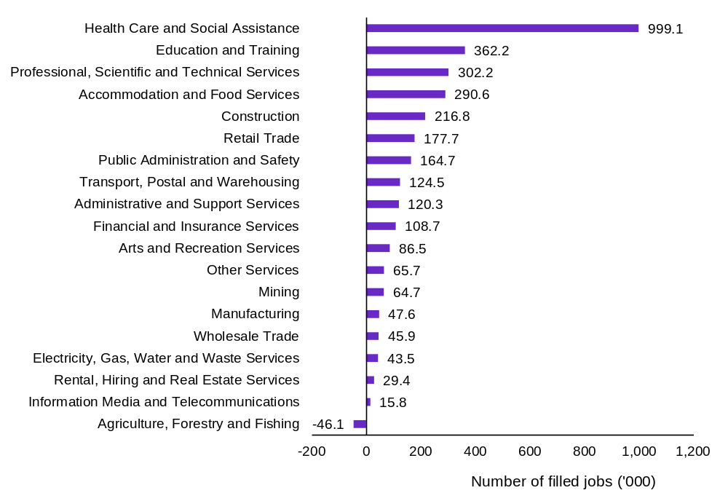
Source: ABS, Labour Account Australia, March 2026, trend.
The care economy is reshaping both workforce participation and the structure of employment growth. The Health Care and Social Assistance industry also has the highest share of female workers (76%) and relatively high rates of part-time work (43%) (ABS 2025b). Together, these trends highlight the growing importance of care work in driving labour market participation and employment opportunities in response to an ageing population.

Longer working lives will increase the need for lifelong skill adaptation
Longer working lives are becoming a defining feature of Australia’s labour market, with older Australians, especially women, working at much higher rates than in previous decades. Figure 2 shows that the labour force participation rate among people aged 55 to 64 and 65 years and older has increased since the late 1970s, with female participation in both age groups almost doubling since the turn of the century. This represents the broader trend of demographic change in reshaping workforce composition, participation patterns and the increased supply of more experienced workers in the workforce.
Figure 2: Older Australians are participating more in work, increasing the importance of flexible upskilling across working life
Labour force participation rate of population aged 55 to 64 and 65 years and older, total and females, 1978 to 2026
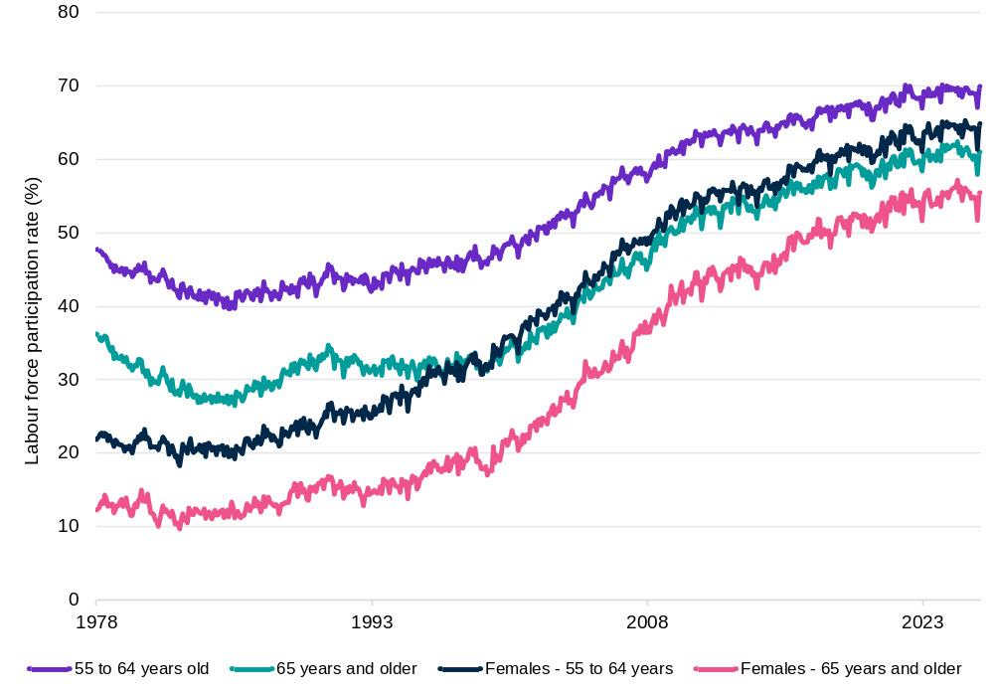
Source: ABS, Labour Force Australia, detailed [time series spreadsheet], March 2026.
While an older and experienced workforce is valued, it heightens the need for workers to be more adaptable to the pace of skill change over the life course. JSA research has found that the pace of skills change within jobs has accelerated over the last decade, particularly within skilled managerial, professional and technical roles (JSA 2026c). Further, this research also finds that workers beyond the age of 30 are less likely to enrol in study leading to a formal qualification or credential. This underscores the importance of lifelong learning, including improving access to flexible upskilling pathways including non-formal learning that support workers to adapt over longer and more varied working lives (Chapter 5). Longer working lives mean that Australia cannot rely mainly on front-loaded education early in life. Workers will need more flexible and accessible opportunities to update skills mid-career and later in working life.

AI, geopolitics, and net zero ambitions are changing work in Australia
AI technologies, geopolitical shocks and net zero ambitions are reshaping business operations, workforce decisions and skill requirements, but their impacts are uneven across industries, business size and regions. Australia’s changing demographic and skills profiles, together with investment capacity means the pace and nature of change could vary considerably across the economy, creating increasingly uneven labour market outcomes.

AI use is becoming mainstream among working-age Australians
Technology has reshaped the world of work for decades, but advances in AI have the potential to accelerate change. AI is becoming embedded in everyday life and work across Australia, from AI enabled assistants, search engines and algorithms to generative AI applications, and agentic tools that augment and automate processes and decisions. The use of AI is already widespread across Australia, with Roy Morgan estimating 13.6 million Australians are engaging with AI tools in their daily lives (Roy Morgan 2026). Uptake is highest in prime working age Australians aged 25 to 34 and 35 to 49, reporting usage rates of 74% and 72% respectively (as shown in Figure 3).
A survey conducted by the Australian Digital Inclusion Index (ADII) further reinforces the growing integration of AI into work and study, with over 60% of respondents reporting using AI for information and advice, and 39% using it to generate content for work or study, highlighting the technology’s expanding role in supporting knowledge tasks and day-to-day productivity (ADII 2025). The ability to effectively utilise AI is becoming a general workforce capability, not only a specific technical skill. JSA’s Generative AI Capacity Study found from a review of workplace surveys that some workers may be using AI for work unofficially (or commonly known as ‘shadow AI use’), due to perceived judgement on performance, with workers in small businesses less likely to be open about AI use (JSA 2025c).
To date, adoption of AI in Australia’s workplaces reflects a key finding in JSA’s AI capacity study: AI has a far greater potential to augment rather than automate occupations, with nearly half of workers in occupations likely to experience change rather than disruption (JSA 2025c). Monitoring by the Department of Employment and Workplace Relations’ (DEWR) Chief Economist completed in 2026 found AI has not caused significant disruption to the labour market, with only a slight softening in employment for AI exposed occupations (DEWR 2026).

Figure 3: AI use is highest among prime working-age Australians
Proportion of Australians in each age group using AI
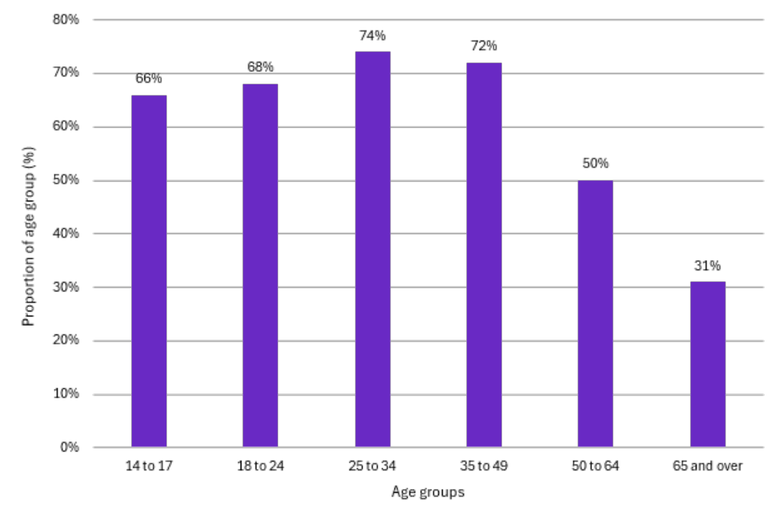
Source: Roy Morgan, 2026.

AI adoption in the workplace is uneven across industries and regions
AI adoption remains uneven across Australia, with larger businesses and metropolitan firms significantly more likely to integrate AI into their operations. As shown in Figure 4, adoption rates increase sharply with business size, rising from around 31% among firms with fewer than five employees to almost 70% among businesses employing 200–500 workers. A persistent regional divide is also evident, with metropolitan businesses reporting higher adoption rates than regional businesses across every size category, contributing to an overall adoption rate of 42% in metropolitan areas compared with 30% in regional Australia. Together, these patterns suggest that access to capital, digital infrastructure and workforce capability are shaping firms' capacity to adopt AI and benefit from technological change.

Figure 4: Large and metropolitan businesses are adopting AI at higher rates than smaller and regional businesses
Proportion of businesses reporting AI adoption by region and number of employees
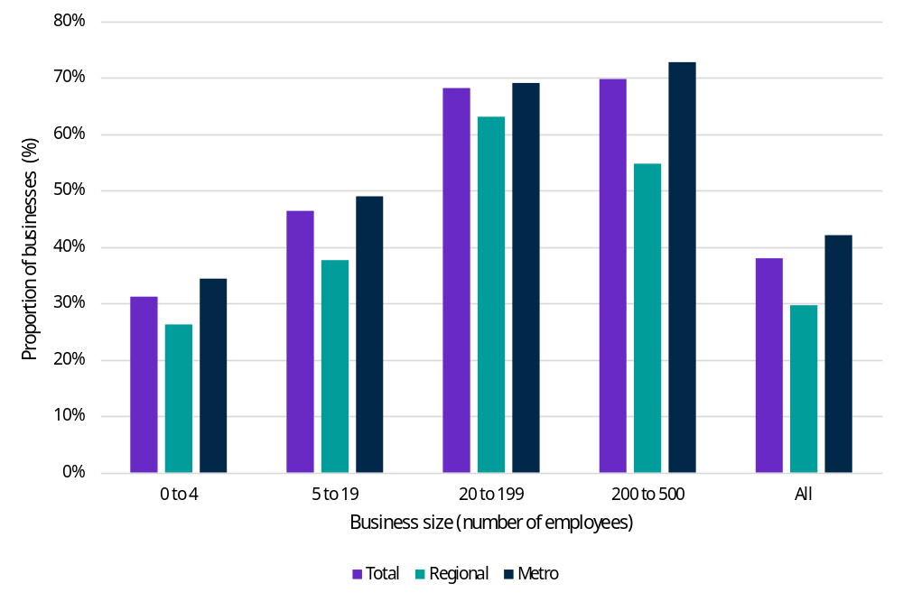
Source: National AI Centre, AI Adoption Tracker, 2026.
The unevenness in adoption extends beyond size and location of businesses. AI adoption is no longer confined to technology-facing industries but is spreading across parts of the economy where firms can use digital tools to lift productivity, manage complexity and reorganise work. Businesses in the Services and Mining sectors reported the highest AI adoption rates (Figure 5) at around 45% of businesses, followed by Health and Education (41%), Retail (39%) and Manufacturing (37%), while adoption is lowest in Agriculture, Forestry and Fishery (19%). This industry pattern suggests the uptake of AI is strongest where businesses have the scale, capital intensity or data assets needed to integrate AI into everyday operations.

Figure 5: The Services and Mining sectors are leading the way in AI adoption in Australia
Proportion of businesses adopting AI by industry, 2026
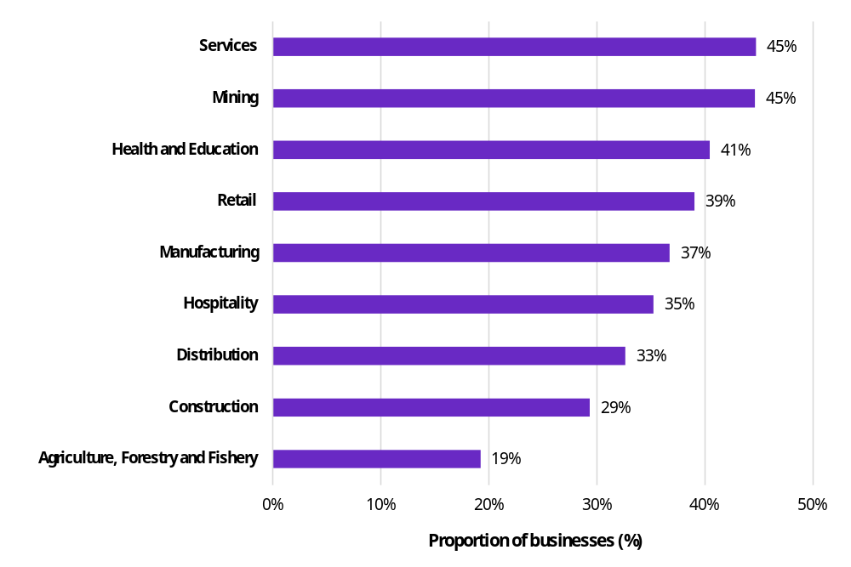
Source: National AI Centre, AI Adoption Tracker, 2026. Data accessed June 2026.
The types of AI being used also point to different pathways of change. ‘Generative AI assistants’ are the most common application across most industries while Mining and Distribution show stronger use of AI for data entry and document processing (National AI Centre 2026). Taken together, these patterns suggest the pace and form of adoption may vary according to industry structure, workforce capability and capacity to invest in new ways of working. Uneven adoption may widen productivity and opportunity gaps between large and small firms, metropolitan and regional employers, and workers with different access to learning.
As adoption remains uneven, so are the likely impacts and exposure of disruption of AI to different cohorts. JSA analysis of AI exposure finds that based on the overall composition of the labour market, women are slightly more exposed to Generative AI in their current roles on average (JSA 2025c). This finding also complements research by the Future Skills Organisation (FSO), which found that financial services occupations with a high female employment share such as Accounting Clerks, Bookkeepers, Payroll Clerks, and Bank Workers, are highly exposed to Generative AI (FSO 2024).
The observed unevenness in the adoption and exposure of AI across industry and workers re-affirms the JSA recommendation from the Generative AI Capacity Study, which advocated for the Australian Government to lead the national stewardship of the AI transition. This should focus on equity, productivity, proportionality and technology neutrality (JSA 2025c). There is already evidence that national stewardship is occurring, with the Australian Government establishing an Office of AI to coordinate across Australian Government agencies to design and legislate the new Australia AI standard and unlock AI training in Australia (PM&C 2026). This is an important step to help guide Australia’s adoption of AI to maximise the opportunity and minimise the inequity for businesses, regional Australia and workers.

Global supply chain pressures are raising business costs and influencing workforce decisions
Recent supply chain disruptions linked to conflict in the Middle East from early 2026 have increased cost pressures across Australian businesses. In response to these pressures, the JSA Recruitment Experiences and Outlook Survey (REOS) introduced targeted questions from 1 April 2026, with Figure 6 showing that around 64% of employers reported some level of impact from rising fuel prices and supply disruptions. This matters because employer demand for labour and skills is shaped not only by long-term structural change, but also by short-term operating pressures. For smaller businesses in particular, these cost pressures appear to have been more prominent, which may affect their broader business confidence and capacity to respond to workforce needs.
Figure 6: Supply chain disruptions are increasing business costs and beginning to affect workforce decisions
Reported impacts by employers from rising fuel costs and supply disruptions by level of severity between 1 April and 1 May 2026
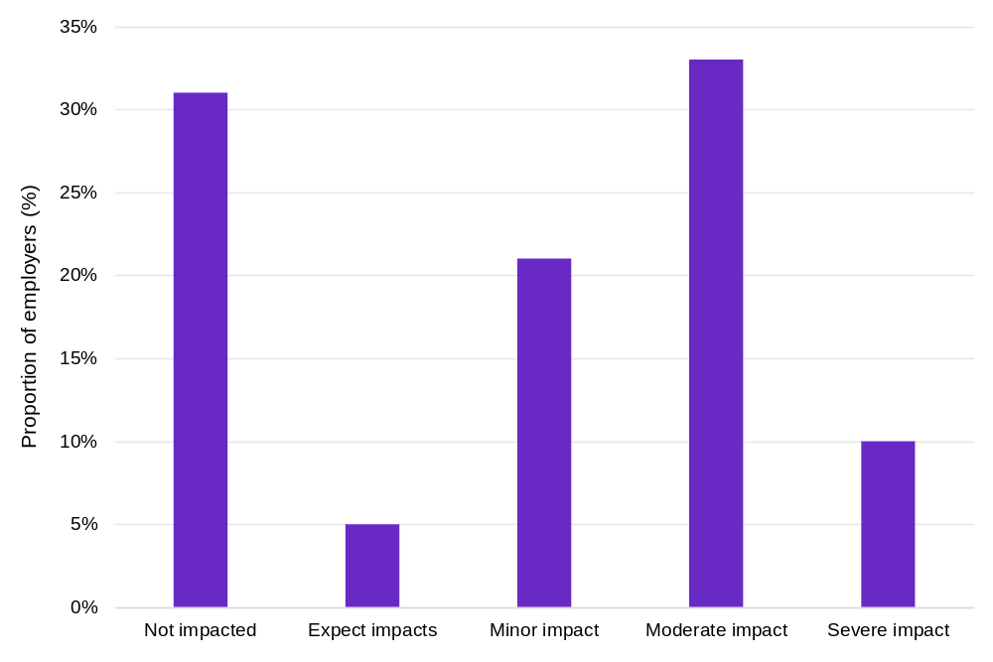
Source: JSA, Recruitment Experiences and Outlook Survey, 2026. The above is based on preliminary employer survey results covering the period of 1 April to 1 May 2026.
Among affected employers from 1 April to 1 May 2026, the most cited challenges were higher operating costs (38%), increased input prices (32%) and elevated delivery and transport costs (27%), underscoring the broad-based transmission of global shocks into domestic cost structures. These pressures are particularly acute in Transport, Postal and Warehousing, where 43% of employers in the March quarter 2026 identified cost increases as their primary business concern. This increase of around 30 percentage points from the previous quarter highlights the sector’s heightened exposure to fuel price volatility and supply chain disruptions.
As shown in Figure 7, these cost pressures are beginning to flow through to workforce decisions, particularly for small and medium-sized businesses. In the May 2026 Australian Bureau of Statistics (ABS) Business Conditions and Sentiment Survey, 9% of small businesses and 13% of medium-sized businesses expected to reduce their workforce due to cost pressures, compared with only 3% of large businesses.
Figure 7: Small and medium-sized businesses were more likely to report reducing their workforce compared to large businesses
Proportion of businesses by size that have reduced the size of their workforce due to the 2026 fuel crisis
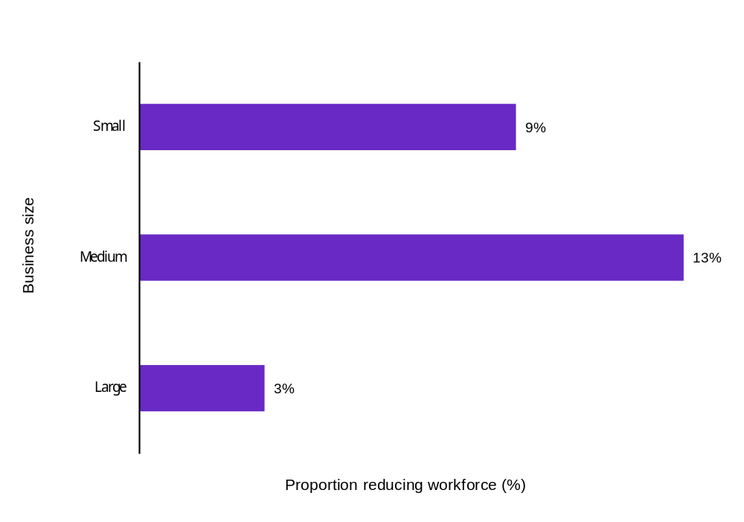
Source: ABS Business Conditions and Sentiment Survey, 2026.
While recent supply chain disruptions demonstrate how external shocks can affect business decisions in the near term, technological adoption is a more enduring driver of workforce change reshaping work organisation and skills demand.
Box 2: Further study on the impact of AI
Australia, through JSA, is participating in an international OECD study examining how AI is being adopted and experienced in workplaces across participating countries. The Australian employer and worker surveys will support international comparison and contribute to JSA’s continuing work to understand AI’s implications for work, skills and workforce transitions.

The net zero transition will require new workforce capability, not just additional capacity
The transition to net zero is an economy-wide structural shift that will change the scale, location and capability of the workforce. It will create demand for additional workers in renewable energy and low-emissions industries, while also reshaping existing jobs in construction, manufacturing, transport, agriculture and professional services (JSA 2023). The workforce challenge is therefore as much about capability as capacity. Australia will need enough workers to deliver the transition, but those workers must also be able to apply new technologies, work across occupational boundaries and adapt established technical skills to changing systems, standards and business models.
The energy transition illustrates this dual challenge. Powering Skills Organisation (PSO) estimates that an additional 42,000 energy trades workers will be required by 2030 (PSO 2026), pointing to a significant need to expand workforce capacity. At the same time, electrification and the integration of renewable generation, storage and grid technologies will change the capabilities required within established trades. Similar change is occurring in automotive services, where the growth of electric and hybrid vehicles will increase demand for technicians with electrical and digital capabilities. The Mining and Automotive Skills Alliance (AUSMASA) projects that Australia will need between 6,500 and 10,500 electric vehicle technicians by 2050 (AUSMASA 2026). Meeting these needs will therefore depend not only on bringing more people into priority occupations, but on enabling existing workers to update, combine and deepen their capabilities throughout the transition.

Labour market opportunities are uneven
The benefits and opportunities arising from labour market change are not being experienced evenly across the workforce. While technological adoption, population ageing and economic growth are creating new jobs and expanding demand in many parts of the economy, their impacts vary considerably. Some workers are increasingly relying on multiple jobs to achieve sufficient hours or income, employment growth is occurring across a diverse mix of knowledge, practical and human-centred occupations, and labour market conditions remain stronger in some locations than others. Together, these trends point to a labour market that is creating new opportunities but becoming increasingly uneven in how those opportunities are distributed.

Multiple job holdings have increased over the last decade
Nearly 1 million Australians held multiple jobs in March 2026, with the multiple job-holding rate rising from 5.7% to 6.5% over the past decade. However, this trend is uneven and is increasingly concentrated among women working in the care economy. Figure 8 shows that women in Health Care and Social Assistance account for around 1 in 7 multiple job-holders, which is largely driven by the large growth in jobs in this sector as well as the relatively high share of females and part-time workers in this industry.
Figure 8: Women working in health care and social assistance account for a large share of multiple job-holders
Number of multiple job-holders by Industry Division, total and females, 2025
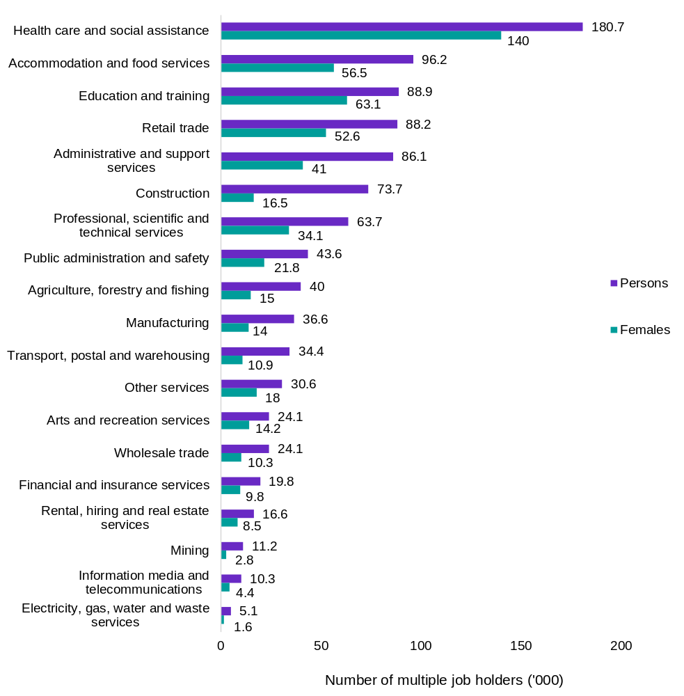
Source: ABS, Multiple Job-holders, March 2026. Original data, ABS Labour Account.
The working-hours profile of multiple job-holders further reinforces this gendered pattern. As seen in Figure 9, female multiple job-holders usually worked fewer hours in their main job on average (26.4 hours) than male multiple job-holders (34.7 hours). This suggests that women holding multiple jobs are more likely to be associated with part-time primary employment and combining hours and income across jobs.
Beyond demographic characteristics, further exploration is required on the impact of the gig-economy, particularly the growing prevalence of digital platform work on multiple-job holdings. For example, 53% of digital platform workers undertook this work in addition to their main job, however only 11% of these workers reported they were multiple job holders in the labour force survey (ABS 2023).
Figure 9: Women holding multiple jobs work fewer hours in their primary job compared to men
Average usual hours worked per week in main and secondary jobs of multiple job-holders, by gender, 2025
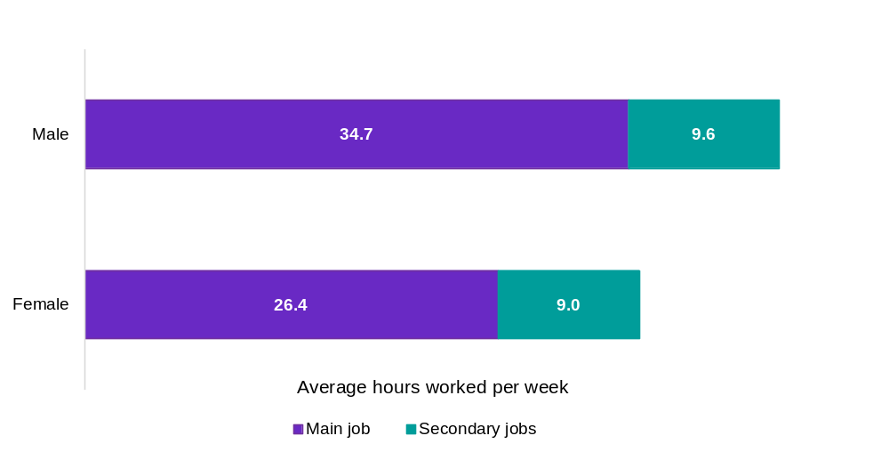
Source: ABS, Multiple Job-holders, March 2026. Original data, ABS Longitudinal Labour Force.

Technology and demographic changes are shaping a labour market that is balanced between knowledge, practical and human-centred work
Employment growth is increasingly spread across knowledge-intensive, practical and human-centred occupations, reflecting the combined effects of technological change, demographic demand and economic growth. Figure 10 shows that the occupations with the highest employment growth are linked to long-term structural change, including care, education, construction and digital capability. While the labour market has continued to shift towards higher-skilled work, the largest growing occupations also include roles that rely on VET qualifications or equivalent experience, such as Aged and Disabled Carers, Electricians and Education Aides. This suggests that Australia’s future workforce needs will not be met through higher education pathways alone but will require a balanced skills system that supports professional pathways and also the practical and human-centred occupations. This has implications for how tertiary education is balanced across vocational, higher education, including work integrated learning, and on-the-job skills formation and deepening.
Figure 10: Beyond the care workforce, digital, education and skilled trades have also grown in line with population growth and technological advancement
Top 10 occupations (Australian and New Zealand Standard Classification of Occupations (ANZSCO) unit groups) with the largest 10-year employment growth. 2016 to 2026
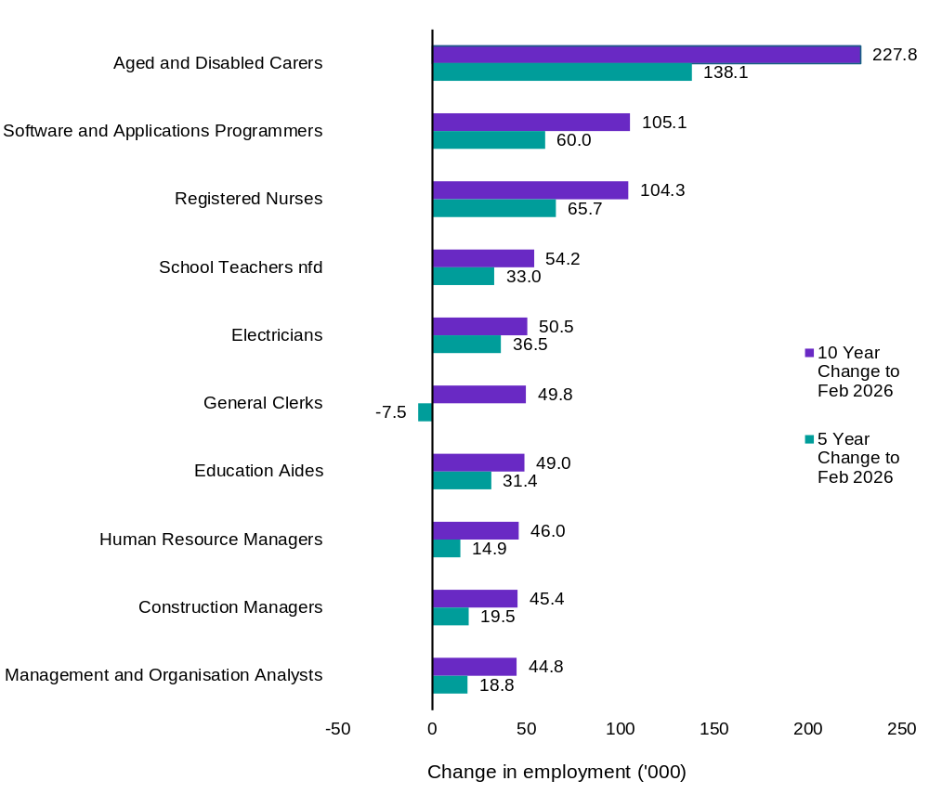
Source: ABS, Labour Force Australia, Detailed, February 2026, data trended by JSA.

Regional labour markets remain uneven, despite signs of resilience outside major cities
Labour market opportunities remain uneven across regions, although some regional areas are demonstrating resilience. Weaker labour market conditions are more common outside major cities, with regional and remote areas more likely to be rated by JSA as below average or poor (Figure 11). Around 38% of regional labour markets fall into these categories, compared with 23% of major city labour markets, while all remote areas record poor ratings. This highlights the continued importance of place-based analysis, as aggregate national indicators can obscure the more acute labour market challenges facing communities with smaller employment bases, thinner occupational markets and more limited access to education, training and progression pathways.
Figure 11: Weak labour market conditions remain more common outside major cities with all remote areas in Australia showing weakness
Proportion of geographic areas by remoteness with below average or poor labour market ratings, March 2026
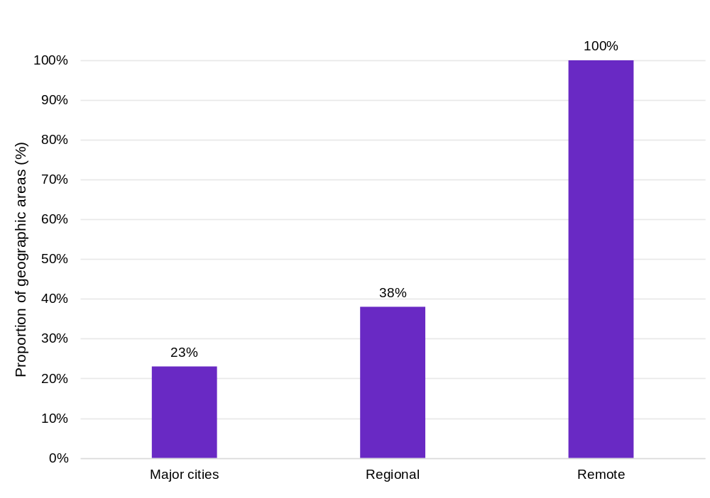
Source: JSA, Regional Labour Market Indicator, March 2026.
At the same time, the latest updates to the ratings in March 2026 suggest that divergence is not only a story of regional disadvantage, and there are signs of improvement and resilience in regional Australia (Figure 12). Improvement was more common outside major cities, with 7 of the 10 areas recording better labour market ratings located in regional areas, while 6 of the 9 areas that declined were in major cities. For the 16 regional areas with average or higher labour market ratings in March 2025, 15 remained resilient with stable or improving ratings in the 12 months to March 2026.
This observation points to a mixed and dynamic regional picture; some regional labour markets remain under pressure and face structural disadvantage, particularly in remote locations, but others show strong and resilient conditions. Policy responses therefore need to distinguish between regions facing persistent structural barriers and those where targeted investment could help consolidate emerging labour market strength.

Figure 12: Some regional labour markets are showing resilience despite broader geographic divergence
12-month change in regional labour market ratings by remoteness between March 2025 to March 2026
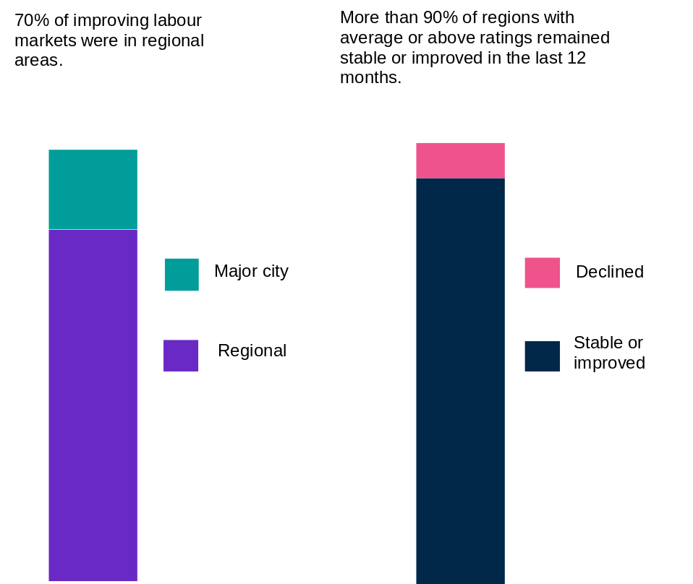
Source: JSA, Regional Labour Market Indicator, March 2026. Note: ‘Regional’ includes all areas classified as ‘Regional’, ‘Cities of Regional Australia’ and ‘Remote Australia’.

Looking ahead
The forces reshaping Australia’s labour market are making workforce adaptability and job design increasingly important to future economic performance. Technology adoption, demographic change and global disruption are altering how work is organised. The skills employers need and where opportunities are emerging are also evolving, while their impacts remain uneven across the workforce.
The chapters that follow examine how Australia can respond to these cross-cutting forces by strengthening the quality, adaptability and depth of its labour market. Chapter 2 focuses on demand for high-quality jobs, including how productivity, job design and workforce capability shape the creation of secure and meaningful work. Chapter 3 then turns to labour supply, examining how demographic change, lower birth rates, migration and changing patterns among new labour market entrants are reshaping the workforce on which Australia can draw. Chapter 4 considers how Australia can make better use of the skills it already has and support effective pathways into work and Chapter 5 explores how to better enable career mobility and career deepening over longer working lives.

Box 3: The Jobs and Skills Roadmap for Regional Australia
Labour market and skills outcomes can vary substantially across regions. The Jobs and Skills Roadmap for Regional Australia responds to this challenge by providing a clearer picture of regional outcomes and identifying opportunities for more coordinated, place-based action.
It brings together regional data, evaluative indicators and extensive stakeholder consultation, supported by an accompanying dashboard that enables outcomes to be compared across regions and monitored over time.
The Roadmap’s vision is for a system that supports everyone in regional Australia to participate in education, training and employment, develop and use their skills, access secure and rewarding work, and contribute to their communities. Its evaluative framework measures progress across 4 connected areas: inclusive participation, skills development, appropriate working arrangements and labour market productivity.
The findings present a mixed picture. Regional Australia has strong labour demand, relatively low unemployment and underemployment, and high work satisfaction. However, participation barriers remain significant, including limited access to housing, transport, childcare and digital services. School attendance remains lower than in major cities, around 1 in 9 young people are not in employment, education or training, and long-term income support reliance is comparatively high.
Skills and productivity pressures are also evident. Youth tertiary participation has fallen to a decade low, apprenticeship completion rates are declining, and employers continue to face difficulty filling vacancies despite elevated job opportunities. Skills mismatch, underuse of existing qualifications and an ageing population further constrain workforce supply and productivity.
In response, the Roadmap highlights opportunities to strengthen local evidence and planning, provide more flexible and coordinated services, improve career and skills pathways, and better support young people and jobseekers facing complex barriers.

Workforce demand – creating attractive, productive jobs
For more information on JSA’s research and analysis on the
themes discussed in this chapter, please scan the QR code


Key themes in this chapter
Workforce demand is expressed not only in the number of workers required, but in where jobs are created, the capabilities they require, and how they are designed, rewarded and organised. This is critical to national productivity. Meeting future workforce needs requires attention to which jobs and skills are in demand and the jobs through which those skills are put to work. This includes designing work to unlock the potential of greater participation from cohorts who have faced greater barriers to participation in work, such as women, people with disability and First Nations people.
The key JSA findings are:
- Future demand growth likely to be concentrated in sectors already experiencing shortages. Employment growth and policy-driven investment are increasingly concentrated in construction trade, engineering, care, technology and energy-related occupations. Many of these occupations are already experiencing shortages, creating workforce risks that cannot be addressed through supply-side responses alone.
- Policy-driven investment may impact demand in the same sectors already facing shortages. Investment in housing, clean energy, healthcare, digital infrastructure and sovereign capability requires skilled workers. Workforce planning is an important condition for delivering national priorities. Shortages are a demand-side problem as well as a supply-side problem.
- There is potential misalignment between student demand for higher education and employment demand for VET. JSA’s employment projections model that if demand fully shaped graduate supply, there would be around 106,000 additional VET trained workers in Skill Level 3 and 4 occupations over the next decade, offset by around 139,000 fewer higher education trained workers in Skill Level 1 occupations than under current supply trends.
- Skills shortages can be driven by job attractiveness. Good job design can help employers attract and retain the skilled workers needed in high-demand sectors. Clear progression pathways, effective skills utilisation and improved working conditions can help reduce turnover and strengthen workforce resilience. Underutilised talent pools can be accessed by designing jobs that are more flexible, accessible and inclusive.
- Increasing productivity in jobs will require broad capabilities, not just technical skills. Future workforce productivity will depend on how effectively broader transversal skills such as problem-solving, initiative and leadership are developed and utilised in the workplace.
- Job design is a productivity lever. Better job design can improve skill utilisation, support technology adoption, strengthen management practices, reduce avoidable turnover and create clearer progression pathways. These outcomes can lift productivity while helping employers meet workforce demand in a tighter labour market.

Policy-driven investment is concentrating future workforce demand in sectors already under pressure
Policy-driven investment may impact demand in the same sectors already facing shortages, making effective workforce planning a central condition for delivery. Despite high rates of labour market participation, persistent shortages have remained in 139 occupations, including those in construction, engineering and health (JSA 2025d). Priority sectors such as housing, health and care, net zero, technology and infrastructure will require more skilled workers. How this demand translates into jobs will shape whether priority sectors can attract and retain workers, develop the capabilities they need and use those capabilities effectively.

Australia’s employment growth will be concentrated in skilled and qualified work—led by care, professional and trade occupations
Australia’s employment outlook forecasts stronger employment growth in high skilled professional jobs and skilled trades alongside growth within the care workforce. This outlook further supports the view that almost all employment growth (93%) will occur in jobs that typically require post-secondary qualifications (JSA 2026i).
JSA’s employment projections are useful for understanding the impact of the current economic and labour market outlook on Australia’s future workforce needs. The projections give insights into trends and growth areas in the labour market and are used by industry and governments to inform policy decisions and workforce planning activities.
As seen in Figure 13, the overall industry structure is not projected to change over the next 5 to 10 years. However, some sectors are growing at faster rates. The Health Care and Social Assistance industry’s share of total employment is projected to increase from 16.2% in 2026 to 18.2% in 2036, with employment projected to grow by 412,500 persons (or 17.2%) to 2031 and by 732,000 persons (or 30.4%) to 2036. The share of total employment in Construction is projected to decline slightly from 9.3% in 2026 to 9.1% in 2036 however employment is still projected to grow across this period, rising by 113,800 persons (or 8.2%) to 2031 and by 187,400 persons (or 13.6%) to 2036.

Figure 13: The industry structure of the Australian labour market is projected to remain unchanged over the next decade.
5 and 10-year employment outlook, by ANZSIC Industry Division
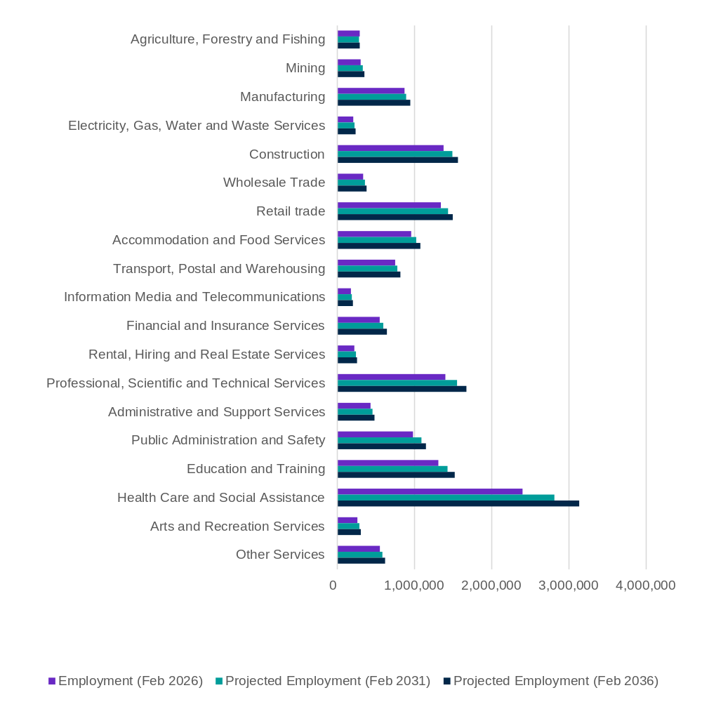
Source: 2026-2036 Employment Projections, produced by Victoria University for JSA
When looking at the employment outlook by occupations, all occupation major groups are projected to increase in employment over the next decade (Figure 14) with Professionals being the largest – and fastest – growing group. Professionals are projected to grow by 564,400 persons (13.9%) to 2031, and by over 1.03 million persons (25.6%) to 2036 – contributing more than 42% of the overall increase in employment over the next decade. The top 3 occupations in this group, by projected share of employment in February 2036, are Registered Nurses (9.5% of Professionals), Software and Application Programmers and Accountants (both 5.1%).
This trend signifies the growth in high skilled jobs, with more than half of projected employment growth over the next decade in Skill Level 1 occupations which require a bachelor degree or higher. However, more than 41% of projected growth to 2036 is in Skill level 2 to 4 occupations which relates to qualifications delivered by VET. Technicians and Trades Workers, which often require the completion of a VET qualification, are currently the second largest occupation major group and is projected to increase by 231,800 (12.0%) in the next decade.
Figure 14: Professionals are projected to grow the fastest and remain the largest occupation major group over the next decade
5 and 10-year employment outlook, by occupation major group
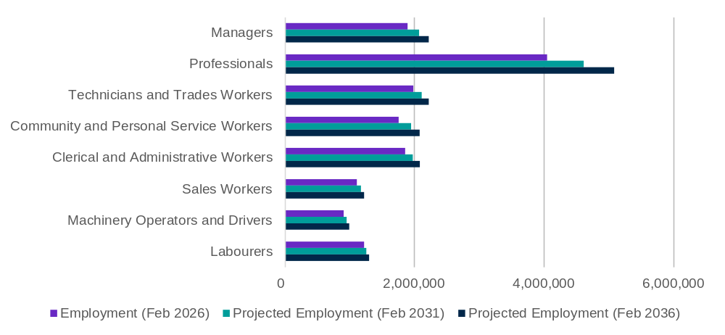
Source: 2026-2036 Employment Projections, produced by VU for JSA.

The unconstrained supply model: analysing how a more responsive educational system could reduce occupation shortages through better alignment between supply and demand
A key feature of the employment projections model is that it takes account of both the current and expected qualification profile of the population. This means the model considers not only the future demand for workers in different occupations and industries, but also whether people with the right skills and qualifications will become available to fill those jobs.
As a result, projected employment growth is influenced by workforce supply constraints. Where there are not enough qualified workers coming through the system, employment growth projections in those occupations and industries will be constrained, even if demand is strong.
For example, there is a relatively small supply of people with Certificate III and IV qualifications in engineering-related fields. This limits the availability of qualified tradespeople and, in turn, constrains how quickly employment can grow in industries such as construction.
More broadly, current workforce supply is generally sufficient to support growth in highly skilled occupations (Skill Level 1). However, growth in the number of people completing Certificate-level qualifications is not keeping pace with projected demand for occupations at Skill Levels 3 and 4, creating ongoing workforce shortages in these areas.
To help understand the extent of these issues, but also how changes in education could alleviate them in the future, JSA and Victoria University (VU) analyse an alternative unconstrained scenario where skill supply constraints are lessened through an increased response of educational attainment to economic demand – effectively creating an estimate of what supply would look like if it conformed to labour demand. This highlights the gap between the education choices of students and labour demand.
In this unconstrained supply scenario, 93.0% of the employment growth over the next 10 years is estimated to be in occupations commensurate with post-secondary qualifications (skill levels 1 to 4) - compared with 93.7% in the baseline case. However, the proportion of the projected growth in Skill Level 1 occupations (those related to a bachelor’s degree or higher as the primary education pathway) declines from 52.6% to 46.9%, while this increases from 41.0% to 46.1% for Skill Level 2 to 4 occupations (those with VET as the primary pathway). These results are similar to the equivalent analysis presented in last year’s Jobs and Skills Report, where the proportion of projected growth in Skill Level 1 occupations was 48.9% and the proportion of projected growth in Skill Level 2 to 4 occupations was 44.9%.
Compared to the baseline 10-year employment projections, employment in the alternative scenario projects that if labour supply conformed to demand there would be:
- lower growth in employment for Skill Level 1 occupations, with the projection of 139,300 fewer persons lowering employment in these areas of the economy by around 2.1% against the baseline scenario.
- additional growth at Skill Level 3, with the projection of 42,600 additional persons increasing employment in these areas of the economy by 1.9% on the baseline scenario.
- additional growth at Skills Level 4, with the projections of 63,500 additional persons increasing employment by around 1.6% on the baseline.
This projection suggests that if education and training supply were more responsive to labour market demand, Australia could support around 106,000 more workers in Skill Level 3 and 4 occupations over the next decade, offset by around 139,000 fewer workers in Skill Level 1 occupations than under current supply trends. This highlights persistent unmet demand for Certificate III and IV pathways and the need for a better balance between VET and higher education supply.
Figure 15: In an 'unconstrained skill supply' scenario, the employment outlook deviates towards skill level 3 and 4 occupations and away from skill level 1 occupations compared to the baseline scenario.
Deviation of the unconstrained skill supply model from baseline employment projections, by skill level, Australia
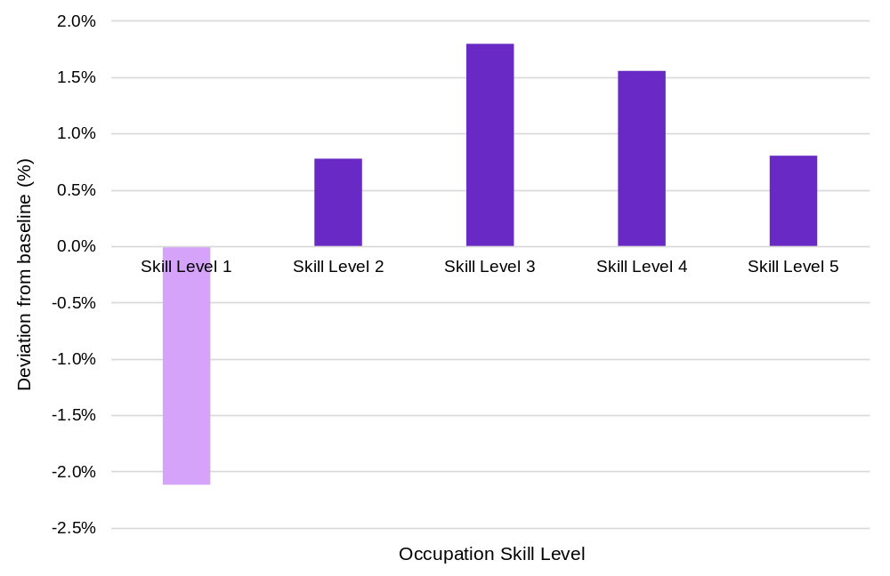
Source: 2026-2036 Employment projections (unrestricted skills supply scenario), produced by VU for JSA.
Note: In the unconstrained scenario, educational and training attainment is fully responsive to labour market demand, whereas in the baseline scenario it is based on recently observed trends in educational attainment by age, gender, and level and field of education.
Box 4: Consideration of the impact of AI in the employment outlook.
The 2026 to 2036 employment outlook is based on a baseline scenario produced by JSA and Victoria University. The baseline reflects current evidence on economic, demographic and labour market trends and is designed to illustrate how employment may evolve if these trends continue broadly as expected.
The baseline does not explicitly model future shocks or major structural changes that may affect the economy and labour market, including technological change such as AI, climate-related transitions, geopolitical events, supply chain disruptions or other unforeseen developments. JSA will continue to use scenario analysis to examine how alternative futures could affect Australia's workforce needs.

Many of tomorrow’s critical occupations are already experiencing shortages today
Occupations that are critical for Australia’s future in healthcare, engineering, manufacturing and construction are already under pressure, with current shortages concentrated in the same sectors expected to drive demand over the next decade. Health care and construction-related occupation groups have high proportions of occupations in shortage (Figure 16), with three of the top 10 groups related to construction, and two related to Health Care and Social Assistance. This points to a critical demand-side constraint as many of the jobs critical for the future rely on skilled workers in occupations where employers are already struggling to recruit.
Figure 16: Workforce shortages are concentrated in occupations that are critical to housing, infrastructure and healthcare
Top 10 Occupation (OSCA) sub-major groups with the highest proportion of occupations (6-digit level) that are in shortage, 2025
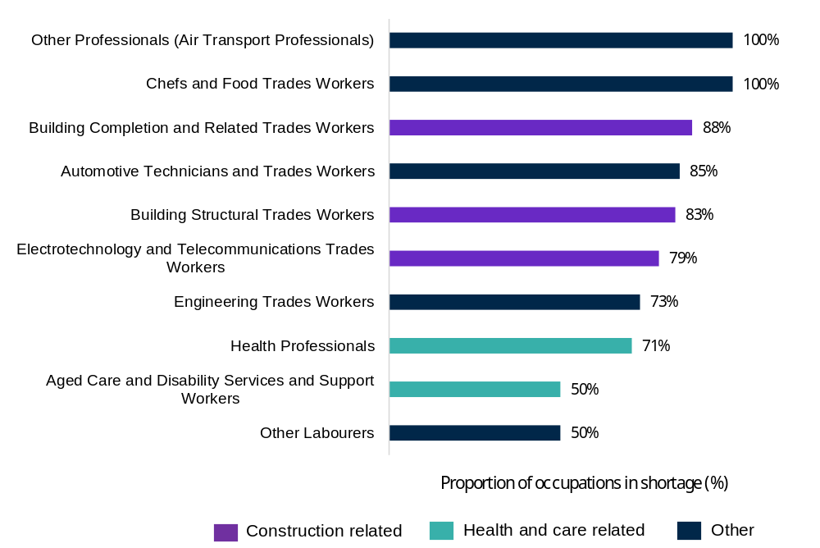
Source: JSA, Occupation Shortage List, 2025. Top 10 occupation sub-major groups with the highest proportion of underlying occupations (OSCA 6-digit level) in shortage. Note: Occupations in shortage refers to occupations (OSCA 6-digit) rated as ‘shortage’ at a national level. Proportion refers to the count of occupations and is not an indicator of workforce gaps, shortfall of jobs or a headcount of workers. The denominator used to calculate the proportion includes all OSCA occupations that are included in the Occupation Shortage List (OSL) dataset. For the purposes of this analysis ‘Other Professionals’ includes Air Transport Professionals only, The OSCA classification also includes Specialist Police Officers in this sub-major group, however this was not included in the OSL ratings for 2025.
Box 5: 2026 Occupation Shortage List
JSA leads work on occupation shortage analysis including the annual Occupation Shortage List (OSL). The 2026 update to the OSL and occupation shortage drivers will be published later in 2026 and will be available on the JSA website.

The alternative projections scenario demonstrates these pressures
The unconstrained skills scenario in the employment projections (conforming graduate supply to labour demand) is also revealing on the challenge of current shortages and future demand. For jobs at Skill Level 3, where the unconstrained scenario shows an increase in employment of 42,600 over 10 years, over 81% of the additional growth (34,600 jobs) would occur in occupations that were in shortage on JSA’s 2025 OSL.
Among Skill Level 3 occupations that were in shortage in 2025, the scenario projects an increase in employment across areas crucial for the construction sector, including Electricians (around 5,200 additional people employed – an increase of about 2.6% on the baseline projection), Carpenters and Joiners (2,800 more) and Plumbers (1,400 more). Beyond construction trades there would also likely be increases in Metal Fitters and Machinists (3,700 more), Chefs (3,200 more) and Hairdressers (2,700 more).
At Skill Level 4 we would expect stronger employment for Aged and Disabled Carers (an additional 16,100 employed) and Nursing Support and Personal Care Workers (4,800 more), lifting employment in this area of the economy by more than 4%. As with Skill Level 3, employment increases in the scenario are more likely to boost occupations at Skill Level 4 that were in shortage in 2025.

Increased investment in housing, clean energy, healthcare and technology will increase demand for skilled workers
Public investment continues to expand across Australia's care and support systems, increasing demand for workers in health care, aged care and disability services (The Treasury 2026). The National Disability Insurance Scheme (NDIS) alone supported more than 774,000 participants as at March 2026, with over $33.5 billion in committed payments and more than 320,000 active providers (NDIA 2026). As demand for care and support services grows, the sector will require not only more workers, but jobs that better support attraction, retention, career progression and service quality.
Beyond the care economy, government-led investment will also contribute to labour demand in construction, engineering, energy and technology occupations that are already facing shortages. Investments in meeting housing targets, the clean energy transition, digital infrastructure and sovereign industrial capability will add to the current demand pressures for skilled workers through VET and higher education (Figure 17). Coordinated workforce planning, stronger skills pathways and attention to job design will be important in managing these impacts.
Stakeholders have expressed concerns that this increasing demand will increase competition for the same pool of skilled workers across engineering and the trades. For example, analysis by Powering Skills Organisation (PSO) has found that an increase of up to 13,000 energy trades workers may be required by 2030 to meet the growth of data centres in Australia (PSO 2026). Rising electricity demand could add further pressure by increasing the workforce needed to build and maintain generation, transmission and distribution infrastructure, particularly for the net zero transition.
Figure 17: Beyond health care and social assistance, investments in technology, energy and housing will also be a key driver of job creation
Key themes in the policy-driven investment pipeline in technology, net zero and housing
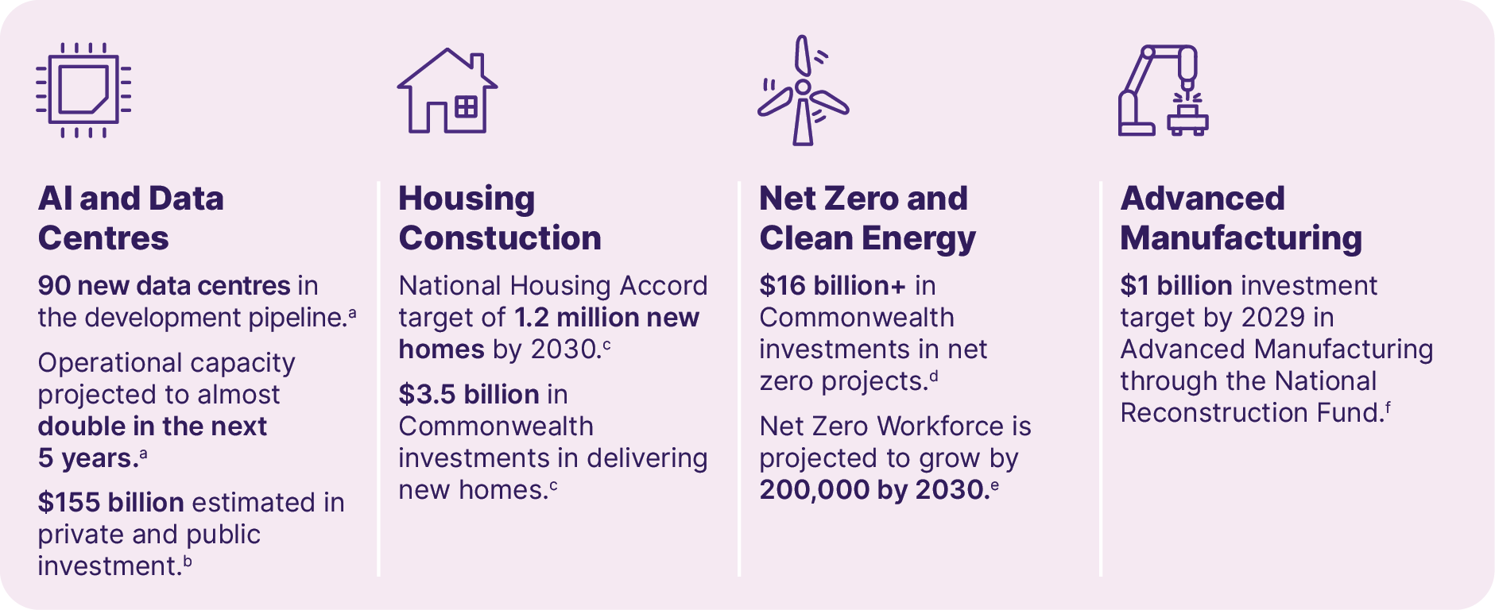
Source: a. Data Centres Australia and DCByte, Australian Data Centre Forecast Report Issue 1, 2026. 2026_Australian Data Centre Forecast Report - Issue 1, b. Westpac, Powering the AI Economy: Australia’s $155bn data centre boom, 2026 er20260529DataBulletin.pdf, c. The Treasury, National Housing Accord, 2022 National Housing Accord 2022 d. Net Zero Economy Authority, Net Zero Investment Map, 2026 Net Zero Investment Map | Net Zero Economy Authority, e. Infrastructure Australia, Delivering Net Zero Infrastructure: Workforce Report, 2025. IA25_Delivering-Net-Zero-Infrastructure-Workforce-Report.pdf, f. National Reconstruction Fund Corporation, Annual Report 2024-25, 2025. NRFC_Annual Report_Digital_FINAL__0.pdf.

Meeting future labour demand requires consideration of job design, not just more workers
Australian workers benefit from working conditions and employment standards among some of the strongest in the developed world. This has been driven through a combination of legislative reform, institutional development, worker advocacy and employer-led practices. Workplace safety has improved substantially over time, alongside the expansion of minimum leave entitlements, superannuation and modern employment protections, and efforts to improve gender equality (including enhanced paid parental leave arrangements), which together have contributed to improved working conditions across the labour market over the long-term. These institutional settings are complemented by a longstanding system of minimum wages and award protections which provide a universal wage floor across the workforce.
Workforce demand is expressed not only in the number of workers required, but in where jobs are created, the capabilities they require, and how they are designed, rewarded and organised. These features affect whether employers can attract and retain workers and use their capabilities effectively.
Beyond base conditions and standards, employers, workers and productivity can benefit when jobs are designed to maximise skills utilisation, enable technology adoption, and support retention and skills growth. Structural underutilisation arises from persistent mismatches between potential workers and available work. This can occur when workers’ skills and those available jobs do not align (which can occur for a broad range of reasons) (The Treasury 2023). Many of the occupations facing the strongest growth and greatest shortages will not be filled through training alone. Meeting future workforce demand will also depend on how jobs are designed, managed and supported (OECD 2026b).

Future jobs will increasingly rely on problem-solving, judgement and adaptability
Improving productivity in jobs will depend on workers being supported to adapt, solve problems and apply judgement as technology changes the nature of work. Figure 18 shows that mentions of critical thinking and problem-solving skills in construction trades job advertisements have more than tripled over the past decade, with an even sharper increase for construction apprentices. While aggregated job advertisement data is not representative of actual or total demand, this trend suggests that demand is not only growing for technical trade skills, but for broader transversal skills that enable workers to use new tools, respond to changing work practices and contribute to safer, more productive job design.
Figure 18: Growing demand for critical thinking and problem-solving skills highlights the changing nature of the construction trades including apprentices
Proportion of job ads that mention critical thinking and problem-solving skills for construction trades and apprentices
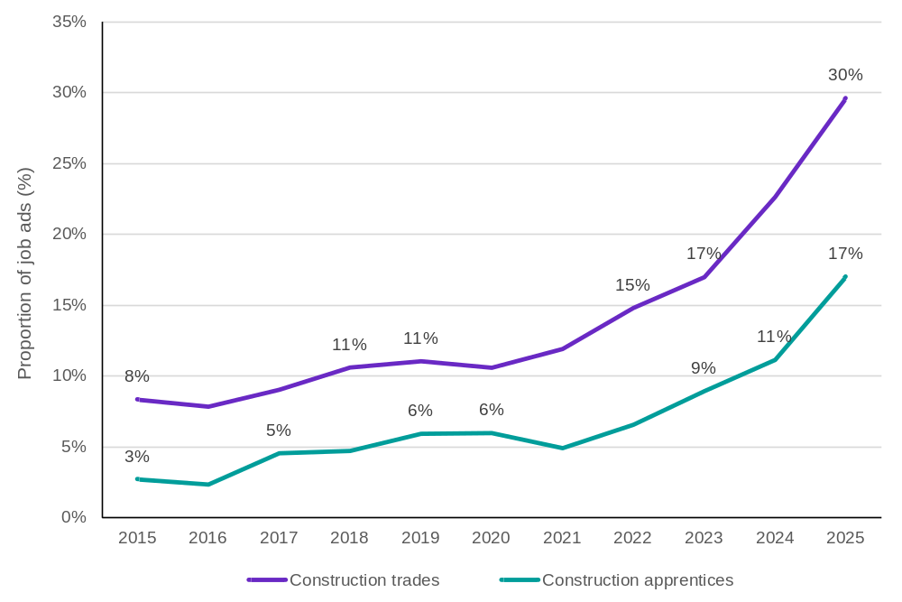
Source: Lightcast, JSA Analysis. Note: Data represents all construction trades job advertisements between 2015 to 2025, grouped under Australian and New Zealand Standard Classification of Occupations (ANZSCO) sub-major groups 33 (Construction Trades Workers) and 34 (Electrotechnology and Telecommunication Trades) that mention skills related to critical thinking and problem solving. Construction Apprentices represent all job advertisements containing ‘Apprentice’ in relevant construction roles. Aggregated job advertisement data has limitations and should be interpreted with caution as it is not representative of total or actual demand in the labour market.
The need for broader transversal skills is also evident in higher skilled engineering and construction roles, where effective job design will depend on workers being enabled to lead change, exercise initiative and coordinate complex work. Figure 19 shows that mentions of initiative and leadership skills in job advertisements have increased over the past decade, particularly for construction and engineering managers, and for engineering professionals. This reinforces that future labour demand in growth sectors will not only require more workers, but jobs and management practice that make better use of technical expertise, judgement and leadership to lift productivity and support workforce resilience.
Figure 19: Demand for professional roles in construction and infrastructure is shifting towards jobs that combine technical expertise with leadership capability
Proportion of job advertisements for engineering professionals and managers that include initiative and leadership skills, 2015 to 2025
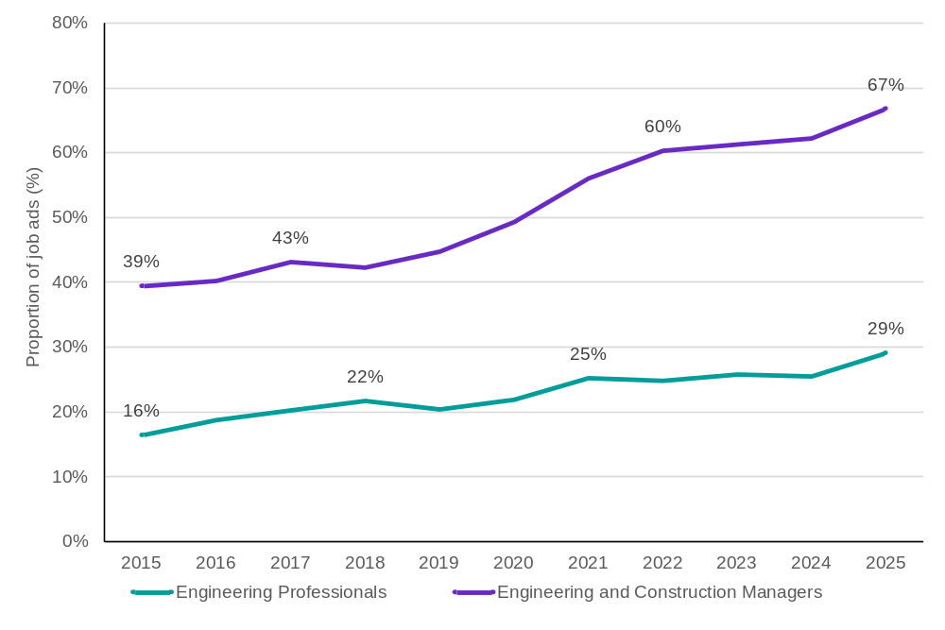
Source: Lightcast, JSA Analysis. Note: Data represented includes all job advertisements grouped under ANZSCO Minor Group 233 (Engineering Professionals), ANZSCO Unit Groups 1331 (Construction Managers) and 1332 (Engineering Managers) that mention skills grouped under ‘initiative and leadership’ skills. Aggregated job advertisement data has limitations and should be interpreted with caution as it is not representative of total or actual demand in the labour market.

Workers are choosing jobs based on quality, progression and working conditions
Job quality is a central demand-side issue, because workers are leaving jobs not only for more opportunities, but for better jobs (OECD 2015). Of the 1.18 million workers who voluntarily left a job in the 12 months to February 2026, more than 2 in 5 (43%) were seeking a change or ‘better’ job, while around 1 in 5 (21%) left because of poor working conditions (Figure 20). This reinforces that meeting future labour demand will require employers to design jobs that make better use of workers’ skills, offer meaningful progression and provide the conditions needed to attract and retain productive workers.
Figure 20: Better job opportunities and working conditions are key drivers of workforce turnover
Reasons people left a job voluntarily in the last 12 months, February 2026
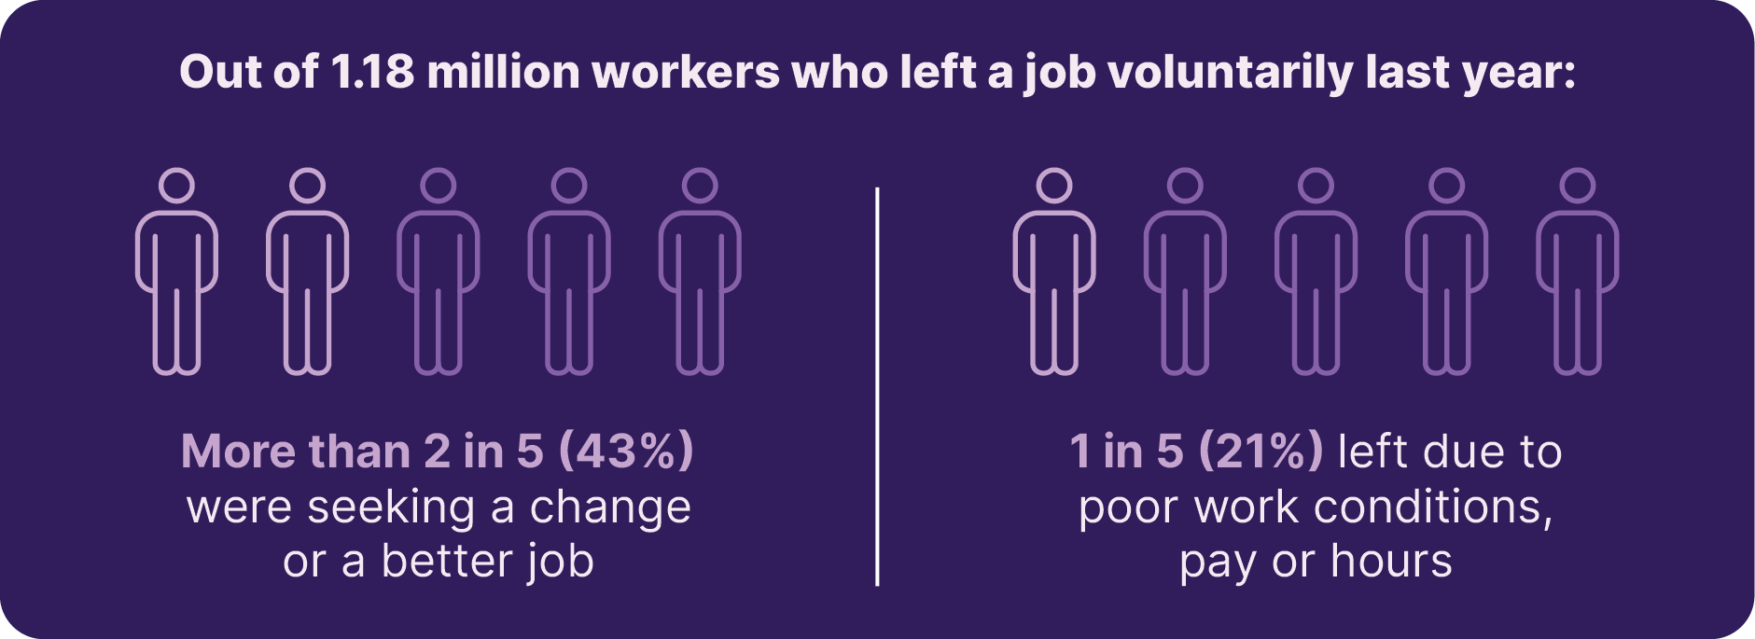
Source: ABS, Job Mobility, February 2026.

Retention will become as important as recruitment in high-demand sectors
In high-growth industries such as Health Care and Social Assistance, attraction, retention and progression are important to meet demand. In recent years, JSA analysis on occupation shortage drivers has found shortages in care and support roles are largely driven by retention gaps as opposed to long training gaps. Figure 21 shows that workers in this industry who change jobs are less likely to move to a different industry or occupation group, compared to workers who changed jobs in all industries. This suggests that retention strategies should focus not only on keeping workers in the sector, but on designing jobs with clear progression pathways, better use of skills and working conditions that support long-term workforce resilience.
Figure 21: Mobility and progression pathways are critical to retaining workers in health and care
Characteristics of people who changed jobs in the last 12 months in Health Care and Social Assistance compared to all industries, February 2025
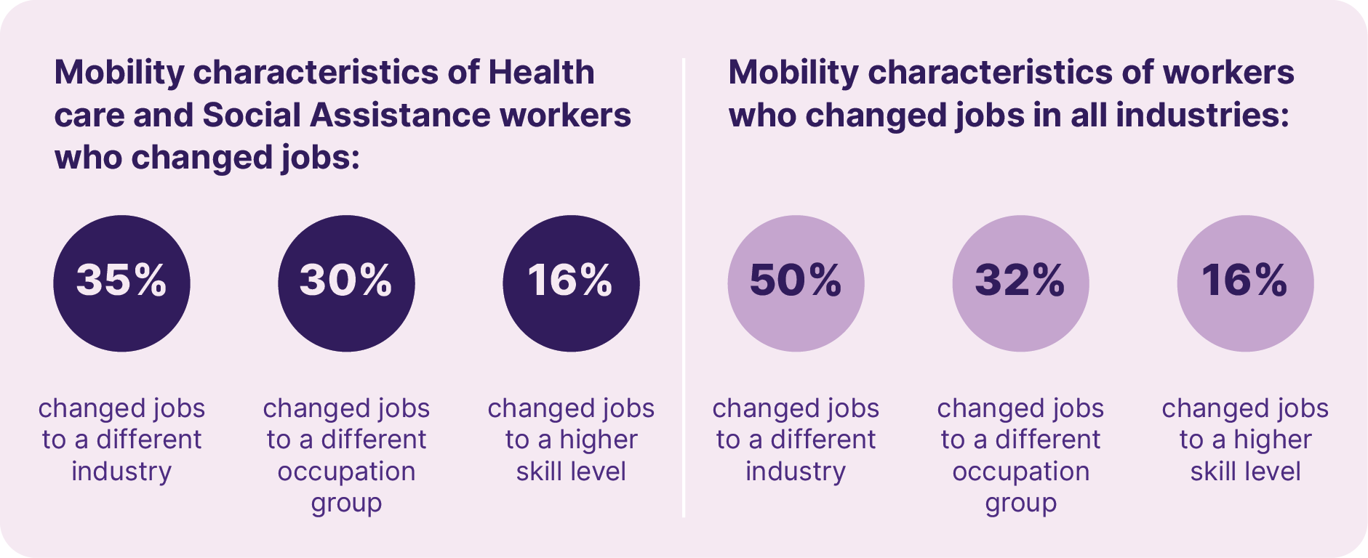
Source: ABS, Job Mobility, 2025. Table 4 Separations and other changes in employment of people employed last year. Data includes people employed in the Health Care and Social Assistance industry who changed jobs in the 12 months to February 2025.
Job design, particularly for care workers, may also need to align to the values of their workers. Aged care workers are one of the largest groups of workers within the industry, and the fastest growing cohort. The Aged Care Workforce Survey has revealed that the workforce is highly motivated by the values of their work, with a majority of respondents reporting that helping others and caring for the elderly as their primary motivation to work in the sector (DoHAC 2024).
As discussed in Chapter 1, the Health Care and Social Assistance workforce is characterised by relatively high rates of part-time work and high numbers of multiple job holding, particularly among women. In this context, meeting future workforce demand is not only about attracting more workers into the sector, but also about creating jobs that provide sufficient hours, clear progression opportunities and greater employment stability. Better job design can help retain workers, make fuller use of existing workforce capacity and support career development within the sector, reducing pressure on recruitment while strengthening workforce resilience particularly in high growth sectors such as health and care.

Inclusive job design can unlock underutilised workforce capability
How workforce demand is expressed through jobs also affects who can participate. Job location, hours, flexibility, recruitment practices and workplace design can either widen access to opportunity or reinforce existing barriers. In sectors experiencing persistent shortages, inclusive job design can help expand the effective labour pool while improving productivity, workforce resilience and equity. By introducing flexibility, adaptive workplaces and creating clearer progression pathways, employers can access a broader range of workers, including people with disability, First Nations Australians and others who may face barriers to employment (DCA 2026).

Better job design can support stronger employment outcomes for First Nations Australians
First Nations Australians represent a significant source of talent, capability and leadership for Australia's future workforce. While progress is being made towards the Closing the Gap employment target, employment rates remain below those of non-Indigenous Australians (Figure 22). The evidence suggests that employment outcomes are strengthened when labour market opportunities align community strengths and local aspirations with workforce demand. As demand grows across construction, engineering, care and other priority sectors, better job design, inclusive recruitment, and place-based pathways can help unlock underutilised capability. Such strategies support stronger participation, retention and long-term career development while addressing demand-side employment shortages by enabling stronger, First Nations-led economic activity and leadership, especially in regions with thin labour markets.
Figure 22: Australia is on track to meet its Closing the Gap employment targets, but there is still a long way to go
People aged 25 to 64 who are employed, by Indigenous status, 1991 to 2021
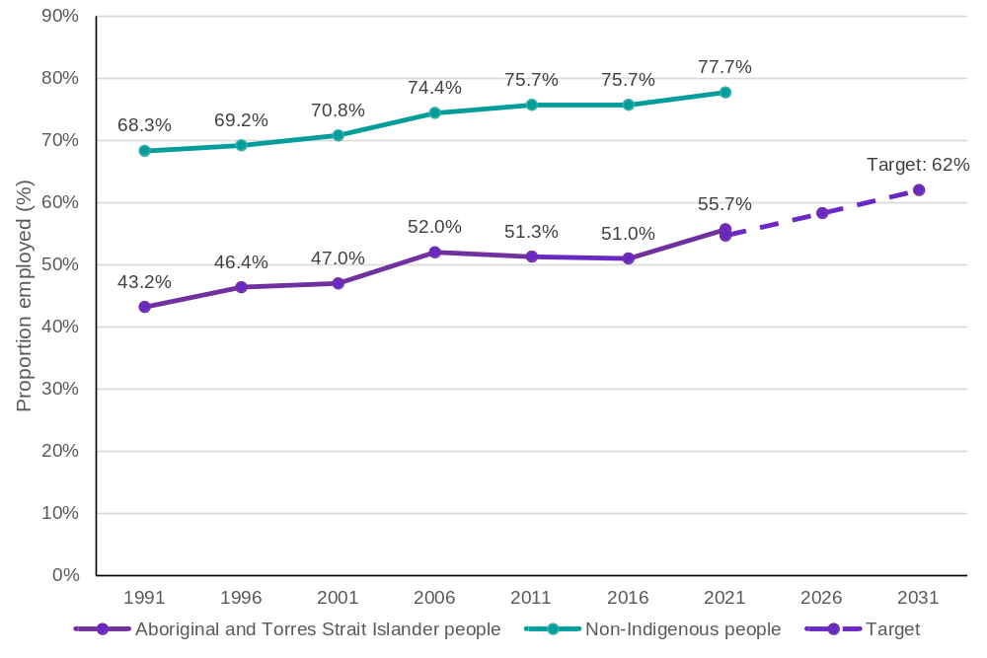
Source: Productivity Commission, Closing the Gap dashboard, 2025.ABS, Census of Population and Housing 1991 to 2021.

People with disability represent an underutilised source of workforce capability
Job design which enables employment of people with disability is a significant opportunity to expand labour supply and make future growth more inclusive. Around 1 in 6 Australians of working age are people with disability, and JSA analysis of the ABS Survey of Disability Ageing and Carers identified that in 2022 there were 260,000 people aged 15 to 64 years old with disability who were not employed but potentially job ready (ABS 2022; JSA 2026a). However, as seen in Figure 23, the labour market characteristics for working age people with disability remain weaker than for those without disability.
Figure 23: People with disability represent an underutilised source of workforce participation
Labour Market indicators of people aged 15 to 64 with disability compared to those without disability, 2022
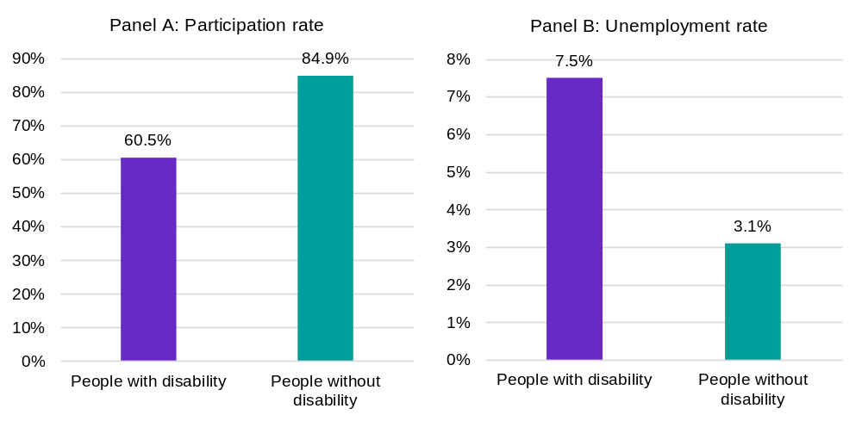
Source: JSA, Employment and disability in Australia, 2026. ABS, Survey of Disability, Ageing and Carers, 2022.

Looking ahead: Demand-side levers can help close workforce gaps
Well-designed jobs impact both demand and supply within the jobs and skills system. Meeting future labour demand will depend not only on the number of workers available, but on whether jobs are designed to be productive, attractive and inclusive. This chapter highlights that projected growth, persistent shortages and major investment are converging around construction, engineering, care, technology and energy-related occupations. Responding to these pressures will require more than expanding skills pathways. Attractive and well-designed jobs can help address workforce pressures in sectors experiencing shortages by more effectively utilising the skills of workers and expanding opportunities to those who face barriers to participation.
Box 6: Apprenticeships and traineeships integrate jobs and training
Apprenticeships and traineeships are distinctive because employment and training are integrated within a single pathway. Apprentices and trainees develop their skills on the job while working towards a formal qualification, meaning outcomes depend on the quality of both the workplace and the training experience. The Organisation for Economic Co-operation and Development (OECD) identifies apprenticeships as a form of work-based learning in which employers, workers, education systems, governments and informal networks all play a role in creating effective learning experiences (OECD 2018).
Although not exclusive to young people, apprenticeships and traineeships play a particularly important role in creating entry-level employment opportunities, including those without formal qualifications or who have not completed school. As both a job and a training pathway, apprenticeships provide a structured route into the labour market while supporting the development of occupational skills. Apprenticeships can help reduce the risk of long-term labour market disengagement by providing young people with a direct pathway into work and training. In 2025, around 8% of young people were not engaged in any employment, education or training (NEET), highlighting the continuing importance of accessible pathways that support participation in both work and learning (ABS 2025a). This may be particularly relevant in regional Australia, where youth disengagement remains higher than in major cities and apprenticeship and trainee completion rates, while declining over time, remain comparatively stronger (ABS 2026c; NCVER 2026a).
Growing apprenticeship supply requires a dual focus on job creation and job quality. Additional commencements are only achieved when apprenticeship opportunities are created by employers, and commencements only translate into skilled workers if apprentices are supported through to completion. A future-focused apprenticeship system should treat employers as central partners in creating apprenticeship opportunities that place greater emphasis on job quality, safety, supervision and design. The OECD highlights the importance of ensuring a good learning experience at work, while the Strategic Review recommends reforms to improve the experience for both employers and apprentices and to support high-quality apprenticeships.
The experience of work is central to supporting apprenticeship completion because apprentices and trainees remain workers throughout their training journey. Policies should therefore focus on the design and availability of the job as well as the formal training. The Strategic Review of the Australian Apprenticeship Incentive System found non-financial factors such as workplace safety, apprentice wellbeing, perceptions of VET and system inefficiencies as important influences on outcomes. The final report also emphasised the need for high-quality apprenticeships that deliver quality employment and training in safe and respectful workplaces.
In 2026-27, JSA will publish new research on the types of non-financial supports that enable quality apprenticeship pathways, alongside new data on the role of employers in creating training capacity within trade pathways.

Skills supply – building and using workforce capability
For more information on JSA’s research and analysis on the
themes discussed in this chapter, please scan the QR code


Key themes in this chapter
Skills supply is essential. Its value depends on whether it aligns with changing job requirements and whether the capabilities formed are recognised and used effectively at work.
Australia has an opportunity to lift skills supply given the large youth cohort moving into tertiary education and strong tertiary outcomes over the next decade. This is complemented by skilled migration. The skills supply system needs active management to meet future demand. The matching of supply and demand is constrained by pathway choices, unmet adult learner demand, uneven skills utilisation and VET system capacity. The priority is therefore not only expanding supply, but aligning pathways, improving skills development and use in workplaces, and ensuring the VET and tertiary systems have the workforce, provider capability and governance needed to turn investment into real skills which are productively utilised.
The key JSA findings are:
- Australia retains multiple strong sources of skills supply through higher education, VET and skilled migration. A larger cohort of learners, strong participation in higher education and VET, and skilled migration are all contributing to a growing supply of skills. Together, these pathways provide Australia with an opportunity to strengthen workforce capability and meet emerging labour market needs.
- Some adults who want to undertake education and training face barriers related to time, cost and flexibility. As population growth slows and workforce needs evolve, reducing these barriers will be important to unlocking additional domestic skills supply and supporting lifelong learning particularly in the workplace context.
- Higher education, VET and skilled migration all make important and complementary contributions to national skills supply. Each pathway plays a distinct role in developing workforce capability. Higher education supports entry into high-skilled occupations, VET provides applied and job-connected skills across the economy, and migration complements domestic supply by addressing specific skilled workforce needs.
- Existing skills pathways generate strong employment outcomes, however more analysis is required to understand how qualifications meet with workforce needs. Education and training continue to deliver positive labour market outcomes for learners; however, the benefits of these pathways depend on whether acquired capabilities are effectively utilised in workplaces and translated into productive work.
- Recognising the skills people already possess is important for understanding supply within the system. A responsive skills system depends not only on developing new skills, but also on identifying and recognising the skills already available in the workforce. This supports better matching of workers skills and jobs, and enables the economy to make more effective use of existing capability.
- Building future capability will require a responsive skills system supported by strong stewardship, workforce capability and adaptable qualifications. Future workforce needs will depend not only on investment in skills, but on the ability of the system to respond to changing demand. Effective stewardship, a sustainable VET workforce, and qualifications that balance flexibility with occupational relevance will be critical to ensuring the skills system remains responsive and fit for purpose. The baseline NSA Balanced Scorecard shows VET is delivering value, however there are areas for improvement.

Australia’s skills pipeline
Australia’s skills pipeline is supported by VET, higher education and skilled migration. The potential of a skilled workforce is increasing with a growing cohort of school leavers entering the skills pipeline over the next decade. Tertiary education will be an important pillar to prepare this cohort for the skilled jobs of the future. In 2024, there were more than 400,000 domestic commencements in a higher education degree, and in 2025 there were more than 1.5 million domestic commencements in a VET program (NCVER 2026c; Department of Education 2025). However, growth in supply does not automatically translate into capability where it is most needed. Future workforce outcomes will depend on how learners move through higher education and VET, whether barriers to participation limit the development of new skills and whether effective migration pathways bolster the skills Australia needs.
Beyond training delivery, there is also a need to focus on job-readiness of workers, especially new labour market entrants. On these issues, persistent drivers of shortage can be used to target policies to deliver a sustainable workforce. From 2023 to 2025, a lack of qualified workers was the key cause of shortages. Many large employing occupations such as health, teaching, construction and trades related roles experienced below average number of qualified applicants per vacancy (JSA 2026f).
Understanding the factors shaping these pathways is critical to assessing whether future supply is aligned with the demand pressures identified in the previous chapter.

A large cohort of school leavers is flowing through with a plateau on the horizon
Australia’s near-term skills supply is being lifted by a large youth cohort, but this demographic boost is temporary and is not flowing evenly across post-school pathways.
This demographic boost is temporary. Figure 24 shows the number of 20-year-olds rose by around 40,000 between 2022 and 2025 and is projected to grow by a further 39,000 by the start of the next decade. After that, record-low fertility rates mean growth is expected to slow and eventually plateau. The question remains as to whether this larger cohort is moving into the pathways most able to meet future demand, with current evidence pointing to a growing preference for higher education over VET. With demand expanding across jobs with both VET and higher education pathways (Chapter 2), consideration needs to be given as to how new entrants can navigate the skills system into quality and productive jobs. The future entrants to the labour market may not be simply making a choice of one or the other, but when and how to access education and training across both systems.

Figure 24: Australia is on the verge of experiencing a large growth in school leavers - caused by the baby boom of the early 2000s
Actual and projected growth of the number of 20 year olds between 2013 to 2035
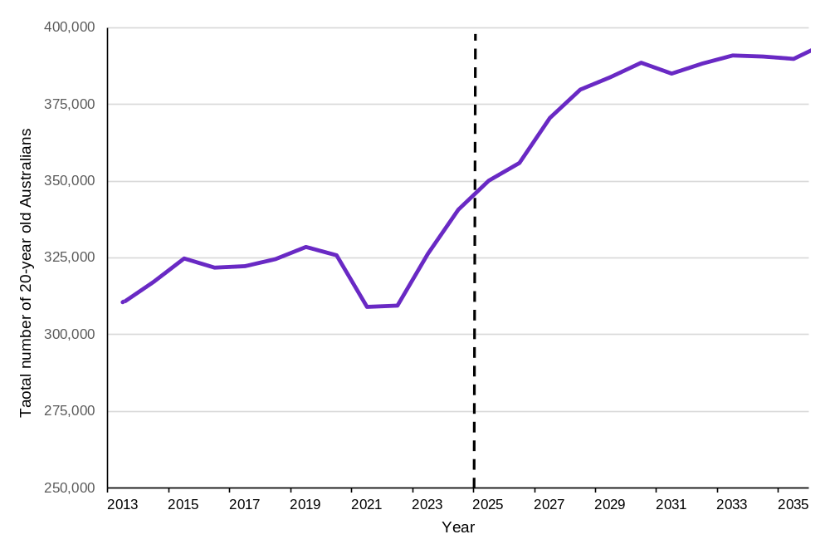
Source: ABS, Treasury Centre of Population.

School leavers have a strong preference for higher education pathways
The current larger youth cohort is not flowing evenly across post-school pathways. Figure 25 shows that among 15 to 24 year-olds currently studying a post-school qualification, more than two-thirds are enrolled in a bachelor degree or higher (‘higher education’), compared with just under 1 in 4 studying VET at Certificate III or above.
This matters because future skills supply will depend not only on the size of the youth pipeline, but on whether learners can access the pathways that match both their goals and labour market demand.

Figure 25: Among young Australians who are currently studying, more than 2 in 3 are studying a higher education degree compared to just under 1 in 4 studying VET at Certificate III or higher
Distribution of 15 to 24 year olds in post-school study by level of education, 2025
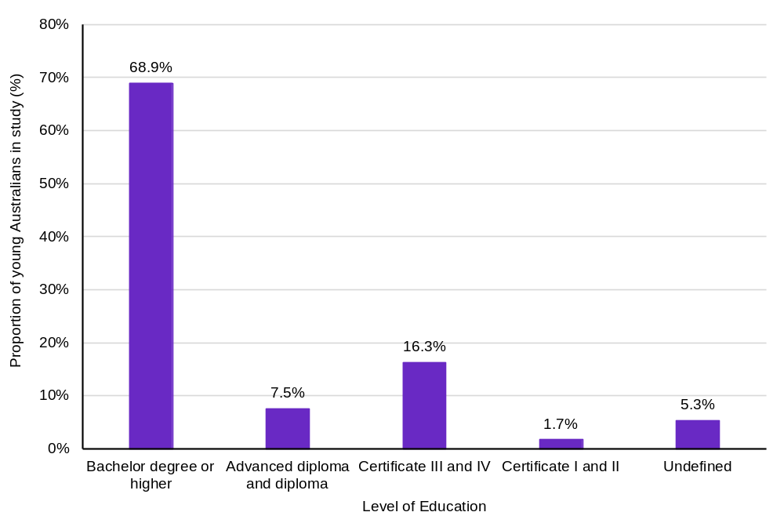
Source: ABS Survey of Education and Work, 2025.

There is unmet demand for tertiary education with time and cost the biggest barriers to participation
Unmet demand for tertiary education is limiting the system’s ability to turn learner intent into skills supply, with time the most significant barrier. Figures 26 and Figure 27 show that around 40% of adults who wanted to undertake tertiary education or study did not participate in 2024‍–‍25. The age distribution of unmet need varies depending on the sector (VET or higher education) with Figure 26 highlighting that unmet demand for higher education increases more with age. Both figures suggest that the unmet demand for VET and higher education is slightly higher in men compared to women.
The barriers to participation in formal study are mostly related to time available and cost. According to the ABS, ‘too much work/not enough time’ is the most reported barrier to participation, and this was similar with those wanting to study below a bachelor level and those wanting to study a bachelor degree or higher (48%) (ABS 2026b). Financial reasons was also a common barrier reported by those wanting to study, however this was higher in those wanting to study a bachelor degree or higher (40%) compared to those wanting to study below a bachelor degree level (30%) (ABS 2026b).
These barriers matter because adult learners will become increasingly important as demographic growth slows and pathway preferences shift. Addressing barriers related to flexibility in learning and costs may be important to increase the pipeline of adult learners to re-skill and upskill in a fast-changing labour market (JSA 2026c). If domestic supply cannot fully meet future demand, skilled migration will remain an important complementary source of capability, provided it is aligned to areas of persistent need. This demographic shift will have impacts on the composition of the workforce into the future. The existing workforce will need to be more adaptable to future skills needs with greater emphasis on lifelong learning.
Figure 26: Unmet demand for VET has increased slightly over the last 4 years, with more than 2 in 5 adults unable to participate in VET
Share of unmet demand for VET qualifications for adults by gender and 10-year age group, 2020-21 and 2024-25
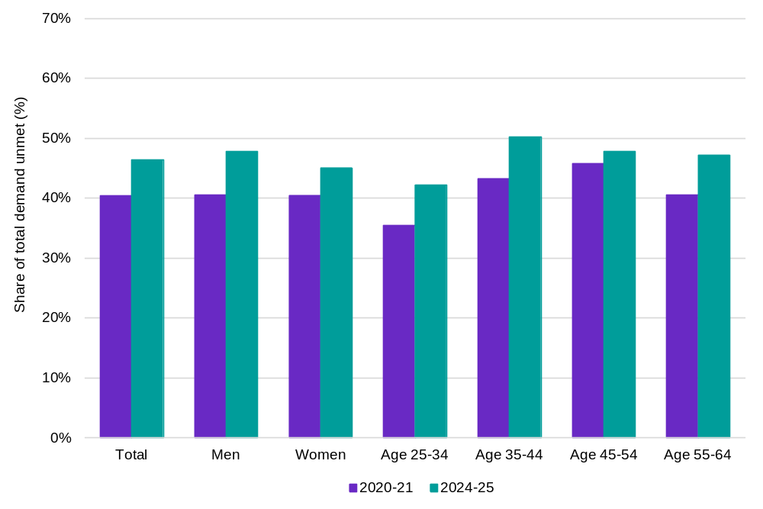
Source: JSA analysis of ABS work-related training and adult learning survey, multiple releases.

Figure 27: The unmet demand for higher education increases as adults get older with time being the biggest barrier to participation
Share of unmet demand for higher education qualifications for adults by gender and 10-year age groups, 2020-21 and 2024-25
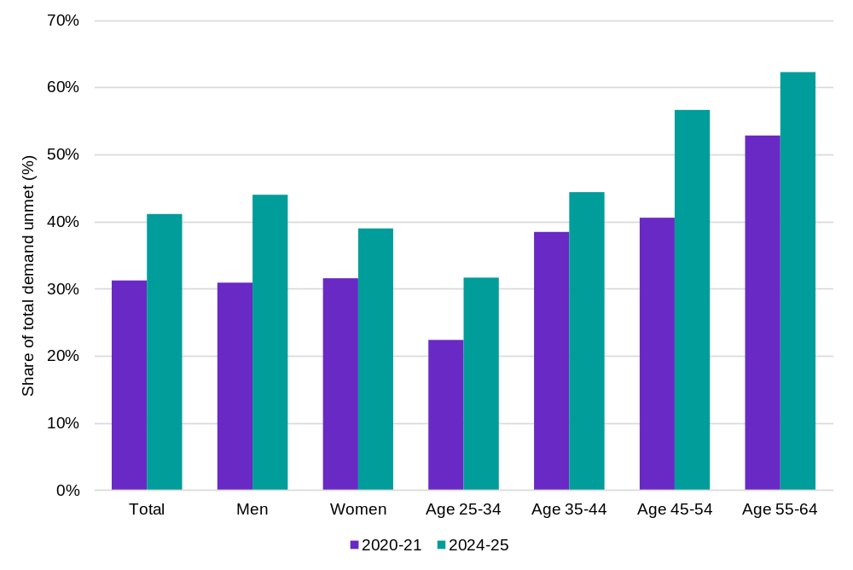
Source: JSA analysis of ABS work-related training and adult learning survey, multiple releases.

The tertiary system is producing positive outcomes for learners and employers, but utilisation of the skills formed remains uneven
The pipeline is producing positive outcomes, but utilisation remains uneven. Higher education, VET and skilled migration all contribute to workforce capability, but outcomes vary across learner groups, fields, occupations and pathways. Skills generate productivity only when workers can apply their capabilities in suitable jobs safely with autonomy, complexity and progression (OECD 2017).

Higher education delivers strong employment outcomes. However, graduate earnings still lag behind inflation
Higher education continues to deliver strong employment outcomes with the latest Graduate Outcomes Survey finding that within 4 to 6 months, around three-quarters of domestic undergraduates are in full-time employment with a median annual salary of $77,000 (QILT 2026). Compared to the 2016 survey, this represents a median annual salary growth of almost $20,000 or 33% (QILT 2026).
Additionally, JSA research has found that the employment and earnings return also increases for adults who complete undergraduate qualifications later in life, but salary growth has not kept pace with inflation across qualification levels (JSA 2026g). Figure 28 shows median full-time salaries for graduates aged over 30 have grown since 2019, alongside sustained employment gains. This suggests higher education is strengthening labour market attachment and earnings, but the real value of these gains is being constrained by broader cost pressures. This may be a compounding factor to other issues related to skills mismatches, job satisfaction post-training and prospects of career deepening.
Figure 28: Higher education delivers sustained employment and earnings gains for undergraduates over 30, however this has lagged inflation for graduates over 30 regardless of qualification level
Growth in median annual full-time salaries of graduates relative to growth in the Consumer Price Index (CPI) (2019 = 100)
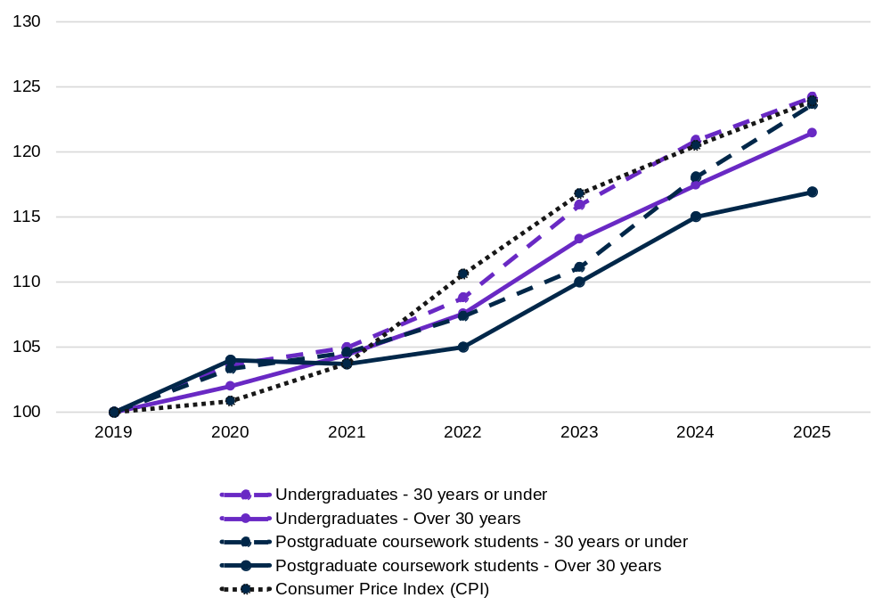
Source: JSA analysis, QILT Graduate Outcome Survey; ABS Consumer Price Index 2019-2024, Australia.

Higher education supports entry into high skilled work, but recent graduates may not be fully utilising their skills
Higher education supports entry into high skilled work, but the productivity return depends on whether graduates can use their capabilities in their roles. Figure 29 shows only a little over half of graduates and employers rated qualifications as important or very important for current employment. However, this does not necessarily mean graduates are not using the skills they gained through higher education. A qualification may not be directly required for a job, while the skills developed through study may still be useful. This is important in a labour market where the focus is increasingly on the skills people bring to a job rather than qualification alone (discussed further in Chapter 5). Based on the most recent Graduate Outcomes Survey, for graduates who reported not fully using their skills and knowledge, about 9% of graduates reported being satisfied with their current job as a main reason for not being in a job that fully uses their skills and knowledge. However, it should be noted that the Graduate Outcomes Survey only captures sentiment of graduates and their employers 4 to 6 months after graduation and may not fully capture overall utilisation of skills beyond this timeframe. The perception of the use of graduate skills differs between graduates and their employers. As seen in Figure 29, employer perceptions of skills utilisation for recent graduates are higher than the graduate perception, however this has remained relatively stable since 2019.
Figure 29: A persistent gap exists between graduates and supervisors in perceptions of the importance of qualifications for current work
Proportion of supervisors and recent graduates who consider qualification important or very important for their current employment, 2025
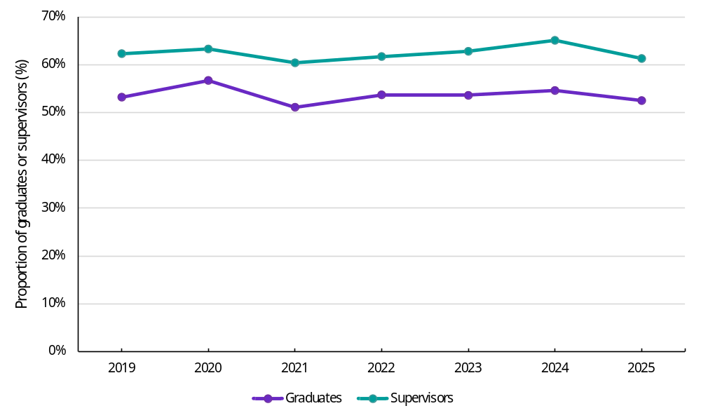
Source: JSA analysis, QILT Employer Satisfaction Survey 2019-25.

VET improves employment and earning outcomes, particularly for cohorts who have been historically disadvantaged
While young people are increasingly favouring higher education, VET remains critical to broadening labour market opportunity and strengthening participation for cohorts who have faced disadvantage (ABS 2025a). Figure 30 and 31 show VET completion is associated with higher income and reduced reliance on income support across selected cohorts, highlighting its role in improving employment and earnings outcomes beyond traditional school-leaver pathways.
Figure 30: VET completion is associated with substantial earnings gains across selected cohorts, with particularly strong income gains for First Nations completers
Change in income after completion of a VET qualification by selected cohorts, 2022-23 VET completers
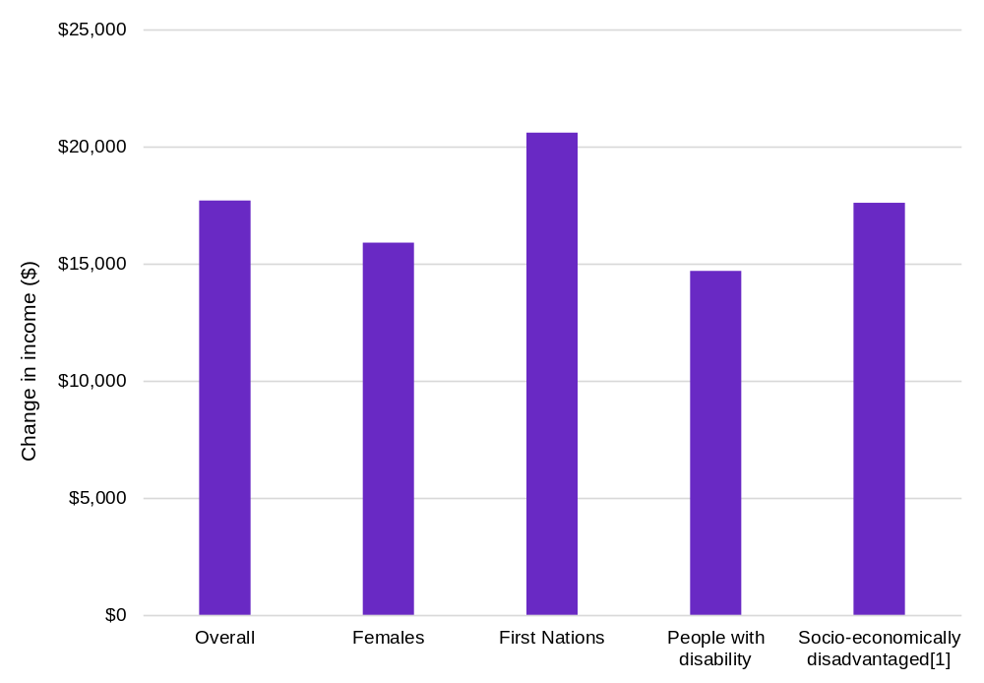
Source: JSA analysis, VET National Data Asset (VNDA), 2026 release (2022/23 VET completers). Note: A full release of this data is expected in late 2026. [1] “Socio-economically disadvantaged” refers to the socio-economic status (SES) quintile 1 from the ABS Index of Relative Socio-Economic Disadvantage (IRSD).
As seen in Figure 30, First Nations VET completers recorded a larger income increase than the overall cohort, indicating the potential of applied, job-connected training to strengthen earnings. However, the income-support exit rate for First Nations completers was below the overall rate (Figure 31). Together, these findings suggest that while training can deliver substantial benefits, post-training outcomes are also shaped by labour market opportunities, workforce participation, inclusive practices and broader economic conditions. While VET remains a critical pathway into economic participation, student outcome measures should be considered alongside how acquired skills are being used effectively in jobs post-training.
Figure 31: More than 2 in 5 VET completers who were on income support prior to commencement, exited income support on completion
Income support exit rate after completion of a VET qualification across selected cohorts, 2022-23 VET completers
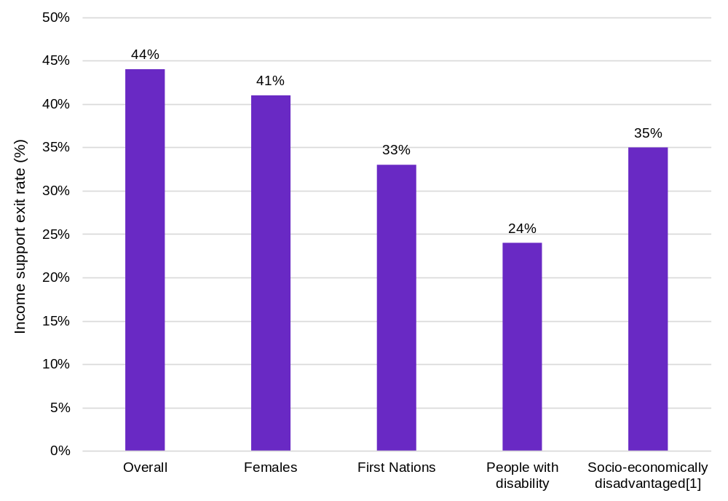
Source: JSA analysis, VET National Data Asset (VNDA), 2026 release (2022/23 VET completers). Note: A full release of this data is expected in late 2026. [1] “Socio-economically disadvantaged” refers to the socio-economic status (SES) quintile 1 from the ABS Index of Relative Socio-Economic Disadvantage (IRSD).

VET can be a pillar for lifelong learning, but available outcome measures reveal less about how acquired skills are used for older learners
VET supports strong job-relevant outcomes, but current measures provide only a partial view of whether acquired skills are being fully used particularly among older graduates over 25. Figure 32 shows almost 9 in 10 graduates over 25 studying for employment-related reasons reported their training was relevant to their post-training job, however like the Graduate Outcomes Survey for higher education, the VET Student Outcomes Survey captures individual perception and does not show utilisation by field of study, occupation or task complexity (NCVER 2026e).
From the employer perspective, National Centre for Vocational Education Research (NCVER) data shows that about 3 in 4 (74.3%) employers were satisfied with vocational qualifications as a job requirement (NCVER 2025a). However, for employers that were not satisfied, 39% reported that the ‘relevant skills were not taught’, however this was an improvement from 2023, where this was more than half (53%) of the reported reasons for dissatisfaction. Other reasons also included ‘training is of a poor quality or low standard’ (54%), and ‘not enough focus on practical skills’ (24%) (NCVER 2025a).
This means VET outcomes should be interpreted as positive but with incomplete evidence of skills use. Better measures are needed to show how training translates into capability in different fields, jobs and workplaces. Nevertheless, previous chapters have demonstrated that the future of the labour market is evolving rapidly and raised the importance of job to skill alignment and lifelong learning. This can be achieved through strengthening system responsiveness, including governance, teaching capacity and adaptable qualifications.
Figure 32: The utilisation of VET remains high, with almost 9 in 10 graduates reporting their qualifications are relevant to their jobs
Share of adults who reported that their training was highly or somewhat relevant to their post-training job
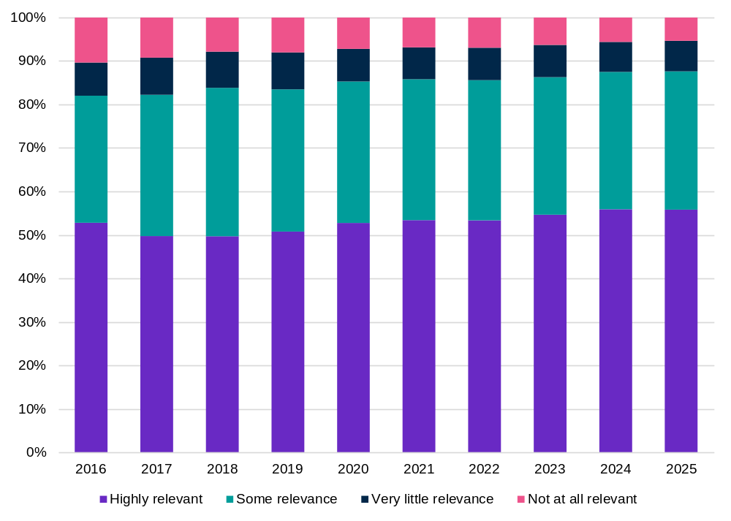
Source: JSA analysis, NCVER, VET student outcomes, VOCSTATS, 2016-2025. Note: Data filtered to include only those with employment-related reasons for study.
Box 7: Gendered differences in skills utilisation
In 2025, JSA completed a landmark Gender Economic Equality Study which examined the gendered nature of work, pay, jobs and education, skills and training in Australia. The study found that around 1 in 3 women (33%) were working in occupations below their skill potential compared to around 1 in 4 men (27%). Skills mismatches were highest among those who completed a qualification at the Australian Qualifications Framework (AQF) 5 or 6 level (equivalent to a Diploma or Advanced Diploma), with just under a half of females with these qualifications working below their skill potential compared to 41% of men (JSA 2025a).

Temporary skilled migration is helping to address labour market shortages
Employer sponsored temporary skilled migration is helping to address occupational shortages in the labour market. Department of Home Affairs data and JSA analysis show that recent Skills in Demand (SID) primary visa grants are concentrated in higher skilled occupations, with 98% of primary visa grants under the Specialist Skills Stream (the higher income threshold stream of the SID visa program) going to managers or professionals, and around 89% of primary visa grants under the Core Skills Stream (the standard income threshold stream of the SID visa program) going to professionals or technicians and trades workers (Figure 33) (JSA 2026h). Figure 34 shows primary employer-sponsored temporary skilled visa grants have continued to rise since Australia’s borders reopened (post COVID-19), reinforcing the role of temporary skilled migration as a complementary source of supply when domestic pathways are not fully meeting demand for suitably skilled and experienced workers.
Figure 33: Specialist Stream SID visas are concentrated in professional occupations as well as high growth sectors such as Health Care and Social Assistance
Top five industries by Specialist Skills Stream visa grants compared to the TSS.
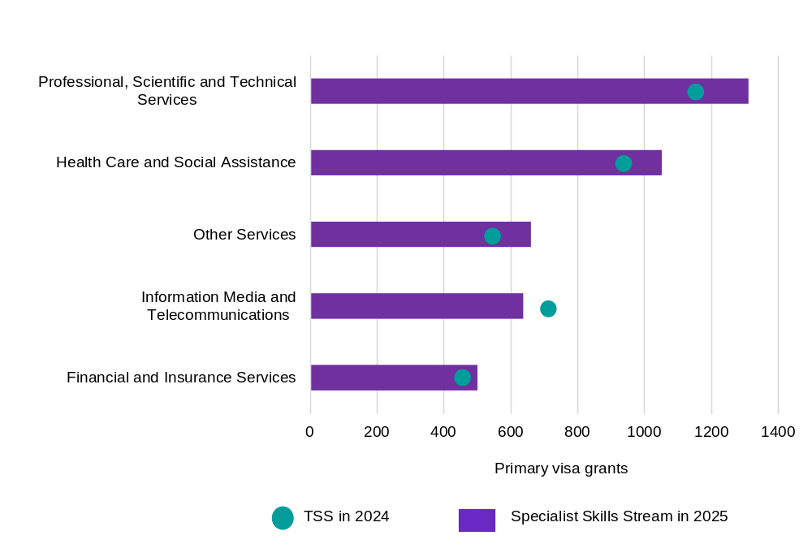
Source: Department of Home Affairs Pivot Table: Temporary Resident (Skilled) visas granted to 30 September 2025 – (accessed 14 November 2025 from www.data.gov.au) and Department of Home Affairs Unreleased Visa Grant Data: Temporary Resident (Skilled) visas granted to 30 June 2025. Note: Asterisk (*) indicates TSS visa grants were filtered to nominated yearly salaries over $135,000 to provide an appropriate point of comparison to the Specialist Skills Income Threshold (SSIT) for the time period. Major Groups 3, 7 and 8 have been excluded.
Figure 34: Primary temporary skilled visa grants continued an upward trend since the opening of Australia’s international borders following the pandemic
Primary Subclass 457 and 482 Visa Grants since January 2022 by Occupation List including the Skilled Migration Occupation List (SMOL) and the Core Skills Occupation List (CSOL)
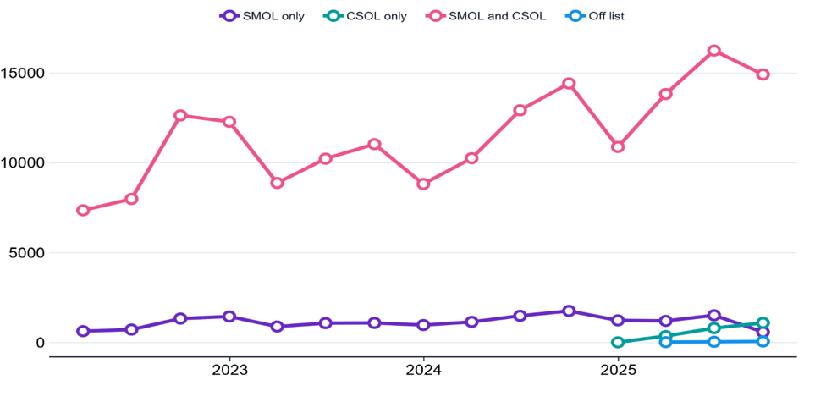
Source: JSA analysis, Department of Home Affairs Pivot Table: Temporary Resident (Skilled) visas granted to 30 September 2025 – (accessed 14 November 2025 from www.data.gov.au). Labour Agreement visa grants excluded. Note: Subclass 482 includes visas granted under all streams of both the Temporary Skill Shortage (TSS) and SID visa programs.

VET system responsiveness depends on coordinated action, teaching capacity and adaptable qualifications
System responsiveness will depend less on funding alone and more on whether investment is converted into measurable improvements in delivery, capacity and learner outcomes. National stewardship has strengthened the foundations, but the system must address VET workforce constraints and ensure qualification reform can be delivered by capable providers. Without those conditions, stronger governance and more flexible qualifications may not translate into the skills employers need or workers can use.

The National Skills Agreement implements an ambitious model of shared stewardship and action
The National Skills Agreement (NSA) commenced in 2024 and established shared priorities, stewardship arrangements, outcome measures and reforms to improve Australia’s VET system. Consistent with the scale of the reform ambition, the first two years of the NSA have focused on establishing the architecture, governance and implementation plans required to support longer-term change, including work on Closing the Gap, foundation skills, TAFE Centres of Excellence, the National TAFE Network, VET workforce capability, improved data and evidence, and lifting completions.
JSA published the baseline National Skills Agreement Balanced Scorecard in August 2026. It provides a baseline view of how the VET system is performing against the outcomes agreed by governments going into the NSA. It should be noted that some of these metrics were from a period before or at the start of the NSA reform measures. Therefore, this should be read as a starting point for reform, not as an assessment of the impact of the NSA itself.
The baseline scorecard’s central message is that VET is delivering clear value for learners and the labour market, but system performance was uneven going into the Agreement. Graduate outcomes are strong with VET completers experiencing substantial income gains, higher employment rates, stronger exits from income support and increased progression to further study. There are also signs that training activity is better aligned to workforce demand. Completions aligned to occupations in national shortage increased from around 370,000 in 2020 to around 467,000 in 2024, and course completions linked to NSA national priorities increased from around 193,000 to around 279,000 over the same period. Skills shortages in occupations with a VET pathway also eased, falling from 33% of assessed VET-pathway occupations in national shortage in 2023 to 27% in 2025.
The scorecard also provides a baseline for monitoring progress under the Agreement over time. While employer satisfaction with nationally recognised training arranged by employers has declined, and student satisfaction has softened slightly, broader measures such as participation, completion rates and subject load pass rates reflect the time required for system-wide reforms to translate into measurable improvements. These results reinforce the importance of the reforms underway to strengthen the relevance, quality, learner experience and credibility of nationally recognised training.
The baseline NSA Balanced Scorecard shows VET is delivering value, but performance remains uneven across the system. While governments are progressing significant reforms to strengthen responsiveness and outcomes, these changes will take time to embed and deliver measurable impact. Sustained focus and investment will be required to ensure reforms translate into improved performance and a more adaptable skills system over the longer term.
Employment outcomes have improved across priority cohorts, and there are positive signs for First Nations learners in some foundation skills measures and post-training income gains. But substantial gaps remain going into the NSA. Completion rates are lower for First Nations learners and people with disability, income support exits are much lower for people with disability, and Closing the Gap education and training outcomes are not yet on track to meet 2031 targets.
Overall, the baseline points to four priorities for the period to 2028:
- Build confidence in nationally recognised training by strengthening relevance, quality, credibility and employer satisfaction.
- Improve learner progression by lifting completion, subject success, student experience and foundation skills, particularly for priority cohorts.
- Target skills supply where training gaps are a genuine constraint, while recognising that attraction, retention and job design require broader employer and policy action.
- Strengthen the evidence base so future scorecards can distinguish implementation activity from measurable improvements in learner, employer, community and economic outcomes.
Table 1 shows baseline performance against selected National Skills Agreement outcome measures and the improvement targets set for 2028, including employer satisfaction, student satisfaction, participation, post-training outcomes and improved employment circumstances.

Table 1: National skills investment strengthens system capacity, but clear and measurable outcomes can help guide how the system should respond - Summary table of select measures, current performance and targets in the balanced score card for NSA outcomes framework
Measures | Baseline performance | Minimum set target for 2028 | Percentage points (ppt) improvement to meet minimum target | Current national direction
Employer satisfaction (nationally recognised training arranged by the employer) (measure 5.1, 7.1, 8.1) | 2025: 76.1% | 80.5% | 4.4ppt | From 2023:  2.4ppt
Student satisfaction with training (measure 6.1, 8.2) | 2025: 84.6% | 87.7% | 3.1ppt | From 2024  0.8ppt
Subject load pass rate (measure 6.3) | 2024: 80.7% | 82.7% | 2ppt | From 2023  No change
Improved numerical skills (measure 6.7) | 2025: 50.2% | 50.6% | 0.4ppt | From 2024  1.3ppt
Improved writing skills (measure 6.8) | 2025: 51.2% | 52.3% | 1.1ppt | From 2024  0.7ppt
Developed problem-solving skills (measure 6.9) | 2025: 78.4% | 79.6% | 1.2ppt | From 2024  0.1ppt
Participation rate in VET programs (measure 7.5) | 2024: 10.8% | 13.4%  * Stretch | 2.6ppt  *Stretch | From 2023  0.4ppt
Employed or in further study after training (measure 7.7) | 2025: 80.9% | 85.5% | 4.6ppt | From 2024  0.9ppt
Improved employment circumstances after training (measure 8.3) | 2025: 58.5% | 66.1% | 7.6ppt | From 2024  1.5ppt
Source: JSA, NSA Outcomes Framework Balanced Score Card: Baseline Report, 2026.
The table reinforces that NSA reforms are built on strong foundations but start with uneven momentum. Some capability measures, including foundation skills indicators, are moving in the right direction, while employer satisfaction, participation and post-training outcomes have softened against recent benchmarks. This underlines the importance of treating the scorecard as an accountability and learning tool: not only tracking whether reforms are being implemented, but whether they are translating into improved learner outcomes, employer confidence and workforce capability.

A constrained VET workforce may limit the system’s ability to expand supply in priority occupations
Continued attention on the VET workforce is required to avoid a critical bottleneck in expanding supply, especially in priority occupations where training demand is expected to grow. Table 2 shows the challenge. JSA research has found that VET Teacher numbers have declined and around 3,800 additional teachers are projected to be required (JSA 2024c). JSA research found that almost half the workforce is aged 50 or over suggesting this is an ageing workforce that will need a strong pipeline of new entrants as more retiring teachers leave the sector. However, the number of completions in Certificate IV in Training and Assessment, which is the most used training pathway, have fallen by almost 25% between 2016 and 2021.
Workforce pressures extend beyond teacher shortages alone. VET providers also rely on teachers who maintain simultaneous employment in industry. While these arrangements keep training connected to industry practice, they can also create workforce challenges where teaching roles are secondary to industry employment. These pressures mean responsiveness will depend on renewing and expanding the VET teaching pipeline, improving retention and building capability for digital, blended and work-integrated delivery. These actions are currently underway as part of the National Skills Plan and the VET Workforce Blueprint National Actions (DEWR 2025a; DEWR 2024b). Without sufficient workforce capacity, more flexible qualifications may not translate into more flexible training, making provider capability central to the next stage of reform.
Table 2: VET workforce renewal is essential to expanding skills supply
Workforce pressure | Evidence
Insufficient teacher supply | Teacher numbers declined by 11%–18%; around 3,800 additional teachers are projected to be required.
Ageing workforce | 46.5% of the VET workforce was aged 50 or over.
Weak entry pipeline | Decline in Certificate IV in Training and Assessment completions with most graduates studying for an existing role.
Pay and retention pressures | Workers leaving VET teaching often move to a higher paying job in another education role.
Changing delivery requirements | Growth in digital, blended and work-integrated learning requiring flexibility in teaching methods.
Limited workforce intelligence | No regular comprehensive national workforce data collection.
Sources: JSA, VET Workforce Study, 2024.
JSA’s research highlights a significant opportunity to strengthen the VET system by building a larger, more culturally capable and community-connected workforce. While the First Nations VET workforce grew by 18 per cent between 2016 and 2021, faster than the workforce overall, First Nations people remain underrepresented in VET roles, accounting for around 2 per cent of the workforce compared with 2.2% of the total Australian workforce and 3.8 per cent of the Australian population (JSA 2026b). Increasing First Nations representation offers an important opportunity to better reflect and respond to the needs of Aboriginal and Torres Strait Islander learners and communities, while also supporting broader workforce and skills objectives.
The evidence shows that culturally responsive, First Nations-led approaches can improve learner engagement and completion outcomes, with Aboriginal and Torres Strait Islander learners often achieving better results when taught by First Nations educators. Realising this opportunity requires a broader focus on workforce capability, including strengthening cultural capability among non-Indigenous practitioners, building trusted relationships between educators and learners, supporting community-based workforce models, and ensuring training environments are culturally safe and appropriate. When designed in partnership with communities and tailored to local cultural, language and geographic contexts, these approaches strengthen the capacity of the VET sector to deliver high-quality training, support First Nations skill development and labour force participation, contribute to Closing the Gap priorities, and help build local workforce pipelines, particularly in regional and remote Australia.

Progressing VET Qualification reform will support better labour market outcomes
Qualifications Reform agreed by the Skills and Workforce Ministerial Council in December 2024, commenced with changes to the Training Product Organising Framework in July 2025 (DEWR 2024a). Jobs and Skills Councils are applying the purpose-led model to Training Product Development activity. The success of qualifications reform over the long term will be assessed by whether learners complete, progress and use their skills across their careers, and whether employers have confidence that more flexible qualifications provide a more adaptable and resilient workforce.
Table 3 shows the new purpose-led model distinguishes qualifications for specific occupations, related industry roles and broader vocational or cross-sectoral learning, shifting the system from unit-first prescription toward qualification-first design with greater emphasis on transferable skills, foundation capabilities and applied knowledge (DEWR 2024a).
Table 3: Qualification reform shifts responsibility from detailed prescription to purposeful design and provider capability
Qualification types and descriptions of the purpose-led approach to qualification design as part of the new Training Package Organising Framework
Qualification Type | Purpose
Purpose 1 | Occupation maintains a level of specificity within Qualifications and Units of Competency and qualifications, for example necessary for safety or licensing requirements, particularly the integrity of the trades, and is unlikely to change substantially from the current approach.
Purpose 2 | Industry focuses on the development of Qualifications and Units of Competency that prepare learners for multiple, related occupations while retaining industry relevance.
Purpose 3 | Vocational Learning and Cross-sectoral provides additional opportunities for innovation in areas such as cross-industry skills, foundation skills and for models beyond Units of Competency, which deliver stronger educational outcomes for learners.
Source: DEWR, 2024.

Looking ahead
A temporarily larger youth cohort, strong tertiary outcomes and skilled migration are expanding the pipeline, but capability will only meet future workforce demand if skills are developed in the right areas, are accessible to learners, used effectively in work and supported by a responsive system. This requires a move towards a joined up tertiary education system that enables students to move between the VET and higher education sectors seamlessly and gain skills that meet labour market needs.

Skills pathways and enablers
For more information on JSA’s research and analysis on the
themes discussed in this chapter, please scan the QR code


Key themes in this chapter
Australia’s tertiary education system will continue to play an important role in providing workers the skills they need for today’s workforce and the jobs for tomorrow. It has the power to uplift individuals, communities and the economy. Skills pathways through tertiary education shape people’s movement into, through and between learning and work. Australia’s future workforce will depend on diverse and connected pathways across higher education and VET supported by completion, lifelong learning, place-based access and better transitions into employment. As technology, net zero, care and construction demand reshape labour market needs, formal qualifications remain critical to providing the foundation to work, further education and lifelong learning.
The key JSA findings are:
- Higher education and VET play complementary roles. JSA’s research on Higher Education Outcomes has found higher education qualifications can build broad, adaptable capabilities, while VET provides practical, occupation-specific skills that support workforce entry, progression and transition.
- Higher education pathways in Society and Culture, and Management and Commerce are more exposed to task change associated with generative AI. AI is likely to impact occupational pathways from broader higher education fields by augmenting tasks rather than fully automating them, increasing the importance of lifelong learning and adaptability.
- Apprenticeships remain central to housing, AI infrastructure, and Net Zero. Demand for construction and electrotechnology workers in housing and infrastructure for net zero and AI is increasing, but commencements in several construction and electrotechnology trades are softening.
- Supporting female apprentices in critical trades is a significant opportunity. Female participation in construction and electrotechnology apprenticeships is rising, creating an important workforce opportunity.
- Completion matters as much as commencements. VET qualification completers generally report stronger employment outcomes than part-completers, although partial completion can still report improved labour market outcomes.
- Pathways between higher education and VET will increase in importance. As Australians work longer, there will be increasing need for effectively reskilling and upskilling to keep up with a changing labour market.
- VET and adult community education (ACE) can be an enabler to uplift cohorts who have experienced a history of disadvantage. This includes supporting lifelong learning and progression for priority cohorts, including First Nations learners and people with disability, helping expand participation and access to higher-level skills.
- Place-based education and training pathways can help regional communities build and retain skilled workers. JSA analysis finds that learners who study regionally are more likely to remain in regional areas after completion.

Meeting future workforce needs will require diverse skills pathways

Australia's future workforce will depend on a mix of skills pathways that develop different types of capability. Higher education and VET each play distinct roles, supplying different occupations, sectors and learners. As technology reshapes jobs, AI changes how work is performed, and demand grows in areas such as construction, care and clean energy, the value of these pathways will increasingly lie in their ability to equip workers with both adaptable, iterative and occupation-specific skills. Understanding their complementary roles and how learners and workers can move within and across pathways is critical to ensuring Australia's skills system can respond to changing workforce needs and support long-term economic growth.

Higher education is a valuable pathway to high skilled work; however, adaptability will become more important in the face of AI
Analysis from the JSA Generative AI Capacity Study has found that high skilled professional work is highly exposed to augmentation by Generative AI (JSA 2025c). Augmentation (where Generative AI will change tasks rather than displace it) is much more likely in high-skilled work than automation (which is complete displacement of the tasks undertaken by a human). As seen in Chapter 3, higher education is an important pathway to high-skilled professional work. The need to better understand how skills are taught within higher education and how they are applied in the workplace, will become more important as technologies such as AI reshapes job profiles.
The pathways from higher education to work are varied and diverse, particularly with degrees in Society and Culture, and Management and Commerce. These are among the largest fields of study for commencing domestic undergraduate students, accounting for 21.6% and 13.1% of commencements respectively in 2024 (Department of Education 2025). JSA analysis on Higher Education Outcomes has found that graduates from these fields have diverse occupational outcomes in a range of professional and managerial roles 5 years post-completion (JSA 2025b).
As shown in Table 4, Society and Culture graduates most commonly move into occupations in Health and Community Services. Occupations within this group require capabilities for highly human centric tasks and while these tasks are not insulated, JSA analysis suggests that they are more likely to be augmented rather than automated (JSA 2025b).
Management and Commerce graduates are also employed across a variety of occupations across accounting, finance, human resources, advertising, sales and management (Table 5). Occupations within Accounting, Banking and Financial Services and Administration and Human Resources are highly exposed to AI augmentation but also have medium exposure to AI automation, which suggests some tasks may be displaced.
These findings suggest that the pathways to high skilled work are likely to be reshaped as AI augments tasks, changes workflows and increases the value of workers who can combine technical tools with human judgement and contextual expertise (JSA 2025c). Therefore, lifelong learning will become increasingly important to help workers to adapt, deepen expertise and continue applying their skills in new ways beyond their skills formed in post-school qualifications including higher education.

Table 4: Top 5 occupation pathways for Society and Culture graduates 5 years after completion, 2011-2022 including average Generative AI automation and augmentation exposure of occupation groups
Occupation Group | Average Augmentation exposure | Average automation exposure
Health and Community Services | Medium | Low
Administration and Human Resources | High | Medium
Legal and Insurance | Medium | Medium
Education and Training | Medium | Low
Advertising, Public Relations, Media and Arts | High | Low
Source: JSA Analysis using Data on Higher Education Outcomes (2025), (Work and Occupation Table 3). Findings based on use of analysis from the JSA Skills Tracker project in the Person Level Integrated Data Asset (PLIDA), ABS DataLab; and analysis from Our Gen AI Transition (2025). Note: The data captures graduates who completed a qualification between 2011 and 2017. Occupation Groups are a custom classification based on the Occupation Matrix and is not fully aligned to ANZSCO. ‘Exposure’ is determined by the average of exposure scores for occupations in each occupation group. Average scores of 0.7 and above are given a rating of high, scores between 0.5 and 0.7 are rated as medium and 0.5 and below are rated as low.

Table 5: Top 5 occupation pathways for Management and Commerce graduates 5 years after completion, 2011-2022 including average Generative AI automation and augmentation exposure of occupation groups
Occupation Group | Average Augmentation Exposure to Gen AI | Average automation Exposure to Gen AI
Accounting, Banking and Financial Services | High | Medium
Administration and Human Resources | High | Medium
Advertising, Public Relations, Media and Arts | High | Low
Sales, Retail, Wholesale and Real Estate | Medium | Low
Executive and General Management | Medium | Low
Source: JSA Analysis using Data on Higher Education Outcomes (2025), (Work and Occupation Table 3). Findings based on use of analysis from the JSA Skills Tracker project in the Person Level Integrated Data Asset (PLIDA), ABS DataLab; and analysis from Our Gen AI Transition (2025). Note: The data captures graduates who completed a qualification between 2011 and 2017. Occupation Groups are a custom classification based on the Occupation Matrix and is not fully aligned to ANZSCO. ‘Exposure’ is determined by the average of exposure scores for occupations in each occupation group. Average scores of 0.7 and above are given a rating of high, scores between 0.5 and 0.7 are rated as medium and 0.5 and below are rated as low.

Apprenticeships remain critical to meeting growing demand in construction and electrotechnology occupations across multiple industry sectors
AI is not only reshaping skills within occupations. It is also increasing demand for workers who build, install and maintain the infrastructure that enables new technologies. As discussed in Chapter 2, investment in AI infrastructure is occurring alongside major national priorities including housing construction and the net zero transition, which is creating strong demand for construction and electrotechnology trades. Apprenticeships are therefore a critical workforce pathway, combining employment with hands-on training that allows workers to develop skills as technologies, equipment and work practices evolve.
Despite this growing demand, apprenticeship commencements have softened across several construction trades compared with the 2022 peak (Figure 35). This likely reflects the end of COVID-era employer wage subsidy programs such as the Boosting Apprenticeship Commencements program (DEWR 2025b). Since 2021, commencements have fallen for Carpenters and Joiners (-33%), Bricklayers and Stonemasons (-43%) and Plumbers (-9%). In contrast, electrical trades have remained more resilient, with growing commencements in Electrical Distribution Trades Workers (+120%) and Air Conditioning and Refrigeration Mechanics (+18%) (NCVER 2026b). Electrician apprenticeships remain the single largest apprenticeship pathway, accounting for more than one-third (34.3%) of commencements however commencements for this pathway have also declined by 11% since its peak in 2022.
These trends suggest that, while demand for qualified tradespeople remains strong, apprenticeship commencements are not keeping pace across all occupations. Occupations such as Electricians, Plumbers, Carpenters, and Metal Fitters and Machinists have been in shortage in every JSA OSL. Addressing these shortages requires more apprenticeship opportunities to be offered and filled, supported by formal VET training. Although commencements have softened in recent years, apprentices who commenced during the COVID-era peak have begun completing their training contracts, contributing to strong growth in completions in 2025.
Figure 35: Apprenticeship uptake has softened in construction and electrotechnology trades; however, the number of completions has strengthened
Number of commencements, completions and cancellations in construction and electrotechnology trade apprenticeships between 2021 and 2025
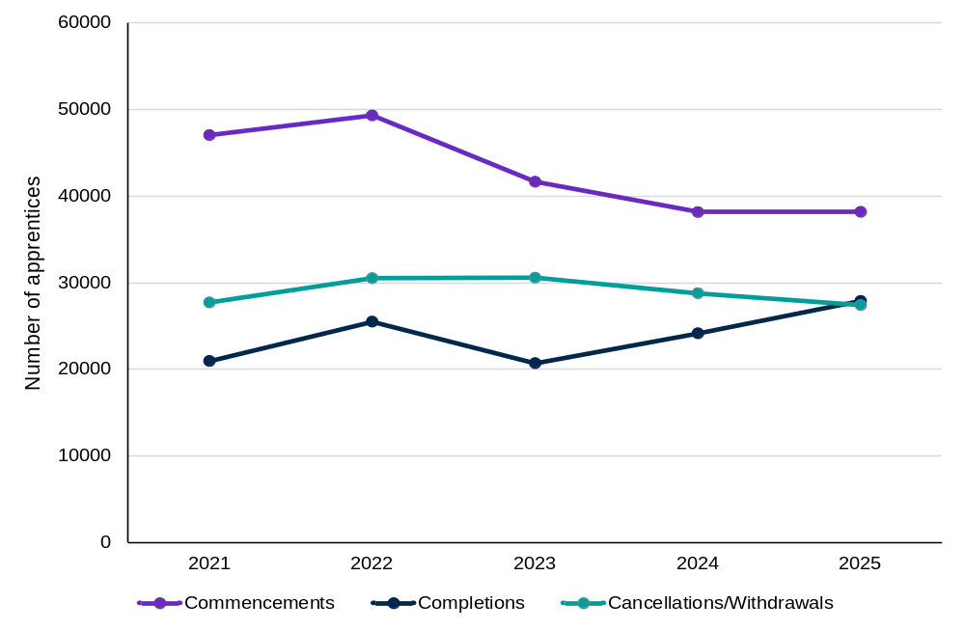
Source: NCVER, 2026. Apprentices and trainees: December quarter 2025, 12-month series. Note: Data above is based on a 12-month series and considers apprentices with intended occupations in ANZSCO sub-major group 33 and 34.

Female participation in apprenticeship pathways is rising, but retention remains critical to expanding the construction and electrical workforce
While apprenticeship commencements have softened across several construction trades, there are signs of growing participation among women. Female representation in key construction occupations remains low, but the number of women entering construction trade apprenticeships has increased over recent years, highlighting an important opportunity to expand the future workforce.
Since 2021, the number of female construction trade apprentices in training has increased by 63%, while completions have risen by 143% (Figure 36). Growth has been particularly strong in electrotechnology pathways, with almost 1 in 2 female construction apprentices in training employed as apprentice electricians, and more than 2 in 5 female commencements in 2025 entering this occupation. These trends demonstrate the growing role of women in meeting workforce demand across construction and energy-related trades.
However, attracting more women into apprenticeships is only part of the challenge. Female commencements, completions and the number of apprentices in training have all increased. Cancellation and withdrawal numbers have also risen as participation has expanded. Further analysis of cohort-based retention and cancellation rates is needed to determine whether female apprentices face a higher or changing risk of attrition.
Figure 36: The number of female construction and electrotechnology trade apprentices in training has increased since the COVID-19 pandemic, however cancellations or withdrawals have also slightly risen
Female construction and electrotechnology trade apprentices in training, commencing, cancelling and completing between 2021 and 2025
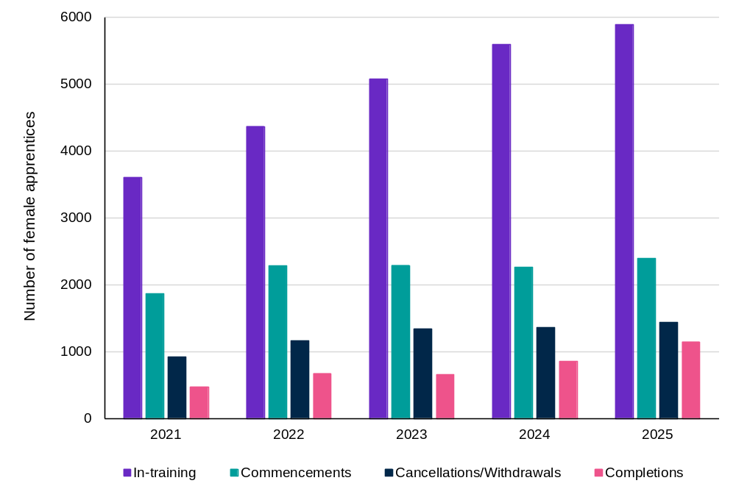
Source: NCVER, 2026. Apprentices and trainees: December quarter 2025, 12-month series. Note: Data above is based on a 12-month series and considers female apprentices with intended occupations in ANZSCO sub-major group 33 and 34.

Strong pathways support successful transitions and workforce outcomes
The value of skills pathways lies not only in participation, but in the opportunities they create for learners to complete training, progress their skills and achieve positive workforce outcomes. As workforce needs become more complex and career pathways less linear, the effectiveness of the skills system will increasingly depend on its ability to support successful transitions between, and blending of, learning and work. Qualification completion, access to information, connections with employers and a better understanding of long-term outcomes can all help individuals make informed pathway choices and build skills that align with labour market demand. Strengthening these factors can improve workforce participation, support career progression and ensure skills investments translate into lasting economic and social benefits.

Completion matters and part completion can also provide benefit
Entering training is only the first step in developing workforce capability. Completing training is often what delivers the strongest labour market benefits (NCVER 2026e). Across most fields of education, VET qualification completers report better employment outcomes than part-completers (Figure 37), suggesting that completion remains an important pathway to stronger workforce participation, career progression and skills utilisation.
As shown in Figure 37 below, about 62% of qualification completers reported an improvement in their employment status compared to 53% of qualification part-completers. The benefits of completion were particularly evident in health and community service-related qualifications, where employment outcomes for completers were substantially stronger than for those who did not finish training. In Community Services, the proportion reporting an improvement in employment status was almost 19 percentage points higher for qualification completers than part-completers, highlighting the importance of completion in occupations where formal qualifications are often required for workforce entry and progression. While completions are more advantageous, JSA’s recent research reveals that improvement in labour market outcomes can still be reported through partially completing a qualification, with 48% of partial completers who were not employed prior to enrolment gaining employment within a year (JSA 2026e).
Figure 37: Completing a VET qualification improves employment status with the strongest improvements seen in electrotechnology, construction and automotive qualifications
Improved employment status after training. Qualification completers and part-completers, top 10 training packages, 2025
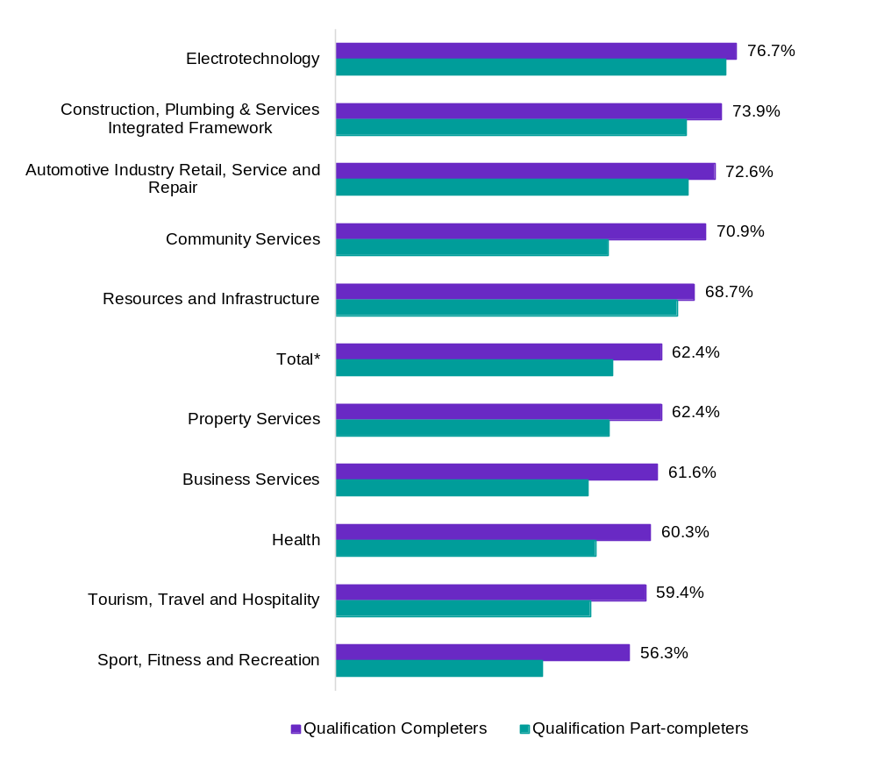
Source: NCVER, 2026. Student Outcomes Survey 2025.
The gap between completers and part-completers was smaller in electrotechnology, construction and automotive qualifications. While completion continued to support positive employment outcomes, many learners in these fields are engaged in apprenticeship pathways that combine paid employment with training. JSA research on partial completions found that apprenticeship pathways deliver some of the strongest employment outcomes among qualification part-completers (JSA 2026d). This may partly reflect the strong labour market attachment of apprentices, who combine employment with training. Nevertheless, qualification completion remains important for obtaining recognised skills, supporting career progression and ensuring a sustainable supply of fully qualified workers in critical trades.

Pathways between higher education and VET can enable learning and skill development at all stages of life
Skills development is a lifelong process rather than a one-off investment made at labour market entry. Pathways that support re-skilling and upskilling across an individual’s working life are important. In this context, VET provides flexible, nationally recognised training that can help workers respond to changing skill requirements, progress their careers and transition into new occupations.
The movement of learners from higher education into VET highlights this growing role. Students with prior studies in higher education accounted for more than 11% of all VET program enrolments in 2025 (NCVER 2026d). More than half of this group were enrolled in Certificate III or Certificate IV qualifications, suggesting that many higher education graduates are using VET to acquire practical, occupation-specific skills that support career progression, specialisation or occupational transition (Figure 38). These patterns demonstrate how pathways between higher education and VET can help individuals build capability throughout their working lives as workforce needs continue to evolve.
Figure 38: More than half of VET students who had prior studies in higher education enrolled in Certificate III or Certificate IV level qualifications
Enrolment distribution of VET students with the highest level of prior education at a bachelor degree or higher, Total, Previous highest education level, Level of education in 2025.
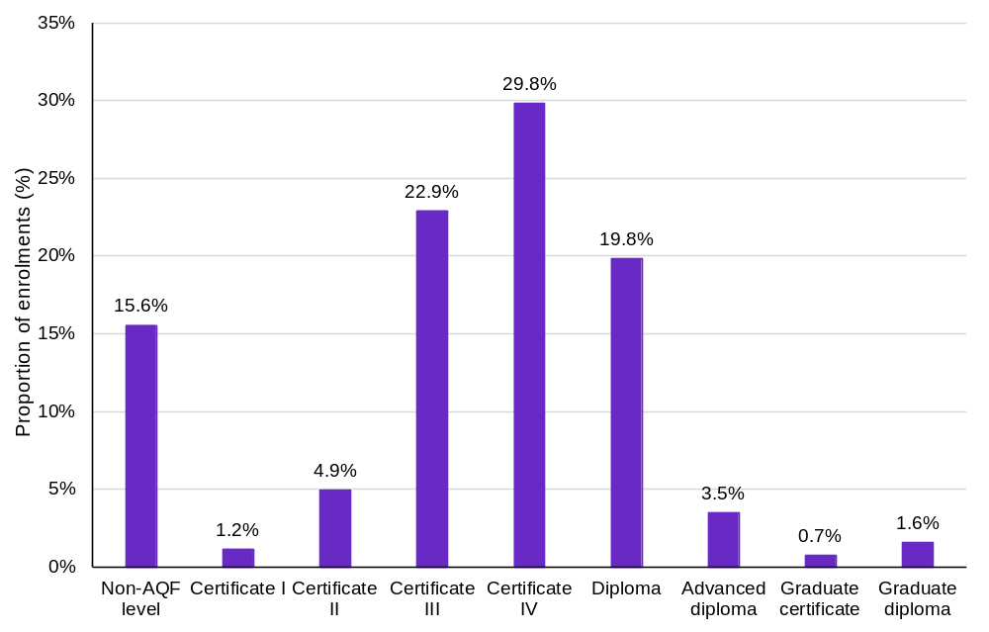
Source: NCVER 2026, Total VET students and courses 2025: program enrolments DataBuilder.
The top 10 qualifications undertaken by learners with prior higher education demonstrate that VET is not solely a pathway into the workforce, but also a mechanism for ongoing capability development. Enrolments in care and support qualifications suggest some learners are using VET to transition into occupations with growing workforce demand, while enrolments in leadership, project management and training qualifications indicate a desire to deepen expertise, broaden capabilities and progress careers (Table 6). As skill requirements evolve and occupational pathways become less linear, these patterns highlight the increasingly important role VET can play in supporting re-skilling, upskilling and career mobility throughout working life.
Table 6: Students with prior higher education use VET to build new capabilities and support lifelong learning
Top 10 qualifications by enrolment of students with the highest prior education at bachelor degree or higher, Total, Previous highest education level, Type of training, Program name in 2025
Qualification | Enrolments
CHC33021 - Certificate III in Individual Support | 14335
TAE40122 - Certificate IV in Training and Assessment | 13190
CHC30121 - Certificate III in Early Childhood Education and Care | 10395
CPP41419 - Certificate IV in Real Estate Practice | 8870
BSB50820 - Diploma of Project Management | 6400
BSB50420 - Diploma of Leadership and Management | 6345
FNS40222 - Certificate IV in Accounting and Bookkeeping | 5575
SIT40521 - Certificate IV in Kitchen Management | 5285
FNS40821 - Certificate IV in Finance and Mortgage Broking | 5150
BSB41419 - Certificate IV in Work Health and Safety | 4965
Source: NCVER 2026, Total VET students and courses 2025: program enrolments DataBuilder,

Effective skills pathways expand opportunities and strengthen workforce participation
Accessible pathways through a more joined-up tertiary system can help unlock workforce potential and strengthen economic participation across Australia. Strong skills pathways are not only important for meeting workforce demand, but they also shape who can participate in education, training and employment. Effective pathways create opportunities for people to build skills, progress through learning and adapt to changing labour market conditions throughout their working lives. This is particularly important for cohorts that have historically faced barriers to workforce participation and for regional communities seeking to build and retain local capability.
Box 8: JSA is working collaboratively with the Australian Tertiary Education Commission (ATEC) to progress work on the Tertiary Roadmap for a more joined up system.

Adult and community education plays an important role in enabling further learning, employment and community participation
The ACE sector provides an avenue for individuals, including those with limited or negative prior experiences with formal education, to build their confidence, improve their foundation skills and to learn in accessible community-based settings.
As learning in the ACE sector often takes place outside the context of nationally recognised training, data on ACE participation and outcomes at the national level is limited. However, evidence at the state and territory level attests to the role of ACE in supporting further learning and workforce participation. For example, Victoria’s 2025 Pre-accredited learner survey results indicated that among respondents who participated in Learn Local courses:
- 86% improved their general education or life skills or had improved their confidence
- 83% were satisfied the training could be a pathway to employment and further training
- 83% achieved their main reason for training (ACFE Board 2025).

VET creates pathways for lifelong learning and skill progression, particularly for learners facing barriers to workforce participation
For many learners, particularly those who have historically faced barriers to education and employment, VET can provide a foundation for ongoing skills development and career progression. Beyond supporting workforce entry, VET creates pathways to further learning, enabling learners to build skills, gain qualifications and respond to changing labour market opportunities over time.
In FY 2022–23, more than one in four VET graduates progressed to further VET study overall, while 16% undertook a higher-level VET qualification (Figure 39). Progression rates were particularly strong among First Nations learners and people with disability, demonstrating the important role VET plays in creating accessible pathways to higher-level skills and qualifications. These outcomes highlight that VET is not only a pathway into work, but also a stepping stone to lifelong learning, career development and greater workforce participation.

Figure 39: VET supports ongoing skill development, with strong progression rates among First Nations learners and people with disability
Proportions of VET graduates progressing to any or higher-level VET qualification by priority cohorts
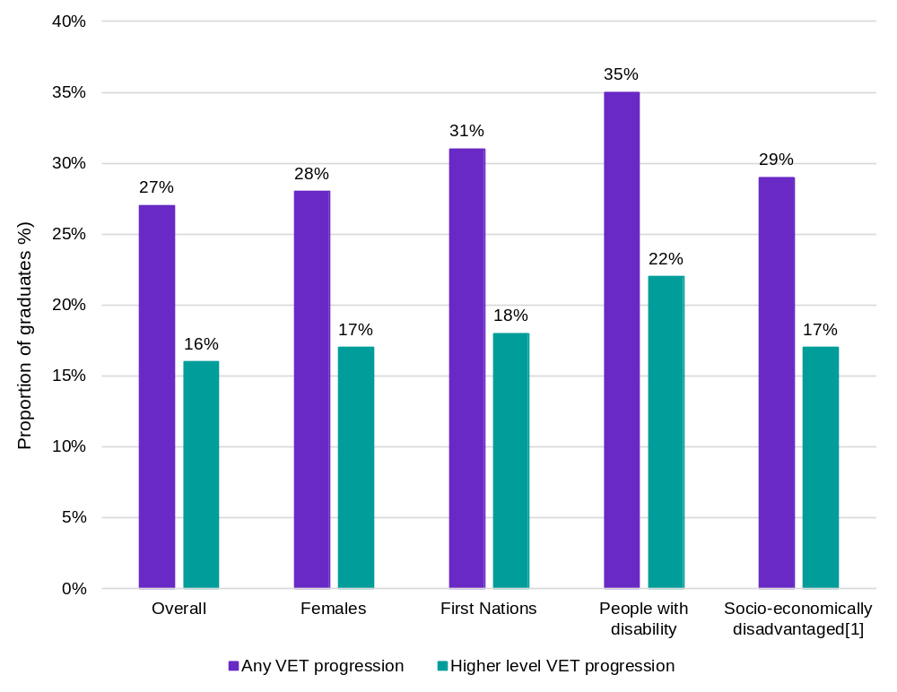
Source: JSA analysis using the VET National Data Asset (VNDA), 2026 release (2022/23 VET completers). A full release of this data is expected in late 2026. Note [1] ‘Socio-economically disadvantaged’ refers to the socio-economic status (SES) quintile 1 from the ABS Index of Relative Socio-Economic Disadvantage (IRSD). Socio-Economic Indexes for Areas (SEIFA), Australia, 2021.

Pathways are not only about ‘what’ and ‘when’, it’s also a matter of ‘where’ – study options close to home may be important for skilling regional workers
Building the workforce capability needed to support regional economies will depend on the availability of local education and training pathways. Place-based learning can play an important role in developing regional workforces by allowing people to build skills while remaining connected to local communities, employers and labour markets. The costs associated with relocation for education or training may also act as a barrier, particularly for apprenticeships and traineeships. The review into the Australian Apprenticeships Incentive System found that some stakeholders expressed concerns on the costs associated with travel to attend in-person training or classes, which may lead to some apprentices or trainees to relocate completely (DEWR 2025b).
Analysis from VET National Data Asset (VNDA) shows that only 1 in 4 regional higher education students who studied in a major city were living in a regional area 4 years after completing their studies, compared with 3 in 4 students who studied in a regional area (Figure 40). A similar pattern is observed among regional VET students, with those who studied in regional areas more likely to remain in regional Australia than those who studied in major cities. These results suggest that place-based education and training may be an important mechanism for developing and retaining the skilled workers needed to support regional growth, noting that people intending to remain regionally may be more likely to study regionally.
Figure 40: Local tertiary pathways may help retain skilled workers in regional communities
Proportion of tertiary students originally from regional areas that are in a regional area 4 years after tertiary study completion
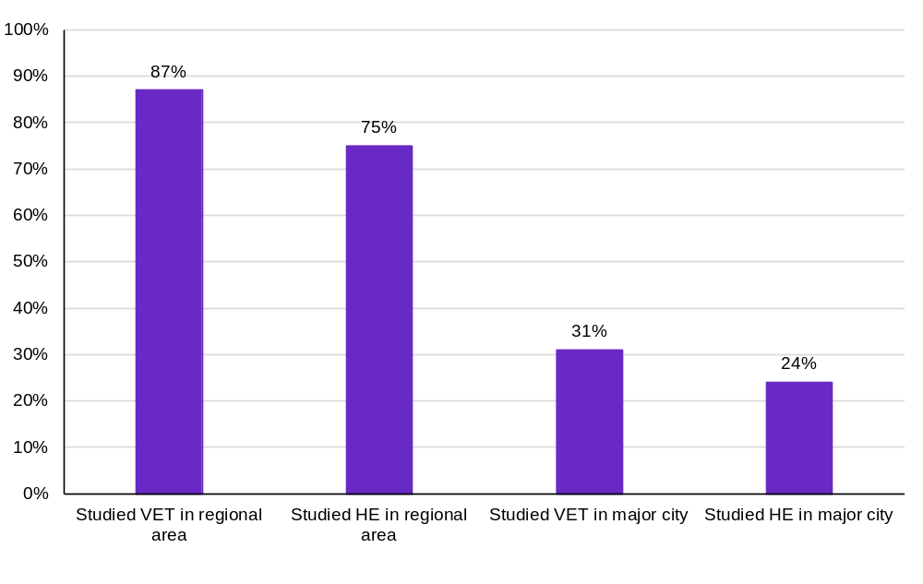
Source: JSA analysis using the VET National Data Asset (VNDA), 2020–21 course completers, unpublished data.

Looking ahead
Tertiary education will remain central to building Australia’s future workforce, but formal qualifications alone will not be enough. VET and higher education provide critical foundations for workforce entry, career progression and aligned employment, particularly when pathways support access, completion and effective transitions into work. The evidence shows that Australia needs diverse, connected and accessible pathways, particularly through a more joined-up tertiary education system. This will help people enter skilled work, move between education and training, and continue developing their capabilities throughout their working lives.
In addition, as technology, industry practice and workforce needs continue to evolve, skills development will also need to extend beyond formal learning. Non-formal learning, workplace-based skill development and better recognition of skills acquired outside qualifications will become increasingly important to helping workers adapt, deepen capabilities and move across occupations over time. The strength of Australia’s skills system will therefore depend not only on the quality of tertiary pathways, but on the harmonisation of VET and higher education in connecting formal education, ongoing learning and skills recognition across people’s lives.

Unlocking capability across working lives
Trevor Gauld
Australia is already pursuing important reforms to improve qualifications, pathways and responsiveness in our post-secondary education systems. The opportunity now is to ensure those reforms help people build and carry capabilities across their entire working lives, not just prepare them for their first job.
Today's workers are navigating an economy that is rapidly changing, as technology, industry transitions and evolving business models are reshaping jobs and skill requirements. While qualifications must continue to prepare people for work, they should also equip them to adapt, move between roles and continue learning as work changes. A qualification should prepare someone to perform an occupation, but it should not confine them to it.
Broadly, Australia's tertiary education systems have made different contributions. The focus of vocational education and training has been on developing occupational competence: ensuring people can perform workplace tasks safely and effectively. Universities have focused primarily on developing disciplinary knowledge and analytical skills. Both approaches are valuable, but the distinction is becoming less clear as jobs increasingly require workers to combine what they know with what they can do.
The challenge is not to weaken either system's strengths, but to build on them. Workers need strong foundations in literacy, numeracy, digital skills, communication, problem solving and safety. They also need work and technical skills relevant to their chosen field. The balance will differ across occupations. Some jobs will require deeper technical competence, while others will require deeper theoretical knowledge. Most will increasingly require both.
Making these capabilities more visible and transferable would help workers, employers and education providers better recognise existing skills, identify pathways between occupations and industries, and target further learning more effectively. It would also make retraining easier and more affordable for workers seeking to adapt to changing labour market opportunities.
Qualifications will continue to play important roles in licensing, professional recognition, wages and worker protections. Those functions should be preserved. The goal is not to replace the foundations of our tertiary system, but to connect them more effectively so that workers can build, apply and renew capability throughout their lives, strengthening productivity, opportunity and economic resilience so that every Australian can realise their full potential.

Careers and capability deepening – building skills, expertise and economic agency
For more information on JSA’s research and analysis on the
themes discussed in this chapter, please scan the QR code


Key themes in this chapter
Lifelong learning will be a critical part of workforce and individual development. Australia is leading the world in its readiness to adopt a skill-first approach. To capitalise on this opportunity, Australia will need stronger pathways for workers to move between occupations, deepen capability within work, and have skills recognised wherever they are developed. The evidence points to a clear tension as career mobility and ongoing learning are becoming more important, but evidence suggests mobility and work-related training are declining. This increases the importance of recognising prior learning and experience and making transferable skills more visible. A shared skills language, supported by the NST, can provide enabling infrastructure for these reforms and contribute to improved productivity, resilience and economic opportunity.
The key JSA findings are:
- Career mobility is becoming more important as skill needs change, but mobility has declined over the past decade. Where workers do move, upward skill transitions are concentrated early in working life, with 57% of occupation transitions by 15- to 24-year-olds involving movement to a higher skill level in 2023–24.
- Mobility pathways differ across life stages, occupations and regions. Entry pathways are more common for younger workers in areas such as construction, hospitality, retail and agriculture, while professional, managerial, ICT and engineering roles often attract mid-career entrants. Regional mobility patterns also reflect local labour demand, with care-related occupations a consistent destination across locations.
- Work-related training is a critical mechanism for continuing skill development, however there is no evidence of training participation increasing over the medium term. Work-related training intensity has fallen in recent years, which raises the importance of re-skilling and upskilling workers as technology and changing work practices changes job requirements.
- Most workers who undertake work-related training apply what they learn, suggesting it has practical value for productivity and adaptation. Employer and workplace support for and investment in training are critical in supporting the workforce’s ability to respond to technological change, changing work practices and longer careers.
- Informal and non-formal learning are likely to be important sources of workforce capability, but they remain poorly measured and inconsistently recognised. A major evidence and system gap exists for how workers engage in informal and non-formal learning, particularly for capabilities developed through work experience, problem-solving, peer learning, professional development and short courses.
- A skills-first system depends on better recognition infrastructure. More consistent credit transfer can reduce duplication of formal learning. More accessible recognition of prior learning, including learning developed through work and other experience, can help make existing skills and capabilities more visible and support more efficient pathways for upskilling, reskilling and mobility.
- The National Skills Taxonomy can provide a common language for describing skills. The NST is central to this reform agenda because it will provide a shared language, built upon a human-centred definition of skill, to describe and compare skills across education, work and experience.

Career mobility is becoming more important as work and skill needs change
Career mobility plays an important role in connecting workers and opportunity, and helping the labour market respond to changing skill needs. As skill needs evolve, the ability of workers to move between occupations is becoming an increasingly important source of workforce adaptability and productivity growth. The Australian Government’s Employment White Paper highlights that labour market mobility is important for both workers and employers (The Treasury 2023). Therefore, mobility not only improves satisfaction and career progression but can also support productivity as workers are more effectively using the skills they have (Racionero 2025). When workers move into roles that use their skills more effectively, businesses benefit from higher productivity, with research consistently showing that moving from one role to another is linked to faster growth in average wages (Deutscher 2019).
Career mobility, the movement of workers between jobs, industries, or occupations, is an important driver of productivity growth across the economy. It enables labour to be allocated more efficiently by matching workers and designing roles that better utilise their skills, experience, and capabilities. When workers move from lower-productivity jobs to higher-productivity jobs, this improved utilisation of their skills leads to an increase in overall economic output, without requiring additional labour or capital.
Career mobility also supports structural adjustment and economic transformation. As technology, consumer preferences, and global markets evolve, some occupations decline while others expand. The ability of workers to move into growing sectors helps the economy adapt to these changes and prevents labour from remaining trapped in less productive activities.
Higher levels of career mobility can also strengthen incentives for education, training, and lifelong learning, along with knowledge transfer and innovation within businesses. When workers have opportunities to move into higher-paying and more productive occupations, they are more likely to invest in developing new skills and bring with them new ideas, practices, and expertise. This growth and transfer of knowledge can improve business processes, encourage innovation, and ultimately increase long-term productivity growth.

Workers are becoming less mobile, but for those who move, the shifts depend on the stages of working life
Workers are becoming less mobile across the labour market, but the transitions that do occur increasingly involve substantial shifts in skill level and career direction (JSA 2026d). JSA analysis using linked administrative data has found that over a ten-year period between 2011-2012 and 2020-21, the percentage of workers who remained in the same occupation in the following year ranged from 83% to 92% (JSA 2024a). JSA analysis shows that mobility has declined over the past decade, however, this is not experienced evenly across the workforce, but it’s shaped by an individual’s stage of life and career.
Figure 41 shows skills uplift is concentrated early in working life, when people are more likely to be moving from post-school education, training or entry-level employment into more highly skilled occupations. In 2023–24, around 57% of occupation transitions made by 15 to 24 year olds involved a move to a higher skill level. This reinforces the need to understand mobility more broadly as a life-course process, as early-career transitions often support skills uplift, while later-career transitions may depend more on transferable skills, recognition of experience and opportunities to deepen capability within or across related fields.
Figure 41: Upward occupation mobility is becoming more concentrated early in working life
Proportion of occupation transitions involving an increased skill level, by age group, 2011-12 to 2023-24
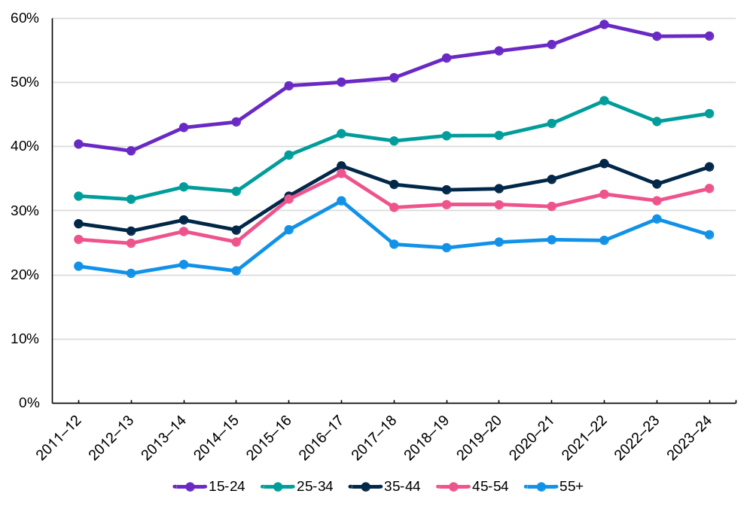
Source: JSA, Systems at work: trends in adult learning and outcomes, 2026. JSA analysis using Skills Tracker, 2011–12 to 2023–24, Income Tax Return (ITR) Data, ABS DataLab. Findings based on use of Person Level Integrated Data Asset (PLIDA) data.
The timing of occupation mobility differs substantially across the labour market, reflecting the varying skills, experience and credential requirements of different occupations. While occupation transitions are often associated with younger workers, Figure 42 shows that this pattern is not universal.
Transitions into many occupation groups, including Construction, Architecture and Design, Electrical and Electronics, Hospitality, Retail and Agriculture, are dominated by workers aged 15 to 24, suggesting these occupations frequently serve as entry points into the workforce. In contrast, more specialised, professional and leadership-oriented occupations attract a much larger share of mid-career entrants. Occupation groups such as Executive and General Management, Information and Communication Technology, and Engineering receive a substantial proportion of inflows from individuals aged 25 and over. This suggests that many workers do not enter these occupations directly, but instead transition into them after building technical expertise, occupational knowledge and transferable skills in other fields.

Figure 42: The transitions into most occupation groups are made by early career individuals, while transitions into professional and managerial roles are mid-career moves
Inflow of workers into each occupation grouping from other occupation groupings by age range, 2023–24
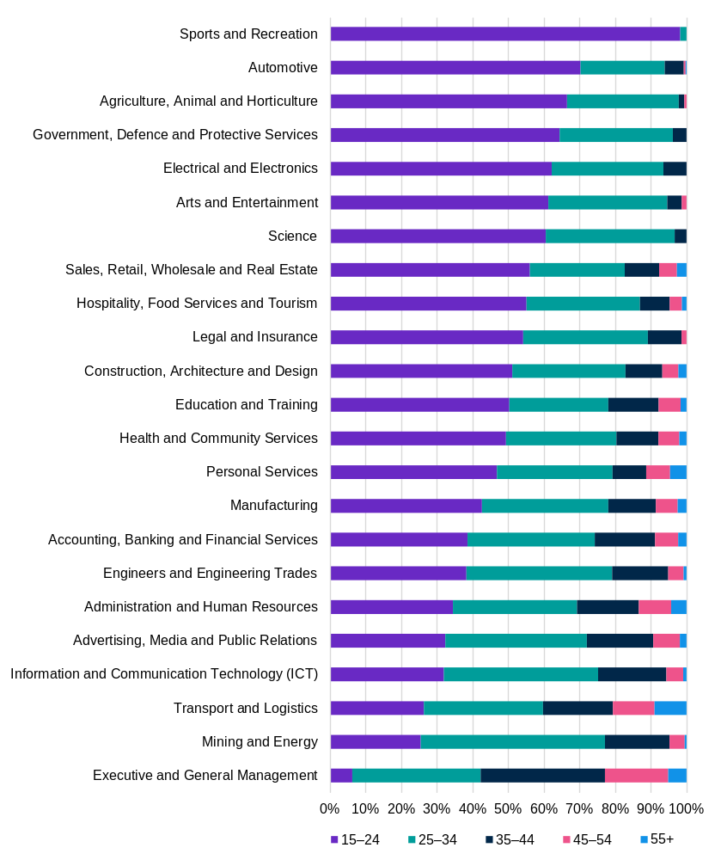
Source: JSA, Systems at work: trends in adult learning and outcomes, 2026. JSA analysis using Skills Tracker, Person Integrated Data Asset (PLIDA), 2011–12 to 2023–24, Income Tax Return (ITR) Data, ABS DataLab. Findings based on use of PLIDA data. Occupation Groups are a custom classification based on the Occupation Matrix and is not fully aligned to ANZSCO.

Occupation mobility reflects the economic structure and workforce needs of regions
Occupation mobility is shaped not only by an individual’s stage of life, but also by where they live. The occupations that workers move into differ considerably across regions, reflecting differences in industry structure, labour demand and available employment opportunities. As a result, mobility pathways can look very different across Australia, with workers often transitioning into occupations that align with the economic strengths and workforce needs of their local labour market.
Table 7 shows that major cities attract inflows into service-based and corporate occupations, including Administration and Human Resources, Sales and Real Estate, and Executive and General Management. In contrast, regional and remote areas are characterised by stronger inflows into occupations associated with Construction, Transport and Logistics, Mining and Energy, and Electrical Trades. While metropolitan labour markets may offer greater opportunities to transition into professional, managerial and business service roles, regional and remote labour markets appear to facilitate movement into occupations that support infrastructure development, resource industries and essential freight and logistics networks.
Despite these differences, Health and Community Services emerges as a consistent source of occupation inflows across all levels of remoteness. The occupation grouping appears among the most common destinations for transitioning workers in major cities, inner regional and outer regional Australia, indicating that demand for care-related skills is widespread rather than concentrated in particular locations, which is consistent with the overall size and the strong growth of the care workforce in response to the ageing population discussed in Chapter 1.
Table 7: Occupation transitions differ across regions, reflecting local workforce demand
Top 5 occupation groupings entered by adults 25 and over from other occupation groupings by remoteness, 2011–12 to 2023–24
Major cities of Australia | Inner regional | Outer regional | Remote
Administration and Human Resources | Administration and Human Resources | Construction, Architecture and Design | Mining and Energy
Sales, Retail, Wholesale and Real Estate | Health and Community Services | Administration and Human Resources | Construction, Architecture and Design
Executive and General Management | Construction, Architecture and Design | Sales, Retail, Wholesale and Real Estate | Administration and Human Resources
Health and Community Services | Sales, Retail, Wholesale and Real Estate | Health and Community Services | Electrical and Electronics
Construction, Architecture and Design | Transport and Logistics | Transport and Logistics | Transport and Logistics,  and  Automotive
Source: JSA, Systems at work: trends in adult learning and outcomes, 2026. JSA analysis using Skills Tracker, Person Integrated Data Asset (PLIDA), 2011–12 to 2023–24, Income Tax Return (ITR) Data, ABS DataLab. Findings based on use of PLIDA data. Transport and Logistics and Automotive were equal fifth for occupation groupings entered by adults living in remote Australia.

Lifelong learning enables workers to deepen capability across longer careers
Occupation changes are one way to increase productivity. However, workers also contribute to productivity growth without moving occupations. They contribute to productivity growth through in-job skill deepening, building greater expertise and undertaking more complex work while remaining within the same occupation (Mustafa and Lleshi 2024). Longer careers and faster skill change mean that adult learning must become a normal part of workforce development, with formal, non-formal and workplace learning all contributing to capability deepening.
Better connection between tertiary education and the workplace can support capability deepening throughout working lives. VET can play an important role in this process by helping workers reskill and upskill as their careers develop. JSA research shows that VET can support older workers to improve their employment and earning outcomes after training (JSA 2024b).
However, much of the learning that occurs across a person’s working life remains difficult to observe. Informal learning through experience, peer support, problem-solving and changing job tasks, and non-formal learning through short courses, vendor training and professional development, are likely to be important sources of capability deepening. Yet these forms of learning are less consistently measured and less readily recognised than formal qualifications. This creates a gap in both the evidence base and the skills system’s ability to value capability developed outside formal education.

Work-related training is essential for capability deepening, but participation and time spent have stagnated or declined
As occupations evolve and skill requirements change, workers increasingly need opportunities to update their skills. Work-related learning provides a critical mechanism for this ongoing skill development, enabling workers to build expertise and adapt to changing job demands without necessarily undertaking a formal qualification. However, there is no evidence of work-related learning participation meaningfully increasing over the medium term, though the two main sources diverge on whether participation is down or near the medium-term average (ABS 2026b).
JSA analysis of longitudinal household data (HILDA) also found that the intensity of work-related training has declined over time, from 28 hours per year in 2007 to 20 hours in 2024 (Figure 43).

Figure 43: Since 2004, adults are spending less time on work-related training
Median hours of work-related learning undertaken by adults in the previous 12 months, 2007 to 2024
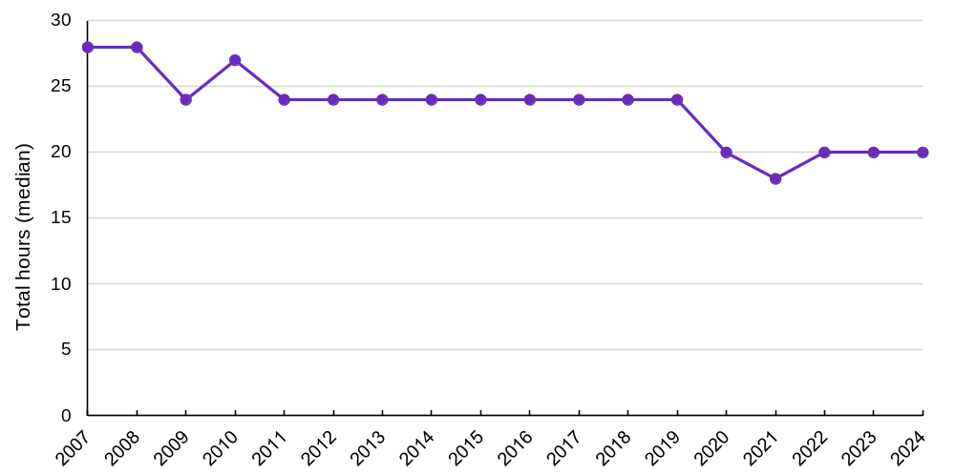
Source: JSA, Systems at work: trends in adult learning and outcomes, 2026. JSA analysis of the HILDA Survey, General Release 24 (Waves 1-24). Note: Data is filtered to include only those who undertook some work-related training (i.e. excludes 0 hours).
While the intensity of work-related learning has declined over time, Figure 44 demonstrates that in most cases, people who undertake work-related learning find that it provides the relevant skills for their jobs. Almost two thirds of adults reported they always or often used the skills or knowledge gained through their most recent work-related training. As careers lengthen and skill needs evolve more rapidly, opportunities for learning within work are likely to become increasingly important for maintaining workforce capability and supporting productivity growth. Workplace learning is an important mechanism through which workers deepen capability throughout their careers. More so than formal qualifications, workplace learning allows workers to develop new skills while remaining attached to employment, enabling them to respond to changing technologies and work practices specific to their job requirements.
Stagnant or declining participation in work-related training increases the importance of employer investment in workforce capability to keep pace with changing skill needs. A recent study by Australian Industry Group using the Household, Income and Labour Dynamics in Australia (HILDA) survey found that 86% of employees undertaking work-related training were engaged in fully employer sponsored training (Australian Industry Group 2025). The analysis also found that approximately 9 in 10 workers engaged in work-related training undertook training in paid work time. These findings indicate the important role employers play in supporting workers to develop and deepen their capabilities.

Figure 44: Most adults apply the skills gained through work-related training in their jobs
Proportion of adults who always or often use new skills / knowledge from their most recent work-related training
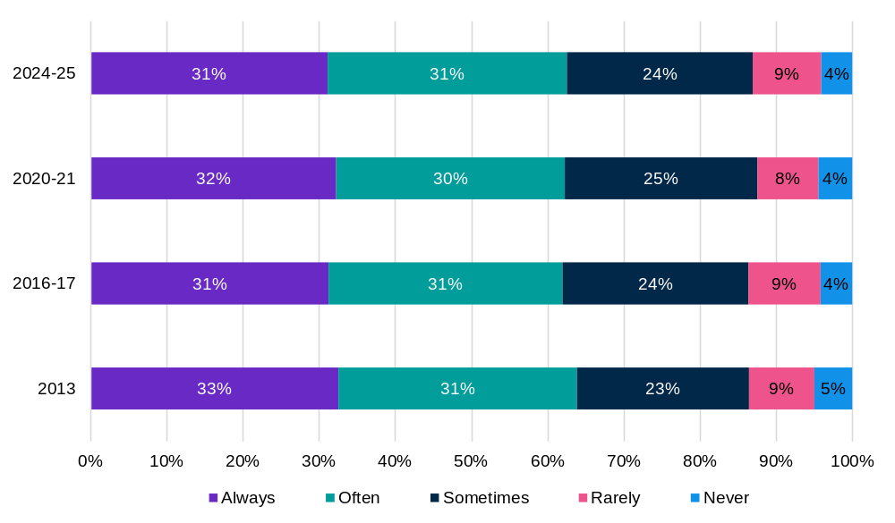
Source: JSA, Systems at work: trends in adult learning and outcomes, 2026. JSA analysis, ABS work-related training and adult learning survey, multiple releases.

A skills-first approach to recognising capabilities supports mobility and lifelong learning
As workers are required to become more mobile and engage in lifelong learning, there needs to be stronger recognition of skills that sit behind job titles, qualifications, credentials and experience. This requires a nuanced and comprehensive understanding of the skills that are held by workers and learners, to support their utilisation.
Skills-first is an international approach that shifts how skills are viewed in workforce development, moving beyond credential-based proxies to a more granular understanding of human capability (Glover and Mohamedou 2026). Australia is in a unique position being the leading OECD nation that has demonstrated the highest level of readiness to adopt this approach (OECD 2026a). To capitalise on this opportunity, a skills-first system depends on three related but distinct forms of recognition infrastructure. Firstly, credit transfer recognises formal learning already completed and reduces duplicative study. Increasing the opportunities for recognition of prior learning (RPL) and recognition of prior experience (RPE) can make capability developed through work, non-formal learning and life experience more visible. By developing a NST (underpinned by a clear definition of skill), skills can be described and compared consistently across education, employment and experience through a shared language. Making skills more visible is important, especially from an equity perspective. Through a review of existing skills frameworks, JSA has formed the view that without a clear definition of skill, skills formed and used in female-dominated industries, particularly in care and human-centric roles, may not be adequately recognised or valued (Lilly 2026). This analysis also found that starting with an inclusive definition has the benefit of better recognising and valuing cultural as well as technical capabilities. Together, these reforms can reduce barriers to mobility, make learning pathways more efficient and support a more equitable understanding of capability.

A stronger credit transfer system can reduce duplication and make reskilling easier
As participation in lifelong learning becomes more important, barriers such as duplicated learning, lengthy qualification pathways and inconsistent recognition of prior study can discourage individuals from pursuing further education and training. Reducing these barriers is critical if workers are to continually develop new capabilities in response to changing labour market demands.
Credit recognition remains inconsistent across Australia's tertiary education system, creating barriers to learner mobility and lifelong learning. A more coordinated national approach is needed to improve the consistency, transparency and efficiency of credit recognition across VET and higher education. JSA’s 2025 report, Opportunity and Productivity: towards a tertiary harmonisation roadmap, identified credit transfer as an enabler of a more connected tertiary education system and recommended that stakeholders work towards a National Credit Transfer System (NCTS). Without a more coordinated credit transfer system, learners face unnecessary duplication of study, while employers wait longer for workers to acquire needed qualifications and skills. Table 8 outlines the benefits of a national approach to credit.
Table 8: Benefits of a National Credit Transfer System. Supporting career mobility through reducing duplication of learning
Benefit | Description
Student mobility | A NCTS will make it easier for students to move between providers and sectors by providing predictable credit for equivalent formal learning, reducing duplication, and supporting smoother transitions.
Lifelong learning, upskilling and reskilling | Clearer recognition of prior formal learning will help improve opportunities for lifelong learning, upskilling, and reskilling by enabling people to build on existing skills, reskill for new industries, and upskill as technologies and workforce needs change.
Improved labour mobility | More consistent credit transfer will reduce repeated study and enables quicker progression into qualifications aligned to emerging roles, supporting faster workforce transitions.
Improving equity in tertiary education | Streamlined credit processes will create more accessible pathways for underrepresented learners, improving participation, progression, and completion across the system.
A more efficient tertiary system | By reducing duplication and administrative burden, a NCTS will lower costs, shorten study time, and help public investment in training translate more efficiently into workforce capability.
Source: JSA analysis
In March 2026, the Australian Government announced that the ATEC would develop an NCRF to reduce duplication and support students with relevant TAFE qualifications to move into university study in the same area (ATEC 2026). RPL and RPE have a distinct but complementary role, enabling capabilities developed through work, non-formal learning and life experience to be assessed and recognised for credit. More accessible RPL could help workers build on these capabilities, transition into areas of demand and build on existing capabilities without facing unnecessary time and financial costs.
A cohesive and robust skills taxonomy would be an enabler for improving RPL and RPE. JSA’s development of the NST is intended to support better recognition of skills in prior learning and experience, not just from formal study and work experience, but other areas of experience throughout life.

Recognition of prior learning and experience can make existing capability more visible
As careers become longer and less linear, workers will increasingly build, develop and enhance skills through workplace experience, non-formal training, self-directed learning and participation in a range of professional and community settings. Expanding existing RPL and RPE beyond formal qualifications can help make these capabilities more visible and reduce barriers to further learning and workforce mobility.
Many of the capabilities that enable workers to perform effectively are difficult to capture through qualifications or job titles alone. Attributes such as judgement, leadership, collaboration, coordination and contextual problem-solving are often developed through experience and applied practice rather than formal study (Lilly 2026). Recognising prior learning and experience more broadly could help address these challenges by enabling skills gained through work and other forms of learning to be recognised alongside formal qualifications. As shown in Table 9, a more outcomes-based approach could support lifelong learning, improve mobility between education and employment and support clearer pathways across working life.
While credit transfer and recognition frameworks can reduce barriers to mobility, their effectiveness depends on being able to identify, communicate and validate capability consistently. This highlights the importance of a shared skills language that can make skills more visible, inclusive, portable and transferable across the economy.

Table 9: A multi-directional credit transfer system can better support the recognition of learning and experience
Features and benefits of a multi-directional credit transfer system
Feature | Benefit
Shared reference points | Credit can be translated as a common currency across sectors and providers including learning volume and level.
Outcomes-based | Allows different learning experiences to be recognised where they achieve the same learning outcomes, regardless of delivery mode or institution.
Recognition of experience and non-formal learning. | Experiential and informal learning can be credited alongside formal study where capability is demonstrable.
Transparency | Enabling people to understand credit opportunities upfront and plan pathways with confidence
Digital | Ensuring credit decisions are timely, consistent and easily accessible across the system while reducing administrative burden.
Source: JSA, 2026. Skills, Mobility and Productivity. Why Australia needs a skills-first tertiary education system.

A National Skills Taxonomy can provide a common language for skills mobility
A NST can make skills more visible, portable and transferable across learning and work. As workers increasingly develop capabilities through formal education, workplace experience and non-formal learning, a common language is needed to identify and recognise those skills consistently. A shared skills language can strengthen the effectiveness of credit transfer, RPL and RPE by providing a consistent way to describe and compare capability.
A shared skills language can only be established through a shared definition of skill. A contemporary definition should recognise skill as dynamic, context dependent and deeply human (Figure 45). The definition that underpins the development of the NST is:
Skill is a valued and purpose-driven human ability that is acquired or refined through learning and practice. It is a dynamic function of an individual’s knowledge, experience, and personal attributes that is continuously influenced by context, interaction with others, and the demands of the environment in which it is exercised (Lilly 2026).

Figure 45: A skills-first system cannot work without a human-centered definition of skill
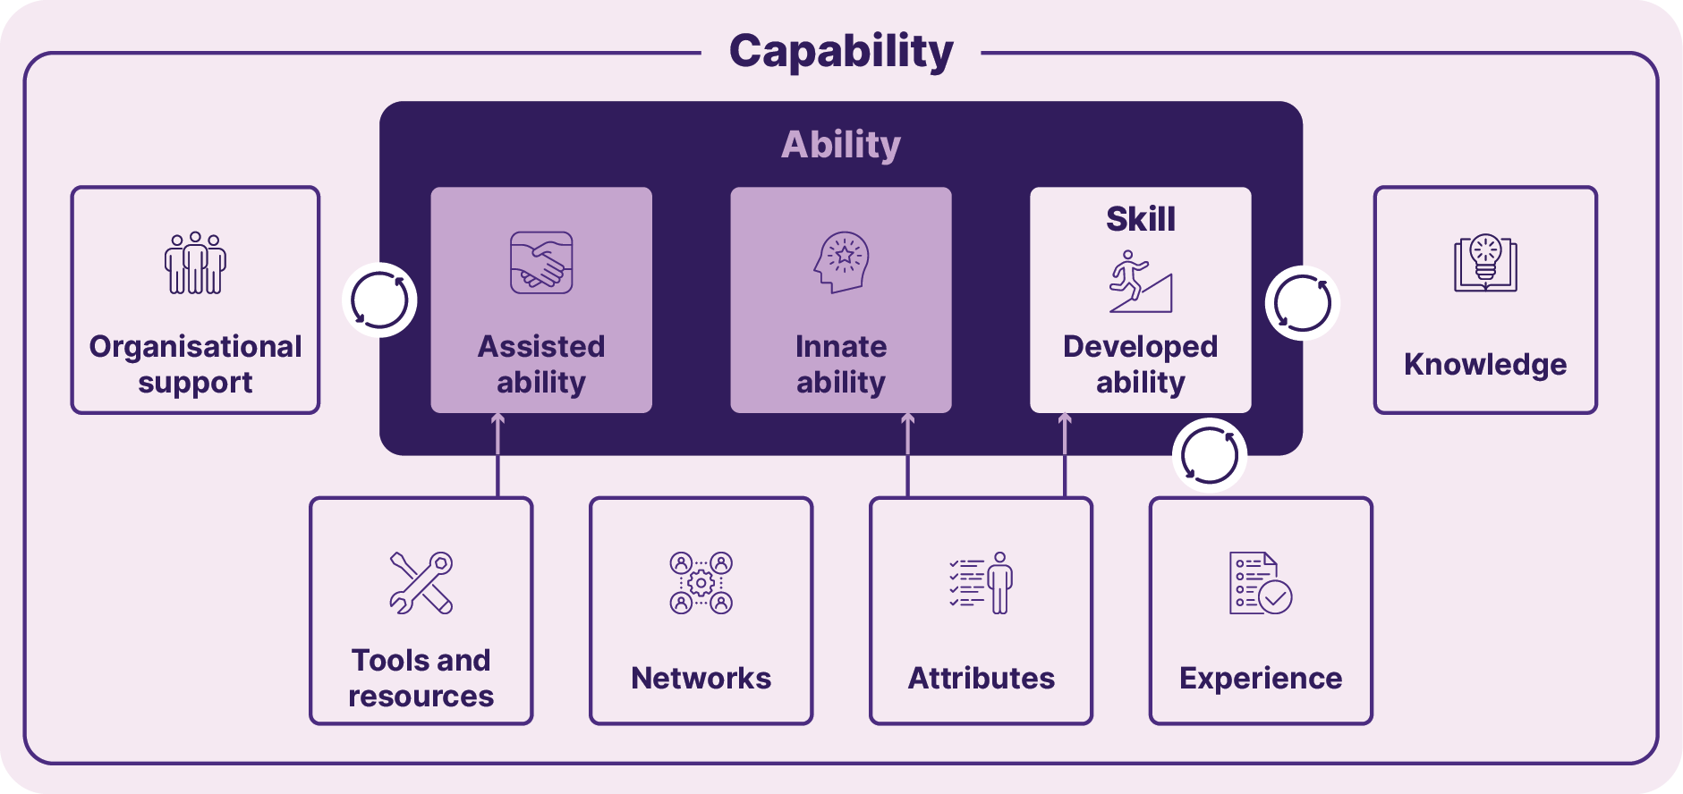
Source: JSA 2025
The definition provides the underlying infrastructure for a consistent skills language across sectors; supports interoperability between education and employment systems; and helps avoid reinforcing bias about what counts as a ‘real’ skill.
Figure 46 illustrates how a skills taxonomy can connect related capabilities within broader skills definition. Rather than viewing occupations and qualifications as isolated categories, a taxonomy makes the underlying skills explicit, showing how capabilities can be developed, recognised and transferred across different learning and employment contexts. This can help workers identify transferable skills, support employers to better understand capability requirements, and improve recognition of learning gained through qualifications, work experience and non-formal learning.
Figure 46: A common skills language can connect workers, employers, educators and occupations
Illustrative example of network security skills within a taxonomical framework
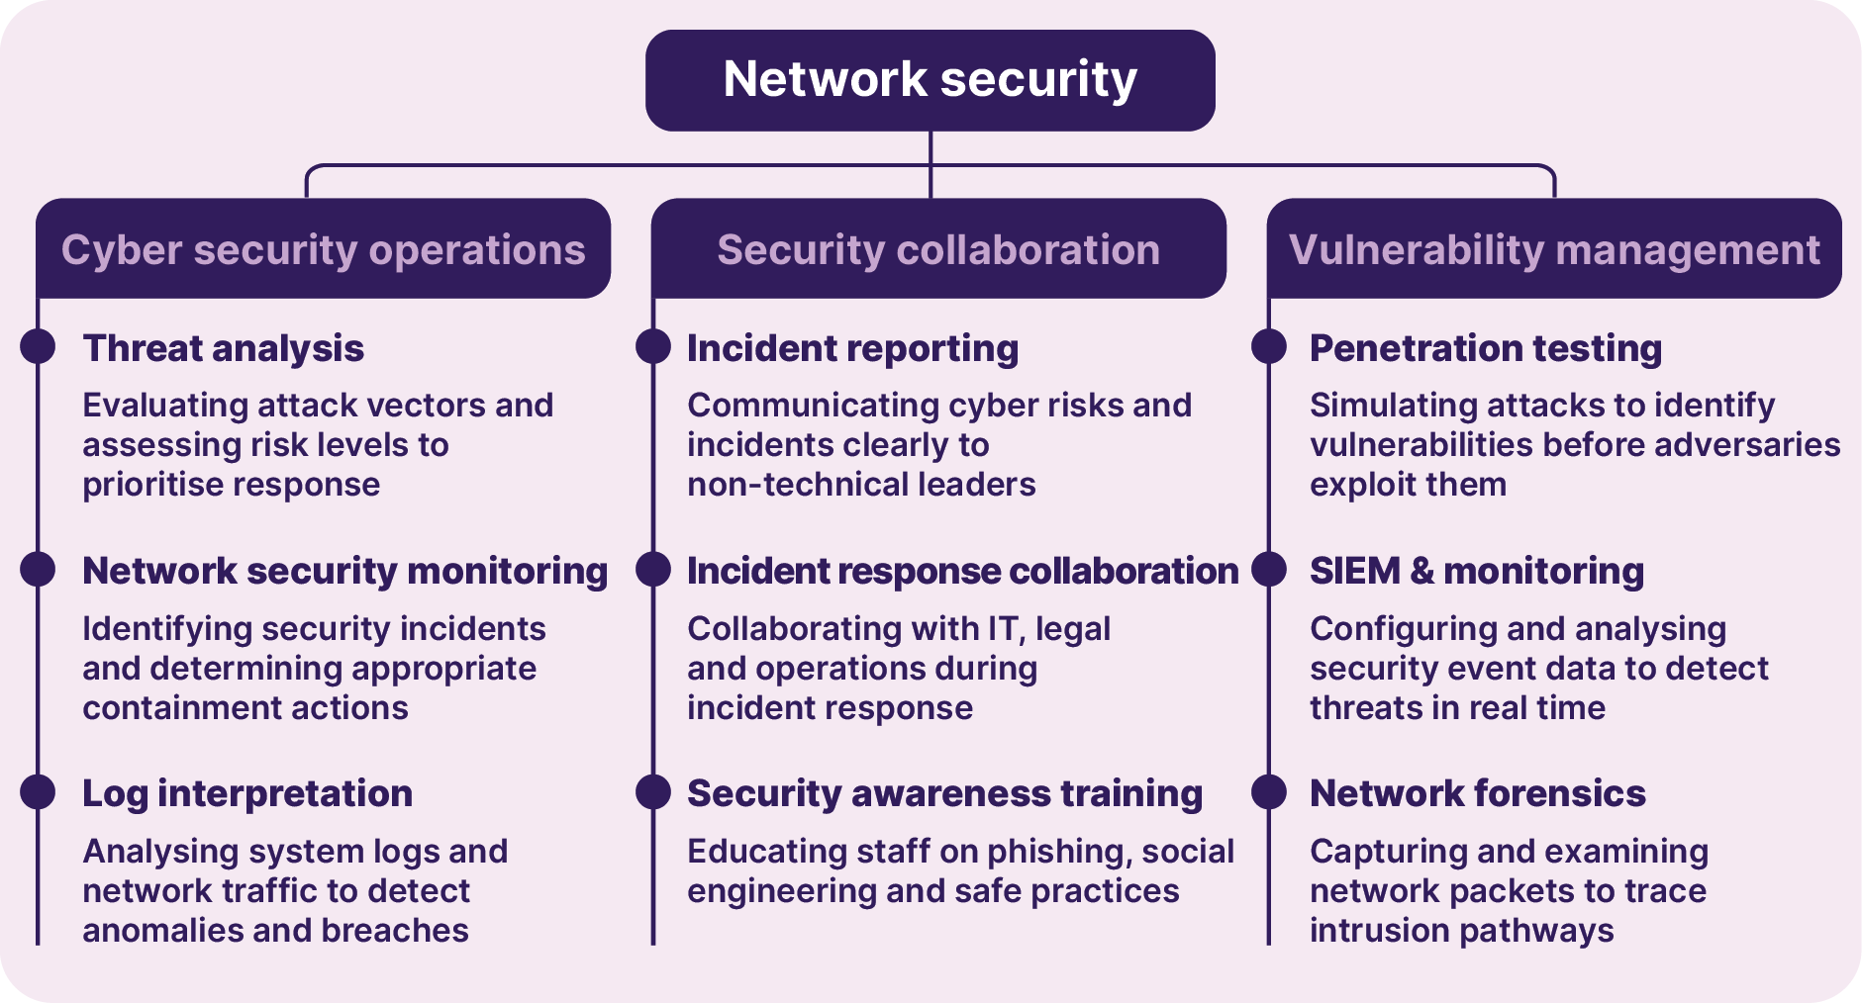
Source: JSA analysis

Looking ahead
Australia's future workforce capability will depend on how effectively individuals can build, apply and transfer skills throughout their working lives. As technological change, demographic shifts and evolving labour market demands accelerate the need for continual adaptation, workforce development can no longer be viewed as a process concentrated at labour market entry or occurring solely within traditional education and training institutions. Supporting career mobility, lifelong learning and the recognition of skills wherever they are developed will help workers respond to new opportunities, deepen expertise and contribute more productively throughout their careers. A skills-first system, underpinned by a shared language for skills, can help make capability more visible, portable and transferable across learning and work, strengthening productivity, participation and economic resilience in the decades ahead.


Skills-first: Inclusive pathways to productivity
Megan Lilly
Australia’s productivity challenge is not just about building more skills. It is also about making better use of the skills people already have, and helping people develop, demonstrate and transfer those skills across learning, work and life.
JSA’s definition of skill gives us a clear starting point:
Skill is a valued and purpose-driven human ability that is acquired or refined through learning and practice. It is a dynamic function of an individual’s knowledge, experience and personal attributes, continuously influenced by context, interaction with others and the demands of the environment in which it is exercised.
What our systems recognise and reward, affects whose capabilities are visible and valued. Skills developed through work, education, caring, volunteering, community participation and cultural experience all contribute to Australia’s economy. Caring, communication, coordination, problem-solving and adapting to change are all learned through practice. They are essential to productive workplaces and our continued economic pressures, but they are often called ‘soft’ skills or considered as secondary to technical skills. A skills-first approach helps make these skills visible and valued alongside technical skills, including skills developed in highly feminised industries, through culture and community, and through life experience.
Better skills recognition can turn this idea into practical opportunity. Recognition of prior learning and skills-based hiring work best when they use a common language of skills. This helps people explain what they can do, move more easily between education and work, and show employers the skills available across the workforce. Qualifications remain vital, but they should sit alongside clearer information about the skills, knowledge and capabilities people have and can build.
Technology, demographic change, the energy transition and new ways of working are reshaping the economy. Australia will need a workforce that can adapt and keep learning. A skills-first approach can give people more agency, strengthen the link between learning and work, and help employers make better use of Australia’s skills.
When skills are visible, trusted and portable, Australia can lift productivity, widen participation and create more inclusive pathways across people’s lives.

Building an adaptive system for capability across working lives
For more information on JSA’s research and analysis on the
themes discussed in this chapter, please scan the QR code


The future jobs and skills system will need to be more adaptive.
Four system functions will become increasingly important: generating trusted signals about emerging change; supporting better decisions about workforce problems and responses; coordinating action across a distributed system; and reducing structural frictions that limit mobility, learning and recognition. JSA has an important role in supporting these functions by improving the evidence base, making system signals more visible, and helping stakeholders use evidence to inform practical action.
Persistent shortages often reflect a combination of supply constraints and job attractiveness, which includes job design, retention, geographic mismatch, underutilisation and barriers to participation. Workers acquire capability through formal qualifications, work experience, non-formal learning and career transitions, but these capabilities are not always recognised or easy to carry between jobs, sectors and forms of learning. At the same time, technological change, population ageing and economic transformation are increasing the importance of lifelong learning, occupational mobility and workforce adaptability.

Signals: Seeing change more clearly and earlier
Changes in technology adoption, workforce participation, occupational mobility, skill requirements and industry structure often develop gradually before becoming significant constraints on growth, productivity or service delivery. Australia therefore needs stronger capability to quickly identify emerging changes in workforce demand, supply, utilisation and mobility.
This requires better visibility of how occupations are changing, how skills are being used within jobs, where workforce pressures are emerging, how people move between occupations and sectors, and where barriers are preventing capability from flowing to areas of need. It also requires greater understanding of capability developed outside formal qualifications, including through work experience, workplace learning and career transitions.
Building this capability will require sustained investment in labour market intelligence, workforce analytics and new trusted sources of evidence. JSA will continue to strengthen Australia's workforce evidence-base and product suite, building on initiatives such as the OSL, Regional Labour Market Indicator, the Jobs and Skills Atlas, VNDA and emerging work on the NST. Over time, JSA will work to expand visibility in areas where evidence remains comparatively weak, including skills utilisation, occupational mobility, informal and non-formal learning, recognition of capability, and the demand-side drivers of workforce outcomes. Better signals will help identify emerging challenges within the system earlier and respond before workforce pressures become entrenched.

Decision support: Understanding problems before choosing solutions
Strong capability is needed to diagnose workforce challenges more precisely and translate evidence into practical action. This means connecting labour market intelligence, education outcomes, workforce supply data and employer insights to better understand what is driving workforce pressures and what interventions are most likely to succeed.
Occupational shortages may reflect insufficient training capacity, but they may also stem from job attractiveness. The goal is to move beyond understanding where workforce problems exist towards understanding why they exist. Treating all workforce problems as supply problems risks directing resources toward symptoms rather than addressing underlying causes.
Diagnosis should distinguish between insufficient skills supply and problems in how workforce demand is expressed through jobs. An apparent shortage may reflect too few qualified workers, but it may also reflect job design, remuneration, location, recruitment practices, retention, skills mismatch or changing task requirements. Different causes require different responses.
JSA has been established to engage with governments, industry, unions, employers, education providers and communities to ensure information and intelligence can lead to meaningful and impactful actions. This means continuing to develop evidence that helps distinguish between different workforce challenges, identify the underlying drivers of shortages and workforce constraints, and assess which interventions are most likely to be effective. As workforce challenges become more complex, the value of decision support will increasingly lie in supporting governments, employers, providers and individuals diagnose problems accurately and select appropriate responses that address root causes rather than symptoms. This reinforces the importance of continuing the collaboration between JSA and JSCs as they play an important role in contextualising the JSA evidence base for their specific sectors.

Coordination: Stewardship across a distributed system
Skills and capabilities are developed through schools, higher education, VET, workplaces and communities. Workforce outcomes are shaped by decisions made by governments, employers, industry bodies, unions, education providers and individuals themselves. No single agency or institution controls the system, and few workforce challenges can be solved by one organisation acting alone. As a result, system stewardship becomes increasingly important.
Many of Australia's national priorities, including housing, care, net zero, and AI adoption, depend on coordinated action across multiple parts of the system. This requires shared understanding of workforce challenges, alignment around priorities and collective responses that operate across institutional boundaries.
Effective coordination is not about central control. It is about creating the conditions for well informed and aligned decision making and action. This includes bringing stakeholders together around shared evidence, fostering a common understanding of workforce challenges and helping translate information into practical responses. It means identifying where effort needs to be aligned, where gaps remain and where collaboration can unlock better outcomes than institutions acting alone.

Reform: Removing friction from learning, work and mobility
Workers will need to move between roles, sectors and forms of learning throughout longer careers. Yet many of the systems supporting these transitions were designed for a labour market characterised by linear careers and front-loaded education.
Capabilities acquired in one setting are not always recognised in another. Learning and qualifications can be difficult to transfer between institutions or sectors. Skills developed through work experience often remain invisible compared to formal credentials. These frictions slow mobility, reduce adaptability and impose unnecessary costs on workers, employers and the broader economy. Reducing frictions is one of Australia's largest opportunities for improving workforce performance.
Future reform should focus on making capability and skill easier to recognise, transfer and build upon throughout working life. This includes strengthening RPL and RPE, improving credit transfer arrangements, supporting movement between VET and higher education, and creating more transparent ways of describing and recognising skills regardless of where they are acquired. This shift towards a skills-first labour market will enable reforms that make capabilities more visible and transferable. A skills-first approach does not mean qualifications matter less. Qualifications will remain essential for licensing, safety, professional recognition, wages, quality assurance and trust. The shift is to ensure a worker's opportunities are not shaped only by the qualifications they hold, but also by the capabilities they possess and can demonstrate.
The NST has the potential to become an important enabling infrastructure for this evolution by providing a shared language for understanding skills across education, work and experience. Its value will depend on whether it helps workers, employers, providers and governments describe skills consistently, identify related capabilities, support recognition and design more efficient pathways for upskilling, reskilling and mobility. The objective is not administrative simplification alone. It is to create a system where capability accumulates over time rather than being repeatedly reassessed, duplicated or lost at transition points.

The pathway to success: adaptive capability across working lives
Throughout this report, workforce challenges have been examined through the lenses of productivity, inclusion, and national capability and resilience. While each lens highlights different priorities, all point to the same conclusion. Australia's future success will depend not only on producing skills, but on how effectively capabilities are developed, recognised, utilised and deepened across working lives.
A more adaptive jobs and skills system can enhance national capability and resilience by ensuring critical workforce capabilities can be developed, renewed and redeployed as economic and strategic priorities evolve. It can lift productivity by improving skills utilisation, supporting better job design and helping capability flow to where it is most valuable. It can strengthen inclusion by enabling more Australians to participate, progress and adapt throughout their careers.
The task ahead is broader than workforce supply. It is to build the system capability needed to support human capability. Stronger signals can help Australia see change earlier. Better decision support can enable more effective responses. Coordination and stewardship can align action across a distributed system. Reform can remove the frictions that slow learning, mobility and recognition. Together, these provide a pathway towards a more productive, inclusive and resilient jobs and skills system, one in which people's capabilities can be continuously developed, recognised and applied throughout longer and more dynamic working lives.

- Glossary
ABS | Australian Bureau of Statistics
ACFE | Adult, Community and Further Education
ACE | adult community education
AI | artificial intelligence
ANZSCO | Australian and New Zealand Standard Classification of Occupations
ANZSIC | Australian and New Zealand Standard Industrial Classification
AQF | Australian Qualifications Framework
ATEC | Australia Tertiary Education Commission
AUSMASA | Mining and Automotive Skills Alliance
ADII | Australian Digital Inclusion Index
COVID-19 | coronavirus disease 2019
CSFP | Centre for Skills-First Practices
CSOL | Core Skills Occupation List
DCA | Diversity Council Australia
DEWR | Department of Employment and Workplace Relations
Formal learning | Learning that takes place through a structured program of learning that leads to the full or partial achievement of an officially accredited qualification (AQF n.d.)
FSO | Future Skills Organisation
Gen AI | generative artificial intelligence
HE | higher education
Higher education | A sector of the Australian education and training system that consists of awards spanning Australian Qualifications Framework (AQF) levels 5-10, which include: Diplomas, Advanced Diplomas, Associate Degrees, Bachelor degrees (including honours), Graduate Certificates, Graduate Diplomas, Masters degrees, Doctoral degrees, and higher Doctoral degrees (Tertiary Education Quality and Standards Agency Act 2011).
HILDA | Household, Income and Labour Dynamics in Australia
Human-centred occupations | Occupations that require empathy, ethical judgement and interpersonal connection.
Industry | Employers, workers and their representative organisations.
Informal learning | Informal learning is learning gained through work, social, family, hobby or leisure activities and experiences. Unlike formal or non-formal learning, informal learning is not organised or externally structured in terms of objectives, time or learning support. See also formal and non-formal learning (AQF n.d.).
Lifelong learning | Lifelong learning is the term used to describe any learning activities that are undertaken throughout life to acquire knowledge, skills and the application of knowledge and skills within personal, civic, social and/or employment-related contexts (AQF n.d.).
IRSD | Index of Relative Socio-Economic Disadvantage
ITR | income tax return
JSA | Jobs and Skills Australia
JSC | Jobs and Skills Council
Job | A ‘job’ is a set of tasks designed to be performed by one person for an employer in return for pay or profit. This includes jobs undertaken via self-employment and jobs undertaken for payment in kind (ABS 2024).
NCRF | National Credit Recognition Framework
NCTS | National Credit Transfer System
NCVER | National Centre for Vocational Education Research
NDIS | National Disability Insurance Scheme
NEET | Not in employment, education, or training
Non-formal learning | Non-formal learning refers to learning that takes place through a structured program of learning but does not lead to an officially accredited qualification. See also formal and informal learning (AQF n.d.)
NSA | National Skills Agreement
NST | National Skills Taxonomy
Pathways | Pathways allow students to move through qualification levels with full or partial recognition for the qualifications and/or learning outcomes they already have. See also credit, credit transfer, recognition of prior learning and articulation (AQF n.d.).
Occupation | An ‘occupation’ is a group of jobs requiring the performance of highly similar sets of tasks (ABS 2024).
OECD | Organisation for Economic Co-operation and Development
OSCA | Occupational Standard Classification for Australia
OSL | Occupation Shortage List
PLIDA | Person Level Integrated Data Asset
PSO | Powering Skills Organisation
QILT | Quality Indicators for Learning and Teaching
QRDG | Qualification Reform Design Group
REOS | Recruitment Experiences and Outlook Survey
RPE | recognition of prior experience
RPL | recognition of prior learning
SEIFA | Socio-Economic Indexes for Areas
SES | socio-economic status
SID | Skills in Demand
Skill | Skill is a valued and purpose-driven human ability that is acquired or refined through learning and practice. It is a dynamic function of an individual’s knowledge, experience, and personal attributes that is continuously influenced by context, interaction with others, and the demands of the environment in which it is exercised (Lilly 2026).
Skill level | The skill level assigned to an occupation in OSCA or ANZSCO. There are five skill levels from 1 (highest) to 5 (lowest). An occupation’s skill level is determined by the range and complexity of the set of tasks performed (ABS 2024).
Skills system | The system of skills education providers, including tertiary education, migration, foundation education, information and non-formal learning.
SMOL | Skilled Migration Occupation List
Tertiary education | Formal education beyond secondary education, including higher education and vocational education and training (VET).
TSS | Temporary Skills Shortage
VET | vocational education and training
VET system | The system of vocational education and training (VET) providers (RTOs) that enables students to gain qualifications and specific workplace skills for all types of employment. RTOs include TAFE colleges, ACE providers and agricultural colleges, as well as private providers, community organisations, industry skill centres, and commercial and enterprise training providers.
VNDA | VET National Data Asset
VOCSTATS | vocational statistics
VUEF | Victoria University Employment Forecasting

- References
ABS (Australian Bureau of Statistics) (2022) Disability, ageing and carers, Australia: summary of findings, ABS website, accessed 14 June 2026.
–– (2023) Digital platform workers in Australia, ABS website, accessed September 2026.
–– (2025a) Education and work, Australia, ABS website, accessed June 2026.
–– (2025b) Labour force Australia [time series spreadsheet], ABS website, accessed June 2026.
–– (2026a) Labour force, Australia, June 2026 [time series spreadsheet], ABS website, accessed June 2026.
–– (2026b) Work-related training and adult learning, ABS website, accessed July 2026.
–– (2026c) Labour force, Australia, 12-month averages of original estimates [Census TableBuilder], ABS website, accessed July 2026.
ADII (Australian Digital Inclusion Index) (2025) Generative AI use, ADII, accessed June 2026.
Australian Industry Group (2025) Learning that works: skills for today and tomorrow, Australian Industry Group, accessed September 2026.
AQF (Australian Qualifications Framework) (n.d.) AQF glossary of terminology, AQF, accessed September 2026.
ATEC (Australian Tertiary Education Commission) (2026) A more joined-up tertiary system: discussion paper, ATEC, accessed July 2026.
AUSMASA (Mining and Automotive Skills Alliance) (2026) 2026 workforce insights report, AUSMASA, accessed September 2026.
Department of Education (2025), Selected higher education statistics -2024 student data, Department of Education, accessed July 2026.
Deutscher, N (2019) Job-to-job transitions and the wages of Australian workers, The Treasury working paper, The Treasury, accessed July 2026.
DEWR (Department of Employment and Workplace Relations) (2024a) Unlocking the potential of VET: improving the relevance and transferability of Vocational Education and Training qualifications, DEWR, accessed July 2026.
–– (2024b) VET workforce blueprint, DEWR, accessed July 2026.
–– (2025a) National skills plan update 2025-26, DEWR, accessed July 2026.
–– (2025b) Skills for tomorrow: shaping the future of Australian apprenticeships, DEWR, accessed July 2026.
–– (2026), AI and employment in Australia: monitoring framework and evidence to date, DEWR, accessed August 2026.
DCA (Diversity Council Australia) (2026) Inclusion@work index 2025-2026, DCA, accessed July 2026.
DoHAC (Department of Health and Aged Care) (2024) Aged care workforce survey 2024, DoHAC, accessed July 2026.
FSO (Future Skills Organisation) (2024) Submission 238 to the senate select committee on adopting artificial intelligence, Parliament of Australia, accessed July 2026.
Ho, T, Glover, B, and Mohamedou, E I (2026) Skills-first: policy and impact, Centre for Skills-First Practices working paper no. 4, Institute for Adult Learning Singapore, accessed July 2026.
JSA (Jobs and Skills Australia) (2023) The clean energy generation: workforce needs for a net zero economy, JSA, accessed September 2026.
–– (2024a) Data on occupation mobility: unpacking worker movements, JSA, accessed July 2026.
–– (2024b) Strong and responsive VET pathways, JSA, accessed July 2026
–– (2024c) VET workforce study, JSA, accessed July 2026
–– (2025a) Education and training divides: gendered skills, pathways and outcomes, JSA, accessed July 2026.
–– (2025b) Higher education outcomes: exploring administrative data, JSA, accessed June 2026.
–– (2025c) Our gen AI transition, JSA, accessed July 2026.
–– (2025d) 2025 OSL key findings report, JSA, accessed July 2026.
–– (2026a) Employment and disability in Australia, JSA, accessed July 2026.
–– (2026b) First Nations VET workforce research paper, JSA, accessed September 2026.
–– (2026c) Forces at work: adult learning and the Australian labour market, JSA, accessed July 2026.
–– (2026d) Occupation mobility across life stages, JSA, accessed September2026.
–– (2026e) Partial VET completions: insights on outcomes and pathways, JSA, accessed, July 2026.
–– (2026f) Survey of employers who recently advertised (SERA), JSA, accessed, July 2026.
–– (2026g) Systems at work: trends in adult learning and outcomes. JSA, accessed, September 2026.
–– (2026h) 2025 skills in demand report, JSA, accessed, July 2026.
–– (2026i) 2026-2036 employment projections, JSA, accessed September 2026.
Lilly, M (2026) Skills, mobility and productivity: why Australia needs a skills-first tertiary education system, JSA, accessed August 2026.
Mustafa, B and Lleshi, S (2024) ‘The impact of lifelong learning and investments in employee development on employee productivity and performance’, Multidisciplinary Reviews, 7(8):1-8, accessed, July 2026.
MyFuture (2023) myfuture glossary, MyFuture, accessed September 2026.
National AI Centre (2026) AI adoption tracker, National AI Centre, accessed June 2026.
NCVER (National Centre for Vocational Education Research) (2025a) Employers’ use and views of the VET system 2025: data tables, NCVER, accessed July 2026.
–– (2026a) Apprentice and trainee completion rates 2012 to 2020 (4-year completion), NCVER
–– (2026b) Apprentices and trainees: December quarter 2025, NCVER, accessed July 2025.
–– (2026c), Total VET students and course, 2025, NCVER, accessed July 2026.
–– (2026d) Total VET students and course 2025: program enrolments [NCVER DataBuilder], NCVER, accessed July 2026.
–– (2026e) VET student outcomes 2025, NCVER, accessed July 2026.
NDIA (National Disability Insurance Agency) (2026), Explore data. NDIA, accessed July 2026.
OECD (Organisation for Economic Coordination and Development) (2015) Measuring and assessing job quality: the OECD job quality framework, OECD, accessed July 2026.
–– (2017) Job quality, health and at work productivity, OECD, accessed July 2026.
–– (2018) Seven questions about apprenticeships: answers from international experience, OECD, accessed July 2026.
–– (2026a), A skills-first labour market, 2026, OECD, accessed July 2026.
–– (2026b) How workers use, or don’t use, their skills in the workplace, OECD
PM&C (Department of Prime Minister and Cabinet) (2026) Office of AI, PM&C, accessed June 2026.
PSO (Powering Skills Organisation) (2026) 2026 targeted workforce update, high load, short supply, PSO, accessed 4 September 2026.
QILT (Quality Indicators for Learning and Teaching) (2026a) 2025 graduate outcomes survey national report, QILT, accessed September 2026.
–– (2026b) Graduate outcomes survey results, QILT, accessed July 2026.
Racionero, M (2025) ‘Enhancing labour market competition and productivity in Australia’ [conference presentation], Competition Policy for the Modern Economy Conference 2024, Sydney, accessed July 2026
Roy Morgan (2026) 13.6 million Australians now use AI tools like ChatGPT, Google Gemini, Microsoft Copilot, Canva Magic Studio and Claude, Roy Morgan, accessed June 2026
The Treasury (2023) Working future: the Australian government’s white paper on jobs and opportunities, The Treasury, accessed June 2026
The Treasury (2026) Budget strategy and outlook: budget paper no. 1, The Treasury, accessed June 2026.

This is a published recommendation in the GenAI Capacity Study. JSA acknowledges this view is not shared by some stakeholders.
For the purposes of this report, a multiple job-holder is a person who works in more than one job at the same time as defined by the ABS.
Ratings determined by the JSA Regional Labour Market Indicator. Regions are rated as ‘strong’, ‘above average’, ‘average’, ‘below average’ or ‘poor’ relative to the national average. These ratings are determined by 11 indicators measure at the Greater Capital City Statistical Area (GCCSA) for Major Cities and Statistical Area 4 level for all other regions.
Note: The current regional labour market ratings are unlikely to have captured any impacts of the current fuel crisis and supply disruptions.
Noting upcoming changes to the NDIS are expected to impact spending under this initiative.
Analysis based on occupation shortage drivers in the 2023 to 2025 Occupation Shortage Lists.
Data should be interpreted with caution due to high margins of error reported in the VET Student Outcomes Survey.

